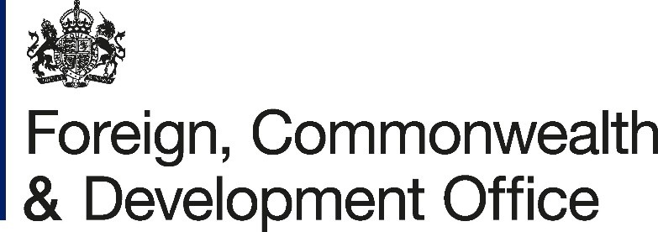

Development Policy &
Partnerships Department
King Charles Street London,SW1A 2AH

www.gov.uk/fcdo

Director, Financing for Sustainable Development Office
Department of Economic and Social Affairs
June 2025

Dear ,
Project Name: Support for the 4th International Conference on Financing for
Development

Project Number: 400469-401

I refer to the Memorandum of Understanding between the Government of the United
Kingdom of Great Britain and Northern Ireland acting through the Foreign,
Commonwealth & Development Office (“FCDO”) and United Nations, acting through its Department of Economic and Social Affairs signed on 4 March 2025.

Following recent discussions, FCDO proposes to delete the words “Funds are earmarked to support the travel of civil society organisations (CSO), who are primarily from developing countries and who are accredited through the CS FfD mechanism, to attend events associated with the 4th International Conference on Financing for Development and its preparatory process.” in paragraph 5 of the original Memorandum of Understanding and replace them with “Funds are earmarked to support the facilitation and travel of accredited civil society organisations (CSO) and academia who are primarily from developing countries to attend events associated with the 4th International Conference on Financing for Development and its preparatory process.”.

In addition, FCDO proposes to add the words “Direct costs associated with facilitation of travel should not exceed 12% of the total value of this grant.” in paragraph 11 of the original Memorandum of Understanding

Following recent correspondence, FCDO proposes to change the end date of the Memorandum of Understanding. FCDO propose that the end date of “14 July 2025” in paragraph 2 of the original Memorandum of Understanding be deleted and replaced with “14 August 2025”.

This letter of amendment will place on record our common understanding of the above change(s) and will come into operation on the date you sign your confirmation below. This note will be known as Amendment No. 1/ 2025.
Please sign both copies of this letter; return one to me and retain the other for your own records.
Signed on behalf of FCDO:
Name:
Position:
Address/Contact Details:
Date:
Signed on behalf of the Partner:
Name:
Position:
Address/Contact Details:
Date:
Yours sincerely,
2

