
OFFICIAL

Accountable Grant Amendment Letter

FCDO Project Name: UK DIGIT – Digitalisation for Growth, Integrity and
Transparency
FCDO Project Number: #400398-404

- I refer to the Accountable Grant between the Government of the United Kingdom of Great Britain and Northern Ireland acting through the Foreign,
Commonwealth & Development Office (“FCDO”) and Eurasia Foundation, United States Tax Identification Number 52-1780162 signed on the 6th of March 2025.

- Following recent discussions and decision on cost extension reached by FCDO and EF, FCDO proposes to change the end date of the Accountable Grant and amount of contribution.

- FCDO proposes increase the amount made available to Eurasia Foundation by £4,299,747 (four million two hundred and nighty nine thousand seven hundred and forty seven pounds steling).

- I propose that the figures and words £4,604,740 (four million six hundred and four thousand seven hundred and forty pounds sterling in paragraph 3 of the original Accountable Grant be deleted and replaced with the figures and words £ 8,904,487 (eight million nine hundred and four thousand four hundred eighty seven pounds sterling).
- I propose that the end date of 30th September 2025 of the original Accountable Grant be deleted and replaced with 31st March 2026.

- This letter of amendment will place on record our common understanding of the above change(s) and will come into operation on the date you sign your confirmation below. This note will be known as Amendment No. 1-2025.

- Please sign both copies of this letter; return one to me and retain the other for your own records.

Signed on behalf of FCDO: | 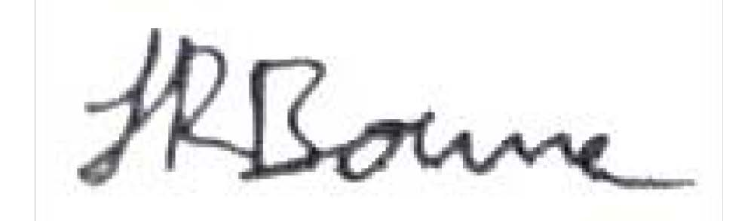
Name: | Jasmine Bourne
Position: | Governance Team Lead
1

OFFICIAL

Address/Contact Details: | British Embassy Kyiv,  9, Desyatynna street, 01024, Kyiv, Ukraine
Date: | 12 September 2025

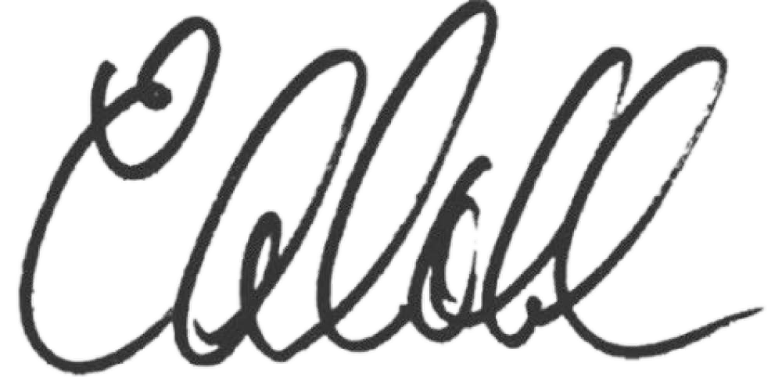
Signed on behalf of the Partner:

Name: | Lisa Coll
Position: | President
Address/Contact Details: | 1717 Pennsylvania Avenue, NW, Suite 1025  Washington, DC 20006  United States of America
Date: | 13 September 2025

