Accountable Grant Amendment Letter

FCDO Project Name: UK DIGIT – Digitalisation for Growth, Integrity and
Transparency
FCDO Project Number: 400398-404

- Following recent discussions, FCDO proposes to delete the words “Where costs are incurred in foreign currency the Partner will use the exchange rate stated in OANDA (www.oanda.com) for the date on which the purchase was made or services acquired by the Partner. Use of any other exchange rate should be approved in writing in advance.” in paragraph 21 of the original Accountable Grant and replace them with “The Partner’s functional and operating currency is the U.S. Dollar (USD). In accordance with U.S. Generally Accepted Accounting Principles (U.S. GAAP), specifically ASC 830 – Foreign Currency Matters, all transactions are recorded in USD within the Partner’s accounting system.
As the approved funding amount is disbursed in Sterling (GBP) and immediately converted into U.S. Dollars (USD) upon receipt, the Partner shall apply the exchange rate that is known and fixed at the time of conversion.
For purchases made or services acquired by the Partner, the First-In, First-Out (FIFO) principle, as outlined in the Foreign Exchange (FEX) Treatment Policy – Advanced Funding (FIFO Application), will be applied”.

- This letter of amendment will place on record our common understanding of the above change(s) and will come into operation on the date you sign your confirmation below. This note will be known as Amendment No. 2 / 2025.

- Please sign both copies of this letter; return one to me and retain the other for your own records.

Signed on behalf of FCDO: | 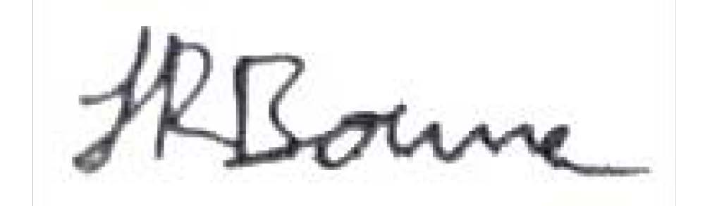
Name: | Jasmine Bourne
Position: | Governance Team Lead / Senior Responsible Owner (SRO)

Address/Contact Details: | British Embassy Kyiv,  9, Desyatynna street, 01024, Kyiv, Ukraine
Date: | 13 October 2025
Signed on behalf of the Partner: 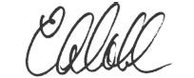
Name: | Lisa Coll
Position: | President
Address/Contact Details: | 1717 Pennsylvania Avenue, NW Suite 1025  Washington, DC 20006 lcoll@eurasia.org
Date: | 14 October 2025

