Annual Review Template

Title: Catalytic Activities Supporting Climate and Disaster Resilience in the Caribbean (CASCaDE)

This is a smaller projects programme

Programme Value £ (full life): up to 1,500,000.00 |  | Review date: 23/12/2025
Programme Code :  AMP ID# 400370 | AMP start date: 23/09/2024 | AMP end date:  31/03/2028

Summary of Programme Performance
Year | 2025
Overall Output Score | A
Risk Rating | Moderate

DevTracker Link to Business Case: | https://iati.fcdo.gov.uk/iati_documents/S4003706.odt
DevTracker Link to results framework: | https://iati.fcdo.gov.uk/iati_documents/D0007596.xlsx

A: SUMMARY AND OVERVIEW

Description of programme

- This programme supports a range of targeted activities that help strengthen the Caribbean’s ability to manage disasters and adapt to climate change. It aims to drive meaningful, lasting change by encouraging actions that promote climate resilience, protect nature, and improve disaster preparedness and response. Key areas of focus include:

- Supporting regional initiatives to make them more sustainable
- Introducing innovative solutions to tackle climate and disaster challenges
- Providing technical assistance to fill gaps in knowledge or capacity
- Incentivising others to act.

These activities are funded through Official Development Assistance (ODA) and can be delivered by a range of partners, such as international organisations, NGOs, and local or international service providers. Expertise may also come from the UK private sector or other UK government departments.

- To date and during this reporting year, two projects were approved by the regional project steering committee:
- An after-action review (AAR) of the Caribbean Disaster Emergency Management Agency (CDEMA) regionally coordinated response efforts in 2024
- Boosting the ‘SMART’ Hospital Initiative sustainability and advocacy with the Pan American Health Organisation (PAHO) and Ministries of Health in the Caribbean.

Summary supporting narrative for the overall score in this review

- The activities agreed have been delivered as expected, which justifies the annual review score of “A”.
Highlights

Strengthening Regional Disaster Response:
- CDEMA convened a regional After-Action Review (AAR) to distil lessons from emergency operations in 2024, with a particular focus on Hurricane Beryl. The workshop in Barbados on 24–25 February 2025, advanced the CDEMA Strategic Objective 2: Building the Next Level Regional Response Mechanism (RRM), which is a network of CDEMA member countries and disaster partners at national, regional, and international levels. Through this network, external response and relief efforts are coordinated to support any CDEMA member state affected by a disaster. The workshop was co-financed by the European Commission, UN agencies (WFP, UNICEF, UNDP), the CDEMA Coordinating Unit, and a 29% contribution from the UK. The event brought together 130 participants from across the region (72F/58M) of which 92 attended in person (52F/ 40M).

- This initiative provided evidence of effectiveness and strengthened capacity and capability of the RRM. These improvements are critical for driving transformational change, helping improve disaster response as threats become more frequent, intense and complex. A Plan of Action (PoA) at operational, strategic, and policy levels is being developed based on findings from the After-Action Review (AAR) process. Recommendations have already been submitted to CDEMA’s Technical Advisory Committee (TAC) and Council, and many improvements were evident in the Hurricane Melissa response for Jamaica in 2025.

Advancing Resilient Health Infrastructure:
- PAHO has updated the ‘SMART’ Hospital Initiative Toolkit to improve user-friendliness and provide additional guidance, including for new hospital builds, while sharing lessons learned. Peer review was completed by the Caribbean Disaster Mitigation Advisory Group (DiMAG) and FCDO Clean Helpdesk experts prior to publication. Twelve new guides were assessed to ensure consistency and integration of gender equality, disability, and social inclusion principles.
- An influencing plan was developed to embed resilient health infrastructure targets in national health adaptation plans, supported by advocacy through regional champions and visibility at national, regional, and international events. Real-world evidence of the toolkit’s effectiveness—demonstrated during Hurricanes Beryl and Melissa—has been widely shared on social media. Regional training events in seven countries have strengthened assessment and preventive maintenance capabilities. This small programme demonstrates all elements of transformational change: evidence of effectiveness, increased capacity and capability, innovation and replicability, scalability support, and sustainability actions.

Major lessons and recommendations for the year ahead

Lessons:
Strengthening the Caribbean Regional Response Mechanism (RRM):
- To remain effective, the RRM must be more agile and adaptable. This means using digital technologies for real-time data and decision-making as well as last mile delivery tracking, ensuring sufficient financial, human, and material resources, and fostering collaboration among national, regional, and international partners—including the private sector and civil society. Aligning expectations and investments between Participating States and partners is critical, as is adopting governance approaches that can adjust to different hazards.
Driving Uptake of the SMART Hospital Toolkit:
- The ‘SMART’ Hospital Toolkit is complex and multifaceted, so ease of navigation and user-friendliness are essential for strong adoption. Leveraging experts to share information and highlight various facets of the toolkit through short testimonials to their networks and encouraging cross-sector exchange of ideas amplified uptake. The influencing plan was strengthened through the ‘SMART’ Hospital Initiative progress evidence collection and inclusive engagement of stakeholders—from ministries to facility staff and end-users.
Building Capacity Through Education Partnerships:
- PAHO collaborating with H. Lavity Stoutt Community College (HLSCC) in the British Virgin Islands to deliver the SMART hospital preventive maintenance course training was effective. By embedding the course within the college’s curriculum, visibility and credibility increased, sustainability was supported and wider adoption of best practices promoted.
Recommendations:
- Leverage the UK’s Networks to disseminate the ‘SMART’ Hospital Toolkit (during Q1-2026)
  - Use UK’s regional networks and the global Alliance for Transformative Action on Climate and Health (ATACH) to actively promote and share the updated ‘SMART’ Hospital Toolkit, ensuring stakeholders across the Caribbean have easy access and understand its practical application.
- Sustain Engagement on Regional Response Mechanism Improvements (ongoing)
  - Continue monitoring progress on CDEMA’s Regional Response Mechanism (RRM) improvement action plan and maintain active participation through the Steering Committee of the new Multi-Source Fund for CDEMA.
- Consider new CASCaDE projects in Disaster Risk Financing (by April 2027)
  - Identify work in disaster risk financing, with a focus on underserved areas such as education. Current regional scoping is underway as part of a global pilot using the FCDO ERRIC Helpdesk (viz. Rapid Assessment of Financial Preparedness in Education in Emergencies (Haiti, Jamaica and Dominica)). Additionally, explore opportunities for advisory/ helpdesk support in partnership with the UK-based Centre for Disaster Protection, which serves as a centre of excellence for helping national governments optimize tools they have and implement effective prearranged financing and layered protection against multiple hazards.

B: PROGRAMME STRATEGY OR THEORY OF CHANGE

- CASCaDE projects are selected based on the following criteria:
  - Supports achievement of Caribbean Country Plan objectives and complements other resilience building activities in our portfolio
  - The extent to which the activities (and their results) contribute to achievement of the theory of transformational change i.e. ‘Change that catalyses further action’ or enables a significant shift to more climate-resilient, nature positive patterns of development or improved disaster risk management and response actions. To this end they should include at least two key elements of transformational change viz: evidence of effectiveness shared; capacity & capability increased; innovation or replicability; scalability support; sustainability actions
  - Responds to identified needs/interests or requests for support from beneficiary countries and complements other donors’ initiatives
  - The ability of delivery partners to provide the services/support required in an effective and timely manner (e.g. strong track record or mandated CARICOM agency)
  - Value for Money (VfM) across the standard 4Es (elaborated in section B2 below)
  - FCDO capacity to provide the necessary financial and human resources to support delivery of the programme
  - Opportunity for wider influence of an organisation or larger initiative.
  - Visibility and an effective communication strategy to maximise the project’s impact.

- This has not changed, and no amendments are recommended as criteria still align with UK/Regional/Post priorities and business plans. Both projects were approved by the regional project board that include Heads and Deputy Heads of Mission, Resident High Commissioners across the region, the Caribbean Development Team and senior management.

C. DETAILED PERFORMANCE AREA AND OUTPUT SCORING

Overall, the programme delivered as expected.

Programme Performance area: | Delivery of projects.
Number: | 1 | Score: | A - Projects have been delivered as expected (any under- or over-delivery is in balance).
Weighting (%): | 100% | Weighting revised since last AR? [If Yes, up or down?] | n/a

Information on the two project outputs, currently approved for the programme, is provided below:

Project 1: CDEMA 2024 Regional Emergency Response After Action Review

- The CDEMA convened a regional After-Action Review (AAR) to distil lessons from emergency operations in 2024, with a particular focus on Hurricane Beryl, the earliest-forming Category 5 hurricane on record, which caused severe impacts across multiple Participating States, notably Grenada (Carriacou and Petite Martinique) and St. Vincent and the Grenadines. Held from 24–26 February 2025 at the Hilton Barbados Resort, the AAR brought together national disaster offices, regional agencies, humanitarian partners, and donors to examine coordination, operational performance, and information management, and to translate findings into practical guidelines to advance achievement of the Next Level Regional Response Mechanism (RRM). FCDO’s contribution directly supported travel and subsistence for CDEMA ODA eligible Participating States, Regional/CARICOM Partners, and Deployment Team representatives.

- The review integrated evidence and insights from the national AARs conducted in Grenada (6–10 January 2025) and St. Vincent and the Grenadines (10–14 February 2025) along with lessons learned from the Tobago Oil spill (February 2024) and Belize wildfires (May 2024). Its primary focus however was on the response to Hurricane Beryl, which necessitated the full deployment of all RRM teams and resources over a 10-week period. Hurricane Beryl highlighted a rapidly evolving risk landscape characterized by more frequent and intense hydro-meteorological hazards, rapid storm intensification, multi-island impacts, complex supply-chain disruptions, and compounding or cascading events.

- The following recommendations were proposed for building the Next Level RRM:
  - Strengthen Disaster Management Financing and Governance
  - Advocate for disaster-related budget tagging in Participating States.
  - Develop a clear costing mechanism for Regional Response Mechanism (RRM) services.
  - Build a systematic governance approach for the RRM to ensure stronger support and effective execution during crises.
  - Improve Operational readiness and crisis planning
  - Establish protocols for seamless integration of deployed vessels into national systems.
  - Review and update disaster plans to address emerging issues such as multi-state impacts, long-term deployments, and transport disruptions.
  - Engage partners to create a harmonized damage and needs assessment tool for post-disaster situations.
  - Leverage Technology and Data
  - Expand use of technology to support emergency response.
  - Invest in GIS applications and specialist training.
  - Standardize data collection formats and templates across agencies.
  - Improve digital systems for data storage, accessibility, and last-mile connectivity for emergency alerts and relief tracking.
  - Enhance Private Sector and Community Engagement
  - Document private sector contributions to emergency response.
  - Actively involve private sector in advance planning for disaster management.
  - Human Resource and Well-being
        - Address burnout and mental health needs of disaster response teams

Project 2: PAHO ‘SMART’ Hospital Initiative sustainability and advocacy strengthening

- A results framework with four outputs was agreed for this project.

- The final evaluation report of the ‘SMART’ Hospital Initiative funded by the UK (2015-2023) included recommendations to:

  - scale up (aiming for the gold performance standard)
  - continue advocacy - fostering adoption of the ‘SMART’ approach in national policies and standards,
  - continued focus on maintenance, the necessity of check consultants,
  - and to improve the ‘SMART’ Hospital Toolkit.

These ambitions were incorporated in the workplan of this project. The ‘SMART’ Hospital blueprint and toolkit is part of the World Health Organization’s framework for health resilience that covers people, systems, finance and infrastructure requirements, and aligns with priorities such as the global Alliance for Transformative Action on Climate and Health (ATACH).

Output Title | The ‘SMART’ hospitals toolkit revised and updated incorporating lesson learnt and new technical guidance as well as usability improved for Ministry of Health planning purposes
Output number: |  | 1 | Output Score: | A
Impact weighting (%): |  | 30 | Weighting revised since last AR? | No

Indicator(s) | Milestone(s) for this review | Progress
Updated ‘SMART’ hospitals toolkit includes:  a) Improved usability and workflow  b) Strengthened green checklist and guide to include latest advances  c) ‘SMART’ checklist for design of new planned facilities  d) Enhanced water and waste management strategies. | The following draft annexes have been produced/updated  - Green checklist and guide  - Cooling and ventilation  - Preventive maintenance guidelines  - Fire safety  - Base isolation for earthquake safety  - Check Consultants importance and use.  - Measures for control of airborne Infections control  - Water  - Wastewater  - Waste (solid infectious, hazardous)  - Design of new facilities-Sustainable construction for the future  - Lessons from Hurricane Beryl | Achieved- draft annexes updated/produced and peer reviewed by DIMAG as well as PAHO and FCDO (with help from the CLEAN helpdesk) in November 2025  Currently reviewing webpage and improving user navigation of the toolkit  .

Output Title | Capacity for application of the rapid vulnerability assessments using the ‘SMART’ toolkit strengthened at country level
Output number: |  | 2 | Output Score: | A
Impact weighting (%): |  | 20 | Weighting revised since last AR? | No

Indicator(s) | Milestone(s) for this review | Progress
Capacity increased on the application of the updated Smart Hospitals tools, including the Hospital Safety Index (HSI) and Green Checklist on-site | Subregional training course is conducted in September in Jamaica with participation from 2 participants from at least 7 countries | Achieved: A training course (on-line and practical sessions) was held 23–25 September 2025 with participation from  Jamaica, Belize, Grenada, St. Lucia, Dominica, SVG (16M/14F). Nine countries were invited.

Output Title | Preventative maintenance / ‘SMART’ resilience 'aftercare' training course established and offered by PAHO technical experts and Caribbean based community college
Output number: |  | 3 | Output Score: | A
Impact weighting (%): |  | 20 | Weighting revised since last AR? | No

Indicator(s) | Milestone(s) for this review | Progress
PAHO conducts ‘SMART’ aftercare hands-on training. Collaboration with academic institution for maintenance training established as part of the sustainability strategy | A ‘SMART’ aftercare training session prepared in BVI in close collaboration with the Community College with 2 participants trained from at least 7 countries | Largely achieved - train the trainer hands on program with participants from BVI, Belize, St. Lucia, Grenada and SVG held 28–29 Oct 2025 (15M/3F).
Output Title | Increased advocacy for integration of SMART blueprint approach within broader health resilience developments.
Output number: |  | 4 | Output Score: | A
Impact weighting (%): |  | 30 | Weighting revised since last AR? | No

Indicator(s) | Milestone(s) for this review | Progress
Increased advocacy to promote ‘SMART‘ standards at national, regional and international levels | Assessment of status of SMART blueprint approach post 2023 conducted (further upgrades, inclusion in Health National Adaptation Plans (HNAPs), climate financing bids etc) and list of key stakeholders and advocates compiled. Influencing plan developed. | Achieved - both the ‘SMART’ Initiative adoption progress assessment and influencing plan)

Briefly describe the output’s activities and provide supporting narrative for the score

- Twelve new annexes (guides and lesson learnt briefs) were drafted for the toolkit to help government, contractors and designers successfully apply the resilience blueprint. They focused on areas that were identified as requiring more support or elaboration from implementation of the ‘SMART’ initiative across 55 health facility sites from 2015-2023 including fire safety, sustainable new construction, natural ventilation, waste management and infectious disease management.

- Regional training was conducted as agreed to boost country capacity to undertake vulnerability assessments and preventative maintenance on hospitals for sustainability.

- The virtual course on Evaluation of Health Facilities using the Hospital Safety Index (HSI) was updated (HSIv2), prior to the regional training. The trained professionals from six countries completed both an online and practical training course and are required to complete an assessment of at least 2 healthcare facilities in their home country following the training. The results will be captured on the PAHO ‘SMART’ Initiative results dashboard. Additionally, the PAHO project team supported the updating of the EcoCheck (Green checklist) and the EcoBase (BAT-assessment) of the ‘SMART’ toolkit for Latin America (Manual de aplicación del kit de herramientas para la implementación de Hospitales Smart en￼.

- The assessment of progress with respect to the ‘SMART’ hospital blueprint rollout and further investment revealed that seven Caribbean countries have now included SMART health infrastructure targets in their health national adaptation plans (H-NAPS) with more in progress.

- Countries like Guyana where significant investment in hospital upgrades and new facilities (building 6 new hospitals in next 2 years) was noted, were targeted for additional engagement from the project team. A meeting with the Ministry of Health (Chief Medical Officer and the Director of Standards) facilitated by the UK High Commissioner and PAHO representative was held to discuss the toolkit updates and support, as well as confirm incorporation of ‘SMART’ performance standards in health facility designs.

- A broad range of advocacy activities continue. Some highlights include:
  - A ‘SMART’ Hospital champion network has been established to assist with the influencing plan. Short video testimonials or social media posts were done by several ‘SMART’ experts highlighting key aspects of the initiative from their perspective and others have done presentations to their peer networks e.g. to Jamaica Institute of Architects (Lessons from the Field: Structural Failures & Mitigation Strategies).
  - The initiative was showcased at The Caribbean Regional Climate Change and Health Event 17-19 June 2025, Barbados (see quote below from Belize Ministry about their progress)
  - An article and Instagram post (see below) was produced on the impact of Melissa on one of the gold standard ‘SMART’ sites in Jamaica Santa Cruz
  - Several journal publications have also been produced including one that highlighted key cost savings from energy and water ‘SMART’ measures (see Figure 1).
  - A presentation, of the Initiative, was done at one of the pavilions during COP30 in Belém, Brazil: ‘Accelerating Sustainable and Climate Resilience in Health Systems: A Zero Regrets Strategy’.

Quote from the 2025 Caribbean Climate and Health Event Synthesis Report:
Belize has taken a significant step by initiating a blue carbon footprint assessment of our health facilities—an advancement that builds on our ongoing ‘SMART initiative. We’ve already drafted legislation to make ‘SMART’ standards mandatory for all new health facilities and any facility undergoing modification. These will be the first national standards specifically targeting health infrastructure, marking a major milestone. The blue carbon footprint approach allows us to evaluate how resilient our health facilities are to climate change impacts. Importantly, this work transcends traditional silos between public and private sectors, recognizing that no single facility delivers every service a patient needs. It’s a collaborative model that supports integrated, climate-resilient healthcare. - John Bodden, Ministry of Health, Belize.

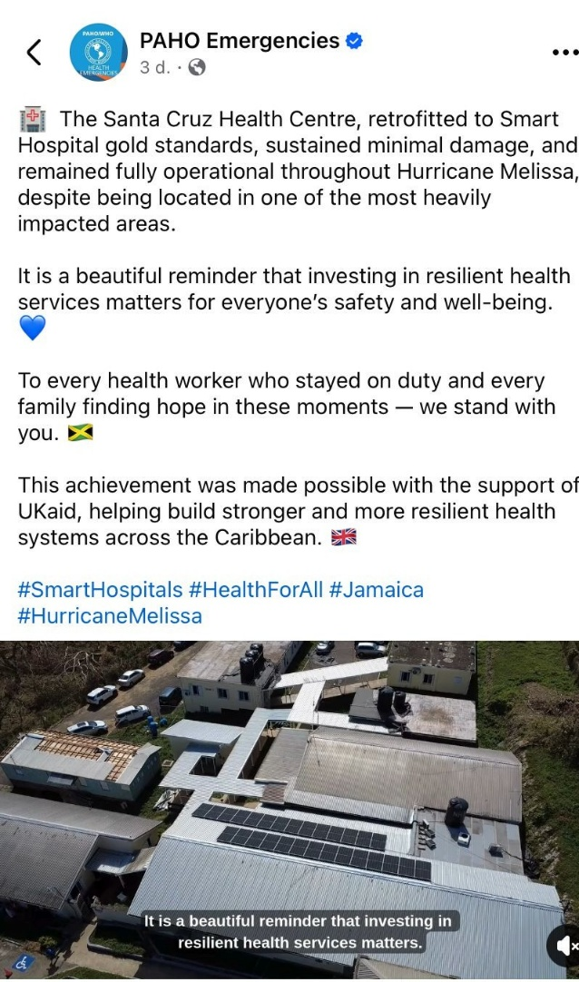
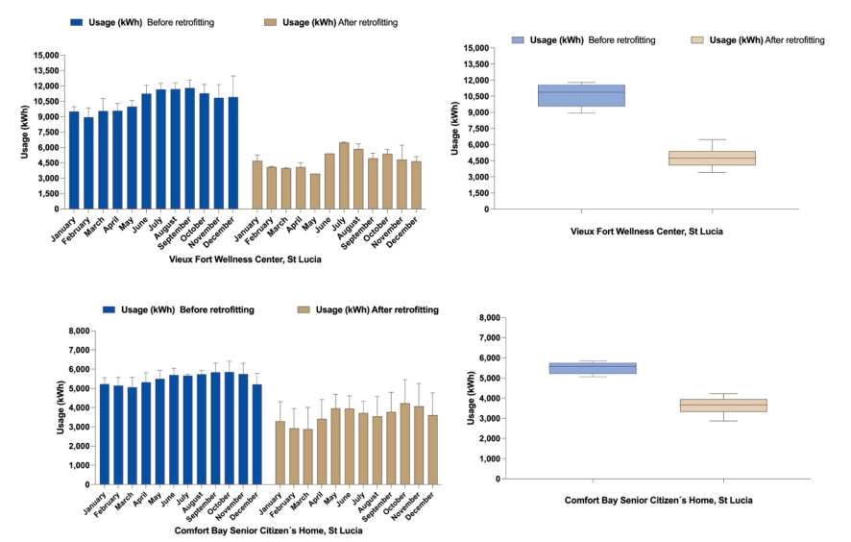
Figure 1: Journal of Climate Change and Health- graphics demonstrating energy savings realized in some of the St Lucia ‘SMART’ retrofitted facilities through a variety of measures.

D: RISK

Overview of risk management

- The programme’s risk appetite across its portfolio and country contexts is assessed as Moderate, consistent with the FCDO’s overall risk appetite. CASCADE is designed to remain responsive to risks inherent in challenging environments, while working closely with stakeholders to address these risks through a range of tactical activities.

- Risks are mitigated through proactive engagement with stakeholders and alignment with FCDO’s new risk management approach. CASCADE’s overall risk appetite across the six categories is as follows:
    - Strategy & Context: Eager
    - Policy & Programme Delivery: Receptive
    - Public Service Delivery & Operations: Receptive
    - Financial & Fiduciary: Cautious
    - Reputational: Cautious
    - Safeguarding: Cautious

- The FCDO team has actively monitored risks throughout the year, updating the risk register regularly and reviewing it in monthly meetings with delivery partners as relevant. All risks have remained within the defined appetites, and no escalations were required during the reporting period.

- Due Diligence Assessments (DDAs) were completed to support new agreements reflecting FCDO’s financial contributions to CDEMA and PAHO. No major risks were identified. Action plans are in place to engage these implementing partners on areas requiring further attention.

- Risks especially the potential disruption of in-person training due to the Caribbean hurricane season or other disasters remains. Currently several project personnel are supporting the Hurricane Melissa response efforts by PAHO.

- Delays in finalizing the MOU and releasing initial funds compressed timelines for this complex project, particularly for updating and reviewing the toolkit prior to publication. PAHO have asked for a no-cost extension to March 2026 which is still within the current financial year and therefore expected to be approved.

- Broader risks tracked included potential reductions in U.S. funding to PAHO in 2025. It was expected that this would affect retention of core personnel essential for project implementation who were not funded by the FCDO contribution. This has not been realised but staff have been affected by the uncertainty and restructuring in Washington.

- The RRM 2024 After Action Review took place amid geopolitical upheavals with implications for national and regional readiness. Those upheavals, as well as shifting policy positions of the United States have revealed the high-risk exposure of the RRM and brings new uncertainties to the Caribbean region, particularly as it relates to previous financial and technical arrangements. The current climate crisis, global hydrometeorological and other implications point to a future where the region’s reliance on its own capacities would be the cornerstone for responses under the RRM, as partners may be forced to increasingly shift their attention to addressing domestic concerns.

. Date of last narrative financial report | PAHO Mid-term Project Report  1 February – 31 August 2025  PAHO (31 Jul 2025) Official Financial Report | Date of last audited annual statement | PAHO Financial Report of the Director and Report of the External Auditor for 2023  Financial Report of the Director and Report of the External Auditor for 2023. (Official Document;370)

Date of last narrative financial report | CDEMA – awaiting | Date of last audited annual statement | CDEMA financial statements for 2020 and 2021

E: MONITORING AND NEXT STEPS

- During the review period, FCDO maintained regular communication and held monthly meetings with PAHO to gather feedback and ensure the programme stayed on track.

- In 2025/6, all committed CASCADE funds have been disbursed totalling £309,015,000.

- The team is exploring potential additional projects to advance our disaster risk financing support.

- A DDA was recently completed for UNICEF Caribbean as a possible new partner.

How the review was conducted:

- The Annual Review was based on programme documents and conducted by the Climate Change and Disaster Risk Management Team, led by the Climate Change and Disaster Resilience Adviser (SRO), with support from the Senior Programme Officer and Programme Responsible Officer (PRO).

F: PROJECTS ANNEX

Name of project partner | Date approved | Value | Delivered according to agreed budget, timescale and quality? | Spend to date | Beneficiary countries
1-CDEMA | February 2025 | £61,000 | Yes -but still awaiting AAR report | 100% | Caribbean regional
2-PAHO | March 2025 | £250,000 | Yes | £248,014.62 / 99.2% | Caribbean regional (ODA eligible states)

Endnotes:

A Smaller Project is defined as a funding arrangement with a single implementing partner normally not exceeding £250k. Such projects can be grouped as a Programme for approval and reporting purposes provided the total budget envelope does not exceed £2m. See PrOF Guide.
Project title: Building ‘SMART’ (Safer, Greener and Sustainable) Health Care Facilities in the Caribbean and Beyond - strengthening the aftercare programme and promotion of the infrastructure resilience standards blueprint
FCDO Education Research in Conflict and Protracted Crisis (ERICC) Helpdesk
Factors are drawn from criteria and theory of change identified in the UK International Climate Fund (ICF) ICF Key Performance Indicators (KPIs) - KPI 15- Extent to which ICF intervention is likely to lead to Transformational Change
CDEMA Regional Response Mechanism
Hospital Safety Index (HSI)v2: -https://campus.paho.org/en/course/health-facilities-assessment-using-hospital-safety-index
https://www.paho.org/es/documentos/ecocheck-lista-verificacion-ecoeficiente.
https://www.paho.org/en/stories/smart-hospitals-jamaica-demonstrate-health-system-resilience
Assessing the Effectiveness of Climate-Smart Health Facilities in Small Island Caribbean Nations, Annals of Global Health. Lichtveld M, Hospedales J, Davenport SR, Buchanich J, Harvey J, Wahid FA, Freitas LD. 2025; 91(1): 00, 1–16. DOI: https://doi.org/10.5334/aogh.4755. Submitted: 30 March 2025, Accepted: 8 July 2025, Smart Greening Initiatives for Healthcare Facilities: A Caribbean Case Study on Environmental Sustainability and Disaster Resilience, The Journal of Climate Change and Health, August 05, 2025. (https://www.em-consulte.com/article/1753253/resume/smart-greening-initiatives-for-healthcare-faciliti

