Annual Review

Title: Ukraine Economic Stabilisation Programme (UESP) / UK Support to Financing of Recovery from Economic Emergency in Ukraine (FREE)
Programme Value (full life):  UESP  £3m in grant (technical assistance)  $3bn in loan guarantees  FREE  £74m grant  $2bn in loan guarantees |  | Review date: August 2025
Programme Code: [AMP ID#]  UESP - 400299  FREE - 301512 | AMP start date:  UESP - 12/09/2024  FREE – 25/03/2022 | AMP end date: UESP – 15/08/2057  FREE Ukraine – 15/10/2051

Summary of Programme Performance
Year | 2022/23 | 2023/24 | 2024/25
Overall Output Score | A+ | A+ | A
Risk Rating | Major | Major | Major

DevTracker Link to Business Case: | UESP – DevTracker Programme GB-GOV-1-400299  FREE - DevTracker Programme GB-GOV-1-301512
DevTracker Link to results framework: | UESP – D0007383.xlsx  FREE - D0006069.xlsx

A. SUMMARY AND OVERVIEW [1-1 ½ pages]

Description of programme [1-2 paragraphs]

At the Ukraine Recovery Conference (URC) in June 2023, the Prime Minister announced a further $3bn in loan guarantees to support World Bank lending to Ukraine, bringing total guarantee support to $5bn. UESP is the programme under which the URC-announced package of $3bn in loan guarantees is managed. Broadly, UESP marks a continuation of the objectives of FREE – the programme under which the initial $2bn of loan guarantees is managed. Both programmes provide additional fiscal support to Ukraine; they achieve this through loan guarantees which enable the World Bank to lend above-and-beyond amounts permitted under its own risk management framework. Lending under both programmes supports essential non-military, government expenditure: guarantees remained through 2024/2025 the largest form of the UK’s non-military support to Ukraine, as they have since the beginning of the Russian invasion.

The core objective of UK loan guarantees is unchanged: mitigate the adverse social and economic impact of the war on Ukraine and ensure Ukraine has capacity to fight its war with Russia. A longer war, combined with the inception of Ukraine’s IMF programme, necessitated scaling up fiscal commitments to meet Ukraine’s needs over the medium term. UESP continues to deliver fiscal assistance essential to Ukraine’s macroeconomic stability and which safeguards the provision of essential services. Earmarked grant money for complementary technical assistance will help support the conditions for early recovery where possible.

Notwithstanding the consistency across the two programmes’ objectives, the ambition of and framework for the UK’s Ukraine loan guarantees have evolved in two key ways across the two programmes. First, whereas initial fiscal support was provided in an urgent, ad-hoc manner under FREE, UESP (agreed in the second year of conflict) responded to the need for more predictable, long-term support on the basis of a longer conflict. The commitment to guaranteeing $1bn a year in lending, between 2024-2026, was the UK’s contribution to the G7-coordinated financing assurances required for the inception and delivery of Ukraine’s IMF programme. Second, UESP reflects the UK’s maturing development objectives in Ukraine. Under UESP, the UK has committed to exploring a more diverse range of World Bank lending instruments beyond PEACE (the instrument of choice under FREE) which incentivise the Government of Ukraine’s delivery of reforms, in line with EU Acquis and Ukraine’s IMF programme.

Given the logical consistency in objectives and risks across UESP and FREE, it was agreed with the FCDO’s Centre for Delivery, per the recommendations outlined in last year’s FREE AR, that both programmes should undergo a single AR process. As the UK has completed its guarantees under FREE, the review concentrates itself on the impact of lending guaranteed under UESP; however, it maintains an oversight of the enduring impact of lending under FREE, in addition to the remaining exposure and risk of UK guarantees being called for lending under FREE.

Summary supporting narrative for the overall score in this review [1-2 paragraphs]

Throughout the reporting period, Ukraine’s economy continued to perform positively. Annex A presents the change in Ukraine’s real GDP over recent years, in addition to forecasts across the IMF’s baseline and downside scenarios on the war trajectory. Growth is modest, which is to be expected for a country facing full-scale invasion, strikes on energy and gas infrastructure, labour shortages and rising reconstruction and repair costs. International fiscal support has been a foundation for this positive performance. With approximately 60% of the Ukraine’s budget going on security and defence, the continued servicing of essential systems and services would not have been possible without external fiscal support, a proportion of which the UK’s loan guarantees provide.

During 2024, the UK guaranteed $1bn of IBRD lending to Ukraine through UESP, delivered under two Growth Foundations Development Policy Operations (DPOs). The facilitation of additional lending is the key objective of UESP: $1bn of guarantees for 2024 is consistent with the expectations of the UK, as outlined by the IMF and its stipulated requirement for financing assurances. This has therefore chiefly driven the overall programme assessment as ‘A: Outputs met expectation’.

There has been strong performance across the remaining outputs: namely The World Bank’s reporting compliance and the timeliness of disbursement of UK-guaranteed funds. These outputs are weighted far more modestly than the chief objective of unlocking additional IBRD lending; their strong performance has therefore been modest in determining the overall programme’s score. This report includes a comprehensive outcomes reporting section to capture the development impact of the contingency element to UK-guaranteed funds. While the impact is not captured across the programme’s output scores and therefore in the overall programme assessment, it should be noted that the programme performed very strongly in delivering the UK’s medium- to long-term development objectives in Ukraine.

Major lessons and recommendations for the year ahead [1/2 page]

- Increase the UK’s role as an informer of reforms under the World Bank’s interventions. Where the UK can draw on its sector-specific, reform expertise (such as in social protection, through the Social Protection for Inclusion, Resilience, Innovation and Transformation (SPIRIT) programme), it should look to coordinate closely with the bank in the project design and implementation stages to enrich and strengthen operations.

- Review planned timings of disbursement for remaining $2bn of UK loan guarantees. At the time of writing, the UK is exploring the prospect of reprofiling its loan guarantees to maximise their contribution to Ukraine’s long-term fiscal stability. Deviating from the original intentions of guaranteeing $1bn/year while ensuring the UK continues meet its financing assurance obligations to the IMF programme, should be seriously considered and reported against in the following AR.

- Concerted effort, per the UESP business case, should be made to ensure the correct mix of instruments is selected to deliver against priority objectives. As 2024 involved exclusive use of DPOs as the instrument of choice. The UK should interrogate whether drawing on alternative instruments would better support development objectives. In particular, consideration should be made as to which lending instruments will best support the UK’s long-standing objectives on reforming Ukraine’s social protection systems, as advanced under the UK’s SPIRIT programme.

- Identify how to maximise the development and catalytic impact of technical assistance. £3m is earmarked under UESP to support Technical Assistance (of which £2.15m remains for disbursement). The UK should consider how this money could best support the programme’s objectives. Consideration should be forward-leaning and ambitious: it should build on areas for improvement as identified in existent or future World Bank DPO policy matrices; it should be cognisant of sectors where the UK has added development value and in-house expertise, such as social protection.

B: THEORY OF CHANGE AND PROGRESS TOWARDS OUTCOMES [1-2 pages]

Summarise the programme’s theory of change, including any changes to outcome and impact indicators from the original business case. [1/2 page]

The theory of change constructed for UESP draws heavily upon that constructed for FREE, given the consistency in objectives across the two programmes. The intended impact of UESP and FREE is to support Ukraine’s macroeconomic stability, mitigating the economic and humanitarian impact of the war, to ensure that it has the resources to continue fighting its war with Russia.

The two theories of change differ in certain areas. First, UESP does not incorporate the level of detail at output reporting as was included under FREE. Per recommendations in previous FREE ARs, the FREE theory of change was amended to align it with the World Bank’s own reporting frameworks. This was not continued for UESP: given alternative instruments to PEACE are planned under this programme, the programme should not adopt the logic of the PEACE results framework. However, reporting against the results of PEACE will continue at the outcomes level of ARs, for as long as is appropriate.

Another significant difference between the theories of change under FREE and UESP is the inclusion within the latter of ambition to drive forward Ukraine’s reform agenda. To enhance Ukraine’s investment environment and support the country’s journey towards EU membership, the programme commits to using guaranteed lending as an incentive for reform, capturing the UK’s medium- to long-term development objectives in Ukraine. In particular, the programme will seek to strengthen social protection mechanisms, building on and working closely with the UK’s SPIRIT programme to deliver this change.

The UESP theory of change is built on the logic that key inputs (UK guarantees and grants) will enable outputs of additional IBRD lending, delivered in a predictable manner with reporting compliance standards met, in addition to complimentary technical assistance. This will achieve the following outcomes:

- Ukraine’s financing gap is met by the international community
- Core functions, essential services and payments are maintained
- The Government of Ukraine implements reforms conductive to growth, stabilisation and improved public services
- Technical assistance delivers against World Bank development priorities in Ukraine
Describe where the programme is on/off track to contribute to the expected outcomes and impact. What action is planned in the year ahead? [1/2 page]

- Ukraine’s financing gap is met by the international community
For the inception and implementation of Ukraine’s IMF programme, the IMF required the G7 to meet Ukraine’s external financing gap by providing financing assurances totalling $152.9bn (including an IMF programme worth $15.5bn) throughout the duration of the programme. The $3bn of loan guarantees committed to under UESP was the UK’s fair burden-share contribution to this financing assurance. The continuation of the IMF programme throughout 2024 and 2025 is testimony to UESP’s meeting its outcome objective of contributing to filling Ukraine’s financing gap. This is substantiated through the documents provided by the 8 IMF reviews completed thus far. Tables evidencing the closed financing gap, provided by the IMF following completion the 8th and latest IMF review, are provided in Annex B to testify to this: the General Government Finances highlight the closed financing gap under the baseline scenario. The IMF also project that, under the baseline scenario, the gap will remain $0 through to 2033.

Actions planned for the year ahead, in relation to this outcome, are twofold. First, the UK is planning to revise the pace at which it delivers loan guarantees, without revising the total amount of loan guarantees under UESP. Originally, the UK committed to guaranteeing lending at a pace of $1bn a year, in line with IMF financing assurance requirements. However, many other G7 partners frontloaded disbursement of their financing assurances, giving Ukraine a modest fiscal surplus for 2025. UK loan guarantees will likely better serve the needs of Ukraine’s long-term fiscal needs if UESP deviates from a guaranteeing at a pace of $1bn/year, backloading support to future years. Reprofiling would not undermine the UK’s commitment to providing financing assurances to the IMF programme: the UK’s disbursement in 2025 of £1.5bn under its contribution to the G7 Extraordinary Revenue Acceleration (ERA) loan scheme (total UK commitment: £2.26bn) means the UK has abided by its financing assurance requirements for 2025.

Second, the UK will coordinate with partners to ensure that existent fiscal commitments suffice as a means of meeting Ukraine’s financing gap. The IMF programme, and the required financing assurances, rested on a baseline scenario in which the conflict comes to an end by December 2025. As this deadline approaches and the war endures, the financing assurances required to meet Ukraine’s financing gap and ensure the continuation of the IMF programme will almost certainly increase. FCDO has already used all available exposure headroom within its risk appetite for loan guarantees.

- Core functions, essential services and payments are maintained
UK-guaranteed lending provided under the two DPOs in 2024 was more fungible than lending guaranteed against the World Bank’s PEACE project under FREE. DPOs provide direct budget support to a government’s treasury, which can be used across sectors and for any expenditure. The PEACE instrument, in contrast, stipulated eligible expenditure and disbursed funds on the presentation of such receipts. It is therefore more challenging to trace the exact contribution of UK guarantees to maintaining specific essential services. Nonetheless, the UK’s commitment to $3bn in loan guarantees was part of a G7-coordianted financing package valuing $152.9bn (including $15.5bn of IMF support). Ukrainian Ministry of Finance officials, in a meeting conducted under the AR process, confirmed that this package of external assistance has been instrumental in enabling Ukraine to continue with the delivery of its essential services.

Moreover, given the significant proportion of Ukraine’s on-budget expenditure that the G7 coordinated financing assurances supported in 2024 and 2025, sources such as the World Bank’s ‘Listening to Citizens of Ukraine Survey’ can be consulted to measure progress against this outcome. In the survey, published in May 2025 and reporting against findings in 2024, the World Bank found that government functions and basic services continued, but unavoidable disruptions did occur. Pension and social assistance payments were largely paid on time without disruptions and health clinics largely remained open. Most children were enrolled in school, but 35% of those aged 6-18 experienced disruptions in Q4 of 2024. Furthermore, following heavy outages in Q2-Q3 of 2024, electricity became more readily available during Q4. The reporting is positive and testimony to importance of G7 financing assistance to ensuring continued support: some breaks in service delivery are to be expected against a landscape of active conflict.

PEACE

While no UK guarantees across the last 12 months supported lending under the World Bank’s PEACE project, guarantees programmed under FREE did. Insomuch as PEACE remains active and the World Bank’s flagship initiative to financing Ukraine’s essential services, the results of PEACE remain a testimony to the impact of UK fiscal support. PEACE fulfils an essential social and humanitarian function, mitigating the human impact of conflict by enabling Ukrainians to access essential, life-saving services. As caveated in historical FREE reports, UK guarantees should be understood as contributory, as opposed to absolute, in driving results under PEACE: total support mobilised under PEACE is $51bn; the UK’s contribution to PEACE $1.95bn. As no guarantees supported PEACE across this AR’s reporting period, the UK’s contribution to PEACE should be caveated even further for this AR.

Regardless, the most recent Project Information Document (PID) that the World Bank produced for PEACE covers the period from PEACE’s inception in August 2022 through to September 2024. Reporting outlined that over an estimated 13 million people have benefited from PEACE: this includes 10 million pensioners, 500,000 education employees, 140,000 government employees, 56,000 fires responders, and 3 million recipients of social assistance payments, including Internally Displaced Persons (IDPs). 90 percent of social assistance payments were made on time as of September 2024. The World Bank also reported that 12,592 schools and 2,180 health services remained functional as of September and August 2024 respectively.

- The Government of Ukraine implements reforms conducive to growth, stabilisation, and improved public services
The UK’s decision to guarantee lending against two Growth Foundations DPO in 2024 marked the strategic shift towards furthering the UK’s medium- and long-term development objectives in Ukraine. In making disbursement of funds contingent upon agreed actions by the Government of Ukraine, UK guarantees were able to support progress against Ukraine’s reform agenda, in line with obligations under both EU acquis and its IMF programme. A breakdown of the key steps and progress made under the 2024 DPO series is outlined below.

Reforming State-Owned Enterprises (SOEs) and Enhancing Market Competition
- Corporate Governance Overhaul: DPO1 supported legislation (Law #3587-IX) to strengthen SOE supervisory boards, increase their independence, and align governance with OECD standards.
- Railway Sector Liberalization: DPO2 supported the submission of a draft law to unbundle the state railway monopoly (Ukrzaliznytsia) into separate entities for infrastructure, freight, and passenger services, opening the sector to private competition.
- Bank Privatization Framework: A new law (Law #3983-IX) established the legal basis for privatizing state-owned banks, aiming to reduce the state’s footprint in the financial sector and improve credit allocation.

Advancing Renewable Energy and Green Transition
- Tariff Reform: DPO1 replaced the fixed feed-in tariff with a competitive auction-based feed-in premium mechanism (Law #3220-IX), improving cost efficiency and transparency.
- Implementation Framework: DPO2 operationalized this mechanism through NEURC Resolution #1381, enabling renewable energy producers to participate in the market.
- Biomethane Export: A new law (Law #3613-IX) and regulation allowed for the export of biomethane, supporting Ukraine’s integration into the EU energy market and promoting circular economy practices.

Strengthening Agricultural Finance and Resilience
- Agrarian Notes: DPO1 introduced digital agrarian notes (Law #3586-IX) as a tradable collateral instrument to improve farmers’ access to credit.
- State Agrarian Registry (SAR): DPO2 operationalized SAR (Law #3980-IX), allowing banks to access agricultural data for credit assessments and enabling rapid disaster relief for farmers.

Improving Access to Finance and Capital Market Regulation
- SME Credit Targeting: DPO1 restructured the 5-7-9 loan program to focus exclusively on SMEs, with a gender-inclusive target.
- Bankruptcy Reform: DPO2 enacted a law (Law #3985-IX) to streamline preventive restructuring procedures, aligning with EU Directive 2019/1023.
- Credit Rating Agencies: A new law (Law #3981-IX) established standards for rating agencies, aligning Ukraine’s capital market regulation with IOSCO and EU norms.

Customs and Trade Facilitation
- Customs Code Alignment: DPO1 supported the submission of a law to align Ukraine’s customs code with EU legislation, which was enacted in October 2024.
- Leadership Reform: DPO2 reformed the selection process for the head of the State Customs Service (Law #3977-IX), introducing international oversight to improve integrity and professionalism.

Enhancing Domestic Revenue and Public Financial Management
- Land Tax Base Reform: DPO1 initiated a pilot mass land valuation; DPO2 published updated valuations, a step toward replacing outdated normative values with market-based assessments.
- Excise Tax Alignment: DPO2 enacted a law (Law #3878-IX) to gradually align fuel excise taxes with EU minimum levels, increasing revenue and discouraging fossil fuel use.
- Procurement Integrity: DPO1 initiated updates to risk indicators in the e-procurement system; DPO2 mandated their use and supported a new draft procurement law to align with EU standards.

Progress against Ukraine’s reform agenda was jointly driven by the support provided by the Government of Japan to the programmatic DPO series. Across the combined support, disbursement of funds under the DPOs was great enough to effectively incentivise structural reform.

Notwithstanding the strong achievements under the Growth Foundation DPOs, it is important to capture the unrealised ambitions of the programmatic DPO series and the challenges that these speak to:

- Complementarity of reforms

Across the two DPO series, multiple challenges were encountered regarding the complementarity of reforms with those required under other pathways, specifically EU Acquis. Many of the outlined triggers for DPO2 were altered across the programmatic series, given that in their original form they risked creating unnecessary burdens or interfering with the reform agenda being driven through under the EU accession plan. This was the case with Trigger 1: Ukraine’s requirement to enhance the competitiveness of the railway market through enacting legislation was amended to requirement that a draft law be submitted to the Verkhovna Rada. This enabled the authorities to engage with the EU and ensure that the details of the proposed law did not conflict with requirements under EU acquis. Similarly, trigger 10, which initially proposed amendment to the public procurement law, was both combined with trigger 9 to streamline the policy matrix and revised to submission of a draft procurement law, to ensure alignment with EU standards.

Staff from Ukraine’s Ministry of Finance highlighted that they would like to see greater complementarity of reforms required under World Bank lending operations with the IMF programme and EU Acquis. More specifically, staff outlined that the process was eased by contingencies involving legislative steps, as opposed to drafting of entire laws.

- Challenge of maintaining reform momentum given the war in Ukraine

In contrast to DPOs delivered in many other countries, Ukraine’s status of being at war with Russia has engendered a challenging political and economic landscape against which reforms are to be advanced. So too did the fixed timeline attached to UK guarantees have a resulting impact on the weight of the Bank’s negotiating position when seeking to advance reforms.
Reform zoom-in: Agrarian notes

As part of the reform agenda to enhance agricultural finance, the Growth Foundations DPO series introduced and operationalized agrarian notes (ANs)—a new digital financial instrument enabling farmers to use future crop yields as collateral. Enacted under DPO1 (Law #3586-IX), ANs are electronic securities designed to reduce issuance costs and improve transparency by circulating through Ukraine’s depository system. DPO2 advanced this reform by enacting legislation (Law #3980-IX) to operationalize the State Agrarian Registry (SAR), granting banks regulated access to comprehensive agricultural data. This integration enables more accurate credit assessments and facilitates targeted public support, including disaster relief. Together, these reforms aim to unlock credit for smallholders and female farmers, with a target of $75 million in financing via ANs by 2026, and a broader goal of increasing agricultural sector credit from UAH 116 billion to UAH 150 billion.

As part of the review process, the UESP programme management team interviewed X of Kernel - the second organisation to issue an agrarian note following the completion of the DPO series. X spoke to the importance of the ambition of the reforms in giving Kernel confidence and ability to lend to small- and medium-sized farmers. Moreover, he highlighted the catalytic effect that making loans more accessible would have in moving farmers away from unofficial markets to trading on formal, official markets, hence bolstering the domestic revenue that can be raised by the government within the agricultural sector.

However, while the ambition was correct, X highlighted there had been technical issues with the process which rendered the agrarian notes inadequate. X spoke to the problems with the national depository system, which continues to use technological infrastructure incompatible with the needs of the agrarian note system. This caused significant delays between submitting the necessary documents and being able to issue the agrarian note, in addition to undermining the digitalising ambitions of the process: paper documents were still required for submission due to the incompatible technology. While the move to allowing farmers to use future crop yield as collateral against lending and the digitalisation of the process was described as “historic” by X, bureaucratic impediments persisted and undermined its purpose.

- Technical assistance delivers against World Bank development priorities in Ukraine
Over the reporting period, £850k of grant money was disbursed to the World Bank to support with technical assistance (TA). This money contributed to activities under the UK’s SPIRIT programme. Staff at the World Bank testified that this strongly supported the World Bank’s development priorities in Ukraine of developing a vision for the country’s postwar economy. The World Bank’s Ukraine Economy of the Future (UEF) aims to inform the resumption of regular economic activities to stabilisation and then recovery and reconstruction. This pathway seeks to increase economic dynamism to accelerate convergence with the EU economies, as Ukraine progresses on its accession path. World Bank staff testified in writing that the TA which UESP funds supported positioned social sustainability needs at the centre of this vision.

The loan guarantees element of UESP will also seek to deliver against this vision, with current plans being to use a portion of remaining UK loan guarantees in support of a dedicated social protection operation.

Justify whether the programme should continue, based on its own merits and in the context of the wider portfolio [1 paragraph]

In its first year, UESP has met an urgent foreign policy priority by contributing to fiscal stability to Ukraine. It achieved this chiefly by unlocking additional IBRD lending to Ukraine; however it also achieved it by functioning as a financing assurance to the IMF programme, thereby enabling the programme’s inception and the provision of an additional $15.5bn of funds. The programme’s continuation is essential to the continued fiscal stability of Ukraine; the key consideration will be whether the programme need be scaled up to meet additional fiscal needs Ukraine is expected over the next year.

UESP also represents an evolution of objectives of FREE by accounting for the UK’s medium- to long-term objectives in Ukraine through the delivery of key reforms to Ukraine’s governance processes and systems. There is opportunity to find efficiencies and improve the processes for reform delivery. However, in its first year, UESP was responsible for driving through challenging and important reforms required for Ukraine’s long-term autonomy and stability. This dimension to UESP further strengthens the case for continuing the programme.

C. DETAILED OUTPUT SCORING [aim for 1 page per output]

Output Title | UK guarantees enable an equivalent volume of additional IBRD lending to Ukraine, over and above what could have been committed otherwise, in line with IMF programme assurance requirements
Output number: |  | 1 | Output Score: | A
Impact weighting (%): |  | 70 | Weighting revised since last AR? | NA

Briefly describe the output’s activities and provide supporting narrative for the score. [max 1/2 page]

In March and December 2024, the UK guaranteed $516m and $484 million respectively, to facilitate two World Bank Development Policy Operations (DPOs) as part of a single programmatic series. Guarantees were necessary as the World Bank had reached the ceiling of permitted lending levels to Ukraine under its internal financial rules: in interviews conducted with the World Bank, staff corroborated that UK guarantees remained essential to the World Bank’s lending additional money to Ukraine. The two DPOs formed part of a programmatic series jointly supported by the Ministry of Finance of Japan, who enhanced credit through the World Bank’s ADVANCE (Advancing Needed Credit Enhancement) Ukraine Trust Fund, bringing the respective values of DPO1 and 2 to $1.5bn (World Bank funds disbursed March 2024) and $1.05bn (disbursed December 2024).

This brings the total amount of additional World Bank lending enabled by the UK, across FREE and UESP, to $3bn. In the UESP business case, the UK committed to guaranteeing lending at a pace of $1bn a year. This pace was agreed in consultation with the IMF and the required timing of financing designed to adequately meet Ukraine’s external financing gap and ensure UK loan guarantees functioned as a financing assurance to the IMF programme.

Describe any changes to this output during the past year, and any planned changes as a result of this review. [1 paragraph]

In advance of 2026, the UK will look to reprofile its loan guarantees, deviating from a pace of $1bn a year to maximise their fiscally stabilising impact. Ukraine’s 2025 fiscal surplus, estimated to be $17.5bn by IMF staff (please see Annex B for a breakdown of IMF staff estimates) has been driven by other G7 partners’ frontloading of fiscal support. Fiscal gaps are projected to emerge from 2026, when UK loan guarantees are likely to have a greater fiscal impact than continuing with as-planned guarantees for 2025. The UK will continue to work closely with partners, in particular the World Bank, to ensure reprofiling does not have an adverse impact on programming.

This approach is consistent with the IMF programme’s status. Following the completion of the 8th review of the IMF programme, the Ukraine authorities requested that funds disbursable under the Extended Fund Facility (EFF) be backloaded to ensure that IMF financing was aligned with Ukraine’s expected balance of payment needs. This reflects the “higher-than-previously projected reserve buffers in 2025Q3.”

Progress on recommendations from the previous AR (if completed), lessons learned this year and recommendations for the year ahead [1-2 paragraphs]

Key recommendations in the equivalent output indicator under FREE (Output 2) included:

- The UK should communicate earlier and in a more predictable manner, new tranches of UK support.
- The UK should plan and advocate for a longer-term approach to financing Ukraine’s fiscal gap.
UESP responds directly to these recommendations. In providing multi-year financing commitment, with a declared intention to guarantee world bank lending at a pace of $1bn a year 2025-2027, UESP represents a movement away from ad-hoc support to predictable support. The multi-year financing commitment was chiefly a consequence of the IMF’s stipulated requirements for financing assurances to the programme. Fiscal support was required on a sustained, predictable basis to be considered a financing assurance to the programme.

Regardless of motive, the commitment to a longer-term financing approach addresses key recommendations identified in the FREE programme. This was corroborated in interviews with the Government of Ukraine’s Ministry of Finance who outlined that being able to programme across a three-year period aided prudent, informed budgetary planning. Ministry of Finance officials also highlighted that multi-year financing supported the World Bank in its programme planning, and other members of the Financial Intermediary Fund (FIF) in determining the timings of their support.

Output Title | UK provides complementary technical assistance focused on shared UK-World Bank development priorities
Output number: |  | 2 | Output Score: | B
Impact weighting (%): |  | 10 | Weighting revised since last AR? | NA

Briefly describe the output’s activities and provide supporting narrative for the score. [max 1/2 page]

As part of the UESP Business Case, it was agreed that £3m would be earmarked for complementary technical assistance on shared UK-World Bank development priorities. Across the reporting period, £850,000 of this earmarked amount was disbursed into the World Bank’s Ukraine Relief, Recovery, Reconstruction and Reform Trust Fund (URTF). These funds are now earmarked within the World Bank’s SPIRIT programme for initiatives designed to catalyse and model more coordinated, efficient social protection systems in Ukraine.

As the SPIRIT programme remains in project preparation phase, the World Bank is yet to utilise the full disbursed amount. As such, the output has been scored modestly. However, early and planned use for the grant demonstrates strong coherency with the UK’s and World Bank’s development objectives in Ukraine. It is helping to ensure that social inclusion is front and centre of the economic vision that the Government of Ukraine is preparing by contributing to creating the foundation and partnerships necessary for the co-creation of the new social protection project. The use is also strongly integrated in a development area for which the UK is a sectoral leader. The use of funds has strong programmatic coherency, given the plan to use a portion of remaining UK loan guarantees to support a dedicated social protection operation.

Describe any changes to this output during the past year, and any planned changes as a result of this review. [1 paragraph]

As a new output, there have been no changes to this output during the year. Nor are there any planned changes: the TA funding available under UESP will continue to be used in a flexible way, as best suits joint UK and World Bank objectives in Ukraine.

Progress on recommendations from the previous AR (if completed), lessons learned this year and recommendations for the year ahead [1-2 paragraphs]

As the first AR completed for UESP, there were no recommendations to action for this output.

As part of the USAID cuts made by the Trump administration in early 2025, dozens of technical assistance programmes were halted in Ukraine. These supported a range of sectors, including public administration reform, anti-corruption efforts, health system modernisation energy sector reform, and digital governance and e-services.

Output Title | World Bank reports detail the use and impact of guaranteed loans
Output number: |  | 3 | Output Score: | A
Impact weighting (%): |  | 10 | Weighting revised since last AR? | NA

Briefly describe the output’s activities and provide supporting narrative for the score. [max 1/2 page]

The World Bank published two reports, relating to the respective DPOs conducted throughout 2024, meeting the target of at least one report per UK loan guarantee. The reports confirm the allocation of IBRD lending to Ukraine and report against the development impact achieved through the conditions agreed between the World Bank and Government of Ukraine for disbursement of funds.

In addition to including the agreed prior actions which must be met for disbursement, World Bank reporting on the programmatic series includes a results framework, with indicators and targets to measure the impact of the implemented reforms. The expected timeline for materialisation of these targets is 2026. While not possible to report against the impact of implemented reforms in this AR, their long-term impact will be captured in the outcomes section of subsequent ARs, in accordance with the scheduling of the World Bank’s own reporting timelines.

Describe any changes to this output during the past year, and any planned changes as a result of this review. [1 paragraph]

There was no equivalent output included within the FREE log frame. The output was introduced, in line with the recommendation of FREE, to substantiate reporting requirements while ensuring outputs can be reported against consistently and throughout the programme’s duration. Per the UESP business case, the precise World Bank lending instruments that will be utilised is undecided. Requiring a minimum of one report per loan guaranteed ensures performance can be assessed against a minimum standard of monitoring and evaluation, while accounting for the potential use of different lending World Bank instruments with varying levels of World Bank reporting practices.

Progress on recommendations from the previous AR (if completed), lessons learned this year and recommendations for the year ahead [1-2 paragraphs]

As a new output, there are no recommendations to implement from the previous AR.

A recommendation for the year ahead is to forego the unimplemented recommendation in last year’s AR that, in line with ensuring proportionality of the programme management to loan lifecycles, the UESP/FREE combined AR should be completed in April. While the timing for disbursement of UK-guaranteed lending is undetermined, retaining a later AR timeline extends the World Bank’s ability to produce high-quality reports and enables programme managers to adequately review and conduct targeted follow-up questions which emerge from scrutiny of World Bank reporting.

Output Title | World Bank lending is provided in a predictable and measured fashion
Output number: |  | 4 | Output Score: | A++
Impact weighting (%): |  | 10 | Weighting revised since last AR? | NA

Briefly describe the output’s activities and provide supporting narrative for the score. [max 1/2 page]

This output was included in the log frame for UESP given the importance of predictable and measured financing to ensuring achievement of the programme’s primary objective: shoring up Ukraine’s fiscal stability. The output’s inclusion drew upon lessons learned under FREE, where the unpredictability of financing risked undermining this objective in minimising the Government of Ukraine’s ability to conduct budgetary planning on a multi-year basis.

The high score reflects the strong progress made in strengthening the predictability of UK guarantees between FREE and UESP. In both the 2023 and 2024 ARs for FREE, the need to adopt a longer-term approach in fiscal assistance to Ukraine was identified as a key recommendation. In interviews conducted with Ministry of Finance officials, as part of this AR process, staff confirmed that the multi-year commitment to financing under UESP was helpful to budgetary planning processes.

Describe any changes to this output during the past year, and any planned changes as a result of this review. [1 paragraph]

There was no equivalent output included within the FREE log frame, and thus no changes during the past year.

Progress on recommendations from the previous AR (if completed), lessons learned this year and recommendations for the year ahead [1-2 paragraphs]

As a new output, there are no recommendations to implement from the previous AR.

As outlined, the UK is exploring reprofiling its loan guarantees to deviate from an established pace of $1bn a year in guarantees. Exploring reprofiling is consistent with and responsive to the output’s stipulation that financing is to be provided in a measured fashion, given continuing at the previously committed rate would risk exacerbating the fiscal surplus foreseen for Ukraine in 2025. Timely and proactive communication with all relevant partners will be important to ensuring that UESP fulfils its objectives of providing measured and predictable fiscal support. The UK should ensure it articulates its intentions clearly and early with all relevant partners (the World Bank, the IMF, and the Ministry of Finance) to achieve this.

D: VALUE FOR MONEY (1 page)

Key cost drivers and performance

Guarantees do not create an upfront cost to the FCDO, but rather a risk of potential future costs. Under FREE and UESP, the potential cost is driven by the probability that the Government of Ukraine defaults on its loans and the UK becomes responsible for fulfilling repayment duties. There has been no call on existing exposures from both FREE and UESP; therefore, the UK has incurred no payout cost to date.

VfM performance compared to the original VfM proposition in the business case

The VfM performance of UESP is broadly consistent with the original propositions of both FREE and UESP business cases, and with that outlined in previous FREE annual reviews.

Economy

Guarantees under FREE and UESP are economical because they increase the IBRD’s lending to Ukraine, initially at zero cost to FCDO. Across both programmes combined, $3bn of additional World Bank lending has been mobilised at a cheaper rate than Ukraine would have been able to access via domestic markets. Cost is only incurred if Ukraine defaults on repayments. When compared to the economic rating of other loan guarantee programmes across FCDO’s global portfolio, UESP has a higher potential cost. This is driven by Ukraine’s low creditworthiness compared to many countries benefiting from IBRD lending, which increases the likelihood of the programme incurring cost.

Notwithstanding this lower comparative economic scoring, the provision of financing assurances to Ukraine’s IMF programme was a top foreign policy priority—both as an enabler of Ukraine’s ability to fight its war and as a framework for long-term development. Given guarantees require zero upfront cost, and no costs have yet been incurred, loan guarantees were assessed—and remain—the most economical means of providing this essential support.

Efficiency

Each $1bn of UK loan guarantees enables $1bn in World Bank lending. The World Bank has maintained its AAA credit rating, allowing it to borrow cheaply on capital markets and lend on relatively affordable terms. World Bank colleagues testified that additional lending to Ukraine without UK guarantees was inconceivable within the terms of their existing risk framework and would have undermined their AAA credit rating.

UESP’s efficiency assessment is consistently positive with the broader loan guarantee portfolio delivered by FCDO globally and is consistent with the VfM proposition outlined in the Business Case. UK guarantees leverage lending to Ukraine at 1:1 ratio, as they do for all bilateral loan guarantee programmes.

Effectiveness

Consistent with previous reporting under FREE, implementation under UESP has enabled core, essential services to continue, as testified by officials in the Ukrainian Ministry of Finance. Loan guarantees have also fulfilled the UK’s duties to contribute to financing assurances required for the IMF programme.

The use of DPOs as the World Bank’s mechanism of choice for UK guarantees represents an improvement in the effectiveness of UK support to Ukraine under FREE. Whereas disbursement of UK-guaranteed funds under FREE was unconditional (excepting the production of receipts demonstrating eligible expenditure), the DPO mechanism selected for the first year and $1bn of support under UESP incentivised the Government of Ukraine to implement reforms consistent with the UK’s development priorities and conducive to its long-term goals of Ukraine’s EU accession. Moreover, the shift to DPOs from the World Bank’s PEACE project has strengthened efforts to stabilise Ukraine’s macroeconomic position.

Equity

UK-guaranteed lending supported essential core services, enabling the government to maintain provisions and systems that Ukrainians depend upon. Under DPOs, and in contrast to PEACE, disbursed money is entirely fungible for non-military expenditure. It is therefore more difficult to outline the contribution of guaranteed funds in driving equitable outcomes.

However, the reform agenda agreed by the Government of Ukraine and the World Bank included specific requirements around equity. DPOs embed equity by promoting inclusive growth and safeguarding vulnerable populations during structural reforms. This is most notable in two specific reforms. First, at least $15m of the $75m in agrarian-note-backed financing is earmarked for female farmers and female-headed/owned farms. The State Agrarian Registry (SAR) now includes a gender-tracking system to monitor uptake. Second, the two DPOs restructured the flagship 5-7-9 loan programme to exclude large firms, focusing it on small and medium-sized enterprises.

Cost-effectiveness

Both UESP and FREE are incredibly cost-effective. They have provided vital fiscal support to Ukraine, without which the Government of Ukraine’s ability to continue essential services and fight its war against Russia would not have been possible. There was no upfront cost to the UK; as a contingent liability, future cost is dependent on if Ukraine’s defaulting against repayments.

Assessment of whether the programme continues to represent value for money

Across every means of assessment, UESP and FREE continue to represent strong VfM. Completing the delivery of the full fiscal package of UESP ($3bn of guarantees) is indispensable to the achievement of the programme’s objectives: giving Ukraine the best possible chance of winning the war. Continuous monitoring of the risk of default will remain essential to ensuring the strong VfM rating endures, given default represents the potential cost to FCDO.

E: RISK [½ to 1 page]

Overview of risk management [1/2 page]

The risk appetites for both UESP and FREE Ukraine are outlined in the below table. The appetites remain consistent with those reported in the latest AR for FREE, with the exception of ‘Financial and Fiduciary’ risk. The programme team has assessed that ‘receptive’ best captures HMG’s appetite for risk, in the context of providing fiscal support to Ukraine. This is chiefly driven by the assignation of the risk that Ukraine defaults against UK-guaranteed lending as ‘financial and fiduciary’. Comparative to other UK loan guarantee programmes, HMG has demonstrated strong appetite in the volume of loan guarantees it takes on for Ukraine.

Importantly, this increase (which elevates the programme’s appetite beyond FCDO’s internal level of risk appetite) is to reflect an HMG, as opposed to FCDO, appetite for financial and fiduciary risk under the programme. The current exposure levels for existent FCDO Ukraine loan guarantees are beyond FCDO’s affordability, per the metrics of the Risk Management Framework. At the time of writing, an SR settlement letter between FCDO and HMT is in the process of being agreed: the settlement letter outlines that, in the instance of Ukraine’s defaulting and the UK’s guarantee payments materialising, HMT would look favourably upon FCDO’s call to the reserves.

In relation to other forms of financial and fiduciary risk, particularly in relation to unintended use of fund and associated reputational harm to the UK, the programme continues to be extremely diligent, applying an in-principle ‘cautious’ approach.

Risk Category | Appetite
Strategy and Context | Eager
Policy and Programme Delivery | Eager
Public Service Delivery and Operations | Cautious
People | Receptive
Safeguarding | Cautious
Financial and Fiduciary | Receptive
Reputational | Cautious

The residual risk of Ukraine’s defaulting and the UK’s becoming responsible for debt servicing the loans it agreed to guarantee is ‘Major’. The continued survival of Ukraine’s IMF programme and Moody’s assessment of Ukraine’s credit rating (May 2025) which reaffirmed a ‘Ca’ rating informed this assessment.

There is one risk, consistent across both FREE and UESP, which exists beyond the relevant (financial and fiduciary) risk appetite. That risk is the opportunity cost of using a large and/or growing proportion of FCDO’s internal risk limit on loan guarantees for Ukraine. This limit is measured in Average In-year Risk-adjusted Exposure (i.e., the annual expected payout for FCDO’s guarantee portfolio). The risk carries a residual rating of ‘Severe’. This assessment reflects the significant trade-offs that a commitment to $5bn in loan guarantees for Ukraine has meant for FCDO’s ability to provide other loan guarantees.

As was practised under FREE, the programme team works closely with the World Bank on their controls and management. This, in tandem with the trusted status of the World Bank as an implementing partner - given FCDO’s has wide-reaching institutional relationship with the organisation - underpins the low residual risk assessment, including those categorised as ‘reputational’ and ‘safeguarding’.

The assurances provided in the Business Case in relation to Public Sector Equality hold. The Bank has policies and procedures that follow best international practice and obligations in respect of race, disability and gender.

Update on Partnership Principles (delete this section if n/a) [1/2 page]

No developments in the last year have raised concerns against initial Partnership Principle assessments.

Annual Statement of Progress (financial aid programmes only – delete if n/a) [1 page]

The fiduciary and reputational risks the World Bank pose as an implementing partner are assessed and managed centrally by the FCDO’s International Financial Institutions Department (IFID).

F: PROGRAMME MANAGEMENT: DELIVERY, COMMERCIAL & FINANCIAL PERFORMANCE [1 - 1 ½ pages]

Summarise the performance of partners and FCDO, notably on commercial and financial issues. [max 1 page]

As a loan guarantee programme, most financial and commercial considerations are not directly applicable. All UK guarantees under UESP for 2024 were disbursed through DPOs, channelled through the World Bank and therefore managed according to their procedures. The UK and World Bank signed two individual Guarantee Agreements during 2024. These agreements are exclusively financial in nature, relating to the UK’s duties as guarantor. The quality of World Bank DPO reports was strong and their timeliness reasonable. To ensure they remain timely, the AR reporting deadlines for both FREE and UESP should remain as they are, contrary to the recommendations in previous FREE ARs to bring the deadline forward to April.

There was strong coordination between the World Bank and the UK on the development of the reform matrix, delivery of which disbursement was contingent. This enabled the UK to leverage its expertise to support the effectiveness of operations, and in particular their alignment with UK development priorities. The UK should seek to maintain, and where possible strengthen, this coordination for future DPOs. At the time of writing, there is strong coordination between the World Bank and relevant UK teams on the make-up of a dedicated social protection loan guarantee, including through an initial workshop in Vienna (July 2025) to begin discussions.

Per the agreed upon reporting procedures, production of Agreed upon Procedure (AUP) reports on PEACE continued throughout the AR reporting period. The World Bank upheld its commitment to present the review reports to UKDEL Washington. Reporting indicated that there were no concerns around the eligibility of expenditures under PEACE: discrepancies uncovered were insignificant.

G: MONITORING, EVIDENCE AND LEARNING [1/2 - 1 page]

Monitoring and Evaluation

As implementing partner, the World Bank is chiefly responsible for monitoring and evaluating the success of the UK’s guarantees. The two programme documents for the respective DPOs represent the core of the monitoring and evaluation process for guarantees used during the last year. Both documents contain a results framework which tracks the Government of Ukraine’s progress against agreed reforms; so too does the results framework include key metrics against which the impact of these reforms will be assessed. The monitoring and evaluation requirements for DPOs executed in this year will continue.

A visit to Kyiv was conducted, in the context of this annual review, to substantiate reporting provided by the World Bank. Interviews were conducted with officials from the Ministry of Finance, World Bank, and with beneficiaries of the reforms implemented under the two DPOs. Subsequent contact over email enabled substantive reporting against both guarantees and TA under UESP.

Evidence

The evidence available on performance is drawn heavily from the World Bank’s reporting and publicly available economic and financial data providers, including IMF reviews.

Learning

The deadline for UESP/FREE annual reviews should remain after the midpoint of the year. This is contrary to last year’s recommendation that the deadline be brought forward to April. The current deadline provides the UESP/FREE programme management team sufficient time to receive World Bank reporting and conduct the necessary, subsequent follow-up.

Annex A) Real GDP, % of 2021, SSSU data, and IMF forecasts
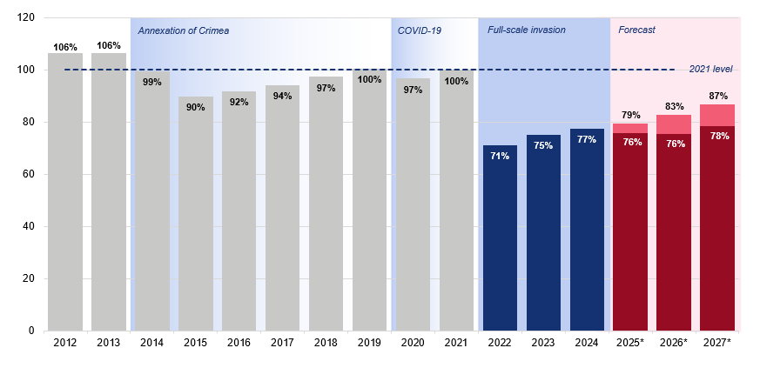

Annex B) IMF 8th review documents
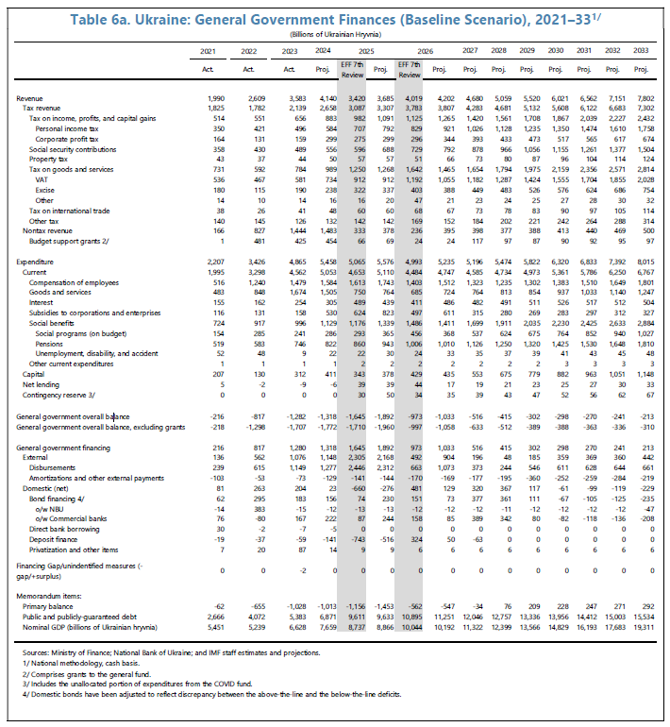

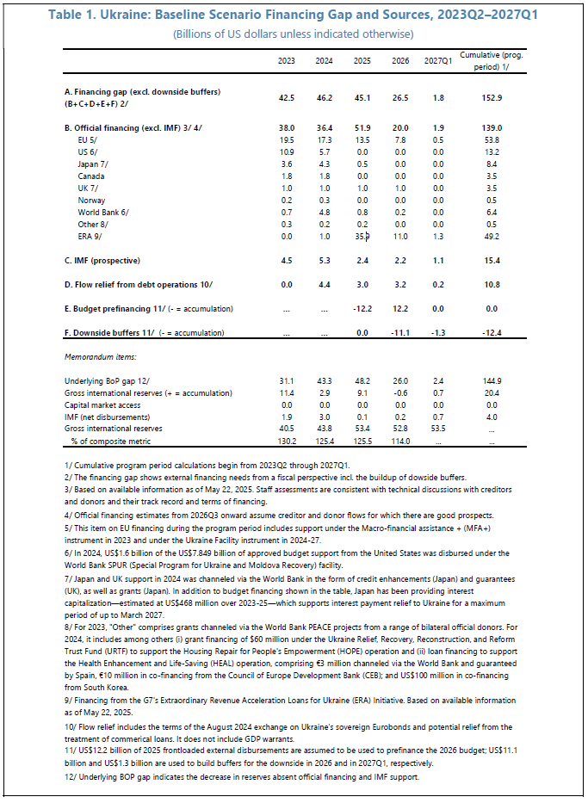

Annex C) IMF staff estimates for 2025 fiscal surplus

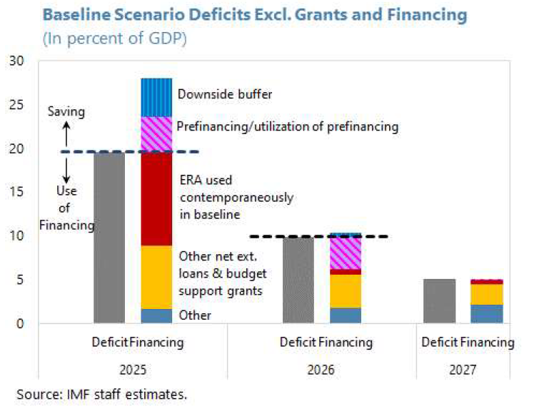

2022/2023 scoring is specific to FREE Ukraine Programme. 2024/2025 marks the first scoring of UESP, a separate programme which is a logical continuation of FREE Ukraine.
As above, 2023/2024 scoring was also specific to FREE Ukraine.
The Centre for Delivery is the FCDO department responsible for providing the standards for compliant programme delivery and supporting programme teams to deliver against these standards.
Ministry of Finance of Ukraine. Budget Declaration for 2025–2027. Published via Kyiv School of Economics, August 2024. Available at: https://kse.ua/wp-content/uploads/2024/08/Budget-Declaration-for-2025-2027.pdf
World Bank. Listening to Citizens of Ukraine Survey – Monitoring Living Conditions in Ukraine. Poverty & Equity Global Practice. Available at: https://www.worldbank.org/en/country/ukraine/brief/listening-to-citizens-of-ukraine-survey
World Bank. Project Information Document – Public Expenditures for Administrative Capacity Endurance (PEACE) in Ukraine (P178946). October 2024. Available at: https://documents1.worldbank.org/curated/en/099121324123031492/pdf/P178946-0ca534f9-19e9-4901-a274-630592b7fb34.pdf
Ukraine: Eighth Review Under the Extended Arrangement Under the Extended Fund Facility, Requests for Modification of Performance Criteria, Rephasing of Access, and Financing Assurances Review-Press Release; Staff Report; and Statement by the Alternate Executive Director for Ukraine in: IMF Staff Country Reports Volume 2025 Issue 156 (2025)
International Monetary Fund. Ukraine: Eighth Review Under the Extended Arrangement Under the Extended Fund Facility, Requests for Modification of Performance Criteria, Rephasing of Access, and Financing Assurances Review – Press Release; Staff Report; and Statement by the Alternate Executive Director for Ukraine. IMF Staff Country Reports, Volume 2025, Issue 156, 2025. Available at: https://www.imf.org/en/Publications/CR/Issues/2025/09/12/Ukraine-Eighth-Review-Under-the-Extended-Arrangement-Under-the-Extended-Fund-Facility-Requests-538633
International Monetary Fund. Ukraine: Seventh Review Under the Extended Arrangement Under the Extended Fund Facility, Requests for Modification of a Performance Criterion, Rephasing of Access, and Financing Assurances Review. IMF Country Report No. 25/78, March 2025. Available at: https://www.imf.org/-/media/Files/Publications/CR/2025/English/1ukrea2025001-print-pdf.ashx

