Annual Review Template

Title: Data for Development - Unleashing the Data Dividend
Programme Value £ (full life): £15,600,000  (Phase 1 - £6,780,000 Phase 2 - £8,820,000) |  | Review date: June 2025
Programme Code: 400025 | AMP start date:  24 October 2023 | AMP end date:  31 March 2028

Summary of Programme Performance
Year | 2024 | 2025
Overall Output Score | A | A+
Risk Rating | Minor | Minor

DevTracker Link to Business Case: | DevTracker Programme GB-GOV-1-400025 Documents (fcdo.gov.uk)
DevTracker Link to results framework: | DevTracker Programme GB-GOV-1-400025 Documents (fcdo.gov.uk)

Scoring your programme

The Annual Review assesses and rates outputs using the following scale. The Aid Management Platform (AMP) and the programme scoring calculator will calculate the overall output score, taking account of the weightings and individual output scores.

Description | Score
Outputs substantially exceeded expectation | A++
Outputs moderately exceeded expectation | A+
Outputs met expectation | A
Outputs moderately did not meet expectation | B
Outputs substantially did not meet expectation | C

A. SUMMARY AND OVERVIEW

Description of programme

The aim of this programme is to empower decision making and accountability by improving the coverage, quality and use of data on and for the Sustainable Development Goals (SDGs). The programme will leverage the UK's technical expertise and reputation as a global leader in data to deliver a well-functioning, coordinated international data system. We will work with national Governments to strengthen data systems, integrate innovative data, tools and methods, and create a culture of evidence-based decision making. This programme positions the UK at the centre of global data initiatives, supporting countries to achieve the SDGs by placing our priorities and values at the core of international efforts and mitigating the impact of malign actors.

The programme is delivered by six implementing partners who each play important roles in supporting both the international and national data system.

The Global Partnership for Sustainable Development Data (GPSDD) is an innovative partnership that aims to improve the quality and availability of data to support the achievement of the Sustainable Development Goals (SDGs). The Global Partnership network consists of over 700 partners from across the globe. Their objectives are:

- To strengthen national data systems that harness and use data from across the public and private sector for timely decision making,
- To make inclusion the norm, putting people at the centre of data production, sharing and use so that their experience is visible and the power of data can be used to fight inequality.
- To change the rules that govern data, fostering more participation and ensuring they are accountable to those who the data is intended to serve.

PARIS21 works primarily with National Statistics Offices (NSO) in over 90 countries, prioritising disadvantaged statistical systems in least developed/low income, fragile states, and small island developing states, and partners with a wide-range of institutions globally with the goal of reinforcing data ecosystems to deliver quality data for sustainable development. FCDO agreed to provide core funding to PARIS21 to deliver against its 2021 to 2025 strategy which focus’ on three priority action areas: Accelerate Innovation, Bridge Data Ecosystems, and Develop Statistical Capacity.

UNSD is committed to the advancement of the global statistical system. Through their contribution to the Data for Now Initiative deliver technical support directly to National Statistics Offices to increase the availability and use of data for SDGs and national decision-making.

The World Bank’s Global Data Facility (GDF) is designed to scale up support for subnational, national, and global data and statistics priorities. The Facility will leverage World Bank IDA/IBRD support and catalyse countries’ domestic financing to strengthen the quality and sustainability of national and subnational data and statistical systems.

Flowminder deliver direct support to priority countries on the use of alternative data sources such as mobile data. They work with partner countries on implementing innovative new methods for data, and then integrating the outputs into thematic use cases that demonstrate the value and impact of data.

WorldPop deliver direct support to priority countries on the use of alternative data sources such as geospatial and earth observation data. They work with partner countries on implementing innovative new methods for data and then integrating the outputs into thematic use cases that demonstrate the value and impact of data.

Summary supporting narrative for the overall score in this review

Although this is the first annual review for this programme, there are long-standing relationships with all the implementing partners through now closed FCDO programmes. The implementing partners have established, trusted, and respected core offers that they continue to maintain and develop.

This has set the programme up for success, as demonstrated by an A+ output score. Where the programme stands to improve is the new aspect of this business case, which is bringing partners together to deliver joint outcomes.

Outputs | Weight | Score
- Coordination and Strategic Leadership | 19% | A+
- Innovation and Modernisation | 19% | A+
- Dissemination and Use of SDG Data | 19% | A+
- Multi-stakeholder partnerships | 19% | A+
- Mobilise resources and coordinate efforts | 19% | A+
- Coordination of Implementing Partners | 5% | A
Overall score | 100% | A+

Major lessons and recommendations for the year ahead

At the start of Phase 2 of this Business Case, the announcement about an ODA reduction to 0.3% GNI was made. At the time of writing this Annual Review, funding for 2025/26 and the Spending Review process for 2026/27 onwards remains unclear. The major implication and recommendation for the year ahead is for implementing partners to build resilience by diversifying their funding and evaluating their VfM to identify potential areas for contraction.

However, the underlying principle of the programme – that by working in partnership we can reduce duplication and increase efficiency – remains.

Collaboration
Partners should share work plans during early stages of development to build in collaboration opportunities early, rather than updating as work is already progressing.

Where multiple technical partners are working in a country, they should develop joint capacity frameworks to maximise resources, reduce duplication, and foster more cohesive approaches.

Impact
Where partners are producing documents for public consumption, they should monitor downloads/page visits, etc. Seek out opportunities to amplify distribution through other partners networks. Look to innovate ways to communicate to broaden audience, and ensure products fit for all country purpose.

For some partners, focus should shift towards understanding where produced data is being used, checking back into old projects to understand whether built capacity still being used, including lessons learned for greater sustainability moving forward.

B: THEORY OF CHANGE AND PROGRESS TOWARDS OUTCOMES

Figure 1 outlines the broad theory of change to help create cultures of data for decision where there is an availability of quality data and users have the capacity and incentives to make effective use of data (outcome). This will lead to improved decision making in society (impact) to accelerate achievement of the SDGs. This Theory of Change is specific to this business case but aligns with internationally accepted best practice and approaches.

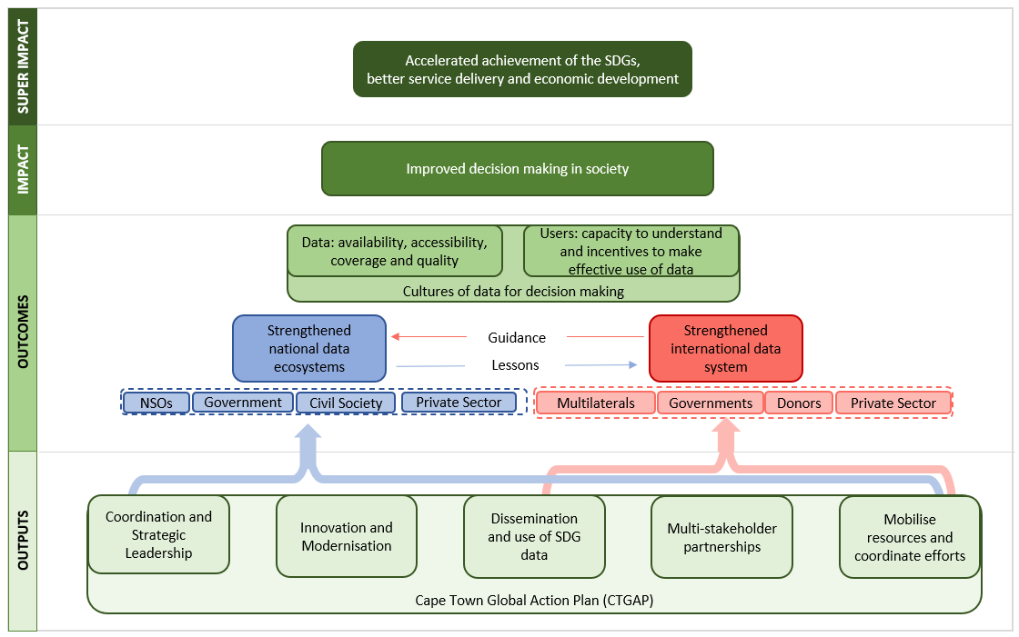

The partners in the programme provided positive feedback on the framing of the business case. Alignment with the Cape Town Global Action Plan (CTGAP) was viewed as helpful as this is a framework that partners have already committed to deliver against. In February 2025 the UN Statistical Commission adopted the Medellin Framework for Action on Data for Sustainable Development. This takes forward the CTGAP and provided a realigned, streamlined and priority-orientated framework for advocacy on data and statistics for sustainable development. The Medellin framework streamlines the six strategic areas of the CTGAP into four actions areas:
- Area 1: Innovation and modernization for better and more inclusive data and statistics
- Area 2: Use and value of data and statistics for better decision making
- Area 3: Institutional leadership in the building of trust, protection and ethics of data and statistics
- Area 4: Partnership to mobilise resources and coordinate efforts to develop data and statistical capacity
Given the clear read across from the CTGAP we will not update the programme theory of change and corresponding logframe indicators during this business case. We will accommodate any updates in annual reports of programme partners if they update to align with the Medellin Framework.

Outcome indicator
The business case outcomes, as shown by the theory of change above, improve cultures of decision making by increasing capacity in two broad areas:

- Availability, accessibility, coverage, and quality of data
- Users have capacity to understand and have incentives to make effective use of data
As the programme implementing partners predominantly work to build capacity alongside technical assistance and learning, we can demonstrate the outcomes at a ministry, department, agency (MDA) or even country level. For example, the modelled population estimates WorldPop worked with Cameroon national statistics office to produce are now being used for the national sampling frame that underpins the Multiple Indicator Cluster (MICS), Demographic and Health (DHS), Household Living Conditions (ECAM) and Quarterly Employment surveys.

In Viet Nam, UNSD partnered with the Statistics Office and local experts to improve small area estimations. This enabled the production of initial estimates of child poverty and food security for relevant MDAs.

At an international level, we rely on global figures to understand whole-system change. Noting that while our programme has a disproportionate impact on the international data for development sector, it is not that only factor at play so we cannot attribute all change to our programming.

Indicator(s) | Baseline | Progress
Statistical Performance Indicators (SPI)  - data use  - data services  - data products  - data sources  - data infrastructure | 2023 Figures for LMIC (all countries)  - 75.5 (76.4)  - 59 (68.7)  - 73.6 (70.5)  - 40.8 (55.8)  - 52.6 (65.8) | 2024 figures released June 2025
Open Data Index  For all data categories  - Overall score  - Minimum score  - Maximum score | 2022 Figures for LMIC (all countries)  - 79.2 (102)  - 7.5 (2.5)  - 122 (178) | 2024 Figures for LMIC (all countries)  - 96 (112)  - 42.5 (38.5)  - 152 (181)
Number of SDG Tier 1 indicators | 148 (2023) | 161 (2025)
Number of countries the programme has worked with directly |  | 58

Global indicators show an increase in statistical capacity and data availability, however, significant gaps between Low- and High- income countries still exist. There is a risk that as High and Upper-middle income countries move towards incorporating AI tools into data production that this gap widens. In addition, changes from major donors in level or approach to investment in data and statistics - collection, system strengthening and modernisation along with capacity building - risk a wider “domino effect” across the sector. We must be proactive to protect the progress made on these outcomes, as well as seek to advance further progress.

Figure 4 shows the thematic areas where there are significant lags between upper- and lower-income countries. While our programme takes a whole-system approach to improving data capacity, it is worth noting the sectors that led and fall behind in making data openly available.

Figure 5 shows that while High income countries have the highest Statistical Performance Index (SPI) and Open Data Indicator (ODIN), there is wide variability across income and region groups. Good data access and governance is a global issue, and a recommendation would be to increase the readiness and availability of tools for all national statistics offices (not just LMIC). By working outside the traditional Data for Development space, we can leverage new advocacy and funding sources to elevate the entire system (uplifting LMIC capacity as part of this process rather than working separately).

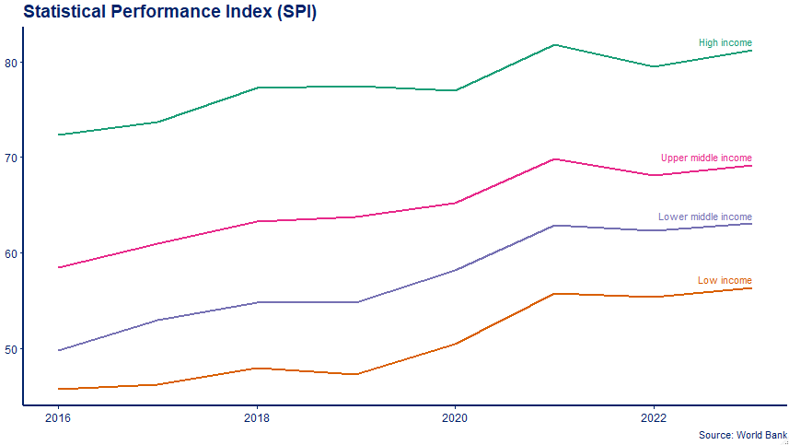

Figure 1: The Statistical Performance Index (figure compiled by World Bank consisting of data use, services, products, sources, and infrastructure) has been increasing over time. Low-income countries have seen a higher increase in their SPI compared to High-Income countries (2016 to 2023; +8.8 and +10.6). Meaning that while the “data gap”, between income groups, is starting to close it remains significant (-24.8 in 2023 compared to -26.8 in 2016). As High and Upper middle-income countries embed AI into official statistics, there is a risk that the SPI gap could begin to widen if investment is not continued for data capacity in low and lower-middle income countries.

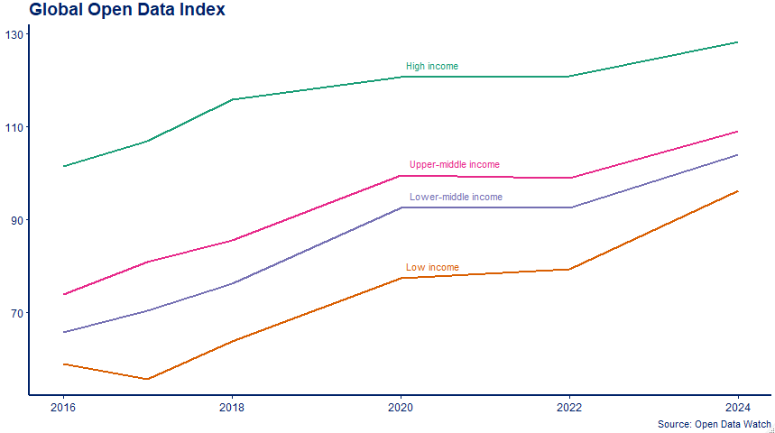

Figure 2: Global Open Data Index (figure compiled by Open Data Watch) assessing the coverage and openness of official statistics. Broken down by income group over time.
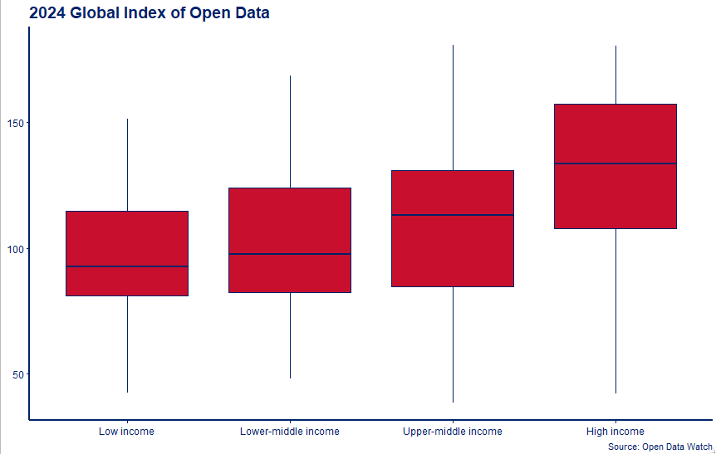

Figure 3: Index of Open Data (figure compiled by Open Data Watch assessing the coverage and openness of official statistics). A gap exists between Low- and High-income countries, with Low-income countries scoring the lowest for openness.

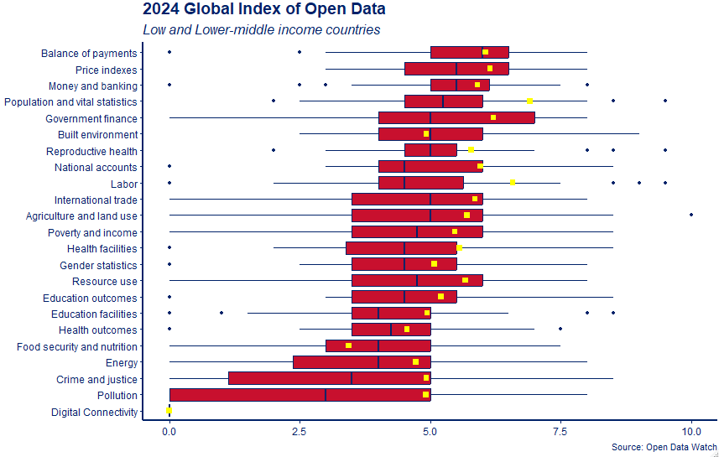
Figure 4: Breakdown of the 2024 Open Data Index (Figure 2) by data type for Low and Lower-middle income countries. Average for High and Upper-middle income countries represented by yellow box. The figure shows how LMIC countries have consistently lower open data across sectors but this is significant for population, labor, and reproductive health data. Of note is also national accounts and health facilities.

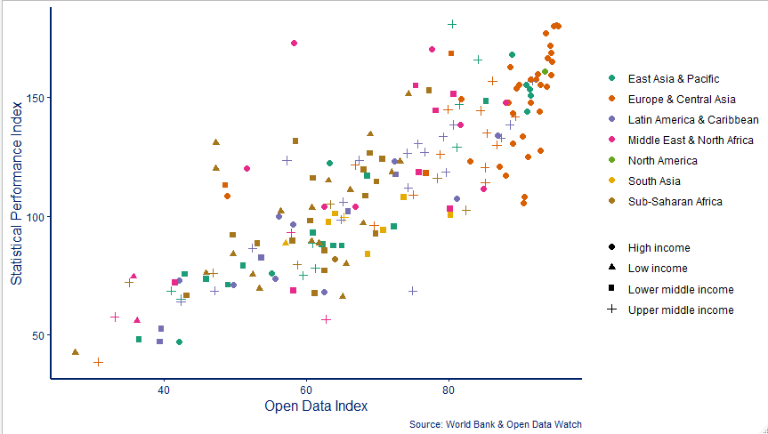

Figure 5: Statistical Performance Index plotted against Open Data Index for countries where both datasets available. Figure shows that while High income countries plot the highest on both index, there is wide variability across other income groups and regions for both SPI and ODIN.

Describe where the programme is on/off track to contribute to the expected outcomes and impact. What action is planned in the year ahead?

Botswana is an example of where programme partner support has helped the country make significant progress towards better coordination and leadership. They are a Power of Data country, who received GDF funding to support the high-impact initiative. In addition to World Bank support, GPSDD facilitated workshops and training to further advance their national plan. As well as support for the new National Strategy for the Development of Statistics (NSDS) and leadership training from PARIS21.

The multi-pronged approach to support appears holistic, and a recommendation is to explore whether coordination of support in future could drive efficiencies and work programmes.

As well as top-down, high-level multistakeholder facilitation around data and statistics – the programme is demonstrating how bottom-up approaches can also be impactful. By unlocking mobile phone access and developing analytical pipelines, Flowminder have brought together the National Statistics Office with the National Agency for Disaster Management and Planning. Demonstrating the use of data has encouraged senior leaders to prepare rather than react by incorporating mobile phone data into planning. Analysis being done at Ghana Statistical Service, builds partnership across government, capacity within their staff, with the same data being used for other analysis (population dynamics and mobility) that could be used across other parts of the Ghanian government.

By coordinating the two-approaches of the programme (top-down and bottom-up), there is opportunity to accelerate progress within a country. Having the strategic vision, senior buy-in, and coordinated support will open pathways for more technical support. While the technical support can quickly demonstrate impact, in a results driven world.

Opportunities to align these approaches, and test this theory are scoped for Phase 2 of the programme. However, the current budget uncertainty creates logistical challenges on implementing this. That said, all aspects of the programme continue to deliver well against the intended outputs, and progress is being demonstrated against outcomes.

Justify whether the programme should continue, based on its own merits and in the context of the wider portfolio

The programme should continue into planned Phase 2, with an end date March 2028. The programme is a demonstration of UK leadership and expertise in the international data space, where data is a key enabler for delivery against the Foreign Secretary priorities. The catalytic impact of targeted FCDO investment is leveraging substantial additional gains across the multilateral system and providing access and influence across a breadth of policy priorities. Direct project investment enables FCDO to retain reputation as a forward looking through leader in data innovation and efficiency and providing agility and rapid results which completements the longer-term impacts of multilateral investment. The structural model – bringing together partners against shared outcomes- is incentivizing greater collaboration with a route to further exploiting efficiencies and amplification of impact.

Fragmented and thematic funding for data doesn’t represent good VfM. It is often driven by donor or development partner needs rather than a country’s priority. There are a multitude of examples, where if data does not align to a country’s interests it sits unused for decision making. This programme provides core funding, where appropriate, to enable partners to use their expertise to their greatest advantage in supporting country-led priorities. Demonstrating to other donors the strength and sustainability of building data capacity through collaboration and delivery against country-led priorities.

Outputs demonstrate the individual and combined success of the programme, while also highlighting areas where we can do more to deliver on outcomes. Outcomes relate to shifting international metrics, of which a lag in seeing improvement is expected. Through impact case studies we can evidence country-level outcome change, and through continued investment expect to see system change over a 2 year + period. (see Annex 1 below listing examples of partner impact case studies).

C. DETAILED OUTPUT SCORING

Output Title | Coordination and Strategic Leadership
Output number: |  | 1 | Output Score: | A+
Impact weighting (%): |  | 19 | Weighting revised since last AR? | No

Indicator(s) | Milestone(s) for this review – March 25 | Progress
G1.1. GPSDD - Number of multi-stakeholder coalitions coming together and making progress on shared agendas | 6 | Substantially exceeded  19
P1.1. PARIS21 - Number of NSDS/RSDS designed and evaluated with PARIS21 support during the year | 7 | Substantially exceeded  14
P1.2. PARIS21 - Number of LMICs participated in PARIS21 NSS leadership trainings | 30 | Moderately exceeded  34
P21F - PARIS21 Foundation meets all objectives in the start-up plan | Yes | Met  Yes
U1.1. UNSD - Share of countries where at least five members of the NSS participate in collaborative activities around prioritized areas of work under Data for Now. | 80% | Met  86%
W1.1. World Bank - Number of current/prospective "Power of Data" countries' with a) data/statistical data gap or statistical modernization assessments undertaken and b) developing statistical modernization action plans | a) 1  b) 0 | Moderately exceeded  - 1  - 2
The programme partners are using their unique delivery and core offerings to drive stronger coordination and leadership within countries. Work across the programme is ensuring national statistical office data production is fit for government purpose by coordinating data priorities across ministries, departments, and agencies. It is also empowering and enabling NSOs to effectively lead data and statistics strategies in their own countries. Outputs for each partner are briefly described below.

G1.1 – This indicator has substantially exceeded expectations. Facilitated coalitions through numerous activities, including Power of Data (13 countries) and other initiatives such as data values and IDC action plan implementation. Held multistakeholder workshops (3 countries), peer exchanges (1), and amplification events at international for a (2).

P1.1 – This indicator has substantially exceeded expectations. Supported design of NDS in 13 countries and one mid-term review (Paraguay), greater than the anticipated 7.

P1.2 – This indicator has moderately exceeded expectations. Delivered leadership training through two regional events. The first was hosted with UNSIAP and Mongolia NSO. The second was in collaboration with STATAFRIC and NISR, with 28 statistical leaders from 20 countries and entitled “Enhancing statistical leadership for heads of national statistics office (NSO) in Africa to foster data innovation in a digital society”.

P21F – This indicator has met expectations. Foundation successfully designed and delivered start-up plan. Recruited contractor who has become embedded into UN Geneva system and has progressed to designing initial strategy and successfully recruiting additional funding.

U1.1 – This indicator met expectations. All Data for Now projects ensured key government data users and producers were mapped out and engaged during assessment and prioritisation phase. This enables the NSO to understand wider government priorities.

W1.1. – This indicator moderately exceeded expectations. Successful assessment of Belize’s statistical system, which is now informing an Action Plan to guide future investments and technical assistance. Modernization plans being developed in Belize and Sri Lanka, the former building off the assessment (a) and the latter as part of the governments new Statistical Strategy.

Describe any changes to this output during the past year, and any planned changes as a result of this review.

The first Annual Review was an Inception Report, so this is the first-time reporting against these specific outputs. Due to uncertainties in the programme post-2026, as a result of the move to 0.3%, any changes to 2025/26 will be light-touch – anticipating new indicators to be designed for a new 2026 onwards programme.

Progress on recommendations from the previous AR (if completed), lessons learned this year and recommendations for the year ahead

The PARIS21 Foundation output relates to the foundations start-up plans, this should evolve to be an output that relates to delivery in line with their strategy.

The UNSD output metric should change to absolute numbers rather than percentage of Data 4 Now countries. The milestone was exceeded because of reducing ambitions on overall countries, due to recruitment delays. While significant progress was still made with the resources available, the indicator can be misleading.

All partner outputs focus on workplans related to improving coordination and strategic leadership within countries, omitting the work partners do in international systems. A recommendation would be to add outputs that speak to this (i.e. for GPSDD Power of Data coordination or UNSC for UNSD).

Output Title | Innovation and Modernisation
Output number: |  | 2 | Output Score: | A+
Impact weighting (%): |  | 19 | Weighting revised since last AR? | No

Indicator(s) | Milestone(s) for this review – March 25 | Progress
F2.1. Flowminder - Number of support opportunities created and/or utilised to build capacity of National Statistical System actors (individuals) to access and/or use alternative data sources (specifically CDRs and Geospatial data) | 12 | Moderately exceeded  15
F2.2. Flowminder - Number of new methodologies developed to improve the utilisation of CDRs data by National Statistical System actors | 1 | Moderately exceeded  3
G2.1. GPSDD - Number of learners/individuals participating in learning activities to support more timely decision-making, inclusive data systems, and accountable data governance (cumulative) | 300 | Moderately  did not meet  247
P2.1. PARIS21 - Number of LMICs with new NSDS which address digitalization | 5 | Substantially exceeded  9
P2.2. PARIS21 - Number of LMICs with NSDS mainstreaming gender | 5 | Substantially exceeded  9
U2.1. UNSD - Share of countries that are able to effectively use different data sources and/or apply innovative methods and technologies [a = no progress, b = identified, c = progressing, d = achieved] | a = 10%  b = 40 %  c = 30 %  d = 20 % | Substantially exceeded  a = 0 %  b = 14%  c = 29%  d = 57%
W2.1. World Bank - Number of country projects developed or influenced, tested and applied (integration, administrative data, geospatial, privately held, metadata).  [a = no progress, b = progressing, c = developed, d = tested, e = applied]  Metric: Number of projects x Progress score | 1 | Moderately exceeded  2
W2.2 World Bank - Number of current/prospective "Power of Data" countries' data/statistical systems supported (including support for new/modern technical data collection tools/CAPI). | 0 | Moderately exceeded  1
WP2.1. WorldPop - Progress on the production of core data outputs (a – no progress/ progress paused, b – discussions initiated, c – production progressing, d – production achieved & outputs progressing, e – outputs achieved) | a = 0  b = 2  c = 0  d = 0  e = 4 | Moderately  did not meet  a = 0  b = 0  c = 1  d = 0  e = 3
The programme is driving innovation and modernization of national statistical systems by supporting the use of novel data sources and techniques, met with governance and strategies that can support these innovations.

F2.1. – This indicator moderately exceeded expectations. Built understanding on the use and limitations of alternative data sources through advocacy at international events. Established relationships and initiated scoping of potential for unlocking alternative data sources through this work.

F2.1. – This indicator moderately exceeded expectations. Developed new use cases and methodology improvement that included socio-economic characteristics, improving displacement detection, and improving population mobility trends.

G2.1 – This indicator moderately didn’t meet expectations. Cancellation of two technical training events due to political changes outwith of GPSDD control (elections in Mauritius and a change in administration in Costa Rica) meant target not met.

P2.1 – This indicator has substantially exceeded expectations. Integrated digitization into NSDS in 9 countries, which acts as an enabler for innovation and is foundational in modernization. 7 of these countries also integrated mainstreaming gender.

P2.2 – This indicator has substantially exceeded expectations. Mainstreamed gender into 9 countries NSDS.

U2.1 – This indicator has met expectations. Higher share of countries using new data and/or methods than anticipated. Includes geospatial data, wider use cases for administrative data, and machine learning.

W1.2 – This indicator has moderately exceeded expectations. Data projects being implemented in Comoros, Madagascar, Malawi, Zambia, Mozambique, Sao Tome and Principle as well as Grenda, Saint Vincent and the Grenadines through the SADC and OECS workstreams, respectively.

W2.2 – This indicator has moderately exceeded expectations. Intensive support for Botswana in the use of the Survey-Solutions platform to conduct CAPI in the 2024/25 Multi-Topic Household Survey.

WP2.1. – This indicator moderately didn’t meet expectations. Outputs produced in three countries. Delays in census production in a fourth country meant push back on timelines. Work still on track to be completed but not within this annual review term.

Describe any changes to this output during the past year, and any planned changes as a result of this review.

Moved F2.2 from an additional indicator to a main indicator, as it represents advances in innovation.

Progress on recommendations from the previous AR (if completed), lessons learned this year and recommendations for the year ahead

Work aligned with this output have strong overlaps with FCDO Digital for Development, humanitarian programmes as well as aligning with UK’s Office for National Statistics objectives. Opportunity to drive greater cohesion across programme outputs and outcomes

There is an opportunity to strengthen reporting of the innovation and modernisation work supported by partners, potentially making great use of narrative examples and case studies in addition to logframe metrics.

The intersection between strategic guidelines, particularly in the context of NSDS are the framework for country prioritisation and strategic action plans, highlights an opportunity for partners to co-represent and coordinate on targeting of delivery. This should also be considered as an opportunity for using platforms such as the Clearinghouse to support in coordinating and aligning investor inputs.

Output Title | Dissemination and Use of SDG Data
Output number: |  | 3 | Output Score: | A+
Impact weighting (%): |  | 19 | Weighting revised since last AR? | No

Indicator(s) | Milestone(s) for this review | Progress
F3.1. Flowminder - Number of use cases developed that use CDRs and/or geospatial data as inputs per:  (a) Stage [of development, on scale of 1= No progress, 2 = Progressing 3 = Developed, 4 = Tested, 5= Applied] | 8 | Moderately exceeded  10
G3.1. GPSDD - Number of knowledge products published/disseminated on data topics | 80 | Substantially exceeded  159
P3.1. PARIS21 - Number of LMICs who (a) received PARIS21 support on ‘data literacy in policy making’ initiative, (b) received support on policy responsive data systems and (c) where data use advocacy campaigned have been implemented. | 6 | Substantially exceeded  17
U3.1. UNSD - National metadata is available for all new produced indicators. | 50% | Moderately did not meet  29%
WP3.1. World Pop - Progress on the publication of core data outputs (a – no progress/ progress paused, b – discussions initiated, c – production progressing, d – production achieved & outputs progressing, e – outputs achieved) | a = 0  b = 2  c = 0  d = 0  e = 4 | Moderately did not meet  a = 0  b = 1  c = 1  d = 0  e = 2

The programme supports data dissemination and use through multiple approaches. The production and expanded use case of novel data sources. Good data governance, through publication and metadata production. Alongside building data capacity within policy makers.

F3.1 – This indicator has moderately exceeded expectations. Mobile phone data pipelines and developed workflows expanded for use across multiple sectors in Ghana, DRC, Haiti, and Kosovo. With discussions progressing in Pakistan. Use cases included population dynamics and mobility analysis, disaster preparedness and response, health including vaccine planning, internal displacement, and nuclear facility provisions.

G3.1 – This indicator has substantially exceeded expectations. Relates to the number of downloads and shares of products on social media. Indicator exceeded due to evolving content plan that published more products than anticipated.

P3.1 – This indicator has substantially exceeded expectations. Aligning data production to policy demand integrated into NSDS design. Gender data focus on how this data is used in policy, including localised recommendations for data systems that better enable uptake and use in policy (Kenya, Rwanda, Maldives, Dominican Republic). Advocacy for the use of climate change data through the Climate Change Data-Driven Advocacy Toolkit (Lesotho, Senegal).

U3.1 – This indicator moderately did not met expectations. Strong advocation for metadata, where data products produced. However, the lack of IT infrastructure and resource in some NSOs has been a barrier.

WP3.1 – This indicator moderately did not met expectations. Delays in publication in two countries, one to align with census planning and publication is planned for next year. Publication in Ethiopia delayed due to political sensitivities.

Describe any changes to this output during the past year, and any planned changes as a result of this review.

Indicator G3.1 does not align with the output and should be removed. Given there will be this Annual Review, and one more, do not recommend replacing with a different indicator. GPSDD have indicators for all other outputs and provide impact case studies that speak to increased and improved use of data.

Progress on recommendations from the previous AR (if completed), lessons learned this year and recommendations for the year ahead

The productions and dissemination is an individual strength of all programme partners and an area where they deliver well. Opportunities to explore wider use cases for produced data across government.

Output Title | Multi-stakeholder partnerships
Output number: |  | 4 | Output Score: | A+
Impact weighting (%): |  | 19 | Weighting revised since last AR? | No

Indicator(s) | Milestone(s) for this review | Progress
G4.1. GPSDD - Number of brokered partnerships delivering technical solutions to address country challenges (cumulative)  a) Brokered, b) Delivering, c) Delivered | 18 | Substantially exceeded  31
P4.1. PARIS21 - Number and inclusive participation of (a) PARIS21 Spring Meetings/Fall Meetings/ Executive Committee Meetings conducted, (b) Global/regional events to learn from pilots and discuss scaling | 10 | Substantially exceeded  19
P4.2. PARIS21 - Number of global, topical partnerships established and maintained by PARIS21 | 1 | Moderately exceeded  3
U4.1. UNSD - Share of Data for Now countries that engage key stakeholder and user groups (academia, civil society, media and private sector) in prioritization, development and dissemination of the statistics. | 30% | Substantially exceeded  86%
W4.1. World Bank - (a) Number of "Power of Data" workshops or similar partner coordination meetings and (b) countries attending, focused on complementary data/statistical systems supported. | 3 | Met  3
W4.2 – World Bank - Number of country coordination meetings with NSO directors & Ministers of Finance | 3 | Met  3
Multi-stakeholder partnerships are a strong feature of programme partner delivery. Through supporting NSOs to produce data for government policy, and to act as leaders on data governance. Facilitating technical assistance and support from across networks to support country problems. And in bringing together the international community for focus on specific topics.

G4.1 – This indicator has substantially exceeded expectations. Brokered partnerships across peer exchanges, technical collaborations, regional initiatives, and CAN fellowships. Includes 1 brokered, 12 delivering, and 13 delivered partnerships.

P4.1 – This indicator moderately did not meet expectations. Brought together committee members. Worked in partnership to hold regional fall meetings in different regions and took advantage of side events at international meetings for host events.

P4.2 – This indicator has moderately exceeded expectations. Established partnerships to expand delivery. Including AI for development project with Google. International Research Centre for SDGs (CBAS) for geospatial training for SDG monitoring of climate change in Kenya. Partnership with Caribbean Development Bank (CDB) initiated with work to begin on targeted support to SIDS in 2025.

U4.1 – This indicator has substantially exceeded expectations. All Data for Now countries have partnerships across NSO with other ministries, departments, and agencies. Partnerships with development partners and academia for technical support and assistance in delivering on projects.

W4.1 – This indicator has met expectations. Power of Data launches in Dominican Republic, Botswana, and Costa Rica. In partnership with GPSDD.

W4.2 – This indicator has met expectations. Power of Data coordination meetings active in Botswana, Dominican Republic, and Costa Rica including engagement between NSOs and Finance Ministries. In Botswana, coordination meetings have resulted in the preparation of a two-year strategic plan, submitted to the government’s National Planning Council. In partnership with GPSDD.

Describe any changes to this output during the past year, and any planned changes as a result of this review.

No changes.

Progress on recommendations from the previous AR (if completed), lessons learned this year and recommendations for the year ahead

Partners strength is facilitating multi stakeholder partnerships between NSOs and MDAs. There is also established and evidence delivery of partnerships with development partners for delivery of technical assistance and capacity building. However, gaps remain in utilising multi stakeholder relationships across development partners to drive efficiency.

Inclusion of Executive Committee meetings in P4.1 represents an internal focus on multi stakeholder partnerships, would recommend removing these as they represent good internal governance rather than organisational delivery. However, due to the anticipated two-year period of this programme no changes will be made.

Output Title | Mobilise resources and coordinate efforts
Output number: |  | 5 | Output Score: | A+
Impact weighting (%): |  | 19 | Weighting revised since last AR? | No

Indicator(s) | Milestone(s) for this review | Progress
G5.1. GPSDD - Number of political commitments and leadership to prioritize data (cumulative) | 15 | Substantially exceeded  28
P5.1. PARIS21 - Number of LMICs covered by the Clearinghouse, including country profiles, advocacy campaigns and case studies. | 10 | Substantially exceeded  24
P5.2. PARIS21 - Number of NSDS with action plans costed with PARIS21 support | 5 | Met  6
W5.1. World Bank - Number of regional data/statistics strengthening/harmonization designed/shaped (for SADC, LAC, and/or OECS) | 0 | Moderately exceeded  2
The output relates to the programmes work to seek sustainable funding for and reduce fragmentation in development partner support for data and statistics. This is being achieved through GPSDD’s work as secretariat to Power of Data, combined with the World Banks technical support to advance national plans. Costed NSDS are a vital tool to ensure delivery on action plans.

G5.1 – This indicator has substantially exceeded expectations. Brought together stakeholders (political, senior leader, development partners, etc) to advocate for the Power of Data alongside workshops targeted to mobilise resources.

P5.1 – This indicator has substantially exceeded expectations. Updated country profiles to show their financing need for data and statistics. Information has formed the basis of multiple blog posts written around the FfD4 momentum, highlighting the timely and relevance nature of the information.

P5.2 – This indicator has met expectations. Costed action plans provide transparency to Ministry of Finance, Development partners, etc on resources required to enact NSDS. For those NSDS without costed plans, it is because they haven’t reached this stage of development but planned for later.

W5.1 – This indicator has moderately exceeded expectations. Mobilising and coordinating resource through technical support to statistical strategies, and harmonizing technical support across MDAs in Power of Data countries.

Describe any changes to this output during the past year, and any planned changes as a result of this review.

No changes.

Progress on recommendations from the previous AR (if completed), lessons learned this year and recommendations for the year ahead

Programme partners should seek to strengthen ties to this work through delivery of other outputs, working to costed action plans, facilitating technical assistance with other development partners to accelerate this output.

If programme continues past 2026/27, an outcome indicator should be countries that have received mobilization and coordination support who have more joined up, sustainable, or greater investment as a result of the programme work.

Output Title | Coordination of Implementing Partners
Output number: |  | 6 | Output Score: | A
Impact weighting (%): |  | 5% | Weighting revised since last AR? | No

Indicator(s) | Milestone(s) for this review | Progress
Number of partners working to common outcomes and impacts demonstrated through joint impact storylines | 1 | 1
Number of partners using Teams site each quarter for collaboration/ information sharing | 3 | 7

Collaboration between partners is primarily evidence at a strategic level. Submitted evidence outlines a selection of events where partners have worked together, and with wider networks, to common outcomes and impacts including co-representation on management boards and relevant expert groups. Collaboration has been strengthened this year with further co-representation on management boards, with GPSDD joining the PARIS21 board. PARIS21 and ODW establishing the Commit to Data Campaign, and co-leading of the data inputs for the Financing for Development outcome document. Partner collaborated in the production and publication of A World That Counts at 10, marking a decade since the publication of A World that Counts, the 2014 report by the United Nations Secretary-General’s Independent Expert Advisory Group on mobilising the Data Revolution for Sustainable Development. Production of this report, and other strategic documents, highlights the role of programme partners, along with Open Data Watch, in leading and coordinating the international system in advancing the global agenda for data for development.

At a working level, implementing partners have, and continue to, work together on a breadth of workshops and side-events at key forums and on some aspects of technical delivery. They also co-represent on expert groups and management boards. Partners recognise the value of these collaborations, communicating case studies through social media. However, no joint storylines were submitted as part of this programmes reporting process.

This programme identifies that amplifying coordination across these implementing partners, who are already demonstrating areas where they can successfully collaborate, could lead to greater efficiencies and amplification of delivery. However, changing organisation delivery plan and workplans takes time to implement.

Through the implementation phase, and first year of programme there has been increasing focus on joint working – including with UK Office for National Statistics. Substantial collaboration has been established between ONS with WorldPop and Flowminder, as well as strengthening of knowledge exchange with PARIS21 as a result of this programme. By aligning programme and ONS activities, we are better able to amplify UK delivery and expertise in the data space.

A communication platform has been established with all partners who have now signed up to the Teamsite. The objective of the site is to maintain a simple filing structure of key documents, enabling collaboration, and providing an agile and efficient mechanism for communications. While all partners have been able to access this site, at a point in time they experience continuing access issues which undermines intended use. Partners do show continued willingness and provide updates through alternative routes. A more effective collaboration mechanism, including nomination of coordination leads from each partner, will be taken forward in the year ahead.

Describe any changes to this output during the past year, and any planned changes as a result of this review.

Review of the Teams site. While partners have all been able to access and show willingness to have a communication platform, continued IT issues have created a barrier for this becoming a useful tool.

Progress on recommendations from the previous AR (if completed), lessons learned this year and recommendations for the year ahead

Changing organisation delivery plan and focus after workplans initiate is difficult. Lessons learnt and recommendations are to bring partners together to discuss upcoming plans (rather than in place plans) to better design collaborative opportunities.

There continues to be opportunity to strengthen collaboration at a practical, delivery, level and provide better sighting and early engagement on upcoming plans. This will enable all to better identify and co-design collaborative opportunities.

There is an opportunity to better recognise the work with key partners who are not directly involved in this business case – the UK Office for National Statistics complementing the investment of FCDO, and Open Data Watch who feature prominently on key international committees and strategic boards.

D: VALUE FOR MONEY (1 page)

Key cost drivers and performance

The Partners agreed to an approach to value for money (VFM) based around the 3E’s – Economy, Efficiency and Effectiveness. Each partner has identified ‘economy’ indicators, relevant to their activities which they have committed to track. At the efficiency and effectiveness levels we will monitor common indicators and ‘VFM areas for discussion’, recognising that quantitative metrics only tell part of the VFM story.

The economy of the programme is assessed by monitoring whether our implementing partners are paying the right price for the staff they employ and consultants they hire, and if they have the necessary expertise. Staffing is recognised as a key cost driver for the different partners. Implementing partners have monitored and reported where applicable against the following economy metrics:
Partner | Staff costs – average total cost per staff member | Technical support – average daily cost of consultant hired | Technical support - average daily cost per person for overseas mission
GPSDD | £83,007  ($112,985) | £424  ($571)
PARIS21 | £102,607  (118,987 EUR) | £239  (278 EUR)
UNSD | £192,571  ($262,000.84) | £254  ($345)
World Bank (GDF) |  | £241  ($328) | £580  ($790)
Flowminder | £25,028 |  | £401
World Pop | £22,691 |  | £518

The efficiency of the programme is assessed by monitoring implementing partner costed workplans. Where FCDO provide core funds, it is important to understand the levels of funds allocated to different funding areas. This enables calculations that are relevant to partner specific outputs. It also informs discussions on partner reprioritisation when overall funds (including funds from other sources) differ from expectations. During the inception phase (Oct 23 – Mar 24) we agreed partner specific indicators that were helpful and agreed on how specific outputs were defined and costed. We also considered whether measures relating to reducing the timeframe needed to deliver specific outputs could be helpful indicators of efficiency improvements.

The effectiveness of the programme is assessed by monitoring outcome storylines that demonstrate how outputs have led to increased data, or increased capacity of national statistics system or international statistics system. All partners have produced these impact storylines. Partners have been encouraged to jointly produce storylines where there has been collaboration. Levels of collaboration are measured under Output 6 of the logframe.

The cost-effectiveness of the programme is assessed by monitoring impact storylines that demonstrate how outputs have led to the use of data to inform decisions linked to the SDGs.

The equity of the programme is assessed by monitoring whether partners are using inclusive approaches in their capacity building activities. This can apply at all levels in the theory of change. For example, at the output level we will consider the participation of males and females in training events and conference attendance, At the outcome and impact levels we will support the use of programming which actively supports inclusive data where citizens, including those who are most vulnerable and excluded, are included throughout the data lifecycle.

An area where we recognise the programme delivers VFM is the extent to which it provides direct support to a range of beneficiary countries. Earlier in the year we asked partners to provide details of their country footprints, which we collated into a spreadsheet. We found this a useful resource when talking internally about our programme footprint – and we know a few others (including ONS) have found it useful to also see where to connect with partners in country. At the last review of this our programme had a footprint across 90 countries, including 36 countries in Sub-Saharan Africa and 24 in Latin American & Caribbean.

Assessment of whether the programme continues to represent value for money

Based on the above analysis of outcome and output attainment, theory of change, VfM and evidence analysis, there is sufficient evidence the programme continues to present the following VFM offer:

- Positive results/scores against Programme Outputs
- Multi-stakeholder partnerships are strengthening programme partner delivery
- Programme is demonstrating innovation and modernization approaches in support of national statistical systems
- Programme is empowering and enabling NSOs to effectively lead data and statistics strategies in their own countries which is increasing sustainability.
- Bringing implementing partners together demonstrates the strength of building data capacity through collaboration.
- All partners produced impact case studies with evidence of a positive change against country-level objectives.
- Programme has developed a relatively large country footprint with the level of FCDO funding.
- Average Technical support costs per consultant/person day are competitive
- Sufficient costed workplans provided by all partners

E: RISK [½ to 1 page]

Six FCDO risk categories are relevant and used for this programme to identify, assess and monitor risk: Strategy and Context, Policy and Programme Delivery, People, Financial and Fiduciary, Safeguarding and Reputational.

There has been regular and proactive dialogue on risks with all partners and at least on a quarterly basis. Following each discussion the risk scores and mitigation actions were reviewed and updated on the risk register held on AMP where necessary.

Our risk appetite for Financial and Fiduciary, People, Reputational and Safeguarding, is cautious. Our risk appetite for Policy and Programme Delivery, and Strategy and Context, is receptive.

Each implementing partner reports on the nine risks below. Eight of the risks are common risks but may be interpreted as relevant by each partner. Each partner has been assessed against and will report against the risk matrix. The table below combines the risk scores of individual partners to provide overall risk levels. Mitigation measures are agreed at the partner level and can be found in the programme’s detailed risk matrix.

Risk | Description | Residual Risk
Strategy and context | C0: As a result of country support not aligning with national priorities and or receiving insufficient ownership from the recipient partner, there is a risk that recipients do not provide the resources to make use of the outputs provided. This might result in programme outcomes being missed and the programme not delivering value for money. | Minor
Strategy and context | C1: As a result of FCDO country posts not being sighted or engaged on programme activity there is a risk that programme delivery does not align with FCDO country plans or priorities. This might result in duplication of effort or conflicting approaches. | Minor
Policy and programme delivery | D2: As a result of an inability to raise funding from other donors, there is a risk that implementing partners have funding gaps in the delivery of their work programmes. This might result in programme outputs and outcome targets being missed and the programme not delivering value for money. | Minor
Policy and programme delivery | D3: As a result of a specific issue identified with individual implementing partner, there is a risk that programme output milestones might not be met. This might result in programme outputs and outcome targets being missed and the programme not delivering value for money. | Minor
People | P4: As a result of implementing partners’ inability to recruit and retain high quality staff, there is a risk that the programme does not have the necessary human resources to deliver high quality outputs. This might result in programme outcomes being missed and the programme not delivering value for money. | Minor
Financial and fiduciary | F5: As a result of fluctuations in international monetary exchange rates and varied rates of inflation there is a risk that FCDO funding supplied in foreign currency decreases in value. This might result in funding gaps for implementing partners and insufficient funding to deliver the outputs specified in the logframe. | Minor
Financial and fiduciary | F6: As a result of criminal intent and inadequate accounting systems of implementing partners or downstream partners there is a risk that programme funding is spent fraudulently. This might result in reputational damage to FCDO and programme implementing partners. | Minor
Safeguarding | S7: As a result of failing to establish and maintain strong safeguards there is a risk that our programme does harm to beneficiaries, staff, implementing partners, the communities where we work, or the environment. This might result in ethical violations, reputational damage and legal challenge. | Minor
Reputational | R8: As a result of a 'secondary partner' of one of the implementing partners being involved in a high-profile scandal there is a risk that implementing partners within the programme will receive negative press. This might result in reputational damage to FCDO and implementing partners within the programme. | Minor

F: PROGRAMME MANAGEMENT: DELIVERY, COMMERCIAL & FINANCIAL PERFORMANCE [1 - 1 ½ pages]

All implementing partners have provided timely and clear financial reports that supported all specific requests for funds/payments. Each Financial report was presented in Pound Sterling and included a breakdown of broad budget lines relating to the costs of delivering the project - this covered the following information:

- The total amount received to date from FCDO;
- Amount of any total unspent balance to date;
- A breakdown and total of the expenditure being requested
- A breakdown and total of the advance payment being requested (where applicable)

Actual expenditure by all partners was made in line with their respective budget forecasts for financial year 2024/25. Partners were able to determine how their specific reports are formatted/structured. All financial reports are certified/signed by someone within their organisation with relevant level of authorisation. They have provided copies/links to the latest published versions of their organisational Audited Financial Reports – these are produced annually or every two years.

Funding Arrangements were agreed by FCDO’s management team based on the availability of funds and proposed costed workplans of implementing partners. All partners were also able to provide helpful indicative budget projection information relating to the percentage of funding they expected to receive from FCDO within their total income from all sources for 2025/26.

Memorandums of Understanding have been agreed and signed with six partners. An Administrative Arrangement has been signed with the World Bank in relation to the Global Data Facility (GDF). Furthermore, the FCDO and the World Bank (GDF) facilitated additional programme buy in funding from FCDO Americas Directorate to support specific activities in the Caribbean and from FCDO Tanzania to support specific activities in Tanzania.

In this programme we also gathered information where relevant on the partners delivery chains which we recognise are short and straightforward. Where FCDO funding is used by any of our direct partners to sub-contract delivery, there are only one, or at the most two, sub-contractor tiers. Subcontractors under this programme fall into three categories:

- Agencies providing technical assistance and/or training activities.
- Individual consultants providing technical assistance and/or training activities.
- Government ministries in recipient countries.

Partners provided clear reporting on this which included details of any sub-contracted partner.

G: MONITORING, EVIDENCE AND LEARNING [1/2 - 1 page]

Monitoring and Evaluation

At programme design it was decided that in Phase 2, funding will be set aside for an independent evaluation. The approach of bringing multiple implementing partners together under one business case in the area of data for development is new. It will be important to test whether this approach is effective and that the Theory of Change holds. The evaluation will be conducted towards the end of Phase 2, with the timing enabling decisions for moving beyond Phase 2. Evaluation questions will be designed in a way that maximises the utility of the findings.

An overarching logframe has been produced to track progress and achievements. This comprises of common indicators at the outcome and impact levels, and partner specific indicators at the output level. Partners have agreed to the common indicators and supplied the output indicators. Partners agreed to capture qualitative evidence in the form of outcome and impact storylines. These are being are developed as the programme progresses.

Global Statistics team and the delivery Partners correspond by email and meet regularly (Teams) to agree ways of working. The following key principles were agreed:

- Partners will work to common outcomes and impacts.
- Partners will produce outcome and impact storylines to demonstrate how their activities and outputs contribute to high level outcomes and impacts.
- Partners will share information on their activities with one another including locations and thematic areas. Work in the same geographies should not be duplicative but provide complementary support.
- Partners will promote each other’s work where relevant and seek to provide indirect support to the achievement of outcomes. In such cases, partners may consider writing joint outcome/impact storylines.
- Partners will share evidence of ‘what works’ and other lessons.

A calendar of all partner meetings was held quarterly and chaired by the FCDO. Agenda items included the following areas:

- Trends analyses: partners to raise emerging topics that they are uncovering in the ecosystem (e.g. At WDF a significant amount of discussion on [a particular issue]) with the aim of sharing intel and potential new areas of interest to work on together.
- Joint problem solving: An opportunity for partners to raise challenges and risks they are facing operationally or strategically to crowdsource solutions or simply raise awareness of issues that might be relevant for others.
- Collaboration opportunities and showcasing: An opportunity for partners to talk about progress they are making on joint initiatives between us. Discuss any upcoming opportunities for collaboration including considering whether an output could be designed that brings together all implementing partners across all strategic areas of the CTGAP- with a view to creating a strong example of what happens when the CTGAP is addressed holistically rather than picking out a specific area to focus on.
- Big moment sharing: a quick run through of any upcoming moments other partners should be aware of.
- New key achievements: keeping each other informed of achievements, including sharing outcome/impact storylines

A communication platform has also been established. All partners have now signed up to the Teamsite although some partners have issues with access which need to be resolved. The site has a news/posts channel and a files section which comprises of key documents and meeting notes/information. The aim is to keep the structure very simple and only populate it with important documents in order to help facilitate navigation.

Global Stats team carried out this Programme review. The implementing partners were required to submit their Annual Progress report together with updates to their impact stories, risk matrix, VfM indictors and latest financial statements. The review covers the following areas:

- Overall output scores
- Recommendations for year ahead
- Progress towards outcome and impact milestones
- Review the Theory of Change
- Detailed output scoring against output milestones
- Lessons and recommendations by output
- Progress on previous recommendations
- Value for Money assessment
- Risk matrix update
- Financial and commercial performance
- Monitoring and evaluation updates
- New evidence collected

Evidence

There have been no significant changes to the main Outputs or Outcomes relating to this programme. There is a range and depth of evidence (supported by impact case studies and partner annual reports). These demonstrate that the programme continues to deliver well against the intended outputs (and targets), and progress is being demonstrated against outcomes.

Learning

Lessons learned summary (see fuller details of major lessons from the Programme outlined in section A above)

- With funding for 2025/26 and outer years remaining unclear, implementing partners should build resilience by diversifying their funding sources and identify potential areas for reduction/savings.
- Working in partnership we can reduce duplication, extent reach and impact, and increase efficiency
- Partners should share work plans during early stages of development
- Where multiple technical partners are working in a country, they should develop ways to maximise resources (and therefore the ability to maximise impact).
- For some partners, focus should shift towards understanding where produced data is being used

Other general lessons to note for enabling effective delivery and management of this and future programmes:

- Where relevant country ownership is a key driver of programme success. It is important to consider ownership at the various levels (i.e. political, institutional, technical) in each country.
- Prioritised country strategies can yield significant successes.
- Donor and implementing partner harmonisation can be beneficial to programme delivery.
- The capacity of the programme implementer and the management arrangements for the project should be considered. A key challenge is distance management – a coordinator in a country or region can be beneficial where relevant.
- The capacity of beneficiaries to absorb the support provided and maintain new initiatives should be considered in order to ensure sustainability of results.
- Programmes should be flexible to responding to challenges and new opportunities.
- Programme design should consider user engagement and awareness raising in order to ensure that outcomes and impacts are realised.
- A theory of change should be established at the design stage with an agreed understanding of the intended outcomes and impacts. Robust monitoring should be established at all levels and evaluations should be considered to test causal chains.
- Monitoring data should measure both quality and quantity of results.
- Centrally managed programmes should establish clear communications protocols both within FCDO and with implementing partners.

Date of last narrative financial report | recent financial reports received from all partners. | Date of last audited annual statement | recent audited statements published by all partners.

Annex 1

Partner – Impact case studies

Flowminder | Haiti Mobility Data | One case study
Flowminder | REACH | One case study
Flowminder | Mobile Aid DRC | One case study
GPSDD | Lusophone Africa/LAC/Suriname/Paraguay | Three case studies
PARIS21 | Kenya/Rwanda/ Regional Leadership Training | Three case studies
PARIS21 Foundation | Zambia BongoHive SME Data/SDG Data gaps Africa/ World Business Council Event | Three case studies
World Bank – Global Data Facility | Making Debt Data Transparent/International Comparison Program/System of National Accounts/Data on Conflict and Disaster/New Poverty Estimates/Southern Africa Development Community/Mobile Phone Data | Seven case studies
World Pop | Cameroon gridded population data | One case study
UNSD | Paraguay Better Water Management/Morocco Liveable cities/Viet Nam’s National Statistical System  Data for Now in Senegal  Palestine SDG 11 Indicators | Five case studies

