Annual Review

Title: Portfolio Risk Assurance Programme (PRAP) III

Programme Value £ (full life): £2,000,000.00 |  | Review date: 01/05/2025
Programme Code: 301477 | AMP start date: 03/06/2024 | AMP end date: 31/03/2029

Summary of Programme Performance
Year | 2024
Overall Output Score | B
Risk Rating | Moderate

DevTracker Link to Business Case: | To be published
DevTracker Link to results framework: | To be published

A. SUMMARY AND OVERVIEW

About changes to UK ODA
- At this time of profound change, with conflicts overseas undermining security and prosperity, the UK Prime Minister has taken the difficult decision to increase spending on defence to 2.5% of GDP from 2027, funded by reducing the UK’s Official Development Assistance (ODA) and reinvesting it into defence. The ODA budget will be gradually reduced to the equivalent of 0.3% of GNI by 2027, to help smooth the transition.
- The UK remains fully committed to playing a globally significant role in humanitarian aid and development. The transition to spending 0.3% of GNI on ODA will require significant shifts, building on those already underway as the government implements its modernised approach to development, which centres on establishing long-term partnerships based on mutual interests and respect.
- ODA allocations and the impact on programmes are being worked through based on various factors, including impact assessments. We will be taking a rigorous approach to ensure all ODA delivers value for money and maximises the impact of our work to best support the people it benefits, including those in humanitarian crises.
- We remain committed to spending 0.7% of GNI on ODA when the fiscal circumstances allow.
Description of programme
Portfolio Risk Assurance Programme III (PRAP III) aims to strengthen the Pakistan Network’s ability to identify, manage, and address governance, management, financial, and safeguarding risks. It also seeks to improve Value for Money (VFM) at the programme level in a challenging external risk environment.

The programme focuses on portfolio risk assurance, building the capacity of implementing partners, and developing tools to mitigate risks for all Official Development Assistance (ODA) programmes. The programme approach is need-based and demand-driven, conducting risk assurance reviews across the portfolio, providing training, and supporting the implementation of risk assurance policies as formally commissioned by PRAP III. The programme demonstrates the UK’s commitment to VFM, safeguarding, zero tolerance for inaction on fraud incidents, and building local capability to deliver high-quality programmes.

The programme has three main outputs:

- Quality Reports and Effective Action Plans: These focus on financial and risk management for partners, including specialist and baseline reviews, technical advice, and the development of financial and other risk mitigation plans.
- Comprehensive Technical Reviews: These are based on the need to conduct cash flow tracking, internal controls, safeguarding controls, and VFM reviews. They verify the authenticity, credibility, and robustness of these systems and provide recommendations for improvement.
- Greater Awareness and Capability Building: This involves increasing awareness within FCDO Pakistan programme staff and implementing partners to manage programme risks by building their capability through training and sharing lessons learned.

Summary supporting narrative for the overall score in this review
The programme started in June 2024 and initiated the procurement process for hiring a commercial supplier. Consequently, the programme agreed on the procurement process results for this first year. Based on the two main process level outputs—publishing tender documents and completing bids evaluation and issuing the contract—the programme has scored a 'B'. The programme team managed to publish tender documents on time and completed bids evaluation on time; however, due to ODA cuts and a temporary pause on the issuance of commercial contracts, the contract award process is not completed.

Many sections of this review document are not applicable given there is no implementation on the ground.

Major lessons and recommendations for the year ahead
- Staff constraints at the Procurement & Commercial Department (PCD) initially caused delays, which could be improved with effective resource planning at the HQ level.
- Once a supplier is on board, the programme team should review the impact of the delay in the start on the overall objectives and propose remedial actions, such as a time extension if needed.

B: THEORY OF CHANGE AND PROGRESS TOWARDS OUTCOMES

The PRAP III Theory of Change Diagram is shared below. The ToC will need to be adjusted to reflect any changes in context once implementation starts and there is clarity after the ODA constraints/pause is lifted.

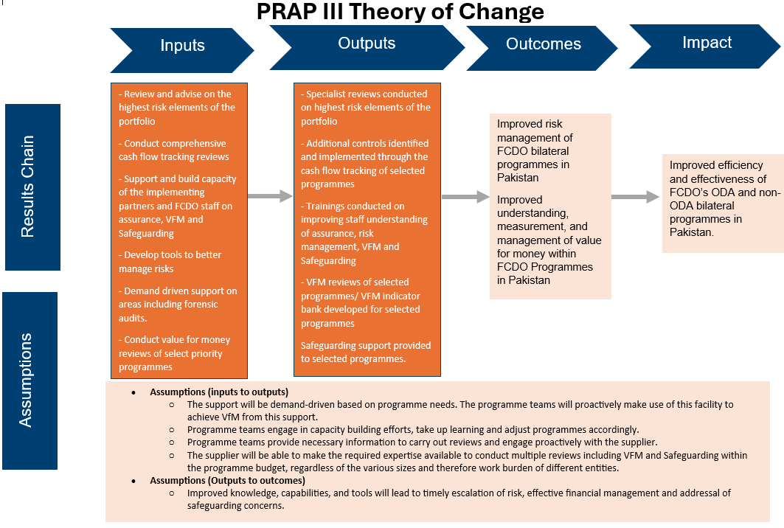

Describe where the programme is on/off track to contribute to the expected outcomes and impact. What action is planned in the year ahead?

This will be analysed during the next annual review once the programme implementation has started.

Justify whether the programme should continue, based on its own merits and in the context of the wider portfolio.

PRAP III has business case demonstrated a clear need for its utility. However, the programme team will continue to seek appropriate adjustments to the programme and its approach, considering the recent ODA cuts and their implications for the country office portfolio.

C. DETAILED OUTPUT SCORING

The programme implementation has not started. The output 1 indicators with milestones for procurement process are explained below.

The programme's key output indicators and milestones will be developed during the implementation phase.

Output Title | PRAP III commercial supplier procurement process is completed, and a supplier is on boarded.
Output number: |  | 1 | Output Score: | B
Impact weighting (%): |  | 100 | Weighting revised since last AR? | Yes

Indicator(s) | Milestone(s) for this review | Progress
Output 1.1: Statement of requirement for commercial contract is finalised with support from PCD colleagues and published for tendering. | Completed by end of December 2024. | Scored ’A’ met expectations.  Programme team and PCD staff completed the tender document in time and published by December 2024.  Mid tender meetings were also held with all the partners to respond to the following queries and questions in time.
Output 1.2: The Bids are received within allocated time, reviewed by panel members and outcome is issued. | Completed by March 2025. | Scored ’B’ moderately did not meet expectations.  A panel was set-up to review bids in time. Bids evaluation completed in time and shared with PCD team.  Outcome letters are not issued because of temporary pause on issuance of new contracts considering the recent ODA cuts.
Briefly describe the output’s activities and provide supporting narrative for the score.

Output 1 has scored a ‘B’, which means it moderately did not meet expectations primarily due to the non-issuance of the contract. However, it met the rest of the procurement process indicators and milestones as explained above. The underperformance on this output is mainly due to changes in the operating context, which are beyond the control of the programme team.

Describe any changes to this output during the past year, and any planned changes as a result of this review.

Due to the delay in procuring a commercial supplier, this year's focus was on setting procurement process indicators to assess programme performance. However, the log frame will be reviewed and finalised during the inception phase of the programme once it starts

Progress on recommendations from the previous AR (if completed), lessons learned this year and recommendations for the year ahead.

- Staff constraints at the Procurement & Commercial Department (PCD) initially caused delays, which could be improved with effective resource planning at the HQ level.
- Once a supplier is on board, the programme team should review the impact of the delay in the start on the overall objectives and propose remedial actions, such as a time extension if needed.

D: VALUE FOR MONEY

Key cost drivers and performance
Not Applicable

VfM performance compared to the original VfM proposition in the business case. N/A
Not Applicable

Assessment of whether the programme continues to represent value for money. N/A
Not Applicable

E: RISK

- Overview of risk management
The overall rating for the programme is assessed as moderate. The programme team has maintained a risk register and set the programme's risk appetite, which is aligned with the Pakistan Network's risk appetite statement. Risks are reviewed at least on quarterly basis or more where needed by the programme team.

In the first year, procurement process delays due to internal resource constraints were significant. This risk impacted the procurement process, but it was escalated and resolved in a timely manner. The procurement process has since been streamlined, and the programme team is awaiting the ODA pause to lift before proceeding in consultation with FCDO’s Procurement & Commercial Department.

F: PROGRAMME MANAGEMENT: DELIVERY, COMMERCIAL & FINANCIAL PERFORMANCE

Summarise the performance of partners and FCDO, notably on commercial and financial issues.
Not applicable.

G: MONITORING, EVIDENCE AND LEARNING

Monitoring and Evaluation, Evidence and Learning.
Not applicable.

Date of last narrative financial report | N/A | Date of last audited annual statement | N/A

