OFFICIAL OFFICIAL

APPENDIX 1

FORM OF CONTRIBUTION ARRANGEMENT

OFFICIAL
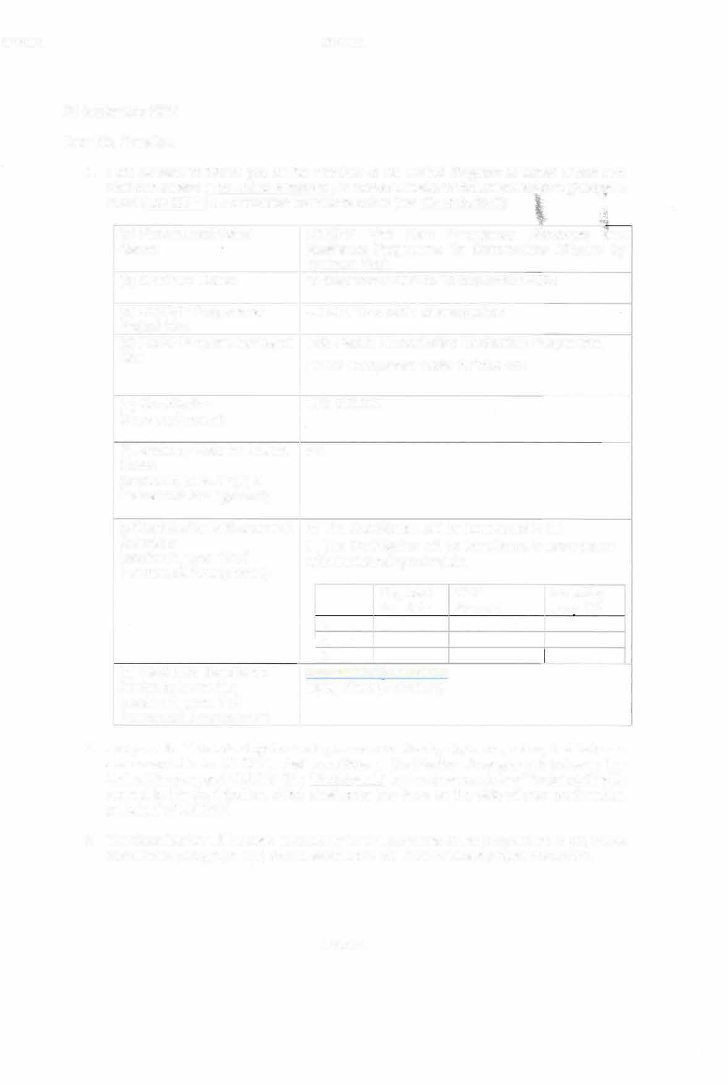
OFFICIAL OFFICIAL

20 September
2024 Dear
- I am pleased to inform you of the intention of the United Kingdom of Great Britain and Northern Ireland ("the United Kingdom") to make available to the United Nations Children's Fund ("UNICEF") a contribution as follows below (the "Contribution"):

(a) Programme/Project Name: | UNICEF Viet Nam Emergency Response and  Resilience Programme for Communities Affected by Typhoon Yagi
(b) Start/End Dates: | 19 September 2024 to 18 September 2025
(c) UNICEF Programme/ Project No.: | UNICEF to provide after signature
(d) FCDO Programme/Project No.: | Inda-Pacific Humanitarian Mechanism Programme, FCDO Component Code: 301369-401
- Contribution Currency/Amount  - Recovery Rate for Indirect Costs:  (section 2, para. 17(a) of Framework Arrangement) | UK£ 500,000  8%
- Contribution Disbursement Schedule:  (section 2, para. 18 of Framework Arrangement)  - Electronic Remittance Advice to be sent to: (section 2, para. 7 of  Framework Arrangement) | IXI□ The Contribution will be transferred in full  The Contribution will be transferred in accordance  with the following schedule:
 |  | 1. | Payment due date | GBP  Amount | Including Levy 1%
 |  | 2.
- I propose that this letter together with your confirmation by signature, below, that its terms are acceptable to UNICEF, shall constitute a Contribution Arrangement between the United Kingdom and UNICEF (the "Participants" and each separately a "Participant") with respect to the Contribution, which shall enter into force on the date of your confirmation on behalf of UNICEF.
3.
- The Contribution will be used exclusively for the purposes of the programme or project as indicated in paragraph 1(a) above, and as laid out in the relevant project document.

OFFICIAL
OFFICIAL OFFICIAL

- The Contribution will be disbursed to subject to a disbursement schedule in accordance with paragraph 1(g) above. UNICEF will submit a payment request to FCDO for each scheduled disbursement. Each payment request submitted in accordance with this paragraph should include the following information:

  - All amounts received under previous disbursements in accordance with this Contribution Arrangement (in UK Pounds sterling and the equivalent amounts in US Dollars);

  - Expenditures against previous disbursements and unutilised amounts remaining, if any (in US Dollars); and

  - The amount requested for further disbursement.

In the event that the Contribution will be disbursed subject to a disbursement schedule in accordance with paragraph 1(g) above, that schedule may be amended by mutual consent of FCDO and UNICEF.

- This Contribution Arrangement shall be an arrangement supplementary to the Framework Arrangement concluded between the Participants. The terms of the Framework Arrangement will apply except as otherwise provided herein/in this Contribution Arrangement.

- It is expected that the Contribution will be fully utilised by the End Date as stipulated in paragraph 1(b) of this Contribution Arrangement or as soon as practically possible after this date. Commitments entered into by UNICEF after the End Date will require the prior agreement of FCDO, to be obtained in accordance with paragraph 7, below.

- This Contribution Arrangement may be modified by written agreement between the Participants.

- This Contribution Arrangement may be terminated by either Participant upon giving not less than three (3) months written notice to the other Participant. Upon receipt by one Participant of the other Participant's written notice of termination of this Contribution Arrangement, the Participants will take all reasonable and necessary measures to conclude the implementation of the Programme or Project and complete their activities in an orderly manner. In accordance with the foregoing, UNICEF may apply any unutilized portion of the Contribution to permit the orderly conclusion of the Programme or Project, including the completion of final reports, the withdrawal of personnel, funds and property, the settlement of accounts between the Participants, and the settlement of contractual commitments or liabilities relating to or in connection with the Programme or Project, including in respect of any implementing partners, contractors, subcontractors, consultants or suppliers.

- The provision regarding Safeguarding for the prevention of sexual exploitation and abuse and harassment are stipulated in the attached Annex 1 - Standard PSEA language.

- In line with these terms, the UNICEF will promptly report all allegations of SEA credible enough to warrant an investigation through the Secretary-Genera'ls reporting mechanism (the "Report"). When the UNICEF reports an allegation of SEA to, or becomes aware of an allegation reported through the Report that is i) directly related to the activities funded

OFFICIAL

OFFICIAL OFFICIAL

by this arrangement or ii) would have a significant impact on the partnership between the UNICEF and FCDO, the UNICEF will promptly notify FCDO at reportingconcerns@fcdo.gov.uk. The UNICEF will report allegations of sexual harassment measures taken through existing reporting mechanisms. Where the UNICEF has determined that allegations of sexual harassment would have a significant impact on the partnership between the UNICEF and FCDO, the UNICEF will promptly notify FCDO at reportingconcerns@fcdo.gov.uk.

- Consistent with numerous applicable United Nations Security Council resolutions, including S/RES/1267 (1999), S/RES/1373 (2001) and related resolutions, the Participants are firmly committed to the international fight against terrorism and the financing of terrorism. It is the policy of FCDO to seek to ensure that none of its funds are used, directly or indirectly, to provide support to individuals or entities associated with terrorism. UNICEF undertakes to use all reasonable efforts to ensure that this Contribution is not made available or used to provide support to individuals or entities associated with terrorism as designated by the United Nations Security Council sanctions regime list.

Sincerely,

Regional Humanitarian Adviser, lndo-Pacific Regional Department, FCDO

OFFICIAL

ANNEX 1: Tackling sexual exploitation and abuse and sexual harassment

ANNEX 1: Tackling sexual exploitation and abuse and sexual harassment

  - Sexual exploitation and abuse
FCDO and the Recipient have a zero tolerance for inaction approach to tackling sexual exploitation and abuse ("SEA'').1 This means the Recipient and its implementing partners will take all reasonable steps to prevent SEA by both its employees and any implementing partner and respond appropriately when reports of SEA arise, in accordance with their regulations, rules, policies and procedures.

Unless inconsistent with a specific regulation, rule, policy or procedure governing the Recipient, the Recipient will apply the IASC Six Core Principles Relating to Sexual Exploitation and Abuse and the following principles and practices when implementing the activities under this arrangement and provide evidence to demonstrate this where required:
    - Adherence to the IASC-Minimum Operation Standards on "Protection from sexual exploitation and abuse by own personnel" and/or [the] SEA elements of the Core Humanitarian Standard on Quality and Accountability.
    - A victim/survivor-centred approach2 to SEA issues;
    - Strong leadership and signaling on tackling SEA;
    - Make all reasonable efforts to address gender inequality and other power imbalances;
    - Reporting to enhance accountability and transparency;
    - Ensure that SEA standards from this arrangement are reflected in funding templates with implementing partners, [for UN entities: by means such as, but not limited to, adherence to the United Nations Protocol on Allegations of Sexual Exploitation and Abuse Involving Implementing Partners].

b. Sexual harassment
FCDO and the Recipient have a zero tolerance for inaction approach to tackling sexual harassment ("SH").3This means the Recipient will take all reasonable steps to prevent SH and

- See UNSG Bulletin ST/SGB/2003/13 for the definition of sexual exploitation and abuse.
- A victim/surv ivor centered- approach is one for which the victim/ survivor's dignity, experiences, considerations, needs, and resiliencies are placed at the center of the process1 from the initial program design to investigating and responding to potential incidents. Consistent with the UN Protocol on Alle gat ions
of SEA Involving Implem enting Partners the victim/ survivor should be informed, consulted Ci.Iring the decision-making process, and provide consent on the
possible use and disclosure of their information. Those interacting with the victim/ survivor and/or handling informat ion regarding the allegation will maintain confidentiality, ensure safety of the victim/ survivor, and apply Vid:im/s u rvi vor-centered principles which are safety, confidentiality, respect, and non- discrimination. When the w:li'Tysurvivor is a child, the approachwill consider the best interests of the child and engage with the fami ly/caregivers as appropriate. Staff and partners should comply with host country and local child welfare and protection legislation and internat ional standards, whichever gives greater protection.
3 See the UN System Model Policy on Sexual Harassment and the UN Secre tary -Genera l's Bulletin ST/SGB/2019/8 for the uniform definition of sexual
harassment in the UN System.

respond appropriately when reports of SH arise, in accordance with its regulations, rules, policies and procedures.

Unless inconsistent with a specific regulation, rule, policy or procedure governing the Recipient, the Recipient will apply the following principles and practices when implementing the activities under this arrangement:
  - A victim/survivor-centred approach to SH issues;
  - Strong leadership and signaling on tackling SH;
  - Make all reasonable efforts to address gender inequality and other power imbalances.
  - Reporting to enhance accountability andtransparency;

- The Recipient will adhere to the following requirements:
  - Allegations of SEA
- The Recipient will promptly report all allegations of SEA credible enough to warrant an investigation through the Secretary-General's reporting mechanism (the "Report").
- When the Recipient reports an allegation of SEA to, or becomes aware of an allegation reported through, the Report that is (i) directly related to the activities funded by this arrangement or, (ii) would have a significant impact on the partnership between the Recipient and FCDO, the Recipient will promptly notify FCDO at reportingconcerns@fcdo.gov.uk of the report made and the relevant arrangement number, if applicable and provide information containing the level of detail that the Recipient is aware of.
- Upon request from FCDO, the Recipient agrees to provide further available relevant information the Recipient is aware of for allegations notified under paragraph 2a (ii) including about subsequent measures taken by the Recipient, unless disclosure of such information would be inconsistent with the Recipient's regulations, rules, policies and procedures concerning disclosure of information
  - Allegationsof SH
- The Recipient will report allegations of sexual harassment and measures taken through existing reporting mechanisms.
- Where the Recipient has determined that the allegations would have a significant impact on the partnership between the Recipient and FCDO, the Recipient will promptly notify FCDO at reportingconcerns@fcd.ogov.uk and provide information containing the level of detail of the existing reporting mechanisms.
- Upon request from the FCDO, the Recipient agrees to provide further available relevant information, that the Recipient is aware of unless disclosure of such information would be inconsistent with the Recipient's regulations, rules, policies and procedures concerning disclosure of information.

- It is understood and accepted that the Recipient's arrangement to report on SEA and SH will be performed in accordance with the Recipient's regulations, rules, policies and procedures, including its rules on confidentiality, and is subject to not compromising the safety, security, privacy and due process rights of any concerned persons.

- When the Recipient becomes aware of reasonablesuspicions, complaints or reports of SEA or SH by its personnel, the Recipient will, as appropriate under its regulations, rules, policies, and procedures, take reasonable, swift and appropriate action to stop harm occurring, investigate and report to relevant authorities (for potential criminal matters), as appropriate and when safe to do so, after considering the wishes of the victim/survivor.

- FCDO or any of its duly authorized representatives may, in accordance with agreed mutually accepted terms of reference, carry out reviews or evaluations or other assessment measures to verify the Recipient's zero tolerance for SEA and SH, provided that such measures are consistent with the single audit principle governing the UN, if applicable. The Recipient will fully cooperate within the scope of the terms of reference with any such reasonable requests by FCDO or any of its duly authorized representatives or agents to carry out such measures.

- Any information or documentation provided in accordance with these provisions will be treated by FCDO with utmost discretion in order to ensure, inter alia, the probity of any investigation, protect sensitive information , ensure the safety and security of persons and respect the due process rights of all involved. FCDO will presume information/documentation to be confidential, deliberative, and investigatory and will ensure that information/documentation provided to FCDO will be available solely to those who strictly require access to such information/documentation. Any disclosure of such information/documentation beyond such personnel will require notification and consultation with the Recipient. FCDO will obtain the express written authorization of the Recipient before disclosing any such information/documentation in a judicial proceeding or to the public, unless disclosure is otherwise required by law applicable to FCDO and is not subject to the Recipient's privileges and immunities under international and/or national law (such as information/documentation constituting UN archives).

- Unless the regulations, rules, policies, and procedures applicable to the Recipient are amended at an earlier stage, and/or there are other substantive changes to any of the referenced policies, processes or mechanisms, the above provisions are subject to possible review two years after the date of FCDO's mutual decision on their text with the Recipient (27 July 2021). Any changes to the above provisions that may be mutually decided following such a review will take effect at least four years after the date of FCDO's mutual decision on the present text with the Recipient, until which time the above provisions will continue to apply.

