Project Name: The Blue Carbon Action Partnership (BCAP) project Project Number: 301203-402
1 . I refer to the Accountable Grant between the Government of the United Kingdom of Great Britain and Northern Ireland acting through the Foreign, Commonwealth & Development Office ("FCDO") and The World Economic Forum signed on 29 August 2023
- Following recent discussions and correspondence with the World Economic Forum, FCDO proposes to agree a 6 month no cost extension to the existing Accountable Grant and to change the end date of the Accountable Grant.
- The no-cost extension (NCE) into FY4 would sustain and consolidate the momentum of BCAP to provide greater opportunity for in-country implementation. The primary goals of the NCE are:
Sufficient operational time for Viet Nam's NBCAP— to launch in FY3—to engage stakeholders, create and finalise its roadmap, connect with investment for roadmap implementation.
Completion of roadmap implementation planning and investment alignment for Indonesia and the Philippines, ensuring integration with COAST Components A and B and enabling a full two years of operational support.
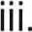Further development of blue finance for roadmap implementation in Indonesia and the Philippines, leveraging global and national stakeholders for a blended finance approach in support of national priorities.
iv. Ensured strong exit from NBCAP support, with key elements of the NBCAP embedded in appropriate government and other stakeholders for continued implementation.
- Deliverables under FY4 No-Cost Extension will include:
Up to two additional months for the Indonesia and Philippines NBCAPs to reach a full 2 years of Secretariat activity (through 31
May, 2026);
  - Up to six months of continued support for the Viet Nam NBCAP, reaching 12 months of total support (through 30 September, 2026), allowing for roadmap launch, stakeholder consultations, and foundational partnerships to take root.
  - Up to six months of reduced global staffing to:
Deliver a coalition of investors for funding country roadmap implementation
Support final roadmap integration with national policy
o Connection partners, policy, and implementation with COAST
Components A and B o Deliver cross-sectoral learning exchanges
Compile final impact reporting and transition materials
Facilitate transition of the NBCAP responsibilities into implementation
- This extension ensures complete delivery of BCAP milestones, additional time to leverage greater blue finance for Indonesia and Philippines roadmap implementation, and wrap-up with government partners and other COAST components. Finalised budget for FY4 will shape the detailed workplan during this period.
- I propose that the end date of "31 March 2026" in paragraph 3 of the original Accountable Grant be deleted and replaced with "30 September 2026".
- This letter of amendment will place on record our common understanding of the above change(s) and will come into operation on the date you sign your confirmation below. This note will be known as Amendment No-I/ 25.
- Please sign both copies of this letter; return one to me and retain the other for your own records.
- [PLEASE ENSURE THE PARTNER SIGNS BEFORE THE FCDO.I
Signed on behalf of FCDO: 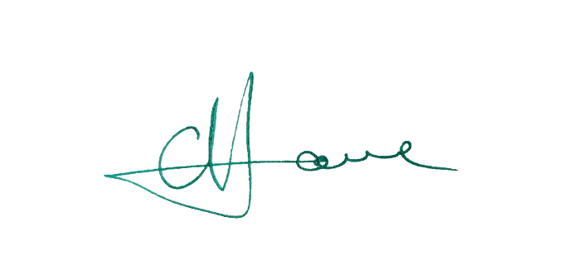
Name: | Gerard Howe
Position: | Head of Climate Resilience Department
Address/Contact Details: | Foreign, Commonwealth and Development Office (FCDO) King Charles Street, London, SW1A 2AH  Gerard.Howe@fcdo.gov.uk
Date: | 05/11/2025

 | Date:
Signed on behalf of the Partner: 
Name: |  | Sebastian Buckup
Position: |  | Managing Director
Address/Contact Details: |  | World Economic Forum  Rte de la Capite 91/93, 1223 Cologny, Switzerland
Date: |  | 
Name: |  | Alois Zwinggi 
Position: |  | Managing Director
Address/Contact Details: |  | World Economic Forum  Rte de la Capite 91/93, 1223 Cologny, Switzerland
Date: |  | 

