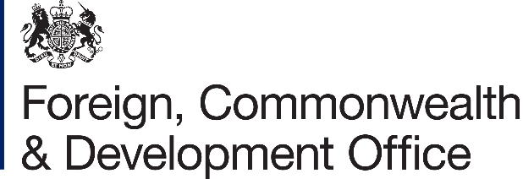

Memorandum of Understanding Amendment Letter #0212025
Project Name: Building Health System Resilience to End Preventable
Deaths in Ethiopia Programme IEPD-E/
Project Number: 301196
1. I refer to the Memorandum of Understanding between the Government of the United Kingdom of Great Britain and Northern Ireland acting through the Foreign, Commonwealth & Development Office ("FCDO") and the Ministry of Finance of the Federal Government of Ethiopia ("The Government") signed on 22 May 2023 and subsequent amendment of 28 June 2024.
- Following recent discussions, FCDO proposes to increase the amount made available to the Government by £13,360,000 (Thirteen Million, Three Hundred and Sixty Thousand Pounds Sterling).
- I propose that the figures and words “£32,000,000 (thirty-two million Pounds Sterling) in paragraph 3 of the Memorandum of Understanding Amendment Letter No.1/2024 be deleted and replaced with the figures and words 45,360,000 (Forty-Five Million, Three Hundred and Sixty Thousand Pounds Sterling).
- In addition, FCDO proposes to delete the words "FCDO increases the amount of budget since it acknowledges that the previous disbursement of £9,000,000 has been utilized based on the Ethiopian financial year (EFY) 2015 comprehensive annual pran. Moreover, Ministry of Health (MOH) is expected to utilize FCDO's budget based on Ethiopian financial year (EFY) 2016 Comprehensive annual plan and as per the Joint Financing Agreement (JFA) Article 8.3" in paragraph 4 of the Memorandum of Understanding Amendment Letter No.1/2024 and replace with them with "FCDO increases the amount of budget since it acknowledges that the previous disbursement of £23,000,000 has been utilized based on the Ethiopian financial year (EFY) 2016 comprehensive annual plan. Moreover, Ministry of Health (MOH) is expected to utilize FCDO's budget based on EFY 2018 Comprehensive annual plan and as per the Joint Financing Agreement (JFA) Article 8".
- This letter of amendment will place on record our common understanding of the above changes and will come into operation on the date you sign your confirmation below. This note will be known as Amendment No, 02/2025.

- Please sign both copies of this letter; return one to me and retain the other for your own records.
Signed on behalf of FCDO:

Name: | Amanda McLoughlin
Position: | Development Director
Address/Contact Details: | British Embassy
Comoros Street
Addis Ababa, Ethiopia
P. O. Box: 858 Tel: +251 116 170100
Fax: +251 116 175 558
Email: amanda.mqlouqhlin@fcdo.qov.uk

Date; 17/11/2025

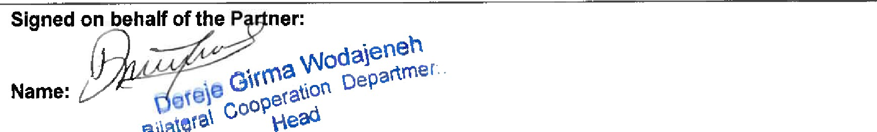
Bilatøta\
bepaame

Position:
Address/Contact Details:
Date:

