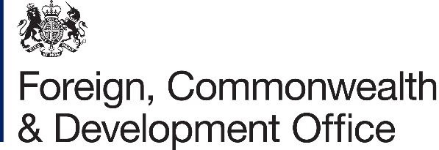

Accountable Grant Amendment Letter - No 1-2024

Project Name: Empowerment of The Ethiopian Human Rights
Commission - 2020-2024

Project Number: 301191-102

- I refer to the Accountable Grant between the Government of the United
Kingdom of Great Britain and Northern Ireland acting through the Foreign,
Commonwealth & Development Office (FCDO) and The Danish Institute for Human Rights (DIHR), Denmark’s National Human Rights Institutions (parliament act No 553/2012) signed on 10 March 2022.

- Following recent discussions, FCDO proposes to increase the amount made available to Danish Institute for Human Rights (DIHR) by £402,570 (Four Hundreds Two Thousand Five Hundred Seventy) and to change the end date of the Accountable Grant.

- I propose that
  - the figures and words £1,000,000 (One Million pounds sterling) in paragraph 03 of the original Accountable Grant be deleted and replaced with £1,402,570 (One Million Four Hundred Two
Thousand Five Hundred Seventy - pounds sterling)

  - Delete disbursement schedule of paragraph 3 of original accountable grant 10 March 2022 and replace with

FCDO Financial Year | Annual Allocation (£GBP)/Payment Schedule
24 February 2022 – 31 March 2022 | £300,000 March 2022
1 Apr 2022 – 31 March 2023 | £200,000 December 2022
1 Apr 2023 – 31 March 2024 | £300,000 May 2023
1 Apr 2023 – 31 March 2024 | £200,000 August 2023
1 Apr 2023 – 31 March 2024 | £402,570 February 2024

  - The end date of “31 March 2024” in paragraph 03 of the original Accountable Grant be deleted and replaced with “31 July 2024”.

- This letter of amendment will place on record our common understanding of the above change(s) and will come into operation on the date you sign your confirmation below. This note will be known as Amendment No. 1/2024.
1

- Except as expressly modified herein accordance with paragraph 3, all the terms of the Grant Agreement shall remain unchanged and shall continue in full force and effect.
- Please sign both copies of this letter; return one to me and retain the other for your own records.
Signed on behalf of FCDO:

Name:
Position: | Development Director
Address/Contact Details: | British Embassy  Comoros street  Addis Ababa  P.O box 858  Tel +251116170100, Fax +251116175558
Date: | 13/02/2024
Signed on behalf of the Partner:
The Danish Institute for Human Rights
Name:
Position:
Address/Contact Details: | Wilders Plads 8 K  1403 Copenhagen K  Denmark  Tel +45 32698888
Date: | 15/02/2024
2

