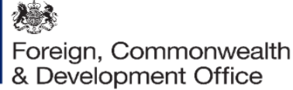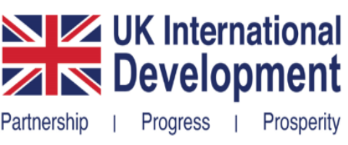
Contribution Arrangement
Amendment Letter 4

Project Name: Saving Lives in Sierra Leone phase 3

Project Number: FCDO Programme No. 301141 – 402
UNICEF Grant No. SC230702

- I refer to the Contribution Arrangement between the Government of the United Kingdom of Great Britain and Northern Ireland acting through the Foreign, Commonwealth & Development Office (FCDO) and The United Nations Children's Fund (UNICEF) signed on 11 December 2023, with the following amendments:
- 28 June 2024 (Amendment 1/2024)
- 18 June 2025 (Amendment 2/2025)
- 26 August 2025 (Amendment 3/2025).

- Following recent correspondence, FCDO proposes to change the end date of the Contribution Arrangement.

- I propose that the end date of 9 December 2028 in paragraph 1b of the original Contribution Arrangement be deleted and replaced with 31 December 2026.

- This letter of amendment will place on record our common understanding of the above change(s) and will come into operation on the date you sign your confirmation below. This note will be known as Amendment No. 4/2026.

- Please sign both copies of this letter; return one to me and retain the other for your own records.

Signed on behalf of FCDO:

Name: | Alexandra Maclean
Position: | Development Director
Address/Contact Details: | British High Commission  6 Spur Road  Freetown  Sierra Leone
Date:
Signed on behalf of the Partner:

Name: | Rudolf Schwenk
Position: | UNICEF Representative
Address/Contact Details: | UNICEF Sierra Leone
Date:

