Annex A: visibility statement template
UK aid and UK International Development visibility statement
As part of your funding agreement with FCDO, you are required to acknowledge funding from the UK government on your ODA funded programme, in written materials and verbal statements and through use of the UK International Development (UK Dev) logo on programme assets. Please refer to the UK Dev branding guidance for further information on how to acknowledge ODA funding from the UK government. Please note that from April 27, 2023, the UK aid logo will be used mainly for humanitarian and rapid onset disaster responses. if you are not clear on what logo to use then check with your FCDO programme manager.
You may be asked to provide, as part of your agreed reporting to FCDO, evidence of the branding in use, including photographs of the logo in the field and examples of communications materials.
By completing and signing this statement you agree to fulfil these requirements.
1. Organisation name: Norwegian Refugee Council (ACAPS and INFORM)
2. Programme name and brief description of what it will deliver:
The Humanitarian Enablers Programme (HEP) will contribute to making humanitarian responses by FCDO and the international humanitarian system more effective as a core priority of the UK Government’s International Development Strategy (IDS). It will support specialised enabling services which are aligned to the three priorities of the Humanitarian Framework: independent data collection and analysis (prioritise); contributing to improved access and inclusion of
vulnerable groups (protect); and strengthening early warning and risk management
(prevent). The programme will deploy enabling services in rapid onset and protracted crises; complementing and informing the FCDO’s response and providing “global public goods” that multiply the impact of others.

3a. Please list the assets that will be delivered by the programme that will carry the UK aid or UK International Development logo or acknowledgement of UK International Development funding.
The donor will be acknowledged on the ACAPS website https://www.acaps.org/who-we-are/our-partners.
To maintain ACAPS independence, the organization does not include donor logos or references on its core products, such as reports. In the case of social media, ACAPS may tag FCDO when sharing content generated from grant-related activities, such as interviews or podcasts. However, ACAPS will not tag FCDO nor other donors in posts directly linked to its core analysis or reports.

Should opportunities arise to feature content such as a podcast episode, a social media tag can be considered (provided it fits with ACAPS’ editorial direction and adds value for its audience).
3b. Please list the assets that will be delivered by the project that will not carry the UK aid or UK International Development logo and/or acknowledgement of funding and explain clearly why these items will not carry UK aid or UK International Development branding. All exceptions require approval by the Head of Department of the team in whose portfolio the programme sits and a record of this approval, e.g. an email, should be kept along with the programme documentation:
Content that is not specific to UK AID support, or content meeting the exception criteria in Section 7 of the UK's Branding Guidance for ODA Programmes. Agreement will be sought by the partner from the FCDO regarding principles for the application of the latter criterion only.
To preserve ACAPS’ editorial independence in the production of its analysis, outputs branded or co-branded under the ACAPS name will not include any donor logos, without exception.

Declaration:
I understand that no UK International Development funds may be used to procure any promotional communications goods or activities that do not have a direct impact on the successful delivery of this programme or serve to increase the transparency of funding.
By signing this statement, you agree to fulfil the commitments stated above:
Partner organisation representative:
Name: Lars Peter Nissen
Job title: Chief Executive Officer, ACAPS
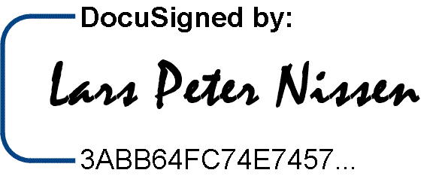
Signature:
Date: 05 August 2025

Agreed by FCDO programme manager:
Name: Liz Peters
Job title, department: Humanitarian Advisor and HEP SRO, Humanitarian Crisis Response Department
Signature: 
Date: 22 July 2025

