Annex A: visibility statement template
UK aid and UK International Development visibility statement
As part of your funding agreement with FCDO, you are required to acknowledge funding from the UK government on your ODA funded programme, in written materials and verbal statements and through use of the UK International Development (UK Dev) logo on programme assets. Please refer to the UK Dev branding guidance for further information on how to acknowledge ODA funding from the UK government. Please note that from April 27, 2023, the UK aid logo will be used mainly for humanitarian and rapid onset disaster responses. if you are not clear on what logo to use then check with your FCDO programme manager.
You may be asked to provide, as part of your agreed reporting to FCDO, evidence of the branding in use, including photographs of the logo in the field and examples of communications materials.
By completing and signing this statement you agree to fulfil these requirements.
1. Organisation name: Danish Refugee Council (Humanitarian-2-Humanitarian (H2H) Network)

2. Programme name and brief description of what it will deliver:
The Humanitarian Enablers Programme (HEP) will contribute to making humanitarian responses by FCDO and the international humanitarian system more effective as a core priority of the UK Government’s International Development Strategy (IDS). It will support specialised enabling services which are aligned to the three priorities of the Humanitarian Framework: independent data collection and analysis (prioritise); contributing to improved access and inclusion of vulnerable groups (protect); and strengthening early warning and risk management (prevent). The programme will deploy enabling services in rapid onset and protracted crises; complementing and informing the FCDO’s response and providing “global public goods” that multiply the impact of others.

3a. Please list the assets that will be delivered by the programme that will carry the UK aid or UK International Devekipment logo or acknowledgement of UK International Development funding.
All assets related to the Humanitarian Enablers Programme funded by UK AID, including but not limited to: press releases, annual reports, research reports, website, marketing brochures and materials, event banners, social media graphics.

3b. Please list the assets that will be delivered by the project that will not carry the UK aid or UK International Development logo and/or acknowledgement of funding and explain clearly why these items will not carry UK aid or UK International Development branding. All exceptions require approval by the Head of Department of the team in whose portfolio the programme sits and a record of this approval, e.g. an email, should be kept along with the programme documentation:
Content that is not specific to UK AID support, or content meeting the exception criteria in Section 7 of the UK's Branding Guidance for ODA Programmes. Agreement will be sought by the partner from the FCDO regarding principles for the application of the latter criterion only.

Declaration:
I understand that no UK International Development funds may be used to procure any promotional communications goods or activities that do not have a direct impact on the successful delivery of this programme or serve to increase the transparency of funding.
By signing this statement, you agree to fulfil the commitments stated above:
Partner organisation representative:
Name: Alice DARCQ
Job title: Head of Operations and finance
Signature: 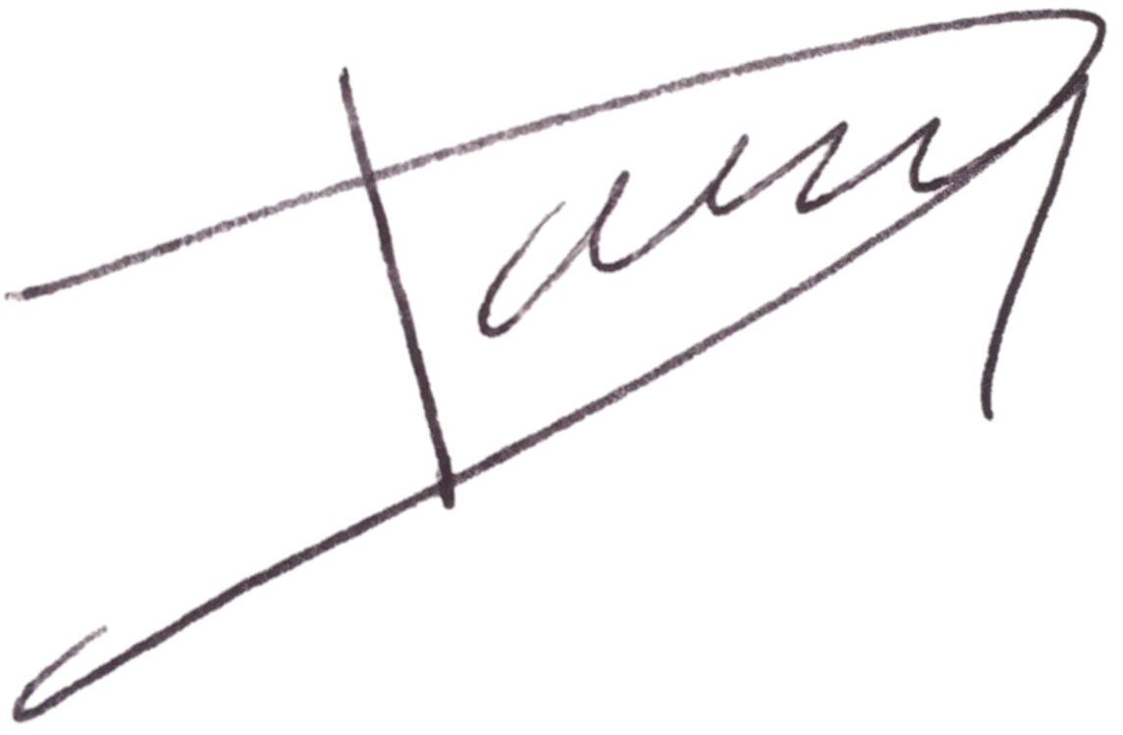
Date: 17/07/2025
Agreed by FCDO programme manager:
Name: Liz Peters
Job title, department: Humanitarian Advisor and HEP SRO, Humanitarian Crisis Response Department
Signature: 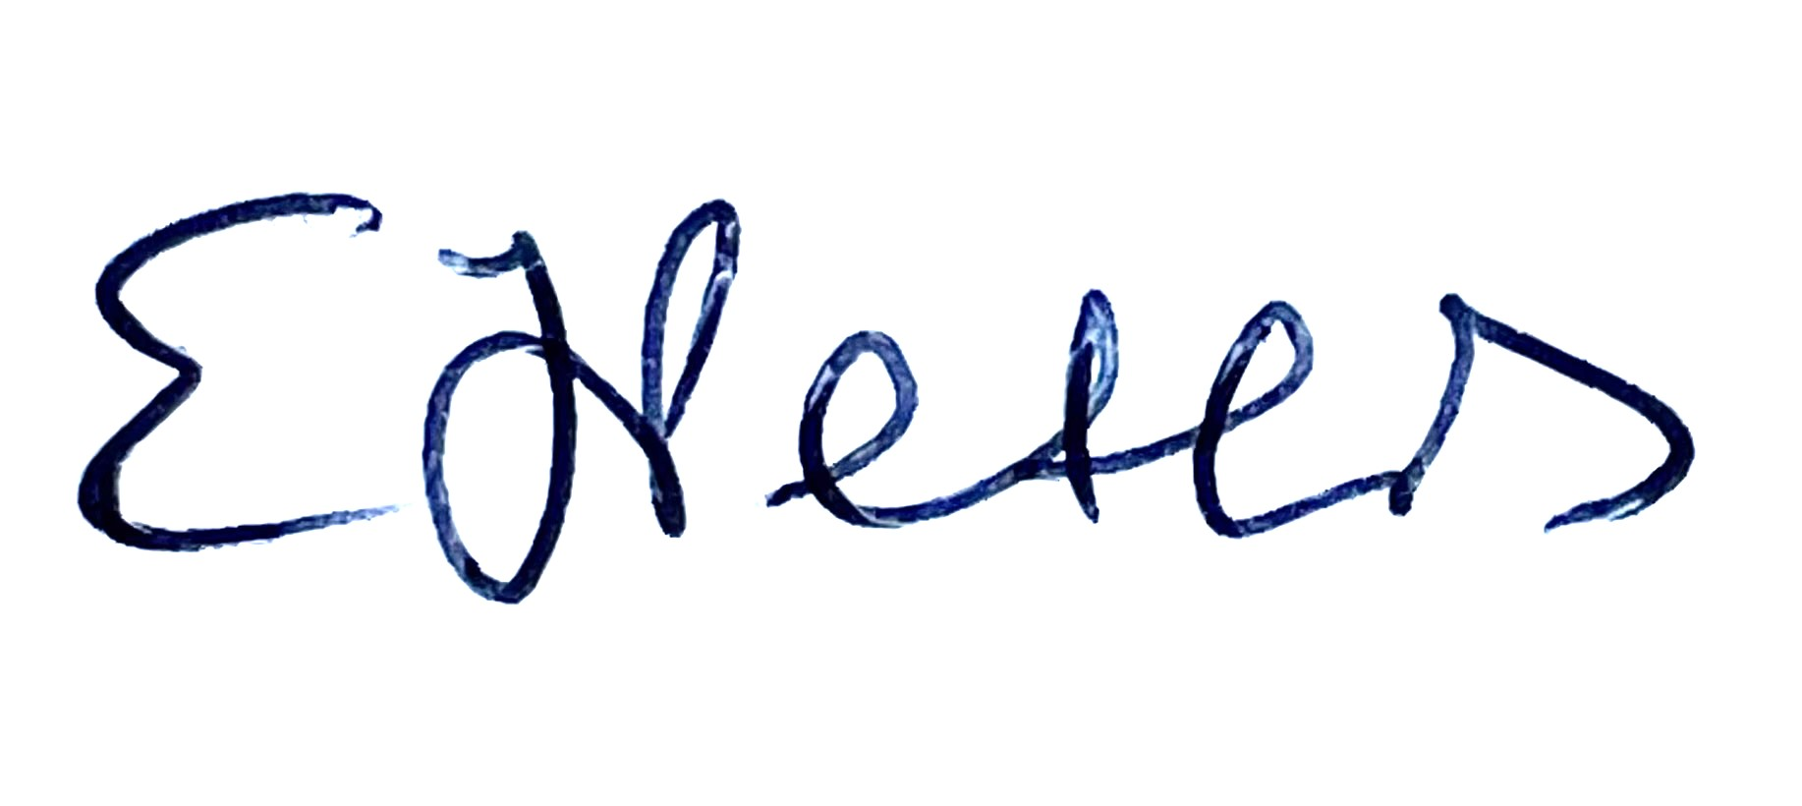
Date: 16 July 2025

