Accountable Grant Amendment Letter

Project Name: Humanitarian Enablers Programme: H2H
Project Number: 301072-101

1. I refer to the Accountable Grant between the Government of the United
Kingdom of Great Britain and Northern Ireland acting through the Foreign,
Commonwealth & Development Office (“FCDO”) and the Danish Refugee Council (“DRC”) signed on 02 September 2022 and subsequent Accountable Grant Amendments:

01/2022 signed on 20 October 2022 – Pakistan Activation
01/2023 signed on 27 February 2023 –Turkey Syria Activation 02/2023 signed on 06 September 2023 – Business Case Addendum
01/2024 signed on 16 July 2024 – Programme uplift
02/2024 signed on 29 October 2024 – Lebanon Activation
01/2025 signed on 12 February 2025 – DRC Activation
02/2025 signed on 07 March 2025 – DRC Activation

Increase FCDO’s contribution

- Following recent discussions, FCDO proposes to increase the total amount made available to the Danish Refugee Council by £150,000 (one hundred and fifty thousand pounds sterling) for the Communication Community Engagement and Accountability Activation as part of the Myanmar Earthquake response.

- I propose that the figures and words “FCDO will make available an amount not exceeding £7.575m (seven million, five hundred and seventy-five thousand pounds sterling)” in paragraph 3 of Accountable Grant Amendment Note 02/2025 be deleted and replaced with the figures and words “FCDO will make available an amount not exceeding £7.725m (seven million, seven hundred and twenty-five thousand pounds sterling).”

- In addition, I propose that the figures and words. “The amount is expected to be allocated across the following years.

FCDO Financial Year Allocation (£GBP)

  - 1 September 2022 — 30 November 2022 £250,000
• 1 December 2022 — 31 March 2023 | £250,000
• 1 April 2023 — 30 June 2023 | £350,000
• 1 July 2023 — 30 September 2023 | £300,000
• 1 October 2023 — 31 December 2023 | £300,000
• 1 January 2024 — 31 March 2024 | £300,000
• 1 April 2024 — 30 June 2024 | £350,000
• 1 July 2024 — 30 September 2024 | £300,000
• 1 October 2024 — 31 December 2024 | £300,000
• 1 January 2025 — 31 March 2025 | £300,000”

in paragraph 3 of the original accountable grant be deleted and replaced with, “The amount is expected to be allocated across the following years.

FCDO Financial Year Allocation (£ GBP)

  - 1 September 2022 — 30 November 2022 £250,000
• 1 December 2022 — 31 March 2023 | £250,000
• 1 April 2023 — 30 June 2023 | £350,000
• 1 July 2023 — 30 September 2023 | £300,000
• 1 October 2023 — 31 December 2023 | £300,000
• 1 January 2024 — 31 March 2024 | £300,000
• 1 April 2024 — 30 June 2024 | £450,000
• 1 July 2024 — 30 September 2024 | £450,000
  - 1 October 2024 — 31 December 2024 £1,082,708
  - 1 January 2025 — 31 March 2025 £267,292
  - 1 January 2025 — 31 March 2025 (DRC) £600,000
  - 1 January 2025 – 31 March 2025 (DRC) £625,000
  - 1 April 2025 — 30 June 2025 £500,000
  - 1 July 2025 — 30 September 2025 £300,000
  - 1 October 2025 — 31 December 2025 £300,000
  - 1 January 2026 — 31 March 2026 £300,000
  - 1 April 2026 — 31 May 2026 £300,000
  - 1 June 2026 - 31 July 2026 £300,000

Acceptance paragraphs and signature

- This letter of amendment will place on record our common understanding of the above change(s) and will come into operation on the date you sign your confirmation below. This note will be known as Amendment No. 03/2025.

- Please sign both copies of this letter; return one to me and retain the other for your own records.
Signed on behalf of FCDO: 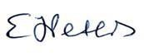
Name: | Elizabeth Peters
Position: | Humanitarian Adviser
Address/Contact Details: | King Charles Street,  London SW1A 2AH
Date: | 29/04/25

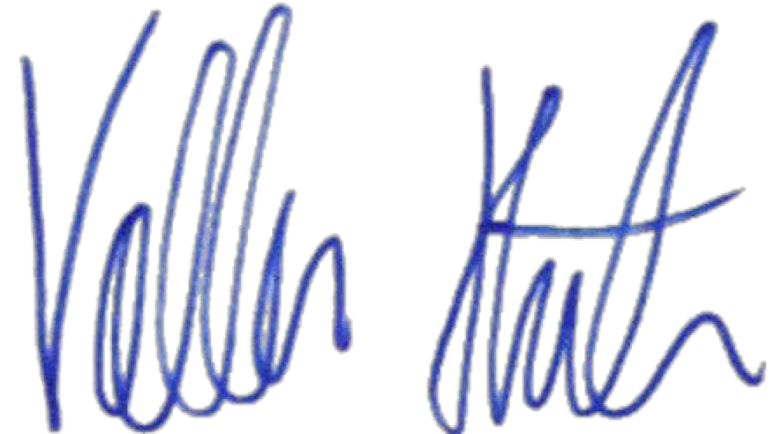
Signed on behalf of the Partner:

Name: | Volker Hüls
Position: | DRC Head of Effectiveness, Knowledge & Learning
Address/Contact Details: | DRC  Borgergade 10  1300 København K Denmark
Date: | 02 May 2025

