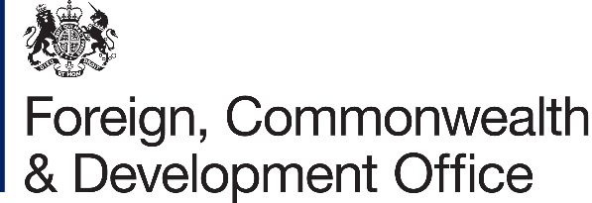

Accountable Grant Amendment Letter

Project Name: Humanitarian Enablers Programme (HEP)
Project Number: 301072-102

1. I refer to the Accountable Grant between the Government of the United Kingdom of Great Britain and Northern Ireland acting through the Foreign, Commonwealth & Development Office (“FCDO”) and the International NGO Safety Organisation (INSO) signed on 30 January 2024.

Increase FCDO’s contribution

- Following recent discussions, FCDO proposes to increase the amount made available to International NGO Safety Organisation (INSO) by £600,000 (six hundred thousand pounds sterling).

- I propose that the figures and words £1.4 million (one million four hundred thousand pounds Sterling in paragraph 3 of the original Accountable Grant be deleted and replaced with the figures and words £2 million (two million Pounds Sterling).

The amount is expected to be allocated across the following years.

FCDO Financial Year Allocation (£ GBP)

• | 1 January 2024 — 31 March 2024 | £300,000
• | 1 April 2024 — 30 September 2024 | £200,000
• | 1 October 2024 — 31 March 2025 | £800,000
• | 1 April 2025 — 30 September 2025 | £200,000
• | 1 October 2025 — 31 March 2026 | £200,000
• | 1 April 2026 — 31 July 2026 | £300,000
OFFICIAL

Acceptance paragraphs and signature

- This letter of amendment will place on record our common understanding of the above change(s) and will come into operation on the date you sign your confirmation below. This note will be known as Amendment No.01/2025.

- Please sign both copies of this letter; return one to me and retain the other for your own records.

Signed on behalf of FCDO: 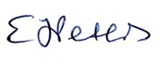

Name: | Elizabeth Peters
Position: | Humanitarian Adviser
Address/Contact Details: | King Charles Street,  London SW1A 2AH
Date:

Signed on behalf of the Partner:

Name: | Nicolas Lee
Position: | Executive Director
Address/Contact Details: | Grote Marktstraat 43-C  2511 BH The Hague
Date: | 14 February 2025

2

