Evaluation Report for the
Review of the Bangladesh Climate and Environment Programme (BCEP) Accountable Grant Supported by BHC/ FCDO
Final Report
RFP Ref: GCA-PR-25-874

GOPA MetaMeta
SocioConsult Ltd.

Contact: Dr. Long Hoang – Program Manager
Long.hoang@gopa.eu





Table of Contents
1 Executive Summary 3
2 Introduction and Context 3
2.1 Country and Sector Context 3
2.2 Programme Overview 3
2.3 GCA Approach 4
2.4 Purpose and Objectives of the Evaluation 10
2.5 Scope and Audience 11
3 Evaluation Methodology 13
3.1 Evaluation Framework 13
3.2 Evaluation Arenas 13
3.3 Methodology 15
3.4 Limitations 17
4 Specific Questions Addressed 18
5 Document and Data Review and Anaysis 18
5.1 Quantitative Document and Data Review and Analysis 18
5.2 Qualitative Document and Data Review and Analysis 25
5.3 GESI Document and Data Review and Analysis 30
6 Theory of Change (ToC) Assessment 36
6.1 Assessing the Theory of Change 36
6.2 Testing the Theory of Change 38
6.3 ToC Conclusions 40
7 Summary Initial Findings (Successes and Where Work Remains in Progress) 41
7.1 What has Worked Well 41
7.2 Where Work Remains in Progress 42
7.3 Underlying factors of successes and limitations 43
8 Lessons Learned (Explicit Learning Focus) 45
8.1 Strategic Lessons 45
8.2 Operational Lessons 46
8.3 Context-Specific Lessons 46
8.4 Transferable Lessons 47
9 Conclusions 48
10 Recommendations 50
10.1 Strategic Recommendations 50
10.2 Operational Recommendations 50
10.3 Closing Note 52
11 Annexes 53

Executive Summary
The Executive Summary is provided, as required by the ToR, as a separate document.

Introduction and Context

Country and Sector Context
Bangladesh is widely recognised as one of the countries most exposed and vulnerable to the impacts of climate change. Its geographic location, low-lying deltaic terrain, high population density, and reliance on climate-sensitive sectors such as agriculture and fisheries combine to create acute and chronic climate risks. These risks include frequent flooding, cyclones and storm surges, riverbank erosion, salinity intrusion in coastal areas, heat stress in urban and rural settings, and increasing variability in rainfall patterns.
Climate change acts as a risk multiplier in Bangladesh, exacerbating existing development challenges related to poverty, inequality, urbanisation, and environmental degradation. While Bangladesh has made notable progress in economic growth and poverty reduction over recent decades, climate-related shocks threaten to reverse these gains, particularly for the poorest and most marginalised populations. Women, children, people with disabilities, and communities in climate-exposed regions face disproportionate risks due to entrenched social and economic inequalities.
At the policy level, Bangladesh has demonstrated strong commitment to addressing climate change. The country has developed a range of national strategies and plans, including the Bangladesh Climate Change Strategy and Action Plan (BCCSAP), and National Adaptation Plan (NAP), which articulate ambitious goals for climate resilience and low-carbon development. However, translating these policy commitments into effective, coordinated, and adequately financed action remains a persistent challenge.
Within this context, the climate adaptation sector in Bangladesh is characterised by:
- A high volume of donor-funded initiatives, often operating in parallel but where many donors are shrinking their commitment to Bangladesh as the country is transitioning to a middle income country
- Fragmentation across institutions and levels of government
- Capacity constraints in planning, implementation, and monitoring
- Gaps between policy formulation and delivery at scale
These challenges underscore the importance of programmes that focus not only on project-level adaptation measures but also on strengthening systems, institutions, and enabling environments for climate resilience.

Programme Overview
BCEP is a large, multi-year, multi-partner programme supported by FCDO, designed to address climate and environmental challenges in Bangladesh through a combination of policy reform, institutional strengthening, technical assistance, and investment mobilisation. BCEP aims to support Bangladesh in achieving more climate-resilient, inclusive, and sustainable development pathways.
GCA’s involvement in BCEP has been enabled through an Accountable Grant of GBP 10 million from FCDO to be used from 2022-2027 for an initiative entitled Scaling up Locally Led Adaptation, Nature-based Solutions, and Financing for Adaptation Programme, which was intended to support specific components of BCEP aligned with GCA’s global mandate and comparative advantage. Rather than acting as a primary implementing agency for large-scale adaptation investments, GCA’s role has focused on:
- Providing technical expertise on climate adaptation
- Supporting policy dialogue and reform processes
- Strengthening institutional and human capacity
- Generating and disseminating knowledge, tools, and evidence
- Convening stakeholders across government, development partners, and other actors
The Accountable Grant was provided in such a way as to allow GCA a degree of operational flexibility while maintaining clear accountability to FCDO for the use of funds and achievement of agreed outputs and outcomes. GCA has worked in close collaboration with government counterparts, implementing partners, and other BCEP stakeholders, positioning itself as both a technical partner and a strategic influencer within the programme architecture.

GCA Approach
Through what has been a flagship initiative GCA has used the FCDO-funded Accountable Grant to support the integration of climate resilience into an estimated USD 1.2 billion of investment in Bangladesh by 2026. The programme has been closely aligned with Bangladesh’s National Adaptation Plan (NAP) 2023–2050, which identifies infrastructure, water resources, agriculture, and urban systems as cross-cutting priorities for climate resilience.
GCA’s approach has focused on embedding climate adaptation and resilience measures into investment projects (referred to hereon as sub-projects and captured in the table below) led by the International Donor and Lending Agencies (IDLAs), International Finance Institutions (IFIs Multilateral Development Banks (MDBs), and other public and private development financiers. Rather than directly financing infrastructure, GCA has operated upstream in the investment cycle, providing technical assistance, analytics, and convening support to influence project design and development, appraisal, and implementation in line with national adaptation priorities.
As the approach is described below, which is important as an anchor for this Report, also included are some cursory insights into impact and effect which draw on the evidence base, this being much more comprehensively reported in the rest of the report and especially Section 5 below, and also in the Replication Package.

Table 1 Overview of the Sub-Projects Led by IDLAs, IFIs, MDBs and various financiers
No. | Sub-project | Doner | GoB partner | Implementing partner
1 | Hatikumrul Bonpara Jhenaidah Road Improvement Project-Phase I | AIIB | RHD | BRAC university, Royal Haskoning, AECOM
2 | Water Supply, Inclusive Sanitation and Hygiene Project in 7 Towns of Bangladesh | AFD | DPHE | Royal Haskoning
3 | Chattogram Water Supply Improvement Project | WB | CWASA | WaterAid Bangladesh, Dushtha Shasthya Kendra (DSK) Chattogram University of Engineering and Technology
4 | Improving Urban Governance and Infrastructure Project | ADB-AFD | LGED | IUCN, IIED (International Institute for Environment and Development)
5 | Coastal Town Climate Resilience Project | ADB | LGED and engaging Pourashavas | BRAC, International Centre for Climate Change and Development, Patuakhali Science and Technology University
6 | Bangladesh Smart Cities Development Project | AIIB | LGED and engaging Pourashavas | Save the Children International, YPSA
7 | Policy Based Lending for Water and Urban Sector | AIIB | Water Development Board, WARPO, Ministry of Water Resources | 4 individual consultants: Dr. Ahsan Uddin Ahmed, Prof. Sharmind Neelormi, Prof. Rezaur Rahman, Dr. Haseeb Irfanullah
8* | Global Hub on Locally Led Adaptation - LACAs | NA | NA | Various
9* | Institutionalized Training on LLA for Public Administrators in Bangladesh | NA | Bangladesh Public Administration Training Centre (BPATC) | Centre for Participatory Research and Development (CPRD), Institute for Housing and Urban Development Studies (IHS)
10* | People's Adaptation Plan in Mongla | NA | Mongla Port Municipality | BRAC, ICCCAD
11* | Capacity building support on developing robust adaptation projects to access GCF fund in Bangladesh (Phase I, II and III), GCF Adaptation Project Development Support IDCOL, and GCF Adaptation Project Development support PKSF | NA | Ministry of Environment, Forest and Climate Change (MoEFCC) Bangladesh Forest Department (BFD) MoEFCC (IDCOL GCF Project)  Economic Relations Division (ERD), Ministry of Finance  Department of Fisheries (DOF), Ministry of Fisheries and Livestock (PKSF GCF Project) | Individual Experts and Cibola Partner, France
12* | Climate Resilient Infrastructure Masterclass for PPPs | NA | NA | C3ER
* Non-investment projects

Systems-Based and Pillar-Driven Implementation
A systems-based approach to adaptation has been used, structured around three interlinked systems: resilient infrastructure networks, resilient cities, and resilient food systems. Across these systems, interventions assessed climate risks and vulnerabilities while also considering financial, social, and environmental returns.
Implementation was guided by GCA’s five-year country work programme for Bangladesh and delivered through three core pillars:
- Locally Led Adaptation (LLA)
- Nature-Based Solutions for Systemic Resilience
- Adaptation Finance
Pillar 1 | Pillar 2 | Pillar 3
Locally Led Adaptation | Nature-Based Solutions for Systemic Resilience  - Resilient infrastructure systems  - Resilient water and urban systems  - Resilient food systems | Climate Adaptation Finance
Figure 1 The Three Pillars
With Water and Urban then also factored in, the evaluation finds that this strategic alignment has provided overriding coherence and enabled FCDO funding to reinforce GCA’s institutional strength in Bangladesh.

Water and Urban
GCA has looked to mainstream climate resilience within urban systems.

Evidence reviewed indicates that GCA moved beyond standalone technical studies and instead embedded climate risk considerations into planning processes, infrastructure design discussions, and financing dialogues. For example, the development of national-level frameworks, most notably the Compendium on Nature-Based Solutions for Urban Resilience in Bangladesh, represents a tangible contribution to the policy and knowledge architecture for urban adaptation.

Capacity-building efforts targeting local government officials have been substantive and recurrent, and climate risk assessments undertaken in vulnerable coastal and secondary cities have provided an evidence base for prioritising adaptation measures. For example, GCA has partnered with the Institute of Water and Flood Modelling (IWFM), BUET to support the Local Government Engineering Department (LGED) and ADB in assessing and prioritizing climate resilience and adaptation solutions for 22 coastal towns and finding NBS solutions for three towns- Bagerhat, Chalna and Morrelganj. This as part of the ADB’s Coastal Towns Climate Resilience Project (CTCRP) which has aimed to address the vulnerability of 22 coastal towns in Bangladesh by improving municipal infrastructure, enhancing livelihoods, and strengthening institutional and local capacity.

Locally Led Adaptation Pillar
Work under the LLA pillar reflects a deliberate shift toward climate adaptation planning using participatory and bottom-up approaches.

For example, working with IDCOL to address adaptation planning needs GCA has offered support to a project which seeks to install 3,050 SIPs and to replace 20,333 traditional 4Hp irrigation pumps (shallow tube well) that run on costly, carbon emitting diesel, in the climate vulnerable areas of Bangladesh, as well as provide capacity building to farmers and project implementing agencies (partner organizations / sponsors) in climate resilient agricultural practices and water management. GCF funding will be used largely as a catalytic fund to develop a sustainable solar pumping eco-system in the country by scaling up the intervention and by enabling private sector participation in the value chain. The project will also pilot “resilience credit”, a potential new form of asset class to incentivize private sector investment in agricultural adaptation actions.

Further, in Mongla, through the Peoples’ Adaptation Planning initiative, adaptation planning quality has clearly improved with plans having become more climate-risk informed and with adaptation considerations being embedded in sector planning cycles. Similarly the field work conducted during the evaluation in Chattagram indicates that GCA’s support is resulting in inclusion and prioritization of additional climate vulnerable LICs beyond the original project scope, and direct CWSIP investments as well as national investments through the City Corporation’s Annual Development budget to climate-related priorities highlighted by the community. Indeed, community recommendations, tailored to each specific ward based on practicality, include the extension of CWASA’s water distribution network, re-excavation and expansion of water bodies, and measures to prevent salt water intrusion into freshwater sources and water treatment plants. In addition, GCA will develop and deliver a dashboard mapping all 106 LICs across 17 wards, highlighting hazard-specific risks, land tenure status, and other critical features to support CWASA in identifying and prioritizing vulnerable LICs for future project development beyond CWSIP.
The evaluation also finds that GCA has placed meaningful emphasis on community agency, particularly among women and low-income groups, through processes that supported local identification of risks and co-design of solutions.

The establishment of the Local Adaptation Champions Awards and the Global Hub on Locally Led Adaptation strengthened visibility, peer learning, and international connectivity. These initiatives have contributed to norm diffusion around locally led adaptation and reinforced Bangladesh’s positioning within global adaptation discourse. While some activities have been primarily catalytic and reputational in nature, there is credible evidence that participatory planning processes influenced local adaptation priorities and strengthened institutional capacity at sub-national levels.

Nature-Based Solutions Pillar
Sub-projects identified and supported under this pillar have focused on integrating climate-resilient solutions into urban planning, financing, water management, food production and infrastructure development, particularly in vulnerable coastal towns and secondary cities. Activities have included:
- Capacity building for local government officials on climate-resilient urban planning
- Developing climate risk informed urban masterplans
- Climate hazard and risk assessments to inform investment decisions
- Development of national-level frameworks, including the Nature-Based Solutions Compendium for Urban Resilience in Bangladesh
- Driving Pathways to Implementing the National Roadmap and Global Tools for NbS work
It is these initiatives which have promoted the complementary use of “grey” and “green” infrastructure referred to above to improve urban resilience, service delivery, and long-term sustainability.
The evaluation finds that work under the NbS pillar has demonstrated added value in consolidating and systematizing knowledge around ecosystem-based adaptation. For example, on the AIIB Hatikumrul–Bonpara–Jhenaidah Phase I Road Improvement Project which was designed to to provide efficient, safe, and resilient connectivity along a critical regional transport corridor in western Bangladesh, GCA proposed s series of economically feasible adaptation solutions to be included on the project to mitigate climate risks. This has included planting vetiver grass for embankment stabilization, placing gabion mesh filled with cobbles at the culvert toes to prevent flood damage, and creating green areas on the median and curbside of the road to prevent heat stress
Essentially the Grant has been used to effectively positioned NbS not only as an environmental concept but as a viable infrastructure strategy with long-term economic and social co-benefits. Engagement with government agencies, IDLAs and IFIs, MDBs, engineers, and planners indicates that GCA has operated at the interface between policy, finance, and technical design. Assessments of mangrove restoration, wetland conservation, and related ecosystem services, for example, have been strategically relevant given Bangladesh’s exposure to sea-level rise and cyclonic events. The evaluation finds that the principal strength of this pillar lies in agenda-setting and technical norm development, while longer-term impact will depend on sustained uptake within investment pipelines.

Adaptation Finance Pillar
Through the Adaptation Finance pillar, GCA has supported government agencies, private sector, civil society and other relevant stakeholders with a view to developing the capacity to access international climate finance, particularly from the Green Climate Fund (GCF). Support has included:
- Technical assistance and capacity building for the Government of Bangladesh, Direct Access Entities (DAEs) and other relevant stakeholders
- Development of bankable adaptation project concepts and funding proposals-focused on climate resilient agriculture and food security, freshwater aquaculture and sustainable coastal forestry.
The evaluation finds that work under this pillar has addressed a critical systemic constraint: limited access to potential international climate finance. Through technical assistance to the Government of Bangladesh and Direct Access Entities, GCA has supported the preparation of concept notes and funding proposals, particularly in areas such as climate-resilient agriculture and food security. The collaboration with institutions including Agence Française de Développement (AFD), the Asian Development Bank (ADB), the Asian Infrastructure Investment Bank (AIIB), and the World Bank Group (WBG), has strengthened the linkage between upstream analytical work and downstream investment programming. Indeed, the Evaluation Team learned that all these agencies are looking to work further with GCA, which is a significant indicator of success. Engagement with national entities such as BPATC, LGED, IDCOL, and PKSF have further reinforced domestic institutional capacity. The evaluation concludes that this pillar is strategically significant, although the ultimate measure of effectiveness will depend on approval rates and disbursement of climate finance over time.

Partnerships and Delivery Modalities
The investment-focused sub-projects have then been delivered in collaboration with the major development finance institutions referred to above.
The non-investment sub-projects have been implemented in partnership with key national institutions such as the Bangladesh Public Administration Training Centre (BPATC), Infrastructure Development Company Limited (IDCOL), Local Government Engineering Department (LGED), and Palli Karma-Sahayak Foundation (PKSF).
The evaluation finds that across the pillars and through these sub-projects, GCA has delivered a substantial portfolio of outputs, upon which there is elaboration below.

Actual Outputs Delivered
Through the workstreams then described above, GCA has delivered a range of outputs during the programme period, including:
- Climate risk assessments
- Funding proposals and concept notes for climate finance
- Subsequent identification and prioritisation of adaptation measures
- People’s Climate Adaptation Plans
- Guidelines, manuals, and technical tools
- Masterclasses and capacity-building programmes
- High-level convenings (e.g. launch of the Global Hub, Local Adaptation Champions Awards, NbS Compendium)
- Cross-cutting knowledge products, including the NbS Compendium
- Institutionalizing GESI into project design and implementation and safeguarding mechanisms

Integration of Gender Equality, Equity, and Social Inclusion (GESI)
With regard to the final bullet point above, regarding Gender Equality and Social Inclusion (GESI), where the ToR expects a specific focus, the evaluation finds a clear trajectory of strengthening integration across the programme. While the intensity of mainstreaming differs between pillars, there is strong institutional commitment to applying a gender lens to adaptation programming. The LLA pillar stands out for its explicit focus on women’s participation and leadership, including initiatives such as Women’s Adaptation Labs, which link adaptation planning to economic empowerment and social enterprise development.
In Infrastructure, Water, Urban, and Climate Finance, gender considerations have been increasingly embedded in climate risk assessments, training modules, and project design processes. Practical measures to enhance participation (childcare provision, flexible scheduling, and safe consultation spaces) indicate attention to structural barriers. Efforts to strengthen sex-disaggregated data systems and partnerships with women’s organisations further reflect institutional learning.

The presence of a dedicated Gender Focal Point in Dhaka, supported by specialist advisors and regular GESI training for staff and partners, provides an enabling architecture for sustained mainstreaming. The evaluation judges this to be a positive and maturing element of the programme, though continued attention will be required to ensure that gender responsiveness moves consistently from process compliance to measurable outcomes.

The GCA Approach - Initial Conclusion
Overall, the Accountable Grant has enabled GCA to operate simultaneously at community, municipal, national, and international levels. Its comparative advantage lies in bridging technical knowledge, institutional capacity, and financing pathways. The principal added value of the Grant has been catalytic - strengthening systems, norms, and pipelines for adaptation investment, rather than delivering large-scale infrastructure directly. The sustainability and long-term impact of these contributions will depend on continued government ownership, successful mobilisation of climate finance, and the institutionalisation of capacity gains within partner organisations.

This Report deepens the analytical findings below, rooted in a robust methodology, anchored after due consideration, in the purpose and objectives behind the evaluation.

Purpose and Objectives of the Evaluation
The primary purpose of this evaluation was to assess GCA’s use of the GBP 10 million Accountable Grant in support of the BCEP, with a focus on both performance and learning. The evaluation has sought to provide a balanced assessment of what was achieved, how it was achieved, and what could be improved in future programming.
Specifically, then, set against the following specific objectives of the evaluation to:
- Capture and assess how far Value for Money (VfM) has been achieved as per FCDO’s recommended "4Es" framework: Economy, Efficiency, Effectiveness, and Equity (and the recently added 5th E: cost-effectiveness)
- Assess the short-term and long-term effects – likely or achieved – of the BCEP program with this relating to the CGA Theory of Change to provide the potential to sustain “improved climate resilience of people, communities and economies in climate vulnerable zones of Bangladesh” over time
- Capture learning from GCA’s sub-project implementation model, including identifying challenges, innovation areas, and potential solutions
- Make recommendations on how the GCA supported activities can strengthen its impact and contribute to lasting change to the active climate adaptation agenda
the evaluation has:
- Assessed the relevance of GCA’s interventions to national priorities, BCEP objectives, and FCDO strategic goals
- Examined the effectiveness of GCA’s use of the Grant in delivering intended outputs and contributing to outcomes
- Analysed efficiency and value for money, including the extent to which GCA leveraged partnerships and non-financial resources
- Explored evidence of impact, recognising the upstream and catalytic nature of GCA’s role
- Assessed the sustainability of results supported by the Accountable Grant
- Generated actionable lessons and recommendations to inform FCDO’s on-going work in Bangladesh and similar contexts
The evaluation has been learning-oriented, seeking not only to judge past performance but also to help strengthen GCA’s and FCDO’s strategic and operational approach to climate adaptation programming.

Scope and Audience
The evaluation covers the full period of implementation of the Accountable Grant (2022-2026) and focuses on activities, outputs, and outcomes directly supported by GCA under the BCEP framework. While the evaluation considers the broader BCEP context, it does not seek to evaluate BCEP itself, nor the performance of other implementing partners except insofar as they interact with or influence GCA’s contribution.
The primary audiences for the evaluation are:
- FCDO, as the funding partner, to support accountability and future funding decisions
- GCA senior management and programme teams, to inform strategic decision-making and organisational learning
- Government and development partners involved in climate adaptation programming in Bangladesh
- The wider climate adaptation community, where relevant, through the dissemination of lessons learned
Below is included a process map which captures the stages the evaluation moved through.
Implemented activities 01 January – 15 February 2026
Kickoff meeting
Finetuned methodology and workplan, all reflected in inception report
Desk review: Retrieval, verification, review
Focus Group discussions: [20, GCA]
KIIs: [7, ADB, WB, ERD, IDCOL, PKSF, GAC, EU]

Deliverables
Inception report – revised to final version addressing comments from GCA and FCDO
Formulation of early findings
Draft Reports #1 and #2
Implemented activities 15 February – 31 March 2026
Further verification: Target KIIs, field visits
In-depth data analysis including completing the VfM case studies
Input and steering from advisory panel
Compilation penultimate final report (main deliverable)
Compilation supporting deliverables including the Replication Package
Delivery of all to FCDO for EQuALS process

Ultimate Deliverables
Final Report amended after feedback from EQuALS
All supporting deliverables
01 January – 15 February 2026
15 February – 31 March 2026
Figure 2 Evaluation Process Map

Evaluation Methodology

Evaluation Framework
The evaluation has used an evaluation framework, which has addressed all the critical questions in the Terms of Reference, the matrix for which was agreed with FCDO and is included as Annex 1. This is grounded in internationally recognised evaluation standards, including the OECD DAC evaluation criteria, FCDO’s guidance on programme evaluation, and good practice in climate adaptation evaluation. This approach is particularly appropriate given the nature of GCA’s role within the Bangladesh Climate and Environment Programme (BCEP), which emphasised upstream policy influence, institutional strengthening, and catalytic support, rather than direct delivery of adaptation investments.
The framework was structured around six core evaluation criteria:
- Relevance
- Effectiveness
- Efficiency and Value for Money
- Impact
- Sustainability
- Cross-cutting themes, including climate adaptation planning rationale, gender equality and social inclusion (GESI), and safeguarding and risk management
Rather than seeking to establish direct attribution between GCA-supported activities and long-term climate resilience outcomes, the evaluation focussed on assessing contribution. This involved examining whether GCA’s interventions have been plausibly linked to observed changes, whether key assumptions have held, and whether GCA’s role has added value within the broader BCEP ecosystem.
The evaluation framework matrix explicitly recognises the complexity and non-linearity of climate adaptation processes, as well as the multi-actor environment in which BCEP operated. As such, it places emphasis on:
- The quality and coherence of intervention design
- The strength of causal pathways articulated in the Theory of Change
- The appropriateness of implementation approaches
- The likelihood that observed changes will be sustained over time
Learning considerations are embedded throughout the framework, with a particular focus on identifying what worked, what did not, and why, to inform future GCA programming.

Evaluation Arenas
The evaluation was then rooted in six interrelated “evaluation arenas,” corresponding to the core criteria and cross-cutting themes. Assessments have been made within each arena through a combination of evaluative questions, evidence review, and analytical judgement.

Relevance
Regarding relevance, the evaluation has examined the extent to which GCA’s use of the Accountable Grant has aligned with:
- Bangladesh’s climate adaptation needs and priorities
- National policies, strategies, and institutional mandates
- BCEP objectives and design logic
- FCDO strategic priorities for climate, resilience, and development
- The needs and capacities of key stakeholders
Assessment has considered both strategic relevance (whether GCA focused on the “right” issues) and operational relevance (whether interventions were appropriately tailored to context and capacity).

Effectiveness
Regarding effectiveness, the evaluation has examined how effectively GCA has used the Accountable Grant, focusing on:
- The relationship between inputs (financial and non-financial) and outputs
- Management and coordination arrangements

Efficiency and Value for Money
Regarding efficiency and value for money, the evaluation has examined how efficiently GCA has used the Accountable Grant to achieve results, focusing on:
- Cost-consciousness and resource allocation decisions
- The extent to which GCA leveraged partnerships, co-financing, and influence
Value for money has been assessed through a quantitative and qualitative VfM lens, considering economy, efficiency, effectiveness, equity, and cost-effectiveness. Two VfM case studies, a clear requirement in the ToR, have been designed and delivered and are included in the Replication Package. They have yielded significant in-depth insight with FCDO’s clear approach to VfM having backdropped the rationale for the studies.

Impact
Regarding impact, the evaluation has explored the evidence of higher-level changes to which GCA-supported activities have plausibly contributed, including:
- Strengthened enabling environments for climate adaptation
- Improved readiness for climate-resilient investment
- Enhanced integration of adaptation considerations into planning and decision-making

Sustainability
Regarding sustainability, the evaluation has assessed the likelihood that results supported by the Accountable Grant will endure beyond the Grant Period. This has included examining:
- The sustainability of the investments that were made more climate resilient with GCA input
- Institutional ownership and embedding of changes and degree of uptake by GoB and IFI’s of recommendations made
- Capacity retention at organisational and system levels
- Alignment with ongoing policy processes and financing mechanisms
- Risks to sustainability, including political, institutional, and resource-related factors
Here it is important to note what has been in GCA's control. Capacity building for civil servants/ government officers can lead to sustainability challenges due to high turnover rates among trained officials and shifting priorities with political changes. When trained staff depart or administrations change, the newly acquired skills and established processes are often lost, creating a "start-over" cycle. For this reason, the Evaluation Team has noted that GCA has focused on institutionalizing the curriculum into government agencies like BPATC, partnership in content creation, training-of-trainers, and engagement at high-levels of government to ensure that ownership remains. Risk mitigation measures, including repeating messaging and actual training have been undertaken to ensure "the best possible" scenario for sustainability.

Cross-Cutting Themes
Cross-cutting themes have been assessed across all evaluation arenas, rather than in isolation. These have included:
- Gender equality and social inclusion (GESI)
- Climate adaptation rationale and evidence base
- Safeguarding and risk management
The evaluation has examined not only whether these themes were addressed, but how systematically and meaningfully they were integrated into design, implementation, and monitoring.

Methodology
The evaluation has employed a mixed-methods approach, combining qualitative and quantitative sources of evidence to enable triangulation and strengthen the robustness of findings. Given the learning-oriented nature of the evaluation and the constraints associated with upstream interventions, qualitative methods form the core of the analysis, but substantial quantitative analysis, is being made.

Document Review
A structured review of programme and project documentation has been undertaken including:
- Relevant national policies, strategies, and plans
- Grant agreements
- BCEP programme documentation
- Selected FCDO guidance and strategic documents including Annual Reports and Output-To-Purpose Reviews
- GCA programme plans, reports, and internal learning documents including especially the Impact Pathways Indicators Tool
The document review has focussed on assessing design coherence, planned versus actual implementation, and reported results.

Key Informant Interviews
Semi-structured interviews have been conducted with a purposive sample of Stakeholders, including:
- GCA programme and technical staff
- FCDO Staff
- Selected government counterparts
- IDLAs and IFIs
- Implementing and delivery partners
- Other BCEP stakeholders, where relevant
Interviews have explored perceptions of relevance, effectiveness, contribution to outcomes, partnership dynamics, and lessons learned based on the questions identified in the Evaluation Matrix. Interview guides have been aligned with the evaluation questions and adapted to stakeholder roles.

Theory of Change Analysis
The evaluation also includes a structured analysis of GCA’s Theory of Change, also a key requirement in the ToR, (See Section 5 below) examining:
- The clarity and plausibility of causal pathways
- The validity of underlying assumptions
- Alignment between activities, outputs, and intended outcomes
- Evidence supporting or challenging the theory

Contribution Analysis and Triangulation
Given the complexity of the programme context, the evaluation has applied some basic principles of contribution analysis, triangulating evidence from sources to assess whether observed changes can plausibly be linked to GCA-supported interventions. This has involved:
- Comparing Stakeholder perspectives
- Cross-checking reported achievements against actual evidence
- Assessing consistency between design intentions and implementation realities

Limitations
The evaluation has faced several limitations, which should be considered when interpreting the conclusions and recommendations articulated below.
First the document base from 2022 has been fragmented with, for example, no ToR and Log Frame having been provided by FCDO to GCA as part of the Grant Agreement, and with monitoring systems not having been fully grounded, from the outset.
Second, the upstream and catalytic nature of GCA’s role has limited the availability of direct, measurable evidence of impact at beneficiary or outcome levels. Many intended results are expected to materialise over a longer timeframe than the grant period.
Third, the evaluation has relied primarily on secondary data, with a certain amount of primary quantitative outcome data that has been generated by the project and by this evaluaiton, and whilst triangulation can be and has been used to mitigate this, some findings reflect informed judgement at this stage rather than definitive proof.
Fourth, the evaluation has been conducted within a complex, multi-actor programme environment, making it challenging to isolate GCA’s contribution from that of other BCEP partners. The evaluation has addressed this to date by focusing on contribution rather than attribution, but residual uncertainty remains.
Finally, constraints related to time, access, and availability of stakeholders have influenced the breadth of perspectives captured, particularly at sub-national levels.
Despite these limitations, the evaluation has been able to draw on varied sources of evidence and applied a systematic analytical framework to provide an informed assessment of GCA’s use of the Accountable Grant and the lessons arising from it.

Specific Questions Addressed
The key evaluation questions which guided the assessment of GCA’s use of the GBP 10 million Accountable Grant under the Bangladesh Climate and Environment Programme (BCEP) have been included in the Replication Package as Survey Instrument. The questions are essentially structured around the core evaluation criteria and cross-cutting themes and stem from the very detailed questions in the Evaluation Matrix and reflect both accountability requirements and learning objectives. The questions were designed to be sufficiently focused to support robust analysis, while also flexible enough to accommodate the complex, adaptive, and upstream nature of GCA’s interventions.
These questions have sought to assess not only whether GCA has been “doing the right things,” but also whether it was well positioned within the broader programme architecture.

Document and Data Review and Anaysis
What follows is a summary of the analysis of the quantitative and qualitative data and a very specific section on GESI given the importance attached to the latter in the ToR. The analysis draws on the evidence base, which is captured in Annexes 3 and 4, and on the overall BCEP Log frame, the specific GCA Log Frame and the Log Frame Monitor and Impact Pathways Monitor and Scorer, included as Annexes 7. 8 and 9 respectively. The evidence base is programme-wide with all sub-projects reviewed, as is the analysis, but the GESI analysis also takes a deep-dive into a sample of the sub-projects.

Quantitative Document and Data Review and Analysis
To assess performance of the BCEP accountable grant, the evaluation has reconstructed, aggregated and analysed quantitative data from three main sources, the BCEP LogFrame, the aggregated financial reports, and the results framework. Where relevant, the quantitative analyses are complemented with qualitative insights from KIIs and group discussions. Quantitative assessment has been made regarding the four VfM “Es” (Economy, Efficiency, Effectiveness and Equity) with the findings as follows.
  - Quantitative Findings on the Economy E
The Economy criteria under VfM demands assessment of the extent to which BCEP has delivered its intended outputs and outcomes in the most economic manner while ensuring quality of these deliverables. The table below presents quantified indicators and outcomes and the associated outputs, constructed and verified based on the BCEP LogFrame and KIIs.

Table 2 Quantification of the outcome and output indicators under the BCEP Accountable Grant
Outcome Indicator 2.1 | Outcome Indicator 2.2
Definition: Value of investment projects influenced by BCEP  Achievement: 1,332,290,000 USD in 2023 to 2025 influenced, under three investment projects.  Source:  - BCEP LogFrame document, and project result framework document  - This total investment volume constitutes three board-approved investment projects from three pillars. Infrastructure and NBS (310 Million USD); Water and Urban (689 Million USD); Locally-led Adaptation (397 Million USD).  - All three investment projects are board-approved. While the project approval document for LLA pillar (WBG Chattogram Water Supply Improvement Project CWSIP Project) does not mention GCA specifically, a technical note acknowledge GCA contributribution. | Definition: Count of projects scoring above 2 on at least one impact pathway  Achievement: By 2026, 9 projects have achieved a scoring of at least 2 for at least one of the impact pathways.  Source:  - BCEP LogFrame Document, the definition of the impact pathways by GCA, and the technical note on update of FCDO GCA BCEP Logframe presenting the scoring methodology for each impact pathway.  - BCEP assessment result on the impact pathways.
Output Indicator 2.1
Definition: Number of infrastructure resilience advisory packages developed or launched with support from GCA
Achievement: 34 advisory packages delivered by 2026.
Source:According to LogFrame data, 30 assessments were conducted, 2 masterclasses implemented, 1 NBS tool for investment quantification developed, and 1 global NBS tool developed for investment prioritisation.
Output Indicator 2.2
Definition: Number of Concept Notes and Funding Proposals (FPs) submitted to GCF, Adaptation Fund or other climate investment fund supported by GCA
Achievement: 9 Concept Notes, Funding Proposals and training models completed or ongoing by 2026
Source: According to LogFrame data, 3 Concept Note completed and 1 ongoing, 1 Funding Proposal completed and 1 ongoing, 3 Training Modules completed

Output Indicator 2.3
Definition: Number of Locally Led People's Climate Adaptation Plans (i) developed and (ii) launched
Achievement: 08 People’s Adaptation Plans completed by 2026
Source: According to LogFrame data, 08 People’s Adaptation Plans on Locally-led Adaptation programme completed between 2024 and 2026
Output Indicator 2.4a
Definition: ICF KP 1: a. Number of direct beneficiaries supported by GCA. This includes the number of people trained by GCA, people who attended workshops held by GCA, and winners of awards ceremonies held by GCA. Milestones are estimated from attendance lists, with a 10% reduction to account for overlapping attendees based on known data.
Milestone: Up to 750 individuals cumulatively as direct beneficiaries by 2026
Achievement: At least 1,300 direct beneficiaries.
Source:LogFrame data, Intermediate Outcomes & Impact Pathways FCDO BCEP with Methodology Note
Output Indicator 2.4b
Definition: ICF KP 1: b. Number of indirect beneficiaries supported by GCA. This includes the number of people that benefit from or are targeted by planned project activities as reported by the IFI.
Milestone: Up to 25,000,000 individuals cumulatively as indirect beneficiaries by 2026
Source:LogFrame data, Intermediate Outcomes & Impact Pathways FCDO BCEP with Methodology Note
Output Indicator 2.5
Definition: ICF TA KP 2: Number of organisations informed by GCA. This includes the number of different organizations represented at GCA events, workshops, and trainings. Milestones are estimated from attendance lists, accounting for increasing overlap as organizations engage more deeply over time.
Milestone: Up to 50 organization cumulatively by 2026
Source:LogFrame data, Intermediate Outcomes & Impact Pathways FCDO BCEP with Methodology Note

Overall, there has been steady progress in delivering targeted outputs and reaching the two outcomes, with growth observed against all indicators at both output and outcome levels. Timewise, delivery of project outputs and reaching the outcomes was rather slow in the first period of 2022-2023, however the subsequent periods from 2023-2025 show significant acceleration. This acceleration is particularly remarkable for output indicator 2.1 (launching infrastructure resilience advisory packages), and for output indicator 2.2 (development of concept notes and funding proposals targeting the GCF, Adaptation funds and other climate investment funds). For outcome indicators 2.4 (direct and indirect beneficiaries), and indicator 2.5 (number of organisations informed by the GCA), only planned milestones are available in the LogFrame and the Evaluation Team’s understanding is that these indicators were added to the LogFrame in September 2025, and project teams are still gathering data to enable assessment of progress against these new indicators.
Outcome indicator 2.1 shows promising achievement, with a total investment volume of 1,332,290,000 USD having been realised. This total volume is attributed to three investment projects being board-approved under three pillars. All projects now have approval documents (PAD).
An overview of the board-approved projects, volume and corresponding pillars is presented below
- Chattogram Water Supply Improvement Project CWSIP (333 Million USD, under the Locally-led Adaptation pillar).
- Results Based Lending- Improvement of Urban Governance and Infrastructure Project (689.290 Million USD, under the Water and Urban pillar)
- ADB Coastal Towns Climate Resilience Project (310 Million USD, under the Infrastructure and NBS pillar)
The number of beneficiaries, both direct and indirect is of special importance in determining value for money. The Evaluation Team cross-checked data from the LogFrame (planned milestones) with actual achievement presented in the results framework to assess performance for output indicator 2.4. Data for direct beneficiaries is only partially available in the results framework, with the count of individuals trained through in-depth GCA training reaching 1,053 during 2022-2025. As per definition of the technical note for the BCEP LogFrame, direct beneficiaries consist of the total number of people trained by GCA, people who attended workshops held by GCA, people who were consulted in people’s adaptation plans by GCA, and winners of awards ceremonies held by GCA. The actual number of direct beneficiaries is therefore expected to be higher, nevertheless the current achievement suggests strong likelihood of successful delivery on this output indicator, the target being 1,330 individuals, cumulatively, in the 2022-2026 period.
Regarding indirect beneficiaries (Output indicator 2.4), an ambitious goal was set of indirectly benefiting up to 25,000,000 individuals by 2027. The planned number of indirect beneficiaries raises concern, where there is a sharp increase between the 2023-2024 period (expected 6,670 individuals) and the subsequent 2024-2025 period (expected 21,000,000 individuals). Whilst further discussion is needed regarding reasoning behind this increase, and more importantly the actual achievement, the Evaluation Team has concerns about reaching this goal. According to figures from the results framework, the actual count of indirect beneficiaries to date is 20,018,170 individuals, cumulatively for the whole project timespan.
Furthermore, the definition and quantification of indirect beneficiaries requires further consideration. According to the results framework, and the technical note for the LogFrame, indirect beneficiaries are counted as “number of people that benefit from or are targeted by planned project activities as reported by the IFI”. In essence, indirect beneficiaries are counted as planned direct beneficiaries of the IFI investment projects. However, these IFI projects are currently at board-approved status, with the figures therefore only estimates and not representing the actual beneficiaries.
  - Quantitative findings on the Efficiency E
This VfM criteria focuses on the translation of inputs and resources to delivering outputs using the Accountable Grant. By relating the timeseries data of two key parameters, namely the burn rate (resource utilization) and the progress delivery during 2022-2025 period, the evaluation concludes that the Grant was utilized efficiently. Non-project Attributable Costs (NPAC) will also be analysed as an important dimension of cost efficiency.
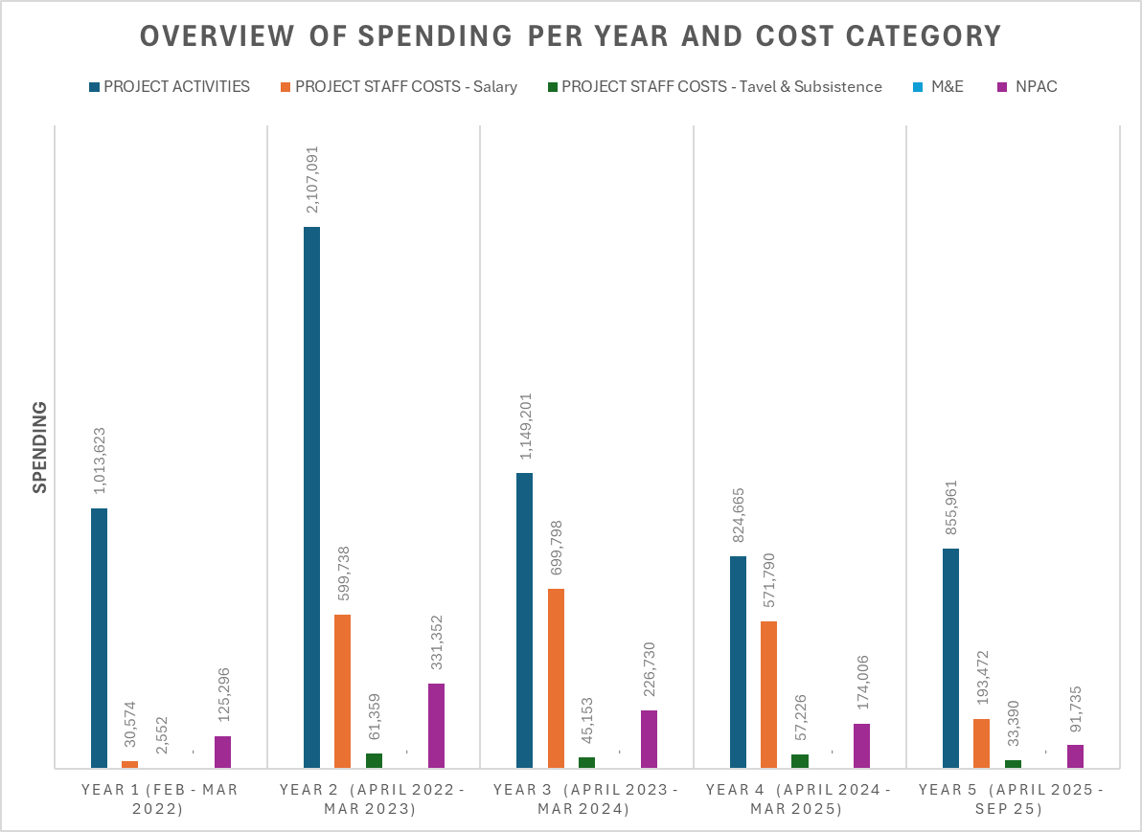
Figure 3 BCEP Grant Spending per year and cost category according to the aggregated financial report
The figure above presents an overview of the BCEP grant spending for each time period and per cost category. By September 2025, the total budget spent reached GBP 9,580,157, corresponding to 96% of the total budget. Overall, a majority of the budget (70%) was utilized for project activities (contracting partners, procuring technical supports and other services). The second-largest cost item is staff salaries for GCA, covering time for project leadership, management, support and administration. In relative terms, this cost item accounts for 26% of the total BCEP grant funding. Additionally, a considerable saving on the staff salary cost is noted during the project timespan. The actual spending for the 2022-2025 period is GBP 2,095,372, showing a reduction of GBP 345,454 compared to the originally planned budget of GBP 2,440,826.
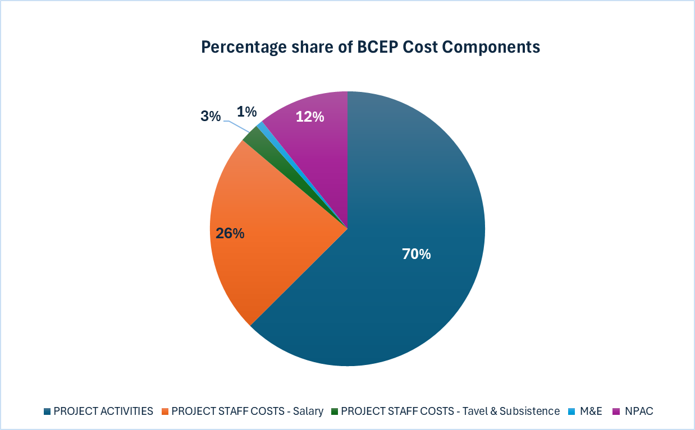
Figure 4 Percentage share of BCEP Grant spending
The Non-Project Attributable Costs NPAC was kept constant at 11.97% of the total budget. This rather low NPAC figure suggests a remarkable GCA effort to keep the overhead cost low and hence enhancing cost-effectiveness. Discussions and KIIs further confirm that active utilisation of synergies with other on-going projects including the Canada-funded project is an important factor contributing to this achievement. Furthermore, GCA strategically contract local partners which could share their overhead costs, especially for activities implemented on the ground. Our cross-reference with GCA’s own calculation of the organisation’s overhead cost for the period of 2021-2023 shows a higher figure of about 15%.
Notably, only 80.000 Pounds (roughly 1%) was spent on M&E to cover this current external end-term evaluation. From the efficiency perspective, this modest spending could be seen as positive. However, this comes at the cost of effectiveness, where the Evaluation Team notes that no mid-term evaluation was implemented, which could have been very helpful in reflecting and drawing early learning experience to improve the overall performance.

  - Quantitative findings on the Effectiveness E
This VfM criteria assesses how the BCEP Grant has delivered its outputs, outcomes and impact. The table below presents the quantified assessment results for the main outputs and outcomes, which suggests that the project has generally delivered well from the effectiveness perspective.
Table 3 Quantified assessment results for the main outputs and outcomes
Output/Outcome | Count | Calculation / Analysis Method | Data Sources
Number of projects and sub-projects completed | 17 | Sum of subprojects completed and formally closed. | BCEP Annual Reports 2025 and 2026. Project Completion Reports, KIIs with project leads and with programme-level leads.  Verification: KIIs and discussion with partners and stakeholder
Direct beneficiaries | At least 1,319 individuals | Sum of individuals directly participating in or receiving services/benefits from activities (disaggregated by gender, group if needed). | Aggregated statistics on log frame. Attendance lists, beneficiary registers, training records, partner reports.  Verification: KII and discussion with partners and stakeholder.
Indirect beneficiaries | To be verified with GCA. | Estimated number of people benefiting indirectly through service improvement, infrastructure use, policy change, or knowledge diffusion | Aggregated statistics on log frame. Project completion reports, KII with project leads and with program-level leads.  Verification: KII and discussion with partners and stakeholder
Infrastructure resilience advisory packages | 34 | Count of completed advisory packages delivered to clients and breakdown to project level. | Aggregated statistics on log frame. KII with project leads and with program-level leads.  Verification: KII and discussion with partners and stakeholder
Concept notes and proposals developed for climate adaptation projects | 09 | Count of concept notes and proposals developed and submitted (and optionally approved/funded) | Aggregated statistics on log frame. Project completion reports, KII with project leads and with program-level leads.
Volume of investment projects implemented | 1,332,290,000 USD | Count of implemented investment projects and/or sum of their total investment budgets | Annual reports and KIIs with projects leads. BCEP LogFrame
Number of trainings, masterclasses and events organized | At least 80 | Count of training sessions, workshops, and masterclasses delivered | Aggregated statistics on the training and participants.  Verification: Training reports, agendas, attendance sheets, event documentation
Percentage of female participants in training, workshops and events | ~35% | Percentage share of female participants | Aggregated statistics on the training and participants.

It is noted that the BCEP program as well as its underpinning projects are at a stage where impact is still at the early stage and it will take more time to fully realize the total impact. To gain further insights about the impact, reference can be made to the combined quantitative-qualitative assessment and synthesis of the BCEP sub-projects against the pre-defined impact pathways. Overall, 9 sub-projects have achieved the benchmark of scoring at least 3 for at least one impact pathway, suggesting considerable impact delivered, as well as to be expected in the post-intervention period.
Table 4 Overview and self-scoring of the BCEP sub-projects against the defined impact pathways

The Evaluation Team has also noted achievements that demonstrate strong effectiveness in achieving the defined objectives, outputs and outcomes. For instance, since its establishment in 2022, the global hub on locally-led adaptation has reported impressive online interactions, with a total number of active users reaching 82,200, and a total page view of 31,500. The breakdown analysis of top five countries with the highest number of users including Bangladesh (11,000 users), Nepal (6,300 users), Kenya (5,500 users), India (5,100 users) and Nigeria (4,700 users). Additional to the highest number of users in Bangladesh, the international coverage of the hub suggests that the reach, and added values go beyond the target country and contribute to the overall discussion on locally-led adaptation at the global level.
  - Quantitative findings on the Equity E
Regarding Equity, quantitative data analysis has focused on the representation of female participants in events, workshops and capacity building trainings (including masterclasses). Overall, the aggregated statistics conducted on the attendance reports of all BCEP project reports a total of circa 1300 participants, of which 340 were females – translating to a percentage of 35%. The KIIs and discussions further suggested remarkable efforts and successes of the BCEP project in ensuring not only female representation but also significant contribution in activities. However, in many sub-projects, due to the nature of the subject matter such as civil engineering, infrastructure, climate finance, female participation of the target beneficiary population is low. Further, several sub-projects have achieved strong representation of female participants in their training and capacity building activities. For instance, the Coastal Towns Climate Resilience Project (CTCRP) project reports a high percentage of female community members engaged in development of the People’s Adaptation Plan. Specifically, 59% of 485 community members in Mongla area, 69% of 420 community members in Patuakhali, 52% of 420 community members in Kuakata, and 28% of 420 community members in Burhanuddin.
List of participants:
Over 80 meetings, trainings, workshops, train-to-trainer sessions and consultations have been held across the projects. So far, about 1,300 individuals have participated in these events, including 319 women, who make up 26% of the participants. Their designations range from students and housewives to professors and deputy directors, representing a wide variety of roles and levels. The orginizations including NGOs, foundations and community-based initiatives been invited and participated. Their work focuses on social development, poverty alleviation, youth empowerment and community resilience, directly engaging with communities to address their needs.

Qualitative Document and Data Review and Analysis
Work on the qualitative data has been through three means, an extensive document review (see Annex 3 but also data sets in the Replication Package), KIIs and FGDs with key stakeholders (see Table 5 below) and a field visit. The analysis follows with exemplary evidence.
Table 5 List of persons interviewed from different organizations
Name of respondents | Organizations | Date | KII (ü)
Name of respondents | Organizations | Date | In person | On-line
- Round table Discussion: Bridging Infrastructure, food system and Finance for climate resilience | GCA | 20/01/2026 | ü
- Adele, Towhid and Tanvir | GCA Dhaka Office | 20/01/2026 | ü
- Arif Ahmed World Bank and Reazul Ahmed Chowdhury PD CWASA Project | World Bank | 01/02/2026 |  | ü
- A Mamun and S Zabeen | ADB | 05/02/2026 | ü
- Salman Chowdhury; Assistant Director | MoEFCC | 05/02/2026 |  | ü
- Ms. Roufa Khanam; DD C3ER | BRAC | 08/02/2026 | ü
- Imran, Project Manager | PKSF | 08/02/2026 |  | ü
- Md. Sabbir Hossain Senior Program Officer | IDCOL | 08/02/2026 |  | ü
- Mr. Sohel, Additional Secretary, ERD | ERD, Planning Commission | 10/02/2026 |  | ü
- Naznin Nahar, Senior Program Officer, Research Division | Bangladesh Railway | 16/02/2026 | ü
- Partha Hefaz Shaikh; Director Program and Policy advocacy | WaterAid Dhaka | 18/02/2026 | ü
TOTAL: |  |  | 6 | 5

Relevance

Alignment with National and Programme Priorities
Qualitative evidence indicates that GCA’s support to the Bangladesh Climate and Environment Programme (BCEP) has been relevant to both national climate adaptation priorities and the strategic objectives of BCEP. Documentation and consulted stakeholders suggest that GCA’s engagement has been grounded in an understanding of Bangladesh’s climate vulnerability context and policy landscape. This includes alignment with key national frameworks such as the National Adaptation Plan (NAP), the Mujib Climate Prosperity Plan, and sectoral resilience strategies.
Some Government counterparts, for example, have reported that GCA’s role is perceived as supportive of nationally led priorities rather than externally driven. This alignment has enhanced the legitimacy of BCEP and facilitated government ownership of programme activities.
“GCA did not come with a pre-packaged model. Their support was framed around what Bangladesh was already trying to do on adaptation, which made it much easier for us as the World Bank to engage.”

Mr. Arif Ahmed Senior Adviser World Bank

Responsiveness to Evolving Needs
Qualitative interviews suggest that GCA demonstrated responsiveness as BCEP evolved from design into implementation. Stakeholders involved in early programme development describe GCA as playing a constructive role in refining BCEP’s theory of change, particularly in clarifying the pathways between technical assistance, institutional strengthening, and adaptation outcomes.
As implementation progressed, GCA reportedly adjusted its focus to respond to emerging demands, including requests for more targeted sectoral support and greater emphasis on translating policy commitments into implementable actions.
“The type of support needed in 2022 was not the same as that needed in 2024. GCA was able to adjust without losing sight of the bigger objectives.”

Mr. Salman Chowdhury Assistant Director GOB MoEFCC

Effectiveness

Quality and Use of Technical Assistance
Documentation and some Stakeholder feedback describe the technical assistance provided by GCA as credible, high quality, and contextually appropriate. Qualitative data indicates that GCA’s effectiveness has stemmed not only from technical expertise, but also from its ability to tailor global adaptation knowledge to Bangladesh’s institutional and policy realities.
Respondents in KIIs and Focus Group discussions have noted that GCA’s analytical products and advisory inputs have been most effective when they were closely linked to specific decision-making processes and specific plans, for example the People’s Adaptation Plans, accompanied by sustained engagement rather than delivered as one-off outputs.
“The GCA support to ERD, especially the training on Climate Finance has been excellent. I have never seen such effective training in my life. The trainers/ facilitators used many different innovative methods to make the topic clear understanding for all. Group works were organized forming WhatsApp groups for interactive discussion and presentation that ensured active participation of all. Now, inspired by GCA, ERD has started a wider staff capacity building initiative using the GCA module and training approach within the ministry and with our own funding.”

Mr. AKM Sohel Additional Secretary GOB ERD

However, some stakeholders have highlighted that uptake of technical outputs depended heavily on institutional capacity and political timing, factors that were largely beyond GCA’s control.

Capacity Strengthening Outcomes
Qualitative evidence also suggests that GCA has contributed meaningfully to capacity strengthening at both individual and institutional levels. Stakeholders have reported improved understanding of climate risk-informed planning, enhanced analytical capacity, and increased confidence among national actors to engage in complex adaptation discussions.
“Capacity development training sessions were organized for the officials and staff of the government departments and other related organizations to improve their knowledge, skill and experience to Develop Concept Notes/ Writing project proposals. The training sessions under this project were somehow different than the other trainings related to climate change projects - focusing mostly on highly technical subjects/issues which are an integral part of the project (concept notes/ project proposals) preparation, especially to apply/access to GC Funds. The methodology and content of the GCA training was useful, relevant and transformative.it was an eye opener in relation to GESI, for example, how lack of access to safe drinking water results in higher ovarian cancer among women. GESI awareness gathered from the training has enabled application of GESI considerations into other projects.”

Mr. Salman Chowdhury Assistant Director GOB MoEFCC
“The training we received was highly interactive due to formation of mixed groups and exchange of ideas and sharing experiences. GCA organized competitions among the groups and prizes were given to the winning groups. As new participant in this type of training course it was an opportunity to learn more about selection of climate resilient projects (writing concept notes; involved in feasibility study considering changing climate).”

Mr. Naznin Nahar Senior Planning Officer-1 Planning Cell GOB Bangladesh Railways

Coherence

Complementarity with Other Initiatives
Qualitative findings indicate that GCA’s support to BCEP has been broadly coherent with the activities of other development partners and national initiatives in Bangladesh’s climate adaptation landscape. Stakeholders describe GCA as playing a coordination and facilitation role, helping to align BCEP with existing programmes and avoid fragmentation.
Government respondents note that GCA’s credibility and neutral positioning have enabled it to engage across ministries and agencies, particularly on cross-sectoral adaptation issues.
“GCA has helped connect different conversations that were happening in parallel. That coordination role was important. For example, GCA has provided excellent technical support for empowering women to participate in the project activities considering water security and safety of women in collecting water addressing climate vulnerability. GCA has also worked with WaterAid to ensure that issues and related to institutional models for community engagement are fully operational.”

Mr. Reajul A. Chowdhury PD Chittagong Water Supply Improvement Project (CWSIP)

Role Clarity and Overlaps
Some stakeholders have reported that, particularly in the early stages of BCEP, there was occasional ambiguity regarding the division of responsibilities between GCA and other technical partners. Where this occurred, it sometimes led to initial inefficiencies or duplication.
However, qualitative evidence suggests that these issues were largely addressed through improved communication, clearer articulation of roles, and strengthened coordination mechanisms.

Efficiency

Use of Resources and Delivery Modalities
While this evaluation does not include a full cost-efficiency analysis of the BCEP Programme , qualitative perceptions suggest that GCA’s use of resources which have been enabled by the Accountable Grant has generally been efficient. Stakeholders have emphasised that GCA’s approach, focused on advisory support, convening, and knowledge brokering, has allowed for relatively lean delivery compared to implementation-heavy models.
Respondents have noted that efficiency was enhanced when GCA leveraged existing national systems and partnerships rather than creating parallel structures.
“GCA’s value was not in spending large amounts, but in using its position and expertise strategically.”

Mr. AKM Sohel Additional Secretary GOB ERD

Nonetheless, some stakeholders have observed that administrative processes and coordination requirements occasionally slowed delivery, reflecting the complexity of working across multiple institutions.

Impact (Early Signals)

Contribution to Policy and Institutional Change
Although it is too early to assess long-term impact, qualitative data does point to emerging signs of contribution by GCA to desired BCEP outcomes. Stakeholders have cited improvements in policy coherence, increased attention to climate adaptation in planning processes, and stronger institutional collaboration as early indicators of impact.
Attribution remains challenging, given the number of actors involved, but respondents generally view GCA as a meaningful contributing partner.
“GCA has brought wide and excellent experience and knowledge in different countries in the world on NBS in providing support to LGED in capacity development related with NbS and climate resilient infrastructure development to BCEP.”

Mr. Abdullah Mamun Team Leader Coastal Town Climate Resilience Project (CTCRP)

Visibility and Strategic Positioning
Several stakeholders have highlighted GCA’s role in strengthening Bangladesh’s visibility in global adaptation discussions and linking national priorities to international platforms. This is perceived as reinforcing the strategic positioning of BCEP and supporting longer-term influence beyond the programme itself.

Sustainability

Institutionalisation of Gains
The qualitative evidence reviewed to date suggests that sustainability of results remains a key challenge. While GCA has contributed to knowledge generation and capacity strengthening, stakeholders have emphasised that sustained impact will depend on the extent to which these gains are institutionalised within government systems. Notwithstanding this, respondents have been appreciative of what GCA has done and have highlighted the importance of continued engagement, embedding tools and approaches into formal processes, and supporting national ownership beyond the life of the overall grant to BCEP.
“GCA has played a pioneering role in Bangladesh by explicitly linking climate adaptation with infrastructure development. While earlier adaptation initiatives largely focused on social sectors such as livelihoods, health, and education, GCA has influenced climate resilience being integrated directly into infrastructure planning and investment design.”

Roufa Khanam Deputy Director BRAC Centre for Climate Change and Environmental Research

Cross-Cutting Lessons
Across the DAC criteria, several lessons have emerged from the qualitative data which has been reviewed:
- Relevance and effectiveness are enhanced when technical assistance is embedded in long-term relationships rather than delivered as discrete outputs.
- GCA’s added value lies in convening, translation of global knowledge, and strategic facilitation rather than direct implementation.
- Clear role definition and early coordination are essential in complex, multi-actor programmes.
- Sustaining capacity and institutional change requires continued support and alignment with national systems.
“The ADB has its own Gender and Inclusion Criteria for all project design to implementation and GCA has looked to support this, for example ensuring that all ADB ToRs have 30% women beneficiaries as mandatory.”
Ms. Suraya Zabeen Gender Consultant on Coastal Town Climate Resilience Project (CTCRP)

GESI Document and Data Review and Analysis
Initial document and date review and analysis of the same provided insight into overall progress made on GESI and Social Inclusion which is captured hereon. Understanding was deepened through further document analysis and fieldwork and is summarised in Section 5.3.6 below. Reference though should also be made to Supplementary Report 3 in the Replication Package which includes a detailed GESI analysis of all the sub-projects.

People’s Adaptation Plans (Project 6 - CWSIP)
Across the Adaptation Plans examined to date, there is a consistent and commendable emphasis on participatory, community-driven climate vulnerability assessment. All plans apply CVRA methodologies, demographic profiling, income analysis, housing typology, stress mapping, and documentation of service gaps. Many explicitly recognize women, children, elderly persons, and people with disabilities as vulnerable groups. Several plans also include “dignity and inequality” reflections, capturing perceptions of exclusion in service access — an important governance-related equity dimension rarely documented in local adaptation planning.
However, while vulnerability recognition is strong, structured GESI integration into actual adaptation remains limited. Gender, disability, and intersectional vulnerabilities are acknowledged primarily at the assessment stage but have rarely been translated into targeted, measurable interventions. The plans focus heavily on infrastructure solutions (drainage, water, sanitation, waste management) without consistently specifying who benefits, how access will improve for marginalized groups, or whether participation in decision-making is equitable. Low-income households have to be central to the discussion. However, there is little evidence of explicit attention having been given to women-headed households, mobility constraints for persons with disabilities, unpaid care burdens, or gender-based safety concerns during climate shocks. Representation in Local Adaptation Committees is not consistently disaggregated, and there is little documentation of women’s leadership roles or disability inclusion safeguards. Overall, GESI is visible as contextual awareness but not yet embedded as a transformative initiative.
However, the above stated, across the Adaptation Plans, there is a clear and encouraging effort to ground planning in community voices. Each plan applies climate vulnerability and risk assessments, demographic and income profiling, housing analysis, and service gap mapping. Many explicitly identify women, children, older persons, and people with disabilities as groups facing heightened climate risks. Some plans even reflect on issues of dignity and inequality, capturing how communities experience exclusion in accessing basic services. This is a meaningful step, as these types of equity concerns are often overlooked in local adaptation planning.
In sum, although gender, disability, and overlapping forms of disadvantage are acknowledged during assessment, they are rarely carried through into clearly defined, measurable interventions. The plans often prioritise infrastructure improvements such as drainage, water supply, sanitation, and waste management, but, they do not consistently clarify who will benefit most, whether access barriers for marginalized groups will be reduced, or how decision-making spaces will ensure equitable participation.

Climate Risk & Vulnerability Assessment Reports - AIIB Hatikumrul Bonpapra Jhineida Road Project
The four assessment reports demonstrate strong technical analysis of climate hazards. Flooding, extreme rainfall, temperature rise, and infrastructure exposure are examined in detail. However, when viewed through a gender, equity and social inclusion lens, the analysis remains limited.
Vulnerability is primarily understood as damage to physical assets or economic loss. Social dimensions of vulnerability — such as how climate impacts affect women, persons with disabilities, elderly people, or low-income households differently — are not systematically explored. While the reports occasionally reference “communities” or “marginal groups,” these categories are broad and not unpacked in a way that reveals differentiated risks. For instance, in the road and infrastructure assessments, adaptation measures are prioritised based on cost-effectiveness, scalability, and environmental co-benefits. What is less visible is an analysis of who benefits most from these investments, or whether certain groups face greater barriers during floods, heatwaves, or service disruptions.
Similarly, while institutional capacity gaps are acknowledged in some reports, there is limited effort to map social vulnerability in a structured way — for example, through sex-, age-, or disability-disaggregated data, or through targeted analysis of socially excluded groups.
In summary, GESI considerations are present at a general awareness level but are not embedded within the core analytical methods. Climate hazards are well modelled, and infrastructure risks are clearly articulated. But an analysis to generate a clear understanding of how those risks play out differently for different groups of people are underdeveloped. Without that layer of analysis, adaptation options may protect assets effectively, but may not fully address inequality or ensure that resilience benefits are shared equitably.

Climate Risk and Vulnerability Assessment - Water Supply Inclusive Sanitation and Hygiene Project in 7 towns
Three city scan reviews were taken as a sample. These cities are - Narail, Bhola and Kushtia.
Key observations include that gender and social inclusion considerations are present and acknowledged across the assessments. All three documents demonstrate careful climate hazard analysis and link these hazards to service systems such as water supply, sanitation, and waste management. Importantly, the reports recognize that climate impacts are not uniform and refer to vulnerable groups, including women, low-income communities, and other socially at-risk populations. In Bhola, for example, the assessment explicitly notes that impacts on vulnerable groups were considered in shaping recommendations, which is a positive and important step.
At the same time, the way vulnerability is analysed remains largely infrastructure- and asset-focused. While socio-economic context and references to vulnerable populations are included, the assessments do not consistently translate these into structured, disaggregated risk scoring or clearly differentiated adaptation actions for specific groups (e.g., women-headed households or persons with disabilities). In other words, the intent to consider equity is visible, and some level of segregation in vulnerability analysis and recommendations is evident, but it is not yet fully embedded as a core analytical lens.
Overall, the reports provide a solid foundation. They demonstrate awareness that climate risk intersects with social vulnerability and take initial steps to reflect this in assessment and recommendations. With further refinement—particularly through more explicit disaggregation and clearer links between identified social vulnerabilities and targeted adaptation measures—the approach could deepen its equity dimension while building on the strong technical base already in place.

Improving Urban Governance and Infrastructure Project – Review & Analysis
The Master Planning Handbook presents a clear and structured approach to integrating climate risk into urban planning processes. It builds logically from foundational climate concepts (hazard, exposure, vulnerability, risk) to practical application within pourashava master planning. It also highlights that climate risk is not just environmental, but deeply social and governance-related.
The handbook also acknowledges that vulnerability is often worsened by social exclusion and marginalisation and that risks disproportionately affect low-income communities, women, children, and those with health vulnerabilities
The stakeholder mapping section promotes inclusive engagement and identifies vulnerable groups, CBOs, ethnic communities, and informal settlement populations as key stakeholders. And it also discusses about the depth of engagement, not just consultation.
However, while vulnerability and inclusion are conceptually recognized, operational guidance remains relatively light. The document does not clearly translate inclusion into measurable indicators, gender-responsive design standards, or monitoring requirements. For example, although it highlights disproportionate impacts on women and marginalized groups, it does not adequately explain how master plans should incorporate gender-disaggregated data, mobility audits for persons with disabilities, or safety considerations in infrastructure design
Inclusion is present, but largely at the framing stage rather than embedded into tools, templates, or accountability mechanisms.
The training slides (PPT) positions climate risk within urban inequality, highlights informal settlements, water access gaps, and infrastructure exposure. The materials repeatedly emphasize that climate hazards disproportionately impact vulnerable groups.
The training also encourages participatory engagement at the pourashava level, including consultation with ward committees and Town Level Coordination Committees.
The training remains stronger on awareness than on operationalization. It discusses “inclusiveness” and “vulnerable groups” but does not provide concrete examples of how to design gender-responsive drainage systems, inclusive public facilities, or safe access to water points. Nor does it clearly outline how to monitor whether marginalized groups meaningfully influence decision-making.
Overall, climate risk is clearly understood as a function of social vulnerability, not just environmental hazard. There is a solid conceptual foundation linking climate resilience with equity. Stakeholder inclusion is encouraged, and vulnerable groups are explicitly named.
However, inclusion remains largely conceptual and process-oriented. It is less visible in design standards, performance indicators, monitoring frameworks, and accountability systems.

Capacity Building Training
The BIBM Pilot Concept Note explicitly acknowledges gender within the rationale and design of the training. It recognizes that climate change disproportionately affects women and girls and highlights the importance of “gender-responsive climate finance.” Gender sensitivity is mentioned as part of the programme design, and alignment with national frameworks and GCF gender requirements is referenced.
In the concept note, gender is framed more in terms of vulnerability and compliance. It is not clearly articulated enough how financial institutions will integrate gender analysis into credit appraisal, investment screening, or climate risk modelling. There is also limited discussion of intersectionality (e.g., disability, ethnic minorities, informal workers, women-headed households) or how financial systems themselves may reinforce exclusion. Limited attention is given to broader social inclusion dimensions beyond women.
More work need to be done to set clear performance indicators to measure application of gender learning.
The training materials on Adaptation Finance had dedicated sessions on gender and GCF gender policies. Participants gained awareness of differentiated climate risks faced by women and marginalized groups. Feedback indicates that the training was impactful and helped shift perspectives.
However, gender integration appears to remain concentrated within specific sessions rather than being consistently woven across technical modules. The technical contents on climate finance mechanisms, risk modelling, investment structuring, and adaptation design—is strong, but it is not clear that gender analysis is systematically embedded within each module. Minimal attention to disability, ethnic minorities, or intersectional vulnerability are covered in the training materials.
It was noted that generally there are only a few women in the infrastructure and finance sector compared to the other sectors. This was also evident in the participant list for the Adaptation Finance training. There is also little evidence found on how the female participants used their knowledge from the training into practical actions, what role/responsibilities are they playing or they were assigned to in their respective organizations and how this training translated into gender-responsive project design.

Sub-Project Analysis and Fieldwork
In the latter stages of the evaluation, the Team’s GESI and Social Inclusion Expert conducted an overall GESI Analysis of all the sub-projects and made a field visit to verify initial conclusions and illuminate the same. A full Supplementary Report on this is included in the Replication Package, but included below is a summary of the fieldwork findings.
A field visit was made to the Chattogram Water Supply Improvement Project (CWSIP). FGDs were conducted with 5 LIC members in wards 29, 35 and 41 under Chattogram City Corporation on 23-24 February 2026. The discussions were lively and open, and what stood out immediately was the strong presence of women.
In all five LICs, women were not only active members but also part of the executive committees. They spoke confidently about their roles, their decisions, and the collective work they had undertaken through the adaptation planning process. Interestingly, male memberships were low in the five visited LICs and attendance of the male members were irregular. When asked why, participants explained in a very practical way that women are more available, as they are home bound, spend more time in the community and are directly responsible for water collection, sanitation and household management. They are also the ones facing challenges due to water scarcity, salinity, drainage and waterlogging more frequently than the male members of the family who spends more time away for work.
While all the five LICs demonstrated high participation of women including representation in the executive body, representation of persons with disability (PwD) was very limited in the LIC memberships. Only Charpara LIC noted of having a few members with disability. None of the executive committees in the five LICs had representation of PwD.
Across all LICs, women clearly understood that climate impacts are not the same for everyone. They explained how children suffer during waterlogging, how elderly people struggle during heatwaves, and how persons with disabilities face additional barriers during cyclones or floods. In Charpara (charbasti), members went further and described very specific concerns: women’s job insecurity, the absence of allowances for elderly people and persons with disabilities, and the difficulty persons with disabilities face in obtaining birth registration, which then affects access to NID cards and social services making them more vulnerable than the others. These reflections show thoughtful awareness and lived experience.
However, a gap remains between awareness and action. While such issues were discussed and in some cases documented, they were rarely prioritised within the final adaptation plans, which tend to focus more heavily on physical infrastructure solutions such as drainage, water supply and sanitation improvements. There was no indication that gender and inclusion considerations were deliberately weighted or guided during the prioritisation exercises.
Another concern relates to follow-through and sustainability. While the adaptation plans emphasise participatory governance and multi-level engagement, the visited LICs reported no active coordination with local social welfare offices, health facilities or disability services. Nor was there evidence that the plans had been integrated into Ward or City Corporation annual development processes.
Overall, women’s leadership at the community level has grown noticeably, and there is a clear understanding that climate risks affect different groups in different ways. However, these insights have yet to meaningfully influence institutional planning, budgeting, or cross-sectoral action. The community has done its part in organising and identifying solutions, but without stronger engagement from local authorities and sustained advocacy to move plans into implementation, the underlying vulnerabilities of these low-income settlements are unlikely to change in any lasting way.

Theory of Change (ToC) Assessment

Assessing the Theory of Change
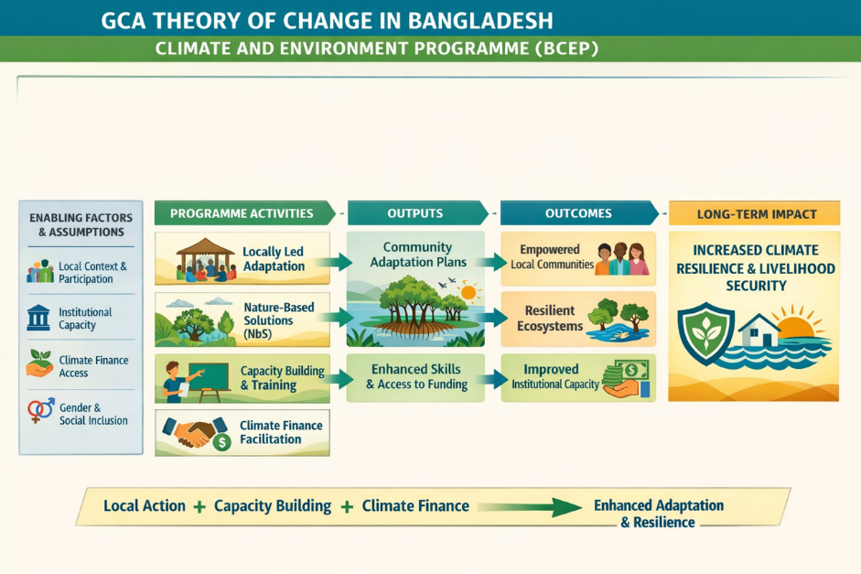
Figure 3 Theory of Change (Abbreviated from Annex 2 in the TOR)

Core ToC Assumptions
At its core, GCA’s ToC has assumed that:
- Bangladesh has strong political commitment to climate adaptation but faces persistent challenges in translating this commitment into climate-resilient investments due to technical, institutional, and coordination constraints.
- IFIs, MDBs, and government agencies play a decisive role in shaping the scale, quality, and sustainability of adaptation investments, and are therefore critical leverage points for systemic change.
- Providing targeted technical assistance, climate analytics, and design support at key points in the investment lifecycle can materially influence project quality and resilience.
- Institutionalising climate resilience within appraisal systems, safeguards, and planning processes will result in longer-term adaptation outcomes that persist beyond individual projects.
- GCA’s comparative advantage lies in technical credibility, convening power, and influence over investment design, rather than in direct engagement with communities (with limited exceptions under the Locally Led Adaptation pillar, delivered through partners).
The ToC and supporting Logistical Framework (Log Frame) (Annexes 2 and 3 in the TOR) have been operationalised through four interconnected workstreams—Technical Assistance, Capacity Building, Advocacy, and Knowledge—which together have aimed to translate climate science and evidence into climate-resilient investments at scale.

Summary of the ToC Pathway

Inputs and Activities
Using the accountable grant, GCA has deployed financial resources, specialist expertise, and convening capacity to support:
- Technical assistance to IDLAs including MDBs, IFIs, , and government project teams, including climate risk analysis, adaptation design, and integration of nature-based solutions where appropriate.
- Capacity building for institutions involved in investment planning and execution, aimed at strengthening long-term uptake and retention of adaptation knowledge.
- Policy engagement and advocacy to improve the enabling environment for climate-resilient investment, including alignment with national priorities and ESG safeguards.
- Generation, packaging, and dissemination of knowledge products, tools, and guidance to inform investment design and promote adaptive learning.
- Multi-stakeholder engagement, including private sector and government actors, to strengthen ownership and coordination.

Outputs
These activities have generated outputs including:
- Climate-informed investment designs and project frameworks.
- Technical guidance, tools, and analytics embedded in investment preparation and appraisal processes.
- Strengthened institutional capacity within IFIs, MDBs, and government agencies.
- Improved policy dialogue and awareness around climate resilience, nature-based solutions, and inclusive adaptation.
- Integration of Gender Equality, Equity, and Social Inclusion (GESI) considerations into policies, tools, and project design.

Intermediate Outcomes
Outputs have been intended to contribute to intermediate outcomes including:
- Adoption of GCA’s evidence-based recommendations within investment project designs, policy frameworks, and institutional processes.
- Institutionalisation of climate adaptation and resilience within IDLA, IFIs, and government investment systems and operations.
- Improved decision-making and readiness to plan, finance, and implement climate-resilient investments.
- Increased coherence between climate policy objectives and large-scale development investments.

Longer-Term Outcomes and Impact
Over time, these intermediate outcomes are expected to contribute to:
- Scaled-up implementation of climate-resilient investments across key sectors.
- Strengthened infrastructure, livelihoods, and financial systems that can withstand climate shocks and stresses.
- Enhanced climate resilience of people, communities, and economies in Bangladesh.

Overall, the conceptual logic of the ToC is strong, coherent, and well aligned with contemporary thinking on climate adaptation, particularly the emphasis on systemic change, institutionalisation, and leverage through major investment channels. The ToC is also consistent with GCA’s global mandate and operating model. However, the evaluation finds that the clarity, articulation, and operationalisation of the ToC has varied across different strands of GCA’s engagement within BCEP.

Testing the Theory of Change

Assumptions Assessed
The evaluation has assessed the extent to which the key assumptions underpinning the ToC have held in practice.
Assumption 1: Influencing investment design and appraisal systems is a critical leverage point for climate adaptation in Bangladesh
This assumption is strongly supported by evidence. Large-scale investments driven by IDLAs, IFIs, and government agencies represent a significant share of climate-relevant expenditure in Bangladesh. GCA’s focus on upstream engagement with these actors has therefore been well founded and aligned with where systemic change is most likely to occur.
Assumption 2: Technical assistance and climate analytics provided by GCA will be adopted within investment projects
This assumption has held partially. Uptake has been strongest where GCA’s engagement has been closely aligned with active project preparation processes and where relationships with IFI/MDB task teams were well established. Where project pipelines have been delayed—often due to lengthy appraisal and board approval processes—uptake and momentum have been reduced, affecting GCA’s ability to influence implementation timelines.
Assumption 3: Institutional capacity building will lead to sustained integration of climate resilience
This assumption has held more strongly at the institutional level than at the individual level. Embedding climate considerations into systems, guidelines, and appraisal processes have showed greater durability than capacity gains focused on individuals, which have been more vulnerable to staff turnover and organisational change.
Assumption 4: GCA’s influence within BCEP is sufficient to shape broader programme outcomes
This assumption has held to a moderate degree. GCA’s influence has been strongest where its role was clearly defined and aligned with specific investment processes. However, BCEP’s complex governance arrangements and the presence of multiple actors with overlapping mandates has constrained GCA’s ability to consistently shape outcomes beyond its immediate areas of engagement.
Assumption 5: External conditions would allow for steady progression from design to implementation
This assumption has been challenged. Delays in IDLA, IFI appraisal systems, political and administrative changes, and external shocks have affected the pace at which investment projects progressed, in turn delaying implementation of GCA-supported adaptation measures.

Evidence Review

Inputs and Activities
Evidence indicates that GCA deployed the Accountable Grant in line with its institutionalised ToC and model. Resources have been primarily directed toward technical assistance, investment design support, capacity building, advocacy, and knowledge generation. Engagement with IFIs, MDBs, and government counterparts have been consistent with GCA’s role as a science-to-design partner.

Outputs
Planned outputs—including technical inputs to project preparation, climate analytics, tools, guidance, and stakeholder engagement activities—have been largely delivered and generally perceived by stakeholders as high quality and technically credible. GCA’s integration of GESI considerations into policy guidance and project design have been noted as a positive and distinctive feature. However, while outputs were well documented, evidence of their downstream use and influence have been less systematically captured.

Intermediate Outcomes
Evidence of intermediate outcomes is credible but uneven. There are examples of climate resilience being integrated into project frameworks, improved awareness among decision-makers, and stronger alignment between climate policy and investment planning. However, systematic evidence linking specific GCA outputs to institutionalised change remains limited, reflecting both monitoring constraints and the inherent time lag associated with upstream influence.

Impact Pathways
As expected, direct evidence of long-term impact is limited. Nevertheless, the evaluation has identified plausible and well-reasoned pathways linking GCA’s support to enhanced climate resilience over time, particularly through institutionalisation of adaptation within investment systems.

Gaps and Risks
The evaluation has identified several gaps and risks affecting the strength of the ToC in practice.
Gap 1: Insufficient articulation of intermediate outcomes
While activities and outputs have been clearly defined, intermediate outcomes have sometimes been broadly framed, limiting the ability to track contribution and progress systematically.
Gap 2: Limited feedback loops for learning and adaptive management
Although learning is a stated objective, mechanisms to capture, synthesise, and apply lessons across workstreams and projects remain underdeveloped.
Gap 3: Dependence on external investment cycles
GCA’s model is inherently dependent on IDLA and IFI project timelines, appraisal systems, and board approvals, introducing risks related to delays that are largely outside GCA’s control.
Risk 1: Over-reliance on individual relationships
Where influence has depended heavily on specific champions within institutions, results have been vulnerable to turnover and shifting priorities.
Risk 2: Breadth versus depth
The wide scope of engagement across sectors and actors has risked diluting impact if not sufficiently prioritised around the most strategic leverage points.

ToC Conclusions
The evaluation has noted that GCA’s Theory of Change for its engagement in BCEP has been appropriate, credible, and well aligned with both national needs and GCA’s institutional mandate. The ToC reflects a realistic understanding of climate adaptation as a systemic, long-term process that must be embedded within investment and institutional systems.
The ToC’s effectiveness in practice has been constrained by:
- Limited specification and measurement of intermediate outcomes
- Dependence on external investment timelines and governance processes
- Challenges in systematically evidencing contribution to institutional change
Strengthening the ToC going forward if there are to be possibilities in Bangladesh, and considering possibilities for replication would benefit from:
- Clearer articulation of outcome pathways and assumptions at the intermediate level
- More explicit strategies for managing influence, partnerships, and investment-cycle risks
- Stronger integration of learning and adaptive management mechanisms

These conclusions provide a robust foundation for interpreting the findings presented in the subsequent sections of the evaluation.

Findings (Successes and Where Work Remains in Progress)

What has Worked Well

Strategic Alignment and Relevance
One of the findings of the evaluation, is the high degree of strategic alignment between GCA-supported interventions, Bangladesh’s national climate priorities, and the objectives of the BCEP. GCA’s focus on climate adaptation, institutional strengthening, and policy engagement closely mirrors government priorities articulated in national strategies and plans.
GCA itself and some consulted stakeholders have noted that GCA’s engagement has addressed real and persistent bottlenecks in Bangladesh’s climate adaptation landscape, particularly the gap between policy ambition and implementation capacity. This alignment has enhanced the credibility and acceptability of GCA’s work and facilitated access to key policy processes. Several consulted stakeholders have though expressed concern about not being involved in key processes.

GCA’s Technical Credibility and Convening Role
GCA’s technical expertise and global standing are perceived as strengths. GCA itself, unsurprisingly, sees the organisation as a trusted source of climate adaptation knowledge, and several Government and partner stakeholders have described GCA as capable of translating global best practice into contextually relevant guidance.
In addition, GCA’s convening role has added value by:
- Bringing together stakeholders across ministries and sectors
- Creating spaces for dialogue on complex adaptation issues
- Supporting coordination within the broader BCEP ecosystem
This convening function has been particularly effective where GCA had a clear mandate and where engagement was sustained over time.

Contribution to Policy and Institutional Processes
The evaluation has found some evidence that GCA-supported activities contributed to improvements in policy coherence, planning processes, and institutional readiness for climate adaptation. Examples include support to policy formulation, integration of climate risk considerations into planning frameworks, and strengthening of technical units within government institutions.
While these contributions did not always result in immediately observable changes, they represent important intermediate outcomes consistent with the Theory of Change. Several recently consulted Stakeholders have emphasised, however, that upstream changes are necessary preconditions for effective adaptation at scale.

Leveraging Partnerships and Resources
GCA has made effective use of partnerships to extend the reach and influence of the Accountable Grant. Rather than duplicating efforts, GCA has generally worked through existing institutional structures and collaborated with other BCEP partners.
This approach has enhanced efficiency and value for money by:
- Avoiding parallel systems
- Leveraging partner expertise and resources
- Amplifying influence beyond the financial size of the grant
The Accountable Grant has functioned as a catalytic resource, enabling GCA to punch above its financial weight.

Strong Climate Adaptation Rationale
Across GCA-supported activities, the climate adaptation rationale has been consistently strong. Interventions have been informed by climate risk considerations and aligned with adaptation principles, rather than treating climate change as an add-on.
This clarity of purpose has helped distinguish GCA’s contribution within BCEP and reinforced its role as a specialist adaptation actor.

Where Work Remains in Progress

Limited Articulation and Tracking of Outcomes
A limitation identified by the evaluation relates to outcome articulation and monitoring. While outputs have been generally well documented, there has been less systematic tracking of intermediate outcomes and contribution pathways, although it has to be noted that the Impact Pathways Tool is yielding enormous progress here.
Nonetheless to date it is difficult to:
- Demonstrate progress beyond activity completion
- Assess which approaches were most effective
The lack of clearly specified intermediate outcomes has seemingly limited the operational usefulness of the Theory of Change.

Gender Equality and Social Inclusion Progress Across the Board
While GCA has demonstrated awareness of the importance of gender equality and social inclusion (GESI) issues and looked to raise awareness of the same across BPEP, fully evidenced progress that these considerations have translated into concrete actions across the board is lacking. In some cases, actions have been taken and explicitly with evidence of impact; in others, it has remained implicit or peripheral.

Dependence on Individual Champions
Several positive outcomes have been closely associated with the presence of committed individuals within GOB and Partner Organisations. This has facilitated progress in the short term, but also suggests a vulnerability in terms of sustaining change.
Staff turnover, reassignment, or changes in leadership especially in GoB but also more across the board, appears to have disrupted momentum in some cases, highlighting the risks of over-reliance on individual champions rather than institutionalised mechanisms.

Safeguarding and Risk Management Not Fully Embedded
The evaluation has only found some evidence of promoting a comprehensive safeguarding approach across the piece, and of proactive safeguarding risk analysis and systematic monitoring by GCA itself, particularly in relation to upstream policy and capacity-building work.
However, safeguarding and broader risk management have been largely addressed through partner systems, which were generally adequate.

Underlying factors of successes and limitations
The evaluation has thus identified several underlying factors that may help explain both successes and limitations.

Nature of the Intervention Model
Many findings are directly linked to the upstream, catalytic nature of GCA’s intervention model. This model is well suited to influencing policy and systems but poses inherent challenges for:
- Outcome measurement
- Attribution of results
- Demonstration of impact within short timeframes
Successes are most evident where expectations are aligned with this model; limitations appear to be there where results frameworks implicitly assumed more linear or short-term change.

Programme Complexity and Governance
BCEP’s complexity has shaped GCA’s performance. Multiple actors, overlapping mandates, and evolving governance arrangements has created both opportunities and constraints.
Where roles have been clear and coordination effective, GCA’s contribution has been visible. Where governance has been less clear, influence has been diluted.

Capacity and Incentive Structures
Institutional capacity constraints and incentive structures within government has affected uptake and sustainability of GCA-supported initiatives. Even high-quality technical support has not always been able to overcome structural limitations or competing priorities.

Monitoring, Evaluation, and Learning Systems
The absence of robust monitoring and learning from the outset, particularly on the part of FCDO, has limited GCA’s ability to:
- Adapt interventions in real time
- Capture evidence of contribution
- Systematically extract lessons
This has constrained both accountability and learning.

External and Contextual Factors
Political dynamics, administrative changes, and external shocks have influenced implementation. While GCA has demonstrated some adaptability, not all risks could be mitigated.

Lessons Learned (Explicit Learning Focus)
This section distils the findings of the evaluation into a set of key lessons intended to inform future GCA and FCDO programming in Bangladesh and comparable contexts. The lessons are organised across four levels: strategic, operational, context-specific, and transferable. Together, they highlight what GCA and FCDO should continue to do, what they should do differently, and what they should do more deliberately in future climate adaptation engagements.

Strategic Lessons
LESSON 1
UPSTREAM, SYSTEMS-FOCUSED INTERVENTIONS ARE HIGHLY RELEVANT BUT REQUIRE EXPLICIT EXPECTATION MANAGEMENT
The evaluation confirms that GCA’s strategic focus on policy, institutional strengthening, and enabling environments is well aligned with Bangladesh’s adaptation needs and GCA’s comparative advantage. However, such interventions inherently produce longer-term and less visible results.
A key strategic lesson is the importance of explicitly managing expectations—internally and with donors—about what upstream interventions can realistically achieve within a given timeframe and budget. Clearer articulation of intermediate outcomes and contribution pathways is essential to maintain credibility and avoid over- or under-estimation of impact.
LESSON 2
STRATEGIC FOCUS AND SELECTIVITY MATTER MORE THAN BREADTH
While GCA’s broad engagement has increased visibility and relevance, the evaluation finds that depth of engagement is more strongly associated with meaningful contribution than breadth alone. Strategic selectivity—focusing on fewer intervention areas where GCA can maintain sustained engagement—enhances influence, learning, and sustainability.
Future strategies would benefit from prioritising areas where GCA’s technical expertise, convening power, and relationships can be most effectively combined.
LESSON 3
INFLUENCE REQUIRES DELIBERATE STRATEGIES, NOT JUST TECHNICAL EXCELLENCE
Technical quality is a necessary but insufficient condition for influence. The evaluation is highlighting the need for explicit influence strategies, including stakeholder mapping, political economy analysis, and deliberate relationship management.
Where influence has been strongest, it was because GCA combined technical support with sustained engagement and an understanding of institutional incentives.

Operational Lessons
LESSON 4
THEORIES OF CHANGE NEED TO BE OPERATIONAL TOOLS, NOT JUST CONCEPTUAL FRAMEWORKS
The evaluation finds that while GCA’s Theory of Change is conceptually sound, it has not always been used as an operational management tool. Stronger linkage between the ToC, workplans, and monitoring frameworks would have enhanced adaptive management and learning.
Future programmes should invest in co-developing a ToC with implementation teams and revisiting them regularly as contexts evolve.
LESSON 5
OUTCOME-ORIENTED MONITORING IS ESSENTIAL FOR LEARNING IN COMPLEX PROGRAMMES
The emphasis on output delivery limited GCA’s ability to track progress toward outcomes and to learn systematically from implementation. For upstream interventions, qualitative outcome monitoring—including structured reflection, outcome harvesting, and contribution analysis—is both feasible and valuable.
Strengthening monitoring systems would support both accountability and continuous improvement.
LESSON 6
PARTNERSHIP MANAGEMENT REQUIRES ACTIVE RESOURCING
Partnerships have been central to GCA’s success, but effective partnership management requires time, skills, and resources. Informal or under-resourced partnership arrangements risk misunderstandings and uneven performance.
Clear roles, shared expectations, and regular communication are critical to maximising partnership value.

Context-Specific Lessons
LESSON 7
INSTITUTIONAL CAPACITY GAINS MUST BE EMBEDDED TO BE DURABLE
In the Bangladesh context, high staff turnover and administrative restructuring pose significant risks to sustainability. Capacity development efforts that focus solely on individuals are unlikely to endure.
Embedding capacity within institutional systems, procedures, and mandates—for example through guidelines, standard operating procedures, or formalised roles—enhances durability.
LESSON 8
ALIGNMENT WITH GOVERNMENT PLANNING AND BUDGET CYCLES STRENGTHENS UPTAKE
GCA-supported interventions were more likely to gain traction when they aligned with existing planning, budgeting, and policy review cycles. Standalone or time-bound initiatives faced greater uptake challenges.
This underscores the importance of timing and institutional alignment in the Bangladesh context.
LESSON 9
GESI REQUIRES INTENTIONAL INTEGRATION IN UPSTREAM WORK
In Bangladesh, social norms and institutional structures can limit the visibility of gender and inclusion issues in policy processes. The evaluation shows that without explicit strategies, GESI considerations risk being sidelined in upstream work.
Dedicated expertise, tools, and accountability mechanisms are needed to ensure meaningful integration.

Transferable Lessons
LESSON 10
CATALYTIC GRANTS CAN DELIVER HIGH STRATEGIC VALUE WHEN WELL TARGETED
The evaluation demonstrates that relatively modest, flexible grants can have outsized strategic impact when they are targeted at critical system bottlenecks and combined with technical credibility and partnerships.
This lesson is transferable to other contexts where large-scale investment is constrained or premature.
LESSON 11
LEARNING MUST BE DESIGNED IN, NOT ADDED ON
Learning has occurred during implementation, but it often informal and under-documented. Designing explicit learning objectives, processes, and responsibilities from the outset enhances organisational learning and accountability.
LESSON 12
SAFEGUARDING AND RISK MANAGEMENT NEED TO BE CONTEXTUALISED FOR UPSTREAM WORK
Developing context-appropriate safeguarding and risk frameworks for upstream work is a transferable lesson for GCA and similar organisations.

Conclusions
This evaluation has assessed the Global Centre on Adaptation’s (GCA) use of a GBP 10 million Accountable Grant from FCDO to support the Bangladesh Climate and Environment Programme (BCEP), with a dual focus on accountability and learning. The evaluation has examined relevance, effectiveness, efficiency and value for money, impact, sustainability, and cross-cutting themes, using a theory-based approach appropriate to the upstream and catalytic nature of GCA’s role.
Overall, the evaluation has concluded that GCA has made a meaningful, relevant, and largely effective contribution to BCEP, particularly in relation to strengthening the enabling environment for climate adaptation in Bangladesh. The Accountable Grant has been used in a manner consistent with GCA’s mandate and comparative advantage, and added value within a complex, multi-actor programme landscape.
Conclusion 1: Strong relevance and strategic fit
GCA’s interventions have been relevant to Bangladesh’s climate adaptation priorities and well aligned with national policies, BCEP objectives, and FCDO strategic goals. The focus on policy engagement, institutional strengthening, and knowledge generation has addressed persistent bottlenecks in Bangladesh’s climate adaptation system. GCA’s positioning as a specialist adaptation actor has been appropriate and valued by stakeholders.
Conclusion 2: Credible contribution to intermediate outcomes, with limits to demonstrable impact
The evaluation has found credible evidence that GCA contributed to intermediate outcomes, including improved policy coherence, enhanced institutional capacity, and greater integration of climate risk considerations into planning and decision-making processes. These outcomes are consistent with the Theory of Change and represent important preconditions for longer-term climate resilience.
However, the evaluation also concludes that direct evidence of impact remains limited, reflecting the upstream nature of interventions, the short-to-medium time horizon of the grant, and constraints in outcome monitoring. This limitation does not undermine the relevance of GCA’s approach, but it does highlight the need for stronger articulation and tracking of contribution pathways.
Conclusion 3: Efficient and catalytic use of resources, with scope to strengthen value-for-money narratives
The Accountable Grant has been used efficiently, with GCA leveraging partnerships, technical credibility, and convening power to extend the reach and influence of relatively modest financial resources. The Grant has functioned effectively as a catalytic investment within BCEP.
At the same time, the evaluation is concluding that GCA could strengthen its articulation of value for money by moving beyond descriptive accounts of activity delivery toward more outcome-oriented and learning-focused narratives.

Conclusion 4: Sustainability prospects are mixed and contingent
Sustainability prospects are strongest where GCA-supported changes have been embedded in institutional processes, policies, or systems. Capacity gains at the individual level appear more fragile, particularly in a context characterised by staff turnover and administrative change. Sustainability is also contingent on continued political commitment, institutional ownership, and alignment with future financing and programming.
Conclusion 5: Learning potential not fully realised
While learning has occurred during implementation, it has often been informal and insufficiently documented. The evaluation is concluding that learning has not been fully systematised or leveraged, limiting its contribution to adaptive management and organisational improvement.
Overall Conclusions Summary
In sum, GCA’s use of the Accountable Grant represents a sound and appropriate investment in upstream climate adaptation systems in Bangladesh. The Grant has achieved many of its intended purposes, particularly in terms of relevance, contribution, and catalytic value. Future engagements of this nature would benefit from sharper focus, stronger outcome articulation, and more deliberate learning and influence strategies.

Recommendations
The recommendations below are designed with both GCA and FCDO in mind, to be practical, actionable, and forward-looking, and are explicitly grounded in the findings and lessons of the evaluation. They are grouped into strategic and operational recommendations.

Strategic Recommendations
Recommendation 1
Return to the original time frame with an end date of march 2027 with funding and give consideration to a two year extension
The Evaluation Team consider this to be critical to ensure sustainability through further institutional embedding of tools and capacity, and the development of a practical exit strategy.
Recommendation 2
Sharpen the Theory of Change with clearer causal pathways and measurable intermediate outcomes and STRENGTHEN ARTICULATION OF CONTRIBUTION AND IMPACT PATHWAYS
GCA and FCDO should strengthen the articulation of intermediate outcomes and contribution pathways in programme design and reporting, rooted in sharpening the Theory of Change. This to include:
- Clearly specifying expected changes at institutional and system levels
- Making assumptions explicit
- Aligning monitoring frameworks with these pathways
This will improve both accountability and learning, particularly for upstream interventions, and to enable GCA to respond to what are significant emerging requests for support from IDLAs, IFIs and MDBs, and for FCDO to consider partnering.
Recommendation 3
Strengthen results-based understanding thorugh improved monitoring and knowledge management
GCA and FCDO should improve programme monitoring and maintenance of the knowledge base including VfM documentation and systematically capturing evidence of contribution to financing mobilisation.

Operational Recommendations
Recommendation 4
STRENGTHEN OUTCOME-ORIENTED MONITORING AND LEARNING SYSTEMS
GCA and FCDO, (the latter where appropriate), should invest in outcome-oriented monitoring approaches suited to upstream work, such as:
- Outcome harvesting
- Structured reflection and learning reviews
- Contribution analysis
These approaches would enable better tracking of progress, adaptive management, and evidence generation.
Recommendation 5
EMBED LEARNING MORE SYSTEMATICALLY IN PROGRAMME MANAGEMENT
Learning objectives, processes, and responsibilities should be explicitly designed into programmes from the outset. This includes allocating time and resources for reflection, documentation, and knowledge sharing.
Such an approach would help ensure that learning informs both ongoing implementation and future programme design.
Recommendation 6
STRENGTHEN INSTITUTIONAL EMBEDDING OF CAPACITY DEVELOPMENT
Capacity development efforts should prioritise institutionalisation, for example through:
- Integration into formal mandates, guidelines, and procedures
- Development of institutional tools and systems
- Support for organisational rather than purely individual capacity
This will enhance sustainability in contexts with high staff turnover.
Recommendation 7
ENHANCE INTEGRATION OF GENDER EQUALITY AND SOCIAL INCLUSION IN UPSTREAM WORK
GCA and FCDO should adopt more intentional and systematic approaches to integrating GESI considerations into upstream policy and institutional interventions. This may include:
- Dedicated GESI expertise
- Practical tools tailored to policy and systems work
- Clear accountability mechanisms
Recommendation 8
CONTEXTUALISE SAFEGUARDING AND RISK MANAGEMENT FOR UPSTREAM INTERVENTIONS
GCA and FCDO should strengthen safeguarding and risk management frameworks for upstream work, ensuring that:
- Risks are identified and assessed proactively
- Reliance on partner systems is complemented by oversight
- Safeguarding considerations are proportionate and context-appropriate

Closing Note
Taken together, these recommendations are intended to help GCA and FCDO build on their strengths, address identified weaknesses and enhance any future contribution to climate adaptation outcomes in Bangladesh and beyond. Implementing them would strengthen both the effectiveness and the credibility of both GCA and FCDO’s engagement in complex climate adaptation programmes.

Annexes
- Evaluation Matrix
- Workplan
- Documents reviewed
- Meetings held
- BCEP Log Frame
- GCA Log Frame
- Log Frame Monitor and Impact Pathways Monitor and Scorer

Evaluation Matrix
The overall objective of the evaluation is to assess the performance of each sub-project within the overall “Scaling up Locally Led Adaptation, Nature-based Solutions, and Financing for Adaptation” program, and contributions to FCDO’s BCEP umbrella, which aims to create a more climate-resilient, cleaner, and less carbon-intensive Bangladesh. GCA expects that learnings and contributions towards climate adaptation and resilience in Bangladesh are weaned from the sub-projects and addressed through an analytical lens.
The specific objectives of the evaluation are to:
- Capture and assess how far Value for Money (VfM) has been achieved as per FCDO’s recommended "4Es” framework: Economy, Efficiency, Effectiveness, and Equity
- Assess the short-term and long-term effects – likely or achieved – of the BCEP program with this relating to the CGA Theory of Change to provide the potential to sustain “improved climate resilience of people, communities and economies in climate vulnerable zones of Bangladesh” over time
- Capture learning from GCA’s sub-project implementation model, including identifying challenges, innovation areas, and potential solutions
- Make recommendations on how the GCA supported activities can strengthen its impact and contribute to lasting change to the active climate adaptation agenda
- Our understanding and appreciation of these objectives anchor this proposal, (See diagram below), and this will serve as the critical reference point to deliver on all requirements.
It is important that the evaluation speaks to evidence of relevance, coherence, sustainability, scale and system mechanism and institutionalisation, and any insights into potential counterfactuals - what would have plausibly happened without GCA support, it being important to have clear verification criteria and thresholds for validation within the data collection. The evaluation has to ensure that, where appropriate, there is response to these questions in the form of lessons learnt and recommendations for future engagement with GoB, IDLAs, IFIs, the Private Sector and DPs with this requiring the right level of advisory support, particularly on governance and political economy, to translate findings into actionable insights.

Validation of Outcomes and Outputs
To what extent have Intermediate-level outcomes and outputs been achieved, and to what extent is there evidence that these have contributed to progress against programme outcomes?
(This is to capture and/or validate intermediate-level outcomes it being too early to capture impacts as per the RFP p28)
P28 | - What has been the value of investment sub-projects reflecting adaptation solutions, including NBS brokered or adaptation finance solutions? (Outcome Indicator 2.1)  - How many infrastructure resilience advisory packages have been developed or launched with support from GCA? (Output Indicator 2.1)  - Number of Concept Notes and Funding Proposals (FPs) submitted to GCF, Adaptation Fund or other climate investment funds supported by GCA? (Output Indicator 2.2)  - How many direct and indirect beneficiaries have been supported by GCA? (Output Indicator 2.4)  - How has the BCEP program been aligned with CGA’s key pillars (Water & Urban, Infrastructure Assets & Nature-based Solutions (NbS), Locally Led Adaptation (LLA), and Adaptation Finance pillars), and how many organisations have been informed by GCA (Output Indicator 2.5)  - What has been the quality of technical assistance provided and how well embedded, adopted, replicated, or appreciated has this been by recipients?  - What has been the quality of the capacity building programs across the pillars and how well have initiatives been embedded, adopted, replicated, or appreciated by recipients?  - Have there been any unintended (positive or negative) outcomes of GCA's interventions and for whom did they occur?  - To what extent is there evidence that, without GCA support, outcomes would not have been achieved?  - To what extent did interventions add value and influence public sector, IFIs (and private sector) to improve designs and capacity and catalyse climate-proof investment in climate adaption and systemic resilience? | - How many of the 12 sub-projects have reported a score of 2 for at least one impact pathway? (Outcome Indicator 2.2)  - How many Locally Led People's Climate Adaptation Plans have been (i) developed and (ii) launched? (Output Indicator 2.3)  - To what extent have the sub-projects responded to the main GCA needs and priorities?  - How have different stakeholders assessed the relevance of the work of the sub-projects including the cross-cutting issues of climate adaptation and social inclusion?  - To what extent have the specific activities and investments been relevant to the direct beneficiaries?  - What unique contributions (e.g. knowledge, governance support, peer-to-peer exchange) have the 12 projects offered that other development initiatives have not? | Primary:  - Desk Review  - Interviews  - Group Discussions  - 2 site visits  Complemented by:  - Stakeholder consultation  - Additional site visits if necessary
Effectiveness
To what extent has the BCEP Programme and its partnerships achieved meaningful progress toward elevating the visibility and political importance of climate adaptation and facilitates solutions, such as smarter investments, new technologies and better planning to become more resilient to climate-related threats?
P28 | - How far have GCA’s knowledge products, tools, and capacity-building efforts been institutionalized within national or partner systems, and what evidence is there that these outputs have or will be sustained, scaled, or replicated by other stakeholders?"  - How much demand has there been from IFIs, MDBs, private sector (private engineering firms), and public sector (government and affiliated agencies) and other investment partners for GCA’s outputs and technical advisory support, and will this demand extend beyond the project period?  - Are the outputs and technical advisory support translating into intermediate outcomes, and to what extent is there evidence that these have or could contribute to progress against programme outcomes?  - How far have GESI dimensions been integrated to the program design and results?  - To what extent were feedback loops used to inform decision-making processes and programme adaptation?  - In relation to the Theory of Change, which programme strategies and/or interventions were most effective in contributing towards planned outcomes, where was progress more challenging, and did key assumptions hold? | - How well have GESI dimensions been developed in the 12 sub-projects. | Primary:  - Desk Review  - Group Discussions with key stakeholders  - Key Stakeholder Interviews  - 2 site visits  Complemented by:  - External consultation  - Additional site visits when convenient
Efficiency
To what extent has GCA provided added value through each sub-project, in helping to create a more climate-resilient, cleaner, and less carbon-intensive Bangladesh?
P28 | - How do partners perceive GCA’s added value and positioning?  - What resources has CGA leveraged (in-kind and others) to enhance the program?  - What is the evidence of value for money (VfM) for each of the 5 E’s in overall program implementation and has impact been maximised for £10m spent over the project's 5 years.  - Were there any inefficiencies that could be avoided in future | - What is the evidence in the sub-projects that the GCA Theory of Change has worked?  - What is the evidence of value for money (VfM) for each of the 5 E’s in the 12 sub-projects and were there any inefficiencies that could be avoided in future? | Primary:  - Desk Review  - Group Discussions  - Key Stakeholder Interviews  - 2 site visits  Complemented by:  - External consultation  - Additional site visits when convenient
Equity: Relevance and Coherence
To what extent have GCA’s objectives, activities, and approaches been aligned with the national climate adaptation priorities of Bangladesh and the needs of vulnerable communities?
P29 | - To what extent are GCA’s objectives, activities, and approaches aligned with the national climate adaptation priorities of Bangladesh and the needs of vulnerable communities?  - How well do the program’s pillars and sub-projects address the country’s most pressing climate risks and development challenges?  - How relevant is GCA’s technical assistance and partnership model to the priorities and operational needs of the Government of Bangladesh, IFIs, MDBs, and other partners?  - How well does the program complement and catalyse other actions or actors working on climate adaptation and resilience? | - How effectively have the 12 sub-projects ensured inclusion and relevance for marginalized or underrepresented groups (e.g. women and low-income communities)?  - When considering inclusion of marginalised and underrepresented groups, what has been the quality of engagement and how meaningful? | Primary:  - Desk Review  - Group Discussions with key stakeholders  - Key Stakeholder Interviews  - 2 site visits  Complemented by:  - External consultation  - Additional site visits when convenient
Economy: Impact, Leverage and Sustainability
To what extent have the outcomes of the BCEP Programme and partnerships had effective impact and financial leverage and are likely to make a sustained impact, considering the financial, institutional, social, environmental, and political capacities in place?
P29 | - How to assess the current or likely change in terms of community resilience and development?  - What evidence exists that GCA-supported leverage and result would not have happened without GCA involvement?  - How are GCA’s products, tools and capacity building efforts institutionalized within national systems?  - To what extent is capacity building contributing to uptake and use of GCA knowledge products and services? | - How to assess the specific leverage of the sub-project in terms of investment, resilience and growth?  - To what extent is there a sense of ownership and leadership from local partner institutions and external parties in shaping, implementing, and sustaining the program’s goals and activities?  - What examples are there at the local level where there is evidence of continuity or scale-up beyond GCA’s direct involvement? | Primary:  - Desk Review  - Group Discussions with key stakeholders and development partners  - Key Stakeholder Interviews  - 2 site visits  Complemented by:  - External consultation  - Additional site visits when convenient

Workplan

Documents reviewed
Document type | Specific Document | Reporting level | Status/notes
Annual progress report | - Annual progress report Y4  - Annual progress report Y3 | BCEP Grant | During first and second years, only quarterly reports were prepared.
Quarterly progress report | - Work progress reports of 2022  - Quarterly progress reports 2024 10-12 (Q3 Y4)  - Quarterly progress reports 2025 01-03 (Q4 Y4)  - Quarterly progress reports 2025 04-06 (Q1 Y5)  - Quarterly progress reports 2025 07-09 (Q2 Y5) | BCEP Grant | Several reports for periods 2022-2023, and Q4 2025 to be shared with evaluation team
Project briefs | - Project brief for the AIIB Bangladesh: Hatikumrul-Bonpara-Jhenaidah Phase I Road Improvement Project  - Project brief for the Coastal Towns Climate Resilience Project  - Project brief for the Chattogram Water Supply  - Improvement Project (CWSIP)  - Bangladesh Smart Cities Development Project  - Building Climate-Resilient and Equitable Cities: Understanding the Impacts- A Policy brief  - Brief note for Enabling Direct Access to Green Climate Fund (GCF): Multi-Phased Capacity building support on developing robust adaptations projects to access GCF fund in Bangladesh (Phase I, II and III)  - Concept note for Training on Adaptation Finance: Enabling Direct Access to the GCF in Bangladesh (Phase I: Climate science in climate finance)  - Concept note: Training on Adaptation Finance: Enabling Direct Access to the GCF in Bangladesh (Phase III)  - Brief note Adaptation Project Development Support to Access “Green Climate Fund (GCF)” for IDCOL: Scaling up solar powered irrigation to ensure food security and enhance resilience in drought prone areas of Bangladesh  - Brief note for Adaptation Project Development Support to Access “Green Climate Fund (GCF)” for IDCOL: Climate Resilient Sustainable Coastal Forestry in Bangladesh  - Brief note for Adaptation Project Development Support to Access “Green Climate Fund (GCF)” for PKSF: Climate resilient freshwater aquaculture in Bangladesh  - Concept note for Masterclass on Climate-Resilient Infrastructure PPP  - Summary on Bangladesh Climate and environment Programme (BCEP): Global Center on Adaptation’s Adaptation Finance Program | Sub-projects | Project briefs were developed for a sub-set of the total 12 BCEP projects.
Project report | - Workshop report on Training on Adaptation Finance: Enabling Direct Access to the GCF in Bangladesh (Phase I: Climate science in climate finance)  - Report for Training on Adaptation Finance: Enabling Direct Access to the GCF in Bangladesh (Phase II)  - Workshop report for Training on Adaptation Finance: Enabling Direct Access to the GCF in Bangladesh (Phase III)
Annual review report of the overarching bilateral BCEP programme | - Annual review reports developed by the FCDO for the BCEP programme for 2023, 2024 and 2025 | Overall BCEP programme managed by the FCDO. | Retrieved from the development tracker platform.
Strategic guiding documents | - LogFrame document for GCA-managed BCEP grant  - GCA theory of change applied for BCEP grant  - GCA MEL framework applied for BCEP grant  - Theory of Change | BCEP Grant
GESI | - GCA Stocktake Report | External documents | Suggestions and improvements on GESI implementation
Financial report and result framework | - GCA Bangladesh Portfolio Budget Tracker  - Non-project Attributable cost Calculation  - Case Study for VfM on AAAP  - Financial report per pillar document  - BCEP Grant Result Framework | BCEP Grant | Tracking budget, actual values and NPAC per programme
Other | - Evaluation of the Africa Adaptation Acceleration Program (AAAP) | Africa Adaptation  Acceleration Program | Not directly relevant for BCEP, but has reference values regarding the GCA model and VfM considerations

Meetings held
Nr | Date | Interview/Meeting title | Participants
- 5 | 8 Dec 2025 | Discussion on Log frame and VfM with FCDO | Abbie Davies – FCDO, John Shotton, Long Hoang, Ellie Yu
- 1 | 5 Jan 2026 | Internal meeting reflection for GCA FCDO kick-off | Ellie Yu, Long Hoang, John Shotton
- 2 | 5 Jan 2026 | Inception Meeting with the FCDO and GCA | GOPA MetaMeta, FCDO, and GCA
- 3 | 5 Jan 2026 | Inception Meeting with the GCA – BCEP Grant Evaluation | GOPA Meta Meta, GCA Global Leads, GCA Project Leads, and CMU
- 4 | 7 Jan 2026 | Post-kick off meeting and overview of programs and projects under BCEP and GCA-BD | John Shotton, Ellie Yu, Hong Hoang, Rita Lohani, Feisal Rahman
- 6 | 8 Jan 2026 | Discussion with GCA project and program leads on overall programmatic delivery | Feisal Rahman & Naz Beykan - GCA, John Shotton, Long Hoang, Ellie Yu
- 7 | 11 Jan 2026 | Discussion the Sub-project Chattogram Water Supply Improvement Project (CWSIP) | Riadadh Hossain, Sharin Mahnan, Rita Lohani
- 8 | 11 Jan 2026 | Organizing documentation of BCEP Grant and sub-projects | Silvi Razzaque- GCA, John Shotton, Long Hoang, Ellie Yu
- 9 | 12 Jan 2026 | Discussion on financial information at project level | Mohamed Haige, Abraar Ahmad, John Shotton, Long Hoang, Ellie Yu
- 1 | 14 Jan 2026 | Discussion on log frame, MEL and overall coordination of BCEP – Physical meeting in GCA HQ | Adele Cadario, Madison Berry, Naz Beykan, Tanim Istiaque, Abraar Ahmad – GCA, John Shotton, Long Hoang, Ellie Yu
- 1 | 20 Jan 2026 | Discussion on the sub-project: Water Supply, Inclusive Sanitation and Hygiene Project in 7 Towns of Bangladesh (AFD) (Nr 2), Improving Urban Governance and Infrastructure Project (ADB-AFD) (Nr 4 IFI); Policy Based Lending for Water and Urban Sectors (AIIB) (Nr 7) | Feisal Rahman & Naz Beykan - GCA, John Shotton, Long Hoang, Ellie Yu
- 1 | 21 Jan 2026 | Discussion on the sub-project: Global Hub on Locally Led Adaptation - Local Adaptation Champion Awards (Nr 8); Institutionalized Training on LLA for Public Administrators in Bangladesh (Nr 9), People's Adaptation Plan in Mongla (Nr 10) | Riadadh Hossain, Long Hoang, Ellie Yu, John Shotton
 | 21 Jan 2026 | KII BCEP Evaluation | John Shotton, GOB Personnel
 | 22 Jan 2026 | KII BCEP Evaluation | John Shotton, GAC and EU Personnel
 | 23 Jan 2026 | KII BCEP Evaluation | John Shotton, ADB Personnel
- 1 | 23 Jan 2026 | Interview on financial reporting and performance | Mohamed Haibe, Ellie Yu, Long Hoang
 | 28 Jan 2026 | Overview of the sub-project: Capacity building support on developing robust adaptation projects to access GCF fund in Bangladesh (Phase I, II and III), GCF Adaptation Project Development Support IDCOL, and GCF Adaptation Project Development support PKSF (Nr 11) | Mosleh Uddin, Long Hoang, Ellie Yu, John Shotton
 | 30 Jan 2026 | Follow-up on Log frame and results framework of BCEP review | Madison Berry, Long Hoang
 | 1 Feb 2026 | Interview with WB for the sub-project Chattogram Water Supply Improvement Project (Nr 3)  Introduced via Riadadh Hossain (GCA)  Interviewee: Arif Ahamed (CWSIP Task Team Leader), Mr. Rejaul A. Chowdhury | Arif Ahamed (World Bank Office, Dhaka), Mr. Rejaul A. Chowdhury (CWASA Project Director)  MetaMeta: Dr Alamgir Chowdhury (Evaluation expert), Dr. Enamul Huda (Evaluation expert), Ms Mourie Chowdhury (Evaluation expert), Mr. Minhaj Faruqui (Country Manager), Mr. John Shotton (Team Leader)
 | 3 Feb 2026 | Meeting with Mosleh to discuss ERD and PKSF interview | Mosleh, Mourie, Alamgir
 | 5 Feb 2026 | Interview with KII for the sub-project ADB Coastal Towns Climate Resilience Project (Nr 5)  Introduced via Touhid Hossain (GCA)  Interviewee: Mamun Abdullah (current CRCRP Team Leader from ADB), Kyaw Thu (former CTCRP Team Leader) | Mamun Abdullah (Team Leader from ADB), Alamgir, Mourie, Minhaj, Long/John
 | 5 Feb 2026 | Interview with KII for all sub-projects under GCA Climate Finance programme  Introduced via Mosleh Uddin (GCA)  Interviewee: Salman Chowdhury (Assistant Director, MoEFCC)  Attendance: Mosleh Uddin (GCA) | Salman Chowdhury (Assistant Director, MoEFCC)  GCA: Mosleh Uddin  MetaMeta: Dr Alamgir Chowdhury, Ms Mourie Chowdhury
 | 8 Feb 2026 | Interview with KII for the sub-project Bangladesh Climate Resilient Infrastructure Masterclass (Nr 12)  Introduced via Tanvir Chowdhury (GCA)  Interviewee: Mr. Md Moinul Islam (attended the Masterclass on Climate-Resilient Infrastructure (14–17 October 2023 at BRAC CDM, organized in partnership with C3ER-BRAC University)), Roufa Khanum | Md. Moinul Islam (Urban Planner, Narayanganj City Corporation), Roufa Khanum (Deputy Director, C3ER)  Interviewer: Dr Alamgir Chowdhury
 | 8 Feb 2026 | Interview with PKSF for the sub-project GCF Adaptation Project Development support PKSF  Dr Fazle Rabbi Sadeque Ahmed, DMD (environment and climate change), Palli Karma-Sahayak Foundation (PKSF) | Interviewees: PKSF  Interviewers: Alamgir, Huda, Mourie, Minhaj
 | 9 Feb 2026 | Discussion with Joep on the BCEP evaluation works | Joep Verhagen, Rita Lohani, Feisal Rahman, John Shotton, Long Hoang
 | 10 Feb 2026 | Interview with KII for the sub-project Capacity building support on developing robust adaptation projects to access GCF fund in Bangladesh (Phase I, II and III)  Introduced via Mosleh Uddin  Interviewee: AKM Sohel, Additional Secretary, ERD (MOEFCC) | AKM Sohel  Interviewer: Dr Alamgir Chowdhury, Ms Mourie Chowdhury
 | 11 Feb 2026 | In-depth discussion on BCEP Cross-cutting work | Rita Lohani, Reisal Rahman, Riadadh Hossain, Tanvir Chowdhury, Abu Touhid Hossain, Tanim Isatiaque, John Shotton, Long Hoang, Ellie Yu
 | 16 Feb 2026 | Early findings presentation with FCDO and GCA | FCDO: Abbie Davies, Nathaniel Smith, Feroz Ahmed, Adam Aspden, Sudeshna Nandy  GCA: Adele Cadario, Joep Verhagen, Rita Lohani, Mosleh Uddin, Silvi Razzaque, Tanir Chowdhury, Tasneem Rahman, Feisal Rahman, Anotoine Brasset  MetaMeta: John Shotton, Ellie Yu, Long Hoang
 | 17 Feb 2026 | Discussions on GESI issues within BCEP | Rita Lohani, Feisal Rahman  Mourie Chowdhury, John Shotton

BCEP Log Frame
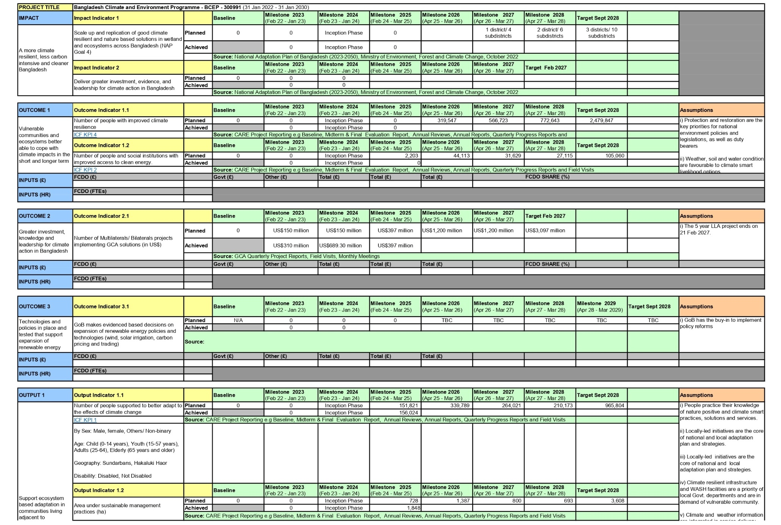
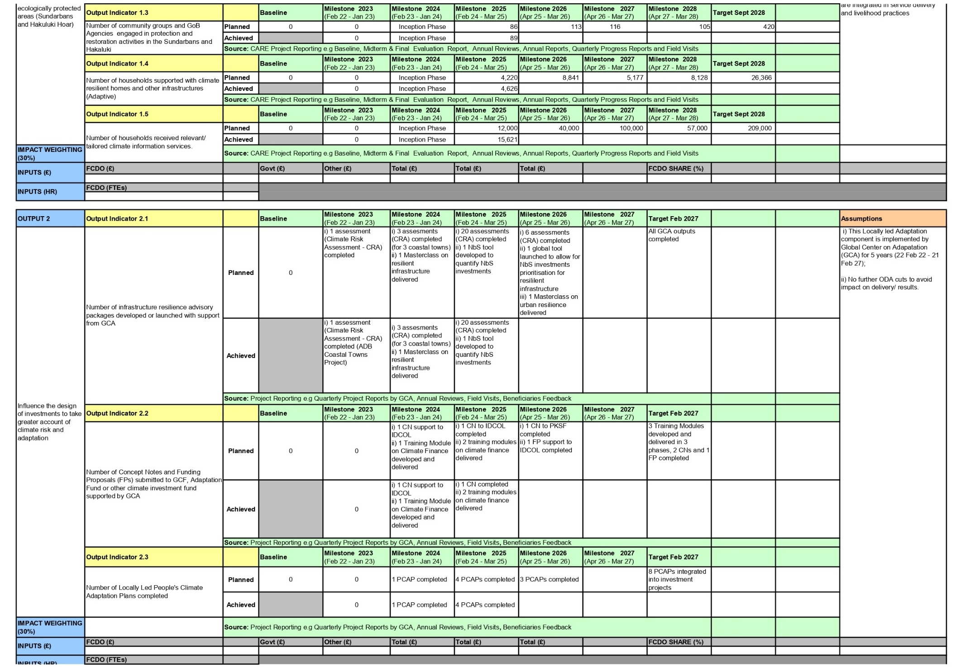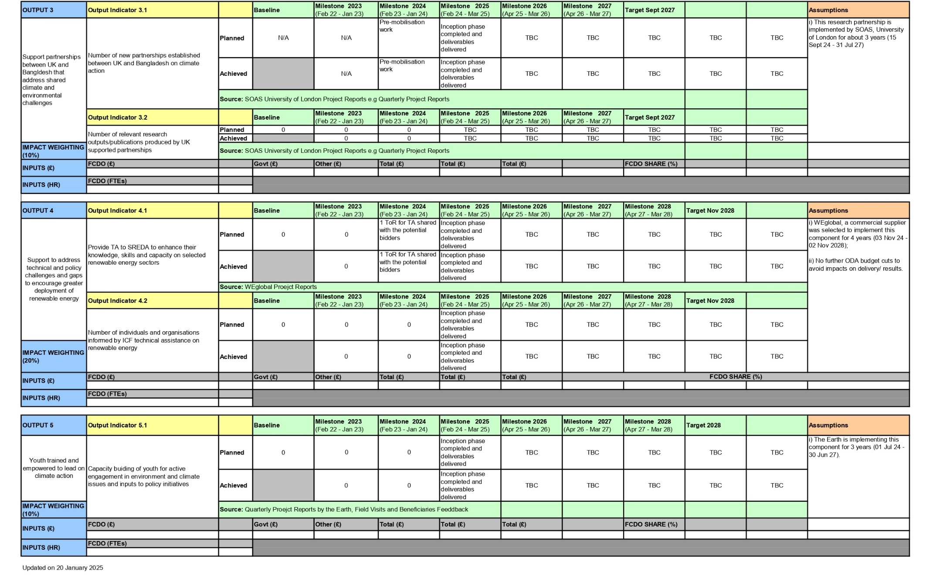

GCA Logframe
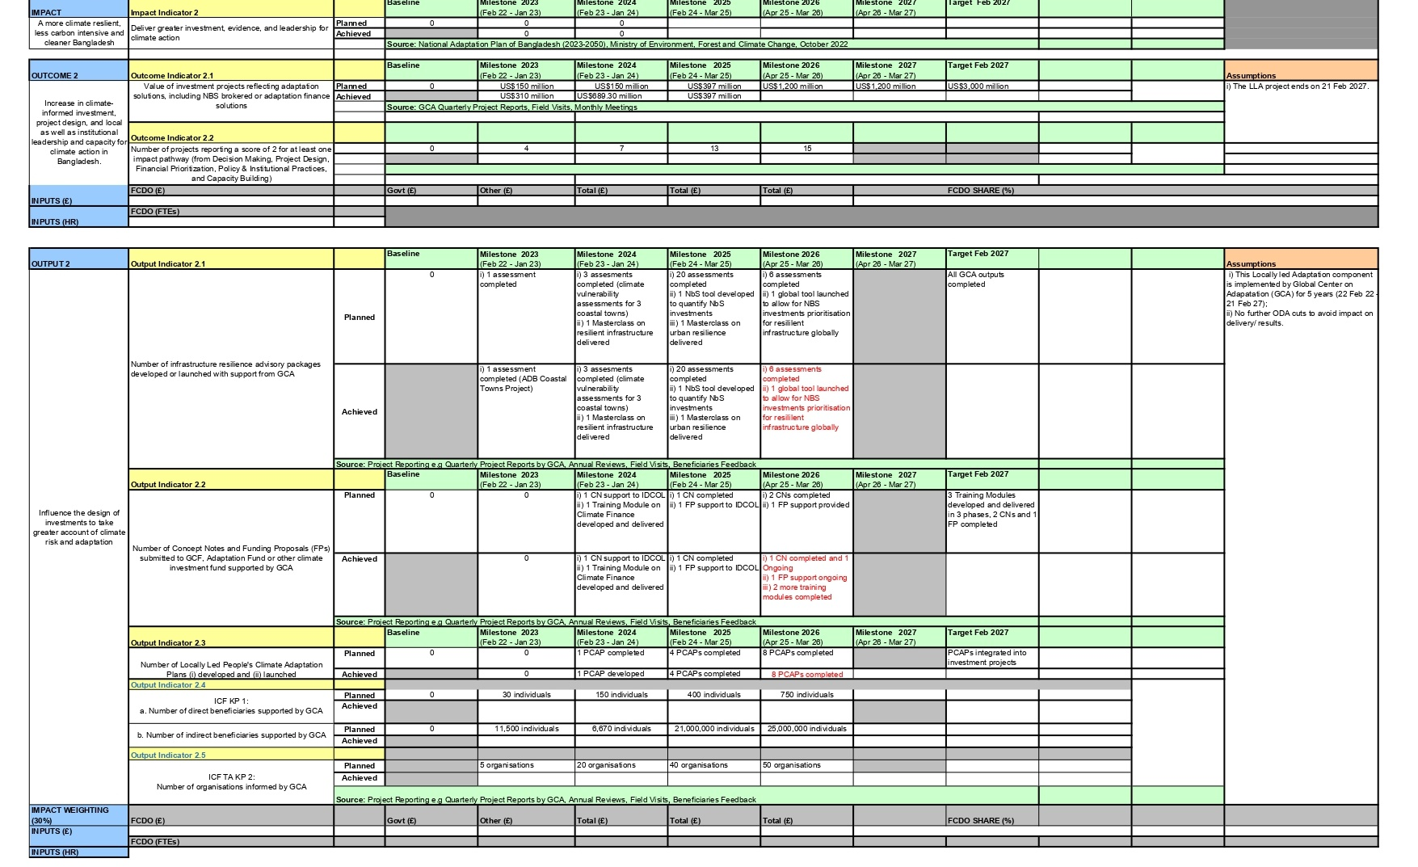

Log Frame Monitor and Impact Pathways Monitor and Scorer

Immediate Outcomes Monitor
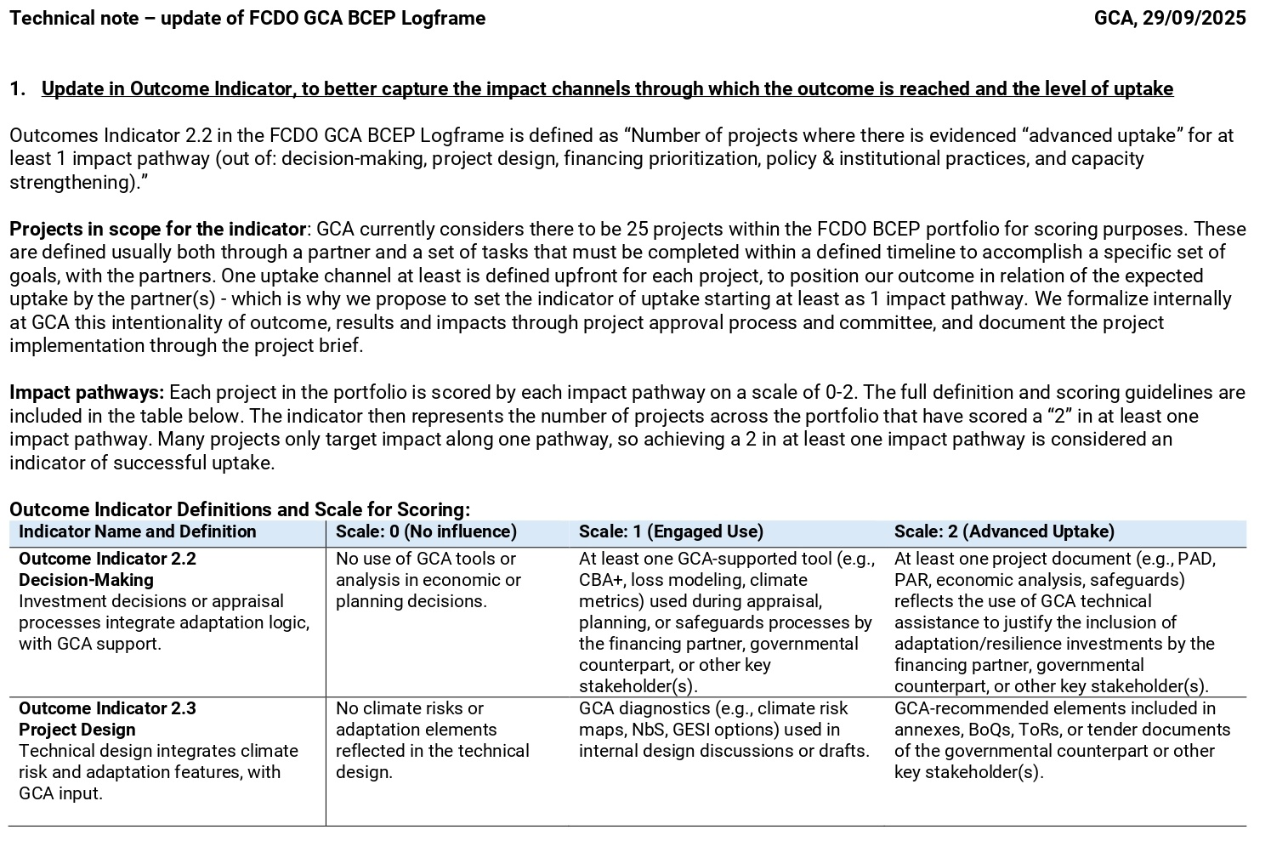
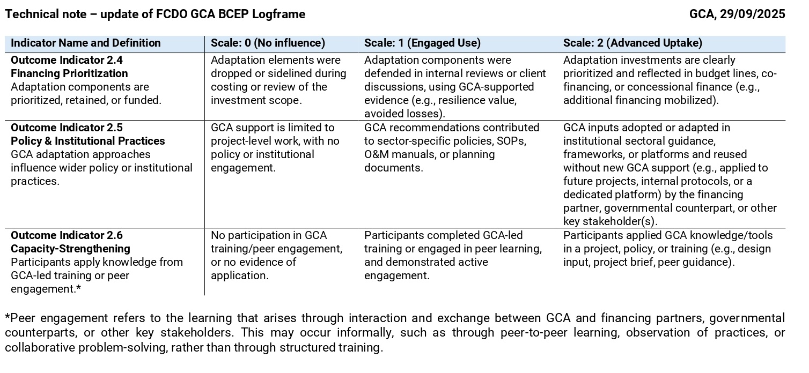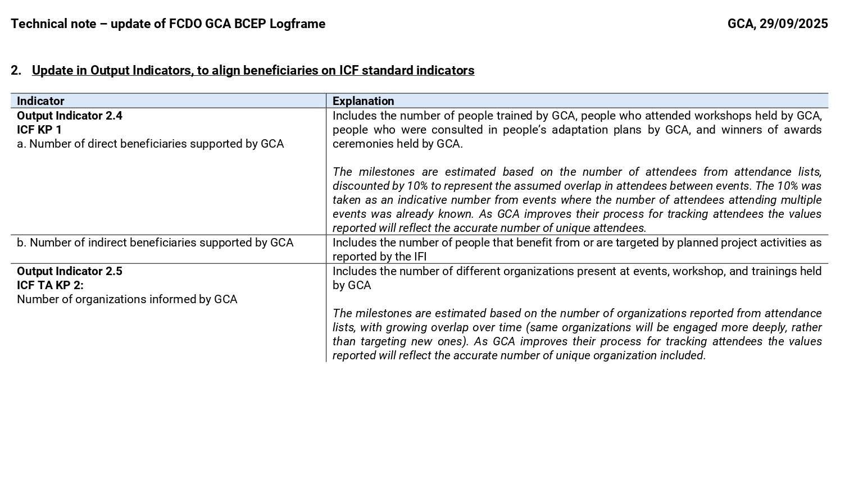

The Pathways Results
Project Name | Score of a 3 in at least 1 pathway | Awareness-Raising Score | Capacity-Building Score | Project Design Score | Financial Prioritization Score | Policy & Institutional Practices Score
ADB Coastal Towns Climate Resilience Project | Yes | 3 | 2 | too early | NA | 2
AIIB Phase 1 Hatikumrul Bonpara Jhenaidah Road Project | No | NA | NA | 2 | too early | NA
Bangladesh National Infrastructure Investment Pipelines | No | 2 | NA | NA | NA | 1
Global Tools for Nature Based Solutions | No | NA | NA | NA | 2 | NA
Bangladesh Climate Resilient Infrastructure Masterclass | Pending | - | - | - | - | -
Global Hub on LLA (including sub-projects like Stories of Resilience, Local Adaptation Champions Awards) | Yes | 3 | 3 | NA | NA | 3
Sub-grant to BRAC [Mongla + 3 ADB towns] | Yes | NA | 3 | 3 | 2 | 3
Chattogram Water Supply Improvement Project (CWSIP) | Yes | NA | 3 | 3 | too early | NA
AIIB Bangladesh Smart Cities Development Project | Yes | NA | 3 | too early | too early | NA
Results Based Lending- Improvement of Urban Governance and Infrastructure Project | Yes | 2 | 2 | 3 | NA | 1
AIIB Policy Lending for Water and Urban in Bangladesh | Pending | - | - | - | - | -
AFD Water Supply, Inclusive Sanitation (Faecal Sludge and Solid Waste Management) and Hygiene Project in 7 Towns of Bangladesh | No | NA | NA | 2 | NA | NA
Capacity building support on developing robust adaptations projects to access GCF fund in Bangladesh (Phase II and III) | Yes | 2 | 2 | NA | NA | NA
Adaptation Funding Proposal development support for GCF to IDCOL | Yes | NA | NA | NA | 3 | NA
Adaptation Concept note and Funding Proposal development support for GCF to PKSF | Yes | NA | NA | NA | 3 | NA
Total | 9
Remarks: Results as of 29-01-26



Nude 54 D, 6702 DN
Wageningen, the Netherlands
https:/metameta.nl/

It should be born in mind that the Grant was scheduled to run to March 2027 but that this was cut by FCDO by a year with the completion date now being March 2026
It should be noted however that there has also been a key fourth sector focus which GCA names Water and Urban which has also required consideration in the evaluation
It should be born in mind that the Grant was scheduled to run to March 2027 but that this was cut by FCDO by a year with the completion date now being March 2026
FCDO’s Approach to Value for Money – Guidance for External Partners
International Donor and Lending Agencies which includes Development Banks and International Finance Institutions
These were addressed by the 2022 Output to Purpose Review vis. Section 9 – “As part of BCEP mobilisation, the programme team will ensure the logframe is finalised for all components, the Theory of Change (ToC) is reviewed, and programme governance is strengthening, by June 2023.”
MetaMeta’s understanding is that there is also now a fifth “E” (Cost) Effectiveness

