Annual Review

Title: Nepal in Business (NIB)
Programme Value £ (full life): £36.2 million |  | Review date: 21/05/2025
Programme Code: 300965 | AMP start date: 25/07/2023 | AMP end date: 31/03/2031

Summary of Programme Performance
Year | 2024 | 2025
Overall Output Score | A | A
Risk Rating | Major | Major

DevTracker Link to Business Case: | D0004649.odt (live.com)
DevTracker Link to results framework:

A. SUMMARY AND OVERVIEW

Description of the programme

Nepal in Business (NIB) is a flagship private sector development programme of the British Embassy Kathmandu (BEK). The UK Government-funded programme aims to unlock economic prosperity in Nepal by fostering the growth of small and medium-sized enterprises (SMEs), creating new jobs, and driving private sector-led economic growth. NIB has 5 priority sectors for investments and targeted interventions: agro-processing, tourism, light manufacturing, information and communications technology (ICT), and renewable energy. These sectors are identified to have high export potential, with strategic products & services that can be catered to niche international markets.

NIB – Growth Advisors oversee the following two components, which are being implemented by DAI Global UK.
- Business Support Facility (BSF): Providing technical assistance and grants to SMEs to enhance their productivity, competitiveness, and potential for job creation.
- Business Environment Reform Facility (BERF): Engaging with stakeholders to advance reforms in business regulations, reduce barriers to trade, and improve the overall enabling environment for SMEs in Nepal.

NIB – Catalytic Finance (previously SME Financing Facility) aims to catalyse investments into the SME ecosystem. The financing gap for SMEs in Nepal is £710 million and is faced by 83% of SMEs. NIB – Catalytic Fund will de-risk investments into Nepali SMEs through a blended finance facility – leveraging grant to mobilise additional capital from Development Finance Institutions (DFIs), Banks & Financial Institutions (BFIs), and Private Equity & Venture Capital (PEVC) Funds into the SME ecosystem.

Monitoring Evaluation and Learning component will use monitoring, evaluation, learning and research across the programme to deliver strategic learning and feed into BEK reporting against the Country Plan. NIB will monitor progress against output and outcome of the programme log frame and through bi-annual visit to grantees. A midterm and end of term evaluation was planned to ensure value for money of the programme and improve global knowledge on enterprise development.

This Annual Review covers the NIB – Growth Advisors (including BSF and BERF components). NIB – Growth Advisors has completed the inception phase (ending January 15, 2025) and entered the implementation phase.

NIB – Catalytic Finance, which was designed in close consultation with the British International Investment (BII) team, has not yet entered implementation phase. DFIs have the expertise to manage blended finance facility and a strong track record of mobilising other DFI and private sector capital. Two DFIs expressed an interest to manage the fund – the International Finance Corporation (World Bank Group), the DFI with the largest portfolio in Nepal and the Dutch Entrepreneurial Development Bank (FMO), who has been active in Nepal since 2007. FMO has been selected as the fund manager, and the team is in advanced stage of negotiations for the Agreement. Once this new agreement is approved to go forward, the process of operationalising the fund will be finalised (including fund management agreement signing).

Summary supporting narrative for the overall score in this review

The completion of deliverables within expected timeframe, including innovative strategies in some areas, supports the overall score of A.

Following the approval from Government of Nepal (GoN) and procurement of delivery partner (DAI Global UK) through a competitive bidding process, the Contract for the delivery of NIB – Growth Advisors was signed in July 2024. The initial 6-month inception period (ending January 15, 2025) was marked by sectoral scoping studies, expert design of focused strategy, finalisation of log frame indicators and milestones.

All 17 deliverables (including BERF strategy, BSF strategy, VfM framework, office mobilisation, risk mitigation strategy, delivery chain mapping, among others) either met or exceeded expectations – providing a good level of confidence that the two components of NIB are ready to move into implementation phase and provide good value for money.

BSF Strategy is focused and identifies sub-sectors that are both aligned with the priorities of Government of Nepal (particularly the Nepal Trade Integration Strategy, NTIS) and holding potential to drive export-led growth through niche products. The strategy for these sub-sectors, i.e., natural fiber (light manufacturing), wellness tourism (tourism), medicinal & aromatic plants (agro-processing) have been developed. The intervention areas for ICT are broad, however the supplier will start with commodity IT and business process outsourcing (BPO) companies and gradually moving towards businesses with more specialised products (and advanced skills’ requirements). The supplier will design a strategy to support to renewable energy sector at the end of year 1 (FY 25/26).

BSF Grants Within a short time frame (2.5 months of implementation for BSF grants rollout), the delivery partner has announced a call for proposals package, shortlisted few companies through applications received in “rolling basis,” and submitted 2 concept notes with detailed intervention plan to FCDO.

BERF Strategy is well aligned with the BSF’s strategic priorities and goes beyond the regulatory & policy architecture - identifying opportunities to help create an enabling environment for the selected sub-sectors through partnerships with relevant stakeholders.

Innovation in Nepali SMEs benefit from a blue ocean thinking where the walls between sectors are fluid and products and services cater to more than one sector, for example agri-business and tourism. NIB is prioritising product innovation using this strategy. For example, on product innovation NIB partners are developing new agriculture products such as tea infused with herbal blends and gummies/ candies for commercialisation of traditional Ayurvedic products with potential linkages to tourism and hospitality. NIB is using technology and backward linkages for process innovation. NIB is supporting the introduction of blockchain technology-based traceability of select Nepali export products. NIB supports partners moving agro-processing closer to where raw materials are available. However, examples of innovation are limited in some sectors. There is an opportunity to further demonstrate innovation, particularly potential for disruptive innovation and out-of-the-box thinking.

Moreover, part of the innovation in delivery comes from alignment between a grants’ disbursement strategy (partnership with high-potential SMEs) and the market systems development approach in BERF.

Through the Monitoring Evaluation and Learning (MEL) component, NIB supported the World Bank’s Nepal Informal Enterprise Assessment (NIEA). This assessment was jointly supported by the Swiss Agency for Development and Cooperation (SDC), International Finance Corporation (IFC) and British Embassy Kathmandu (BEK). The NIEA will help improve the business environment by addressing the barriers to firm formalization. The findings from the surveys will also help understand the financing needs and requirements of informal businesses in Nepal and contribute to the design of policies to support access to sustainable financial services to micro, small and medium enterprises (MSMEs) and households. The data collection of the survey has been completed and will be available on the Enterprise Surveys portal https://www.enterprisesurveys.org/en/informal-businesses/coverage.

Major lessons and recommendations for the year ahead

To maximise the impact and VfM of the programme, the following lessons would be valuable for the programme implementing team:

Lessons
Informal firms in Nepal are micro enterprises and retailors. The World Bank is yet to release the details of its enterprise survey, but initial findings show that most of the firms are micro enterprises, operated by one person. Most of these firms are retailers and many operate from their households. As expected, the organisation capability of the enterprises in Kathmandu is higher than those outside. For example, Kathmandu is a positive outlier on indicators such as keeping written business records. This is probably also true for SMEs in Nepal and gives enterprises in Kathmandu an edge over their counterparts in other parts of the country on the uptake of the technical assistance that programmes like NIB can provide.

Innovation is critical to supporting value for money for BSF partnerships. Innovation is critical to improve the productivity and competitiveness of Nepali firms. NIB should also focus on product innovation that goes beyond the pre-defined sectors. For example, products & services that could cater to both the agribusiness sector and wellness tourism sector demonstrates an appetite for this type of innovative thinking and focusing on untapped consumer markets. Further demonstration of strategies to turn non-consumers into consumers would add value to programme implementation. This could be explored more in sectors like ICT, where tech could act as an enabler across different sectors of the Nepali economy.

B: THEORY OF CHANGE AND PROGRESS TOWARDS OUTCOMES

Summarise the programme’s theory of change, including any changes to outcome and impact indicators from the original business case.

The steps to achieving outcome and impact are valid. The Theory of Change logic, supporting evidence and assumption have not been tested as the program has not gone into ground implementation. For this annual review two Theory of Change (ToC) are relevant: the ToC in the business case, and of Growth Advisors which is nested within the business case ToC. The consistency in logics of these two ToCs are examined in a rapidly evolving development scenario.

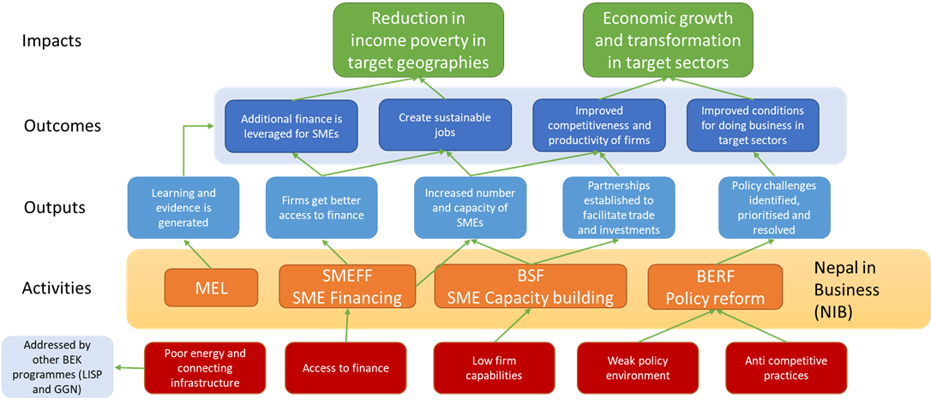

The business case for Nepal in Business aims to support "inclusive economic growth, creating jobs and improving productivity and competitiveness of firms and fostering competition" by stimulating the private sector, particularly SMEs. The interventions aim to address three cross sectoral constraints to business growth (weak policy environment, low firm capabilities and poor access to finance) and indirectly address anti-competitive behaviours. Additionally, TOC assumes that another key constraint related to poor energy and connectivity infrastructure will be addressed through other BEK programs, especially Local Infrastructure Support Programme (LISP) and Green Growth Nepal (GGN).

The NIB- Growth Advisors program is in its early stages and is well placed to address the constraints. On the other hand, NIB Catalytic Finance is yet to start. Without this component, a key constraint to SME growth- access to finance- will remain unaddressed by NIB. Similarly, under the reduced ODA contexts, LISP and GGN's ability to provision energy and connectivity infrastructure may be limited. Even with LISP and GGN’s contributions, it is unlikely to meet the energy and connectivity needs of SMEs. The program should look at leveraging GoN support to meet these needs through BERF. Emerging evidence shows that this will be a big structural constraint that will limit economic growth along with SME growth. It will be important for NIB-Growth Advisors to track and monitor infrastructure constraints for SME growth as a learning agenda.

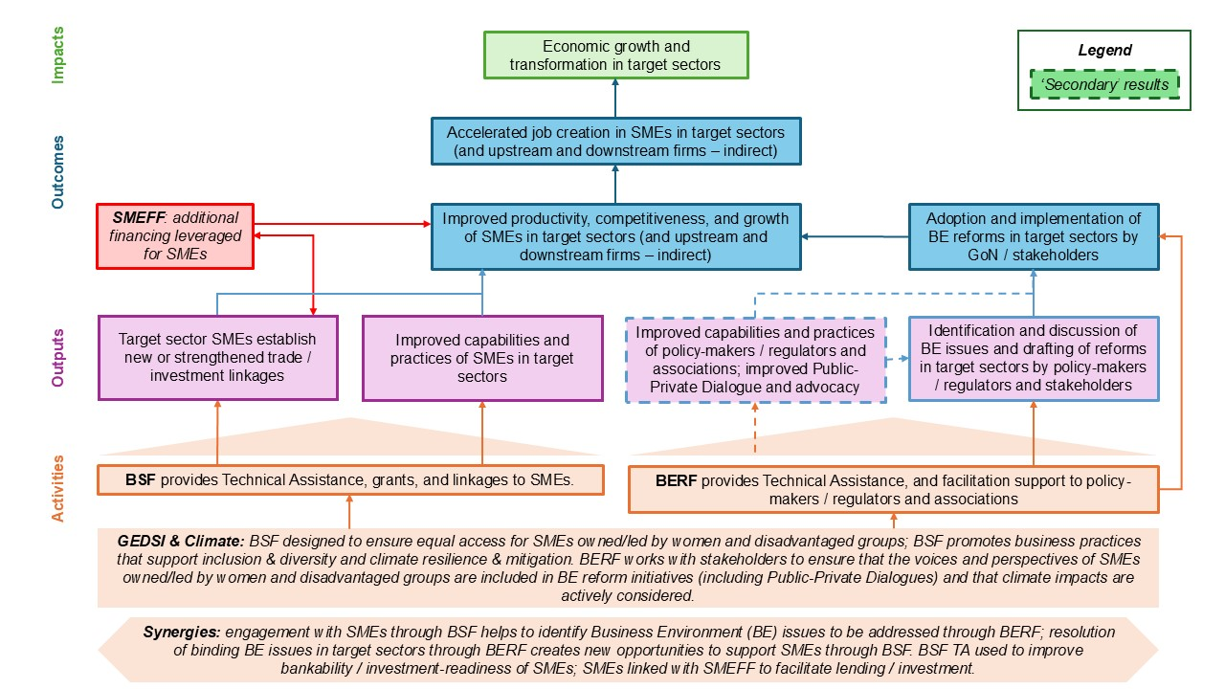

A nested ToC (above) has been further developed by Growth Advisors - NIB. This Growth Advisors ToC is largely an unbundling of the business case ToC, so the impacts and outcome targets are consistent, and the outputs and activities are described in greater detail. For the Business Support Facility, the intended outputs include, strengthening trade/investment linkages and improving capabilities via provisioning of specialised Business Development Services for SMEs. Similarly, the intended outputs for Business Enabling Reform include improving capabilities of policy actors to be provided through technical assistance on targeted issues, and promotion of public-private dialogue and advocacy.

Although 'anti-competitive practices' can hinder NIB’s inclusive growth agenda, the ToC neither directly nor indirectly aims to work on 'anti-competitive practices' and thus is unlikely to address another structural constraint for SME growth- skewed market power among Nepal's big business houses.

Describe where the programme is on/off track to contribute to the expected outcomes and impact. What action is planned in the year ahead?

The program is largely on track to contribute to the expected outcome and impact. NIB- Growth Advisors should add into their ToC whether and how they aim to tackle or navigate 'anti-competitive practices'. Similarly, the structural constraint of SME's access to finance has not altered but there are movements within Nepali economy which will likely have a major impact. First, the liquidity has increased in the financial sector which has not been absorbed by the private sector despite reduced interest rates. SMEs will find it difficult to access finance because Banks and Financial Institutions (BFI)s have a large and increasing portfolio of non-performing assets (NPAs) and are unwilling to take risks (either real or perceived) on SMEs as they find it difficult to meet the collateral requirements of BFIs. Similarly, the cooperative sector which has traditionally provided access to finance for smaller businesses is under a severe crisis due to rampant frauds. This will also make access to finance for SMEs difficult and providing support more pertinent. NIB Catalytic Finance, once in implementation, aims to address these problems.

Justify whether the programme should continue, based on its own merits and in the context of the wider portfolio

The programme should continue as it has been set up to deliver impact as discussed throughout this Annual Review.

C. DETAILED OUTPUT SCORING

Output Title | Improved capabilities and practices of SMEs in target sectors - Business Support Facility (BSF)
Output number: |  | 1 | Output Score: | A
Impact weighting (%): |  | 50% | Weighting revised since last AR? | No

Indicator(s) | Milestone(s) for this review | Progress
Number of SMEs supported by BSF to enhance productivity and competitiveness;  Volume of additional private finance mobilized as a result of NIB support. | BSF strategy developed and approved by FCDO. | BSF strategy was developed, with inputs and guidance from relevant stakeholders, and in alignment with the priorities identified in the Government’s Nepal Trade Integration Strategy (NTIS). BSF strategy (one of the key deliverables during the 6-month inception phase) identifies opportunities within specific sub-sectors and niche product categories, with high potential for export-led growth. The focus sub-sectors are: i) natural fiber, including both plant-based fiber and animal-based fiber (light manufacturing), wellness tourism (tourism), medicinal & aromatic plants (agro-processing). Additionally, ICT sector has a nuanced approach with a broader focus, given the nature of the technology industry and Nepal’s realities.  BSF activities include a package comprising of grant capital and knowledge capital (TA) to select high-potential enterprises in the defined sub-sectors. Strategic support with certifications (and removing other non-tariff trade barriers), international market linkages, and investment partnerships emerge as a common theme for interventions across sectors.

Briefly describe the output’s activities and provide supporting narrative for the score.

The output indicators presented in the table above do not represent an exhaustive list of all indicators in the programme logframe. Most of the indicators and milestones are relevant in the future years of implementation. Given this review period is focused mostly on the inception phase, only relevant indicators (with clear milestones) for the outputs have been included.

The progress till date justifies output score of A against this output.

The inception phase was followed by 2.5 months of implementation phase during this AR period. During the early phase of implementation, socialisation events to spread awareness of the funding opportunity for SMEs helped create a wider interest in partnering with NIB.

Additionally, the strategies are well tailored to NIB’s aspirations of supporting Nepal’s export-led growth through focused efforts on high potential sub-sectors and niche international markets. The key progress during this AR period, which are not captured in the table above, include:
- Finalisation of Concept Note template (including FCDO’s approval of 2 concept notes with detailed intervention plan to partner with select SMEs);
- Finalisation of Partners’ Scoping Report for each of the priority sectors;
- Submission of NIB Grant Manual, with robust grant management processes and dedicated human resource for grants management;
- Submission of ESG Checklist to be used to enhance ESG standards of partner SMEs;
- Finalisation of GEDSI Strategy, in line with BEK’s new GEDSI Strategy.
Lessons learned through this output, and recommendations for future programming

Innovation and “Blue Ocean Strategy”: Innovation in the private sector is often constrained because of the traditional red ocean thinking – where market size is defined as a given (notion of market shares within limited pool of consumers) and where industry walls are seen as rigid.

For NIB, there is an opportunity for thinking deeper into possibilities where the “walls” between sectors are not rigid. The thinking – particularly exploration of products & services that could cater to both the agribusiness sector and wellness tourism sector - demonstrates an appetite for this type of innovative thinking. There would be better VfM through helping firms - across sectors - think about the currently untapped consumer markets (blue ocean), by making the industry/ sector walls fluid. Further demonstration of strategies to turn non-consumers into consumers would add value to programme implementation. This could be explored more in sectors like ICT, where tech could act as an enabler across different sectors of the Nepalese economy.

Greater Focus on Investment Readiness and Potential Synergies with NIB – Catalytic Finance: While selecting the partner firms for BSF interventions & grants package, it is essential to emphasise investment readiness further, particularly looking at companies through the lens of DFIs and commercial investors (who deploy returnable capital in the market). Standalone grants without improving prospects for investment readiness will have limited impact of the grants/ non-returnable capital.

As the NIB - Catalytic Fund operationalises, exploration of any synergies with fund would help maximise the impact of the overall programme.

Nuanced Approaches to Addressing Human Capital Constraints from Labour Demand Side (as opposed to Labour Supply): Capacity constraints, particularly related to human capital, represent a major challenge to Nepal’s private sector growth across sectors. Given that NIB is designed to work on the side of Labour Demand (helping firms grow and become able to demand more labour from the market), it is important to develop nuanced approaches to capacity building – through investment in knowledge capital at firm level – and not on approaches that work on the Labour Supply side (skilling, reskilling, upskilling). Intervention concepts that focus on Labour Supply would run the risk of deviation from the core programme objectives, as NIB’s design is to intervene (limited number of SMEs) in the Labour Demand side of the equation.

Most skilling programmes, including BEK’s previous programme Skills for Employment (SEP), focused on enhancing employability of individuals through capacity building initiatives.

Recommendations

S.N. | Recommendations | Responsibility | Timeline
1 | Focus on designing innovative partnerships that span across sectors to create new opportunities. The suppliers’ plan to add resources to identify partners that offer cross- sectoral interventions will help in focusing on this strategy. | NIB Growth Advisors | On-going. At least one in FY 25/26.
2 | Provide TA to potential pipelines for DFIs. | NIB Growth Advisors | On-going. At least one in FY 25/26.
3 | Develop a working relationship with NIB Catalytic Fund and BII. | NIB Growth Advisors | Dec 2025
4 | Maintain a strong focus on enterprise development through BSF grants. | NIB Growth Advisors | On-going

Describe any changes to this output during the past year, and any planned changes as a result of this review.

N/A

Progress on recommendations from the previous AR (if completed), lessons learned this year and recommendations for the year ahead

N/A (Since this AR period covers 6-month inception phase to define overall programme strategy and finalize results framework, followed by 2 and half months of implementation).

Output Title | Improved business environment in target sectors - Business Environment Reform Facility (BERF)
Output number: |  | 2 | Output Score: | A
Impact weighting (%): |  | 50% | Weighting revised since last AR? | No

Indicator(s) | Milestone(s) for this review | Progress
Number of stakeholder communiques identifying and prioritising significant and tractable business environment issues in target sectors;  Number of FA initiatives identified and agreed with MoICS to improve competitiveness and productivity in targeted sectors. | BERF strategy developed and approved by FCDO. | BERF Strategy was developed in close consultation with key stakeholders: Government of Nepal (Ministry of Industries, Commerce, and Supplies), business associations, and sectoral associations/ agencies. The strategy was further refined with inputs from FCDO – particularly to employ a market systems development approach with a focus on sub-sectors & niche product categories identified for BSF interventions.  BERF Strategy also includes priority areas of FA mobilisation for the Ministry.  The strategy for BERF implementation stems from a firm-focused & sub-sectoral approach while maintaining strong government engagement. For this, reforms across the three pillars will be identified in priority sub-sectors and shortlisted based on the priority of firms and respective stakeholders. Once identified, a detailed Political Economic Analysis (PEA) will be performed for the reforms followed by consultations and PPDs to prepare the policy proposal. BERF will adopt both a strategic and opportunistic approach to engagement for targeted reforms. The strategic approach entails developing a long-term vision for subsector transformation and aligning reform initiatives accordingly. The opportunistic approach entails cashing in on opportunities that are mostly time sensitive. For instance, incentives and schemes for the private sector through fiscal and monetary policies can go a long way in terms of designing the right incentive structures for these promising sectors & sub-sectors.

Briefly describe the output’s activities and provide supporting narrative for the score.

The output indicators presented in the table above do not represent an exhaustive list of all indicators in the programme log frame. Most of the indicators and milestones are relevant in the future years of implementation. The progress till date justifies output score of A against this output.

The inception phase was followed by 2.5 months of implementation phase during this AR period. During the early phase of implementation, the intensity of engagement with the line ministry (Ministry of Industries, Commerce, and Supplies) was enhanced through rounds of discussions with senior government officials, both within the Ministry as well as its line agencies and departments including the Department of Industries (DOI), Office of Company Registrar (OCR). The delivery partner conducted focused discussions with business associations and provincial chapters as well as with government counterparts in the 3 priority provinces of BEK.

Although the strategy finalisation took slightly longer (slipping beyond the initially planned inception phase), the strategy is tailored to NIB’s objectives and well aligned with the focus of the other component (BSF) under NIB – Growth Advisors.

Lessons learned through this output, and recommendations for future programming

Business environment reform initiatives may run the risk of being fragmented and unable to deliver the intended impact without a focused, programme-specific strategy: Given the broad nature of “business environment” it is not always obvious what type of strategy works best for each private sector development programme. Business environment constitutes broader structural factors of the political economy (including rule of law and legal clarity and predictability), macroeconomic factors, sector specific factors (including sector regulations & policies and availability of shared platforms that benefit the entire ecosystem), institutional arrangements, and capacity of dedicated agencies and associations. Given the breadth of business environment and focused nature of NIB, it is important to devise strategies that are tailored to the aspirations of the programme and able to benefit the specific sub-sectors priorities in other component(s). Broader macroeconomic environment and investment environment are beyond the scope of NIB.

Improving business environment requires thinking beyond the policy & regulatory architecture, and thinking creatively about spending grants for ecosystem building approach: One key learning from interactions with a wide range of entrepreneurs is that the businesses operating in high promise yet difficult sectors often have to go above and beyond their role of managing their company – and invest in broader ecosystem building initiatives. However, the “free rider problem” often restricts individual firms from investing in these broader platforms and initiatives because other players from the sub-sector could reap the benefits without having to invest. The NIB team has recognised the importance of these creative solutions for BERF implementation. The programme has been adapted to adopt sectoral initiative approach informed by their interactions with the relevant stakeholders during socialisation events and meetings with promising SMEs.

Recommendation

S.N. | Recommendations | Responsibility | Timeline
1 | Maintain a clear line of sight on the impact of the BERF support to line ministries and stakeholders. Attribution of programme activities must be clear at the outset of partnerships. | NIB Growth Advisors | On-going
2 | To increase VfM of the programme, identify critical bottlenecks in policy, regulation and business environment in priority sectors. It is better to focus on a few key challenges than spread the programme’s resources too thin across multiple work areas. | NIB Growth Advisors | On-going

Describe any changes to this output during the past year, and any planned changes as a result of this review.

N/A

Progress on recommendations from the previous AR (if completed), lessons learned this year and recommendations for the year ahead

N/A (Since this AR period covers 6-month inception phase to define overall programme strategy and finalize results framework, followed by 2 and half months of implementation).

D: VALUE FOR MONEY

Key cost drivers and performance
The Business Case proposes the following Value for Money indicators.

Economy: assess the degree to which inputs are being purchased in the right quantity and at the right price, including cost of programme management/ overheads, cost of consultants, and cost of managing funds for the SMEFF (renamed as NIB – Catalytic Finance).

Efficiency: assess how efficiently the project is delivering its outputs, considering the rate at which intervention inputs are converted to outputs and its cost-efficiency

Effectiveness: assess the quality of the interventions by assessing the rate at which outputs are converted into outcomes and impacts

Equity: degree to which the results of the intervention are equitably distributed (including proportion of jobs created for women and DAGs and proportion of SMEs supported that are owned by women)

VfM performance compared to the original VfM proposition in the business case

Details on the VfM framework, considerations, and indicators (finalised during inception) are tabulated below (starting next paragraph). Based on the two concept notes submitted for BSF partnerships – and approved by FCDO – here is a brief assessment of VfM for the implementation phase:
- Development returns (Effectiveness): Job creation remains a key criterion for concept evaluation. The two concept proposals submitted have a case for creation of 150-160 jobs surpassing the average target of 135 jobs through two partnerships representing 11% better effectiveness (than planned earlier).
- Development returns (Equity): Job creation for women and DAGs constitute to 30% of the total jobs. Furthermore, NIB has selected sub-sectors with high chances of engagement with women and DAGs – medicinal & aromatic plants and natural fiber, for example.
- Development returns (Additional Benefits): The partner onboarding process of NIB includes ESG, climate and energy audit to inform interventions that will contribute to ICF indicators, GHG reduction, waste management (3R principle) among others.
The Value for Money (VfM) framework for NIB – Growth Advisors has been finalised by the delivery partner during inception phase. The key considerations and indicators for VfM are presented in the table below. Building on the business case, this framework is tailored to the nature of NIB interventions and presents key VfM considerations at each level of the 4E Framework. Monitoring and reporting of VfM is discussed in good detail in the detailed VfM framework, which was approved by FCDO as one of the inception phase deliverables.

4Es | VfM considerations | VfM indicators
Economy (£ to inputs) | - What policies and processes are in place to ensure the programme gets the best value when procuring goods and services (especially consultant days)?  - Are inputs “right-sized” for the needs of the programme?  - Are administrative and overhead costs suitable for the size and nature of the programme?  - Is the programme fully exploiting the available economies of scale? | - Average fee rates (£)  - National consultant utilisation rate (% consultant days performed by national consultants)  - Overhead costs (as % of total programme spend)  - Examples of cost savings (£)  - Findings of external financial audit (qualitative)
Efficiency (inputs to outputs) | - Are interventions and activities delivered on-time and on-budget?  - Is the programme selecting the right firms to support, with demonstrated commitment and buy-in? Is the programme selecting the right Business Environment (BE) issues to target?  - Is the package of TA / grants tailored to the specific needs of each partner, and necessary and sufficient to support the desired practice change or innovation?  - Are consultants deployed and managed effectively to deliver the requisite outputs?  - Is the programme effectively leveraging partner resources and investment?  - Are outputs monitored on a regular basis, with non-performing partnerships / BE issues exited in a timely manner (‘fail fast’)?  - Could the same outputs be achieved with fewer inputs using an alternative approach / methodology? | - Partner leverage ratio (ratio of programme spend to additional partner spend)  - Partner adoption rate (% partners adopting new or improved practices)  - BE issue submission rate (% of BE issues targeted that reach the drafting and submission stage)  - Average input cost per BSF partner successfully adopting a practice change; average input cost per ‘failed’ partner  - Average cost per BE issue that successfully reaches the drafting and submission stage; average cost per ‘failed’ BE issue
Effectiveness (output to outcome)  Cost effectiveness (£ to outcome) | - Has the programme selected and prioritised the right sectors? Is the programme targeting binding firm- and BE-constraints to improved productivity and growth?  - Is there a clear causal logic linking outputs to outcomes and impact, underpinned by robust hypotheses, assumptions, and evidence? To what extent are successful outputs feeding through to outcomes?  - Are the interventions and partnerships delivering change that is sustainable and that maximise spillovers?  - Are synergies between components and programmes being effectively exploited?  - Are outcomes monitored on a regular basis, with non-performing partnerships / BE issues / sectors exited in a timely manner? | - Partner improvement rate (% of partner firms improving their productivity or competitiveness)  - Spillover ratio (ratio of number of partner firms with improved productivity or competitiveness to number of non-partners with improved productivity or competitiveness)  - BE issue adoption rate (% of BE issues targeted that reach the adoption stage)  - BE issue implementation rate (% of BE issues targeted that reach the implementation stage)  - Average number of jobs created per firm supported  - Cost per additional job created (total programme spend ÷ number of additional Full Time Equivalent jobs created)
Equity | - Is GEDSI effectively mainstreamed in programme and sector strategies, processes, and partnerships?  - To what extent are firms adopting inclusive practice changes?  - To what extent is GEDSI actively considered in the BE reform process?  - To what extent are women and marginalised groups benefiting from NiB interventions?  - Is the impact of interventions on women and marginalised groups actively monitored (including checking for potential harm)? | - Percentage of jobs created that are filled by women and marginalised groups  - Percentage of firms adopting or updating inclusive practices.  - Number of BE issues that actively address GEDSI concerns.  - Evidence from annual reviews regarding GEDSI mainstreaming (qualitative)

Further to the considerations and indicators developed (presented above), the team has demonstrated practical applications of VfM, where possible. The programme team coordinated with FCDO to transfer some must-needed items like office furniture, ICT hardware, and smaller computer accessories in March 2025. Laptops were transferred to the team from the Gurkha Welfare Trust in February 2025. Some assets that have been agreed for transfer at the beginning of the following fiscal year (beginning April 2025) include vehicles from Nepal Renewable Energy Programme (NREP) as well as additional furniture from Data for Development (D4D).

E: RISK

Overview of risk management

The overall risk for NIB programme remains “Major”. The programme team and the partner regularly review, discuss and update the programme risks. The following picture provides a summary of the current NIB programme risk register.

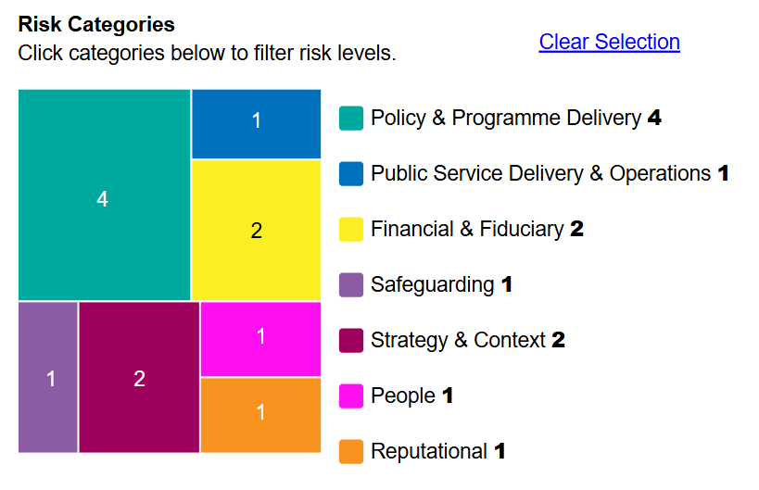 | 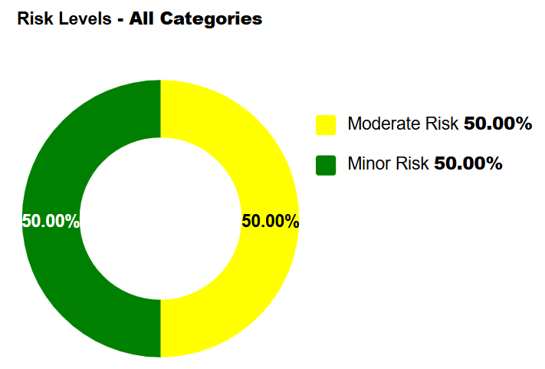

As shown above, the NIB risk register has seven types of risks and there are twelve active risks in total.

The main risks identified, and the mitigation plans are as follows.

Financial & Fiduciary:

Misuse of funds or corruption in the context of suppliers, supply chains, or other downstream funding mechanisms could result in loss of funds, delivery disruptions, hindered goal achievement, and mistrust. To mitigate these risks, DAI will implement counter-fraud measures, including robust eligibility criteria and due diligence of SMEs, partners, and fund-receiving organizations. Partners will be fully vetted before contracting, and fund disbursements will be conditional on achieving contractual milestones. A regularly updated Delivery Chain Map will track the flow of funds and recipients. Regular spot checks, due diligence assessments, and technical and financial reports will be conducted. Contracts will include ethical and behavioural clauses in line with DAI’s Code of Business Conduct, the UK’s Anti-Bribery Act, and relevant FCDO policies. DAI will provide capacity-building activities, including ethics training, and establish clear escalation lines for emerging issues. Strict conflict of interest (COI) protocols will be applied, including a COI register and annual COI declaration forms for procurement staff.

Strategy & Context:

In the absence of political will for substantive reform or failure to secure project buy-in from national and sub-national institutions, the programme outcomes, particularly the Business Environment Reform Facility (BERF) component, may be impacted. This could be due to resource/skills gaps, political instability, or external shocks. To manage this, DAI's experienced Government Partnerships Lead will work with government entities to ensure programme activities align with their strategic/political aims. Our iterative co-creation approach will address the specific needs of each target geography, building on regular analysis and stakeholder engagement to ensure consistent buy-in and adapt interventions as needed.

Safeguarding:

Breaches of the Code of Business Conduct and Ethics, including bullying, conflict of interest, corruption, fraud, and sexual or gender-based harassment, could result from a lack of awareness and enforcement measures by the implementing partner. To mitigate these risks, DAI will provide security awareness training, including training on sexual and gender-based violence and personal security measures. A harassment reporting mechanism will be established, and training provided on its use. DAI will ensure adherence to the Code of Business Conduct and Ethics through structured mechanisms. All staff will undergo an introductory briefing on DAI's Code of Business Conduct and Ethics and sign it as part of their contract. Mandatory annual training in ethics and safeguarding will be conducted. DAI's Speak Up Line will allow staff to raise concerns about bullying, dishonesty-based misconduct, conflict of interest, etc. Discrimination-based concerns and sexual harassment cases will be addressed by DAI's Head of Diversity, Equity, Engagement, and Inclusion through quick escalation. DAI's Project Human Resources will address issues of bullying and management.

Public Service Delivery & Operations:

Failure to increase the social and economic participation of women and other disadvantaged groups (WODG) through weak recruitment of appropriate companies could result from political blockages, cultural reasons, or lack of willingness of SMEs. This could reinforce economic and social exclusion for WODG. To mitigate these risks, the NIB Team/DAI will conduct periodic audits to ensure adherence to standards. KPIs related to WODG will monitor their inclusion and participation. Selection criteria for companies will focus on WODG-owned or managed businesses. Conflict and GESI analyses will guide the project to avoid exacerbating exclusion. Implementation and investment strategies will be carefully constructed.

Policy & Programme Delivery:

Failure to secure appropriate local partners or experts, and constraints in their commitment, capacity, or capability, could result in delays or failures in delivering planned activities and outputs. This may be due to partners lacking logistical or institutional capability. To manage this risk, the NIB Team/DAI will proactively seek experts and partners with the necessary skills and capabilities, leveraging their extensive network in Nepal and internationally through both online and offline channels.

Update on Partnership Principles

[There is a £1m Financial Aid budget allocated under this programme to support the Ministry of Industry and Commerce. However, we have not spent any financial aid budget during this reporting period. A MoU was signed between FCDO and GoN in February 2024 which cites the partnership principles.

In November 2024, the British Embassy Kathmandu updated its Partnership Principles Assessment and concluded that the overall direction of travel in Nepal was “medium commitment” to all four thematic areas of the Partnership Principles is observed in this year’s assessment. A stable trajectory with some areas of improvements and some areas of increasing risk which must be closely monitored.

We expect to see an improved trajectory in some areas, and this has been noted in domestic accountability and managing fiduciary risk. This marks a shift from previous years, where medium commitment with stable progress/trajectory was observed for each Partnership Principle. The stable trajectory for domestic accountability is because the first electoral cycle (at local, provincial and federal levels) has passed in an orderly and peaceful manner, as have recent by-elections. An opening of the political landscape with new emerging actors is both an opportunity and a risk for strengthening democratic practices in Nepal, but not one that is currently judged to pose a significant threat to the overall trajectory. Improved fiduciary performance has been noted across all spheres of the GoN, according to our internal FRAs, and the latest PEFA, suggesting fiduciary risks are better managed now. However, risks around public sector effectiveness and delivery remain significant and must be closely tracked, including its impact on VFM.

Consistent progress/trajectory has been noted in other areas of the Partnership Principles. For instance, progress on human rights continues to move in the right direction, with gradual improvements in planning/enacting/implementing legal frameworks. However, despite progress, such as the adoption of, the Citizenship Bill and the TJ Act, the main challenges remain in implementation (such as the appointment of individuals to the two TJ commissions who generate confidence in the process,). The widespread and well-founded perception that the Federal Government’s commitment to human rights is determined by political interests and is uneven for different population groups, as observed by the TJ process, limits more effective progress in this area. Similar concerns about politics (and culture) trumping good law(-making) are now arising in relation to proposed digital governance legislation.

BEK will continue to assess and monitor performance against the Partnership Principles through our ODA portfolio and strategic risk registers.

F: PROGRAMME MANAGEMENT: DELIVERY, COMMERCIAL & FINANCIAL PERFORMANCE

Summarise the performance of partners and FCDO, notably on commercial and financial issues.

The Nepal in Business (NIB) programme was approved in 2023 with a total budget of £36.2 million. The programme has four major components:
1. Business Support Facility (BSF)
2. Business Environment Reform Facility (BERF)
3. SME Finance Facility (SMEFF)
4. Monitoring and Learning
To ensure better value for money and maximize complementarity and cohesion between components, the BSF and BERF were combined into a single contract. DAI Global was selected through a competitive bidding process to implement the BSF and BERF components (Growth Advisors). Since the NIB - Catalytic Finance, implementing SMEFF, component has not started yet, this report mainly covers the NIB - Growth Advisors.
The table below gives the breakdown of spend against the programme’s component is as follows:
Components | Spent (GBP)  as of March 2025,
NIB – Growth Advisors | £510,657.00
EFO with World Bank for Informal Sector Enterprise Surveys (ISES) – funded through MEL component | £75,176.00
Insourced Role | £43,984.00
Total | £629,817.00

NIB – Growth Advisors is implemented by DAI Global UK from July 2024. The inception phase was completed on 14th January 2025, and the implementation phase started from mid-January 2025 onwards. This report covers the assessment of commercial and financial performance from 15th July 2024 to 31st March 2025.

Implementing partner DAI Global UK is managing the programme well. The implementing partner submitted all the inception deliverables and the deliverables for mid-January to March 2025 on time. The Programme Management Team conducted a financial spot check of the programme and observed that DAI has strong internal control systems in place. They use online financial transactions software, through which all records of various incurred transactions were verified.

The total forecast for this reporting period (July 2024 to March 2025) was £539,164. Out of this total forecast, they spent £510,657. The forecasting through this period is within the 5% variance. The main variance resulted from the VfM savings made on capital expenditure such as office furniture and IT hardware. These capital items were obtained from other FCDO closed programmes, i.e., NREP and D4D programmes. Additionally, there is a 25% variance in the travel, accommodation, and subsistence budget category. This is due to that corporate rate secured from various hotels and Long Term Agreement (LTA) with two travel agencies provided discounted ticket rates (up to 6%).

The table below provides a breakdown of the actual spend against the forecast for the reporting period.

Budget Category | Forecast 2024/25 | Actual spend 2024/25 | Variance | %
Programme Staff cost | £452,612 | £452,612 |  | 0%
Capital cost | £32,397 | £9,622 | £22,775 | 70%
Programme activities | £33,321 | £32,833 | £488 | 1%
Travel, Accommodation and Subsistence | £20,834 | £15,590 | £5,244 | 25%
 | £539,164 | £510,657 | £28,507 | 5%

During the spot checks, it was noted that NIB has properly maintained the assets registry. However, some key information was missing, such as purchase value, purchase/acquisition date, and asset user/location. As recommended, the NIB team has now updated the assets registry with all necessary labels.

Date of last narrative financial report | 31 March 2025 | Date of last audited annual statement | Not due yet

G: MONITORING, EVIDENCE AND LEARNING

During the inception phase, a slightly revised programme Theory of Change (ToC) was developed based on the programme Terms of Reference, alongside the key strategy documents. The ToC is the foundation of the MEL system and illustrates the high-level impact objectives of NIB and the programme logic. Furthermore, the ToC guided the development of the NIB Monitoring Evaluation and Learning (MEL) framework to ensure accountability and transparency of programme activities, as well as support the team for evidence-based decision making to enhance sustainability by integrating learning and adaptive management.

Based on the ToC and MEL framework, a monitoring evaluation and learning system was developed to support continuous evidence-based decision making across all programme level – from firm level engagement to overall strategy. The MEL system provides required information to meet the OECD, DAC and FCDO evaluation criteria such as effectiveness, efficiency, impact, relevance, appropriateness, and sustainability as well as incorporating DCED Standard for Measuring Results in Funds Management. The system integrates field visits, quarterly partnership firm reviews, component level reviews and bi-annual programme reviews which provides a structured mechanism for assessing progress and collecting feedback.

Results framework (including logframe indicators) was finalised for both BSF and BERF components - which provides a structure tool for planning, monitoring and evaluation activities as well as supports in defining programme activities, indicators and means of verification. Based on all these technical documents, a MEL system was developed which will be utilised to assess programme performance and progress, thereby ensuring that NIB delivers measurable and impactful results. The MEL system is built around two key objectives: providing results for accountability and improving results through continuous learning and adaptation. The MEL system emphasises robust data collection, analysis, and use of reporting systems to generate credible evidence of NIB’s achievements, enabling the programme to optimise resource allocation and maximise its impact.

The programme has institutionalised learning as a core pillar of its MEL system. NIB team has developed a Knowledge Management Manual that uses a structured approach informed by realist evaluation to understand what works, for whom, and in what context. Learning questions are embedded within each component’s results chain and will be reviewed during formal adaptive management process, including quarterly reviews, bi-annual strategic reviews, and stakeholder workshops.

The programme is in initial stage of delivery and there have been no changes to the MEL structure and evidence. The initial key lesson identified is that a proactive stakeholder engagement is required to maintain momentum on programme activities.

Counterfactual – What could have happened during the year
N/A, since the programme is in its initial stage of implementation and is currently identifying potential partners to deliver programme objectives. Counterfactual analysis is a key pillar in the approved MEL system of NIB for future years of implementation.

