ADDENDUM TO BUSINESS CASE INCLUDING FOR BRIDGE FUNDING AND SCALE-UP COST EXTENSIONS

SUMMARY INFORMATION
Project Name | AT2030
Country or region targeted | Africa and South-East Asia
Type of cost extension (if applicable) | Cost and Time extension
Original project budget | £19.8m  (plus 100% match funding)
Original project start and end dates | 13 Dec 2019 to 1 Oct 2024
Cost extension value (if applicable) | Up to £31m  (up to a combined total budget of £50.8m, with 100% match funding)
New reduced budget (if applicable)
New project end date (if applicable) | 31 March 2030
Business Case Quest Document No. | N/A

INFORMATION
What is the project’s purpose?
The AT2030 programme develops, tests and delivers proven models of what works to improve access to affordable life-changing assistive technology (AT) for people with disabilities.

The WHO and UNICEF estimate 2.5 billion people need assistive technology – products such as wheelchairs, hearing aids, prosthetics, digital devices, and eyeglasses. However, as few as 3% have access to AT in low-and middle-income countries (LMICs)2.

Providing affordable access to AT for all unlocks economic potential by increasing productivity and participation in work, education and in the community. It enables people with disabilities and older people to lead productive, inclusive, independent, and dignified lives.

With 100% match funding, the programme seeks to further leverage government and private sector investment to sustainably improve access to AT for those who need it the most, effectively doubling the total investment.

The AT2030 programme focuses on:
- co-designing, developing and testing innovative technology and products;
- developing new innovative service delivery models; and
- creating new methodologies and approaches to increase scale, reach thereby building capacity in the AT sector.

Through the UK’s Global Disability Innovation (GDI) Hub, AT2030 provides global leadership on AT innovation.

Since inception the programme has delivered:
- 11 innovative ATs scaling, or on track to scale access to AT e.g. MiracleFeet clubfoot brace, a non-surgical method of treatment for clubfoot that uses a low-cost AT brace;
- 31 new ventures supported for sustainability;
- 47 countries or organisations implementing AT2030 funded ideas (findings, research or new methodologies);
- 9 innovative service delivery models on track to scale e.g. Training in Assistive Products (TAP) online (Massive Open Online Course - MOOC) modules to equip non-specialists personnel to provide assistive products and the 1-stop-shop pilots (WHO).

This addendum will further deliver:
- 30 more AT innovations on track to scale;
- 60 more AT Ventures supported for sustainable growth;
- 45 more countries or organisations implementing AT2030 funded ideas;
- 15 more innovative service delivery models on track to scale.

The uplift will build on the learnings and deliverables from the programme thus far, working towards the goal of reaching the people with unmet AT need in low- and- middle- income countries (LMICs), driving a lifetime of potential.
“I wholeheartedly support the AT2030 Addendum to the Business Case for an extension to 2030 and uplift of £31 million. Assistive Technology is absolutely critical for people with disabilities to lead productive, dignified and fulfilling lives and AT is a core part of FCDO's 2022 Disability Inclusion and Rights Strategy”,

Penny Innes, Head of Disability Inclusion Team, Education, Gender and Equalities Directorate.

What is the objective of the cost extension or other changes?
The uplift will advance AT2030’s key activities and learnings to radically scale-up impact working across the four programme clusters :
- Data & Evidence, improving data and evidence to unlock investment into AT;
- Innovation, funding innovative AT's and their delivery models, primarily through ‘GDI Accelerate’ (which builds on the success of ‘Innovate Now’ and the ‘AT Impact Fund’);
- Country Implementation, laying the foundations for market shaping and systems level change;
- Capacity & Participation, building community solutions, promoting inclusive design, and maximising the power of the Paralympics to overcome stigma.

The four key priorities of the cost extension will support the AT2030 clusters to:

1. Scale access to assistive technology innovations in LMICs. Building venture and sector evidence on the use of innovative products and approaches to crowd-in investment for AT, including from multilaterals and the private sector.

FCDO’s AT2030 investment has already catalysed new market entrants and generated a new focus on the sector from other donors. However, the sector has not yet been sufficiently de-risked for substantial private sector and multilateral investment, which are essential for new AT innovations and systems in LMICs to reach scale.

To scale access to AT innovations in LMICs, a substantial envelope of up to £10 million will be ring-fenced for ‘GDI Accelerate’ – GDI Hub’s new AT vehicle for innovation investments. GDI Accelerate has been designed as a unique UK offer for global impact through a mix of knowledge capital, network capital and financial capital. GDI Accelerate builds on the lessons learned through AT2030’s ‘Innovate Now’ and ‘AT Impact Fund’ sub-programmes, as well as the recently published ’AT Impact Fund Playbook’ to move the sector from ‘market making’ to ‘market shaping’ (an approach successfully applied across the health sector).

This will include the trial of blended finance options for business-to-business (B2B) and business-to-customer (B2C) approaches to address both the affordability and accessibility of AT. The programme will also investigate the feasibility of various finance options to de-risk and lock-in investment for ventures within the AT sector that can demonstrate potential for scaling and offer a return on investment, thereby providing large scale access to AT. Crucially GDI Accelerate will offer patient capital, which gives time for ventures to develop sufficient evidence (knowledge capital), partnerships for business-critical elements like distribution (network capital) and financial capital to grow their capacity to deliver. A blueprint for the vehicle needed to best unlock the potential in the AT markets is currently being co-designed by GDI Hub and PWC.

By attracting investment, and therefore scaling context-specific innovations, AT2030 can ultimately reach more people directly with the AT that they need to live a quality life with independence and dignity. The resulting blueprint will be used to position the UK as a leader within this emerging global market, continuing the legacy of disability innovation from London 2012.
AT Impact Fund – Koalaa

The AT Impact Fund works with AT innovators in Africa to develop a path to sustainable scale through the provision of capital and venture building support. Venture building support includes business model development, product design and manufacturing, financing, and marketing.

In order for AT companies to scale sustainably, AT2030 also contributes towards the growth of the AT ecosystem. The programme is focused not only on the ventures, but on crowding in investors, developing partnerships, and sharing insights from our work.

Koalaa are a UK based venture developing upper limb prosthetics, initially for the Sierra Leone market:

2. UK leadership of research, partnerships, and evidence in the AT sector. Promote UK’s research, technology, and business excellence in AT internationally.

AT2030 has made the UK a world-leader in the area of assistive technology, and GDI Hub as the programme lead, sought-after for their technical expertise, innovations and cutting-edge research by the international community.

Due to the learning and insights funded under the AT2030 programme, GDI Hub at UCL was awarded the status of Collaborating Centre on Assistive Technology by WHO, approved by the UK Health Secretary during the COVID pandemic. This accolade followed the development of the data tools and evidence for the first Global Report on Assistive Technology (GREAT), including 150 academic papers. But more is still needed. There are gaps in the global data sources and the evidence which does exist needs to be easier to digest for decision makers to unlock markets. Therefore, the focus of the cost extension is to:
- Strengthen the mechanisms to turn data into insights, through use the novel technologies such as AI and the principles of good design within human-computer interaction;
- Build a robust evidence base that will allow new technologies to overcome market barriers, for example making the case for digital manufacture and trialling local ecosystem interventions;
- Test the use of advanced statistical methods to address data gaps (e.g. through the rapid Assistive AT Assessment (rATA) and Country Capacity Assessment predictions, utilising under consider existing demographic datasets; through rATA and Country Capacity Assessment (CCA) predictions (which enable data collection at both a systems and community level to provide an overarching view on a national landscape in relation to AT), and utilise often overlooked existing demographic datasets;
- Develop new standardised tools which will enhance global understanding of AT need and use.

These priorities will sit alongside ongoing efforts to build the evidence on using mobile phones as AT, in the ‘Mobile as AT’ research project led by GDI Hub in partnership with ATscale (the global partnership for AT) and Google. The project will leverage the capabilities of smartphones and mobile apps to empower individuals, enabling them to lead healthier, more productive, and dignified lives.
"In low- and middle-income countries, many persons with disabilities could benefit hugely from mobile phones but do not own them, could not afford them, and do not know how to use the applications that could change their lives. This project will eventually look more closely at government policy and market failure, as well as demonstrate the value of these technologies to potential users".

Pascal Bijleveld, CEO of ATscale

Furthermore, the programme continues to track the very first dispersal of AT for humanitarian response in Ukraine and understand how to destigmatise disability in novel ways.

This will be achieved by extending and expanding partnerships with actors across government, private sector innovators, investors and civil society, specifically with Organisations of and for Persons with Disabilities (OPDs) to support high-quality research and the delivery of new approaches to AT innovation and service delivery. Many of these partnerships offer considerable match funding opportunities.

Research will then be presented at key global events including:
- The 2025 Global Disability Summit hosted by Jordan and Germany ensuring AT is strongly represented, through hosting a side event and a plenary session;
- The Conference of Parties (COP 28) where AT2030 learnings will be central to a side event on inclusive climate resilient infrastructure;
- The World Urban Forum, where key learnings on the inclusive climate resilient infrastructure workstream will be shared. GDI Hub colleagues have previously hosted a side event and been invited to speak at panel discussions;
- The Joint International Conference on Digital Inclusion, Assistive Technology & Accessibility, where GDI Director(s) are expected to be invited to speak and present on AT2030’s findings;
- And other high level WHO, ATscale and UNICEF AT events as well as at the upcoming China AT Expo in Beijing, where GDI Hub’s CEO is presenting.

By presenting these leading, evidence-based research findings, which in turn build momentum and drive the development of further partnerships, the programme will continue act as a key pillar in the development of the AT ecosystem.

AT2030 in Ukraine: The UK is leading in innovation and insight, responding to crisis and wider economic development
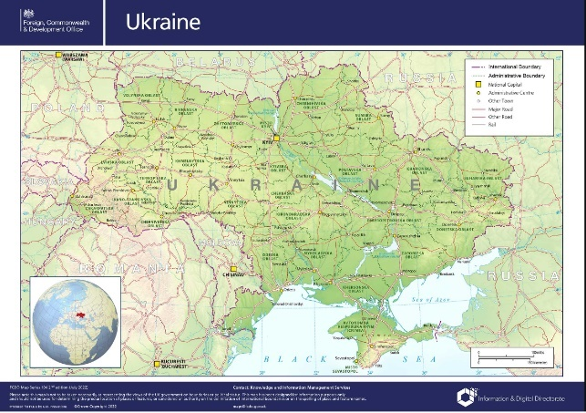
Prior to Russia’s invasion of Ukraine, the Government of Ukraine used a number of tools co-developed through AT2030 and delivered by GDI Hub, UNICEF, WHO and CHAI to identify their AT needs. Results from tools such as, the Rapid AT assessment, Country Capacity Assessment, and Assistive Priority Products list, meant that the Government already knew what AT they needed.

AT was systematically sent to crisis for the first time


Aligned with WHO’s strategy for Ukraine, this enabling work made it possible for WHO, for the first time in a crisis situation, to support the Government of Ukraine with the provision of Assistive Products. Boxes AT6 (AT products for 50 people in a hospital ward) and AT10 (AT products for 50 people outside of a surgical ward) were procured and sent to Ukraine – only possible because of the earlier work done to identify their AT needs. In total, approximately 3000 products were shipped. While AT2030 did not buy the assistive products, it offered catalytic insights and tools, innovation in process, and research on impact without which AT procurement and provision during the crisis would not have been possible.

AT2030 through the GDI Hub is now working with the WHO to learn the lessons and map next steps to extend the provision of AT to other crisis situations e.g. Turkey and Syria.

AT2030 Procurement Workshop to a Global Readiness Response

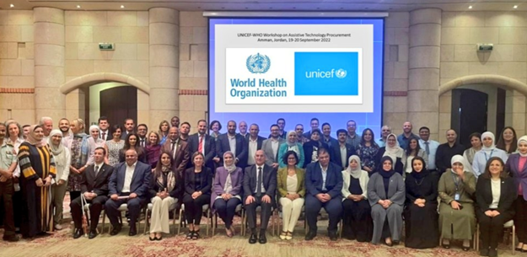
As a direct result of the AT2030 regional procurement workshop held in Jordan in 2022, new work is being scoped on AT (access) in Humanitarian settings (country TBC, in consultation with WHO). This ‘global readiness response’ work will also serve to support the WHO to continue to evolve and pilot their approaches to integrate AT into health systems to substantially increase access to AT, including people with disabilities who have been displaced.

Ripples from AT2030 research creating new partnership opportunities
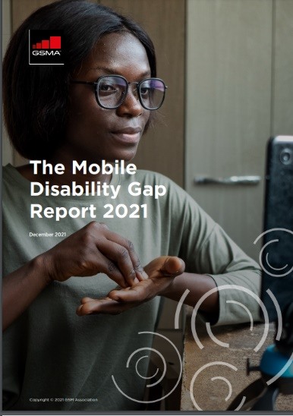
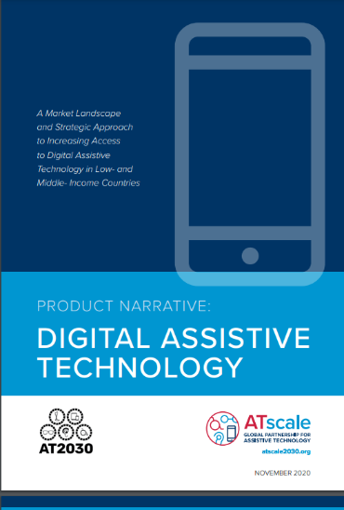
AT2030 research has the effect of creating ripples which spark new partnership opportunities.

For example, the initial support to evidence the mobile disability gap with partners GSMA, combined with the Digital Product Narrative (both AT2030 outputs) catalysed interest in ‘Mobile as AT’, which has now attracted $400k of matched funding from ATscale (the global partnership for assistive technology) and Google.

This in turn led to the discovery that low-cost Android devices are inaccessible to blind people, and a further partnership with Safaricom to ensure their next entry-level smartphone will be fully accessible.
.

3. Leverage AT2030’s global networks to provide an offer to FCDO and Posts on a new localised, transformational approach to AT. This will include an offer to:
- build the evidence base of what works to provide AT to people with disabilities, an underserved and marginalised population in relevant countries;
- test the development of new technologies and innovative approaches; and
- generate insights and proven methods, to support diplomatic relationships and boost ‘soft power’ with national governments.

Below are the priority countries for AT2030 at present, though this can be enhanced where strong alignment is found with FCDO and Posts’ priorities.
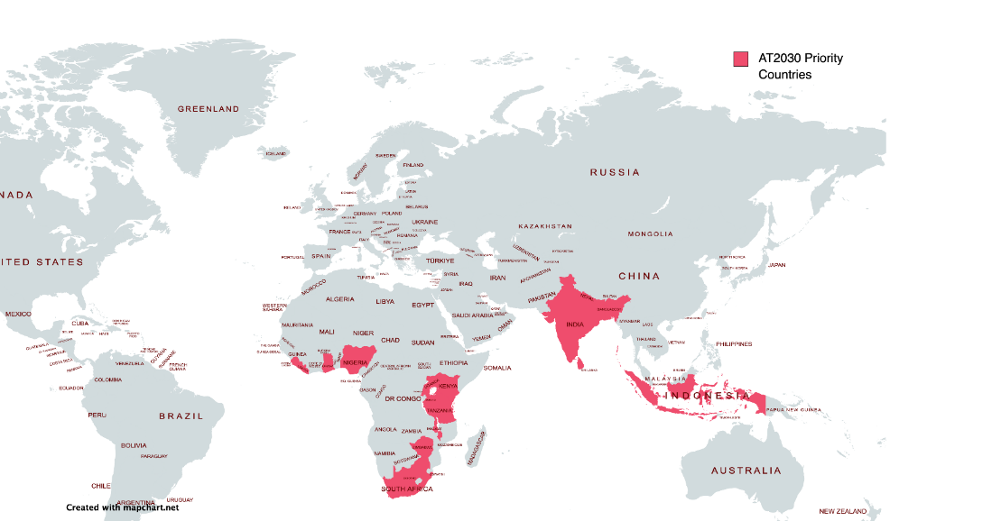

This offer to FCDO and Posts:
- will help them design and deliver national AT action plans built on AT2030’s innovative (health, education or technology) systems strengthening work;
- offer new insights on AT and associated services (including the design, use and testing of new artificial intelligence (AI) tools); and
- drive innovation ecosystem building.

The support will extend AT coverage but also develop wider data sets to offer critical learning. A process to access this support will be identified with FCDO and GDI Hub. We will take account of partner match funding opportunities to maximise UK investment.

GDI Hub is well placed to deliver this transformational approach to AT systemic change, as they are already working with other regional partners and bi/multilaterals (World Bank, IFC, Asian Development Bank, UNICEF) as well as private sector partners (Google, Microsoft, PWC) to begin this work.

4. Research and Evidence to Support Cross-Government priorities.

The extension to AT2030 has been designed to support:
- FCDO’s International Development Strategy (IDS), contributing to seven of the SDGs (see summary on next page);
- FCDO’s 2022 Disability Inclusion and Rights Strategy and commitments made at the 2022 Global Disability Summit.
- The Open Science for Global Resilience campaign, one of the seven UK Development Leadership campaigns;
- The UK’s International Technology Strategy through the development of inclusive technology solutions via mission-driven investment.
The programme scale-up will provide opportunities for UK cross-government collaborations through the development of AT measurement and other tools (e.g. the Country Capacity Assessment) and increasing focus on AT research, innovation and scale. Minister Pursglove MP, Minister for Disabled People, is planning to announce the programme uplift at the major Conference of State Parties to the Convention on the Rights of People with Disabilities in June 2023, as part of the drum beat of the Open Science for Global Resilience Campaign.

As an example, opportunities to engage with the Department of Business, and Trade (DBT) will be sought to create opportunities for import and export tax breaks, incentives for the provision of assistive products in LMICs and the promotion (and growth) of AT entrepreneurs and businesses through DBT’s networks and trade shows.

GDI Hub will also strengthen its links with UK focussed departments and organisations such as Cabinet Office on their AT action plan, UK Research and Innovation (UKRI), Nesta, and the Department of Health, where there is potential for AT2030 to engage on the potential for use of prosthetic innovations in the UK.
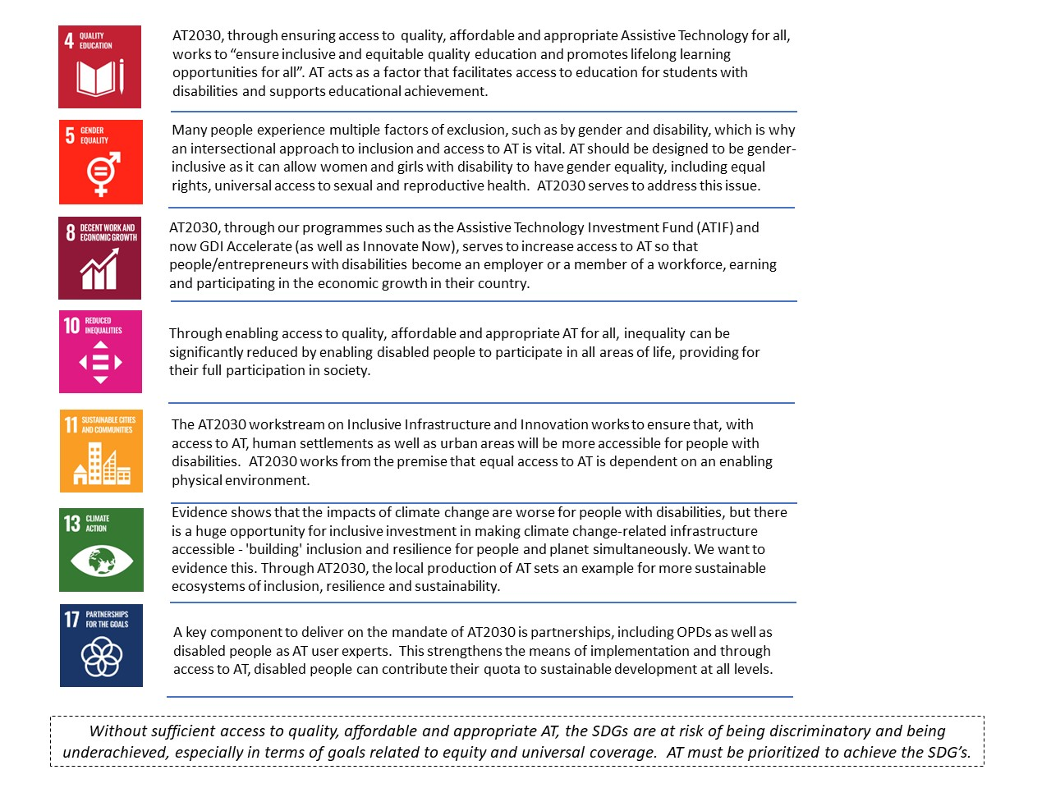

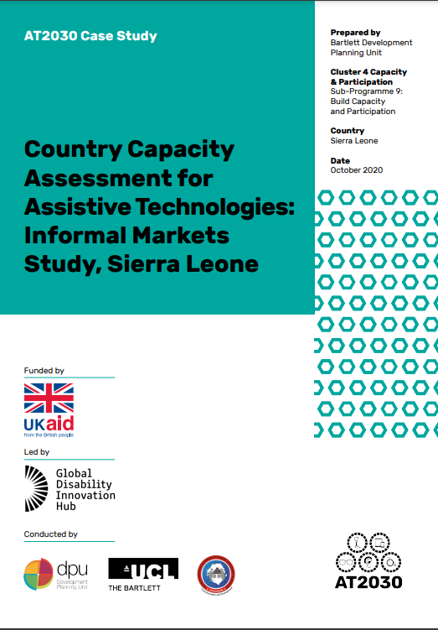
Country Capacity Assessments (CCA) from LMICs to the UK

AT2030 developed and tested CCAs to better understand the national landscape of AT supply and demand. Working with University College London (UCL), the WHO and Clinton Health Access Initiative (CHAI), GDI Hub developed and refined the CCA approach across 10 LMICs. These include the AT Capacity Assessment tool and the rapid AT Assessment tool measuring population data, to create a CCA toolkit.

Bringing fragmentated stakeholders together for the first time, CCAs have proven to be instrumental in raising policymakers and wider stakeholders’ awareness of the need for and the importance of AT - as well as the current gaps in AT provision - aiding decision-makers to understand what their AT priorities are. By enabling data collection at both a systems and community level, the process of embarking on and concluding the CCA process both enabled the collection of data, and motivated countries to pursue continued progress in the access of AT for people with disabilities.

Following the success of AT2030's implementation in LMICs of CCAs, a CCA was commissioned for England by the Cabinet Office in 2022. An announcement of the publication of the CCA will be made by Minister Pursglove, Minister for Disabled People, at the Conference for State Parties (COSP) in June 2023.

What is the additional and total support the UK will provide?
The period of the programme will be extended to 31 March 2030 (depending on milestones being met). The programme value will increase by up to £31 million. This will bring the programme total to up to £50.8m by 2030. AT2030’s 2023/24 and 24/25 budget planning include provision for the programme’s scale-up activities and is already factored in and affordable under Research & Evidence Directorate’s ODA R&D allocation. The anticipated disbursement amounts and timelines for the £31m uplift are shown below, including planned spending per Cluster:

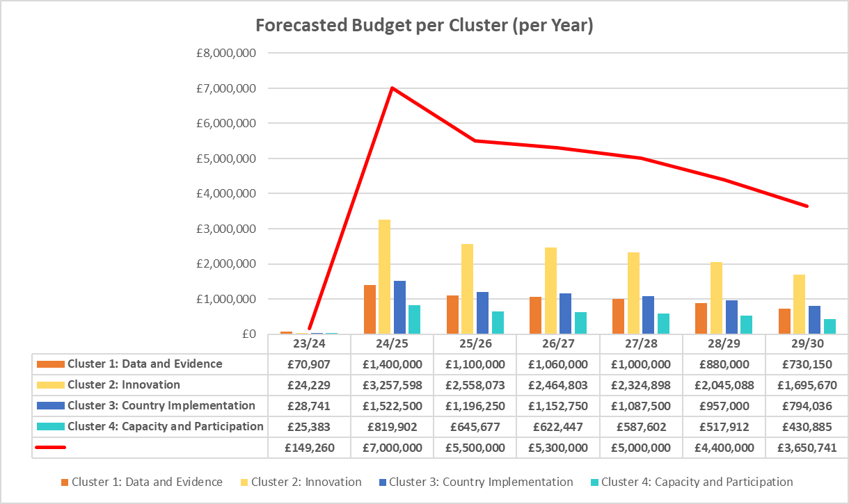

AT2030 will continue to have (and deliver on) a 100% match funding target.

To date (as of 31 March 2023, the end of the most recent reporting period) AT2030 has raised £15.3m match funding (exceeding its 22/23 annual target of £15m) and well on the way to its overall £19.8m target - and it has leveraged £12 million of additional private sector investment.

What are the expected results?
With an additional £31 million over a 5-year period, the uplift will deliver the following:

Outcomes:
- 30 more AT innovations on track to scale;
- 15 more innovative service delivery models on track to scale;
- 60 (including 10 through GDI Accelerate) more AT Ventures supported for sustainable growth.
- 45 more countries or organisations implementing AT2030 funded ideas (findings, research, or new methodologies).

Outputs:
Data and Evidence
- 80 peer reviewed journal articles published
- 120 influencing papers, answering critical research questions
- 220,000 downloads/views of publications/papers
Innovation
- 38 innovative ATs supported
- 22 innovation ecosystem development intervention
Capacity and participation
- 50 partnerships supported to increase AT capacity
- 75 strategic tools developed to increase AT capacity
- 30 case studies produced
- 100% (£31 million) in match funding (in cash or in-kind) through partnerships
Country testing and implementation
- 8 procurement pilots/frameworks at the country, regional and global level
- 30 Country level strategies for disability inclusion and AT access

What is the approach to implementation?
The (up to) £31m uplift and 5-year extension to the programme will enable AT2030 to build on its success to date, prioritising four main areas:
- Scale access to assistive technology innovations in LMICs. Building the evidence base around the use of innovative products and approaches to crowd-in investment for AT including from multilaterals and the private sector.
- UK leadership of research, partnerships and evidence in the AT sector reaching millions. Promoting UK’s research, technology and business excellence in AT internationally.
- Leverage AT2030’s global networks to provide an offer to FCDO and Posts on a new localised, transformational approach to AT.
- Research and evidence to support UK cross-Government priorities.

The time and cost extensions will extend programme delivery under each of the existing four programme clusters: Research Data and Evidence; Innovation; Country Implementation; and Capacity & Participation – as summarised below.

Geographically, AT2030 will prioritise its work based on a combination of national political will/engagement on disability and AT, the evidence-based need, and demand from Posts, in a focused range of countries, likely to include: Ethiopia, Ghana, Kenya, Liberia, Malawi, Nigeria, Rwanda, Sierra Leone, South Africa, Tanzania and Zimbabwe (in Africa), , Indonesia and South Asia. This will deepen our understanding of ‘what works’ in the AT sector, for AT innovations and investments, to ‘fail fast’ and scale the interventions that work to reach even more people with the life-changing AT they need. The final list of countries will be dependent on ongoing conversations with and uptake from FCDO Posts and departments.

As outlined above, the AT2030 uplift will continue to be organised under four programme Clusters:

- Cluster 1 - Data and Evidence: new research on AT and disability inclusion
This cluster of sub-programmes improves data and evidence to enable better decision making by innovators, entrepreneurs, policy makers, programme managers and investors to scale access to affordable AT and unlock investment into the sector.

Already, AT2030 has developed a broad set of research and evidence tools, such as five ‘Product Narratives’ which provide a market landscape for five key assistive products (wheelchairs, spectacles, digital devices, prosthetics and orthotics and hearing-aids and digital tools such as the AT data portal). In total 175 research and evidence outputs have been created to date (as of 31 March 2023) of which 58 were peer reviewed publications.

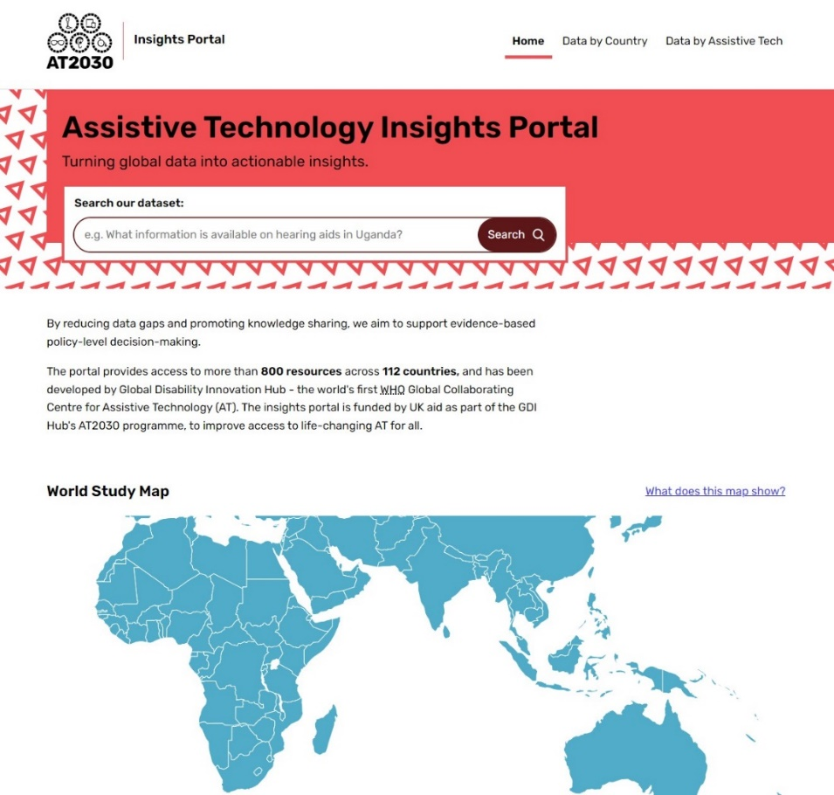

These tools underpin the other three clusters of work, collecting data and analysis to understand what innovations, interventions and approaches work and in what context. The cluster conducted the research for six background peer-reviewed papers for the WHO and UNICEF Global Report on Assistive Technology covering reviews of: supply and demand, humanitarian contexts, innovation strategies, economic evaluations and market shaping. The cluster team were also part of the authorship and expert review panel for the UNICEF/WHO Global Report on AT, ensuring data and evidence collected across AT2030 e.g. rapid assessments of assistive technology (rATA) were represented in the report.

Data from AT inclusive studies - e.g. r(ATA) data, cohort studies and national routine data collection efforts - are being used to enhance the AT data portal, which will be the primary source of knowledge for policy-makers, academics and entrepreneurs within the AT space. Further developments of the tool will introduce a digital storytelling agent powered by artificial intelligence (AI), to allow for these user groups to infer and synthesise new knowledge about the need for AT using large datasets, complementing traditional population household survey techniques. Household surveys are also being conducted and a new AT2030 tool – the Functional Needs Assessment for AT (FNAT) has been developed which, for the first time, will enable a single mobile application to screen for hearing loss (using ‘Hear X’ technology), vision loss (using the London School of Hygiene and Tropical Medicine’s (LSHTM) ‘Peek’ technology) and mobility and cognitive impairments using validated questionnaires. The tool has been developed to work offline and is a collaboration between LSHTM and UCL. A pilot usability study was conducted in Uganda in April to assess the validity and reliability of results, learning from which will feed into a revision and update of the mobile FNAT tool.

Further, a data and evidence partnership between AT2030 and the International Society for Prosthetics and Orthotics (ISPO) led to the first review of digital manufacturing processes (such as Computer Aided Design and 3D printing) in the sector. This was accompanied by a stakeholder consultation process which involved interviews with AT users and practitioners. AT2030 found that there is a severe lack of evidence for innovations in prosthetics and orthotics (P&O) manufacturing beyond technology readiness level 5. Building on the work of AT2030, ATscale, the Global Partnership for AT, are supporting two ISPO projects to improve the quality of evidence in the prosthetics sector.

AT2030 data and evidence have also supported the study design for evidence collection across the innovation cluster of programmes. Examples include:
  - Conducted the first clinical study of a new prosthetic liner in Kenya. This study was designed by partners at UCL, the AIC Cure Hospital in Kijabe, Kenya and the Association for the Physically Disabled of Kenya (APDK) rehabilitation clinic in Mombasa.
  - Assessed the Innovate Now curriculum and programme - conducted by Maynooth University and the University of Nairobi with support from UCL.
  - Conducted assessments of the role of mobile and digital technologies in empowering people with disabilities in Kenya. This work resulted in a number of academic peer-reviewed publications (‘Wheelchair Manufacture - Value beyond function: analysing the perception of wheelchair innovations in Kenya manufacture’, and ‘Wheelchair User and mobile - The Social Network: How People with Visual Impairment use Mobile Phones in Kibera, Kenya’).

AT2030 also developed the data collection protocol for GSMA’s first Mobile and Disability Gap Report, 2019. This protocol has been re-used in subsequent gap reporting by GSMA. A final paper from the 2019 GSMA data set was written by UCL and LSHTM researchers and will be published in 2023.

All of the research outputs have been re-analysed against AT2030’s overarching research questions to establish a collection of evidence of ‘what works’. A series of papers will be published from this body of work. The evidence from this review will be shared through targeted dissemination plans at international, national and local levels to build capacity on what works to improve the affordability and accessibility of AT and will feed into plans for the future development of the AT2030 programme.

All AT2030 research outputs (as of 31 March 2023) can be found here.

What the uplift will deliver
Based on recommendations from the WHO/UNICEF 2022 Global Report on AT, the extension will test and develop evidence on new and emerging areas of insight and innovation in AT and disability, such as Education Technology - aligned to Research and Evidence Directorate’s EdTech programme; Digital AT including AI; and support for non-physical disabilities such as neurodiversity. In alignment with FCDO’s IDS priorities, AT2030 will extend its research, evidence and solutions to build on the AT sector’s understanding of; inequality of access to AT for girls and women; AT in humanitarian contexts; and inclusive climate resilient infrastructure, alongside the role of digital in unlocking assistive products and services for the afore mentioned groups and contexts. Research partners currently include leading academic, and policy bodies in the sector, digital leaders and local partners: UCL, LSHTM, Google, Maynooth University, Loughborough University, the United Nations Educational, Scientific and Cultural Organisation (UNESCO) Centre on AI, the WHO, Kathmandu University, and the University of Nairobi.

AT2030 will work with teams across Research and Evidence Directorate (RED) to establish shared objectives. For example, working with:
- Education, Gender and Inclusion Team on EdTech AT.
- Technology and Innovation Unit’s (TIU) Mobile for Humanitarian (M4H) and Mobile 4 Development (M4D) programmes implemented by GSMA (GSMA already have an established AT partnership with AT2030), to level up access to mobile technology for people with disabilities. We will also work with the TIU through the GSMA on mobile as an AT in a range of settings.
- Tech, and Green Cities Centre of Excellence through the TIU and the Infrastructure Centre of Excellence the Growth Research Team, establishing respective offers on disability inclusion and AT.

The programme will conduct roundtables to identify shared priorities with a number of UK Government Departments including Cabinet Office, the Department for Business and Trade (DBT), the Department of Health (DoH), and the Office for National Statistics (ONS). We will support data collection and analysis and build collaborative opportunities, for example, working with DBT on research around tariffs for AT import and export in alignment with other life-changing health products to assess if there is an improvement in access to AT.

- Cluster 2 - Innovation: greater investment in, and evaluation of AT innovations and entrepreneurship

AT market failure has been driven by a lack of awareness of the need for AT, discrimination and stigma, a weak enabling environment, lack of political prioritisation, limited investment, and market barriers on the demand and supply side. The AT2030 programme has demonstrated the AT market is a sector of sectors. This makes the task of scaling innovations more challenging (Holloway et al. 2021). Furthermore, there is a lack of innovations globally which support AT provision or supply, which means novel products fail to reach the marketplace (ibid) as they realise too late that distribution and provision will be a significant challenge.

The innovation cluster seeks to develop, trial and test new innovations including AT products and service delivery models to establish lower cost and high-quality manufacturing methods and products. The uplift to the programme will support entrepreneurs and innovators with a range of capital, venture building support, business knowledge and skills, environments for medical testing, and improved service delivery models to further test ‘what works’. Coupled with building a stronger enabling environment, the sub-programme will improve supply and demand for AT and develop and prove the business case to attract private sector investment and venture capital into the AT market. It will do this by developing evidence to support business development and connect ventures to new LMIC markets through targeted partnerships. The cluster will investigate the feasibility of a range of finance options and conduct robust research to de-risk the market and build confidence among potential investors in AT.

Innovation and entrepreneurship support has been tested through AT2030 via an early-stage accelerator in Kenya (Innovate Now) and an Africa-wide AT Impact Fund (ATIF). Innovate Now has demonstrated the ability to build a pipeline of African ventures through a proven curriculum and toolkit (Smith, 2021). ATIF has demonstrated the value of more bespoke packages of support for later-stage ventures. Since the inception of Innovate Now there has been a significant increase in the number of accelerators joining the AT space. There is now an established AT innovation pipeline through Innovate Now, which now draws funding from NORAD, after successfully testing ‘what works’ through AT2030. However, there is not the same growth in later-stage innovation funding and evidence development, which is most critical for future scale of the sector.

Innovate Now and ATIF are individual elements of an emerging AT ecosystem. AT2030 has learnt that:
- The Innovate Now (IN) curriculum is proven to enhance and progress ventures, but there is too big a gap between IN and ATIF.
- There is a clear demand for further evidence to unlock investment which is necessary for ventures which have come out of an accelerator. However, accelerators often only get ventures to the point of pre-trial. This demonstrates a large gap which is supported by the recent ISPO and AT2030 review of digital manufacturing of P&O as a sector.
- There needs to be better connections between AT accelerators in LMICs and scale support which develops the evidence and the business case alongside one another.
- Development of a global AT ecosystem which leverages the global expertise within the UK for design, robust data and evidence can be used to develop south-to-south venture learning and support whilst also offering more opportunities for UK companies to easily enter emerging markets.
- The role of digital AT is imperative for unlocking the opportunities for scale and mobile technology will be key to this success. Mobile can unlock potential as it can be used as a diagnostic tool, can replace traditional assistive products (e.g. screen readers) and can be used for novel AT e.g. automatic sign language recognition. Based on expertise demonstrated through AT2030, GDI Hub are also currently exploring a partnership with Google which would support a future study to investigate the power of mobile as AT, which would include donations of mobile phones and technical support. Furthermore, AT2030 is collecting case study evidence of examples of digital financing of AT by individuals linked to employability.
- Ventures are often geographically isolated, having been incubated and accelerated within a city or country. Often for these ventures to scale they will need to have a global mindset seeking opportunities for where their product and market offer is most acceptable. For example, there are emerging examples of cross-subsidy models between high- and middle-income markets.
- Grant income and technical support is not enough to de-risk the investment of non-aid public money or private investments. As part of ATIF, the proven ‘scale studio’ model worked (i.e. the provision of technical and venture support alongside grant) but larger investments need to be trialled to demonstrate market commitment and confidence in AT ventures, if these products are to be affordable and accessible to people in need, moving from thousands of users to millions of users. The blueprint for this new vehicle is being worked up at present with PWC providing low bono support.

What the uplift will deliver
Drawing on AT2030’s experience of innovation accelerators, venture building and networks, GDI Hub launched ‘GDI Accelerate’, a new products-to-scale investment vehicle. The programme uplift will provide significant funding to ‘GDI Accelerate’ (up to £10m), to connect entrepreneurs to dedicated researchers to develop the evidence they need, give access to global leaders for mentorship and provide bespoke business support through partners and introductions to investors at the right time. This programme of work will include a strong research component, to develop and strengthen the evidence base to attract investment into the sector. GDI Accelerate is focused around three key elements, an insights hub, venture studio and bespoke consultancy. Together they will harness the value of innovation to drive impact.
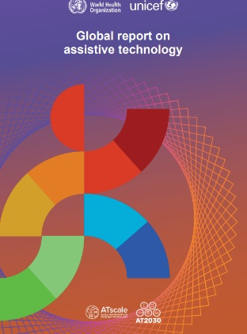
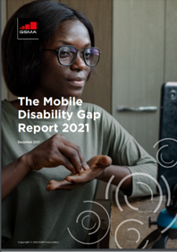
Building on the learning focused on digital AT, mobile phones have the power to mainstream the use of innovative AT. They allow mobile ‘pay as you go’ payment models to be tested, allow people to search for AT and can host applications which act as AT. For example, around 50% of the products in the Assistive Products List could be replaced by mobile apps or applications. However, using Kenya as an example, while around 70% of people have access to mobile phones, many do not know how to use them, particularly accessibility apps, applications and features and therefore, they require training. AT2030 will build on the work completed by programme partners GSMA to pilot delivery on the recommendations of the ‘Global Disability Gap Reports’ from 2020 and 2021, which assessed usage and ownership of mobile technology among people with disabilities in seven low- and- middle- income-countries. The ‘mobile as AT’ sub-programme will have two core deliverables. First, AT2030 will deliver mobile-accessibility pilots and wrap-around research, testing the feasibility and impact of mobile phone provision for people requiring assistive technology (AT), aligned to our countries of focus. Second, support mobile-enabled AT ventures to scale within ‘GDI Accelerate’, and in collaboration with GSMA, leverage private sector investment and open the door for scale through the telecoms sector.

- Cluster 3 - Country Implementation: new pilots and initiatives at the country level, to embed AT into national policy landscapes

To open-up market access, AT2030 is aligning and consolidating global AT efforts, as well as laying the foundations for systems level change by providing a set of global benchmarks and standards for AT. We have (so far) produced 26 assistive product specifications, describing the minimum requirements related to the technical performance and function that products should meet for safe and effective use, addressing six key areas of functioning (mobility, hearing, vision, communication, and self-care). General descriptions rather than describing a brand allows competition amongst suppliers which can bring down costs. This provides a starting point for procurement teams.

Further, led by the Clinton Health Access Initiative (CHAI), the programme developed a series of product narratives (for wheelchairs, digital devices, eye-glasses, prosthetics, hearing-aids) to scope market shaping opportunities and drive global investment. Each product narrative provided a set of objectives and recommendations to target the root causes of market shortcomings (for each product) at the demand and supply side to improve market outcomes and make AT more accessible.

Bringing together the WHO, GDI Hub and CHAI, AT2030 developed and refined the ATA-C (AT assessment of capacity) and rATA (rapid AT assessment of population data) tools to create a Country Capacity Assessment (CCA) toolkit. This was, designed to enable data collection at both a systems and community level respectively to give an overarching view of the national landscape in relation to AT. The tools have now been trialled across a number of countries, including 7 countries in Africa, Mongolia and Indonesia. These have raised policymakers and wider stakeholders’ awareness of the need for and the importance of AT - as well as the current gaps in AT provision - aiding decision-makers to understand what their AT priorities are. These tools further support countries to develop national action plans. AT2030’s Country Investment Fund trialled a range of activities (based on national action plans) in five countries to deliver foundational, strategic and agreed AT priorities to build an evidence based on what works to get AT to the people who need it.

WHO have been instrumental in supporting procurement processes through the AT2030 funded Training for Assistive Products (TAP) module and TAP MOOC (massive open online course, available to all); in addition to the trial and testing of One-Stop-Shop models of AT Provision at the country level. Further research, analysis and evidence will provide a set of options for country governments to consider in their approach to sustainably improving affordable access to AT.

What the uplift will deliver
The uplift to the programme will expand access to, and further develop and pilot, the ‘Assistive Products Standards’ (APS), developed through AT2030 with the WHO, and will develop a new AT service standard, which guides local/national procurement teams in developing their own procurement specifications. The operationalisation of the APS will have a focus on Accessible and Assistive Tech (AAT) apps and tools which have been recently demonstrated in Rwanda to procure hearing aids, achieving a reduced unit price from around $2000 to $140.
Radically reducing the cost of AT

Incorporating specific ATs into the UNICEF catalogue can radically reduce the price per unit (from 2,000 USD per unit when procured in country to 140 USD per unit when procured via UNICEF). Access to hearing aids has increased somewhat in the country but the support that is needed to truly increase access and use is related to funding and scaling (linked to cluster 2).

We will also trial support of national, regional, and global procurement mechanisms to improve access to Assistive Products aligned to the APS, through partners including UNICEF, CHAI, ATscale and WHO. This includes support for country-level demand generation as well as practical support for procurement processes - continuing to build the evidence base.

Separately, further investment through innovative country implementation pilots (trialled through the Country Investment Fund approach) will drive strategic ‘trial and test’ policy and implementation solutions already identified through a series of ‘Country Capacity Assessments’ (CCAs). CCAs enable data collection at both a systems and community level to provide an overarching view on a national landscape in relation to AT. Country implementation pilots will trial approaches to implementing CCA recommendations, underpinned by research evaluating the impact of investments for each funded project and, disseminating the research findings via stage 1 implementation Evaluation Case Studies.

The uplift will support the development of national action plans, developed by in-country stakeholders including governments in four more countries based on an open call for support (learning from what worked in the existing four pilot countries). It will also work with WHO to consider how to streamline and reduce the costs of CCA activity, following a successful combined approach for the Cabinet Office in England (by GDI Hub). This work will be conducted in consultation with ATscale, the Global Partnership for Assistive Technology, as once AT2030 has tested and proved these new approaches, ATscale will take over as the longer-term implementation partner for this work at scale. WHO impact research will be conducted as well as case studies written up to ensure dissemination of the newly gathered evidence.

A cross cutting theme of the work which will be drawn out is ‘Social Justice’. This will place a gender lens across the whole programme drawing out differentials in insight, innovation and impact. This cross-cutting approach will also consider the ‘for what’ of AT (a framework) building out and testing the AT Social Justice model currently in development (the need for which is set out in Austin & Holloway, 2022).

- Cluster 4 – Capacity and Participation: expanded global partnerships to build and leverage commitments and investments from multilateral, bilateral, private sector, and NGOs

The programme has learned from and builds the capacity of existing community-led activities through action research. Scoping community-led solutions to AT, researching their practice and developing mechanisms for the amplification of AT users in informal settlements in Sierra Leone and Indonesia, has informed the broader programme.

‘Inclusive Infrastructure’ considers that equal access to AT is dependent on an enabling physical environment that allows for participation in various life domains e.g. education, employment etc. The sub-programme engages a range of stakeholders including city officials, Mayoral offices, urban planners, and builders and with the inclusion and participation of AT users, to help shape the design of an inclusive built environment. Substantial learning and momentum gained from case study research undertaken in six global cities (Nairobi-Kenya, Varanasi-India, Solo-Indonesia, Ulaanbaatar-Mongolia, Freetown-Sierra Leone, and Medellin-Colombia), will culminate in a Case Study Comparison Report and a Global Action Report. FCDO Posts were engaged in the dissemination events.

AT2030 has been instrumental in growing the global partnership to galvanise efforts to ensure that AT reaches those that need it. Across the programme important partnerships have been developed such as with the International Society for Prosthetics and Orthotics (ISPO), and with a range of academic partners across the globe. We work with over 70 partners in 41 countries and have supported the growth of ATscale, the Global Partnership for AT. All evidence points to the fundamental importance of partnerships and networks.

Separately, AT2030 supported the broadcast of the Tokyo Paralympics to 49 sub-Saharan counties for the first time ever, alongside research on parasport and stigma.
Para Sport Against Stigma Research

With programme partners, the International Paralympic Committee (IPC), TV Media Sport (TVMS) led the distribution and broadcast of the 52-minute highlight packages of African centred content to 49 National broadcasters across Sub Saharan Africa for the first time. The highlights aimed to highlight stories of Para athletes from the region. Loughborough University conducted parallel research to better understand the impact of the broadcasts.

The findings indicate that Paralympic broadcasting is an important vehicle in disability representation and the development of empowering disability narratives. However, Paralympic broadcast through National state TV alone is not sufficient to challenge widespread intersectional forms of disability stigma and discourses around AT use. For the Paralympic broadcast to have reach and impact in Sub-Saharan African countries with a communication/ media ecology and infrastructure such as Malawi, and to be sustainable as a social change vehicle, a range of media activities and diverse forms of distribution will be required. This should include broadcast via more accessible platforms such as radio and digital streaming, as well as community screening via community hubs (e.g. in schools).

Localising Paralympic content through Chichewa interpretations and commentary was successful. The Chichewa interpretations and commentaries were important in localising the content for Malawian audiences and making it more accessible for a wider audience share. Further, the translations provided additional audio content to the highlights package that tackled local understandings and narratives around disability discrimination, stigma and AT use.

For the broadcast to be financially and socially sustainable medium for long term cultural change, commercial independent broadcasters with the capacity to invest in the Paralympic highlights package and provide additional programming with may be more suitable than National state television broadcast channels.

Audience and community research indicate that Paralympic coverage is a useful tool for tackling negative cultural disability attitudes and showcasing the role of AT in enabling individuals with a disability to play sport and participate in civic life. The use of personal and localised stories of Para athletes were particularly powerful in capturing audiences and reducing some forms of disability stigma.

What the uplift will deliver

As part of this extension, provision will be made for a tailored technical and practical research and innovation offer to FCDO and Posts including Centres of Expertise. The programme team will identify opportunities for impact, working through the AT2030 FCDO Senior Responsible Owner, Posts and advisers to provide an appropriate offer. Decisions will be based on available resources and potential for impact and learning.

Thematic areas will include:
- AT and girl’s education (education/education technology programmes more broadly)
- AT and health
- AT and humanitarian and
- AT and economic empowerment.

This will build an evidence base to embed an inclusive approach to a range of FCDO countries (through an offer to Posts), programmes and portfolios and enable AT innovations, services, and approaches to test and scale. AT2030 will work with dvisers at FCDO Posts, BII and UK Government Departments to establish and address mutual aims and objectives.

Advocacy work will build on, and leverage, the global disability inclusion movement (comprising multilateral, bilateral, private sector, NGOs, and Disabled Persons Organisations (DPOs)) focussing on the Indo-Pacific, and Africa regions. Building on the programme’s existing track record at platforms such as UNFCCC-COP (United Nations Convention on Climate Change – Conference of the Parties) and the World Urban Forum, it will extend existing programme linkages with the Asian Development Bank (ADB) to support outreach in the Indo-Pacific region.

The ‘Inclusive Infrastructure’ sub-programme will be expanded to include Disability Inclusive and Climate Resilient Cities. This builds on current research which highlighted the impacts of climate change on the lives of persons with disabilities living in cities. This will be explored further, building an alignment with FCDO’s ‘Economic Empowerment’ and ‘Green Cities and Infrastructure’ Centres of Expertise to develop a stronger evidence base to underpin FCDO’s approach to inclusive and climate resilient infrastructure and urban development. Further, the uplift will allow the recommendations from the Global Action Report to be implemented, by supporting a pilot city through the process, building evidence through embedded research to demonstrate what is possible for delivering an inclusive built environment that supports the use of AT in everyday lives. The process will be documented to support other cities take forward the recommendations.

The ‘Para Sport Against Stigma’ sub-programme will continue to build on this learning and extend community level work ahead of and around the Paris 2024 Paralympic Games. This will optimise relationships with the International Paralympic Committee (IPC), the UK Envoy for the Olympics and Paralympics in Paris and international disability inclusion campaigns.

Programme Reach

Through a £31m uplift, AT2030 will reach 9 million more people directly and 12 million more people indirectly with AT and its associated services. This brings the total reach numbers to direct reach to 18 million and indirect reach to 40 million.

In the previous phase of the programme, we targeted a wide number of countries to build a broad data and evidence base. We also undertook a range of work to achieve systemic change at the national level, e.g. the development of AT policies and action plans which had a wide reach, often across a country’s population.

In this new phase of the programme, we are moving focus and investment to build on AT2030 research and evidence and to implement our findings, while making our research and data more accessible. The programme scale-up will therefore target a more focussed set of countries and deepen our understanding through further research. We will also provide a greater proportion of programme capital and venture building support to a smaller number of innovations with high potential to reach scale. These actions in relation to AT will prove the return-on-investment, de-risk ventures for potential investors and crowd in funding from private sector and multilateral organisations for scale and sustainability, while in parallel developing the AT ecosystem in country.

While the programme will continue to develop the policy environment, there will be less emphasis on this in the scale-up (and therefore less ambitious reach numbers) as we focus instead on Government implementation of policy. However, it is expected that by growing a range of sustainable AT ventures, and sharing the lessons learned of what does and does not work with other AT ventures and entrepreneurs, reach numbers will continue to grow beyond the life of the programme. Through this approach, AT2030 learning will support more context specific affordable AT ventures and innovations to scale, improving investment in, and access to AT on a larger scale over time.

The original business case contained a gender equality impact statement. This remains valid. AT2030 evidence already shows a gender disparity i.e., women have less access to AT than men. The programme will enhance its activities to measure the disparity between access based on gender and identify gender specific interventions to better understand what works to redress this imbalance.

AT2030 complies with Programme Operating Framework Rule 5 on compliance on climate and environmental impact and risks.
- This is a research programme and as such, there are not considered to be any climate and environmental risks.
- We will ensure that the programme aligns with target countries’ climate plans during the early stage of co-designing target interventions with Advisers at Post.

Describe any key changes to the original business case including the theory of change or new evidence from ongoing monitoring, evaluation or learning work?
The scale-up on AT2030 is informed by emerging evidence from the existing programme.

A full list of AT2030’s evidence and research (as of April 2023) available here. The most current version of the Theory of Change for the existing programme is shown below.
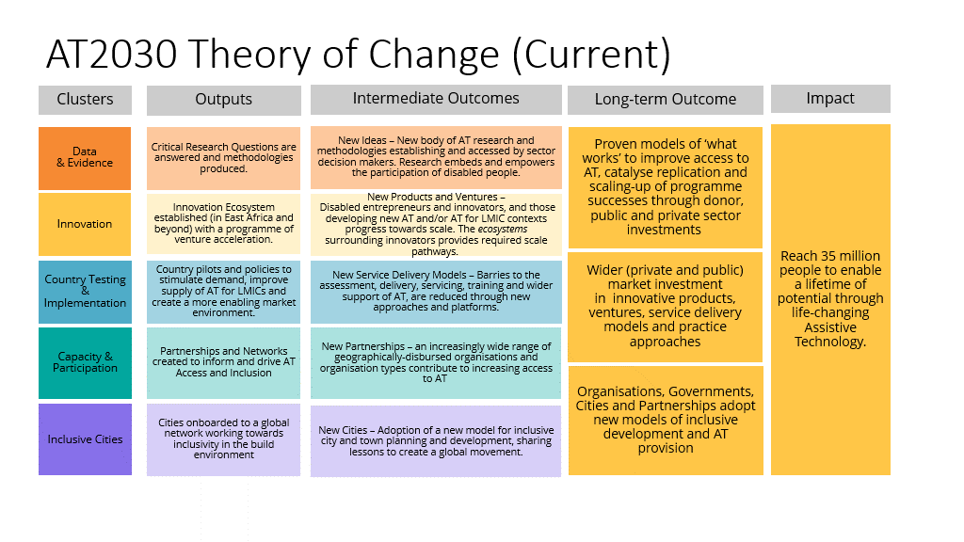

A ‘light touch’ review of the Theory of Change was undertaken in April 2023, and is included below. The following changes have been incorporated (i) cluster names simplified, (ii) outputs, intermediate outcomes and long-term outcome descriptions revised, and (iii) the impact reflective of the additional and cumulative beneficiaries to be reached. These changes clearly depict the change of focus of the programme, building on what has already been learnt and achieved, such as moving from new products and innovations to Scaling Innovation and Trialling Implementation Models.
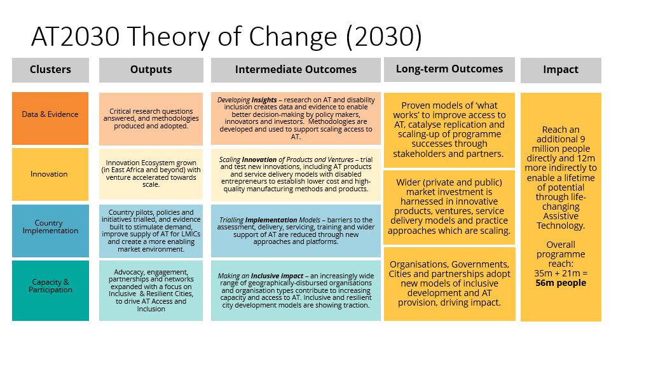
Lessons: AT2030 has identified a number of important insights from work to date:

Cluster 1: Data and Evidence
- The AT sector is not yet ripe for simply traditional market shaping methods alone . It is evident that AT is still in a stage of market-making, and public goods and innovation are still necessary to demonstrate and stimulate the market.
- The AT innovation sector needs to be more strategically joined up. Significant progress has been made, but we have learned that Innovate Now and ATIF need to be better joined up and businesses need to be aligned to real procurement opportunities (from Governments etc) to enable products to reach millions rather than thousands of people. We now need to invest further in taking AT to scale.
- We can now focus on deeper work in fewer countries (the programme so far having touched 70+) with a more strategic alignment of a series of interventions to drive transformational change in partnership with Government, Multilateral Development Banks and ATscale.
- A focus on digital AT e.g. mobile, and data and evidence to assess needs, provision, and barriers to scale is required.

These key learnings have served to inform the design of the next tranche of work in this cluster and its sub-programmes i.e. new research to focus on AT and disability inclusion to continue to improve data and build the evidence base to enable better decision-making by key stakeholders in order to scale access to affordable, appropriate, quality AT and to unlock investment into the sector.

Cluster 2: Innovation
- We must now consolidate and grow an offer building on the lessons learned on developing and scaling innovations in this nascent sector. In the next phase we will provide capital for a single AT venture vehicle ‘GDI Accelerate’, which will pool innovator and investor networks across the spectrum of venture maturity - innovation, acceleration, and investment, and it will be combined with sector growth. The new vehicle will have a wider geographic focus (i.e. beyond Africa).
- We must de-risk private investment through testing equity stake models.
- Roll-out the playbook for innovators entering new markets.
- This sector is on the radar of Venture Capitalists, but the business case for investment still needs to be made. We must now build out the evidence on return on investment to leverage private sector capital and venture funds.

From these lessons learnt, the design of the next phase of work in this cluster and its sub-programmes will focus on greater investment in, and evaluation of AT innovations and entrepreneurship.

Cluster 3: Country Implementation
- The UNICEF catalogue has proven successful as a funding mechanism for procurement of AT. We must continue to trial different funding mechanism options.
- We must strengthen the link to both public sector procurement and private sector investment, through further, deeper work on market shaping and market making.
- Where CCA data already exists (and building on lessons from existing CIF countries), we must continue to test, trial, and scale across a wider range of geographies.
- For implementation of the recommendations from the 2022 WHO/UNICEF Global Report on AT, we must trial new mechanisms such as expanded work (at a country level) on the role of mobile and digital AT.
- AT for what? (Austin, 2022) highlighted the need for a social justice framework for AT access, more work is needed to address this, as well as the need to apply a gender lens to the whole programme.

From the above key learnings this cluster and its associated sub-programmes will focus on new pilots and initiatives at the country level to embed AT into national policy landscapes, such as further developing and piloting the ‘Assistive Products Standards’ (APS), working with WHO to develop new AT service provision guidelines, trialling support of national, regional and global procurement mechanisms, and further investment through innovative country implementation pilots and the development of national AT action plans. A cross cutting theme of the work which will be drawn out is ‘Social Justice’. This will place a gender lens across the whole programme drawing out differentials in insight, innovation and impact.

Cluster 4: Capacity and Participation
- We must focus on ‘Disability Inclusive Climate Resilient Cities’, through extending the ‘Inclusive Infrastructure’ sub-programme to include the effects of climate change and consolidate work on building inclusive cities.
- Testing the recommendations from ‘Inclusive Infrastructure’ with a pilot city is important as the research has highlighted how a lack of implementation of policies and regulations is a critical issue for the creation of inclusive cities.
- Building on the lessons learned from the 2020 Tokyo Paralympics (which took place in 2021), we must extend our work with Paralympic cities, and test the stigma toolkit ahead of Paris 2024. This work leverages AT2030’s origin in the London 2012 Games and the creation of the inclusive infrastructure sub-programme from the lessons created by the London Olympic Park. The link between each Paralympic city, its built environment, inclusivity and impact on the perception of AT continues to be a key research focus for AT2030.

The above insights for this cluster and its sub-programmes have served to inform the next iteration of work with the objective of expanding global partnerships to build and leverage commitments and investments from multilateral, bilateral, the private sector and NGOs. The ‘Inclusive Infrastructure’ sub-programme will be expanded to include ‘Disability Inclusive and Climate Resilient Cities’ and the ‘Sport Against Stigma’ sub-programme will extend community level work ahead of and around the Paris 2024 Paralympic Games.

Assistive technology (AT) is the application of organized knowledge and skills related to assistive products, including systems and services. Assistive technology is a subset of health technology.
WHO & UNICEF. 2022. Global report on assistive technology. 1 ed. Geneva, WHO & UNICEF.
An assistive product (AP) is any external product (including devices, equipment, instruments or software), especially produced or generally available, the primary purpose of which is to maintain or improve an individual’s functioning and independence, and thereby promote their well-being. Assistive products are also used to prevent impairments and secondary health conditions. Source: Priority assistive products list. Geneva: World Health Organization; 2016 https://www.who.int/publications/i/item/priority-assistive-products-list, accessed 20 April 2022).
Innovative AT refers to new AT products (e.g. physical/software tools or devices) and AT-related innovations, or existing AT products and AT-related innovations used in new ways to enable access. ‘On track to scale’ refers to a venture that, as a result of AT2030 programme, experiences a projected increase in funding, user base, or proves the validity of their product.
‘Ventures’; describes the business organisation and surrounding ecosystem to support AT innovation
AT2030 engages and collaborates with a broad and active range of different organisations to “test what works” to improve access to AT. This includes formal partnerships and other types of collaborations with governments (departments, agencies, and public bodies), intergovernmental organisations, bilateral & multilateral organisations, specialized agencies, universities and academic institutions, Disabled People’s Organisations (DPOs), non-governmental organisations (NGOs), the private sector, AT innovators and entrepreneurs, support networks, media, foundations, innovation labs and manufacturers among others.
‘Ventures’, describes the business organisation and surrounding ecosystem to support AT innovation
AT2030 engages and collaborates with a broad and active range of different organisations to “test what works” to improve access to AT. This includes formal partnerships and other types of collaborations with governments (departments, agencies, and public bodies), intergovernmental organisations, bilateral & multilateral organisations, specialised agencies, universities and academic institutions, Disabled People’s Organisations (DPOs), non-governmental organisations (NGOs), the private sector, AT innovators and entrepreneurs, support networks, media, foundations, innovation labs and manufacturers among others
See example here: https://www.resna.org/sites/default/files/conference/2020/GAATO/150Barbareschi.html
FCDO and GDI Hub are founding members of ATscale, which was launched at the Global Disability Summit in 2018, with the aim of reaching 500m more people with AT by 2030. FCDO continues to support the fund.
https://at2030.org/static/at2030_core/outputs/Product_Narrative-Eyeglasses_final.pdf
https://ec.europa.eu/research/participants/data/ref/h2020/wp/2014_2015/annexes/h2020-wp1415-annex-g-trl_en.pdf
The importance of mobile in unlocking the potential of AT innovation was highlighted through the work of the data and evidence cluster within the WHO/UNICEF Global Report on AT and associated AT2030 research papers.
Countries of focus are anticipated to be Ethiopia, Ghana, Kenya, Liberia, Malawi, Nigeria, Rwanda, Sierra Leone, South Africa, Tanzania and Zimbabwe (in Africa), Indonesia and South Asia to surrounding nations such as Sri Lanka, Bhutan or Bangladesh)
The final list may change as a result of our outreach to FCDO and Posts, political will in country.
ATscale, the Global Partnership for AT was established at the Global Disability Summit in 2018. Founding partners were China Disabled Persons’ Federation, Clinton Health Access Initiative, Global Disability Innovation Hub, Government of Kenya, International Disability Alliance, Norwegian Agency for Development Cooperation, Office of the UN Secretary-General’s Special Envoy for Health in Agenda 2030 and for Malaria, UK’s FCDO, UNICEF, United States Agency for International Development, World Health Organization .The partnership’s vision is to vision is to enable a lifetime of potential where every person can access and afford the life-changing AT they need
AT2030’s 'What Works' workstream will deliver distilled and policy-focused findings based on AT2030 learning and research. This work will be delivered under the current Accountable Grant. The What Works project will pull together learning from across AT2030 to address the question ‘What Works to improve access to AT’. This work is motivated and framed by around 30 sub-questions which speak to the variety of delivery under AT2030. Each sub-question will be addressed by delivery leads and experts to produce written outputs capable of being compiled to a final volume which outlines ‘What Works to improve access to AT’. This project aims to influence the uptake within the AT and Disability Inclusion sector around increasing access to AT.
https://at2030.org/systems-thinking-and-market-shaping/
https://at2030.org/systems-thinking-and-market-shaping/
https://at2030.org/assistive-tech-impact-fund-the-story-so-far/

