Annual Review: 2023/24
Title: AT2030 – Life Changing Assistive Technology for All
Programme Value £ (full life): £50.8m |  | Review date: 31/10/2024
Programme Code: [AMP ID#]  300815-101 | AMP start date:  28/01/2019 | AMP end date:  31/03/2030

Summary of Programme Performance
Year | 1 | 2 | 3 | 4 | 5
Overall Output Score | A+ | A+ | A+ | A+ | A+
Risk Rating | Moderate | Moderate | Moderate | Moderate | Moderate

DevTracker Link to Business Case: | https://iati.fcdo.gov.uk/iati_documents/58742745.odt
DevTracker Link to results framework: | To be added before publication

A: SUMMARY AND OVERVIEW
Globally, 2.5 billion people are in need of Assistive Technology (AT), such as wheelchairs, hearing-aids, prosthetics, eyeglasses and digital products. Yet access can be as low as 3% in some LMIC countries. AT unlocks economic potential and enables access to healthcare and essential services, offering people with disabilities opportunities to contribute to community and family life.
Research and Evidence Directorate’s (RED) AT2030 programme tests ‘what works’, to improve access to affordable AT. AT2030 focuses on innovative new products, AT service delivery models and global capacity support. Continued learning and programme flexibility are critical parts of the programme - making a series of investments in new approaches, contexts and/or technologies to ‘fail fast and scale successes’ for a higher rate of return, reaching more people with affordable AT.
In June 2023, Minister Mitchell approved a Business Case Addendum (BCA) for AT2030 - a £31.8m uplift and a time extension to March 2030 (from October 2024).
AT2030 is delivered by a consortium (detailed in Annex 1) led by the UK’s Global Disability Innovation (GDI) Hub. With the BCA approval, this programme will benefit 18 million directly and 40 million people indirectly, an increase of 9 million people directly and 12 million people indirectly (see Annex 2 for definitions of reach) by 31 March 2030.
AT2030 is registered on IATI (International Aid Transparency Initiative) with the Activity Identifier GB-COH-11126312 and was last updated on 31st March 2024.

Summary supporting narrative for the overall score in this review
This report covers April 2023 - March 2024, where AT2030 exceeded or met expectations against all impact, outcome and output indicators.
AT2030 is proving to be a good investment for FCDO. In the reporting period 2023/24 AT2030 has:
- Developed innovative global solutions: working with Google to trial their ‘Relate’ AI application for users with nonstandard speech in Ghana, supporting the Koalaa to trial their easy to fit, low cost upper limb prosthetic and service delivery model in Sierra Leone, which has since been used to treat patients in Gaza, and the programme is developing the world’s first AT Growth Fund, an ambitious scaling pathway for high-potential growth stage accessible and assistive technology ventures.
- High reach and life changing impact: the programme has significantly increased access to affordable AT, reaching nearly 1.2 million people directly in total, an increase of nearly 200,000 in the last year. The real-life impacts have been captured in 30 qualitative ‘life story’ examples (in total – 10 were added this year).
- A localisation approach: AT2030 has a strong approach to localisation. The inclusive infrastructure sub-programme worked with local governments and NGOs in six LMIC cities to design and undertake the research, empowering stakeholders to own and address recommendations.
- Built capacity: Venture building support was provided through the AT Impact Fund, which supports entrepreneurs to take their innovations to scale.
- Developed new products: The programme has scaled 13 new AT products, such as Google's Mobile Relate application, which enables people with non-standard speech to communicate more easily.
- Supported ventures: AT2030 has supported 36 ventures, demonstrating substantive progress to critical sustainability milestones.
- Undertook five AT procurement pilots in Sierra Leone, Nepal, India and Jordan and supported the development of three national strategies for AT in Sierra Leone and Malawi.
- Strong value for money: with a 100% match funding target.

AT2030 has accomplished significant achievements. It has had positive impact at all levels: international, national, community and individual, and has already reached a total of 35 million people (directly and indirectly) demonstrating its value for money. Overall, AT2030 scored an A+ in this Annual Review (AR).

Major lessons and recommendations for the year ahead

Lessons
- GDI Hub found that creating the GDI Accelerate (GDIA) was more complex than expected and needed significant technical skills. GDIA supported four ventures as a pilot, offering targeted mentorship, resources, and workshops to enhance the skills and knowledge of AT pioneers. This approach worked well and will be applied to new innovations going forward.
- Some logframe targets were not set for adequate programme stretch when reviewed in the 2023/24 period. More stretching indicators therefore must be put in place during regular reviews of programme progress.
- A scoping review of all outputs evidence from the previous four years was conducted and published, to establish improved learning processes across the programme and to record and disseminate lessons learned to date. This project provided an understanding of ‘what works’ to investigate and evaluate novel approaches to systemic problems.
- The new quarterly partner reporting template provides more effective recording of the lessons learnt on ‘what works’, in each sub-programme, the challenges faced and how they were overcome to enhance key learnings.
- Motivation: An initial batch of wheelchair prototypes were not appropriate for user testing and required significant improvements to meet expected standards and quality. Recognising the need to pivot, Motivation used learning from the production of the initial batch of prototypes, and in partnership with the same local manufacturer, transitioned into the production of a second batch that allowed for use in field trials.

Recommendations
- Local partnerships: AT2030, supported by UCL and GDI Hub academics, will enhance local partners' capacity and reputations as disability inclusive researchers by sharing technical knowledge and co-authoring papers.
- Gender: Researchers, including internal staff and external partners, will receive an information pack and/or training on the importance of gender-specific research and how to effectively capture and analyse gender-disaggregated data.
- Gender: Existing learnings on differences in AT access by gender will be consolidated.
- Dissemination: While the AT2030 website’s functionality and search function were improved in 2023/24, further development will take place in 2024/25 to improve access to existing research, data and evidence.
- Logframe: Targets should be reviewed on a rolling 6-monthly basis to ensure they are up to date and remain stretching.

B: THEORY OF CHANGE AND PROGRESS TOWARDS OUTCOMES
Figure 1: AT2030 Theory of Change (revised, April 2022)
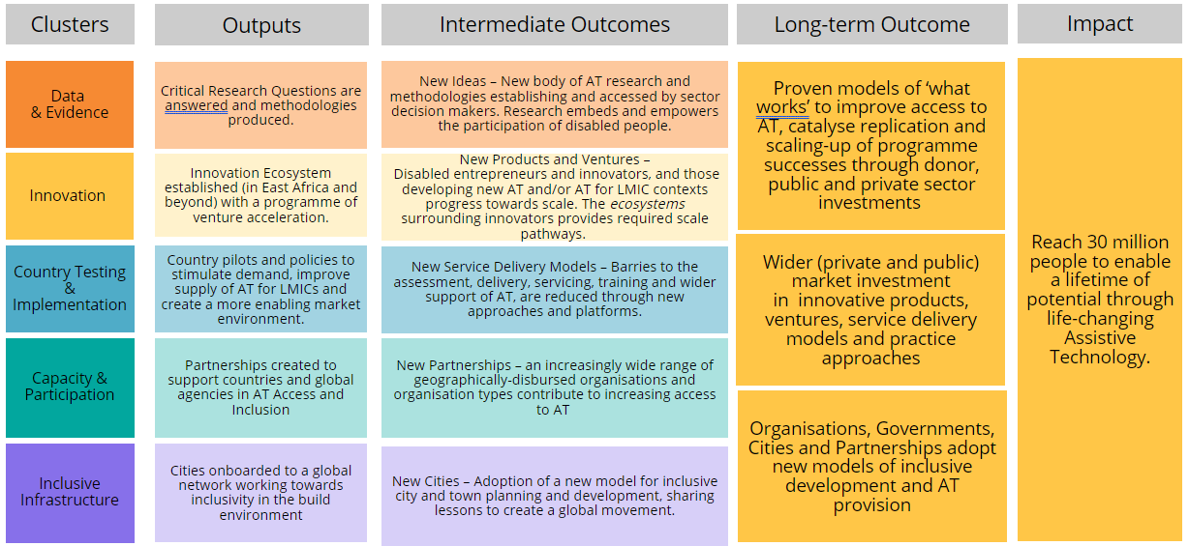
AT2030 outcome targets remain on track which suggests that the Theory of Change (ToC) logic holds true. Annual logframe targets were reviewed for a number of outputs and outcomes (although not all) at the beginning of 2023/24 to ensure the programme continues to deliver stretching results.
In preparation for the next phase of the programme following approval of the BCA, AT2030 revised its approach to programme delivery. GDI Hub and FCDO agreed significant changes to the ToC and logframe to capture a revised set of indicators and targets. The updated ToC and logframe will be outlined in the next AR.

Tracking progress on impact indicators
Impact, outcomes and outputs are tracked by all programme partners quarterly. Total ‘reach’ increased by 3.7 million, to a total of 37,330,600. See Table 2 below for a breakdown.

Describe where the programme is on/off track to contribute to the expected outcomes and impact. What action is planned in the year ahead? [1/2 page]
Impact Indicator | 1 & 2
Title | Reach
Assessment | Substantially exceeded expectations

Table 1: Cumulative target for the project
Reach
2023/24 Target | 32 million people (cumulative total)
2023/24 Achieved | 37.3 million people (cumulative total)

Table 2: Breakdown of reach
Reach | Achievements in 2024/25 | (Cumulative) Target  By 31 March 2024 | (Cumulative) Achieved*  By 31 March 2024
Direct (People) | 196,732 | 1,000,000 | 1,193,145
Direct (Systemic) | 208,900 | 7,000,000 | 8,020,300
[Direct total] | [405,632] | [8,000,000] | [9,213,445]
Indirect | 3,311,500 | 24,000,000 | 28,117,100
TOTAL | 3,717,132 | 32,000,000 | 37,330,545
Please note: apart from direct reach (people), numbers are rounded to the nearest 100. A paper outlining AT2030’s full definitions of reach can be found in Annex 3.

Box 1: Disability Management Information System (DMIS), Rwanda. (Example of Impact Indicator 1 & 2)

Persons with disabilities continue to face significant inequalities and exclusion from society, which is exacerbated by a lack of comprehensive data. This dearth of information poses challenges for OPDs and governments to develop appropriate policies, allocate funding, implement targeted interventions, effectively advocate for change and to measure progress.

Led by the Clinton Health Access Initiative (CHAI), the DMIS is an innovative digital tool designed to identify and register all persons with disabilities, offering a case-management support feature. By providing up-to-date and reliable information, the DMIS will provide policymakers and decision-makers with the necessary data:
(a) to provide equitable access to appropriate and affordable AT, inclusive health services and social services,
(b) for evidence-based advocacy for increased access to affordable AT and
(c) enable real time needs assessments for AT, social protection and other social services for people with disabilities.
Direct Reach (People): Over 112,000 (Quarter 3 of 2023/24)

Impact Indicator | 3
Title | Number of life stories reflecting AT life-changing impact
Assessment | Met expectations

‘Impact Stories | AT2030 Programme’ detail the direct impact of AT2030 on the lives of people with disabilities. 10 Impact Stories were added this year, making a cumulative total of 30 since the beginning of the programme.

OUTCOMES
AT2030 outcomes are divided into four categories: New Products, Ventures, Ideas, and Delivery Models.
Outcome Indicator | 1
Title | New Products
Target (2023/24) | Scale 13 new products (cumulative)
Achieved (2023/24) | Scaled 13 new products (two new products scaled in 2023/24)
Assessment | This outcome met expectations

Two new products were achieved this year, the digital redevelopment of Mosso’s Ergograph (see Box 2) and Google’s Mobile Relate app.
This outcome captures progress scaling new AT products (e.g. physical/software tools or devices) and AT-related product innovations. It includes existing AT products and AT-related product innovations used in new ways to enable increased access. Please note these may also be linked to ventures but are differentiated as the product/service itself (the ‘what’), rather than the operational/delivery service model (the ‘how’). The latter can be found at Outcome Indicator 2.
Box 2: Digital re-development of Mosso’s Ergograph (Example for Outcome 1)
THE ISSUE: Despite the availability of more sophisticated measuring tools, Mosso’s Ergograph, a Muscle Fatigue Testing Machine, is still used in medical schools for its basic functionality. However, it is a large, antiquated manual device designed in around 1920.
THE SOLUTION: A digital re-development of Mosso’s ergograph was undertaken by AT2030. This digital version of the tool is compact and intelligent. By adding sensors, this AT measures and records the effort put into activities that involve steady pressure. It is smaller and easier to use and the digital visualisation makes learning more interesting.
Figure 2: Digital reimagined Mosso’s Ethnograph.

Outcome Indicator | 2
Title | Ventures
Target (2023/24) | 35 (cumulative total)
Achieved (2023/24) | 36 (cumulative total), 5 new ventures supported to scale this year
Assessment | This outcome met expectations

‘Ventures’, describes the business organisation and surrounding ecosystem to support AT innovation. Five new ventures were brought to scale in this reporting year:
- Accessible Transsion mobile phone devices,
- Accessible Safaricom mobile phone products,
- Ugani, an AT venture providing affordable, high-quality prosthetics and orthotics,
- IWAYPLUS, an India based venture that offers a solution to generate geocoded indoor maps,
- Google Relate Application launching in three new English-speaking African countries: Uganda, Tanzania, Kenya.
Two more ventures were supported but did not reach scale.
This outcome describes AT ventures that demonstrate substantive progress to critical sustainability milestones as a result of AT2030 support.
Box 3: Android Phone as AT project - A partnership project with Google (Example for Outcome 2)
Countries: Kenya, Brazil and India
THE ISSUE: Mobile phones are not accessible for people with disabilities in LMICs, which leads to increased exclusion and stigmatisation. Available data shows that “the proportion of people with disabilities who are not engaging in the financial sector and classified as ‘unbanked’ is significantly higher than that of people without disability”.
The barriers to accessing formal financial services for persons with disabilities include physical and digital inaccessibility, absence of alternative communications such as sign-language and Braille, and denial of services to persons with disabilities who are seen as not ‘credit-worthy.’
THE SOLUTION: GDI Hub partnered with Google to deliver AT2030’s ‘Android Phones as AT’ project.
After identifying the accessibility challenges of the phone casing (or skin) with Transsion manufactured mobile phones, Google facilitated a partnership with Safaricom (Kenya’s Mobile Network Operator) to develop a new, low cost, affordable and therefore accessible Safaricom branded device.
Reviews of their System on a Chip (SoC) - an integrated circuit that combines all the essential components of an electronic system onto a single chip - were undertaken to determine how to make their mobile products more accessible.
Additionally, the accessibility of the Android Go operating system on these devices was evaluated, along with a heuristic evaluation of their overall device i.e. how well the hardware (the SoC) and software (Android Go) work together to ensure the device is easy to use for people with disabilities.
Safaricom has agreed in principle to make their own-name branded smartphone accessible, and specifically to make the M-PESA app accessible, Africa's most successful mobile money service and the region’s largest fintech platform. This will enable people with disabilities to make mobile digital financial transactions, which could be transformative in terms of removing barriers to exercise financial independence for some persons with disabilities.
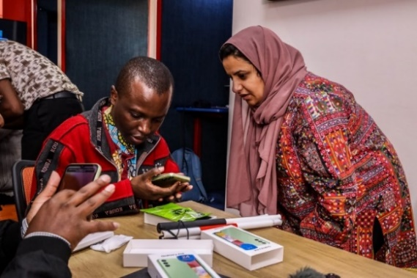
Figure 3: Participant of the Android Phones as AT workshop in Nairobi Kenya

Outcome Indicator | 3
Title | Idea Uptake
Target (2023/24) | 50 (cumulative)
Achieved (2023/24) | 51 (cumulative, four achieved this year)
Assessment | This outcome met expectations

Four governments/organisations have implemented AT2030’s ideas during this reporting period:
- FCDO’s Frontier Tech programme have implemented learning around mobile solutions,
- Operation Namaste utilised AT2030 research and local production methodologies to create and repair bespoke prosthetic products in Nepal,
- Transsion used learning from the Android as AT project to improve the accessibility of their mobile phones
- Safaricom adopted AT2030’s accessibility adaptions to their smartphones and to their M-PESA app.
This outcome captures the uptake of AT2030 programme ideas, findings and methodologies when there is evidence that they have been adopted by governments or organisations.
Box 4: Frontier Tech Pilot using AT2030’s ideas
Countries: Kenya, Colombia and India
Figure 4: MATT (from Colombia) and Neo Motion (from India) ‘3rd wheels’ ready for trials in Kenya
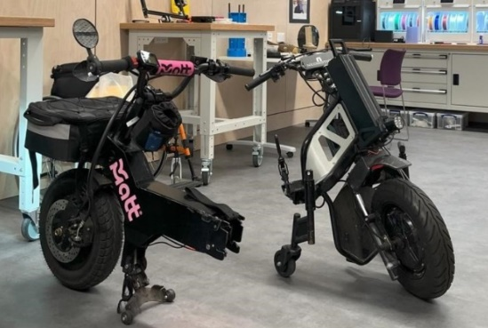
THE ISSUE: Valuable lessons have been learned across the programme, however getting research-led evidence into policy and practice, can be difficult. It is critical to ensure that robust research can be used to inform plans by government, organisations and other researchers. Evidence generated under AT2030 demonstrates that locally produced and context-specific AT and mobility solutions support sustainability.
THE SOLUTION: FCDO colleagues in RED (at Post in Kenya and in the UK), partnered with the GDI Hub and applied for a grant under FCDO’s Frontier Tech project. This was to pilot and test solutions that are showing promise in Colombia and India in a new context.
AT2030 knowledge of programme design for disability inclusion and the innovation of new products fed into the approach to the project. It ensured that people with disabilities and their representative groups were meaningfully involved at each stage, and that the solution would be adapted for the context. The team used AT2030’s experience and knowledge of mobility solutions, local production and manufacturing, which, coupled with FCDO’s local expertise on the Kenyan context, laid the groundwork for piloting a new electric micro-mobility solution in Nairobi.

Outcome Indicator | 4
Title | New Service Delivery
Target (2023/24) | 10 (cumulative)
Achieved (2023/24) | 11 (cumulative) 1 achieved this year
Assessment | This outcome met expectations

One new service delivery model for Koalaa was achieved in this reporting year.
This outcome captures the use of AT2030 frameworks and approaches to guide the design, development, deployment, operation and retirement of AT services.

Box 5: Changing the way prothesis are delivered; Koalaa in Sierra Leone
Figure 5: Man wearing a Koalaa upper limb prosthetic in Sierra Leone
THE ISSUE: In Sierra Leone the concentration of amputees is roughly 15 times the global average. However, there are a lack of clinicians and affordable, fit for purpose prosthetics available for adults and children in the country.
THE SOLUTION: Koalaa develops and supplies context-specific affordable upper limb prosthetics for adults and children designed for the Sierra Leone market. They have scaled access and distribution of their product in Sierra Leone by establishing a duty-free delivery and distribution model for their product, which can be carried in a small suitcase and fitted by health workers with limited training.
Their model combines in-person delivery of specific prosthetic components, and a storage facility within Sierra Leone’s National Rehabilitation Centre. Koalaa has also established a supply chain from their United Kingdom based manufacturing facility to a rural location in Sierra Leone to support local distribution.

Justify whether the programme should continue, based on its own merits and in the context of the wider portfolio.
The programme should continue. As this report demonstrates in detail, AT2030 has surpassed its annual impact targets, and met or exceeded all outcome, and output targets. AT2030 is closely aligned with FCDO’s Disability Inclusion and Rights Strategy: 2022 to 2030, and increasing access to AT for people with disabilities was a RED commitment ahead of the 2022 Global Disability Summit. Disability inclusion is an important part of the ‘Leave No One Behind’ agenda and is essential to achieving the SDGs. Further, AT2030 has grown global momentum to improve the provision of AT products and services, through partnership with over 100 organisations.

C. DETAILED OUTPUT SCORING
Output Title | Innovation Ecosystem established with acceleration programme
Output number: |  | 1 | Output Score: | A
Impact weighting (%): |  | 25 | Weighting revised since last AR? | N/A

Indicator(s) | Milestone(s) for this review | Progress
1.1 Number of innovative ATs supported | 32 | 33  Met expectations  3 were achieved in 2023/24
1.2 Number of Innovation Ecosystem development interventions | 14 | 14 Interventions  Met expectations  4 were achieved in 2023/24  InnovateNow and the AT Impact Fund were replaced by GDI Accelerate (GDIA) in 2022/23.
NB. the indicators above are cumulative milestone indicators

Briefly describe the output’s activities and provide supporting narrative for the score.
Meeting all output 1 logframe targets, three new innovative ATs were supported including the development of Google’s Relate app in Ghana, and four innovative ecosystems were developed, including the launch of India’s first AT accelerator.

  - Number of Innovative ATs supported: output examples
Three innovative ATs were supported: (1) All-India Institute of Medical Science (AIIMS) New Delhi received AT2030 expertise to develop a concept note and grant proposal for additional funding, (2) IIT Delhi were supported to successfully apply for £10,000 of additional funding and (3) development of the Google Relate mobile application in Ghana.
- The AIIMS New Delhi received AT2030 expertise to develop a concept note and proposal for a grant application to secure additional funding from the UCL-IITD Partnership Seed Grant for their Low Vision Rehab Application. This product helps patients who gradually lose sight by supporting their mental and physical well-being.
- IIT Delhi successfully applied for £10,000 of additional funding for their reimagined digital Muscle Fatigue Testing Machine, a physiology instrument used by medical students to determine skeletal muscle fatigue (Box 2, p.5 above). With this funding, IIT Delhi is further developing their product in partnership with the Assistive Technology Accelerator Programme (ATAP) and ADInstruments.

  - Number of Innovation Ecosystem development interventions
There were four new innovation ecosystem development interventions: (1) launch of Attvaran, India’s first AT start-up accelerator, (2) establishment of the Enabling Fridays Community in Nepal, (3) a sustainable wheelchair repair and maintenance mechanism established in Nepal and (4) completion of phase 1 of implementation for the AT Growth Fund: a proposal request for partners in impact-driven investing to develop the strategy, underpin the business model, and to mobilise and manage the fund. ATGF will become the world’s most ambitious scaling pathway for high-potential growth stage accessible and assistive technology ventures. Moving forward, ATGF has ambitions to work towards developing a financial model for capital flow and return on investment in AT ventures.

Box 6: The Enabling Friday Community (EFC) - What works to support the development of a local production and repair economy for AT in Nepal (Example Output of indicator 1.2)
AT2030 supported the establishment of the EFC in Nepal. This community oversees the development of bespoke, low cost, locally produced AT prostheses products in Nepal. Their mission is to work together to build sustainable AT provision in Nepal by supporting infrastructure development through advocacy, evidence-based practice, service system standards and innovation.
This includes:
- Building a sustainable community who will collaborate on approaches that address problems in service.
- Working together, led by people with disabilities, to collectively own the vision for Nepal.
- Identifying streams of the provision process where local actions should be foremost.
- Creating and retaining links between AT experts and wider support services.
- Focussing on long term improvements in services for the local community rather than short term fixes.
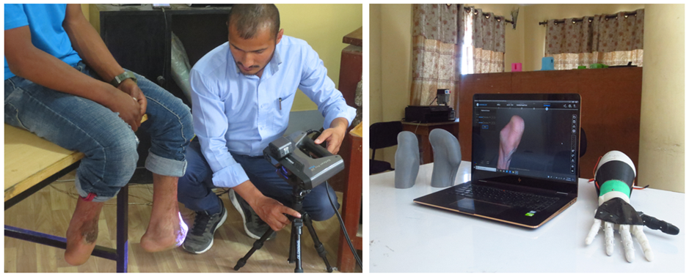
Figure 6: The local innovative approaches for producing prosthetics in Nepal as part of the Systems Strengthening: Local Production Systems of AT project.

Describe any changes to this output during the past year, and any planned changes as a result of this review.
Output indicator 1.1: number of innovative ATs supported: The target was increased from 25 to 32 during the 23/24 period.
Following the approval of the BCA, a new logframe was developed. From April 1, 2024, all new indicators and targets will measure the programme’s progress.

Progress on recommendations from the previous AR (if completed), lessons learned this year and recommendations for the year ahead
Progress on lessons learned from last year’s (2022/23) AR:
- Localisation approach: Due to GDI Hub’s strong localisation efforts in sub-programmes like 'Para Sport Against Stigma’ (PSAS) and 'Inclusive Infrastructure’, it was recommended that this agenda be included across all sub-programmes. Following the approval of the BCA, all sub-programmes now involve downstream organisations in LMICs, including academic and research institutions. AT2030, supported by UCL and GDI Hub academics, will enhance local partners' capacity and reputations as disability inclusive researchers by sharing technical knowledge and co-authoring papers. OPDs and local persons with disabilities will continue to be meaningfully involving in adapting tools and innovations for the local context.
- Innovation ecosystem: The GDI Accelerate (GDIA) model brought together GDI Hub’s learning and support for early to later stage innovators, InnovateNow and the ATIF. This will enable improved follow-through of support during the innovation stages and create a pipeline for the ATGF, which will provide debt and equity support to take ventures to scale.
GDI Hub found that creating the GDIA was more complex than expected and needed significant technical skills. Last year, the recommendation was to support four ventures as a pilot. GDIA achieved this target, offering targeted mentorship, resources, and workshops to enhance the skills and knowledge of AT pioneers.
- Accessible research findings: It was recommended that AT2030 ensure that research findings from GDIA were accessible through the ‘Insights Hub’ within four months of publication (by 31 March 2024). Processes and guidance were updated to ensure the target would be met.

Output Title | (OP2: DATA & EVIDENCE) Critical research questions are answered, and methodologies produced.
Output number: |  | 2 | Output Score: | A++
Impact weighting (%): |  | 25 | Weighting revised since last AR? | N/A
NB. the indicators in the table below are cumulative milestone indicators
Indicator(s) | Milestone(s) for this review | Progress
Number of peer reviewed journal/conference papers published | 45 | 80  Substantially exceeded expectations
Number of influencing papers, answering critical research questions published | 90 | 99  Moderately exceeded expectations
Number of downloads/views for articles/papers above. | 140 000 | 208 761  Substantially exceeded expectations

Briefly describe the output’s activities and provide supporting narrative for the score.
This was a strong output for AT2030 during this reporting period with two indicators substantially exceeding expectations. The programme continues to produce quality peer reviewed academic papers and influencing papers.

Output 2.1: Number of peer reviewed journal and conference papers published
AT2030 conducts wraparound research to build and share evidence to generate new insights and to answer critical research questions. These insights are published in top academic journals and are also translated into more accessible formats. They are widely disseminated and used to inform the AT sector globally.

A substantial amount of research and analytical work was completed this year. A full list of AT2030 peer reviewed journal and conference papers can be found in Annex 4. This target was substantially exceeded partly because it is difficult to predict when academic papers will be published. There were also a number of unexpected or unplanned publications e.g. to address emerging trends and current issues. Further, during the reporting period GDI Hub and UCL’s Academic Research Centre (ARC) increased their research capacity through expanding AT2030’s global networks and partnerships with other researchers and institutions. This led to more collaborative research and co-authorships, increasing the number of publications.

Box 7 Example: Repair strategies for assistive technology in low resource settings (UCL and GDI Hub).
Publication: Disability and rehabilitation: Assistive Technology (Volume 19, 2024)
This study found that the AT industry is currently limited and extremely specialised, mostly serving the requirements of high-income settings. When this AT model was implemented in low-resource settings, the lack of access to repair and maintenance services significantly hindered its effectiveness.
The paper reviewed the existing literature on the repair of assistive products in low resource settings and reported on primary research carried out in four low resource settings (Kenya, Uganda, Sierra Leone, and Indonesia) which included collecting data on community-based repair of assistive products. The article examined some of the different models by which repair occurs in the studies.

Output 2.2: Number of influencing papers answering critical research questions published
A full list of influencing papers, including links can be found in Annex 5. The annual target was substantially exceeded as there is a direct link between the number of peer-reviewed papers and the number of influencing papers; often with the influencing papers being a more user-friendly version of the academic paper. Additionally, partners, of their own accord, delivered unplanned influencing papers.

Box 8: Evidence brief on engaging communities in Para sport in Malawi
Authors: Loughborough University London and University of Malawi
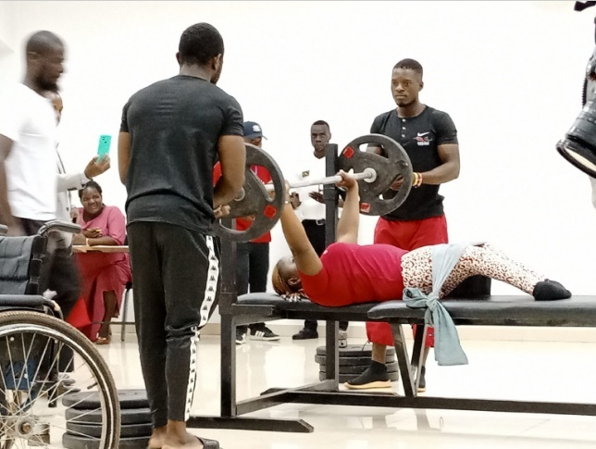
Insights: Stigma and discrimination are among the most pressing challenges facing persons with disabilities and their families in Malawi. This leads to social exclusion from many areas such as education, employment, and sport. Challenging stigma can support wider rights and entitlements access, including improvements to access to disability services and AT.
The Paralympics and para sport can be a powerful platform for addressing local forms of disability stigma. Para athletes are powerful role models and can counter internalised stigma. Local stories and community engagement around Paralympic sport is critical to drive social change. Engaging schools in para sport can advance inclusive education, inclusive sport, and support the identification of the next generation of Para athletes. Malawi is leading the way across Sub-Saharan Africa in using Paralympic sport as a platform for social change.
Figure 7: Woman with disabilities weight training
Recommendations: Ministries and partners across sport, disability and media/communication channels need to collaborate to support Para sport and Para sport localisation. Activities should be led or co-developed with organisations based in LMICs and with voice and leadership of people with disabilities and with community engagement. Implementing partners should make use of the ‘Making Noise’ toolkit, a resource that creates a network of disability sport groups, disability service providers and advocacy groups, the media, and communication practitioners. The toolkit brings groups together to use the Paralympic platform to advance local agendas to foster localisation and community engagement efforts.

Box 9: National Manufacturing Kenya: Innovation Stack (an accessible/ digestible approach to the presentation of information)
Authors: Motivation UK and UCL

Motivation, a UK disability inclusion charity and social enterprise, developed a wheelchair manufacturing model for Kenya to learn if national manufacture can provide one method of overcoming global supply challenges. Their approach aligns with the Kenyan Government's plans to boost the manufacturing sector, improve the provision of AT, and to be a regional AT provider.

Learning points:
- Philanthropic funding and reliance on imports – it was found that the philanthropic model was economically and politically challenging due to donor sustainability and changes in political priorities. This led to a desire to seek alternative models of provision i.e. local production.
- Local provision exploration – Motivation previously developed several small workshops which could keep AT in circulation. Ultimately these were unsustainable, but valuable learnings were gained from them.
- Choosing a home for national provision – Motivation selected a country with manufacturing capacity for quality scaled production along with governmental support and ambition.
- Designing a local wheelchair – effective training and user feedback are essential. Motivation adapted their MW3 wheelchair which is suitable for 50-60% of local users.
- Developing a full-life cycle approach – localised manufacturing needs to be interlinked with full-service provision including repair and end-of-life aspects of the model.

Output 2.3: Number of downloads/views for articles/papers
AT2030 has been monitoring the number of downloads, views and citations for all programme research papers through metrics taken from ResearchGate, AT2030.org, journal analytics and partner websites. At end March 2024, this indicator substantially exceeded expectations with 208,761 downloads and views, against a target of 140,000. The is likely due in part to outreach efforts and a full programme audit/review of the number of historical citations, downloads and views of all AT2030’s papers.

Describe any changes to this output during the past year, and any planned changes as a result of this review.
As previously mentioned, the logframe and its outputs and targets were reviewed for the 2024/25 reporting period.

Progress on recommendations from the previous AR (if completed), lessons learned this year and recommendations for the year ahead.
In the previous AR, it was recommended that there be an increased focus on gender data disaggregation and understanding of the nuances between male and female barriers, challenges and access to AT. In response, AT2030 has increased its gender research expertise, and improved data collection methods. Researchers, including internal staff and external partners, will receive an information pack and/or training on the importance of gender-specific research and how to effectively capture and analyse gender-disaggregated data. Existing learnings on differences in AT access by gender will be consolidated.
Despite being open access, it was noted last year that research, data and evidence can be difficult to find on AT2030’s website and this should be improved. As a result, the website’s functionality and search function was improved and further development will take place in 2024/25.
Recommendations for 2024/25:
Logframe targets should be reviewed on a rolling 6-monthly basis to ensure they are up to date and remain stretching.

Output Title | (OP3: CAPACITY & PARTICIPATION) Partnerships directly supported and tools and lessons learnt developed to support countries and global agencies
Output number: |  | 3 | Output Score: | A+
Impact weighting (%): |  | 25 | Weighting revised since last AR? | N/A

Indicator(s) | Milestone(s) for this review | Progress
Number of partnerships supported to increase AT capacity. | 95 | 125  Met expectations  (This indicator target should have been increased last year)
Number of strategic tools developed to increase AT capacity | 68 | 86  Exceeded expectations  (Although this indicator should have been extended last year, it is judged that an addition of 19 tools in this reporting year, substantially exceeded expectations)
Number of case studies produced (including from: Inclusive Infrastructure and Sport against Stigma). | 20 | 35  Met expectations  (This indicator target should have been increased last year)
Value of match funding provided through partnerships | £17,000,000 | £19,732,532  Exceeded expectations
NB. the indicators in the table above are cumulative milestone indicators.

Briefly describe the output’s activities and provide supporting narrative for the score.
This output continues to be a strength for AT2030. AT2030 exceeded expectations against two targets and met two targets during the reporting period. The programme has excelled at working with a variety of organisations to maximise its outputs. See Figures 8 to 12.

Match funding exceeded expectations, raising more than £2m over the annual target. Strategic Tools and Case Studies are set out below in Table 3 and Box 10.

3.1 Number of partnerships supported to increase AT capacity
To date the programme has worked with 125 organisations globally in 77 countries. In this reporting period, eight new partnerships were formed. These global partnerships are diverse in terms of organisation types, from the private sector, NGOs, governments, universities and hospitals. See the Figures below for breakdowns.

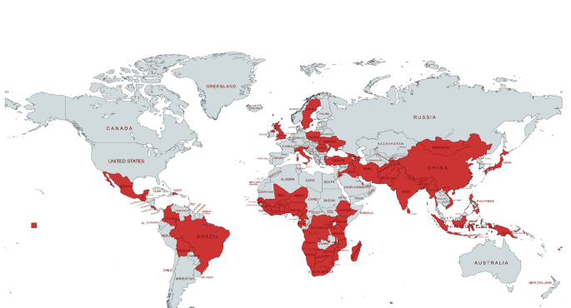 | 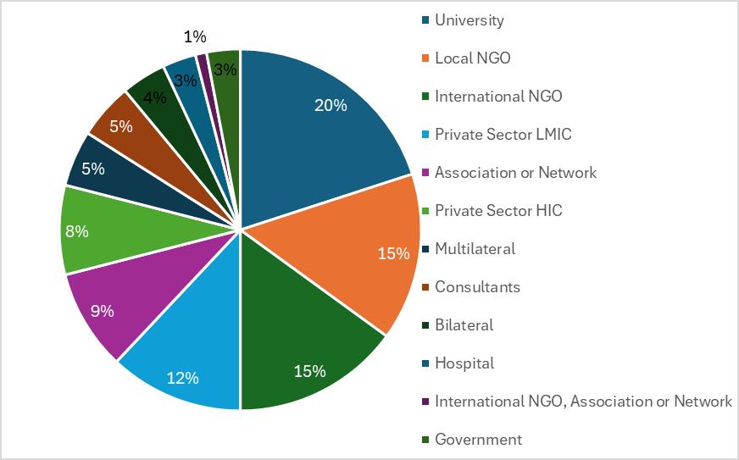
Figure 8: Partnerships by country (all tiers) | Figure 9: Partnerships by Type of Organisation

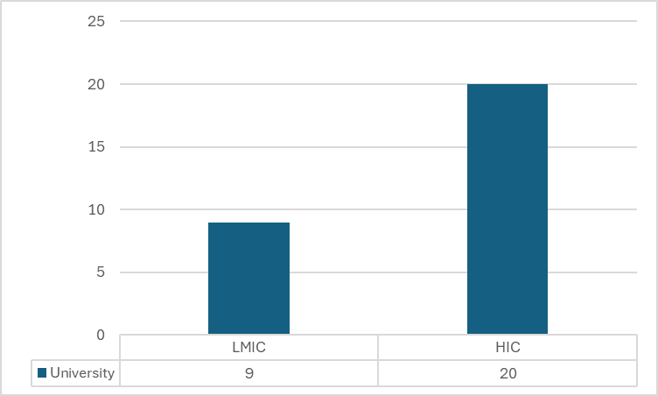 | 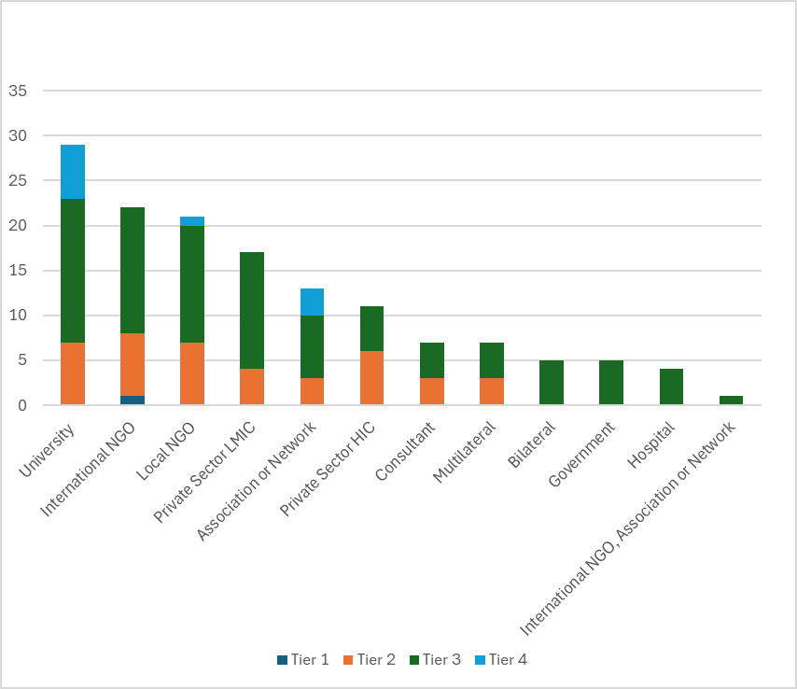
Figure 10: Partnerships by HIC v LMIC | Figure 11: Partnerships by type and tier

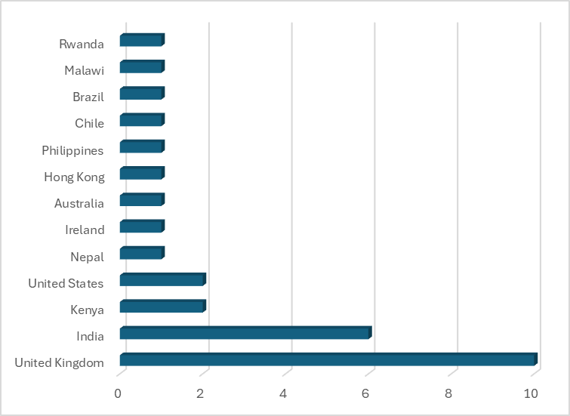
Figure 12: Partnerships by Country

3.2 Number of strategic tools developed to increase AT capacity
AT2030 added 19 ‘strategic tools’ during the reporting period. See examples in Table 3 below.

Table 3: Sample of Strategic Tools
Tools | Link
The ‘Assistive Technology Innovation Portal’ (ATIP) includes a map of over 300 AT innovators globally. Data can be downloaded from the website and AT innovators can self-register to join the list. | AT Innovators Innovation Portal (atinnovationportal.com)
The second phase of the AT2030 insights portal was completed. The portal is for anyone involved in research and analysis of need and availability of AT at country level. | AT2030 Insights Portal (at2030-insights-portal.org)
Wheelchair provision guidelines were published by WHO, providing information to improve access to appropriate wheelchairs. | WHO releases new Wheelchair provision guidelines
The open access online course on Assistive Technology is hosted on IDA’s learning platform. It develops knowledge and skills on AT, barriers to access, and strategies for advocacy for universal access. | Online course on Assistive Technology

3.3 Number of case studies produced (including from Inclusive infrastructure and Sport Against Stigma).
Case studies are designed to engage a range of diverse audiences based on contextualised analysis, recommendations and lessons from a detailed study of a specific subject, such as a person, group, event or phenomenon. A full list of case studies can be found in Annex 6. 60 Decibels delivered four more Performance Snapshots and Inclusive Infrastructure and Parasport Against Stigma produced case studies to document their progress and outcomes. See Box 9 below for a sample of case studies produced in 2023/24.

Box 10: Inclusive Infrastructure Case Studies:
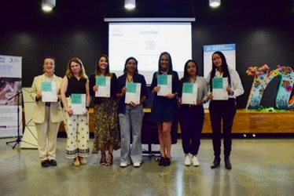 | Medellin, Columbia: This case study shares findings and recommendations for infrastructure, the built environment and urban development. Its core aim is driving global action for more accessible and inclusive cities. An overview of the current state of the built environment in Medellín also helps researchers, city designers and local governments to understand the potential for inclusive design to address barriers to inclusion for persons with disabilities.  Figure 13: Inclusive Infrastructure report launch in Medelin, Colombia as part of Inclusive Infrastructure Sub-programme
GDI Accelerate, Lugha Ishara Performance Summary: Kenya  Figure 14: Women and children play at Lugha Ishra Hangout Hub programme  Lugha Ishara's Hangout Hub is a meeting place designed to provide a safe space for individuals who are deaf or hard-of-hearing to connect and socialize with others. The platform includes features such as video chat, instant messaging, and group activities that cater to the unique communication needs of the deaf and hard-of-hearing.  This report, developed by 60 Decibels and GDI hub explores Lugha Ishara’s customers, their profiles, outcomes and experiences. It looks at key performance and impact metrics to understand customer loyalty, feedback and overall impact to user’s lives. |  | 

3.4 Value of matched funding provided through partnerships
AT2030 includes a 100% match funding target, in cash or in kind. As of the end of March 2024, the programme had raised £19.2m in match funding against an annual (cumulative) target of £17m.

Figure 15: Match Funding
In 2023/24, GDI Hub raised £4,345,178. This was due to unanticipated contributions by partners as well as substantial ongoing support from UCL. Notable additions in this reporting period include:
- £618,753 from CHAI, consisting of cash (partner direct co-funding into the project) and in-kind (staff time donated to the project, physical location support – including provision of office space, and support for recruitment and training).
- £318,947 from ATscale/Google/UCL (time in kind) for the Android Phones as AT research project; and project funding contributions of $200,000 from ATscale and $200,000 from Google.
- £141,815 from Loughborough University as part of the PSAS sub-programme, including partner co-funding (cash), staff time and physical location support, such as goods, equipment and supplies. PSAS funding was also secured from K2 Transformers, and the Office of the Vice President of Malawi.
- £30,000 – staff time in-kind from PWC for the development of the Blueprint for the ATGF.

Describe any changes to this output during the past year, and any planned changes as a result of this review.
No changes were made to this output during the reporting period.

Progress on recommendations from the previous AR (if completed), lessons learned this year and recommendations for the year ahead
Although last year it was recommended that all logframe targets were stretched, it appears that some were missed or set too low. Despite this, the programme has performed well. The logframe is being redesigned from 2024/25 onwards and will include updated targets to be used in next year’s annual review.
AT2030 developed new tools to aid decision making for innovators, ventures, and ecosystem stakeholders, including governments. Last year, it was recommended that AT2030 promote the value and usage of their tools, particularly digital tools. This year, workshops provided hands-on training to help stakeholders incorporate the digital tools into their work.

Output Title | (OP4: COUNTRY TESTING & IMPLEMENTATION) Evidence from in-country pilot activity through investment to; stimulate demand, improve supply of AT for LMICs and create a more enabling market environment.
Output number: |  | 4 | Output Score: | A+
Impact weighting (%): |  | 25 | Weighting revised since last AR? | N/A

Indicator(s) | Milestone(s) for this review | Progress
4.1 Number of procurement pilots/frameworks at the country, regional, global level | 7 | 10  Moderately exceeded expectations
4.2 Country level strategies for disability inclusion and AT access (CCAs, Action Plans etc.) | 24 | 28  Met expectations  (This indicator target should have been increased last year)
NB. the indicators in the table above are cumulative milestone indicators.

Briefly describe the output’s activities and provide supporting narrative for the score.
AT2030 moderately exceeded output indicator 4.1. Output indicator 4.2 should have been revised upwards this year, however this was missed in error. Therefore, this indicator is judged to have met expectations, rather than exceeded it.
4.1 Number of Procurement pilots/frameworks at the country, regional, global level
In 2023/24, the programme developed five procurement pilots or frameworks for disability inclusion and AT access. Examples are set out in Boxes 11 and 12.

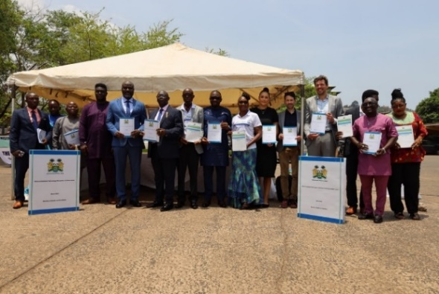
Box 11: Sierra Leone
In Sierra Leone, AT2030, with CHAI's support, conducted a landscape assessment of AT services and piloted national standards, including procurement guidelines and quantification tools. These guidelines aim to ensure AT access for people with disabilities by outlining the procurement mechanisms for quality assistive products, prioritising safety, fair pricing, and diverse procurement channels. This pilot also offers a framework for regional and global implementation, potentially serving as a model for other countries.
Figure 16: Launch of the Assistive Technology Standards and Procurement Guidelines in Freetown, Sierra Leone
Box 12: Nepal, India and Jordan
The WHO ran three procurement pilots in Nepal, India, and Jordan. These aimed to integrate AT into health systems by collaborating with Ministries and offering technical support for procurement and system strengthening. The focus was on boosting workforce capacity through developing WHO's online TAP modules to train health workers and improve the TAP platform's accessibility.

4.2 Number of Country Level Strategies for Disability Inclusion and AT Access (CCAs, Action Plans, NPC Partnerships etc.)
Three country level/national strategies were supported by AT2030 this year. Two were in Sierra Leone and the other in Malawi, which is outlined below in Box 13 below.
Box 13: Malawi Country level strategy
AT2030 supported Malawi to create a strategy to incorporate AT services into their Health Service Package framework. This strategy included additional interventions (not explicitly mentioned by international classifications) i.e. prostheses and orthotics, to ensure they remain priorities for care delivery.
The pilot integrated 207 detailed AT interventions into Malawi’s National Health Service Package, across primary, secondary, and tertiary care levels. This now serves as a platform for planning, advocacy, and quality improvement. Additionally, 59 rehabilitation products were procured for Malawi’s new Medical Rehabilitation Unit

Describe any changes to this output during the past year, and any planned changes as a result of this review.
As the AT2030 BCA starts full implementation in April 2024/25, a new reporting period, a new logframe was developed, outputs revised, and targets updated.
Progress on recommendations from the previous AR (if completed), lessons learned this year and recommendations for the year ahead
As the programme has effectively been redesigned during this reporting period, there are no recommendations for this output.

D: VALUE FOR MONEY (1 page)
VfM performance compared to the original VfM proposition in the business case
AT2030 continues to provide strong value for money across the ‘5 Es’: effectiveness, cost effectiveness, equity, economy and efficiency. See examples in Table 4 below.
Table 4: Value for Money
ECONOMY - refers to the careful management of resources to ensure that inputs (such as funds, materials, and human resources) are procured at the lowest possible cost without compromising quality.
- Implementing technology solutions such as Airtable for project management and knowledge sharing has helped streamline operations and reduce administrative costs for the GDI Hub project team. This automation and use of digital tools has enhanced efficiency and minimised the need for manual, time-consuming processes.
- AT2030 employs robust financial management practices to monitor spending closely, ensuring that all expenditures are necessary and justified. This includes regular audits and quarterly reviews to maintain transparency and accountability.
- AT2030 often leverages in-kind contributions from partners, such as expertise, facilities, and materials. These contributions help reduce direct costs while still ensuring high-quality inputs for the programme.
- The majority of programme inputs are person hours. AT2030 makes extensive use of building its human resource capacity through hiring academic partners. Instead of using high consulting fee rates, costs are determined by using academic salary scales. This offers comparable quality professional inputs at a significantly lower cost. For instance, using AT2030's grant structure, a senior researcher costs approximately £210 per day, while a (discounted and long-term) service level consultancy charge-out rate costs £462 for the same level of expert.
EFFICIENCY - refers to the relationship between the resources used (inputs) and the outputs or outcomes achieved. It focuses on ensuring that the maximum possible outputs or outcomes are obtained from the resources invested.
- The programme employs robust monitoring and evaluation frameworks, including bi-weekly meetings, quarterly reviews, and annual reports. These mechanisms ensure that progress is tracked effectively, issues are identified early, and corrective actions are taken promptly to maintain efficiency.
- Partnerships and Collaboration - AT2030 makes use of common resources and knowledge by collaborating closely with a variety of partners, such as governments, non-governmental organisations, and businesses. This cooperative strategy minimises effort and duplication and improves resource use. For instance, through regular coordination meetings with ATscale, the GDI Hub's coordination and collaboration function ensures that partners avoid duplication and identify opportunities for program efficiencies and shared learning.
- GDI Hub's specialised communications capacity helps disseminate research findings by utilising the scope and reach of partner networks, such as the Global Alliance of Assistive Technology Organisations (GAATO), GATE Network, European Assistive Technology Information Network (EASTIN), Association for the Advancement of Assistive Technology in Europe (AAATE), and programme partners (to name a few).
- The WHO and UNICEF, two AT2030 partners, collaborate to create demand for the addition of new products to their global procurement catalogues to significantly lower the cost of goods in LMICs. This initiative enables governments to access low-cost, high-quality hearing aids through strategic supplier engagement and global tendering with the WHO. In Rwanda, the price of hearing aids was reduced by 94%, from $2,000 to $118, resulting in a shipment of 1,200 hearing aids as part of a pilot program. This work improves accessibility and reduces the global economic burden of unaddressed hearing loss. Additionally, this saves governments, INGOs, NGOs, and others time and resources (human and competitive pricing).
EFFECTIVENESS – refers to the extent to which a programme achieves its intended outcomes and objectives – it focuses on the actual impact and results of an intervention.
- AT2030 has met or exceeded all output, outcome and impact targets. Programme achievements have established AT2030 as the global leader on AT.
- High levels of academic engagement through knowledge dissemination and influencing are demonstrated through 208,761 downloads, views and citations of AT2030’s published materials.
- Effectiveness is demonstrated through the facilitation of access to critical AT information and resources. The programme's AT Insights Portal and AT Innovators Map provide access to data and evidence on AT for government policymakers, International Non-Governmental Organizations (INGOs), OPDs, and specialised agencies. This enables informed evidence-based decisions, advocacy, and advancements in academics and innovation in AT. The AI-enhanced search functionality allows users to interrogate robust global data from 112 countries, influencing practices and driving innovation across the sector.
- ‘Android Phones as AT’ project outcomes are influencing mobile phone developers to improve their accessibility and are being used to inform AT2030 and other programmes such as FCDO’s AI for Development (AI4D) to understand how digital and AI can benefit, or further exclude, people with disabilities in LMICs.
- ‘Positioning OPDs as Equal Partners on AT’ with IDA strengthened the role of persons with disabilities and their representative organisations (OPDs) in advocacy for the use of and access to AT.
EQUITY – fair distribution of resources and benefits among particularly marginalised populations – aims to reduce inequalities, ensuring that interventions reach those most in need and contribute to overall social and economic inclusivity.
- AT2030 develops AT that is specifically designed to be accessible and affordable for people with disabilities in LMICs, ensuring that these individuals can benefit from AT to enhance their quality of life.
- AT2030 uses a person-centred approach, involving persons with disabilities in the design, implementation, monitoring and evaluation phases of projects. This ensures that their knowledge, experiences, needs and perspectives are central to the solutions being developed.
- The programme conducts training and capacity-building activities for local organisations and stakeholders, empowering them to support and advocate for the needs of people with disabilities within their communities.
- AT2030 works in multiple countries, focusing on LMIC regions where access to AT is often limited. This approach helps bridge the gap between high-resource and low-resource settings.
- The PSAS project addresses the social inclusion and representation of people with disabilities through sports. Specifically, PSAS promotes inclusive participation, empowerment, para-athletes as role models, and community engagement. It seeks to change perceptions, influence policy and provides access to resources e.g. adaptive sports equipment.
COST-EFFECTIVENESS – refers to the ability of a programme to achieve its desired outcomes at the lowest possible cost – evaluating whether the resources invested are being used efficiently to produce the maximum benefit.
- AT2030 has raised over £19.7m in cash or in-kind donations. The programme aims to achieve 100% match funding through increased third-party funding from donors, governments, and private companies, as well as working through a wide and diverse range of partnerships (NGOs, academic institutions, and the private sector).
- AT2030 focuses on developing affordable scalable and replicable AT solutions that can be adapted to different contexts, for example Koalaa’s work in Sierra Leone (Box 5).
- By focusing on cost-effective innovations, the programme ensures that a larger number of people can benefit from the technologies at the lowest cost. The Training in Priority Assistive Products (TAP) initiative by WHO, supported by AT2030, is a cost-effective innovation that trains primary health and community-level personnel to provide basic assistive products. TAP helps to address the global shortage of trained personnel, which is a significant barrier to access.

Assessment of whether the programme continues to represent value for money.
Table 4 demonstrates that AT2030 continues to deliver strong results, and good value for money across all 5 ‘E’ indicators and should continue. Programme outputs, outcomes and impact (11/11 Outputs, 4/4 Outcomes and 4/4 Impacts) met or exceeded expectations. The programme also has a 100% match funding target and has raised over £19.7m to date.
AT2030 is a key element of RED's 2022 Global Disability Summit commitments and supports FCDO's 2022 Disability Inclusion and Rights Strategy. The ‘Leave No One Behind’ initiative is not possible without disability inclusion, and the Sustainable Development Goals cannot be achieved without prioritising the needs of individuals with disabilities.

E: RISK [½ to 1 page]
Overview of risk management [1/2 page]
AT2030 is an innovative disability inclusion programme, designed with flexibility to ‘fail fast and scale successes’ to reach more people with disabilities and older people with the AT that they need. This is a nascent area, with new approaches, contexts, and/or technologies. The overall risk appetite and rating for AT2030 remains unchanged as ‘Moderate’.
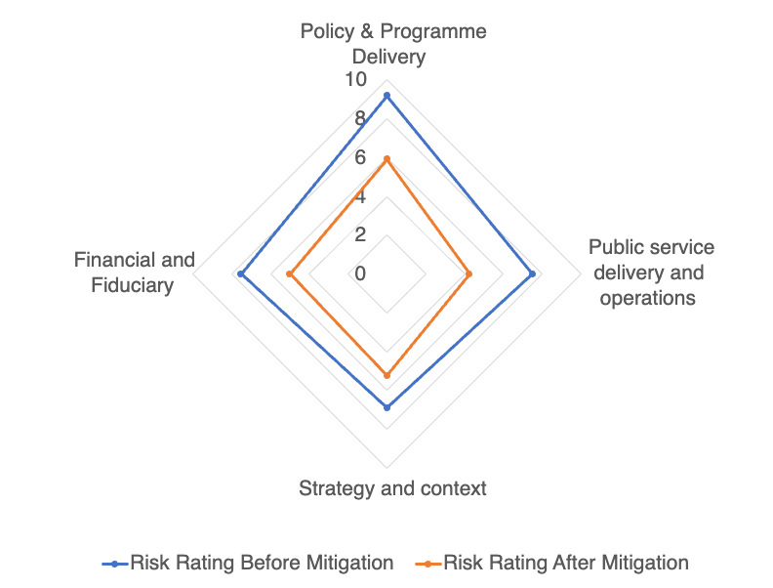
The programme manages risk by using well-established systems to continually monitor and proactively manage risks. This includes using FCDO's risk categories with clear risk owners, mitigation actions, and timelines.
At the end of the 2023/24 financial year, the programme team took a snapshot of the programme risk profile based on feedback from delivery partners and project managers.
Figure 17 summarises the results of this risk assessment. Risk ratings capture an index measure of each risk’s probability and impact on programme delivery. Figure 17 details risk profile before and after mitigation actions.
There are effective mitigations in place against the biggest risks – external context – and a generally balanced risk portfolio overall (ignoring ‘Other’ and the low risks related to Financial and Fiduciary).
Figure 17: AT2030 Risk Profile 2023/24

Risks are discussed with FCDO during bi-weekly meetings and more formally through quarterly reporting / review meetings. No change to risk appetite is foreseen, and in the next reporting period programme management processes across delivery partners will continue to improve the visibility and responsiveness of risk management practices.

F: PROGRAMME MANAGEMENT: DELIVERY, COMMERCIAL & FINANCIAL PERFORMANCE [1 - 1 ½ pages]
Throughout the reporting cycle, the GDI Hub communicated with FCDO and programme partners on a regular basis. GDI Hub produced monthly email updates to all partners (including FCDO), which included highlights and media outputs. The GDI Hub also engaged in biweekly catch-up calls with FCDO, hosted quarterly AT2030 Advisory Board meetings and attended formal quarterly review meetings with FCDO.
The financial year end accounts of implementing partners are checked by the GDI Hub and provided to FCDO annually. In 2023/24 GDI Hub was audited as part of its commitment to FCDO. The auditors confirmed there were no material errors relating to the grant accounting and no significant weaknesses relating to internal controls. Programme forecasts and expenditure were managed closely and have broadly been in line with budget. Quarterly and annual programme forecasts are provided to FCDO at the beginning of each quarter and clarify any changes or variance.
Year-end variance for 23/24 was £6,601 (overspent) (i.e. 0.2% variance) against the ceiling budget for the year of £3.315m.
With continued support from FCDO, AT2030 will expand and build on its achievements through the implementation of the BCA. Continuous coordination with FCDO Posts ensures that in-country programmes and partner connections are optimised.

G: MONITORING, EVIDENCE AND LEARNING
Monitoring and Evaluation
AT2030 has a comprehensive monitoring system that includes bi-weekly meetings of the Directors and FCDO which has a set agenda (highlights, challenges, opportunities, etc.), regular operational meetings with members of the Programme Management team, quarterly review meetings and quarterly Advisory Board meetings. Advisory Board meetings are supported by detailed documentation such as a Programme Report, Partner Reports, and a slide deck. They provide partners with an opportunity to present their work and offer insights to improve the programme.
An Annual Report and presentation are produced after Q4 and the programme also incorporates field visits (see Box 14), stakeholder engagements, and meetings focused on Monitoring, Evaluation, Learning (MEL). These efforts ensure continuous and robust interaction with the FCDO team, addressing questions, discussing issues and risks, reviewing the logframe and targets, and suggesting improvements to enhance the quality and delivery of AT2030.
Box 14: Mission to Malawi
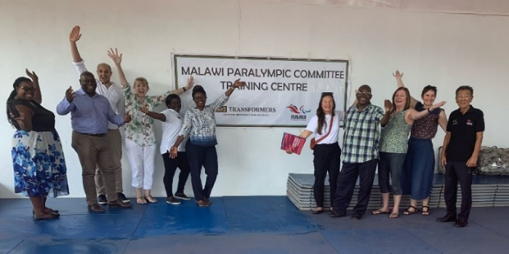
Representatives from FCDO, GDI Hub and Loughborough University travelled to Lilongwe as part of the monitoring and evaluation of the PSAS Project led by Loughborough University London.
This mission included participation in a ‘Knowledge Exchange Forum’ on I’mPOSSIBLE held at the Bingu National Stadium; a school visit and a visit to the Malawi Paralympic Committee’s new training centre, sponsored by K2 Transformers.
Figure 18: Site visit in Lilongwe, Malawi

Evidence
AT2030, has a strong focus on producing comprehensive and robust evidence. A programme audit capturing systemic reach ensured that all impact-related reach was accurately captured and reflected in the programme's logframe. The facilitation of evidence access is supported by AT2030’s strategic tools, such as the Wheelchair Provision Guidelines and the Online Assistive Technology Course which was developed as part of the 'Positioning OPDs as Equal Partners on AT' sub-programme.
Furthermore, GDI Hub enhanced partner reporting using improved reporting forms and automations within an Airtable database (a knowledge and project management software platform). They continued capacity-building activities, with internal and external partners, by developing and sharing key logframe indicator descriptions and examples of each to improve quarterly reporting.
Partner reporting now incorporates data disaggregation of direct beneficiaries by gender (sex), research participation, AT beneficiaries, and persons with disabilities. Additionally, it includes country-level data to map and track the programme's geographic reach. Robust project scoping, implementation, and overall delivery within programme schedules have proved efficacy and efficiency due to the strong relationships that GDI Hub maintains with AT2030 partners.

Learning
A scoping review of all outputs evidence from the previous four years was conducted with an eye towards developing improved learning processes and to record and disseminate lessons learned. This project provided an understanding of ‘what works’ to investigate and evaluate novel approaches to systemic problems. During the past year, an academic paper was published entitled “What Works to Improve Access to AT” which was disseminated at two conferences - the GDI Hub Summit on 13-14 September 2023 and the AfriNead conference in Cape Town, 30 November to 1 December 2023.
An updated quarterly partner reporting template is now used to more effectively record lessons learnt about ‘what works’, the challenges experienced and how they were overcome (if applicable) to enhance key learnings.
In addition to learning about ‘what works’, AT2030 also learns from ‘what does not work’, an example of which can be found in s Box 14 below.
Box 15: Motivation
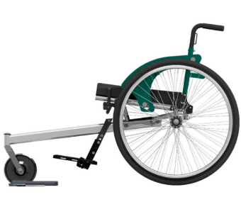
Motivation is an international development charity and social enterprise based in Kenya. They aim to provide wheelchairs that meets users’ needs as well as the environment they live in. This year, Motivation are engineering a Kenyan 3-wheelchair (KEN3WH) that is appropriate for high-volume production.
The initial batch of prototypes were insufficient for user testing and required significant improvements to meet expected standards and quality for production.
Motivation recognised the need to pivot.
Using learnings from the production of the initial batch of prototypes, Motivation, in partnership with the same local manufacturer, were able to transition into the production of a second batch of KEN3WH prototypes that would allow for use field trials in 2024/25.
Figure 19: A Motivation KEN3WH wheelchair

AT2030 has had a challenging but successful year delivering against logframe indicators while designing an extension for the programme. GDI Hub and their partners have worked incredibly hard to maintain high quality outputs on time and to manage and monitor the programme effectively. Next year AT2030 will be delivering against a new set of challenging indicators to continue to improve access to AT for those who need it the most.

Date of last narrative financial report | 4/06/2024 | Date of last audited annual statement | 31/03/2023

UNICEF and WHO Global Report on AT.
Prior to the approval of the BCA, by end October 2024 the programme aimed to reach 35.1 million people (1.1 million directly (people), 8 million directly (systemic) and 26 million indirectly
Where possible the programme collects and disaggregates data by gender, disability, AT beneficiaries, research participation, and geography for more nuanced learning from the programme and to inform future targeted and mainstreamed interventions. In line with the ‘nothing about us, without us’ tenet, people with disabilities are targeted by interventions, and meaningfully included throughout the programme cycle, from design through to delivery and monitoring and evaluation.
‘Scale’ is assessed using realistic ambitions for progress over the venture/product/innovation’s support. For example, a venture ‘on track to scale’ is considered to have experienced a projected increase in funding, user base, or proves the validity of their product, while a venture ‘scaling up’ is considered to have experienced an increase in funding, a broader user base or has proven the validity of their product/service.
Examples include: improved product development methods, development of robust evidence proving the validity of solutions, acquiring commercial, distribution and/or service links with relevant national and international partners, demonstration of funding or user base increases, or successful implementation of business plans.
World Bank. A landscape review of ICT for disability-inclusive education. Washington (DC): World Bank Group; 2021. Puli, Louise; Layton, Natasha; Bell, Diane; Shahriar, Abu Zafar. Financial Inclusion of people with disabilities: a scoping review. 2024.
Christian Blind Mission. (2016). A case for Financial Inclusion of Persons with Disabilities: CBM Livelihood Technical Guideline. Jiya, A. N., Opoku, M. P., Nketsia, W., Dogbe, J. A., & Adusei, J. N. (2022). Achieving Financial Inclusion for Persons With Disabilities: Exploring Preparedness and Accessibility of Financial Services for Persons With Disabilities in Malawi. Journal of Disability Policy Studies, 92-102.
Christian Blind Mission. (2016). A case for Financial Inclusion of Persons with Disabilities: CBM Livelihood Technical Guideline.
Output 1 describes the development of AT products or services themselves to a point where they have been user tested and are ready for market (i.e. Output markers). These are differentiated from outcomes, which evidences their path to scale and sustainability, through the specific Outcome markers of: investment, partnerships, agreements, successful pilot programmes etc.
16 partners representing 11 institutions in the development sector, academia, private companies, hospital and clinics, and innovation centres
Core academic partners within AT2030 include University College London (UCL), Maynooth University, Loughborough University (LUL), and the London School of Hygiene and Tropical Medicine (LSHTM), with individual inputs from the Global Alliance of Assistive Technology Institutions (GAATO) and the Indian Institute of Technology (IIT) Delhi.
i.e., not peer reviewed / journal articles. Typically published as Policy Papers, Insight Papers or other Programme Lessons

