Annual Review: 2022/23

Title: AT2030 – Life Changing Assistive Technology for All
Programme Value £ (full life): £19.8m |  | Review date: 13/12/2023
Programme Code:  300815-101 | AMP start date:  28/01/2019 | AMP end date:  01/10/2024

Summary of Programme Performance
Year | 1 | 2 | 3 | 4
Overall Output Score | A+ | A+ | A+ | A+
Risk Rating | Moderate | Cautious | Cautious | Cautious

DevTracker Link to Business Case: | https://iati.fcdo.gov.uk/iati_documents/58742745.odt
DevTracker Link to results framework: | https://iati.fcdo.gov.uk/iati_documents/58849946.xlsx

A. SUMMARY AND OVERVIEW
The WHO estimates that 2.5 billion people are in need of assistive technology (AT) such as wheelchairs, hearing-aids, prosthetics and orthotics, eyeglasses and assistive digital products. However, access can be as low as 3% in developing countries. AT is a key enabler for change and can be transformative and life changing for people with disabilities. Providing affordable AT unlocks economic potential by increasing productivity and participation in work and education and for community inclusion. AT2030, is delivered by a consortium led by the UK’s Global Disability Innovation (GDI) Hub. The programme tests and builds an evidence base on what works’ to improve access to affordable AT. The programme invests in and supports solutions to scale AT with a focus on innovative products, new AT service delivery models and global capacity support. Continued learning and flexibility is essential - making a series of investments in new approaches, contexts and/or technologies to ‘fail fast and scale successes’ for a higher rate of return, reaching more people with affordable AT. AT2030 aims to reach 35.1 million people (1,1 million directly (people), 8 million directly (systemic) and 26 million indirectly ) by 2030 to enable a lifetime of potential through access to life-changing AT.

AT2030 is registered on IATI with the Activity Identifier GB-COH-11126312 and was last updated on 31st March 2023.

Summary supporting narrative for the overall score in this review

This reporting period covers the period from April 2022 to March 2023. During this period, AT2030 exceeded or met expectations against 4/4 Impact, 4/4 Outcome and 11/12 Output indicators, and delivered a strong value for money assessment, which includes a 100% match funding target. Overall, in this Annual Review AT2030 scored an A+. Already the programme has reached 33.6 million people and captured 20 ‘life stories’ to provide a qualitative interpretation of the programme’s impact.

Major lessons and recommendations for the year ahead
High level lessons and recommendations are outlined in Table 1 below.
Table 1: 2022/23 High Level Lessons and Recommendations
Cross-programme lessons and recommendations
Lessons | Recommendations
The Para Sport Against Stigma (PSAS) and Inclusive Infrastructure programmes have taken a strong approach to localisation which has delivered strong results. For example:  - Engage local partners to undertake the research (Inc Infrastructure)  - Local partners work with government and local authorities for buy in to the programme and acceptance of results (Inc Infrastructure)  - Localisation of materials (I’MPOSSIBLE teacher toolkit) (PSAS)  - Teachers in Malawi trained to deliver the I’mPOSSIBLE toolkit in schools  - Local partners train local sports coaches, and work with I’mPOSSIBLE teachers and DPOs to identify para-athletes for development (PSAS)  - Malawi’s National Paralympic Committee works with government departments for programme sustainability. (PSAS) | In line with Research and Evidence Directorate’s ‘Areas of Research Interest’ (document to be published in December 2023), and having proved strong results in this area already, AT2030 should look across the programme and where possible:  - Build the capacity of local researchers (and research institutions), building their reputations and supporting them to publish papers on project outcomes.  - Co-authorship of academic papers, with local researchers leading from academic institutions  - Build local partnerships in LMICs for programmatic delivery led by LMIC organisations including research institutions.  - Work with local partners and DPOs to localise public goods and tools to scale programmatic impact.  A localisation indicator should be built into the logframe by 31 March 2024 for delivery from 1 April 2024 onwards.
As the programme nears the end of ‘AT2030 V2’, outputs will slow before V3 funding kicks in in 2023/24. | While planning for V3 began in earnest in 2022/23, AT2030 should maintain focussed on the achievement of current targets for the end of 2022/23 in the logframe.
(OP1: INNOVATION) Innovation Ecosystem established with acceleration programme
Lessons | Recommendations
GDI Accelerate (GDIA) conception and implementation was difficult, complex and took time.  Procurement and design of the AT Growth Fund will begin in 2023/24 and is expected to be implemented with the first ventures in 2024/25. | Despite the challenges in the design and operations of GDIA, it is nevertheless important that the programme continues to maintain momentum, continues to learn and measure impact, test the approach and build the local capacity in scaling a minimum of four ventures with AT pioneers through the GDIA programme Venture Studio, by end March 2024.  It is however important that the programme continues to maintain momentum, continues to learn and measure impact, testing new approaches and building the local capacity through accelerating a ventures with AT pioneers through the GDIA programme, Venture Studio component, by 31 March 2024 in order to reach the annual target  In line with the overarching GDIA offering, AT2030 should ensure that research findings are accessible through the ‘Insights Hub’ workstream of GDIA, within four months (by 31 March 2024) to provide the foundational knowledge required by entrepreneurs as well as researchers’ critical to innovation in the AT arena.

B: THEORY OF CHANGE AND PROGRESS TOWARDS OUTCOMES

Summarise the programme’s theory of change, including any changes to outcome and impact indicators from the original business case.

The Theory of Change (ToC) for AT2030 [most recent version] is at Figure 1 below.

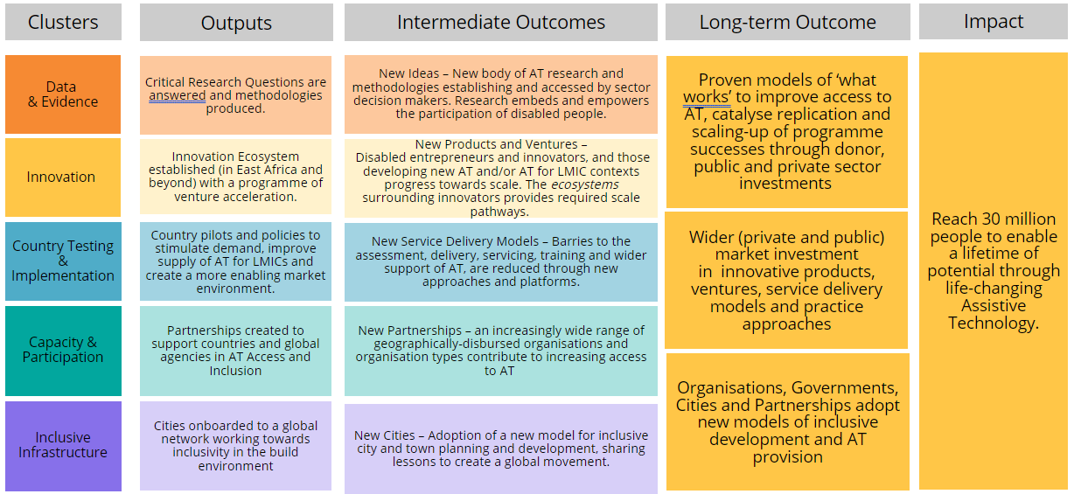
Figure 1: AT2030 Theory of Change [Revised, April 2022]

Following the 2020/21 Annual Review (AR) the ToC was revised to better articulate Intermediate and Long-Term Outcomes, as per Figure 1 above. Current evidence suggests that the ToC logic still holds, as delivery achievements, (see Figure 3 below –‘outcomes’), remain on target. Additionally, following achievements against targets in previous years, despite challenging global circumstances, targets were again increased to continue to deliver stretching results.
The 2022/23 Logframe tracks impact, outcomes and outputs from all programme partners quarterly. Year on year, AT2030 has set more stretching impact (reach) targets. Reach was extended from 800,000 in reporting year 2021/22, to 975,000 in reporting year 2022/23. This breaks down as an additional 175,000 people reached directly (to a cumulative total of 9.1 million), and an additional 3 million people reached indirectly (to a cumulative total of 26m).
“Appropriate accessible and affordable assistive technology (AT), including wheelchairs, prosthetics and orthotics, spectacles, hearing-aids and digital devices, is a key enabler for change. AT is critical for inclusion and transformative for people with disabilities and older people. It is an area where UK science and innovation is world leading.

We will bridge the disability divide through mobile and digital technologies that can link excluded people to education, jobs, finance and markets and create opportunities for marginalised voices to be heard.”

FCDO Disability Inclusion and Rights Strategy

Box 1: AT2030 targets people with disabilities in low- and middle- income countries

Wherever possible the programme collects and disaggregates data by gender, disability, access to AT and geography for more nuanced learning from the programme and to inform future interventions. In line with the ‘nothing about us, without us’ tenet, people with disabilities are targeted by interventions, and meaningfully included throughout the programme cycle, from design through to delivery and monitoring and evaluation (See Box 1).
Note, a Business Case Addendum was approved following the end of this reporting period (1 April 2022 - 31 Mar 2023), increasing AT2030’s budget by £31 million to £50.8 million in total, and to extend the programme to 2030. Therefore, both the logframe and the ToC will be revised by 31 March 2024 as the main spend under the extended programme begins on 1 April 2024. Therefore, delivery against the new logframe and ToC will be measured from 1 April 2024 onwards. These changes will be outlined in the next Annual Review.

Describe where the programme is on/off track to contribute to the expected outcomes and impact. What action is planned in the year ahead?

Impact (reach): Significantly exceeded target
2022/23 Target: Reach 29,9 million people (cumulative total)
2022/23 Achieved: Reached 33,6 million people (cumulative total)

Table2: Reach targets and achievements
Reach | 2021/22  Target | 2021/22  Achieved | (Cumulative) Target  By 31 March 2023 | (Cumulative) Achieved*  By 31 March 2023
Direct (People) | 862,408 | 862,408 | 975,000 | 996,413
Direct (Systemic) | 3,951,313 | 5,046,928 | 6,000,000 | 7,811,419
[Direct total] | [4,813,721] | [5,909,336] | [6,975,000] | [8,807,832]
Indirect | 20,000,000 | 22,487,343 | 23,000,000 | 24,805,647
TOTAL | 24,813,721 | 28,396,679 | 29,975,000 | 33,613,479
Note, a paper outlining AT2030’s definitions of direct (people and systemic), and indirect reach is at Annex A.

* Prior to the recent disaggregation of Direct Reach in early 2022, the programme did not have specific targets against the ‘Direct (People)’ and ‘Direct (Systemic)’ categories; the numbers provided here are imputed from the target set for the original ‘Direct Research’ total.

Impact indicators
- Direct reach (total)
- Total reach (direct and indirect)
These impact indicators substantially exceeded expectations

Last year, FCDO and the GDI Hub agreed to increase the overall reach target from 29m people (total) to 35,1m people (total), to be achieved by the end of the current programme (October 2024). Figure 2 below shows programme performance against impact indicators and projected future delivery.

Examples of Impact progress include:
- Direct Reach (People) – Nearly 87,000 people were reached from continued implementation of the Para Sport Against Stigma sub-programme via the International Paralympic Committee’s (IPC) I'mPossible athlete development, coaching and schools programmes in quarter 1 of 2022/23.
- Direct Reach (Systemic) – Nearly 52,000 people benefitted from the pilot and implementation of the World Health Organisation’s (WHO) online Training in Assistive Product’s modules and 1-stop-shop in Tanzania’s Rudaki district.
- Indirect Reach – 45,700 people were indirectly reached (tracked through social media and website engagements) via the launch of the Assistive Technology Impact Fund (ATIF) Playbook. The playbook was designed to help current and future AT fund operators and ventures learn from the work of the AT Impact Fund (ATIF).
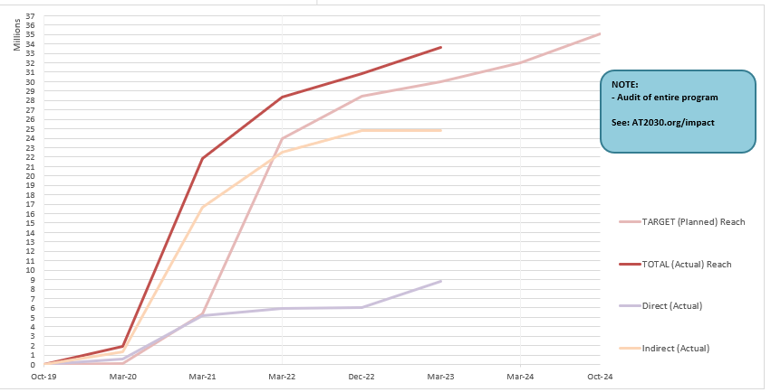
Figure 2: Impact Performance

Impact target (3) ‘Number of life stories reflecting AT life-changing impact’
This impact met expectations

Seven life stories were added this year, taking the cumulative total to 20.

Outcomes

Figure 3 shows achievements against outcomes. All targets were exceeded or met. The blue line outlines targets by the end of the current programme (with the figures above the columns). The targets for the number of innovative assistive technology scaling up / on track to scale and AT Ventures supported for sustainability was narrowly exceeded, as well as the number of entities (countries or organisations) implementing AT2030 funded ideas. Targets to March 2024 remain stretching, (due in part to an already increased target for NEWTECH), therefore it is recommended that existing targets for the 2023/24 reporting period remain. Note, definitions for the outcomes are detailed below.

Figure 3: Outcome Performance

Outcome Indicator 1: New Products
2022/23 Target: scaled 11 new products
2022/23 Achieved: scaled 11 new products
This outcome met expectations

This outcome captures progress scaling new AT products (e.g. physical/software tools or devices) and AT-related product innovations, or existing AT products and AT-related product innovations used in new ways to enable increased access.
[Note, these may be linked to an AT Venture, but they are differentiated as the product/service itself (the 'what'), rather than the operational and delivery service model (the 'how').]

Examples from this reporting year funded through AT2030’s AT Impact Fund:
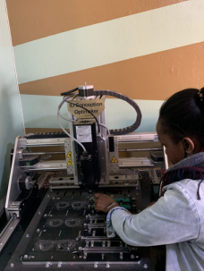

- hearXs’ Lexie hearing aid for the Kenyan market provided 38 bilateral hearing aids (scaling to Kenya) alongside a 45-day mHealth hearing aid support programme in partnership with Illara Health. The Lexie hearing aid connects to the consumer facing Lexia app via Bluetooth allowing the end-user to do an in-ear hearing test, programme the devices, connect to an online hearing expert who can remotely fine-tune the devices, and work through the proprietary digital onboarding and retention programme that rewards good hearing aid usage. In total, hearX has also reached 401 people via training, hearing tests or hearing aids across both South Africa and Kenya, as well as 496 people through a combination of feasibility studies, user research, usability and hearing aid outcome studies.
Figure 4: hearX clinicians with Lexi hearing-aids
- Wazi, a Ugandan owned venture which locally designs and manufactures high-quality afro-centric glasses has now been able to reach an in-store inventory of 980 pairs of glasses, the sale of 226 pairs of glasses as well as the distribution of 135 pairs to vulnerable populations. As a part of ATI F and in partnership with Cubitts, a UK based manufacturer, Wazi have been able to test and validate their business model for sustainable scale, building production, brand and distribution. Wazi are the first company to manufacture locally designed prescription glasses frames in Africa.
Figure 5: Making frames and lenses for spectacles at Wazi

Outcome Indicator 2: Ventures
2022/23 Target: 30
2022/23 Achieved: 31
This outcome moderately exceeded expectations

This outcome describes AT ventures that demonstrate substantive progress to critical sustainability milestones as a result of AT2030 support. ‘Ventures’, describes the business organisation and surrounding ecosystem to support AT innovation. Examples include: improved product development methods; the development of robust evidence proving the validity of solutions; the acquisition of commercial, distribution and/or service links with relevant national and international partners, demonstration of funding or user base increases, or the successful implementation of business plans.

Example from this reporting year:
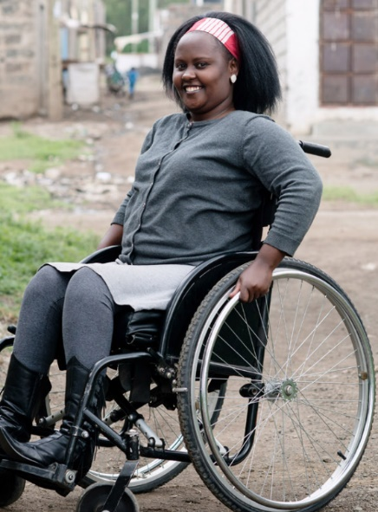
- Motivation, an international development charity and social enterprise aims to provide wheelchairs that meets users’ needs as well as the e nvironment they live in. Under AT2030, in this reporting year, Motivation began tackling the chronic shortage of wheelchairs in low-and-middle-income countries by testing the technical and economic viability of manufacturing appropriate wheelchairs at scale. Motivation are ISO testing and value-engineering a Kenyan 3-wheelchair that is appropriate for high-volume production. As well as the health, social, educational and income generating benefits to appropriate wheelchairs users and their families, the project offers potential employment and tax benefits to Kenya and for Kenya to become a regional wheelchair supplier and contributes to a sustainable business model.
Figure 6: Motivation wheelchair
Outcome Indicator 3: Ideas
2022/23 Target: 45
2022/23 Achieved: 47
This outcome moderately exceeded expectations

This outcome captures the uptake of AT2030 programme ideas, findings and methodologies when there is evidence that they have been adopted by governments or organisations.

Examples this reporting year include:
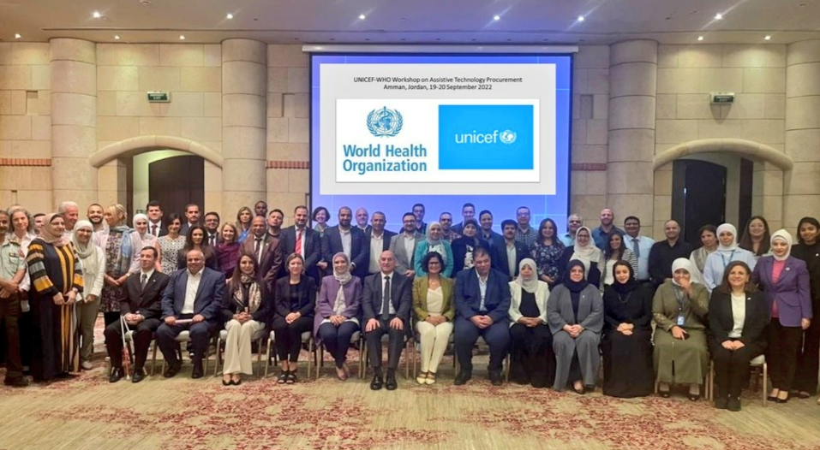
- The uptake and use of the AT2030 1-stop-shop model, tested in Tajikistan and Jordan (see Figure 7), for integrated AT service provision in the Ukraine.

Figure 7: The 1-stop-shop workshop in Jordan


- Para Sport Against Stigma (PSAS) – engagement with the Government of Malawi; Department for Disability and the Elderly in the utilisation and uptake of PSAS evidence (i.e. I’mPOSSIBLE localised Malawi toolkit and Making Noise Campaign (MNC) to tackle stigma). The National Paralympic Committee (NPC) of Malawi has stated that the ministry aims to take excerpts from I’mPOSSIBLE to add to the national curriculum.
- The UK’s Cabinet office conducted a Country Capacity Assessment (CCA), utilising the AT2030 Insights Portal as a data tool.
Figure 8: Para Sport Against Stigma Evidence Brief

Outcome Indicator 4: Delivery Models
2022/23 Target: 9
2022/23 Achieved: 10
This outcome moderately exceeded expectations

This outcome captures the use of AT2030 frameworks and approaches to guide the design, development, deployment, operation and retirement of AT services. Models may include any of the following:
- Communicating the service offerings and products
- Identifying and prioritising demand for capacity development services
- Determining the appropriate level and methodology for service delivery
- Identifying potential partnership opportunities
- Resourcing capacity development initiatives and/or
- Delivering services.
*Note: this target was achieved in 2021/22. The target remained the same to allow GDI Accelerate (which replaced the AT Impact Fund (ATIF) and Innovate Now (IN)) to be conceptualised and implemented.

Examples this reporting year include:
- The WHO, is implementing the 1-stop-shop service delivery model, a model of assistive product service provision piloted by AT2030, in Tanzania, strengthening the service provision infrastructure and improving the range and quality of Assistive Products (APs) available.​ This model of delivery is literally one ‘shop,’ a unified and integrated provision system model in which APs can be accessed at a community level.​ The 1-stop-shop model includes the procurement of assistive products, training of the relevant workforce, the establishment of referral mechanisms and other related activities. In Tanzania, 14 mentors, alongside 42 learners from Primary Health Centres and dispensaries, have been trained and 140 community-based workers have completed the TAP modules which were translated into Swahili. 30 facilities across Tanzania now have APs and WHO partners HelpAge International, Ministry of Health, President’s Office Regional Administration and Local Government (PO-RALG) have completed supervision visits to four TAP facilities.

Match Funding:

See Figure 9. AT2030 will deliver 100% match funding in cash or in kind.

As at end of March 2023, the programme had raised nearly £15.4m in match funding against a target of £15m.

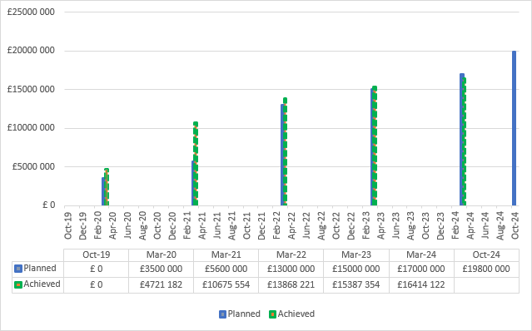
Figure 9: Match Funding Progress

Examples are included in the Output section below.

Justify whether the programme should continue, based on its own merits and in the context of the wider portfolio

The programme should continue. AT2030 has surpassed its impact targets, reaching over 33.6 million people, against a target of 30 million people reached. Overall, building on previous years’ progress, the programme has met or exceeded 4/4 outcome, 4/4 impact and 11/12 output targets in this reporting year and has a strong value for money assessment, including a 100% match funding target. AT2030 is closely aligned with FCDO’s Disability Inclusion and Rights Strategy: 2022 to 2030, and increasing access to AT for people with disabilities was a Research and Evidence Directorate (RED) 2022 Global Disability Summit commitment. Disability inclusion is an important part of the Leave No One Behind agenda and is essential to achieve the SDGs. AT2030 has grown global momentum to improve the provision of AT products and services, supporting people with disabilities to achieve their potential.

Inclusion of Persons with Disabilities and their representative organisations
The needs and priorities of people with disabilities, stakeholders, and Disabled People's Organizations (DPOs) are at the centre of AT2030's approach to research, and the development of AT products and activities, and new service delivery models. To maximize programme impact and sustainability, policy makers, NGOs, and DPOs are deliberately targeted for dissemination, learning, and uptake.

C. DETAILED OUTPUT SCORING

Output Title | (OP1: INNOVATION) Innovation Ecosystem established with acceleration programme
Output number: |  | 1 | Output Score: | A
Impact weighting (%): |  | 26 | Weighting revised since last AR? | N/A

Indicator(s) | Milestone(s) for this review | Progress
1.1 Number of innovative ATs supported | 30 | 32  Moderately exceeded expectations  This indicator was achieved in the previous reporting year. See narrative below for explanation.
1.2 Number of Innovation Ecosystem development interventions (GDIA) | 11 | 10 Interventions  Moderately did not meet expectations  IN and ATIF were replaced by GDI Accelerate (GDIA) which took time to conceptualise, develop and roll-out, and recruit ventures.
NB. the indicators above are cumulative milestone indicators

[Note: Output 1 describes the development of AT products or services themselves to a point where they have been user tested and are ready for market (i.e. Output markers). These are differentiated from outcomes, which evidences their path to scale and sustainability, through the specific Outcome markers of: investment, partnerships, agreements, successful pilot programmes etc.]

Briefly describe the output’s activities and provide supporting narrative for the score.

2021/22 was the main delivery year for the AT Impact Fund (ATIF) i.e. 2021/22 Output targets 1.2 (“Establishment of Innovate Now’s (IN) accelerator programme and number of cohorts run”), and Output 1.3 (“Number of AT Impact Fund (ATIF) Investments”) were replaced with one Output in 2022/23 (“Number of Innovation Ecosystem development interventions (GDIA)”)

In this reporting year, the programme focussed on learning important lessons from ATIF and InnovateNow to develop new and improved approaches. Therefore, informed by programme learning, AT2030 has focussed on reviewing the approach to scaling AT innovations and approaches to improve (and change) delivery to support innovation ecosystem acceleration.

In early 2023, the GDI Hub commissioned PWC to begin co-designing the funding instrument for the follow up to the ATIF, the AT Growth Fund (ATGF). Progress will be reported in the 2023/24 Annual Review.

  - Number of ATs supported
2022/23 target: 30
2022/23 achieved: 32
Moderately exceeded expectations

Testing What Works in AT Innovation, Tacilia, developed by the GDI Hub is an assistive technology that provides access to refreshable tactile displays for low- and middle-income markets. With support from AT2030, GDI Hub conducted user studies with students with visual impairments in India and published papers on the findings. The team are trialling a new business model of open innovation for technically complex AT, developing an open-source toolkit to enable global innovators to make diverse products with Tacilia technology - developing capacity to produce products for low- and middle-income markets. Designed in an open and inclusive way from the beginning, Tacilia is opening up new conversations with local AT manufacturers in Africa. Tacillia won the Innovation of the Year Award in 2023.

  - Number of Innovation Ecosystem development interventions (GDIA) (target re-worded, replacing 2021/22 targets 1.2 and 1.3 and now focused on the ‘Number of Innovation Ecosystem development interventions’)

2022/23 target: 11
2022/23 achieved: 10
Moderately did not meet expectation

One Innovation Ecosystem development intervention was achieved in 2022/23:

To support the development of the innovation ecosystem in Kenya, Motivation partnered with the Kenyan Government, Jomo Kenyatta University for Agriculture and Technology as well as a local production partner to position Kenya as a regional wheelchair supplier to neighbouring countries and a potential contributor to a sustainable revenue model. National production will also provide a route to develop the technical skills, wheelchairs and modified supportive seating products needed to meet the rights of people with more complex mobility impairments.

The Assistive Technology Impact Fund (ATIF) concluded at the beginning of the reporting period. An intentional decision was taken by GDI Hub and FCDO to consolidate learning from ATIF (see Box 2 below) and InnovateNow, to design an appropriate new vehicle that could address the challenges and barriers of working in a nascent ecosystem, to scale solutions. GDI Hub onboarded a new position, the Head of Innovation at GDI Hub to lead on the design and implementation of the new vehicle, GDI Accelerate (GDIA).

Working with PWC, the GDI Hub conceptualised, developed and launched GDIA with longevity and sustainability as core principles, incorporating the functions of ATIF and InnovateNow. GDIA incorporates a design to target the critical transition from early stage to growth; the ‘valley of death’ for many AT ventures. It contains three core products: an insights hub, venture studio and bespoke consultancy.

Concept development, the exploration and consolidation of ATIF learnings and recruitment of the Head of Innovation led to delays in the identification and recruitment of suitable ventures for innovation ecosystem development interventions. Onboarding Koalaa, to test and prove their model of scaling sustainably in Sierra Leone, including all elements of the product and service provision process, was delayed. Scope development and refinement within the new vehicle took longer than anticipated and, to ensure the effectiveness, value for money and long-term sustainability of the AT innovation. To maintain quality, the contracting of Koalaa was delayed into quarter 1 of 2023/24. Therefore, this target was narrowly missed.
Box 2
Highlights of Learning from ATIF: 60 Decibels Report – The Impact of Assistive Technology (Link: https://at2030.org/the-impact-of-assistive-technology/)
This research resulted in insights from across the AT start-up ecosystem, culminating in six main learnings.

- Emerging AT companies working in innovation are reaching users with AT for whom no good alternatives exist. While nearly half of the users report prior use of similar AT products, 85% say they cannot think of a good alternative to the AT company’s offering. This suggests that the offerings of these emerging AT companies are superior to what’s available on the market for this set of users or limited user knowledge exists of what is available.
- AT products are making a positive difference in users’ lives across a variety of dimensions. AT improves users’ confidence and self-esteem, ability to work and social participation. Nearly four in five users report improved quality of life, citing improved functioning and independence. Nearly all the AT companies surveyed outperform the 60 Decibels global benchmark for impact on quality of life.
- Many users report challenges with AT, which inhibit value creation and satisfaction. A consistent link across companies is that users who report challenges have a significantly lower Net Promoter Score than those who don’t experience challenges. However, challenge resolution can improve customer satisfaction, i.e., companies can use user voices to describe challenges and suggestions for improvement to improve user satisfaction.
- The impact of AT and the potential for scale is higher among rural users. AT users living in rural areas report higher improvements in quality of life because of their AT product compared to their urban and peri-urban peers. Furthermore, findings on scalability show that a higher proportion of rural users say their AT product is a ‘must have’ compared to urban and peri-urban users. Expanding reach in rural markets can help emerging AT companies meet their inclusivity and impact goals.
- AT companies are showcasing that gender inclusivity is not a distant goal. The overall gender distribution across all products surveyed is almost equal, with 58% male and 42% female users. Moreover, specific AT services, such as a Hangout Hub (a safe space for individuals who are deaf or hard of hearing), have reached 71% female users. Users of the Hangout Hub and users of a product distributed by a second AT company explicitly expressed that their quality of life improved due to increased self-esteem and confidence, which are key contributors to well-being.
- Lean Data is a promising pathway for assistive tech impact measurement and driving insights. Users spent 15 to 30 minutes sharing how AT impacted their lives, challenges, and suggestions for AT companies, indicating they care deeply about their AT.

Describe any changes to this output during the past year, and any planned changes as a result of this review.

The co-design of the ATGF funding instrument (with PWC) began late in 2022/23. Full implementation of the commercial process to identify and contract a venture building organisation to manage the funding instrument began in earnest following Ministerial approval of the Business Case Addendum in June 2023, which will be reported in the 2023/24 AR. It is likely that full operationalisation of an appropriate new funding instrument will take all of 2023/24 and into early 2024/25 before ATGF scale ventures can be onboarded. Therefore, and based on the programme’s achievements and challenges to date, existing targets for 2023/24 (OP1 = 32 and OP2 = 14) will remain unchanged. A full logframe review will take place in 2023/24.

Progress on recommendations from the previous AR (if completed), lessons learned this year and recommendations for the year ahead

Table 3: 2021/22 Output 1 Recommendations
(OP1: INNOVATION) Innovation Ecosystem established with acceleration programme
Lessons & Recommendations | Progress
LESSONS:  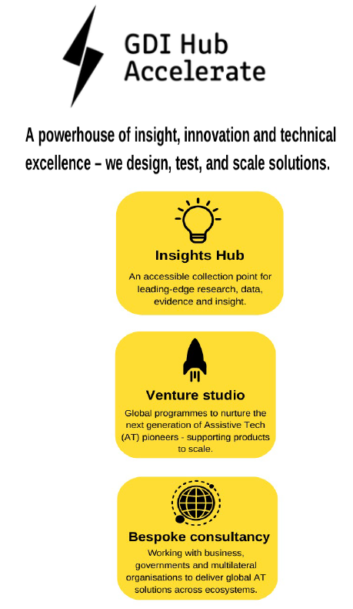  With learning from the programme, review the approach to the ‘Innovation’ cluster of programmes, to assess if this is the most effective programmatic approach for AT2030 to take to build the AT ecosystem and support innovators/ventures from early stage to scale  RECOMMENDATIONS:  Review AT2030’s programmatic approach to innovation and share learning on what works.  [By end 22/23]  Where possible (with the funding available) implement any recommendations for changes to the programmatic approach  [By end June 2023] | DONE  AT2030’s programmatic approach to innovation reviewed and GDI Accelerate mobilised. (ATGF to wait until 2024/25)  - GDI Accelerate: provided a refreshed offer (developed and published), comprising three core products (1) Insights Hub, (2) Venture Studio and (3) Bespoke Consultancy.  - This offering provides a more coherent entry point for a global audience, helping them to understand AT2030 and GDI Hub’s innovation offer, and how to engage in the best way.  - For example: the Insights Hub now directs website visitors to the AT2030 Insights Portal and the Innovator’s Map.  - Venture Studio now houses the Spark, Start-up and Scale components of the previous accelerate offer. Combining these activities into a single offer enables the programme to demonstrate the pathway from early stage to growth stage.  - Comms – the offering was published on the website and a printed brochure made available.  - Development of the GDIA curriculum in response to feedback from founders and investors, regarding the investment readiness of ventures leaving the programme.  - The first round of venture follow-on funding analysis was also completed, with recommendations on how best to operationalise the process in future.  - AT Growth Fund: development of the new fund concept to blueprint stage.  - The proposition targets the critical transition from early stage to growth – the ‘valley of death’ for many AT ventures.  - For rolling out 2024/25.  DONE  The learnings on What Works (across all 4 clusters) was shared both as a Highlights Report, as well as the full paper (scoping review which provides the key learnings and overarching research questions). The learnings, at a high level, were also shared at the Disability Inclusion and Health in Africa and Beyond Conference in Cape Town, South Africa and at AAATE (in Paris), with the paper entitled: “Unpacking ‘what works’: a commentary of the key learnings from ICT from the AT2030 program”
RECOMMENDATION:  Distil AT innovation learning into accessible materials to ensure that the evidence reaches (and is understandable for) AT innovators and ecosystem stakeholders who can benefit from it, to scale access to affordable, context specific AT through a stronger ecosystem.  [By end June 2023] | DONE  - In order to widely disseminate the value and use of AT2030 tools, the following outputs have been developed:  - ATIF Playbook  - What Works Sways  - What Works Highlights Report  - Research Summaries  IN PROGRESS  - The following outputs are in the current pipeline:  - Motivation local production in Kenya Case Study (as a Sway)  - 60 Decibels Impact Report  - Innovation ‘spotlights’  - Innovate Now Playbook (learnings)  - Koalaa Case Study  - Develop and refine the GDI Accelerate curriculum, to ensure it remains highly relevant, is more accessible and can be accessed on-demand.  - AT2030 will further explore the digitisation, creative commons licensing and accessibility of all of these materials.

Table 4: 2022/23 Lessons and Recommendations
(OP1: INNOVATION) Innovation Ecosystem established with acceleration programme
Lessons | Recommendations
GDIA conception and implementation was difficult, complex and took time.  Similarly, procurement and design of the AT Growth Fund will begin in 2023/24 and is expected to be implemented with the first ventures in 2024/25.  It is however important that the programme continues to maintain momentum, continues to learn and measure impact, testing new approaches | Build local capacity through accelerating ventures with AT pioneers through the GDIA programme, Venture Studio component, by 31 March 2024 in order to reach the annual target  In line with the overarching GDIA offering, AT2030 should ensure that research findings are accessible through the ‘Insights Hub’ workstream of GDIA, within four months (by 31 March 2024) to provide the foundational knowledge required by entrepreneurs as well as researchers’ critical to innovation in the AT arena.
GDIA was built on lessons from InnovateNow and the ATIF. However, evidence is needed to prove that the new approach works and is effective in its aims. | AT2030 should test the GDIA Insights Hub (new ideas) model by:  - Tapping into networks to seek new ventures that can be supported, both in terms of their AT innovations (services), and their role in the Innovation Ecosystem, in order to strengthen it. While the programme is beginning to slow towards the end of ‘version 2’, some good progress related to the onboarding of New ventures (products or services) to meet existing logframe targets should be evident before the end of March 2024.  - AT2030 should employ ‘Bespoke Consultancy’ for rapid scaling - generating evidence of unlocking new innovation pathways to overcome wicked problems, tackling product and market-based challenges to maximise impact. Evidence of activities and impact should be made accessible (published or shared online) by end June 2024.

Output Title | (OP2: DATA & EVIDENCE) Critical Research Questions are answered and methodologies produced.
Output number: |  | 2 | Output Score: | A++
Impact weighting (%): |  | 24 | Weighting revised since last AR? | N/A
NB. the indicators in the table above are cumulative milestone indicators
Indicator(s) | Milestone(s) for this review | Progress
Number of peer reviewed journal/conference papers published | 40 | 69  Substantially exceeded expectations
Number of influencing papers, answering critical research questions published | 70 | 82  Substantially exceeded expectations
Number of downloads/views for articles/papers above. | 80 000 | 129 458  Substantially exceeded expectations

Briefly describe the output’s activities and provide supporting narrative for the score.

This was a strong output for AT2030 during this reporting period. Across all indicators in this output, AT2030 has substantially exceeded expectations. The programme continues to produce high quality academic and influencing papers. The number of downloads and views have exceeded expectations, likely due to in part to outreach efforts and a full programme audit/review of the number of historical citations, downloads and views of all of AT2030’s papers.

Output 2.1: Number of peer reviewed journal and conference papers published.
2022/23 target: 40
2022/23 achieved: 69
Substantially exceeded expectations

The boxes below highlight examples of work completed under this output. A full list, including links to the papers and articles is at Annex B.

During the reporting period a substantial amount of research and analytical work was completed. Common research themes included:
- The awareness, understanding, impact and prioritisation of AT globally
- Methods in Estimating Demand and Supply of AT
- AT Need; Results from Population-Based Surveys

Core academic partners within AT2030 include: University College London (UCL), Maynooth University (MU), Loughborough University (LUL), and the London School of Hygiene and Tropical Medicine (LSHTM) alongside individual inputs from: the Institute of Innovation and Public Purpose (IIPP UCL), Development and Planning Unit (DPU UCL), Kathmandu University, University of Malawi, University of Nairobi, Indian Institute of Public Affairs (IIT Madras) and Indian Institute of Technology Delhi (IIT Delhi).

Box 3: Assistive technology access in longitudinal datasets: a global review
UCL and GDI Hub

Downloads: 11

“This review aims to identify and collate what data exist globally, seeking all population-based cohorts and repeated cross-sectional.”

For the AT sector this is relevant as it identifies that functional limitations become more prevalent as populations age, emphasising an increasingly urgent need for assistive technology (AT). Critical to meeting this need trajectory is understanding AT access in older ages. Yet few publications examine this from a longitudinal perspective.

Of 81 cohorts and 202 surveys identified, 47 and 62 meet inclusion criteria respectively. Over 40% of cohorts were drawn from high-income countries which have already experienced significant population ageing. Cohorts often exclude participants based on pre-existing support needs. For surveys, Africa is the most represented region (40%). Globally, 73% of waves were conducted since 2016. 'Use' is the most collected AT access indicator (69% of cohorts and 85% of surveys). Glasses (78%) and hearing aids (77%) are the most represented AT.

Collating these datasets and comparing study designs and world regions highlights critical data gaps, opportunities for analyses that are possible with existing data, and key opportunities to improve data collection across the sector. These steps are critical to generate evidence, demonstrate need, mobilise political will, and ultimately expand access to AT.

Box 4: Experiences of lower limb prosthesis users in Kenya: a qualitative study to understand motivation to use and satisfaction with prosthetic outcomes
UCL and GDI Hub

Views: 1,329

“This study employed a qualitative approach to explore the motivations and satisfaction of individuals with lower limb loss engaging with a prosthetic service in Mombasa, Kenya. In-depth interviews were conducted … with 10 lower limb prosthesis users”

The purpose of this study is to explore the personal and system factors that motivate and enhance outcomes for patients accessing a prosthetic service and using a lower-limb prosthesis within a low resource setting.

Five key themes emerged: acceptance, self-determination, hope, clinician relationship and perception. These findings demonstrate the importance of hopeful thinking and a supportive community in overcoming physical and stigmatising challenges. The findings further highlight the value of the service provider relationship beyond just prescribing an assistive device.

Implications for rehabilitation:
- This research provides an understanding of lower-limb prosthesis users’ satisfaction of a device and motivation for engaging with a prosthetic service within a low resource setting.
- The relationship the rehabilitation professional has with the service user plays a significant role in facilitating motivation during rehabilitation.
- Rehabilitation professionals should consider how they can foster a network of support amongst service users when planning services in remote, rural locations.
- Rehabilitation professionals should be aware of how hopeful thinking can be facilitated during rehabilitation to support motivation.
- When reviewing the success of services, or designing new service models, the service users should be consulted on what they would deem as a successful outcome.
These results have relevance in developing patient-centred services, assistive devices and personnel training that are responsive, motivating, and cognisant of the service user. This is of particular interest as assistive technology services are newly developed in low resource settings.

Output 2.2: Number of influencing papers answering critical research questions published
2022/23 target: 70
2022/23 achieved: 82
Substantially exceeded expectations

The boxes below highlight examples of work completed under this output. A full list, including links to the papers is at Annex C.
Box 5: Why inclusive design is important for climate and crisis resilience in cities?
GDI Hub

Views: 36

Cities worldwide are significantly exposed to the growing impact of climate crisis, from increased heat, intense weather changes, to disasters. According to the U.S. Climate Resilience Toolkit, resilience is the, ‘capacity of a community, business, or natural environment to prevent, withstand, respond to, and recover from a disruption.’

AT2030 is conducting inclusive design case studies on six cities around the world. The researchers saw first-hand the need for inclusive climate and crisis resilience in lower resourced settings. People with disabilities are among the most at risk to the impacts of climate change​.

Even though people with disabilities make up 15% of the world’s population, interventions designed for climate mitigation and adaptation often fail to consider disability inclusive design. Without inclusive solutions, the impacts of climate change can exacerbate existing disabilities and cause new ones​. The climate crisis will worsen health issues and inequalities with disruption to social protection and health care.

Food security can be lower with extreme events affecting production. Infrastructure destruction and damage can impact on secure housing and cause relocation to areas with low or no accessibility. Sanitation and water supplies are also impacted due to stress on supply, flooding, and contamination.

The built environment sector should be encouraged to ensure all retrofit projects undertaken for climate resilience are also audited for inclusion, reducing the need for further retrofitting. In parallel, there is also a responsibility to consider the sustainability and resilience of inclusive design solutions.

Box 6: Assistive Technology in Two Humanitarian Contexts, Bangladesh and Jordan
UCL and GDI Hub

Downloads: 32, Views: 151

Despite increased focus on the need for assistive technology (AT), along with estimates of need and gaps in provision in humanitarian contexts, very little is actually known about how people who need AT are managing in these contexts.

The research found that it is clear that the provision of AT (in this case mainly assistive devices) is ad hoc, and largely related to the access, availability and focus of NGO-funded projects in camps or communities. This is perhaps unsurprising, given the general level of access to goods and services by refugees in both these settings.

When it was available, for many of those interviewed, AT had a positive impact on their lives. However, devices alone cannot ensure wider inclusion – for that, there still needs to be attitudinal change, environmental adaptations, better provision of resources (including rehabilitation) and much wider awareness about the policies and legislation that support the rights of persons with disabilities, including those who have crossed an international border to seek safety and security.

However, there is still very little research around the nexus between social protection and humanitarian responses, particularly for persons with disabilities. Turning inclusion into action requires more connected thinking on joining up social assistance.

Box 7: Para Sport Against Stigma: Research Report on the Tokyo 2020 Broadcasting in Sub-Saharan Africa
Loughborough University
Downloads: 23, Views: 49

This report documents the research insights from the broadcast research theme of Para Sports Against Stigma. It provides key insights, and an analysis of ‘what works’ in order to enhance the sustainable development, reach and impact of the Paralympic broadcasting across Sub Saharan Africa as a vehicle for disability stigma reduction and AT adoption.
The research was developed through fieldwork activities conducted Malawi in collaboration with colleagues at the Centre of Social Research (CSR), University of Malawi.
The research provided important knowledge on: (a) the successes and challenges in the development and distribution of the Paralympic Tokyo 2020 highlights package; (b) audience experiences of watching the Paralympic highlights package; and (c) the cultural impact of the broadcast on disability stigma reduction and the reduction of barriers to AT adoption.
Focus group audience research conducted in Malawi indicates that the impact of the Paralympic broadcast on audiences’ disability attitudes was positive. A proportion of the Malawian Paralympic audience suggested Paralympic coverage was a useful tool for tackling negative cultural disability attitudes and showcasing the role of AT in enabling individuals with a disability to play sport and participate in civic life.
Personal and localised stories of Para athletes and their experience of disability were particularly powerful in capturing the audience and reducing some forms of disability stigma. Paralympic coverage can play an important role in addressing disability stigma and AT use, but content needs to be localised to engage communities in local Para athlete stories of disability. It is imperative to consider the power of disability narratives in the Paralympic coverage and consider how these can be developed to better challenge intersectional forms of disability stigma and AT uptake.

Box 8: Virtual Live Labs: Tacilia Innovation Stack
GDI Hub

Views: 69

Tacilia, a new technology for tactile display devices, aims to reduce the complexity of refreshable tactile displays by reducing the number of components required to actuate a pin array. The development of Tacilia encountered many challenges, and it was constantly overcoming challenges with the people who will be using the technology.

The author created a tactile e-ink to solve the problem of a lack of affordable tactile graphic solutions globally.

The first and most important challenge was to explore and understand what users desire. For Tacilia, they learnt that students and professionals need more tactile information on a large surface quickly. Students and professionals faced challenges understanding and following visual media, waiting long periods for accessible content, and finding bespoke or specific tactile graphics required for education.

In terms of products and devices, quick, bespoke, and extensive information is presented by refreshable tactile displays. These devices reciprocate an array of closely packed pins. The selective movement of pins and their positions creates a tactile effect when the fingers explore the display. Existing tactile displays cost from £15,000 - £50,000. This price point is prohibitive for most individuals and research centres.

The innovators is constantly improving Tacilia’s technical performance and interactions. They work closely with the global community of people with visual impairments by actively involving users as co-designers of the interactions with the technology. They are developing creative and strategic partnerships with manufacturers, distributors and suppliers of AT and consumer goods to ensure Tacilia reaches students and professionals with visual impairments.

Output 2.3: Number of downloads/views for articles/papers above
2022/23 target: 80,000
2022/23 achieved: 129,458
Substantially exceeded expectations

AT2030 has been monitoring the number of downloads, views and citations for all programme research papers through metrics taken from ResearchGate, AT2030.org, journal analytics (which are typically shown next to publications) and partner websites (as part of Quarterly reporting). As at end March 2023, this indicator substantially exceeded expectations with 129,458 downloads and views, against a target of 80,000.

Describe any changes to this output during the past year, and any planned changes as a result of this review.

AT2030 is producing a substantially larger amount of content (academic and grey literature) than originally anticipated. Data and Evidence (especially the production thereof) is a cross-cutting theme across all Clusters and GDI Hub, as a ‘Research and Practice Centre’ has embedded research into all aspects of the programme. Further, research to build the evidence base is disseminated in various ways i.e. academic journal articles as well as blogs, vlogs, insights, influencing papers etc. as grey literature. It is proposed that the targets for this Output be increased in consultation with FCDO and programme delivery partners.

Progress on recommendations from the previous AR (if completed), lessons learned this year and recommendations for the year ahead

Table 5: 2021/22 Output 2 Recommendations
(OP2: DATA & EVIDENCE) Critical Research Questions are answered and methodologies produced. https://at2030.org/impact-stories/
Learning & Recommendations | Progress
LEARNING:  Gender research is a RED and FCDO priority. While the programme has produced some outputs on the differences in access between men, women, boys and girls, this could be prioritised in future studies e.g. pulling together the programme’s existing learning on gender differentiation across research, evidence and data outputs and increasing focus on this in future.  RECOMMENDATION:  Increased programme focus on gender disaggregation and understanding of the nuances between male and female barriers, challenges and access to AT. Share the results with relevant stakeholders.  [Be able to demonstrate substantive outputs in the next Annual Review] | DONE  - As from Q2 2022/23 all partners have been asked, as far as is reasonably possible, to report on gender disaggregated data.  - This includes, for example, research participants, workshop attendees, AT recipients etc.  IN PROGRESS  - The AT2030 programme (at a project level, where possible) will include a focus on gender disparities and access to AT from the outset of scoping the work. These will be/are part of AT2030’s overarching research question related to gender.  - GDI Hub is in the process of advertising for a Research Assistant to support a Scoping Review to under the nuances between the barriers and facilitators experienced between females and males, with regards to access to AT.  - The recommendations will also provide guidance regarding the future direction of more focused research.
LEARNING:  A high volume of research, evidence and data has been produced by the programme. However, it is not always clear where the linkages are between these outputs, and with broader programme outputs, i.e. how the research is informing/has informed progress and decision making across the AT2030 programme  RECOMMENDATION:  Make stronger links between research, data and evidence outputs and how/where they support broader programme outputs, outcomes and impact e.g. through some impact tracing and/or through the programme’s website  [By end June 2023] | DONE  - The ‘What Works to improve access to AT? Interim AT2030 findings: October 2018 – July 2022’ publication, collated 153 AT2030 outputs, 95 of which were analysed showing alignment to the overarching Cluster research questions and those at a Sub-programme level. The 95 outputs included 57 scientific papers and 38 grey literature/knowledge translations materials.  - This scoping review highlighted what is working (overall and per cluster) and made six recommendations for next steps. This included the provision of a set of 20 research questions being answered (up to July 2022).  - In addition to the above substantive body of work, to ensure stronger links between research, data and evidence outputs, impact tracing is conducted in the following ways and reported on: (1) citations of academic / influencing papers, (2) downloads of academic / influencing papers, and (3) unique views through the AT2030 website.
LEARNING:  Outputs are open access and available through various research and data portals however these can be difficult to find.  RECOMMENDATION:  Ensure research, data and evidence outputs are accessible through the AT2030 website.  [By end March 2023] | DONE  - All research, data and evidence outputs for the period 2022/23 (up to 31 March 2023) are published and accessible through the AT2030 website.  - This is an ongoing process currently with 8 peer-reviewed papers, 6 influencing papers and 1 case study to be added.  - Work is also being undertaken to make the website easier to navigate.
LEARNING:  AT2030 has surpassed logframe targets during this reporting period  RECOMMENDATION:  Agree stretch logframe targets  [By end December 2022] | DONE  With further stretch revisions to be proposed following this Annual Review.

Table 6: 2022/23 Output learning and recommendations
(OP2: DATA & EVIDENCE) Critical Research Questions are answered and methodologies produced
Lessons | Recommendations
Women and girls experience access to AT differently from men and boys | Building on last year’s recommendation, researchers should build in a research question (where possible) to capture the nuances between the barriers, challenges and access to AT experienced by women and girls, as opposed to men and boys  From December 2023 onwards

Output Title | (OP3: CAPACITY & PARTICIPATION) Partnerships directly supported and tools and lessons learnt developed to support countries and global agencies
Output number: |  | 3 | Output Score: | A+
Impact weighting (%): |  | 25 | Weighting revised since last AR? | N/A

Indicator(s) | Milestone(s) for this review | Progress
3.1 Number of partnerships supported to increase AT capacity. | 90 | 117  Substantially exceeded expectations
3.2 Number of strategic tools developed to increase AT capacity | 65 | 67  Moderately exceeded expectations
3.3 Number of case studies produced (including from: Inclusive Infrastructure and Sport against Stigma). | 19 | 27  Substantially exceeded expectations
3.4 Value of matched funding provided through partnerships | £15,000,000 | £15,387,354  Moderately exceeded expectations
NB. the indicators in the table above are cumulative milestone indicators.

Briefly describe the output’s activities and provide supporting narrative for the score.

This output continues to be a strength for AT2030. AT2030 has substantially exceeded expectations for two of the targets and met (slightly exceeding) expectations for the remaining two targets during the reporting period. With 117 partnerships contributing to programme delivery, the programme excels at working with a variety of organisations to maximise its outputs. See Figures 10 and 11.

Match funding is reported in Figure 9, Section B of this Annual Review, and all the Strategic Tools and Case Studies produced by the programme in this reporting period are listed in Table 7 below.

3.1 Number of partnerships supported to increase AT capacity
2022/23 target: 90 (increased target from 80)
2022/23 achieved: 117
Substantially exceeded expectations

The number of partnerships formed through AT2030 has been much greater than anticipated during programme design. The programme has now involved 117 organisations globally (summarised by country in Figure 10 i.e. 76 countries, including 49 as part of the Paralympics Broadcasting). In this reporting period, 18 new partnerships were formed through programme delivery. These global partnerships also reflect diversity in terms of organisation types from the private sector, NGOs, governments, universities and hospitals, as shown in Figures 11 and 12.

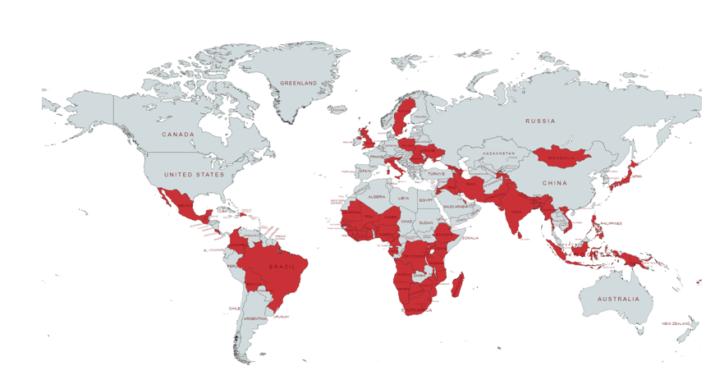
Figure 10: Partnerships by country (all tiers)
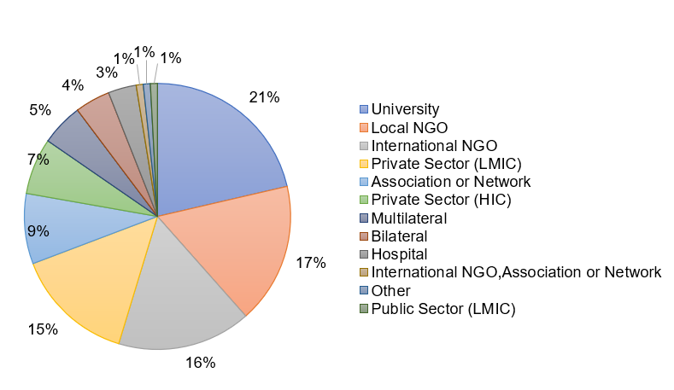
Figure 11: Partnerships by Type
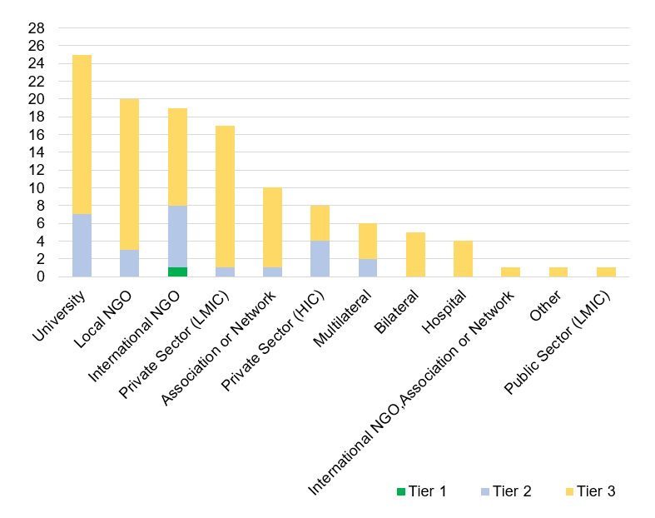
Figure 12: Partnerships by Type and Tier
Tier 1: partners contracted directly by GDI Hub, Tier 2: partners sub-contracted by Tier 1 partners, Tier 3: partners sub-contracted by Tier 2 partners

3.2 Number of strategic tools developed to increase AT capacity
2022/23 target: 65
2021/22 achieved: 67
Moderately exceeded expectations

AT2030 added four ‘strategic tools’ during the reporting period against a target of two. See Table 7 below. These tools, such as the ATIF Playbook and ‘Training in Assistive Products’ (TAP) modules will continue to be developed through buy-in with, and across, the AT sector and are supported by the recommendations of the 2022 Global Report on AT.

Note: The AT2030 Insights Portal will be counted in Q1 23/24 when Phase 2 has been completed.

Table 7: Strategic Tools

Tools | Link
ATIF Playbook  The new Assistive Technology Impact Fund (ATIF) playbook provides a window into AT2030’s experiences in taking innovations to scale. It explores the challenges, learnings and mechanisms for Assistive Tech ventures entering and scaling new markets in Africa. The AT Impact Fund supported 5 ventures through a series of innovation sprints; from establishing resilient business models and developing user-centred products and services, to championing localisation and thinking through new ideas and markets. The process also explored how scale could be unlocked. | https://at2030.org/atif-playbook/
Training in Assistive Products (TAP) - Introduction to AT  *This online module aims to equip community-level personnel working in any context to safely and effectively provide a range of basic assistive products. | https://www.gate-tap.org/courses/introduction-to-assistive-products/
Training in Assistive Products (TAP) - Mobility Assistive Product’s* | https://www.gate-tap.org/courses/mobility-assistive-products/
Training in Assistive Products (TAP) - Vision Assistive Products* | https://www.gate-tap.org/courses/vision-assistive-products/

3.3 Number of case studies produced (including from Inclusive infrastructure and Sport Against Stigma)
2021/22 target: 19
2021/22 achieved: 27
Substantially exceeded expectations

The case studies are designed to engage a range of diverse audiences based on contextualised analysis, recommendations and lessons. A full list of case studies is included in Annex D. This reporting period, AT2030 concluded the current Case Studies workstream. See Table 8 below.

Table 8: Case Studies
Project  [Location] | Case Study | Links
AT Impact Fund  [Sierra Leone] | User feedback of Koalaa prosthetics by CHAI in Sierra Leone  This document provides reporting on evidence from the experience of 27 Koalaa prosthetic users by CHAI, in collaboration with AT2030, the Sierra Leone Ministry of Health and Sanitation and the Global Disability Innovation Hub - including outcomes and recommendations. | https://at2030.org/user-feedback-of-koalaa-prosthetics-by-chai-in-sierra-leone/  Full report:1 page
Inclusive Infrastructure  [Indonesia] | Video: Disability, Resilience and Inclusion in our Cities  Cities worldwide are increasingly exposed to the growing impact of the climate crisis, from increased heat and other extreme weather changes and to humanitarian disasters. 1 in 7 people around the world are people with disabilities, and approximately 80% live in potentially climate vulnerable countries.  This video tells the story of people with disabilities who are most at risk when a disaster occurs e.g. floods or extreme heat. In these situations, orientation and mobility are their top priorities. | https://at2030.org/video-disability-resilience-and-inclusion-in-our-cities/  Full report:1 video
AT Impact Fund  [Uganda] | Wazi Impact Performance Snapshot  Wazi were part of ATIF. ATIF provided catalytic capital with venture-building, to unlock new solutions for scale, building AT ecosystems and driving change. This report, developed by 60Decibels, explores Wazi’s customers; their profiles, outcomes and experiences - looking at key performance and impact metrics to discover customer loyalty, feedback and overall impact on quality of life. | https://at2030.org/wazi-impact-performance-snapshot/  Full report: 5 pages
Innovate Now  [Kenya] | Signs TV Case Study  Signs Media TV was launched in 2015 when the company was granted permission by the Communication Authority of Kenya to run a television station broadcasting in sign language. Since joining AT2030’s Innovate Now accelerator program, the team at Signs Media has been recognized for its high-quality journalism, with several of its journalists and reporters being awarded for their work. These awards are testament to the platform’s commitment to producing accurate, relevant, and insightful news and information. | https://at2030.org/signs-tv-case-study/  Full report: 7 pages
Para Sport Against Stigma  [Across 49 African countries] | TVMS Paralympics Broadcaster Report  The AT 2030 Para Sport Against Stigma project aimed to examine how disability stigma can be overcome through Para sport and thus increase assistive technology (AT) adoption in Africa. The project centred on a four-theme approach: education, athlete development, Paralympic broadcast and cross-cutting research activity.  This research report documents the research insights from the broadcast research theme. It provides an overview of the research conducted, insights, and an analysis of ‘what works’. The purpose was to understand how to enhance sustainable development, reach and impact of the Paralympic broadcasting across Sub Saharan Africa as a vehicle for disability stigma reduction and AT adoption. | https://at2030.org/para-sport-against-stigma--research-report-on-the-tokyo-2020--broadcasting-in-sub-saharan-africa/  Full Report: 15 pages

3.4 Value of matched funding provided through partnerships
2022/23 target: £15,000,000
2022/23 achieved: £15,387,354
Exceeded expectations

AT2030 includes an ambitious 100% match-funding target. The programme leveraged a total of £15,387,354 in cash or in-kind, against an (already stretching) target of £15,000,000. See Figure 9 in Section B. The forms of match contributions are varied. Notable additions in this reporting period include:

- £278 917 from University College London (UCL) counted as additional institutional match funding from waiver of usual margin on Higher Education Institution (HEIs) Costs.
- £312,278 from CHAI, consisting cash (partner direct co-funding into the project budget and in-kind (staff time to project, physical location support – including provision of office space to the project, and support for recruitment or training)). CHAI’s work in this reporting year has included, ‘A Market Shaping Approach to Activate Public Procurement of AT’, for example work in Nigeria related to APS, work in Sierra Leone on validation of AT standards and procurement guidelines and work in Rwanda on training the Disability Mainstreaming Officers (DMO’s) on the Disability Management Information System (DMIS).
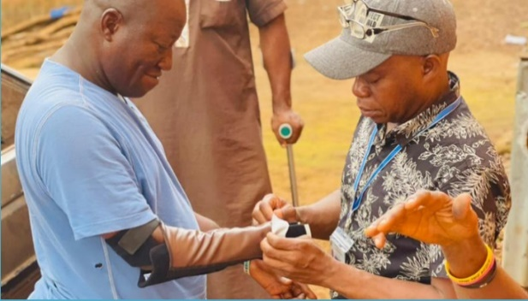
- £114 723 from GDI Hub, including towards ATIF for (a) MiracleFeet - relationship Building, Product Testing and Brace Video financial contribution plus in-kind time contribution for piloting to commercialize the MiracleFeet brace in Nigeria—where 9,500 children are born every year with clubfoot; (b) Koalaa – human resources and personnel in-kind contribution for Koalaa to have an end-to-end service blueprint for distributing their prosthetic arm in Sierra Leone, creating an accessible service to provide people with disabilities in low resource contexts with Koalaa’s prosthetic arm; (c) Wazi Vision - human resources, personnel and operational in-kind contribution for the local manufacturing and distribution of glasses in East Africa using upcycled materials and local Afro-centric artisan designs; (d) hearX - human resources and personnel in-kind contribution to support community-based hearing care for adults in South Africa and Kenya. Further, through GDI Hub’s UCL relationship, in-kind participation in Microsoft Research, IIT Bangalore and IIT Delhi Tactile Interactivity Seminar Series.
Figure 13: Fitting a Koalaa prosthetic arm
- £37,022 – from Loughborough University London - partner direct co-funding and staff time in-kind to the Para Sport Against Stigma project.
- £9,250 – from The Global Alliance of Assistive Technology Organizations (GAATO) consisting of time in-kind (staff and resource provision) for the research and writing of the Scoping Review on Quality Service Provision Guidelines.
Describe any changes to this output during the past year, and any planned changes as a result of this review.

No changes to this output were made during the past year. Although the overall target will be increased following Ministerial approval of a BC Addendum (to be reported in the next AR), there are no planned changes to the Milestone 5 target (2023/24 reporting year), which remains stretching.

Progress on recommendations from the previous AR (if completed), lessons learned this year and recommendations for the year ahead

Table 9: 2021/22 Recommendations
(OP3: CAPACITY & PARTICIPATION) Partnerships directly supported and tools and lessons learnt developed to support countries and global agencies
Learning & Recommendation | Progress
LEARNING:  The programme has performed well this year against logframe targets  RECOMMENDATION:  Review and agree stretch logframe targets  [By end December 2022] | DONE  - With further stretch revisions to be proposed following this Annual Review (Partnerships and Case Studies)
LEARNING:  Innovative new tools have been created/developed and tested during the reporting period which can add value through supporting innovators, ventures and ecosystem stakeholders (including governments) to inform decision making. These tools now need to be shared and socialised with stakeholders who can derive benefit from them  RECOMMENDATION:  Widely disseminate the value and use of AT2030 tools (digital tools in particular – and how to use them), with a targeted stakeholder approach.  [By end June 2023] | DONE  - In order to widely disseminate the value and use of AT2030 tools, the following tools have been shared via a website and social media:  - AT2030 data insights portal (Phase 1)  - rATA tool  - CCA tool  - Assistive Product Specifications  - Toolkit  IN PROGRESS  - Speaking slots and workshops at the upcoming GDI Hub Summit in September on sharing the value and use of AT2030 tools.  - Webinar on the use of the mobile tool for data collection in LMICs.  - Webinar(s) for FCDO advisers, ATIF innovators, and the ATIF selection panel to socialise learning and progress from the ATIF process and ventures themselves.

Output Title | (OP4: COUNTRY TESTING & IMPLEMENTATION) Evidence from in-country pilot activity through investment to; stimulate demand, improve supply of AT for LMICs and create a more enabling market environment.
Output number: |  | 4 | Output Score: | A
Impact weighting (%): |  | 25 | Weighting revised since last AR? | N/A

Indicator(s) | Milestone(s) for this review | Progress
4.1 Number of Procurement pilots/frameworks at the country, regional, global level | 5 | 5  Met expectations
4.2 Country Level Strategies for Disability Inclusion and AT Access (CCAs, Action Plans etc.) | 23 | 25  Moderately exceeded expectations
NB. the indicators in the table above are cumulative milestone indicators.

Briefly describe the output’s activities and provide supporting narrative for the score.

AT2030 met the indicator target for output 4.1: Number of Procurement pilots/frameworks at the country, regional and/or global level; and moderately exceeded the target for output 4.2: Number of country level strategies for Disability Inclusion and AT Access, achieving 25 against a target of 23.

4.1 Number of Procurement pilots/frameworks at the country, regional, global level
2022/23 target: 5
2022/23 achieved: 5
Met expectations

This reporting year, 2022/23, the programme added two procurement pilots/frameworks at the country, regional, global level, bringing the programme total to five. One, was WHO’s implementation plan for the 1-stop-shop pilot for Tanzania, and the second, was the inclusion of hearing aids and wheelchairs into UNICEF’s global procurement catalogue.

The inclusion of products in the catalogue enabled UNICEF to collaborate with the government of Rwanda, supporting them to take a step towards realizing their new (approved) policy for hearing health. This involved a pilot in four districts (out of 30 in Rwanda) in which staff were trained and fitting centers set-up. 1250 Hearing aids were procured for the pilot which enabled the first validation of the Rwanda hearing health plan. A direct result in Rwanda, was regional strengthening of the ecosystem including the creation of a national after care plan for children that received a hearing aid. Furthermore, as a result of the addition of hearing aids into UNICEF’s supply catalogue, the price of the products significantly reduced from 2000 USD per unit, to 118 USD per unit when procured through UNICEF, and increased their availability in low-income countries.

4.2 Number of Country Level Strategies for Disability Inclusion and AT Access (CCAs, Action Plans, NPC Partnerships etc.)
2022/23 target: 24
2022/23 achieved: 25
Moderately exceeded expectations

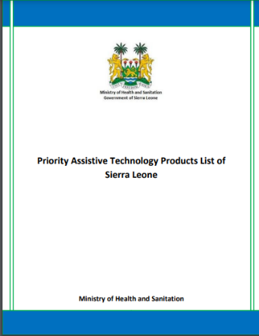
Three were delivered this year. The implementation of the Country Investment Fund (CIF) led by the CHAI, enabled the Ministry of Health and Sanitation in Sierra Leone to develop four documents: AT Policy and Strategic Plan (2021 – 25), National Assistive Technology Standards of Sierra Leone, Assistive Technology Procurement Guidelines of Sierra Leone and the Assistive Technology Products List of Sierra Leone (including 70 assistive products). Together, these documents guide the procurement of AT in Sierra Leone, setting standards for coordination to procure and distribute AT products. The AT standards and procurement guidelines will be launched in quarter 1 of the 2023/24 reporting year.
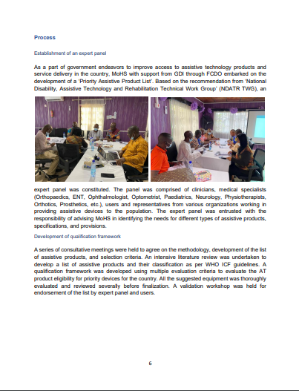 Figure 14: Priority Assistive Tech Products List for Sierra Leone

In Nigeria, CHAI also led the development of the National Assistive Products List (including 44 assistive products), which was used as a guiding policy instrument to develop the country’s first National AT Scale Up Plan, including an investment case. This plan was developed in collaboration with the Government of Nigeria via the newly established National Commission for Persons with Disabilities. CHAI also led the development of the draft Assistive Technology Specifications alongside the Standards Organisation of Nigeria who hold the statutory responsibility to finalise and establish the document as a policy for AT procurement. Finally, CHAI also supported the development of digital AT specifications for Nigeria, to be finalised and launched in quarter 1 of the 2023/24 financial year.

Describe any changes to this output during the past year, and any planned changes as a result of this review. [1 paragraph]

Completing in this reporting period, the Country Investment Fund generated a cohort of four countries Liberia, Nigeria, Rwanda and Sierra Leone, which are now on a pathway to government procurement of a more expansive range of assistive products, shifting from an NGO-led provision model to government-led provision of AT.

Progress on recommendations from the previous AR (if completed), lessons learned this year and recommendations for the year ahead

Table 10: 2021/22 Recommendations
(OP4: COUNTRY TESTING & IMPLEMENTATION) Evidence from in-country pilot activity through investment to; stimulate demand, improve supply of AT for LMICs and create a more enabling market environment.
Learning & Recommendations | Progress
LEARNING:  With the conclusion of CCA, CIF, One-Stop-Shop pilots and the Tokyo Paralympics, the Output targets for this area of work have been completed.  RECOMMENDATION:  Replace these with new indicators to capture work on Country Testing and Implementation focused on procurement. E.g.:  - Number of Procurement pilots/frameworks at country level  - Number of Country Level Strategies for Disability Inclusion and AT Access (CCAs, Action Plans, NPC Partnerships).  [By end December 2022] | DONE  - The previous indicators have been replaced by the two new indicators in this reporting period.

D: VALUE FOR MONEY (1 page)

VfM performance compared to the original VfM proposition in the business case
Examples of VfM from the programme are detailed in table 11 below.
Table 11: VfM
Effectiveness
- The AT2030 Insights Portal (Phase 1) has reduced data gaps and promotes knowledge sharing to support evidence-based policy-level decision-making. It provides access to more than 800 resources on AT across 112 countries from one site.
- What Works’ learnings from the first four years of the programme were summarised in a Highlights Report and the full Scoping Review report – including an analysis of 98 papers (up to July 2022). The outcomes proposed research questions for the programme clusters and sub-questions to set future programme direction.
- The UNICEF and WHO Workshop on Assistive Technology Procurement in Jordan brought together 81 multistakeholder participants (policymakers, academicians, NGOs, AT users and professionals) from 12 countries across the region. The workshop introduced tools that could be applied by countries to aid identification of AT need/unmet need and a tool to survey the country capacity on AT. The data and tools can be used to set policy direction and national budgets for AT, while providing processes to bring together government departments and services providing different aspects for access to AT.
- AT2030 partners, CHAI and WHO, have worked together to generate demand to increase the uptake of newly added AT products to their global procurement catalogues which substantially reduces the pricing of products in LMIC countries. This also reduces the time and resources (human and competitive pricing) for Governments, INGOs, NGOs etc for the procurement of AT.
- Rwanda’s Disability Management Information System (DMIS) developed through CHAI under AT2030, can be adapted and implemented in other countries to strengthen country-level healthcare systems and the supply, demand and procurement of AT.
Cost-effectiveness
- AT2030 has a 100% match-funding target achieved via working through a wide and diverse range of partnerships (NGOs, academic institutions and the private sector), and increased third-party (from donors, governments and private companies) funding. As at the end of March 2023, AT2030 raised over £15.3m in cash or kind.
- Programme inputs are largely person time, utilising a large proportion of human resource capacity via the procurement of academic partners. Costs are based on academic salary scales rather than consultancy fees. This provides a considerable cost saving while providing comparable quality professional inputs. For example, a senior researcher costs approx. £210 per day through AT2030’s grant structure compared to a (discounted and long-term) service level consultancy charge-out rate of £462 for the same level of expert.
Equity
- AT2030 is designed to reach the most vulnerable and 'hard to reach' demographics, particularly older adults and people with disabilities. Reaching the last mile is the focus of country-level work, such as the work in Sierra Leone, which focussed on people living in extremely poor conditions, including informal settlements.
- With learning from the ATIF and InnovateNow, AT2030, through its new GDI Accelerate model, can scale a greater number of ventures developing and providing AT and AT services to reach more people with disabilities in LMICs, and make AT more accessible and affordable for the most vulnerable populations.
Economy
- Local partners in-country delivered inclusive infrastructure case studies by utilizing their connections to local authorities and communities. This more economical and effective approach was a result of travel restrictions during Covid-19, and it has been continued given the effectiveness of programme outputs.
- The match funding target, is used to strongly encourage partners to contribute in cash or in kind e.g. the provision of lower cost or cost-free physical spaces, and time from partners which reduces the relative overall cost per programme.
Efficiency
- GDI hub worked closely with the Global Cooperation on Assistive Technology (GATE) team providing access to an extensive network and knowledge across the world in the AT sector. Further, GDI Hub’s dedicated communications capability aids in the dissemination of research findings, using the range and reach of GATE’s partner networks.
- GDI Hub’s coordination and collaboration function ensures that partners avoid duplication and identify possible programme efficiencies. For example, monthly meetings with ATscale to co-ordinate activities.

Assessment of whether the programme continues to represent value for money

The AT2030 programme continues to deliver strong results, and good value for money and should therefore continue. Programme outputs, outcomes and impact (11/12 Outputs, 4/4 Outcomes and 4/4 Impacts) were either substantially exceeded, marginally exceeded or met expectations (except for output 1, an innovation-related indicator being narrowly missed). The programme has a strong value for money assessment, including a 100% match funding target.

AT2030 supports FCDO’s 2022 Disability Inclusion and Rights Strategy and is a core component of RED’s 2022 Global Disability Summit commitments. Disability inclusion is a crucial component of the Leave No One Behind agenda, and the Sustainable Development Goals (SDGs) cannot be achieved without focusing on people with disabilities.

E: RISK

Overview of risk management

AT2030 is an innovative disability inclusion programme, designed with flexibility to ‘fail fast and scale successes’ to reach more people with disabilities as well as older people. It invests in a nascent area, with new approaches, contexts, and/or technologies. The overall risk appetite and rating for AT2030 remains unchanged as ‘Cautious’.

The program manages risk by using well-established systems to continually monitor and proactively manage risks, using FCDO's risk categories with clear risk owners, mitigation actions, and timelines.

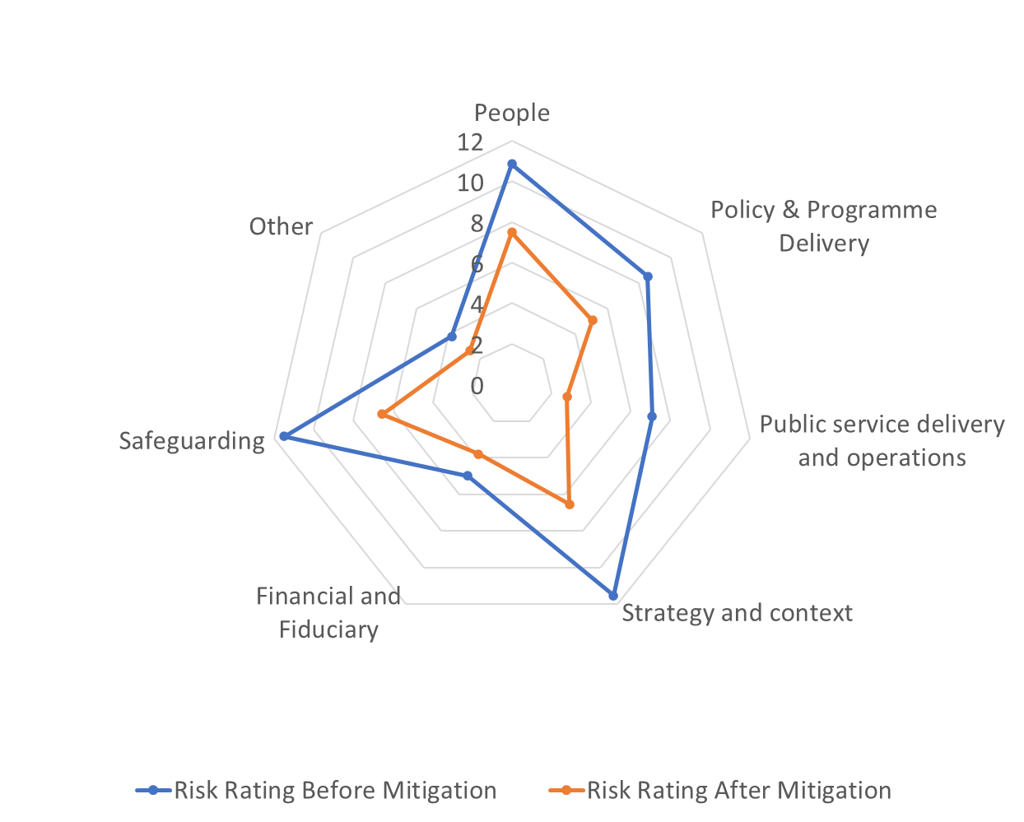
At the end of FY 2022/23, the programme team took a snapshot of the programme risk profile based on feedback from delivery partners and project managers.

Figure 15 summarises the results of this risk assessment. Risk ratings capture an index measure of each risk’s probability and impact on programme delivery, and the diagram details risk profile before and after mitigation actions.

Figure 15: AT2030 Risk Profile 2022/23

Case: Risk Management
PSAS Project is headed by Loughborough University London (LUL), with downstream partner The International Paralympic Committee (IPC) working with the in-country partner in Zambia. After an IPC investigation in August 2022, it was found that of the payments from the PSAS Project, an amount of EUR 4,006 had not been accounted for. Essentially the IPC has evidence that activities took place using the EUR 4,510 (£3,446.29) but no receipts.

  - Outcome: IPC cancelled PSAS operations in Zambia & triggered a membership suspension process. Activities have ceased with the activities being moved to Malawi.
It is important to note that this risk had been identified upfront by LUL, with risk mitigation strategies in place. All due processes were followed with a report as well as all supporting evidence being provided to FCDO.

There are effective mitigations in place against the biggest risks – external context – and a generally balanced risk portfolio overall (ignoring Other, and the low risks related to Financial and Fiduciary).
Risks are discussed with FCDO during regular bi-weekly meetings and more formally through quarterly reporting / reviews. No change to risk appetite is foreseen, and in the next reporting period programme management processes across delivery partners will continue to improve the visibility and responsiveness of risk management practices.

F: PROGRAMME MANAGEMENT: DELIVERY, COMMERCIAL & FINANCIAL PERFORMANCE

AT2030 leads GDI Hub, regularly engage with FCDO and programme partners throughout the reporting cycle. The GDI Hub provided timely quarterly financial and narrative reports, engaged in bi-weekly catch-up calls with FCDO, provided fortnightly delivery and coordination email updates to all partners (including FCDO) - including highlights and media output – attended formal quarterly review progress meetings with FCDO, hosted quarterly AT2030 Advisory Board meetings, and made contributions to the programme Annual Review including presentation/discussion to/with FCDO.

The financial year end accounts of implementing partners are checked by the GDI Hub and provided to FCDO annually. In 2021/22 GDI Hub was also audited as part of its commitment to FCDO. The auditors confirmed there were no material errors relating to the grant accounting and no significant weaknesses relating to internal controls. Programme forecasts and expenditure were managed closely and have broadly been in line with budget. Quarterly and annual programme forecasts are provided to FCDO at the beginning of each quarter and financial year with quarterly updates addressing any changes or variance. Year-end spend was £9.914 (overspent) (i.e. 0.2% variance) against the ceiling budget for the year of £4,265m (£3.905m agreed budget + £360K uplift in Q4).

GDI Hub programme leads have received support from FCDO throughout the performance year (see Section G below). With this support, the program will continue to grow and build on its successes. In-country program and partner linkages will continue to be optimised thanks to ongoing coordination at the country level through the FCDO’s AT2030 Senior Responsible Owner.

As part of the Quarterly Reporting process and narrative reports received from all partners, GDI Hub provides program-level risk reporting, which supports the strategic level risk matrix for AT2030 which is shared and discussed with FCDO during quarterly review sessions.

G: MONITORING, EVIDENCE AND LEARNING

Monitoring and Evaluation

There is a robust AT2030 programme monitoring system in place, which includes:
- Bi-weekly meetings (with a standing agenda such as highlights, challenges, opportunities etc.),
- Quarterly review meetings (typically April/May, July/August, October/November and January/February),
- Quarterly AT2030 Advisory Board meetings (with documentation including a Programme Report, detailed Partner Reports known as the 5_15’s, and a slide deck),
- An Annual Report accompanied by a review meeting and presentation,
- Field visits (refer to Box 9 below),
- Engagements with stakeholders, for example meetings regarding MEL and Research/Communications facilitated by FCDO Technology and Innovation Unit (TIU). These sessions include other large FCDO programme partners and are designed to share good/best practices and learnings to improve the programme management of AT2030.
Engagement between GDI Hub and FCDO through these monitoring activities has improved the quality of the AT2030 programme. This engagement includes discussions around issues, regular review of the progress against logframe targets and areas for improvement.

Box 9: Mission to Kenya  Members of the GDI Hub team recently returned from Nairobi, where alongside FCDO we met partners and collaborators, heard from innovators, witnessed the delivery of AT2030 supported products, viewed live lab activities and heard how AT is being embraced within the region. During the week we launched the latest Inclusive Design and Accessibility of the Built Environment case study of Nairobi (to a packed room), attended a WHO roundtable on Strengthening Partnerships for Universal Health Coverage (in which AT featured heavily) and met many of our brilliant partners. | 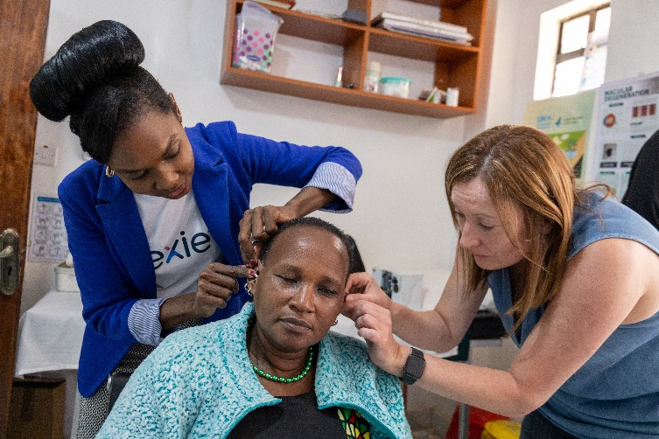  Figure 16: HearX and FCDO SRO fitting hearing aid in Nairobi, Kenya

The programme visit (outlined in Box 9), provided an opportunity for the FCDO AT2030 SRO and GDI Hub partners to engage with project delivery and AT and project beneficiaries, around their experiences and the impact the programme has had.

GDI Hub programme visits have supported ventures to further develop their business models. For example, Koalaa (a venture that was originally part of ATIF) scoped an extended their project to build capacity to begin to scale their operations (piloting and testing the rapid fitting, of context specific, affordable and functional upper-limb prosthetics). Using this model, they plan to deliver hundreds of high-quality products, including a quality service experience to AT users in Sierra Leone. The Koalaa approach is expected to be both replicable and repeatable in other countries and regions.

Evidence
AT2030 leads GDI Hub have dedicated efforts to ensure the breadth and robustness of evidence produced. Within the reporting period, the GDI Hub completed a full programme audit to ensure all outputs, as well as reach relating to impact, were accurately captured and reflected in the programme Monitoring and Evaluation framework, i.e., logframe. As reflected within this annual review, AT2030 has produced a significant number of rigorous outputs. For peer reviewed papers and journal articles, AT2030 has published 69 outputs against a target of 40, for influencing papers, 82 were produced against a target of 70, and reach in terms of downloads, views and citations at the end of this reporting period is 129,458 against a target of 80,000. Strategic tools developed by the programme such as the AT Insights Portal and the AT Innovators Map, support the creation and facilitation of access to evidence for the sector. AT2030 has also observed the uptake of AT2030 funded ideas (key learnings, research findings or new methodologies) by 47 entities during this reporting period.

Additionally, within this reporting period, GDI Hub, as AT2030 lead, improved partner reporting via capacity building initiatives that included the provision of detailed examples of AT2030 log frame targets, and sharing knowledge regarding indicator definitions, which led to a marked improvement in partner reporting. To support the ‘Leave no one Behind’ agenda, partner reporting includes the disaggregation of data by gender (sex), alongside country level implementation data to map and monitor the geography of the programme. Due to the strong relationships GDI Hub holds with AT2030 partners, robust project scoping as well as implementation and overall delivery within programme timelines has demonstrated effectiveness and efficiency.

Learning
In terms of learning processes to capture and share lessons, a scoping review of all outputs evidence over the past four years was undertaken. This work extrapolated learnings on What Works to explore and test innovative ways to address systematic challenges. A full paper was produced, a highlights report, two conference presentations and a session is planned for the GDI Hub Summit on 13-14 September 2023. Additionally, lessons, new evidence and know-how is shared with the AT sector globally through research summaries, sways, playbooks, innovation spotlights, learning notes (e.g. CIF – reflections on implementation), innovation stack, blogs, webinars, influencing papers and through strategic tools such as the data insights portal. To better capture lessons learnt on ‘what works’ on a continuous basis, the quarterly reporting template for partners was improved.

Date of last narrative financial report | 7/06/2023 | Date of last audited annual statement | 22/09/2022

Annex A: AT2030 Reach Definition

The AT2030 programme is designed to find out ‘what works’ in getting AT to the people that need it around the world, in order to create blueprints for scale. It is therefore foundational, explorative research and innovation; rather than being a programme which solely tries to map AT units to individuals. The Logical Framework (logframe) indicators were initially agreed in 2018 as part of an addendum to the existing FCDO Ideas 2 Impact (I2I) business case in line with the co-creation and scoping work that had been undertaken. The Log Frame was reworked in 2019 when AT2030 developed a new business case for a stand-alone programme, but the approach to developing ‘reach’ figures remains unchanged, and in line with the Global Strategy on AT.
After analysis and collaboration, including that presented in the scoping report on AT funded by FCDO (here), it was considered that the priority interventions necessary to improve access to AT were more complex and more systemic than simply providing AT; which would be a) a drop in the ocean of the problem and b) could be piecemeal and not transformational. The programme was, therefore, founded upon the hypothesis (tested in the scoping review) that interventions should need to span market shaping, innovation, systems intervention, and community participation – as well as the direct provision AT, as a first principles impact priority.
At inception it was felt important that the programme incentivised action at a systemic level.
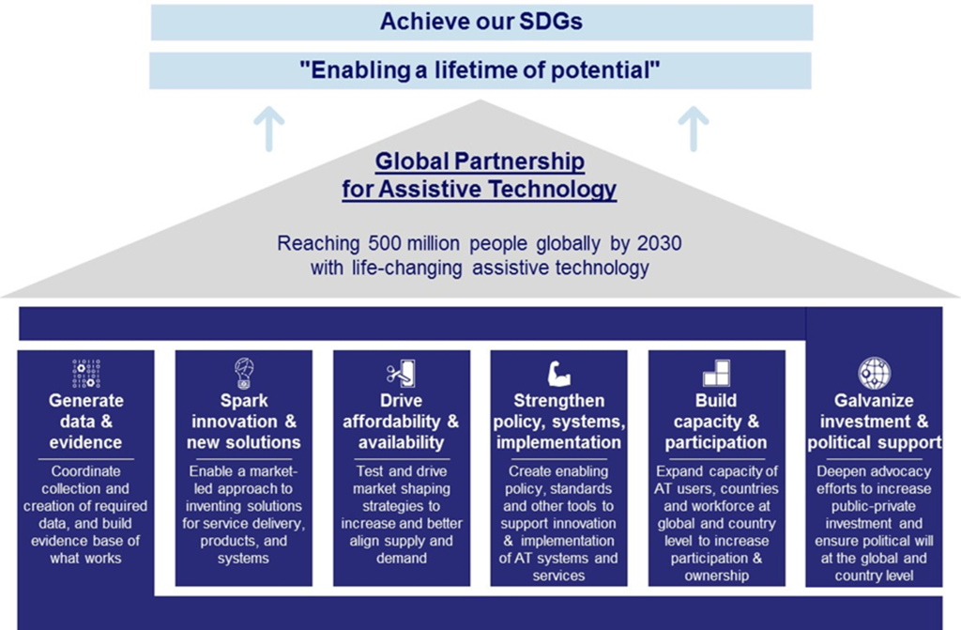
AT2030 includes top-level impact indicators which target ‘Reach’ (Direct (People), Direct (Systemic) and Indirect). These quantitative indicators sits aside a qualitative measure of impact captured in the 2019 AT2030 Log Frame - Impact Stories. The ‘Reach’ indicators cover all aspects of AT2030 delivery, including research, product innovation, delivery pilots, media outreach, advocacy, capacity building, partnership development, match-fund mobilisation, policy reform and venture investment.
Reach Definitions
Direct Reach (People):
People who participate at an individual level in the activities and/or outputs of AT2030. This includes individuals reached by the programme in its endeavour to find out ‘what works’- is not the same as beneficiary counting, as we are interested in benefits as well as inclusion. This reach nevertheless typically refers to individuals.

Direct Reach (Systemic):
Groups who benefit from the outputs and outcomes of the AT2030 relating to improved provision of AT through policy and system advances, and community- and organisational-level change. This includes systemic changes of a defined and specific magnitude in terms of the number and manner of people affected and included. This reach typically refers to groups. This captures core success factors for the appropriate provision of AT set out in the Scoping Report 2018 and notably includes changes in the provision of rights and recognitions and the engagement of people with disabilities in the process.

Indirect Reach:
Individuals who are not directly connected with the programme but could still derive benefit from it. This (likely) does not involve direct interaction with the programme but can be reasonably identified as included within programme community/national-level catchment.

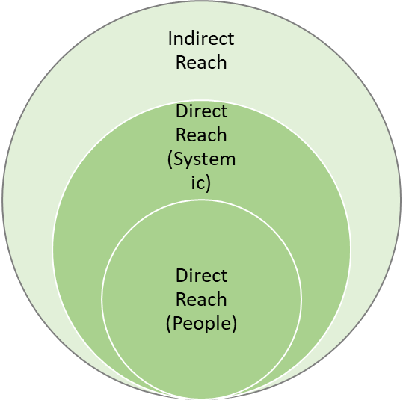

Direct Reach (People)
The participation of people with disabilities in research on issues which affect their lives is an essential element of ensuring that disability research is robust and focused on the issues of greatest importance and the participation of people with disabilities in co-designing a more inclusive world is also necessary for achieving it. Innovators know that user-centered design is essential, and this is also the case with research. We describe this as necessary to create the conditions for ‘socially just’ pedagogy (Goodley, 2007).
People with disabilities are substantially underrepresented within research (including research on disability issues). Emancipatory research, as first identified by Oliver (1992), was based on changing the social relations of research production. In other words, for emancipatory research to be possible the balance of power within the research process would have to change and move towards a more equal relationship between the researcher and the people with disabilities who are being ‘researched’. Disability research would have to be done with (i.e. in partnership with) people with disabilities rather than on them - as had been the case with traditional approaches. With a focus on a social model of disability, commentators such as Oliver and Zarb forwarded models of ‘emancipatory’ research as a response not only to the exclusion of people with disabilities from the research process, but as a necessary reaction to the oppression of people with disabilities in society and the systematic denial of their rights. In recent years Disability Emancipatory Research has been operated in practice seeking to drive participation of disabled people as research co-creators forward, but it is not without challenge in implementation and is naturally always imperfect (Goodley, 2007; Deepak, 2019).
For the above reason, across research conducted within AT2030, we count the reach of participants with disabilities in recognition of the ‘basic’ (adequately reflecting perspectives) and ‘emancipatory’ (addressing social relations and rights through inclusion and research awareness) importance of research practice. This specific cohort of direct reach (i.e., research participants) will be disaggregated within the overall category and supported by future research on the emancipatory power of research inclusion within the field of disability.
In respect of supporting the physical delivery of AT products (hearing aids, wheelchairs, prosthetics etc.), which is only one part of what AT2030 does, we count people receiving or being assessed for AT and their support personnel (if applicable). Relieving pressure on carers and support persons is a well-recognised benefit of providing AT to a user, in addition to the benefit realised by the user themselves.
With respect to the delivery of capacity building and system strengthening work within country organisations, the reach aims to capture the size of the team or organisation which is strengthened, along with qualitative feedback from participants to validate this impact.
Direct Reach (Systemic)
A core pillar of the AT2030 is to trial strengthening policy, systems and implementation to create enabling an environment for innovation and AT. A substantial component of programme delivery is aimed at the creation of this enabling environment within which people with disabilities live. While over the course of 10-15 years we would expect to see increased delivery of AT units as a longer-term result of this enabling environment, that long-term impact is beyond the scope of AT2030’s results chain.
People benefit from rights by virtue of having them (even for example when they don’t draw upon them). For example, people who have never committed a crime, are nevertheless still beneficiaries of the right to a fair trial; those who live without arbitrary encumbrances on their liberties are nevertheless beneficiaries of human rights provisions (where these exist).
For the reasons above, within Reach we count those groups of disabled people newly covered by rights and policy provisions as a result of AT2030 efforts. The methodology for capturing this reach is based on the identification of the intervention type and the nature of the output/outcome delivered. Crucially, in order to be direct systemic reach, the change created must be of a defined and specific magnitude in terms of the number of people affected and included the way in which they are affected/included and at a level of greater specificity to general (DP) population impact. In referring to systemic change this is necessarily compliance indicator, rather than performance indicator, and while necessarily limited in the nuance it can capture, is comparable to the use of indicators and statistics within the United Nations human rights system.
A key example here, would be the expansion of provision of AT within primary health care policy coverage – and the fact that not every single person will, at that moment, make a claim for AT, but all functionally eligible and included persons are from that point capable of making such as claim. This is distinct from broad policy catchment, as the policy shift captured here (rather than under Indirect) are immediately implementable in their passing. These changes are substantial impacts and advancements for increasing access to AT. We don’t count whole national populations despite the fact that conceivably these rights and provisions have nationwide impacts for all citizens. It is also worth noting that due to systematic and seismic underestimates in disability prevalence rates, even the reach that is counted here is likely an underestimate of impact. To date we have only counted those populations specifically targeted by policies in South Africa, Liberia and Kenya, which are passed along with the capability to implement (e.g. financial or practical), for example which includes:
- 95,000 directly reached during the programme’s engagement with Ministries including interviews informing the product narratives, ministry capacity building, and direct pilot service delivery (such as the Liberia eye health pilot), since the programme began in 2019.
- 900,000 people with disabilities that will benefit directly from the Kenya Disability Medical Assessment and Categorization Guidelines and National Strategy for Scaling Rehabilitative Services and Increase Access to Assistive Technology. This is a subset of the approximately 4m disabled people in Kenya in scope of a more inclusive policy environment, with the number here referring to those specifically provided for in the Medical Assessment Guidelines and Rehabilitative Services, as identified though the process of policy formulation. This substantial systemic impact addressed the needs for the provision of AT set out in the Scoping Report 2018, and captures the importance of domestic policy and resource mobilisation.
1.9m learners covered by the Integrated School Eye Health in South Africa and 400,000 learners covered by a similar School Eye Health framework in Liberia. This reach captures the number of learners provided for by the policy adopted by government as a result of the pilot and is both a substantial impact for the programme in catalysing systemic change with a direct user group in focus and aligned to priorities for the provision of AT set out in the Scoping Report 2018.

Another large part of AT2030’s programmes of activities are focused on awareness raising, behavioural change and project participation. This is measured through demonstrations of positive actions by people on AT and disability topics and actions which address stigma.
Work addressing and seeking to better understand stigma around disability is one such example. Additionally, where the programme works to change the way third-party entities implement AT-related work, the breadth with which AT2030 is able to engage with organisations is crucial to the sustainability of impact achieved. This also relates to the programme Outcome to see third-party entities (countries or organisations) implementing AT2030 funded ideas (findings, research or new methodologies).
For this reason, in Reach, we capture audiences actively participating and interacting with advocacy and outreach materials or workshops (for example, around positive inclusion messaging on disability and participation). NB. We do not count within reach the total audience size without evidence of interaction. For example,
- 1,569 people have participated in AT2030’s Disability Live webinars focused on sharing insights from the programme and offering an opportunity for panel engagements.
- AT2030 Stigma reducing work in Kenya delivers change though positive disability messaging in comics and social media. Programme research indicated that approximately 7.7 million Kenyans aged 15-24 years old received a range of media from the programme; however only a sub-set of this is counted as direct reach – such as the 297,655 (over a two year period) who clicked onto the online resources to get further information of the AT providers, reached out to the implementing partner on SMS, or responded to the call outs and then connected to a service and/or product provider. Also included are those receiving project materials which address stigma and support behavioural change, where these are supported by evidence showing a material and direct impact on people’s perceptions of disability and ability/willingness to engage in addressing stigma. A parallel example might be counting the number of bed-nets disbursed with evidence of their efficacy in reducing malaria.

Indirect Reach
Indirect reach is collected across the breadth of the programme, and reflects the diversity of delivery approach and domains, inclusive of policy strengthening, capacity and participation, political support, behavioural change and innovation ecosystem growth. The impact counted as indirect in contract to direct reach, cannot be either directly identified as specific individuals or specific groups. Examples from the programme to date include:
- 6.3m indirectly reached based on the population catchment of PWD covered by new national policies and frameworks in Liberia, Indonesia, South Africa, Kenya. NB. Not counted here are the approximately 55,000,000 total PWD population covered by the Country Capacity Assessments and Action Plans developed under AT2030, across eight counties, even though in-time benefits are likely to be realised from this.
- 1.2m radio show broadcast audience members receiving programmes which address issues of disability stigma.
- 675,000 Social Media users who viewed and clicked the #DisabiltyInnovationDay tag attached to AT2030 work, and those viewing media from our Stigma programme on social media.
- 4,000 unique users accessing AT2030 material on AT2030.org

All of the figures above are measured and tracked through:
- Partner reporting, especially with respect to service delivery models where change and uptake at the national/organisational level can be identified.
- Research and insights monitoring by partners and/or third-party research/evaluation to ascertain the value-add of programme support.
- Media analytics and event monitoring.

Annex B: Output 2.1: Peer reviewed articles / journal articles published

Previously Reported in 2021/22 Annual Review | Newly Reported in this Annual Review Period

Paper Title | Platform / Journal
- New economics of assistive technology: A call for a missions-approach | UCL Institute for Innovation and Public Purpose https://at2030.org/new-economics-of-assistive-technology:-a-call-for-a-missions-approach/
- Critical Junctures in Assistive Technology and Disability Inclusion | The Official Journal of RESNA, Volume 22, 2021, Issue Sup 1: Companion Papers to the Global Report on Assistive Technology  https://doi.org/10.1080/10400435.2021.2003658  https://at2030.org/critical-junctures-in-assistive-technology-and-disability-inclusion/
- Introduction to the companion papers to the global report on assistive technology | The Official Journal of RESNA, Volume 22, 2021, Issue Sup 1: Companion Papers to the Global Report on Assistive Technology  https://doi.org/10.1080/10400435.2021.2003658  https://at2030.org/companion-papers-to-the-global-report-on-assistive-technology/
- GREAT: Self sustainable Assistive & Accessible Technology for Low Resource Settings | Great Summit Submission Theme 9: ‘Effective Access to AT’, Overcoming systematic global barriers to AT: a new methodology and quick start testing through a £20m programme.  https://discovery.ucl.ac.uk/id/eprint/10084627/1/107_AUSTIN_Victoria-Overcoming-systematic-global-barriers-to-AT-a-new-methodology-and-quick-start-testing-through-a-%C2%A320m-programme.-V2.pdf  https://at2030.org/great-selfsustainable-assistive-and-accessible-technology-for-low-resource-settings/
- “Give Us the Chance to Be Part of You, We Want Our Voices to Be Heard”: Assistive Technology as a Mediator of Participation in (Formal and Informal) Citizenship Activities for Persons with Disabilities Who Are Slum Dwellers in Freetown, Sierra Leone | Int. J. Environ. Res. Public Health 2021, 18(11), 5547; https://doi.org/10.3390/ijerph18115547  https://at2030.org/assistive-technology-as-a-mediator-of-participation/
- “This Is the Story of Community Leadership with Political Backing. (PM1)” Critical Junctures in Paralympic Legacy: Framing the London 2012 Disability Inclusion Model for New Global Challenges | Sustainability 2021, 13(16), 9253; https://doi.org/10.3390/su13169253  https://at2030.org/critical-junctures-in-paralympic-legacy/
- A review of innovation strategies and processes to improve access to AT: Looking ahead to open innovation ecosystems | The Official Journal of RESNA  Volume 33, 2021 - Issue sup1: Companion Papers to the Global Report on Assistive Technology  https://www.tandfonline.com/doi/full/10.1080/10400435.2021.1970653  https://at2030.org/a-review-of-innovation-strategies-and-processes-to-improve-access-to-at-looking-ahead-to-open-innovation-ecosystems/
- Could Assistive Technology Provision Models Help Pave the Way for More Environmentally Sustainable Models of Product Design, Manufacture and Service in a Post-COVID World? | Sustainability 2021, 13(19), 10867; https://doi.org/10.3390/su131910867  https://at2030.org/assistive-technology-provision-models/
- Estimating need and coverage for five priority assistive products: a systematic review of global population-based research | BMJ Global Health, 2022; 7: e007662. doi:10.1136/ bmjgh-2021-007662  https://gh.bmj.com/content/7/1/e007662.abstract  https://at2030.org/estimating-need-and-coverage-for-five-priority-assistive-products/
- Measuring assistive technology supply and demand: A scoping review | The Official Journal of RESNA  Volume 33, 2021 - Issue sup1: Companion Papers to the Global Report on Assistive Technology  https://doi.org/10.1080/10400435.2021.1957039  https://at2030.org/measuring-assistive-technology-supply-and-demand-a-scoping-review/
- Developing inclusive and resilient systems: COVID-19 and assistive technology | Disability & Society, Volume 36, 2021, Issue 1  https://doi.org/10.1080/09687599.2020.1829558
- “When They See a Wheelchair, They’ve Not Even Seen Me”—Factors Shaping the Experience of Disability Stigma and Discrimination in Kenya | April 2021  International Journal of Environmental Research and Public Health 18(8):4272  DOI:10.3390/ijerph18084272  https://at2030.org/experience-of-disability-stigma/
- Shifting the focus to functioning: essential for achieving Sustainable Development Goal 3, inclusive Universal Health Coverage and supporting COVID-19 survivors | Global Health Action, Volume 14, 2021, Issue 1, https://doi.org/10.1080/16549716.2021.1903214  https://at2030.org/shifting-the-focus-to-functioning-essential-for-achieving-sustainable-development-goal-3-inclusive-universal-health-coverage-and-supporting-covid19-survivors/
- Estimating Need for Glasses and Hearing Aids in The Gambia: Results from a National Survey and Comparison of Clinical Impairment and Self-Report Assessment Approaches | Int. J. Environ. Res. Public Health 2021, 18(12), 6302; https://doi.org/10.3390/ijerph18126302  https://at2030.org/estimating-need-for-glasses-and-hearing-needs-in-the-gambia/
- Measuring Access to Assistive Technology using the WHO rapid Assistive Technology Assessment (rATA) questionnaire in Guatemala: Results from a Population-based Survey | Disability, CBR and Inclusive Development 2022, 33 (1), https://doi.org/10.47985/dcidj.573  https://at2030.org/rata-in-guatemala/
- Exploring the Use of Washington Group Questions to Identify People with Clinical Impairments Who Need Services including Assistive Products: Results from Five Population-Based Surveys | International Journal of Environmental Research and Public Health 2022, 19 (7), 4304, https://doi.org/10.3390/ijerph19074304  https://at2030.org/clinical-impairments-and-at/
- Assistive Technology (AT), for What? | Societies 2022, 12 (6), 169, https://doi.org/10.3390/soc12060169  https://at2030.org/at-for-what/
- Experiences of lower limb prosthesis users in Kenya: a qualitative study to understand motivation to use and satisfaction with prosthetic outcomes | Disability and Rehabilitation 2022, https://doi.org/10.1080/09638288.2022.2152875  https://at2030.org/experiences-of-lower-limb-prosthesis-users-in-kenya/
- Global report on assistive technology | UNICEF, WHO 2022, https://www.who.int/publications-detail-redirect/9789240049451  https://at2030.org/global-report-on-at/
- Towards Proactive Information Retrieval in Noisy Text with Wikipedia Concepts | CEUR Workshop Proceedings 2022, https://ceur-ws.org/Vol-3318/paper10.pdf  https://at2030.org/noisy-text-wikipedia-concepts/
- Assistive technology access in longitudinal datasets: a global review | International Journal of Population Data Science 2023, 8 (1), https://doi.org/10.23889/ijpds.v8i1.1901  https://at2030.org/at-access-in-longitudinal-datasets/
- Responding to the coronavirus disease-2019 pandemic with innovative data use: The role of data challenges | Data & Policy 2023, 5, E11, https://doi.org/10.1017/dap.2023.6  https://at2030.org/responding-to-the-coronavirus/
- Prevalence of Cognitive Impairment and Its Association With Hearing Loss Among Adults Over 50 Years of Age: Results From a Population-Based Survey in Santiago, Chile | American Journal of Audiology, 2023, https://doi.org/10.1044/2022_AJA-22-00042  https://at2030.org/prevalence-of-cognitive-impairment-and-its-association-with-hearing-loss/
- Assistive technology needs, access and coverage, and related barriers and facilitators in the WHO European region: a scoping review | Disability and Rehabilitation 2022, https://doi.org/10.1080/17483107.2022.2099021  https://at2030.org/assistive-technology-needs,-access-and-coverage,-and-related-barriers-and-facilitators-in-the-who-european-region/
- Disconnected from Reality: Do the core concepts of the metaverse exclude disabled individuals? | TIAM23 Workshop at ACM CHI 2023, https://doi.org/10.48550/arXiv.2303.08222  https://at2030.org/workshop-disconnected-from-reality/
- People with Clinical Impairments Who Need Services including Assistive Products: Results from Five Population-Based Surveys | International Journal of Environmental Research and Public Health 2022, 19 (7), https://doi.org/10.3390/ijerph19074304  https://at2030.org/clinical-impairments-and-at/
- Paralympic Broadcasting in Sub-Saharan Africa: Sport, Media and Communication for Social Change | International Association for Communication and Sport 2022, https://doi.org/10.1177/21674795221093722  https://at2030.org/paralympic-broadcasting-in-subsaharan-africa/
- Co-creating Inclusive Public Spaces: Learnings from Four Global Case Studies on inclusive Cities | The Journal of Public Space 2022, 7 (2), https://doi.org/10.32891/jps.v7i2.1500  https://at2030.org/co-creating-inclusive-public-spaces/

Newly Identified Outputs – AT2030 Audit

Paper Title | Platform / Journal | Reporting Year

- A review of innovation strategies and processes to improve access to AT: Looking ahead to open innovation ecosystems | The Official Journal of RESNA 2021, 33 (1), https://doi.org/10.1080/10400435.2021.1970653  https://at2030.org/a-review-of-innovation-strategies-and-processes-to-improve-access-to-at-looking-ahead-to-open-innovation-ecosystems/ | 2020/2021
- GREAT: Self-sustainable Assistive & Accessible Technology for Low Resource Settings | CHI Extended Abstracts 2020, https://doi.org/10.1145/3334480  https://at2030.org/great-selfsustainable-assistive-and-accessible-technology-for-low-resource-settings/ | 2020/2021
- Intersections between systems thinking and market shaping for assistive technology: the smart (Systems-Market for assistive and related technologies) thinking matrix | International Journal of Environmental Research and Public Health 2018, 15 (12),  https://doi.org/10.3390/ijerph15122627  https://at2030.org/systems-thinking-and-market-shaping/ | 2018/2019
- Mobile technologies as assistive technologies in humanitarian and development contexts | IEEE Global Humanitarian Technology Conference 2019, https://doi.org/10.1109/GHTC46095.2019.9033055  https://at2030.org/mobile-technologies-as-assistive-technologies-in-humanitarian-and-development-contexts/ | 2019/2020
- Measuring assistive technology supply and demand: A scoping review | The Official Journal of RESNA 2021, 33 (1, https://doi.org/10.1080/10400435.2021.1957039  https://at2030.org/measuring-assistive-technology-supply-and-demand-a-scoping-review/ | 2020/2021
- Additive manufacturing techniques for smart prosthetic liners | Medical Engineering & Physics 2020, https://doi.org/10.1016/j.medengphy.2020.11.006  https://at2030.org/additive-manufacturing-techniques-for-smart-prosthetics-liners/ | 2019/2020
- GReAT: Overcoming systematic global barriers to AT: a new methodology and quick start testing through a £20m programme | Global perspectives on assistive technology: proceedings of the GReAT Consultation 2019, World Health Organization, Geneva, Switzerland, 22–23 August 2019. Volume 2  https://apps.who.int/iris/handle/10665/330372 | 2019/2020

Annex C: Output 2.2: Influencing papers

Previously Reported in 2021/22 Annual Review | Newly Reported in this Annual Review Period

  - AT2030: Community Led Solutions. Assistive Technology in Informal Settlements in Sierra Leone and Indonesia https://at2030.org/at2030-community-led-solutions-assistive-technologies-in-informal-settlements-in-sierra-leone-and-indonesia/
  - Exploring the experience of persons with disabilities of using mobile technology in their daily lives in Kenya and Bangladesh https://www.disabilityinnovation.com/blog/exploring-the-experience-of-persons-with-disabilities-of-using-mobile-technology-in-their-daily-lives-in-kenya-and-bangladesh
  - Disability, inclusion and cities: can COVID-19 trigger change? https://www.iied.org/disability-inclusion-cities-can-covid-19-trigger-change
- Opportunities and challenges for disability inclusion during the COVID-19 pandemic https://www.disabilityinnovation.com/blog/opportunities-and-challenges-for-disability-inclusion-during-the-covid-19-pandemic
- AT Impact Fund: How we do impactful research https://www.disabilityinnovation.com/blog/at-impact-fund-how-we-do-impactful-research
- Gender and disability in informal settlements during COVID-19: What we have learnt so far https://at2030.org/gender-and-disability-in-informal-settlements-during-covid19.what-we-have-learnt-so-far/

- Building the Assistive Technology ecosystem, one coffee at a time https://at2030.org/building-the-assistive-tech-ecosystem,-one-coffee-at-a-time/
- The Politics of Making Disability Visible in Community-led Urban Research https://at2030.org/the-politics-of-making-disability-visible-in-community-led-urban-research/
- Assistive Technology: What is in a name? https://at2030.org/assistive-technology,-what-is-in-a-name?/

- Innovation Action Insights Episode 5 podcast – materials https://innovationaction.org/podcasts/

- Shujaaz Inc. Groundtruth Report https://www.at2030.org/static/at2030_core/outputs/Annex_A_-_SHUJAAZ_INC_DISABILITY_CAMPAIGN_DESK_REVIEW__GROUND_W0TJ7Fp.pdf
- Shujaaz Inc. Final Report https://www.at2030.org/static/at2030_core/outputs/SHUJAAZ_INC_FINAL_NARRATIVE_REPORT.pdf
- Assistive Technology in urban low-income communities in Sierra Leone & Indonesia https://www.ucl.ac.uk/bartlett/development/sites/bartlett_development/files/rata_report_final_20jan22.pdf

- Preventing lifelong impairment: Access to clubfoot treatment in low-and-middle-income countries https://at2030.org/static/at2030_core/outputs/AT_Clubfoot_Narrative_April_2021_Final.pdf

- Understanding the mobile disability gap https://at2030.org/static/at2030_core/outputs/GSMA_Understanding-the-mobile-disability-gap_116pg_Accessible_QEXwKVP.pdf
- Country Capacity Assessment for Assistive Technologies: Informal Markets Study, Sierra Leone https://www.ucl.ac.uk/bartlett/development/sites/bartlett/files/at2030_dpu_informal_merkets_study_sierra_leone_16_nov.pdf
- Country Capacity Assessment for Assistive Technologies: Informal Markets Study, Indonesia https://www.ucl.ac.uk/bartlett/development/sites/bartlett/files/at2030_dpu_informal_markets_study_indonesia_final_16_nov_.pdf
- Lessons learned from assistive technology country capacity assessments, 2019-2020 https://at2030.org/static/at2030_core/outputs/CCA_Lessons_Learned_-_AT_2030_template_final_OCT_2020.pdf

- Ghana Country Assessment https://at2030.org/internal/resources/Country_Assessments/
- Malawi Country Assessment https://at2030.org/internal/resources/Country_Assessments/
- Zambia Country Assessment https://at2030.org/internal/resources/Country_Assessments/
- GDI Hub at COP26 https://www.disabilityinnovation.com/news/gdi-hub-at-cop26
- A World Apart: A Global Clubfoot Journey Fuelled by One Woman’s Resolve https://www.disabilityinnovation.com/blog/a-world-apart-a-global-clubfoot-journey-fuelled-by-one-womans-resolve
- hearX – ENT UK Global https://www.disabilityinnovation.com/blog/a-world-apart-a-global-clubfoot-journey-fuelled-by-one-womans-resolve
- Assistive technology innovators across emerging markets https://at2030.org/at-innovators/map/
- Kenyan Assistive Technology Ecosystem Strengthening https://at2030.org/kenyan-assistive-technology-ecosystem-strengthening/

- Designing for resilience through circular economy https://at2030.org/designing-for-resilience-through-circular-economy/
- A Preliminary Study to Understand How Mainstream Accessibility and Digital Assistive Technologies Reaches People in Lower- and Middle-Income Countries https://at2030.org/resna-annual-conference-2021/

- Profit for impact in the Assistive Tech space [Part of our new blog series: AT, Entrepreneurship & Finance - with Assistive Tech Impact Fund] https://at2030.org/profit-for-impact-in-the-assistive-tech-space/
- Para Sport Against Stigma: Research Report on the Tokyo 2020 Broadcasting in Sub-Saharan Africa https://at2030.org/para-sport-against-stigma--research-report-on-the-tokyo-2020--broadcasting-in-sub-saharan-africa/
- Marketing matters [New blog series: AT, Entrepreneurship & Finance - with Assistive Tech Impact Fund] https://at2030.org/marketing-matters/
- Changing the investment landscape for AT [Part of our new blog series: AT, Entrepreneurship & Finance - with GDI Hub's Assistive Tech Impact Fund] https://at2030.org/changing-the-investment-landscape/
- Balancing Volatility - Emerging African Ecosystems [Part of our new blog series: AT, Entrepreneurship & Finance - with GDI Hub's Assistive Tech Impact Fund] https://at2030.org/emerging-african-ecosystems/
- What is Climate resilient inclusive design and why do we need it? GDI Hub at COP26 https://at2030.org/what-is-climate-resilient-inclusive-design-and-why-do-we-need-it/
- GDI Hub is upping the heat on COP26 climate talks to ensure a disability-inclusive future https://at2030.org/gdi-hub-is-upping-the-heat-on-cop26-climate-talks-to-ensure-a-disability-inclusive-future/
- Techshare Conference 2022, London https://at2030.org/abilitynet-techshare-pro-2022/
- Virtual Live Labs: Hope Tech Plus Innovation stack https://at2030.org/hope-tech-innovation-stack/
- Virtual Live Labs: Tacilia Innovation Stack https://www.at2030.org/tacilia-innovation-stack/
- Validate to find customers in AT ventures [New blog series: AT, Entrepreneurship & Finance - from Assistive Tech Impact Fund] https://at2030.org/validate-to-find-customers-in-at-ventures/
- Making the direct-to-consumer model work for AT [New blog series: AT, Entrepreneurship & Finance - from Assistive Tech Impact Fund] https://at2030.org/making-the-direct-to-consumer-model-work-for-at/
- Why inclusive design is important for climate and crisis resilience in cities? https://at2030.org/why-inclusive-design-is-important-for-climate-and-crisis-resilience-in-cities/
- IPC Annual Report (How Broadcasting the Paralympics can help tackle stigma in Africa) https://at2030.org/ipc-annual-report-and-how-broadcasting-the-paralympics-can-help-tackle-stigma-in-africa/
- Regulations in Assistive Technology https://at2030.org/regulations-in-at/
- Assistive Technology in Two Humanitarian Contexts, Bangladesh and Jordan https://at2030.org/assistive-technology-in-two-humanitarian-contexts,-bangladesh-and-jordan/
- Para Sport Against Stigma: Research Report on the Tokyo 2020 Broadcasting in Sub-Saharan Africa https://at2030.org/para-sport-against-stigma--research-report-on-the-tokyo-2020--broadcasting-in-sub-saharan-africa/

Newly Identified Outputs – AT2030 Audit

Paper Title | Reporting Year
- Opportunities and challenges for disability inclusion during the COVID-19 pandemic https://at2030.org/opportunities-and-challenges-for-disability-inclusion-during-the-covid/ |  | 2019/2020
- Prevalence of Coverage of Assistive Technology in the WHO European Region https://apps.who.int/iris/handle/10665/344520 |  | 2021/2022
- Final Report: Assistive Technology Country Capacity Assessment in seven African Countries using WHO Assistive Technology Assessment-Capacity Tool https://at2030.org/final-report-at-country-capacity-assessment/ |  | 2019/2020

Annex D: Output 3.3 – Full list of case studies
Additions this Reporting Period
  - User feedback of Koalaa prosthetics by CHAI in Sierra Leone, Full Report (1 Page)
  - Disability, Resilience and Inclusion in our Cities, Video
  - Inclusive Design and Accessibility of the Built Environment [Nairobi, Kenya], Full Report (15 Pages)
  - Celebrating the launch of the findings of AT2030’s sub-programme in Indonesia. From Citizens to Cities: Participatory Approaches to Building Disability-Inclusive Cities Video
  - Wazi Impact Performance Snapshot, Full Report (5 Pages)
  - Signs TV Case Study, Full Report (7 Pages)
  - Characterising mobile phone inclusion among Assistive Technology users, Full Report (30 Pages)
  - TVMS Paralympics Broadcaster Report, Full Report (15 Pages)
  - Understanding the impact of COVID-19 on disabled people’s daily lives, Full Report (19 Pages)
  - Changing Prosthetic Service Delivery with Amparo, Video

Reported in Previous Annual Reviews
- Inclusive Design and Accessibility of the Built Environment [Varanasi, India], Full Report (112 Pages)
- Inclusive Design and Accessibility of the Built Environment [Solo, Indonesia], Full Report (13 Pages)
- ‘How mobile operators are driving inclusion of persons with disabilities” case study, documenting digital inclusion initiatives implemented by mobile network operators and providing recommendations for the digital inclusion of people with disabilities Full report (36 pages) Full Video
- AT innovation ecosystem design – a Kenyan case study Full Report (17 Pages)
- An AT Innovator Case Study: Amparo Full Report (16 pages)
- Access to life changing spectacles for millions. A new vision for KwaZulu Natal, South Africa Full Report (4 pages)
- Applying market shaping approaches to increase access to assistive technology: Summary of the wheelchair product narrative as an illustrative case study Full Report (17 Pages)
- Case study: Developing product narrative to guide sector investments behind a unified access approach Full Report (6 Pages)
- Inclusive Design and Accessibility of the Built Environment [Ulaanbaatar, Mongolia], Full Report (87 Pages)
- Catalysing AT access: Scaling rehabilitative services and increasing access to AT [Kenya], Full Report (Pages)
- The Liberia Evidence Lab: A new scalable model to deliver School Eye Health [Liberia], Full Report (7 Pages)
- A unified approach to fund and provide AT services [Indonesia], Full Report (5 Pages)
- How does mobile empower me? Angie’s story, Video
- How does mobile empower me? John’s story, Video
- How does mobile empower me? Joseph’s story, Video
- How does mobile empower me? Sumona’s story, Video
- Practitioner Case Study: Assistive Technology Country Capacity Assessment using WHO Assistive Technology Assessment-Capacity Tool, Full Report (6 Pages)

https://at2030.org/static/at2030_core/outputs/-Scoping-Report_2019-compressed-192.pdf
Includes, Global Cooperation on AT, Global Partnership for Assistive Technology (ATscale), UCL, CHAI, London School of Hygiene and Tropical Medicine (LSHTM), Motivation, UNICEF, Loughborough University, Hogan Lovells, Development Planning Unit (UCL), IIPP (UCL), Microsoft, Kota Kita, Kiran Society, Maynooth University, SLURC, International Paralympic Committee (IPC), WHO, Brink, Catalyst Fund, Wazi, hearX, MiracleFeet, Koalaa, OADCPH, 60 Decibels, Clinton Health Access Initiative (CHAI), Kilimanjaro Blind Trust Africa (KBTA), Kounkuey Design Institute (KDI), El Comité, International Disability Alliance (IDA), Global Alliance of Assistive Technologies Organizations (GAATO), Google, IIT Delhi, IIT Madras.
AT2030 agreed definitions of programme ‘reach’ with the Foreign Commonwealth and Development Office (FCDO) – the full document is at Annex A.
This is an increase from 2021 Annual Review estimates - from 9 million to 9.1m people reached directly and from 21m to 26m people reached indirectly (earlier target numbers published in the 2021 AT2030 Annual Review)
Direct (people) - Individuals who participate in AT2030 activities and/or outputs (benefits and inclusion); Direct (systemic) - Groups who benefit from the outputs and outcomes of AT2030 relating to improved provision of AT through policy and system advances, and community- and organisational-level change, including changes in the provision of rights and recognitions and the engagement of people with disabilities in the process; Indirect - Individuals who (likely) do not have direct interaction with the programme, but who could still derive benefit from it. These people can be reasonably identified as included within community/national-level catchment.
AT2030 Reach falls into three categories as per the detailed Reach Definitions attached to the programme. In this reporting period AT2030 delivered: 996,413 in Direct Reach (People); 7,811,419 in Direct Reach (Systemic); and 24,805,647 in Indirect Reach. See Footnote (4) for short definitions of reach.
A small amount of budget from the £31m extended budget will be spent in quarter 4 of 2023/24, however this has already been reflected in targets for the 2023/24 reporting year.
This model of delivery is literally one ‘shop,’ a unified and integrated provision system model in which assistive products (APs) can be accessed at a community level. The 1-stop-shop model includes the procurement of assistive products, training of the relevant workforce, the establishment of referral mechanisms and other related activities
New AT products (e.g. physical, software, tools or devices) and other AT related innovations, or existing AT products and AT related innovations being used in new ways to enable access
‘Scale’ is assessed using realistic ambitions for progress over the venture/product/innovation’s support. For example, a venture ‘on track to scale’ is considered to have experienced a projected increase in funding, user base, or proves the validity of their product, while a venture ‘scaling up’ is considered to have experienced an increase in funding, a broader user base or has proven the validity of their product/service.
The AT Impact Fund was launched in April 2020 to facilitate the growth of the AT ecosystem by combining grant capital with venture-building (bespoke and sustainability-focused) support to help AT innovators launch and scale solutions.
‘Ventures’ are distinct from Outcome 1, ‘Products’, which focuses on specific AT innovation products and their journey from development to scale. In the first half of AT2030 there is some overlap with AT Ventures supporting AT Products (with both counted in each results chain), however these metrics and chain, do and increasingly will also diverge, hence the separation in Outcome types
This model of delivery is literally one ‘shop,’ a unified and integrated provision system model in which assistive products (APs) can be accessed at a community level. The 1-stop-shop model includes the procurement of assistive products, training of the relevant workforce, the establishment of referral mechanisms and other related activities
‘Overcoming systematic global barriers to AT: a new methodology and quick start testing through a £20m programme’, Austin, Victoria, https://discovery.ucl.ac.uk/id/eprint/10084627/
Microsoft Sway is an interactive, visually appealing presentation and storytelling program. It allows users to combine text and media to create a presentable website.
i.e., not peer reviewed / journal articles. Typically published as Policy Papers, Insight Papers or other Programme Lessons
A partnership is described as the participation of a (registered) organisation in the delivery of one or more of AT2030's activities. The GDI Hub has sub-contracts/MOUs with some partners but not all. These partnerships include those with 'beneficiary partner organisations' such as local governments in cities where inclusive infrastructure programming occurs.
Sen, A., 1999a. Freedom as development. Oxford University Press, Oxford.
For a summary of the main points and arguments see Abberly, Oliver, Zarb and others in ‘Disability, Handicap and Society’ (1992) Vol.7, No.2; and Barnes and Mercer, Oliver, Ward, Zarb and others in ‘Doing Disability Research’(1997), edited by Barnes and Mercer
Oliver, M (1992) Changing the Social Relations of Research Production, in ‘Disability, Handicap and Society’, Vol. 7 No. 2
Zarb, G (1992) On the road to Damascus: first steps towards changing the relations of disability research production, ‘Disability, Handicap & Society’, Vol. 7, No. 2. And Zarb, G (1997) Researching Disabling Barriers, in ‘Doing Disability Research’, Barnes and Mercer (Eds.) Leeds: The Disability Press
Goodley, D., 2007. Towards socially just pedagogies: Deleuzoguattarian critical disability studies. Int. J. Incl. Educ. 11, 317–334. https://doi.org/10.1080/13603110701238769
Deepak, S. 2019. Challenges of Emancipatory Disability Research in Developing Countries. Conference: Essere Persona: Disabilita nel Mondo - Quali Diritti, Inclusione e Riabilitazione Milan, 5-6 April 2019At: Milan
Bhachu, A. S., Hine, N., & Woolrych, R. (2012). The role of assistive technology in supporting formal carers. In J. C. Augusto, M. Huch, A. Kameas, J. Maitland, P. McCullagh, J. Roberts, A. Sixsmith, & R. Wichert (Eds.), Handbook of Ambient Assisted Living: Technology for Healthcare, Rehabilitation and Well-Being (Vol. 11, pp. 283-303). (Ambient Intelligence and Smart Environments; Vol. 11). IOS Press. https://doi.org/10.3233/978-1-60750-837-3-283
UN Office of the High Commissioner for Human Rights (OHCHR), Human Rights Indicators: A Guide to Measurement and Implementation, 2012, HR/PUB/12/5, available at: https://www.refworld.org/docid/51a739694.html [accessed 14 February 2022]
Mont D. 2007. Measuring disability prevalence: Special Protection, World Bank

