Annual Review Template

Title: Building Resilience and Addressing Vulnerability to Emergencies (BRAVE)
Programme Value £ (full life): £97 million |  | Review date: May-June 2025
Programme Code: 300798 | AMP start date: August 2021 | AMP end date: August 2028

Summary of Programme Performance
Year | 2022 | 2023 | 2024 | 2025
Overall Output Score | A | A | A | A
Risk Rating | Major | Major | Major | Major

DevTracker Link to Business Case: | DevTracker Programme GB-GOV-1-300798 Documents
DevTracker Link to results framework: | DevTracker Programme GB-GOV-1-300798 Documents

A. SUMMARY AND OVERVIEW

Description of programme
- BRAVE is a £97m seven-year (2021-2028) climate resilience programme that aims to save lives and improve the coping capacity of the most vulnerable people, while increasing the ability of the Government of Pakistan (GoP), civil society, and communities to mitigate and respond to the effects of climate change.

- The programme delivers through four interlinked components through a range of implementing partners and overseen by the BRAVE Technical Board and Steering Committees:
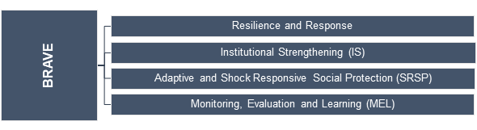

- BRAVE will:
- Deliver community-based resilience pilots and develop the capacity of at least 3 million marginalised and vulnerable people to anticipate, absorb, and adapt to climate change.
- Deliver a predictable, timely, flexible, and effective humanitarian response in the event of both small and large-scale shocks.
- Develop institutional capacity and capability of the GoP, at both national and sub-national levels, and that of civil society to address climate resilience.
- Extend the GoP social protection programme to enable it to respond better to vulnerable communities in the event of a crisis, thereby making the system shock-responsive.
- Improve evidence-based decision-making, accountability, and operational research at all levels, for the delivery of quality climate resilience interventions in targeted areas. The programme will use this to inform key stakeholders, specifically the GoP, on the processes that work for adaptation and resilience programming in Pakistan and provide options for scalable, replicable models.

- The transition to spending 0.3% of Gross National Income (GNI) on Official Development Assistance (ODA) may require significant shifts, building on those already underway as His Majesty’s Government (HMG) implements its modernised approach to development, which centres on establishing long-term partnerships based on mutual interests and respect. This approach is already at the centre of BRAVE’s operating model and Theory of Change (ToC). We will be taking a rigorous approach to ensure all ODA delivers value for money (VFM) and maximises the impact of our work through BRAVE to best support the people it benefits, including those in humanitarian crises.

Summary supporting narrative for the overall score in this review
- Since the last year, BRAVE has made significant progress in operationalising key new programme partnerships (Monitoring, Evaluation, and Learning (MEL) component and a “South Consortium” for resilience and response after its cost extension in May-24, extending from 2 to 5 provinces. The programme delivered a nationwide humanitarian response to over 1.16 million people in addition to ongoing resilience building activities which reached nearly 1.3 million people and are delivering dividends to participants across many International Climate Finance (ICF) criteria. Despite procurement delays in the Institutional Strengthening (IS) component, which scored a B, partners are actively engaging the GoP directly at district and provincial levels to create buy-in and opportunities to scale successes in the future. BRAVE is in the process of building a robust evidence-base of what works to build resilience, while delivering meaningful technical assistance which has enabled the GoP’s Social Protection (SP) systems to increase their shock-responsiveness. Three out of four outputs (weighing 70%) scored an A/A+, resulting in an overall score of A.

Progress against last year’s recommendations
- The 2023/24 Annual Review identified seven major recommendations, which were a summary of those also found within output sections. Thus, their progress tracking can be found within output sections of this report. Overall achievement was satisfactory, with staffing gaps filled, MEL procured, and shock-responsive social protection (SRSP) recommendations achieved. Institutional Strengthening (IS) procurement delays impacted achieving some GoP engagement and coordination recommendations, which are repeated this year as a priority.

Major lessons and recommendations for the year ahead
- The major lessons and recommendations below are in addition to those provided throughout the report at the output level and represent cross-cutting and major areas aimed to improve the overall outcomes and desired impact of BRAVE.

Major Lessons
- Humanitarian response and localisation: BRAVE has already tested and bore the fruits of its Business Case Addendum approved in May 2024, with the capacity to adapt quickly and respond to the 2024 Monsoon Floods through pre-agreed financing arrangements with existing (or in progress) partners. The effectiveness of localisation of humanitarian assistance in Pakistan was demonstrated by Concern Worldwide’s (CWW) consortium, whereas the International Organisation for Migration (IOM) and World Food Programme (WFP) relied more heavily on international non-governmental organisations (INGOs) as implementing partners. A comparative analysis between the two approaches, including VFM, is an area the MEL supplier (Integrity Global) can explore in 2025/26, particularly in the context of USAID’s “RAPID” facility which funded emergency response through over 60 Local NGOs (LNGOs) recently closing. Localisation should continue to be a focus of BRAVE’s work by considering CWW’s LNGO network for future responses, even within “South Consortium” resilience areas of Sindh, Balochistan, and Punjab.

- WASH infrastructure: While BRAVE delivers a vast range of projects, often selected by communities to best meet their specific needs, the “Build Back Better” Water, Sanitation, and Hygiene (WASH) rehabilitation infrastructure was observed to deliver dividends across villages and sectors. Raised platform drinking water handpumps and latrines mitigate future flood intrusion, while also contributing to reduced water borne diseases (which can also contribute to childhood malnutrition), and were observed to enhance the dignity and protection of female latrine users. Communal washing platforms also saved women travel time to riversides and provided a space to foster community cohesion whilst washing in a dedicated space that reduced standing greywater (and associated disease vectors). Further comparative analysis and best practice guidance is expected through BRAVE’s WASH Technical Working Group (TWG) in the coming year.

- Two consortium partners: Given the registration uncertainty NGOs face with the GoP from time to time, and global funding constraints, BRAVE is commended for expanding to two resilience and response consortium partnerships this year (one INGO-led and one UN-led). While this represents a huge amount of work and coordination effort to manage two consortiums, the expanded number of partners will provide business continuity and risk spreading, as well as enhance opportunities for scalability and cross-fertilisation.

Major Recommendations
- Prioritising Institutional Strengthening and GoP engagement: As mentioned elsewhere in the AR (Output 2, Risks, Programme Management), the main priority in the coming period is to complete the IS procurement process and closely engage in the IS Inception Phase. In light of IS component delays, FCDO Advisers should also put more energy into building and fostering their federal and provincial GoP networks to ensure they are proactively identifying gaps and scalable opportunities the IS supplier can eventually consider. Not only are increased field visits required, but a greater understanding of the political economy, extent of devolution at the coordination and technical levels, and budgeting allocations/priorities at the provincial and target district-level is needed. The upcoming IS component will serve as an entry point for this approach, while implementing partners can bring us up to speed on their own experiences and observations. This will be captured and tracked internally in a GoP engagement strategy led by BRAVE’s Governance Adviser. [Action: BRAVE SRO and PRO by October-25]

- Anticipatory Action: While technical efforts are underway to link BRAVE’s preparedness work with the Pakistan Meteorological Department (PMD) and Early Warning Systems (EWS), actual Anticipatory Action (AA) has not yet been observed. In climate vulnerable contexts, disasters should be expected with AA frameworks in place to improve timeliness and achieve VFM. Nationwide, there remains issues with harmonisation of terminology and approaches, including across GoP, UN, and NGO stakeholders. BRAVE should extend funding to the UN’s Office of the Coordination of Humanitarian Affairs (OCHA) this year, given their leadership and coordination role with the National Disaster Management Authority (NDMA) on Anticipatory Action (AA). FCDO’s Humanitarian Adviser (HA) should begin actively participating in the National AA TWG while advancing AA within BRAVE. In the absence of the IS component, OCHA funding can also support District Disaster Management Authorities (DDMAs) to better prepare and coordinate emergencies. [Action: BRAVE Humanitarian Adviser during FY-25/26]

- Disaster Risk Financing: While BRAVE offers its implementing partners Pre-Agreed Financing (PAF) for disaster response, at a policy-level the GoP requires additional disaster risk financing (DRF) instruments in order to self-fund its own response activities (in line with BRAVE ToC impact statement). This AR recommends that DRF/PAF is explored in more depth with partners and the GoP, to identify opportunities for technical assistance either through the World Bank (WB) on SRSP financing and/or through the IS component to national and provincial authorities. Partnerships and influencing opportunities with the centrally-funded Centre for Disaster Protection, World Bank DRF Team, Global Shield, and/or START Ready Network can be explored to maximize impact. Effort in this area is not only in line with the UK’s new commitment to increase PAF globally but will deliver a more predictable and timely humanitarian response for beneficiaries. [Action: BRAVE Humanitarian Adviser during FY-25/26]

- BRAVE component coordination: As two delivery partners were in their Inception Phases in early 2025, BRAVE’s focus on enhancing interlinkages between components was not at the forefront of FCDO or partner’s work and mainly took place informally. With the BRAVE Technical Board, Provincial Steering Committees, and consortium-level TWGs all now established and three BRAVE G7 Advisers now in place, FCDO needs to fully roll out its envisioned BRAVE Governance Structure (see figure below) and step-up its active engagement with partners to identify areas that require more cohesivity across components and geographies. “BRAVE Bites” – a regular but informal lunch-time virtual series – should be established to provide regular opportunities for partners across all tiers to present on specific activities, host virtual visits to project sites, provide downstream partners more visibility, and enhance learning. [Action: BRAVE SRO, PRO and Humanitarian Adviser during FY-25/26]
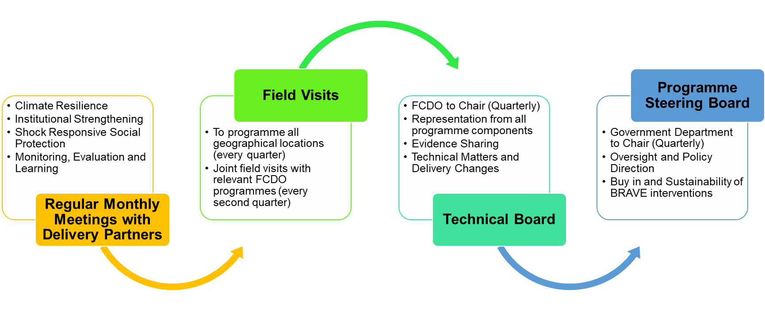Figure 1 – BRAVE Governance Structure

- Knowledge management: BRAVE’s community-based project selection approach has resulted in a large number of initiatives and achievements, which are difficult to aggregate and quantify except at the total beneficiary number level. With its MEL partner in place and three more years of project implementation planned, BRAVE should invest in developing a knowledge management platform or database using smart technology solutions and artificial intelligence (AI) that is easy for users to keep up to date. Possible opportunities exist for such a platform to enable aggregation across FCDO programmes (i.e. reporting total number, type, and location of Nature-based Solutions (NbS) together with FCDO’s Water Resource Accountability in Pakistan (WRAP) programme or facility solarisation projects with health/education teams), enhance transparency and governance outcomes, deliver additional accountability to affected populations (AAP), and even provide GoP with a replicable model. [Action: BRAVE SRO, PRO and Humanitarian Adviser during FY-25/26]

B: THEORY OF CHANGE AND PROGRESS TOWARDS OUTCOMES

Summarise the programme’s theory of change, including any changes to outcome and impact indicators from the original business case.
- The BRAVE Theory of Change (ToC) has been informed by evidence of what works to improve resilience and help communities anticipate, adapt to, and absorb the impact of shocks and stresses caused by climate change and natural disasters. After the Business Case Addendum approval of a £59m uplift in May 2024, BRAVE’s ToC was updated at the Output level to reflect the expansion of disaster risk management (DRM) activities and a humanitarian response provision to protect BRAVE’s developmental gains combined with enhanced geographical outreach. BRAVE’s Impact and Outcomes have remained steady.

- Creating lasting change through BRAVE is based on the following premise:
- If the UK provides context-specific community resilience activities while strengthening federal, provincial, and district institutions and civil society;
- If humanitarian relief is provided in a timely manner when required;
- If this is combined with developing an adaptive and shock-responsive social protection (SRSP) system; and
- If robust evidence and research leads to the identification of scalable models for resilience which can be replicated by the Government of Pakistan (GoP);
- Then resilience of the most vulnerable people will be increased while empowering the GoP, reducing the need for international assistance, laying the foundations for a self-financed exit from aid.

- Expected Impact: Increased capacity of the GoP, civil society, and communities to mitigate and respond to climate-related shocks and stresses, alongside increased GoP investment, reduced reliance on international support and the foundations laid for a self-financed exit from aid.

- Expected Outcome: Approaches to climate resilience are sustained in target districts, and the GoP uses evidence generated through BRAVE to scale-up and replicate resilience activities in other districts.

- For the intended outcome and impact to be realised, BRAVE must effect change through three pathways.
Pathway One – Bottom-up change: Increased capacity of the most vulnerable Households (HHs) and communities to anticipate, adapt to, and absorb the impact of shocks and stresses induced by climate change and natural disasters (including measurable changes in gender roles and social inclusion).

Pathway Two – Top-down needs-based change: Increased GoP focus on mitigating and responding to climate-related shocks and stresses at federal, provincial, and district levels.

Pathway Three – Evidence: GoP is provided with an evidence base of scalable approaches to climate resilience and adaptation, drawing on innovation and best practice generated through BRAVE.

- Since business case approval, several external shocks have changed the context within which BRAVE operates. These include: 2022 catastrophic flooding which displaced 33m people; 2023 macroeconomic crisis; 2024 regional flooding affecting 1m people; and 2025 Indo-Pakistan conflict, as well as seasonal heatwaves, drought, and an ongoing Afghan refugee response. While the ToC remains valid and is strengthened by adding a humanitarian response capacity to address such natural and man-made crises, each response further weakens resilience and detracts focus from resilience building efforts.

- During 2024 monsoon, BRAVE was able to programme £13.5m in a staged approach, ensuring the UK’s proportionality for relief and recovery efforts. Concern Worldwide (CWW), World Food Programme (WFP) and International Organisation for Migration (IOM) targeted a total of 186,000 households affected by 2024 flooding (over 1.2 million individuals) and delivered critical humanitarian assistance in 16 severely affected districts across Khyber Pakhtunkhwa (KP) (DI Khan, Upper & Lower Chitral), Gilgit-Baltistan (Ghizer & Astore), Balochistan (Naseerabad, Sohbatpur & Jaffarabad), Sindh (Dadu, Badin, Matiari, Mirpurkhas, Jacobabad, Sujawal & Sanghar) and Punjab (Rajanpur).

Describe where the programme is on/off track to contribute to the expected outcomes and impact. What action is planned in the year ahead?
- After 18 months delivering community-based resilience activities in Gilgit Baltistan (GB) and Khyber Pakhtunkhwa (KP), CWW is on track to achieve the intermediate Outcome related to building resilience at the local level (Pathway 1). International Organisation for Migration (IOM) has a strong plan in place to do the same over the coming three years, but will only start implementation this year. With the Monitoring Evaluation and Learning (MEL) component now in place, the evidence needed to determine effective and scalable resilience interventions to achieve the intermediate outcome (Pathway 3) will begin being generated. If partners sustain their delivery, the programme will remain on-track.

- While there are three years left to deliver BRAVE’s higher-level outcomes and impacts, the programme risks going off-track if the Institutional Strengthening (IS) component is not imminently procured in the next six months. Sufficient time is required for this component to carryout GoP consultations that deliver a meaningful Inception Phase. Realistically, this will only leave around two and half years to implement technical assistance and capacity building support to GoP stakeholders. Delivering IS in a way which achieves sustainable institutionalisation of transformative changes will require realistic ambition, adaptive planning, sustained energy, and collaboration across all BRAVE partners to achieve a shared result. Without a sufficient IS component, BRAVE will suffer reduced GoP capacity and associated top-down change (Pathway 2), face more difficulty in scaling-up successful interventions, and jeopardise a self-financed exit from international aid. Thus, this Annual Review has recommended finalising IS procurement as a key recommendation alongside increasing political engagement through FCDO staff and partners to raise BRAVE’s priority ranking. See outcome indicators assessment below:
Outcome Indicator | Milestone(s) for this review | Progress
Indicator 1:  Community Resilience: Number of people whose resilience has been improved as a result of project support (ICF-KPI 4) | CWW Consortium: 40% of targeted population (239,200 beneficiaries) improved resilience against the baseline value.  IOM Consortium: Generate baselines for all the targeted locations and mapping the climate resilience interventions, knowledge, and practices. The baseline and interventions to be agreed with all the stakeholders at national, provincial and district levels by May 2025. | Community resilience of 42% (251,160 beneficiaries) improved as per CWW’s internal AR of BRAVE. This will be triangulated through the end line study at the completion of BRAVE Phase I after June 2025.  Score: A – Outcome indicator met expectation.  Baseline data collected and finalized across 10 of IOM’s districts, covering 1,740 villages. By June 2025, the data was fully analysed with a report still being compiled to present the key findings and interventions to key stakeholders.  Score: B – Outcome indicator moderately did not meet expectation.
Indicator 2:  Institutional Strengthening (IS): Level of integration of resilience and climate change into national, sectoral or institutional policy and planning as a result of ICF support (ICF-KPI 13) with corresponding budget allocations | IS procurement completed with contract in place by end May 2025. | The IS component procurement was significantly delayed due to ODA cuts and commercial resource constraints. The contract is now expected to be in place by October 2025.  Score: B – Outcome moderately did not meet expectation.
Indicator 3: Shock Responsive Social Protection (SRSP): National and federal Social Protection (SP) policies and tools are responsive to climate change, with corresponding budget allocations. | Consultations with federal and provincial counterparts are finalised to secure alignment from the GoP steers/directions for sustainable SP arrangements between the federation and the provinces. | Consultations secured broad alignment on fiscal sharing arrangements between provincial and federal government stakeholders. A vision paper outlining detailed options is in the final stages of GoP review.  Score: A - Outcome met expectation.
Indicator 4:  Percentage of beneficiaries (SADD) reporting satisfaction (targeting, timeliness and quality) with the humanitarian assistance received. | CWW & IOM: Humanitarian Response: 80% of beneficiaries reporting satisfaction with the humanitarian assistance received (appropriate, safe and accessible). | Overall: 95.3% of beneficiaries reporting satisfaction with the targeting, timeliness, and quality of the humanitarian and early recovery assistance they received.  CWW: 98.5% (916,809 ppl) and  IOM: 72% (128,577 ppl)  Score: A+ – Outcome moderately exceeded expectation.

Justify whether the programme should continue, based on its own merits and in the context of wider portfolio
- BRAVE is both ambitious and adaptable, designed to deliver immediate results while creating systems transformation longer-term. BRAVE is already delivering – including assistance to nearly 2 million people in this reporting period – and is in a strong position to scale-up further in the coming year. As a highly climate vulnerable country with a large at-risk population, Pakistan is a ripe context to deliver the FCDO Foreign Secretary’s priorities to “tackle climate change and build state and community resilience to shocks through a stronger, more locally led humanitarian system.” BRAVE should continue as a key programme delivering the UK Pakistan Network’s Country Business Plan “Campaign Goal 4: Climate, Resilience, and Humanitarian”, alongside WRAP and the Climate Investment Fund for Pakistan (CIFPAK). BRAVE’s partners have proven they are ready to scale-up when financing allows, in contribution to the UK’s global International Climate Finance (ICF) key performance indicators (KPIs) and financial commitments, as well as supporting new PAF targets.

- Furthermore, BRAVE’s approach aligns with the new UK-Pakistan Development Strategy, pivoting towards a partnership model with the GoP, working across a wide number of ministries and departments at federal, provincial, and district-levels through institutional strengthening approaches to sustainably exit from traditional international assistance. BRAVE aligns strongly with GoP’s National Climate Change Policy and Disaster Risk Management Framework, supporting operationalisation of ambitions, while also delivering the Clean Green Pakistan national initiative. Key opportunities exist to institutionalise and scale-up lessons learned from FCDO’s prior and ongoing project successes, such as the current Sub-National Governance 2, (SNG2), Sustainable Energy and Economic Development (SEED), and WRAP programmes, and predecessors Building Disaster Resilience Programme (BDRP) and Multi-Year Humanitarian Programme (MYHP).

C. DETAILED OUTPUT SCORING

Output Title | Component 1: Community Resilience and Humanitarian Response  Increased capacity of the most vulnerable and at-risk communities (especially women and extreme poor) to anticipate, adapt to, and absorb the impact of climate induced shocks and stresses
Output number: |  | 1 | Output Score: | A+
Impact weighting (%): |  | 50% | Weighting revised since last AR? | No
Indicator(s) | Milestone(s) for this review | Progress
Resilience and Humanitarian Response:  Number of people supported to better recover from and adapt to the effects of climate change (ICF KPI 1)  Disaggregated by gender and disability | CWW Consortium Resilience:  Direct Beneficiaries:  Total: 598,000 individuals (cumulative)  Male: 304,980; Female: 293,020  Persons With Disabilities (PWDs): 29,900  Indirect Beneficiaries/ Med Intensity:  Total: 672,200  CWW Consortium Humanitarian  Beneficiaries  Total: 800,000 individuals  Male: 408,000; Female: 392,000;  PWDs: 40,000  WFP Humanitarian  Total: 108,000 individuals  51% men/boys; 49% women/girls  IOM Consortium Resilience  1) Baseline to be generated;  2) Multi-Hazard Vulnerability and Risk Assessment (MHVRA) conducted and Gender-Conflict analysis completed.  IOM Consortium Humanitarian  Total: 126,530 individuals  Stockpiles prepositioned:  121,000 beneficiaries by May 2025 | CWW Consortium Resilience:  Direct Beneficiaries/ High intensity: Total: 619,164 individuals (cumulative)  Male: 315,774; Female: 303,390; PWD: 31,270  Indirect Beneficiaries/ Med Intensity: Total: 798,119 individuals  Score: A+ (Output Indicator Moderately Exceeded Expectation)  CWW Consortium Humanitarian  Overall Beneficiaries: 916,809 individuals  Male: 441,244; Female: 475,565; PWDs: 4,387  Score: A+ (Output Indicator Moderately Exceeded Expectation)  WFP Humanitarian  Total: 114,376 individuals  59,292 (51%) m/b; 55,084 (49%) w/g  Score: A (Output Indicator Met Expectation)  IOM Consortium Resilience  1) Baseline data collected and finalized across 10 districts, covering 1,740 villages. The data has been fully analysed, and a report is currently being compiled to present the key findings and interventions to key stakeholders.  2) MHVRAs conducted for 5 districts in Balochistan however, existing MHVRAs for Sindh have been utilised with a refresh agreed with PDMA. The Gender Analysis Summary Report is completed.  Score A (Output Indicator Met Expectation)  IOM Consortium Humanitarian  Total: 128,577 individuals  Male 65,214; Female: 63,363  Stockpiles prepositioned:  142,800 individuals (23,800 HH) by March 2025.  Score: A+ (Output Indicator Moderately Exceeded Expectation)  Overall Score: A+ (Output Indicator Moderately Exceeded Expectations)  Resilience: 1,417,283 beneficiaries  Humanitarian: 1,159,762 beneficiaries
Resilience:  Number of Climate Adaptation Forums established (or revived already established forums) at Village and Union Council (UC) level and are functioning effectively. | CWW: 360 Village and 41 UC level Climate Adaptation Forums are functional and supporting their communities.  WFP: 80 Climate Adaptation Forums established (or revived existing forums) at Village and UC level and are functioning effectively.  IOM: Inception Phase completed with geographical targeting and implementation interventions agreed with FCDO. | CWW: 404 Village and UC Climate Adaptation Forums established and being operationalised, with 347 Adaptation Plans developed.  WFP: 250 village level Climate Adaptation Committees established 102 mixed gender, 97 male only, 51 women only participation.  IOM: Inception Phase with geographical targeting completed and implementation interventions being agreed.  Overall Score: A+ (Output Indicator Moderately Exceeded Expectations)
Resilience: Number of Climate Adaptation Forums demonstrating evidence of transformational change in policy & planning, leadership, empowerment, decision-making and innovation (CF KPI15). | CWW: 50% of the Climate Adaptation Forums (180) showcase transformative achievements (likely to happen), emphasizing strategic planning, policy shifts for resilience, innovative approaches to tackle climate challenges, transparent and participatory decision-making, and effective leadership and empowerment. (Score 2 and above on transformational change score card).  IOM: Inception Phase completed with geographical targeting and implementation interventions agreed with FCDO. | CWW: As part of the FCDO BRAVE and CWW led ARs, consultations with sample (Union Council - Climate Adaptation Forums) UC-CAFs and (Village Climate Adaptation Forums) V-CAFs confirmed demonstrating transformational change in planning, leadership, empowerment, decision-making and innovation. This will be triangulated through the end line study at the completion of BRAVE Phase I after June 2025.  IOM: Inception Phase with geographical targeting completed and implementation interventions being agreed.  Overall Score: A (Output Indicator Met Expectations)

Briefly describe the output’s activities and provide supporting narrative for the score.
- BRAVE’s Output 1 focuses on increasing the capacity of the most vulnerable and at-risk communities to anticipate, adapt to, and absorb the impact of climate-induced shocks and stresses. Adaptive capacity is achieved through establishing strong community structures and delivering sequenced disaster risk reduction (DRR) and climate resilience interventions, with additional protection offered through timely humanitarian and recovery support in the event of disasters. Through engaging two consortium leads and a total of 15 downstream partners, this community resilience and humanitarian response component represents 62% of BRAVE’s budget (£60m). Resilience interventions are longer-term in nature (2-3 years) across at least 17 districts in all 5 regions of Pakistan. Humanitarian response has national outreach capacity with pre-agreed finance in place, but is approved by FCDO on a needs-basis using a ‘No Regrets’ approach.

- This year represents a significant step forward in BRAVE’s delivery, with an additional “South Consortium” led by International Organisation for Migration (IOM) selected and their Inception Phase completed in March 2025, including a baseline assessment and various deliverables. The “North Consortium” led by Concern Worldwide (CWW) delivered resilience activities across the entire reporting year, while both Consortia, and a new partnership with WFP, flexed to stand-up and deliver a £13.5m humanitarian response after the 2024 Monsoon Floods in September. Positive progress through locally-led, evidence-driven, and systems-informed approaches have directly contributed to Theory of Change (ToC) Pathway One – Bottom-up change by increasing the capacity of vulnerable households and communities, resulting in Output 1, scoring an A+.

- CWW’s Consortium has undertaken a tremendous number of community and household resilience, adaptation, and sustainable livelihoods activities during the reporting period and has reached over 600,000 individuals to better recover from and adapt to the effects of climate change. CWW has made strong progress in strengthening resilience in the three districts of Ghizer, Astore, and Chitral in Gilgit-Baltistan (GB) through its implementing partner the Aga Khan Foundation (AKF) and in the two districts of Charsadda through CESVI and Nowshera through Welthungerhilfe (WHH) in Khyber Pakhtunkhwa (KP). After establishing 360 Village Climate Adaptation Forums (VCAFs) and 44 at the Union Council level (UC-CAFs) by the time of the previous AR (total 404). Moreover, this year the capacity strengthening focus shifted to completing Multi-Hazard Climate Change Resilience Vulnerability Assessments (MH-CCRVAs) and accompanying Climate Adaptation Plans (CAPs). Participatory adaptation planning approaches have empowered communities, with results that are formally endorsed by district authorities. Both GB and KP Provincial Disaster Management Authorities (PDMAs) have committed to integrating CCRVAs into District Disaster Management Plans (DDMPs), insuring institutional uptake and sustainability beyond the lifespan of BRAVE. Furthermore, the inclusion of women, youth, the landless, and persons with disabilities in CAFs indicates an inclusive approach to decision-making and empowerment, with UC members emerging as key agents of change in their communities. All UCs were given emergency tool kits and received First Aid and Search and Rescue training in collaboration with 1122 and registered as district volunteers. A broader partnership with 1122 should be further explored through the IS component, given the role all provinces are now embracing to create more capable GoP first responders nationwide.

- Additionally, two innovative approaches are worth highlighting which also demonstrate efforts towards achieving transformational change. Five Knowledge Hubs in each district and anchored to institutions like the Karakoram International University and Bacha Khan University, have identified research priorities and facilitated seed system strengthening, climate-smart planning, and localised research on agro-ecological zoning and seed germination under extreme weather conditions. The Cereal Crop Research Institute endorsed its interventions, like certified seed production and hermetic storage technology, for scale-up by the Directorate of Agriculture Research in KP. Similarly, five Business Hubs have engaged local authorities, private sector actors, academia, civil society, and communities to co-develop market-driven adaptation strategies in priority sectors such as agroforestry, livestock development, and aqua-life conservation. In Nowshera, the Hubs’ success has been recognised at the district-level and recommended for provincial replication. An independent and a comprehensive evaluation will take place to test the potential and robustness of transformational change finally achieved through these and other initiatives underway.

- Formal partnerships like a Cooperative Agreement with the Pakistan Meteorological Department (PMD) are supporting enhanced anticipatory planning, data-sharing, use of Kisaan App, and community early warning through radio advisories and digital platforms. At the local level, coordinated interventions with District Forest Departments, vocational institutes, and agriculture directorates ensured sustained technical delivery. The provincial Project Steering Committees, convened with key provincial government counterparts remain an essential activity to ensure institutional buy-in. Planning and Development (P&D) departments brought together officials from agriculture, forestry, disaster management, and academia to guide strategic alignment. The institutionalisation of inclusive climate planning was strengthened through capacity-building of 767 officials (311 women), leading to new Planning Commission form -1 (PC-1s) that embedded gender inclusion in agriculture, infrastructure, and disaster preparedness efforts.

- The IOM-led “South Consortium” has completed contracting with five downstream partners and undertaken inception activities, including geographical targeting, in eastern Balochistan (4 districts: Jaffarabad, Naseerabad, Usta Muhammad, Sohbatpur), Sindh (7-8 districts: Khairpur, Noushero Feroz and/or Shikarpur, Mirpur Khas, Jacobabad, Sanghar, Badin, Sujawal), and southern Punjab (Muzaffargarh). Baseline data collection in 1,740 villages in 10 districts has been completed, as well as key strategic documents and governance structures finalised. Once village selection is completed, next year IOM will prioritise establishing community-based Disaster Risk Management (DRM) structures following N/PDMA’s guidelines and undertaking hazard vulnerability mapping and development of DRM action plans (similar to those completed by CWW).

- In response to the 2024 Monsoon Floods, BRAVE engaged both consortiums and World Food Programme (WFP) in humanitarian response and early recovery activities across Sindh, Punjab, KP, GB, and Balochistan. All three partners exceeded their targets and reached over 1.1 million beneficiaries, delivering a wide range of humanitarian activities such as: multi-purpose cash assistance (MPCA), in-kind food items, non-food items (NFIs), emergency shelter and shelter repair kits, hygiene, menstruation, and dignity kits, water trucking, chlorination of water points, fumigation and vector control, psychosocial support and hygiene promotion sessions, and back-to-school and recreation kits. Early recovery activities included the provision of agricultural inputs, small ruminants, vocational skills training, micro-enterprise grants, cash for work, debris removal, rehabilitation and maintenance of handpumps, drinking water schemes, latrines, irrigation channels, road links, pedestrian pathways, small bridges, and community ponds. Several examples of “building back better” have been observed, including using raised platforms for latrines and handpumps to avoid future flood intrusion. Although delays to contracting under this new BRAVE activity with IOM resulted in a greater emphasis on early recovery activities over immediate humanitarian assistance, local Non-Governmental Organisation (NGOs) offered a clear advantage in implementation and were meaningfully involved in community mobilisation and delivery.

- WFP was contracted at pace, given the second long-term consortium was under finalisation at the time of the flooding. WFP exceeded their target and proved a reliable delivery partner, though our agreement closed 31 March 2025. In order to facilitate recovery project selection, WFP established 250 Village Development Committees (VDCs) through BRAVE (though their function strongly aligns with the spirit of CAFs). The AR team recommended that all partners support sustainability by facilitating the formal registration of such committees with the Tehsil and/or District Council, where appropriate.

- Overall, BRAVE continues to be a major contributor to the Pakistan Network’s ICF and humanitarian objectives spending over £13 million International Climate Finance- Official Development Assistance (ICF-ODA) and £19 million of humanitarian spend with over 2.6m direct and indirect beneficiaries across multiple ICF KPIs monitored and evidenced through partner results frameworks.

Changes to this output this year and any planned changes as a result of this AR.
- With the approval of the Business Case Addendum in May 2024, Output 1 was expanded to include humanitarian response and recovery activities in addition to original resilience targets. In response to the 2024 Monsoon Floods, CWW and IOM were given budget approval to respond and associated milestone targets were included. WFP was added as a partner with humanitarian targets.

Progress on previous AR’s recommendations, lessons, and new recommendations.

Progress on recommendations from the previous AR
- The progress on recommendations is partially achieved, largely due to the delay in procuring the IS component supplier.

2023/24 Recommendations | 2024/25 Progress
It is now important to move as quickly as possible to have a MEL contract in place in order to validate results for the community resilience component and establish baseline data for BRAVE. | Completed. MEL contract is awarded, and the baseline evaluation is scheduled for Q2 FY 2024/25.
The Ministry of Economic Affairs (EAD) provided comprehensive feedback on BRAVE to a) ensure good coordination, empowerment, and leadership of the programme by Provincial departments; and b) to streamline coordination by reducing the number of implementing and delivery partners. | In process. Recommendations related to Community Resilience component were addressed during the Inception Phase. Without IS in place, EAD’s overall structural coordination concerns remain partially unaddressed.
CWW needs to develop a formal relationship management and coordination strategy to ensure government buy-in. CWW to conduct consultation meetings with National Disaster Management Authority (NDMA) and Gilgit Baltistan (GB’s) PDMA with informed consent of FCDO to establish a collaborative process for developing and finalising the relationship management and coordination strategy. | In process. CWW is coordinating with government bodies including Provincial Disaster Management Authority (PDMAs,) P&Ds, PMD and relevant provincial departments, including through the Project Steering Committees. However, a dedicated, formalised strategy including federal counterparts will only be completed in collaboration with the IS supplier next year.

Recommendations for the year ahead 2025/26
Recommendations
CWW has made positive progress in linking community-level plans with district governments. The next step should be to build ownership and formalize resource allocation at the provincial level and integrate MH-CCRVAs into DDMPs and into the provincial development plans. Other potentially scalable opportunities are emerging through Knowledge and Business Hubs, while numerous formal partnerships have been established through BRAVE. Recommendation: Given the delay in IS, FCDO’s Governance Adviser and MEL supplier should co-facilitate a session with Consortium partners to identify potential areas of opportunity for future IS support and map existing formal partner relationships (MoUs, etc). This would also serve to document local models of success to advocate for provincial and federal policy integration. [Action: BRAVE SRO and Governance Adviser during FY-25/26]
VCAFs have played a critical role in community mobilization and planning for BRAVE. Given GoP’s increasing commitment to climate expenditures, further investments in capacity building may be required. Recommendation: A Sustainability Strategy for VCAFs should be formulated to explore models for their continued functionality beyond programme funding, including formal linkages with local government budgets, community-managed funds, or integration into existing community-based organizations. [Action: BRAVE PRO, Governance and Humanitarian Adviser during FY-25/26]
Programme Steering committee (PSCs) should go past information sharing and serve as platforms for government endorsement and commitment to implementing the programme’s interventions. Recommendation: Stronger GoP buy-in should be prioritised within the PSC meetings by determining key agenda items for GoP participants. PSCs could be improved by being outcome-oriented sessions with concrete commitments, resource allocations agreed, directives issued, and policy integration secured, and actions being regularly tracked. An influencing tracking approach should be designed and employed. [Action: BRAVE SRO and Governance Adviser during FY-25/26]
Output 1 currently represents a significant amount of the budget and field activities, across both humanitarian and resilience, which proves difficult to capture within the AR. Recommendation: The logframe should be reviewed and consider splitting humanitarian and resilience into two outputs moving forward. [Action: BRAVE SRO, PRO and Humanitarian Adviser during FY-25/26]

Output Title | Component 2: Institutional Strengthening  Increased capacity and capability of federal, provincial, and district government departments to mitigate, prepare for and respond to climate-related shocks and stresses.
Output number: |  | 2 | Output Score: | B
Impact weighting (%): |  | 30% | Weighting revised since last AR? | No

Indicator(s) | Milestone(s) for this review | Progress
Institutional capability and capacity is increased at provincial and district levels within planning and disaster management authorities to respond to climate change and shocks. | IS procurement completed with contract in place by end May 2025. | The procurement for the IS component was significantly delayed due to Official Development Assistance (ODA) and commercial resource constraints with the contract now expected to be in place by October 2025.  Score: B (Output moderately did not meet expectation).
Increased dialogue, coordination and consultation among key actors (including public and private actors), and/ or between Federal, Provincial and District government authorities on climate resilience. | Institutional Strengthening procurement completed with contract in place by end May 2025. | The procurement for the IS component was significantly delayed due to ODA and commercial resource constraints with the contract now expected to be in place by October 2025.  Score: B (Output moderately did not meet expectation).

Briefly describe the output’s activities and provide supporting narrative for the score.
- Output 2 is focused on strengthening the capacity of the Government of Pakistan (GoP) to mitigate and respond to climate-related shocks and stresses at the federal, provincial, and district levels. The Institutional Strengthening (IS) component is the only contract not yet in place for BRAVE and is a key risk and priority now and for the year ahead. IS component remains a focus given its strong alignment with the new UK-Pakistan Development Strategy (in terms of future partnerships with the GoP) and aims to build resilient and shock-responsive national government systems.

- Procurement for the IS component was delayed, resulting in the milestone not being achieved during the review period. Considering circumstances were outside of the BRAVE team’s control and effort put forth to push forward the procurement and find alternative supportive engagement opportunities, this component has scored, ‘B’.

- At the time of the last review, the Terms of Reference (TORs) had been drafted and subsequently updated following the approval of the costed Business Case Amendment in May 2024. A second Early Market Engagement (EME) was conducted in June 2024 to further inform the procurement process. However, the issuance of the invitation to tender was delayed due to multiple restructurings within FCDO’s central commercial teams. This was further compounded by the UK Government’s announcement in February 2025 to reduce ODA to 0.3%, which resulted in a temporary pause on all new contracts and projects, including the procurement of the IS component. In response, an exemption request was proactively submitted to Ministers in March 2025 and was successfully approved in April, allowing the procurement process to resume.

- Looking ahead to creating efficiencies and streamline technical assistance if programme cuts in CG4 are required, the Water Resource Accountability in Pakistan (WRAP) and Climate Investment Fund for Pakistan (CIFPAK) teams’ feedback was sought to strengthen the TORs and build in additional flexibility, if required. A new Commercial focal point has been assigned, but progress remains slow.

- Given the centrality of strong political economy analyses (PEAs) for the delivery of targeted institutional strengthening, BRAVE’s existing implementing partners have contributed to our stakeholder understanding through their work. As part of its Inception Phase, IOM has carried out stakeholder mapping and a PEA related to its intervention areas. Integrity Global, as the BRAVE MEL partner, as part of its Inception Phase delivered a revised broader PEA to inform the IS component’s coordination strategy. This work is now overseen and complemented by BRAVE’s newly onboarded Governance Adviser, who will also lead the IS component moving forward, in close coordination with CG5’s UKB Senior Governance Adviser.

- With an eye towards complementing and building on FCDO’s IS experience, BRAVE’s SRO has participated in CG5’s Sub-National Governance 2 (SNG2) Provincial Steering Committee meetings where there are complementarities with BRAVE’s priorities. This includes SNG2 work with the Sindh PDMA on disaster risk management and Punjab Social Protection Authority. Lessons have been learned from SNG2 and conversations on IS priorities were undertaken as part of the AR mission in Sindh with Provincial Disaster Management Authority (PDMA) and District Disaster Management Authority (DDMA) Mirpur Khas authorities. Further lessons sharing with the Water Resource Accountability in Pakistan (WRAP) and Sustainable Energy and Economic Development (SEED) programmes may also significantly enhance efficiency, amplify impact, and ensure new interventions are built upon existing foundations.

Changes to this output this year and any planned changes as a result of this AR.
- No changes were made to the output, though the TORs were expanded to cover potential CG4 technical assistance needs. As planned during the last Annual Review (AR), the output indicators will be reviewed once the partner for IS component is in place and ahead of the next AR.

Recommendations for the year ahead 2025/26
- The previous AR’s single recommendation on developing coordination and coherent mechanisms will be taken forward this year once the IS supplier is on board.

Recommendations
Further IS component delays threaten BRAVE’s achievement of its ToC. Recommendation: BRAVE SRO needs to prioritise and closely monitor procurement timelines, continue engaging the central Commercial team, and escalate where necessary, to support the efficient closure of the process and onboarding of a supplier by October 2025. [Action: BRAVE SRO and PRO by Oct-25]
AR engagements with PDMA, DDMA, and Benazir Income Support Programme (BISP) provided significant insights into sub-national needs and capacities. Recommendation: BRAVE Advisers including Humanitarian, Social Protection and Governance direct government engagements should be further systematised through a stakeholder engagement strategy and expanded to include other critical ministries and departments involved in climate resilience, to strengthen FCDO’s capacity to provide IS oversight and better assess TA focal priorities. [Action: BRAVE SRO and Advisers during FY 25/26]
Recommendation: The IS Inception Phase should purposefully explore opportunities in BRAVE Component 1 (Resilience) target districts, with an aim to reinforce and further embed community resilience initiatives through a capacitated and supportive policy environment. [Action: BRAVE SRO and PRO during BRAVE IS Inception till Mar-26]
SNG2 will draw to a close in 2025/26 without a successor programme, while other FCDO programmes have piloted successful initiatives recently. Recommendation: IS should explore opportunities in the Inception Phase to facilitate upscaling successful pilots under SNG2, WRAP, and SEED (formalising disaster resistant infrastructure codes in KP), as a starting point to further build on the UK’s successful prior work. [Action: BRAVE SRO and Governance Adviser during BRAVE IS Inception till Mar-26]

Output Title | Component 3: Shock Responsive Social Protection (SRSP)  The national social protection system is better prepared to adapt and respond to climate related shocks, with more informed decision making on shock responsive and adaptive social protection at the federal and provincial level.
Output number: | 3 | Output Score: | A
Impact weighting (%): | 10% | Weighting revised since last AR? | No

Indicator(s) | Milestone(s) for this review | Progress
Coordination mechanisms designed and piloted and utilised for Federal/ Provincial/ Regional collaboration on shock responsive and adaptive Social Protection (SP) initiatives. | SP spending data, including disaster response allocations for 2019, 2020, and 2023, is analysed to identify SP spending trends between the federation and the provinces. | A federal–provincial SP spending analysis (2017–2023) was completed clearly identifying spending trends between the federation and the provinces.  Score: A (Output met expectation).
Expanded National Socio-Economic Registry (NSER) utilises vulnerability assessment and technological solutions for data exchange and targeting. | Phase 2 analysis of NSER data collection modalities completed to evaluate their impact on data quality, and practical improvements for targeting and operational processes are identified. | The NSER Quality Review (Mind the Gap) identified key limitations and is informing improvements to registry operations and targeting.  Score: A (Output met expectation).

Briefly describe the output’s activities and provide supporting narrative for the score.
- Output 3 focuses on strengthening Pakistan’s social protection (SP) systems to better anticipate, absorb, and respond to climate-related shocks at both the federal and provincial levels. It supports the development of more adaptive targeting approaches, more resilient and dynamic delivery systems, and clearer institutional arrangements for SP across different tiers of government. This component also creates a stronger evidence base and enhanced technical capacity to inform future SP reform pathways. By delivering technical assistance (TA) through a World Bank Executed Trust Fund (WBETF). BRAVE supports establishing a nationally owned and funded system, which is more integrated and can deliver shock-responsive social protection (SRSP) system to reliably reach vulnerable populations with timely support as the scale and frequency of climate-induced and covariate shocks increase.

- Reports for both milestones were delivered on time with an exceptionally high quality, while numerous additional pieces of TA support were delivered to the Benazir Income Support Programme (BISP) team and provincial Social Protection Authorities (SPAs) during the reporting year. Clear progress across institutional, technical, and policy fronts in line with the workplan, result in this component scoring an A.

- Effective SP is dependent on a strong delivery chain, including the step which correctly identifies the most vulnerable households. To strengthen this capacity, BRAVE supported a quality review of BISP’s National Socio-Economic Registry (NSER). This culminated in the Mind the Gap: Assessing Pakistan’s NSER report, which was publicly launched in June 2025. While the NSER holds data for 84% of Pakistan’s households, the analysis identifies key operational and outreach barriers that limit the registry’s performance, including gaps in enrolment, updating, and verification. Its findings are now being used to guide design changes in registry operations and to inform broader policy dialogue on strengthening adaptive and accurate targeting in Pakistan.

- Given the devolution of SP to the provincial level, developing a coordinated federal and provincial vision for SP is an essential first step to progress decentralisation systematically nationwide. To support long-term sustainability and clarify institutional roles, BRAVE supported a federal–provincial fiscal responsibility vision paper outlining policy options for how responsibilities for SP can be shared across areas of targeting, delivery, and financing. The paper considers provinces’ varying capacities and explores cost-sharing arrangements to enable a more predictable and fiscally responsible system. Following senior-level consultations, the draft is undergoing final clearance and is expected to inform future dialogue on institutional reform and financing of SP in Pakistan.

- To underpin the development of this shared vision, BRAVE completed an updated federal–provincial SP spending analysis covering the period from 2017 to 2023. The analysis maps trends in allocations and disbursements across major programmes at both levels of government, highlighting overlaps, funding gaps, and areas of potential reform. It provides a critical evidence base for future dialogue on cost-sharing arrangements and the long-term fiscal sustainability of SP in Pakistan.

- In addition to the logframe milestones, the programme delivered on a range of high-value technical outputs: two flagship reports were launched and disseminated; BISP adopted accrual accounting with audited financials; design support was provided for beneficiary-centric payment model now under State Bank review; a bespoke Management Information System (MIS) was developed from the Sindh SPA own resources to enable adaptive shock response; GIS expertise for anticipatory planning was leveraged; a public SP expenditure review was initiated in KP; and operational manuals were developed for provincial nutrition conditional cash transfer (CCT) programmes.

- In line with the workplan, the World Bank (WB) also delivered TA across a number of key Government of Pakistan (GoP) demand-led topics. With inflation eroding the value of fixed cash transfers, timely adjustments to benefit levels are critical for maintaining support to low-income households. In response, BRAVE supported an indexation analysis to assess the adequacy of BISP benefits. The study explored different indexing mechanisms to ensure future adjustments remain responsive yet fiscally sustainable. Its findings directly informed GoP’s decision to increase the quarterly benefit from PKR 10,500 to PKR 13,500 from 1 January 2025. This 28.5% increase in the transfer value improved the adequacy of the programme and aimed at safeguarding the purchasing power of vulnerable households.

- The indexation analysis serves as the technical foundation to advocate for making CPI-linked adjustments systematically in the future, rather than infrequent ad-hoc revisions. The government has started developing indexation protocols, these indexation analysis and options provide adequate information for the next steps. Proper indexation will not only safeguard individuals and families from the adverse effects of inflation but will also contribute to the overall sustainability of BISP Kafaalat by reducing poverty rates and thereby making fiscal space for more poor and vulnerable families to be covered by the cash transfer.

Changes to this output this year and any planned changes as a result of this AR.
- Milestones were updated this year as part of the routine annual process to ensure continued alignment with GoP demand-led TA. As a result of this review, next year’s workplan will more clearly link TA activities to BRAVE’s Theory of Change (ToC) and delivery of shock responsive SP while strengthening coordination with BRAVE’s implementing partners.

Progress on previous AR’s recommendations, lessons, and new recommendations.
2023/24 Recommendations | 2024/25 Progress
Moving forward, a more structured monitoring mechanism should be established. Quarterly meetings involving FCDO, WB, and BISP staff should be implemented to ensure systematic oversight and consistent progress tracking. This will provide a formalised platform for addressing issues and aligning TA activities with BRAVE objectives. | Implemented. Meetings were held between WB and FCDO monthly over the past year, enabling close coordination and timely resolution of operational issues. BISP was present at 2 field missions, but tripartite meetings remain recommended for the year ahead.
The work to date focuses on SRSP, which pays out after a disaster has occurred, helping affected communities recover quicker. However, the ToC notes that an adaptive social protection system is required, to help build recipients’ resilience (assets, skills, reserves), so that they can cope better with shocks. More attention should be given to how to make this system more adaptation focussed, thereby increasing its cost-effectiveness. | Implemented. The programme has laid important groundwork for adaptive social protection, with new analysis on climate resilience, labour market shocks, informality, and benefit indexation. The latter directly supported an increase in BISP transfer value this year, helping to maintain support adequacy and help build recipient’s resilience amid rising inflation.  Resilience through reserves and assets has been built through the “Hybrid SP Scheme,” which has been piloted in 15 districts (81,000 people) and is currently completing an evaluation. It has created a safety net through savings and financial inclusion for the “missing middle” (bottom 40%) who were not covered by BISP and further enhanced adaptation.
The World Bank should also consider extending the climate change variables included in the social protection system. So far this only considers flood events, whereas Pakistan is vulnerable to a range of climate change related shocks and stresses including drought, heatwaves sea level rise and rainfall variability. | In process: When there are funds in place to do so, BISP’s strengthened delivery systems can respond to a wide range of covariate shocks, not just floods. Where unconditional cash is the appropriate response modality, BISP could be further supported by multi-hazard risk models that inform disaster risk financing (DRF) products and utilisation of a risk layering approach to funding.

Recommendations for the year ahead 2025/26
Recommendations
FCDO maintains strong relationships with the WB but has not recently invested in fostering its relationship directly with GoP SP stakeholders. Recommendation: Increase structured tripartite engagement between FCDO, the World Bank, and BISP to ensure alignment and adaptation of government priorities and programme activities. Engage further in SNG2’s work in Punjab and meet SPAs in the provinces, and visit BISP independently, to further appreciate both federal and provincial SP priorities to also feed into IS component priorities. [Action: BRAVE SRSP Adviser during BRAVE IS Inception till Mar-26]
SRSP has delivered high quality SP delivery chain strengthening TA but has not focused on the system’s financial disaster response capacity. Recommendation: Revisit FY2025/26 workplan priorities and deliverables to ensure a comprehensive approach to shock-responsive systems is reflected. This should include opportunities to contribute to further thinking on disaster risk financing (DRF) for SRSP, unpacking provincial Global Shield proposals for CCT programmes, and ensuring federal and provincial SP policies and tools are responsive to climate change, with corresponding budget allocations. Facilitate linkages within the WB’s London DRF team to support experience sharing and identification of first steps to take with GoP. [Action: BRAVE SRSP Adviser by Oct-25]
Limited awareness of SP programmes and NSER registration processes among potential beneficiaries was identified during the AR and reinforced by recent World Bank analysis. Recommendation: Given the extensive community-level engagement of BRAVE partners, facilitate the WB to share key findings in order to improve awareness and generate thinking on pathways for BRAVE beneficiaries to increase access to SRSP and NSER registration. [Action: BRAVE SRSP and Humanitarian Adviser by Dec-25]
The WB has generated high-quality products, which have the potential to reach and influence a wider audience. Recommendation: Dissemination and visibility of SRSP analytical outputs and system strengthening work should be prioritised to support knowledge uptake and policy influence. More consistent showcasing of key deliverables would support wider uptake across GoP and partners and reinforce the value of technical assistance across federal and provincial levels. [Action: BRAVE SRSP and Humanitarian Adviser during BRAVE IS Inception till Mar-26]

Output Title | Component 4: Monitoring, Evaluation, and Learning (MEL)  Better understanding and evidence of what works for climate resilience in Pakistan to inform programme adaptation and advocacy/ policy dialogue
Output number: | 4 | Output Score: | A+
Impact weighting (%): | 10% | Weighting revised since last AR? | No

Indicator(s) | Milestone(s) for this review | Progress
Number of evidence studies and documents produced on climate change resilience and adaptation to climate extremes in Pakistan. | MEL inception phase completed by end April 2025 with:  1) BRAVE technical board established; and  2) TPM and evaluation methodologies agreed with FCDO | The Inception Phase was completed on time, with TPM and Evaluation methodologies agreed, and an ‘Excellent’ (93%) grading received from Evaluation Quality Assurance and Learning Service (EQUALS).  BRAVE’s Technical Board is established with a clear workplan for starting MEL activities from Q1 FY2025/26.  Score: A+ (Output moderately exceeds expectation).
Dissemination of evidence studies and facilitation of learning on how to build climate resilience.

Briefly describe the output’s activities and provide supporting narrative for the score.
- Output 4 focuses on BRAVE’s independent Monitoring, Evaluation, and Learning (MEL) component. It is designed to work across geographies, implementing partners, and project components nationally to generate robust, concrete evidence on climate resilience and adaptation in Pakistan. MEL supports FCDO’s commitment to preparing for an eventual sustainable exit and deepening our partnership approach with the Government of Pakistan (GoP).

- The activities completed to date as part of Integrity Global’s Inception Phase demonstrate significant progress and lay a strong foundation and are critical precursors for future MEL efforts. Demand-led evidence and learning priorities have been identified alongside contractual deliverables, which all indicate readiness for implementation to start on track in Q1 FY2025/26. The quality of deliverables exceeded expectations and scored an A+. Moreover, the adaptive MEL approach being used specifically addresses the evolving landscape of implementing partners, disaster-impacted environment, delayed operationalisation of IS, and uncertain future funding environment demonstrate a flexible, yet consistent, commitment to attaining the output’s overarching objectives. This flexibility will ensure that MEL activities remain relevant and effective despite potential programmatic shifts.

- A highlight during the reporting period, was the BRAVE Evaluation design. It encompasses three cycles (baseline in 2025, midline in 2026, and endline in 2028) and is comprehensive and well-structured. Its objectives to generate independent evidence, facilitate evidence-based decision-making and build evidence base on climate resilience are clear and aligned with BRAVE’s overall Theory of Change (ToC). Integrity’s Evaluation methodology was reviewed by EQUALS and graded an ‘Excellent’ rating (93%) which underscores it methodological rigour and quality. Moreover, the engagement of primary, secondary, and tertiary stakeholders during the evaluation’s design phase, particularly the emphasis on tailoring the evaluation to meet programme needs, is a positive indicator of future uptake and utility of findings.

- The approved of Third-Party Monitoring (TPM) approach is also strong, which emphasises independence, adaptability, and ethical engagement through a co-design process with BRAVE’s implementing partners. The tailored, component-specific approach, with high-frequency monitoring of each component, indicates a nuanced understanding of programme’s diverse needs. Particularly where TPM can face resistance from those being monitored, the cyclical delivery model, rigorous sampling strategies, and integration of qualitative and quantitative tools will undoubtably contribute to its credibility and the usability of TPM findings. Moreover, the commitment to mainstreaming Gender Equality, Disability, and Social Inclusion (GEDSI) is also highly commendable. Providing timely and independent insights, identifying issues earlier, and enabling real-time course correction remains vital for BRAVE to utilise adaptive management in Pakistan’s dynamic environment.

- A key achievement during the MEL Inception Phase is the establishment of the BRAVE Technical Board, which will meet at least twice per year moving forward. This serves as a crucial governance mechanism for oversight and strategic alignment of BRAVE’s learning agenda. Technical Board Meetings (TBMs) will facilitate sharing of critical evidence, provide technical quality assurance, and foster collaboration across BRAVE’s implementing partners. The Board is comprised of representatives from FCDO, Integrity, and technical leads from all of BRAVE’s implementing partners, with GoP and Short-Term Technical Assistance (STTA) proposed as optional attendees. While flexibility on GoP participation will not cause delays to holding TBMs, it remains vital to strategically leverage GoP engagement to ensure alignment with national priorities and facilitate policy uptake of BRAVE evidence across various levels of government. The first TBM was held in Feb 2025 with the next one scheduled for August 2025 at conclusion of BRAVE AR.

- Overall, BRAVE MEL will maintain a tailored and adaptive project management approach that aligns with the needs of key stakeholders including FCDO BRAVE Team, delivery partners, target communities, and provincial and federal government counterparts. MEL findings will be systematically shared with government counterparts through regular briefings and tailored outputs to ensure integration into national and provincial planning processes.

Changes to this output this year and any planned changes as a result of this AR.
- There have been no changes to this output or its milestones, nor are they planned.

Progress on previous AR’s recommendations, lessons, and new recommendations.

Progress on recommendations from the previous AR
2023/24 Recommendations | 2024/25 Progress
It is now important to move as quickly as possible to have a MEL contract in place in order to validate results for the community resilience and humanitarian components and establish baseline data for BRAVE. | Completed: The MEL contract is in place, Inception Report approved, and baseline schedule for Q2 this year.

Recommendations for the year ahead 2025/26
Recommendations
GoP participation in TBMs at required times will ensure that evidence generated is directly accessible to and championed by GoP stakeholders while facilitating policy uptake and accelerating scaling-up of effective resilience initiatives. Recommendation: Sustained effort should be prioritised by FCDO to move towards mandatory and active GoP engagement in TBMs, including dedicated agenda items for GoP feedback and policy alignment. [Action: BRAVE SRO, PRO and Advisers during FY 25/26]
GoP participation in TBMs or report launch events should not be assumed sufficient to accomplish knowledge transfer and behaviour change. Recommendation: Once the IS component is contracted, MEL should work with the implementer to develop a clear Knowledge Transfer Strategy for how knowledge transfer will be accomplished to relevant GoP entities. This could consider leveraging BRAVE evidence to build compelling business cases for GoP investments. [Action: BRAVE SRO, PRO and Advisers during FY 25/26]
There is a clear risk that the breadth and diversity of Output 1 interventions will not be properly captured or aggregated. Recommendation: Through demand-driven MEL, a concept note for developing a BRAVE partner knowledge management platform / database should be requested. Scope could be explored through a partner workshop, but could potentially capture, organise systematically, geotag, and store all resilience and recovery projects and BRAVE evidence generated, potentially including a handover plan with GoP and/or further expansion to WRAP’s related NbS and WASH-related activities. [Action: BRAVE SRO and PRO during FY 25/26]

D: VALUE FOR MONEY

Key cost drivers and performance
- The BRAVE programme’s financial structure reflects a delivery-heavy, field-intensive, and adaptive delivery model, with costs broadly concentrated in three interlinked areas: direct beneficiary support, personnel and field implementation, and technical oversight.
- Human Resources and Local Implementation: Across all partners staff salaries, field presence, training, and coordination activities represent a significant portion of the budget. These costs underline the programme's human-centered delivery model, which relies on close community engagement, localised support, and ongoing interaction with beneficiaries. This investment ensures that the transfer systems, community relationships, and support structures are functional, adaptive and effective.
- Direct Transfers to Beneficiaries: Given BRAVE delivered over GBP 13.5 million in humanitarian assistance just during FY24, the largest cost driver across the programme remained the cash-based assistance provided to target populations, highlighting the programme’s strong focus on immediate impact through direct aid delivery. This cost is critical not just in monetary value, but also in fulfilling the programme’s core humanitarian and resilience objectives.
- Monitoring, Evaluation, and Accountability: A vital but comparatively lean cost driver is technical oversight, including MEL systems and learning functions. Led by BRAVE MEL and supported by others, this ensures quality control, data-driven decision-making, and robust partner accountability. While it may be a smaller proportion of the budget, it is critical for adaptive management and long-term effectiveness.
- Non-Project Attributable Costs (NPAC): While individual partners show variation, the overall NPAC rate for the BRAVE programme is estimated between 13% and 15%, which is considered reasonable for a multi-partner, field-heavy resilience and humanitarian programme in Pakistan. This includes indirect support, reporting, administrative coordination, and general operating costs not directly tied to service delivery.

- The BRAVE programme demonstrates a compelling Value for Money (VfM) proposition for the British taxpayer, underpinned by a strategic and adaptive approach to climate resilience and humanitarian interventions. VfM principles are embedded across all operational and delivery mechanisms, ensuring that resources are used efficiently, effectively, and equitably. With the Monitoring, Evaluation, and Learning (MEL) partner now fully engaged and additional programme components mobilised during the reporting period, BRAVE is prioritising the development of a comprehensive, harmonised VfM framework. This framework will be systematically monitored and refined by the MEL provider throughout the programme lifecycle. While the overarching VfM framework remains under development pending full component mobilization by March-26, the programme is well-positioned to deliver measurable impact, accountability, and continuous learning aligned with VfM best practices. See assessment below across all 5 E’s.
VfM performance compared to the original VfM proposition in the business case

Economy – Maximising input cost-efficiency without compromising quality
- The programme consistently prioritised cost reductions and benchmarking through strategic staffing, local partnerships, and context-sensitive delivery models. Staffing costs under the BRAVE programme accounted for just 14% of the total budget substantially lower than the around 24% climate resilience and humanitarian industry benchmarks. Concern Worldwide (CWW’s) localisation approach use of 100% national and local staff further reduced overheads.

- In the World Food Programme (WFP) led interventions, activities utilised community-based venues, local trainers, and adapted materials, reducing expenditure while enhancing relevance. Co-financing mechanisms encouraged through cooperating partners yielded up to 20% of Non Food Items (NFI) budgets co-funded, multiplying donor resources. Community-led infrastructure construction replaced external contractors, lowering costs and building local ownership.

- Competitive procurement under the World Bank (WB) and International Organisation for Migration (IOM) unlocked significant savings. The IOM reached an additional 63,707 people through humanitarian aid due to unit cost reductions and vendor arrangements through robust procurement processes, realising £321,000 in savings. Likewise, savings of £250,799 allowed IOM to increase Water, sanitation and hygiene (WASH) NFI kits prepositioning from 15,000 to 20,000, supporting post-flood recovery. CWW’s use of Village Climate Adaptation Forums (VCAFs) and Union Council Village Climate Adaptation Forums (UCAFs) was delivered under budget, achieving £29,000 in savings that were reinvested into community capacity development. Specifically, CWW’s economic gains were further amplified by £585,937 in foreign exchange savings, redirected to reach an additional 90,700 beneficiaries across key sectors without extra funding. The WB’s approach also demonstrated economy through bulk procurement and leveraging in-house SP experts.

Efficiency – Maximising outputs for given inputs through smart integration and delivery
- The programme demonstrated high operational efficiency through strategic layering of interventions and integrated delivery models. The WB Technical Assistance (TA) streamlined federal-provincial SP mandates, enhanced coordination, and built federal institutional capacity, particularly improving financial reporting and targeting at Benazir Income Support Programme (BISP).

- WFP’s approach of layering FCDO-funded activities on previous programmes enabled advanced trainings, product refinement, and stronger market linkages for programme beneficiaries. Skills training was integrated with infrastructure delivery, ensuring immediate application of learning and optimising return on investment. Humanitarian delivery through CWW and IOM adhered to a 5 to 15-day delivery window per key modality, improving responsiveness and impact of delivered interventions.

- Despite a marginal £1 increase in cost per farmer for agricultural inputs (above £75 benchmark), the intervention was justified by timely seed distribution, 95–100% germination rates, and 92% beneficiary satisfaction. Through its significant scale-up, BRAVE overall demonstrated enhanced operational efficiency, enabling the support of a greater number of individuals with optimised resource utilisation and improved economies of scale. The timely and adaptive expansion of interventions not only ensured responsiveness to emerging needs but also amplified the overall impact, leaving behind a more resilient and empowered community.

Effectiveness – Achieving desired outcomes and impact
- The programme remains firmly on track to meet its humanitarian and resilience objectives. WB TA’s demand-led delivery model ensures strong stakeholder ownership, enhancing the likelihood of sustained SP reform.

- Findings from post-distribution monitoring validate programme effectiveness:
- 84% of CFW beneficiaries found the assistance highly effective.
- 81% of shelter recipients saw significant improvements in living conditions.
- 98% of food aid recipients found the food fully sufficient; 100% confirmed cultural appropriateness.
- 100% of NFI recipients stated their needs were fully met; 85% rated quality as excellent.
- 89% of latrine grant recipients reported major sanitation improvements; 100% said grants fully covered costs.

- Adoption of Climate Smart Agriculture (CSA) practices was strong. In Nowshera, 99% of farmers adopted improved land preparation techniques; line sowing (69%), organic fertilizer (52%), and water management (49%) also saw uptake. These practices led to better resilience, higher yields, and efficient resource use.

- Vocational training was equally impactful. 3,662 trainees completed skills programmes and received toolkits. Early tracer results show employability rising from 25% to 42%, with female employment increasing from 20% to 46%, signalling meaningful gender-transformative outcomes.

- The TPM assessments also validated the effectiveness of BRAVE interventions through improvements in beneficiary knowledge, attitudes and practices. Additionally, since humanitarian interventions were completed by March-25, some outcome level indicators were also assessed, with a primary focus on the on livelihoods and resilience of the communities.

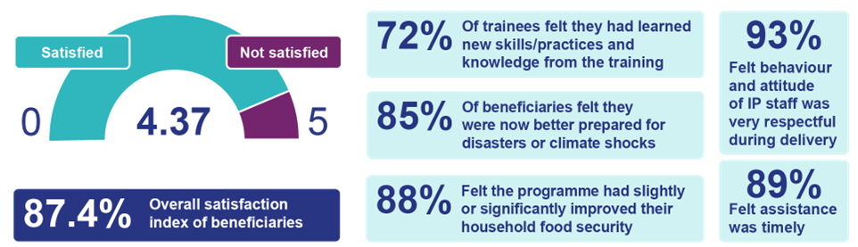

Equity – Fair access to benefits, especially for vulnerable and marginalised groups
- Equity remains a core principle for the BRAVE programme. Of the 1,778,926 beneficiaries reached through BRAVE’s support 51% were women and girls, 2.6% elderly and 2.1% were differently abled.

- Governance mechanisms such as VCAFs had 45% female membership, and exclusive women’s forums enabled inclusive planning. In UCAFs, women accounted for 10% of membership, a notable achievement in traditionally male-dominated spaces.
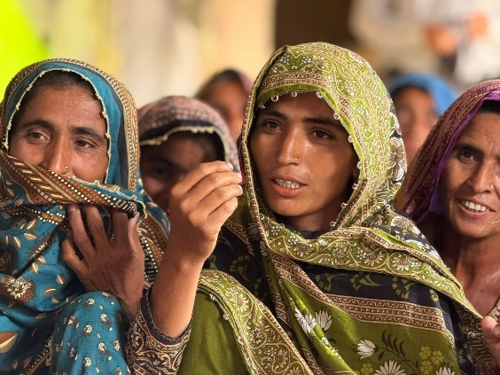 | 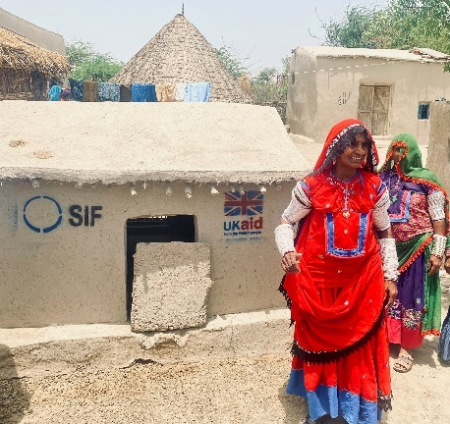 | 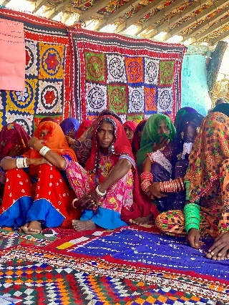
BRAVE Women Discussing Context and Climate Resilient Interventions with FCDO AR Team | BRAVE Women Beneficiary showcasing Climate Resilient Livestock Hut to FCDO AR Team | FCDO AR Team Meeting Women Members of BRAVE VCAF

Cost-effectiveness – Maximising long-term returns and outcomes per £ spent
- BRAVE effectively translated investments into measurable socio-economic gains. With £791,704, the vocational skills programme to strengthen community climate resilience increased employability from 25% to 42%, with beneficiaries earning an additional PKR 6,000/month, supporting income generation and resilience.

- Climate resilient infrastructure investments yielded high returns:
- In Charsadda, water access improved for 88% of respondents, irrigation expanded from 2,281 to 2,784 acres, and crop yields doubled from 20–40 to 40–60 maunds/acre, with some surpassing 1,000 maunds/acre.
- Farmers introduced high-value crops (musk melon, strawberry, guava) based on agro-ecological assessments and climate smart agricultural practices, increasing income diversification.
- In Nowshera, 80% of farmers under the maize programme reported higher production and improved sale prices, enabling reinvestment into future cropping cycles.

- These outcomes demonstrate how strategically targeted, inclusive interventions deliver tangible benefits, strengthening long-term household and community resilience.
Assessment of whether the programme continues to represent value for money
- Although early in implementation, the programme has demonstrated a strong value-for-money proposition. By combining cost containment (economy), smart delivery (efficiency), robust results (effectiveness), inclusive outreach (equity), and long-term returns (cost-effectiveness), BRAVE presents a coherent, data-backed case for VfM and should be continued with its adaptive and needs based delivery approach. Continued attention to institutional strengthening and acceleration of social protection initiatives will further consolidate impact and sustainability over the coming year.

E: RISK

- The BRAVE programme maintains a ‘Major’ risk rating, consistent with the previous Annual Review and Business Case. While several earlier risks have been mitigated, new challenges have emerged, most notably the FCDO’s global 0.3% ODA cuts, which threaten the programme’s scale, focus, and delivery. Additionally, delays in procuring the IS component continue to hinder overall programme progress and impact against the Theory of Change.

- Given BRAVE’s complexity spanning a substantial budget, multiple partners, and diverse components, robust risk management is embedded across all delivery layers. Partners are contractually required to maintain and submit updated risk registers with quarterly progress reports or as and when they arise. These are reviewed at least quarterly by the BRAVE team, who consolidate findings into the programme-level risk register on Aid Management Platform (AMP). Regular partner engagement and dedicated project-level risk tools enable proactive risk identification and timely mitigation, strengthening programme resilience and adaptive management.

- BRAVE’s risk appetite falls with the Pakistan Network’s risk appetite, as follows:
Category | Pakistan Network Appetite | BRAVE Appetite | BRAVE Residual Risk Ratings
Strategy & Context | Eager | Eager | Major
Policy & Programme Delivery | Eager | Eager | Major
Public Service Delivery & Operations | Receptive | Receptive | Major
Financial & Fiduciary | Receptive | Cautious | Moderate
People | Cautious | Cautious | Minor
Reputational | Cautious | Cautious | Minor
Safeguarding | Cautious | Cautious | Moderate

- Since the 2023/24 Annual Review (AR), CG4 has made significant progress on addressing its human resource gaps resulting in a reduction in BRAVE’s People risk from ‘Major’ to ‘Minor’. BRAVE is now fully resourced, with an experienced G7 UKB Humanitarian and Resilience Adviser in place, fulltime G7 CBS Governance Adviser successfully completing her probationary period, and permanent Senior Programme Manager (PRO) and Deputy Programme Manager shifting internally within FCDO. Since January 2025, BRAVE has also been supported 50% of the time by an accredited G7 CBS Social Development Adviser. New staff are quickly coming up to speed on the programme, with the AR process highlighting areas where better integration across all components can be achieved in the next reporting year to ensure BRAVE delivers its full potential.

- The main risks of ‘Strategy & Context’, ‘Policy & Programme Delivery’, ‘Public service delivery & Operations’ relate to the volatile political and security environment in Pakistan which results in frequent turnover of staff in key disaster management and climate change portfolios at national, provincial, and district levels. Despite this, federal level leadership in the Ministry of Climate Change (MoCC) and National Disaster Management Authority (NDMA) have continued to show vision and commitment to their mandates, which have enhanced the policy environment. Government of Pakistan (GoP) delays in renewing Non-Governmental Organisation (NGO) partner registration and issuance of No Objection Certificates (NOCs) create access and operational constraints which impact both programme quality and the timeliness of interventions. All of BRAVE’s lead and downstream partners are required to follow the registration policies of the GoP and share programme progress with government counterparts at regular intervals. In October 2024, one partner’s registration renewal was escalated to BHC leadership for assistance in swift resolution with key GoP Ministries and was subsequently resolved. This risk was already identified and had been mitigated by contracting two resilience and humanitarian response delivery partners (one INGO and one UN).

- By design, BRAVE activity locations are geographically vulnerable to natural disasters, including heatwaves, Glacial Lake Outburst Floods (GLOFs,) floods, and drought-like conditions, which are worsening due to climate change. Natural disasters, instability, and/or disease outbreaks could impact access, operations, and ultimately programme delivery. Increased threats of terrorism in 2024/25 in Balochistan and enhanced fragility in India-Pakistan relations further deepen these external risks. The programme follows a proactive approach by monitoring the situation, ensuring an adaptive design of project interventions with robust Third-Party Monitoring (TPM) and contingency plans in place, if necessary. BRAVE has put in place pre-agreed finance mechanisms to respond to any major natural or man-made disasters. Funds can be quickly released to address immediate and on-going critical humanitarian needs and recovery.

- To further mitigate against contextual and external risks, the BRAVE programme continuously engages GoP counterparts across all levels to find areas of mutual collaboration and support. The delayed procurement of the Institutional Strengthening (IS) component not only threatens the level of GoP institutional strengthening BRAVE can facilitate but also weakens the programme’s negotiating and influencing approach with government stakeholders particularly at the federal level.

- BRAVE’s Safeguarding risks have been assessed as moderate due to the programme’s direct interaction with beneficiaries and the environment. All implementing partners have safeguarding policies tailored and contextualised for the programme in line with FCDO Due Diligence standards on safeguarding. The safeguarding policies include Code of Conduct, Programme Participant Protection Policy, Child Safeguarding Policy and Anti-Trafficking in Persons Policy, expressly committed to protecting beneficiaries, including adults and children at risk, and partners’ staff from bullying, harassment and any form of abuse. However, the programme team will work further with partners earlier this fiscal year to align the programme’s safeguarding assessment against the new sub-categories for SEAH; Human Rights Violations or Other Harm to Communities (excluding Sexual Exploitation and Harassment - SEAH), and Environmental Damage.

- Reputational and Financial & Fiduciary largely remain unchanged, manageable within agreed programme appetite.

F: PROGRAMME MANAGEMENT: DELIVERY, COMMERCIAL & FINANCIAL PERFORMANCE

Commercial Performance
- While only two partners were contracted during the previous review period (CWW and the World Bank), BRAVE operationalised agreements with three additional partners this year. This included an MoU worth £30m with IOM as a Consortia lead for the Climate Resilience and Humanitarian Response (CRHR) in Central and Southern Pakistan; a Contribution Arrangement with WFP worth £3m for the Humanitarian Recovery through Asset Creation and Livelihood Support project; and a commercial contract valued at up to £4.5m with Integrity Global for the MEL component.

- The programme remained adaptive to emerging needs, including undertaking the quick humanitarian contracting of WFP in response to new humanitarian needs after the 2024 Monsoon Floods. The existing central Humanitarian Stabilisation Operations Team (HSOT programme / HEROS contract) agreement was utilised to provide 50% humanitarian surge capacity, after collaboration within the Afghanistan Pakistan Directorate assisted in filling the resourcing gap. Furthermore, the team completed the Due Diligence Assessment (DDA) for a new partnership with United Nations Office for the Coordination of Humanitarian Affairs (OCHA) during the reporting period, for approval in June 2025. HSOT surge capacity is lined up in the event of a major 2025 monsoon event which outstrips our now fully staffed BRAVE team.

- BRAVE utilised FCDO’s existing commercial procurement framework to identify Integrity Global to lead the MEL component. Integrity has completed the induction of its two downstream partners, the Institute of Social and Policy Sciences (ISAPS) and GLOW consultants and completed its Inception Phase by end April 2025. Integrity organised the first BRAVE Technical Board meeting in February 2025 and submitted all inception phase contractual deliverables as agreed, including their evaluation and Third-Party Monitoring (TPM) approaches.

Delivery
- The 2023/24 Annual Review (AR) period marked a critical phase of BRAVE’s evolution, characterised by the successful programme extension and onboarding of key partners Integrity and IOM, through two well-executed Inception Phases. Despite notable CG4 staffing constraints, BRAVE demonstrated strong delivery performance, particularly as the Pakistan Network’s only humanitarian programme during the 2024 Monsoon Floods. Delivery progressed across all programme components, with the exception of Institutional Strengthening (IS), underscoring the programme’s resilience and adaptability under pressure.

- All partners submitted comprehensive reports in line with agreed templates and timelines monthly, quarterly, or bi-annually, providing consistent updates on progress, achievements, and challenges. These reports detailed delivery against work plans and financial utilisation, which was closely monitored. Partners maintained proactive communication with FCDO, ensuring timely updates on contextual shifts and securing prior approval for any required adjustments. No unexpected deviations in delivery were identified during the AR, reflecting the effectiveness of regular and transparent communication. Performance was assessed against predefined milestones and results matrices, with timely submission of all deliverables, enabling the release of subsequent payments.

- To ensure effective delivery, monthly engagements with all direct implementing partners were prioritised. FCDO actively participated in partner-led inception workshops and events. During the AR, downstream partners were engaged through bilateral meetings and field visits. Although more than five field visits were planned, only three were conducted due to security and mobility constraints. These included two World Bank Joint Missions with government counterparts on Shock Responsive Social Protection (SRSP) Component 2, and one visit to Sindh Province with CWW, WFP, and IOM to monitor flood response and climate resilience interventions. A virtual field visit arranged by ACTED for BRAVE team in Balochistan enabled remote engagement with three communities and direct interaction with beneficiaries. Given the scale of BRAVE’s operations and ongoing travel challenges, expanding virtual field visits is recommended for the coming year.

- CWW convened two Provincial Steering Committee meetings in Gilgit-Baltistan and Khyber Pakhtunkhwa, while International Organisation for Migration (IOM) conducted an Inception Workshop in Sindh, with another scheduled for July in Balochistan. All climate resilience and humanitarian interventions were endorsed by the relevant government counterparts. The programme’s ability to adapt strategies in response to evolving contexts was facilitated by consistent communication between partners and provincial/district authorities. This coordination will be further enhanced by a Political Economy Analysis (PEA) developed by IOM in its operational areas. Field-level collaboration is ongoing with WRAP partners in Gilgit- Baltistan (GB) and Khyber Pakhtunkhwa (KP) through Concern worldwide (CWW’s) Knowledge Hubs. However, formal coordination between CWW’s North Consortium and IOM’s South Consortium has yet to commence, as IOM recently concluded its Inception Phase.
Financial Performance
- BRAVE has established itself as a prime Official Development Assistance (ODA) programme within the Pakistan Network, playing a pivotal role in advancing International Climate Finance (ICF) and humanitarian commitments. It covers a substantial share of the annual Pakistan ODA allocation, reflecting its strategic importance and sustained impact.

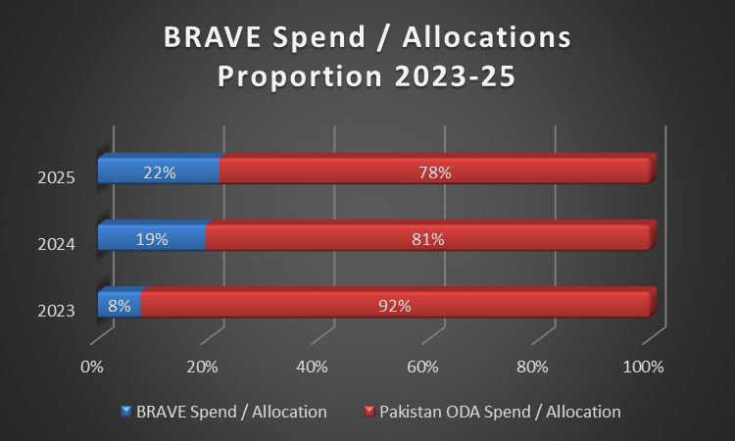

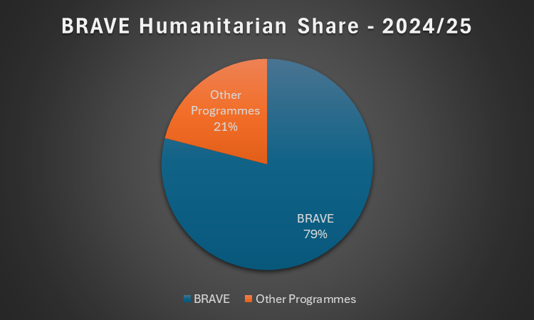 | 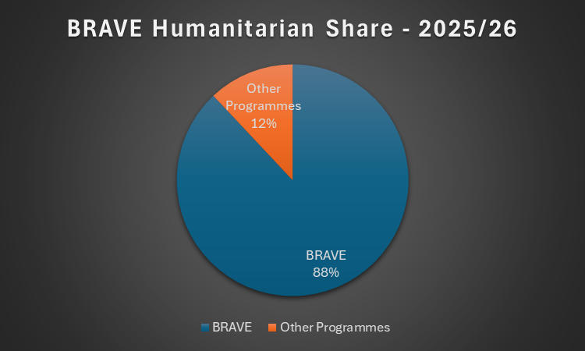

- BRAVE’s budget utilisation was exceptionally strong during the review period. The total spend in FY 2024/25 was £19.55m out of the originally allocated £18.76m, which remains within the acceptable variance threshold level i.e., 4% against target of 5%. The programme has spent 23% of its approved budget (£22m out of £97m) to date and remains on track for overall programme delivery. Furthermore, BRAVE’s close financial monitoring contributed to ensuring CG4 maintained an overall portfolio variance of less than 1%, while contributing to spending adjustments across the Pakistan Network during March-25.

- BRAVE’s strong financial performance was due to robust monitoring of all partners across the review period. All partners shared interim reports on budget expenditures and forecasts with FCDO monthly, while ensuring invoices were submitted on time. This enabled FCDO to make timely decisions on financial adjustments to maximise the programme’s impact. FCDO also increased the accuracy of financial reporting through designing effective financial reporting templates for its partners. BRAVE managed variances in the overall programme by flexing its humanitarian budget which resulted in accurate forecasting throughout the year.

- The following table demonstrates the financial performance of all active partners during the reporting year.

BRAVE Components and Delivery Partners | Allocation 24/25 (GBP) | Spend  24/25 (GBP) | Spend Proportion
Climate Resilience & Humanitarian Response (CRHR) - Western and Northern Pakistan – CWW | 11,234,168 | 11,876,150 | 106%
Climate Resilience & Humanitarian Response (CRHR) - Central and Southern Pakistan – IOM | 3,288,963 | 3,520,867 | 107%
Humanitarian Recovery through Asset Creation and Livelihood Support – WFP | 3,000,000 | 3,000,000 | 100%
Technical Advisory Inputs on Climate Resilience, Humanitarian and Governance – HSOT & PFP | 36,040 | 47,914 | 133%
Technical Assistance for adaptive and shock responsive social protection in Pakistan – The WB | 1,100,000 | 1,015,997 | 92%
Monitoring Evaluation and Learning – Integrity | 100,000 | 94,007 | 94%
Total | 18,759,171 | 19,554,936 | 104%

- In line with FCDO asset management compliance standards, comprehensive asset registers are managed by all partners and reported to FCDO quarterly. However, spot checks for assets could not be conducted in the reporting period due to human resource limitations and multiple cancellations of field visits.

Progress on recommendations from the previous AR
2023/24 Recommendation | 2024/25 Progress
The team should consider merging the separate provincial committees for BRAVE and WRAP into a single committee for each province (KP and GB), to enhance synergies, improve coordination, and reduce transaction costs for FCDO and partners. | Completed. BRAVE and WRAP implementing partners have strengthened coordination at a technical and working field level, particularly in GB. Teams decided not to pursue merging steering committees, given their different objectives and stages of implementation.

Recommendations for the year ahead 2025/26
Recommendations
IS procurement is a top priority but is dependent on teams within Headquarter (HQ) commercial unit. Recommendation: The SRO, and where needed CG4 Team Leader and Development Director, should immediately prioritise and escalate procurement delays at Post and in the Commercial Department to ensure timelines are reviewed and brought back on track. [Action: BRAVE SRO and PRO by Oct-25]
Given Pakistan remains highly prone to disasters with significant unmet humanitarian needs, BRAVE will have utilised more than 80% of its Humanitarian pot this year. Recommendation: Review programme’s and partners cost and time extension requirements as soon as spending review allocations are confirmed. It is recommended to increase partners humanitarian pot by at least 25% where they have utilised around 75% of their existing allocations to keep the pre-arranged financing mechanisms adaptive and impactful. [Action: BRAVE SRO and PRO by mid-August 25]
Recommendation: The PRO and PM should prioritise asset spot checks for all partners this year according to a plan agreed with the SRO. [Action: BRAVE PRO by Aug-25]
Integrity Global has received pushback from the World Bank and UN on undertaking TPM. Recommendation: FCDO Lead Advisers should participate in conversations with UN and World Bank partners on TPM approaches, to facilitate an agreement in line with overall BRAVE MEL objective. [Action: BRAVE SRO, PRO and Advisers by Oct-25]
During AR meetings with downstream partners, they all requested more regular opportunities to engage with FCDO directly as only communicating via the Consortium lead had limitations. Previously, CG4 was short staffed, but these gaps have now been filled. Recommendation: It is recommended that FCDO team members ensure each partner is met with independently at least once in 2025/26. The addition of “BRAVE Bites” will also give partners a direct opportunity to present their own work to FCDO Advisers, while virtual visits will do the same. [Action: BRAVE SRO, PRO and Advisers during FY 25/26]

G: MONITORING, EVIDENCE AND LEARNING

- As detailed in the Programme Management section above, BRAVE’s programme activities and implementing partners are actively monitored through monthly partner meetings, regular feedback on the narrative and financial reports, and tracking progress against Key Performance Indicators (KPIs), International Climate Finance (ICF) objectives, payment-based deliverables, and the logframe and its milestones using detailed workplans. Three field visits provided an opportunity to speak to downstream partners and beneficiaries to further verify reported information and collect more candid feedback.

- During the recent Sindh field visit, meetings with Local Non-Governmental Organisation (LNGO) implementing partners, community committees, and activity-specific beneficiary (including women-only) focus group discussions were held. Independent household and community infrastructure were visited and observed in use, with records reviewed. LNGOs expressed how Concern Worldwide (CWW’s) approach to capacity building and empowerment was invaluable, reiterating the localisation opportunities in Pakistan. The overwhelming sense was that communities were well-targeted, in significant need, and UK funding was central in supporting their recovery post-2022 and 2024 flooding. UK visibility and complaint feedback mechanism availability were consistent.

- Programme partners all have their own internal Monitoring & Evaluation (M&E) systems and are encouraged to document and share lessons/best practices and continue building an evidence base for strengthening resilience. In International Organisation for Migration (IOM’s) resilience intervention areas, they have designed four different implementation models they will test in the initial 18 months of the project before determining which approach is most effective to use in the second half of the project. Facilitated by CWW, Aga Khan Foundation (AKF) staff from Gilgit Baltistan (GB) undertook an exposure visit to CESVI’s activities in Khyber Pakhtunkhwa (KP) in January 2025. Both partners reported directly to the Annual Review (AR) team, that this visit was a highlight which provided an excellent opportunity to engage with on-going resilience building activities in other districts and share partner learning. Facilitated by CWW, Knowledge Hubs in five districts in partnership with academic institutions, have been instrumental in identifying key research priorities including indigenous knowledge and mapping new agro-ecological zones. Hubs foster cross-sector collaboration, including with Water Resource Accountability in Pakistan (WRAP) partners, while advancing the integration of evidence-based adaptation models into district-level climate resilience planning.

- In order to standardise best practices, the BRAVE North and South Consortia have both established Technical Working Groups (TWGs) on sector-specific themes (WASH, DRR, Protection, etc), in addition to a Monitoring Evaluation and Learning (MEL) TWG. TORs and workplans of TWGs are now in place which aim to enhance collaboration and deliver consolidated sector evidence and guidelines to the benefit of GoP and wider resilience community over the coming three years. An overall major recommendation (above) is to enhance BRAVE component coordination, which includes ensuring that North and South TWGs also come together to ensure nationwide learning, as well as draw upon the deep experience gained during FCDO’s previous Multi Year Humanitarian Programme (MYHP) and Building Disaster Resilience in Pakistan (BDRP) programmes in Pakistan.

- As part of FCDO’s internal learning, an Humanitarian Stabilisation Operations Team (HSOT) consultant along with BRAVE SRO prepared a 2024 Flood Response Lessons Learning report to improve flood response and preparedness. It outlined approximately 20 recommendations for BHC Islamabad, National Disaster Management Authority (NDMA), and UN. Significant progress has been made on implementation of recommendations which serves as a strong framework for future responses. This year BRAVE has prepositioned response Water, sanitation and hygiene (WASH) and shelter items for 23,800 households (142,800 individuals) ahead of the monsoon season, has pre-agreed financing mechanisms and an adaptive humanitarian reserve in place for two consortium partners, and will continue to maintain a ‘No Regrets’ strategy in deciding its response. Recommendations related to strengthening the National Anticipatory Action (AA) Framework will be prioritised this year.

- BRAVE prioritises Accountability to Affected Populations (AAP), with its Consortium leads ensuring robust complaints and feedback mechanisms (CFM) are in place in all intervention areas. For instance, CWW managed 826 pieces of feedback and complaints, promptly addressing issues related to construction work, activity selection criteria, inclusion for assistance, and entitlements. Wherein, the need to enhance women’s access to their mechanisms is also identified to ensure that women’s voices are adequately captured. World Food Programme (WFP) has established a confidential community feedback mechanism including toll-free hotline and received 25 complaints that were investigated and resolved. IOM’s humanitarian assistance evaluation found that, despite positive outcomes in safety and meaningful access, there was a concerningly low ‘accountability score’ of 42% among surveyed beneficiaries. Moving forward, IOM is considering revising its consortium wide approach to establish a standardised and more effective community feedback mechanism.

- BRAVE’s Consortiums have carried out gender analyses and integrated inclusive planning into their programme designs. Both Consortiums include a Protection and Social Inclusion TWG, with the South Consortium co-led by CARE International who also lead’s FCDO’s CG5 Awaaz programme on the same. The North Consortium has a partnership with HelpAge International to support the integration of gender, age, and disability inclusion across the programme cycle. Through BRAVE, IOM plans to test its global Women’s Participation Project frameworks to mobilise communities in comparison to other DRR approaches. In Pakistan, ‘Leave No One Behind’ also requires appropriate consideration of vulnerable ethnic groups, such as Hindu communities in rural Sindh, indebted and landless tenant farmers, and transgender (Khwaja Sira) communities. Field visits confirmed that these populations were reached through BRAVE, but quantification is not possible without systematic reporting. IOM is engaging a housing, land, and property (HLP) expert this year to building staff capacity and support legal awareness across target districts.

- While CWW carried out its baseline survey in the previous AR reporting period, IOM has led a baseline assessment as part of its Inception Phase. Initial results from finalised baseline data collection and analysis, covering 10 districts, are being incorporated into result framework and methodology note. To ensure continuity and comparability of resilience programming performance data overtime, this baseline data set will be instrumental for MEL, which will serve as a foundation for their planned baseline evaluations during 2025.

- As outlined in Output 4, BRAVE is complemented by a £4.5m MEL component which engaged BRAVE partners in a participatory workshop in February 2025 as part of its Inception Phase and will begin MEL delivery in Q1 FY2025/26. Initial activities for the coming year include carrying out independent TPM, a baseline evaluation, and hosting a coordination event with all BRAVE partners. These activities will greatly increase our confidence in the regular partner reporting and overall direction of the programme in achieving outcomes and recommendations of this AR.

- As more components and partners are now coming online, it is recommended that demand-led MEL support the establishment of a knowledge management platform or database for BRAVE to easily aggregate similar activities, geolocations, and facilitate coordination and learning between the North and South Consortiums, as well as SRSP efforts. BRAVE should also consider where Artificial Intelligence (AI), machine learning, telecom, and satellite imagery can be better utilised to support efficient data collection, needs assessments, and inform decision-making. An opportunity to partner with the FCDO’s centrally managed programme (CMP) Data for Development Unleashing the Data Dividend, IOM, OCHA, and Flowminder is being explored to support this in the next reporting year.

- The AR was led by CG4’s newly appointed Humanitarian Adviser with other sections completed by recently joined PRO, Deputy programme Manager, Governance and Social Development Advisers. This ensured an independent review took place with enhanced technical scrutiny during over 30 hours of bilateral meetings held with partners to reach the AR’s conclusions and recommendations.

Date of last narrative financial report | CWW – March 2025  WFP – March 2025  WB – Development Portal – March 2025  IOM – Interim report – March 2025  Integrity – March 2025 | Date of last audited annual statement | CWW: March 2025

ANNEX 1: BRAVE STORIES FROM FIELD
HELPING FARMERS GET BACK ON THEIR FEET
In District Badin, the BRAVE programme supported flood-affected tenant and sharecropper farmers with certified wheat seed, fertilisers, and training in climate-smart practices. As part of the climate-
smart agricultural inputs, 50 kg of certified wheat seed and hands-on training in improved farming practices was provided to the farmers.  The results were transformative. The high-quality seed, with a germination rate of up to 98%, yielded approximately 22 metric tons per acre – an increase of 15-25% over previous harvests. This boost not only met household food needs but also empowered farmers with a surplus of superior-quality seed for next season. Recognising its value, many farmers engaged in informal seed exchange within and beyond their villages, often receiving double the quantity of wheat grain in return.  This exchange system had a ripple effect: the acquired grain covered annual household consumption and generated surplus for sale in local markets. The resulting income strengthened food security and enabled reinvestment in farming activities, fostering a sustainable cycle of growth and self-reliance. | 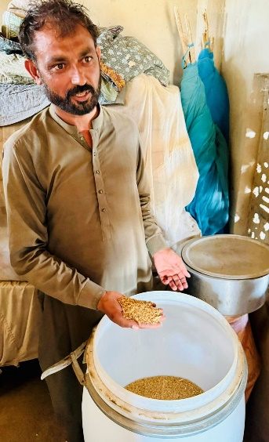
To ensure long-term impact, the programme also introduced sealed hermetic storage drums, protecting seeds from moisture and pests during monsoon and flood seasons. These drums preserve seed quality and are often shared among neighbouring farmers, promoting community-wide seed security and resilience.

This initiative not only restored livelihoods but also laid the foundation for a more resilient, self-sustaining agricultural future in Badin.

TRANSFORMING GGPS CHANRI: A DUAL ROLE IN SAFETY AND EDUCATION
During the BRAVE 2024 annual review visit to Government Girls Primary School (GGPS) Chanri in Badin, the school stood out as a powerful example of how integrated humanitarian and resilience interventions can serve both immediate and long-term community needs.
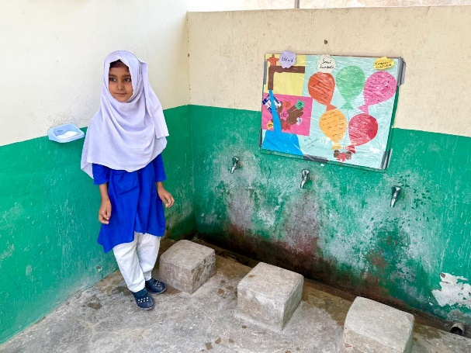 | Originally built on elevated ground, GGPS Chanri was a natural choice for flood evacuation. Through BRAVE, the programme enhanced its capacity as a safe, dignified shelter during monsoon floods providing critical refuge close to home.  Beyond its emergency role, the school’s rehabilitation has significantly improved its educational environment. Upgraded WASH facilities including repaired latrines, handwashing facilities, and a new hand pump ensured access to clean water and sanitation. Hygiene awareness sessions, especially with the School
Hygiene Club, empowered students to promote healthy practices with their classmates, families, and communities.  The installation of a 3 KW solar system now powers fans, lights, and water supply, creating a comfortable learning space and ensuring the school remains functional during heatwaves and emergencies. This reliable energy also supports better management and protection during disasters.  The impact is clear: student enrollment has increased by 15-20%, reflecting renewed community trust in the school as both a safe haven and a center of quality education. More girls are attending regularly, benefiting | 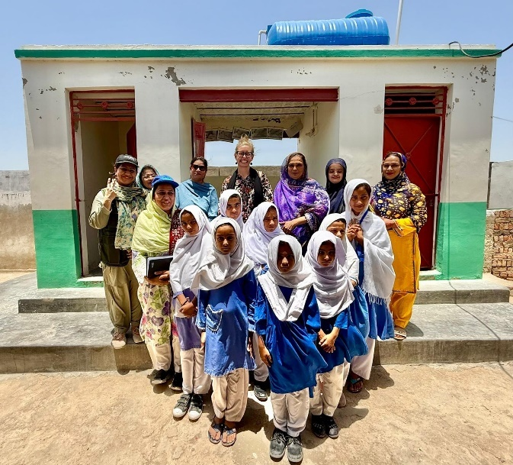
from a healthier, more supportive learning environment.

GGPS Chanri exemplifies how strategic humanitarian recovery interventions can deliver dual benefits, enhancing disaster preparedness while strengthening access to education.

RESTORING DIGNITY AND BUILDING RESILIENCE THROUGH SAFE WATER ACCESS
During the BRAVE programme’s annual review, a visit to Muhammad Hashim Shar village in Sindhri, Mirpur Khas, offered a compelling look at how climate-resilient infrastructure can transform lives. BRAVE rehabilitated hand pumps damaged by the 2024 floods, this time using a “build back better” approach. Installed on raised platforms and connected through lead lines, the pumps now ensure reliable access to clean water, even during future floods.
Before this intervention, women in the village walked nearly two kilometres daily, often in extreme heat or rain just to fetch water. This exhausting routine consumed hours of their day, exposed them to health risks, and limited their ability to engage in other activities.  Today, the rehabilitated hand pumps strategically located near 4-6 family home clusters have brought lasting change. Women now have more time and energy for their families and have resumed income-generating activities such as embroidery and livestock rearing. This shift has not only improved household incomes but also enhanced their sense of dignity, safety, and independence.  This story from Mirpur Khas is a powerful example of how practical, community-driven solutions can meet urgent needs while laying the foundation for long-term resilience and empowerment. | 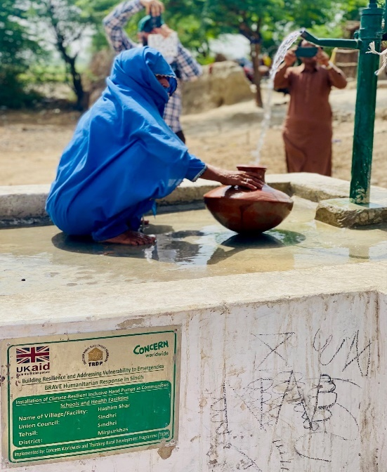
The facilities have further been tested and cleared by formal government authorities; and formally handed over to both respective government departments and community forums for regular maintenance and long-term sustainability.

ANNEX 2: ACRONYM LIST

AA | Anticipatory Action
AAP | Accountability to affected populations
AI | Artificial Intelligence
AKF | Aga Khan Foundation
AR | Annual Review
BHC | British High Commission
BISP | Benazir Income Support Programme
BDRP | Building Disaster Resilience in Pakistan
BRAVE | Building Resilience and Addressing Vulnerability to Emergencies in Pakistan
CAF | Climate Adaptation Forums
CESVI | Cooperazione e sviluppo (Italian NGO)
CG4 | Campaign Goal 4 (Climate, Resilience, and Humanitarian)
CIFPAK | Climate Investment Fund for Pakistan
CMP | Centrally Managed Programme
CWW | Concern Worldwide
DDMA | District Disaster Management Authority
DDMP | District Disaster Management Plan
DRM | Disaster Risk Management
EME | Early Market Engagement
EQUALS | Evaluation Quality Assurance and Learning Service
EWS | Early Warning System
FCDO | Foreign Commonwealth and Development Office
GA | Governance Advisor
GNI | Gross National Income
GB | Gilgit Baltistan
GoP | Government of Pakistan
GEDSI | Gender Equality, Disability, and Social Inclusion
HA | Humanitarian Adviser
HEROS | Humanitarian Emergency Response Operations and Stabilisation Programme
HH | Households
HLP | Housing, land, and property
HSOT | Humanitarian Stabilisation Operations Team
ICF | International Climate Finance
IOM | International Organisation for Migration
INGO | International Non-Governmental Organisation
IS | Institutional Strengthening
KMS | knowledge management system
KP | Khyber Pakhtunkhwa
KPI | Key performance indicator
LNGO | Local Non-Governmental Organisation
MEL | Monitoring Evaluation and Learning
MHCCRVA | Multi-Hazard Climate Change Resilience Vulnerability Assessments
MHVRA | Multi-Hazard Vulnerability and Risk Assessment
MIS | Management Information System
MYHP | Multi Year Humanitarian Programme
NADRA | National Database and Registration Authority
NbS | Nature-based Solutions
NDMA | National Disaster Management Authority
NGO | Non-Governmental Organisation
NSER | National Socio-Economic Registry
OCHA | Office of the Coordination of Humanitarian Affairs
ODA | Official Development Assistance
PAF | Pre-Agreed Finance
PC-1 | Planning Commission form -1
PDMA | Provincial Disaster Management Authority
PEA | Political Economy Analysis
PMD | Pakistan Meteorological Department
PRO | Programme Responsible Owner
PWD | Persons With Disabilities
SDA | Social Development Adviser
SEED | Sustainable Energy and Economic Development
SNG2 | Sub National Governance 2 programme (CG5 Open Societies)
SP | Social Protection
SRO | Senior Responsible Owner
SRSP | Shock Responsive Social Protection
SSPA | Sindh Social Protection Authority
TMB | Technical Management Board
ToC | Theory of Change
TOR | Terms of Reference
TPM | Third Party Monitoring
WB | World Bank
UC | Union Council
UN | United Nations
WBETF | World Bank Executed Trust Fund
WRAP | Water Resource Accountability in Pakistan

Please refer to Annex A for a complete Acronym List
Anticipatory Action refers to taking action ahead of predicted hazards to prevent or reduce acute humanitarian impacts before they fully unfold. OCHA outlines three essential components for effective anticipatory action: - Pre-agreed Triggers: Thresholds and decision-making rules based on reliable, timely, and measurable forecasts that indicate when action should be taken. - Pre-agreed Activities: Specific, accountable, and effective interventions designed to support vulnerable communities during the window of opportunity between the trigger and the full impact of a shock. - Pre-arranged Financing: Ensure that funding is guaranteed and can be rapidly released once the trigger is met, enabling timely implementation of the planned activities.
See Output 2 for comprehensive details on IS component.
Insufficient baseline data on PWDs in the affected area made it difficult to deliver targeted interventions. It has been confirmed by TPM that PWDs were included on all key decision forums.
See Stories from Field at end of this Annual Review.
See Stories from Field at end of this Annual Review.
A snapshot of some of the activities delivered by BRAVE: - 530 farmer field schools held with high adoption rates of climate smart agricultural techniques, increased yields, and improved livestock survival rates reported. - 48,090 female-led homestead gardens started, 68% with ‘excellent’ harvests. - 2,100 farmers supported with certified seed and TA, boosting yields (40-87%). - 830 climate-resilient fruit orchards (45 trees) established with high export potential. - 295 forests established (over 1.2ha) with native species using the miyawaki method to foster dense, self-sustaining biodiverse ecosystems as part of GoP’s Clean Green Pakistan programme, in partnership with the Forestry Department. - 314 communal irrigation and 8 flood mitigation schemes installed to improve irrigation efficiency and reduce water loss, benefiting 69,750 households. - 3,662 people (53% women) enrolled in market-based, climate-resilient livelihood skills training across a diverse range of trades and provided with tool kits. - 762 of the above trainees placed within the private sector for work experience. - 338 entrepreneurs (47% women) took boot camps on 5 climate-resilient value-chains and were given 145,000 PKR grants to foster new ventures. - 331 awareness raising campaigns and sessions on climate risks and adaptation.
See Stories from Field at end of this Annual Review.
Village Climate Adaptation Forums (VCAFs) were established at just £150 each, compared to the benchmark of £265, and Union Council Climate Adaptation Forums (UCAF) at only £71 each also well below the same benchmark. Similarly, Village Climate Adaptation Plans were developed at an average cost of £156 per plan, significantly under the benchmark of £418.

