- OFFICIAL Updated November 2024

Foreign, Commonwealth

& Development Office

Memorandum of Understanding Amendment Letter

Project Soteria: Stopping perpetrators of sexual exploitation and abuse and sexual harassment from working in the aid sector

Project Number: 300784-101

- I refer to the Memorandum of Understanding between the Government of the United Kingdom of Great Britain and Northern Ireland acting through the Foreign, Commonwealth & Development Office ("FCDO") and INTERPOL signed on 20 May 2021.

Change the end date

- Following recent discussions and correspondence dated 1 APRIL 2025 ''Request for a No-Cost Extension to Project Soteria", FCDO proposes to change the end date of the Memorandum of Understanding.

- I propose that the end date of "30 APRIL 2025" in paragraph 3 of the original Memorandum of Understanding be deleted and replaced with "31 MARCH 2026".

1

OFFICIAL
•

Foreign, Commonwealth & Development Office

Acceptance paragraphs and signature
- This letter of amendment will place on record our common understanding of the above change(s) and will come into operation on the date you sign your confirmation below. This note will be known as Amendment No. 2/2025.
- Please sign both copies of this letter; return one to me and retain the other for your own records.
Updated November 2024
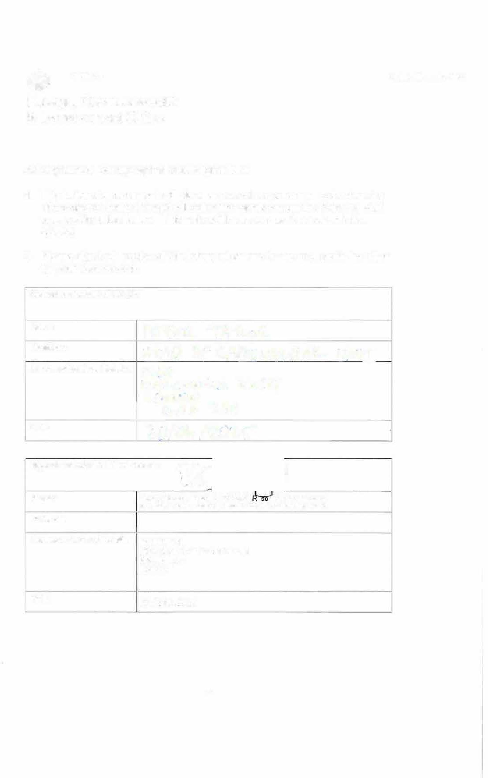
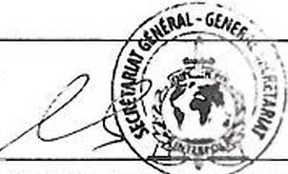
Address/Contact Details: INTERPOL
Signed on behalf of FCDO:
Name:
Position: Address/Contact Details:
Date:

Signed on behalf of the Partner:
Name: , Executive Director, e urce Management p.p. , Director, Human Resources Management
Position:
200 Quai Charles de Gaulle 69006 Lyon
France
Date: 30 April 2025

2

