Annual Review Template

Title: St Helena Economic Development Investment Programme [EDIP]
Programme Value £ (full life): £30m |  | Review date: June 2025
Programme Code: 300714 | AMP start date:  30/7/2018 | AMP end date:  31/3/2028

Summary of Programme Performance
Year | 2020 | 2021 | 2022 | 2023 | 2024-25
Overall Output Score | A | B | A | A | A
Risk Rating | Moderate | Moderate | Moderate | Moderate | Moderate

DevTracker Link to Business Case: | https://iati.fcdo.gov.uk/iati_documents/48790896.odt
DevTracker Link to results framework: | https://iati.fcdo.gov.uk/iati_documents/62262122.xlsx

A. SUMMARY AND OVERVIEW
Description of programme
St Helena is one of the world’s most remote inhabited islands with limited capacity to support self-sustaining economic growth: economic development remains highly constrained by barriers like high unit costs, and insufficient resources (physical, human, business, and financial), which can prevent economy of scale and result in a low capacity to drive sustainable growth. UK Official Development Assistance (ODA) is the main source of funding for St Helena. The St Helena Economic Development Investment Programme (EDIP) was approved in March 2019, with the purpose of supporting economic development in St Helena by investing in sustainable and resilient capital investments and physical infrastructure. The programme’s purpose has been expanded, as recommended in the breakpoint review of 2022, to also consider capital investments that facilitate and support social development and access to key critical services.

The current programme budget is £30m, and the implementing partner is St Helena Government (SHG), with delivery led by its Programme Management Office (PMO). An addendum to the EDIP Business Case was agreed in 2024 which allowed SHG to proceed with Phase 2 of the Programme and have access to the full project allocation. In preparation for the 2025/26 financial year, additional investments which can be supported by the provided capital allocations, including on Fuel Infrastructure, have been identified for inclusion under EDIP.

Summary supporting narrative for the overall score in this review
The Annual Review has been based on progress and results up to end of June 2025. The programme has scored an A in this review. While the project has experienced some challenges and delays since the last review, progress against the project milestones has generally been positive; it will be critical to ensure continued progress and take steps to correct assumptions and remedy areas that are offtrack.

EDIP governance processes are functioning well and provide valuable oversight across the range of EDIP interventions. The PMO has continued to mature and bed-in with positive results. s. During the reporting period, the PMO has provided substantial reporting and transparency, regularly engaging across all stakeholders, including SHG Portfolio’s and Governor’s office, demonstrating key capabilities required by a PMO managing a major capital investment programme. Progress has also been made on Field Road, and critical reports and designs relating to the prison and wastewater will assist future delivery. Funding for micro projects continues to be in high demand and the PMO has made progress with a bidding process, for example sifting according to a set criteria and welcoming feedback from the Board on improved prioritisation.

The Ruperts Bay Development has suffered from delays over the review period, but confidence is growing that the revised transition date will be met, it will require strong and proactive engagement to keep this on-track. Progress has also been limited on the renewable energy side.

Major lessons and recommendations for the year ahead

Lessons
- The absence of a clear project plan at the outset has continued to have a legacy impact on the Ruperts Bay project.
- The Steering Committee and relevant programme boards play a crucial role in providing oversight to the programme and ensure senior level engagement.
- There remains a strong reliance on a small but committed PMO team: with demands set to rise over the coming year in line with increased capital funding allocations, SHG and FCDO will work together to ensure the PMO is supported to deliver the range of EDIP projects, bolstered by international expertise as appropriate. It is to be noted that recruitment remains a challenge.

Recommendations
- It is critical that all necessary steps are taken to ensure that the target date of September for the transition of port operations to Ruperts Bay is met. All stakeholders must remain engaged in the process. [PMO action by July-August.]
- The new St Helena Government (due in September) will need to be quickly inducted into the EDIP governance processes to ensure ongoing continuity and oversight of the programme.
- Ensure the smooth transition of the Bulk Fuel Infrastructure project as part of the EDIP portfolio of projects [SHG tender due to commence in July].
- Following completion of this review, the FCDO programme team will work with SHG (led by the PMO), in reviewing and updating the programme log frame to ensure it reflects the current status and operating context. [Updated log frame by end of September].
- The Theory of Change should also be reviewed and revised again in the coming year to reflect new government priorities and funding allocations as appropriate. [Updated by end of October].
- Progress required under the Renewables space in particular resolving any licencing concerns related to renewable energy supply.
- A key lesson identified in the last year is that licencing requirements under the Utility Service Provider can present a barrier to planning and driving project execution through private companies. Early decision making by the newly elected government on this issue in September will help ensure that priority projects can continue at pace.
- The ensure progress on operations and maintenance, including so that assumptions within the theory of change can be more clearly assessed, PMO to assess the ongoing state of recurrent budget outward planning allocations, and its adequacy for new and legacy capital infrastructure on island. [PMO action by December]
- Consideration should be made on whether the programme title should be updated to reflect the programmes’ wider purpose of seeking to meet all capital needs of St Helena.

B: THEORY OF CHANGE AND PROGRESS TOWARDS OUTCOMES

Summarise the programme’s theory of change, including any changes to outcome and impact indicators from the original business case.

The programme’s theory of change has been updated since the last review to better reflect its expanded purpose beyond just providing capital investments that act as a catalyst for economic growth, this was also reflected in a Business Case Addendum. Under the revised theory of change (shown below) the programme seeks to improve the quality of life and ease of doing business on St Helena through investment in St Helena’s infrastructure and infrastructure services.



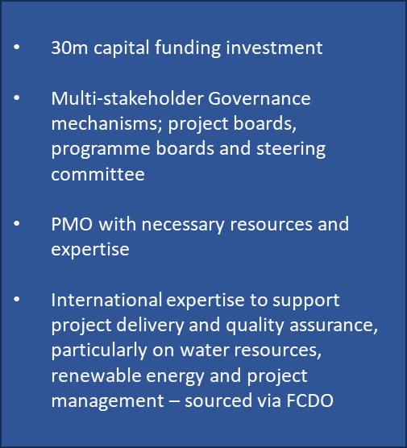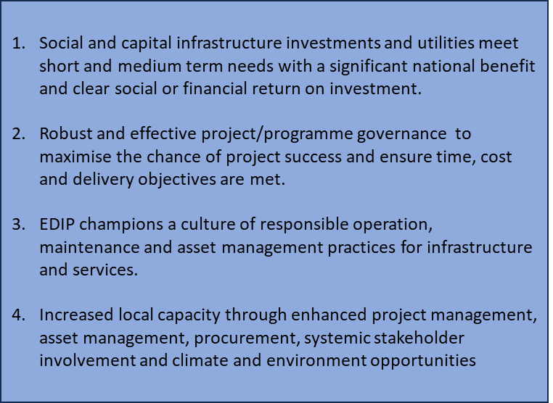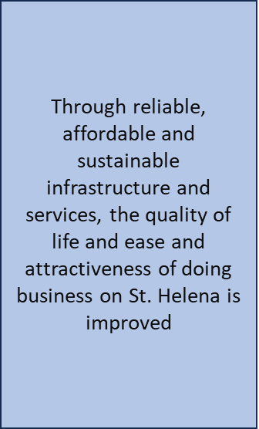

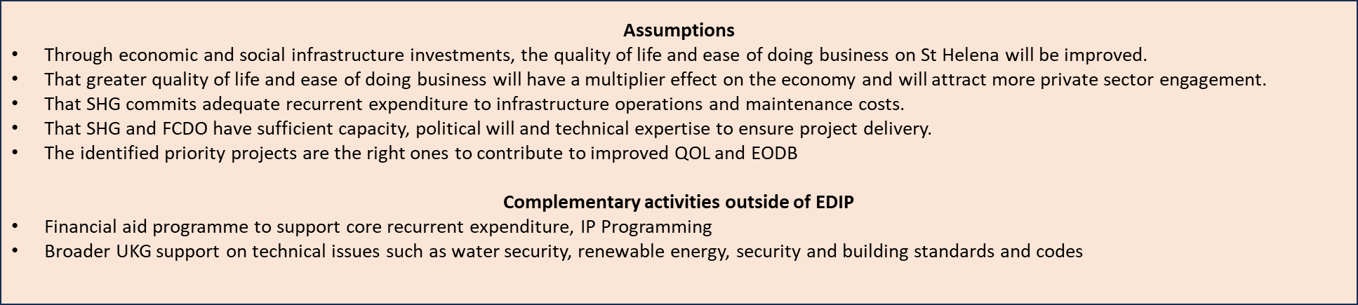

The programme seeks to benefit all of St Helena’s population due to the breadth of project interventions proposed, and as such it will be critical to assess the impact new capital infrastructure, such as the new port facilities at Ruperts, has on the island. This monitoring work will be assisted by the successful recruitment of a Monitoring, Evaluation and Learning Officer into the PMO and SHG’s ongoing work on Outcome Frameworks.

Describe where the programme is on/off track to contribute to the expected outcomes and impact. What action is planned in the year ahead?

The programme remains broadly on track to positively contribute to the expected outcomes and impact. The strengthened governance functions have resulted in improved oversight and monitoring of the programme, particularly enabling the resolution of issues that could otherwise impact the timely delivery of projects.

The challenges faced by a small and remote location such as St Helena have been well documented, as has the island’s exposure to external shocks such as the Covid-19 pandemic and other world events which can impact on trade and the availability/costs of goods and materials. It will be important to continuously monitor and mitigate the impact of these events on the project costs and timelines. Additionally, St Helena has a limited supplier base and is relying on a small yet dedicated PMO, bolstered where possible by contracted expertise, to deliver a range of capital projects. In recognition of these challenges the project end date has been extended until March 2028 to allow a more sequenced, risk-assessed and less crowded plan of project spend and delivery.

In the coming reporting year, major projects include: the completion of the Ruperts Bay transition and operationalising of port facilities; commencement of works on a new prison; commissioning of new bulk fuel infrastructure; and implementing project plans on renewable energy and wastewater.

The PMO takes a proactive approach to engaging with the local population on planned projects and interventions. Frequent public information meetings are held, which allow citizens to ask questions directly to the project delivery teams.

Justify whether the programme should continue, based on its own merits and in the context of the wider portfolio.

As demonstrated in this review, and in the reviews to date, this programme is on course to make a lasting contribution to the island’s economic and social development. It remains a key shared goal for SHG and UKG to maximise the benefits offered by the St Helena Airport in terms of tourism and economic growth. The programme continues to effectively support SHG’s long term sustainable development objectives, and to promote closer alignment between SHG and UKG priorities

This programme is the only avenue that provides St Helena access to key infrastructure funding, both in terms of supporting economic growth but also in ensuring and supporting the delivery of key services to the island.

C. DETAILED OUTPUT SCORING

Output Title | Social and economic development infrastructure investments and utilities delivered to meet short term and medium-term needs with a justifiable return on investment
Output number: |  | 1 | Output Score: | A
Impact weighting (%): |  | 30 | Weighting revised since last AR? | No

Indicators | Milestones for this review | Progress
1.1 Number of prioritised social and capital infrastructure investments under the pipeline developed and approved by the Steering Committee. | N/A | No milestone for this review.
1.2 Share of new and resilient infrastructure spending planned and executed. | By July 2026:  100% spend target met | On track.  SHG continue to make progress in both forecasting and spending its allocation.
1.3 Ruperts Bay development constructed against a high-quality business case with justifiable benefits. | By July 2026: Implementing phase-2 interventions of the Ruperts master plan. | On track
1.4 Water security, solid waste and wastewater feasible solutions being implemented | By July 2026:  - HTH & Jamestown sewerage system commissioned.  - Implementing the water resources action plan | On track  Two important pieces of design and analysis have been completed during the review period.

Briefly describe the output’s activities and provide supporting narrative for the score.

Indicator 1.2 –There continues to be incremental progress against this indicator which measures EDIP’s ability to disburse allocated funding. Building on the progress flagged in the last Annual Review whereby Phase 1 funding was fully allocated and reaching 54% of annual allocation spend by December 2023. During 2024/25 SHG spent 80.6% of its initial FCDO allocation for the year. Based on their final 2024/25 forecasts for the year SHG ultimately spent 95.2% of its projections. Indicator 1.2 scores an A. While the capital provision has been increased for 2025/26, the late confirmation of funding has impacted on SHG and the PMO’s planning process.

Indicator 1.3 - This indicator measures progress against the planned activities for development of Ruperts Bay. While there have been delays to this project over the reporting period which have seen the transition timeline pushed back, good proactive engagement to mitigate and reduce the scale of delays means that the SHG remains on track to meet the July 2026 milestone and all EDIP funded components of the Ruperts Bay transition will have been delivered. Indicator 1.3 scores an A.

Indicator 1.4 – This indicator measures the progress made by EDIP in supporting development of St. Helena’s water (supply, storage, and treatment) and sanitation infrastructure. The review period has seen the completion of a preliminary design report for wastewater and a finalised inception report for Water Resource Management Strategy, important steps for identifying infrastructure solutions in both areas. The PMO expects to receive completed detailed designs by November 2025 and purchase the sewage treatment plant and have in place an Action Plan on water before the end of the financial year. Indicator 1.4 scores an A.

Describe any changes to this output during the past year, and any planned changes as a result of this review.
No changes have been made to this output since the last review. Revision of the existing project outputs, indicators and milestones will be actively considered following completion of this annual review.

Progress on recommendations from the previous AR (if completed), lessons learned this year and recommendations for the year ahead

Previous recommendations
- As the Ruperts project and field road project conclude, it is important that a plan for operationalisation and handover is agreed with key stakeholders (i.e. port authorities, customs officials and private importers) – Still a work in progress, with handover due for completion in September 2025.
- Continue to develop an asset management system to catalogue EDIP funded infrastructure, including recommended maintenance schedule and indicative maintenance costs as part of the standard business case – Still a work in progress.

New recommendations
- Undertake a full review, in consultation with PMO on the project log frame and theory of change to inform the needed steps to meet original project outcomes. Action by FCDO and PMO by September 2025 for log frame and October 2025 for theory of change.
- Set out a plan and timeline for delivery of the water security, solid waste and wastewater feasible solutions. Action: undertaken by PMO by August 2025.
- Assess the type of projects to be worked up to realise the full range of benefits brought by the Ruperts Bay project. Action: undertaken by PMO by October 2025.

Output Title | Robust and effective project/programme governance to maximise the chance of project success and ensure time, cost and delivery objectives are met.
Output number: |  | 2 | Output Score: | A
Impact weighting (%): |  | 15 | Weighting revised since last AR? | No

Indicators | Milestones for this review | Progress
2.1 Project/programme management embedded within the public service at a strategic level. | By July 2026:  PMO function is matured and Framework fully established; focus is on continual improvement. | On track
2.2 EDIP projects governance arrangements are periodically reviewed. | By July 2026:  EDIP governance is reviewed and developed in accordance with the four pillars of effective governance. | On track
Briefly describe the output’s activities and provide supporting narrative for the score.
Indicator 2.1 – The PMO continues to mature and grow its capability to support the delivery of the range of infrastructure projects proposed under EDIP. The quality and responsiveness of its project management continues to improve as does the management information provided for scrutiny. It has demonstrated proactive engagement with all stakeholders, responsiveness to feedback and there is also greater awareness across SHG of the role of PMO. The PMO is actively seeking to become a centre of excellence within the SHG structure, with a view to building programme management capability across the public service, improving cross-departmental collaboration to support successful project completion. Indicator 2.1 scores A. The PMO’s approach is subject to continuous review.

Indicator 2.2 – The governance processes that oversee EDIP are now well established and provide a valuable forum and structure for decision making. Indicator 2.2 scores an A. The governance process and structure are subject to continuous review.

Describe any changes to this output during the past year, and any planned changes as a result of this review.

No changes have been made to this output since the last review. Revision of the existing project outputs, indicators and milestones will be actively considered following completion of this annual review.

Progress on recommendations from the previous AR (if completed), lessons learned this year and recommendations for the year ahead

Previous Recommendations
- Ensure the role and authority of respective EDIP governance bodies is well understood within SHG, including how these bodies interact with Portfolios and Ministerial responsibilities, and ensure that the route for Ministerial input into EDIP governance is well understood by SHG. – Completed, but awareness-raising will continue, noting regular staff rotation and upcoming changes to Ministerial team
- Continue to review how the EDIP Programme board feeds into, and receives, direction from both the steering committee and the Executive Committee. – Ongoing.
- Ensure that procurement and legal advice is sought from the procurement team and AG’s Chambers well in advance, in order to inform procurement and contracting timelines. – Ongoing requirement.
- Using the agreed pipeline, propose a programme of recruitment pre-emptively, in order to ensure necessary capacity is in place to deliver on the agreed ambitions of the pipeline. – Ongoing.
- The log frame and theory of change need to be updated, with the support of the Monitoring, Evaluation and Learning Officer, to improve the relevance and usefulness of these key documents for the programme’s second phase. – Theory of change updated since last review and will be revised again in the coming year to reflect new government priorities and funding allocations as appropriate; the log frame will also be updated following completion of this annual review.

New Recommendations
- Review and revise the theory of change to reflect new government priorities and increased funding allocations. [Review/revise by October 2025].
- Undertake a full review, in consultation with PMO on the project log frame. Action by FCDO and PMO by September 2025, with revisions actioned by October 2025, taking into account any changes to the theory of change as appropriate.
- Ensure sufficient inductions and briefings are undertaken for new Ministers following the September election on the current EDIP governance processes. Establish at an early stage if any changes will be proposed to these arrangements. Action: Initial written assessment undertaken by PMO by October 2025.
- It will be important that PMO is able to recruit for the key positions that it has identified to bolster its capacity to deliver the range of projects under EDIP. Action: PMO to self-assess and communicate to FCDO their capacity to recruit and deliver on EDIP projects by September 2025.

Output Title | Well prioritised, high quality, well justified high return social and economic development investments developed
Output number: |  | 3 | Output Score: | A
Impact weighting (%): |  | 30 | Weighting revised since last AR? | No

Indicators | Milestones for this review | Progress
3.1 Number of Business Cases with realistic options and quantifiable benefits considered - submitted and approved. | By July 2026:  All approved EDIP investments having formal benefits monitoring framework implemented. [longer term piece of PMO using new BC development process more broadly] | On track
3.2 Reduction in size of investments as a result of improved quality of project development processes | By July 2026:  5m savings reduction from first business case to approved BC. | Not assessed under this review
3.3 Number of changes made to project proposals as a result of public consultations, to reflect an improvement in the project development processes. | By July 2026:  25 | On track

Briefly describe the output’s activities and provide supporting narrative for the score.
Indicator 3.1 – The re-defined Business Case process flagged in the last review continues to operate well and has been a valuable step in the process of scrutinising and approving new projects to feature under EDIP. This indicator scores an A.
Indicator 3.2 – The rationale for this milestone as worded by former programme leads is unclear to all current parties and is therefore not assessed in this review.
Indicator 3.3 – Public consultation remains a valuable tool that the PMO is adopting across the full project portfolio. This process keeps citizens updated on planned developments and provides a mutually beneficial information forum. This indicator scores an A.

Describe any changes to this output during the past year, and any planned changes as a result of this review.

No changes have been made to this output since the last review. Revision of the existing project outputs, indicators and milestones will be actively considered following completion of this annual review.

Progress on recommendations from the previous AR (if completed), lessons learned this year and recommendations for the year ahead

New Recommendation
- Undertake a full review, in consultation with PMO on the project log frame and theory of change. Action by FCDO and PMO by September 2025 for log frame and by October 2025 for theory of change.

Output Title | Increased local capacity through enhanced prog management, assets management, procurement capabilities, systematic stakeholder involvement and climate and environment opportunities.
Output number: |  | 4 | Output Score: | A
Impact weighting (%): |  | 25 | Weighting revised since last AR? | No

Indicators | Milestones for this review | Progress
4.1 Assets and facilities management system setup and incorporated into O&M plan. | By July 2026:  Asset condition updated, O&M Planned and budgeted under Financial Aid for 50% of Infrastructure of Infrastructure O&M needs met through FA | Action for the PMO clarified and on track
4.2 % of project forecasts being achieved and timely completion of EDIP projects within budget and to specification | By July 2026:  100 percent of project forecasts hold true within 10 percent allowance of initial estimate. VfM Assessments of proposed investments opportunities undertaken. | On track
4.3 Programme management capacity strengthened. | By July 2026:  Capacity gaps strengthened with additional training for all PMU. | On track
Briefly describe the output’s activities and provide supporting narrative for the score.
Indicator 4.1 – As part of the enhanced business case process, all new capital projects are required to include whole life costings. Ahead of July 2026 it will be important for the PMO to ensure engagement with the wider government and finance colleagues to ensure O&M receives the necessary provision in budget discussions and prioritisation. Indicator 4.1 scores A.
Indicator 4.2 – The PMO has improved the accuracy of its project forecasting over the reporting period. All project forecasts are reviewed on, at least, a monthly basis and are subject to discussion at the relevant project/programme board. These improvements have been realised without economist expertise it will be important to seek this support to strengthen future VfM assessments. Indicator 4.2 scores A.
Indicator 4.3 – The review period has seen extensive training and professional development undertaken by PMO staff and two Programme Managers are now in place. It is important that there is continuous development of the PMO staffing resource, in recognition of the variety of projects being managed and the evolving skills, techniques and technology that will support their delivery. Indicator 4.3 scores A.

Describe any changes to this output during the past year, and any planned changes as a result of this review.
No changes have been made to this output since the last review. Revision of the existing project outputs, indicators and milestones will be actively considered following completion of this annual review.

Progress on recommendations from the previous AR (if completed), lessons learned this year and recommendations for the year ahead

Previous Recommendation
- EDIP should continue to support capacity, resourcing, and learning and development in the PMO. This will ensure that it becomes the centre of excellence for project delivery in SHG, and is capable of delivering on SHG’s ambitions. - Ongoing
- There is a need to agree at an earlier stage the ‘owner/client’ responsible for project operationalisation and benefits realisation, to facilitate a more gradual handover between the EDIP team at the latter stages of project delivery. – Ongoing

New Recommendation
- Undertake a full review, in consultation with PMO on the project log frame and Theory of Change. Action by FCDO and PMO log frame by September 2025, Theory of Change by October 2025.

D: VALUE FOR MONEY

Key cost drivers and performance

Achieving value for money on large scale infrastructure investments in the Overseas Territories, or any Small Island Developing States, is difficult, as their small size leads to diseconomies of scale. Challenges include long supply chains and lead times for international procurement which increase costs and extend project timelines, as well as a limited supplier base on the island which reduces the competitiveness of tenders and capacity to implement projects in parallel. A key cost driver for capital projects in St Helena is the securing and transporting of critical materials, equipment, and personnel to island. Due to the island’s remoteness, transportation costs are high and if a shipment is missed there can be significant cost implication and impact on project timelines. As flagged in this review SHG’s estimates and forecasts have improved, further improvements will be critical as new interventions are added to the programme.

VfM performance compared to the original VfM proposition in the business case

The 2022 EDIP breakpoint review positively indicated that EDIP’s Chartered Engineer provided considerable reassurance on the cost-effectiveness of technical solutions and the contracts awarded to implement these. Since this point, the PMO has continued to strengthen and firmly establish itself within the SHG system. Its work and focus has been supplemented by the arrival of the Monitoring, Evaluation, and Learning Officer.

Evaluating VFM against the Business Case’s VFM Matrix:

Level | Projects Implementation | Achievement and recommendations
Economy | - Independent assessment of delivery agent’s procurement and contract management capacity  - Evidence of quality indicators of operations and works  - Quality factors, such as proposed approach to construction supervision, environmental and social impacts, on-going maintenance, etc.  - Local procurement and transport costs where possible  - Cost deviations from Budget | - Conducted through Breakpoint review, no regular independent assessments  - Local procurement is standard, where possible, in all EDIP projects. Some larger projects (e.g. new build prison) necessitate international competition, as exceptions.  - The OTPD Infrastructure Adviser is working with EDIP to improve their maintenance plans.  - EDIP Projects are generally delivered on budget, with the exception of instances where project scope has increased.
Efficiency | - % of payments that are linked to outputs  - Transparent and competitive procurement  - Standardization of procurement, contracts, and performance standards  - Implementation time vs. original schedule | - Payments by SHG are made according to the delivery of milestones  - Local and international procurement is transparent and competitive, although it is important to recognise that the limited size of domestic supplier base does constrain the competitiveness of any local procurement.  - Procurement and contracts are standardised, with scope to flex with specific needs  - Project delivery times can overrun, due to supply chain issues and due to labour constraints – contingencies will be included in project plans.
Effectiveness | - Amount of construction risk being taken on by contractor  - Service Quality (e.g. households connected, outage days, etc).  - Revenue collection | - Little risk is taken on by contractors, ultimately resting with SHG  - EDIP delivered infrastructure is generally of a high quality and receives positive public feedback.  - No EDIP infrastructure built to date generates revenue directly.  - EDIP funded infrastructure is generally of high quality. Post-project reviews are required for further assurance
Equity | - All new build includes a professional assessment and implementation of disabled access for a range of disabilities; and includes consultation with disabled and user groups.  - Access by minority groups  - Gender and ethnicity targets for SME funds and other individually accrued benefits  - Gender and beneficiary analysis included in prioritisation/choice of infrastructure/approval discussions | - Consultations with user groups are carried out routinely, and new builds are assessed by EDIP’s chartered engineer, although explicit reports on these are not produced, they can be requested.  - Universal access is a design consideration at business case stage of project proposals  - Equity impacts are considered by the EDIP Programme Board.  - Beneficiary analysis is not explicitly considered in project prioritisation or approvals process but remains an underlying factor. This needs to be brought out more explicitly going forward.  - To further strengthen approach to safeguarding, FCDO is seeking to update safeguarding guidance in project MOU to reflect the St Helena context.

Assessment of whether the programme continues to represent value for money

St Helena has a continuing need for capital investment in social and economic infrastructure and will do so for the foreseeable future. EDIP is central to meeting this need, and ensuring value for money is essential to maximising benefits from limited resources. A key component part of EDIP in the coming year will be to assist in the backlog maintenance of key assets and infrastructure; investing now will help guard against the need for more expensive replacement infrastructure.

Further real-time and post-implementation evaluation is ongoing and assisted by the recruitment of the Monitoring, Evaluation and Learning Officer within the PMO will bolster efforts to gauge and maximize VFM.

E: RISK

Overview of risk management

The Overall Risk rating for EDIP is Moderate.

The most significant risk flagged as major under the programme is:
New (and existing infrastructure), does not have adequate provision for maintenance, leading to reduced operational life and exposure to health and safety and reputational issues.

Other key risks are:
- EDIP funded interventions fail to implement proper controls, causing harm to the people or the environment of St Helena.
- The Project Management Office (PMO) fails to sustainably build project management and delivery capability in SHG, EDIP fails to contribute to capacity building, dependence on small numbers of SHG officials risks loss of institutional memory.
- Failures in SHG's procurement practices resulting in resources getting wasted, which in turn reduces the ability of FCDO to continue funding the programmes as planned.
Work to mitigate these risks and those others identified under the programme is continuous. SHG, through the PMO leads much of the mitigation and are supported by the FCDO, and Governor’s Office teams.

The programme risks are subject to frequent review and monitoring, the project risk matrix is reviewed on a quarterly basis and the PMO submits a monthly monitoring workbook, which includes a tab for risks. The workbook is reviewed at EDIP Programme Board as a standing agenda item.

F: PROGRAMME MANAGEMENT: DELIVERY, COMMERCIAL & FINANCIAL PERFORMANCE

Summarise the performance of partners and FCDO, notably on commercial and financial issues.

All projects under EDIP fall under authority and oversight of the joint FCDO-SHG governance structure, comprised of an EDIP Programme Board and a strategic level Steering Committee. This has resulted in a more cohesive and strategic approach, which has helped to strengthen SHG and UKG engagement and collaboration to foster a greater sense of partnership. The steering committee receives Business Cases for review after they have been cleared by the Programme Board, which sits at the technical level.

Programme monitoring is conducted by the PMO and provides a monthly programme monitoring report to its Board and UKG. Once received, a Programme Board meeting takes place to discuss the report. The quality of reporting continues to improve and includes a narrative around progress on each project including timeline, actual/projected spend, activity log, risk log, along with a financial summary for the year. In addition to this, the PMO and FCDO programme team meet regularly to discuss in more detail, any issues arising with projects, delays, forecasting/budgeting etc.

G: MONITORING, EVIDENCE AND LEARNING

Monitoring and Evaluation

EDIP continues to fall under the authority and oversight of a joint FCDO-SHG governance structure, comprised of an EDIP Programme Board and a strategic level Steering Committee. FCDO staff actively participate in these boards where key project and programmatic decisions are made. These forums also allow scrutiny of SHG’s reporting in terms of project spend and progress

FCDO staff attend the programme boards and many of the project boards. Project and programmatic decisions are made in these boards, on the basis of value for money, risk, and alignment with programme objectives, with evidence provided through business cases and formal project proposals.

During the implementation of specific projects (i.e. those with significant direct impact on local communities), quarterly beneficiary feedback sessions are held by SHG’s EDIP team, in order to understand the impacts of ongoing works, and to address any issues that may arise.

This Annual Review has been led by the new EDIP Programme Responsible Owner (PRO), with support from the Infrastructure Adviser (former PRO), Development Attache, and EDIP Programme Officer. In addition, representatives from SHG’s Programme Management office have also provided inputs and insights during the review process. Ahead of this review the PRO, Infrastructure Adviser and Programme Officer all visited the island in February 2025 for a range of discussions and site visits hosted by the PMO.

Date of last narrative financial report | Apr-May 2025 | Date of last audited annual statement | SHG Management Accts March 2025

