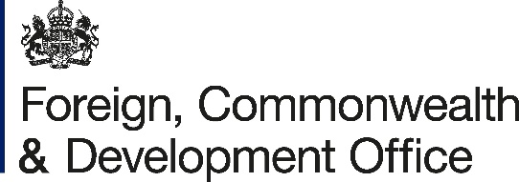

Memorandum of Understanding Amendment Letter 3

Project Name: Enhancing Access to Climate Finance for Ethiopia

Project Number: 300588-401

- I refer to the Memorandum of Understanding between the Government of the United Kingdom of Great Britain and Northern Ireland acting through the Foreign, Commonwealth & Development Office (“FCDO”) and the Global Green Growth Institute (GL17737071741712) signed on 28 June 2024, and the subsequent amendments made on 26 June 2025 and 21 September 2025.

- Following recent discussions, FCDO proposes to extend the end date of the Memorandum of Understanding.

- I propose that the end date of “31 December 2025” in paragraph three of the Amendment No.2/2025 be deleted and replaced with “31 March 2026”.

- Unless clearly stated here, other terms and conditions remain valid as stated under the original Memorandum of Understanding and Amendment No. 2/2025 signed between the Government of the United Kingdom of Great Britain and Northern Ireland acting through the Foreign, Commonwealth and Development Office(“FCDO”) and Global Green Growth Institute (GGGI).

- This letter of amendment will place on record our common understanding of the above change(s) and will come into operation on the date you sign your confirmation below. This note will be known as Amendment No.3/2025.

- Please sign both copies of this letter; return one to me and retain the other for your own records.

Signed on behalf of FCDO:
Name:
Position:
Address/Contact Details:
Date:
Signed on behalf of the Partner:
Name:
Position:
Address/Contact Details:
Date:

