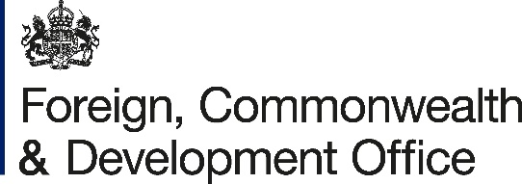

Memorandum of Understanding Amendment Letter 1
Project Name: Enhancing Access to Climate Finance for Ethiopia Project Number: 300588-402

- I refer to the Memorandum of Understanding between the Government of the United Kingdom of Great Britain and Northern Ireland acting through the Foreign, Commonwealth & Development Office (“FCDO”) and the Global Green Growth Institute (GL17737071741712) signed on 28 June 2024.
- Following recent discussions FCDO proposes to extend the end date of the agreement by three months.
I propose that the end date of “30 June 2025” in paragraph 2 of the original Memorandum of Understanding be deleted and replaced with “30 September 2025”.
- Unless clearly stated here, other terms and condition remain valid as stated under the original Memorandum of Understanding signed between the Government of the United Kingdom of Great Britain and Northern Ireland acting through the Foreign, Commonwealth & Development Office (“FCDO”) and the Global green Growth Institute (GGGI).
- This letter of amendment will place on record our common understanding of the above change and will come into operation on the date you sign your confirmation below. This note will be known as Amendment No.1/2025.
- Please sign both copies of this letter; return one to me and retain the other for your own records.
Signed on behalf of FCDO:

Name:
Position:
Address/Contact Details:
Date:
Signed on behalf of the Partner:

Name:
Position:
Address/Contact Details:
Date:

