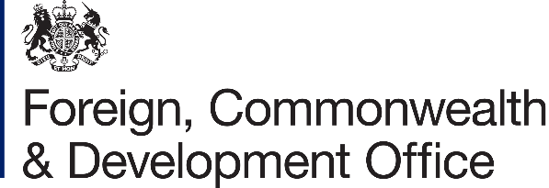

Project Name: Strengthening Data Systems for the Demographic Dividend in Mozambique

Project Number: 300586-105

- I refer to the Memorandum of Understanding between the Government of the United Kingdom of Great Britain and Northern Ireland acting through the Foreign, Commonwealth & Development Office (“FCDO”) and the United Nations Population Fund (“UNFPA”) signed on 10th December 2021, and the Memorandum of Understanding Amendment signed on 26th June 2024.

- Following recent discussions, FCDO proposes to increase the amount made available to UNFPA by £150,000 (One hundred and fifty thousand pounds sterling).

- I propose that the figures and words £5,050,000 (Five million, fifty-thousand-pound sterling) in paragraph (3) of the amendment letter 1, 2024 be deleted and replaced with the figures and words “£5,200,000 (Five million, two hundred thousand, pounds sterling)”.

- This letter of amendment will place on record our common understanding of the above change(s) and will come into operation on the date you sign your confirmation below. This note will be known as Amendment No. 02/2025

- All other Articles of the original Agreement and amendment No.01/2024 shall remain unchanged.

- In witness whereof, the undersigned, duly authorised representatives of the Parties, have signed the present Amendment in two copies.

Signed on behalf of FCDO:

Name:
Position:
Address/Contact Details: | Av. Vladmir Lenine 310  Maputo  +258 2132 6000
Date: | 16th October 2025
Signed on behalf of UNFPA:

Name:
Position:
Address/Contact Details: | Rua Orlando Mendes  Sommerschield 213  Maputo  +258 21 49 0686
Date: | 19th October 2025

