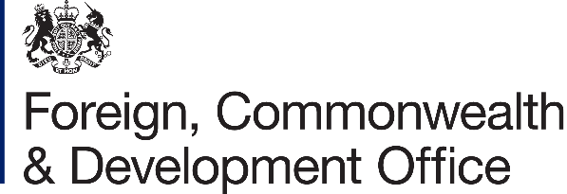

Project Name: Increase the use of modern, high-quality family planning methods by women in Mozambique, especially amongst those most vulnerable.

Project Number: 300586-102

- I refer to the Memorandum of Understanding between the Government of the United Kingdom of Great Britain and Northern Ireland acting through the Foreign, Commonwealth & Development Office (“FCDO”) and the United Nations Population Fund (“UNFPA”), signed on 10th December 2021.

- Following recent discussions, FCDO proposes to increase the amount made available to UNFPA by £4,950,000 (Four million, nine hundred and fifty thousand pounds sterling).

- I propose that the figures and words “£3,111,124 (Three million, one hundred and eleven thousand, one hundred and twenty-four-pound sterling)” in paragraph (e) of the original Memorandum of Understanding, and the figures 5,799,999 in amendment 01/2024 be deleted, and replaced with the figures and words “£10,749,999 (Ten million, seven hundred and forty-nine thousand, nine hundred ninety-nine pounds sterling)”.

- This letter of amendment will place on record our common understanding of the above change(s) and will come into operation on the date you sign your confirmation below. This note will be known as Amendment No. 02/2025

- All other Articles of the original Agreement and amendment No.01/2024 shall remain unchanged.

- In witness whereof, the undersigned, duly authorised representatives of the Parties, have signed the present Amendment in two copies.

Signed on behalf of FCDO:

Name:
Position: | British High Commission, Maputo
Address/Contact Details:
Date: | 26th September 2025
Signed on behalf of UNFPA:

Name:
Position:
Address/Contact Details:
Date: | 22nd September 2025

