ADDENDUM TO BUSINESS CASE INCLUDING FOR BRIDGE FUNDING AND SCALE-UP COST EXTENSIONS

SUMMARY INFORMATION
Project Name | GSMA’s Mobile for Humanitarian Innovation Programme
Country or region targeted | Africa & Indo-Pacific
Type of cost extension (if applicable)
Original project budget | £15.5 million
Original project start and end dates | September 2017 – March 2022 (end date extended from Sept 2021 with 1 million increase in impact number)
Cost extension value (if applicable) | £15 - £20 million
New project end date (if applicable) | March 2027
Business Case Quest Document No. | Programme code (300446)

INFORMATION
What is the project’s purpose?
In 2017, 92 million people were in need of humanitarian assistance. The models and ways of working in a mobile-enabled humanitarian future, and the role of the private sector in it, were not yet well understood nor proven at scale. Critical questions about how private sector and technology could meaningfully address humanitarian need, remained unanswered.

At that time, the GSMA, through its Mobile for Humanitarian Innovation (M4H) programme set out to reach 6 million (later increased to 7 million) people with improved access to and use of life-enhancing mobile-enabled services in humanitarian preparedness, response and recovery. M4H has now reached 5.8 million people (by 31 March 2021) and is on track to achieve its target of 7 million by 31 March 2022.

The M4H programme has sought to address barriers identified in 2017, through: building a common language between humanitarian actors and mobile network operators (MNOs); identifying sustainable and replicable business models; creating supportive policy and regulatory environments; and addressing a siloed approach to the integration of mobile technology in humanitarian action.
While these barriers have been successfully addressed in some contexts and through specific successes, this addendum provides an approach that goes further in addressing them at scale. M4H will tackle global humanitarian challenges with mobile-enabled and digital services to a higher ambition with a proven and evidence-based approach.
The programme’s successes to date have achieved ambitions set out in 2017:
- Develop and scale mobile-enabled solutions for humanitarian preparedness, response, and recovery;
- Enable the role of mobile and the private sector to meet humanitarian needs; and
- Develop research and innovation in this area.
Some examples of programme success under these areas include….
Develop and scale mobile-enabled solutions for humanitarian preparedness, response, and recovery

The programme has played an active role in humanitarian preparedness, response, and recovery operations, including through its early focus on disaster response. 159 mobile network operators from over 111 countries have committed to support improved access to communication and information for those affected by humanitarian crisis through signatory of GSMA’s Humanitarian Connectivity Charter (HCC). This tool convenes operators and humanitarians in both sudden and slow onset emergencies, prioritising connectivity for crises affected populations. A recent example was following the August 2020 Beirut explosion: M4H facilitated connections between UNDP and MNOs in Lebanon to disseminate rapid socioeconomic assessment surveys through bulk SMS to people affected in Beirut and its immediate suburbs. This coordination enabled UNDP to leverage mobile technology to rapidly assess the affected populations’ needs.
M4H has focused on identifying key requirements for shifting humanitarian operations to support digital cash distribution and addressing barriers to operationalising mobile money-enabled cash and voucher assistance in humanitarian response. Drawing on GSMA’s mobile money expertise, M4H has built the evidence base on this topic, developing assets that can drive forward the inclusive adoption and scaling of mobile financial service enabled CVA with humanitarian and private sector partners, including through its partnership with the World Food Programme.

Mobile enabled solutions have been developed, and shown evidence of scale, through Innovation Fund projects that span improving access to essential services such as water, sanitation and energy to testing frontier digital solutions and adapting existing technologies for pressing humanitarian problems. Through three funding rounds, M4H had awarded 22 grants which have impacted the lives of people in 27 countries. As many of the projects in the portfolio begin to realise their goals, examples of positive mobile-enabled impact are emerging, and more solutions are being scaled and replicated with support from additional funders. To date, four grantees have scaled or replicated their innovation in new contexts and six grantees have reported a collective £8m from private funders and awards to support additional rollout and product development.

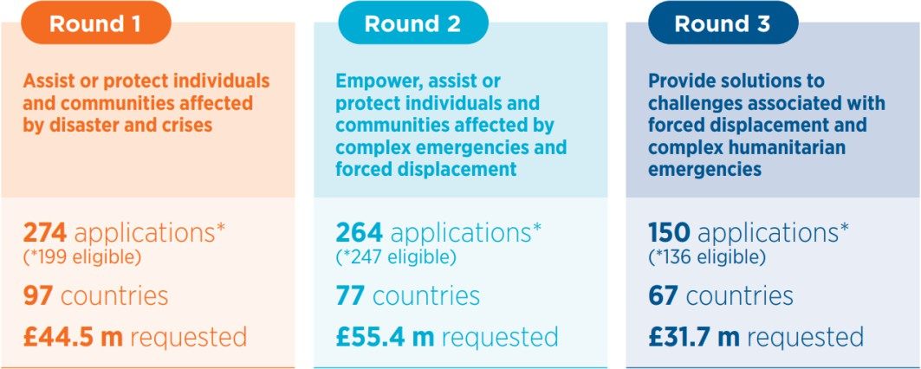
*Each of the Innovation Fund rounds was adapted slightly to respond to learnings from the previous round and to assist in the transition to scale for more promising innovations.
In response to heightened demand and interest in using mobile technology to address humanitarian challenges during COVID-19, M4H carried out activities that leveraged the power of mobile technology in the global pandemic response. The M4H Innovation Fund awarded additional, targeted funding for six existing grantees to adapt their projects in response to COVID-19. The programme promoted MNO initiatives including through the “Pandemic Response in Action” blog series (KDDI Japan, Turkcell, Vodafone, Millicom and Cassava Fintech Burundi). M4H supported FCDO’s Social Protection Approaches to COVID- 19: Expert advice helpline (SPACE) to explore the role of mobile technology in addressing the primary and secondary impacts of COVID-19, especially on social protection systems.
The programme published and promoted several practical recommendations for governments and central banks to facilitate the use of mobile and mobile money platforms in humanitarian assistance during the pandemic.
Enable the role of mobile and the private sector to meet humanitarian needs

The role of mobile and the private sector has been leveraged to build enabling policy environments in humanitarian contexts. Examples include a major policy change breakthrough in Uganda that resulted in 600,000 displaced persons able to access SIM in their own name, enabling them to connect with loved ones, access vital information and financial services, and receive humanitarian assistance. In Kenya, M4H convened government stakeholders, humanitarian partners and local operators around the topic of Know Your Customer “KYC” compliance, that led to a policy review that unlocked access to vital mobile services for marginalised groups. M4H has worked with governments and policy makers towards enabling policy environments for improved resilience and response to disasters by leveraging and supporting mobile network infrastructure. M4H has shaped National Emergency Telecoms (NET) plans through its capacity building course ‘Responding to Disasters and Humanitarian Crises’.
New technology solutions have been tested and integrated. One example is the successful pilot of the use of Voice ID technology to authenticate mobile money-enabled cash assistance. The pilot demonstrated a sustainable business case for both Telesom and CARE now being scaled to reach a cumulative 7,800+ households in Somaliland. As a result, M4H is working on cross-network verification with Hormuud Telecom in South Central Somalia and Gollis Telecom in Puntland, Somalia to integrate the system with additional humanitarian organisations, including FAO.

Women have been trained as mobile money agents in collaboration with the Grameen Foundation and MTN Uganda, using GSMA’s Digital Financial Literacy Training Guide. Mobile money agents are essential to the digital ecosystem, and M4H worked with MTN Rwanda to integrate protection into their mobile money operations through the training of their mobile money agents in the humanitarian Code of Conduct and protection from sexual exploitation. The training has been digitised to reach 80,000 MTN agents in Uganda and is now being replicated and scaled to other countries.
Develop an evidence base through unique research (original wording “Develop research and innovation in this area”)
Research of the programme has quantified the digital gender gap1 and digital disability gap among refugees and host communities, building understanding of the importance of

1 The gender gap in mobile phone ownership and mobile internet use is calculated using the same formula as in the GSMA Mobile Gender Gap analysis. It is presented as a percentage of how less likely a woman is to own/use a mobile phone or certain mobile features than a man.
connectivity for refugees. The broader portfolio of research and insights of the programme has underpinned advocacy work and supported evidence-based decision-making in the design and implementation of inclusive digital interventions. M4H has had success in contributing to more enabling regulatory environments for refugees. M4H has built the interest of mobile operators to respond to displaced populations, articulating the business case of these communities being fully integrated into the digital ecosystem. M4H partners closely with humanitarian organisations with a displacement focus, including the UNHCR.

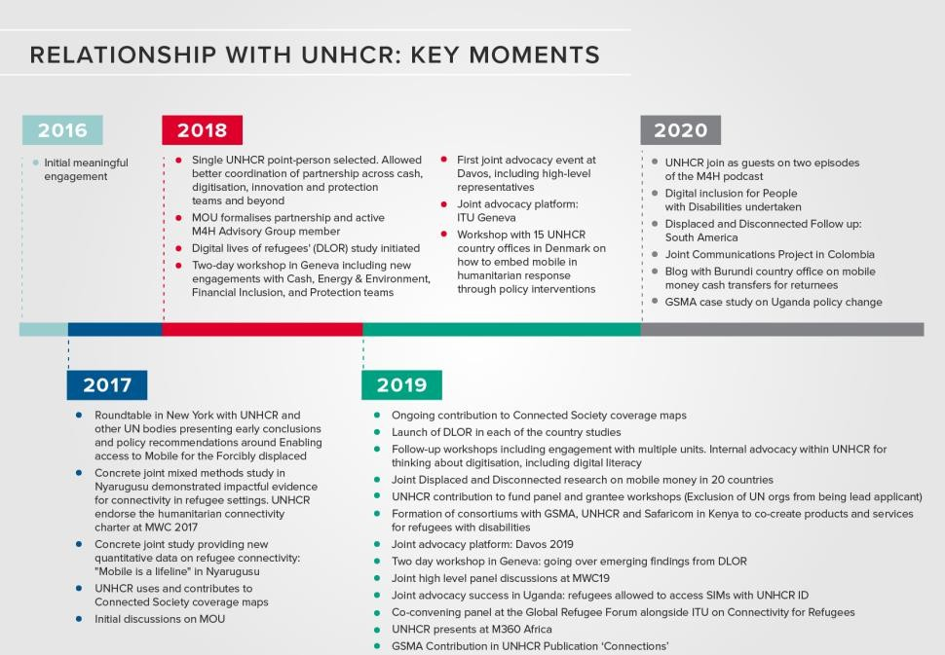

To generate robust data that goes beyond anecdotal evidence, M4H partnered with UNHCR on a multi-country research project - The Digital Lives of Refugees. The demand for such robust data led to a new partnership with REACH and the Emergency Telecommunications Cluster, or ETC to create the Connectivity Needs and Usage Assessment (CoNUA) toolkit that enables others to replicate the methodology and collect standardised data in any humanitarian context. The toolkit, through testing and implementation, will bolster the evidence base on digital access and needs, overcoming one of the key barriers to digitising humanitarian assistance on a large scale.

M4H has designed and implemented an ambitious monitoring, evaluation, and learning framework that ensures the programme collects, analyses and reflects on evidence related to its work. In the remaining year of the grant, the programme will ensure it has a strong and robust evidence base that will be published in an end line report before March 2022. This evidence will enable the programme to continue to pursue the most effective and influential activities in the implementation of its next strategy, driving increased efficiency in securing impact.
What is the objective of the cost extension or other changes?
Pre-pandemic, in 2020, the number of people in need of humanitarian assistance had
increased from 92 million (2017) to 168 million. The COVID-19 pandemic has pushed this number up a further 40 per cent, with 235 million people worldwide expected to need

humanitarian assistance and protection in 20212. Further, climate change is driving humanitarian need, causing more frequent disasters, increasing displacement, and heightening food insecurity. Humanitarian agencies, donors, governments and the private sector face mounting pressure to meet the needs of people affected by humanitarian crises.
M4H has demonstrated that new partnership models, together with scalable, innovative tools and approaches are effective in addressing the growing global humanitarian challenge.

In 2021, the tumultuous new reality of COVID-19 solidified mobile technology’s pivotal role in addressing humanitarian need. When restrictions on movement came into force in early 2020, mobile technology was often the only channel for humanitarian organisations to deliver life-saving information and support. Humanitarian organisations have used new digital channels to respond to humanitarian need, and existing mobile use cases have become particularly important including information as aid, mobile-enabled cash assistance, and data collection and use.
M4H is now uniquely positioned to reach humanitarian need at an even larger scale, contribute to reforming the humanitarian system, and share evidence and learning to a global network – paving the way for a safe, inclusive, and dignified digital humanitarian future. M4H will leverage expertise and assets of the programme with new partners and in new geographies, building on its existing foundation. This will lead the programme to delivering significantly more to affected populations at scale.
The original business case agreed five thematic areas where there was potential for mobile-enabled digital services to meet humanitarian need: Mobile financial services; Mobile enabled utilities; Food security and climate change; Digital identity; and Gender and Inclusivity. These solutions have delivered for people affected by humanitarian crises, and
the work of M4H has covered a broad scope across these areas. As a result, the programme will organise its work based on the recognised trends in humanitarian action, enabling it to demonstrate its contribution to addressing the global humanitarian challenge through tried and tested solutions.

M4H will focus on five humanitarian trends that mobile-enabled services have a role in addressing:
- Increased demand for use of humanitarian cash and voucher assistance
- Increased frequency and intensity of natural disasters
- Increasing number of forcibly displaced people
- Increasing global hunger
- A climate emergency underway

These themes are in line with specific areas of the UK’s seven global challenges where the UK can make the most difference3. Alignment is focused on, but not limited to, the priority on “Humanitarian Preparedness and Response: Lead strong collective international response to crises and famine. This includes reforming the international humanitarian system, maintaining a minimum FCDO crisis aid reserve, and promoting science and digital technology to offer faster and cheaper delivery to those affected by crises”.

2 https://www.unocha.org/sites/unocha/files/GHO2021_Press%20Release_EN.pdf
3 FCDO letter, from the Rt Hon Dominic Raab MP - Secretary of State for Foreign, Commonwealth and Development Affairs, to: Sarah Champion MP, Chair, International Development Committee
The focus of M4H’s next phase will also geographically align with the UK’s development interests, ie: “sub-Saharan Africa and the Indo-Pacific region”. To date, M4H has had a primary focus on Africa. While this will remain, the team will diversify its portfolio by increasing work in Indo-Pacific.

Organising the programme under these five themes will help M4H demonstrate its impact in addressing challenges across the humanitarian landscape. The themes build on specific successes of the programme to date, and will enable the programme to collaborate with relevant partners across the humanitarian and private sectors to amplify impact.

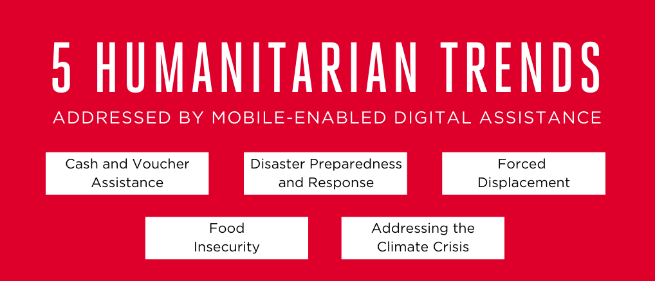

A brief overview of each trend: (with expected outputs and results in the following section):

1. Increased demand for use of humanitarian cash and voucher assistance

Commitment 3 of the Grand Bargain, agreed at the 2016 World Humanitarian Summit and co-convened by the UK and the World Food Programme aims to increase the use and coordination of cash-based programming. Cash and voucher assistance (CVA) helps to deliver greater choice and empowerment to affected people and strengthens local markets, however it remains underutilised.4 The volume of cash and voucher assistance has doubled in past years from 10.6 per cent in 2016 to 17.9 per cent of all humanitarian assistance in 20195. Despite this increase, much remains to be done to shift operations to deliver digital humanitarian assistance at scale.

The business case for mobile money providers has been tested and demonstrated, and is an area that has seen increased uptake by the private sector, creating interest in responding to humanitarian needs more broadly. Leveraging mobile financial services to deliver CVA has the potential to increase efficiency in delivering cash assistance by offering a faster, more secure and transparent means to getting help to communities most in need, and thus more efficient humanitarian programming.

4 https://interagencystandingcommittee.org/increase-the-use-and-coordination-of-cash-based-programming
5 https://reliefweb.int/sites/reliefweb.int/files/resources/SOWC2020-Executive-Summary.pdf
Transformational benefits, including access to financial and digital services, although not always common outcomes, are encouraged through a user-centred approach when digitising CVA. Only by designing with, and for, the most marginalised recipients, will the benefits of CVA be realised and equitable for all.

- Increased frequency and intensity of natural disasters
Disasters, including hurricanes, floods, earthquakes, and extreme heat, are increasing in intensity, and predictive modeling shows that the frequency and number of people affected is set to increase. The role of mobile-enabled services is a lifeline to disaster-affected communities, and the business case for mobile operators (revenue, reputation, competition and influence) puts GSMA in a unique position to respond to slow and sudden onset disasters.

M4H was launched as an evolution and expansion of GSMA’s FCDO-funded Disaster Response programme (2012-2017). Despite disaster response being less of a focus in the current phase of the programme, sustained engagement and demand from mobile operators and humanitarian partners has continued. M4H is a member of the advisory group for the Disaster Connectivity Maps, a joint initiative of the International Telecommunication Union (ITU) and the Emergency Telecommunications Cluster (ETC). M4H became an active member of the Emergency Telecommunications Cluster in 2018.
Robust and well-functioning mobile networks contribute significantly to effective disaster response. They are relied upon to provide a wide spectrum of services encompassing early warning messages, facilitating emergency response and logistical coordination and assessments, and supporting vital communication and information flows between and to affected populations. Operators are uniquely placed to support disaster preparedness and response, and effective involvement with national actors and platforms can be valuable for everyone involved. Including mobile operators in the planning stages can help shape how strategies are designed and improve their effectiveness in the longer term. M4H can build on the strength of its work so far to increase engagement and activity of mobile operators in the field of disaster preparedness, response, and recovery.

- Increasing number of forcibly displaced people

The 80 million people now forcibly displaced is the highest on record, and nearly double the 2010 number of 41 million. Displaced communities often live without the connectivity and mobile-enabled services that can be life-saving and life changing. Refugees living in camps and settlements often lack connectivity due to regulatory barriers, and as a result are disconnected from vital information, means to communicate with loved ones, and essential services such as water, energy, livelihood and protection.
Even where connectivity is available, many host-countries’ increasing emphasis on proof-of- identity requirements to access mobile SIM cards and mobile money services, prevents large numbers of underserved groups (including refugees) who lack the acceptable identification and are therefore unable to be digitally, socially and financially included in their own name.
M4H, with its experience of quantifying the digital gender and disability gap among refugees and host communities, providing enabling positive regulatory environments, and providing
access to essential services can now address humanitarian need of forcibly displaced
people globally at scale. The interest and successes of mobile operators can be leveraged further to bring displaced communities fully into the digital ecosystem.
- Increasing global hunger

The global pandemic has had a significant impact on people who are acutely food insecure. Early predictions warned that COVID-19 could almost double acute global hunger.6 Digital solutions through mobile-enabled technology can contribute to tackling this growing humanitarian challenge. Investing in and building the resilience of rural communities reduces the risk of food insecurity. Mobile network data can provide localised, granular and accurate data for weather and early warning information, and services that improve climate smart agriculture.
M4H has addressed this trend through its current thematic focus on food security and climate change. Activities include measuring child malnutrition through new technologies; remote mapping of food security and nutrition in hard to reach areas; and utilising mobile money to deliver digital assistance to food insecure populations through partnership with the World Food Programme. Food-insecure households can be provided predictable transfers of cash and voucher assistance to tackle chronic food insecurity, rural poverty, and vulnerability.7
MNOs working in food insecure environments are increasingly collaborating with M4H to tackle humanitarian needs. The expertise of the GSMA’s AgriTech programme that supports scalable commercial digital solutions that impact smallholder farmers and the agricultural industry at large, can be leveraged for humanitarian purposes - bridging the humanitarian- development nexus.

- A climate emergency underway
Climate change is driving humanitarian need. Climate-related disasters are estimated to potentially double the number of people requiring humanitarian assistance by 20508. Climate change is increasingly recognised as a contributor of forced displacement, adding to or worsening the threats that refugees face9. In the past decade, 83% of disasters triggered by natural hazards were caused by extreme weather and climate related events, such as floods, storms and heatwaves. Communities affected by armed conflict are also disproportionately impacted by climate change, increasing humanitarian need in situations of displacement, impacted food production, and weakened health-care systems10. More frequent and intense floods, droughts and storms contribute to food and nutrition crises11. Rising temperatures will likely impact health risks, such as cholera, malaria, and dengue fever, impacting some communities already affected by humanitarian crises.
Adaption and resilience to the stresses and shocks that are resulting from climate change can be greatly enhanced by mobile solutions. M4H has demonstrated that mobile technology can provide effective early warning systems for disasters, help governments and donors to gather data and information on what help is needed where, and facilitate rapid and secure distribution of cash transfers via mobile money solutions.

6 https://www.wfp.org/stories/risk-hunger-pandemic-coronavirus-set-almost-double-acute-hunger-end- 2020?_ga=2.172855715.1258110959.1614944445-1602575758.1614944445
7 Link to Ethiopia report when published
8 https://reliefweb.int/report/world/cost-doing-nothing-humanitarian-price-climate-change-and-how-it-can-be-avoided
9 https://www.unhcr.org/uk/climate-change-and-disasters.html
10 https://www.icrc.org/en/document/icrc-report-climate-change-and-conflict-are-cruel-combo-stalk-worlds-most-vulnerable
11 https://www.wfp.org/climate-action
What is the additional and total support the UK will provide?
FCDO to input
What are the expected results?
Impact: The programme proposes to reach XXX people with mobile-enabled humanitarian preparedness, response, and recovery by 2027. Log frame provided in Annex X

Under the five humanitarian themes, M4H will increase mobile enabled innovation and demonstrate effectiveness and scale in humanitarian preparedness, response, and recovery.

Proposed outputs under the five areas are as follows:
- Cash and Voucher Assistance: Realising the potential of mobile financial services as an enabler of digital humanitarian assistance:

  - Utilise M4H’s developed assets and knowledge across new markets, deepening partnerships with mobile operators and humanitarian organisations, and reducing regulatory barriers.
  - Build on research of the user experience of CVA, drive a person-centred approach, ensuring cash distribution reaches marginalised groups. M4H will promote mobile money use beyond cash-outs, using humanitarian cash transfers as a gateway to digital inclusion and linking to other programmes such as social safety nets.
  - Build a quantitative picture of CVA being delivered via mobile money and track trends over time.
  - Leverage the GSMA’s mobile money expertise, continuing to build the persuasive business case for mobile money providers, understanding the benefit to them in addressing humanitarian need.
- Disaster preparedness and response: Drive the adoption of mobile enabled technologies for timely, efficient, appropriate and effective humanitarian operations:

  - Provide a rapid response capacity to real time humanitarian crises, including through support to FCDO country programmes.
  - Build engagement and implementation of the Humanitarian Connectivity Charter, working with new and existing signatories to enhance disaster coordination, scale and standardise disaster preparedness and response. Drive the community of practice formed by the mobile operators and the humanitarian community, including through increasing mobile operator’s participation in groups such as the Emergency Telecommunications Cluster.
  - Promote adoption of M4H tools in disaster response, including the Connectivity, Needs and Usage Assessment Toolkit (CoNUA), overcoming key barriers to digitising humanitarian assistance on a large scale. Providing resource to test and promote adoption in collaboration with co-architects of the tool (ETC).
  - Promote inclusive policy and regulatory frameworks, including capacity building and shaping National Emergency Telecoms (NET) plans and carrying out training through
M4H’s capacity building course on ‘Responding to Disasters and Humanitarian Crises’.
- Identify the opportunity for mobile operators in anticipatory action and response. Build participation in initiatives such as: the Risk Informed Early Action Partnership, Early Warning Early Action, Global Parametrics, the Centre for Disaster Protection and the FCDO’s SHEAR initiative.
- Mobile enabled services to meet unique needs of forcibly displaced communities:
  - Replicate M4H initiatives that have shown the impact of public-private partnerships in addressing humanitarian need of forcibly displaced communities, including: access to essential services, enhanced protection, and increased resilience.
  - Further build the evidence base on access and use of mobile technology of displaced populations. Build insights on the experience of marginalised groups in refugee settings, influencing operational practice to meet the needs of the most marginalised in an inclusive and dignified way.
  - Focus on enabling regulatory environments for displaced populations through policy and advocacy experience and expertise, building on successes such as in Uganda and Kenya. Capitalise on increased interest from MNOs to jointly advocate with humanitarian partners, host-country governments and regulators for flexible and proportionate policies for forcibly displaced persons.
- Utilising digital technology to address increasing global hunger:

  - Focus on the use of mobile/digital services to address food insecurity, including the potential for these services to contribute to anticipatory action in hunger crises.
  - Deepen partnerships with mobile operators in markets where there is food insecurity and threat of famine. A recent example being the latest signatory of the Humanitarian Connectivity Charter: ECONET Wireless-Cassava FinTech, that operates in Zambia, Zimbabwe, and Burundi. This partner, among others – are developing Humanitarian Positioning Strategies with M4H to tackle this growing trend.
  - Gather data of hard to reach, food insecure, populations - informing humanitarian response and provide opportunities for early action. Current example: M4H Grantee GeoPoll
  - Build on successful use cases of AI in improving food security and reliability of food distribution.
  - Collaborate with other GSMA Mobile for Development programmes, such as AgriTech, on mobile-enabled technologies and partnerships that can address food insecurity in emergency contexts, bridging the humanitarian-development divide.
- Addressing the Climate Crisis:

  - Through the humanitarian areas of focus outlined above, notably disasters, displacement, and food insecurity, the M4H programme will address the humanitarian impacts of climate change, supporting global adaption efforts.
  - M4H will contribute to a GSMA wide approach on climate change, including through collaboration other M4D programme and through the work of the GSMA and its members on the issue.
  - M4H will use relationships and influence with mobile operators, humanitarian organisations, and governments to drive an urgent digital response to the climate
crisis. Insights, narrative, and strategic direction will provide evidence on the impact of climate change on humanitarian need, and the opportunity of mobile-enabled technology to address it.
What is the approach to implementation?
The outputs to deliver the intended impact and outcome (based on the original business case):
Outputs: The outputs to deliver the intended impact and outcome are:

- Catalyse and support partnerships between private sector and humanitarian organisations to develop and scale new and proven humanitarian services, specifically demonstrating the role mobile operators play to deliver benefits for the end user;
- Catalyse innovation by providing seed and grant funding for mobile-based solutions, establishing a proof of concept for new innovations targeting humanitarian challenges and replicating earlier successes;
- Deliver research, evidence and learning to providing unique insights on the role of mobile technology in humanitarian action, informing the future of digital humanitarian response;
- Advocate and disseminate learnings and insights, enabling policy change, replication and scaling of new business models;
- Underpin the programme with high quality monitoring and evaluation to assess programme impact and allow for continual learning and adaptive programming.
A sixth output is proposed in this Addendum: flexible humanitarian response capacity. M4H has developed the expertise and network to contribute to real time humanitarian response and to on the ground actors, including FCDO country programmes. Without this flexible capacity built into the programme thus far, capability to respond quickly and/or pick up ad hoc requests and opportunities has been successful but limited.
- Provide flexible humanitarian response expertise and capacity to operational humanitarian actors, including FCDO country programmes.
Catalytic impact can be expected by resourcing such an output and would be twofold:
  - Play an active role in humanitarian response, as per the thematic area of Disaster Preparedness, Response, and Recovery. This builds on GSMA’s early focus and success in the Disaster Response programme and Humanitarian Connectivity Charter that saw significant impact, and engagement of the private sector in humanitarian action
  - Build and enable a “draw-down” surge capacity to FCDO country programmes. This flexible capacity will be deployed on a call down basis to support FCDO humanitarian programmes to strengthen their ability to support delivery through mobile network operators and integrate mobile-enabled digital solutions to address humanitarian challenges.
Mobile for Humanitarian Innovation
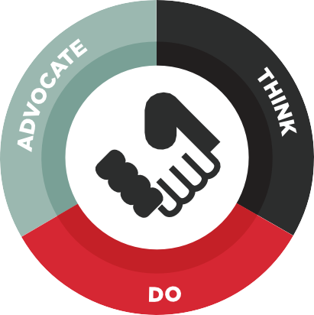Accelerating the delivery and impact of digital humanitarian assistance

THINK – Research and insights to unlock opportunities
- Positioning M4H as a thought leader informing the future of digital humanitarian assistance
- Driven by 4 learning agenda questions: 1) business case; 2) path to scale;
3) impact on end users and humanitarian organisations; and 4) enabling policy environment

DO – Our impact and projects on the ground
Innovation Fund Strategic partnerships
- Resilience building • Strengthening foundations
- Enhancing protection • Innovative new tech solutions
- Improving access to essential services • Innovative new partnerships
- Investing in technology • Growing the ecosystem

ADVOCATE – Removing barriers to help drive change
- Promote regulatory environments conducive to delivering humanitarian aid via mobile, through Capacity Building courses and in-country engagements
- Collaborate with M4H partners to develop Joint-Advocacy positions on addressing humanitarian challenges and deliver these at high-level fora

Advisory Group: M4H convenes an Advisory Group, of 20 key stakeholders of the programme (MNOs, humanitarian organisations and FCDO), twice per year. Advisory Group meetings include key updates of the programme, and provide opportunity for strategic discussion that is built upon with interested and relevant partners throughout the year. Most Advisory Group members have a sustained and direct bilateral engagement with the programme. Advisory Group meetings and bilateral discussions will continue to be used to identify collaboration opportunities for future impact under M4H’s next phase.

3 Principles will underpin the work of the Programme:

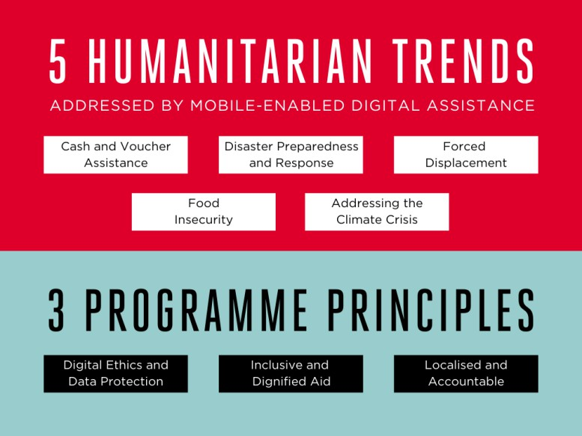

Digital Ethics, Privacy & Data Protection in Digital Humanitarianism: Within the acceleration of digitisation, the importance of ethical questions, such as control of the use of one’s personal data, are growing and considered as a crucial component of humanitarian programmes, garnering growing attention in past years. Ethical considerations and moral
principles that govern the design, development and deployment of digital technologies (and the data they use and generate), are becoming central to principled humanitarian action.
GSMA’s M4D has developed a Digital Ethics Landscaping Report that includes scoping, considerations, challenges, risks and opportunities for M4D programmes, including M4H. Central to this is the Ethical Considerations Canvas that can assist in guiding decision making that can be operationalised into M4H’s next phase: building evidence and best practice, and promoting application of ethical decision-making through public private partnership in humanitarian action. M4H will provide capacity support and thought leadership across the humanitarian and private sectors, supporting debates on how to safely and ethically deliver mobile-enabled solutions in humanitarian contexts, leveraging the GSMA’s expertise in data protection and privacy.

Inclusive and dignified humanitarian action: leaving no one behind:
While the fast-paced digitisation of humanitarian assistance provides many benefits, it also carries risks. Inability to access digital tools can lead to exclusion from basic services and vital information. In humanitarian contexts, as assistance is increasingly delivered through digital channels, it is imperative that marginalised communities are able to access them. This is important not only to ensure they are digitally included in a more general sense, but also so that they can access assistance in an expedient, dignified, and efficient way. Grand Bargain Commitment 6, a “Participation Revolution”, calls for humanitarian action to include people receiving aid in making the decisions which affect their lives.

M4H has built evidence and recommendations on responding to groups in humanitarian settings that have specific needs, including women, the elderly, persons with disabilities, and those who lack formal means of identification. For example, understanding the user-journey of cash recipients in humanitarian contexts, leads to inclusive humanitarian response. M4H advocates inclusive methods for working with marginalised populations that face intersecting barriers and is increasingly requested to share evidence and recommendations in this area of work. The programme will work with mobile operators and humanitarian partners to foster inclusive and dignified humanitarian action.
System reform through localised and accountable approaches: Localisation of aid is a commitment to make principled humanitarian action as local as possible and international as necessary, and is part of the Grand Bargain under Commitment 2 to provide “More support and funding tools to local and national responders”.

The M4H team has already made changes in its work, including updating its style guide to be more inclusive and working to remove language that reinforces biases and prejudices. M4H has increasingly identified local consultants and project partners to carry out project implementation, analysis and translation, and explores new ways to contribute to a reformed humanitarian system that breaks down structural racism, inequality, and supports a decolonised approach to aid. M4H has provided platforms where individuals affected by humanitarian crises have told their stories using the medium of their choice, controlling creative direction and narrative.

The programme will continue to promote digital humanitarian assistance as a tool to put power in the hands of communities affected by humanitarian crises. By engaging users themselves as partners in crafting new programming, mobile operators and humanitarian organisations will better understand these barriers and address them appropriately, increasing the sustainability of services. In addition to human-centred design and methodologies for inclusivity, M4H will explore how mobile and digital technologies can themselves address communication, participation, and feedback – leading to informed
changes in humanitarian action that are accountable to affected populations.

Describe any key changes to the original business case including the theory of change or new evidence from ongoing monitoring, evaluation or learning work?
The main changes to the original business case already detailed in this document are as follows:
- Shift from unproven models and unanswered questions on public-private sector partnerships in addressing humanitarian need TO further replicating and scaling success, evidence and learning to meet humanitarian need (Question 1: What’s the Project’s Purpose)
- Reframing five thematic focus areas of the programme as humanitarian trends to be address through mobile-enabled services (Question 2 and Question 3: What are the expected results?)
- Proposing a 6th output to the existing model, in the form of flexible response capacity
(Question 4: What is the approach to implementation?)
- Providing 3 principles that underline the work of the programme (Question 4)

Theory of change: The original Theory of Change remains relevant to the next phase of the programme. M4H will continue to collect evidence linked to the assumptions reflected in the theory of change below and any relevant updates. This work will enable the programme to provide a detailed picture of how closely the ultimate impact model of M4H reflects the original hypothesised model.

Mobile for Humanitarian Innovation
Theory of Change

xm people have improved access to and use of life-enhancing mobile enabled services during humanitarian and disaster preparedness, response and recovery
Monitoring & evaluation to asses programme impact and allow for continual learning and adaptive programming
Impact

Outcome statement: Increase mobile enabled innovation in humanitarian delivery to demonstrate and scale cost-effective improvements in humanitarian preparedness, response and recovery
Outcomes

New technological innovations
/ business models
Replications in other countries / regions, which are based on insights, innovations and business models
Changes in global and country policies /regulations gradually building a more enabling environment
Adoption of insights coming from the programme’s work

Catalyse partnerships between private sector and humanitarian organisations to develop new humanitarian services
Outputs

Catalyse innovation by providing seed and grant funding for mobile-based solutions
External influence and policy change through advocacy work and dissemination of learnings and insights



Delivery of a research, evidence and learning to develop an understanding of what works and unique insights on mobile enabled technology’s role to improve humanitarian response

Monitoring, Evaluation, and Learning
M4H has designed and implemented an ambitious monitoring, evaluation, and learning framework that ensures the programme collects, analyses and reflects on evidence related to its work. In the remaining year of the grant, the programme will ensure it has the strongest, most robust evidence base available that will be published in an end line report before March 2022. This evidence will enable the programme to continue to pursue the most effective and influential activities in the implementation of its next strategy, driving increased efficiency in securing impact. The MEL work will:
- Build out detailed indicator trackers for all the programme’s work that go beyond indicators agreed in the log frame. This will allow work to be monitored on an ongoing basis and provide quantitative articulations of success and progress of all elements of the team’s work.
- Evaluate the journey and impact of projects supported by the Innovation Fund and as strategic partners. This builds the evidence base on which technologies and business models can have impact on people affected by crisis and will help the team prioritise the projects to support in future.
- Collate and reflect on the work of M4H in specific countries and how this has galvanised the digital humanitarian ecosystem. This work helps to articulate the key outcomes the team has achieved outside of specific, ‘on-the-ground’ projects and can refine future approaches.

