Annual Review Template – from April 2021

Title: Mobile for Humanitarian Innovation (M4H)
Programme Value £ (full life): £31 million (£15.5m Phase 1, £15.5m Phase 2) |  | Review date: June 2022
Programme Code: 300446 | AMP start date: September 2017 | AMP end date:  March 2025

Summary of Programme Performance
Year | 2018 | 2019 | 2020 | 2021 | 2022 | 2023
Overall Output Score | A+ | A+ | A+ | A+ | A+
Risk Rating | Major | Major | Major | Major | Major

DevTracker Link to Business Case: | http://iati.dfid.gov.uk/iati_documents/33097787.odt
DevTracker Link to results framework: | Pending (recently updated)

A. SUMMARY AND OVERVIEW

Description of programme
The Mobile for Humanitarian Innovation (M4H) programme focusses on investing in innovation, catalysing partnerships, unlocking policy barriers and delivering original research that accelerates the delivery and impact of digital humanitarian action. M4H aims to reach ten million people with improved access to and use of life-enhancing mobile-enabled services during humanitarian preparedness, response and recovery by September 2023. The programme is working towards this goal by:

- Building a repository of unique insights on technology's role to improve humanitarian preparedness, response, and recovery;
- Convening the private sector and the humanitarian community to deliver digital humanitarian programmes and solutions in action, building evidence of what works;
- Providing catalytic funding to support innovative solutions to humanitarian challenges through the Mobile for Humanitarian Innovation Fund;
- Enabling the private sector, public sector and the humanitarian community to develop policy environments that improve the lives of those affected by humanitarian crises.

This model is applied across the following five focus areas: mobile financial services; mobile-enabled utilities; food security and climate change; gender and inclusivity; and digital identity.

Summary supporting narrative for the overall score in this review

The programme has exceeded all its annual outcome and output targets and has already exceeded its end date impact target having reached 9.9 million people to date (directly and indirectly) with improved access to and use of life-enhancing mobile services during humanitarian preparedness, response, and recovery.

Key achievements from this fifth year of the programme include:
- M4H Innovation Fund portfolio are reaching scale and replicating: Scaling of grantee projects (Mercy Corps, Lumkani and Sesame Workshop) have impacted almost 2.2 million people during the period. Innovators have adapted their solutions in light of new Covid realities, demonstrating the power of digital technology to address humanitarian challenges.
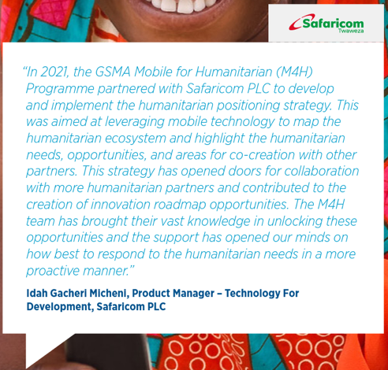
- Stronger business case emerging for MNO investment in digital humanitarian assistance: M4H has supported mobile network operators (MNOs) to develop business cases and positioning strategies to create and expand partnerships with humanitarian agencies e.g., Safaricom (Kenya), Telesom (Somaliland) and Econet (Burundi). This has resulted in MNOs designing and delivering sustainable and relevant products and solutions for humanitarian action, such as using Voice ID to verify receipt of humanitarian cash and voucher assistance by end users in Somaliland.

- Digitisation of humanitarian assistance is scaling: The M4H Connectivity Needs and Usage Assessment (CoNUA) toolkit enables humanitarian organisations to assess how people in humanitarian contexts access mobile technology as deployed in Niger, Sudan and Uganda. This enables humanitarian organisations to design effective, inclusive and large-scale digital humanitarian programming.

- Coordinated with partners in sudden onset emergency response efforts, including the Emergency Telecommunication Cluster (ETC), UNHCR, UN OCHA, and mobile operators for Tonga tsunami, Philippines typhoon Rai, Haiti earthquake, and the Ukraine crisis where GSMA facilitated direct cooperation between the mobile industry and humanitarian partners. Feedback from this Ukraine response included the following from UNHCR:

“I wanted to share with you some good news on our partnerships with MNOs in Poland, Romania, and Moldova. We have, thanks to you and GSMA who has proactively bridged the communication gap, been able to include, integrate and leverage the presence of MNOs in the UNHCR Emergency response coordination structure (RETS). Most operators have since then engaged with us, our partners, and the extended humanitarian community, shared critical information and data and allowed us to respond more efficiently by enable our business on the ground in border areas. We would appreciate if your support can be offered systematically during all emergency response operations led by UNHCR, MNOs are sensitive to the credibility that GSMA brings and ensure. Thank you once again for your support.”

Global IT Emergency Coordinator, UNHCR

- Emergency response policy frameworks are being developed with support from the programme: the programme engaged with policymakers to develop National Emergency Telecommunications Plans (e.g., Somaliland), building capacity to leverage the power of mobile in humanitarian preparedness, response, and recovery.

Major lessons and recommendations for the year ahead

Key lessons include:

- Qualitative and quantitative research on user perspectives and local humanitarian contexts drives more dignified and effective humanitarian programming and must be integrated in projects prior to design and implementation of digital humanitarian services and solutions.
- Mapping connectivity needs and usage in humanitarian contexts provides solid evidence for sustainable business models including future network expansion, service diversification and innovative humanitarian programming.
- Convening the private sector and the humanitarian community beyond single project-based initiatives has led to commercially sustainable and scalable humanitarian solutions, with MNOs integrating humanitarian solutions within their core business strategy, including three mobile operators (Safaricom, Telesom and Econet) developing humanitarian positioning strategies with M4H.

Key recommendations include:

- Update phase 1 logframe, reflecting overachievements of existing targets (August 2022)
- Review learnings and evidence from the past 5 years of M4H to develop the most impactful operationalisation plan for M4H 2.0, including:
  - Develop Learning Agenda for Phase 2 (February 2023)
  - Identify thematic focus of the next Innovation Fund round (July 2022) and fund launch within the 2022/2023 financial year
  - Conduct an ‘Endline’ study with the M4H MEL partner to document M4H’s impact and influence through the course of the current grant (October 2022)
  - Use Outcomes Assessment of Strategic Partnerships work to develop portfolio moving forward (October 2022)
  - Select Monitoring, Evaluation, and Learning partner for Phase 2 (October 2022)
  - Finalise sudden onset strategy including consultation with key partners (September 2022)
  - Implement integrated new way of working with GSMA Innovation Fund team, integrating evaluation recommendations and building on lessons learned to date (ongoing)
  - Increase engagement with FCDO advisers through engagement dialogues (ie: research focused discussion by end of 2022) and bilateral outreach/cooperation (ongoing)

- Focus on strategic programme delivery that has potential to influence sector and industry wide transformation, such as:
  - Connectivity Needs and Usage Assessment (CoNUA) toolkit: Publish and promote final toolkit with evidence from deployments; support widespread adoption to inform dignified and effective digital humanitarian action (September 2022).
  - Launch of flagship research: Publish and disseminate reports on User Perspectives on mobile phone usage in South Sudan, Papua New Guinea, and Lebanon to inform future programming by GSMA, its member operators, and the humanitarian sector (October 2022).
  - Developing sustainable public-private partnerships: Continue to convene the mobile industry with humanitarian partners to develop comprehensive collaboration that leads to long term partnership across a portfolio of solutions, including supporting an increasing number of mobile operators to develop dedicated humanitarian strategies (Ongoing).

B: THEORY OF CHANGE AND PROGRESS TOWARDS OUTCOMES

Summarise the programme’s theory of change, including any changes to outcome and impact indicators from the original business case.

By September 2023, the M4H programme aimed to impact at least 9.8 million people (directly and indirectly) with improved access to and use of life-enhancing mobile services during humanitarian preparedness, response, and recovery. M4H works to accelerate the delivery and impact of digital humanitarian assistance using the following five-part model:
- Build a learning agenda to inform the future of digital humanitarian response
- Catalyse partnerships and innovation on new digital humanitarian services
- Advocate for enabling policy environments
- Monitor and evaluate
- Disseminate insights and profile achievements

Within the review period, M4H updated its theory of change (Figure 2), to reflect how the team operates and lessons learned. It also demonstrates the forward looking potential based on impact to date demonstrating that digital solutions and public-private partnerships are impactful in addressing humanitarian challenges. The programme also conducted a thorough process review of the Innovation Fund, to inform future rounds under the programme’s next phase.

Revised M4H Theory of Change
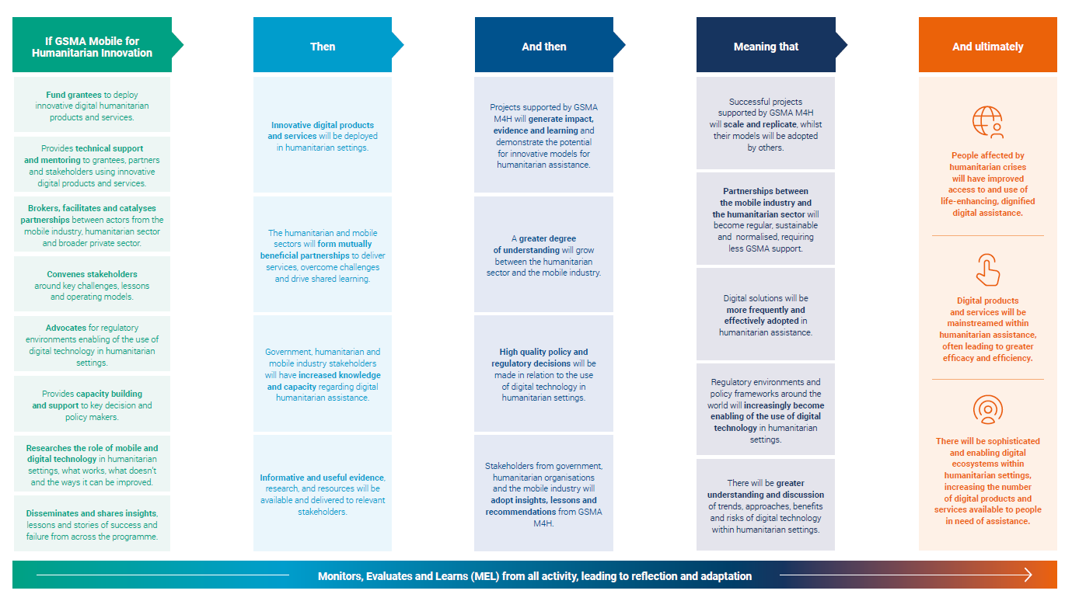

Figure 2. Mobile for Humanitarian programme Revised Theory of Change

M4H previously revised its Logframe targets (approved September 2021) from 7 million to 9.8 million recipients, to reflect overachievement of most targets and to align with activity timelines. This Logframe, updated with this year’s achievements, is available in Annex A.
Describe where the programme is on/off track to contribute to the expected outcomes and impact. What action is planned in the year ahead?

The M4H programme has met or exceeded its expected impact, outcome and output targets, reaching 9.9 million people to date, exceeding the June 2022 target by 1.2 million and the overall programme target due in September 2023 by 184k.

In the period under review, the M4H programme reached almost 1.7 million people with improved access to and use of mobile services in humanitarian contexts with Innovation Fund grantee investments accounting for approximately 1.3 million and the remaining 368k people being reached through strategic partnership projects.

Outcome Indicators
The programme has exceeded all outcome targets in the period. The programme’s key progress against outcome indicators is listed in Table 1, with full supporting evidence available in Annex B.

Outcome Indicator | Milestone target | Progress  (+ for the year) | Notes
Outcome 1: Number of cases where there is evidence that the programme insights have been used by programme stakeholders (cumulative) | 75 | 86 (+21)  Exceeded | - Significant citations of M4H insights by multilateral organisations, including UNCDF and the World Bank. Continued increase in citations from humanitarian organisations.
Outcome 2: Number of new technological innovations or business models supported through the programme (cumulative) | 30 | 33 (+5)  Exceeded | - Supported five new technological innovations or business models: i) a Remote SGBV Training using IVR tech ii) Smart water meter ii) Land degradation assessment & reseeding using drone tech iv) Remote community mobile enabled feedback (Ushahidi) and v) Cross network Voice ID verification
Outcome 3: Number of services (including technological innovations and business models) supported by the programme that are replicated in other countries / regions (cumulative) | 12 | 13 (+4)  Exceeded | - British Red Cross innovation replicated in Ethiopia and Lebanon  - Sesame Workshop innovation replicated in Turkey  - Maternal Health Messaging replicated in Burundi with Pathfinder and Econet (replicating previous work with Alight Rwanda)  - Agent network digital and financial literacy in Eswatini with Grameen Foundation, MTN, Eswatini Mobile and Digi Image (local Fintech) replicating previous projects with Grameen Uganda and MTN
Outcome 4: Number of cases where there is evidence that the programme has influenced policy makers, regulators and international influential bodies (e.g. WEF, UN etc.) (Cumulative) | 10 | 11 (+2)  Exceeded | - Engaged with Government of Somaliland (Ministry of ICT) to develop country’s first National Emergency Telecommunications Plan (NETP) to streamline coordination and engagement across government, humanitarian agencies, service providers & communities during crisis.  - Engaged and supported Norwegian Refugee Council (NRC) with the deployment of Connectivity Needs and Usage Assessment toolkit in Sudan , using M4H Strategic Partnerships report to structure their digitization agenda in Sudan

Digital Access and Barriers in Displacement-affected Communities in White Nile, Sudan

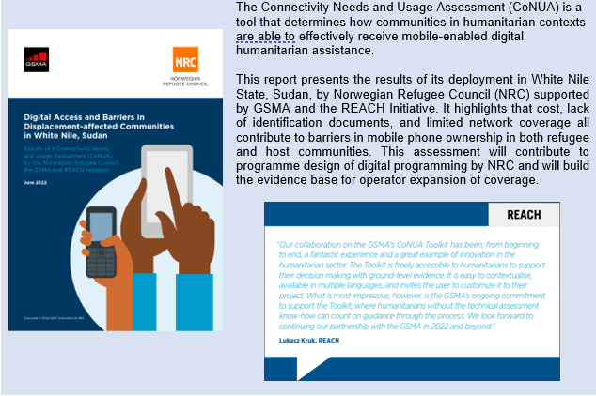

Justify whether the programme should continue, based on its own merits and in the context of the wider portfolio

The M4H programmes continues to represent significant value for money. Some key elements of this are as follows:

- Impact and scale: Revised impact target already exceeded within the current budget envelope with 9.9 million people reached with improved access to and use of digital humanitarian services. Innovation Fund grantee projects and Strategic Partnership projects are already demonstrating that replication/scaling is feasible.
- Innovation Fund: To date, grantees have leveraged £2.6m grant funding to secure an additional £9m in follow-on funding (excluding grant-match funding) to support continued delivery and scale. MNO roadmaps are currently in place with four grantees pursuing MNO partnerships.
- Research and Policy: The programme is demonstrating influence through its thought leadership, unique insights and data collation. M4H is contributing to impactful policy change and building the evidence base for effective digital humanitarian action.

C. DETAILED OUTPUT SCORING

Output Title | Private sector and humanitarian organisations actively engage with GSMA M4H to implement programme activities.
Output number: |  | 1 | Output Score: | A+
Impact weighting (%): |  | 50% | Weighting revised since last AR? | No

Indicator(s) | Milestone(s) for this review | Progress  (+ for the year)
1.1 Number of cases where the programme has engaged with programme stakeholders (excluding policy makers) to improve humanitarian delivery (cumulative) | 44 | 53 (+15)  Exceeded
1.2 Number of cases with evidence of partnerships established between programme stakeholders (MNOs, humanitarian organisations, donors, non-governmental organisations, private sector) to improve humanitarian delivery as a result of M4H (cumulative) | 28 | 33 (+6)  Exceeded
1.3 Number of cases where the programme has engaged with policy/regulatory/international influential bodies to improve humanitarian delivery (cumulative) | 22 | 26 (+6)  Exceeded

Briefly describe the output and provide supporting narrative for the score.
Output 1 refers to M4H activities with programme stakeholders to improve humanitarian delivery and the operationalisation of these engagements through the establishment of partnerships between humanitarian organisations, donors, MNOs, and the wider private sector. Engagement with all programme stakeholders continued to flourish, exceeding all indicators under Output 1.

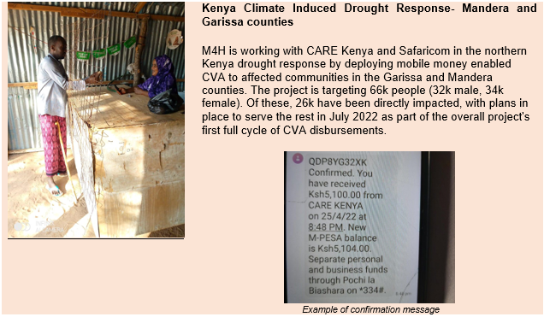
1.1 Number of cases where the programme has engaged with programme stakeholders (excluding policy makers) to improve humanitarian delivery (cumulative)
The M4H programme exceeded its target under this indicator, reporting 22 new engagements with senior officials of various stakeholders to improve humanitarian delivery over the past year, reaching a cumulative 60 engagements.

Emergency response – Typhoon Rai, Philippines
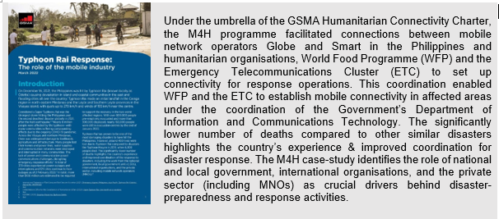

1.2 Number of cases with evidence of partnerships established between programme stakeholders (MNOs, humanitarian organisations, donors, NGOs, private sector) to improve humanitarian delivery (cumulative)
During the past year, M4H facilitated 6 new partnerships, adding to a cumulative total of 31 partnerships, delivering 37 projects, engaging 30 humanitarian organisations, 17 MNOs and 5 fintech companies across 9 countries. The programme’s portfolio of 37 projects has so far impacted the lives of almost 769k people with improved access to and use of digital humanitarian solutions and services.

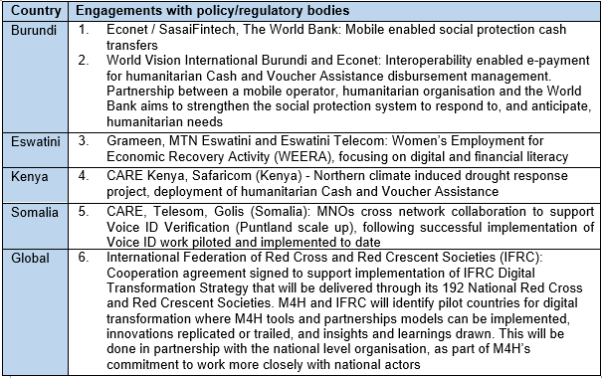
1.3 Number of cases where the programme has engaged with policy/regulatory/international influential bodies to improve humanitarian delivery (cumulative)
The M4H programme exceeded its target under this indicator, with 6 new cases of engagement with policy/regulatory bodies during the reporting period adding up to 26 (cumulative).

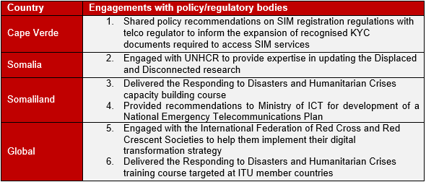

The “Responding to Disasters and Humanitarian Crises” training course was delivered 4 times and trained 55 participants from countries including Angola, Bangladesh, Democratic Republic of Congo, Egypt, Ghana, Haiti, Indonesia, Iran, Japan, Latvia, Nepal, Rwanda, Somaliland, and Switzerland.

Below is a Somalia/ Somaliland actor and engagement map to show partnerships facilitated by the M4H programme between 2020 to 2022:
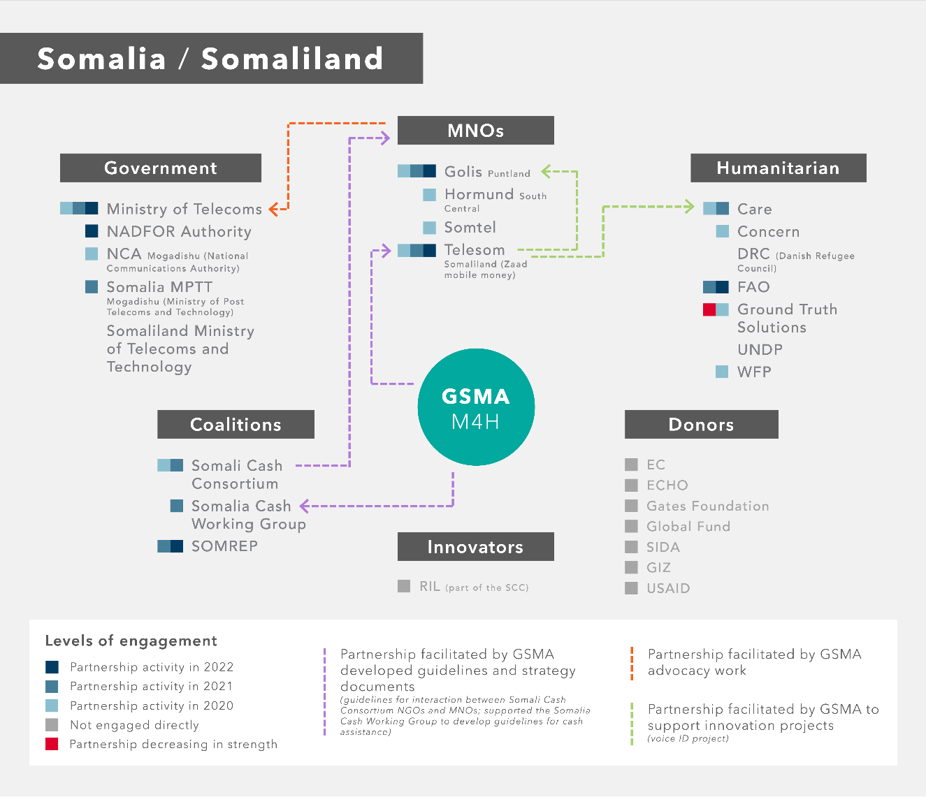
Additional details on the above programme engagements are included in Annex B.

Assess the value for money of this output compared to the proposition in the Business Case, based on performance over the past year
The activities under Output 1 continue to represent good value for money as seen by the following examples:

            - Impact and scale: Expanding partnerships and supporting projects to scale and replication have increased M4H’s reach and impact.
            - Deepening partnerships: By building on established partnerships and developing new ones, M4H has targeted collaboration where it can have maximum impact (e.g., through its MoU with IFRC)
            - Influencing the system: through policy influence of governments in developing NET plans, and engagement with Cash Working Groups, M4H has shifted the debate on the role and use of mobile-enable digital technology.

Describe any changes to this output, and any planned changes as a result of this review.
During the year under review, the programme has increased its targets against all three output indicators as indicated in the updated logframe.

Progress on recommendations from the previous AR (if completed), lessons learned this year and recommendations for the year ahead

Recommendation YR4 | Progress
The programme should continue to explore partnership models with Cash Working Groups (CWG) to support the smooth transition to digital CVA by working with the CALP Network to conduct CWG mapping. [December 2021] | Ongoing:  - The programme has transitioned multiple mobile enabled CVA projects from pilot phases to full scale in Uganda, Kenya, Somalia and will continue to replicate these in other markets  - The programme has engaged with the CALP Network and presented to Cash Working groups
Focus on climate change, resilience and sustainability by adapting disaster risk reduction efforts to incorporate climate risk engaging local partnerships to better understand vulnerabilities and improve resilience; recognising climate as a cross-cutting issue that drives humanitarian need; and reflecting these through our publications and communications. [March 2022/ongoing] | Completed:  - Published The Climate Crisis: Mobile-enabled solutions in humanitarian emergencies which outlines five use cases in which mobile technology plays a critical role in addressing the climate challenge in humanitarian contexts  - The programme is scaling up its climate resilience projects in Kenya for a further 2 years due to the initial success of the project  - The programme has joined the FCDO funded Risk-Informed Early Action Partnership (REAP) to further strengthen its engagement and influence in the growing space of anticipatory and early action - addressing the humanitarian challenge of climate change

Lessons Learned this year:
- M4H has the track record and credibility to expand and deepen partnerships with private sector and humanitarian organizations

Recommendations for the year ahead:
- Continue to develop partnerships with FCDO and Humanitarian Cash Working Groups
- Engage regularly with the FCDO funded REAP to add value through GSMA’s expertise - deepening networks in this rapidly growing space and contributing to the success of the next M4H Innovation Fund round

Output Title | Technological innovations and business models selected and funded by the Innovation Fund
Output number: |  | 2 | Output Score: |  | A
Impact weighting (%): |  | 30% | Weighting revised since last AR? |  | No
Indicator(s) |  |  |  | Milestone(s) for this review |  | Progress
2.1 Number of applications received through Innovation Fund rounds (cumulative) (disaggregated by geography) |  |  |  | N/A |  | N/A  Exceeded Jun 21 (695)
2.2 Number of grantees of the Innovation Fund (disaggregated by geography) (cumulative) |  |  |  | N/A |  | N/A  Exceeded Jun 21 (28)

Briefly describe the output and provide supporting narrative for the score.
All Output 2 targets had been exceeded in the previous reporting periods.

All remaining Round 3 grantees will complete implementation by the end of 2022. Completed grantees are continuing to report post-grant impact (up to 18 months after grant close out), contributing to the overall programme impact figure. In the year ahead, with the launch of M4H’s next phase under a new grant, the next round of the Innovation Fund will be developed and launched, with grantees expected to begin implementation in mid-2023.

Assess the value for money (VfM) of this output compared to the proposition in the Business Case, based on performance over the past year
Impact and scale: In this reporting period, Innovation Fund (Round 2 & 3) grantees contributed approximately 1.3 million people having improved access to and use of digital humanitarian services and solutions. These grants continue to demonstrate that replication/scaling is feasible, as evidenced by grantees British Red Cross whose 121 Digital Cash Aid Program (replicated in Ethiopia where it is integrated with HelloCash and Lebanon where it is not integrated directly with a Financial Service Provider) and Sesame Workshop’s The Trusted Messenger Model (replicated in Turkey through partnership agreed with Turkcell to share content on the HelloHope App) directly building on models developed through GSMA partnership and funding.

Describe any changes to this output, and any planned changes as a result of this review.
No changes were undertaken against this output in the year under review.

Progress on recommendations from the previous AR (if completed), lessons learned this year and recommendations for the year ahead
Recommendation | Progress
The M4H programme will continue efforts to engage with other Innovation Funds and their portfolios to maximise lesson sharing, efficiency and impact. In the coming year the programme will expand its current circle of organisations (Grand Challenges, HIF, WFP), and find the most appropriate way of formalising relationships to ensure they are sustained. [Ongoing] | Ongoing:  - Convenings with these innovation funders continued, expanded and supported by the working group on the State of the Humanitarian Industry report on Innovation. Discussions with other funders including Danish Relief Alliance and the Disaster and Emergencies Preparedness Programme were facilitated through this process. These efforts should be sustained.  - M4H continued role as a mentor for the WFP Innovation Accelerator programme leveraging M4H expertise to support innovators funded by WFP, as well as profiling our own knowledge, resources and grantees.
The M4H programme will build grantee level and portfolio wide Monitoring, Evaluation and Learning. [Ongoing] | Ongoing:  - M&E activities have been conducted at both the individual grantee level, as well as at the portfolio level to synthesis lessons and insights. A revised Theory of Change (see Section B) has strengthened visibility of the Innovation Fund and its intended outcomes.
The M4H programme will undertake an evaluation to assess the M4H Innovation Fund design and operations to understand what is working well and what could be improved. This will provide key lessons and actionable recommendations to support programming and processes for future IF rounds. It will also aim to optimise the Fund’s contribution to broader M4H and M4D strategy as well as the wider humanitarian innovation sector. [March 2022] | Completed:  - M4H commissioned Triple Line consulting to conduct a full process evaluation of the Innovation Fund. A few recommendations for future rounds of funding were put forward by the consultant. The team has already actioned a number of these and will consider others in the planning for future rounds.
The M4H team will continue to consolidate lessons from across the portfolio, demonstrating where successes and challenges have helped answer the programme’s key learning agenda questions, particularly the role of the private sector and what sustainable business and/or services models in the humanitarian sector could look like. [March 2022] | Ongoing:  - M4H continues to do this in a number of ways. In the latest review period, the team worked on a systematic review of evidence from Round 2. This complements previous work on Round 1 and SP projects, consolidating lessons learned across the portfolio. A review of Round 3 will be undertaken in the next period  - The team continues to produce case studies highlighting key outcomes and lessons from completed innovation fund grant projects – with Round 2 case studies set to be published in the coming months
The M4H programme will launch a curriculum (developed FY20/21) for innovators using mobile technology to enhance humanitarian service delivery. The curriculum combines existing and new resources, tools and training materials on key processes in the innovation journey, with a focus on mobile innovation in humanitarian contexts. The curriculum will strengthen the ability of M4H to offer remote capacity building support to grantees past, present and future, as well as M4H stakeholders, such as Grand Challenges, Elrha’s Humanitarian Innovation Fund and WFP Accelerator, and serve as a valuable resource for the sector. [March 2022] | Ongoing:  - The curriculum, renamed the M4H Innovation Fund playbook, has been completed. Its contents will be used to support future grantees, as well as being leveraged to build capacity during the application stage. The content remains highly valuable, and can be utilised by the M4H Innovation Fund team, and the broader programme going forward. It will also be shared with stakeholders.

Lessons Learned this year:
- Some activities have continued to suffer given the barriers that remain to face to face engagement, and virtual meeting fatigue
- Undertaking an intervention logic exercise and assessing the M4H Innovation Fund objectives against the GSMA parameters will strengthen the approach to future rounds of funding

Recommendations for the year ahead:
- Review and implement appropriate recommendations arising from the independent process evaluation
- Continue to expand engagement with internal teams, FCDO and other humanitarian innovation funders to understand and identify opportunities to make the funding process more streamlined, effective, and impactful
Output Title | Research, insights and learning generated and disseminated to stakeholders by the programme
Output number: |  | 3 | Output Score: | A+
Impact weighting (%): |  | 20% | Weighting revised since last AR? | No

Indicator(s) | Milestone(s) for this review | Progress
3.1 – Usage: number of publications downloaded from the GSMA M4D website and physically distributed (content relevant to the partnership) (cumulative) | 65,000 | 65,449 (+11,595)  Exceeded
3.2 –Thought leadership: publications which demonstrate new insight including reports, and case studies (cumulative) | 52 | 53 (+5)  Exceeded
3.3 – Events: number of convenings with at least 3 different types of stakeholders and whose purpose is to disseminate learnings (cumulative) | 125 | 133 (+18)  Exceeded

Briefly describe the output and provide supporting narrative for the score.
Output 3 refers to the research, insights and learning generated by M4H and the programme’s level of success in disseminating these widely to stakeholders. Overall, the programme exceeded all milestones.

3.1 – Usage: number of publications downloaded from the GSMA M4D website and physically distributed (content relevant to the partnership) (cumulative)
Reports and case studies by the M4H programme were downloaded 11,595 times during the year under review, adding to a cumulative total of 65,449, exceeding the Year 5 target of 65,000. The top 3 downloaded reports include:
- A monitoring, evaluation and learning framework for humanitarian innovation programmes
- The Connectivity Needs and Usage Assessment (CoNUA)
- Digital lives of refugees: How displaced populations use mobile phones and what gets in the way

3.2 – Thought leadership: publications which demonstrate new insight including reports, blog posts, and case studies (cumulative)
The M4H programme published 5 thought leadership pieces, exceeding its target with a cumulative of 53 reports against a target of 52. Highlight reports published this year included “The Climate crisis: Mobile-enabled solutions in humanitarian emergencies”, The programme also published a policy-focused guide on National Emergency Telecommunication plans

The Climate Crisis: Mobile-enabled solutions in humanitarian emergencies
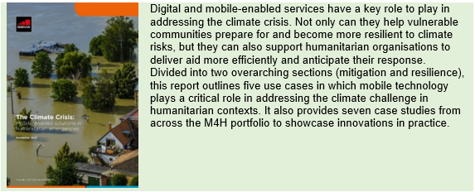

National Emergency Telecommunications Plans: Enablers and Safeguards – A brief evaluation guide for policy practitioners

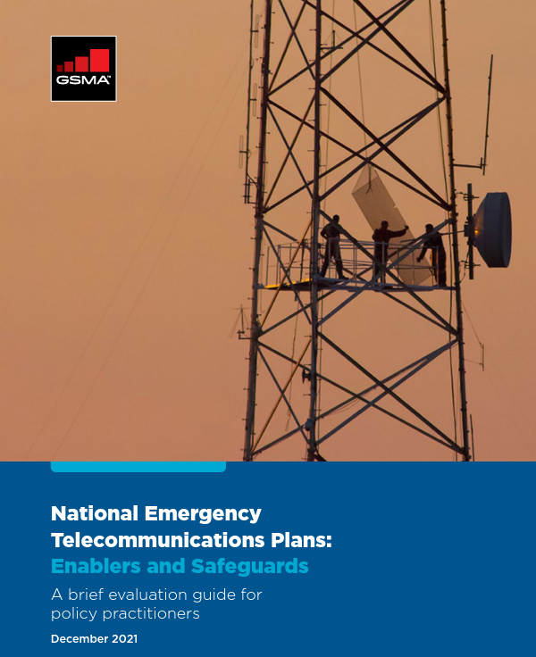 | M4H has developed a brief evaluation guide to assist national authorities, regulators and policymakers make a rapid assessment of mobile-enabled National Emergency Telecommunications Plans (NETPs) to ensure:  - mobile services are adequately provisioned during emergencies;  - nationwide operability and interoperability are achieved; and  - responders and regulators have a unified vision that allows informational services to be coordinated.  Based on this expertise, M4H is actively advising governments on development of their country NETPs.

The programme also produced numerous blogs to support dissemination of specific reports, or position M4H by highlighting key learnings from important convenings and events.

3.3 – Events: number of convenings with at least 3 different types of stakeholders and whose purpose is to disseminate learnings (cumulative)

M4H continued to convene and engage with humanitarian partners and the mobile industry to share learnings to contribute to the shift towards digital solutions. Key workshops, conferences and sector events included Nethope & RightsCon and partner events with ALNAP, the Danish Refugee Council, ITU, WFP, UNDP and UNHCR. The team engaged with academia, think tanks such as ODI and IIED and various networks, including CGAP, the CALP Network, Centre for Financial Inclusion, Financial Inclusion Forum, Smart Communities Coalition and the Dignified Storytelling Alliance. M4H briefed Cash Working Groups in Ethiopia, Burkina Faso, Central African Republic, Burundi, Uganda and the Global Cash Working Group (GCWG). M4H also participated in a Digitharium Digital Dilemmas debate, “Connectivity as Aid”, hosted by the ICRC. Full details included in Annex B

Assess the value for money of this output compared to the proposition in the Business Case, based on performance over the past year
See section E for VfM results

Describe any changes this output, and any planned changes as a result of this review.
The three output indicator targets have increased since the last reporting period as per M4H Revised logframe (September 2021).

Progress on recommendations from the previous AR (if completed), lessons learned this year and recommendations for the year ahead

Recommendation | Progress
To provide a holistic understanding of the impact of mobile technology on people in humanitarian contexts, the programme should scope End User research to generate data on people’s experiences of accessing and using mobile technology, including the benefits, challenges and risks of using mobile-enabled services. Such research should seek to explore new trends related to mobile access and use in humanitarian contexts, including the impact of COVID-19; misinformation, disinformation and hate speech; and the ever-increasing threats related to climate change. [March 2022] | Ongoing:  In September 2021, M4H kicked off its mixed methods end user research in partnership with UNHCR focused on three humanitarian contexts i) Papua New Guinea (with West Papuan refugees in Iowara), ii) South Sudan (with internally displaced peoples in Bor), and iii) Lebanon (with Syrian refugees in Tripoli and Akkar). Since the start of 2022, M4H has been working with local researchers to conduct a range of qualitative data collection activities i.e., digital day diaries, in-depth interviews and focus group discussions. Initial key findings from the qualitative research were published. The research will further explore user perspectives, behaviours and usage in a quantitative survey, with full findings published in October 2022.

Lessons Learned this year:
- The programme continues to have most impact through larger pieces of thought leadership and sustained and focused marketing and dissemination
- Engagement and dissemination through targeted outreach and convening based on programme expertise is critical for maximizing influence

Recommendations for the year ahead:
- Continue to monitor the rapidly changing external environment through ongoing landscaping and engagement with key stakeholders to be able to respond to and influence the sector
- Launch a research theme on connectivity in crisis which can build evidence on key barriers to connectivity in different types of humanitarian contexts and develop robust recommendations on expanding coverage through innovative approaches to infrastructure and financing
- Deepen research on the theme of increasing inclusion in mobile-enabled solutions with an output on risk communication and anticipatory action
D: RISK [½ to 1 page]

Overview of risk management

Overall, the risk of the FCDO-funded GSMA Foundation Mobile for Humanitarian Innovation programme remains Major due to the operating environments where M4H is focused and the new realities faced by COVID-19.

- While the team has continued to deliver remotely during the pandemic through reliance on relationships developed pre-COVID, virtual fatigue has started to impact engagement. Ability to meet with partners in person will be crucial to move successfully into the next phase of the programme.
- Limitations of the team to meet with partners and visit humanitarian contexts due to travel security poses risks to delivery of future programme targets. Mitigation is currently being reviewed internally.
In its sixth year of operation, the following key risks could impact the ongoing delivery against M4H’s planned timeframe (full risk matrix in Annex D):

Risks & Description | Probability  (H, M, L) | Impact (H, M, L) | Mitigating Actions
There are limitations to the ability of GSMA and its staff to engage directly in sanctioned or high-risk markets. | H ↑ | H - | The programme is mitigating this risk by cooperating with locally based implementing partners where required
COVID-19 restrictions continue to impact implementation of innovation fund grantees, strategic partnerships, fieldwork for research projects and dissemination of programme messages. | H ↑ | M - | The programme is mitigating these by working with partners, leveraging previous experience to share insights and joint messages, and adapting its activity plan to virtual engagements

E: PROGRAMME MANAGEMENT: DELIVERY, COMMERCIAL & FINANCIAL PERFORMANCE [1 - 1 ½ pages]

Summarise the performance of partners and FCDO, notably on commercial and financial issues, and including consideration of value for money measures of economy and efficiency.

Delivery against planned timeframe
Compared to the original business case, original Logframe and original budget, the programme remains on track. This annual report is the report concluding the fifth year of implementation for the programme and:

- All output indicators (operator engagement, innovation fund and insights generation / dissemination) have been exceeded
- All outcome indicators have been exceeded
- The programme has already exceeded the June 2022 impact target of 8.8 million beneficiaries as well as programme target of 9.8 million beneficiaries (direct and indirect)

Summary of performance

GSMA: The GSMA has continued to prove themselves as an industry leader at the nexus of digital and development with a unique offering; close links to mobile network operators and other private sector stakeholders, the ability to be a convener between private sector and development partners, and exceptional technical expertise across a broad range of thematic areas.

The FCDO continues to find the partnership to be honest, open and based on mutually agreed impact aims despite the residual challenges of COVID-19 and subsequent budget uncertainty. The GSMA have continued to respond in a timely fashion to all requests and demonstrated extraordinary flexibility in their ability to absorb additional funding in-year (e.g. ASEAN, non-ODA) to drive engagement with FCDO colleagues around the world. Indeed, their continued excellent results show how effective and critical mobile-enabled services can be to the delivery of essential services to low-income groups.

M4H specific: The M4H grant continues to exceed expectations, including already overachieving on its total programme impact number (itself having been increased previously). Facing a continuingly challenging external environment (in which the demand for digital humanitarian expertise is increasing), the team has worked diligently and effectively to support the ecosystem in both strategic and emergency response scenarios. This includes providing instrumental support to UNHCR and the Emergency Telecommunications Cluster regarding events in Ukraine.

The overall performance of the programme and team has been very strong as it continues to build a solid evidence basis for digital humanitarianism. It continues to receive positive feedback and engagement from key stakeholders; including the programme’s Advisory Group and FCDO Humanitarian HoP, alongside strong results through the Innovation Fund, evidenced through the unlocking of £9m capital. The programme clearly justifies its expenditure and A+ scoring for this year.

Value for Money considerations (Economy, Efficiency, Effectiveness & Equity)

The overall performance of the programme continues to provide better value for money than the original business case had assumed with the programme continuing to exceed its initial targets, as outlined in section B.

 | VfM Measures | Relevant examples
Economy | Procurement: The GSMA is governed by the GSMA Procurement Policy covering all purchasing process, whether as purchasers. Robust procurement process is in place, which are consistent with international good practice.  Human resources: The GSMA has strict policies in terms of recruitment, remuneration (based on set market benchmarks) and performance appraisal. In addition, staff are generally recruited in the market / close to the market of programme focus.  Travel: Booked in advance and at the cost of economy fare only. The hotel and subsistence rates meet GSMA’s strict travel policy guidelines to ensure value for money. | - M4H managed the procurement process for 5 research contracts in the year under review. In total, the programme was able to ensure good value for money through competitive sourcing and negotiate additional savings of £50k.  - Low travel and low physical events after lifting of Covid restrictions (Feb 22 onwards) marked the reporting period.
Efficiency | Input maximisation: cross-collaboration between M4D programmes to mutualise inputs (suppliers, travels, processes, monitoring and evaluation) and maximise output impact (joint research and joint advocacy)  Collaboration with other FCDO Humanitarian programmes and grants  FCDO Profiling: GSMA M4H activities have been able to leverage GSMA flagship events (MWC 22) and high-level platforms to profile the programme outputs  Monitoring and evaluation: constant improvement of services based on user feedback, business intelligence and monitoring and evaluation feedback.  Strengthened due diligence to mitigate risks that sub-grantees of the Innovation Fund could misuse funds  Efficient stakeholder management in response to crisis and emergencies. | - To maximise content synergies, reduce collaboration complexity and save budget, the M4H programme has partnered with other M4D programmes to produce relevant content – including Mobile Money (non-FCDO-funded), Digital Utilities and the Central Insight Unit (CIU). GSMA also supports the outcomes of M4H by funding policy activities.  - Collaboration with Grand Challenges i.e., co-convened Innovation Fund grantee workshop on operating in complex environments  - GSMA has developed a risk assessment framework to analyse country risks and align the sub-grant pre award due diligence and monitoring processes with the risk.  - M4H’s capacity to mobilise and activate the necessary support of MNOs for coordinated and effective preparedness and response to crisis and emergencies for Typhon Rai in the Philippines and Ukraine. (See section 2)
Effectiveness | Achievement and overachievements of all targets as set in the agreed Logframe  Crowding-in by start-ups and the amount initially invested in the M4H grantees | - M4H has exceeded all its targets for the period under review.  - Has now reached £9m in crowd-in funding, demonstrating a high level of effectiveness of the grantees’ portfolio
Equity | The M4H programme has user perspective and human centred design at the core of M4H programming | - M4H research grounded in ensuring inclusion of affected communities to ensure digital humanitarian assistance is safe and dignified e.g. user perspective research with displaced communities in Papua New Guinea, South Sudan and Lebanon.

Monitoring activities through the review period

Qualitative and targeted monitoring, evaluation and learning (MEL) continues to be a cornerstone of the M4H programme, ensuring that the work is informed by evidence on what is working and why. In the period under review, nine live innovation fund grantees and nine projects delivered through strategic partnership received tailored support on evaluation and active learning. As part of this work, the team has published four case studies highlighting lessons and outcomes from projects: Flowminder, Nokia, REFUNITE and Voice-ID. The Voice ID solution was shown to be cost-effective and accurate for humanitarian partner CARE, whilst maintaining commercial potential for operator, Telesom. The impact is included in the diagrams below.

Impact of Voice-ID solution on users

Through a partnership convened by the programme, CARE International and Telesom developed and deployed an innovative ‘Voice ID’ solution that utilises a user’s voice response (IVR) technology as verification for cash and voucher assistance (CVA). The evaluation showed the following project outcomes:
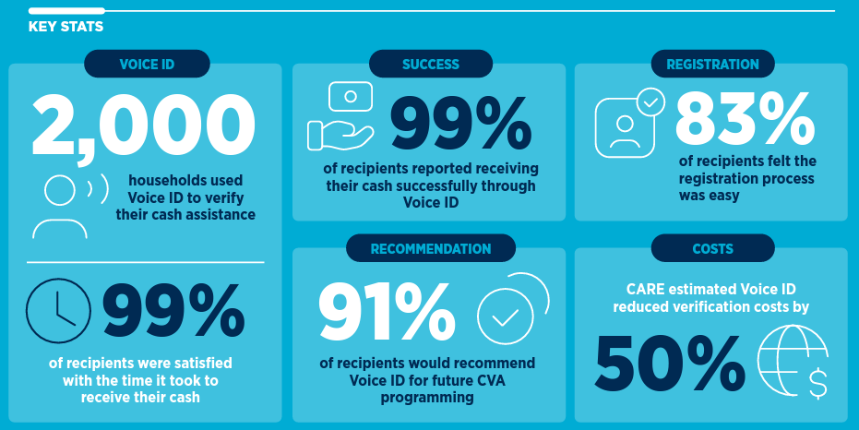

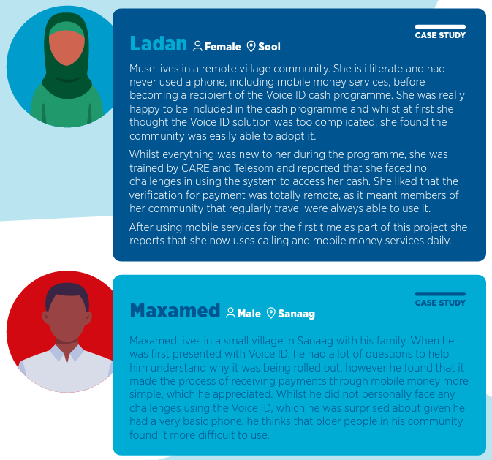

The programme intends to share similar case studies for all Round 2 grantees in the next period. Additionally, in the past few years the M4H team has worked with consultants to implement systematic reviews of evidence generated by supported projects. In the reporting period a new review of all evidence linked to the second round of the Innovation Fund was conducted, with outputs expected to be shared in the next period. All MEL activities in this review period contribute to strategic design of M4H’a programming such as the M4H 2.0 proposal, future innovation funding rounds and partnership projects.

M4H also continued to work on programmatic MEL. During the review period, M4H worked with their external MEL partner to analyse the results from numerous ecosystem reviews. The visuals below provide a mapping of outcomes by country against the 6Rs and highlight of GSMA’s value addition to the ecosystem. It aims to highlight the components where the M4H programme is making the most influence and contributions for each country between 2020 and 2022. M4H will use these learnings to inform programme strategies to magnify the programme’s impact and extend its influence with new stakeholders.

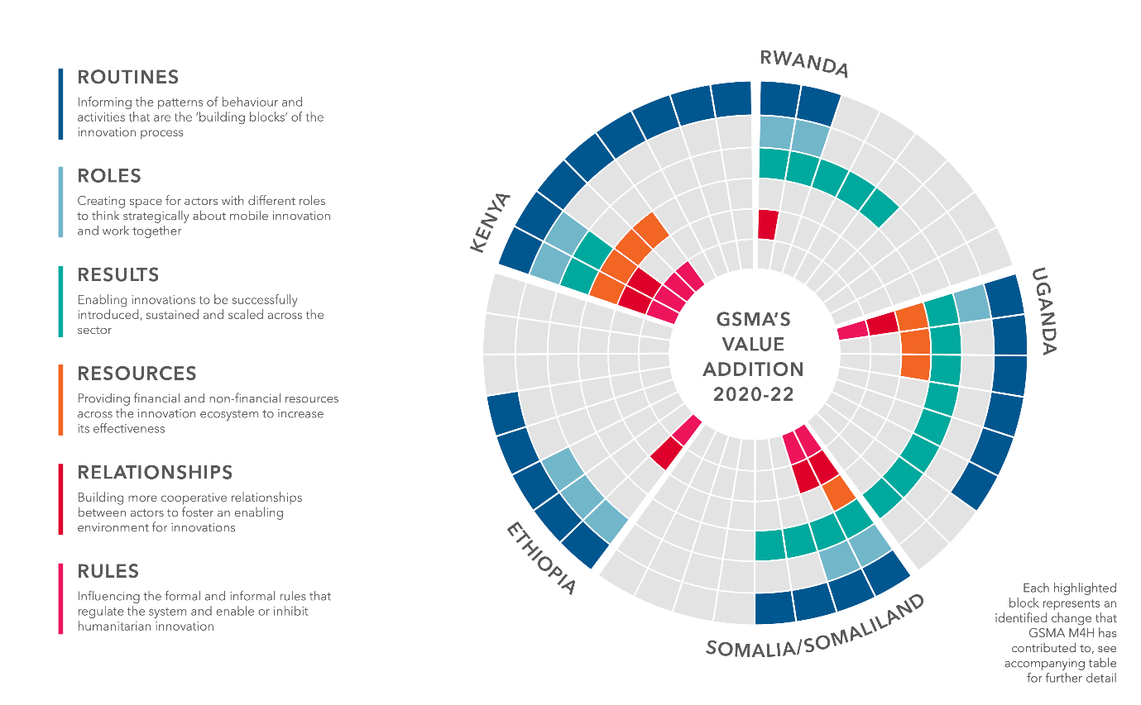

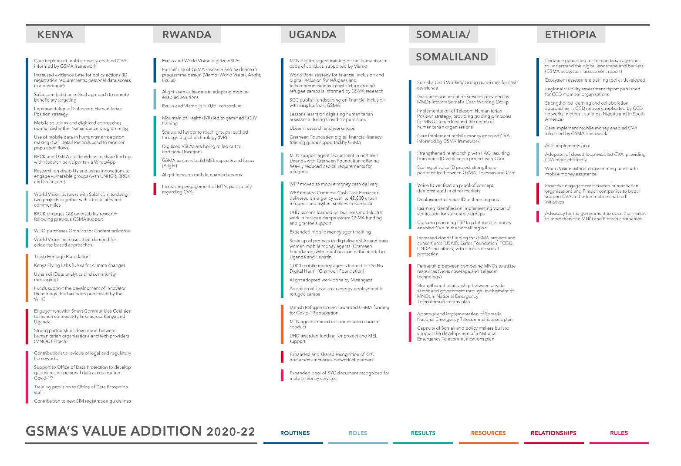

Date of last narrative financial report | May 2022
Date of last audited annual statement | May 2022

ANNEXES TO BE INCLUDED WITH ANNUAL REPORT

- M4H Logframe June 2022
- M4H Logframe Evidence
- M4H Financial Report
- M4H Full risk matrix
- Downstream partner mapping
- Asset register

Based on M4H Round 1 and Round 2 Innovation Fund grantee projects scale
All figures under Output 3 are cumulative and include numbers achieved from the Strategic Partnership’s Disaster Response Programme, as agreed in the original logframe.
Consultants review all documentation, internal and published, as well as interview grantee representatives and GSMA staff to triangulate lessons and trends of interest to GSMA and the broader sector.

