Annual Review 2025

Title: UK-INDIA Partnership on National Investment and Infrastructure Fund - Green Growth Equity Fund
Programme Value £ (full life): £130m (£120m FT + £10m TA) |  | Review date: 11 October 2025
Programme Code : [AMP ID – 300418] | AMP start date: 26/09/2018 | AMP end date: 31/07/2029

Summary of Programme Performance

Year | 2019/20 | 2021 | 2021/22 | 2022/23 | 2023/24 | 2024/25 | 2025/26
Overall Output Score | A | A | A+ | A+ | A | A | A+
Risk Rating | Major | Major | Major | Moderate | Moderate | Moderate | Moderate

DevTracker Link to Business Case: | Business Case
DevTracker Link to results framework: | Log frame
A. SUMMARY AND OVERVIEW
Description of programme

The UK India Green Growth Equity Fund (GGEF) programme was established following a commitment between the UK and India in April 2017 to promote climate-focused investments and mobilise institutional capital. The Fund supports UK Government climate priorities through a modern partnership model and contributes to economic growth in both countries. GGEF consists of two key components, as outlined below

1. Development Capital Component of £120 million invested into GGEF:
The UK (through FCDO) and India (through National Investment and Infrastructure Fund (NIIF)) anchored the GGEF with a capital contribution of £120 million. GGEF is structured as a private equity fund to invest in green growth sectors of India such as renewable energy, energy distribution/transmission, clean transportation, water treatment and management – and to raise additional capital into the fund, and into its companies. The investments are expected to contribute to sustainable development goals (SDGs) including SDG 7 Affordable and Clean Energy, SDG 13 Climate Action, SDG 9 Industry, Innovation and Infrastructure, SDG 17 Partnerships for the Goals, as well as the mobilisation of finance while delivering financial returns to the UK taxpayer. After a competitive international procurement exercise, Eversource Capital was appointed as the Fund Manager of GGEF in April 2018. GGEF’s size stands at 560m, exceeding its target of 500m as it attracted more institutional capital from 2018 to 202

The intended UK growth links include strengthening of the City of London’s position as a partner of choice for financing Indian infrastructure, opportunities for UK investors to enter or expand their portfolio in India and for UK firms to compete to provide goods and services to the projects the fund invests in; and returns to the UK’s investment in the Fund.

The programme contributes to the UK’s climate commitment under the International Climate Finance (ICF). Programme interventions directly support Indian government’s climate goals and commitments made in international climate negotiations to reduce CO2 emissions intensity and increase the share of Non-Fossil Fuel in electricity as set out in Nationally Determined Contribution (NDC).

2. Technical Assistance (TA) Component of £10 million

The TA component was developed to address policy and inclusion linkages related to green growth sectors of India. This intervention has helped address a few market failures in green growth investments in India. This has also helped improve the investment ecosystem & inclusion linkages, and strengthen Environmental, Social and Governance (ESG) standards of green investments in India (please refer to previous annual reviews for details).

Although spending on this component is paused, the intended objectives are being pursued through multiple channels: a) collaboration with HMG teams on climate policy in India, b) engagement with the Government of India and industry associations, and c) guidance through the Environmental, Social & Business Integrity (ES & BI) panel, which includes representatives from HMG and other key investors such as NIIF, the Green Climate Fund (GCF)

GGEF also aligns with UK India Vision 2035, the Country Business Plan and supports delivery of UK’s priority on Climate and Growth.

About changes to UK ODA

At this time of profound change, with conflicts overseas undermining security and prosperity, the UK Prime Minister has taken the difficult decision to increase spending on defence to 2.5% of GDP from 2027, funded by reducing the UK’s Official Development Assistance (ODA) and reinvesting it into defence. The ODA budget will be gradually reduced to the equivalent of 0.3% of GNI by 2027, to help smooth the transition.

The UK remains fully committed to playing a globally significant role in humanitarian aid and development. The transition to spending 0.3% of GNI on ODA will require significant shifts, building on those already underway as the government implements its modernised approach to development, which centres on establishing long-term partnerships based on mutual interests and respect.

ODA allocations and the impact on programmes are being worked through based on various factors, including impact assessments. We will be taking a rigorous approach to ensure all ODA delivers value for money and maximises the impact of our work to best support the people it benefits, including those in humanitarian crises.

We remain committed to spending 0.7% of GNI on ODA when the fiscal circumstances allow.

Summary supporting narrative for the overall score in this review

This is the seventh annual review of the programme. In the current review period, the GGEF programme has scored ‘A+’ based on the progress against the log frame milestones and indicators.

The Green Growth Equity Fund (GGEF) was established to showcase the commercial potential of climate-focused sectors and to catalyse private sector investment - not just into the fund itself, but into the broader ecosystem it supports. While it has successfully attracted institutional capital into the Fund during the previous review periods, GGEF is now beginning to generate systemic impact in select sectors by acting as a first mover. Its rapid growth is encouraging more players to enter these industries, although growth capital is still largely sourced from development finance institutions (DFIs). A notable milestone was the successful exit from one of its portfolio companies during the review period, reinforcing the fund’s commercial viability and the ability to attract commercial investors.

Performance and Additionality
With approximately 4.5 years remaining in its term, GGEF has nearly deployed its entire corpus across portfolio companies and is now seeking external capital to support their next growth phase. Currently, four portfolio companies are collectively raising around £250 million - primarily from Development Finance Institutions (DFI)s. This is partly because these companies were incubated by the fund and had no prior operations. As a result, they require more time to scale to levels attractive to commercial investors. Encouragingly, commercial investors have begun showing interest and are expected to support future growth while providing exit opportunities for GGEF and its stakeholders, including HMG.

Two companies in the circularity sector—focused on waste-to-energy and water treatment—are facing challenges due to technology risks and the nascent frameworks (e.g. standardised contracts, payment guarantees). Despite this, these ventures have created valuable infrastructure, such as India’s largest biogas plant in Indore and a sewage treatment facility in Kolkata, which will serve as foundational models for future projects in the sector.

Exits
In early 2025, GGEF successfully exited Ayana, a renewable energy company incubated by British International Investment (BII, the UK government’s DFI). GGEF helped Ayana scale to over 4 GW of operational capacity with a robust future pipeline, delivering strong financial returns to shareholders, including HMG. With 4.5 years left in its term, the fund is well-positioned to exit all remaining investments while achieving both developmental and financial outcomes.

Policy Influence
GGEF has played an active role in shaping policy through strategic partnerships. Notably, it co-authored India’s carbon market roadmap with CRISIL, influenced ESG standards via national platforms, and supported regulatory advancements in emerging sectors like e-mobility and waste-to-energy. GGEF actively contributed to industry forums and panels, demonstrating thought leadership and influencing climate policy. In recognition of these efforts, the Fund received the 'Impact Initiative of the Year – Asia, 2024' award at the Environmental Finance Impact Awards.

Outcomes
GGEF’s portfolio has set industry benchmarks and attracted new entrants in many sectors including e-mobility green financing and smart-meters. Quantitatively, the fund has delivered notable results:
- 13.4 million tonnes of GHG emissions avoided
- 156 million+ lives positively impacted
- 15,572 jobs created
- 6.6 million tonnes of waste processed
- 89,000+ green loans disbursed
- 442 million+ electric miles powered

ESG, Gender & Inclusion
GGEF integrates ESG and gender inclusion as core strategic priorities. In FY25:
- 48% of beneficiaries were women
- 31% female leadership at the fund level
- Up to 45% female workforce representation in portfolio companies
These results stem from sustained efforts over the past two years to mainstream gender and ESG practices, including tailored SMART Gender Action Plans. Through strong ESG frameworks, digital tracking tools, and stakeholder engagement, GGEF ensures transparency and measurable impact.

Major lessons and recommendations for the year ahead

Lessons:

- A supportive ecosystem—comprising enabling policies and regulatory frameworks—is crucial for the success of emerging climate sectors, as demonstrated in e-mobility, renewable energy, and green finance.
- Technology-related risks remain a significant challenge for nascent climate-focused industries.
- Integrating ESG principles from the outset helps companies progress from basic compliance to sector leadership.
- Blended finance models and patient capital are essential for scaling early-stage green enterprises.
- Engaging local communities in infrastructure projects enhances both operational efficiency and social impact.
- Advancing gender inclusion requires customised, sector-specific strategies and infrastructure support.
- Digital ESG platforms and tailored methodologies improve data accuracy and impact measurement.
- Strategic exits, such as Ayana’s help to validate the potential of scalable, ESG-aligned business models.

Recommendations:

- Collaborate with the Fund Manager to draft a note on policy measures that can support the growth of the waste-to-energy sector, and coordinate with xHMG teams to help establish a conducive regulatory environment. Continue engaging with HMG stakeholders during the Fund’s growth phase to support policy enablers and attract private sector buyers for exits.
- Collaborate closely with the Fund Manager to design and implement exit strategies for portfolio companies.
- Continue to institutionalise gender and diversity, equity, and inclusion (DEI) strategies across all portfolio companies, building on the Gender SMART framework.
- Enhance ESG data systems and strengthen Net-Zero preparedness through sector-specific methodologies and targeted capacity-building initiatives.
- Maintain engagement with the Government of India to showcase achievements and advocate for policy reforms that support GGEF’s focus sectors.
- Collaborate with the Department for Business and Trade (DBT) to identify and develop UK-India growth opportunities.
- Strengthen partnerships with industry associations, investors, and stakeholders to foster mutual learning and share insights at industry events, enhancing visibility and sector-wide impact
Progress on recommendations from previous AR:

Recommendation | Progress
Continue to work with DBT colleagues during the high growth phase of the portfolio companies to derive secondary benefits wherever possible. | Team is continuously engaging with colleagues across team and DHCs
Work with the Government of India on the progress of GGEF and the achievements of its portfolio companies. Work with the Communication team accordingly. | GGEF regularly features in joint statements including the 13th UK India Economic and Financial Dialogue. UK in India Communication team has highlighted the Fund’s important milestones through its handles.
Apply learning of the programme particularly on two aspects a) internal controls: governance, risk mechanism and working with Politically Exposed Persons b) mobilisation of capital at the fund and investee levels, to the development capital programmes being operationalised | The learnings of this programme are fed into the design of new programmes including Pioneering Climate investment in India and Investment in Green Enterprises
Feed in portfolio learning to relevant policy teams on climate, climate finance, and energy transition team at post and in the UK | The learnings from India Development Capital portfolio including the GGEF is disseminated through multiple Climate contact groups and forums in HMG and industry forums and events
Undertake a review of the policies and governance mechanisms since the various portfolio companies have entered a new phase of dynamic growth | A third-party review was conducted and the recommendations were implemented  ESG risks are reviewed by dedicated ES & BI (Environmental, Social & Business Integrity) panel comprising key investors and integrated into operations and investment decisions.  Structured internal audits and risk assessments are conducted regularly.  Financial review concluded recently
Continue to build on the good progress made on gender diversity and inclusion, especially at the leadership positions and in the frontline workforce of the portfolio companies. Conduct a study in collaboration with the Fund Manager to devise innovative mechanism to improve gender diversity in these sectors | Completed – Details can be seen in the summary section and output 4 of the AR

B: THEORY OF CHANGE AND PROGRESS TOWARDS OUTCOMES [1-2 pages]

Summarise the programme’s theory of change, including any changes to outcome and impact indicators from the original business case. [1/2 page]

There has been no change in the Theory of Change since September 2023

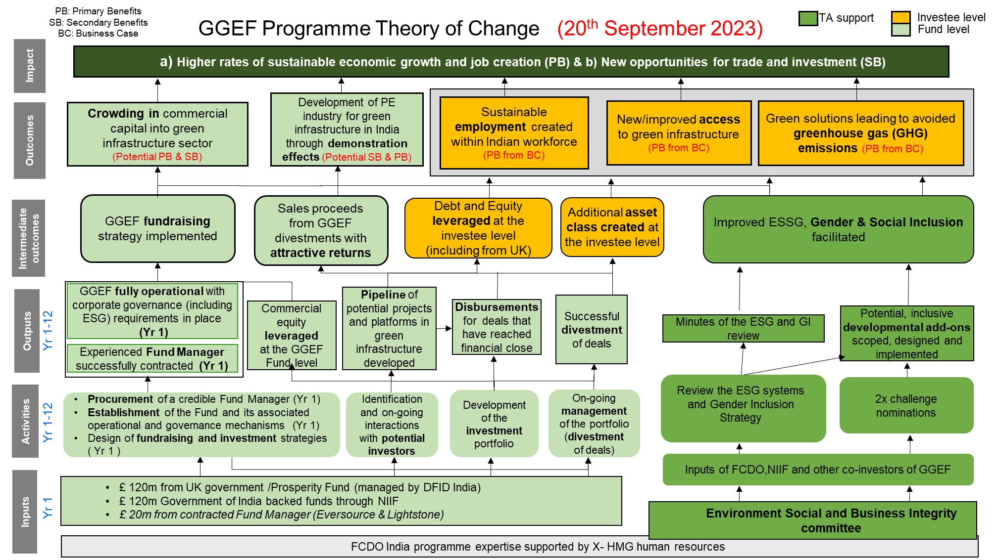

Describe where the programme is on/off track to contribute to the expected outcomes and impact. What action is planned in the year ahead?

The programme’s Theory of Change remains consistent, focusing on mobilising private capital into under-invested green sectors to catalyse India’s green infrastructure and services. It aims to build scalable, commercially viable platforms that deliver measurable environmental and social impact. No changes have been made to the outcome or impact indicators from the original business case.

Progress is on track, with over £560 million mobilised, making GGEF India’s largest climate fund. Four of the seven portfolio companies are now among the largest players in their respective sectors, demonstrating GGEF’s ability to build scalable, commercially viable platforms. GGEF has seeded a new generation of climate funds in India. Alumni from the fund have moved into leadership roles across emerging green investment platforms, shaping the next wave of sustainable finance. The UK-India partnership model has inspired similar collaborations with Japan and the US, further amplifying GGEF’s impact. Further, the Fund is attracting new entrants in the sector that it operates in, as the portfolio companies continue to expand (details in the later sections)

ICF KPI | Milestone | Achieved (As on June 30, 2025)
ICF KPI 12 - Private Debt and Equity mobilised at the investee level | INR 80,000m (£685m) | INR 107,900 Mn (~£916 Mn) as of Feb 2025
ICF KPI 5 -Number of direct jobs created | 15000 | 15,572
ICF KPI 6 - Net change in greenhouse gas emissions (GHG) in tonnes of (tCO2e) ~reduced or avoided | 11m tCO2 | 13.42 mm tCO2
ICF KPI 7 – Clean Energy (Installed Capacity) | 2300 MW | 2446 MW

Justify whether the programme should continue, based on its own merits and in the context of the wider portfolio

GGEF aligns with UK India Vision 2035, the Country Business Plan and supports delivery of UK’s priority on Climate and Growth

The programme has invested almost all the investible corpus, achieved a successful exit from Ayana with commercial returns, and demonstrated sector leadership in ESG integration, innovation, and inclusive growth. Its model of strategic capital, operational support, and impact-driven governance makes a compelling case for continuation and expansion.

GGEF has already begun generating commercial returns which was noted in the 13th UK India Economic and Financial Dialogue. GGEF regularly features in the UK-India bilateral statements since its inception. The Fund has helped strengthen G2G partnership as it has strong alignment with the Government of India’s objectives by advancing clean energy, circularity, and inclusive green finance. The Gender strategy and DEI(Diversity, Equality and Inclusion) initiatives reflect India’s push for gender mainstreaming in emerging sectors, while investments in e-mobility, bio-CNG, and smart water infrastructure directly contribute to India’s priorities like Swachh Bharat, (Clean India) and Skill India

The programme has also contributed to the UK Growth alongside its core climate and developmental goals. The Fund has attracted ~£65 million of UK private capital into commercially viable green sectors in India and is likely to provide more opportunities for the UK private sector in the future. During the review period, the Fund Manager has operationalised a smart-metering business in partnership with a UK institutional investor on the back of experience in managing GGEF. The programme has also helped in attracting UK technologies into green sectors in India – notably in the waste management and water treatment

The programme also contributes to HMG’s International Climate Finance (ICF) KPI targets (refer to previous section). GGEF’s portfolio has delivered measurable environmental and social outcomes—avoiding over 13 million tonnes of GHG emissions, benefiting 156 million people, and creating 15,572 direct jobs. Companies have scaled responsibly across clean energy, e-mobility, waste, water, and green finance, with ESG deeply embedded in operations.

C. DETAILED OUTPUT SCORING

Output 1 and 2 were achieved before the review period and hence are not reported here.

Output Title | Fund develops and manages a portfolio of investments
Output number: |  | 3 | Output Score: | A+
Impact weighting (%): |  | 75% | Weighting revised since last AR? | Yes

Indicator(s) | Milestone(s) for this review | Progress
Commitments to investees | Milestone removed during the review period | The commitment amount is not expected to change materially as the investment period of the fund has ended.
Disbursements for investments | INR 42,000 m (~£380m) | Exceeded expectations:  Approximately INR 46,200 Mn (~£410 Mn) has been disbursed
Exits | Nil | Exceeded expectations:  GGEF has exited from one of its portfolio companies – Ayana during the review period 5 years ahead of the end of fund term

Briefly describe the output’s activities and provide supporting narrative for the score.

Till the last review period, the Fund largely deployed its own capital. With its internal capital largely exhausted during the current review period, the Fund concentrated on scaling its portfolio companies by securing external investments, including from Commercial and Development Finance Institutions (DFIs). Notably, the Fund has achieved diversification across climate sectors—allocating roughly one-third each to renewable energy, e-mobility, and circularity (including waste and water recycling)—as well as across geographies, with operations spanning 16 of India’s 28 states (refer Annexure 3). A detailed list of portfolio companies and their descriptions is provided in Annexure I. These companies operate in nascent to mature sectors and have made substantial contributions to the climate sector, as illustrated in the chart below. Except for Ayana, the Fund has either launched new companies that disrupt established players in mature industries like renewable energy, or ventured into emerging sectors, taking a pioneering role.

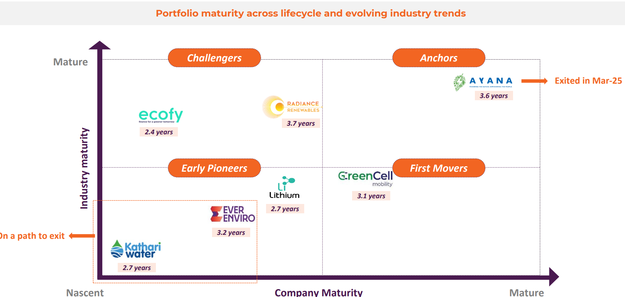

Key Portfolio Developments:

Ayana Renewable Power (utility scale renewable energy)
Ayana, classified as an anchor company in the chart, was successfully exited during the review period. This exit replaced capital from HMG and other investors with private sector funding, aligning with the Fund’s original business case. Over the next few years, four additional companies from the “Challengers” and “First Movers” categories are expected to transition into “Anchors,” thereby attracting more private capital.

Radiance Renewable Energy (Distributed Generation renewable energy)
Operating in the distributed generation (DG) solar sector, Radiance supplies clean energy to commercial and industrial clients. Despite facing supply chain and land acquisition challenges, recent policy changes—such as reduced taxes and increased domestic panel production—are expected to support its projected expansion from ~600 MW to 2.2 GW within 18 months. Although the industry was more developed than sectors like e-mobility, waste, and water, Radiance has shown that emerging players can successfully challenge established ones, fostering healthy competition and encouraging participation of new players in the sector.

Greencell Mobility (e-bus operations)
GreenCell has benefited from favourable government policies promoting electric buses, including payment guarantees through standardised contracts. It also runs private bus services, which saw significant growth during the review period. With 1,200 e-buses currently in operation, the company is poised to scale to over 3,000 buses in the next 18 months. Greencell has emerged as a first mover in a nascent sector, paving the way for private players to enter the space. Moreover, its active role in shaping the e-bus policy framework, particularly through collaborations with the UK government and NITI Aayog during earlier review period, has not only benefited the entire industry but also positioned Greencell as a sector leader

Lithium Urban Technologies (e-cab operations)
The company faced technology risks and supplier dependency issues, with frequent breakdowns due to India’s hot climatic conditions. These problems are being addressed, and the company is expected to benefit from strong sectoral demand from the corporates who want to reduce the carbon footprint while transporting their employees. If Lithium succeeds in solving the operational issues in the coming years, it will pave way for more companies to enter this sector.

Ecofy Finance (Green Finance)
One of the few green finance platforms targeting retail and MSME customers, Ecofy offers ESG-integrated digital lending for green assets. Its rapid growth is driven by rising demand in the e-vehicle and solar rooftop segments. Over the past year, the company has doubled the size of its portfolio and successfully offloaded a portion of its loan book to investors. This move has unlocked capital, enabling the company to issue new loans. The practice of transferring loans to investors is known as securitisation—a common method used to attract capital from a broad base of investors who prefer low-risk, seasoned loans. Notably, Ecofy has recently completed India’s first securitisation deal in the rooftop solar sector.

EverEnviro Resource Management (Waste Management)
This company converts waste into energy and recyclable materials. Its operations faced setbacks due to technological mismatches—imported equipment from Europe and the UK proved incompatible with the nature of Indian waste. However, the company has leveraged these experiences to adapt its approach to local conditions, resulting in the creation of foundational assets that could support future ventures in the sector. Compared to e-mobility and renewable energy, the enabling ecosystem for this industry remains underdeveloped and will require more time to mature. The combination of technological uncertainty and a nascent enabling framework continues to pose challenges for both this company and the broader waste-to-energy sector.

Kathari (Water treatment)
Like the waste-to-energy sector, the water industry requires more time to develop a supportive policy framework. Kathari has invested in a single asset—a sewage treatment plant under India’s flagship Namami Gange initiative—and has not pursued further expansion in recent years due to limited internal capital and the early-stage nature of the sector’s enabling environment. Nonetheless, the company successfully operationalised this project during the review period, laying the groundwork for future developments in the space.
Recognition and Impact
The portfolio companies have received multiple awards and pioneered several industry-first initiatives, detailed in Annexure II.

Describe any changes to this output during the past year, and any planned changes as a result of this review.

An exit indicator was introduced this year as the Fund concluded its investment phase. Since the investment period has just ended, no specific milestones were set for the year, with the first exit originally anticipated in 2026. The Fund is expected to execute one exit annually over the next two years, followed by four additional exits during the final 2.5 years of its term.

Progress on recommendations from the previous AR (if completed), lessons learned this year and recommendations for the year ahead.

Please refer to the summary section.

Output 4 |  | ESG processes and inclusion of the Fund Manager and portfolio companies strengthened.
Output number |  |  | 4 | Output Score: |  | A+
Impact weighting |  |  | 25% | Weighting revised since last AR? |  | Yes
ESG process strengthened, and the number of critical incidents reduced. | ESG process updated and implemented across 100% of the portfolio entities.  Critical incidents within the portfolio companies’ control to be reduced by 25% (ultimate goal is to reduce to zero through effective systems and processes in place] |  |  |  | Exceeded expectations  Systematic strengthening of ESG processes and a 40% improvement in the number of incidents (against huge increase in the scale of operations), indicating that progress on the indicator has exceeded the expectations  The investors (through ES & BI panel) have initiated an independent evaluation of ESG Management System implementation both within GGEF and its portfolio entities aiming to enhance best practices and continuous improvement of ESG processes. Serious incidents are jointly investigated, and learnings are shared across the portfolio
Improved gender ratio in the employees of the Fund and Portfolio companies | The proportion of female employees maintained at Fund Level at around 45-50%  The proportion of female employees increased to 20% in the portfolio companies. |  |  |  | Met expectations.  Fund Level: ~48%  Portfolio Companies Level: 22%
Portfolio entities improve the livelihood of people in the project sites | 2 programmes targeting community development at project sites completed |  |  |  | Exceeded expectations  6 programmes – 1 each by Ayana, Radiance, EverEnviro Green cell, Kathari Water & Ecofy completed skill development and other training at the project sites benefitting over 49 million people.

GGEF’s portfolio companies are driving systemic change in ESG processes and frameworks, particularly in emerging sectors where established standards are lacking. By setting benchmarks in e-mobility, waste, and water, GGEF is creating a reference point for new entrants to follow.

In the current reporting year, GGEF significantly strengthened ESG processes across its portfolio. All companies now operate with tailored ESG Management Systems, supported by over 70 ESG professionals. The use of digital tools that enable real-time tracking of over 180 Key Performance Indicators (KPI)s, contributing to improved compliance and transparency. As a result, the number of critical incidents reduced, and safety performance improved, with over 96 million safe man-hours and 450,000+ training hours recorded.

Companies like GreenCell, Lithium, and EverEnviro conduct route risk assessments and document every incident to avoid recurrence. There is a strong emphasis on incident-led learning, predictive driver training, and real-time monitoring to reduce accidents and equipment damage.

Gender inclusion saw marked progress. Women now represent 48% of GGEF’s workforce (against 28% in 2022), with portfolio companies averaging 22% female representation in corporate teams (against 12% in 2022). Radiance’s Drishta initiative empowered 75 rural women through skill-building and income enhancement, while GreenCell Mobility onboarded transgender employees and developed inclusive HR strategies including the SMART gender action plan. Outlined below are some well-thought interventions that have brought about the change-
- Inclusive Hiring Practices both at the fund and investee levels
- Developing safe infrastructure for women employees
- Introduction of inclusive policies
- Training and development of both men and women including leadership development programmes.
These focused interventions began with Electric Vehicle Sector. The fund plans to roll it out in other sectors in due course.

Livelihoods at project sites were positively impacted through targeted community programmes. TERI and IPCA-led assessments helped GreenCell and EverEnviro align services with local needs, while Kathari and EverEnviro supported municipal systems and waste workers through behavioural change and operational training. These efforts reflect GGEF’s commitment to inclusive, data-driven sustainability.

Describe any changes to this output during the past year, and any planned changes as a result of this review.

No changes to the output

Progress on recommendations from the previous AR (if completed), lessons learned this year and recommendations for the year ahead

Please refer to the Summary section

D: VALUE FOR MONEY (

Key cost drivers and performance

The programme offers strong value for money by efficiently deploying its capital, achieving its £500 million mobilisation target, and maintaining a declining management fee structure aligned with fund maturity. It has delivered high impact, including 13.42 million tonnes of CO₂ emissions avoided, 156.6 million people benefiting from clean energy access, and over 15,000 direct jobs created. The fund has leveraged private capital effectively, achieving a 3x investment-level multiplier and catalysing further climate finance in India. ESG systems are deeply embedded across portfolio companies, with real-time tracking of over 180 KPIs. Gender inclusion has also advanced, with nearly 48% female representation at the fund level and a 51.6% increase across portfolio companies, aligning with FCDO’s value-for-money principles. The assessment of the VfM indicators against the expectations in the business case is provided below.
Indicators (as per the Business Case) | Status
Economy Indicators
Fund Manager management fee | As anchor investors, FCDO and NIIF negotiated a value-for-money management fee at fund inception. The fee is now reducing as the fund has completed its investment phase and is preparing for exits, in line with the legal agreement.
Time Taken to raise funds to the target level | £500m target achieved; final close completed during investment period
Efficiency Indicators
Time taken to invest in first direct investment / Pace of deployment and exit of Capital | Nearly full corpus deployed; exits on track within fund term
Effectiveness Indicators
- Private equity multiplier – fund level 1x; investment level 3x  - UK Private equity multiplier  - Volume of public finance mobilised for climate change purposes due to funding (ICF indicator)  - Volume of private finance mobilised for climate change purposes because of funding (ICF indicator)  - Return on equity multiple – target 1.9  - IRR of investments and of the overall fund  - Number of people with improved access to clean energy as a result of programme (ICF indicator)  - Cost per kWh of installed capacity of clean energy as a result of investment  - Number of direct jobs created as a result of investments (ICF indicator)  - Cost per tonne of CO2 equivalent avoided emissions as a result of investment  - Per cent of the sub-fund portfolio value in India’s poorest states/areas | The Fund has prioritised additionality in investments, establishing focused investment platforms. Higher than expected investments were made in emerging sectors such as e-mobility and waste-to-energy emphasising the catalytic nature of HMG and NIIF capital.  In addition, GGEF has also started contributing to the investment ecosystem as it pulls in new companies into climate through its demonstration effect as explained in earlier sections. The Fund is also contributing significantly to policy framework in the sectors that it operates in thereby paving way for maturity of these sectors  156.6 million cumulative beneficiaries  15,572 jobs created in FY25
Equity Indicators
- Proportion of women employed.  - Proportion of women reached through the products/services | Gender inclusion is a key focus area, with women representing 48% of employees at the fund level and 22% across portfolio companies, as reported in Output 4. These achievements reflect the programme’s commitment to both financial effectiveness and social impact, ensuring that value for money is delivered in line with FCDO’s principles.

Assessment of whether the programme continues to represent value for money

GGEF has continued to demonstrate coming together of two governments on an important agenda of climate change and with their capital have set up platforms which have been successful in attracting equity and debt funding. The programme has also contributed to the ICF KPIs during the review period.
As envisaged, the programme has also started contributing to the climate investment ecosystem in India with few financial institutions launching climate focussed funds as GGEF has demonstrated the market potential of the emerging climate sectors and developed a talent pool.
GGEF continues to represent strong value for money, leveraging public capital from the UK and India to attract significant private investment. The programme has exceeded key output targets, including GHG emissions avoided, jobs created, and clean energy capacity installed, while maintaining robust ESG standards and a declining management fee structure.

The fund’s commitment to gender and inclusion, with 48% women at the fund level and 22% in portfolio companies, further demonstrates its holistic approach to value creation. These achievements, combined with rigorous risk management and independent oversight, confirm that the programme continues to deliver strong value for money for both governments and the wider climate investment ecosystem.

E: RISK

Overview of risk management

The overall risk of the programme remains Moderate.

The programme is progressing well toward its intended goals, particularly in generating systemic impact and continuing to attract capital into its focus sectors. While the extent of systemic change varies depending on the maturity of the enabling environment, the Fund is largely succeeding in positioning first movers in emerging sectors and challenging incumbents in more established ones. The risk is currently assessed as moderate but would be monitored continuously.

Risk category | Risk description | Residual Risk | Mitigation Strategy
Context/Strategy | External shocks (such as: COVID-19 pandemic, abrupt policy changes and geopolitical risks) leading to reduced demand for green infrastructure and services in India | Moderate | - Regular monitoring to take timely corrective action helping to minimise potential impact
Public Service Delivery & Operations | Delays in exiting investments or failure to achieve expected financial returns—due to factors like market volatility or weak management—could reduce profitability and hinder the demonstration of commercial viability. | Moderate | - Conduct regular reviews of market conditions and portfolio performance to identify exit opportunities early.  - Strengthen governance and operational support for investee companies to improve management efficiency.  - Develop clear exit plans during the investment stage, with flexibility to adapt to changing market conditions.  - Maintain close engagement with the Fund Manager to monitor progress and address challenges proactively.  - Use Advisory and LPAC meetings to assess exit readiness and align on timelines and strategies.
Financial & Fiduciary | Risk of misuse of funds, corruption, and financial leakage during project construction and operations | Moderate | - Risk management systems are regularly updated to align with evolving business conditions.  - Fund Manager's operating procedures are clearly defined in the agreements.  - Thorough due diligence is conducted on projects and promoters before investing.  - Audits, including independent ones by IAD, are conducted as per agreement terms.  - Procedures and controls are reinforced during reviews and monitored periodically.
Policy & Programme Delivery | The absence of adequate strategic focus on downstream investments poses increased risks to both financial performance and their potential to deliver meaningful development outcomes. | Moderate | - To manage risks related to limited strategic focus on downstream investments, the programme team conducts periodic site visits and engages directly with downstream investees.  - The Fund Manager provides regular performance updates in a structured format. While these measures help maintain oversight, direct engagement with downstream entities remains limited due to resource constraints
Safeguarding | In the absence of strong due diligence, monitoring and reporting there is a risk that programmes may unintentionally cause negative environmental or social impacts. | Minor | - The programme focuses on green sectors like renewable energy and water/waste management to ensure environmentally friendly investments.  - Robust ESG due diligence is conducted for each project before committing funds.  - Dedicated ESG officers are placed in all active platform companies to manage environmental and social risks throughout the project lifecycle.  - Any incidents are reported within 24 hours, and ESG compliance is tracked through quarterly and annual reports.  - Monthly ES & BI panel meetings, comprising experts from all investors, monitor ESG performance and advise on emerging issues.  - An independent third party conducts a Due Diligence assessment focused on any one or all of the five core areas of Due Diligence

F: PROGRAMME MANAGEMENT: DELIVERY, COMMERCIAL & FINANCIAL PERFORMANCE

Summarise the performance of partners and FCDO, notably on commercial and financial issues.

As part of the programme management processes, we receive regular quarterly reports from the Fund Managers. Their reports contain information on financial performance, risks, ESG, progress on development indicators and others. Quarterly meetings are held to review programme progress. Monitoring of the funds is carried out via the LP Advisory Committee (LPAC) comprising anchor investors, co-investors and the Fund Manager. The ES & BI panel meets monthly to review the ESG systems and processes and recommends updates based on past learning and international best practices where appropriate.

Disbursements are closely monitored; forecasts are regularly reviewed and uploaded on to programme and financial management systems. Payments are made in ongoing projects only after outputs undergo mandatory quality assurance process by the SRO. The FT agreement with the GGEF Fund Manages has built in forecasting and reporting requirements such as annual audited, valuation, ESG and Quarterly progress reports for periodic monitoring review.

The total Programme spend as of August 2025 is £117.50m, consisting of TA spend of £1.68m and FT spend of £115.82m including management fee for the Fund Manager. Remaining FT of £4.18m will be used towards follow on investments, fund’s fee and expenses for the remaining fund period.

G: MONITORING, EVIDENCE AND LEARNING

Monitoring and Evaluation, Evidence & Learning

The GGEF programme is monitored and evaluated by several key groups working together. The Fund Manager is responsible for tracking the day-to-day progress of investments, collecting data on important indicators like emissions reduced, jobs created, gender balance, and safety, and sharing regular reports with the UK government (FCDO) and other partners. The FCDO reviews these reports, visits project sites, and checks that the programme is meeting its goals and delivering value for money. Portfolio companies also play a role by putting ESG and inclusion policies into practice and reporting their results.

Oversight and guidance come from committees that include representatives from the UK and Indian governments, investors, and independent experts. These committees meet regularly to review progress, discuss risks, and suggest improvements. External auditors and evaluators provide independent checks through annual audits and reviews. In addition, annual meetings bring together all stakeholders—including government, investors, and investee companies—to share progress, lessons learned, and feedback, helping to keep the programme on track and continuously improving.

Date of last narrative financial report | June 2025 | Date of last audited annual statement | March 2025

Annexure 1: GGEF Portfolio companies

Investment Platform | GGEF’s ownership | Brief description
Ayana Renewables (Exited during the review period) | Minority stake (less than 20%) | Utility Scale renewable energy platform with an operational capacity of over 4GW. Exited during the review period
Radiance Renewables Pvt Ltd | 100% | Commercial & Industrial (C&I) Solar Rooftop facilities. with an operational capacity of around 600 MW and a pipeline of over 1.5GW
GreenCell Mobility Pvt Ltd | 100% | E-mobility service provider operating 1200 e-buses currently and over 1600 in pipeline in the short term. Vision is to become India’s largest e-Mobility as a Service (e-MaaS) platform by 2028 with 8,000+ buses under management.
EverEnviro Resource Management Pvt Ltd | 100% | Waste management and Waste-to energy platform with an operational waste processing capacity of over 6500 tonnes per day currently with a vision to process over 30,000+ tonnes per day (TPD) of waste and emerge as one of the largest players the waste-to-energy sector
Kathari Water Management Pvt Ltd | 100% | Water as a Service company focussing on recyclability and reuse of water and wastewater. with under construction capacity of 187 million litres per day
Lithium Urban technologies Pvt Ltd (New investment during the review period) | More than 75% | E-fleet operator mainly operating cabs for corporate customers.
Accretive Cleantech Finance Pvt Ltd (Ecofy) | 100% | Climate Finance institution that lends to retail customers for purchase of rooftop solar, electric vehicles etc.

Annexure 2: List of Awards and recognitions received by EverSource portfolio companies from Sep’23 – Aug’24

Category | Awards
EverEnviro
SABERA Awards - Promising Responsible Business of the Year 2023 | 
SKOCH ESG Award in the Gold category for Green Energy Development in 2024 | 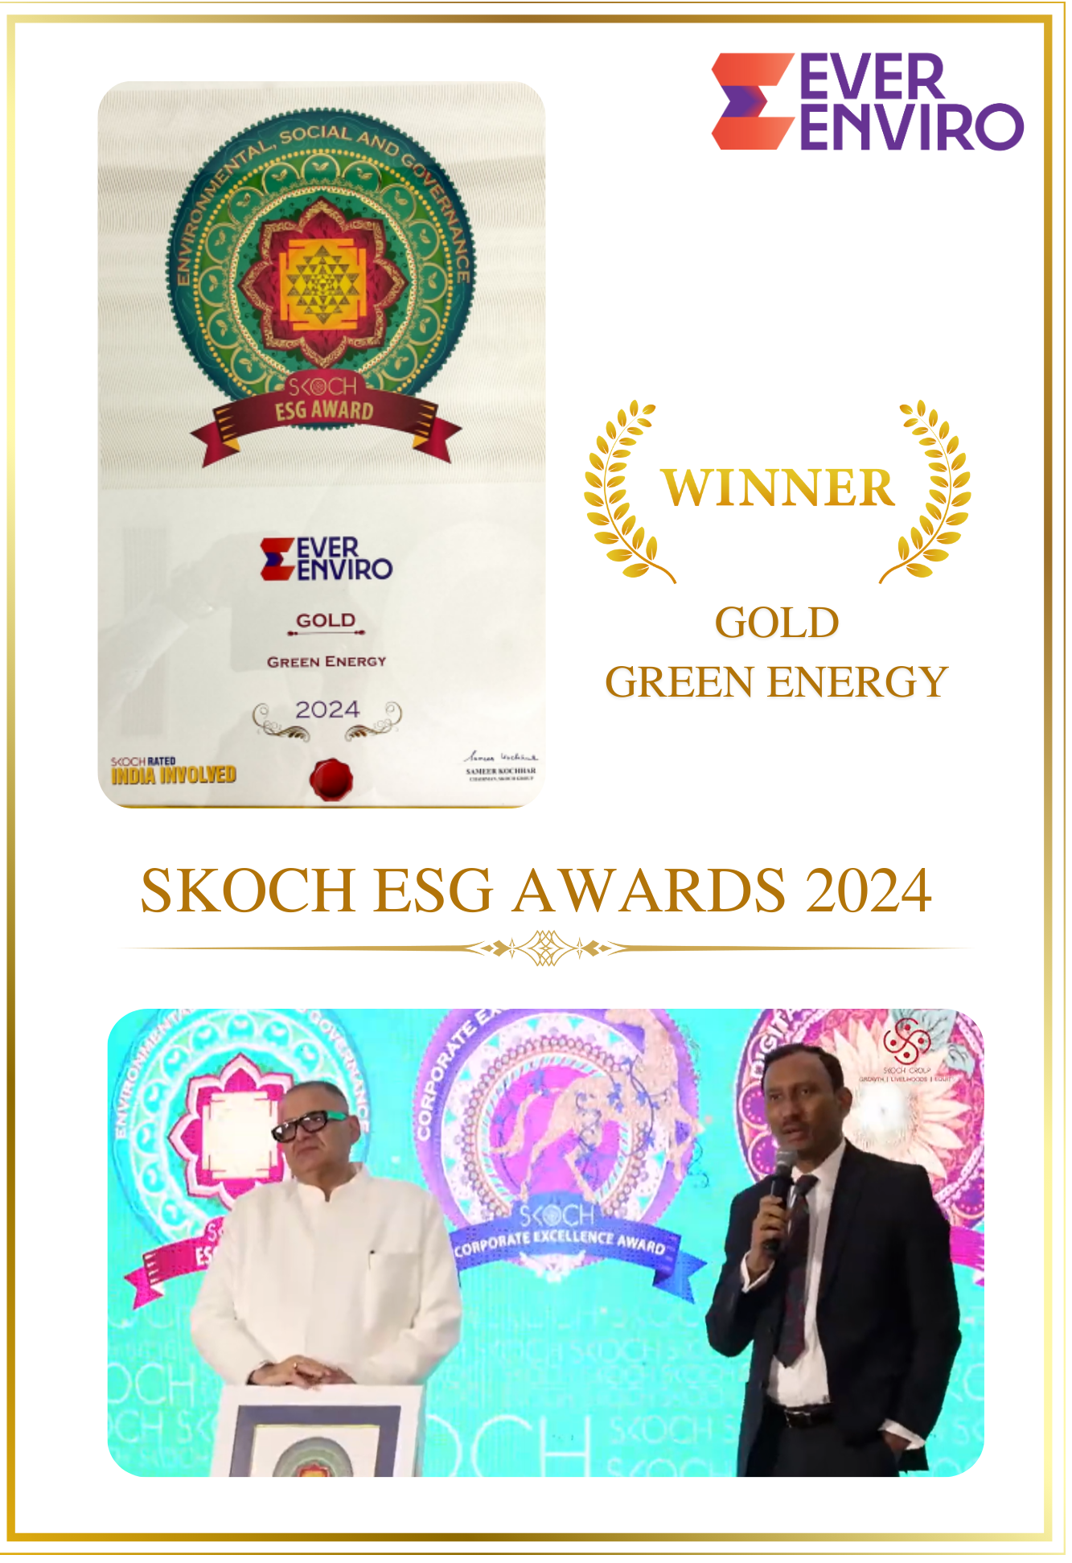
Groundbreaking ceremony 4.0 award certificate for commissioning for UP Projects by PM in 2024 | 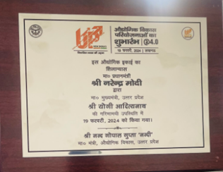
World HRD Congress 2024 – National Best Employer Brand 2023 | 
Realty Pus – Harit Bharat Construction materials award - BRICK | 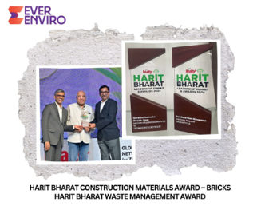
Realty Plus – Harit Bharat Waste Management Award
Kathari Waters
Smarterhomes won the 'Innovation in Water Technology' category at the 12th Edition of the FICCI Water Awards in September 2024

Lithium Urban technologies Pvt Ltd
Innovation in Supply Chain - Aegis Graham Bell Award 2023
Most Sustainable Customer Service initiative of the year - 2nd Annual CX Excellence Awards 2023
Best Sustainable Mobility Partner Award - 2nd Edition Sustainability Summit & Awards 2023 by UBS Forums
India Fleet Excellence Awards 2023 with a hat-trick victory in 3 key categories - Emobility, FirstView Media Ventures
i. Innovative Fleet Management Technology for Commercial Vehicles
ii. Corporate Mobility Solution Provider (Commute)
iii. Charging Infrastructure for Fleet (Captive)
Radiance Renewables Pvt Ltd
Radiance was chosen for the best sustainable RE developer award (September-2023) | 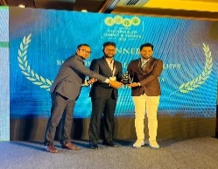
CEO - Manikkan S. secures Solar Quarte Power 100 award featuring India’s most powerful Solar leaders (October-2023) | 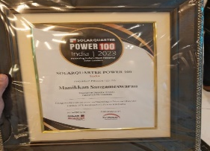
Radiance Renewables clinched the EHS Management Practice award in renewable energy at the India Health, Safety, and Environment Conclave and Awards (December 2023) | 
CEO - Manikkan S. secures the coveted Business Leader of the Year award at the World CSR secretariat conference in February 2024 | 
Most Admired Company of the year - Radiance Renewables (February 2024) | 
Radiance Renewables secured a Gold Award under the Apex India Occupational Health & Safety Awards in March 2024. | 
Radiance Renewables has been awarded the prestigious 'Greentech Global EHS Awards 2024' in the 'EHS Best Practices' category for excellence in Environmental, Health, and Safety standards. (June-2024) | 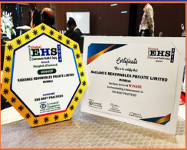
Best Solar Energy Startup as Radiance Renewables (April-2024) | 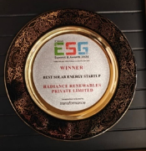
Radiance Renewables has been recognized by Silicon India Magazine as one of the 10 BEST CLEANTECH STARTUPS - 2024! (March-2024) | 

Annexure 3: GGEF’s geographical footprint

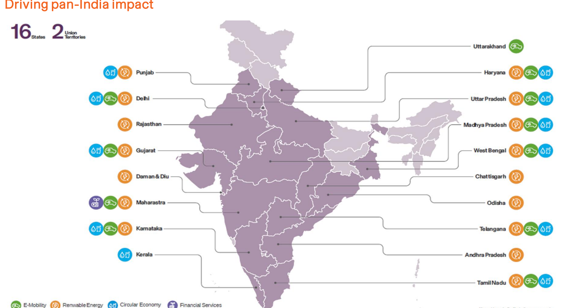

Legend:
- E-Mobility – Greencell & Lithium (Green)
- Renewable Energy – Ayana, Radiance (Orange)
- Circularity – EverEnviro, Kathari (Blue)
- Financial services – Ecofy (violet). The map only shows the headquarter; the company lends loans to people and MSME|s in almost all the states in India

Credit Rating Information Services of India Limited - is an Indian analytical company provides ratings, research, and risk and policy advisory services.
The figures represent contribution from GGEF and do not specifically attribute to the investment of FCDO in GGEF
Source: GGEF Sustainability Report 2024-25

