Annual Review

Title: UK-INDIA Partnership on National Investment and Infrastructure Fund -Green Growth Equity Fund
Programme Value £ (full life): £130m (£120m FT + £10m TA) |  | Review date: 11 October 2024
Programme Code : [AMP ID – 300418] | AMP start date: 26/09/2018 | AMP end date: 31/07/2029

Summary of Programme Performance

Year | 2019/20 | 2021 | 2021/22 | 2022/23 | 2023/24 | 2024/25 | 2025/26
Overall Output Score | A | A | A+ | A+ | A | A
Risk Rating | Major | Major | Major | Moderate | Moderate | Moderate

DevTracker Link to Business Case: | Business Case
DevTracker Link to results framework: | Log frame
A. SUMMARY AND OVERVIEW
Description of programme

UK-India Partnership on National Investment and Infrastructure Fund – Green Growth Equity Fund (GGEF) programme comprised two components as below.

1. Development Capital Component of £120 million invested into GGEF:

The GGEF, promoted jointly by the UK and India through National Investment and Infrastructure Fund (NIIF) aims to crowd in private sector investment from global institutional investors including from the City of London. NIIF and FCDO anchored the GGEF with a capital contribution of £120 million each. GGEF is structured as a private equity fund to invest in green growth sectors of India such as renewable energy, energy distribution/transmission, clean transportation, water treatment and management – and to raise additional capital into the fund, and into its companies. The investments are expected to contribute to sustainable development goals (SDGs) including SDG 7 Affordable and Clean Energy, SDG 13 Climate Action, SDG 9 Industry, Innovation and Infrastructure, SDG 17 Partnerships for the Goals, as well as the mobilisation of finance while delivering financial returns to the UK taxpayer. After a competitive international procurement exercise, Eversource Capital was appointed as the Fund Manager of GGEF in April 2018.

The intended secondary objectives for the UK include strengthening of the City of London’s position as a partner of choice for financing Indian infrastructure, opportunities for UK investors to enter or expand their portfolio in India for UK firms to compete to provide goods and services to the projects the fund invests in; and returns to the UK’s investment in the Fund.

The programme contributes to the UK’s climate commitment under the International Climate Finance (ICF). Programme interventions directly support Indian government’s climate goals and commitments made in international climate negotiations to reduce CO2 emissions intensity and increase the share of Non-Fossil Fuel in electricity as set out in Nationally Determined Contribution (NDC)

2. Technical Assistance (TA) Component of £10 million

The TA component was developed to address policy and inclusion linkages related to green growth sectors of India. This intervention has helped address a few market failures in green growth investments in India. This has also helped improve the investment ecosystem & inclusion linkages, and strengthening Environmental, Social and Governance (ESG) standards of green investments in India (please refer to previous annual reviews for details).

There is no further funding for analytics or capacity building, but the team explores opportunities and is engaging with relevant HMG teams.

Summary supporting narrative for the overall score in this review

This is the sixth annual review of the programme. In the current review period, the GGEF programme has scored ‘A’ based on the progress against the log frame milestones and indicators. A summary of updates over the review period is below:

Investments and Operations: GGEF has completed its active investment period and has invested i.90% of its investable corpus in seven portfolio companies in 2023 and has almost invested the remaining during the review period. Refer to Annexure 1 for details of GGEF’s investments. During the review period, the focus was to increase the number of operational projects post the construction phase. Multiple projects across the portfolio were operationalised during the year. The overall revenue of the portfolio companies has grown over 25%; the revenue growth is more pronounced at over 75% excluding Ayana, which is a more mature company and has relatively stagnant revenues. This growth of the portfolio companies would help in the timely exit of these investments over the next 5 years, within the fund term. Three of the portfolio companies are looking for external funding for the next phase of growth. The valuation of the portfolio is 35% higher than the invested amount indicating that the portfolio is on track to achieve financial returns in addition to creating impact which is discussed below.

Exits: The Fund’s term is ending in 2029 and is extendable by two years as per the legal agreement. As per the strategy discussed with the FCDO team, the Fund Manager is preparing the portfolio for exits within the stipulated time. The Fund is in advanced discussions for exit of one of the companies, which is likely in the next year. The Fund Manager is on track to exit 3-4 investments by 2027 and the entire portfolio by 2029, when the term ends.

Impact: Sectors such as e-mobility, waste-to energy and distributed renewable energy had not attracted much interest from commercial investors till recently. There were only few small companies operating in these sectors. GGEF has created large companies in these sectors bringing in economies of scale to provide affordable green services. GGEF has catalysed USD 2.5 billion (~£1.91 billion) of global capital both commercial and concessional into the climate opportunity in India. Investments made across its portfolio have created high impact financially sustainable and scalable enterprises, creating more than 12000 direct jobs, targeting to avoid 30 million+ tonnes of GHG emissions by 2030. The details are available in GGEF fourth annual sustainability report. Some of the awards received by the Fund and its facilities are summarised in Annexure 2.

ESG: The ESG processes are upgraded continuously to reflect the fledgling and dynamic nature of the green sectors that the fund operates in. The Fund has constituted environmental, Social & Business Integrity committee with members from all the investors including the UK, NIIF, BII and FMO. Eversource Capital prepared and implemented the third version of its Environmental, Social and Governance Management Systems (ESGMS) during the review period with guidance from ES&BI panel. The third version is updated to include (i) a zero-incident work culture commitment in the ESG policy, (ii) incorporates human rights and prevention of safeguarding violation commitments, (iii) strengthened the ESG integration into the investment process, (iv) defined triggers for a responsible exit, (v) strengthened the ESG integration into portfolio-level opportunities and (vi) provided more detailed appendices on risk mapping, procurement and training.

Gender: There has been increased focus in improving the gender ratio during the year. The share of women in the workforce is 45% at the Fund level and 24% at the corporate offices of the portfolio companies and an improving 8% including the frontline workforce (the industry norms is less than 5% in India given the nature of the sectors). The net additions during the review period also indicate an improving gender ratio as 2 female employees and 1 male employee were added (adjusting for exits) at the Fund level during the review period. Women employees across Eversource and its portfolio companies have increased by 52% during the review period. The review period also saw two female senior level hires at the portfolio companies. There has been a conscious effort to boost the gender ratio in the front-line personnel and the senior leadership of the fund and the portfolio companies, but there is still potential for improvement and leading the industry.

Major lessons and recommendations for the year ahead

Lessons:

- GGEF is investing in new economic, dynamic sectors where the definition of ESG and standards are evolving. These need to be defined and managed carefully. GGEF’s ability to tap into specialist expertise including of domestic and international development finance institutions, use of technological interventions for value creation and cross-learning among the portfolio companies have helped it update the ESG standards for these sectors.
- New green businesses take a longer time to stabilise and attract capital for growth. This needs a patient approach. Sectors such as e-vehicles, though attracting commercial capital, are taking a longer time than the traditional businesses on the pathway to profitability. This emphasises the need for development capital at an earlier stage to mobilise commercial capital at the later stages of growth.

- Kathari resource management, which operates in the water sector, has relatively subdued growth compared to other companies in the portfolio due to huge capital requirements and market barriers in this nascent sector. The industrial water recycling sector has the potential to grow faster if patient capital is available while the municipal water supply sector needs policy enablers that could ensure timely payments to private sector water suppliers (similar to the establishment of a central body for renewable energy sector to ensure timely payments to power suppliers) .Water and other adaptations sectors such as cooling solutions and smart- agriculture need dedicated focus, capital and policy enablers from governments and development financial institutions to unlock the sector.

Recommendations:

Actions unless otherwise specified are for the UK Programme team to take forward within the next year.

Strategic & Policy initiatives:

- Continue to work with DBT colleagues during the high growth phase of the portfolio companies to derive secondary benefits wherever possible. Action: FCDO and DBT teams.

- Work with the Government of India on the progress of GGEF and the achievements of its portfolio companies. Work with the Communication team accordingly

- Apply learning of the programme particularly on two aspects a) internal controls: governance, risk mechanism and working with Politically Exposed Persons b) mobilisation of capital at the fund and investee levels, to the development capital programmes being operationalised.

- Feed in portfolio learning to relevant policy teams on climate, climate finance, and energy transition team at post and in the UK.
Implementation:

- Undertake a review of the policies and governance mechanisms since the various portfolio companies have entered a new phase of dynamic growth.

- Continue to build on the good progress made on gender diversity and inclusion, especially at the leadership positions and in the frontline workforce of the portfolio companies. Conduct a study in collaboration with the Fund Manager to devise innovative mechanism to improve gender diversity in these sectors.

Progress on recommendations from previous AR:

Recommendation | Progress
As the fund is in the monitoring and consolidation phase, GGEF team should strive to raise profile of the fund portfolio with good examples especially on UK linkages and Gender inclusion – Action Eversource & FCDO | This is ongoing and continuous. The fund is the first and largest climate fund in India, continuing to achieve several milestones – please see annexure 2 for achievements. DBT continues to work across the portfolio to assess opportunities
GGEF to come up with robust fund’s exit strategy and FCDO team to review and provide timely inputs based on learnings from other funds exits under the portfolio. | FCDO team reviews the exit strategy at regular intervals. This activity will continue till the end of the fund term. GGEF Investor Meeting on 30 September reviewed this in good detail with all investors, including expected valuations and commercial approaches.
Being the largest climate fund GGEF needs to strengthen its gender, diversity and inclusion strategy at all levels of fund and portfolio companies | The concerted effort has borne fruit. This remains a priority which the FCDO team reviews regularly both bilaterally and with other investors during the monthly ES & BI panel meetings. It is encouraging to see the marked positive movement in gender and inclusion during the review period.
Revise log frame with exit pathway milestones and indicators and SRO/PRO to start reporting from next year | Completed. The log frame is revised to include exit indicator and a new output to strengthen ESG & inclusion

B: THEORY OF CHANGE AND PROGRESS TOWARDS OUTCOMES [1-2 pages]

Summarise the programme’s theory of change, including any changes to outcome and impact indicators from the original business case. [1/2 page]

There is no change in the Theory of Change during the current review period,

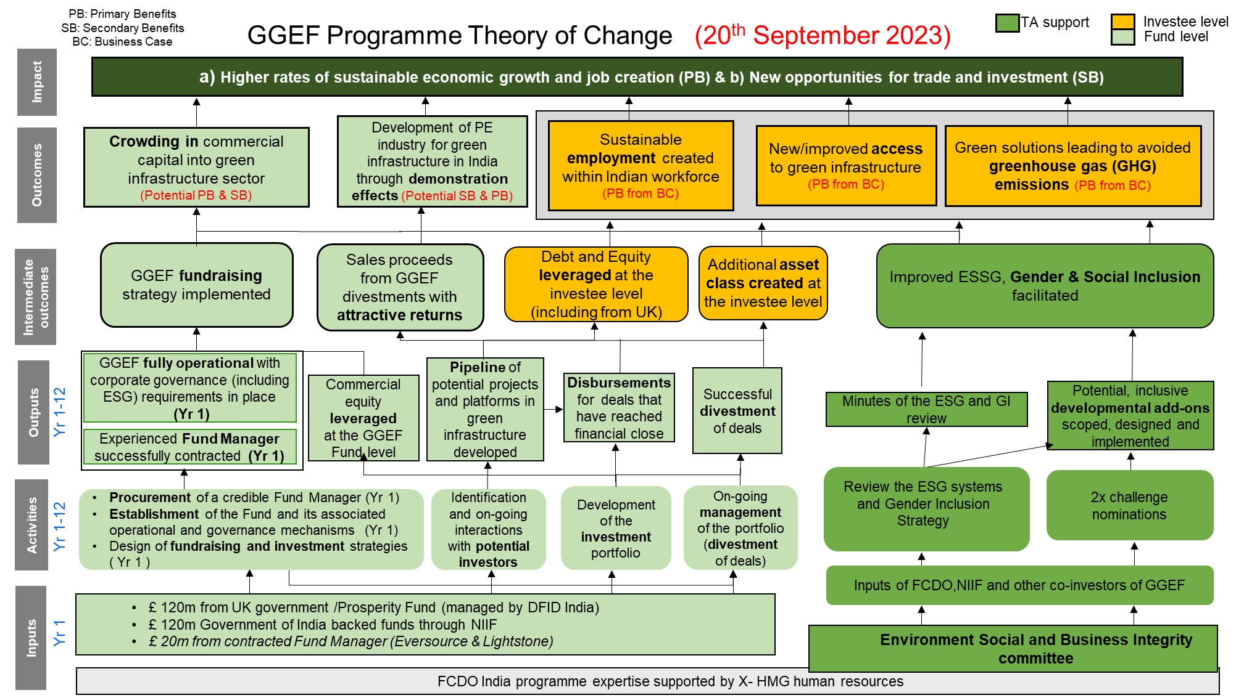

Describe where the programme is on/off track to contribute to the expected outcomes and impact. What action is planned in the year ahead?

GGEF’s primary outcome is to invest and crowd in private capital into green segments especially in under-invested climate segments. The Fund has already mobilised £560 million making it the largest climate fund in India. Further each of the investees set up under the GGEF is expanding rapidly and is looking to raise additional capital from the private sector in the next two years. Four of seven companies are now amongst the largest players in their sectors.

The programme has begun to show tangible results at the eco-system level. There has been an increase in the number of climate funds in the Indian market. These are led by financial institutions with international investors. GGEF being the first and largest climate fund, its talent pool has moved to these new institutions and played a major role in developing their green funds and ventures.

Outside GGEF the Fund Manager has entered a partnership with a UK based investor to invest £90m in electricity smart metering business which is expected to provide significant energy efficiency savings and reduce the carbon footprint of consumers. This would not have been possible, if HMG and NIIF had not played a catalytical role and provided an opportunity to develop expertise in green investments.

Based on GGEF’s success in the mitigation sector, team has developed a new programme in the climate adaptation and emerging mitigation space. NIIF has also expanded its climate portfolio based on the UK India partnership model, and this has extended to their partnership with Japan and the US. The Fund is on track to exit the investments by the end of the term in 2029, a few of which may happen in the next two years.

The programme is also on track to achieve the expected outcomes on jobs, beneficiaries and clean energy generation below.

ICF KPI | Milestone | Achieved (As on June 30, 2024)
ICF KPI 12 - Private Debt and Equity mobilised at the investee level | INR 60,0000m (£600m) | INR 68000 (~£680m)
ICF KPI 5 -Number of direct jobs created | 15000 | 16,000+
ICF KPI 6 - Net change in greenhouse gas emissions (GHG) in tonnes of (tCO2e) ~reduced or avoided | 8m tCO2 | 8.7mm tCO2
ICF KPI 7 – Clean Energy (Installed Capacity) | 1900 MW | 2070 MW

Justify whether the programme should continue, based on its own merits and in the context of the wider portfolio

The programme has achieved its mobilisation target of £500m and has deployed 90% of the mobilised capital in large scale green projects which has hitherto seen limited interest from private sector. Most of the GGEF investees have now expanding operations and are in the process of attracting more private capital for the next phase of growth. It is hence imperative for the programme to continue to allow the growth of the investees and demonstrate the commercial attractiveness of green infrastructure in India.

The programme aligns well with climate objectives agreed with the Indian Government and supports the funding requirements of India’s green transition. Further, the programme contributes to the ICF KPI targets of HMG and is on track to achieve the intended outcomes and impact as set out in the business case.

NIIF is a major initiative of the Indian government. As HMG has co-invested in GGEF along with NIIF, continuing with this programme contributes to the wider HMG - Indian government partnership. In particular, the GGEF provides opportunities to senior officials/Ministers of both governments to showcase the work; and its progress is noted in joint statements and dialogues which serve to strengthen the bilateral partnership.

The programme has also achieved secondary benefits by attracting ~£65 million of UK private capital into commercially viable green sectors in India and is likely to provide more opportunities for the UK private sector in the future. During the review period, the Fund Manager has entered a partnership with UK investor for investment into a smart-metering business. The programme has also helped in attracting UK technologies into green sectors in India – notably in the waste management and circular economy.

C. DETAILED OUTPUT SCORING]

Output 1 and 2 were achieved before the review period and hence are not reported here.

Output Title | Fund develops and manages a portfolio of investments
Output number: |  | 3 | Output Score: | A
Impact weighting (%): |  | 75% | Weighting revised since last AR? | Yes

Indicator(s) | Milestone(s) for this review | Progress
Commitments to investees ( | INR 46000 m (£ 460m) | Approximately INR 49,420m (£492m) has been committed to investees.
Disbursements for deals that have reached financial close | INR 35,000 m (£350m) | Approximately INR 40,000m (£400m) has been disbursed to the deals that reached financial close.
Exits | There are no exit milestones for the review period. The exits are expected from the next review period

Briefly describe the output’s activities and provide supporting narrative for the score.

The Fund focussed on operationalisation of the projects under construction in the various portfolio companies to achieve high growth and impact. The Fund has prepared an exit strategy which will be reviewed every quarter. Currently one of the portfolio companies is being prepared for exit; four companies are looking to mobilise additional capital from commercial investors to fund their next phase of growth. The exits of these four companies are likely to happen post expansion in the next 2 to 4 years well within the end of the fund term. The revenue growth of these portfolio companies during the review period ranged between 50% and 150% indicating the sustainability of these business. The growth is likely to continue for the next few years. The key highlights the achievements of some of the portfolio companies are listed below:

Key highlights of the investments include:

Ayana: Ayana is continuing to invest in the next phase of India’s renewable growth. It has created the capacity for round-the-clock (RTC) power supply with energy storage capacity through hydro-lifting. The RTC supply capability is important for renewable energy producers and is expected to propel growth in future.

Greencell: Greencell introduced its first intercity e-bus in India between city-pairs of distance ranging between 250 and 400 km (one of the first operators to introduce such long-distance e-buses in the world). It also introduced the first women-only intercity e-bus in select routes to assure women of safe travel especially at night. The company continued to grow with 30% increase in the number of operational buses during the review period. The company is ensuring its growth stays green. It is consistently increasing its sourcing of power supply from renewable sources, which now stands at 60% and is on its way to 100% in the next few years.

EverEnviro: The company operationalised three renewable natural gas and construction waste recycling plants during the review period. The company has multiple projects under execution and a significant proportion of these projects import critical machinery and components from the UK given the commercial leadership of the UK in these segments

Kathari: The company has completed the construction and is ready to operationalise the sewage treatment plant in Kolkata. The company has developed wireless smart water meters, which will help in scaling up this business to measure water usage to reduce wastage.

Lithium: Lithium has expanded its business to develop charging infrastructure during the year and is working on technology to extend the battery life of vehicles.

Ecofy: Ecofy has grown exponentially during the year with its loans portfolio growing 26 times, lending to renewable energy projects of about 2.2 GW and to more than 20,000 customers buying e-vehicles (2 & 3 wheelers). The company has opened new doors in green inclusive finance as they only lend to retail customers and small & medium enterprises who struggle to get green loans.

Key challenges:
- The rapid growth of the portfolio companies which are in relatively new green sectors in India requires a constant vigil to ensure the systems and controls commensurate with the commercial growth of the company
- Kathari, the water platform of GGEF, needs larger scale to create an impact. The current committed capital under GGEF may not be sufficient to scale up this company to the expected level. We expect it will be relatively more difficult to attract commercial investors into the platform as compared to the other platforms of GGEF.

Describe any changes to this output during the past year, and any planned changes as a result of this review.

The exit indicator is added during this year. However, the fund has just completed the investments and require more time to exit all the investments, there are no milestones set for the year.

Progress on recommendations from the previous AR (if completed), lessons learned this year and recommendations for the year ahead.

Please refer to the summary section.

Output 4 | ESG processes and inclusion of the Fund Manager and portfolio companies strengthened.
Output number |  | 4 | Output Score: | A
Impact weighting |  | 25% | Weighting revised since last AR? | Yes

ESG process strengthened, and the number of critical incidents reduced. | ESG process updated and implemented across the portfolio.  Critical incidents within the portfolio companies’ control to be less than 5 each year. | Met expectations  New version of ESG system implemented  Critical incidents under the control of the portfolio companies reduced to 3.
Improved gender ratio in the employees of the Fund and Portfolio companies | The proportion of female employees-maintained Fund Level  The proportion of female employees increased to 20% in the portfolio companies. | Met expectations. GGEF team is making concerted effort to further improve this.
Portfolio entities improve the livelihood of people in the project sites | 2 programmes targeting community development at project sites completed | Exceeded expectations  4 programmes – 1 each by Ayana, Radiance, EverEnviro and Green cell completed skill development and training at the project sites benefitting over 600 people.

The portfolio companies' ESG systems need to be updated on a regular basis as they operate in sectors where no large corporations have ever operated. This is especially critical for Greencell, Lithium, and EverEnviro, which have public touchpoints and run vehicles on Indian public roads. International best practices need to be adapted for the Indian environment, and systems must be regularly updated based on learnings and incorporating international best practices when appropriate. Eversource, with the assistance of the ES and BI panel, upgraded the ESG systems to drastically reduce critical events throughout the review period. For example, the fatality rate per kilometre of operations is comparable to Transport for London (TfL), which ranks among the best in the world. A new version of the ESG system is implemented during the year. Details are provided in the summary section.
As described in the summary section, focused efforts have resulted in a significant improvement in the gender ratio. Senior management at the Fund level will require longer time to achieve adequate female representation as there are not many women in the infrastructure fund industry who could join the fund manager currently. The infrastructure industry in India often has a smaller number of female workers in senior management and frontline roles. The Fund Manager aims to establish an industry benchmark, albeit from a low base.
The portfolio companies through their CSR initiatives have skilling schemes in place to help people living around project sites. Four portfolio companies have trained more than 600 people, primarily women and students, contributing to overall economic growth in and around remote project sites.

Describe any changes to this output during the past year, and any planned changes as a result of this review.

The output is introduced during this year to reflect the increased importance of ESG and inclusion during the operational growth phase of the portfolio companies.

Progress on recommendations from the previous AR (if completed), lessons learned this year and recommendations for the year ahead

Please refer to the Summary section

D: VALUE FOR MONEY (1 page)

Key cost drivers and performance

GGEF is a good VfM. It has exceeded the mobilisation target within the set timelines. Programme is on track in terms of log frame outcome and outputs as detailed in section B above. The Fund Manager has made investments in underinvested segments such as waste to energy, e-mobility, and water management. The UK funds are effectively deployed in segments which are highly additional which could lead to more commercial interest in these segments in future. The Fund is currently expanding the operations of the portfolio companies and on track to exit the investments within the end of the fund term. The assessment of the VfM indicators against the expectations in the business case is provided below.
Indicators (as per the Business Case) | Status
Economy Indicators
Fund Manager management fee | As anchor investors, FCDO and NIIF negotiated management fee to derive value for money at the beginning of the fund term. The annual management fee is reducing as the fund has completed its investments and has started preparing for exit (in line with the legal agreement)
Time Taken to raise funds to the target level | The programme has achieved its mobilisation target of £500m with the final close during the investment period.
Efficiency Indicators
Time taken to invest in first direct investment / Pace of deployment and exit of Capital | The Fund has deployed almost all the investible corpus and is on track to exit the investments within the end of the term.
Effectiveness Indicators
- Private equity multiplier – fund level 1x; investment level 3x  - UK Private equity multiplier  - Volume of public finance mobilised for climate change purposes due to funding (ICF indicator)  - Volume of private finance mobilised for climate change purposes because of funding (ICF indicator)  - Return on equity multiple – target 1.9  - IRR of investments and of the overall fund  - Number of people with improved access to clean energy as a result of programme (ICF indicator)  - Cost per kWh of installed capacity of clean energy as a result of investment  - Number of direct jobs created as a result of investments (ICF indicator)  - Cost per tonne of CO2 equivalent avoided emissions as a result of investment  - Per cent of the sub-fund portfolio value in India’s poorest states/areas | The Fund has prioritised additionality in investments, establishing focused investment platforms. Higher than expected investments were made in emerging sectors such as e-mobility and waste-to-energy emphasising the catalytic nature of HMG and NIIF capital.  In addition, GGEF has also started contributing to the investment ecosystem as multiple financial institution have launched climate funds in India on back of success of GGEF and the availability of talent pool developed by GGEF.  The outcome indicators of the Fund are already discussed in the earlier sections
Equity Indicators
- Proportion of women employed.  - Proportion of women reached through the products/services | There has been significant increase in female representation at the fund level with almost half of the team comprising of women, in line with the 2X challenge women employment criteria. Women employees across Eversource and  its portfolio companies have increased by 51.6% during the review period. Other details are available in earlier sections.

Assessment of whether the programme continues to represent value for money

GGEF has continued to demonstrate coming together of two governments on an important agenda of climate change and with their capital have setting up platforms which have been successful in attracting equity and debt funding. The programme has also contributed to the ICF KPIs during the review period.
As envisaged, the programme has also started contributing to the climate investment ecosystem in India with few financial institutions launching climate focussed funds as GGEF has demonstrated the market potential of the emerging climate sectors and developed a talent pool.

E: RISK

Overview of risk management

The overall risk of the programme remains Moderate.

Risk category | Risk description | Residual Risk | Mitigation Strategy
Public Service Delivery & Operations | Failure to achieve timely exits and the expected financial returns due to factors such as external market conditions, inefficient management may lead to lower profitability and delayed exit of investments and hence unable to demonstrate commercial viability. | Moderate | - Period review of exit strategy with the Fund Manager along with co-investors  - Periodic interactions with the Fund Manager and the portfolio entities to assess the financial performance and take adequate course correction measures if the investment is not on track to achieve profitability.  - Deep dive analysis of the valuation reports and cashflow assumptions in the report to avoid any future surprises.
Financial & Fiduciary | Risk of finances being utilised for unintended purposes by the Fund, corruption and funds leakage in construction and operational phases of the projects.  Risk of abuse of power leading to kickbacks of investees | Moderate | - Risk management system upgraded periodically to reflect the changes in the business environment  - Operating procedure for the Fund Manager is clearly drawn as a part of the agreements.  - Due diligence of projects and promoters are carried out before  investment decisions are made.  - Audits and checks are / will be carried out on the individual projects and the Fund as per the agreements, including independent audits by IAD  - The operating procedures and controls are strengthened during the review period. This will be monitored on a periodic basis
Policy & Programme Delivery | Lack of sufficient direct focus on downstream investments leading to greater risk on the financial performance and development impact of the downstream investments | Moderate | - Periodic site visits and interactions with the downstream investees by the programme team.  - Regular reporting of the fund manager on the performance of downstream investees in a specific format. Despite these mitigation measures the direct focus on the downstream  - m investees will be limited due to resource constraints at the programme team level
`Safeguarding | In the absence of strong due diligence, monitoring and reporting mechanisms there could be a risk of unintended environment and social consequences of programmes | Minor | - Focus on green sectors such as renewable energy, and water/waste treatment leading to selection of environment friendly projects  - Robust due diligence mechanisms including environment, social and governance due diligence, in place  - Due diligence of each project before funds are committed  - Timely incident reporting within 24 hours of the incident  - Reporting of ESG adherence in the quarterly and annual reports Dedicated ESG officers in all active platform companies to manage the environmental, social and governance issues across the project life cycle e) Monthly ES& BI panel (comprising experts from all the investors) meeting monitoring and advising solutions for any issues that may happen.

F: PROGRAMME MANAGEMENT: DELIVERY, COMMERCIAL & FINANCIAL PERFORMANCE

Summarise the performance of partners and FCDO, notably on commercial and financial issues.

As part of the programme management processes, we receive regular quarterly reports from the Fund Managers. Their reports contain information on financial performance, risks, ESG, progress on development indicators and others. Quarterly meetings are held to review programme progress. Monitoring of the funds is carried out via the LP Advisory Committee (LPAC) comprising anchor investors, co-investors and the Fund Manager. The ES & BI panel meets monthly to review the ESG systems and processes and recommends updates based on past learning and international best practices where appropriate.

Disbursements are closely monitored, forecasts are regularly reviewed and uploaded on to programme and financial management systems. Payments are made in ongoing projects only after outputs undergo mandatory quality assurance process by the SRO. The FT agreement with the GGEF Fund Manages has built in forecasting and reporting requirements such as annual audited, valuation, ESG and Quarterly progress reports for periodic monitoring review.

The total Programme spend as of August 2024 is £117.50m, consisting of TA spend of £1.68m and FT spend of £115.82m including management fee for the Fund Manager. Remaining FT of £4.18m will be used towards follow on investments, fund’s fee and expenses for the remaining fund period.

G: MONITORING, EVIDENCE AND LEARNING

Monitoring and Evaluation

This programme is monitored in line with corporate governance arrangements between FCDO and Eversource Capital. These are included in GGEF’s Investment Policy and are reported to FCDO via GGEF’s corporate governance oversight arrangements. The investment decisions are made by the Investment Committee constituted by the Fund Manager. FCDO is not actively involved in investment decisions. The Advisory Committee provides strategic oversight to the Fund Manager and recommends solutions on circumstances such as conflicts of Interest. The Advisory committee comprises 7 members form various investors including FCDO, NIIF, BII and FMO. The programme performance is measured against the log frame, work plan and previous year’s recommendations. Programme review meetings are held with Fund managers. Standing agenda items include risk management, finance management, investment status, stakeholder engagement and relationships management.

The EverSource ESG team have regular meetings with investees and field visits are held to understand ground realities, to gain insights into operations, assess preparedness and verify site compliance, with periodic update to the ES & BI panel and Investor Advisory Committee. ESG team has already conducted 3 site visits in Q1 FY2025. Dignitaries from UK including ICAI and IAD have also visited investee companies at various opportunities.

FCDO also has commissioned a mid-term financial review of the Fund and its operations to ensure that the funds are used for intended purposes as per the legal agreements. The review is likely to be completed in November 2024.

Evidence

The quarterly progress, financial and annual reports shared by the fund managers are the good evidence base for reporting progress made by the programme during the year. Field visits are critical for gathering evidence and interacting directly with stakeholders. SRO and PRO had site visits and held regular meetings with the Fund Managers to discuss the progress and future exit strategy.

Date of last narrative financial report | June 2024 | Date of last audited annual statement | March 2024

Annexure 1: GGEF Portfolio companies

Investment Platform | GGEF’s ownership | Brief description
Ayana Renewables | Minority stake (less than 20%) | Utility Scale renewable energy platform which has an operational capacity of 2.2 GWdc currently and 3.55 GWdc under construction. The company was incubated by British International Investment (BII) in 2018 and is currently owned by BII, NIIF and GGEF jointly
Radiance Renewables Pvt Ltd | 100% | Commercial & Industrial (C&I) Solar Rooftop facilities. with an operational capacity of 488 MWdc currently with 49 MWp under construction The Company is developing ~1 GW of open access solar and wind-solar hybrid parks in states like Maharashtra, Rajasthan, Karnataka, and Tamil Nadu.
GreenCell Mobility Pvt Ltd | 100% | E-mobility service provider operating 1100 e-buses currently and around 800 in pipeline in the short term. Vision is to become India’s largest e-Mobility as a Service (e-MaaS) platform by 2028 with 8,000+ buses under management.
EverEnviro Resource Management Pvt Ltd | 100% | Waste management and Waste-to energy platform with an operational waste processing capacity of over 6500 tonnes per day currently with a vision to process over 30,000+ tonnes per day (TPD) of waste and emerge as one of the largest players the waste-to-energy sector
Kathari Water Management Pvt Ltd | 100% | Water as a Service company focussing on recyclability and reuse of water and wastewater. with under construction capacity of 187 million litres per day
Lithium Urban technologies Pvt Ltd (New investment during the review period | More than 75% | E-fleet operator mainly operating cabs for corporate customers.
Accretive Cleantech Finance Pvt Ltd (Ecofy) | 100% | Climate Finance institution that lends to retail customers for purchase of rooftop solar, electric vehicles etc.

Annexure 2: List of Awards and recognitions received by EverSource portfolio companies from Sep’23 – Aug’24

Category | Awards
EverEnviro
SABERA Awards - Promising Responsible Business of the Year 203 | 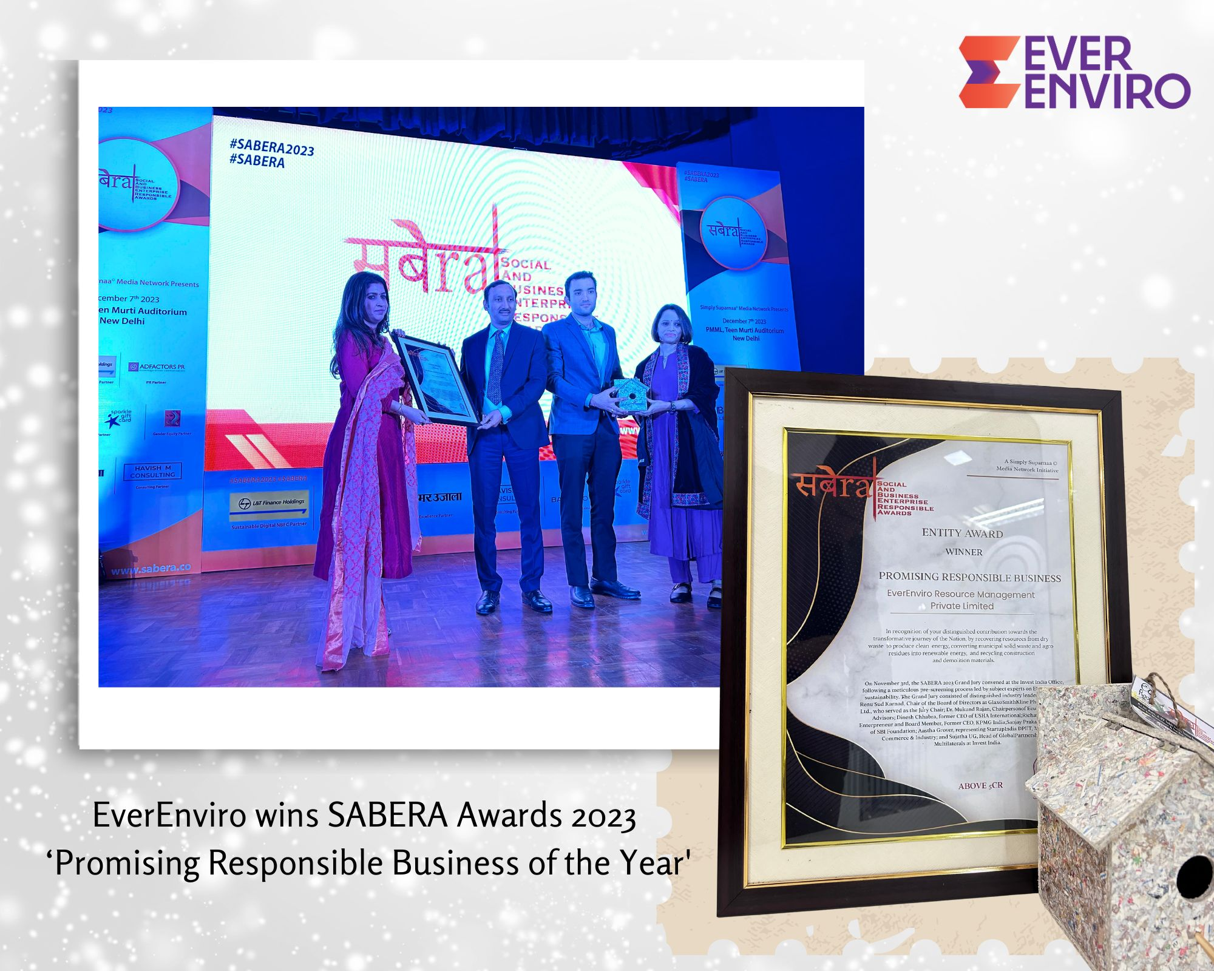
SKOCH ESG Award in the Gold category for Green Energy Development in 2024 | 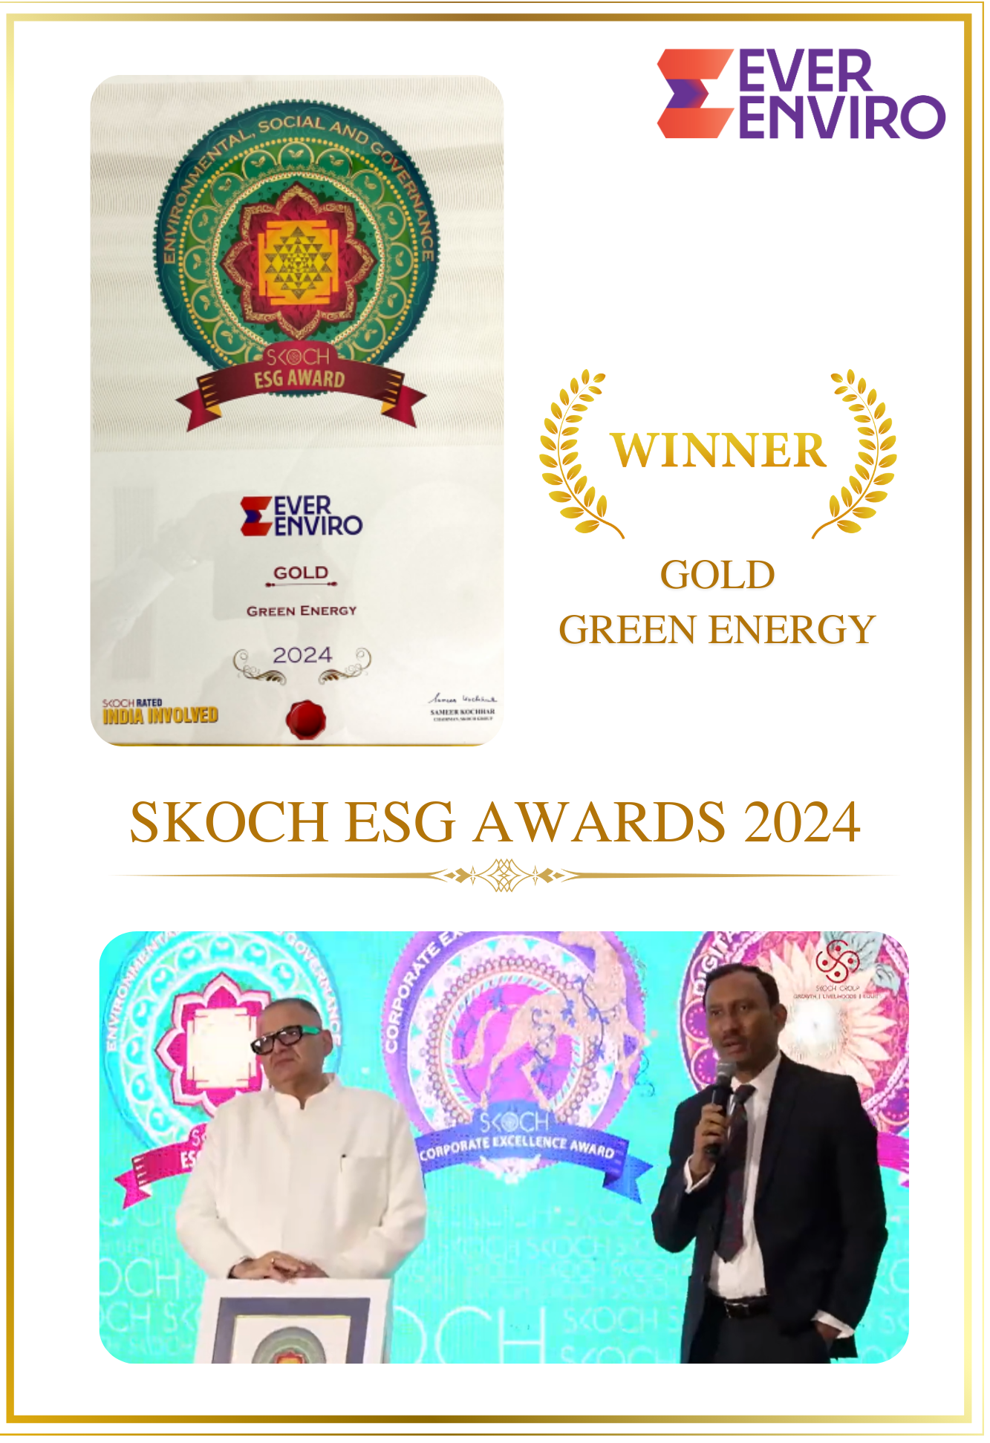
Groundbreaking ceremony 4.0 award certificate for commissioning for UP Projects by PM in 2024 | 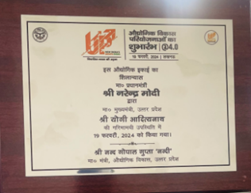
World HRD Congress 2024 – National Best Employer Brand 2023 | 
Realty Pus – Harit Bharat Construction materials award - BRICK | 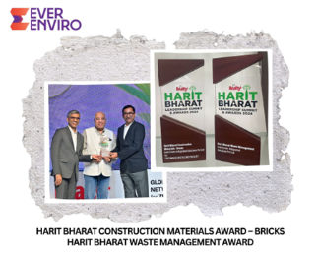
Realty Plus – Harit Bharat Waste Management Award
Kathari Waters
Smarterhomes won the 'Innovation in Water Technology' category at the 12th Edition of the FICCI Water Awards in September 2024

Lithium Urban technologies Pvt Ltd
Innovation in Supply Chain - Aegis Graham Bell Award 2023
Most Sustainable Customer Service initiative of the year - 2nd Annual CX Excellence Awards 2023
Best Sustainable Mobility Partner Award - 2nd Edition Sustainability Summit & Awards 2023 by UBS Forums
India Fleet Excellence Awards 2023 with a hat-trick victory in 3 key categories - Emobility, FirstView Media Ventures
i. Innovative Fleet Management Technology for Commercial Vehicles
ii. Corporate Mobility Solution Provider (Commute)
iii. Charging Infrastructure for Fleet (Captive)
Radiance Renewables Pvt Ltd
Radiance was chosen for the best sustainable RE developer award (September-2023) | 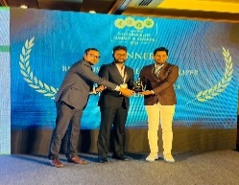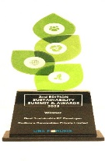
CEO - Manikkan S. secures Solar Quarte Power 100 award featuring India’s most powerful Solar leaders (October-2023) | 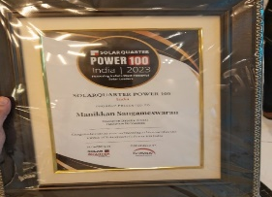
Radiance Renewables clinched the EHS Management Practice award in renewable energy at the India Health, Safety, and Environment Conclave and Awards (December 2023) | 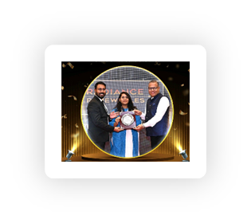
CEO - Manikkan S. secures the coveted Business Leader of the Year award at the World CSR secretariat conference in February 2024 | 
Most Admired Company of the year - Radiance Renewables (February 2024) | 
Radiance Renewables secured a Gold Award under the Apex India Occupational Health & Safety Awards in March 2024. | 
Radiance Renewables has been awarded the prestigious 'Greentech Global EHS Awards 2024' in the 'EHS Best Practices' category for excellence in Environmental, Health, and Safety standards. (June-2024) | 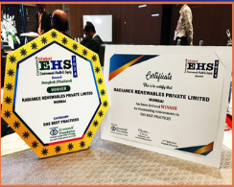
Best Solar Energy Startup as Radiance Renewables (April-2024) | 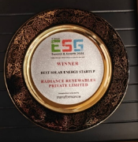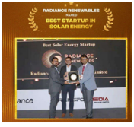
Radiance Renewables has been recognized by Silicon India Magazine as one of the 10 BEST CLEANTECH STARTUPS - 2024! (March-2024) | 

The figures represent contribution from GGEF and do not specifically attribute to the investment of FCDO in GGEF

