SIMF Annual Review 2025

Title: Supporting the International Monetary Fund (SIMF)
Programme Value £ (full life): £21,740,000 |  | Review date: 23 Oct 2025
Programme Code: 300381 | AMP start date: 23 Oct 2018 | AMP end date: 31 March 2026

Summary of Programme Performance
Year | 2019 | 2020 | 2021 | 2022 | 2023 | 2024 | 2025
Overall Output Score | A | A | A | B | A | A | A
Risk Rating | Minor | Minor | Minor | Minor | Minor | Minor | Minor

DevTracker Link to Business Case: | https://iati.fcdo.gov.uk/iati_documents/38775785.odt
DevTracker Link to results framework: | https://devtracker.dfid.gov.uk/projects/GB-GOV-1-300381/documents

A. SUMMARY AND OVERVIEW

Description of programme

Developing countries need to increase their tax take, maintain stable economic conditions, and spend wisely, to foster growth and reduce poverty effectively. The Support to the International Monetary Fund (SIMF) programme funds the International Monetary Fund (IMF) to deliver capacity development, policy advice and technical assistance to key government institutions in a range of developing countries.

This technical assistance seeks to improve revenue administration, Public Financial Management (PFM), fiscal and monetary policy, and other areas of economic policy. Assistance is provided through 6 IMF initiatives, 2 of which have concluded, which form the components of the programme. The work undertaken under SIMF supports countries to reduce their reliance on development assistance.

- Tax Administration Diagnostic Assessment Tool (TADAT): A diagnostic tool to help countries assess their tax administration systems.

- Revenue Mobilisation Thematic Fund (RMTF): A fund that provides technical assistance on Domestic Revenue Mobilisation (DRM).

- African Regional Technical Assistance Centre (AFRITAC) East (AFE): The regional technical assistance centre covering East Africa.

- AFRITAC South (AFS): The regional technical assistance centre covering Southern Africa.

- AFRITAC West 2 (AFW2): The regional technical assistance centre covering anglophone West Africa.

- Global Public Finance Partnership (GPFP): GPFP was launched in 2024 and combines (previously separate) external financing of all IMF capacity development (CD) in taxation, spending, public financial management and macro-fiscal issues under one roof.

During 2024 SIMF also supported the newly launched GPFP for the first time, and it has continued to do so in 2025. GPFP is the successor to two initiatives that have previously formed a part of SIMF, but which concluded activities in 2024: the TADAT and the RMTF.

SIMF has been granted a one-year time extension to the end of March 2026

Summary supporting narrative for the overall score in this review

The overall score for this review is an A.

Output number | Output Description | Impact Weight (%) | Output Performance
1 | TADAT | 10% | Outputs moderately did not meet expectation (B)
2 | RMTF | 10% | Outputs moderately exceeded expectation (A+)
3 | AFE | 40% | Outputs moderately did not meet expectation (B)
4 | AFS | 20% | Outputs met expectation (A)
5 | AFW2 | 20% | Outputs met expectation (A)

This annual review covers the period of October 2024 to September 2025, inclusive. However, to align the results in the logframe with the IMF reporting system, results are reported for the IMF’s financial year, which ran from May 2024 to April 2025.

SIMF has had a successful year, as TADAT and RMTF closed and the GPFP was established. Many output indicators were met and a few fell short. This should be contextualised, as TADAT and the RMTF closed recently, and their work has been picked up by the newly launched GPFP. This has led to, for example, fewer TADAT assessments completed in the year. GPFP has picked up quickly where the RMTF left off, supporting 15 countries with their Medium-Term Revenue Strategies (MTRS). The AFRITACs supported their beneficiaries despite the backdrop of a difficult economic environment. Disruptions in 2024 and 2025 have slowed economic recovery from earlier shocks, such as the COVID-19 pandemic, and the AFRITACs have supported their beneficiaries to navigate this.

At the outcome indicator level, SIMF is exceeding its targets. This is not translating to success at the impact indicator level though, as macroeconomic conditions weigh heavy. Despite that, it is plausible to think that SIMF has improved the impact indicators relative to the counterfactual.

Major lessons and recommendations for the year ahead

The previous annual review for SIMF made recommendations in the following areas:
Recommendation area | Progress
Disaster Risk Finance (DRF) | Disaster Risk Finance (DRF) is recognised as important by the IMF but is secondary to their priority activities of Public Financial Management (PFM) and Domestic Revenue Mobilisation (DRM). Nonetheless, they are exploring DRF. For example, AFE supported Uganda to introduce a natural disaster module into their macro-framework. AFS have been providing climate change related training to the Seychelles and have supported them to introduce climate budget tagging and to review their Public Investment Management (PIM) policy to include climate considerations.
Evaluation of Medium-Term Revenue Strategies (MTRS) | The RMTF Final Program Report was published in May 2025. It shows that 11 more beneficiary countries are now adopting and utilising MTRS. The report found that The MTRS is a framework that brings together a broad consensus on the level of revenue mobilization effort needed and how it might be achieved. MTRS also serve as a framework for coordinated technical assistance and training. The MTRS helped focus tax system reforms. MTRS made it clearer that integrating good spending design and implementation was critical to ensure the revenue collected was spent well.
Enhanced Value for Money (VfM) reporting | The IMF continue to report on VfM indicators, as reflected upon in the VfM section of this report. The previous AR suggested it would be valuable to extend similar reporting to other UK funded IMF vehicles outside of the SIMF programme. Discussions are ongoing.
Impact | Reporting on impact has improved significantly in the last few years, including the recent adoption of more structured reporting on verifiable instances of policy impact setting out the issue, support provided and results. The quality of results monitoring will continue to be a strong focus for FCDO investments going forward.
Fragile and Conflict Affected States (FCAS) | CD delivery in FCAS remains an important priority for the Fund. During FY25, 25% of Fund CD (single country) was delivered to FCAS.
Mapping | The consolidation of the TADAT and the RMTF into the GPFP brings those elements of IMF CD closer together. The GPFP is thinking through how it will work with the AFRITAC’s and has presented to the UK on this.

This review makes the following recommendations:
- Revise the logical framework: New targets should be set for the upcoming period. The FCDO will also review the strategic logical frameworks being developed by the IMF and the Regional Technical Assistance Centres, providing input where necessary, and reflecting how they can inform the SIMF logical framework.

- Review the TADAT Field Guide when revised: The TADAT Field Guide is undergoing a review process, and a revision is expected in 2025. FCDO should collaborate with the IMF on the revision to ensure key thematic areas are covered.

B: THEORY OF CHANGE AND PROGRESS TOWARDS OUTCOMES

Summarise the programme’s theory of change, including any changes to outcome and impact indicators from the original business case.

SIMF’s Theory of Change (ToC), included as Annex A, is still valid and no changes have been made in the past year.

Although some of the vehicles have changed, for example, with creation of the GPFP, the ToC has not. The activities the GPFP will undertake still fit with this ToC and they include activities that were previously being done under another name – such as tax diagnostics and revenue mobilisation.

Describe where the programme is on/off track to contribute to the expected outcomes and impact. What action is planned in the year ahead?
The SIMF logical framework (logframe) that accompanies this report can be accessed on DevTracker if you wish to compare across earlier years.

The logframe for the SIMF measures the following Outcome Indicators:

OUTCOME |  |  |  | IMF FY24 | IMF FY25 | Source
Governments receiving SIMF support under reforms to improve revenue administration, revenue mobilisation, public financial management, and/or fiscal policy. | Outcome Indicator 1 | Number of LIC or LMIC countries supported under a Medium-Term Revenue Strategy (MTRS), or analogous holistic medium term reform plan. | Planned | 2 per annum | 2 per annum | Reporting by RMTF and/or Platform for Collaboration on Tax (PCT).
 | Outcome Indicator 1 |  | Achieved | 10 | 23
 | Outcome Indicator 2 | Number of LIC or LMIC countries supported under a holistic reform plan to improve fiscal, public financial and/or public investment management. | Planned | 5 per annum | 5 per annum | SIMF vehicle Annual Reports.
 | Outcome Indicator 2 |  | Achieved | 23 | 27  Of which:  27 for GPFP  6 for AFE  9 for AFS  6 for AFW2 | SIMF vehicle Annual Reports.
 | Outcome Indicator 3 | Verifiable instances of SIMF capacity building support contributing to improved economic policy or administration in supported countries. | Planned | 2 per component per annum | 2 per component per annum | Case studies, highlights, and information from Annual Reports and RBM reports.
 | Outcome Indicator 3 |  | Achieved | 1 for TADAT  4 for RMTF  4 for AFE  2 for AFS  3 for AFW2 | 5 for GPFP  5 for AFE  2 for AFS  3 for AFW2

Outcome Indicator 1 significantly surpassed its target as has been the case since IMF FY 2019. It is worth considering an increase in the target for the next period. At 23 countries supported, this is the most of any year under SIMF, indicating a successful period, and greater utilisation of MTRSs.

Outcome Indicator 2 significantly surpassed its target as has been the trend throughout the lifetime of the SIMF programme. It is worth considering an increase in or broadening of the target for the next period. The target set was to support 5 countries per annum. AFS alone supported 9.

Outcome Indicator 3 was also significantly surpassed by most vehicles.

The logical framework (logframe) for the SIMF measures to following Impact Indicators:

IMPACT |  |  |  | 2024 | 2025 | Source
Developing countries mobilise more domestic revenue, strengthen their fiscal and public financial management systems, put in place growth-oriented financial systems, and improve their macroeconomic and financial statistics. | Impact Indicator 1 | Number of LIC and LMIC countries supported by SIMF which improve General Government Revenue / GDP as compared to 2017. | Planned | 30 | 30 | IMF World Economic Indicators
 | Impact Indicator 1 |  | Achieved | 45 | 33 | IMF World Economic Indicators
 | Impact Indicator 2 | Number of LIC and LMIC countries supported by SIMF which improve General government primary net borrowing / GDP as compared to 2017. | Planned | 35 | 35 | IMF World Economic Indicators
 | Impact Indicator 2 |  | Achieved | 35 | 29 | IMF World Economic Indicators
 | Impact Indicator 3 | Number of LIC and LMIC countries supported by SIMF which improve General Government Gross Debt / GDP as compared to 2017. | Planned | 25 | 25 | IMF World Economic Indicators
 | Impact Indicator 3 |  | Achieved | 20 | 13 | IMF World Economic Indicators

Further information on the geographical coverage of SIMF and which countries make up the scores shown here is included in Annex III.

Only Impact Indicator 1 has met its target in this period, possibly reflecting a strained global macroeconomic environment. The impact indicators are of course affected by drivers broader than SIMF as they are further along the casual chain. There has been significant variability in the impact indicators throughout SIMF’s lifespan, with them sometimes being met and sometimes not.

Justify whether the programme should continue, based on its own merits and in the context of the wider portfolio.

SIMF’s ToC remains valid, and the need for it is as pressing as ever. Globally, decreasing flows of Official Development Assistance (ODA) make DRM increasingly important to reduce reliance on ODA, and vulnerability to fluctuations in it. Reliance on ODA is decreasing as countries improve their DRM (see chart below), but more work is needed (including from the type of support provided by SIMF), particularly for lower income countries.

Additionally, public debt has been rising in developing countries (see chart below). Rising debt servicing costs restrict the amount of financial capital available to governments in developing countries.

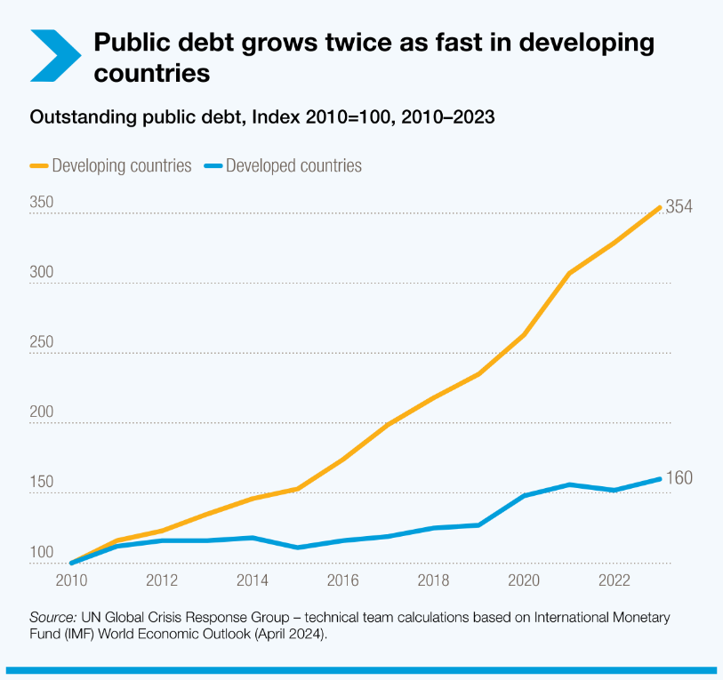
SIMF aligns well with the UK governments growth mission, through its support to global economic stability and sustainable and inclusive growth in markets of the future. It also increases developing countries’ capability to respond and adapt effectively to climate risks and impacts.

There is also evidence to suggest that SIMF’s approach works. For example, repeat TADAT assessments show an increase in scores of nearly 0.3 points (on a scale of 1 to 4), suggesting that TADAT assessments help identify improvements which are then made.

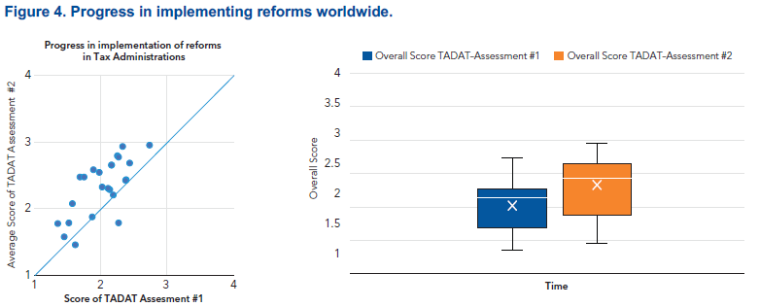

RMTF beneficiary countries observed an average increase of 0.88 percentage points in tax-to-GDP ratios by the program’s conclusion.

Working through the IMF enables the UK to extend the reach of our ODA, drawing on the IMFs deep technical expertise, strong relations with beneficiary countries and global footprint.

This annual review shows that SIMF continues to deliver support that is highly valued by its partners against a challenging backdrop. It shows that vehicles can be consolidated, such as the GPFP and its legacy funds, and work closer aligned, without significant disruption to service.

SIMF continues to provide value for money, as costs are under control, quality is high, outcomes delivered, and the work is appreciated by the beneficiaries. FCDO posts report positively on the work of SIMF vehicles in country.

C. DETAILED OUTPUT SCORING

Output Title | Tax Administration Diagnostic Assessment Tool (TADAT)  Tax authorities in developing countries use TADAT tool to analyse tax administration.
Output number: |  | 1 | Output Score: | B
Impact weighting (%): |  | 10% | Weighting revised since last AR? | No

Indicator(s) | Milestones for this review | Progress
1.1: Number of TADAT assessments completed per annum. | 20 | 13
1.2: TADAT training and assessment is of good quality:  - Proportion of TADAT-trained assessors who are satisfied with the TADAT training course.  - Proportion of TADAT reviewed countries which are satisfied with the assessment team's work. | 90%  90% | 95.6%  93.5%
1.3: Proportion of TADAT diagnostics carried out in LICs or LMICs. | 60% | 44.4%
Briefly describe the output’s activities and provide supporting narrative for the score.

This output scored a B.

TADAT is a diagnostic tool that provides an objective, standardised and comparable assessment of a country’s tax administration system. A TADAT assessment helps country authorities and other stakeholders to:

- understand the relative strengths and weaknesses of their tax administration system;
- set reform objectives; and
- establish and sequence reform priorities.
TADAT closed in October 2024, so this progress reflects the work undertaken up to that point. As TADAT only operated for half of the year, but SIMF still aimed for targets comparable to when it was operating for the full year, some have been missed.

Only 13 TADAT assessments were completed, compared to the target of 20. Positively though, this is a greater rate of TADAT assessments than the year before.

As has been the case throughout the life of the programme, TADAT training and assessment is considered to be of good quality by both the assessors and the countries engaging with it.

TADAT was unable to meet the target of 60% of their diagnostics being carried out in Low-Income Countries (LICs) or Lower Middle-Income Countries (LMICs).

It is worth noting a few of the key achievements of TADAT throughout its 10-year lifespan. It has evolved into one of the most popular tax administration assessment tools globally. 180 TADAT assessments were conducted in 107 countries. TADAT has provided training to more than 4,000 tax officials and tax experts (see chart below). TADAT has also developed into a knowledge hub for capacity development in tax administration – producing over 300 podcasts.

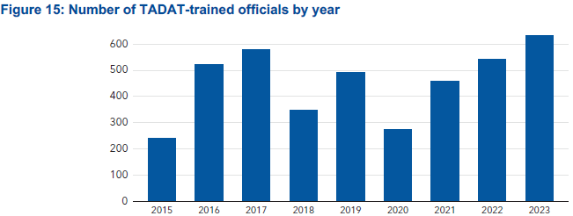

Describe any changes to this output during the past year, and any planned changes as a result of this review.

This work has now been rolled into the GPFP, which will reduce the administrative costs associated with running it separately, and bring more harmony to IMF CD efforts.

Progress on recommendations from the previous AR, lessons learned this year and recommendations for the year ahead.

Although the TADAT Trust Fund has been closed, it’s work continues through the GPFP. Therefore, the recommendations made in the previous annual review apply to the GPFP. Two recommendations were made, concerning the following topics:

Recommendation area | Progress
The TADAT Field Guide | The TADAT Field Guide update for 2025 has not yet been released and socialised. Therefore, FCDO should still ensure that key thematic areas are adequately covered within it.
Impact Measurement | The TADAT 10th Year Report was published in June 2024. It is a snapshot highlighting achievements and impacts of TADAT over the past decade. The report reviews the performance of the tool, measures progress of tax administrations and discusses tax in different topics such as VAT, digitization and transparency.

This annual review makes no new recommendations on TADAT, as it has closed, but carries forward recommendation 1 on the Field Guide.

It does provide the following reflections on TADAT, which will become recommendations for the GPFP:

- Separate customs authorities: TADAT assesses revenue systems, including customs. That is the right approach in principle. However, in countries where revenue and customs authorities are separated, it would be useful to standardise the approach for managing this separation. Each authority should be getting feedback and actions on issues that are within their control.

- Assessor teams: Multi-agency teams of assessors are preferable and should be the default. The UK would like to have the opportunity to engage on TADAT assessments where we have a particular focus on strengthening tax administrations.

- Report sharing: Understandably, some governments do not wish their TADAT reports to be made public. Notwithstanding those constraints, for the purpose of monitoring delivery and coordinating interventions, it would be helpful to find a process by which more of that information can be shared with those funding TADAT (or the GPFP in the future).

- Tax effort and potential: TADAT assessments could evolve to include estimates of tax effort and potential, focused on the administration gap, as opposed to the policy gap, as an additional indicator of effectiveness. It would also be useful information generally.

Output Title | Revenue Mobilisation Thematic Fund (RMTF)  Tax Authorities in Developing Countries use Technical Assistance to improve their Revenue Administration.
Output number: |  | 2 | Output Score: | A+
Impact weighting (%): |  | 10% | Weighting revised since last AR? | No

Indicator(s) | Milestones for this review | Progress
2.1: Number of countries receiving support on development of a Medium-Term Revenue Strategy, or equivalent medium-term plan for domestic revenue mobilisation. | 8 | 15
2.2: Proportion of country projects which are underlain by an analysis of political opportunities for reform & IMF comparative advantage. | 100% | 100%
Briefly describe the output’s activities and provide supporting narrative for the score.

This output scored an A+.

RMTF provides capacity development to low and lower middle-income countries on Domestic Revenue Mobilisation (DRM), including by making use of diagnostic tools such as TADAT. The RMTF operates within a matrix management system that includes the AFRITACs. Its project portfolio has a broad geographical coverage with 38 country-specific and regional CD programs activated worldwide.

RMTF closed in April 2024, however its work has been taken over by the GPFP. The progress reported in this annual review and its accompanying logical framework are from the GPFP.

A target of 8 was set for Output Indicator 2.1, and the GPFP were able to support 15 countries with their MTRSs or similar reform plans. This shows good continuity and is a similar number of countries supported per year under the RMTF.

All GPFP programmes underlaid their projects with political analysis.

It is worth noting a few of the key achievements of the RMTF throughout its 7-year lifespan. RMTF beneficiary countries experienced an average increase of 0.88 percentage points in tax-to-GDP ratios by the program's conclusion, reaching an average tax to Gross Domestic Product (GDP) ratio of 14.5% in 2024 (see chart below). 63% of beneficiary countries improved their tax-to-GDP ratios, whilst some encountered revenue generation hurdles that hindered their fiscal sustainability.

Ongoing RMTF projects were seamlessly transitioned into the GPFP to minimize disruptions to continuing support to countries.

Describe any changes to this output during the past year, and any planned changes as a result of this review.

The work that had been undertaken by RMTF has now been rolled into the GPFP, which will reduce the administrative costs associated with running it separately, and bring more harmony to IMF CD efforts.

Progress on recommendations from the previous AR, lessons learned this year and recommendations for the year ahead.

Although the RMTF has been closed, it’s work continues through the GPFP. One recommendation was made for the RMTF, concerning the following topic:

Recommendation area | Progress
Evaluation of MTRS’s | The RMTF Final Program Report was published in May 2025. It shows that 11 more beneficiary countries are now adopting and utilising MTRS. The report found that the MTRS is a framework that brings together a broad consensus on the level of revenue mobilization effort needed and how it might be achieved. MTRS also serve as a framework for coordinated technical assistance and training. The MTRS helped focus tax system reforms. MTRS made it clearer that integrating good spending design and implementation was critical to ensure the revenue collected was spent well.

This annual review makes no new recommendations on the RMTF, as it has closed.

Output Title | AFRITAC East (AFE)  Member countries improve revenue administration & economic management through tailored support to government institutions to design and implement economic reform plans effectively.
Output number: |  | 3 | Output Score: | B
Impact weighting (%): |  | 40% | Weighting revised since last AR? | No

Indicator(s) | Milestone(s) for this review | Progress
3.1. AFE Member states are supported to improve revenue administration:  - Number of countries supported to strengthen their revenue administration and governance arrangements.  - Number of countries supported to strengthen their core tax administration functions. | 6  7 | 5  7
3.2. AFE Member states are supported to improve budget execution & transparency:  - Number of countries supported to undertake comprehensive, credible and policy-based budget preparation.  - Number of countries supported to improve budget execution and control.  - Number of countries supported to strengthen identification, monitoring and management of fiscal risks. | 3  2  4 | 3  0  5
3.3. AFE Member states are supported to improve fiscal transparency:  - Number of countries supported to improve coverage and quality of fiscal reporting.  - Number of countries supported to improve quality of government finance statistics. | 6  7 | 3  7
3.4. Proportion of country projects which are underlain by an analysis of political opportunities for reform & IMF comparative advantage. | 100% | 100%
Briefly describe the output’s activities and provide supporting narrative for the score.

This output scored a B.

AFE, based in Tanzania, provides technical advice on PFM; revenue administration; monetary policy and operations; financial sector supervision; economic and financial statistics; and macro-economic training. Resident advisors and short-term experts provide technical assistance and training for beneficiary countries’ government staff. AFE is a collaborative venture between the IMF, recipient countries and development partners. AFE serves 8 countries in East Africa, shown on the map below.

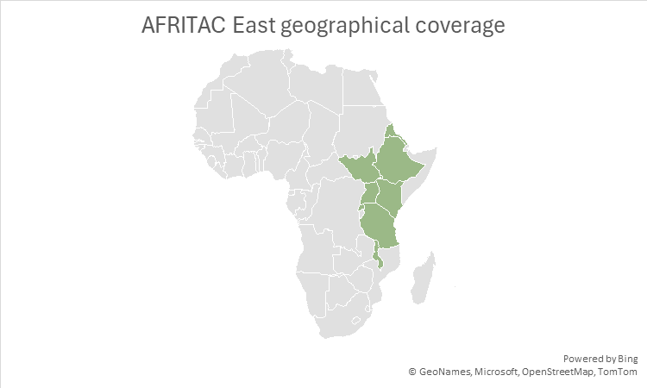

AFE conducted its work in IMF financial year (FY) 2025 against a backdrop of rebounding growth in sub-Saharan Africa, exceeding expectations, but with tough headwinds. Trade tensions and reduced ODA inflows are expected to slow growth, and vulnerabilities remain as financial buffers remain depleted.
AFE conducted 157 CD activities in IMF FY 2025, including 119 technical assistance (TA) missions, 31 bilateral trainings and regional workshops and 7 professional attachments. AFE had a particular focus on Revenue Administration (RA) and PFM and was able to provide considerable support to the East African Community (EAC) (see charts below). More information on AFE activities during IMF FY 2025 is available in AFE’s Annual Report 2025.

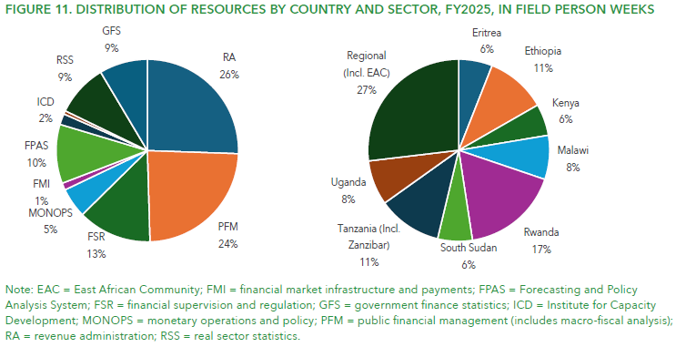

100% of AFE country projects were underlain by an analysis of political opportunities for reform and the IMF’s comparative advantage. It should be noted that this appears to be the result of successful change within AFE, as at the beginning of SIMF, this proportion was only 71%.

Describe any changes to this output during the past year, and any planned changes as a result of this review.

Aside from setting fresh targets for 2025, there were no changes to this output during the past year. As the SIMF programme will run another year, new targets will be set for 2026.

Progress on recommendations from the previous AR, lessons learned this year and recommendations for the year ahead.

The previous annual review made recommendations in the following areas:

Recommendation area | Progress
Gender diversity of short-term consultants | The IMF have shared a breakdown of the gender diversity of short-term consultants with the FCDO for this annual review and the previous one. This is shown in the Value for Money section below (Section D). AFE continues to step up efforts and encourages gender diversity is adopted in all invitation letters to training and regional events. Short-term experts are drawn from the IMF’s system of experts, roster-database.
Results measurement | AFE started internal work to provide more strategic logframes, and will harmonise with the IMF, to avoid creating different reporting mechanisms in the institution.
Delivery in Fragile and Conflict Affected States | The AFE external mid-term evaluation has been ongoing and has included a large number of fragile and conflict-affected states (FCAS) for review (which exceeds the portion of CD resources allocated to them), to learn lessons as an important priority. The amount of resource allocated to FCASs also increased by over 9% from FY24 to FY25. AFE continues to adjust their delivery modalities, work program and content to customize them to the specific needs of the FCASs they work with.

This annual review makes no further recommendations on AFE but carries forward the recommendation on results measurement.

Output Title | AFRITAC South (AFS)  Member countries improve revenue administration & economic management through tailored support to government institutions to design and implement economic reform plans effectively.
Output number: |  | 4 | Output Score: | A
Impact weighting (%): |  | 20% | Weighting revised since last AR? | No

Indicator(s) | Milestone(s) for this review | Progress
4.1: AFS Member states are supported to improve revenue administration:  - Number of countries supported to strengthen their revenue administration and governance arrangements.  - Number of countries supported to strengthen their core tax administration functions. | 12  10 | 11  11
4.2: AFS Member states are supported to improve budget execution & transparency:  - Number of countries supported to undertake comprehensive, credible and policy-based budget preparation.  - Number of countries supported to improve budget execution and control.  - Number of countries supported to strengthen identification, monitoring and management of fiscal risks. | 6  8  6 | 6  8  5
4.3: AFS Member states are supported to improve fiscal transparency:  - Number of countries supported to improve coverage and quality of fiscal reporting.  - Number of countries supported to improve national accounts data. | 6  10 | 9  9
4.4: Proportion of country projects which are underlain by an analysis of political opportunities for reform & IMF comparative advantage. | 100% | 100%
Briefly describe the output’s activities and provide supporting narrative for the score.

This output scored an A.

AFS, based in Mauritius, provides technical advice on PFM; revenue administration (tax and customs); monetary policy and operations; financial sector supervision; financial market infrastructure; economic and financial statistics; financial and fiscal laws and macro-economic training. Resident advisors and short-term experts provide technical assistance and training for beneficiary countries’ government staff. AFS is a collaborative venture between the IMF, recipient countries and development partners. AFS serves 13 countries in Southern Africa and the West Indian Ocean region, shown on the map below.

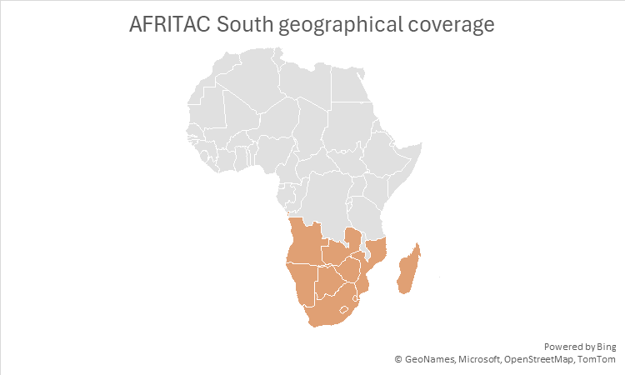

AFS continued to support its partners despite a difficult global outlook, including trade tensions. A third of AFS members face fragile and/or conflict situations. 5 currently have a lending program with the IMF. 3 grapple with double-digit inflation. 1 member is in debt distress. 7 have general government gross debt over 60% of GDP. 9 have more than 0.5% of their GDP exposed to US tariffs.

AFS ran over 145 CD activities, including 25 regional workshops and 2 independent evaluations. AFS trained over 550 officials during the IMF FY. AFS conducted 36% of its work in Fragile and Conflict Affected States (FCAS) (see chart below). Notably, in IMF FY 25, AFS achieved gender parity in female participation (52 percent). More information on AFS activities during IMF FY 2025 is available in AFS’s Annual Report 2025.

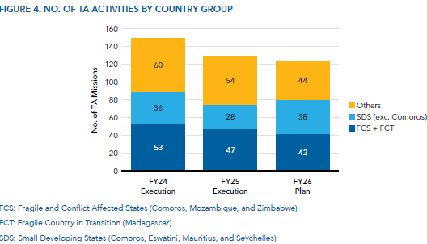

100% of AFS country projects were underlain by an analysis of political opportunities for reform and the IMF’s comparative advantage. It should be noted that this appears to be the result of successful change within AFS, as at the beginning of SIMF, this proportion was only 83%.

Describe any changes to this output during the past year, and any planned changes as a result of this review.

Aside from setting fresh targets for 2025, there were no changes to this output during the past year. As the SIMF programme will run another year, new targets will be set for 2026.

Progress on recommendations from the previous AR, lessons learned this year and recommendations for the year ahead.

The previous annual review made recommendations in the following areas:

Recommendation area | Progress
Structured reporting on impact | AFS’s outreach documents (such as their Annual Report, newsletters and presentations to development partners) highlight the most recent CD success stories. These stories set out the challenges faced by the countries, the support provided by AFS and the ensuing results from the technical assistance and training provided.
Delivery in Fragile and Conflict Affected States | AFS delivers targeted technical assistance and training to Comoros, Mozambique, and Zimbabwe (FCAS countries) to support government reform initiatives. They remain aligned with IMF’s CD and FCAS strategies and adapted to the local needs. This approach has supported several success stories, including achievement of IMF-agreed structural benchmarks. With backing from Japan, resident advisors also offer expertise on debt legislation and management. A new AFS and Fiscal Affairs Department (FAD) supported project in Zimbabwe aims to develop a small trader program for the informal sector to give defined benefits to help women traders and other marginalized groups.

This annual review makes no further recommendations on AFS.

Output Title | AFRITAC West 2 (AFW2)  Member countries improve revenue administration & economic management through tailored support to government institutions to design and implement economic reform plans effectively.
Output number: |  | 5 | Output Score: | A
Impact weighting (%): |  | 20% | Weighting revised since last AR? | No

Indicator(s) | Milestone(s) for this review | Progress
5.1: AFW2 Member states are supported to improve revenue administration:  - Number of countries supported to strengthen their revenue administration and governance arrangements.  - Number of countries supported to strengthen their core tax administration functions. | 6  6 | 6  6
5.2: AFW2 Member states are supported to improve budget execution & transparency:  - Number of countries supported to undertake comprehensive, credible and policy-based budget preparation.  - Number of countries supported to improve budget execution and control.  - Number of countries supported to strengthen identification, monitoring and management of fiscal risks. | 6  6  6 | 6  6  3
5.3: AFW2 Member states are supported to improve fiscal transparency:  - Number of countries supported to improve coverage and quality of fiscal reporting.  - Number of countries supported to improve national accounts data. | 6  6 | 6  6
5.4: Proportion of country projects which are underlain by an analysis of political opportunities for reform & IMF comparative advantage. | 100% | 100%
Briefly describe the output’s activities and provide supporting narrative for the score.

This output scored an A.

AFW2, based in Ghana, provides technical advice on PFM; revenue administration; monetary policy and operations; financial sector supervision; economic and financial statistics; and macro-economic training. Resident advisors and short-term experts provide technical assistance and training for beneficiary countries’ government staff. AFW2 is a collaborative venture between the IMF, recipient countries and development partners. AFW2 serves 6 countries in anglophone West Africa, shown on the map below.

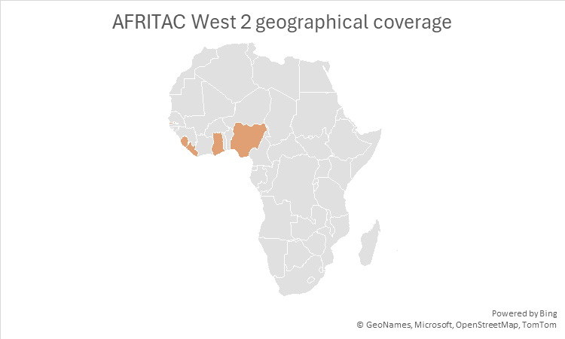

The region’s recovery in 2024 following the crises over the past four years has been interrupted by new shocks in 2025.

AFW2 celebrated 10 years of building macroeconomic capacity in Anglophone West Africa in 2024. At end- April 30, 2025, AFW2 executed 136 CD activities including 107 TA missions, 24 regional and interregional workshops, and 5 professional attachments.

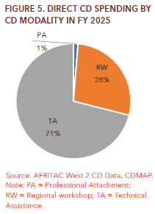

100% of AFW2 country projects were underlain by an analysis of political opportunities for reform and the IMF’s comparative advantage. It should be noted that this appears to be the result of successful change within AFW2, as at the beginning of SIMF, this proportion was only 34%.

Describe any changes to this output during the past year, and any planned changes as a result of this review.

Aside from setting fresh targets for 2025, there were no changes to this output during the past year.

Progress on recommendations from the previous AR, lessons learned this year and recommendations for the year ahead.

The previous annual review made recommendations in the following areas:

Recommendation area | Progress
Budget execution and transparency | Budget utilisation in IMF FY 2025 was 92%, slightly down on 96% in IMF FY 2024. However, a larger number of CD activities were achieved in IMF FY 2025 (136 compared to 133). Total spend ($8.3m) in IMF FY 2025 was slightly down on IMF FY 2024 ($8.4m).
Delivery in Fragile and Conflict Affected States | Nigeria is AFW2’s only FCAS State.  In FY 2025, 9% of direct CD spending went to Nigeria.  An in-country resident advisor continues to work on tax policy and administration, with support from AFW2 LTXs. Nigeria has participated in almost all regional and peer-learning activities.  Following the 12th Steering Committee Meeting in Abuja, on July 7-8, 2025, AFW2 management and advisors have strengthened engagement with country authorities towards improved traction and successful execution of the FY 2026 workplan which is currently ongoing.

This annual review makes no further recommendations on AFS.

D: VALUE FOR MONEY

Key cost drivers and performance

SIMF disbursed £2.5m in financial year (FY) 2024/25. This is an 150% increase on the £1m disbursed in FY 2023/24, and is the highest disbursement under the programme since FY 2020/21. The UK is also a major shareholder in the IMF.

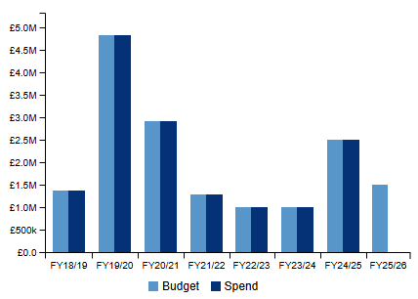

The FCDO and the IMF apply a structured framework to assess the value for money (VfM) of IMF CD initiatives. Each year, the IMF provides FCDO with a VfM report covering cost-effectiveness drawing on data on salaries, expert fees, travel, and operational expenses.

FCDO also receives annual reports on staff costs, including the professional and managerial distribution by nationality and gender. While costs have risen with the return of in-person delivery, the IMF’s cost-control measures, financial oversight, and structured staffing approach continue to support VfM in CD delivery.

Aligned with the VfM proposition of the SIMF business case, the assessment considers the “4Es”: Economy, Efficiency, Effectiveness, and Equity, drawing on key statistics from the 2017 to 2025 findings.

Economy

Economy is measured by the average cost of the ‘CD day’, representing the daily cost of the IMF staff delivering capacity development. Personnel costs - covering salaries, allowances, and benefits for resident long-term experts (LTX) and short-term experts (STX) continue to be the largest expenditure category during this year’s report. Salaries, benchmarked against World Bank and UN scales are relatively high, but reflect the technical expertise required and the organisation’s strong reputation. The IMF actively manages staffing using STX in place of LTX where it offers better value.

VFM Measure |  | 2017 | 2018 | 2019 | 2020 | 2021 | 2022 | 2023 | 2024 | 2025
Average cost of a Capacity Development (CD) Day  Amount charged to subaccount / Number of CD days (TA mission days for staff, training days (inc. preparation time), LTX and STX (inc. travel, pre and post), desk-based TA, backstopping, project management) | AFE | $1,981 | $1,605 | $1,669 | $1,650 | $1,069 | $1,126 | $1,394 | $1,692 | $1,909
 | AFS | $2,225 | $2,185 | $1,825 | $1,825 | $1,146 | 1,235 | $1,664 | $1,810 | $1,884
 | AFWII | n/a | $1,312 | $2,035 | $1,783 | $962 | $1,313 | $1,860 | $1,778 | $2,021
 | RMTF | n/a | $1,550 | $1,486 | $1,553 | $1,031 | $1,148 | $1,406 | $1,332 | n/a
 | TADAT | $1,200 | $1,200 | $1,135 | $1,190 | $1,059 | $1,230 | $1,430 | $1,730 | $4,244

In 2025, the average cost of a Capacity Development (CD) day rose across all active SIMF vehicles compared to 2024, driven by a return to in-person delivery and increased use of short-term experts. AFE increased from $1,692 to $1,909, AFS from $1,810 to $1,884, and AFW2 from $1,778 to $2,021. TADAT saw a sharp rise from $1,730 to $4,244 is due to the massive reduction (89%) in the number of CD days, but within the context of some continued expenditure on project management costs to wind down and integrate (into GPFP) operations. IMF divided the inputs by 11% of the prior number of days so it produces a high per day cost in the final FY. RMTF was discontinued and did not report 2025 data.

Efficiency: Efficiency is measured by 1) the average cost of a participant day, that is, the average amount of expense required for an individual to receive a day of technical assistance from the IMF and 2) The execution or actual spend against annual working budgets.

VFM Measure |  | 2017 | 2018 | 2019 | 2020 | 2021 | 2022 | 2023 | 2024 | 2025
Average cost of a participant day: Workshops or Peer Learning Event  FY Participant costs / (Participants *days present)  FY onwards Participant costs (Travel) + Staff (Salary + Travel) + STX (Salary + Travel) / (Participants *days present) | AFE | $473 | $675 | $615 | $718 | $194 | $90 | $509 | $475 | $612
 | AFS | $339 | $328 | $339 | $341 | $19 | $117 | $336 | $365 | $565
 | AFW2 | n/a | $452 | $368 | $458 | $21 | $177 | $274 | $506 | $654
 | RMTF | n/a | $491 | $237 | $342 | $42 | $48 | $337 | $475 | n/a
 | TADAT | $38 | $174 | $204 | n/a | n/a | $13 | $18 | $86 | $115

The average cost rose in FY25 due to two main reasons: 1) nearly all interactive learning events were conducted in person, with only taking place in hybrid formats. 2) More STXs were hired to support the delivery of the courses in emerging fields such as climate.

The rise in FY2025 costs reflects several factors: higher costs of experts, interpretation costs, and a strong return to in-person delivery, which has driven up travel and accommodation expenses. Further contributors include the engagement of specialized short-term experts for emerging topic areas such as climate, alongside inflationary pressures affecting airfare and hotel rates.

To mitigate these trends, measures are being implemented by the IMF to enhance cost efficiency, including optimizing workshop scheduling to reduce travel and hotel costs, renegotiating rates with vendors, incorporating hybrid delivery where appropriate, applying results-based management to prioritize high-impact activities, and strengthening budget monitoring to address potential overruns. The IMF remains committed to delivering high-quality capacity development while ensuring prudent use of resources.

Initiatives include:
- reducing costs for all services with competition on all contracts
- using ATI training space (which is co-located) and interpreters more efficiently
- careful use of the composition of faculty - maximizing use of the ATI faculty (which is co-located with AFS)
- joint procurement by ATI and AFS to maximize scale economies

Budget execution improved for AFE, AFS, and TADAT in 2025, showing better alignment of spending with planned activities. AFW2 saw a slight decline, though it remained above the 80% target threshold.

VFM Measure |  | 2024 | 2025
Working budget execution | AFRITAC East | 70% | 80%
Working budget execution | AFRITAC South | 89% | 96%
Working budget execution | AFRITAC West 2 | 97% | 93%
Working budget execution | RMTF | 100% | n/a
Working budget execution | TADAT | 96% | 100%

Effectiveness: Cost effectiveness is measured as the percentage of outcomes judged as largely or fully achieved via the RBM system which are reported in annual reports.

VFM Measure |  | 2023 | 2024 | 2025
Percentage of outcomes largely or fully achieved via the RBM system | AFE | 57% | 44% | 50%
 | AFS | 62% | 46% | 48%
 | AFW 2 | 57% | 37% | N/A
 | RMTF | 53% | 65% | N/A
 | TADAT | N/A | N/A | N/A

Equity: Equity metrics were not captured in the Business case but we have considered the equity from the perspective of hiring decisions, access to CD and content of technical assistance.

The gender and regional ratios are calculated based on number of missions, not distinct number of individual STX, meaning the same expert may be counted multiple times if they delivered multiple missions throughout the year in different RTACs.

Gender Balance of STX

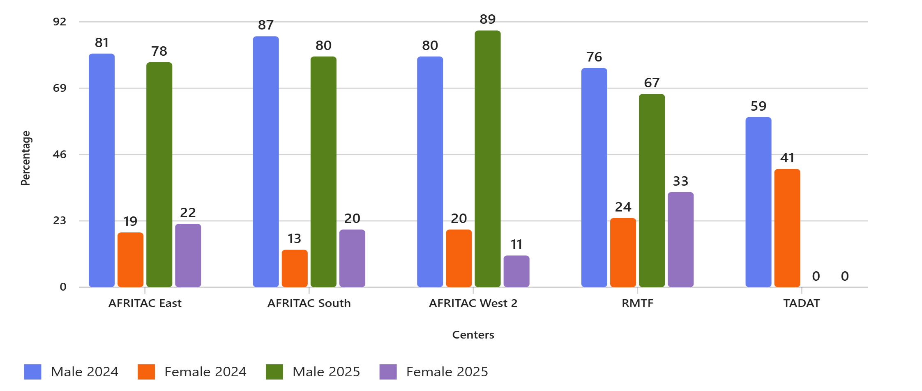

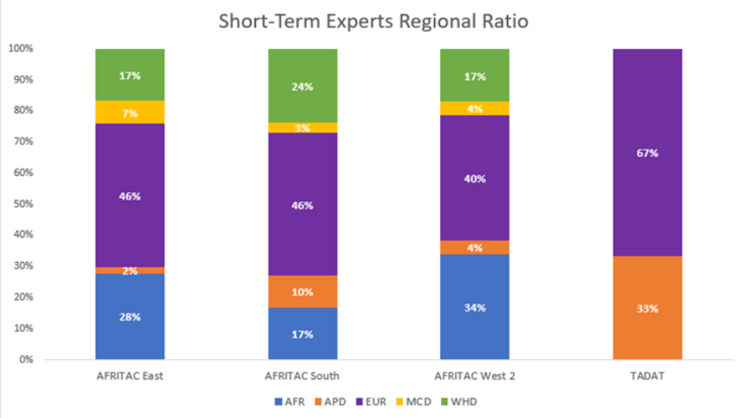

The IMF’s short-term expert (STX) hiring process relies on informal departmental networks, which has limited gender and regional diversity in the STX pool. While the share of female and regional experts has grown in recent years, disparities remain. This lack of diversity may hinder the effectiveness of technical assistance.

The graphic shows continued efforts toward improving equity in technical assistance delivery, yet gender representation among STX missions in 2025 remains uneven across vehicles, reflecting a predominantly male profile. For example, AFRITAC East improved female representation from 19% in 2024 to 22% in 2025, while AFRITAC South rose from 13% to 20%, signalling progress. In opposition, AFRITAC West 2 saw female participation decline from 20% to 11%, increasing the gender gap. RMTF demonstrated the strongest improvement, with female representation growing from 24% to 33%, while TADAT remained at 41% female in 2024, with no 2025 data reported. Overall, the trend indicates that while improvements have been made, further efforts are needed to ensure consistent gender balance across all components of the program.

VfM performance compared to the original VfM proposition in the business case.

As anticipated, the key cost drivers are related to staffing. Salaries of IMF HQ staff are set by an IMF Executive Board-approved process. Salaries of IMF Experts (LTX and STX) are set against a shadow IMF staff grade and reflect individual skills and experience. Salaries of local staff (e.g. office managers in RTACS) are set using United Nation (UN) scales. Cost metrics remain comparable to previous years.

Assessment of whether the programme continues to represent value for money.

SIMF continues to provide value for money. Whilst there have been some increases in cost metrics that need to be interrogated, the work continues to be of high-quality and valued by partners. Feedback from FCDO posts on the work undertaken by SIMF vehicles is also positive.

E: RISK

Overview of risk management

The programmes risk rating is Minor.

We are monitoring 17 active risks associated with the programme, of which 9 have a minor residual risk after mitigation and 8 have a moderate residual risk after mitigation. There are no risks that sit outside the FCDO’s risk appetite for the programme. Risks are reviewed on a quarterly basis.

Three principal risks are identified below.

- Monitoring and Evaluation: The IMF continues to face challenges in measuring long-term impact, cost-effectiveness, and integrating M&E findings into its broader capacity development strategy. While progress across components has been uneven thus far, the IMF staff are working to build on and refine the current RBM framework and platform to develop a set of high-level indicators to measure progress and inform CD strategically at the country level as well as to promote learning. While progress has been made in linking capacity development outcomes with activities, further improvements are required. FCDO should continue to encourage reforms in line with recent recommendations.

- Coordination with Donor Partners: Engagement with other development agencies or NGOs is not always sufficiently structured, which can lead to technical assistance being directed to areas with limited reform potential, and fragmented CD support. FCDO will continue to support efforts to strengthen donor coordination, utilising common donor platforms, in line with commitments under the IMF’s capacity development strategy.

- Sufficient Donor Funding: Although IMF capacity development programmes remain broadly well supported, certain components face funding pressures as they enter new phases amid declining aid budgets and competing priorities. This includes SIMF-supported vehicles such as AFS and AFW2, which have some of the shortest liquidity projections among IMF RCDCs. Continued donor engagement will be essential to ensure delivery, value for money, and complementarity with other multilateral and bilateral initiatives. Beyond maintaining current donor contributions, there is a growing need to increase coordination with other development partners, including bilateral donors, to ensure that they can help meet key CD needs in a complementary manner.

All other risks remain moderate or minor. The IMF’s financial management systems are considered strong, with effective controls that ensure FCDO funds are allocated and spent in line with agreed workplans. The IMF assumes the risks of exchange rate fluctuations, operates with robust oversight mechanisms, and carries no unacceptable fiduciary or reputational risks. Its in-house delivery model and administrative capacity provide additional assurance of effective programme management.
F: PROGRAMME MANAGEMENT: DELIVERY, COMMERCIAL & FINANCIAL PERFORMANCE

Summarise the performance of partners and FCDO, notably on commercial and financial issues.

The partnership with the IMF remains strong and well established, supported by regular and structured communication. The IMF ensures that FCDO and other stakeholders are kept informed throughout the project cycle through a mix of formal mechanisms such as Steering Committees, statutory reporting such as annual reports including financial reports and quarterly newsletters as well as regular check-ins. There are also helpful communications products such as newsletters and bulletins. These efforts have strengthened collaboration, although some challenges remain around the timeliness and transparency of data, which can limit real-time decision-making and oversight.

On financial management, the IMF maintains robust systems and controls that help mitigate the risk of fraud or misuse of funds. Funding allocations are closely linked to each component’s financial position and related workplans, ensuring alignment with programme priorities.

The Partners Connect platform is the primary tool for financial monitoring, offering insights into funding gaps and cash balances across Trust Funds (TFs) and Regional Technical Assistance Centres (RTACs). However, delays in updating this data have occasionally constrained FCDO’s ability to maintain a fully accurate financial overview. To help address this, the IMF has provided tailored financial reports upon request, which has improved access to critical information.

G: MONITORING, EVIDENCE AND LEARNING

Monitoring and Evaluation
This annual review has been prepared in collaboration with the IMF and the FCDO network. The IMF provided data for the logframe and qualitative inputs, as well as being collaborative and cooperative throughout the year. Further information was gathered through desk-based research.

The logframe itself has been designed from the outset to harmonise with the IMF’s Results Based Management (RBM) system. That ensures that the outputs, outcomes and milestones are comparable across contexts.

Evidence
The IMF continue to be cooperative by providing valuable data on the gender and regional breakdown of their short-term consultants.

The 2024 Review of the Fund’s Capacity Development Strategy (CDSR) recommended enhancing monitoring and evaluation and better linking it to strategy development. Work to implement the CDSR recommendations is underway, and staff have been prioritizing implementation of the highest priority recommendations, which includes work on monitoring and evaluation. Staff are working to build on and refine the current RBM framework and platform to develop a set of high-level indicators to measure progress and inform CD strategically at the country level as well as to promote learning. The IMF is also working to build on existing results narratives to develop a more consistent approach to reporting CD results, and Theories of Change to articulate how CD project results associated with specific workstreams are expected to lead to high-level results captured by the indicators.

Learning
The main formal learning mechanisms of SIMF components are annual and semi-annual steering committee meetings including recipients and supporting donors during which an update is provided on progress and lessons from delivery are discussed.

Evaluations are conducted mid-way in each 5-year funding phase and provide updates on progress against objectives and evaluate delivery against the Organisation for Economic Co-operation and Development (OECD) Development Assistance Committee (DAC) criteria.

The IMF has recently begun conducting thematic evaluations across CD delivery vehicles.

Finally, the overall CD Strategy of IMF is reviewed every 5-years, and this is usually informed by an analysis conducted by the Independent Evaluation Office.

Date of last narrative financial report | TADAT: 30/04/2025  RMTF: N/A  AFE: 11/08/2025  AFS: 02/10/2025  AFW2: 09/10/2025  GPFP: 30/06/2025 | Date of last audited annual statement | TADAT: 30/04/2025  RMTF: N/A  AFE: 11/08/2025  AFS: 02/10/2025  AFW2: 09/10/2025  GPFP: 30/06/2025

Annex I: Acronym guide

AFE | AFRITAC East
AFRITAC | African Regional Technical Assistance Centre
AFS | AFRITAC South
AFW2 | AFRITAC West 2
CD | Capacity Development
CDSR | Capacity Development Strategy Review
CoE | Centre(s) of Expertise
DAC | Development Assistance Committee
DfID | Department for International Development
DRF | Disaster Risk Finance
DRM | Domestic Revenue Mobilisation
EAC | East African Community
FAD | Fiscal Affairs Department
FCAS | Fragile and Conflict-Affected State(s)
FCDO | Foreign, Commonwealth and Development Office
FY | Financial Year
GDP | Gross Domestic Product
GPFP | Global Public Finance Partnership
IMF | International Monetary Fund
LIC | Low-Income Country(ies)
LMIC | Lower Middle-Income Country(ies)
Logframe | Logical Framework
LTX | Long-term experts
MTRS | Medium-Term Revenue Strategy(ies)
ODA | Official Development Assistance
OECD | Organisation for Economic Co-operation and Development
PFM | Public Financial Management
PIM | Public Investment Management
RA | Revenue Administration
RBM | Results Based Management
RMTF | Revenue Mobilisation Thematic Fund
SIMF | Supporting the International Monetary Fund
STX | Short-term experts
TA | Technical Assistance
TADAT | Tax Administration Diagnostic Assessment Tool
ToC | Theory of Change
UN | United Nations
VfM | Value for Money

Annex II: SIMF Theory of Change

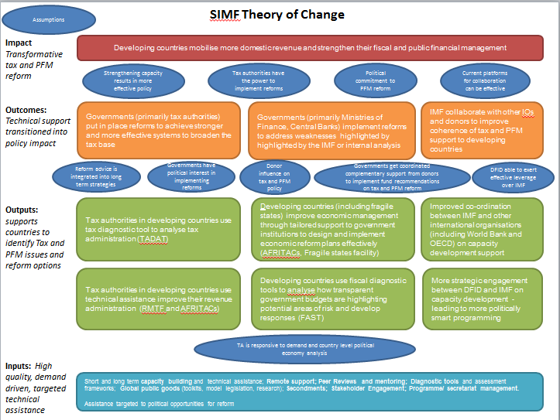

Annex III: Impact Indicators country level detail

 |  |  |  |  |  |  |  | 2017 |  |  | 2024 |  |  | Change between 2017 and 2024
Country | Income Group | TADAT | RMTF | AFE | AFS | AFW2 | GPFP | GGR/GDP | PNB/GDP | GGGD/GDP | GGR/GDP | PNB/GDP | GGGD/GDP | GGR/GDP | PNB/GDP | GGGD/GDP
 | Totals: | 6 | 44 | 7 | 9 | 5 | 43 | - | - | - | - | - | - | 33 | 29 | 13
Angola | Lower middle income | No | Yes | No | Yes | No | No | 15.3% | -2.6% | 60.5% | 16.5% | 3.9% | 62.5% | 1.2% | 6.5% | 2.0%
Benin | Lower middle income | No | Yes | No | No | No | Yes | 13.6% | -2.8% | 39.6% | 15.2% | -1.3% | 54.0% | 1.6% | 1.5% | 14.4%
Bolivia | Lower middle income | No | Yes | No | No | No | Yes | 30.8% | -6.7% | 51.3% | 28.4% | -7.3% | 95.0% | -2.4% | -0.5% | 43.8%
Burkina Faso | Low income | No | Yes | No | No | No | No | 19.3% | -6.1% | 33.9% | 21.0% | -3.5% | 52.7% | 1.7% | 2.5% | 18.8%
Burundi | Low income | Yes | Yes | No | No | No | No | 19.1% | -4.3% | 46.9% | 17.6% | -3.4% | 43.2% | -1.5% | 0.9% | -3.7%
Cambodia | Lower middle income | No | Yes | No | No | No | No | 15.4% | -0.5% | 22.6% | 14.6% | -2.8% | 26.6% | -0.8% | -2.3% | 4.0%
Cameroon | Lower middle income | Yes | Yes | No | No | No | Yes | 14.5% | -3.9% | 36.5% | 16.0% | 0.4% | 42.7% | 1.5% | 4.3% | 6.1%
Central African Republic | Low income | No | Yes | No | No | No | Yes | 12.8% | -0.7% | 50.3% | 14.6% | -4.1% | 60.7% | 1.8% | -3.4% | 10.4%
Chad | Low income | No | Yes | No | No | No | Yes | 11.1% | 1.0% | 38.9% | 16.6% | -0.7% | 33.8% | 5.6% | -1.7% | -5.1%
Comoros | Lower middle income | No | Yes | No | Yes | No | Yes | 18.8% | 0.0% | 18.9% | 16.4% | -3.2% | 30.8% | -2.3% | -3.2% | 11.9%
Democratic Republic of the Congo | Low income | No | Yes | No | No | No | Yes | 10.6% | 0.5% | 23.2% | 15.8% | -1.5% | 19.3% | 5.2% | -2.0% | -3.9%
Republic of Congo | Lower middle income | No | Yes | No | No | No | Yes | 21.0% | -4.0% | 88.5% | 25.4% | 6.5% | 95.4% | 4.4% | 10.5% | 7.0%
Cote d'Ivoire | Lower middle income | No | Yes | No | No | No | Yes | 14.8% | -2.0% | 32.6% | 16.4% | -1.3% | 59.3% | 1.6% | 0.7% | 26.7%
Djibouti | Lower middle income | No | No | No | No | No | Yes | 23.7% | 0.8% | 48.0% | 17.5% | -4.2% | 33.3% | -6.2% | -5.1% | -14.7%
Eritrea | Low income | No | No | Yes | No | No | No | 36.8% | -3.6% | 290.4% | - | - | - | - | - | -
Eswatini | Lower middle income | No | Yes | No | Yes | No | No | 28.2% | -5.7% | 21.9% | 29.9% | 1.1% | 36.4% | 1.6% | 6.8% | 14.5%
The Gambia | Low income | No | No | No | No | Yes | Yes | 19.3% | 0.0% | 87.0% | 20.5% | -1.0% | 72.9% | 1.2% | -1.0% | -14.0%
Ghana | Lower middle income | No | Yes | No | No | Yes | Yes | 13.6% | 1.2% | 57.0% | 15.6% | -3.7% | 70.5% | 2.0% | -4.9% | 13.5%
Guinea | Lower middle income | No | Yes | No | No | No | No | 15.3% | -1.1% | 41.9% | 13.9% | -2.0% | 47.8% | -1.4% | -0.9% | 6.0%
Guinea-Bissau | Low income | No | Yes | No | No | No | Yes | 16.8% | -0.8% | 51.8% | 13.6% | -3.9% | 82.3% | -3.2% | -3.1% | 30.5%
Haiti | Lower middle income | No | Yes | No | No | No | Yes | 9.9% | -0.2% | 22.5% | 11.5% | 6.9% | 14.9% | 1.6% | 7.1% | -7.6%
Honduras | Lower middle income | No | Yes | No | No | No | Yes | 26.5% | 0.2% | 41.5% | 24.9% | 0.5% | 42.6% | -1.6% | 0.3% | 1.1%
Jordan | Lower middle income | No | No | No | No | No | Yes | 25.1% | -0.7% | 75.7% | 25.0% | -2.8% | 95.9% | -0.1% | -2.1% | 20.2%
Kenya | Lower middle income | No | Yes | Yes | No | No | Yes | 17.8% | -4.2% | 53.9% | 17.4% | -0.4% | 65.6% | -0.4% | 3.8% | 11.7%
Lebanon | Lower middle income | No | Yes | No | No | No | Yes | 21.9% | 0.8% | 150.0% | 16.4% | 1.1% | 164.1% | -5.5% | 0.3% | 14.1%
Lesotho | Lower middle income | No | No | No | Yes | No | Yes | 48.4% | -1.0% | 41.0% | 60.7% | 10.0% | 59.8% | 12.3% | 11.0% | 18.8%
Liberia | Low income | Yes | Yes | No | No | Yes | Yes | 27.9% | -6.7% | 31.8% | 19.2% | -1.6% | 56.5% | -8.7% | 5.1% | 24.6%
Madagascar | Low income | No | No | No | Yes | No | Yes | 12.8% | -1.4% | 40.1% | 13.6% | -2.2% | 50.4% | 0.8% | -0.8% | 10.3%
Malawi | Low income | No | Yes | Yes | No | No | Yes | 15.8% | -2.4% | 40.0% | 18.3% | -1.5% | 74.4% | 2.5% | 0.9% | 34.4%
Mali | Low income | No | Yes | No | No | No | No | 20.1% | -2.0% | 38.2% | 22.1% | -0.8% | 51.8% | 2.1% | 1.2% | 13.6%
Mauritania | Lower middle income | No | Yes | No | No | No | Yes | 20.8% | 1.4% | 55.7% | 24.0% | 0.9% | 44.9% | 3.2% | -0.6% | -10.7%
Mozambique | Low income | No | No | No | Yes | No | Yes | 26.6% | 1.0% | 103.8% | 27.5% | -2.3% | 96.6% | 0.9% | -3.2% | -7.2%
Myanmar | Lower middle income | No | Yes | No | No | No | No | 16.3% | -2.0% | 41.9% | 15.2% | -2.7% | 61.3% | -1.0% | -0.8% | 19.4%
Namibia | Lower middle income | No | No | No | Yes | No | No | 33.1% | -2.0% | 43.8% | 36.3% | 1.6% | 67.7% | 3.2% | 3.6% | 23.9%
Nepal | Lower middle income | No | No | No | No | No | Yes | 20.9% | -2.4% | 25.0% | 19.2% | -1.3% | 47.9% | -1.8% | 1.1% | 22.9%
Niger | Low income | No | Yes | No | No | No | No | 15.4% | -3.4% | 36.5% | 9.2% | -2.5% | 47.2% | -6.2% | 0.9% | 10.7%
Nigeria | Lower middle income | No | No | No | No | Yes | Yes | 6.6% | -4.1% | 25.4% | 14.4% | -0.8% | 52.9% | 7.9% | 3.2% | 27.5%
Pakistan | Lower middle income | No | Yes | No | No | No | Yes | 14.0% | -1.4% | 62.1% | 12.6% | 1.0% | 70.1% | -1.3% | 2.3% | 7.9%
Papua New Guinea | Lower middle income | Yes | Yes | No | No | No | Yes | 15.9% | -0.4% | 32.5% | 16.7% | -1.2% | 53.7% | 0.8% | -0.9% | 21.2%
Philippines | Lower middle income | Yes | Yes | No | No | No | Yes | 18.7% | 0.9% | 38.1% | 21.1% | -1.4% | 57.1% | 2.4% | -2.3% | 18.9%
Rwanda | Low income | No | Yes | Yes | No | No | Yes | 22.6% | -1.5% | 45.6% | 22.2% | -4.2% | 67.2% | -0.4% | -2.7% | 21.6%
Sâo Tome and Principe | Lower middle income | No | Yes | No | No | No | No | 28.8% | -2.5% | 74.7% | 20.2% | 1.7% | 43.5% | -8.6% | 4.2% | -31.3%
Senegal | Lower middle income | No | Yes | No | No | No | Yes | 19.5% | -1.1% | 61.1% | 19.3% | -7.6% | 113.7% | -0.2% | -6.5% | 52.5%
Sierra Leone | Low income | No | Yes | No | No | Yes | Yes | 9.4% | -4.2% | 44.2% | 13.0% | -2.0% | 43.0% | 3.7% | 2.2% | -1.2%
Somalia | Low income | No | Yes | No | No | No | No | 3.3% | 0.4% | - | 7.5% | 0.2% | - | 4.3% | -0.2% | -
South Sudan | Low income | No | Yes | Yes | No | No | Yes | 97.4% | 9.5% | 163.0% | 24.2% | 5.2% | 54.3% | -73.2% | -4.3% | -108.6%
Sri Lanka | Lower middle income | No | Yes | No | No | No | No | 12.8% | 0.0% | 72.3% | 13.7% | 2.2% | 99.4% | 0.9% | 2.2% | 27.2%
Syria | Low income | No | No | No | No | No | Yes | - | - | - | - | - | - | - | - | -
Tajikistan | Lower middle income | No | No | No | No | No | Yes | 28.1% | -5.2% | 46.3% | 27.5% | -1.8% | 29.5% | -0.6% | 3.4% | -16.8%
Tanzania | Lower middle income | No | Yes | Yes | No | No | Yes | 15.2% | 0.4% | 40.1% | 15.8% | -0.6% | 48.2% | 0.6% | -1.0% | 8.1%
Togo | Low income | No | Yes | No | No | No | Yes | 16.1% | 1.1% | 57.1% | 18.8% | -2.2% | 70.6% | 2.8% | -3.3% | 13.5%
Tunisia | Lower middle income | No | Yes | No | No | No | Yes | 23.1% | -3.4% | 67.1% | 27.9% | -1.9% | 83.1% | 4.8% | 1.5% | 16.0%
Uganda | Low income | No | Yes | Yes | No | No | Yes | 12.5% | -1.8% | 33.6% | 14.6% | -2.2% | 51.8% | 2.2% | -0.4% | 18.2%
Uzbekistan | Lower middle income | No | Yes | No | No | No | Yes | 20.9% | 0.8% | 17.3% | 25.5% | -1.6% | 32.7% | 4.6% | -2.5% | 15.4%
Yemen | Low income | No | No | No | No | No | Yes | 3.5% | -4.7% | 83.8% | 6.4% | -0.4% | 70.9% | 2.9% | 4.3% | -12.8%
Zambia | Lower middle income | No | Yes | No | Yes | No | Yes | 17.5% | -3.5% | 66.6% | 22.2% | 2.9% | 114.9% | 4.7% | 6.4% | 48.3%
Zimbabwe | Lower middle income | Yes | Yes | No | Yes | No | Yes | 17.5% | -9.4% | 68.9% | 16.6% | -1.1% | 94.6% | -0.9% | 8.3% | 25.7%

An Acronym Guide is included as Annex I.
At the time the SIMF business case was prepared, AFRITAC West 2 was prioritised over AFRITAC West due to a more favourable coverage of Department for International Development (DfID) priority countries.
It should be noted that GPFP has not been discussed in isolation in this review, as it does not currently have its own section of the logical framework. When the logical framework is agreed for the next period, consideration will be given as to whether the GPFP should have new distinct Output Indicators.
The SIMF Annual Review 2024 is available here: https://iati.fcdo.gov.uk/iati_documents/D0006104.odt
The RMTF Final Program Report can be accessed here: https://gpfp.imf.org/content/dam/GPFP/Documents/RMTF-Final-Program-Report-and-Assessment.pdf
The ten countries who developed, adopted and/or implemented the MTRS framework with RMTF support are: Benin, Côte d’Ivoire, Ethiopia, Ghana, Kenya, Papua New Guinea, Rwanda, Senegal, Sierra Leone, Uzbekistan and Uganda.
The Theory of Change is included as Annex II.
Outcome Indicators are distinct from the Outputs of the programme, which are discussed in detail in Section C. Outcome Indicators identify what will change as a result of the Outputs generated by the programme. In the case of SIMF, an Output might be a specific project or training course. The Outcome is an improved policy in the supported country.
Please note that some countries supported by GPFP were also supported by the AFRITACs, and GPFP also supported some countries that are not reached by the AFRITACs under the SIMF programme, hence why the subtotals do not add to the total.
Impact Indicators measure the long-term goal the project is contributing to achieving. In the case of SIMF, this is improving key macro-economic indicators, such as the ratio of revenue to GDP. This way, by following the logic chain set out in the ToC, we can see if the programme has had an impact. For example: Did the training happen and was it of sufficient quality? Did the training lead to policy changes? Did the policy changes lead to improvements in fiscal metrics?
Please note that because this annual review has been prepared in 2025, the results shown here compare the indicator in question in 2024 compared with 2017, as 2024 is the last year of complete data in most cases. Where data is incomplete, the IMF provides estimates, which have been used where necessary, but the year from which estimates begin vary by country and indicator.
The OECD projects a 9 to 17% drop in official development assistance (ODA) in 2025. ODA in 2027 is projected to fall back to 2020 levels. Needs continue to grow, and the projected ODA cuts will impact the poorest countries and vital services hardest. Source: Cuts in official development assistance: Full Report | OECD
This chat is based on Foreign, Commonwealth and Development Office (FCDO) calculations using World Bank data. It should be noted that there is no data available in the dataset for many low-income countries.
Source: Debt crisis: Developing countries’ external debt hits record $11.4 trillion | UN Trade and Development (UNCTAD)
The TADAT 10th Year Report is available here: https://www.tadat.org/en/tadat-anniversary/tadat-anniversary.html
The RMTF Final Program Report can be accessed here: https://gpfp.imf.org/content/dam/GPFP/Documents/RMTF-Final-Program-Report-and-Assessment.pdf
The 11 countries who developed, adopted and/or implemented the MTRS framework with RMTF support are: Benin, Côte d’Ivoire, Ethiopia, Ghana, Kenya, Papua New Guinea, Rwanda, Senegal, Sierra Leone, Uzbekistan and Uganda.
Eritrea, Ethiopia, Kenya, Malawi, Rwanda, South Sudan, Tanzania and Uganda.
Please note that a ‘Field Person Week’ equals six working days.
AFE’s Annual Report 2025 can be accessed here: https://www.eastafritac.org/annualreports?title=Annual%20/%20Mid%20Year%20Reports&parentMenu=Publication
Angola, Botswana, Comoros, Eswatini, Lesotho, Madagascar, Mauritius, Mozambique, Namibia, Seychelles, South Africa, Zambia, and Zimbabwe.
AFS’s Annual Report 2025 can be accessed here: https://www.southafritac.org/annualreports?title=Annual%20Reports&parentMenu=Publications
Cabo Verde, The Gambia, Ghana, Liberia, Nigeria and Sierra Leone.
This is referring to UK financial years.
SIMF expenditure can be seen at: DevTracker Programme GB-GOV-1-300381
It should be noted that the IMF Capacity Development (CD) Strategy aims to integrate more explicitly with surveillance and lending activities.
The key for the acronyms on the Short-Term Experts Regional Ratio graph are: African Department (AFR), Asia and Pacific Department (ADP), European Department (EUR), Middle East and Central Asia department (MCD) and Western Hemisphere Department (WHD).
It should be noted though that there is a one-month lag for information to be reflected from IMF systems to partner countries.
The 2024 Review of the Fund’s Capacity Development Strategy can be accessed here: Review of the Fund’s Capacity Development Strategy—Towards a More Flexible, Integrated, and Tailored Model
Income Group information has been taken from the World Bank Data Catalog, accessed on 08/09/2025.

