Annual Review

Title: Strengthening Climate Resilient Systems for Water, Sanitation and Hygiene Services in Ethiopia (SCRS – WaSH)
Programme Value £ (full life): £95 million |  | Review date:  October 2024 - September 2025
Programme Code: 300237 | AMP start date: October 2019 | AMP end date:  September 2026

Summary of Programme Performance
Year | 2019/20 | 20/21 | 21/22 | 22/23 | 23/24 | 24/25
Overall Output Score | A | A | A | A | A | A
Risk Rating | Moderate | Moderate | Moderate | Moderate | Moderate | Moderate

DevTracker Link to Business Case: | https://iati.fcdo.gov.uk/iati_documents/90000044.odt
DevTracker Link to results framework: | https://iati.fcdo.gov.uk/iati_documents/D0006825.xlsx

Abbreviations

AR – Annual Review
BC – Business Case
CR WaSH - Climate Resilient Water supply, Sanitation and Hygiene
CWA - One WaSH Consolidated Account
DP- Development Partners
EFY – Ethiopian Fiscal Year
FCDO – Foreign Commonwealth and Development Office
GoE – Government of Ethiopia
IAD – Internal Audit Department
MHM - Menstrual Hygiene Management
MoE – Ministry of Education
MoH – Ministry of Health
MoU – Memorandum of Understanding
MoWE – Ministry of Water and Energy
NRW – Non – Revenue Water
NWCO - National WaSH Coordination Office
NWSC - National WaSH Steering Committee
OWNP - One WaSH National Programme
POM – Programme Operational Manual
RHB – Regional Health Bureau
RWB – Regional Water Bureau
REB – Regional Education Bureau
SCRS-WaSH - Strengthening Climate Resilient Systems for Water, Sanitation and Hygiene Services in Ethiopia
ToC – Theory of Change
VfM – Value for Money
A. SUMMARY AND OVERVIEW

Description of programme

Ethiopia is among the most climate-vulnerable countries globally, facing frequent droughts, floods, and disease outbreaks worsened by climate change. This climatic shock causes chronic shortages of water, which has severe impacts across all sectors. Inadequate WaSH is a major killer and devastates public health. As per the global Joint Monitoring Programme report - 2025 (WHO/UNICEF) only 56% of people have access to potable water supply in Ethiopia. The infectious diseases that spread through unsafe water, have a profound effect on high rates of infant mortality, malnutrition, and chronic illness in the general population. Diarrheal disease, driven by poor WaSH facilities, is the leading cause of child mortality in Ethiopia. Addressing public health and climate resilience requires improved water and sanitation, especially in drought-hit regions. To address this critical challenge, in 2019, Ethiopia launched the phase two of the One WaSH national programme to accelerate SDG-6 progress and deliver climate-resilient WaSH infrastructure through pooled donor funding. The UK has been a lead donor since inception, providing extensive financial and technical support.

In March 2019, the United Kingdom (UK) approved the Strengthening Climate Resilient Systems for Water, Sanitation and Hygiene Services in Ethiopia (SCRS-WaSH) programme with a budget of £95 million. The programme aims to provide 300,000 people in drought-affected areas with climate resilient water supply services. It supports the climate-resilient pillar of the Government of Ethiopia’s (GoE) One WaSH National Programme (OWNP), which is financed through multiple instruments. The primary financing mechanism is the One WaSH Consolidated Account (CWA), a pooled fund through which major development partners, including the UK/FCDO, channel resources via government systems.

Based on GoE’s request and recommendations from the 2023 Internal Audit Department (IAD), the programme was extended to September 2026 to address implementation delays caused by contextual challenges during the first three years, including COVID-19, war and conflict in various regions.

The UK’s support focuses on building climate-resilient systems to prevent future drought impacts and provide reliable water supplies and improved sanitation to the most climate-affected communities. It also includes institutional WaSH improvements in schools and health facilities, as well as capacity-building initiatives. By prioritizing the most drought-affected areas, the programme balances critical need against scale, recognizing that the technical nature of the work requires higher financial and time investments but delivers transformative benefits to the most vulnerable populations.

A reliable, sustainable source of WaSH services is critical to achieving climate resilience, providing a sustainable solution to humanitarian challenges, and tackling poverty in Ethiopia. The UK is delivering, reporting and funding through the national, Government-led, One WaSH approach, alongside other donors. This allows for coordination and prioritisation of target areas. Our support to the Government of Ethiopia through the One WaSH programme, is supported by targeted technical assistance to ensure skills and capacity are in place to achieve sustainability beyond the programme period.

UK support to One WaSH through the SCRS WaSH programme is delivered in partnership with others, including the World Bank which committed £240m, Saudi Fund for Development £50m (leveraged by UK), Finland £3.6m, South Korea £5.6m, UNICEF £4m, and Netherlands £8m. Denmark just joined with £3.5m, and have indicated they will contribute a substantial allocation in Phase Three. Their focus on climate resilience was influenced by the UK’s focus on climate-smart WaSH and targeting of drought-affected areas.

Beyond the resources contributed by development partners, the Government of Ethiopia (GoE) has significantly increased its federal budget commitment to the water sector. In 2024/25, GoE allocated ETB 25 billion (GBP 117.5 million), including a specific budget for climate-resilient water supply in drought-affected regions. This allocation rose markedly to ETB 40 billion (GBP 188 million) in EFY 2025/26. The significant budget increase clearly reflects the government’s sustained dedication to improving access to water supply and sanitation services, particularly in drought-prone areas, through climate-smart and resilient water supply solutions.

The SCRS WaSH programme combines Financial Aid (FA) and Technical Assistance (TA). FA is focused on constructing climate-resilient WaSH facilities to benefit households, communities, schools and health facilities in drought-prone woredas (districts) prioritised by GoE. The TA, which has been delivered by UNICEF and NIRAS International, a private supplier, complements this work by:
- Strengthening the operational efficiency of rural and small urban water utilities.
- Supporting women-led enterprises to maintain WaSH facilities and to supply spares.
- Establishing a national domestic financing strategy for the WaSH sector.
- Filling critical gaps in government capacity at both federal and regional level.
- Piloting an initiative to build the private sector supply of menstrual hygiene products in targeted schools and to reduce the stigma of menstruation, targeting adolescent schoolgirls, and
- Establishing evidence on best practices and lessons to inform the design of the next phase of the One WaSH National Programme (OWNP).
The TA components, managed by NIRAS and UNICEF, concluded in January and June 2025 respectively, successfully meeting their objectives and delivering high-quality learning materials for sector-wide scaling. This review period marks the final annual report for the programme, covering October 2024 to September 2025.

Summary supporting narrative for the overall score in this review

The programme achieved an overall score of A, with all three output milestones for the review period fully delivered. Of the five programme outputs, only the three output indicators discussed below in the output section include milestones relevant to this final annual review period. The remaining two outputs were completed and reported in the previous Annual Review (2023/24).

Notable progress was made during the review period in constructing planned water supply schemes so meeting the 2024/25 milestone as presented in the programme logframe. In addition, significant achievements have also been made, on water source development (drilling works), construction of institutional WaSH facilities (at schools and health centres), finalisation of system-strengthening activities for small-town utilities, and production of knowledge products.

From the completed scheme in Afar, 53,000 people gained access to climate-resilient water services, with 46% (24,380 people) directly attributable to FCDO’s contribution to the pooled fund. In addition, the construction of 14 climate-resilient water supply schemes has progressed well in six regions. Furthermore, efficiency gains from system-strengthening efforts under the UNICEF-managed TA component enabled an additional 204,568 people to access resilient water supply services, as revealed by the endline survey conducted. Since this TA was fully funded by FCDO, these results are entirely attributed to UK support. In total, 228,948 people benefited directly from FCDO funding during the review period. The TA outcomes reflect cumulative efforts across the entire project duration, demonstrating the transformative impact of investing in system strengthening.

These successes are largely attributed to strengthened monitoring by the lead Ministry, the Ministry of Water and Energy (MoWE), together with other WaSH sector Ministries (Health, Education and Finance). These include a monthly high-level review meeting chaired by the State Minister of MoWE with participation from pooled fund co-chairs (World Bank and FCDO), a dedicated task force for delayed contracts, bi-monthly virtual coordination between federal and regional programme management units, and oversight through joint supervision missions.

Major lessons and summary of recommendations for the year ahead:

- High-Level leadership: Targeted and frequent follow-up led by senior leadership has continued to play a critical role in accelerating implementation, as reflected in the improved construction performance during this review period. As the programme approaches its final implementation year and all schemes are underway, MoWE should intensify efforts and strengthen monitoring through the established mechanisms; the dedicated task force, biweekly virtual reviews, monthly Three-C monitoring (Client, which is MoWE, Contractor and supervising Consultant), and ministerial-level monthly follow-up must continue and be reinforced.
- Emphasis on post construction maintenance: Sustainability of services depends on timely maintenance and proper handling of WaSH facilities constructed. Therefore, the Ministry of Education and Regional Bureaus should enhance regular monitoring to avoid falling back and prevent further service gaps. FCDO will follow up with both MoE and the Regional Bureaus and encourage other partners to do so too.
- Strengthening post-construction operations and management systems: Our TA has shown that by investing in smarter water management, timely maintenance and loss prevention, and efficient bill collection, utilities can dramatically enhance service delivery as a result of substantial efficiency gains. Recognizing the crucial role of strengthening post-construction systems in sustaining services and expanding access to additional beneficiaries and leveraging the evidence and lessons generated through our TA, the MoWE Post-Construction Desk should ensure that these insights and proven practices are scaled up during Phase 3 of the programme implementation.
- Logframe revision: As mentioned under the output one description, considering the replacement of the scheme in Amhara region which has an impact on the programme end result target, the FCDO WaSH Team need to revise the programme logframe well ahead of the PCR work.

B: THEORY OF CHANGE AND PROGRESS TOWARDS OUTCOMES

Summarise the programme’s theory of change, including any changes to outcome and impact indicators from the original business case.

The SCRS-WaSH Theory of Change argues that two streams of work, one focused on the construction of climate-resilient water supplies, the other focused on systems strengthening and the provision of TA, will together result in the increased use of climate-resilient WaSH services. This in turn will contribute to community resilience to climate change and improved health. This is clearly demonstrated in this year’s achievement of programme outcomes through systems strengthening. Acknowledging the significant contribution of the seconded key expert through the TA, the Government of Ethiopia secured funding to retain the technical experts previously seconded by FCDO support after the UNICEF-managed TA programme concluded. Overall, the fundamental argument that drives the Theory of Change remains valid. No changes are made to both outcome and impact indicators.

Describe where the programme is on/off track to contribute to the expected outcomes and impact. What action is planned in the year ahead?

The programme outcome is: “ Increase in number of people with access to safe water supply and sanitation service in programme areas”. There are two specific Indicators:

Indicator 1: Number of additional people with sustainable access to climate-resilient water supply through UK support.

Indicator 2: Number of additional people with access to improved latrine facilities through UK support.

Related to Outcome Indicator 1, the September 2025 outcome milestone targeted providing 24,288 additional people with sustainable access to climate-resilient water supply through UK support. This milestone was successfully achieved and significantly exceeded expectations. Strong leadership from MoWE senior management, improved capacity within the programme management unit, and the effectiveness of TA interventions in strengthening delivery systems were key factors driving this success. As outlined in the summary narrative above, the FA and TA provided have enabled an additional 228,948 people to gain reliable, climate-resilient water services through UK support. The target for Outcome Indicator 1 has been fully met and was already documented in the previous Annual Review (2023/24).

Given this enhanced performance, the programme remains on track to meet its overall outcome targets. Looking ahead to the final implementation year, it is critical for the Ministry of Water and Energy and its regional bureaus to sustain current best practices in close monitoring and accelerate implementation efforts. This will ensure that all intended outcomes are fully realised by the end of the program period.

Justify whether the programme should continue, based on its own merits and in the context of the wider portfolio.

The programme has entered its final year with accelerated implementation to meet end-line targets. Its continuation to achieve its targets remains vital, as it supports the development of climate-resilient water supply systems in Ethiopia’s most drought-prone areas. Reliable access to water and sanitation services significantly reduces the adverse effects of climate change on communities’ well-being and livelihoods. Under the One WaSH National Programme, SCRS-WaSH addresses these climate-induced challenges in targeted regions and districts, while strengthening community resilience and reducing future dependence on humanitarian assistance.
Beyond its core objectives, the programme delivers broader benefits by improving other essential services. Through its multi-sectoral approach, it contributes to health and education outcomes, supporting girls’ education, reducing under-five mortality linked to diarrheal diseases, and improving overall public health. The programme continues to perform strongly against its output and outcome indicators.
Additionally, SCRS-WaSH strengthens delivery systems by improving the operational efficiency of water utilities and reinforcing systemic elements, resulting in increased service coverage and sustainability. It also promotes women’s empowerment, protection and employment; aligns with FCDO priorities with Ethiopia continuing to be a priority for a full spectrum, modern development partnership, and specifically contributes to our ambitions in global health, climate change, and economic growth.

C. DETAILED OUTPUT SCORING
Output Title | Increase in climate resilient water supply schemes in programme areas with FCDO support
Output number: |  | 1 | Output Score: | A
Impact weighting (%): |  | 60% | Weighting revised since last AR? | No

Indicator(s) | Milestone(s) for this review | Progress
Number of new climate-resilient water supply schemes constructed in programme areas | One CR water supply scheme completed benefiting 52,800 people (Assaita Afambo in Afar) and 13 schemes completed 30% - 50% of the construction work. | Achieved:  - One CR water supply scheme, Assaita Afambo in Afar region completed benefiting 53,000 people (46% is attributed to FCDO).  - 14 schemes are under construction with civil works (reservoirs, distribution lines and water points) in six regions, are at different stage of construction.  - For example, Hawassa Zuria scheme in Sidama Region is 86% completed, Agamber and Bursa in Amhara region 63% and 40% respectively, Siraro in central Ethiopia 43%, Ayun in Somali 47%. These five are expected to serve 152,466 people when completed.  - In addition, drilling of 17 boreholes completed for six water supply schemes in Oromiya , Central Ethiopia and South regions securing sufficient water source for community requirements.

Output activities and supporting narrative
This output focuses on constructing climate-resilient water supply schemes in drought-affected regions, each designed to serve between 10,000 and 70,000 people. Based on data from the One WaSH National Programme Consolidated WaSH Account (OWNP/CWA) 2024/25 annual and quarterly reports, field visits to Afar, Central Ethiopia, and Sidama, and consultations with MoWE’s Climate-Resilient WaSH Team and regional water bureaus, the programme has met its milestone for the review period and demonstrated strong progress in advancing construction across most schemes.

During this period, one major scheme - Assaita Afambo in Afar—was fully completed. This large and technically complex system serves 53,000 people across two woredas, as well as schools and health facilities. The project initially faced delays due to poor contractor performance, which was resolved through senior-level engagement by the Ministry of Water and Energy. The scheme includes a bridge crossing, booster station to serve people in the second district Afambo, and a fluoride treatment plant to address water quality concerns. Of the total beneficiaries, 46% (24,380 people) are attributable to FCDO based on our contribution to the pooled fund.

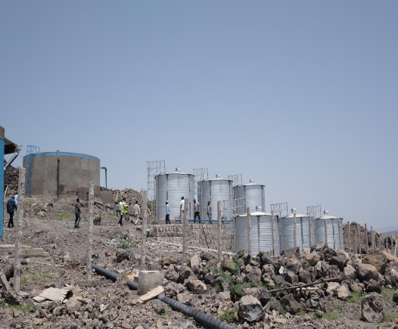
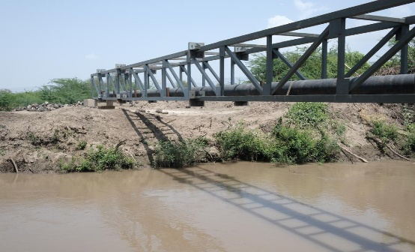
Left: Assaita Afambo one of the main reservoirs and the fluoride treatment plant Right: River crossing bridge for main pipeline to the beneficiaries at Afambo woreda

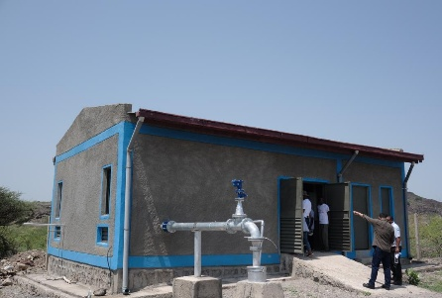
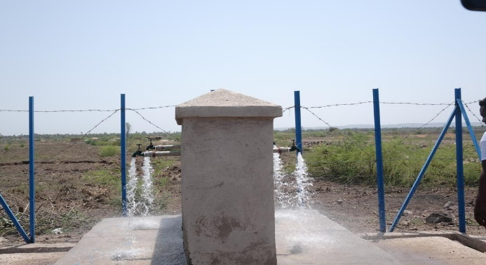
Assaita Afambo completed scheme in Afar; Main Borehole with the pump and generator house (left) and water flowing from one of the completed water points (right)

Construction of 14 additional schemes are ongoing at various stages. For example, Hawassa Zuria in Sidama is 86% complete; Agamber, Bursa and Yayawerke in Amhara are at 63%, 40% and 36%; Siraro in Central Ethiopia at 40%; and Ayun and Guradamole in Somali at 47% and 25%. Hawassa Zuria has completed all civil works and is awaiting electromechanical equipment currently under inspection at MoWE. Siraro has advanced significantly, completing reservoirs, distribution networks, and 43 water points. Once finalized, these seven schemes will serve 199,082 people, along with schools and health facilities.

The remaining seven schemes—located in South Ethiopia (3), Tigray (1), and Oromia (3), are progressing well being in the range of 15 to 26%. At the time of this report writing, these schemes have also made substantial progress since end of September. Additionally, the programme has completed drilling of 17 boreholes, which are ready for subsequent construction of reservoirs, main and distribution lines, and water points in Phase Three of the OWNP.

Based on the above performance this output has met the milestone set for the review period so is awarded A.

At the start of the review period, MoWE introduced an accelerated implementation strategy that included establishing a dedicated task force to closely monitor schemes that began late, such as those in Oromia, Tigray, and parts of the South, conducting frequent follow-ups through both physical and virtual means, and ensuring high-level ministerial oversight, including field visits. These measures have been instrumental in advancing the accelerated plan developed earlier in the year. As the programme enters its final year, maintaining this momentum is critical to ensure timely completion and achievement of all targets.

In Amhara, three schemes were delayed due to the need to replace the originally selected scheme. The initial design required funding far beyond the programme’s scope, as it was intended to serve 87,000 people. Consequently, MoWE, in consultation with the regional government, substituted three ready to implement schemes that fit within the allocated budget. These replacements will serve 38,548 beneficiaries, reducing the original programme target of 603,412 by approximately 50,000 people. Since UK attribution for the end-year target was based on the previous figure, the logframe must be revised to reflect the updated beneficiary numbers from the replacement schemes.

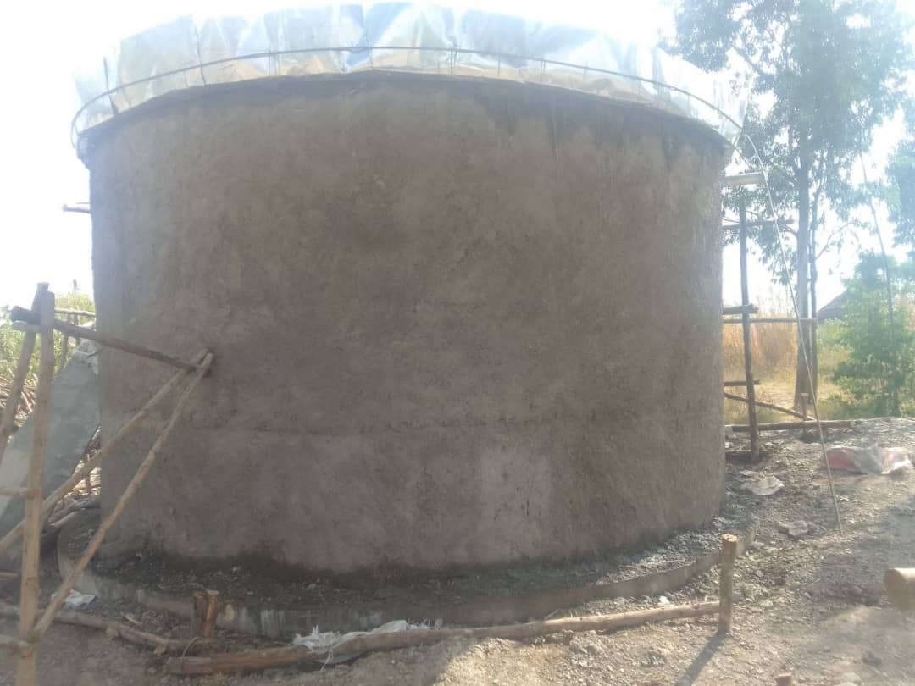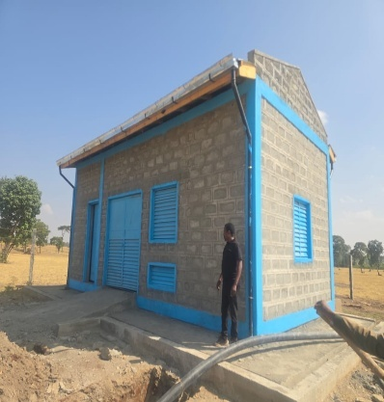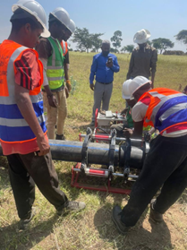
Siraro in Central Ethiopia close to completion; Main reservoir, pump and generator house and main pipeline at advanced stage

Describe any changes to this output during the past year, and any planned changes as a result of this review.

No changes were made to this output during the review period. However, as noted earlier, the adjustment in Amhara, replacing the originally planned scheme, has reduced the overall beneficiary target from the FA support by approximately 50,000. Consequently, the logframe will be updated to reflect this revised target.

Progress on recommendations from the previous AR
Recommendation | Status
Use of solar power: In order to address the critical problem of unreliable, expensive and polluting power sources and taking the lesson from some ongoing solar powered schemes, MoWE in the design of OWNP Phase Three should prioritise the use of renewable energy (solar power) as the main energy source in the water supply development, while using the fuel or grid connection for back up. | Following UK expert advice and provision of data produced during the current programme phase, in the design for OWNP Phase Three, solar energy has been prioritised as the main power source wherever feasible. Furthermore, Denmark, the newest development partner in this second phase, has committed its resources to solarise most CR schemes scheduled for completion during the current phase. .
Catchment management: Drilling of deep boreholes cannot ensure resilience of water supply system by itself, MoWE in coordination with Ministry of Agriculture and their regional bodies need to give due emphasis to source protection through catchment management, including sufficient budget allocation under the design of the next phase of OWNP. | All the learning materials which capture success examples, have been shared with MoWE to help inform the phase three design. MoWE has shared these resources with the consultants helping them with design of the post-construction pillar of the programme.
Continuation of the Three C follow up monitoring: Building from the current year experience, MoWE needs to enhance the continuation of the above-mentioned high level “Three C monitoring meeting” led by the State Minister to accelerate the implementation pace in the remaining two years period. | The monthly follow-up and monitoring meetings involving MoWE, the consultant, and the contractor have been maintained. These meetings have played a key role in significantly advancing the construction of the planned CR water supply schemes.
Upon completion of the exchange rate assessment in the coming weeks and revision of the work plan by the National WaSH Coordination Office (NWCO), the FCDO WaSH Team need to revise the programme Logframe to capture the associated changes in the programme end result targets. | The introduction of the new foreign exchange policy in 23/24 generated some gains that benefited the programme. However, during the remaining implementation period, significant cost increases for 14 ongoing water supply schemes have been anticipated, and there remain critical gaps in post-construction sustainability. The National WaSH Steering Committee, comprising Ministers of Finance, Water, Health, and Education, have therefore decided to allocate these gains to three priority areas mentioned under the VFM section and have not proposed any additional new water supply development above the planned 18 schemes.

Lessons identified this year
- Targeted and frequent follow-up led by senior leadership has continued to play a critical role in accelerating implementation, as reflected in the improved construction performance during this review period. MoWE should maintain this momentum to further expedite progress.
- The innovative approach adopted by the contractor for the Siraro climate-resilient water supply scheme in Central Ethiopia, and the remarkable progress achieved within short period of his deployment demonstrates how committed and capable contractors can significantly fast-track construction activities. This best practice should be shared with other contractors engaged in the programme to replicate similar results.

Recommendation:
- As the programme approaches its final implementation year and all schemes are underway, MoWE should intensify efforts and strengthen monitoring through the established mechanisms, especially for the three Oromia schemes delayed by extended procurement. The dedicated task force, biweekly virtual reviews, monthly Three-C monitoring, and ministerial-level monthly follow-up must continue and be reinforced.
- Building lessons from the completed Galifage scheme in Afar, MoWE should accelerate the transition to solar power for newly completed or soon-to-be-completed CR WaSH schemes, replacing fossil fuel systems.
- MoWE needs to prioritize the inspection and timely deployment of electrotechnical equipment for the Hawassa Zuria scheme to enable the contractor to finalize remaining works, conduct testing and commissioning, and complete handover as scheduled.
- The planned horizontal experience-sharing forum among contractors should be fast-tracked to promote the exchange of best practices and lessons learned, supporting quicker and more efficient implementation.

Output Title | Gender-sensitive improvements in institutional WaSH facilities (schools, heath centres and heath posts).
Output number: |  | 3 | Output Score: | A
Impact weighting (%): |  | 25% | Weighting revised since last AR? | No

Indicator(s) | Milestone(s) for this review | Progress
3.1 Number of schools and health facilities (health centres and health posts) with full WaSH packages in the programme areas with FCDO support. | The full WaSH package is provided to 32 schools and 29 Health Facilities. | Achieved: 32 schools and 36 health facilities have been provided with full WaSH package.

Output activities and supporting narrative
This output indicator focused on the provision of a full WaSH package to schools and health facilities in programme woredas/districts. The school WaSH package includes the provision of clean water supply, gender-separate, disability-inclusive toilets (girls’ toilets being designed and equipped to enable menstrual hygiene), and handwashing stations. For health facilities, the WaSH package includes clean water supply, separate latrines, handwashing stands (provided at the toilet and at the point of care), solid waste disposal, a medical incinerator and placenta pit. These activities are undertaken by Ministry of Health and Ministry of Education and their respective regional bureau.

According to the National WaSH Coordination Office report and discussions with the Health and Education WaSH programme management units, during the review period, 201 schools have been provided with a comprehensive WaSH package, including access to water supply, inclusive latrines, and menstrual hygiene facilities for adolescent girls. Of this achievement, 16% (32 schools) is attributed to the UK’s contribution to the institutional WaSH component. Similarly, 227 health facilities have been equipped with full WaSH services, comprising water supply, inclusive latrines, and safe waste disposal. The UK’s support accounts for 16% of these results (36 health facilities).

During a recent field visit to Sidama Region, covering Aleta Chuko woreda, the team visited Gambela Health Facility and Dange Primary and Secondary School, where they saw the significant impact our provision of comprehensive WaSH packages was having on safe health service deliveries in health facilities and strengthening teaching and learning in schools. Both Gambela Health Centre and Dange School have received the full WaSH package under the programme.

During the tour of the facilities supported, the head of Gambela Health Centre expressed strong appreciation for the assistance, noting that it addressed critical gaps in the facility. He highlighted that reliable water access in the maternity ward, mothers’ waiting room, laboratory, and outpatient areas, combined with inclusive latrines, handwashing stations, and waste disposal systems such as placenta pit and dry waste pits, has greatly enhanced service delivery and infection prevention efforts. Similarly, the Director of Dange Primary and Secondary School praised the support, emphasising its positive impact on students and the wider school community, particularly adolescent girls who now benefit from the newly constructed Menstrual Hygiene Management (MHM) facility.

The visit to Aleta Chuko Health Centre demonstrated strong ownership by the management, reflected in proper facility handling, timely maintenance, and cleanliness, all of which support sustainable service delivery. In contrast, the visit to Dange Primary and Secondary School revealed concerns about inadequate management and maintenance of the constructed facilities, which could jeopardize service sustainability and the gains of the investment made.

During the review, it was observed that the school’s water supply had been out of service for two months due to minor maintenance needs. Despite having a large plot of land and generating income by renting part of it to nearby farmers, the school failed to allocate resources for quick repairs. This issue could have been easily resolved by the school management instead of leaving students without water for an extended period. The review team strongly advised the head teacher and school community to prioritise timely maintenance of WaSH facilities.

To close these gaps, the Ministry of Education and the Regional Education Bureau should strengthen monitoring and follow-up in programme schools, working closely with school leadership to reinforce ownership. This includes allocating small budgets for routine maintenance and ensuring the replenishment of MHM supplies so that adolescent girls continue to benefit from the facilities. Although the programme has met the milestones set for the review period, some backlogs from the previous year remain. In follow-up discussions with the MoE PMU team, they confirmed that plans are in place and implementation has already begun to clear all outstanding activities across regions within the current fiscal year (EFY 2018/2025–26), which marks the programme’s final implementation phase.

Based on the above performance this output has met the milestone set for the review period so is awarded A.

Describe any changes to this output during the past year, and any planned changes as a result of this review:

- There is no change made to this output milestone.

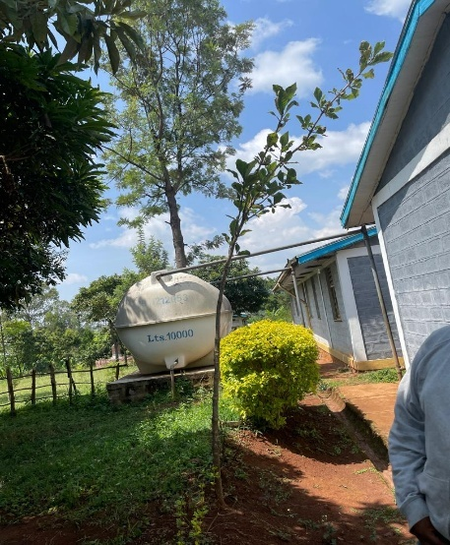
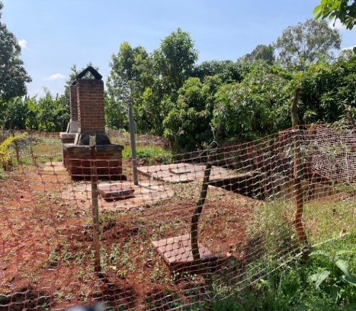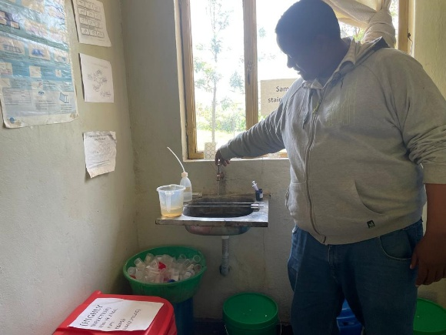
Gambella Health Center with WaSH facilities. Water Supply connected to the maternity ward, fenced waste disposal facilities and head of the Health Center showing water flowing in the laboratory.

Progress on recommendations from the previous AR
Recommendation | Status
MoH is encouraged to expedite the implementation of its new initiative to support timely maintenance and cleanness of facilities built. | MoH is actively rolling out its new “WaSH FIT” initiative across health facilities at all levels. This effort has greatly improved the timely maintenance, management, and handling of WaSH facilities supported by the programme as confirmed during a field visit to Sidama Region.
• MoE should expedite the recruitment and fulfilment of the three critical technical experts to catch up backlogs of implementation of WaSH at schools. FCDO together with other DPs should follow up on this through the regular joint follow up missions. | As the recruitment process required additional time to be completed, the steering committee agreed that the water programme management team would step in by assigning some of their procurement specialist’s time to support the Ministry of Education. This assistance has enabled the MoE to accelerate planned procurement activities and advance the implementation of WaSH facilities in schools. This is recognized as a positive example of effective coordination within the sector.

Lessons identified this year
- Constructing the facilities alone does not guarantee continued access to WaSH facilities in the schools and health facilities. Sustainability depends on timely maintenance and proper handling. Therefore, the school management and the governing body (Parents Teachers Association - PTA) need to give due emphasis for proper handling and timely maintenance of the facilities and the allocation of the small budget required for timely maintenance as observed on the excellent experience of Gambella health centre in Sidama region
Recommendations
- Proper emphasis on strengthening post-construction follow-up and preventive maintenance is crucial to ensure sustained service of the constructed facilities. Therefore, Ministry of Education and Regional Bureaus should enhance regular monitoring to avoid fall back and prevent further service gaps. The FCDO WaSH team together with the other programme DPs will follow up with both MoE and BoE.

Output Title | Increased systems of delivery setups of resilient water supply schemes with FCDO support in the programme areas.
Output number: |  | 5 | Output Score: | A
Impact weighting (%): |  | 15 | Weighting revised since last AR? | No

Indicator(s) | Milestone(s) for this review | Progress
Number of rural and urban water utilities established and operational with responsibilities for CR Multi-Village Schemes constructed in the programme area. | Nine (one phase I – Assaita-Afambo) + eight phase II utilities become fully operational | Achieved: The last tranche of nine utilities in the seven regions managed through UNICEF have become operational.

Output activities and supporting narrative
This output indicator focused on strengthening utility systems, transforming small town water utilities into self-sustaining entities capable of delivering reliable and equitable services. During the review period, UNICEF-managed Technical Assistance played a key role in strengthening and fully operationalizing the remaining nine utilities. These include one from Phase I (Assaita Afambo in Afar) and eight from Phase II, as outlined in the 2025 milestone: i) Awash 7 Kilo in Afar Region, ii) Hudet TWU in Somali Region, iii) Yechila, iv) Abi Adi TWUs in Tigray Region, v) Zuy Hamusit TWU in Amhara Region, vi) Karat TWU in South Ethiopia, vii) Bule Hora TWU in Oromia Region, and viii) Hantate TWU in Sidama Region. This achievement marks the successful completion of the milestone set for the period.
The support focused on seven core areas: preparing and implementing business plans; improving human resource; enhancing asset management; developing operation and maintenance strategies; strengthening billing and accounting systems; enhancing financial management; and reducing non-revenue water losses. These efforts were complemented by the provision of essential equipment such as welding machines, leakage detection tools, bulk water meters, and computers with billing and accounting software. As a result, the utilities have significantly improved operational efficiency, increased revenue generation, and expanded service delivery to reach more beneficiaries.
Based on the UNICEF completion report, and the field visit made in Hantate Utility in Sidama region, the key achievements include:
  - Proactive leak management and meter replacements improved service performance from the saved water
  - Significant increase in revenue collection and payment compliance
  - Improved billing systems and collection tracking
  - Reaching additional number of people with sustainable and resilient water supply services.
After completing the agreed programme targets successfully and achieving its intended objectives, the UNICEF-managed TA came to an end during this review period in June 2025. The overall achievement of this TA project is an excellent demonstration that strengthening and improving systems can make a significant difference in WaSH service improvement. This efficiency gain translates directly into expanded service coverage enabling thousands of new beneficiaries to access clean water using existing infrastructure and resources (without needing to increase water production).

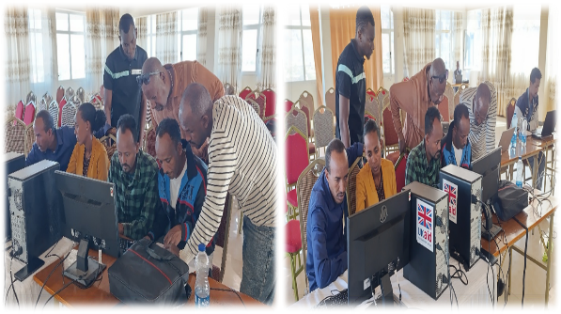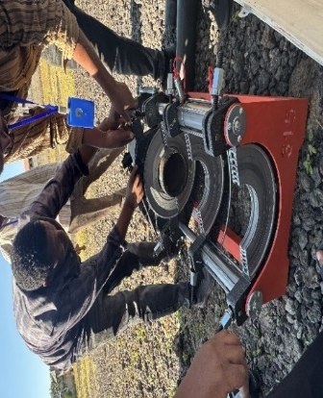
Hantate, Abi Adi , Alemgebya and Sekota utilities with the tools and equipment supported and receiving practical training on key systemic elements.
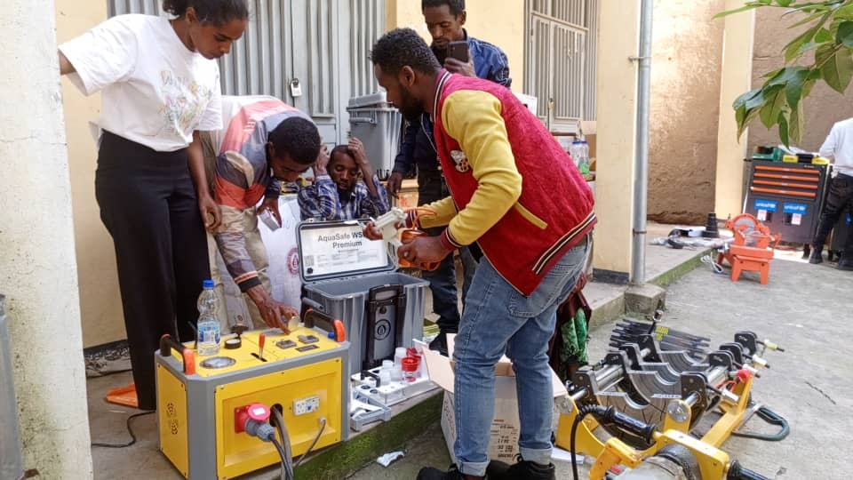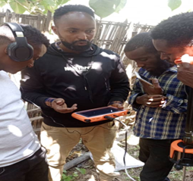
As per the schedule during the design period, an end line survey was conducted in ten towns as the project approached the closing period to assess the impact of the project work on strengthening systems of delivery units (the small-town utilities). The findings of the endline survey are captured in the final completion report submitted by UNICEF in October 2025, which also informed this annual review. These ten towns selected are utilities where reliable baseline data was collected.
Accordingly, based on the assessment, UK funding through this TA project has resulted in over 204,568 additional people being served with improved access to sustainable water supply using the same volume of water, through reductions in Non-Revenue Water (NRW). This is a result achieved at the end of the project because of the cumulative support given over the TA project period. By minimizing losses caused by leaks, and metering inaccuracies, the utilities have significantly expanded access to safe water, without increasing production of additional water. This is impressive and clear evidence on the critical role of strengthening systems in improving access to target communities. Investing in water loss prevention ensures that every drop counts, building healthier, more resilient communities. This achievement will significantly contribute to the porgramme outcome target, making the total number of people that received access to resilient and sustainable water supply with FCDO support 291,500.
Based on the above-mentioned assessment this output indicator is judged to score an A.
The below table drawn from the UNICEF completion report demonstrates the additional beneficiaries reached from each town over the project period as result of the support given and the above-mentioned efficiency gains in the ten small town utilities covered by the end line survey.

# | TWU | Baseline NRW (per cent) | Final NRW (per cent) | NRW Reduction (per cent) | Per cent change |  | Total Population (2025) |  | Additional Beneficiaries
1 | Bule Hora | 40 | 28.9 | 11.1 | 27.8 |  | 135,000 |  | 24,975
2 | Yabello | 21 | 8.1 | 12.9 | 61.4 |  | 120,274 |  | 19,640
3 | Abbi Addi | 30 | 13.14 | 16.86 | 56.2 |  | 108, 000 |  | 26,013
4 | Sekota | 9.5 | 15 | -5.5 | -57.9 |  | 59,800 |  | -3,634
5 | Hantate | 51 | 16 | 35 | 68.6 |  | 45,360 |  | 32,400
6 | Kebridehar | 35 | 20 | 15 | 42.9 |  | 125,000 |  | 28,846
7 | Chereti | 50 | 37.4 | 12.6 | 25.2 |  | 18,000 |  | 4,536
8 | Karat | 54 | 25.1 | 28.9 | 53.5 |  | 58,912 |  | 37,012
9 | Alem Gebeya | 47 | 23.1 | 23.9 | 50.9 |  | 54,000 |  | 24,351
10 | Filtu | 30 | 20 | 10 | 33.3 |  | 73,000 |  | 10,429
 | Total |  |  |  |  | 36.2 |  | 689,346 |  | 204,568

Using a standard NRW reduction formula, the analysis highlighted (the above table) the number of additional beneficiaries in each town. The average NRW reduction across the ten towns stands at 36.2 per cent, with towns like Hantate, Karat, and Kebridehar showing the most substantial gains. In contrast, Sekota initially experienced a setback due to rising non-revenue water, which negatively affected service coverage prior to the peer-to-peer support initiated in January 2025. However, following targeted learning exchange sessions focused on NRW reduction, Sekota demonstrated notable gains, highlighting the value of collaborative learning in reversing performance challenges.
Overall, the TA support given on strengthening systems have created resilient and self-sustained delivery systems, utilities, who can self-finance their own operation and maintenance as well as future expansion for increased future demand without waiting for any government subsidy or external support.
Describe any changes to this output during the past year, and any planned changes as a result of this review:

- There is no change made to this output milestone
.
Progress on recommendations from the previous AR

Recommendation | Status
Use of Solar power: In order to address the critical problem of power source and taking the lesson from some ongoing solar powered schemes such as Galifage new CR Water Supply, MoWE in the design of OWNP III, should prioritise the use of renewable energy (solar power) as the main energy source in the water supply development, while using the fuel or grid connection for back up. | As mentioned under output one, this recommendation is well-taken by MoWE to solarise the completed CR Water Supply schemes including capturing into its key policy document, the Ethiopian Water Resources Management Policy.
Lessons identified this year
- Addressing the critical pillars of post construction systemic elements is critical to ensure sustainable water supply service delivery from investments made. By investing in smarter water management, timely maintenance and loss prevention, and efficient bill collection, utilities can dramatically enhance service delivery and community well-being. This approach strengthens operational efficiency and supports broader development goals, ensuring that every drop of water counts toward building healthier, more resilient communities.
- The combination of software and hardware support, providing essential tools and equipment was instrumental in achieving the intended objective of the programme. It has been revealed that allocation of sufficient funding is essential to enhance post construction systems.
Recommendations:
- Recognizing the crucial role of strengthening post-construction systems in sustaining services and expanding access to additional beneficiaries and leveraging the evidence and lessons generated through this FCDO-supported Technical Assistance project, the MoWE Post-Construction Desk should ensure that these insights and proven practices are scaled up. This will be key to establishing and reinforcing resilient small-town utilities nationwide.

D: VALUE FOR MONEY

Key cost drivers and performance
- The Ethiopian Fiscal Year (EFY) 2017 fourth-quarter interim financial report from the Ministry of Finance indicates that, similar to the previous year, construction activities —along with associated supplies such as pipes, fittings, and electromechanical equipment (including generators and pumps), remained the primary cost drivers of the program.
- For the TA component, the main expenditures were related to the procurement of essential tools and equipment for small-town utilities. UNICEF successfully completed all procurement and deployment of these items to the utilities during the previous review period.
VfM
Economy:
- For all required procurements, the programme used a competitive bidding following the World Bank procurement rules and guidelines as agreed in the programme operational manual. World Bank also provide clearance for all procurement plans on behalf of DPs as part of its fiduciary oversight role. These procurement procedures helped to ensure the required inputs for the construction of the water supply system (pipes, fittings and electromechanicall equipment, procurement of drillers and contractors) are procured with appropriate quality at the right price maintaining good VfM.
- Following the huge increase in inflation earlier in the review period, the programme faced significant price increases, particularly for major cost drivers such as drilling, construction, and supplies. However, the introduction of the new foreign exchange policy later provided some exchange rate gains that benefited the programme. Considering the remaining implementation period, the sharp cost escalation for the 14 water supply schemes under construction, and the critical gaps in post-construction sustainability, the National WaSH Steering Committee, the programme’s highest governing body comprising Ministers of Finance, Water, Health, and Education, decided to allocate these gains to the following priority areas:
- Covering the substantial cost overruns compared to the original design estimates for the planned schemes, which otherwise would have required downsizing.
- Completing drilling works for the remaining 23 projects that were previously delayed due to budget constraints.
- Strengthening post-construction service delivery for newly completed schemes that could not benefit from FCDO TA following its closure. This includes establishing utilities, solarizing selected schemes, and implementing catchment management measures to protect water sources, activities previously deprioritized due to funding limitations.
As a result of this decision, no additional water supply schemes will be added beyond the 18 originally planned for the programme period (four completed and 14 currently under construction).
Efficiency:
- The programme has successfully achieved all planned milestones for the 24/25 review period across all the three output indicators as outlined in the logframe and the OWNP annual work plan and budget. Among the major cost drivers under the FA component, the construction of the planned CR water supply scheme is completed in line with the 2024/25 milestone. Furthermore, considerable progress is recorded on five additional schemes, with construction performance ranging from 43% to 86%. For example, Siraro reached 43% completion shortly after contractor mobilization, Hawassa Zuria achieved 86% ahead of schedule, and Agamber in Amhara Region attained 63% despite security challenges in the area. Overall, the programme has met its milestones as planned and with the allocated resources while maintaining a strong level of efficiency.

- Under the Technical Assistance component, UNICEF successfully supported the final nine small-town utilities across six CR WaSH regions by strengthening key systemic pillars and introducing innovative approaches such as the Mentee-Mentor model. In addition to deploying capacity-building consultants and leveraging internal expertise, UNICEF implemented this initiative by pairing high-performing large-town utilities, Adama, Bishoftu, and Hawassa with programme utilities. This approach proved highly effective in supporting Phase II utilities in Afar, Tigray, Somali, Amhara, Oromia, Southern Ethiopia, and Sidama regions. Formalized through a Memorandum of Understanding, the partnership facilitated a series of learning sessions beginning in January 2025. These efforts resulted in notable improvements in utility performance, including reduced Non-Revenue Water (NRW), increased revenue collection, and strengthened organizational structures as a result of efficiency gains.

Effectiveness:
- Based on the VFM statement of the programme, this relates to the extent to which the programme’s activities and outputs led to programme outcomes. Accordingly, during the review period, the programme completed the planned climate-resilient water supply scheme in Assaita Afambo (Afar Region), providing sustainable and resilient water services to 53,000 people and contributing to the overall outcome target. Of this achievement, 46% (24,380 people) is attributed to FCDO support. The completion of this scheme fulfilled the intended outcome for the review period as outlined in the logframe, which is benefiting 24,288 people.
- The end-line survey conducted on the UNICEF-managed TA confirmed that the TA component of the programme delivered exceptional effectiveness, driven by comprehensive support for system strengthening and operational efficiency improvements across ten small-town utilities. This systems-focused approach enabled water supply access for an additional 204,568 people in the intervention towns, a significant achievement and contribution to the programme outcome that demonstrates the impact of investing in systemic improvements, not only for enhancing service quality but also for expanding access to new beneficiaries. One point to clarify is, this result reflects cumulative efforts throughout the entire project period, rather than being limited to the review period, and has substantially contributed to the programme’s outcome target, bringing the total number of people with access to climate-resilient water supply to date to 291,068.

- Beyond expanding coverage, the utility system-strengthening support also tripled operating revenue—from ETB 13.65 million to ETB 46.55 million—driven by improved billing systems, stronger customer engagement, and enhanced operational efficiency.

Equity:
- Expanding access to water supply directly promotes gender equity by reducing the heavy burden on women and girls, who often walk long distances to fetch water—leading to frequent school absences for girls. Of the 291,068 people who gained access to climate-resilient water, 50% are women. The funded water supply schemes are located in drought-prone communities that face high poverty risks during climate shocks. In such conditions, women and girls are disproportionately affected, as they bear the responsibility of finding water, exposing them to health risks and vulnerability to harassment or gender-based violence while travelling long journeys. Providing WaSH services at home and in schools removes these barriers, supports girls’ education and women’s empowerment, and protects them from violence, delivering strong value for money.

- The programme also ensures inclusivity by installing WaSH facilities in schools and health centres, with separate latrines for women and girls and accommodating for the specific needs of adolescent girls and persons with disabilities.
Assessment of whether the programme continues to represent value for money.
- The output scores reported in Section C demonstrate that the current state of progress aligns with the programme expectations exceeding the outcome milestone for the period. Most importantly, this programme is targeting the most drought-affected areas of Ethiopia. This will gradually contribute to the scaling down of humanitarian response in these areas in the years to come, representing good value for money. It remains difficult to immediately scale down the humanitarian response because some areas still have urgent WaSH needs. These needs will continue until the planned schemes are fully completed and become operational. As the programme is in its final year, MoWE, MoH and MoE and their regional bodies have accelerated the implementation, follow ups and monitoring aiming to reach the final programme target as planned.

The programme also contributes to the achievement of health and education outcomes through its multi-sectoral approach. Therefore, we assess that the programme continues to represent good value for money as achieves outcomes aligned to other BE Addis Ababa priorities.

- In addition, recognising its critical role in drought-affected areas, UK’s and other DPs’ enhanced support, GoE has also given due emphasis for CR WASH implementation which is demonstrated in an increased dedicated budget allocation. For example, the water sector received a substantial federal budget allocation in 25/26, (ETB 40billion/£192m), showing a significant increase compared to the previous EFY 2024/25 (ETB 25 billion / £120m).

E: RISK

The overall risk rating of the programme is moderate. Relevant risks are identified against each of the risk categories through the risk register and are being monitored on a quarterly basis. The last quarterly update is carried out in this month of December 2025. The Senior Responsible Owner, the Programme Responsible Owner together with the Programme Officer jointly support the review and management of identified risks on regular basis. Risks can be escalated to the Human Capital team risk register and then to the Embassy’s Delivery Committee as appropriate. Risk appetite for the SCRS-WaSH programme is in line with the Embassy-wide risk appetite.

The last Partnership Principles Assessment was updated in December 2025. The PPA captures inputs from wide spectrums of areas and sectors including WaSH. It concluded that there is a mixed level of commitment by the GoE to poverty reduction and domestic accountability while commitment to civil and political rights has shown continued deterioration. On the other hand, commitment to public financial management has shown continued improvement. In recognition of these challenges, the FCDO has introduced a series of controls. These include human rights and peacebuilding, public financial management, and programme monitoring including safeguarding.
At the government level, the Programme Operational Manual (POM) which is endorsed by both GoE and pooled fund Development Partners (DPs) since 2019, has clearly outlined how to mitigate the social, environmental, and fiduciary risks to be monitored while implementing the programme and puts in place necessary mitigation measures. These are monitored during the joint review missions, and interim quarterly monitoring as well as by the World Bank as part of their oversight role representing pooled fund Development Partners including FCDO.
Programme Delivery:
Delays in finalising contractor procurement for planned schemes entering construction were identified as a key delivery risk. To mitigate this, MoWE implemented several mitigation strategies, including splitting contracts into smaller lots, creating a dedicated task force for regular follow-up and timely decision-making, and holding monthly “Three C” meetings (Contractor, Supervising Consultant, and Client/MoWE) chaired by the State Minister. Additionally, monthly reviews of high-value contracts, attended by pooled fund Development Partners’ Co-Chairs (World Bank and FCDO), have been instrumental in closely monitoring risks and accelerating implementation.

At the TA level, UNICEF conducted regular risk monitoring, maintaining updated risk registers until project closure in June 2025. Quarterly risk review meetings are held with the FCDO programme team, and inputs from these discussions feed into FCDO’s broader risk management processes.

Strategy & Context
Continued conflicts in the Amhara region and parts of Oromia have been identified as major risks, limiting access and slowing programme implementation, including physical monitoring of construction activities. To mitigate these risks, regional authorities engaged influential community leaders to negotiate safe passage for contractors, which enabled progress on construction works, as reflected in the performance of schemes in Amhara. Additionally, the federal programme management unit adopted virtual monitoring methods to compensate for restricted physical visits, conducting fortnightly online meetings with regional PMUs to maintain oversight and provide support.

Further mitigation measures include FCDO’s collaboration with GoE, World Bank, and other development partners to proactively track changes in the political and security context and recommend additional actions. These measures involve more frequent monthly monitoring meetings, biannual joint missions, and quarterly discussions with programme regions. In line with this approach, a comprehensive follow-up and monitoring meeting with all programme regions was held in Jimma Town of Oromia region from September 5–7, led by the State Minister.

Fiduciary
Fiduciary risks are managed by close scrutiny of the quarterly Interim Financial Reports (IFRs) from the Ministry of Finance (MoF) including periodic joint financial management group meetings chaired by MoF. The periodic meetings review all the fiduciary aspects which include, financial management, procurement, and audits. In addition, the World Bank fiduciary experts, as part of their fiduciary oversight of all DPs’ resource including FCDO’s, carried out a dedicated periodic financial management supervision mission to ensure compliance with agreed rules and procedures.
The challenges in timely finalising procurements of contractors for the water supply construction by GoE is the major potential risk identified in the risk register since it will delay the pace of the overall implementation and the timely completion of planned construction activities. As a mitigation measure, MoWE has substantially enhanced the programme management unit placing a dedicated team for some critical tasks such as procurement specialist.
As per the EFO arrangement entered for fiduciary and safeguards oversight, WB fiduciary experts are also intensively scrutinising submitted procurement bids. For procurements greater than ETB 10m (GBP 140,000) WB closely controls the procurement process of the supplies. If the proformas are less than ETB 10m WB does controls taking sample procurements. Measures include, rejecting approval of contracts, and re-directing to rebidding process of contracts as well as suspension of contracts. Apart from the intensive supervision, the WB procurement specialists are providing continuous capacity building in the areas of procurement and contract management to government fiduciary experts, which should minimise such risk in a sustainable way. FCDO seconded technical experts both in CR WaSH regions and the Ministry, which are now financed by GoE since June 2025, have been very instrumental in supporting the procurement process and expedite the construction work addressing the relevant capacity gaps.
Safeguarding
As part of their oversight role for fiduciary, social and environmental safeguards compliance of the programme, follow ups with WB safeguard expert have been held ensuring compliance with the agreed safeguarding instruments. The key social safeguarding risk related to the Financial Assistance (FA) support is land displacement as a result of WaSH facilities construction. This could lead to conflict and disruption of programme activities and reputational risk for FCDO. To mitigate these risks, the WB social safeguard instruments, which are endorsed by GoE are properly applied while implementing the programme. FCDO WaSH programme team ensures safeguarding issues are well monitored and reported through the regular joint missions, follow-up meetings and reports.
Additionally, FCDO and other partners, have funded capacity building for implementing ministries and their regional bodies through the capacity building and programme management pillar of the programme to ensure safeguarding risks and mitigation measures are properly implemented and monitored. These include continued training for GoE Programme Management Unit staff both at Federal and Regional level in safeguarding, fiduciary management, and monitoring and evaluation of programme implementation. No safeguarding incidents have been reported in this programme period.
Overlooking gender-based violence is also a potential risk identified related to the TA implementation. These risks if they are not managed well will lead to reputational risk to UK. As mentioned, the programme is designed and implemented to respond to the needs of women and girls with emphasis to increased access to clean water which contributes to reduced GBV including abduction and as women and girls will be able to have better access to water supply in their locality.
As additional mitigation measure, a quarterly risk discussion including the delivery chain maps has been held regularly with UNICEF until the closure date. As indicated in the PrOF rule # 18, the programme partners are aware of FCDO’s safeguarding compliance requirements.

F: PROGRAMME MANAGEMENT: DELIVERY, COMMERCIAL & FINANCIAL PERFORMANCE

Financial Performance

During FY 2025/26, SCRS- WaSH programme had an ODA-approved budget of £22.83 million, and expenditure of £20.67million, (91%) has been incurred as of October 2025. Of this, £20.06 million is FA and £0.61 million is TA. This payment has made a substantial contribution to both CDEL and ICF spend targets of the office. The remaining £2.16million is a saving from the TA component.

FCDO’s financial management and disbursement to the One WaSH National programme for the SCRS WaSH implementation is based on its MoU agreement with the Government of Ethiopia and the provisions outlined in the Programme Operational Manual (POM) that was endorsed by the NWSC in September 2019. The POM was revised in September/October 2023, in line with the mid-term review recommendations, to address implementation backlogs that resulted from contextual challenges, such as COVID-19, the war in the northern part, and various regional conflicts encountered during the first two to three years of implementation..

GoE as outlined in the POM has committed to providing quarterly Interim Financial Reports (IFR) which are reviewed and cleared by the World Bank. GoE also provides quarterly, biannual and annual progress reports. Accordingly, the 4th quarter IFR, which also captures the annual financial performance, was submitted in September 2025. In general, these reports have been timely and met the expectation in the POM. Based on the 4th quarter IFR, (quarter ended on July 7, 2025), the programme has utilised 91% of the transferred amount. The rest of the amount been committed to various contracts that are under implementation. The commencement and advancement of all the planned construction work, and timely settlement of expenditures resulted in sustained good fund utilisation, settlement and reporting.

During the current reporting period, UNICEF successfully achieved the milestone set for the project period strengthening and capacitating the operational systemic elements of the final 9 small town utilities and fully achieving the project target. Payments to UNICEF are made based on submission and approval of bi-annual reports. As mentioned above this TA ended in June 2025. As per the requirement UNICEF has submitted the final Project Completion Report (PCR) in October 2025 both to FCDO and Ministry of Water and Energy including the supporting annexes that capture learning materials and knowledge products. This completion documents have substantially informed this Annual Review. As per the PCR, the project has fully utilised the allocated £5million and delivering the anticipated results in the 18 small town utilities.

The table below shows the programme budget and spends for November 2019 – October 2025

Programme Budget and Spends for November 2019 – October 2025

Component | Total Programme life budget | Spend | Spend | Spend | Spend | Spend | Spend | Spend | Total Spend to date in %
Component | Total Programme life budget | 19/20 | 20/21 | 21/22 | 22/23 | 23/24 | 24/25 | 25/26 | Total Spend to date in %
SCRS WaSH FA through the OWNP CWA for building capacity of government institutions for effective delivery of WaSH services | £80m | £20m | £2.85m | £5m | £7m |  | £25m | £20.06m | 100%
i) Technical Service Provider through NIRAS | 7.5m | - | - | £0.23m | £1.46m | £2.8m | £2.5m | £0.23m | 99.00%
ii) Technical Assistance through UNICEF | £5m | 1.2 | - | - | £2.5m | £0.6m | £0.48m | £0.22m | 100%
iii) Saving from the TA contract and Oversight and Quality Assurance Service - SCRS - through World Bank EFO and flexible funding for needed assessments and analytical works for the programme. | £2.5m | £0.12m |  | £0.12 | £0.13m | £0.09m |  | £0.16m | 16.4%
Total (FA +TA) | £95m | £21.32m | £2.85m | £5.35m | £9.9m | £3.49m | £28m | £20.67m | 97.5%

Q4 IFR for Quarter Ended on July 7, 2025 | August 2025
UNICEF Final project completion report | October 2025

G: MONITORING, EVIDENCE AND LEARNING

MONITORING
A comprehensive joint monitoring and performance management system is in place at the programme level. Key components include biannual Joint Implementation Review and Support (JIRIS) missions with field visits across all programme areas, quarterly financial and performance reports prepared by the Government of Ethiopia (GoE), external audits, and quarterly fiduciary group meetings. To provide additional assurance, development partners engaged the World Bank to oversee fiduciary, social, and environmental safeguards. This oversight involves reviewing and approving GoE’s quarterly performance reports, annual external audit reports, follow-up action plans, and procurement plans. Furthermore, the World Bank fiduciary team conducts biannual financial management supervision missions in programme areas.

During the reporting period, GoE submitted four quarterly reports and one annual narrative and financial report. These were initially reviewed by the World Bank and subsequently by all Consolidated WaSH Account donors, including FCDO. Feedback was communicated to GoE through the National WaSH Coordination Office. In line with the agreed monitoring framework, biannual joint monitoring missions were also carried out. The most recent mission took place in September 2025 in Jimma, Oromia Region, where progress on actions agreed during the June 2025 mission was assessed and discussed.

UNICEF also submitted both biannual and completion reports for the TA component. In addition, regular three-way monitoring meetings involving MoWE, FCDO, and UNICEF were held every two months to review progress, address outstanding issues, and make joint decisions aimed at improving TA performance.
At the governance level, the National WaSH Steering Committee — the highest decision-making body of the programme, provides overall oversight and strategic direction. This committee comprises ministers from key WaSH sector ministries (Water, Health, Education, and Finance) along with development partners contributing to the pooled fund, including FCDO. The most recent meeting was held in August 2024, where key decisions were taken, including the approval of the EFY 2017 (2024/25) work plan, which was a prerequisite for FCDO’s financial assistance last disbursement in November 2025.
The annual review was informed by field visits to Afar, Central Ethiopia, and Sidama regions, complemented by beneficiary feedback. The team inspected the completed water supply scheme at Assata Afambo in collaboration with the Saudi Fund for Development, ongoing construction sites in Siraro and Hawassa Zuria, and WaSH facilities at a health centre and school in Sidama. Consultations were also held with programme beneficiaries, regional bureaus, and the Hantate utility in Sidama.
Regional bureaus expressed appreciation for FCDO’s support, emphasizing its significant impact on improving livelihoods in completed project areas and fostering hope in communities awaiting completion. A representative from Assata Afambo described access to clean water from nearby taps as “a rebirth,” highlighting previous challenges of relying on unsafe sources and traveling long distances. Communities and local officials in Siraro and Hawassa Zuria underscored the need for expedited follow-up by federal and regional authorities to ensure timely completion of remaining works in the coming months.
The head of Hantate Utility, along with his technical team, emphasized the transformative impact of FCDO’s support in building institutional capacity. The provision of essential tools, equipment, and software applications has enhanced operational efficiency, facilitated the repair of damaged water supply networks, expanded service coverage to more clients, and contributed to increased revenue generation.

EVIDENCE AND LEARNING:
Evidence
Documenting evidence and lessons from best practices remains a core principle of the programme. The quality of periodic reports and data has improved significantly due to embedded capacity-building measures and the integration of Monitoring, Evaluation, and Learning (MEL) within the Technical Assistance (TA) component. Evidence generated through TA managed by NIRAS and UNICEF demonstrates that prioritizing system strengthening delivers substantial improvements in access, complementing new infrastructure investments.

As noted earlier, efforts to enhance operational systems and efficiency within small urban utilities throughout the project period enabled an additional 204,568 people to gain sustainable access to water supply. This provides compelling evidence of the critical role post-construction delivery systems play—not only in safeguarding service sustainability from existing investments but also in expanding access by optimizing operational performance. These findings will serve as an important input for the Government of Ethiopia and development partners in designing and reinforcing post-construction systems under the One WaSH Phase Three programme.

Learning:
One of the key objectives of the TA component of the programme is producing learning materials and knowledge products on key aspects of the implementation of climate resilient water supply and delivery systems that withstand climatic shocks to inform the wider WaSH sector in general, and to the design of the GoE flagship programme in particular. Accordingly, in the review period, UNICEF managed TA following the closure of the project, together with the project completion report has produced excellent learning materials, knowledge products and shared both to FCDO and MoWE. This will substantially support in filling the critical knowledge gap in the sector in the enhancement of systems for complex climate resilient water supply system. Some of the learning has already been used by the phase three design consultants and some Development partners that are aiming to support climate smart WaSH under the umbrella of Phase Three of the One WaSH National Programme (such as the African Development Bank) already serving its purpose.

Furthermore, in the coming weeks, as part of the closure tasks, the WaSH Team in coordination with the comms team will prepare case studies, internal reporting, external news stories and other comms materials to inform the UK public about what UK support has achieved over many years in reducing the impact of climate change and changing people’s livelihood in the country’s most drought-stricken areas.

