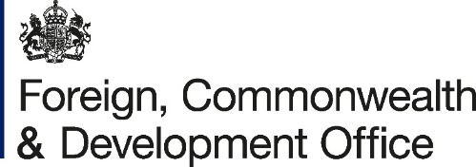
Updated Sep 2024

AMENDMENT NO. 3
JOINT PROGRAMME STANDARD ADIMINSTRATIVE ARRANGEMENT
BETWEEN
THE FOREIGN, COMMONWEALTH AND DEVELOPMENT OFFICE (FCDO)
AND
THE UNITED NATIONS CHILDREN’S FUND (UNICEF)
- I refer to the Standard Administrative Arrangement dated 31 December 2018, and Amendment Numbers 1 and 2 dated 22 December 2023 and 02 October 2024 respectively, signed between the Government of the United Kingdom of Great Britian and Northern Ireland, acting through the Foreign, Commonwealth & Development Office (FCDO) and the United Nations Children’s Fund (UNICEF) for the Sudan Free of Female Genital Mutilation Phase two.

- I propose that the date and the amount of payment in tranche four (4) of the amendment number 2 to the Standard Administrative Agreement be deleted and replaced with:

Tranche | Date | Amount (GBP) | Condition of payment
4 | October 2025 | 1,047,346.46 | Upon FCDO’s internal approval for the year 2025 and 2026.
5 | October 2025 | 1,452,653.54 | Upon FCDO’s internal approval for the year 2025 and 2026.
6 | December 2025 | 560,000 | Upon FCDO’s internal approval for the year 2025 and 2026.

- The payments in 2025 and 2026 are contingent on FCDO’s internal approvals for the FCDO’s financial year 2025/26. The Donor shall confirm to UNICEF if approvals have been granted. In the event that FCDO is not able to disburse any instalment(s), or needs to disburse a modified/lesser amount of any instalment, the Donor will provide UNICEF as much notice as reasonably possible and the two parties will discuss in good faith, with other PUNO’s the impact on the project and its continuation including, if applicable, amending the project’s terms or concluding it at an earlier date than originally planned.

- All other items and conditions of the Agreement dated 31 December 2018, including the annexes and amendments dated 22 December 2023 and 02 October 2024 remain unchanged and applicable.

- Please sign both copies of this letter and return one to FCDO and retain the other for your own records.
Signed on behalf of FCDO:

Name:

Position:

Address/Contact Details:

Signature:

Date:

Signed on behalf of UNICEF:

Name:

Position:

Address/Contact Details:

Signature:
Date:

