Programme Completion Review

Title: Strengthening Disaster Resilience and Responding to Humanitarian Emergencies in Nepal
Final Programme Spend £ (full life): £55,020,944 | Review Date: | May 2025
Programme Code: [AMP ID#] 300003 | Start Date: 06 Sep 2016 | End Date: 31 Mar 2025

Summary of Programme Performance
Year | 2017 | 2018 | 2019 | 2020 | 2021 | 2022 | 2023 | 2024 | 2025
Overall Output Score | A | B | B | A | A+ | A | A | A | A
Risk Rating | Major | Major | Major | Major | Major | Major | Major | Major | Major

DevTracker Link to Business Case: | https://devtracker.dfid.gov.uk/projects/GB-GOV-1-300003/documents
DevTracker Link to results framework: | https://devtracker.dfid.gov.uk/projects/GB-GOV-1-300003/documents

A. Summary and Overview

Description of the programme and what it has achieved

The Strengthening Disaster Resilience and Responding to Humanitarian Emergencies in Nepal (SDR) programme, from May 2017 to March 2025, has provided up to £56 million to reduce risk and build resilience to natural hazards in Nepal at the federal, provincial and local levels.
The programme has adjusted to a rapidly changing landscape over its delivery-span: pivoting in 2020-22 to respond to Nepal’s COVID-19 humanitarian response; focusing on resilience from 2022-24 before again pivoting to respond to the West Nepal Earthquake via a joint early recovery programme in 2024-25, as well as responding to small and medium-scale disasters across Nepal.
The Business Case for SDR, which was established in 2016, outlines 6 key components:
- Component 1: Improvements to urban building and planning in disaster prone urban centres (risk reduction).

- Component 2: Promoting safer public buildings, particularly schools (risk reduction).

- Component 3: Strengthening readiness to respond to humanitarian emergencies (preparedness to respond).

- Component 4: Emergency contingency fund to respond to humanitarian emergencies (early action and response).

- Component 5: A flexible and adaptive resilience “Policy and Institutions Facility” (PIF).

- Component 6: Evidence generation through monitoring, evaluation, and learning (MEL).
SDR has also adjusted to broader delivery variables from the UK as a donor: the merger of DFID and the FCO in 2020, as well as the UK reduction of its Official Development Assistance (ODA) to 0.5% of GNI in 2021, shifting the SDR’s focus from long-term resilience to prioritising life-saving measures and building COVID-19 response capacity. Due to emerging crises and the prioritisation of funding, the programme also saw the closure of several projects such as the Nepal Safer Schools Project, the Monitoring Evaluation & Learning (MEL) Unit and the Strengthening Urban Resilience and Engagement (SURE) project.
In 2023, the British Embassy Kathmandu (BEK) agreed a no-cost extension with the Government of Nepal (GoN) on the MoU for the SDR programme until March 2025, extending the timeframe of SDR, and enabling BEK to close programme components responsibly and design the successor RAIN (Resilience Adaptation and Inclusion in Nepal) programme.
Previous SDR Annual Reviews covered the results and recommendations for the programme by year, since 2017.
The programme delivered at a time of change for Nepal: established shortly after the 2015 Gorkha Earthquake and subsequent fuel blockade, since its inception Nepal has faced frequent severe floods and landslides across the country, as well as infrequent major earthquakes. More broadly, it has come at a time in which Nepal has transitioned to federalism, and in which it continues to transition to a middle-income developing country.
Overall, SDR has scored an ‘A’ based on its performance since it was established in 2016.
Major lessons learned, evidence generated and recommendations

 | Major Lessons Learned | Recommendations
1 | Adjusting to crises: The programme has pivoted to emerging responses significantly over its delivery span. Although this has enabled SDR to respond well to a changing landscape (emerging humanitarian crises, as well as domestic UK funding cuts), it has meant the programme was less coherent overall from its original assumptions, and did not fully deliver some of its original objectives (notably policy components, and Monitoring Evaluation & Learning - MEL). | The programme team could consider a clearer threshold to trigger any future humanitarian response (for instance, a specific size/scale of emergency), or to factor in extra capacity for standalone programmes in order to respond to crises beyond the original intended outcomes of future programmes.  Responsible: Climate and Resilience Team (Green Growth Group) as part of RAIN’s Internal Risk Facility (IRF) and Start Fund Nepal (ongoing until March 2027)
2 | Future Challenges: Since the programme’s inception in 2016, new challenges have materialised in Nepal, notably the impact of climatic shocks across the country. This material threat to livelihoods is highly likely to increase over future decades. | Future programmes could integrate climate and disaster resilience to a greater extent, focusing on the resilience aspects of development, as well as a greater focus on government and local capacity-building (and anticipatory action rather than direct humanitarian response).  Responsible: Climate and Resilience Team (Green Growth Group) as part of RAIN’s implementation (ongoing until programme closes)
3 | Safeguarding: Although significant safeguarding measures were in place for all projects, the limited number of reports and concerns raised in the final years of the programme pose questions as to the viability of the mechanisms in place (particularly given the scale and contexts in which SDR delivered). Aspects of the programme, including JRAP’s standalone safeguarding lead based in the RCO - operating across all agencies, were among the examples of good practice. However, a more comprehensive approach is needed. | Steps could be taken in future programming to consider a more qualitative and pro-active approach to safeguarding measures (for instance, a comprehensive follow-up with affected communities via a standalone PSEA focal point across all delivery partners). Furthermore, greater engagement across donor working groups on SEAH reporting could be considered to improve system coherence.  Responsible: Climate and Resilience Team as part of RAIN implementation (Green Growth Group) (ongoing until programme closes)
4 | Anticipatory Action: The SDR’s approach to enhancing anticipatory action initiatives was effective overall. However, more could be done to consider the proportion of funding actually needed for AA initiatives, as monitoring equipment can be relatively cheap, with limited maintenance. | To consider the proportion of spend actually needed to deliver future AA initiatives. To ensure partners gather data through a more comprehensive range of information, and to encourage the dissemination of data and lessons-learned across delivery partners.  Responsible: Climate and Resilience Team as part of RAIN implementation (Green Growth Group) with early action PIN-led consortium consortia and Start Fund Nepal (by summer 2026)
5 | Localisation: As the programme progressed, SDR improved its localisation efforts. However, more could be done in the future to improve the proportion of funding to local actors, and importantly the insights and needs of locally affected populations in designing the response. | To ensure greater participation of local actors from the outset of response, in the development of projects, as well as their clear engagement throughout project delivery and closure (including a clear plan for building the capacity of local NGOs to manage donor funds at first tier).  Responsible: Climate and Resilience Team as part of RAIN implementation (Green Growth Group) with early action PIN-led consortium consortia and Start Fund Nepal and in the event of an Internal Risk Facility funded intervention (ongoing).
6 | Monitoring, Evidence & Learning: In response to UK ODA funding cuts from 0.7% of gross national income (GNI) to 0.5%, the MEL component of SDR was concluded early. This (necessary) change likely impacted the programme’s ability to monitor the effectiveness of programming and adjust accordingly. | Future programming should continue to prioritise MEL. The integrated approach in SDR had benefits and a similar approach is taken in successor programme RAIN to enable strategic learning. However, the team should also consider a more a more flexible approach to MEL where needed (utilising external evidence and evaluations). BEK also has a portfolio monitoring function. One particular aspect is the need to set up better value for money indicators to track this better.  Responsible: Climate and Resilience Team as part of RAIN implementation (Green Growth Group). (ongoing)
7 | Transition to 0.3: In light of the announcement in 2025 that the UK would reduce its aid budget, greater consideration will be needed to ensure future funding is as effective as possible, and aligns closely to any revised UK development priorities. | In order to utilise a smaller development budget from donors across Nepal, greater engagement and coordination may be needed with both like-minded and emerging donors in the region, as well as the private sector, in order to reduce duplication and synergise funding. Closer engagement with the GoN in order to secure increased allocation of domestic budgets for disaster risk management and climate adaptation work should be considered. Further engagement may be needed through humanitarian & development diplomacy, in order to ensure the maximum impact of programming.  Responsible: Climate and Resilience Team (Green Growth Group) as part of RAIN’s implementation (ongoing until programme closes)
8 | Threshold for humanitarian response: As Nepal continues to transition to a middle-income developing country and builds greater capacity to respond to domestic crises and ODA is reducing globally, BEK could consider a higher threshold for humanitarian intervention. | Consideration of a higher threshold at which BEK intervenes in humanitarian response (ie to focus only on a specific scale or type of humanitarian emergency), and to focus on resilience and climate adaptation in the interim.  Responsible: Climate and Resilience Team (ongoing). To note that BEK’s Humanitarian Preparedness and Response Plan includes a set of humanitarian intervention criteria which reflect this. It is in line with BEK’s ODA strategy that we will gradually exit/reduce the threshold for humanitarian response. Continued support will be provided to Start Fund Nepal in the first two years of RAIN implementation given the inclusion of anticipatory alerts, contribution to resilience building (avoidance of negative copying mechanisms) and focus on capacity building for local actors.
9 | Disability, Equity and Inclusion: SDR considerably improved its approach to disability and inclusion as the programme progressed, including a standalone protection and inclusion expert within the JRAP project. | More could be done to ensure disability and inclusion is incorporated from inception of future programmes, ideally with a standalone gender and social inclusion expert who is able to enhance the knowledge and delivery of partners especially in preparedness and humanitarian programming. Equal emphasis will be given to incorporate GEDSI dimensions in technical assistance projects.  Responsible: Climate and Resilience Team (Green Growth Group) as part of RAIN’s Internal Risk Facility (IRF),Start Fund Nepal and a focus on disability inclusion in the early action consortium workplan (with a disability focused local NGO part of the consortium) (ongoing until programme closes).
10 | Portfolio Approach: SDR was a portfolio programme with major components and a dedicated policy and institutions facility and a monitoring unit. However, multiple components within the programme led to complexity in delivery due to changing UK priorities and humanitarian response took precedence during Covid-19, 2017 floods and 2023 earthquakes. | Whilst taking a portfolio approach, it is critical to appraise interventions and their interconnectivity to wider resilience and adaptation programming in Nepal. For example, urban and infrastructure - NURP within SDR was shifted to the Economic Growth Team for coherence within BEK. Lessons will be utilised during RAIN implementation but remaining flexible to adapt when context changes.  Responsible: Climate and Resilience Team (Green Growth Group) as part of RAIN implementation

How this report was conducted

This report was conducted over a 2-week period by a member of FCDO external to BEK. It draws upon the expertise and advice of BEK staff, in-person meetings with key UN and NGO partners, and existing reporting and reviews of the programme.

Actions following approval of this report

BEK will ensure the receipt of any remaining audited statements for the JRAP programme, as well as the recovery of any unspent funds. BEK’s Climate and Resilience Team will follow up with Start Network and the Multi Donor Trust Fund (MPTF) managed by UNDP to recoup unspent funds and the audit statements will be reflected in the final reporting (expected by December 2026).

Recommendations will be used to inform the delivery of RAIN, the successor programme to SDR, as well as any key related future programmes.

B: Theory of Change and Outcome Assessment

 | Starting point | Final result
Budget | £46,000,000 | £55,020,944
Timeframe | 06 Sep 2016 - 31 March 2022 | 06 Sep 2016 - 31 Mar 2025
Outcomes | Risk reduction; Preparedness; Response  Mainstreaming; Evidence. | Key success through Response and Preparedness.

Overall assessment of programme outcomes, sustainability and VfM

The core of the theory of change for SDR was that through supporting different entry points for effective management of disaster risk (risk reduction, preparedness and response), as well as mainstreaming, Nepal would strengthen its overall resilience to disasters.

Outcomes
The programme aimed for Nepal to reduce risk and build resilience to natural hazards, particularly to earthquakes, in urban centres and at a national level.

It aimed to achieve this by addressing six problem statements, through a range of investments, activities and partnerships, as well as the deployment of (FCDO) staff time in terms of wider influencing, coordination and leadership.

Over the duration of the programme, the logframe outcomes were achieved within the timeframe and budget originally allocated. However, the logframe was amended significantly over the delivery period in order to accurately measure the response to new and emerging crises.

The final iteration of the logframe, which focuses on the last year of delivery (2024/25), can be found here: SDR Logframe - DevTracker

Value for Money

The original business case proposed that a standalone MEL unit would be used to generate management information and results data to inform decision making for the programme. The unit would design a series of Value for Money metrics for the components under the Disaster Resilience and Climate Smart programmes.

However, this component of the programme ceased in June 2022. Although the programme demonstrates an awareness to ensure VFM throughout its delivery-span, and utilises mechanisms and partners in order to ensure cost-effectiveness, the closure of the MEL component likely impacted the overall value for money approach of SDR.

Equity

Some projects within SDR performed better on equity than others. For instance, NURP’s efforts led to the preparation of inclusive local economic development plans in three cities, featuring initiatives such as public-private dialogue forums, business promotion centres, and eco-tourism activities, and Gender Equality and Social Inclusion integration was supported by dedicated gender specialists, resulting in GESI-aligned budgets in policy and budgeting processes. Likewise, for humanitarian interventions during Covid-19 response, 2017 flood response, 2024 Jajarkot earthquake recovery and through Start Fund Nepal focus was on the most vulnerable and marginalised including people with disability where partners deliberatively ensured equity considerations using a gender responsive selection criteria which was vetted by the government counterparts.

However, some aspects were harder to manage. Within the EPR2 project, in relation to the development of Humanitarian Staging Areas (HSA’s), only 11 precent of training participants were female, although this accurately reflects the male-dominated nature of the armed forces in Nepal.

Overall, projects within SDR generally provided clear disaggregation of data by age, sex and particularly geography – notably when it came to cash programming, with gradual improvement on data provided on disability.
Summarise the programme’s theory of change and results framework, including any changes to outcome indicators.
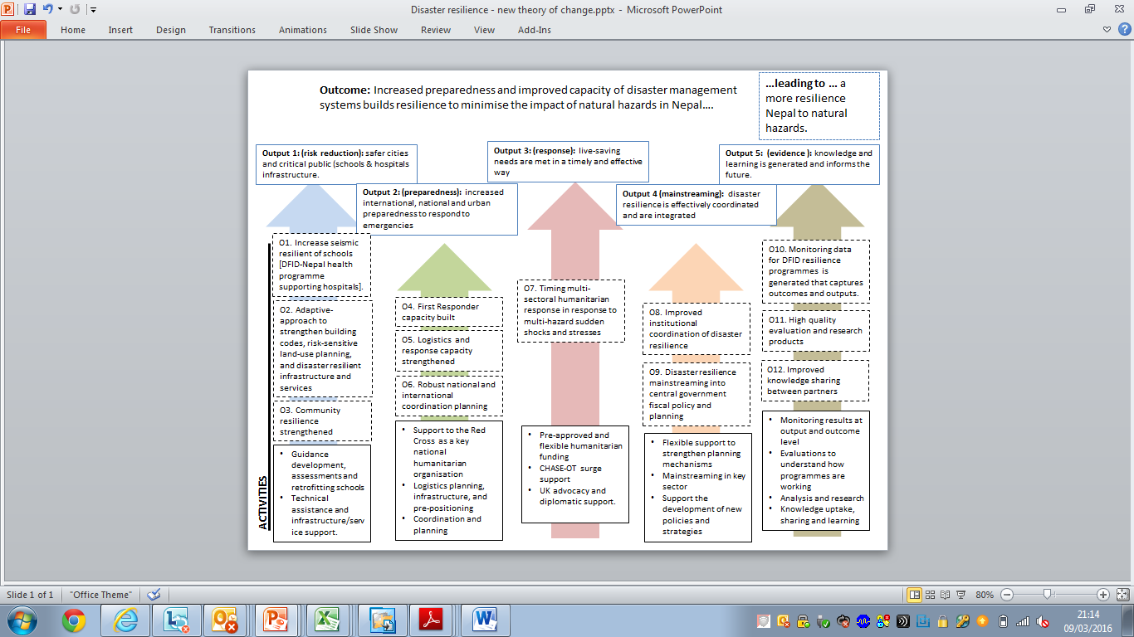
Figure 1 HDF's Theory of Change (2016)
The SDR Theory of Change incorporated strategic interventions on risk reduction, emergency preparedness, humanitarian response and policy support, informed by comprehensive monitoring, evaluation and learning across the portfolio, and contributing to the mitigation of disaster risk and resilience building in Nepal. Each programme component had its own (inter-connected) theory of change that was designed to be updated, alongside outputs and indicators, when the context changed.

The SDR Theory of Change assumptions have been significantly tested over the programme’s lifespan. COVID-19 forced the programme to rapidly reprioritise humanitarian assistance, at the expense of building longer-term resilience. This is reflected in the difficult decisions to close project components (such as NSSP, RMEL and SURE) and free limited resources for the pandemic response.

The Nepal Urban Resilience Programme (NURP) Theory of Change remained robust within the COVID-19 context. In response to “building back greener”, a Green, Resilient and Inclusive Development (GRID) framework piloted in Nepal by the World Bank and 16 development partners in September 2021 (and formally launched at CoP26) for three cities was developed and fully implemented. The GRID approach was a strong driver for refocusing the NURP Theory of Change and support toward building municipality awareness of low-carbon vision for urban centres and developing transition pathways to reach these objectives.

Overall, SDR’s theory of change was successful in building in flexibility, however the programme has ultimately focused on the response and policy components of the TOC, and the evidence and risk reduction components have received less funding in order to prioritise resources towards emerging crises.

A number of assumptions underpinning the TOC remain broadly accurate for future responses, including: ‘That Government of Nepal and international humanitarian actors can productively collaborate to ensure that preparedness planning and investments are coherent and coordinated, and achieve maximum impact in an emergency’, and ‘that there will humanitarian needs over the life of the programme, where national capacity isn’t sufficient and international support is requested’.

However, the assumption ‘That there are ‘islands of leadership’ in the Government of Nepal in the area of disaster resilience (e.g. education, urban planning and preparedness), and that the programme can help to strengthen these whilst advocacy for greater coherence overall’ was in transition due to federalism and established of the new disaster management authority. This created new opportunities, and these changes were not envisaged in the ToC and the programme adapted and flexed based upon context to align programmatic objectives with government’s priorities on demand led technical assistance.

C: Detailed Output Assessment

Output Number and Title |  | 1. Urban Resilience. Green, Resilient and Inclusive Urban development in municipalities is strengthened through improved governance, infrastructure and economic development planning and implementation.
Output Score |  | A
Impact weighting (%) |  | 10% | Impact weighting revised since last AR? | Yes
Output Indicator | Starting Target |  | Final Logframe Target | Final Result Achieved
Aligned policies/strategies/ manuals/guidelines/plans/processes supported, endorsed and implemented in target municipalities contributing to green, resilient, and inclusive development. | From the initial concept of urban disaster risk reduction, the targets for this component were revised under inception and were aligned based upon the COVID-19 context (2020-21) and the change in budgets (2022-23). It broadly followed the ethos of urban resilience in selected municipalities strengthened through improved governance, infrastructure and economic development planning and implementation. |  | 50 policies, plans, guidelines, tools related to green, resilient, and inclusive development and building liveable cities are supported, out of which 40 are endorsed and owned by the municipalities. | 81 policies, acts, strategies, manuals, guidelines and plans, against the set target of 50  Target Met: A
GESI is integrated in all areas of work in the target municipalities;  Improved participation of citizens (and vulnerable groups in specific) in design/planning of policies and initiatives in target municipalities |  |  | Evidence of GESI integration in all the working areas/sectors in municipalities at all stages: planning/budgeting/program implementation, with improved citizens' participation  municipalities have improved LISA scores (Local Government Institutional Capacity Self-Assessment) in GESI | Allocation of targeted budgets for GESI mainstreaming in annual municipal planning processes. Janakpurdham and Pokhara have appointed GESI focal persons. This dedicated effort has led to significant improvement in LISA scoring in the thematic area of “social inclusion”  Target Met: A
% of increase in budget allocated to GRID (including external investment) in target municipalities |  |  | Against project baseline | GRID aligned budget increased for the three municipalities: Pokhara from 1.33 to 3.16 to 7.14%, Butwal from 1.45 to 2.34 to 3.4 % and Janakpur from 0.44 to 4.78 to 4.85% in 21/22, 22/23 and 23/24 respectively.  Target Met: A

Briefly describe the output’s activities and achievements during its lifetime, and provide supporting narrative for the score.

Output 1 included the £6.18 million Nepal Urban Resilience Project (NURP) implemented by ICF consulting services from January 2019 to January 2024 initially focussed on building resilience of urban cities to natural hazards. However, after the inception phase the focus was adapted to support urban and local economic development and this component sat outside the Climate and Resilience Team but within the Economic Growth Team at BEK. NURP focused on sustainable urban development in the cities of Pokhara, Butwal, and Janakpurdham. It supported local government initiatives in urban planning, investment pipelines, and economic development. Despite facing challenges, including the transition from disaster resilience to economic development and the impacts of COVID-19, NURP successfully adopted the Green Resilient and Inclusive Development (GRID) framework. It prepared inclusive economic plans and developed Risk and Inclusion-Sensitive Land Use Plans.

NURP also established the Urban Resilience Group (URG) at the federal level, comprising government representatives and donors. This group facilitated the adoption of the GRID approach by the Ministry of Urban Development (MOUD), aligning with the Government of Nepal's priorities. The URG, which included the Ministry of Federal Affairs and General Administration (MoFAGA), ensured the sustainability of the knowledge products developed by NURP. Embedded Technical Assistance (TA) teams at the municipal level strengthened institutions, resulting in inclusive economic plans, urban planning initiatives, and project development.

NURP has supported the development of inclusive local economic development plans in three cities, with initiatives such as public-private dialogue forums, business promotion centres, and eco-tourism activities. These plans are currently being implemented in Pokhara and Janakpur. In Janakpur, the public-private dialogue forum is operational under the co-chairship of the Mayor and provincial chamber of commerce and industries. In contrast, Butwal has not yet advanced the NURP-supported business promotion centre or dialogue forum.
Urban planning progress includes Risk and Inclusion-Sensitive Land Use Plans and municipality-specific building code bylaws, now being taken forward by the World Bank.
.

Three municipal revenue enhancement plans were prepared and implemented, with varying degrees of success across the cities. Pokhara fully implemented 55.6% of the 72 proposed activities, Butwal completed 60.7% of the 61 suggested activities, and Janakpurdham achieved 44.2% of the 43 proposed activities.

Gender Equality and Social Inclusion (GESI) integration was supported by dedicated gender specialists, resulting in GESI-aligned budgets in policy and budgeting processes. Collaboration and partnerships were strengthened through the establishment of the Urban Resilience Working Group (URWG) and the Urban Development Partners’ Group. Moreover, NURP facilitated learning and knowledge management through platforms such as Municipal Learning Alliances and municipal-to-federal (M2F) learning events, enhancing coordination between the federal and municipal governments.

Lessons learned through this output, and recommendations for future programming

- NURP faced significant challenges during its inception phase, particularly regarding the shift from disaster resilience to economic resilience. The implementing partner made considerable efforts to secure commitment from municipal governments, both to embrace this shift and to accept partnerships with the private sector in a context where such relationships were almost non-existent. By the end of the programme, NURP had successfully navigated these challenges. An end-of-project impact survey conducted in the three municipalities revealed positive changes in the services and infrastructure provided, improved environmental quality, and increased resilience to external shocks. These results indicate that the technical assistance delivered to the municipalities was effectively implemented.

- NURP’s embedded technical assistance model proved highly effective, helping municipal staff build capacity and maintain continuity through political transitions and the COVID-19 pandemic. This approach enabled cities like Janakpur and Pokhara, previously lacking planning experience, to independently develop development plans and integrate GEDSI priorities. In contrast, Butwal has shown reluctance in advancing NURP-supported initiatives and engaging stakeholders, particularly following changes in political leadership.

- A long-term, multifaceted approach is essential to help local governments attract and manage investment effectively. (i) Strengthening urban development systems requires broad improvements in planning, public expenditure management, and urban planning to create investment-ready cities. (ii) Facilitating public-private partnerships and private investment demands not just technical capacity but also strategic project prioritization at the local level, ensuring resources are directed toward high-impact, locally relevant initiatives..

- When NURP was implemented in the three cities, none had a formal economic or urban plan. In instances where annual plans were in place, these were not supported by the necessary policies for implementation. This led to many ad-hoc requests for support for overly ambitious activities that required careful management.

- Collaboration and learning between different levels of government, donors, and the private sector can be resource intensive. NURP recognised that effective intergovernmental, donor, and private sector collaboration is essential for achieving lasting results.

- Future programmes should focus on investment facilitation, leveraging established coordination mechanisms, and exploring city cluster development to enhance the impact of programming and this is now being taken forward under Component 2 of the Green Growth Nepal (GGN) programme.

Output Number and Title | 2. Disaster Risk Reduction. Schools are safer and more disaster resilient.
Output Score | A
Impact weighting (%) | 10% |  | Impact weighting revised since last AR? | No (The same as the previous reporting period)
Output Indicator |  | Starting Target | Final Logframe Target | Final Result Achieved
# of schools (one school averages 11 classrooms) that are retrofitted or reconstructed to seismic, other risk in a gender, disabled friendly manner that are handed over to the School Management Committee (SMC) |  | Initially this output had the ambition of retrofitting 200 schools across three provinces in Far-West Nepal but due to COVID-19, this component was closed early, and the indicators were adjusted for a responsible closure which has been documented in the 2018-2021 Annual Reviews. | Cumulative target: 4 Schools (91 classrooms retrofitted 2 classrooms reconstructed) handed over to the respective SMCs  52 schools with at least one child, disabled and gender (CDG) friendly toilet and handwashing stations respectively | 91 classrooms retrofitted and 2 classrooms reconstructed in 4 schools and handed to School Management Committee (SMC)  Construction of 52 child, disabled and gender friendly toilets in 52 schools. 104 handwashing stations (with and without ramps) completed in 52 schools (refer to annex for Infographics)  Target met: A
# of boys and girls attending a safer school (data disaggregated, where possible on disability/gender/ geography) |  |  | Cumulative target: 11,644 students, teachers and staff attend a safer school | 4,135 students, teachers and staff are attending safer schools (2,154 Girls, 1,981 Boys and 33 Differently abled students)  Target not met due to early closure: A
# of schools with Gender and Social Inclusion (GESI) responsive DRR issues and pandemic response included into School Improvement Plan (SIP) and # no of schools ensuring student learning through distance learning packages |  |  | Cumulative target: 32 schools with GESI-responsive DRR issues and pandemic response included into School Improvement Plan and 52 schools ensuring student learning through distance learning packages | 50 schools with GESI responsive DRR issues and pandemic response included into School Improvement Plan  52 schools ensuring students are learning through distance learning packages  Target met: A
% of trained masons using their retrofitting/seismically resilient construction skills. |  |  | Cumulative target: 242 masons trained of which 50% of trained masons are using their skills | 355 masons trained of which 26% are using their skills for school retrofitting and rebuilding, and WASH infrastructure construction  Target not met due to early closure: A-
# of schools practicing drills to meet Comprehensive School Safety Minimum Package (CSSMP) minimum requirement based on identified hazards and # of focal teachers conducting DRR orientation sessions in schools |  |  | Cumulative target: 10 Municipalities testing DRM plans and 32 schools practising drills to meet CSSMP minimum requirements. 44 focal teachers trained to conduct DRR sessions in schools | 17 municipalities tested their DRM plans, 51 schools are practicing drills to meet CSSMP minimum requirement based upon identified hazards and 52 focal teachers trained to conduct DRR orientation sessions in schools  Target met: A
Briefly describe the output’s activities and achievements during its lifetime, and provide supporting narrative for the score.

Due to COVID-19 and the changing health and humanitarian priorities in the UK, a decision was made in August 2020 to close the Nepal Safer Schools Project (NSSP) by September 2021, which was implemented by Crown Agents. The outputs of the project were revised, and the original £12 million contract was reduced to £4.94 million.

Although NSSP successfully completed COVID-19-related activities such as the distribution of non-food item (NFI) kits in schools, the construction of handwashing stations with accessibility ramps, and child, gender, and disability-friendly toilets by March 2021, the second wave of the pandemic (from April to June 2021) delayed the retrofitting of 30 classrooms in the Bardiya and Achham districts. Despite lockdown restrictions, all outstanding activities were completed by August 2021, including virtual learning sessions and dissemination workshops. The formal closure of NSSP was endorsed in January 2022 during the Fifth Steering Committee meeting between the UK government and the Government of Nepal.

A final Knowledge, Attitude, and Practice (KAP) survey revealed a greater likelihood that municipalities would comply with comprehensive safety standards and utilise local budgets for school safety. NSSP also encouraged four local governments to allocate their resources for upgrading and retrofitting additional classrooms, aligning with the School Sector Development Plan and the Comprehensive School Safety Framework. By 2022, 12 local governments allocated funds specifically for implementing school safety activities. With the support of NSSP, all 17 palikas developed Education Contingency Plans that included disaster risk reduction measures. 15 of these plans were formally approved by June 2021. There was a 21% increase in teacher and student understanding of safety and school-based DRR within NSSP schools, compared to a 10% increase in control schools.

Lessons learned through this output, and recommendations for future programming

Lessons learned from the National School Safety Program (NSSP), can inform other UK-funded local infrastructure programming, including:

- To ensure that the Ministry of Education, Science, and Technology (MoEST) and the Ministry of Urban Development (MoUD) strictly monitors and adhere to building codes and engineering practices. These guidelines significantly influence the design and retrofitting of classrooms.

- Although COVID-19 limited real-time construction monitoring, remote methods were valuable for tracking progress against milestones, particularly for the construction of handwashing stations and child, gender, and disability-friendly toilets. If remote monitoring methodologies are incorporated into future local infrastructure programs, it is crucial to first reflect on and learn from the effectiveness of this approach.

- Political Economy Analysis (PEA) proved useful in understanding the availability of sub-national fiscal resources for constructing new classrooms and retrofitting existing ones, as well as the willingness to co-finance if technical assistance is provided through development projects.

- It is important to share insights gained from rapid visual assessments with MoEST to help shape nationwide structural integrity assessment surveys for public buildings, including schools and hospitals. This work is led by the National Disaster Risk Reduction and Management Authority (NDRRMA) as part of the Jajarkot Detailed Damage Assessment (DDA) following the 2023 earthquake.

- It remains essential to share lessons from rapid visual assessments with MoEST and to help shape nationwide structural integrity assessment surveys for public buildings (including schools and hospitals), which NDRRMA is leading as part of Jajarkot Detailed Damage Assessment (DDA) after the 2023 earthquake.

Output Number and Title |  | 3. Preparedness: Increased international, national and local preparedness to respond to disasters
Output Score |  | A
Impact weighting (%) |  | 15% | Impact weighting revised since last AR? | No
Output Indicator | Starting Target |  | Final Logframe Target | Final Result Achieved
# of humanitarian logistics bases established with prepositioning of search and rescue and emergency telecommunications equipment | The output indicators have changed to reflect the changes in funding modality with WFP and additional commitments including the construction of HSAs, food security assessments and the purchase of Search and Rescue equipment, which has been reflected in previous annual reviews |  | Cumulative target: 6 of 6 HSA land allocation agreements signed. 6 HSAs established will full sustainability plans.  Search and Rescue equipment deployed across the country | Completed the construction of 6 Humanitarian Staging Areas (HSAs) in Nepalgunj, Dhangadi, Surkhet, Bhairahwa, Birgunj and Biratnagar and 3 mobile HSAs  Sustainability and Handover Plans Developed and SoPs approved – HSAs have now transitioned as of June 2025 (post programme closure).  All Search and Rescue equipment handed over and deployed  Target met: A
# of people trained in Emergency Logistics and Telecommunications to enable effective national and local level responses  % of satisfaction rate of participants trained in managing logistics infrastructure |  |  | # At least 780 humanitarian partners and government officials (at least 30% women) trained in emergency logistics and telecommunications  80% user satisfied in managing logistic infrastructure | 1,716 partners trained with (11.5% female) in emergency telecommunications and logistics  79% users satisfied in managing logistics infrastructure (as per the provisional report of June 2022)  Target met: A
# of municipalities mainstreamed DRR plan in annual/sectoral plan and # of municipal contingency plans and initiatives supported | Changes in the output indicator has happened due to the shift of programming after Performance Improvement Plan (PIP) and closing the component due to COVID-19 which has been elaborated in the Annual Reviews (2019-2021). |  | 4 municipal contingency plans revised, and tested in monsoon preparedness plan through simulations  COVID-19 response (risk communication, sanitisation of community, WASH facilities installation at community/ quarantine facilities, PPE support | 3 municipalities (Buddhanilkantha, Godawari and Pokhara) endorsed Volunteer Mobilisation guidelines and DRRM Act and Disaster Preparedness and Response Plans incorporating GESI issues. 4 municipal contingency plans revised, and disaster management funds established. Budget allocated for DRR was 6.9% for fiscal year 2020/21 and 6.28% for 2021/22 (decrease due to budgets being reallocated to COVID-19 response)  101 radio jingles, 101 episode of TV scroll, 6 events of radio programme, 21 episodes on COVID-19 pandemic awareness jingles broadcasted, 4 events of earthquake safety day (one in each 4 municipality) and 4,500 units awareness raising IEC materials  Handwashing stations installed in 8 schools were repaired and WASH materials distributed to 21 schools in response to COVID-19  Target met: A
# of trained first responders in municipalities to response to disaster (first aid, search and rescue, psychosocial support) |  |  | 190 Ward disaster committee members trained on DRR mainstreaming at their respective wards  688 trained champions provide first aid at their community  488 trained CADRE mobilised to response disaster | 209 (79 female, 130 male) ward disaster management committee members trained  283 champions (204 female, 79 male) trained on first aid  952 champions (221 female, 731 male) and 895 volunteers (417 female, 478 male) mobilised for COVID-19 response activities  95 CADRE (57 female, 38 male) trained and 35 mobilised for DRR and COVID-19 response  Target partially met: B
Coordinated UN preparedness efforts effectively and jointly support a Government of Nepal- led and managed humanitarian response system | Changes to this output indicator has been minimal and support to UNRCO has been consistent from 2017 - 2024 |  | # of joint UN preparedness actions developed and in place Target: 10  # of joint UN humanitarian programmes undertaken as a result of the preparedness actions | Monsoon Emergency Response Plans (ERP) and COVID-19 Response Plan (CRP) and Earthquake Emergency Response Plan (ERP), Protection Strategy, Common Cash Framework developed alongside provincial ERPs and Anticipatory Action (AA) Plans  Capacity-building, needs analyses, pre-crisis risk assessments and SOPs developed. COVID-19 Economic Vulnerability Index report produced.  Target met: A

Briefly describe the output’s activities and achievements during its lifetime, and provide supporting narrative for the score.

The Strengthening Urban Resilience and Engagement (SURE) programme aimed to enhance the disaster resilience capacity of wards, municipalities, and communities through a multi-hazard and network-based approach. Implemented by the British Red Cross (BRC) in partnership with the Nepal Red Cross Society (NRCS), the £4,820,874 million programme underwent significant redesign in April 2020. This redesign was necessary due to changes in the country’s context, including federalisation, realigned administrative boundaries, and increased authority at the municipal level. Additionally, concerns arose that the initially ambitious geographic scope was limiting the programme's impact. As planned, SURE concluded in December 2021.
SURE was placed on a performance improvement plan in 2019 due to concerns regarding programme management, including adequate reporting and demonstrating progress against outcomes. The complexity of the programme was further challenged by multiple changes in key staff members. While good progress was made in addressing these issues, a delayed mid-term review led to the decision to reduce the programme's scope from seven to four municipalities and cancel some activities, such as the planned prepositioning of supplies. Institutional support was halted early due to ongoing challenges with NRCS's senior leadership, which made reform difficult.
SURE supported and trained community ‘champions’ to connect with wards and local governments, advocating for high-priority issues facing vulnerable and marginalised populations, such as disaster risk reduction (DRR), climate change, and gender equality and social inclusion (GESI). In collaboration with mayors and DRR focal points, British Red Cross (BRC) and Nepal Red Cross Society (NRCS) developed champion profiles and helped incorporate this "champion model" into local government planning and budget processes. Approximately 1,070 champions are now included in local government emergency response mechanisms. Of these, 36 champions have already been mobilised for risk reduction activities, and 232 for response operations related to COVID-19, floods, and landslides.
Of the 567 advocacy requests raised by the champions, 83 percent were successful. Valued at £46,210, these requests included constructing retention walls and irrigation canals, building disabled-friendly footpaths, installing streetlights, paying education fees for orphaned children, securing social schemes for senior citizens, funding goat rearing and handlooms, supporting citizenship applications, providing health insurance, and facilitating access to relief for vulnerable groups affected by COVID-19.
SURE adapted its activities in response to the COVID-19 pandemic and quickly addressed community needs. Leveraging the extensive NRCS volunteer network and champions, SURE communicated COVID-19 risks to vulnerable populations and supported broader responses by conveying key health messages, reaching over 325,000 people. In seven target municipalities, SURE has reached more than 62,000 vulnerable individuals with support that included:
- 222 schools completing the Safer School Package, benefiting 8,260 students (4,217 girls and 4,043 boys);
- 209 Ward Disaster Management Committee members trained in risk analysis and planning;
- 2,369 community first responders trained and established, with over 60% being women and marginalised individuals;
- Emergency equipment prepositioned in 12 high-risk wards; and
- Economic security support provided to 469 vulnerable individuals to enhance their resilience.
Under the Emergency Preparedness and Response (EPR) phases 2 and 3, the World Food Programme (WFP) utilised £4,118,047 million in UK funding from 2017 until 2024 to improve emergency logistics capacity at federal, provincial, and local levels. WFP established six provincial Humanitarian Staging Areas (HSAs) and three mobile HSAs, as well as conducted remote trail mapping in seven districts in west Nepal. Over 2,000 representatives from the security forces (including the Nepal police, armed police force, and Nepal army), the Red Cross, and international NGOs received supply chain management training from WFP. A notable success has been the integration of WFP EPR training into the Disaster Management Training School/Division of three government security forces, which institutionalises this important capacity-building modality.
The gradual transition of HSAs from WFP to a capable government has been the programme's intent since its inception. However, unforeseen challenges such as COVID-19 and delays in finalising land agreements have interrupted progress. While the HSA Standard Operating Procedures have been endorsed by the Government of Nepal (GoN) for 2024, the implementation of the SOPs remains undelivered.
Due to reputational risks and expectations for eventual government management, short-term UK funding to WFP continued until March 2024 to prioritise the HSA transition process. It was critical to reach an agreement with the GoN that emphasised, at a minimum, a recurrent budget for continued operations and maintenance.
Shock Responsive Social Protection (SRSP): This £0.6 million UNICEF programme focused on SRSP in Nepal. Although the project produced a strong analysis of vulnerability and facilitated useful engagement with the government, it was unable to pilot the SRSP in response to flooding as originally intended, despite the floods that occurred in July 2019. In 2019, staffing issues during the monsoon and preparatory work, such as pre-identifying the most vulnerable individuals for horizontal expansion, agreeing on fund flow mechanisms, and ensuring complementary humanitarian support, were not adequately completed. Consequently, FCDO determined that it would not be appropriate to conduct a test. Addressing these issues will be critical in new programmes.
Support to UNRCO Under this sub-component, which received around £700K in funding, the FCDO continued to second a staff member to the UN Resident Coordinator Office from 2016 until 2020, when the position was discontinued due to COVID-19. This support provided dedicated roles in the RCO for accountability to affected populations and information management. This role has been vital in assisting with UN COVID-19 planning processes, the 2017 flood response, updating the UN Humanitarian Country Team (HCT) earthquake contingency plan, and enhancing disaster resilience and humanitarian coordination.
Building on this framework and in line with UN Secretary-General reforms, new support was agreed upon in late 2019, piloting an innovative program called "Making Preparedness Pay," which focused on joint humanitarian preparedness among key agencies: WFP, UNICEF, WHO, and UN Women. This initiative was later adapted to address the COVID-19 crisis.
BEK continued to fund essential emergency preparedness and response staff (including a Humanitarian Adviser, Information Management Coordinator, and Project Coordinator) in the UN Resident Coordinator’s Office. These staff members helped update the UN Humanitarian Country Team in response to the earthquake and monsoon contingency plans, produced a UN COVID-19 Response Plan, and supported internal UN humanitarian coordination. The UN’s COVID-19 Response Plan fostered an environment conducive to coordination in various areas, including protection, nutrition, food security, health, points of entry, prevention of gender-based violence (GBV), and increased focus on gender equality and inclusion, as well as the least served and most vulnerable (GESI/LNOB) issues. Given that international humanitarian staff were not unable to deploy to Nepal during COVID-19 lockdowns, RCO staff were crucial in aligning emergency planning and responses between the UN, National Disaster Risk Reduction and Management Authority (NDRRMA), and the Ministry of Home Affairs (MoHA) during the 2021 monsoon season.
The dual crises of COVID-19 and political instability in 2021 prompted the RCO to expand the scope and volume of its analytical reporting for the UN Country Team (UNCT) and headquarters. The RCO coordinated the joint production of 23 security and political incident maps that provided context for pandemic transmission rates, safety and security incidents, street clashes, and protest trends. The RCO also supported the Government of Nepal in its chairmanship of the Regional Consultative Group on Civil-Military Coordination.
In addition to funding the RCO’s humanitarian coordination role, the UK supported UN agencies (WFP, UNICEF, WHO, and UN Women) in coordinating their preparedness, response capacity building, and community resilience strengthening activities. UNICEF and WFP co-led the development of the UN Common Humanitarian Cash Response Framework, which outlines key considerations for joint or collaborative UN cash responses to emergencies in Nepal. It is important to note that this framework was developed with minimal engagement from the Nepalese government or NGOs, and has not yet been implemented.

WFP enhanced targeting tools and data for assessing the feasibility of cash interventions, developed 72-hour assessment guidelines and standard operating procedures (SOPs) for the Food Security Cluster, and conducted market assessments in 24 flood-prone districts.
UNICEF coordinated the development of the UN HCT Protection Strategy, established GBV indicators aligned with protection data management, developed the PMIR system, and created the National Family Mid-Upper Arm Circumference (MUAC), which enables family members to identify malnourished children at home, given that visits from trained health workers were not possible during COVID-19 lockdowns.
UN Women integrated gender equality and social inclusion (GESI) into humanitarian preparedness and response plans and mobilised women’s groups to provide relief and raise funds for local emergency responses.

Lessons learned through this output, and recommendations for future programming

- Since 2011/12 (before SDR was established) the UK had funded key humanitarian staff within the RCO. While these positions have been crucial for coordinating humanitarian assistance and emergency response information management, the overall preparedness impact and VFM have been difficult to determine. BEK worked with UNRCO to phase out UK support in a way that minimised staffing gaps and any impacts on response capacity.

- SURE’s lessons learned from ward/community-level engagement has parallels with NURP and the Green Growth Nepal design team (particularly the inclusion of the ‘champion’ model in local government planning and budget allocation processes), and lessons were applied where feasible.

- During the monsoon season, there is usually limited RCO capacity to facilitate joint needs assessments and information management. This is a critical gap. The UK advocated for the WFP 72-hour assessment to become the joint UN-NGO-Red Cross multi-sector impact tool for future monsoon seasons.

Output Number and Title |  | 4. Response. Lives saved and increased resilience of vulnerable individuals to shocks due to the monsoon and other disasters through the provision of timely humanitarian assistance.
Output Score |  | A+
Impact weighting (%) |  | 45% | Impact weighting revised since last AR? | Increased to 45% due to high spend between 2017-2025
Output Indicator | Starting Target |  | Final Logframe Target | Final Result Achieved
Timely approval and disbursement of FCDO-Nepal funding (for humanitarian emergency) to pre-approved INGO/NGO partners and other partners in emergency. | The output indicators have changed and have expanded and contracted based upon the humanitarian response delivered by the UK upon request from the government which is covered in the Annual Reviews 2017-2025. |  | NGO funding decisions made within 3-weeks of the activation of the framework.  Contingency funding utilised for pre-positioning | UK Responded to the following humanitarian emergencies with funding decisions made within 1-2 weeks of proposal submission:  - 2017 Floods: £2.87 million  - 2020-2022 COVID-19 Response: £10m  - Earthquake Response (2023): £200k  - Joint Recovery Action Plan (JRAP) 2024-25: £13.225 million  - Start Fund Nepal (2021-2025): £2.2 million  - UK Prepositioned Stocks (2017-2022): £550K  Target Met: A
# of people (disaggregated by gender) who have received humanitarian cash transfers |  |  | Based on fund being 'triggered' and on actuals | Refer to narrative below, infographics below and Annual Reviews  Target Met: A
# of people (disaggregated by gender) who have received in-kind humanitarian sectoral goods and services (e.g. nutrition, shelter, WASH, health, protection etc). |  |  | Based on the fund being 'triggered' and on actuals | Refer to narrative below, infographics below and Annual Reviews  Target Met: A

Briefly describe the output’s activities and achievements during its lifetime, and provide supporting narrative for the score.

Under this component BEK successfully contributed to a range of humanitarian responses between 2017-2025. A brief summary of each emergency is described below. The overall score is an A+, based on the strong results in relation to the pace and utilisation of funding since 2017, and the aggregation of strong results from cash transfers and in-kind humanitarian assistance.

2017 Floods (Target partially met: B)
In mid-August 2017, Nepal experienced widespread flooding affecting the southern Terai districts amidst the context of pending local and federal elections. An Initial Rapid Assessment (IRA) confirmed that more than 1.7 million people were affected. The UK provided £400,000 to the IFRC Appeal, appeal with a focus on WASH, livelihoods and protection/health, and £2.3m to a joint proposal from UNICEF and WFP for treatment and prevention of severe and moderate acute malnutrition in the most flood affected districts. Later in 2017 the UK contributed £829,288 to Oxfam for specific winterisation support (i.e. providing support to flood affected people to protect them from the cold winter such as warm clothes and thermal mats). Overall, the humanitarian response was slow due to the impact of elections, and IFRC did not start delivery until May 2018.

UNICEF/WFP
The programme faced significant delays initially due to a lack of pre-existing agreements with implementing partners, with activities not starting until early 2018. An acceleration plan was agreed upon with DFID in February 2018, which improved delivery speed, although WFP required a three-month extension to complete its activities. Despite accelerated efforts, the quality of UNICEF’s interventions may have been compromised.

The interventions positively impacted malnutrition rates, but chronic malnutrition in Province 2 highlights that short-term efforts had limited impact. While collaboration with the government was strong, capacity limitations and uncertainties under federalism presented ongoing challenges in tackling malnutrition. Both agencies took steps to address prior delays, such as developing joint training packages, but further documentation, collaborative planning, and emergency preparedness are needed. 15,201 children were admitted for severe acute malnutrition (UNICEF) and 212,264 children and 43,886 pregnant and lactating women reached with blanket supplementary feeding (WFP).

International Federation of the Red Cross
Significant delays marred programme implementation, with direct benefits to affected populations starting only in May 2018. Challenges included procurement issues, and decisions to construct new infrastructure without assessing existing needs, raising questions about whether the most vulnerable were in fact reached. Initial plans for cash for work were replaced by conditional cash for livelihoods and latrine construction, which may exacerbate debt for already struggling families. 16056 households were supported with 1184 families receiving conditional cash support.

Oxfam
Despite facing election-related delays in late 2017, Oxfam managed to complete activities efficiently in early 2018 and winterisation support met urgent needs by providing kits to 800 families.

2020-2022 COVID-19 Response (Target met: A+)
As part of COVID-19 response, the UK provided WFP with £5.28 million (£1.085million contributed by the Climate Smart Development Programme) to implement the Livelihoods and Economic Recovery Programme (LERP), £2.79 million to Mercy Corps and £2.71 million to Save the Children to implement voucher programming, and contributed £5.1 million (£1.3 million contributed by Health Programme) to the UN Multi Partner Trust Fund (MPTF), for which partners included WFP, UNICEF, UNFPA, UN WOMEN, IOM, UNDP and UNRCO as part of UN COVID-19 Preparedness and Response Plan.

WFP successfully managed the Livelihood and Economic Recovery Project (LERP), completing cash-for-assets activities despite challenges from COVID-19 lockdowns and unreliable banking in remote areas. A total of 9,051 female-headed households received conditional cash transfers (£1.33 million) and contributed to the construction and rehabilitation of 196 community assets, exceeding initial plans. Vulnerable households unable to participate received unconditional cash transfers (totalling £0.53 million).

The project’s cash-based interventions allowed beneficiaries to meet immediate needs, such as clearing debt and purchasing food. However, questions remain regarding LERP’s long-term impact on sustainable livelihoods, especially since improvements were noted primarily in irrigation and farming, while the productivity of other infrastructure was less clear. Concerns arose that landowners benefitted more than the landless contributors, indicating limited community engagement. Many Operation and Maintenance (O&M) committees struggled to function due to inadequate skills, lack of awareness, and funding. Enhancing their technical and financial capacities remains essential for infrastructure sustainability and cost-effectiveness.

Additionally, a £787,000 extension for the Blanket Supplementary Feeding Programme (BSFP) allowed WFP to deliver significant nutrition support to children and pregnant women during COVID-19 and monsoon challenges. However, the need for procurement quality adjustments delayed the programme. WFP adapted by providing nutrition counselling via phone, reaching 84,284 individuals, and distributing educational materials. The BSFP aimed to improve food security, and a survey showed that 60% of children and 65% of pregnant and lactating women consumed diverse foods, suggesting that nutrition levels were maintained but highlighting that short-term interventions cannot address long-term undernutrition. Finally, the LERP’s last component (PURNIMA) improved six trails with local labour, benefiting approximately 26,000 people in the surrounding areas.

Voucher Programming: Two UK-funded consortia, led by Mercy Corps and Save the Children, focused on distributing commodities and vouchers to those vulnerable due to COVID-19 and the 2021 monsoon. Both successfully delivered their voucher activities.

From October 2020 to April 2021, Mercy Corps provided two cash tranches (NPR 13,500 and NPR 10,250) to 10,345 households. Post-distribution monitoring indicated that 98% used the vouchers for essential purchases. Despite initial hesitations, Mercy Corps piloted unconditional cash transfers via debit cards, benefiting nearly 1,000 households and enhancing local business support through the enrolment of 110 vendors. This initiative improved financial literacy, empowering over 70% of women to decide on the use of cash assistance. Mercy Corps also recruited a Cash Coordinator to improve cash transfer coordination among humanitarian actors, helping standardize expenditure rates and facilitate collaboration. UK funding extended to August 2022 to continue this effort, particularly in response to flooding.

Save the Children’s consortium reached 21,671 households using commodity vouchers. Additional support included cash-for-work programmes for repairs and installations across communities, benefiting hundreds of households. The timing of voucher disbursements was crucial in maintaining food security during lockdowns. An additional £100,000 was given to both consortia for procuring health items, which were distributed but many remained unused, indicating a need for better asset management. Both consortia faced challenges in beneficiary selection due to COVID-19 restrictions and pressure on Save the Children, leading to discrepancies in support duration. Enhanced collaboration with local governments was necessary to ensure proper targeting and ownership.

The UN Multi-Partner Trust Fund (MPTF) supported the Government of Nepal (GoN) in COVID-19 preparedness and response, facilitating timely assistance to UN agencies while reducing administrative burdens. The MPTF addressed the urgent needs of vulnerable populations, focusing on areas such as information management, sexual and reproductive health, gender-based violence, nutrition, logistics, and WASH. Recognising COVID’s disproportionate impact on women, it emphasised gender equality and social inclusion (GESI).

As the pandemic continued and monsoon floods struck in October 2021, the MPTF provided flexibility for UN agencies to respond to evolving needs, contributing a total of £5.1 million. Key achievements included:

- Logistics: Co-led by MoHA and WFP, nearly 3,000 MT of essential supplies were transported, supporting 39 humanitarian organisations.
- Food Security and Nutrition: WFP offered cash transfers to over 1,200 households and set up community food banks. Nutrition support reached over 38,000 pregnant and lactating women and children, while UNICEF treated 4,000 severely malnourished children.
- Points of Entry: IOM facilitated the repatriation of 113 vulnerable migrants and trained officials for COVID-19 management at borders.
- WASH: UNICEF improved facilities for around 87,000 individuals, disinfected schools used as quarantine centres, and provided essential supplies to communities affected by COVID-19 and floods.
- Health: WHO and partners assessed vulnerabilities, supported contact tracing for over 571,000 people, and vaccinated nearly 970,400 individuals.

Overall, despite challenges, the coordinated response increased access to vital services for crisis-affected communities.

Earthquake Response (2023) (Target met: A)
The UK government allocated £200,000 to support earthquake-affected families through the World Food Programme (WFP), which also used its own funds for the response. WFP assisted 3,055 households, benefitting 18,158 people, including 9,320 males and 8,811 females. In Jajarkot, specifically in Barekot and Nalgad local governments, as well as in Rukum West under Aathbiskot, WFP reached 1,730 households with funding from the FCDO. Each household received an unconditional cash transfer of NPR 15,000 (approximately £90) as per national relief standards, based on the Minimum Expenditure Basket established by the Cash Coordination Group. WFP coordinated with District Disaster Management Committees and local governments for effective cash assistance. Additionally, they provided nutritional support to pregnant and breastfeeding mothers and children aged 6 to 23 months through the distribution of nutritious food. WFP also addressed recommendations from the Internal Audit Department to mitigate fraud and corruption risks in its operations.

Joint Recovery Action Plan (JRAP) 2024-2025 (Target met: A+)
The £13.225 million Joint Recovery Action Plan (JRAP) was initiated in response to the devastating 6.4 magnitude earthquake that struck western Nepal in November 2023, severely impacting vulnerable communities in Jajarkot and Rukum West districts. Coordinated by the Resident Coordinator’s Office (RCO) and implemented by IOM, UNFPA, UNICEF, and WFP, JRAP aimed to support displaced and marginalised populations, including female-headed households, children, persons with disabilities, and ethnic minorities. The programme focused on critical recovery interventions across multiple sectors, including food security, nutrition, WASH, protection, shelter, and accountability to affected populations (AAP). In September 2024, JRAP's scope was expanded to address urgent needs arising from floods in eastern Nepal, complementing government response efforts with life-saving interventions.
Food Security: JRAP also provided substantial food security support to earthquake-affected households in Jajarkot and Rukum West districts. Conditional and unconditional cash transfers were distributed to 50,253 individuals, including vulnerable groups such as persons with disabilities. Additionally, £4 million was disbursed to support the reconstruction of 25 community assets and the planting of 40,480 trees for bio-engineering solutions. Furthermore, nutrition top-ups were provided to 905 lactating women, 842 pregnant women, and 2,801 children, totalling £0.272 million.
Nutrition and WASH: JRAP strengthened nutrition services by providing Infant and Young Child Feeding (IYCF) counselling to 8,566 mothers and caregivers, and training 624 community health workers and Female Community Health Volunteers. In the WASH sector, JRAP repaired and reconstructed 71 water supply schemes, benefitting over 27,000 people, and supported the reconstruction of 5,512 toilets. Hygiene promotion sessions reached 82,070 people, and critical WASH supplies were provided to 10 local governments.
Protection, Shelter, and AAP: Protection initiatives under JRAP enhanced access to gender-based violence (GBV) services for 392 women and adolescent girls and provided safe ANC and delivery services to 33,572 women. Child protection systems supported 2,518 vulnerable children and established four child-friendly spaces. Shelter assistance included training 690 masons and engineers, constructing 26 houses, and establishing 28 stone-cutting enterprises. Accountability to affected populations (AAP) was ensured through 171 community-level PSEA awareness events and 6,000 household interviews, fostering a culture of respect and safety.
UK support to the RCO ensured effective coordination to deliver the JRAP interventions and effective collaboration between UNFPA, UNICEF, IOM and WFP reflecting ‘a one UN approach’ to deliver the time-sensitive interventions. This support was catalytic to achieve the programmatic outcome and objectives and also ensured a joined-up approach towards safeguarding, protection, inclusion and accountability towards affected population.
Start Fund Nepal (2021-2025) (Target met: A)
In recognition that localised disasters have devastating impacts on communities and local organisations are a key first responder, Start Fund Nepal started delivery from June 2021 until March 2025 as a modality for national and international NGOs to respond to small and medium-scale hazards (floods, landslides, forest fires, cold waves and heatwaves) across Nepal.

Overall, Start Fund Nepal has 31 members (15 international and 16 local/national NGOs) who are all involved in decision-making regarding which emergency alerts members should respond to (based on pre-agreed criteria) and how funding should be allocated. In this period, SFN raised 24 alerts across 22 events and reached 81,800 households reaching 215,639 people with 109,647 females and 105,990 males supported across the seven provinces of Nepal. Cash and voucher support, non-food items, protection and risk communication support were also provided to beneficiaries including food items, GBV sensitisation and WASH support.

UK Pre-positioned Stocks (2017-2025) (Target met: A)
The UK provided £300k to Save the Children and £549k to Care Nepal for prepositioning warehouses around the country for future responses, and to restock relief items that had already been used in the initial flood response (e.g. shelter kits, hygiene kits). Both Care and Save achieved procurement efficiencies and ensured quality control through strategic item placement, with relief items procured and pre-positioned by NGOs in 7 locations across 5 provinces. This included 3850 dignity kits, 3550 hygiene kits, 5150 shelter kits, 2550 winterisation kits, 2700 baby packs and assistive devices for people with disabilities. The use of these NFIs kits were delivered between 2019-2025 and reflected in the Annual Reviews. This PCR notes the remaining stocks via infographics in the Annexes.

Lessons learned through this output, and recommendations for future programming

A lessons-learnt report on the 2017 floods was completed, yet no independent review occurred, revealing a gap in the evaluation process. The government’s flood recovery unit has been disbanded, and a national post-flood reconstruction plan is lacking, which is critical given the recurring flooding across Nepal.

Key lessons from:

MPTF: During the 2022 Annual Review of SDR, UN agencies raised concerns around the timeliness of financial disbursements from UNDP (as the UN signatory) in relation to the Multi-Partner Trust Fund (MPTF). This had impacted timely responses to the pandemic, and decreased effectiveness when compared to other NGO and UK-UN bilateral funding mechanisms. An internal UN learning review of the MPTF raised concerns regarding the collective design process, accountability and ownership of aligned activities and joint outcomes.

BEK independently reviewed the joint UN preparedness and response funding modalities in Nepal (MPTF and Making Preparedness Pay, plus UNRCO coordination and information management) in 2023, in order to identify what impact UK funding, through joint UN programmes, has had on long-term disaster preparedness and system strengthening to protect vulnerable people, provincial and local-level capacity building, and supporting a timely, appropriate, and high-quality humanitarian response to medium and large-scale disasters in Nepal; and to assess whether current MPTF modalities for joint UN approaches remain suitable for preparedness, response, and coordination/information management.

As part of the delivery of JRAP, the recommendations from the FCDO review of MPTF were shared with the RCO and the UN agencies engaged with the programme, as a condition of delivery and improvement.

The agencies achieved the agreed recommendations outlined in the 2023 review, notably in terms of ensuring the RC role being central to the coordination process, and as a position the FCDO supports and advocates. The MPTF review also recommended more could be done to improve a future approach in the design phase: clearer planning, training of staff and capacity-building where necessary in advance of disaster scenarios is needed, with all agencies convened by the RCO.

JRAP: Key lessons from the earlier stages of SDR were applied to programming in its final years of delivery – notably the JRAP component. This included the empowerment of the RCO as a convener for future UN coordinated projects, and for BEK to advocate this approach among key and emerging donors in Nepal. This proved particularly effective when it came to ensuring key UN agencies operated effectively and swiftly together. To ensure the sustainability and cost-effectiveness of infrastructure, it is recommended to strengthen the technical and financial capacities of Operation and Maintenance (O&M) committees. This includes providing targeted training, raising awareness of their roles and responsibilities, and securing adequate funding to enable them to function effectively.

Steps could be taken to enhance localisation commitments and local voices from the outset of future programmes (including implementation of RAIN), including, where possible, in the design phase.

START Fund: Similar to JRAP, this component acted swiftly and drew upon lessons-learned from previous years. Improvements could be made through the utilisation of a wider range of existing tools when delivering anticipatory action (broader utilisation of weather forecasting data; consultation with humanitarian actors & local communities; lessons from existing anticipatory projects in Nepal and in similar contexts globally).

START Fund will need to continue to ensure coordination and continued relationship management with both the National Disaster Risk Reduction and Management Authority (NDRRMA) and provincial, local government.
This component could also consider a qualitive approach to Safeguarding and AAP, in order to ensure a comprehensive approach to any reporting concerns and feedback, and to ensure all concerns are reported and where necessary acted upon.
Voucher Programming: Mercy Corps and Save the Children focused on distributing commodity and value vouchers to those vulnerable due to COVID-19 and the 2021 monsoon. Post-distribution monitoring indicated that 98% used the vouchers for essential purchases. Despite initial hesitations, Mercy Corps piloted unconditional cash transfers via debit cards, benefiting nearly 1,000 households and enhancing local business support through the enrolment of 110 vendors. Mercy Corps also recruited a Cash Coordinator to improve cash transfer coordination among humanitarian actors, helping standardize expenditure rates and facilitate collaboration. Save the Children’s consortium reached 21,671 households using commodity vouchers.

Both consortia faced challenges in beneficiary selection due to COVID-19 restrictions and pressure on Save the Children, leading to discrepancies in support duration. Enhanced collaboration with local governments was necessary to ensure proper targeting and ownership.

Output Number and Title | 5. Disaster resilience is effectively coordinated between the Government of Nepal and Development Partners, and integrated into Government of Nepal planning, fiscal policy, and sectoral strategies.
Output Score | A
Impact weighting (%) | 10% | Impact weighting revised since last AR? | Yes reduced to 10% from 20% from the 2024 SDR Annual Review

Output Indicator | Starting Target | Final Logframe Target | Final Result Achieved
Development of collaborative mechanisms to support effective operationalisation of the National Disaster Risk Reduction and Management Authority (NDRRMA) and DRRM structures at federal, provincial and local Government. | Given the endorsement of the Disaster Risk Reduction and Management (DRRM) Act in 2017 which envisioned the formation of the NDRRMA. The start and end targets have shifted and been defined by evolving context and political economy. Changes to output indicators and milestones have been reflected in the Annual Reviews from 2019 onwards with revisions made due to COVID-19 (2020-2021) and funding decisions (2022-23). | NDRRMA is operational, with effective coordination with provincial and local government. | NDRRMA, established in December 2019 is now operational with over 50+ staff members. Some technical and administrative positions remain unfilled. The following policy support provided to the government that were endorsed:  - Disaster Preparedness and Response Plan (DPRP) (2019)  - Volunteer Mobilisation Procedures (2021)  - Procedures for Relocation and Rehabilitation of Risky Settlements, Procedures for Private or Multi-Owner Private Housing in Heritage Settlement, Procedures for Integrated Settlement Development, Procedures for Providing Private Housing, Reconstruction Grants for Home Built Before Technician Deployment,  - Procedures for Prevention, Restoration and Reconstruction of Disaster Affected Heritage (2022)  - Disaster Management Fund Mobilisation Guidelines and Disaster Risk Reduction and Management (DRRM) Planning and Budgeting Guidelines (2022)  - Gender, Disability and Social Inclusion (GEDSI) and Guidelines and Recovery and Reconstruction Guidelines and Procedures (2024)  - Standard Operating Procedures for Humanitarian Staging Areas (HSAs) (2024)  - Shock Responsive Social Protection Guidelines (SRSP) (2025)  - Draft on the delineation of roles and responsibilities on DRRM and multi-hazard EWS framework (completed but not endorsed by GoN).  Target Met: A+
Policy processes and strategies supporting disaster risk reduction and management across governments (federal, provincial and local). |  | Research, learning, and analysis from PIF is being used to support decision making for effective implementation of policies. | The following learning outputs have been completed and uploaded to OPM’s website:  - Summary of lessons learned from implementing PIF in Nepal  - PIF Interactive Timeline  - PIF Knowledge Products  These knowledge products have been used by BEK to design the RAIN programme and is likely to be used by stakeholders and governments to inform and implement policies.  Target met: A

Briefly describe the output’s activities and achievements during its lifetime, and provide supporting narrative for the score.

Oxford Policy Management (OPM) implemented the £4.25 million Policy and Institutions Facility (PIF) to support the Government of Nepal (GoN), specifically the National Disaster Risk Reduction and Management Authority (NDRRMA) and the Ministry of Home Affairs (MoHA). This initiative aimed to enhance the GoN's institutional capacity and facilitated the development of essential policies and legal frameworks related to disaster risk management. The project duration spanned from August 2017 to December 2023.The PIF achieved significant outcomes due to its long-term, flexible technical assistance, willingness to take risks, and adaptation of work plans in response to changing contexts. The co-creation process and leadership from GoN counterparts were critical in building capacity and fostering collaborative efforts, which ultimately led to the endorsement of vital policies and legal reforms in disaster risk reduction and management (DRRM).

The PIF collaborated with the GoN and other development partners to endorse the regulations on DRRM (2019) according to the DRRM Act (2017), resulting in the establishment of the NDRRMA in December 2019. The PIF also assisted the NDRRMA in approving the Disaster Preparedness and Response Plan (2019), the National Strategy for Disaster Risk Financing (2020), the Disaster Fund Mobilisation Guidelines (2022), and the Volunteer Mobilisation Guidelines (2022). Additionally, PIF supported the endorsement of the Guidelines for the Localisation of DRR in accordance with the National Strategic Plan of Action (2021) and the Guidelines for DRRM Budgeting and Planning (2023). Some of these policies were approved and endorsed during the COVID-19 pandemic, necessitating a collaborative approach between the PIF and GoN counterparts. Delays in approval were often beyond their control, stemming from internal processes and discussions within and between GoN federal ministries, as well as bureaucratic and hierarchical endorsements from the Executive Committee on DRRM.

The PIF also conducted political economy analyses focusing on DRRM and landslide management, as well as a review of the Nepal Risk Reduction Consortium (NRRC). Learning from the National Reconstruction Authority (NRA) was crucial for informing the NDRRMA, especially since the NRA's tenure ended in December 2022, leading to the transfer of some responsibilities to the NDRRMA. This transition required the rapid drafting and approval of various resettlement, relocation, and rehabilitation procedures for private housing and cultural heritage in early 2023. The NDRRMA is now operational, with over 50 staff members, although some technical and administrative positions remain unfilled. Nonetheless, the NDRRMA is collaborating with local and provincial governments on recovery and reconstruction efforts following the 2022/23 earthquakes in West Nepal. Despite slow disbursement of grants for constructing temporary shelters from the NDRRMA to local governments, the NDRRMA is leading recovery and reconstruction efforts alongside other GoN federal ministries.

Additionally, PIF worked with SDR partners to co-draft policy documents, including Standard Operating Procedures (SoPs) with WFP on Humanitarian Support Activities (HSAs) and with the Red Cross on Volunteer Mobilisation Guidelines, DRRM Acts and Policies, Preparedness and Response Plans, Disaster Fund Mobilisation Guidelines, and Climate and Risk Profiles for local governments. PIF also contributed to the draft of the Concept Note for the Multi-Hazard Early Warning System (MHEWS), along with SoPs for Early Warning Systems and SoPs for Bipadportal. However, these documents remain under discussion by the NDRRMA and were not endorsed during the project implementation.

While the PIF's contract was geared toward identifying critical constraints in reforming disaster risk management in Nepal, and its policy and institutional support contributed to the establishment of the NDRRMA and the approval of directives to harmonise DRM activities, there was a missed opportunity to track the impact of legal reforms at the federal, provincial, and local levels. Furthermore, there was always a delicate balance between co-creating legal drafts with the GoN and inadvertently substituting the capacity to draft policies with a focus on outputs rather than long-term impacts and potential unintended positive and negative outcomes.

A final lessons-learned workshop was held in November 2023, which was attended by government counterparts, FCDO, stakeholders from UN, I/NGOs, Red Cross and SDR partners.

Lessons-learned through this output, and recommendations for future programming

- BEK has applied the lessons-learned from the PIF to shape the Technical Assistance and Strategic Learning component of the new climate and disaster resilience program, Resilience, Adaptation, and Inclusion in Nepal (RAIN). This component will emphasise collaboration, coordination, and coherence through a systems-strengthening and patient development approach, taking into account gender, disability, and social inclusion considerations at the federal, provincial, and local levels.

- BEK will closely collaborate with the Evidence and Knowledge Hub and the Governance and Social Development Group to establish principles for provincial and local engagement. Together, they will provide technical assistance aimed at building institutional capacity for disaster risk management while simultaneously implementing RAIN, guided by data, evidence, and contextual governance analysis. It is crucial to prioritise knowledge management and the documentation of successes and challenges encountered by the GoN in implementing disaster risk management policies and legislation. This should include an analysis of how change occurs, the obstacles to policy endorsement and implementation, and the sustainability of policy and institutional reforms regarding disaster risk management.

- Certain influencing objectives should be mutually agreed upon by BEK and any future technical assistance provider, extending beyond the duration of the technical assistance contract. Additionally, there should be an evaluation of the most effective types of technical assistance for the Government of Nepal (GoN). This is being led by the Climate and Resilience Team (Green Growth Group) at BEK as part of RAIN implementation and is ongoing as part of agreeing the workplan for implementation with partners with specific influencing and advocacy objectives and will be completed by December 2025.

Output Number and Title |  | 6. Knowledge and learning is generated that informs future disaster resilience programming in British Embassy, the Government of Nepal and other development partners
Output Score |  | A
Impact weighting (%) |  | 10% | Impact weighting revised since last AR? | Yes, same as 2022 AR.
Output Indicator | Starting Target |  | Final Logframe Target | Final Result Achieved
Description of relevant and quality evidence products (e.g. evaluations and research studies) | The starting milestones were to ensure that the evidence from the MEL Unit is used to support the annual review and supports the portfolio on learning through bi-annually portfolio review meetings and have a knowledge management strategy. However, due to COVID-19 and budget cuts the targets kept shifting and this has been captured in the annual reviews between 2019-2022. |  | Conduct LNOB and VFM Reviews for SDR portfolio to support the Annual Reviews.  Analyse interconnections between resilience of people, institutions, and services.  Learning Study/Evaluative Enquiry related to SDR partner impact on resilience.  Research on impact on poor and vulnerable due to COVID-19  Support local governments, Humanitarian Synthesis on Cash/Voucher Transfers. | - VFM toolkit for Post RMEL developed and discussed with BEK  - LNOB and VFM reviews were conducted annually  - Project specific Cost-Effective Analysis conducted for SDR  - NSSP Third Party Verification and COVID-19 Inclusion Monitoring completed  - COVID-19 Inclusion Learning completed.  - Verification and Learning for LERP completed and shared/discussed with WFP  - Indicators for Resilience of People, Services and Institutions developed and shared  - Supported to develop 5 knowledge products for SURE as part of project closure.  - Real Time Monitoring for Voucher Programming and Learning Reports  Target Met: A
Learning events and meetings with implementation partners where agreed actions are followed up |  |  | 2 x 6-monthly learning events held (yearly)  Inter-portfolio learning event with learning events with BEK | - 14 Portfolio Review Meetings held between 2017-2022  - Virtual workshops organised for Data Management and Sustainability, COVID-19 inclusion monitoring and for Resilience indicator framework and participated in SPR meetings  Target Met: A
Quality and timely monitoring of disaster resilience portfolio |  |  | Functional monitoring and evaluation system in place for SDR portfolio to support in review, synthesis and analyses of evidence.  Maintain documentation, maps, infographics, data visualization as required. | - Functional monitoring and evaluation system in place such as quarterly portfolio monitoring reports for SDR  - 10 Infographics for START Fund, COVID-19 Humanitarian Response and Prepositioned NFIs developed  - MS-Access database created and handed over to BEK on monitoring across the SDR portfolio  Target Met: A

Briefly describe the output’s activities and achievements during its lifetime, and provide supporting narrative for the score.

The £2.6 million Resilience Monitoring, Evaluation, and Learning (RMEL) Unit, implemented by IOD PARC, was a shared facility that consolidated and disseminated learning across BEK’s efforts in strengthening disaster resilience, climate-smart development, WASH, and post-earthquake reconstruction. RMEL provided support for monitoring, research, communication, and synthesis to enhance the portfolio, along with recommendations for program improvement through biannual Portfolio Monitoring Committee meetings. Due to ODA budget cuts, the decision was made to close the project by June 2022, leading the RMEL Unit to reprioritise and reduce its activities. The focus shifted to ensuring that the knowledge generated thus far, particularly in areas such as Gender Equality and Social Inclusion (GESI), Leave No One Behind (LNOB), Value for Money (VFM), resilience indicators, data management, and infographics, was effectively handed over to BEK.

As part of the project closure in June 2022, BEK engaged in handover activities involving data archiving, common data collection, and transitioning infographics. Additionally, GESI/LNOB checklists and a VFM toolkit for analysis were developed. The COVID-19 Inclusion Monitoring examined barriers to inclusion from GESI and LNOB perspectives, with findings presented to BEK. The Resilience Monitoring Framework, which addresses the resilience of people, services, and institutions, was completed as part of the transition. Contributions from each project were included in the portfolio monitoring reports. In 2021, while the MEL Unit was slow to enhance its humanitarian monitoring capacity, it conducted two rounds of real-time monitoring for NGO voucher programming, which proved critical in supporting the programme. Despite this, RMEL was able to verify COVID-19 restrictions for the NSSP and LERP. A review discussing the use of cash for assets, vouchers, and unconditional cash during the COVID-19 response was shared with BEK and implementing partners in September 2021.

RMEL produced infographics that effectively highlighted the UK’s COVID-19 response during the Independent Commission for Aid Impact (ICAI) review in November 2021. These infographics illustrated how non-food items were distributed based on need during the 2021 monsoon response, along with a synthesis of the nutrition voucher and cash-for-work projects.

Lessons-learned through this output, and recommendations for future programming

Lessons-learned and recommendations from this output helped inform BEK continued cross-program learning and knowledge management aligned with BEK's campaign goals. Some key points include:

- Limitations to how lessons and recommendations from the Portfolio Monitoring Reviews were utilised to inform programmatic choices, which were affected by COVID-19 and subsequent budget cuts in 2022.

- For the SDR portfolio, a need for improved analysis of outcomes and impact, as current reporting primarily focuses on outputs, making it challenging to assess progress in strengthening long-term disaster resilience.

- Clear expectations must be set with implementing partners regarding the integration of GESI/LNOB into activities, outcomes, and impacts (especially short-term) life-saving humanitarian responses or resilience interventions that aim to drive transformative change.

- The SDR portfolio requires a critical reflection on its data and reporting needs. With the closure of RMEL and no additional MEL capacity within the SDR team, a transparent and manageable data management and archiving process was essential.

D: Value for Money

VfM performance compared to the original VfM proposition in the business case
At the portfolio level, the Strengthening Disaster Resilience (SDR) Programme demonstrated a comprehensive and strategic approach to Value for Money (VfM) across the 4Es—Economy, Efficiency, Effectiveness, and Equity—through its diverse components, including Emergency Preparedness, Humanitarian Response, Urban Resilience, Safer Schools, Policy Support, and Monitoring and Learning components. Economically, the programme leveraged competitive procurement and local sourcing to reduce costs, such as achieving 8–28% savings on HSA construction, over 60% savings on trail mapping, and nearly 90% cost recovery through a user-pay system. NURP managed inflation impacts by selecting alternative vendors and maximised reach through partnerships with municipalities and development partners, while PIF used fixed-term contracts to reduce consulting costs. Efficiency was evident in the rapid mobilisation of community champions, timely cash and voucher distributions (with over 70% of project costs reaching beneficiaries), and pooled funding mechanisms like JRAP and the Start Fund, which reduced duplication and streamlined management. NURP’s wide beneficiary coverage and adaptive management using GRID principles further enhanced efficiency, while RMEL contributed by developing VfM indicators and conducting assessments.
Effectiveness was reflected in the programme’s ability to adapt to COVID-19 disruptions while maintaining delivery milestones, influencing local government investments, and saving lives through coordinated humanitarian responses. PIF played a key role in influencing policy and unlocking government financing for disaster management, although its long-term institutional impact remains harder to quantify. NSSP, despite early closure, maintained green ratings for economy and efficiency but had limited effectiveness due to delays and incomplete outputs. Equity was embedded across the portfolio, with inclusive targeting of vulnerable groups such as daily wage labourers, PLW, returnee migrants, and disadvantaged communities. NURP mainstreamed GESI through recruitment and safeguarding measures, while NSSP promoted gender-responsive infrastructure and inclusive employment. However, gender disparities in training participation, particularly in male-dominated sectors, highlight areas for improvement. Despite some delays in fund disbursement and implementation, SDRs’s strategic resource use, adaptive delivery, and inclusive programming underscore its commitment to delivering impactful, equitable, and cost-effective disaster resilience outcomes across Nepal. Individual assessment for the programme components has been elaborated below:
- Nepal Urban Resilience Project
Personnel costs dominated NURP's expenditure due to the nature of its technical assistance, with the highest spending in the first quarter of each year focused on planning. The programme team effectively managed inflation impacts on costs by selecting alternative vendors post-COVID to reduce expenses. Partnerships with municipalities and development partners provided additional resources, increasing the project's reach and impact while reducing costs through shared resources and economies of scale. NURP's beneficiaries included the entire population of the municipalities, ensuring a wide impact and a low cost/benefit ratio, thus maximising the efficiency of resource utilisation and impact.
NURP selected partners and subcontractors based on the project's concrete needs, following strict procurement procedures. The adaptive management approach allowed for effective issue choice, using the Concept Note tool to screen new activities through the GRID principles, ensuring sustainability. Equity was embedded throughout the programme, with support for municipalities to define and orientate GESI focal persons, ensuring meaningful mainstreaming and budgetary commitments. Safeguarding was prioritised, with all team members receiving training and signing up to ICF’s Code of Conduct. The programme also focused on improving gender balance in the delivery team, with GESI considerations adequately mainstreamed in recruitment processes.
- Nepal Safer Schools Project
NSSP: Due to project closure, there was limited VFM reporting for NSSP this review period. NSSP received a green RAG rating for its planning, unit costs, procurement, resource sharing, and record keeping (economy). Similarly, efficiency was rated green (compliance, quality assurance, clearly defined milestones, and effective ToRs) and satisfactory. NSSP performance was assessed against Key Performance Indicators with linked payments. Overall, the projects effectiveness (cost per output and outcome indicators per beneficiaries) received an amber RAG rating due to early project closure. NSSP contributed to GESI-responsive activities by employing disadvantaged groups in construction activities, engaging with female School Management Committee leaders, and piloting child, gender, and disability-friendly toilet construction (equity).
While the NSSP COVID-19 interventions were timely and cost-effective, earlier challenges with implementation (frequent leadership changes and significant delays in beginning activities) and the subsequent closure of NSSP led to satisfactory cost-effectiveness for retrofitting classrooms. Analysis from RMEL indicates an increase in cost-effectiveness over time from 9 in 2019/20 to 13 in 2021/22, which is low in comparison to other SDR projects. This is a function of the early closure of the NSSP without achieving its outputs and outcomes.
- Emergency Preparedness

SURE: SURE performed well on VFM metrics, with a green RAG rating across all 4 areas of cost effectiveness. BRC used its resources appropriately when adapting to COVID-19 (in discussion with BEK) while also delivering other key milestones. Analysis from RMEL indicates a decrease in cost effectiveness over time from 20.2 in 2019/20 to 17.6 in 2021/22 due to the decreasing number of beneficiaries and budgets repurposed for COVID-19 in target municipalities.

Targeted municipalities mobilised community champions in response to COVID-19 and other local disasters, demonstrating the ongoing value and sustainability of this model and investment (efficiency). BRC used approximately £8,600 to build the advocacy skills of champions, who then influenced local governments to invest over £46,000 on issues that were of high priority to vulnerable and marginalised community members. SURE helped municipalities establish emergency funds which should expediate responses to local disasters.

The construction costs for HSAs and mobile HSAs were 8-28 percent lower when compared to WFP’s initial engineering estimates. Trail mapping costs were reduced by over 60 percent after the initial pilot. Nearly 90 percent of costs has been recovered for HSAs through a user-pay system. As per the Return of Investment (RoI) findings, construction of HSAs has saved USD 15 cents for every dollar invested, and the actualised savings for trail mapping is USD 3.7 million considering a 10-year timeframe. In terms of equity, only 11 precent of training participants were female, although this accurately reflects the male-dominated nature of the armed forces in Nepal.

Several joint UN activities were delayed due to slow fund disbursement, which made a timely UK response to COVID-19 challenging. At the time, an intended review was not completed, which made it difficult to assess the effectiveness of this joint approach. The UN Common Cash Framework, when adopted for emergency response, should promote a more collaborative UN approach, reduce resource duplication and expand coverage. Some UN agencies (UNDP, WFP and UN Women) were able to distribute cash as part of the COVID-19 response while others (IOM) did not receive formal permission.

- Humanitarian Response

2017 Monsoon flood response
Save the Children’s bulk procurement ensured savings of approximately £60k, which was then used to purchase additional items. Effective Oxfam procurement similarly resulted in a saving of £31,392 which was then returned to (at the time) DFID. The high quality of materials/interventions and the relatively timely completion of activities (both completed all activities by early 2018) mean that support to these NGOs provided good value money. Given the lengthy delays of the IFRC appeal, and the questionable appropriateness of some of the interventions it judged to be poor value for money. Interventions were lifesaving, despite the slow timeline and likely did deliver adequate value for money.

LERP: WFP achieved value for money by using local resources and procuring construction materials through competitive bidding, which boosted local markets, created jobs and supported businesses. Local suppliers of Wheat Soya Blend (WSB) were considered economic VFM when compared to regional and international competitors. Despite COVID-19 lockdowns, LERP delivered conditional and unconditional cash to nearly all beneficiaries within three months. Nearly 79 percent of total expense reached households as cash transfers. LERP leveraged approximately £73,000 in co-funding from local governments. BSFP utilised existing NGO agreements to help address malnutrition among children impacted by the 2021 monsoon and COVID-19. Most beneficiaries were from poor and vulnerable households who were not covered through social protection schemes and unemployed returnee migrants; BSFP beneficiaries were PLW and children between 6-24 months. WFP ensured that beneficiary targeting was equitable, which demonstrated good VFM in terms of cash-for-work appropriateness and speed, but overall timeliness was impacted due to delays in WSB procurement.

Voucher Programming: For the NGO consortia (Mercy Corps and Save the Children) competitive bidding processes and strong budget negotiations resulted in more than 70 percent of project costs (cash and vouchers) being received directly by beneficiaries. The use of e-vouchers, paper vouchers and prepaid cards mitigated the risk of misuse. Beneficiaries included daily wage labourers, people living with disabilities, landless, single women affected by the 2021 monsoon and COVID-19. While selection criteria were equitable and inclusive, there were some challenges around joint validation and agreement of beneficiary lists with local governments. The voucher programming provided strong VFM in terms of appropriateness, quality and timeliness.

UN MPTF: UK support to the UN was in line with the COVID-19 Response Plan and effectively leveraged previous support (such as RCO humanitarian staffing and joint UN preparedness project). While funding channelled through the MPTF created additional overhead costs, the administrative and management burden for BEK was reduced. This allowed the UK to fund a greater number of sectors and UN agencies on a larger scale. Co-funding between SDR and BEK health programme helped maximise VFM on priority sectors such as health, infection control, points of entry and logistics. On the UN side, there were delays in finalising programme agreements and slow disbursement of funding from UNDP to UN agencies, leading to the slow implementation of activities. From a BEK perspective, this raised concerns around the effectiveness of MPTF as a rapid emergency response mechanism. The UN used globally competitive procurement, contracting and recruitment processes that allow for appropriate implementing partners to be selected at a minimum economic cost. Through the MPTF, the UN contributed to the overall implementation of national priorities and helped reduced the loss of life from COVID-19.

JRAP: The programme utilised a pooled funding approach to both JRAP (UN) and START Fund (NGO), demonstrating value for money through a collective approach to funding and pooling resources amongst agencies.
A pooled funding approach also reduced the overall programme management resources required from the donor (FCDO), as opposed to standalone due diligence assessments and agreements with each partner, and less duplication among agencies.

Through a series of meetings with agencies as part of this review, UN partners in particular commended the cohesive approach set out by the RCO, and referred to many instances where agencies co-shared or represented on the behalf of each agency (a ‘One-UN’ approach) in order to achieve the objectives of the programme. For instance, agencies coordinated clearly in advance to ensure access in hard-to-reach areas through vehicle sharing, improving value for money. For example, BEK negotiated with UN Agencies (WFP, IOM, UNICEF and UNFPA) more % to direct delivery and less overheads and staffing which meant that nearly 60% of resources went directly to affected communities as part of WASH, Shelter, Nutrition and Food Security. Accountability Towards Affected Population (AAP) assessments were commissioned by RCO and there were some delays in using the evidence to inform programmatic delivery; however UNFPA, WFP, IOM and UNICEF used the real time analysis to inform effectiveness and equity considerations into their programming.

Start Fund: Each Start Fund member agreed to use standard procurement guidelines, which ensures consistency. Regular monitoring ensured efficient delivery of interventions. The average time to reach marginalised and vulnerable disaster-affected communities with life-saving assistance was three to five days. Partners made joint decisions on whether to respond to a local disaster within 72 hours. The Start Fund pilot was effective, given 215,639 people were reached with an average of £30.46 per beneficiary. Approximately 75 percent of funds were used by international and national NGOs for a humanitarian response. More than half of beneficiaries were women. This pilot demonstrated good VFM in terms of timeliness, quality and appropriateness.

- Policy and Institutions Facility (PIF)

PIF: PIF was an output-based contract where performance was scrutinised using Key Performance Indicators biannually which included a dedicated section on VFM. PIF had a core team that aimed to reduce costs (economic: fixed-term contracts are more cost-effective than daily consulting fees) and provided contextual advice to the government counterparts (NDRRMA and MoHA) based upon specific requests as mentioned in the workplan.

Whilst cost-effectiveness might be hard to measure for a technical assistance facility, PIF demonstrated effective influencing, such as the approval of key policy documents that have helped the government to spend its financial resources on disaster management (see previous annual reviews), support to the establishment of the disaster management authority (which was envisioned as an outcome in the SDR Business Case). Efficiency gains were made through PIF support to other UK-funded partners, such as WFP and Red Cros and YI Labs, in developing and approving key SOPs, such as local government policies (laws, directives and strategies), operation and management of the logistics hubs and institutionalising data management.

Overall, PIF helped to unlock government financing on recovery and rehabilitation. However, long-term policy impact (well-functioning and coordinated NDRRMA) was harder to measure and quantify, and PIF achieved medium VFM.

- Monitoring, Evaluation and Learning (MEL) Unit

RMEL: While RMEL undertook VFM for commercial suppliers contracted under the SDR programme, VFM on this output only began in March 2020. RMEL developed several indicators for each of the 4 areas of efficiency, and undertook a self-assessments against these, which was presented to BEK in portfolio committee meetings. The RAG rating for RMEL was green overall, and this component concluded in 2022, having a limited delivery span and limited impact.

E: Risk

Overview of programme risk during the past year and over the life of the programme, drawing on FCDO’s Risk Management Policy and Risk Appetite Statement and wider risk guidance.

Current level of fiduciary risk and direction of travel since last ASP | Major
The overall risk for the SDR Programme was “Major”, but it remained within the BEK’s corporate risk appetite. All implementing partners updated their risk registers regularly and executed appropriate mitigation actions as part of the formal reporting requirements (as set out in DFID/FCDO’s MOUs & Grant Agreements).
During implementation, the programme team revised SDR’s risks based on the Internal Audit Department’s (IAD) recommendations, working closely with implementing partners to identify and mitigate risks.
Strategy and Context (Appetite: Receptive)
Strategy and Context remained a significant risk for the SDR programme. Frequent changes at the ministerial level (GoN) impacted opportunities to endorse key policy reforms, including transitioning the logistics hubs and delineating roles and responsibilities in disaster risk management.
A lack of clarity in the jurisdiction between the federal, provincial, and local governments on disaster resilience led to uncoordinated efforts to prepare and respond to humanitarian crises. This remained a significant risk and programme components were closed. BEK utilised senior UK leadership (Ambassador) to raise concerns with the government on endorsing the SoPs to hand over the HSAs to GoN sustainably. Due to the closure of PIF, BEK relied on internal staffing and technical experts on political economy analyses and opportunities to raise pertinent issues and influence the GoN on disaster resilience. These risks were kept under close review, and a receptive appetite was maintained, leading to moderate residual risk.
Policy and Programme Delivery (Appetite: Receptive)
A major risk to delivery was always accepted for policy and programme delivery. There were unclear guidelines on using unconditional multipurpose humanitarian cash by national and international NGOs in Nepal. However, UN agencies delivered unconditional cash (which was not the case with I/NGOs). Start Fund Nepal members relied on engagement and agreement with local government on using conditional and unconditional humanitarian cash and vouchers without clear directives on using humanitarian cash. Overall, humanitarian cash was widely accepted due to increased safeguards for mitigating risks from fraud and corruption. The UN and I/NGOs continue to work with the GoN to agree and endorse directives on cash transfers. The SDR Programme was audited by the Internal Audit Department (IAD) in 2023 and specific recommendations on having additional safeguards for reducing risk of fraud and corruption on cash transfers was implemented during humanitarian response between 2023-2025.
A large-scale disaster (such as an earthquake or flooding) could have impeded UK operations in Nepal. A humanitarian response plan with clear roles and responsibilities was in place and frequently reviewed. BEK regularly undertook training on crisis and post-preparedness in addition to the annual review of the preparedness plan, including using the FCDO risk profile tool and training on humanitarian information management. The UK supported UN humanitarian coordination and strongly collaborated with donors on preparedness and emergency response. The UK also invested in preparedness (Humanitarian Staging Areas and some pre-positioned stocks across Nepal) and maintained strong links with the Nepali military (who act as first responders) through BEK’s Defence Attaché. Despite a major risk-appropriate mitigation action, the overall risk was moderate with an appetite to be receptive.
Financial and Fiduciary (Appetite: Cautious)
A major level of risk was accepted for delivery under SDR. Under the humanitarian component of the programme, SFN partners and WFP engaged with local government, beneficiaries, project staff, and financial service providers to agree on cash or voucher transfers. There was a risk that UK funds were diverted and not used for the intended purposes if there was collusion and fraud between local governments whilst selecting beneficiaries and if bogus beneficiaries received humanitarian support.
To mitigate this, real-time monitoring (including checking receipts) and due diligence assessments assured BEK that adequate processes and internal controls were in place to reduce the fiduciary risk due to fraud and corruption.
BEK advised conducting fraud risk assessments across the delivery chain for all humanitarian implementing partners based upon IAD recommendations to ensure transparency and accountability and appraise the ability of downstream partners to manage UK funds. This occurred for SFN and WFP whilst delivering humanitarian operations for FY 23/24. The appetite for this risk was cautious, with a net risk of moderate after the aforementioned mitigation measures.
Reputational (Appetite: Cautious)Reputational risk was a major risk for the programme, with the net risk being moderate after appropriate mitigation measures, with a cautious appetite. SDR had a range of programmes operating in high risk contexts, in which reputational risks remained major.
In the final year of delivery, there was a risk that both SFN and non-SFN implementing partners may be unable to manage the UK funds, leading to improper financial settlements or misuse of UK taxpayer resources, thereby increasing the reputational risk for the UK in Nepal. BEK raised this issue proactively with SFN, and whilst this was not against the rules to fund non-SFN members (as mentioned by IAD), BEK acted upon ICAI recommendations (2022) and UK’s commitment towards localisation (2017) where local actors (NGOs) have access to UK funds to make informed and rational programmatic choices. BEK ensured that SFN took steps to build the capacity of NGOs through a tailored capacity-building programme (informed by extensive due diligence assessments). SFN provided assurances that the lead implementing agency was responsible for conducting due diligence on the non-Start local NGO receiving UK funds indirectly, and had adequate controls (ie. a due diligence process before signing agreements and evidence from past performance and partnerships) to minimise reputational risks.
Safeguarding (Appetite: Cautious)
Given the high volume and range of delivery partners throughout the programme, there remained a major risk that SDR partners did not have adequate information or processes to raise safeguarding concerns with FCDO. Furthermore, partners had adequate safeguarding policies and controls in place per corporate requirements. There was a risk however that consultants and downstream partners may not have understood them, and that they might not be implemented in the field during implementation. Inefficient controls for implementing safeguarding policies, including reporting, posed constraints on effective delivery and could harm beneficiaries and pose a reputational risk for BEK.
The programme team engaged with implementing partners and shared FCDO’s reporting process via Reporting Concerns (which is part of MoUs, AGs and Contract) and reminded them to share this in equal token with downstream implementing partners and consultants such that they are comfortable in reporting any concerns to FCDO anonymously. Partners revised their safeguarding risks and mitigation measures, which were discussed as a recurring agenda during quarterly discussions on organisational reporting. Controls were in place for monitoring, prevention, detection, and reporting. Likewise, due diligence was carried out for lead partners, who are responsible for carrying out further checks on downstream implementing partners, sharing these reports with FCDO and providing assurance on reporting and controls (for example, Start Fund Nepal and WFP).
The programme team continued to work across BEK with the Safeguarding Champion and adopt a consistent approach to mitigating safeguarding risks, sharing lessons and best practices to better understand these risks, reporting as necessitated, and adopting a zero-tolerance tolerance for safeguarding. This included the use of a safeguarding field checklist that we use during monitoring visits. After the mitigation measures, this net risk was moderate, with a cautious appetite.
Public Service Delivery and Operations (Appetite: Receptive)
This was also a major delivery risk as WFP had not transitioned the HSAs to GoN despite efforts on advocacy and influencing from BEK and WFP to GoN. However, following continued advocacy by WFP, BEK and other donors, the HSA SOPs have been endorsed and facilities were being transitioned at the time of writing of this report (June 2025). We will continue to track developments in case of reputational risks which may arise if the HSAs are not maintained adequately. GoN Staffing and finances need to be committed. The main HSA in Kathmandu will remain under WFP management for the foreseeable future, so risks are low there.

F: Programme Management: Commercial and Financial Performance, Monitoring and Evaluation

Summarise the performance of partners and FCDO, notably on commercial and financial issues, and including VfM measures of economy and efficiency.

Nepal Safer Schools Project: February 2018 – September 2021: £4,940,132.80

Due to shifting priorities related to the COVID-19 pandemic, the Nepal Safer Schools Programme (NSSP) contract value was reduced from £12 million to £4.94 million in January 2021. A subsequent decision was made to close the project by September 2021. By the end of the programme, NSSP had expended a total of £4,395,288, which included the retrofitting of all four pilot schools.
NSSP operated under a defined set of Key Performance Indicators (KPIs), which were reviewed biannually. The programme performed well in its final assessment. A comprehensive asset disposal plan was developed and implemented in coordination with Crown Agents.
The project was closed responsibly, with all outstanding activities completed by the contract end date. This included the archiving of knowledge products, asset management, and the handover of responsibilities and assets to local governments and School Management Committees.
Date of last narrative financial report | 13 December 2021
Date of last audited annual statement | 13 May 2022

Nepal Urban Resilience Project: January 2019 – 2024. £6,367,181

The Nepal Urban Resilience Programme (NURP) implemented by ICF Consulting consortium consistently performed to a high standard, delivering impactful results and striving to exceed targets throughout its implementation. The programme expended a total of £6,188,882.
NURP operated under a Technical Assistance delivery model, leveraging external resources from both the public and private sectors to support implementation. The programme successfully achieved all its Key Performance Indicators (KPIs), which were directly linked to payment. Notably, 10% of milestone payments were placed at risk on a six-monthly basis, incentivising performance.
The Internal Audit Department (IAD) audit, conducted in Q1 of FY 2023/24, highlighted the strength of ICF’s financial, audit, and programme management systems. These robust procedures enabled high-quality reporting, accurate forecasting, and strong compliance with operational requirements.
Date of last narrative financial report | 16 March 2024 | Date of last audited annual statement | 24 May 2023

Strengthening Urban Resilience and Engagement (SURE): September 2016 – December 2021. £4,820,874

The Strengthening Urban Resilience and Engagement (SURE) project, implemented by the British Red Cross (BRC) in partnership with the Nepal Red Cross Society (NRCS), concluded in December 2021. BRC submitted quarterly technical and financial reports, based on which payments were made on a reimbursement basis. This component was on a Performance Improvement Plan (PIP) for between June-December 2019 and after performance improved, implementation carried on until December 2021.
Regular reporting and monitoring meetings were integral to tracking project progress. Asset reports were submitted bi-annually, and the final asset disposition was carried out in close coordination with BRC, involving the handover of assets to NRCS district chapters.
The project maintained robust Value for Money (VfM) indicators and demonstrated effectiveness by leveraging local government funds. A comprehensive final audit was conducted, covering all financial transactions under the SURE project.
Date of last narrative financial report | 15 February 2022
Date of last audited annual statement | 24 May 2022

WFP - Emergency, Preparedness and Response (EPR) III: May 2017 - March 2024. £4,118,047

Since its inception in May 2017, the project underwent several MoU amendments with the World Food Programme (WFP) to adapt to evolving contextual needs and priorities.
WFP submitted regular quarterly reports, and monitoring meetings were held consistently. The programme featured a comprehensive delivery chain mapping, detailing cost allocations to key partners, including: contractors for the construction of Humanitarian Staging Areas (HSAs) and warehouses; contractors for trail mapping, government agencies/contractors for the institutionalisation of emergency telecommunications and logistics training, UN agencies for the procurement of Search and Rescue, logistics, and IT equipment
A comprehensive final closure report was submitted in July 2024.
The project demonstrated strong Value for Money (VfM), with notable economic and efficiency savings, including:
Economic Savings:
- Construction cost reductions:
  - Negotiations with vendors led to a 29% cost reduction for HSAs in Dhangadhi and 28% in Nepalgunj, compared to WFP’s engineering estimates.
  - The savings were reinvested into project implementation activities.
- Training cost efficiencies:
  - The Armed Police Force reduced the Practical Emergency Logistics Training from 4 to 3 days, resulting in a 25% cost saving.
  - The Strategic Emergency Logistics Training was shortened from 4 to 2 days by focusing on strategic and policy-level content, achieving a 50% cost reduction.
Efficiency Gains:
- Cost recovery at the Kathmandu HSA:
  - 91% of operational costs were recovered from users.
  - The project aimed to achieve 100% cost recovery for the operation of all HSAs.

Date of last narrative financial report | 18th April 2024 | Date of last audited annual statement | NA

UN - Strengthening humanitarian preparedness, response and accountability capabilities within the UNRCO: July 2019 to March 2022. £793,653
This project, valued at £563,196, was managed and monitored by the Disaster Resilience and Humanitarian Adviser based within the United Nations, reporting directly to the UN Resident Coordinator’s Office (RCO). Reporting to the Foreign, Commonwealth & Development Office (FCDO) was conducted in line with the standard FCDO–UN MoU agreement.
In addition to the initial funding, an additional £230,457 was provided for the period June 2022 to March 2024.
The UN Resident Coordinator’s Office in Nepal served as the grant recipient. A no-cost extension of the MoU was approved, extending the project duration from December 2023 to March 2024.
Date of last narrative financial report | 3rd May 2024 | Date of last audited annual statement | NA

Livelihoods & Economic Recovery Programme: November 2020 – March 2022. £5,287,872

This project was partially funded through the Climate Smart Development Programme, with nearly 80% of the budget delivered directly to beneficiaries and remote communities via cash transfers. The World Food Programme (WFP) submitted monthly and mid-term technical and financial reports, which were followed by regular monitoring meetings to ensure effective oversight.
WFP was able to rapidly sign agreements and initiate most activities. However, during the second phase (June 2021 – March 2022), the implementation of the nutrition programme faced challenges due to delays in the procurement of super cereal. Despite these setbacks, the programme was highly impactful, reaching directly affected communities swiftly and effectively during a critical period.
Date of last narrative financial report | 26 April 2022
Date of last audited annual statement | N/A

Shock Responsive Social Protection System in Nepal: December 2017 - February 2020. £586,264

UNICEF implemented the project titled “Shock Responsive Social Protection System in Nepal – Building the Preparedness and Capacity of Social Security Allowance Schemes for Disaster Response”, which commenced in December 2017 and was initially scheduled to conclude by October 2019. A no-cost extension was approved, extending the project until February 2020 to allow for the completion of outstanding activities. A total of £586,264 was disbursed to UNICEF for this initiative. The final project report was received in May 2020.
The project included detailed delivery chain mapping. During implementation, a few minor concerns were raised regarding the management of downstream partners; however, these were appropriately addressed and mitigated.
Date of last narrative financial report | May 2020
Date of last audited annual statement | N/A

Prepositioning of Emergency lifesaving Non-Food items (NFI) kits: 1st November 2018 – 31st March 2019. £549,324

A CARE-led consortium was awarded £549,324 under the Nepal Emergency Response Facility (NERF) for the prepositioning of emergency life-saving non-food item (NFI) kits, with implementation scheduled from 1st November 2018 to 31st March 2019.
Due to procurement delays affecting certain items, the Accountable Grant was extended until 30th April 2019 to allow for the completion of procurement activities and submission of final reporting to the Foreign, Commonwealth & Development Office (FCDO), formerly DFID. Comprehensive records of stockpiles, disaggregated by location across Nepal, were also submitted.

Voucher Programming: July 2020 - August 2021. £5,579,394

- COVID-19 Secondary Impact Resilience Response: The Save the Children (SC) consortia, consisting of CARE International, Action Aid, Rural Reconstruction Nepal and Humanity and Inclusion, received £2,710,000 for voucher programming.

- Resilience Plus: Building Resilience and Ensuring Basic Needs: The Mercy Corps consortia (Plan International Nepal, Nepal Red Cross Society, NEEDS and MANDWI) received £2,869,394 for voucher programming.

During the first phase of implementation, both voucher programmes submitted weekly and monthly reports, which changed to monthly and quarterly reporting in the second phase. Payments were made by BEK in arrears.

Both consortia demonstrated flexibility and responsiveness in adapting to the rapidly evolving COVID-19 context. These projects delivered good value for money, particularly in terms of cost, quality and effectiveness, with more than 70% of programme costs going directly to beneficiaries as cash transfers.

Date of last narrative financial report | Save the Children: 2 December 2021  Mercy Corps:13 December 2021
Date of last audited annual statement | Save the Children: 29 October 2021  Mercy Corps: 22 March 2022

Resilience Plus: July 2020-March 2023. 2,869,394

Remaining within the allocated budget of £2,869,394, an additional £200,000 was provided to extend activities through March 2023. In February 2023, a field visit was conducted to observe ongoing initiatives, including assessments of local government preparedness and training on the localisation of the BIPAD portal.
The final financial report was submitted in May 2023, in accordance with the terms outlined in the Accountable Grant (AG). The final audit report for the project was subsequently shared with the British Embassy Kathmandu (BEK) in June 2023.
Date of last narrative financial report | 25 May 2023 | Date of last audited annual statement | 25 March 2022  Final in June 2023

UN Multi Partner Trust Fund: August 2020 – December 2021, £5,192,262

- Enhancing the quality of preparedness in Nepal (Making Preparedness Pay-off): With oversight provided by RCO, implementing partners were: UN Women (£81,508/$102,600), WHO (£81,937/$103,140), WFP (£268,278/$337,703) and UNICEF (£269,061 /$338,688). The total contribution was £700,783.

- Preparedness and Response to COVID-19: Implementing partners were: UN Women (£664,837/$836,884), UNDP (£125,497/$157,973), IOM (£210,281/$264,698), UNFPA (£252,338/$317,638), WHO (£451,003 /$567,714), WFP (£1,253,625/$1,578,038) and UNICEF (£1,580,329/$1,989,286, including health programme contributions). The total contribution was £4,537,909 ($5,712,229).

Out of the total programme value of £5,192,262, £1.3m was contributed by the Health Programme and the remaining £3.89m was contributed from this programme. MPTF reported to BEK via Steering Committee meetings, although these occurred infrequently. Outside of the Steering Committee, the UK had limited direct contact with UN agencies, aside from through the RCO, which made overall MPTF progress difficult to track (especially the preparedness component).

Reports were submitted according to the UN MPTF-FCDO MoU, although given the number of UN agencies contributing and page limits, these were relatively broad. UN agencies raised issues around the timeliness of financial disbursements from UNFP (as the UN signatory), which were delayed up to four months for one partner. This impacted timely responses to COVID-19 and decreased MPTF effectiveness when compared to NGO and UK-UN bilateral funding mechanisms.

Date of last narrative financial report | 30 May 2024 | Date of last audited annual statement | NA

Start Fund Nepal: April 2021 - June 2024. £2,210,000

The MoU for this partnership with Save the Children UK (SC-UK) and the Start Fund Nepal Secretariat (SFN) was hosted by Care Nepal. The programme was due to end in March 2024, but with an MoU amendment this programme was (at no-cost) extended until March 2025 to allow for a smooth transition to a new phase under the RAIN programme.

An advance payment was made to SC-UK to enable rapid access to funding by implementing NGOs to deliver emergency response.

Allocation to Start Fund Nepal members (national, international and local NGOs) responding to disasters was delivered swiftly after receiving the fund transfer request. Quarterly reports were provided on time, and subsequent tranches were released by FCDO based on spend records.

An audit for this component is due in June 2025 to cover two financial years. BEK will ensure that annual audits are carried out for the successor programme RAIN.

Date of last narrative financial report | 4th February 2025 | Date of last audited annual statement | Due in June 2025

Policy and Institutions Facility (PIF): August 2017 - December 2023. £4,482,800

The Programme Implementation Facility (PIF), managed by Oxford Policy Management (OPM), served as a shared resource jointly supported by the Strengthening Disaster Resilience and Climate Smart Development (CSD) programmes, with both contributing equally to its operations.
PIF submitted quarterly financial forecasts and reports, with disbursements made contingent upon the achievement of key agreed deliverables. The audit for the period April 2022 to December 2023 was completed and submitted to the British Embassy in Kathmandu, accompanied by relevant management recommendations.
Asset disposal was conducted in accordance with the Programme Operating Framework (PROF) and as the formal approval received from the Development Director at the British Embassy Kathmandu.
Date of last narrative financial report | 23rd Feb 2024 | Date of last audited annual statement | 23rd Feb 2024

RMEL Unit: August 2017 – June 2022. £2,639, 932

A shared facility within BEK’s Climate Resilience and Inclusion (CRIT) portfolio, the total contract limit was £2,639,932 and the contribution from this programme was £1,319,966.40 with the remaining figures contributed by the Climate Smart Development Programme.
The performance of the Results, Monitoring, Evaluation, and Learning (RMEL) component was reviewed on a quarterly basis, supported by regular coordination meetings focused on monitoring, learning, value for money, and risk assessment.
Disbursements were made upon the submission and approval of quarterly reports that demonstrated measurable progress against agreed key workstream deliverables. While RMEL played a critical role in supporting CRIT’s monitoring and learning functions, the project was concluded early by June 2022 due to budgetary constraints.

Asset disposal was conducted in accordance with the Programme Operating Framework (PROF) and as the formal approval received from the Development Director at the British Embassy Kathmandu.
Date of last narrative financial report | 29 July 2022
Date of last audited annual statement | 10 May 2022

Joint Recovery Action Plan: 1st April 2024 - 31st March 2025. £12,725,000

The Joint Recovery Action Plan (JRAP) was financed through the Nepal Multi-Partner Trust Fund (MPTF), which operated under a pass-through fund management modality. The UNDP Multi-Partner Trust Fund Office served as the Administrative Agent (AA) for the Fund. Each participating UN agency receiving funds entered into a standard Memorandum of Understanding (MoU) with the Administrative Agent.
The allocations were as follows:
- WFP (Nutrition and Food Security): £7,000,000
- UNICEF (WASH): £2,400,000
- UNICEF (Protection): £440,000
- UNICEF (Nutrition): £100,000
- IOM (Shelter): £2,000,000
- UNFPA (Protection): £560,000
An additional £225,000 was allocated for flood response activities, implemented jointly by UNICEF and WHO.
Each Participating UN Organization (PUNO) assumed full programmatic and financial accountability for the funds disbursed to it by the Administrative Agent. The British Embassy Kathmandu (BEK) maintained regular and close oversight of JRAP fund utilization through the respective UN agencies.

With consistent monitoring, the Multi-Partner Trust Fund (MPTF) modality proved highly effective in supporting recovery efforts. This also significantly contributed to fostering strong collaboration among the implementing UN agencies.

In accordance with the terms of the MoU, the final financial report is due by June 2025. Following its submission, any unspent balances will be refunded to the MPTF and subsequently returned to the FCDO.

Support to UN RCO: 1st April 2024 - 31st March 2025. £500,000

Funding was allocated to the United Nations Resident Coordinator’s Office (UNRCO) to provide oversight for the Joint Resilience and Accountability Programme (JRAP). The programme was governed by a Steering Committee comprising the Resident Coordinator, Heads of participating UN agencies, and the Foreign, Commonwealth & Development Office (FCDO), which collectively provided strategic guidance and oversight.
The UNRCO, serving as the Convening Agency, was responsible for coordinating the programmatic components of JRAP. The Administrative Agent managed the financial administration, while each participating UN agency retained full programmatic and financial accountability for the funds disbursed to them. The UNRCO facilitated quarterly coordination meetings with participating agencies to monitor progress, identify emerging challenges, and document key learnings. Regular progress updates were shared with FCDO, and a comprehensive financial report is scheduled for submission by June 2025.

Date of last narrative financial report | JRAP: Final financial reporting is expected to be June 2025, as per the MoU agreement  UNRCO: June 2025 | Date of last audit report | JRAP: Based on the participating UN agencies’ audit publication dates  UNRCO: NA

Programme-level approach to monitoring and evaluation

SDR had a wide-ranging approach to field visits across a broad range of geographies and types of responses. These were timely and regular, and on average 3-4 field visits per year were conducted between 2017-2024.

The Annual Reviews for SDR were conducted externally in 2017, 2019, 2022 and 2025, and internally by incoming SROs in 2018 and 2023 and internally in 2020, 2021 and 2024 by programme teams.

RMEL contributed to strategic learning during Covid-19 with real-time third-party monitoring and verification of programmatic and humanitarian interventions, which were used to design and adapt the portfolio.

Partner Meetings were held at a minimum monthly across all components of the programme, both in person and virtually.

Oversight for SDR was delivered through 14 Portfolio Monitoring Meetings (twice/thrice every year). 5 External Steering Committee Meeting between BEK and Government of Nepal were conducted.

Overall, monitoring was effective and field visits were carried out during COVID-19 as well (at least 7-8 in 2021) to monitor the high spend in the humanitarian components and this helped to manage active risks and inform portfolio and programmatic decisions.

ANNEXES
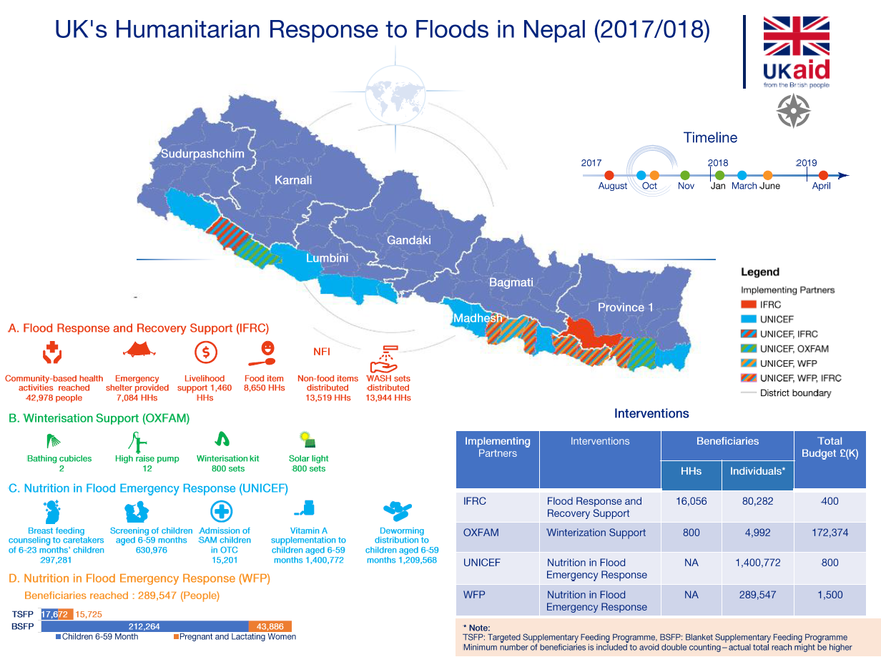
Figure 2 Response to 2017 Floods

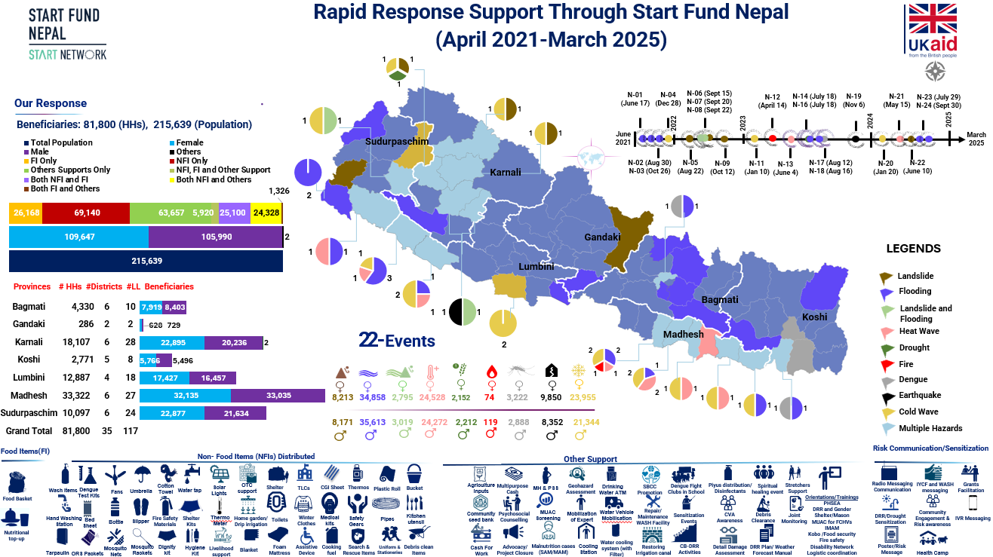

Figure 3 Start Fund Nepal Response (2021-2025)

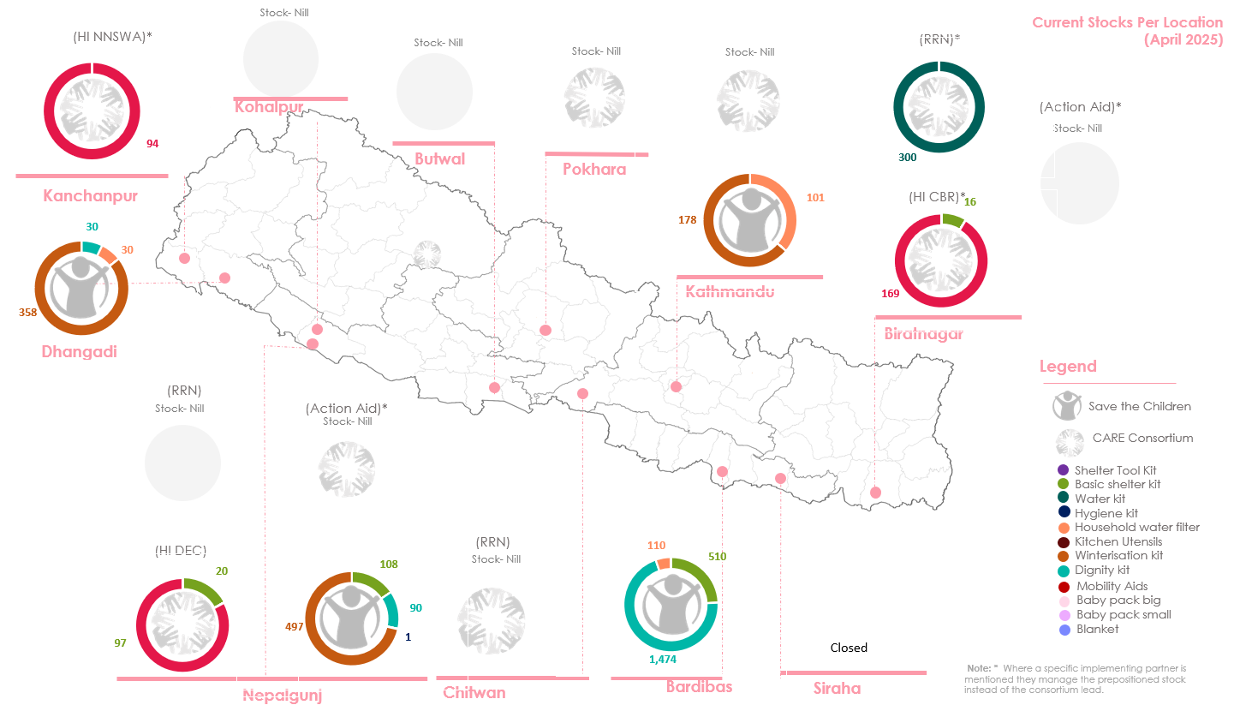

Figure 4 Remaining UK NFIs across Nepal

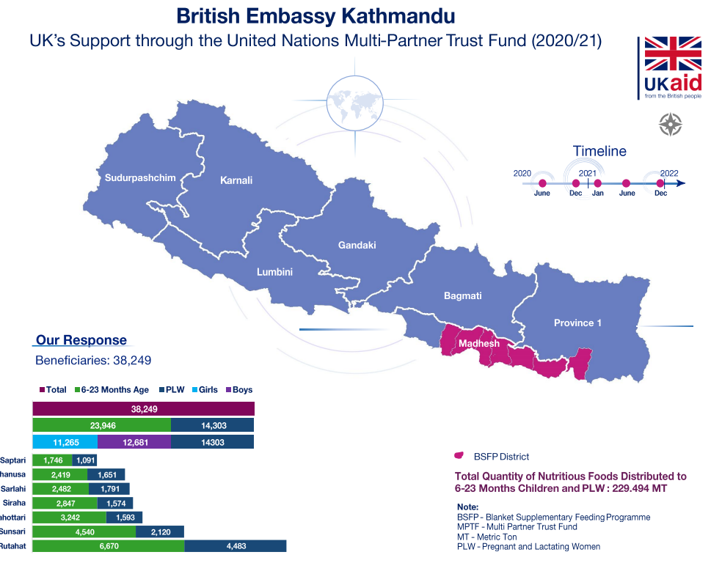

Figure 5 Results from the Blanket Supplementary Feeding Programme (BSFP) under the UN Multi-Partner Trust Fund
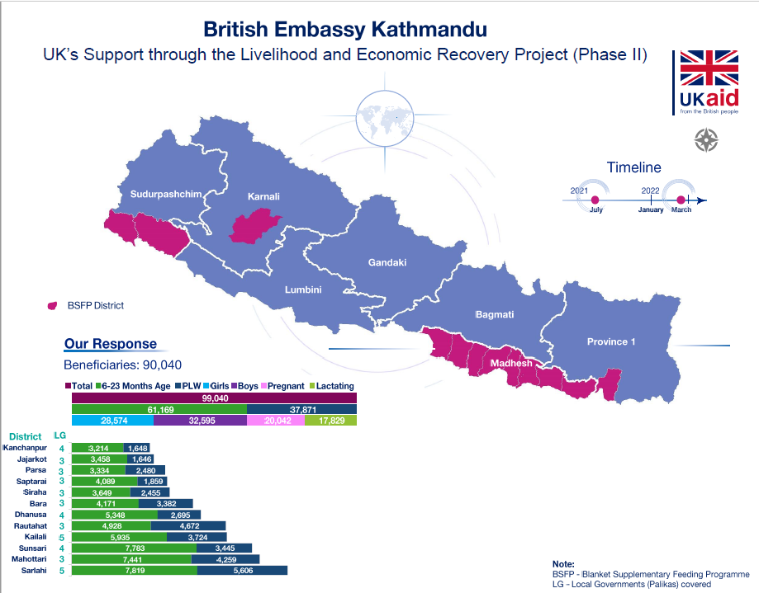

Figure 6 Cumulative Results from the Blanket Supplementary Feeding Programme (BSFP) July’21-March’22

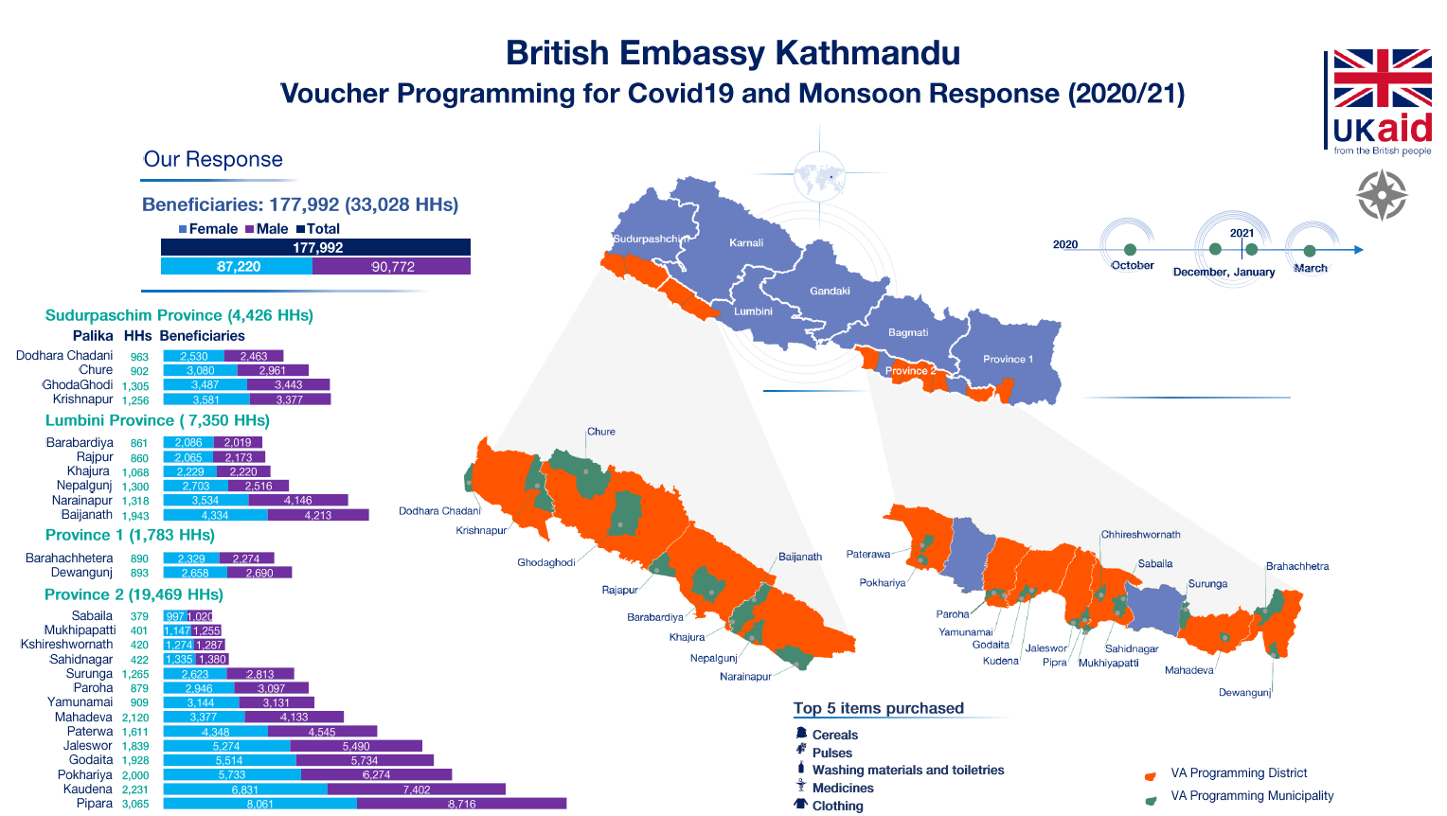

Figure 7 Cumulative Results from Voucher Programming July’20-August’21

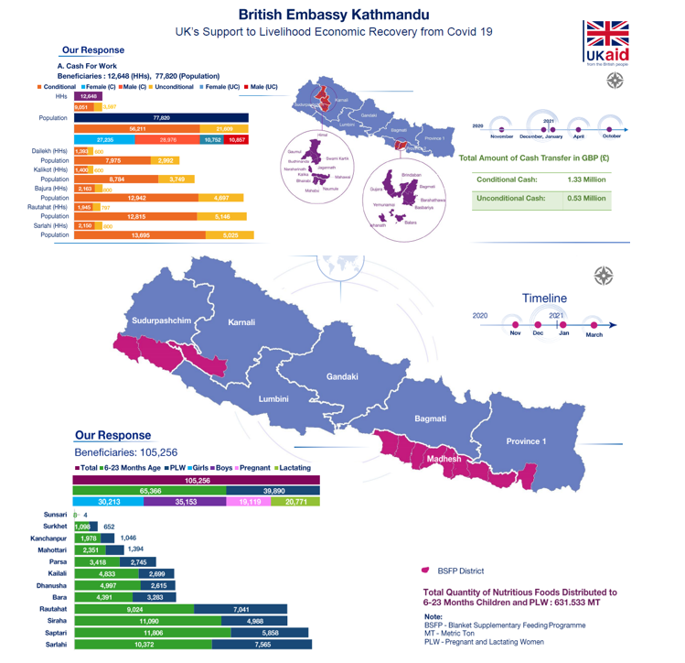

Figure 8 Cumulative Results from Livelihood and Economic Recovery Project (LERP) Oct’20-Aug’21.

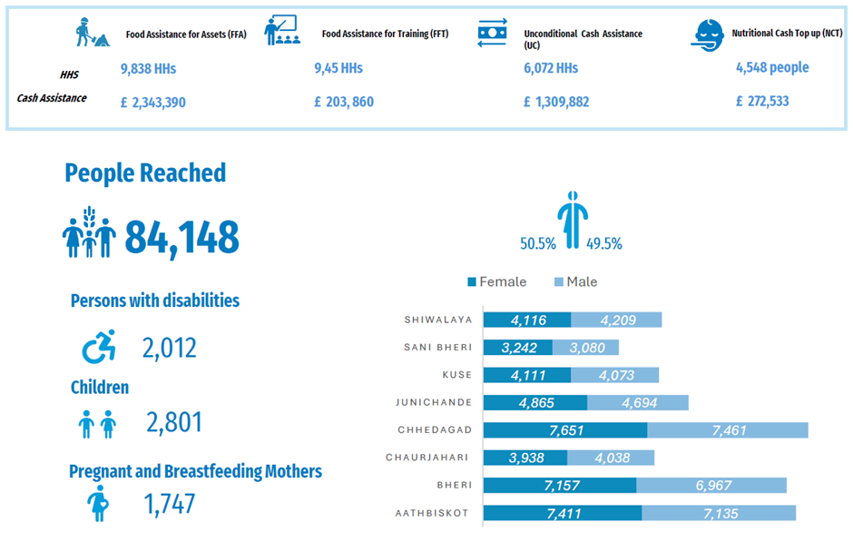
Figure 9 WFP Infographic outlining Strategic Achievements for the Food Security Cluster funded by JRAP (2024/25)
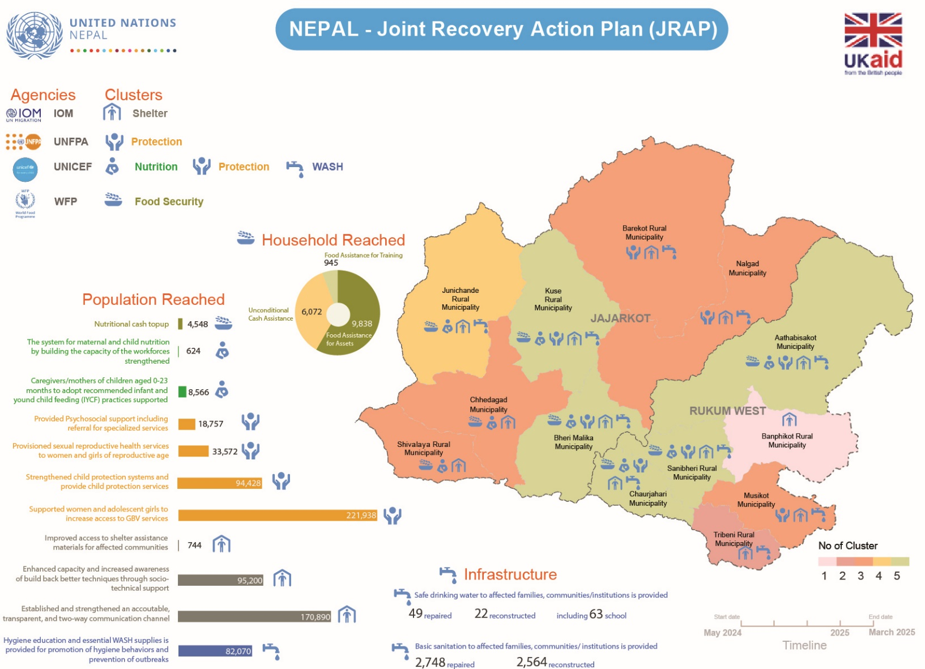
Figure 10 Infographic outlining Strategic Achievements for the Joint Recovery Action Plan (JRAP) (2024/25)

COVID-19 Response Plan Nepal May 2021 | UN Nepal Information Platform
UN teams respond to deadly earthquake in western Nepal | UN News
Prime Minister announces merger of Department for International Development and Foreign Office - GOV.UK
A reduction in ODA resulted in changes to for the financial year 2022/23, in addition to a reprioritisation of funds for COVID-19 in May/June 2020.
UN and partners launch $415 million appeal to aid quake-stricken Nepal | UN News
Jajarkot Earthquake Impact Monitoring Dashboard | UN Nepal Information Platform
Federalism in Nepal, enshrined in the 2015 Constitution, marked a historic shift in its governance
Climbing Higher: Toward a Middle-Income Nepal
Nepal’s diverse terrain amplifies climatic shocks in many instances regions, including a higher number of landslides due to unseasonal/high volume rains, worsened by steep terrain.
Reduction in the UK’s 0.7 percent ODA target - House of Lords Library
While the MEL Unit was slow to enhance its humanitarian monitoring capacity, it conducted two rounds of real-time monitoring for NGO voucher programming, which proved critical in supporting the programme
UK to reduce aid to 0.3% of gross national income from 2027
A self-governing urban local body that administers smaller urban areas than municipal corporations
Nepal: Flooding Response Plan (August 2017-February 2018) - Nepal | ReliefWeb
BEK established a Multi-Partner Trust Fund (MPTF) in 2019 for preparedness. Funding was channelled in response to the COVID-19 pandemic in 2020, which supported both the Government of Nepal (GoN) and the UN, through: WFP, UNICEF, UNFPA, UN Women, IOM and WHO, with coordination through the UN Resident Coordinators Office (UNRCO).
It noted ‘siloed’ implementation for programme coordination as well as the timeliness of finalising agreements, and also raised concerns around the effectiveness of the MPTF as a rapid emergency response overall, and doubts around longer-term preparedness and capacity-building in Nepal.
This was to ensure timely delivery without delay in disbursement of funds from MPTFO to UN HQ, followed by disbursement in Nepal.
A standalone review did occur after the programme, outlined under MPTF sections
As well as the existing organisational reporting and control mechanisms in place
Overall, PIF spent £4,250,251.85
RMEL expensed £2.639 million
This PCR review was conducted in May 2025.
FCDO staff external to BEK

