ADDENDUM TO BUSINESS CASE

INCLUDING FOR BRIDGE FUNDING AND SCALE-UP COST EXTENSIONS

SUMMARY INFORMATION
Project Name | Commercial Agriculture for Smallholders and Agribusiness Programme (CASA)
Country or region targeted | Africa and Asia
Type of cost extension (if applicable) | Cost Extension
Original project budget | £29.9 million
Original project start and end dates
  Start Date:  01 July 2017 | End Date:  31 March 2026
Cost extension value (if applicable) | £25.5m
New reduced budget (if applicable) | n/a
New project end date (if applicable) | 31 March 2026 (no-cost extension approved on 16/10/2023)
Business Case Document No. | 205118

INFORMATION

What is the programme’s purpose?
Context, issue, and problem statement
The Commercial Agriculture for Smallholders and Agribusiness (CASA) programme recognises the importance of the agri-food sector to livelihoods in LMICs, and the criticality of smallholder farmers and small scale agribusiness to food security in these countries. CASA responds to the lack of opportunities for these actors to engage in commercial value chains and to access finance, coupled with their vulnerability to climate change.
Almost 1 billion people are chronically food insecure and over 3 billion cannot afford a healthy diet, including 2.4 billion people moderately or severely food insecure in 2022.
Small-scale farmers and related supply chain actors contribute to a significant share of global food production. Small farms contribute 35% of the world’s food and manage 12% of total agricultural land. In South Asia and sub-Saharan Africa, agri-SMEs dominate agrifood supply chains, channeling 65% of food.
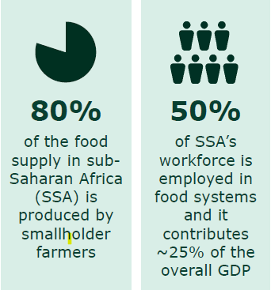
Smallholders in the developing world need more opportunities to engage in commercial value chains. Less than 7% of the world’s 500 million smallholders are commercially active and involved in “tight” value chains. Most, especially women, operate on a subsistence basis. This lack of economic activity is a major contributor to poverty, with 80% of the world’s poor living in rural farming areas.
Bringing emerging commercial smallholders into high potential value chains increases rural incomes and productivity, while creating rural jobs and expanding domestic agri-food production. If 10% of the estimated 150m emerging commercial smallholders were to access formal markets, the increase in rural incomes is estimated to exceed £1.8 billion. If combined with investment in agribusinesses in the same value chains demand for smallholder produce is secured leading to income uplifts and new employment opportunities.
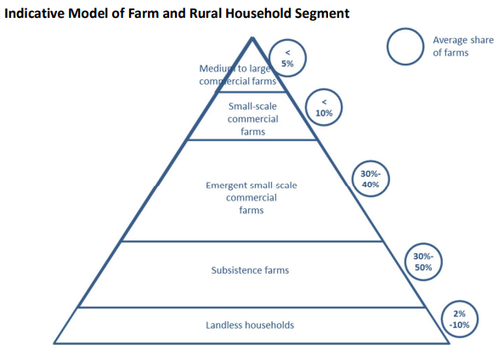
Small-scale producers and the agri-SMEs serving them are expected to face the most severe impacts of climate change and have limited capacity to manage them. Despite their criticality to food production, emissions, and climate vulnerability, small-scale farmers and agri-SMEs receive a meagre share of climate finance.
Despite their importance, there is a ~$75Bn gap between supply and demand for finance for agri-SMEs driven by key structural barriers in the agri-SME financing market, leaving a large unserved market gap affecting a majority of smaller and less commercially attractive agri-SMEs in the poorest geographies, especially in Africa. DFIs are generally ill-equipped to overcome these structural barriers, despite donors’ prioritization of the agri-food sector.
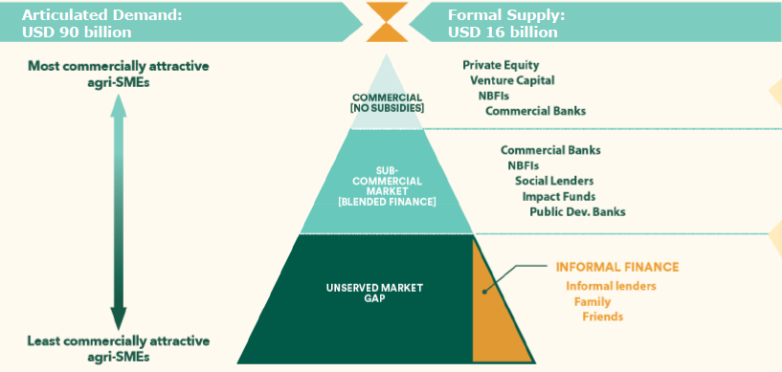

UK’s CASA programme
CASA supports a shift from subsistence farming, toward economic opportunity and climate resilience for smallholder farmers in Africa and Asia – or agriculture transformation – driving innovation to better link smallholders and agri-SMEs to finance and resources, including in fragile contexts. CASA scored an ‘A’ for the last annual review period. In July 2023, its two main components had (since 2019):
- provided technical assistance to 75 agribusinesses (CASA’s Technical Facility has also directly supported 7 investor partners and 9 FCDO Posts)
- leveraged additional private and public sector investment into smallholder farmer inclusive business models and value chains (Component A - £2.3m and Component B - £2.1m)
- directly supported smallholder producers and micro-entrepreneurys to improve their productivity, routes to market, incomes, and climate resilience (Component A – 293,694 and Component B – 55,055)
CASA supports FCDO strategic priorities. In June 2022 the programme was included in UK Government pledge in support of countries on the food security frontline. As of 2022, 100% of the CASA budget allocation contributes to the UK International Climate Finance (ICF) commitment, with all interventions designed to support climate change adaptation, and mitigation where possible, as well as to improve nutrition and gender inclusion results. In 2023 CASA has further enhanced its climate approach, with ICAI assessing its progress to be in line with its recent recommendation to ensure all FCDO agriculture programmes and investments have an integral focus on climate and nature.

Component A – CASA Country Interventions, Learning and Influencing
The Market System Development component of CASA (or Component A) is implemented by NIRAS in association with Swisscontact, with a total budget of £17.5m. Country interventions in Ethiopia, Malawi, Nepal and Rwanda support small agribusinesses across selected value chains, bringing more poor smallholders in commercial food production for domestic markets and preparing agri-SMEs for local investment. Activities include:
- Linking smallholders to agribusinesses and markets: support to businesses, cooperatives and local NGOs for interventions linking more farmers to domestic food markets, e.g. through contract farming, outgrower schemes.
- Supporting smaller agribusinesses in food value chains to prepare for investment: technical assistance to improve financial accounting, governance, operations, strategic planning and to support smaller agribusinesses to identify and engage with investors.
- Climate risk management and resilience for smallholders and agri-SMEs in food value chains: support to smallholder farmers to better adapt to the effects of climate change, increasing smallholder and agri-SME climate resilience and mobilising additional public and private sector climate finance.
As of July 2023, NIRAS country teams have engaged in partnerships with a cumulative total of 50 SMEs (current target to March 2025 is 60), reaching 293,694 smallholders (target to March 2025 in 350,000). 27 SMEs improved their investment readiness and 11 have accessed commercial finance (targets to March 2025 are 35 and 20, respectively).
CASA also undertakes targeted evidence, learning and influencing activities to course-correct within CASA projects, improve the evidence base on the commercialisation of smallholder farmers, and influence the debate on smallholder agriculture and the approaches of specific investors, donorsc, and governments. 25 policy-relevant research reports, have been produced, including regular iterations of the FCDO Commercial Agriculture Portfolio Review.

Component B – CASA Technical Assistance Facility
CASA Technical Assistance Facility (TAF) is a £10m component of CASA implemented by the international non-profit development consulting organisation TechnoServe in support of a climate resilient and inclusive global agriculture sector in over 15 countries in Africa and Asia. CASA TAF provides long-term technical assistance to investment-ready agribusinesses to enable them to expand their smallholder farmer supply chains. This increases the development impact of investment and attracts further climate-smart finance, ultimately increasing the incomes and climate resilience of smallholder farmers and rural communities.
CASA TAF has partnered with 7 DFIs (including BII, FMO, Norfund) and impact investors to support 25 businesses within their portfolios. This has increased the development impact of existing investments and leveraged an additional £2.1m investment (as of 22/23) in smallholder related agribusinesses and value chains. In 2022/23 CASA TAF reached a cumulative 55,055 smallholder farmers. In 2022/23, this support resulted in average additional net income of £152 per farmer (62.1% increase).
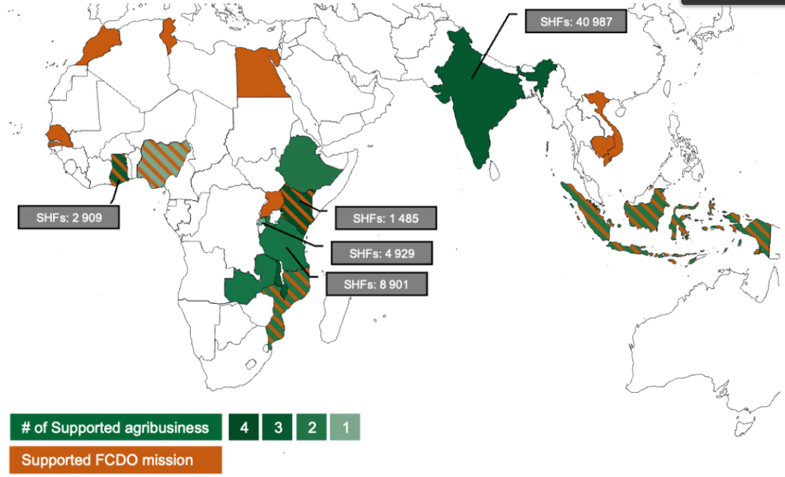
Building on CASA’s TAF’s original approach of partnering with DFIs and impact investors, in 2021 a second prioritisation route began. This piloted the provision of on-demand technical assistance for a small number of FCDO posts to identify and shape agri-food markets to prioritise. This evolved into CASA TAF acting as the agriculture leg of the UK Centre of Expertise for Green and Inclusive Growth by 2022. Nine FCDO country posts are supported by CASA TAF as of July 2023, with a target of 15 by March 2025
Following strong interest of DFIs in CASA, in 2023 FCDO instructed TechnoServe to develop a CASA Plus platform, modelled on the CASA TAF, to attract contributions from BII and FMO (and potentially from Norfund and DFC). Several iterations of consultative planning led BII and FMO to commit $1.5m each, to expand the ongoing work by TechnoServe under the existing CASA agreement. This will allow TechnoServe to deliver specialist technical assistance aimed at: a) expanding the impact on smallholder farmers of existing DFI investments in minimum 18 additional agri-SMEs already in BII and FMO investment portfolios; b) attracting new sustainable investments in minimum 7 additional agri-food SMEs identified by BII and FMO; c) shaping specific agri-food markets in two large countries in Africa (likely Nigeria and Tanzania) to prepare for additional climate finance in the medium term.
In the two-year pilot phase, BII and FMO contributions will add an estimated 10k smallholder farmers beneficially included in formal agri-food value chains (up to 50k in the expected life of the investments after the intervention). FCDO will continue to contribute to the technical assistance facility through the existing contract and agreed allocations to TechnoServe. This participation in CASA Plus allows FCDO to retain substantial influencing over two major DFIs to join efforts and align policy for critical technical assistance to deploy and leverage much needed agri-food investment in low and low-middle income countries, and to promote the approach to further DFIs and investors (Norfund has expressed a preliminarily interest).

What is the objective of the cost extension or other changes?
The objective of the cost extension is to scale up CASA’s results over the next two years via proven delivery arrangements, as well as to test new delivery models. This will provide a bridge to the next generation of FCDO’s commercial agriculture and food security flagship programme.
Extensive site visits and the 2023 Annual Review have confirmed CASA’s success expanding, consolidating, and benefitting SMEs’ networks of smallholder farmers. Consistently good performance by the suppliers at output level has been matched by emerging evidence of outcome level results, although hindered by ODA budget cuts and planning volatility. The programme’s implementing partners were resilient and adapted well to these limitations. In the context of CASA’s success and resilience it is advisable to use the maximum capacity of existing CASA delivery agreements, currently extended to March 2026, and a proportionate increase of the funding ceiling of both contracts, to make room in the business case for “buy-in” from FCDO posts, and to add a proportionate capital investment envelope to test seed funding for investment in agri-SMEs.

£4.5m RDEL Scale-up of CASA Country Interventions and Learning
Although the duration of CASA business case is extended to March 2026, the residual budget available to NIRAS contract for Component A (country interventions) and Component C (learning and influencing) is only sufficient to continue implementation in FY2024/25 and not for full delivery into the last year of the programme.

A1 – Additional results in food value chains in four countries
An extension of budget of £3.5m RDEL for full implementation in FY2025/26 will allow CASA Component A to maximise results, enhancing and increasing overall impact, and offering greater value for money on FCDO’s investment. Interventions in Ethiopia and Rwanda will benefit from a full 18–20-month lifecycle, ensuring outcomes for agri-SME partners and their smallholder suppliers, and building a solid pipeline of investment ready and investible businesses. The extension will allow projects in Malawi to scale successful activities, embed the pivot from poultry and aquaculture into alternative feeds, and develop more innovative funding mechanisms. In Nepal the extension will deepen the work begun under Centre of Expertise programme to test and prepare for the upcoming Nepal in Business programme.

A2 – Final stages of learning and influencing from CASA
A proportionate amount of the additional budget to the NIRAS contract (estimated at £300K of the £3.5m) will allow for the continued delivery of CASA’s evidence, learning and influencing work in 2025/26. This will consolidate and amplify a wide range of evidence and thematic learnings from within and beyond CASA, adding more (and building on previous) learning papers and on three editions of the FCDO Commercial Agriculture Portfolio Review. It will also deliver formal monitoring and learning, including final outcome assessment surveys conducted with smallholders and agribusinesses in all four countries, focusing on outcome harvesting.

A3 – Ethiopia food production “buy-in” project
FCDO Ethiopia has proposed to allocate £1m RDEL from 2024-26 in CASA Components A and C from its bilateral budget for a “buy-in” arrangement aimed at improving productivity and production in selected value chains relevant for national food security. It will also generate strategic lessons and knowledge to inform future bilateral resilience programming.

£11m RDEL Scale-up of CASA Technical Assistance Facility
The CASA TAF model has opened the opportunity to scale up in some countries and to work upstream with investors and with FCDO posts to identify and shape more investable opportunities to expand income and resilience of smallholder farmers. The cost extension will allow further testing, replication and scale-up of CASA TAF along two funding streams.

B1 – Country “buy-in” for investment technical assistance to agri-SMEs
£10 RDEL to allow sufficient headroom for FCDO posts to “buy-in” to CASA TAF. Several FCDO posts in Africa and Asia are keen to continue or expand the CASA TAF model and have allocated, or are considering, country level budget provisions. To date:
- FCDO Egypt has recently launched a two-year CSSF-funded programme of £2.0m to help SMEs and smallholders to ramp up domestic wheat production and to support more sustainable use of fertiliser.
- FCDO Kenya has allocated up to £2.0m in FY2024/25 to tailor CASA TAF and increase agri-food climate smart and inclusive investment around secondary towns in synergy with other FCDO interventions. The anticipated aim is to support 6 high potential agri-businesses in FY24/25, expanding in 24/26 if budget is sustained.
- FCDO South Africa is willing to allocate £1.5m-£2.0m in FY2024/25 to tailor CASA TAF and to support the creation of a project pipeline for investments, including ones to improve jobs and services in Mpumalanga, as part of UK’s contribution to South Africa’s Just Energy Transition (JET). The anticipated aim is to support three to five high potential agri-businesses in FY24/25, selected in the high margin fruit and nuts sector, expanding in other parts of 2025/26 if the budget is sustained.
Additional FCDO posts in Sub-Saharan Africa are considering possible buy-in allocations into CASA to support with technical assistance facilities of respective agriculture investment programmes. Among them FCDO Mozambique (MAJI programme), FCDO DRC (Mokili Green Growth programme) and FCDO Zambia (Rural Climate Resilience Programme). As recommended in the PrOF guidance, to ensure financial headroom in CASA to accommodate the country allocations up to March 2026 a cost-extension of £6.0m RDEL is recommended in addition to Kenya and South Africa’s allocations.

B2 – Additional investment technical assistance to agri-SMEs
The programme needs a minimum budget increase of £1m RDEL to scale implementation in 2024-25 and to deliver proposed high potential follow on Centre of Expertise projects from country allocations (DRC, Cambodia, Ghana, Indonesia, Senegal).

£10.0m CDEL Seed Funding for Investment in Agri-SMEs
£10m CDEL will be used for small scale (<£500k) co-investment or blended investment through one or more impact or patient capital fund(s), accompanied by and closely linked to technical assistance. The FCDO’s British Investment Partnership Directorate allocated £10m in FY2024/25 to make available much-needed seed capital (small-scale blended finance) connected with CASA TAF for smaller, early-stage businesses in selected countries in Sub-Saharan Africa. The final delivery modality and grant agreement will be based on robust independent technical review and be subject to FCDO Director sign off following SRO advice.

What is the additional and total support the UK will provide?
- Existing CASA main BC = £29.9m

- CASA BC Addendum = up to £25.5m
  - £4.5m RDEL allocated by BIPD to transfer to HMFD central budget
  - up to £11.0m RDEL from posts for “buy-in” programmes
  - £10.0m CDEL allocated by BIPD to transfer to HMFD central budget

- CASA Total Budget = up to £55.4m

What are the expected results?

£4.5m RDEL Scale-up of CASA Country Interventions and Learning

Projected Additional Outcomes across Ethiopia, Malawi, Nepal and Rwanda:
- 42,000 additional smallholder producers and micro-enterprises benefiting (60% of farmer outreach set as additional 72,000 SHF reached).
- 20% increase in income amongst smallholder farmers reached by CASA that can be credibly linked to the effects of the programme.
- 65% uplift in number of households reporting women having greater decision-making power over agricultural income and production decisions.
- £1,000,000 additional private sector investment leveraged into smallholder related agribusiness in CASA Component A supported businesses models and value chains.
- additional 6 policy and investment decisions by Government, investors, and agribusinesses in favour of smallholder agriculture that are attributable to CASA outputs.

£11m RDEL Scale-up of CASA Technical Assistance Facility

Projected Additional Outcomes for each sub-component:
- Enhancing Smallholder Climate Resilience and Prosperity in Kenya: Tailored TA to 13 agri-SMEs; at least 5 agri-SMEs demonstrate commercial benefit; 10,000 smallholder or microenterprises beneficially included in agri-SME supply chains; 7,000 smallholders adapting to climate change (ICF KPI 1).
- South Africa JETP/Mpumalanga project: pre-investment TA to 3-5 high potential fruit/nut producers; 100-200 jobs created.
- CASA TA projects in two/three additional countries - to be confirmed at inception with FCDO Posts providing the allocations
- CASA TA projects identified with other FCDO Posts- to be confirmed at inception in DRC, Cambodia, Ghana, Indonesia, and Senegal

£10.0m CDEL Seed Funding for Investment in Agri-SMEs

To be confirmed at inception. Maximising the results offer for this component will be the key parameter to select the most impactful option for implementation (see next section “What is the approach to implementation”).

What is the approach to implementation?

The extension will be implemented through a combination of extensions to existing contracts with NIRAS and TechnoServe, and new standalone grant agreements. Implementation will be in line with FCDO commercial rules, with the commercial team closely involved.

£4.5m RDEL Additional Funding for CASA Country Interventions
Extend existing contract with NIRAS to 31 March 2026 and add £4.5m to its maximum cost, of which £3.5m for funding CASA Country Interventions in FY2025/26 (including £300k for learning and influencing activities), and £1.0m for additional food security interventions in Ethiopia. This contract extension is within the commercial limits set by CASA Lot 1 tender.

£11m RDEL Scale-up of CASA Technical Assistance Facility
A double track to keep separate and self-standing the continuation of the CASA TAF from the implementation and the accountability of country buy-in projects.

B1 – Country Buy-in
In line with FCDO PrOF guidance on “buying into another programme”, CASA technical assistance projects in Kenya, South Africa and other countries, FCDO Posts have expressed preference to retain the cost centre at Post and to ask CASA to fund proposals tailored to the country context (most probably through self-standing accountable grants) and to regulate the relationship with CASA central team with a “double lock” agreement. This corresponds to Model 1B in the buy-in guidance, although Model 2B could also be applicable.

B2 – Additional investment technical assistance to agri-SMEs
Extend the existing contract with Technoserve to 31 March 2026 and add £1m to its maximum cost, to continue the Centre of Expertise modality on demand by posts that cannot allocate own budgets. This contract extension is within commercial limits set by CASA Lot 2 tender.

£10.0m CDEL Seed Funding for Investment in Agri-MSMEs
Set up a dedicated grant agreement with a suitable organisation to be selected in 2024. A dedicated task team will oversee a six-week study to recommend the best delivery option. This study will be based on a mapping of suitable funds and investors in countries where CASA TAF is prioritised, reviewing options against a set of technical criteria: geographic alignment with CASA TAF; opportunities for affordable investment targeting small agri-SMEs well below DFI’s typical minimum ticket size of $10m; opportunities for affordable investment in local currency; opportunities to deliver investment alongside technical assistance to deepen smallholder benefits and to crowd-in additional investment; and feasibility of FCDO delivery of grant funding within FY2024/25.
There are four options broadly available and in principle appropriate to deliver the new CASA funding for investment capital:
- delivery through impact investors already partnering with CASA TAF, with a number of dedicated grant agreements that CASA TAF can identify and shape alongside the provision of technical assistance on demand from FCDO Posts
- a grant agreement to endow the funding to AgDevCo’s upcoming Venture Plus programme alongside and in addition to other FCDO funding
- a grant agreement with Aceli to expand Aceli’s reach in countries where CASA is prioritised
- a UK contribution to the new US/Norway-led initiative “Financing Agricultural Small-and-Medium Enterprises in Africa”.

Gender Equality (compliance with UK’s Gender Act)
The CASA programme delivers on the UK’s Gender Act and contributes to reducing gender inequality through interventions promoting gender equality, as part of an overall focus on inclusive technical assistance. In response to the last Annual Review, CASA is taking an even more deliberate approach to driving gender inclusion. Component A has recruited country level advisors for gender and social inclusion, who conducted audits of past programming and advise on the design of future projects. Component B is using a gender diagnostic tool to assess where companies require improvement and launch deeper, targeted gender initiatives with companies with low inclusion of women.
The programme has metrics to track results for women, and in response to annual review recommendations the log-frame has been upgraded to better reflect the work being done and progress made (beyond merely setting targets for and capturing the number of women farmers reached). CASA’s Commercial Agriculture Portfolio Review also sets out how FCDO commercial agriculture programmes are performing against FCDO’s gender and social inclusion objectives and recommends how they can better integrate gender objectives, actions, and measure results.

Compliance with UK’s Terrorism Act
The risk of funds being used for terrorism is low. Although CASA projects operate across many countries, UK ODA funds are delivered for direct implementation of the activities to reputable organisations headquartered in the UK, US, or the EU and subject to FCDO’s due diligence. There are no direct fund flows to Governments of the recipient countries or to local public or private entities. Specific clauses to ensure compliance with the Terrorism Act 2000 and all subsequent anti-terrorism regulations are included in the agreements with all implementing partners (49.1 to 49.4 of FCDO’s standard commercial terms and conditions). These will remain valid for any contract extension or included in new agreements necessary for the implementation of this Addendum.
Describe any key changes to the original business case including the theory of change or new evidence from ongoing monitoring, evaluation or learning work?
Recommendations and follow up action from CASA Annual Review 2023: The last 2023 Annual Review recommended an extended programme duration to at least March 2025, and increased budget ceiling. This was to ensure completed crisis response projects, implementing G7/CHOGM pledges on global food security crisis response and delivering overall programme ambition that had slowed due to COVID and ODA budget cuts. In late 2023 a no-cost extension to March 2026 was approved and work with FCDO posts has scaled up and work is in train to support posts’ planning of bilateral budgets (as recommended). CASA also significantly enhanced its climate approach following the Annual Review in 2023, introducing climate audits and strategies across for its four countries and a climate risk assessment for all business plans. CASA TAF introduced a climate intervention diagnostic as part of its Inclusive Business Planning process. FCDO updated the logframe in late 2023 to better align with ICF results framework and to add several new disaggregated parameters to monitor climate impacts. A CASA climate learning paper is due for publication in Spring 2024. On gender and nutrition: new gender indicators were added to the logframe, learning papers on gender and nutrition are planned for 2024/5, and contracted support on nutrition integration will be deployed for the next Commercial Agriculture Portfolio Review.

Expansion of the Results Offer and Modified Theory of Change: The additional funding for scale-up of CASA Market Development interventions, continued learning and evidence, and expansion of CASA TAF will not change the substance of CASA Theory of Change. It will require an expansion of the same results offer in the logframe at outcome level. It will also require some adjustments and further disaggregation of the target output and outcome indicators for dedicated reporting in countries with post “buy-in” agreements. These changes to the logframe will be discussed in detail with implementing partners at the point of approval of the relevant contract amendments and agreements for new country projects.

The new CDEL funding creates a material modification to CASA Theory of Change with the inclusion of available investment capital for agri-SMEs. This is illustrated in the modified CASA Theory of Change diagram on next page.

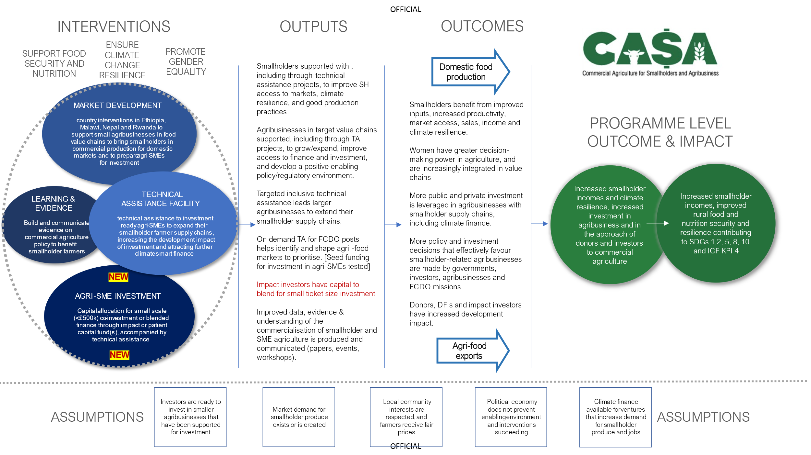

The end date in the 2017 Business Case was 31/06/2023, extended to 31/03/2023 before the start of implementation due to delays in the design and mobilisation phase. A further no-cost extension to 31/03/2026 was approved in October 2023
FAO: SDG Progress Report 2023
those with less than two hectares of land
The Climate Finance Gap for Small-Scale Agrifood Systems (CLIC, November 2023)
Landscape mapping and market sizing of Agri SME financial service providers in Sub Saharan Africa (ISF, March 2023)
IFAD Value Chain toolkit and CGAP, Focus Note Segmentation of Smallholder Households 2013.
Agriculture Overview: Development news, research, data | World Bank, (2023)
DFID’s Conceptual Framework on Agriculture (Nov 2015)
CASA adopts a flexible definition for smallholder farmers based on the specific context of the geography.
Based on a minimum £120 income uplift per year, derived from i) estimates of famer income uplift of $150 from AgDevCo Smallholder Development Unit and ii) evidence supporting a 10-50% uplift in incomes which is applied as 30% to one 1/3 of the average SSA income in 2016 (£1250) equates to an income uplift of £133.
The Climate Finance Gap for Small-Scale Agrifood Systems (CLIC, November 2023)
ISF Advisors, “The state of the agri-SME sector – Bridging the finance gap”, 2022
Sum of cumulative totals reported under outputs 1.1 and 4.2 in the logframe since the start of the programme.
Thanks to the pledge, CASA scaled up support to SMEs and smallholder farmers in food value chains (such as poultry, aquaculture, vegetables, diary, edible oils) in Malawi and Nepal and started operating also in Ethiopia and Rwanda; the additional results from these range of new food production projects will become apparent from next programme annual review, due in July 2024
Aquaculture (Malawi and Rwanda), Dairy (Nepal), Poultry (Malawi and Rwanda), Soybean (Ethiopia) and Vegetable (Nepal and Rwanda).
Also implemented by NIRAS, previously in association with the Centre for Agriculture and Bioscience International (CABI).
Available at: Evidence - CASA (casaprogramme.com)
CAPR 2022 available at: Commercial-Agriculture-Portfolio-Review-2022.pdf (casaprogramme.com)
Estimated at £10m for the programme lifetime in the 2017 Business Case, the initial agreement was for up to £8m to March 2024, currently being extended of £1.9m to March 2026
Cambodia, D.R.C, Egypt, Ghana, India, Indonesia, Kenya, Mozambique, Nigeria, Philippines, Senegal, South Africa, Tanzania, Tunisia, Uganda, Zambia.
Ghana, Indonesia and Vietnam, in the pilot phase
draft PrOF Guide Buying into Another Programme
PrOF Guide Buying into Another Programme
This is a self-standing intervention that has no operational links with CASA main programme, although using the same approach and implementing partners.
In particular the SUED flagship programme
Some FCDO Posts identified for assistance in 2023/24 (among them Egypt, Ethiopia, Morocco, Tunisia, Zambia and Zimbabwe) have been de-prioritised for various reasons, but this allocation will provide a certain amount of flexibility in case small scale opportunities should emerge.
Few FCDO Posts identified for assistance in 2023/24 (among them Egypt, Ethiopia, Morocco, Tunisia, Zambia and Zimbabwe) have been de-prioritised for various reasons, but this allocation will provide a certain amount of flexibility in case small scale opportunities should emerge.
max 2 years to March 2026 (already extended with no extra budget).
max 2 years to March 2026 (already extended) and up to £3.2m extension (of which £1.9 already added to the original contract)
a new concessional fund being explored by AgDevCo to support smaller investments of $1- $3m in high potential, fast growing agri-SMEs; FCDO Pan Africa Directorate is separately considering grant funding, to complement the UK's $50m equity investment in AgDevCo through BII.
Integrating KPIs 1, 4, 11 and 12, with 4 (people with improved climate resilience) a new impact indicator,

