Annual Review of Transforming Energy Access (TEA) Platform 2026
Programme Value £ (full life): £265.4m |  | Review date: March 2026
Programme Code: 204867 | AMP start date: 23/03/16 |  | AMP end date: 31/03/2028

Summary of Programme Performance
Year | 2016/17 | 2017/18 | 2018/19 | 2019/20 | 2020/21 |  | 2021/22 | 2022/23 |  | 2023/24 | 2024/25 | 2025/26
Score | A | A | A | A+ | A+ |  | A+ | A |  | A | A | A+
Risk Rating | Moderate | Moderate | Moderate | Moderate | Moderate |  | Moderate | Moderate |  | Moderate | Moderate | Moderate
DevTracker Link to Business Case and Results Framework |  |  |  |  |  | Link

A. SUMMARY AND OVERVIEW
Transforming Energy Access (TEA) is the flagship FCDO research and innovation platform supporting early-stage testing and scale up of innovative technologies and business models that accelerate access to affordable and clean energy in developing countries, enabling sustainable and inclusive growth. This includes clean energy supply technologies (e.g. next generation solar, zero-emission generators), super-efficient end-use technologies (e.g. efficient appliances, sustainable cooling) and smart delivery solutions (e.g. energy storage, green grids, clean hydrogen). It directly contributes to Sustainable Development Goal (SDG) 7 to “ensure affordable, reliable, sustainable and modern energy for all” by 2030, SDG13 on “urgent action to combat climate change and its impacts”, and the Paris Agreement on Climate Change limiting the global temperature increase to 1.5°C above pre-industrial levels. Through UK technology and expertise, and strong local and global partnerships, TEA also informs major energy access initiatives, including Mission 300 via ESMAP, which seeks to bring electricity to 300m people in Africa by 2030 and has evolved in the reporting year to secure the backing of 30 African Heads of State.
TEA is the largest delivery mechanism for the UK government’s up to £1 billion Ayrton Fund for clean energy innovation, which is part of the wider £11.6 billion of International Climate Finance (ICF) between 2021 and 2026. In January 2026, the Cross-Government Ministerial ODA Board approved the ODA R&D Approach for 2027-2030, including a focus on energy innovation and listing Ayrton as the Delivery Mechanism for it in the coming period. TEA helps deliver key Ayrton Challenges, including making the diesel generator redundant, generating breakthroughs in energy storage, and making solar power accessible to the bottom billion. TEA is also the primary technology innovation instrument in the Growth Investment Partnerships (BIP) toolkit and the current FCDO Green Cities, Infrastructure and Energy (GCIE) Centre of Expertise.
The International Development Committee (IDC)’s Inquiry and 2025 report on ‘Empowering Development: Energy Access for Communities’ drew extensively on TEA evidence and projects. TEA is also central to delivering on a number of the commitments in the HMG Response. In testimony at the Inquiry the Minister for Development Baroness Chapman said: “The initiatives that we have been leading on Transforming Energy Access have been successful. We should continue with things that are working and still seem to work because they are flexible and responsive to local needs.”
TEA is delivered via five Tier 1 partners - the Carbon Trust, Innovate UK, Shell Foundation, CLASP and the World Bank’s Energy Sector Management Assistance Program (ESMAP) – and a network to date of over 840 innovators, academics, entrepreneurs, and civil society partners delivering research and innovation activities in 60 countries. The TEA theory of change is organised around the following intervention areas/outputs (budget figures are rounded):
- Data, skills, and capabilities (~£21m): Improve the availability and quality of relevant clean energy public goods data and evidence informing decisions and action, and build the skills and capabilities needed to deliver an inclusive energy transition in developing countries.
- Open calls (~£82m): Stimulate a pipeline of new ideas and innovators, particularly UK-international collaborations, in clean energy technologies and business models that can be commercialised and scaled-up in Sub-Saharan Africa, South Asia and the Indo-Pacific.
- Technology accelerators (~£25m): Solve key performance and cost challenges in Ayrton Challenge priority sectors, which act as barriers to the commercialisation and scale up of clean energy access.
- Venture building (~£51m): Through targeted R&D support, build up pioneering “lead firms” delivering new clean energy access technologies and business models, capable of leveraging private capital, achieving impact at scale, and shifting whole markets.
- Market building (~£40m): Developing the market, policy and regulatory conditions for clean energy access, including the platforms, partnerships, such as Mission 300, and institutions linking innovators, financiers, policymakers, regulators and other key stakeholders.
- Research Programme Delivery Consortium (RPDC) including Supporting Services to TEA and the Ayrton Fund (~£15m): Support portfolio management, knowledge generation, and research dissemination, and implement TEA portfolio Support Services e.g. on gender, disability, local inclusion, and health and safety.
- Country Demonstrators (~£30m): Enable FCDO Country Posts to fund clean energy demonstrators in their countries and regions via TEA partnerships.
An overview of TEA projects and partnerships can be found on the TEA Website.

Summary supporting narrative for the overall score in this review
Over the last year, the TEA platform has exceeded expectations across most Outputs, as documented in this annual review, with particularly strong performance in the higher weighted outputs most central to TEA’s Theory of Change, including data and skills, open calls, venture building, and market shaping, justifying an overall performance rating of A+. Partners continued to deliver strongly across the platform, and four out of five Outcome KPI milestones for 2025 exceeded, with four endline targets also achieved ahead of schedule, including over 36m people reached with improved clean energy access, 210,000 green jobs created and supported, £1.8 billion in public and private investment leveraged, and 6.1m tonnes of CO₂ emissions avoided (the same as removing over 4m UK cars off the road for one year). While performance was mixed in Country Demonstrators funded by FCDO Posts, all have delivered important results and delays in meeting some KPI targets for some of these did not outweigh over-delivery elsewhere, or detract from the programme’s strong contribution to system-level change. Performance by Output is presented in section C, with the headline scoring narrative set out below.
Output 1 - Data, skills and capabilities (A++). Performance was very strong, with substantial over-delivery across knowledge products and capability-building indicators. Critical market data, including research and state of the market reports has grown to 441 products published (target 320), and informal articles published to 597 (target 150). Research outputs are made accessible on the TEA website and FCDO’s R4D. TEA projects have increased report dissemination in the year achieving 73,606 engagements (views and/or downloads, against target of 70,000). 1,670 young Africans have been supported with job placements in clean energy businesses (target 1,450), with a retention rate of 80%. Furthermore, 5,639 people (target 1,220) have been trained, with notable contributions by the Energy Access Talent Initiative (EATI), Low Energy Inclusive Appliances (LEIA), and Growing Government Engagement in Energy Access (GGE-EA). 78 universities (target 36) have been supported to expand research and teaching on clean energy access, while 1,158 students (target 474) have enrolled in TEA-supported Master’s programmes, with 185 students completing their studies so far. A final 10 Chevening scholars from Africa, Asia and the Pacific are currently undertaking clean energy Master’s degrees in the UK co-funded by TEA (meeting the target of 30).
Output 2 - Open calls (A+). Performance was strong, with delivery continuing at scale and milestones for projects, innovations and evidence generation exceeded. TEA open calls have supported 427 new clean energy innovations to date vs a target of 387, a significant contribution to SDG7. In 2025, the Energy Storage Challenge supported 24 new organisations including NaBEDA, which is testing UK-made Sodium Ion batteries in Liberia with MOPO and the South African Council for Science and Innovation Research (CSIR) - visited by the FCDO Chief Scientist in October 2025. Energy Catalyst supported R&D across 27 technologies, while Powering Renewable Energy Opportunities (PREO) added 23 new projects and LEIA five. Collectively, these Open Call windows are supporting an ecosystem of innovators in energy storage, e-mobility, productive-use appliances and energy efficiency. Knowledge generation through Open Calls also performed well this year, producing 63 new publications (284 to date vs 185 target), including 49 peer-reviewed, contributing new evidence on storage technologies, productive-use applications and e-mobility systems.
Output 3 - Technology accelerators (A). Largely on track, with milestones for 9 of 12 KPIs met or exceeded. The Ayrton Zero-Emission Generators (ZE-Gen) Challenge exceeded milestones for demonstrations (19 vs target of 15) and installed 1,706 zero-emission generators (target 1,500). The Cross-Boundary Mini-Grid Innovation Lab (CBIL) exceeded the alpha-testing target, but remained below target on developer engagement and cost per connection ($683 vs $600). The Ayrton Next-Generation Solar Challenge lead, TEA@Sunrise substantially expanded its network to 316+ members across 37 countries and exceeded targets for technologies identified (9 vs 6), but did not deliver planned demonstrators due to slow progress on module production. The Ayrton Energy Storage Challenge met targets for UK research group engagement, supported by 13 convening events and a new Battery Network series. The Ayrton Inclusive Energy & Leave No-one Behind Challenge substantially exceeded targets contributing to 1,644,266 people benefiting from improved healthcare access (target 1,562,500), while Transforming Humanitarian Energy Access (THEA) tested 6 new humanitarian business models (against a target of 1). The Ayrton Sustainable Cooling Challenge also progressed well with 19 cooling innovations tested, five business models supported, and three policy dialogues delivered, including through the launch of the new multi-stakeholder Kenya Cold Chain Accelerator.
Output 4 - Venture building (A++). Performance was very strong, with all investment mobilisation and venture support KPIs surpassing targets. Transforming Inclusive Energy Markets (TIME) continues to be the largest venture building programme within TEA with notable R&D investments in the year including 13 new business models tested, including through the Climate Innovation Network (supporting 6 innovators) and Advik (an OEM who are integrating a UK-designed serviceable and re-usable battery into their value chain in Sub-Saharan Africa). Acumen’s PEII+ investments included Energy Assured (Nigeria), and four follow-on investments. The value of TEA Venture Building R&D funding (venture building grants, returnable grants, equity and debt) was £11m in 2025, contributing to a cumulative total of £119m (vs a £64.35m target). The total number of companies supported by TEA reached 858 (target 760) with 526 business models tested (target 340) largely driven by ZE-Gen and PREO. This year, the FCDO RED Deputy Director visited some of the innovators supported by TEA in Kenya, including M-Kopa, Roam, Burn, Keep-it-Cool and Ampersand.
Output 5 - Market building (A+). Performance was very strong, with 18 of 20 milestones met or exceeded. The most notable change was the inclusion of the Energy Access Institutions Facility (EAIF) as TEA’s primary mechanism for supporting Market Institutions (MIs), reinforcing FCDO’s commitment to R&D via market shaping platforms and enabling stronger sector learning, coordination and collaboration. Memberships across TEA-supported platforms have continued to grow, with 840 organisation-memberships to date. Sector convening has remained strong, with a cumulative total of 180 coordination events (target 83) and 76 published reports (target 53) delivered across the portfolio to date. The most significant progress, however, is reflected in the market enabling KPIs, which have grown substantially including a 30% increase in market-enabling platforms supported, sustained growth in sector coordination events and knowledge products, and a sharp rise in national and sub-national policies influenced across energy access and market regulation. Support to seven additional platforms this year, including via the EAIF as well as Pacific regional platforms (NDC Hub, Office of the Pacific Energy Regulators (OPERA), and the Pacific Centre for Renewable Energy and Energy Efficiency (PCREEE)), amongst others, resulted in a 30% growth. Policies influenced (national and sub-national) have also grown significantly, with 25 policies influenced in 2025 between the EAIF, LEIA and the ENACTUS Country Demonstrator - contributing to a total of 110 over the life of TEA.
Output 6 - RPDC and Support Services (A). Performance was on track, with Support Services operational and delivering, alongside strong communications. Over the past year, the TEA Support Services on Gender & Disability, Impact measurement, Local Partnership Inclusion (LPI), Research and Health & Safety have been up and running and delivering on targets. The updated TEA GEDSI Toolkit was published, gender and disability training provided to TEA partners, as well as Local Partnership Inclusion work expanded, providing 22 partners with tailored expert support including for the development of proposals for specific Open Call windows. Communications channels saw strong growth following the main website redesign and increased LinkedIn activity with 2,000+ new followers. TEA’s Research Support Service (RSS) published their first report Mind the gap: Rethinking transitions along the energy access finance continuum. Ayrton Support Services progressed according to plan, with rising engagement in the Ayrton Explorer (5,000+ new users; total 9,306 users to date), 1,000+ new followers on LinkedIn, and the Locally-Led Action and Equitable Partnerships Deep Dive published (watch webinar here).
Output 7 - Country Demonstrators (A). Performance was mostly on track, with 9 of 14 milestones met or exceeded, with a series of high-profile Demonstration impacts achieved across six Posts. ENACTUS in Uganda exceeded its clean cooking access target by over 50%, reaching 9,085 households through effective co-operation with the private sector and both the Kampala City Government and Ugandan Clean Cooking Unit. In the Pacific, 11 countries (target 1) were supported with NDC implementation and financing. In Somalia, the first Sharia-compliant solar investment was made in KIMS Solar, fast-tracking Somalia as a priority country in the Hardest-to-Reach Fund (which closed financing of $250m including from BII in January 2026). However, out of the £1.8m available for investment in Somalia through TEA, only £1.3m was deployed, reflecting tight delivery timelines (with only a six-month investment window), limited market maturity, a small pipeline of investment-ready firms, and constraints on absorptive capacity. In Rwanda, LEIA-R was extended by 12 months due to procurement delays and importation challenges, however it has now installed 180 PUE appliances in refugee camps, and exceeded its gender target, with 57% of supported micro-enterprises being woman-owned. The Energy Catalyst Tanzania demonstrator, launched in 2025, has already validated five technological innovations and two business models, including green mini grids for fish farming. Post contributions via ESMAP were also made in the year, informing and embedding innovation in World Bank energy projects in Indonesia (£5m) and Tanzania (£1m), with the latter already reaching over 10,000 people attributable to FCDO funding.
Major lessons and recommendations for the year ahead
A summary of progress against the previous AR recommendations is provided in Annex 1, with 11 out of 13 now completed, one in progress, and one deferred to TEA3. Key learnings and recommendations for the year ahead are grouped by intervention area in the Output Section (C). As TEA2 enters its final phase of delivery, a set of priority lessons and forward-looking recommendations is outlined below to inform implementation in the year ahead and support the transition to the next phase of the platform currently in development, and pending approval (TEA3):
- Begin to apply TEA3 Principles and Shifts, which reflect the modernised development approach: TEA partners should begin applying the eight TEA3 Principles and Shifts during 2026/27, where affordable and deliverable within existing resources, including targeted use of Scale-Up and Pivot funding to test new approaches, build new co-funding partnerships, improve value for money, and better align country engagement with likely priority geographies, without changing existing approved TEA2 scope or pre-empting decisions on TEA3 approval.
- Develop and apply differentiated country engagement models: RPDC and FCDO should adopt a structured approach to tailoring TEA engagement by country, based on demand, context, and TEA3 priority status. This should include stronger and more systematic collaboration between TEA partners, FCDO Country Posts, and government counterparts, through earlier alignment on upcoming opportunities and more consistent involvement in key processes such as the Delivery Review Workshop (DRW). The approach should balance deeper engagement in priority countries with targeted, high-efficiency engagement elsewhere, to strengthen impact while minimising transaction costs.
- Synthesise cross-portfolio learning informing future support: RPDC to convene Tier 1 partners following the DRW to undertake a structured synthesis of TEA cross-portfolio learning, drawing on existing evidence including the mid-term review, annual reviews, Ayrton studies (including the Localisation, UK Secondary Benefits and Ayrton Challenges Review), Research Support Service outputs, TEA Scaling Archetypes and Shell Foundation’s Inflection Points analysis. The synthesis should explicitly link findings to the TEA3 Principles and Shifts, to generate design and delivery model recommendations for TEA3 and the future Ayrton portfolio, as well as generalised lessons for other research and innovation, and energy transition support.

B: THEORY OF CHANGE AND PROGRESS TOWARDS OUTCOMES
The TEA Theory of Change, summarised below, remains unchanged from last year.
There have been minor adjustments to selected Outputs, which are discussed in the relevant Output sections. At the Outcome and Impact levels, the only substantive change is the reframing of Impact KPI 4. Originally defined as “Number of zero-emission generators installed”, this KPI remained under development last year due to the absence of any agency or system systematically collecting this data. As an interim measure, TEA has therefore adopted a proxy indicator that tracks trends in fossil-fuel generator deployment in developing countries.
For some Outputs, impact weightings have been slightly adjusted to align these with budget allocations across interventions areas.
In response to a Mid-Term Review recommendation, TEA partners also adopted an enhanced reporting and quality assurance approach, strengthening assumptions and increasing confidence in KPI reporting, including through the completion of ICF checklists.
Shell Foundation, which is the biggest contributor to TEA outcome results has also engaged an independent third-party to validate reporting from the highest-contributing TIME projects, including Odyssey, EEGF, SIMA EARF, Persistent and Mirova.
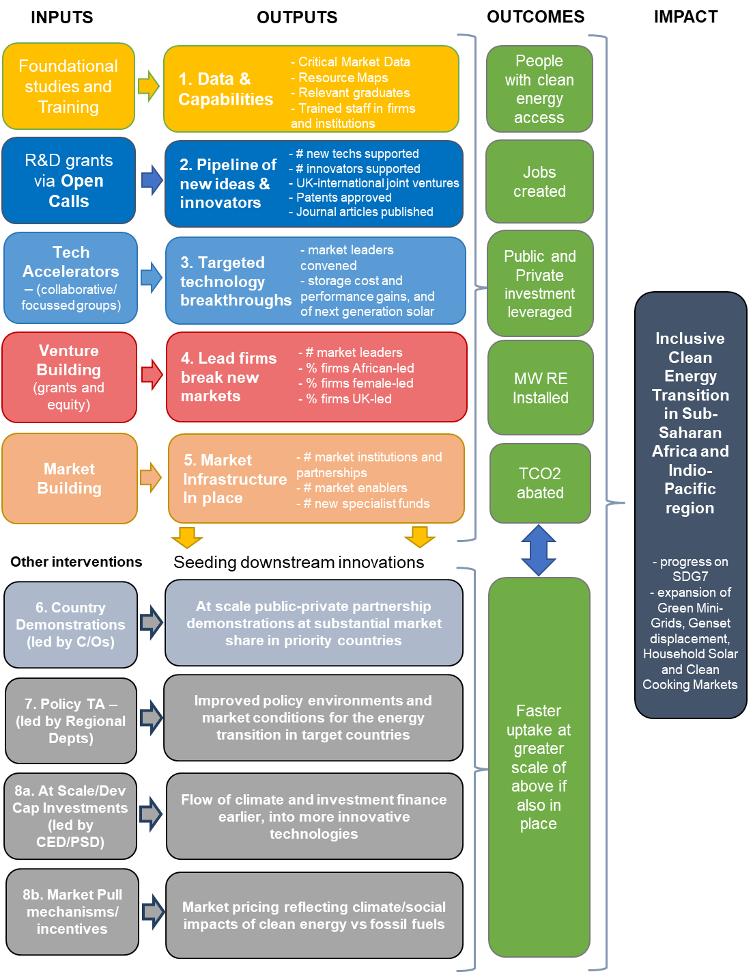
Describe where the programme is on/off track to contribute to the expected outcomes and impact. What action is planned in the year ahead?
The following section describes progress on the TEA Outcome indicators:
Outcome Indicator P1: People with improved access to clean energy
Milestone: | (F) 11,250,000 | (M) 11,250,000
Achieved: | (F) 17,552,939 | (M) 18,988,772
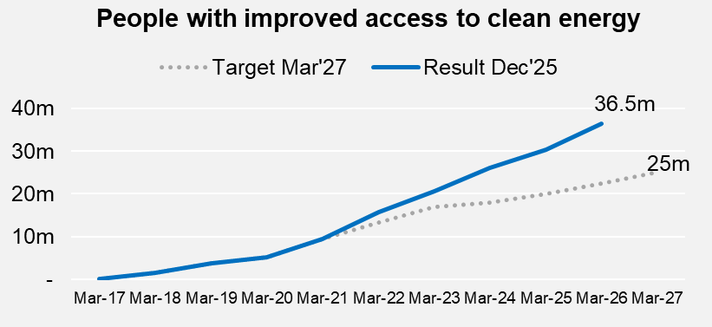
Performance against this KPI remains strong and continues to significantly exceed the final target of 25m people, with substantial year-on-year growth driven by later-stage innovation investment, deployment and scaling activities (e.g. the catalytic investment activities of the venture portfolio). To date, TEA-stimulated innovations have improved access to clean energy for an estimated 36.5m people in developing countries, an increase of 6m over the last year. Of these, around 75% are in Sub-Saharan Africa and 21% in South Asia, and 1,773 people in the Indo-Pacific. The remaining results come from earlier returns that did not disaggregate results by country. Overall, results remain higher for men than women, which is partly attributable to incomplete gender disaggregation in the early years of TEA. The largest single contributor to this year’s increase was TIME, which reported an additional 3.6m people. Acumen also increased its reported contribution from PEII+, rising by over 1m to 1.46m. CLASP reported a new contribution of 205.5k people linked to Market Institutions supported via the EAIF, and 461,000 people associated with a £2.5m contribution to ESMAP was included this year.
Outcome Indicator P2: Green jobs created and supported
Milestone: | (F) 45,000 | (M) 110,000
Achieved: | (F) 48,715 | (M) 161,194

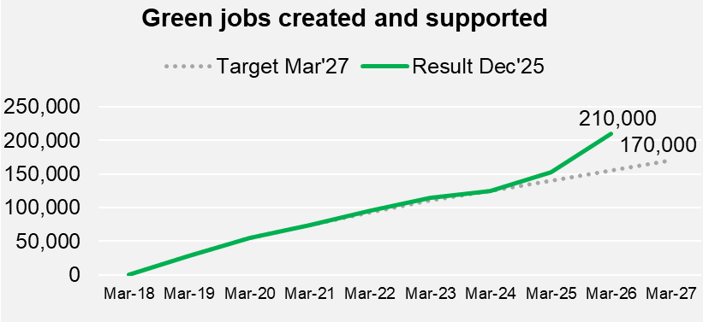
Performance against the green jobs KPI has accelerated over the past year, exceeding milestones for both men and women for the first time and reflecting strong portfolio-wide employment effects. To date, TEA-supported projects have created and supported an estimated 210,000 green jobs, representing an increase of 57,181 jobs since last year. Most of these roles (99%) are local jobs in developing countries, while 2,283 are in non-developing countries and 92 in the UK. Geographically, 91% of jobs are in Sub-Saharan Africa, 8% in South Asia, and 69 jobs in the Indo-Pacific, with the rest in the UK and other countries. Overall, 77% of jobs have been held by men and 23% by women. While this gender imbalance partly reflects incomplete disaggregation in the early years of TEA delivery, it also mirrors broader labour market dynamics within the clean energy sector. Notably, this year marks the first time that the female employment milestone has been exceeded, surpassing the target by 3,722 jobs. This improvement is driven largely by a substantial increase reported by the TIME portfolio, which has a strong gender approach, and accounted for approximately 18,000 additional jobs enabled by their gender inclusion strategy which also targets 30% of the portfolio having women in leadership.
Outcome Indicator P3: Investment Leveraged
P3.1 Private sector funding leveraged Milestone: £900m – Achieved: £1.16bn
P3.2 Public sector funding leveraged Milestone: £275m – Achieved: £651m
P3.3 Returnable funding deployed Milestone: NA – Achieved: £37.5m
P3.4 Returnable funding recovered and re-invested Milestone: NA – Achieved: £3.2m
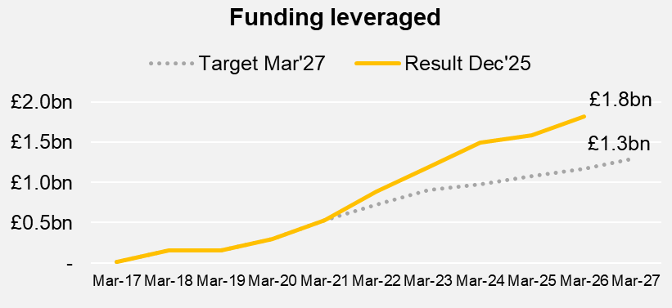
Investment leverage continues to perform strongly and remains well above targets, with resumed growth over the past year alongside improved quality assurance and attribution. To date, the TEA portfolio has leveraged £1.8 billion in combined private and public investment, representing an increase of £231m since last year. Private sector leverage increased by £119m, driven primarily by the TIME portfolio, with additional contributions from PEII+, ZE-Gen, and ESMAP. Public sector leverage increased by £112m, largely attributable to ESMAP, with smaller contributions from other partners. As part of an enhanced QA process, a potential double-counting issue was identified, and £27m of private finance attributed to the Crowd Power project was removed from cumulative results in this year. £37.46m in returnable funding has been deployed by the portfolio to date primarily through TIME, but also Crowd Power, of which £3.19m has been recovered so far and will be reinvested in future clean energy innovation activities.
Outcome Indicator P4: Installed clean energy capacity
Milestone: 600MW | Achieved: 562MW
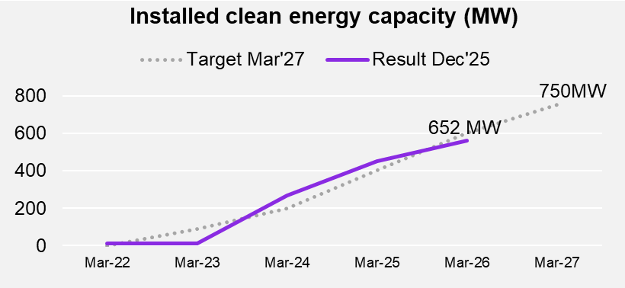
Installed clean energy capacity is broadly on track and with a total of 562 MW achieved to date (7% under target). Over the past year, just over 233MW of additional capacity was installed, driven primarily by ESMAP (122 MW) and TIME (84.6 MW). However, this indicator under-represents the full contribution of the TEA portfolio, as several partners do not report installed capacity but instead contribute primarily to emissions reductions under Outcome KPI P5 (see below). The Zero-Emissions Generators (ZE-Gen) initiative has only delivered 2.3MW to date - however, redeployments of underspends in the Accelerator to R&D activities expected to deliver more on this indicator are expected in the coming reporting year.
Outcome Indicator P5: CO2 reduced or avoided
Milestone: 2.2Mt/CO2 | Achieved: 6.1Mt/CO2

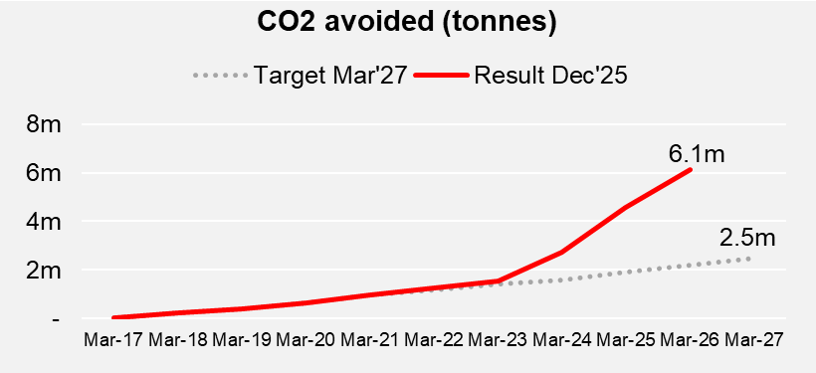
This CO₂ reduction KPI has significantly exceeded its final target (2.5 MtCO₂), reaching 6.1 MtCO₂ to date which is equivalent to the CO2 emissions of more than 1m people in the UK. This represents a single-year increase of 1.5 MtCO₂, reflecting strong performance in late-stage innovation and scaling activities. The largest contributions this year came from PEII+ (0.44 MtCO₂) and TIME (0.2 MtCO₂). Notably, earlier-stage innovation mechanisms also made substantial contributions, including LEIA (0.6 MtCO₂) and Energy Catalyst (0.29 MtCO₂), the latter reflecting improvements in reporting quality and methodology for this indicator. A downward correction of -0.15 MtCO₂ was applied following a quality-assurance review of P2PS reporting.
The following section describes progress on the TEA Impact Indicators:
- People Without Access to Electricity (m)
SDG7 People Without Access to Electricity (m):
7.1a – People Without Access to Electricity (m) – Milestone: 430m – Achieved 666m
7.1b - People Without Access to Clean Cooking (m) – Milestone: 1,400m – Achieved 2,078m
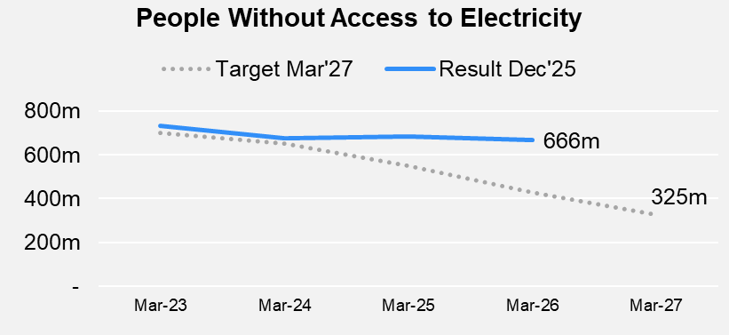
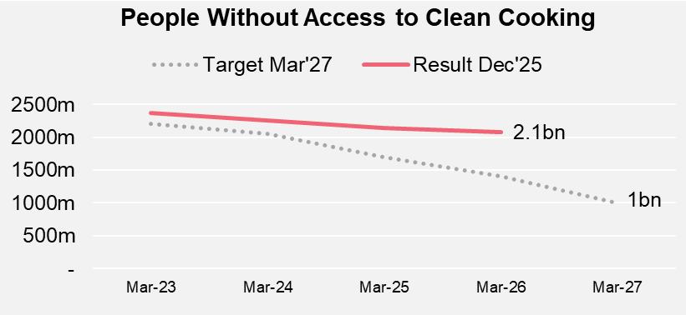
Progress against both SDG7 impact KPIs (electricity access and clean cooking access) remains significantly off-track relative to the 2030 targets, with the gap between milestones to 2030 and achieved values continuing to widen. These results are drawn from the SDG7 Tracking Framework and reflect 2023 data, due to a two-year global reporting lag. For electricity access, an estimated 666m people worldwide remained without access in 2023, down from 685m the previous year, reflecting the fact that rapid population growth has largely offset new connections, rather than a lack of progress in electrification efforts. For clean cooking, an estimated 2.1bn people still lacked access, representing a reduction of 63m people compared with the year before, indicating somewhat faster progress relative to population growth due to accelerated adoption of cleaner cooking technologies and fuels. While the rate of progress on both KPIs has begun to accelerate, overall gains remain insufficient to offset population growth, especially in Sub-Saharan Africa. As a result, the current trajectory remains misaligned with the SDG target of universal access to electricity and clean cooking by 2030. In response, large-scale global initiatives are increasingly shaping the delivery landscape. Most notably, the World Bank and African Development Bank’s Mission 300 initiative has emerged as the single largest coordinated effort to electrify 300 million people in Africa by 2030, securing $50bn in commitments to date. TEA has directly supported the design and development of Mission 300 through an R&D contribution via ESMAP, including £1m in January 2026 to drive innovation, delivery and co-ordination in Mission 300. TEA is also pivoting its innovation and scaling activities to align with Mission 300, supporting delivery, learning, and market development to enable system-level impact at scale.
- Operational Mini-Grids in Developing Countries
- People Benefiting from Access to Electricity through Off-Grid-Solar Devices
- Mini-Grids | - Milestone: 8,400 | - Achieved: Not reported yet (6,043 in 2024)
Off-Grid Solar Users | - Milestone: 680m | - Achieved: Not reported yet (561m in 2024)
No new data is available for KPIs 2 and 3 this year, as both rely on biannual reporting from industry associations. As a result, current performance against milestones cannot yet be confirmed. Updates for these indicators are dependent on publications from the Mini-Grid Partnership/ESMAP and GOGLA, respectively. Reporting cycles have been aligned to provide updates in the next TEA AR in 2027. While these market expansion indicators are expected to remain off track, ramp up of Mission 300 programming and target delivery is expected to have a major impact between now and 2030. For operational mini-grids, the most recent achievement (2024) was 6,043 installations, against a 2025 milestone of 7,000. To meet the current milestone of 8,400, a further 2,357 mini-grids would need to have become operational since the last reporting period. For off-grid solar access, the most recent figure shows 561m people benefiting from access, compared to a 2025 milestone of 620m.
Milestone: N/A (reporting only) | Achieved:173.9 GW (2023)
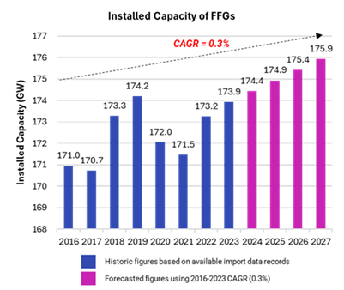
- Generators being utilised in developing countries: Installed capacity of fossil fuel generators (FFGs)
In 2023, data modelling indicates that the estimated installed capacity of fossil-fuel generators (FFGs) across 17 priority countries stood at 173.9 GW, equivalent to around 350 large coal power stations, indicating that reliance on backup fossil-fuel generation remains substantial. TEA, and in particular ZE-Gen, aims to reduce reliance on FFGs and accelerate the transition to renewable alternatives. This KPI was developed to assess the size and trajectory of the market for petrol and diesel generators, addressing a critical evidence gap in understanding demand for backup power in developing countries. Due to data limitations, a bespoke methodology was developed to model installed FFG capacity across priority countries, using a 2016 IFC baseline and extending through to 2023. Figures for 2024–2027 have been forecast based on the growth rates observed between 2016 and 2023. The relatively steep drop in 2020 is assumed to be linked to the COVID-19 pandemic, with installed capacity falling by only ~1.5% compared with an 8.9% collapse in global trade – the steepest fall since the 2009 financial crisis.
Analysis indicates that total installed FFG capacity grew at a modest compound annual growth rate of approximately 0.3% between 2016 and 2024. While installed capacity associated with small diesel generators has declined, capacity for other FFG types has continued to increase, resulting in a mixed overall picture. These trends underscore the importance of accelerating structural power-sector reforms including increased penetration of renewable energy, improved grid reliability, and more supportive policy and financing frameworks, to reduce ongoing demand for backup generators and stabilise the market. Some observed patterns may also reflect data constraints, including potential under-reporting of generator trade flows in major markets such as India and the exclusion of domestic manufacturing from the modelling approach. Further research is required to strengthen the evidence base, improve understanding of market segmentation and demand drivers, and better capture the conditions under which declines in installed FFG capacity can be sustained over time.
- Transformational Change (ICF)
The TEA Mid-Term Review, conducted by Oxford Policy Management in February 2025 using the ICF KPI 15 methodology, assessed TEA against criteria for transformational change, including political will and local ownership, innovation, scale, replication, leverage and sustainability, and assigned an average score of 4 out of 5. It found the strongest evidence of transformational contribution in early-stage innovation, catalytic risk-taking and private-sector engagement, particularly through Energy Catalyst, TIME and market-shaping partnerships that demonstrate replicable models with potential to scale. Recommended improvements being implemented across the portfolio include strengthening portfolio-wide communications, learning synthesis, outcome reporting, and post-project monitoring.
Milestone: NA (previous 3) - Achieved: NA (previous 3.9)

Justify whether the programme should continue, based on its own merits and in the context of the wider portfolio
The TEA platform should continue based on strong standalone performance, clear value for money, and increasing strategic relevance within the wider ICF and FCDO clean energy portfolio. TEA has consistently achieved A and A+ ratings in all Annual Reviews to date, and has been a disproportionately strong driver of ICF outcomes (see table below); for example, up to March 2025, despite accounting for 1% of total ICF spend, it delivered 34% of ICF results for people provided with improved energy access and nearly 10% of total public and private finance mobilised. An independent Mid-Term Review in 2025 rated TEA ‘Very Good’ for Value for Money, with ‘Excellent’ for Economy and Cost-Effectiveness, commending its transformative impact, venture-building success, strategic engagement, and collaboration with FCDO Country Posts. Most recommendations from the previous Annual Review and Mid-Term Review have been completed, with some ongoing and others deferred to TEA3, strengthening delivery coherence and assurance. In a context of heightened pressure on the development finance landscape, including major disruption and reductions in ODA across the world, TEA’s role in coordinating donors, philanthropies, and private capital is increasingly important, with a sharpened focus on catalytic, scalable impacts aligned to SDG 2030 timelines. This includes successfully seeding high-risk, high-impact ventures that have subsequently mobilised significant follow-on capital (for example, TEA-supported MOPO surpassing 32m battery rentals and securing commercial investment, while also testing new TEA-supported Sodium Ion Battery chemistries in the field), as well as deepened engagement with FCDO Country Posts through Demonstrators that link R&D to delivery at scale and inform large-scale multilateral initiatives including Mission 300.
In its 2025 report Empowering Development: Energy Access for Communities, the IDC highlighted the UK’s strong contribution to global energy access, noting that it has been “instrumental” and widely regarded as “transformative” by sector stakeholders, with consistent leadership on under-explored areas such as clean cooking, low-energy appliances, and energy for displaced populations. The Committee described the UK’s emphasis on research, innovation, and partnerships as “highly commendable”, recognising the role of the Ayrton Fund in deploying world-class innovations and situating the TEA platform within this portfolio as the key mechanism supporting early-stage testing and scale-up of innovative technologies and business models.
Proportion of ICF portfolio results attributed to the TEA platform (up to March 2025)
Note: ICF results are published annually in September/October. Therefore, the table below includes the results reported by the TEA platform and incorporated into ICF results up to March 2025. The results in this annual review will be included in the next ICF results publication.
 | ICF portfolio results  (Apr’11 to Mar’25) | TEA results included in ICF portfolio results  (Oct’17 to Dec’25) | TEA share  of ICF results
People with improved clean energy access | 89.2 million | 30.3 million | 34%
GHGs avoided or reduced (million tonnes) | 145.8 million | 4.6 million | 3%
Public finance mobilised | £10.6 billion | £703.4 million | 7%
Private finance mobilised | £10.5 billion | £1.19 billion | 11%
ICF/TEA spend linked to results reported | £18.4 billion | £181.2m | 1%

C. DETAILED OUTPUT SCORING
Output 1 - Foundational Data and capabilities in place for a just and inclusive energy transition
Impact weighting (%): | 8% | Score: | A++ Output substantially exceeded expectations

Indicators | Milestone  (by Dec 25) | Achieved  (by Dec 25) | Score
1.1 Data
1.1.1 Critical market data published | 320 | 441 | A++
1.1.2 Newsletters, blogs and briefs published | 150 | 597 | A++
1.1.3 TEA Reports engagement (views or downloads) | 70,000 | 73,606 | A+
1.2 Capabilities
1.2.1a Young people supported with job placements in clean energy access businesses | 1,450 | 1,670 | A+
1.2.1b Average job retention rate following job placements | 70% | 80% | A+
1.2.2 People trained in energy access firms and institutions. | 1,220 | 5,639 | A++
1.2.3a Universities supported to expand research and teaching on clean energy access | 36 | 78 | A++
1.2.3b Students enrolled in a Masters’ programme supported by TEA | 474 | 1,158 | A++
1.2.3c Students who complete a Master’s programme supported by TEA | 167 | 185 | A+
1.2.4 UK clean energy scholarships awarded to students from developing countries (e.g. Chevening) | 30 | 30 | A

Performance Summary
5 out of 10 Output KPIs substantially exceeded their milestones, 4 exceeded, and 1 was met – resulting in an A++ score. This Output has fully delivered its planned scholarship commitments, exceeded job placement and training targets well ahead of schedule, and significantly surpassed all data and research dissemination milestones.
1.1.1 – 1.1.3: Milestones have been exceeded with 441 critical market data publications (target 320) and 597 newsletters, blogs and briefs published (target 150). TEA reports (1.1.3) have been viewed or downloaded 73,606 times (target 70,000). Notable research outputs during the year include: the African Association for Rural Electrification (CLUB-ER) comprehensive map of mini-grids covering 34 African countries, improving data availability for developers and supporting more robust planning and viability assessments for rural electrification; Low Energy Inclusive Appliances (LEIA) published Designing For Sustainability: Blueprint For a Low-Carbon Cold Room, which found that optimised cold chain management has the potential to reduce Sub-Saharan Africa absolute and per capita GHG emissions by 66%. The Energy Storage Challenge (ESC) published a joint Market and Technology Assessment of Flow Batteries For Developing Economies, which highlights South Africa, Indonesia, Thailand and India as the most promising developing economy markets for flow batteries, together with many island communities. SEforALL and CLASP also collaborated on the Medical Appliances For Resource-Constrained Settings report which explores how to avoid energy-intensive, wrong-sized and poorly maintained electrical medical equipment which undermines healthcare services.
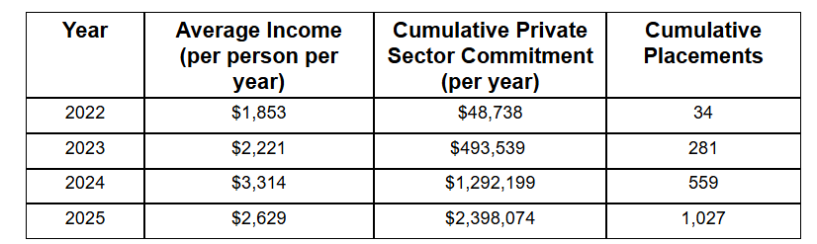
1.2.1a – 1.2.1b: To date, 1,670 young people have been placed in jobs in clean energy businesses in Africa (target 1,450). This is mainly attributable to the Energy Access Talent Initiative (EATI), which achieved 1,429 job placements driven by a deliberate focus on supporting employers with high-volume recruitment needs, alongside continued engagement with long-standing partners established under EATI. Employers included Regen Organics, Fresh Life, Ampersand, and Sun King, complemented by newer partners such as EarthEnable, M-Power, Divine Bamboo, Keep It Cool, and Kaboni Energy.​ Collectively, these partnerships accounted for over 400 job placements across critical operational and technical functions. EATI’s retention rates remain strong with 80% of job placements staying in post for one year+ after support ended (target, 70%). EATI has tracked an increased average annual income per person supported of 41% over a 4-year period since 2022 (Table 1).
Table 1: Energy Access Talent Initiative, average annual salary increasing by 41% over 4 years (data collected on placements made between 2022 – 2025 (1.2.1b).
1.2.2 5,639 people have been trained in energy access firms, which is roughly 5x the target (1,220). EATI and the TEA Learning Partnership (TEA-LP) joint Future Female Leaders (FFL) in Energy initiative, has achieved a total of 427 enrolments, with 316 women completing the programme over its duration, against a target of 300. Key success stories from the course includes Hannah Muthoni who graduated from Future Females in February 2025, and just weeks later made a courageous leap by leaving her role as a Solar Engineer in Nairobi to pursue her long-standing dream of starting her own energy enterprise - Hannathon Ecodesign and Energy. She credits much of her courage and clarity to the leadership module of the FFL programme. LEIA trained 1,925 individuals, including 1,327 (882 women) farmers and individuals by R&D grantee, Synnefa Green, in installation, automation, maintenance and trouble-shooting of off-grid solar appliances. Growing Government Engagement in Energy Access (GGE-EA) and TEA-P-SPC Pacific Post-funded Demonstrator provided capacity building to 660 rural electrification officials (320 trained in 2025) and 306 participants, respectively.
1.2.3a 78 universities have received support to expand research and teaching, significantly over target (36). The TEA-LP has so far supported 32 universities with curriculum delivery, while LEIA have supported seven new universities in 2025, through the Design Challenge participation. Following a successful first year, ESC have continued their Battery Ambassador initiative. ESC have re-appointed eleven Ambassadors (each associated with a different University) to support skills enhancement, knowledge transfer and battery technology development for emerging economies.
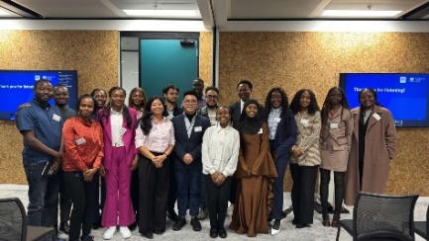
1.2.3b – 1.2.3c TEA-LP have significantly exceeded the target for number of students enrolled (1,156 against 832) and 185 students completed their master’s programme (185 against 167 target) since the launch of phase 2. Mzuzu University, Papua New Guinea University, Kumasi Technical University, University of Cape Coast, University of Energy and Natural Resources and Ghana Communication Technology University all launched their revised master’s programmes in 2025. and drove most enrolments, reflecting strong early uptake of updated curricula aligned with TEA priorities. Completions are expected to increase significantly in 2026 and 2027.
Chevening TEA and AfOx scholars at the 2025/2026 welcome event
1.2.4 10 (6F; 4M) new Chevening TEA Scholars started master’s programmes in the UK in 2025, attended a public speaking workshop, a welcome event, and were paired with mentors from across the TEA network. 30 scholars (17F;13M) have been supported through the TEA platform as planned. This year also witnessed new partnerships being formed with African Oxford Initiative (AfOx) and Global Clean Power Alliance (GCPA). As part of this partnership, TEA scholars have been invited to attend an AfOx scholars events at Oxford University, while the mentorship scheme has itself been opened up to the partnership, with one GCPA scholars currently being mentored by individuals from TEA.
Output Changes: KPIs 1.2.3b and 1.2.3c were revised to track enrolment in and completion of full TEA-LP-supported Master’s programmes, avoiding double counting across modules. KPI 1.2.2 was updated from “managers” to “people” to accurately reflect the range of roles receiving the training.
Lessons and Recommendations

Recommendation 1.1: RPDC to strengthen links between TEA-supported UK and Southern Universities, especially TEA-LP, and a more co-ordinated network of engaged UK Universities. The upcoming UK-Global South Academic Symposium funded through the TEA Scale-Up and Pivot budget, will lay the groundwork for this partnership, including facilitation of UK academic leadership to coordinate in a more structured way with TEA.
Recommendation 1.2: All Tier 1 partners to transition successful capacity-strengthening initiatives where R&D activity has concluded towards wind-up, including responsible exit strategies and facilitation of linkages to follow-on downstream funding, while consolidating continuing initiatives where justified and additional (e.g. considering options such as maintaining a TEA–Chevening mentoring link even where TEA does not directly co-fund scholarships).
Recommendation 1.3: Carbon Trust to review Output 1. Data and Capabilities logframe targets (particularly for KPI 1.2.2 and 1.2.3b) to ensure they are realistic and aligned with delivery capacity and the remaining programme timeframe.
Output 2 - Open Calls: Enable a pipeline of new ideas and innovators
Impact weighting (%): | 31% - increased | Output Score: | A+ Output moderately exceeded expectations

Indicators | Milestone  (by Dec 25) | Achieved  (by Dec 25) | Score
2.1 Innovations and innovators supported
2.1.1 Projects supported via Open Calls | 345 | 404 | A+
2.1.2a Organisations supported via Open Calls | 500 | 447 | B
2.1.2b Of which are start ups | No target | 83 | n/a
2.1.3 Novel innovations supported from a technological perspective | 387 | 425 | A
2.2 Knowledge creation and sharing
2.2.1a Patents submitted | No target | 156 | n/a
2.2.1b Submitted patents that have been approved | 110 | 91 | B
2.2.2a Published research papers, journal articles and other publications, which have not been peer reviewed | 185 | 284 (63 new) | A++
2.2.2b Published research papers, journal articles and other publications, which have been peer reviewed | 165 | 284 (49 new) | A++

Performance Summary
The core KPIs under Output 2 that are within TEA’s direct control exceeded expectations, with milestones surpassed for projects supported (404 vs 345), novel innovations delivered (425 vs 387), and peer-reviewed and non-peer-reviewed publications (568 vs 350). The two KPIs that fell short include organisations supported (447 vs 500) and patent approvals (91 vs 110), which was largely influenced by factors outside TEA’s control. In line with the programme’s theory of change, greater weight is placed on innovation delivery and knowledge generation, supporting the A+ score.
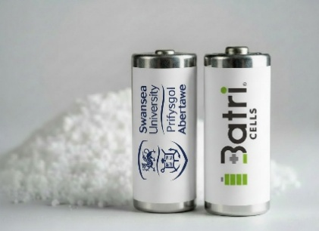
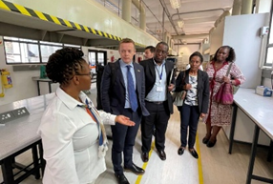
2.1.1–2.1.2b Projects and organisations supported: The Faraday International Energy Storage Challenge (ESC) supported 41 companies through a consortium-based model that fosters academic-industry collaboration to power energy access. Engagement was driven through its flagship NEXGENNA sodium-ion programme, six Concept to Demonstrator (C2D) projects and the SEED portfolio, which is focused on earlier phase R&D. Notably, the C2D project led by Swansea University catalysed a partnership with Batri which spurred the development of the UK’s first manufactured sodium-ion cylindrical battery cells. Aligned to this, a partnership with the University of South Africa is propelling the development of South Africa’s first locally-designed Sodium Ion cells, as part of a strong TEA portfolio and UK leadership on Sodium Ion. Powering Renewable Energy Opportunities (PREO) supported 23 new projects across the Indo-Pacific and sub-Saharan Africa, five of which are led by start-ups, focussing on clean transport, energy efficiency, and clean cooking. Projects in the Indo-Pacific have progressed into the installation phase, with equipment procurement and site preparation underway. Low Energy Inclusive Appliances (LEIA) contracted five organisations for their flagship Kenya Cold Chain Accelerator, which will provide cold-chain companies with R&D grants and a tailored support package to strengthen market insight, enhance workforce capabilities, and bring businesses closer to investment readiness. Energy Catalyst continued to support 29 ongoing projects across sub-Saharan Africa, South Asia, and the Indo-Pacific. Notable successes of companies supported by Energy Catalyst include Kenya-based BURN, which opened a manufacturing facility in Malawi to scale its cooking appliance operations and Sheffield-based MOPO, which secured investment from Octopus Energy to scale its battery rental business. Supamoto secured $4.3m to expand clean cookstoves in Zambia, reaching 74,000 people and growing its workforce. Vox Cool and ASSIST Vietnam received $350K to scale lower-emission “Cold Battery” technology and boost market readiness. Three larger Concept-to-Innovation Demonstrator projects were also launched with funding from the British High Commission in Tanzania; these projects are focused on energy demand-side management, aquaculture production and energy storage for e-mobility applications. ENACTUS scaled five clean and modern cooking services in informal settlements in Uganda. SEforAll Powering Healthcare delivered 4 projects across Africa including improving solar system reliability in Ghana and Sierra Leone with Odyssey Energy Solutions; strengthening energy-health data integration within Nigeria’s DHIS2 system with SAO Energy; piloting data-driven performance-based financing approaches in the DRC; and introducing digital monitoring and energy-as-a-service models in a refugee health facility in Malawi. Finally, Transforming Humanitarian Energy Access delivered 18 projects including the establishment of the Humenergi facility, an off-grid energy financing facility for energy access innovators working in refugee settlements in Uganda. Lightrock have pledged to co-fund Humenergi, agreement to be signed in 2026.
FCDO Chief Scientist, visits South Africa’s
Council for Scientific and Industrial Research
The UK’s first produced sodium based battery cells supported by research funded by TEA and developed by Swansea University and Batri (ESC)
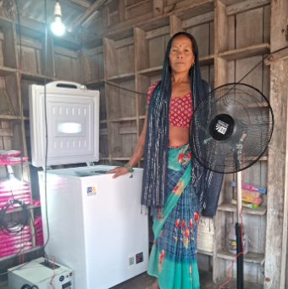
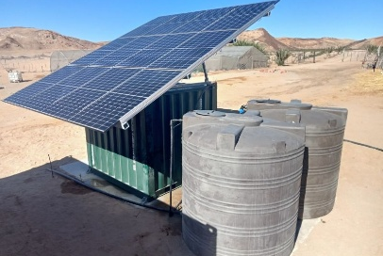
2.1.3 Novel technological innovations: This year, Energy Catalyst supported R&D of 27 new technologies, including 22 in Sub-Saharan Africa and five in South Asia. These innovations span a range of applications, including lithium-ion battery manufacturing for PAYG productive use in Kenya, modular energy storage integrated with clean hydrogen, and floating solar systems. The Faraday Energy Storage Challenge also drove the development of novel technologies critical to energy access. For example, the NEXGENNA project produced prototype low-cost Sodium Ion cells via a new scalable electrolyte-production process. Sheffield University partnered with MOPO to evaluate the characteristics of sodium batteries enabling improved thermal performance at higher temperatures and under faster charging regimes for electric vehicles. Oxford University and Bbox developed a novel and rapid screening and characterisation approach to test and grade LFP cells for application in warmer climates. CrossBoundary Mini-Grid Innovation Lab supported five novel innovations, including a mesh-grid pilot in Nigeria and published an Innovation Insight showcasing mesh-grids as a cost-effective and scalable approach for rural electrification. Powering Healthcare delivered four key innovations, including an AI-powered predictive maintenance tool for solar PV systems, and an open-source performance-based financing platform.
A customer in Uttar Pradesh, India with DivyaDayal PayGo solar fridge
Bluemont Desalination System in Fiji and Tonga, serving communities of up to 190 people (PREO)
2.2.1 Patents: Despite a wider UK downward trend in patent applications, TEA R&D funding continues to generate patents at a positive rate. In 2025, Energy Catalyst supported the award of five patents and the development of seven patent applications. NEXGENNA generated one patent titled "Nafion-NA as an additive for high-power sodium-ion batteries". Meanwhile, LEIA grantees successfully submitted one patent application linked to the development of India’s first PAYGo solar fridge.
2.2.2 Research papers, journal articles and other publications: In 2025, Open Calls generated evidence and research outputs (112 new publications in 2025, including 49 peer-reviewed). This includes for example, a Market and Technology Assessment of Flow Batteries for Developing Economies which identified South Africa, Indonesia, Thailand, India and island regions as promising markets for flow battery technology development and deployment; a PREO report examining how interoperability can support the growth of electric mobility in sub-Saharan Africa; a cross-sector LEIA report on the role of off-grid solar appliances in the decarbonisation of agriculture which laid the foundation for the new Agri-Energy Coalition, now comprising 25 organisations. The TEA Research Support Service (RSS) published Mind the gap: Rethinking transitions along the energy access finance continuum. Finally, TEA@Sunrise published 7 research papers on Next Generation Solar material requirements, end life sustainability and device characterisation.

Lessons and Recommendations:
Recommendation 2.1: Carbon Trust and Innovate UK to continue connecting Open Call companies to investment opportunities via the TEA Venture Facility to strengthen pathways from innovation to scale and finance.
Recommendation 2.2: Carbon Trust and FCDO to facilitate strategic co-funding, manufacturing, and deployment partnerships between researchers, industry, and other FCDO programmes, to scale proven approaches (such as Hinckley Recycling and ROAM with Manufacturing Africa) and accelerate technologies towards deployment.

Output 3 – Technology Accelerators & Challenges tackle key off-track technologies for SDG7
Impact weighting (%): | 10% – increased | Output Score: | A Output met expectations

Indicator | Milestone  (by Dec 25) | Achieved  (by Dec 25) | Score
3.1 Green Grids/Smart Energy Systems, CrossBoundary Innovation Lab
3.1.1a Developer engagement sessions held | 37 | 31 | B
3.1.1b No. of innovative business models alpha-tested in Africa | 5 | 6 | A+
3.1.1c Capital cost per mini-grid connection (USD) | 600 | 683 | B
3.2 Energy Storage (Ayrton Challenge)
3.2.1a UK research groups engaged in energy storage research with potential for applications in SSA | 35 | 35 | A
3.2.1b Research groups from low-income countries engaged in energy storage | New | 2 | n/a
3.2.1c Tested, improved or pre-commercialised energy storage technologies | 21 | 16 | B
3.3 Next Generation Solar (Ayrton Challenge)
3.3.1a NGPV key technologies identified for energy access context | 6 | 9 | A++
3.3.1b Technology prototypes developed | 1 | 1 | A
3.3.1c Technology Demonstrators | 2 | 0 | C
3.4 Inclusive Energy & Leave No-one Behind - LNOB (Ayrton Challenge)
3.4.1a Business models tested for humanitarian settings | 1 | 6 | A++
3.4.1b People with access to improved healthcare | 1,562,500 | 1,644,266 | A
3.5 Zero-Emissions Generators (Ayrton Challenge)
3.5a ZE-Gen pilot or demonstration projects | 15 | 19 | A+
3.5b Zero emission generators installed | 1,500 | 1,706 | A+
3.6 Sustainable Cooling for All (Ayrton Challenge)
3.6.1a Cooling technology innovations tested | New | 19 | n/a
3.6.1b Cooling innovative business models supported | New | 5 | n/a
3.6.1c Dialogues with government representatives on cooling needs/pathways | New | 3 | n/a

Performance Summary
Overall Output 3 met expectations, with strong delivery across many areas and with 8 of 12 milestones met or exceeded. Milestones for ZE-Gen and Inclusive Energy and Leave No-One Behind, were surpassed with significant upticks on last year, with deployment and access outcomes achieved. Some milestones under Green Grids, Energy Storage, and Next Generation Solar were partially off-track, however these were balanced by over-performance in other areas, resulting in the A rating.
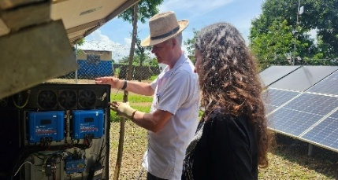
3.1 Green Grids / Smart Energy Systems - CrossBoundary Innovation Lab (CBIL) partially met targets, exceeding business models tested (6 vs 5). This included 2 approaches to healthcare electrification: a containerised system and inverter expansion with mobile battery packs; and 3, 2nd-life batteries tests (pack design, testing template and import/export simulation). CBIL also tested mesh-grid configurations in Nigeria, with results showing a 41% reduction in CapEx per connection ($803 vs $1,358 for mini-grid control site) and achieved >96% reliability (vs <60% at mini-grid sites). Developer engagement sessions are below target (31 vs 37), reflecting a shift towards targeted convenings at sectoral events, like the 8th Mini Grid ALE Event and the Bridging Continents workshop at COP30. CBIL’s cost model was updated to reflect 2nd-life battery BaaS cost reductions, resulting in estimated $683/connection (target $600). Further reductions are expected as alpha-tests progress.
Differ Community Power demonstrating TEA-funded inverter, battery and smart monitoring system at Lemwe Health Facility, Malawi.

Differ Community Power demonstrating TEA-funded inverter, battery and smart monitoring system at Lemwe Health Facility, Malawi.
3.2 Energy Storage (Ayrton Challenge) partially met targets. The challenge engaged 12 new UK research groups, reaching a total of 35 as planned. It engaged 2 new research groups from low-income countries, (FUTO, and Strathmore). The Challenge achieved 16 (target 21) tested/improved storage technologies, including 4 new technologies supported in 2025 (sodium-ion batteries, flow batteries and novel BMS development for battery lifetime extension). Delivery was supported by a strong convening platform, including 13 events and a new Battery Network series attracting ~1,500 participants from 50+ countries. Challenge Governance was maintained through 3 Leadership meetings.
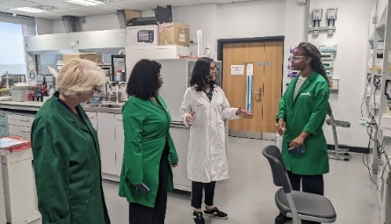
3.3 Next Generation Solar (TEA@Sunrise) partially met targets. The project exceeded its target for key NGS technologies identified (9 vs 6), supported by an expanded network of 316+ members in 37 countries. Priority applications were identified through network engagement, including tandem perovskite and emerging use cases such as assistive technologies, floating solar and mobility integration. Planned technology demonstrators were not delivered this period, reflecting issues in module production and the limited readiness of NGS technologies for high-temperature LMIC environments. Potential demonstration sites are now being explored through network members, including for Oxford PV tandem modules and Heliatek OPV modules. NGS Ayrton Challenge leadership was strengthened, with 3 strategic leadership group meetings and increased African representation.
TEA Chevening Scholars visiting TEA@Sunrise lab at Swansea University
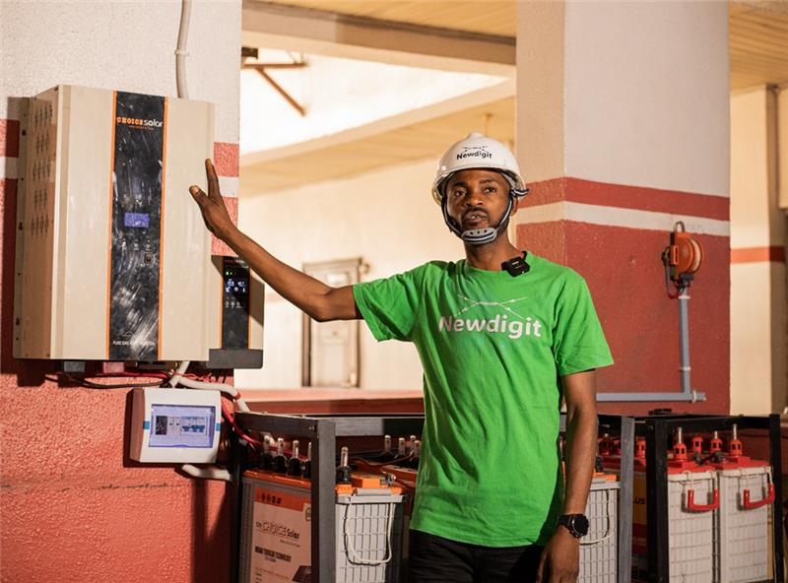
3.4 Inclusive Energy and Leave No-One Behind (Ayrton Challenge) made strong progress, with activities ramping up under Transforming Humanitarian Energy Access (THEA), Low Energy Inclusive Appliances Scale-Up in Rwanda (LEIA-R), and Enter Energy Somalia (EES). 3.4.1a 6 business models were tested in displacement settings (target 1), including group savings-linked lending, results-based funding and revenue-linked repayable grants. The business range in size from micro-enterprises (THEA) to medium size distributors (LEIA-R). THEA designed 2 grant mechanisms, Inclusive Investment Pilots (IIPs) and Refugee-led Energy Enterprise Accelerator (REEAs), to prove how refugee-led clean energy initiatives can achieve impact and scale. 3.4.1b. Access to improved healthcare increased due to Powering Healthcare’s (PH) Innovation Fund, which improved energy services at 18 health facilities in Nigeria, Uganda and Madagascar, reaching over 90,000 patients.
3.4.1b Newdigit Just Add Water modular PEM fuel cell solution that uses grey water and solar power to produce oxygen and electricity.
3.5 Zero-Emissions Generators (ZE-Gen) (Ayrton Challenge) exceeded its targets for the first time. The project delivered 19 pilot and demonstration projects (target 15), including five projects progressing from Phase 1 to Phase 2 of the accelerator to scale fossil fuel generator replacement technologies. Installations also exceeded target, with 1,706 zero-emission generators installed against a milestone of 1,500, largely driven by the Green Genset Facility (GGF). The GGF, seeded with £250k of ZE-Gen funding, is piloting the use of “results-based inventory finance” and bulk procurement to reduce costs and improve flow of quality product to Distributors. Since its inception, the Facility has secured over £5.7m in additional funding from the IKEA Foundation, DOEN Foundation, and Good Energies. As of November 2025, it has committed £2.1m to 14 distributors across nine countries, supporting approximately 1,705 installations this reporting period. ZE-Gen also partnered with CLASP to launch the Global LEAP Awards Solar Generator Competition, strengthening quality assurance standards and market confidence. In 2025, two Strategic Leadership Group meetings strengthened ZE-Gen governance, aligning partners and refining sector priorities to support more targeted delivery.
3.6 Sustainable Cooling for All (Ayrton Challenge) progressed well, reaching 19 cooling innovations tested against this new KPI (added after last year’s annual review), and 5 innovative business models supported, reflecting progress across R&D grants, appliance testing and cold chain demonstrators. Technologies tested included solar-powered refrigeration, cold storage solutions and PAYGo fridges, alongside pilot testing of walk-in cold rooms and distributed RE cold chain models. Three policy dialogues were delivered, including a multi-stakeholder workshop in Kenya under the Kenya Cold Chain Accelerator, engagement at the Africa Food Systems Forum, and participation in the Global Cooling Pledge discussions, strengthening coordination across government and other stakeholders and improving the enabling environment for cold chain development. Five Challenge Leadership Group meetings were held in 2025, bringing partners together to review progress, for portfolio mapping, and align lessons to inform future priorities.

Lessons and Recommendations
Recommendation 3.1: Carbon Trust to review and document lessons from the TEA Technology Accelerators in the first half of 2026 to synthesise cross-portfolio learning, inform the design of TEA3, and produce publishable insights for wider energy and innovation practice, including proposed UK Cleantech Challenges.
Output 4 – Venture Building support enables lead firms to break open new markets
Impact weighting (%): | 19% - decreased | Output Score: | A++ Output substantially exceeded expectations

Indicator | Milestone  (by Dec 25) | Achieved  (by Dec 25) | Score
4.1 Venture building - Creating Lead Firms
4.1 Organisations supported via the TEA platform | 760 | 858 | A+
4.2 Venture Building - Business Models Tested
4.2 Novel/new business models tested | 340 | 526 | A++
4.3 Venture Building - R&D Investment
4.3.1 Value of R&D investments | £64m | £119m | A++
4.3.2 Number of R&D investments | No Target | 149 | n/a

Performance Summary
Output 4 performed very strongly and significantly exceeded all milestones, resulting in an A++ score. By December 2025, TEA had supported 858 organisations (target 760), tested 526 novel or new business models (target 340), and mobilised £119m in R&D and venture investment, substantially surpassing the £64m milestone. Performance was driven primarily by the TIME portfolio and Acumen’s PEII+, alongside growing linkages from Open Calls and Technology Accelerators into Venture Building. While delivery has been highly effective in scaling venture support and mobilising capital, results are concentrated in a subset of mechanisms and countries. Whilst the pace of growth is expected to reduce slightly in the coming year with fewer scheduled Open Calls, this will be counteracted by some newer initiatives (such as ClimaFii and 500Global Climate Innovation Network) and the continued delivery of TIME initiatives which in turn will add more supported innovators at Tier 3.
4.1 Venture building - Creating Lead Firms: Energy Portfolio Analytics (EPA) database analysis shows that TEA has supported 858 businesses to date across an array of geographies, representing an increase of 109 from last year. This is 98 above target, primarily due to new businesses supported under PREO, ZE-Gen and TIME – which has also started in the year to work more via venture support platforms such as ClimaFii and 500Global which combined support 18 companies (14 of which are new to TEA). Examples of new businesses supported and their activities, and key achievements of TEA-supported companies include:
- CEESOLAR, supported with R&D via ZE-Gen, have received a credit guarantee from InfraCredit, supported by the UK funded Climate Finance Blending Facility, to mobilise local currency debt enabling the construction of four solar hybrid minigrids in underserved Cross River State (Nigeria).
- KAMIM Technologies have now raised $2.1 million in blended capital to scale their capacity, pilot smart irrigation, and digitise the food chain network (support from the University of Hertfordshire’s Big Data Labs), building on validation from their ZE-Gen Circularity Challenge project.
- 500 Global has been supported to launch a Climate Innovation Network, a Seed and Series A/B programme to identify, support and scale leading climate technology companies for energy deficit countries. It is attracting additional funding via UNDP, Gates Foundation, Kingdom of Morocco and Government of UAE.
- MOPO (previously Mobile Power) continues to grow having been supported by Energy Catalyst and ZE-Gen. This year they have secured an investment from Octopus Energy, signed a strategic partnership with IFC, won the Transformational Impact in Clean Energy Access and overall Judges’ Award for Excellence at the Financial Times and World Bank Africa Sustainable Futures Awards and passed a landmark of 30 million battery rentals in 2025.
- The Green Genset Facility, since the £250k in seed capital from TEA, has secured £5.7m in funding from the IKEA Foundation, DOEN Foundation, and Good Energies. As of November 2025, the GGF had committed £2.1m capital to 14 local distributors in 9 countries, equal to 1550 solar generators installed.
- Savanna Circuit Technologies is a solar-powered Cooling-as-a-Service (CaaS) company working in the dairy and fish value chains enabled by IoT monitoring and digital payments. They have been proven to cut spoilage by 30–40% and raise incomes by up to 45%.
- Ampersand has closed a funding round to expand across East Africa, securing working capital from BII. The round also brought in new equity from Seedstars Africa Ventures, Gaia Impact, the Rwanda Green Fund and Raspberry Syndicate, alongside increased commitments from existing backers including Ecosystem Integrity Fund, AHL Ventures, Acumen, HEHF and TotalEnergies.
- Energise Africa, through its partnership with CEI Africa is helping bridge the RBF financing gap by providing flexible construction finance that aligns with real project timelines and RBF disbursements. This includes a financing package of approximately USD 2.9 million to support the construction of nine solar mini-grid Plants across rural communities in Benin.
4.2 Venture Building - Business Models Tested: The total number of new business models tested has increased to 526 (target of 340). This has been driven by ZE-Gen through the Green Genset Facility and IUK invested projects, PREO via Wave 6 companies, LEIA with the launch of the Kenya Cold Chain Accelerator and through TIME’s portfolio. The increasing importance of energy-as-a-service models has been a significant contributing factor in this growth, along with business models that integrate more fully with the whole value chain through off-take agreements and bundled energy solutions. In addition, TIME’s focus on different venture scaling models within the energy access sector has unlocked new models. Examples of new/novel business models supported this year by TEA include:
- Stima Mobility Limited (PREO) is designing a battery standard that can work for multiple Original Equipment Manufacturer (OEMs) currently operating in Africa and piloting swap stations to host the batteries through a franchise model.
- Kuza Coolers (LEIA KCCA) is implementing a large capacity solar-powered cold storage and fish aggregation hub integrated with a digital fish marketplace. They provide Cooling-as-a-Service (CaaS) and market linkage solutions to smallholder aquaculture farmers and artisanal fishers, enhancing income and reducing losses.
- Sleekabyte with CitiBIM Nigeria (ZE-Gen) are developing an autonomous, mesh-grid-ready mobile solar generator with rentable energy capsules for bankable distributed renewable energy, providing power to public and private sector buildings along with the surrounding community.
- Fanmilk (TIME) are testing the leveraging of large FMCG companies’ distribution networks for the deployment of cold storage units to microenterprises in Ghana.
- Ampersand (TIME) are being supported to create an open, interoperable electric 2-wheel platform that supports both local OEMs and future global entrants.
- Advik (TIME) is an Indian OEM (with a UK arm) integrating a UK-designed serviceable and re-usable battery into their value chain for faster deployment across sub-Saharan African markets.
4.3 Venture Building - R&D Investment: This KPI was refined to distinguish direct investments in TEA-supported businesses from grant funding delivery through Open Calls. The value of such investments (including returnable grants, debt and equity) has reached £119m in 2025 (including direct co-funding, such as from Shell Foundation). The main contributing projects for this investment total were TIME and PEII+. As of 2025, TIME has contributed £59.5m to this KPI, with £9m spent in 2025/26 to support 13 new business models entering the testing and early scaling phase. Over the same period, PEII+ made two new investments in productive use energy companies (Energy Assured and eBik) and completed four follow on investments (BioMasters, Keep It Cool, Ampersand and Easy Solar), reinforcing TEA’s role in supporting R&D in ventures beyond initial investment and into scale.

Output Changes
No change.

Lessons and Recommendations
The Venture Facility has highlighted that there is still a gap between what companies are supported to achieve under grant programmes, and what investors require of companies to make investments. New mechanisms, such as those under the Venture Facility, Investment Catalyst Facility, CROWD Group and ClimaFii, can help to close this gap but more needs to be done.
Recommendation 4.1: Carbon Trust to develop a synthesis and recommendations report to consolidate and refine TEA’s Venture Building approach under TEA3, drawing on lessons from the Venture Facility, other venture-building initiatives, and grant programmes. This should include working with FCDO and Shell Foundation to improve the alignment of the TIME pipeline by improving joint project sourcing and selection for the remainder of TEA2, and into TEA3.
Recommendation 4.2: FCDO to agree a clear framework for the use, reinvestment, and governance of returnable grants with partners (including SF), in line with revised FCDO DevCap guidance, to ensure consistency, transparency, and suitability for potential continuation under TEA3.
Output 5 – Market Infrastructure in place to underpin clean energy transition
Impact weighting (%): | 15% - decreased | Output Score: | A+ Output moderately exceeded expectations

Indicator | Milestone  (by Dec 25) | Achieved  (by Dec 25) | Score
5.1 Market infrastructure - Energy Access Institutions Facility (EAIF)
5.1a Number of market institutions supported | 8 | 8 | A  see output summary
5.1b Sector coordination meetings convened | 28 | 63 | A  see output summary
5.1c State of market/thought leadership reports published | 31 | 52 | A  see output summary
5.2 Market infrastructure - Last Mile Distributors
5.2a Partners/members | 290 | 294 | A
5.2b Sector coordination meetings | 3 | 10 | A++
5.2c State of market/thought leadership reports | 3 | 5 | A+
5.3 Market infrastructure - Inclusive Energy
5.3a Partners/members | 16 | 112 | A++
5.3b Sector coordination meetings | 7 | 50 | A++
5.3c State of market/thought leadership reports | 1 | 3 | A+
5.4 Market infrastructure - Mini-Grids
5.4.1 Mini-Grid Partnership
5.4.1a Partners/members | 357 | 367 | A
5.4.1b Sector coordination meetings | 3 | 15 | A++
5.4.1c State of market/thought leadership reports | 2 | 2 | A
5.4.2 African Forum for Utility Regulators (through AMGED)
5.4.2a Number of Project Steering Committee partners/members | 70 | 67 | A
5.4.2b Sector coordination meetings | 42 | 42 | A
5.4.2c State of market/thought leadership reports | 16 | 14 | B
5.4.3 Mini-Grid Funders (MGF) group
5.4.3a Active attendees of MGF group quarterly meetings | 28 | 18 | B
5.4.3b Total MGF members-committed funds as reported through MGF database | $1,900m | $2,628m | A+
5.5 Market Enablers
5.5.1 Market enabling platforms/sector-wide service offerings created/supported | 15 | 27 | A++
5.5.2 Specialist funds created expanding financing options for clean energy access businesses | 34 | 51 | A+
5.5.3 Policies influenced (national and sub-national) | 34 | 110 | A++

Performance Summary
Output 5 moderately exceeded expectations overall, with milestones for 18 of 20 KPIs achieved or exceeded, resulting in an A+ score. Performance was strongest in areas related to market coordination, policy influence and platform development, notably through the EAIF and TEA-supported sector platforms. By December 2025, TEA had supported 27 market-enabling platforms (target 15), influenced 110 policies (target 34), and convened coordination activities at a scale well above expectations. While a small number of KPIs (primarily related to platform participation and reporting cadence) fell marginally short of milestones, these did not materially detract from Output-level performance. Overall, results demonstrate good progress in strengthening market infrastructure and enabling environments.
5.1 Market Infrastructure – Energy Access Institutions Facility (EAIF) has got off to a strong start with innovation support (5.1a) to 5 Market Institutions (MIs): AMDA, GDC, GOGLA, VeraSol, the Clean Cooking Alliance (CCA), and 3 national market accelerators including the Uganda Off-Grid Market Acceleration (UOMA), Ethiopian Energy Market Accelerator (EMA) and Nigeria Off-Grid Market Acceleration Programme (NoMAP). With EAIF support, now across five donors, the MIs convened 50 new sector coordination meetings (5.1b), leading to a total of 63 across global platforms, strengthening public-private dialogue, peer learning, sector and policy alignment. This included policy roundtable discussions and technical working groups tackling key challenges in the mini-grid, off-grid solar, clean cooking, and productive-use energy ecosystem. MIs produced 29 state of the market and thought leadership reports this year (5.1c) that informed policy processes, investment decisions, quality-assurance adoption and energy-access planning, including key publications such as Off-Grid Solar: Powering Climate Resilience by GOGLA and the Clean Cooking Industry Snapshot- Top Trends report by CCA. A further milestone for EAIF was the commissioning of a sector-wide MI landscape assessment which delivered a comprehensive mapping and diagnostic now used to guide EAIF’s strategic targeting and portfolio development. As this is a new set of KPIs and the milestones have been underestimated, this project is scored an A, rather than an A+ (a recommendation is included to update these).
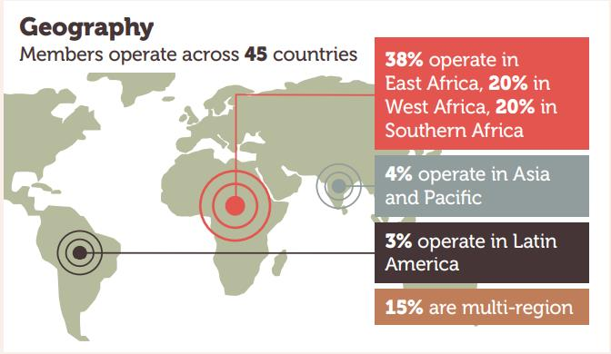
5.2 Market Infrastructure – Last Mile Distributors (LMDs). Milestones have now been exceeded. Notably, the Global Distributors Collective (GDC) welcomed 3 new funders and $1m in new funding to expand and deepen project activities and catalyse access to finance for women-led and locally-owned LMDs through the launch of their flagship financing facility, the Investment Catalyst Facility. Response to the launch has been very positive with two new funders interested in co-funding the facility. The launch of the Facility also contributed to the increase in GDC’s membership of last mile distributors (LMDs) (5.2a) with an increase of 75 members in the reporting period, exceeding the target. During 2025, 1 key sector event was hosted (5.2b): the West African Member Learning and Collaboration event in Nigeria. 250 GDC members convened through 4 topical webinars, including the Peer Learning Series, Selling Refrigerators for Productive Use, Extending Product Lifetimes through Decentralised Repair Services, Global Launch of the State of the Sector Report 2025, Financing the last Mile - Should Distributors Offer Credit. GDC produced 3 new knowledge products (5.2c): the Artificial Intelligence Innovation Spotlight, the Last Mile Distribution: State of the Sector Report, and How to Sell Refrigerators for Productive.
Figure 2 GDC membership overview, taken from the State of the Sector 2025 report
5.3 Market Infrastructure – Inclusive Energy. Milestones have been met. (5.3a.) THEA engaged a selection of humanitarian agencies throughout the year to co-develop briefing notes and align on energy projects resulting in a total of 112 partner members being achieved against a target of 16. THEA also supported GDC and ZE-Gen to mainstream humanitarian contexts into their programming. (5.3b), (target 7 achieved 50), THEA hosted a workshop with off-grid energy companies, last mile distributors and refugee-led organisations on barriers to working in displacement settings, and to soft launch the Humenergi Facility at the Renewable Energy Conference (Oct. 2025) in Uganda. Powering Healthcare (PH) hosted Energizing Healthcare in Nairobi (Feb. 2025), a two-day conference convening 200 experts from the energy and health sectors. To support the publication of PH’s (5.3c) Medical Appliances for Resource Constrained Settings (co-delivered with CLASP), PH hosted a webinar and workshop in Kisumu County, Kenya, including local government officials who supported the study and are considering how to use the findings in healthcare electrification plans (target 1, achieved 3).
5.4 Market Infrastructure – Mini-Grids. TEA continues to strengthen mini-grid market infrastructure through its support to the Mini-Grid Partnership (MGP) (5.4.1), the African Forum for Utility Regulators (AFUR) (5.4.2) and the Mini-Grid Funders Group (MGF) (5.4.3). AFUR retained engagement from 67 representatives across 14 countries (5.4.2a), MGP welcomed 5 new members (5.4.1a) including Sierra Leone Renewable Energy Association (REASL), Mozambican Renewable Energy Association (AMER), Lusophone Renewable Energy Association (ALER), Renewable Energy Industry Association of Malawi (REIMA) and the Solar Industry Association of Zambia (SIAZ).
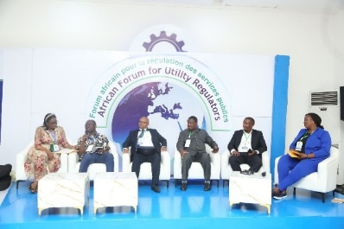
MGP remained active in facilitating 4 sector events in 2025, of which 3 were donor coordination meetings including a mini-grid developers’ roundtable in Zambia, a donor coordination session at the MiniGrid Action Learning Event in Lusaka-Grid Action Learning Event in Lusaka, and a targeted financing roundtable on the Mission 300 initiative convened with GEAPP (5.4.1b). MGP also participated in a regional multistakeholder forum in Indonesia focused on productive use of energy in the fisheries sector. AFUR held 3 PSC meetings in 2025, meeting the target (5.4.2b). In addition, AFUR published 1 article (5.4.2c), Access a tool to manage mini-grid regulatory uncertainty in Africa, while broader media engagement was limited due to timelines and a strategic focus on in country work, training and conference participation. The MGF hosted four quarterly meetings, with an average of 18 active attendees in 2025 (5.4.3a). Finally, the MGF members reported a commitment of $2,628m to developing the mini-grid sector.
Members and key stakeholders at the 21st AFUR Annual Conference in Cameroon
5.5 Market Enablers
5.5.1 Market enabling platforms: 7 market enabling platforms were supported through the TEA platform in 2025. This included support to four Pacific regional platforms through the TEA-P-SPC Country Demonstrator, including the Nationally Determined Contribution Hub (NDC Hub), Pacific Centre for Renewable Energy and Energy Efficiency (PCREEE), and the Office of the Pacific Energy Regulators Alliance (OPERA). TIME supported 4 platforms during the year: the SIDBI–Shell Foundation Risk Sharing Facility, Sterling Bank Clean Energy Finance Partnership, 500 Global Sustainable Innovation Programme, and the MESH Digital Platform for Green Livelihoods. These platforms focused on unlocking finance for clean energy enterprises, strengthening early-stage innovation ecosystems and enabling inclusive employment linked to clean energy markets.
5.5.2 Specialist funds created expanding financing options for clean energy access businesses: TIME supported the establishment of 1 new specialist fund through Lendable, increasing the availability of suitable financing for clean energy access enterprises and building on the specialist fund pipeline initiated fund pipeline initiated- in 2024. The first close of $300m for this innovative blended finance was supported by funding from TEA, via TIME, coming in as the anchor for the catalytic layer of the fund, unlocking other catalytic funders and commercial capital at other layers. TEA funding also embedded a stronger research and learning component in the fund which will provide additional data and evidence on the economics of different business models for the sector.
5.5.3 Policies influenced: Across the TEA portfolio, 25 policies were influenced at national and sub-national levels in 2025 bringing the total to 110, reflecting sustained engagement with government and regulators. Market Institutions (MIs) support by the EAIF contributed to 14 policy and regulatory improvements, including reforms on national energy planning, fiscal frameworks, solar quality standards adoption, mini-grid regulation, and carbon market governance. These include policies such as Kenya’s National Energy Compact (Mission 300) incorporating stronger off-grid solar commitments, Sierra Leone’s Finance Act 2026 introducing zero import duties for clean cooking technologies, and Nepal’s approval of four national electric cooking appliance standards (NS 606–609) that establish a foundation for large scale eCooking transitions. LEIA supported 10 policy and programme frameworks including the removal of the proposed value added tax on off grid solar products in Kenya’s Finance Act 2025, and the formal use of VeraSol testing and certification as eligibility or procurement criteria in 6 programmes: DECIM Madagascar, ASCENT Malawi, DARES Nigeria, PUFF Round Two, EWAS Ethiopia and Nigeria, and CES4W Kenya, together steering more than $125 million toward quality-assured products and strengthening programme design. LEIA also strengthened the global quality assurance ecosystem through the development of 3 test models: a Rapid Product Assessment Method for Agro-Processing Machines, a VeraSol Test Method for Solar Generators and technical contributions to IEC 63447. ENACTUS supported 1 affirmative policy action at the local government level, resulting in the formal appointment of dedicated energy focal persons within the Kampala Capital City Authority (KCCA) following structured engagement with the Ministry of Energy.

Output Changes
A key change to the Market Building intervention during the reporting period was the formal inclusion of the EAIF within the logframe. As a result, market institutions supported through EAIF are now captured under the newly framed Market Building intervention (5.1), providing a more coherent and consolidated approach to reporting market level support. In line with this change, GOGLA and AMDA are no longer reported as standalone indicators, as support to these institutions has been channelled and reported through EAIF from 2025 onwards. This adjustment streamlines reporting, reduces duplication and better reflects how institutional support is delivered across the portfolio. Furthermore, changes in leadership within THEA during the year led to a downward revision of Output 5.3 targets to better align with delivery capacity and implementation timeline level support.

Lessons and Recommendations
Recommendation 5.1: Tier 1 partners should, as some platforms and partnerships come to fruition or reach the end of R&D phases in TEA2, wind down support in the coming year towards responsible exit, facilitating partners to raise further and downstream funding where appropriate, and consolidating or combining efforts in other cases.
Recommendation 5.2: The RPDC Review of TEA2 delivery approaches should include review of the market building portfolio, and both the market institutions (in conjunction with EAIF) as well as the enabling platforms approach (across a wider set of partners), and provide recommendations on what has worked and what hasn’t, and where R&D is still needed - to inform the TEA3 inception phase if approved, but also contribute to a wider research publication. Informed by learning to date, realistic milestones and targets should also be set for this work under TEA3.
Recommendation 5.3: Carbon Trust to review Output 5 logframe targets (particularly for KPI 5.1) to ensure these are realistic and aligned with the latest plans and the remaining programme timeframe.
Recommendation 5.4: Carbon Trust to review achievements under KPI 5.5.3 ‘Policies influenced’ and develop a small set of “stories of change” as part of a TEA website Transformation Story and/or Deep-Dive learning session.
Output 6 – Support services and management enable enhanced co-operation, coherence and impact
Impact weighting (%): | 6% | Output Score: | A Output met expectations

Indicator | Milestone  (by Dec 25) | Achieved  (by Dec 25) | Score
6.1 TEA Support Services
6.1a Gender and Disability support service delivered | 1 | 2 | A+
6.1b Impact measurements support service delivered | 1 | 3 | A+
6.1c Local partnership inclusion support service delivered | 2 | 2 | A
6.1d HSE support service delivered | 1 | 1 | A
6.1e Independent review undertaken | 2 | 2 | A
6.2 RPDC Management, Reporting, Coordination, Cross-Learning
6.2a Annual reviews undertaken | 9 | 9 | A
6.2b TEA wide annual/biannual coordination meetings (in person) | 12 | 15 | A+
6.2c TEA wide quarterly coordination meetings (remote) | 16 | 16 | A
6.3 RPDC Comms
6.3a Newsletters | 16 | 14 | B
6.3b Followers on LinkedIn | 4,100 | 7,644 | A++
6.3d TEA website unique page views | 80,000 | 81,915 | A
6.4 Ayrton Fund Support Services
6.4.1 Ayrton Research Support
6.4.1a Energy Portfolio Analytics (EPA) updates | 9 | 9 | A
6.4.1b Ayrton Fund Explorer online tool updates | 6 | 3 | B
6.4.1c Ayrton Fund thematic research and reporting | 5 | 4 | B
6.4.2 Ayrton Comms Support
6.4.2a Ayrton Fund engagement and coordination | 7 | 7 | A
6.4.2b Ayrton Fund newsletters | 13 | 12 | A
6.4.2c Ayrton Fund social media - Social media posts | 140 | 346 | A++

Performance Summary
Output 6 met expectations overall, with the milestones for 14 of 17 KPIs met or exceeded, with the levels of achievement balancing to an A score. Performance was strongest across TEA Support Services and RPDC management and coordination, where all core milestones were met, alongside strong growth in communications and digital engagement. Support Services on gender, disability, local partnership inclusion, health and safety, impact measurement and research were fully operational and delivering, while TEA-wide coordination and reporting functions were implemented consistently. A small number of KPIs (primarily related to newsletters, thematic research outputs and updates to the Ayrton Explorer) fell short of milestones due to staffing issues and sequencing constraints, but delivery in these areas remains ongoing and did not materially affect overall Output performance.
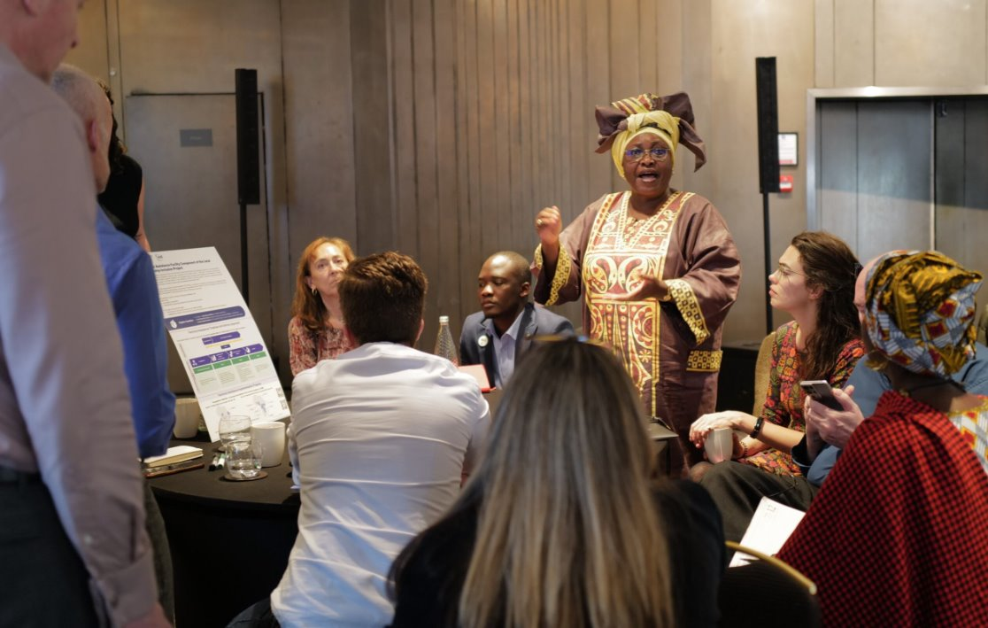
6.1 – TEA Support Services. TEA continued to successfully deliver Support Services and inform wider sector learning. Highlights included the updated TEA GEDSI Toolkit (with tools on procurement, safeguarding and an action plan template), and launching a dedicated GEDSI page on the TEA website, where the toolkit and other guidance materials are available. The Gender Support Service (GSS) ran a virtual bootcamp attended by 38 organisations, leading to in-depth technical support to four organisations, including TEA@Sunrise. The Disability Support Service delivered multiple trainings and webinars, including a six-part Disability Inclusion and Innovation for Energy Access, provided bespoke support to eight TEA partners, and established the Disability Inclusion Innovation Network. The Local Partnership Inclusion (LPI) Facility supported 22 local organisations with R&D grant proposals in response to TEA Open Calls. Of these, three were successfully awarded TEA grants. The Research Support Service (RSS) published Mind the gap: Rethinking transitions along the energy access finance continuum (reported under 2.2.2b), and supported the RPDC with research synthesis and strategic input. New phases of the Voice of Customer support service (TEA VoC) has completed 7 of the 13 TEA assessments for companies and projects with actionable user feedback insights. The new phase of the Health and Safety support service (TEA H&S), now run via the EAIF and delivered by CLASP and AMDA, launched in July 2025 and has produced three H&S Country handbooks for Kenya, Nigeria, Zambia, and a Mini-Grid H&S Standards Mapping Report. Into 2026, the TEA H&S Support Service will implement a communications strategy for these new publications to support dissemination and mainstreaming of H&S standards across the African Mini-Grid sector and launch the TEA H&S mini-grid helpdesk.
TEA delegates discussing Local Partnership Inclusion support service at DRW in Mar 25.
6.2 RPDC Management, Reporting, Coordination, Cross-Learning. The Research Programme Delivery Consortium, (RPDC), met all indicators (6.2a, 6.2b and 6.2c). The 2025 Annual Delivery Review Workshop (DRW) was hosted in London across 2 days and joined by 119 in person and 50 online, making this its largest attended DRW to date. Feedback was positive, with an overall satisfaction rate of 4.64/5. Due diligence was refreshed across all Carbon Trust’s tier partners, supporting the strengthening of H&S and Cyber Security risk management, and reviewing partner compliance across IATI and climate commitments setting requirements.
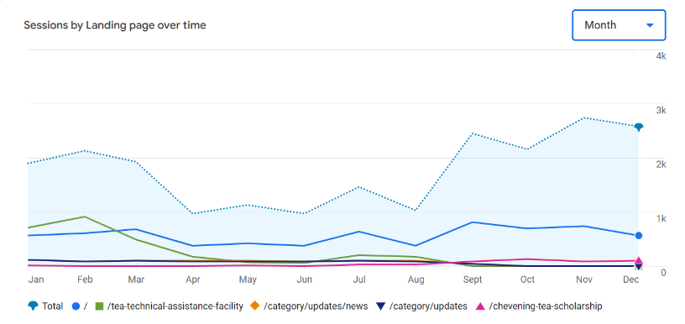
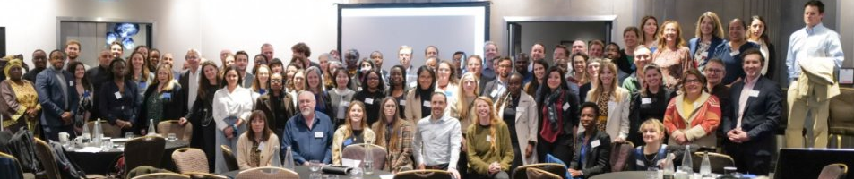
6.3 RPDC Comms. In 2025, TEA’s communication channels grew, leading to a strong increase in followers, impressions, and engagement. TEA’s LinkedIn followers increased by over 2,000, to 7,644. The Chevening TEA Scholars event post had the highest engagement rate (40.5%), while the LPI Grant writing webinar post had the most impressions (4,575). The TEA website was redesigned focusing on increased storytelling and knowledge products. It launched in September, and since then monthly visits have increased from 1,000 to 2,500. The site recorded 15,869 unique page views, exceeding the target by 1,900. RPDC also produced three TEA newsletters in 2025 (due to unforeseen staffing constraints the target of four was missed).
Delegates at the 2025 TEA DRW
6.4 Ayrton Fund Support Services. Activities are mostly on track, and the TEA RPDC continues to respond flexibly to FCDO needs and priorities, alongside those of DESNZ and DSIT, including in preparation for the second phase of Ayrton under ICF4. The annual Energy Portfolio Analytics (EPA) update took place as planned in spring 2025 (6.4.1a). The Ayrton Explorer online search tool (6.4.1b) has received periodic refreshes to content, though the planned full review and refresh has been deferred from 2025 to 2026, which will allow the Explorer to be updated fully for ‘Ayrton 2’ positioning. Since its launch in 2023, the Explorer has now had 9,306 site users, an increase of 5,006 from last year. The Ayrton Fund webinar on Locally-led action and equitable partnerships for clean energy access in November presented cases studies and recommendations from the Locally-Led Action and Equitable Partnerships Insights Study (6.4.1c). Two more Ayrton research studies started in autumn 2025: (i) UK Secondary Benefits of Ayrton Fund programmes; and (ii) the Ayrton Challenges Review; reports will be completed by April 2026. Ayrton Fund LinkedIn followers grew from 1,373 to 2,377. With 90 posts on LinkedIn, social media posts now total 346 (6.4.2c). Four Ayrton Fund newsletters were sent (6.4.2b), meeting the annual target and with subscribers growing from 511 to 538.
Graph shows unique page views of TEA website, per month, in 2025.

Output Changes
KPI ‘6.3c - Followers on Twitter/X’ has been removed, as this is no longer a target media platform.

Lessons and Recommendations
All Support Services will conclude during 2026, with the primary emphasis shifting to dissemination and engagement. The focus will be on sharing key outputs more widely, strengthening stakeholder engagement, and systematically capturing lessons learned and recommendations. These insights will be used to inform programme design and delivery, helping to maximise impact and shape the strategic direction of TEA3.
Recommendation 6.1: Carbon Trust to develop a concise summary of TEA1-2 Support Services covering (i) the main accomplishments delivered under each Support Service, (ii) an assessment of how far these services strengthened TEA delivery and results, including demand, and (iii) an indicative outline of fewer, more targeted and impactful activities that could be taken forward under the three consolidated TEA3 Support Services (GEDSI, Local Partnership Inclusion, and Health & Safety).
Output 7 – Country Specific Demonstrator Projects
Impact weighting (%): | 11% | Output Score: | A Output met expectations

Indicator | Milestone  (by Dec 25) | Achieved  (by Dec 25) | Score
7.1 Pacific - TEA-Pacific Community - Framework for Energy Security and Resilience in the Pacific (FESRI) |  |  | B
7.1.1 Pacific Island Countries supported in financing and implementing their NDCs | 1 | 11 | A++
7.1.2 Countries with improved sex-disaggregated data available on energy sector | 14 | 0 | C
7.1.3 TAs and services provided to national industrial bodies | 4 | 1 | C
7.2 Rwanda - Low Energy Inclusive Appliances Scale-Up in Rwanda (LEIA-R) |  |  | B
7.2.1 PURE appliances deployed in refugee camps and host communities | 250 | 180 | B
7.2.2 Micro-enterprises supported | 200 | 84 | C
7.2.3 Percentage of micro-enterprises supported owned or managed by women | 50% | 57% | A+
7.3 Somalia - Hardest-to-Reach/A Bright Future for the Barwaaqo IDP Camp |  |  | A
7.3.1a Off-grid SMEs invested/supported | 2 | 2 | A
7.3.1b Investment to 1-2 solar home system or mini grid providers in Somalia (£) | £1.8m | £1.3m | B
7.3.2a SMEs using energy for productivity, due to PUE initiative | 100 | 149 | A+
7.3.2b Households provided with electricity via new hybridised solar PV power | 3,000 | 2,700 | A
7.4 Uganda - Enabling African Cities for Transformative Energy Access |  |  | A+
7.4.1 Innovations/best practices scaled/replicated in urban areas of GKMA/beyond | 1 | 1 | A
7.4.2 Households/small businesses/institutions with improved clean cooking | 6,000 | 9,085 | A++
7.5 Clean Energy Demonstrators in Tanzania (Energy Catalyst) |  |  | A
7.5.1 Novel technological innovations supported via EC Tanzania demonstrator | 5 | 5 | A
7.5.2 New business models tested via EC Tanzania demonstrator | 2 | 2 | A

Performance Summary
9 of 14 KPIs have been met or exceeded in the Post-funded Demonstrator projects, resulting in an overall A score. The Uganda Demonstrator is performing ahead of expectations at A+ with clean cooking access surpassing targets by over 50%, the Somalia Demonstrator has scored an A with strong overall performance in a challenging environment, and the Tanzania demonstrator has also progressed well meeting its targets. However, the Rwanda and Pacific Demonstrators are both scoring at B after delays outside of the direct control of delivery partners, although both now delivering, with some KPIs exceeding targets such as supporting 11 Pacific countries on NDC implementation (vs target of one).

7.1 Pacific - TEA-Pacific Community (TEA-P-SPC). The project supports delivery of the Framework for Energy Security and Resilience in the Pacific (FESRIP) 2021–2030, with a focus on policy, capacity building and gender inclusion. The NDC Hub supported seven Pacific Island Countries (PICs) to advance the financing, updating and implementation readiness of their NDCs, bringing the cumulative total to 11 countries supported since project inception (7.1.1). In 2025, Niue, Tuvalu, the Federated States of Micronesia, Solomon Islands and Vanuatu were supported to develop and submit NDC 3.0 updates, while French Polynesia and New Caledonia contributed to updated submissions under France’s NDC. Progress across other workstreams was mixed, reflecting local capacity constraints and the withdrawal of USAID funding, which delayed or constrained planned activities (7.1.2). One qualifying technical assistance activity was delivered through the Solar Technology and Application Resource Centres validation and training workshop, strengthening regional technical standards and industry engagement, with additional planned activities deferred due to capacity and delivery constraints.

7.2 Rwanda - Low Energy Inclusive Appliances Scale-Up in Rwanda (LEIA-R). LEIA-R aims to install 250 standalone solar-powered appliances for Productive Use of Energy (PUE) across three refugee camps and host communities to demonstrate the impact of PUE on refugee livelihoods. 180 PUE appliances have been installed so far; with lengthy procurement and importing processes delaying the initial installation of appliances, and with the remaining appliances to be installed by March 2026. The FCDO Post is also considering extending this project further in 2026/27. Awareness raising activities have supported PUE business demand activation, along with the product subsidy set at 80%, based on consultations and ability to pay analysis. LEIA-R published Energy Appliances for the Rwandan Humanitarian Context and The Procurement Handbook for Off- and Weak-Grid Appliances, the latter a resource for procurement officers, implementers and energy consumers, with guidance on durable appliances to contribute enhanced energy efficiency and provide long-term economic viability.

7.3 – Somalia 7.3.1a and 7.3.1b. Mobilising the Hardest-to-Reach (H2R) Initiative in Somalia. Between Sept. 2024 - March 2025, the H2R Somalia initiative (delivered via Acumen) sought to invest up to £1.8m in two local companies to expand clean energy access in a challenging and nascent market. Due to limited market maturity and the small number of companies able to absorb capital within the project timeframe, a total of £1.3m was deployed. This included $1.25m to KIMS Solar (comprising a $1m investment and $250k in technical assistance and grants), supporting the scale-up of solar home energy distribution through a pioneering Sharia-compliant company and strengthening core lending and operational systems. In addition, $250k was provided to GOLIS Energy in technical assistance and grants to build operational capacity, support core business functions, and improve investment readiness. While the original investment target was not fully met, the initiative performed well by deploying catalytic capital, strengthening local firms, and laying the foundations for future clean energy investment in Somalia, an important outcome as the H2R Fund has now closed at $250m including $20m from BII and $50m from GCF, which Somalia should benefit from sooner because of this work.
7.3.2a and 7.3.2b. A Bright Future for the Barwaaqo IDP Camp: Enter Energy Somalia (EES). EES is a public–private partnership (PPP) model aiming to demonstrate a scalable and sustainable model for clean electricity access in fragile, displacement-affected settings. Between Sept. 2024 - March 2025, EES extended Baidoa’s electricity distribution network into the Barwaaqo internally displaced persons (IDP) settlement and surrounding areas, combining infrastructure delivery with targeted support to PUE. 2,700 households (7.3.2b) were connected to the grid, and 149 (112 owned by women) (7.3.2a) IDP PUE businesses supported with finance, appliances and training. The household connection target has not been fully met (90% only) due to an overestimation by the camp management of the number of new IDP households that would be established during the project’s lifecycle.
7.4 Enabling African Cities for Transformative Energy Access: Uganda Scale Up – ENACTUS. Launched in August 2024, with end date March 2026, ENACTUS unites multiple partners (PPP model) operating in the energy access space to enable scaled and sustainable access to clean cooking for informal settlements in Kampala. Households with improved access to clean cooking (7.4.2) has been exceeded by 50% reaching 9,085, driven by strong market uptake and effective support to delivery. ENACTUS provided grants to five private sector companies across three consortia to support business model development, market entry and product distribution. Another success was the coordination between national and local governments, and the increased institutional capacity through embedded support to the setup of the Clean Cooking Unit (CCU).
7.5 Clean Energy Demonstrators in Tanzania. Launched in May 2025, with an end date of March 2026. This demonstrator aims to leverage local Tanzanian partnerships to validate or field test innovations, aligned with SDG7 and 13, and the Ayrton Challenges. This year, it met both its targets, achieving five novel technological innovations and two business models through the delivery of three projects focused on renewable-powered micro-grids with intelligent energy management for fish farming; showcasing solar, wind and anaerobic digestion technologies to charge batteries for e-mobility and a project focused on optimising Demand-Side-Management.
Additional Country Activity: in addition to the above projects, in 2024 FCDO Posts made contributions to the World Bank’s ESMAP for: i) £5m FCDO Indonesia contribution to the World Bank’s $1.5bn Indonesia Sustainable Least-cost Electrification – 2 (ISLE-2) programme (2025-2032), which will upgrade 2,000km of transmission lines, enable 540MW of solar and wind, connect 3.5m people to clean electricity, and cut power costs by 8% and emissions by 10% in Kalimantan and Sumatra. The programme will mobilise $345m in private finance and includes $35m for 100MW of battery storage, to which FCDO contributes £2.5m, alongside £2.5m for technical support. The latest progress report confirms the programme is on track, with a full results framework in place though no results reported yet. ii) £1m FCDO Tanzania contribution to the World Bank’s Accelerating Sustainable and Clean Energy Access Transformation (ASCENT) – Tanzania programme (2024–2028), which aims to provide 4m people with access to clean electricity by expanding grid electrification, scaling distributed renewable energy, and using results-based financing to deploy solar home systems, clean cookstoves and other distributed renewable solutions. The latest progress report confirms the programme is on track, with 2.46m people already reached with electricity access, of which 10,398 people (0.42%) are attributable to FCDO’s £1m ($1,267,680), based on $300m committed so far.

Lessons and Recommendations
Recommendation 7.1: Carbon Trust to capture lessons from Country Demonstrators to inform TEA3, and FCDO to conduct a follow-up survey of Country Posts to gather structured feedback on their experience of the TEA Country Demonstrator offer.
Recommendation 7.2: FCDO to work with Indonesia and Tanzania Posts to agree future milestones for the World Bank Demonstrators funded via ESMAP.
Recommendation 7.3: Carbon Trust to review logframe KPIs for the Pacific Demonstrator (particularly KPI 7.1.2) to ensure these are aligned to the latest delivery plan for the project.

D: VALUE FOR MONEY (VfM)
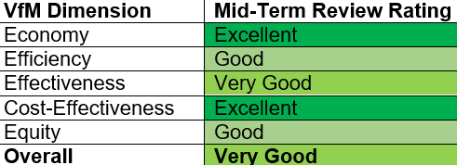
TEA underwent an independent Mid-Term Review and VfM assessment, completed in February 2025 and findings were reported in the 2025 Annual Review. The assessment rated TEA as Very Good overall for VfM, with Excellent scores for Economy and Cost-Effectiveness. A number of recommendations were made and subsequently implemented during the year; with a summary of progress set out below.
Economy (Excellent): Tier 1 partners continue to demonstrate strong economy management practices. Leveraging of public and private finance substantially exceeded annual targets in 2025, with endline targets also surpassed. Partner overheads are projected to remain within the ranges agreed with FCDO, and all Tier 1 partners have taken steps to reduce overhead costs. In response to the VfM assessment recommendation to strengthen Tier 1 partner reporting, an ICF KPI methodology checklist has been implemented across the portfolio to improve evidence quality. This directly addresses last year’s finding that reporting needed to “significantly improve”, particularly in documenting methodologies and leveraged finance. In addition, recognising the diminishing influence of early TEA investments over time, a tapered three-year limit was introduced on post-TEA investment claims for outcomes from Venture Building and other investments. This measure takes a conservative view of attribution as investments mature and other funding plays a larger role in the financing of outcomes, even while early-stage RD&D investments are likely to have been the most catalytic.
Efficiency (Good): Partners continue to strengthen processes to manage key efficiency drivers, with 78.5% of Outputs on track, meeting the threshold for a Good rather than Excellent rating. To further support efficiency, Tier 1 partners and FCDO reallocated budgets during the year to ensure resources were deployed optimally (see Section F). Where project savings were realised, funding was reinvested to maximise delivery and impact. Based on the proportion of Outputs on track and an assessment of medium-to-high (rather than high) returns, efficiency remains strong.
Effectiveness (Very Good): Two issues prevented an Excellent rating including (i) results management, with reporting focused on a limited set of outcomes that did not fully reflect the breadth of TEA’s work and likely achievements; and (ii) the absence of systematic monitoring of the sustainability of energy capacity installed under TEA. These issues have been addressed through a mid-2025 review of the TEA logframe to ensure KPIs better capture qualitative and systemic impacts, and the introduction of the ICF methodology checklist to ensure verification of installed capacity.In addition, Tier 1 partners have increased cross-portfolio learning and alignment of initiatives where possible.
Cost-Effectiveness (Excellent): In the previous assessment, the only outcome not exceeding business case expectations was Outcome 4 (installed clean energy capacity, MW). In 2025, all five outcomes meet or exceed their business case benchmarks. The cost per MW for Outcome 4 decreased from approx. £420k in the VfM assessment to approx. £330k per MW this year, based on £214m spent to date. This demonstrates the benefits of scale and improving efficiency as delivery expands.
Equity (Good): TEA has continued to strengthen its work on gender, disability, social inclusion and localisation (GEDSI), as well as the consideration of energy in humanitarian contexts. Most GEDSI-focused projects have met or exceeded their targets (including EES, TEA VoC, LPI-TA, GSS, DSS, THEA and LEIA-R). GEDSI trainings were delivered to 63 TEA partners and 101 stakeholder organisations. Technical support was provided to 12 TEA partners, supporting the development and implementation of GEDSI Roadmaps and the integration of GEDSI considerations across project design, market research, marketing and customer outreach, disability inclusion action planning, and inclusive product design. As a result, TEA is making strong progress against the Equity VfM criteria.
Areas for Strengthening: Overall, TEA demonstrates strong progress on VfM and has effectively responded to the VfM assessment findings. Over the next year, continued focus will be placed on improving efficiency to ensure delivery against end-of-programme output targets. Equity will remain a priority as new GEDSI-focused activities are developed, with final project reports explicitly assessing the impacts of TEA’s support service interventions.

E: RISK

Overview of risk management
FCDO risk appetite for TEA is shown below, and all TEA risks fall within appetite:
Pillar | FCDO risk appetite
Strategy & Context | Receptive
Policy & Programme Delivery | Receptive
Financial & Fiduciary | Cautious
Safeguarding | Cautious (Receptive for H&S risks)
Reputational | Cautious
The overall risk rating for TEA is Moderate. All risks are actively managed through appropriate mitigation measures and discussed with FCDO monthly. Each project maintains a live risk register, reviewed regularly with project managers, while The Carbon Trust maintains a portfolio-level TEA risk register that is updated on an ongoing basis and formally reported to FCDO quarterly. Key current risks relate to Health & Safety, external context, delivery, and cyber security. Mitigation measures include increased Health & Safety awareness and training for partners, verification of appropriate insurance cover, and targeted spot checks and oversight of delivery partners where risks are assessed to be higher. Contextual risks highlighted in last year’s review, such as Ebola outbreaks and the dismantlement of USAID, have been actively mitigated, resulting in reduced net risk ratings.
A 2025 programme due diligence update recommended strengthening TEA’s oversight of Health & Safety and Cybersecurity, reflecting issues identified across the wider FCDO portfolio and some incidents in the TEA portfolio. A review of downstream delivery partner policies and capabilities identified several gaps and corresponding recommendations. These include strengthening Health & Safety policies, increasing oversight of downstream partners, increasing the frequency of cybersecurity training for staff, and improving incident reporting systems. Progress against these recommendations will be reported to FCDO in Q1 of FY 2026/27. To further manage supply chain risks, near-term and longer-term actions have been agreed with FCDO, with new controls introduced to enhance oversight and additional workstreams under consideration through to the end of TEA2.

F: PROGRAMME MANAGEMENT: DELIVERY, COMMERCIAL & FINANCIAL PERFORMANCE
A no-cost extension of the TEA platform was approved in December 2025, extending the programme end date from March 2027 to March 2028. This provides additional flexibility to complete delivery and, where required, spend any residual budget during FY27/28, without increasing the overall budget envelope. The total approved TEA budget is £265.4m. Of this, £256m is committed through funding agreements with Tier 1 partners. The remaining £9m headroom (from £30m in business case headroom) remains available for FCDO Country Posts to support TEA Demonstrators. By December 2025, £214m had been spent, with the remaining balance profiled across FY26/27 and FY27/28.
Overall programme management and commercial performance remained robust during 2025, with Tier 1 partners continuing to meet reporting, governance and contractual requirements. Forecasting accuracy has improved and financial controls remain robust, enabling early identification of issues and timely budget reallocations where required. However, a few delivery challenges emerged during the year. Several major components experienced underspends and under-delivery, most notably Energy Catalyst and ZE-Gen, requiring active re-profiling of budgets.
The pipeline of new, investment-ready deals through TIME has been slower to develop than anticipated, although this showed signs of improvement towards year end. There also remains a structural misalignment between TEA and TIME in geographic and thematic priorities, which has constrained coherence across parts of the portfolio and will need to be addressed through the design of TEA3. In addition, progress on agreeing and operationalising the reinvestment of Shell Foundation returnable grants has been slower than expected and will require focused attention in 2026, in line with recommendations under Output 4. Despite these challenges, no material contractual or fiduciary risks arose, and corrective actions are in place to protect delivery against end-of-programme objectives.

G: MONITORING, EVIDENCE AND LEARNING
TEA Tier 1 partners engaged regularly with FCDO through Governance or Board meetings, Investment Committee sessions and monthly oversight updates. The Carbon Trust conducts monthly updates and quarterly delivery monitoring of its own partners against pre-defined evidence. All TEA partners embed established project management monitoring practices within routine partner interactions, allowing for early identification of risks, delivery challenges, and opportunities for enhanced delivery. Where appropriate, monitoring is supplemented by site visits, including partner and grantee visits within situ, to verify implementation progress, validate reported results, collect qualitative feedback from end users and stakeholders, and promote the impactful activity UK ODA funding is enabling. For example, PREO undertook trips to the Pacific and visited Motu Juice, Archipelago Energy, and Sunshine Pacific Ltd, along with visits to Inter Ethiopia Solutions and S&Y Electrical Material in Ethiopia. The Faraday Institution visited NEXGENNA in St Andrews, as well as all Seed and Sprint projects and new concept-to-demonstrator projects.
Convening to capture and share project learnings has been a key focus of TEA MEL. In addition to quarterly remote TEA-wide meetings, a hybrid bi-annual review was held in September 2025, (using ‘hubs’ approaches trialled in 2024, in Cape Town, Nairobi, London and Edinburgh), and an in-person Delivery Review Workshop was held in London in March 25 (to be held again in Nairobi in April 2026). A TEA3 design workshop was convened by FCDO in November 2025, bringing together stakeholders across the energy access sector to strategise and share learnings. The Carbon Trust convened quarterly MEL workshops to support continual learning and best practice across the platform. Additionally, quarterly Local Partnership Inclusion working group meetings continued to progress localisation support across the TEA platform. Training material (guidance videos, slide decks, etc.) is available to all partners for reporting requirements, core reporting activities (e.g. periodic monthly, quarterly, annual reporting etc., Science Based Targets setting, Energy Portfolio Analytics reporting, IATI reporting and more).
Across the platform, TEA projects undertook structured beneficiary engagement, including focus group discussions, surveys, interviews, and post-activity feedback mechanisms (e.g. TEA VoC, LEIA, and TIME). These were used to assess participant experience, relevance of interventions, and early outcomes, and directly informed programming decisions such as adjustments to delivery models, sequencing of activities, and the design of follow-on support. Continuing efforts have also been made to improve collection of disaggregated data: i) the Gender and Disability Support Service developed GEDSI Toolkit has provided detailed guidance to partners to support GEDSI results monitoring and disaggregated data collection across the portfolio, ii) the broader Support Services portfolio also provided expert advice directly to TEA partners to further support this effort.
The quality of evidence was strengthened through improved data collection templates, independent validation, and clearer reporting protocols. For example, to further strengthen data integrity and transparency, Shell Foundation have engaged an independent third-party to validate reporting from our highest-contributing partners, including Odyssey, EEGF, SIMA EARF, Persistent and Mirova. This review ensures that reported data is accurate and consistent, and avoids double counting. The Carbon Trust has also implemented further data verification checks and QA measures for this Annual Review process, resulting in increased auditability of results, although collation timelines still challenge this approach. At the same time, TEA recognised KPI limitations and challenges, including uneven data availability, disruptions caused by external shocks (e.g. funding withdrawals or geopolitical factors), and challenges in aggregating evidence across highly diverse interventions.
This year’s AR drew upon extensive reports and analysis synthesis by the RPDC. Following recommendations, The Carbon Trust met with all partners to discuss findings regarding impact, collaboration, and lessons learned. TEA also underwent its second mid-term review completed in February 2025, resulting in several recommendations that have been tracked and actioned throughout the year to ensure continuous improvement.
Tier 1 Partner | Last audited annual statement
Carbon Trust | Annual report: For the year ended 31 March 2025
Innovate UK | UKRI Annual Report 2024-25
Shell Foundation | Shell Foundation Annual Report and Accounts 2024
CLASP | 2024-CLASP-Audited-Financial-Statements.pdf
ESMAP | CFS with audit reports

ANNEX 1 – Progress against Annual Review Recommendations 2025
Recommendation | Status | Comments
- Post-Graduation Engagement: Introduce a systematic post-graduation tracking mechanism for Chevening TEA Scholars (and consider doing the same for TEA-LP Master's students) to assess the short- and long-term impacts of the Scholarship on their careers. Data collection should occur annually, starting one year after completion of studies in the UK. | Completed | In response to this recommendation, CT have designed an annual survey that can be used by both TEA-LP sponsored master's students and Chevening TEA Scholars. The objective of this survey is to collect short- and long-term impacts of the two programmes.
- Southern Leadership in Research: Enhance efforts to increase southern leadership in TEA research, leveraging the Local Partnership and Inclusion (LPI) Support Service, and building on the findings of the Ayrton Fund deep dive on Localisation and Equitable Partnerships. | Completed | Findings of a UCT completed Rapid Evidence Assessment of the number of public facing TEA research reports have shared that most TEA research outputs are led/delivered by Global North stakeholders.  These findings have been shared with the LPI Working Group and Ayrton Fund localisation deep dive stakeholders.
- Research Excellence: Deepen the focus on Research Excellence fostering expansion from master’s programmes towards Research Groups and PhDs. | Completed | TEA RSS presented on research excellence at the TEA Bi-Annual meeting. Expansion towards PhD programmes has been tabled for further consideration.
- Open Calls Strengthening: Align Open Calls with FCDO strategic priorities and local needs and, enhance resource allocation to support these initiatives. | Completed | Report complete and outlined during the TEA Bi-Annual meetings. Findings have informed the Open Calls Annual Review output section.
- Open Calls Strengthening: Explore co-funding partnerships through joint commissioning and coalitions of clean energy leaders in both the north and south. | Completed | Report complete and outlined during the TEA Bi-Annual meetings. Findings have informed the Open Calls Annual Review output section.
- Next Generation Solar Action Plan: TEA@SUNRISE to develop action plan to improve knowledge-sharing and networking initiatives, including webinars, member presentations, and additional events. The plan should also explore alternative KPIs that effectively capture evolving priorities, progress, and impact. | Completed | Swansea University has developed a knowledge sharing action plan. A new indicator focused on network-driven collaboration/partnerships was proposed to include the main LogFrame. FCDO suggested keeping the previous KPI (Technology prototypes developed), hence moved this to project-specific indicators.
- Shift to commercialisation: Pursue more ambitious integration with BII, PIDG, FSDAi, Manufacturing Africa and REPP on linking TEA innovations with DevCap investments, closing capital continuum gaps, with a focus on developing UK-Southern energy access and transition industrial champions. | Completed | Investor outreach approach has been developed. 1-1 engagement being conducted for specific opportunities and as part of TEA3 development.  The TEA Venture Facility is up and running with a management team and Steering Committee in place including (BII and PIDG).
- Country Alignment: Improve alignment between TEA and Shell Foundation on country priorities for Venture (and Market Building), balancing questions such as extent of need, policy alignment, market potential etc. | Completed | Movement with SF to broadened geographics scope. Wrapped broader discussion into TEA 3 shifts and priorities discussion. Finalisation deferred to TEA3 design and priorities.
- Shift to Market Shaping: Review and optimise the Market Building portfolio regarding a shift to Market Shaping, strengthening links to technical assistance and Centres of Excellence/Expertise facilities, improving impact data collection and communication of market work via EAIF. | Deferred (TEA3) | Ideas for market shaping in TEA 3 forming. Suggestions for logframe revisions declined; FCDO confirmed to be reviewed for TEA3
- M300 Engagement: TEA to engage with the Mission 300 initiative delivered in partnership with the World Bank's ESMAP, given its potential to be a transformational funding and policy vehicle for energy access in Africa, and route to scale for TEA-supported innovations. | Completed | Engagement with M300 has occurred throughout the year on several projects, with potential scale up work considering further ways to more deeply engage. TEA3 discussions closely consider M300 alignment in scoping activities. M300 representatives are invited to all TEA meetings.
- Support Services: Ensure that monitoring and lesson learning is in place around the effectiveness of support services, including polling partners and externals on the value they have brought. Consider options to scale-up and pivot particular offerings if they show particular over-demand (e.g. TA Facility). | In-Progress | H&S and TEA VoC are both contracted and fully in delivery. There will be an end of project LPI-TA report which reflects on the pilot, and this will be used to design a scale up and work with other partners to see how the results can be used to improve LPI across the platform in early 2026., along with an assessment of TEA support service engagement and effectiveness overall.
- Carbon Trust Due Diligence Refresh: FCDO to conduct a due diligence refresh of the Carbon Trust in 2025, to ensure robust risk management and effective and updated due diligence processes. | Completed | FCDO due diligence to CT completed. Downstream partner refresh is also complete. A final report is being compiled and will be regularly updated.
- Country Demonstrators: Strengthen the effectiveness of Country Demonstrators through improved communication, extended timelines, and integration of learnings, including:  Pacific: Increase communication between FCDO Pacific staff and the SPC team to enhance collaboration and streamline efforts.  Somalia: Gather and communicate learnings from the EES Somalia demonstrator as part of the broader Humanitarian Energy Ayrton Challenge work, coordinated by Mercy Corps.  Uganda: Ensure local project team engages at all levels of government to maintain momentum and progress in clean cooking initiatives.  Indonesia/Tanzania: Incorporate results from the new ESMAP Country Demonstrator projects into the next annual review, in collaboration with FCDO Country Posts. | Completed | - Pacific: Following engagement with FCDO Pacific and SPC, we have implemented regular coordination meetings to facilitate ongoing partnership.  - Somalia: Mercy Corps and Acumen presented results in June 2025.  - Uganda: CT monthly meetings with FCDO Uganda transferred to ICLEI Africa. CT to continue meeting with FCDO Uganda on a quarterly basis. Beyond reporting, ICLEI Africa (through the ENACTUS project activities) meets with UCCP partners - MECS, GGGI and NREP - on a monthly basis (at least).  - Indonesia/ Tanzania: FCDO Indonesia has confirmed that its full £5 million allocation will be directed to the World Bank’s ISLE-2 programme, rather than to ESMAP activities in Indonesia, and are currently checking with the Bank what reporting arrangements will be in place for the programme. In the TEA AR, agreed to in both cases calculate FCDO share of results based on the level of funding the FCDO has contributed to ESMAP during the World Bank fiscal year FY2025 (1 July 2024 – 30 June 2025).

This includes ~£1.6m spent on irrecoverable VAT during Phase 1 of TEA, under a now closed contract with the Carbon Trust.
Average annual UK car emissions of 1,470,120 grams CO2
TEA3 Principles and Shifts include: 1) a sharper solution-led R&D focus; 2) refined country prioritisation; 3) expanded co-funding and partnerships; 4) stronger links between R&D and downstream investment; 5) greater consolidation and integration to improve value for money; 6) deeper UK–Southern partnerships; 7) better leverage of UK expertise; and 8) improved learning, comms and evidence use.
KPI error corrections are recognised in the year in which they are identified therefore this reduction is made between 2024 and 2025.
2024 UK carbon dioxide net emissions were estimated at 371m tonnes (Mt) / or an estimated 5.4 per capita
Uses ESMAP tracking data with two-year lag, therefore this report utilises 2023 data.
ICF 2025 results: UK International Climate Finance results 2025 - GOV.UK
GlobalData reports a 43% decline in renewable energy-related patent applications in Q3 2024 compared to the previous quarter while patent applications to the UK Intellectual Property Office decreased by 5.1% between 2023 and 2024.

