Annual Review

Title: TRANSFORM - Market-based solutions and behaviour change for low-income households (partnership with Unilever and EY)
Programme Value £ (full life): Phase 1: £20 million (£20m co-financing), Phase 2: £20 million (£30m co-financing) |  | Review date: May 2026
Programme Code: 204415-101/102 | AMP start date: 21/11/2014 | AMP end date: 31/12/2026

Summary of Programme Performance
Year | 2015 | 2016 | 2017 | 2018 | 2019 | 2020 | 2021 | 2022 | 2023 | 2024 | 2025 | 2026
Overall Output Score | A | A | A | A | A | A | A+ | A | A | A | A+ | A+
Risk Rating | Major | Mod* | Mod | Mod | Mod | Mod | Minor | Mod | Mod | Mod | Mod | Mod
*Mod = Moderate

DevTracker Link to Business Case:
DevTracker Link to results framework:

A. SUMMARY AND OVERVIEW

Description of programme

Innovation is a powerful enabler of sustainable development, economic growth, and poverty reduction. Small and medium-sized enterprises (SMEs) are central to this agenda. Start-ups and social enterprises bring agility, creativity, and a deep understanding of local needs. These characteristics enable them to pioneer disruptive solutions in support of the Sustainable Development Goals.
However, despite their potential, many of these enterprises face significant barriers to scale - ranging from limited access to early-stage capital to gaps in technical capacity and market readiness.
To address these challenges, TRANSFORM supports early-stage business models through a combination of grant funding (£100,000 - £250,000) and tailored venture strengthening assistance. The programme plays a critical role in generating and disseminating evidence on what works to scale inclusive businesses and behaviour change interventions. Its overarching goal is to enable people to adopt behaviours and access products and services that lead to lasting improvements in health, livelihoods, and environmental outcomes.
As a public-private partnership, TRANSFORM leverages the strengths of its founding partners. The FCDO brings development expertise and funding, while Unilever contributes deep sector knowledge, supply chain access, funding and convening power in the fast-moving consumer goods (FMCG) industry. EY provides in-kind technical assistance in the form of dedicated consulting support to target specific challenges, 1:1 coaching to provide a sounding board on the enterprise growth journey, peer learning and development opportunities, and access to EY networks.
TRANSFORM has impacted the lives of 1.95 million people in this reporting period. Overall to date, TRANSFORM has positively impacted 20.8 million people across 19 countries. The programme has funded 163 projects across 19 countries, providing £33.7 million in grants.
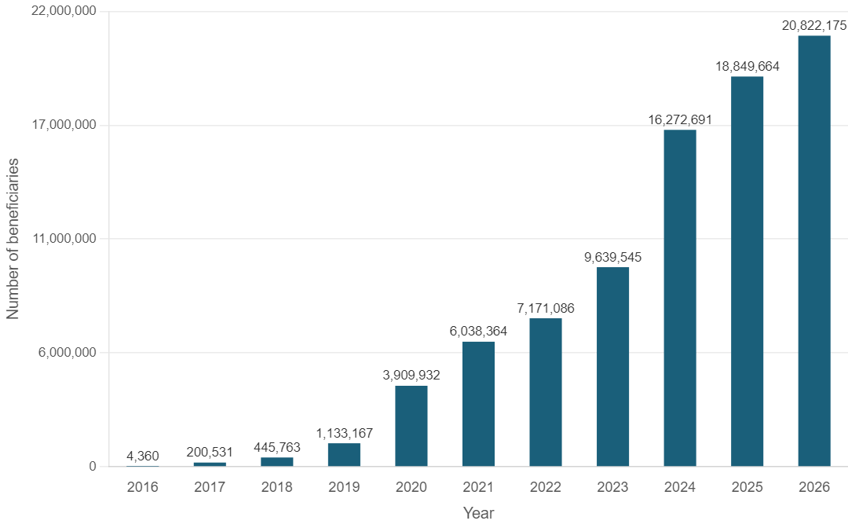
Figure 1: Number of people benefitting from TRANSFORM from 2016 – December 2025.

Summary supporting narrative for the overall score in this review
This year’s Annual Review scores an A+ in recognition of the achievements set out in this review. The headline result is that the programme met or exceeded all of the Logframe targets in areas of high priority to FCDO, with continued sound management and strong value for money. The programme operates efficiently and is well-managed.
Box 1: EcoBrixs - Improving livelihoods through waste removal in Uganda
EcoBrixs was founded in Masaka, Uganda in 2017 in response to a lack of waste management systems in the country, as well as high levels of unemployment. They believe in creating a waste-free world where everyone is given the opportunity to live and work in a safe and healthy environment, and in so doing, help to create resilient cities.
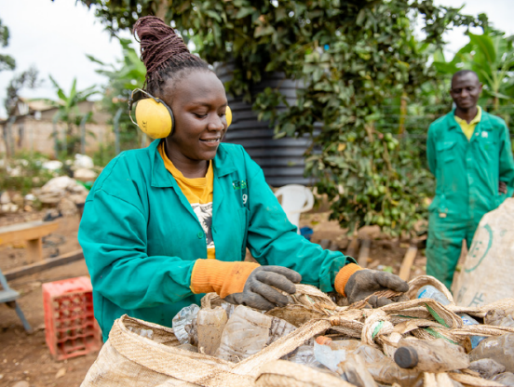
EcoBrixs pays waste collectors for plastic that is recycled into products such as bricks, lumber and furniture, which Eco Brix sells. The revenue is then used to purchase more plastic from the community, creating a sustainable circular model.
TRANSFORM funding enabled EcoBrixs to expand its recycling focus and impact by increasing its collection and processing of rigid and flexible plastics and employing vulnerable groups to improve livelihoods and reduce waste around Mbarara, Uganda.

Highlights from this reporting period
Reaching its ten-year anniversary this year, the programme’s achievements over the last year include:
- Regionalisation –TRANSFORM advanced its regionalisation strategy during this period, shifting grant decision-making from global to regional panels to strengthen contextual relevance and local ownership. Regional panels in India and Bangladesh reviewed 151 applications and selected five grantees- Animeta Agritech,Terra Ecopreneurs, Green Worms Waste Management, Royal Bengal Greentech, and OmniStrateG -reflecting strong alignment with local needs and market opportunities. With regional selection panels completed by April 2025, TRANSFORM has found that the regional grants have reached 2.37 million people and created 695 jobs with notable concentration in the Waste Free World, for example the EcoBrix project (Box 1), and Protect & Regenerate Nature pillars-together accounting for 91% of beneficiaries reached this period.

- Outsourcing Programme Operations: In 2024–25, TRANSFORM underwent a significant operational shift by outsourcing of core operations to Resonance, aimed at strengthening scalability, neutrality, and long-term efficiency. This transition has now been in place for one year and has yielded early insights into how externalised operations can efficiently support a partnership of TRANSFORM’s breadth and complexity.

Box 2: Green Bean Manufacturing: Manufacturing turmeric processing machinery project selected during the East Africa selection panel in 2024
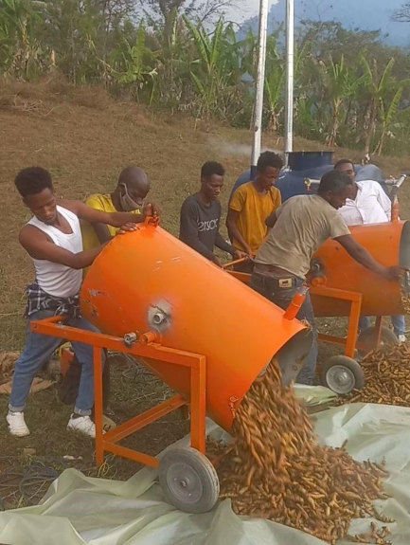
The Green Field Turmeric Value Chain Project was launched to address longstanding processing challenges faced by smallholder turmeric farmers in Ethiopia. Traditional boiling, drying, and polishing methods produced inconsistent quality, reduced market prices, and limited access to premium buyers. Through the TRANSFORM grant, Green Bean aimed to modernise this system by manufacturing and deploying advanced boilers, slicers, and polishers, while also strengthening farmer livelihoods, promoting sustainable fuel use, and building foundational governance systems for long-term operational maturity.

- Communicating success of the TRANSFORM model: In the reporting period, communications outputs continued to be shaped and driven by TRANSFORM’s regionalisation approach. Emphasis was put on showcasing local enterprises and impact through human-led storytelling, regionally led announcements, as well as speaking opportunities. Celebrated in late 2025, TRANSFORM’s 10-year anniversary was a flagship moment, generating over 240 pieces of media pieces in 2025 alone and strong media engagement both locally and globally, illustrating the success of the public-private partnership model and locally driven innovations. Local media engagement and enterprise spotlights drove a 72% increase in total published assets, from the year before and TRANSFORM’s visibility was boosted by attending major events in key regions.

- From evidence to impact – a sharpened research strategy for scaling change: TRANSFORM launched a new research strategy to focus on generating actionable insights that help social entrepreneurs build and scale impactful, market-based solutions for low-income consumers. The two core pillars are:-
- Refill entrepreneurship: In Autumn 2025, TRANSFORM commissioned a new research project with Enviu exploring how entrepreneurs can successfully develop and scale refill solutions in low-income communities in the Global South. The research will examine practical challenges such as partnership building, supply chain redesign, regulatory compliance and technology choices, with the aim of translating insights into concrete guidance for entrepreneurs and policy makers.
- Corporate value chain integration: TRANSFORM also commissioned new research on the integration of small and medium enterprises into global value chains through corporate partnerships. The project is led by the London School of Economics (LSE) through the International Growth Centre supported by FCDO and explores how collaborations with large corporates can enable social enterprises to overcome barriers to scale, access new markets and strengthen competitiveness.
Together, these two new research projects demonstrate TRANSFORM’s evolving approach to evidence generation: combining academic rigour with a strong emphasis on practical relevance.

- TRANSFORM deepened its capacity for programmatic and enterprise impact on social inclusion and environmental sustainability through the GEDSI work and the Life-Cycle Analysis (LCA).
- Strengthening Gender Equity Disability and Social Inclusion (GEDSI) – Key Initiatives and Progress in 2025: The programme significantly strengthened internal capacity on gender and inclusion through a comprehensive five-module training series delivered by Palladium GEDSI experts. Nineteen TRANSFORM team members participated live.
Alongside this strengthened capacity, TRANSFORM launched tailored technical assistance for five enterprises supported by preliminary gender and disability inclusion assessments:
- Animeta (Improving Livelihoods, India)
- Appcyclers (Waste Free World, Ghana)
- EcoBrixs (Waste Free World, Uganda)
- Green Worms (Waste Free World, India)
- Terra Ecopreneurs (Improving Livelihoods, India)

Early engagement identified concrete, achievable entry points such as improving incentive schemes for women workers, expanding women’s leadership opportunities, supporting employer enabled childcare, and strengthening participation in producer organisations.

- The Life Cycle Analysis (LCA) attempted to capture climate insight from a selected number of TRANSFORM enterprises (such as Smartfill Box 3). Partnering with Sphera, the programme delivered LCA guidance and analysis for 10 TRANSFORM enterprises, supported by structured interviews, baseline data collection, and workshops designed to build enterprise understanding and readiness.

Box 3: Smartfill - EcoUplift: Low-income Communities Leading Global Change
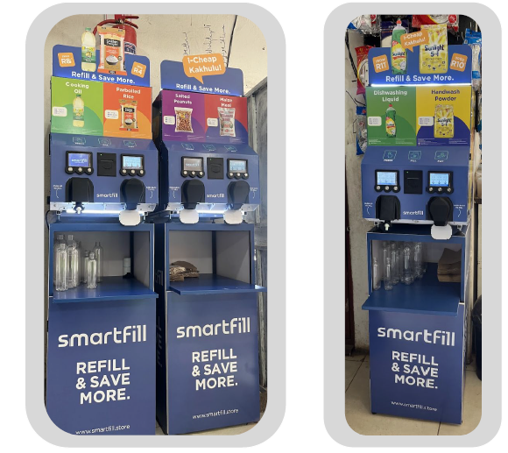
Smartfill is transforming access to affordable essentials in low-income communities across South Africa and Zambia by replacing single-use plastics with smart refill dispensers placed directly in township spaza shops. Through support from TRANSFORM, Smartfill deployed its V10 Internet of Things-enabled dispensers in Tembisa, enabling customers to purchase- trusted staples - such as rice, maize meal, dishwashing liquid, and fabric softener - in any quantity they can afford, while eliminating plastic packaging at the source. The model immediately demonstrated strong traction: within the learning pilot alone, 3,722 transactions were recorded, dispensing 1,016.5 kg of product, saving 39.8 kg of plastic and 238.8 kg CO₂ for just three stores.
By 2025, Smartfill expanded to five operational stores in Tembisa, supported by trained brand ambassadors who drive community awareness and assist first time users. Over 53% of surveyed shoppers became repeat refill users, many refilling weekly or even daily, demonstrating rapid behaviour adoption once price savings and ease of use were understood. Experiments such as the “bring-a-friend” referral incentive proved effective - 100% of simple R2reward cards were returned, showing how social advocacy accelerates uptake in closeknit communities
Smartfill is positioned to scale toward its ambition of 50,000 package-less sales and 200,000 consumers reached, providing a replicable, high impact model for reducing plastic waste across the Global South.

Major lessons and recommendations for the year ahead

There are four main themes of lessons and recommendations: 1) Successful Closure and Programme Legacy; 2) New Operating Model; 3) Global Uncertainty and Scaling; and 4) Deepening Capacity for Impact.

- Ensuring Successful Closure and Programme Legacy
Lessons learnt
- Strong systems, clear processes, and inclusive capacity-building are essential for responsible programme closure and enduring legacy: As the programme winds down, TRANSFORM is supporting grantees until their projects end and ensuring all projects have been successfully closed by the end of September 2026. In support of this goal, we have learned that tracking project closures across the portfolio is critical to ensure projects do not slip past the September deadline. New tools are helping with this, including:
  - Risk tracking.
  - Deliverable reviews.
  - Regular touchpoints.
Key recommendations
Responding to these lessons and the need for a responsible close of the TRANSFORM programme, it is critical that all stakeholders have what they need once the programme is closed. To this end, we recommend:
- Clear communications to all stakeholders:
  - A grantees closure package should be sent to each enterprise with a project completion letter capturing the goal of the project, funds received, and if possible, a quote from a regional stakeholder supporting the programme and, if possible, the specific enterprise.
  - Partners should be sent the programme branding package including the transfer of branding and assets, a branding licensing letter from Unilever authorising its use and the agreed upon guidelines for the future use of the TRANSFORM brand.
  - Regional stakeholders should be sent communications celebrating successes and thanking them for their part in programme achievements.
- As TRANSFORM concludes, research publications and practitioner-focused outputs should be housed on EY and FCDO GRTD websites.
- Position TRANSFORM visibly in global fora in 2026 to reinforce its external legacy. This should be the focus of the 2026 communications plan that includes celebration events and the sharing of programme learnings.
- Capture and share learnings on how impact enterprises can prepare to partner with corporates to support business integration in the future. This includes the Programme Playbook currently being developed.

- New Operating Model – Outsourcing Programme Operations
Strong programme operations should remain a priority as the programme ends.

Key recommendations
- Strengthen MEL-Communications-Operations integration via regular check-ins to ensure alignment in grantee engagement and project updates and improve logframe target tracking.
- Ensure completeness of historical programme knowledge management.
- Streamline the outreach and request from the programme to grantees.
- Complete effective closure of projects over 2026 ensuring projects are completed on time.
- Build a Programme Closure Project Plan to ensure clarity on key workstream deliverables, timelines and ownership as the programme is closed in 2026.

- Global Uncertainty impact on Scaling
Lesson learned
- Across the globe, there has been a change in the type of funding available to support enterprises in scaling their businesses. The TRANSFORM programme has responded to this trend with targeted support through the Scale Pilot to help four selected enterprises (Alner, WeCyclers, Drinkwell, and Reeddi) raise debt or equity. Grants totalling £900,000 were awarded last reporting period.
Key recommendations
These challenges are difficult to influence, but there are things that can be done to make an impact:
- Support to the TRANSFORM portfolio on raising non-grant funding: a Scale Accelerator programme has been commissioned with a Social Investment Consultancy based on learnings from the Scale Pilot. This research will facilitate investor readiness for 20 TRANSFORM entrepreneurs and facilitate matchmaking between investors and the cohort.
- Continued support to grantees’ ability to scale: As a programme focused on scaling inclusive businesses, organisational and business model support for grantees has been a critical component to the success of TRANSFORM. The programme should maximise support from EY, Unilever and TRANSFORM.

- Deepening TRANSFORM’s capacity for impact on social inclusion and environmental sustainability.
TRANSFORM has invested in the strengthening of the programme’s GEDSI capabilities through practical, role-based staff training, which led to key insights and lessons highlighted below.

Lessons learnt
- GEDSI:
  - Targeted, role-relevant GEDSI capacity building for programme staff can be very effective at embedding inclusion more systematically into programmes.
  - The delivery of a structured set of practical GEDSI training modules strengthened staff understanding of gender inclusion and increased confidence to engage partner enterprises on inclusion-related topics.
  - Feedback indicates that grounding training in real programme decisions helped staff translate inclusion principles into day-to-day practice.
- Life Cycle Analysis:
  - Enterprises value LCAs most when they directly support fundraising, carbon credit applications, and partnership development. LCA outputs should be accompanied by enterprise specific action plans to strengthen operational relevance.
  - Methodologically, the assessments drew on aggregated datasets, which created limitations in granularity and comparability across enterprises. Future LCAs would benefit from more consistent data collection frameworks to improve cross enterprise synthesis.
Key recommendations
- Finalise LCA review research to draw insights and learnings from process and enterprise experiences.

B: THEORY OF CHANGE AND PROGRESS TOWARDS OUTCOMES

Summarise the programme’s theory of change, including any changes to outcome and impact indicators from the original business case.

The overall goal of the TRANSFORM programme is to test, refine and scale business models that deliver low-income households’ needs sustainably and protect the environment (IMPACT). This is measured by the number of people impacted by TRANSFORM-supported businesses. The programme is implemented through two mutually reinforcing workstreams: business model support and research.

TRANSFORM’s impact statement is supported by three OUTCOMES which TRANSFORM directly contributes to:

- TRANSFORM-supported businesses reach scale, measured by (i) the total value of additional capital raised by TRANSFORM-funded enterprises; (ii) the number of business-models that scale beyond being dependent on grant funding.

- TRANSFORM partnerships and businesses are replicated by other stakeholders, measured by “significant activity”, such as programmatic investment, policy recommendation or changes in strategic intent.

- TRANSFORM’s learnings and evidence is widely disseminated and influential, measured by the number of citations and references to TRANSFORM in reputable reports and articles.

There are four OUTPUTS which are fully attributable to the programme:

- Business models are tested and strengthened, allowing enterprises to transition towards scale, measured by (i) the number of individual projects contracted; (ii) the number of projects which have an EY-approved business plan to achieve financial viability; (iii) the number of businesses that have progressed towards scale; and (iv) the total value of cash and in-kind contributions leveraged by TRANSFORM.
- Partnerships are formed and actively engaged, measured by the number of partnerships facilitated by the TRANSFORM team.
- Generation of high-quality research and evidence in support of the SDGs, measured by (i) the number of enterprise-level project learnings and insight reports generated; (ii) the number of insights papers produced by the programme; (iii) number of external research reports; and (iv) the number of externally commissioned academic journal articles.
- Effective dissemination of published research, evidence and partnership-model learnings, measured by (i) the published assets, (ii) conference presentations; and (iii) the number of downloads of reports from the TRANSFORM webpage.
There were no changes to the Theory of Change during the last reporting year.

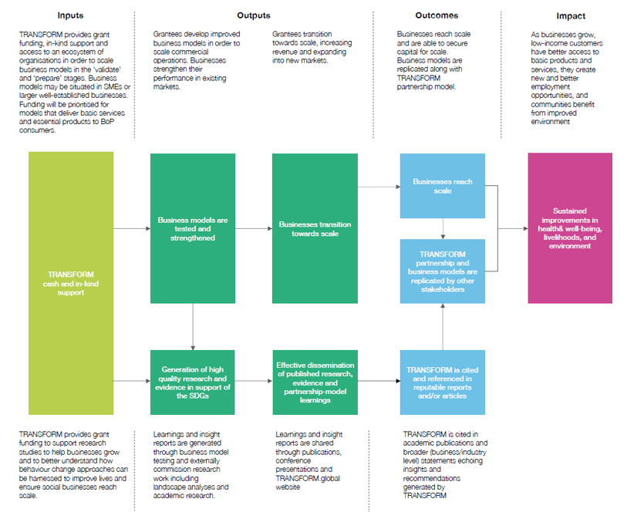
Figure 2: TRANSFORM Theory of Change.

Describe where the programme is on/off track to contribute to the expected outcomes and impact. What action is planned in the year ahead?

Overall, the programme performed well in a challenging environment. TRANSFORM has exceeded its impact indicator target, with a significant number of people positively impacted by TRANSFORM's enterprises and wider impact.

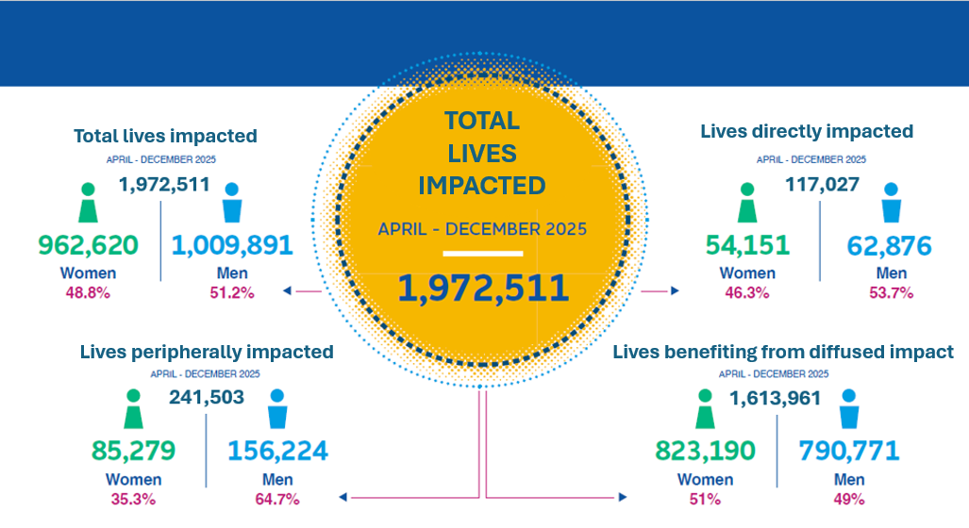
Figure 3: Number lives impacted by gender in 2025.

The programme exceeded its overall impact target of 19.99 million, having benefitted a total of 20.8 million people. This includes an additional 1,972,511 in this reporting period, with 117,027 directly impacted and 1,855,484 indirectly impacted through the work of the enterprises. Of the total beneficiaries, 49% were women and 51% were men; for direct beneficiaries the gender split was 46% female and 54% male. During the last reporting period (April 2025 – December 2025) the greatest progress has been made by the following five enterprises: African Reclaimers (South Africa): 802,537; AppCyclers (Ghana): 356,947; Scrapays (Nigeria): 267,948; Animeta (India): 151,324; and Chanja Datti (Nigeria): 143,460.

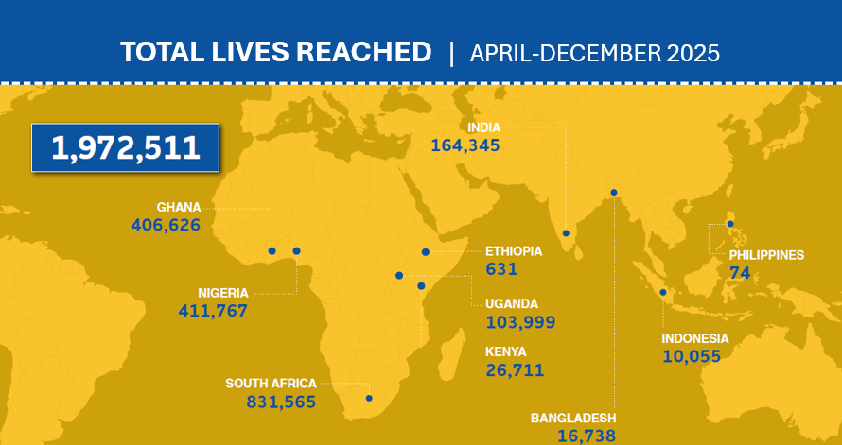
Figure 4: Number lives impacted by geography in 2025.
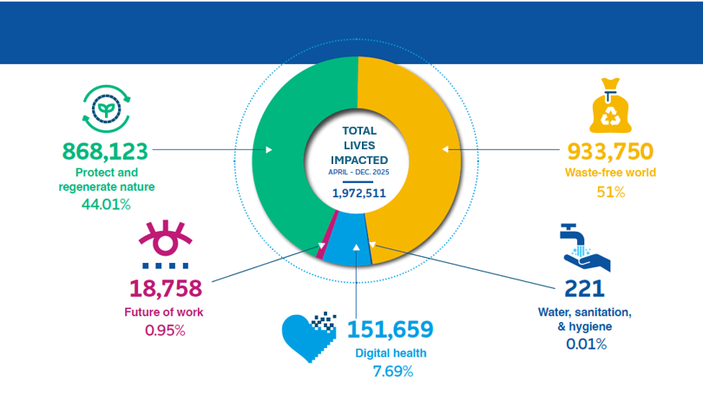
Figure 5: Number lives impacted by thematic sector in 2025.

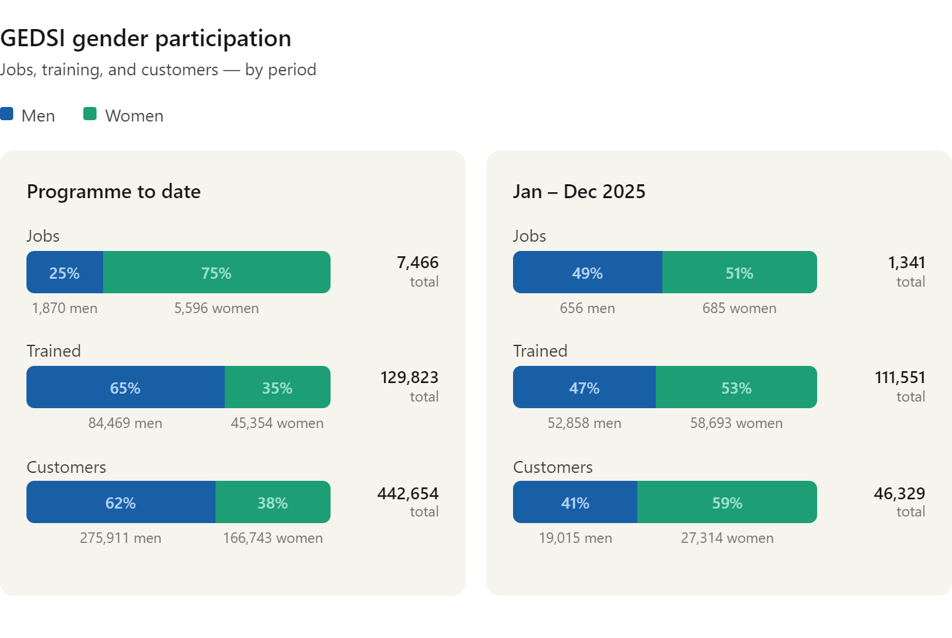
Figure 6: Impact by gender across jobs, training, and customers.

Outcome Indicator 1 - Number of business models funded by TRANSFORM that are ready for scale
This indicator was exceeded (target of two) with three new enterprises joining the list, bringing the cumulative total for this indicator to 18: Ecobora (Kenya), Coast4C (Indonesia), and PT Solusi Sirkular (Alner, Indonesia).
- Ecobora has transitioned from operating primarily as a charitable organisation to registering as a business, which demonstrates its growth over the TRANSFORM grant period.
- Coast4C has raised a total of £639,929.6 in this reporting period and has also raised its profile, having been a Finalist of the Earthshot Prize and establishing the business line that the TRANSFORM pilot supported.
- Alner received both a TRANSFORM and a Scale Pilot grant and has now raised a total of £342,029 from the additional support provided through the scale pilot grant.
- Coast4C and Alner both raised funds. However, these enterprises also established revenue streams through the support of the TRANSFORM grant, for which they are now raising funding from other investors and donors.
Outcome Indicator 2 - Total value of additional capital raised by TRANSFORM-funded enterprises
This indicator was exceeded with a total of £4,782,442 raised (target £1 million), in the reporting period (£1,427,766 in grant funding and £3,354,676 in private capital). The top three countries from which enterprises have raised funds are: Nigeria (£1,529,314), India (£1,130,753) and Philippines (£639,930). Additionally, we note the success of the Scale Pilot, with the highest amount of private capital raised by a Nigerian enterprise: Wecyclers (£1,053,751.68). Saltech (India) raised the highest amount of grant capital (£532,540.54).

Outcome Indicator 3 - Number of times TRANSFORM partnership model and business models are replicated by other influential stakeholders and/or influence policy and practice – This indicator was met with a total for this indicator remaining at 15 partnerships formed. Knowing that we were entering a year with a challenging environment for partnerships like TRANSFORM, the target for this indicator was set to zero and no new partnerships were formed in the reporting period.

Outcome indicator 4 - Number of citations and references to TRANSFORM by others in reputable reports, articles, or endorsements – This indicator was exceeded, with 35 new citations of TRANSFORM’s peer-reviewed academic research papers as recorded by Dimensions during this reporting period. This brings the total number of citations to 128 (target 114). The portfolio of published research continues to be referenced by scholars, underscoring its ongoing significance within the academic community.

Justify whether the programme should continue, based on its own merits and in the context of the wider portfolio

The TRANSFORM programme should continue until its planned end date of December 2026, as it has demonstrated strong performance and strategic alignment with FCDO’s priorities. It met or exceeded all impact-level and outcome-level targets and met all but 2 of its output milestone indicators, underscoring its effectiveness and value for money. The programme aligns with FCDO’s priorities to end extreme poverty, private sector development, making markets work for the poor, and locally led development by strengthening alignment with the private sector, encouraging investments to stimulate economic growth, empowering women and girls, and tackling global challenges, including climate change and the environment.

Going into the final year of the programme, TRANSFORM has proven to be a programme that repeatedly delivers results against logframe targets and objectives. The decision not to extend the programme was not due to programme performance, but due to funding constraints. The remainder of the programme will be focused on the continued support to scale TRANSFORM grantees, the successful wrapping up of our engagement with regional stakeholders, sharing TRANSFORM learnings and celebrating its decade of impact, and the solidification of the TRANSFORM legacy as a successful programme and partnership model.

C. DETAILED OUTPUT SCORING

TRANSFORM
Output TRANSFORM | Business models tested, strengthened and transition towards scale
Output number: |  | 1 | Output Score: | A+
Impact weighting (%): |  | 40% | Weighting revised since last AR? | No

Indicator(s) | Milestone(s) for this review | Progress
1.1 Number of individual business model projects contracted by TRANSFORM | 119 | Exceeded: 120 (10 in the reporting period)
1.3 Number of TRANSFORM-funded business models that, at grant completion, have an EY-reviewed business plan to achieve future financial viability | 40 | Met: 40 (9 in the reporting period)
1.4 Number of TRANSFORM-funded business models that have progressed towards scale. | 62 | Exceeded: 63 (6 enterprises moved at least one scale for at least one of the three criteria in TRANSFORM’s scale assessment)
1.5 Total value of cash and in-kind contributions leveraged by TRANSFORM to the programme, to TRANSFORM projects, and to the Support Hub to deliver benefits for low-income populations in LMICs | £20.58m | Exceeded: £20.76 (£683,512 in the reporting period)

Briefly describe the output’s activities and provide supporting narrative for the score.

The programme was able to achieve 10 new and approved projects in the reporting period. This includes one project that was approved in the previous reporting period but was not contracted until this period, from the last East Africa Panel; four contracted from the India Panel; one contracted in Bangladesh; and three grantees absorbed from the replicated USAID programme CIRCLE which was cancelled in January 2025. A full list of all selected grantees can be found in Annex B.

EY completed three targeted projects during the reported period:
- Alner, on strengthening their end-market value proposition.
- Drinkwell, in developing a Managed IT Services (MIS) solution to help the organization run efficiently.
- Kuza, on crafting a strategic multi-year business plan for achieving investment readiness.
In addition, 6 enterprises Green Worms, Concept Loop, Animeta, Chanja Datti, Groove Tech and Ecobora, benefited from 6 months of dedicated 1:1 coaching from EY.

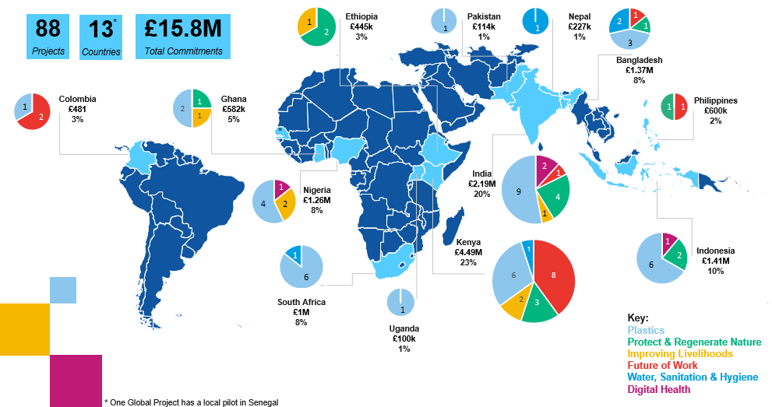
Figure 7: TRANSFORM 2 current approved portfolio (contracted, completed, live) by thematic pillars and geographies.

Describe any changes to this output during the past year, and any planned changes as a result of this review.

The 2024 decision to end the TRANSFORM Support Hub partnership is reflected this year in the discontinuation of the Output Indicator 1.2 (Number of enterprises that engage with the TRANSFORM Support Hub).

Progress on recommendations from the previous Annual Review (if completed), lessons learned this year and recommendations for the year ahead

The previous Annual Review recommended assessing the trade-offs of reducing grant sizes, particularly how smaller awards might limit value chain integration and enterprise scaling. With TRANSFORM now scheduled to close at the end of 2026, the Management Team redirected this recommendation toward research focused on founder locality. The locality research examines whether the level of local leadership among TRANSFORM funded enterprises has changed between globally selected and regionally selected cohorts in TRANSFORM 2. This work is underway and will be completed in the next reporting period.

TRANSFORM
Output TRANSFORM | Partnerships are formed and actively engaged
Output number: |  | 2 | Output Score: | A+
Impact weighting (%): |  | 15% | Weighting revised since last AR? | No

Indicator(s) | Milestone(s) for this review | Progress
2.1 Number of partnerships facilitated by the TRANSFORM team | 21 | Exceeded: 22 (3 in the reporting period)
Briefly describe the output’s activities and provide supporting narrative for the score.

This output captures TRANSFORM’s progress in forming new partnerships, which may include Additional Partner Joining Agreements, partnerships facilitated between grantees or corporates and grantees, corporate strategies amended. The milestone for output 2.1 captures partnerships where at least one TRANSFORM-funded grantee is involved.

Output 2.1 was met with three new partnerships facilitated through the TRANSFORM programme. TRANSFORM-funded grantees Alner and Taka Taka Ni Mali received awards through the FCDO Research Commissioning Centre (RCC) Impact Fund Pilots following an introduction. Ecobora was also awarded $25k through a partnership between ServiceNow, Acumen and EY after a referral from TRANSFORM.

Describe any changes to this output during the past year, and any planned changes as a result of this review.

The 2024 decision to end the TRANSFORM Support Hub partnership is reflected this year in the discontinuation of the Output Indicator 2.2 (Number of partnerships facilitated by TRANSFORM Support Hub for low-income populations in LMICs).

Progress on recommendations from the previous Annual Review (if completed), lessons learned this year and recommendations for the year ahead.

TRANSFORM has built on the success of the Scale Pilot, in which selected enterprises focused on raising debt or equity, to deploy recommendations from those projects: The Scale Accelerator, currently in implementation, will engage an investment adviser to provide tailored capital raise advisory to 20 high-impact enterprises across Africa and Asia, with a focus on tackling waste, protecting and regenerating nature, water, sanitation and hygiene, digital health, improving livelihoods and the future of work. The offering spans six areas: investment readiness, research, advisory, capital mobilization, management, and monitoring. Each is designed to meet the unique needs of the enterprises, enabling catalytic capital deployment. The Scale Accelerator will be completed in the next reporting period. It is recommended to continue the accelerations support in the year ahead, based on budget availability.

TRANSFORM
Output TRANSFORM | Generation of high-quality research and evidence in support of the SDGs
Output number: |  | 3 | Output Score: | A
Impact weighting (%): |  | 30% | Weighting revised since last AR? | No

Indicators | Milestones for this review | Progress
3.1 Number of enterprise-level project learnings and insight reports generated by business model testing | 79 | Nearly met: 76 (12 in the reporting period)
3.2 Number of insight papers produced by the programme | 39 | Met: 39 (9 published in the reporting period)
3.3 Number of external research reports | 4 | Met: 4 (1 in the reporting period)
3.4 Number of externally commissioned academic journal articles (submitted or published) | 6 | Met: 6 (3 submitted in this reporting period)

Briefly describe output activities and provide supporting narrative for the score.
This output captures TRANSFORM research and evidence generation activities, which is a central part of the programme’s Theory of Change. See Annex C for a full list of publications.

Grantees generated 12 project learning reports in this reporting period, which fell short of the 15 targeted. This is due to a few project level delays in implementation that will be successfully caught up in the final year of the programme.

During the reporting period one research project has completed. The project, led by Busara, tested behavioural and participatory prototypes to improve identity and dignity for sanitation workers in Sub-Saharan Africa. Busara published a report of the research in its Groundwork series and in November 2025 the team submitted an article to the Journal of Water, Sanitation and Hygiene for Development.
Following completion of the project, Busara convened a panel of sector experts to promote the results of the research project through the webinar Beyond Infrastructure: Rethinking Dignity and Identity in Sanitation Work. The session, chaired by Lisa Hawkes (TRANSFORM/Unilever), examined the behavioural, social, and policy factors influencing the experiences of sanitation workers and highlighted the need to embed dignity, recognition, and safety into sanitation systems. It emphasized that sanitation infrastructure alone is insufficient without addressing the lived realities of the people who operate and maintain these systems. Panellists included Doctor Christy Adeola Braham (WIEGO), Andrés Hueso, Senior Sanitation Policy Analyst, WaterAid, Rowan Harrity, Director, Public Health & Climate Change, Busara and Francis Kuria, Product Manager for TRANSFORM supported enterprise Fresh Life. The panel shared practical approaches for improving worker well-being, advancing equity, and strengthening public health outcomes across communities.
During the reporting period (April to December 2025) TRANSFORM published nine insight papers: one under the WASH theme, one under Digital Health, three under Waste Free World and three under Improving Livelihoods. One paper was also published in partnership with Global Solidarity Fund and shares insights learned by three enterprises supported by TRANSFORM in Colombia. Seven papers describe insights learned during individual enterprise projects and two papers share thematic insights learned by refill entrepreneurs supported by TRANSFORM (see Annex C for a full list).
In addition to the journal article submitted by Busara, two other journal articles were submitted during the reporting period (Annex C). Bopinc submitted an article on the drivers of adoption of reuse-on-the-go systems among low-income consumers in Kenya. This article is the output of the research project on consumer behaviour change that will complete in March 2026. The Johns Hopkins Centre for Communication Programmes also submitted an article (see Annex C below) on the role of WASH-focused community discussions to bridge the gap between service users and service providers. This article is the output of the TRANSFORM research project, led by Johns Hopkins and completed in 2024, on the role of social networks and motivators for spreading information about WASH behaviours and products among members of a community.
Describe any changes to this output during the past year, and any planned changes as a result of this review.

N/A

Progress on recommendations from the previous AR, lessons learned this year and recommendations for the year ahead.

Following last year’s recommendation, the research strategy was refreshed in collaboration between FCDO and Unilever. The new strategy sets two priorities. First, addressing critical knowledge gaps on how entrepreneurs can build and scale refill business models in low- and middle-income countries, supporting alternatives to single-use plastics. Second, how SMEs integrate into global value chains through partnerships with large corporations, identifying enabling conditions, benefits, and risks. Further details are provided in the highlights section at the beginning of this review.

The last Annual Review also recommended TRANSFORM strengthen its work to commission cross-grantee thematic reports as part of the new research strategy. The newly commissioned research projects on refill entrepreneurship and SME integration into global value chains will each deliver thematic reports in the next reporting period. Enviu will deliver the Scaling Refill Models Playbook in March 2026, and LSE will deliver its Evidence Review on SME Integration into Global Value Chains through Corporate Partnerships in July 2026. These legacy documents will be hosted on partner websites and disseminated in webinars and other events within budget.

TRANSFORM
Output TRANSFORM | Effective dissemination of published research, evidence and partnership-model learnings
Output number: |  | 4 | Output Score: | A
Impact weighting (%): |  | 15% | Weighting revised since last AR? | No

Indicator(s) | Milestone(s) for this review | Progress
4.1 Number of published assets from learnings and insights generated through business model testing, landscape analysis and applied research publications (open access) | 1,656 | Nearly met: 1,606 (850 in this reporting period – a 72% increase from last year’s target)
4.2 Number of conference presentations to and roundtables hosted with academic and non-academic audiences | 108 | Exceeded: 111 (12 in this reporting period, Annex D)
4.3 Number of downloads of TRANSFORM learning/insight reports from the TRANSFORM website | 8,147 | Exceeded: 8,170 (953 in this reporting period)

Briefly describe the output’s activities and provide supporting narrative for the score.
In the reporting period communications outputs continued to be shaped and driven by TRANSFORM’s regionalisation approach. Highlights include over 240 pieces of media pieces celebrating the programme’s 10-year anniversary in 2025 alone.

Five core regions/countries (Indonesia, Bangladesh, India, East Africa and Southern Africa) were engaged to deliver tailored press releases, social posts and impact infographics. At the regional level, the Indonesia press release generated substantial local coverage (245 pieces), including placements in reputable publications AP, The Jakarta Tribune, Indonesia Environment Watch and more. Globally, the launch achieved top tier cut through. Unilever (Rianne Buter) and EY (Gillian Hinde) produced a joint opinion piece which was placed in the World Economic Forum’s Agenda, in the run up to the World Economic Forum meeting in Davos.
Impact graphics created to mark TRANSFORM’s 10-year milestone

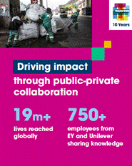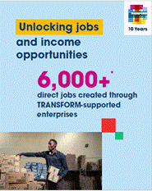

Local media engagement and enterprise spotlights drove a 72% increase in total published assets, from the year before

Beyond the celebration campaign, TRANSFORM’s work was profiled through local announcements and articles on programme learnings and enterprise impact – increasing from 495 last year to 850 in this reporting period. Examples include:
- Announcements of the cohorts selected through the West Africa and East Africa Challenges generated 296 pieces of coverage (West Africa coverage, Citizen Digital, and Business Capital).
- TRANSFORM announced Sonke’s first automated refill store – SKUBU – through a press release, which generated 254 pieces of coverage in outlets such as Business Beat 24, Caj News Africa and Packaging Europe. This enterprise has gone on to become viral on TikTok for its store – something that could have been aided by this widespread media coverage.
- Enterprises were also supported by TRANSFORM to do their own announcements, using the programme’s messaging. An example includes Smartfill’s new refill stations launch, where it was supported with TRANSFORM key messages for its interviews with Circular Online and Iono FM.

TRANSFORM’s visibility was boosted by attending major events in key regions - TRANSFORM exceeded KPIs on placements at conferences / events, amplifying insight dissemination and visibility for both the programme and enterprises.

- TRANSFORM’s impact was shared through online and in-person conferences such as GSPN, GSMA, AVPN and The Economist’s Sustainability Week Africa.
- In April, TRANSFORM hosted an interactive session at the Marmalade Festival to explore how global development organisations can meaningfully shift power to local leaders, enterprises and communities. The event was a huge success with over 540 sign-ups (room capacity limited to 100), and received positive feedback from attendees through the feedback forms.
- TRANSFORM also supported enterprises with profiling opportunities at events. For example, Gwiji attended the UK-Kenya event on combatting gender-based violence in Nairobi.

Challenges affecting delivery

Coordinating feedback and sign-off from multiple stakeholders, particularly securing timely approval for regional releases and consolidating up-to-date impact figures, delayed the launch of the 10-year milestone campaign from November to December 2025. Some regions were only able to launch their respective announcements in 2026, which will be included in the next reporting period. Output indicator 4.1 on publications would have been surpassed had these announcements gone ahead in the planned timeline.

Describe any changes to this output during the past year, and any planned changes as a result of this review.

In 2025, ambitious targets were set to reflect the success seen across media, events and website engagement over the previous years. Challenges associated with the launch of the new website due to an unexpected but necessary platform change, led to a significant decline in downloads, resulting in an agreed adjustment to the target in November 2025. This was approved in the month before the Annual Review end date as TRANSFORM had brought this date forward to allow for its planned closure.
- On the website - despite initial challenges following the launch, a targeted mix of tactics were put in place, including dedicated social posts, tailored copy for core partners’ internal channels, and Project Lead engagement, which enabled TRANSFORM to surpass the revised download target of 930.
- On published assets – as per the section above, this KPI was surpassed by mid-January when all of the local 10-year anniversary announcements had been published.

Looking ahead to 2026, ambitious targets for media outputs and speaker placements have been retained, while recognising the implications of the programme’s closure in September. The most significant planned change is the adoption of a more conservative website download target, with scope to revisit should there be improvements.

Progress on recommendations from the previous Annual Review (if completed), lessons learned this year and recommendations for the year ahead.

Good progress has been made against last year’s recommendation to strengthen relationships with regional stakeholders in support of global amplification of TRANSFORM’s mission and impact. As the programme approaches closure, a key priority for the year ahead is to further enable regional teams to act as advocates and spokespeople for TRANSFORM’s legacy. This should be complemented by deeper engagement with impact enterprises and their Project Leads, as they are key to coordinating enterprise participation. Impact enterprises have shown a strong willingness to engage with media and have compelling stories to tell, so opportunities to profile them should be prioritised.

It is recommended that TRANSFORM continues to prioritise video content that personalises its account and showcases the people behind the programme. To support efficient content creation more widely, early stakeholder buy-in should be secured through agreement on high-level outlines.

D: VALUE FOR MONEY

Key cost drivers and performance

The table below outlines the key cost drivers in relation to FCDO, EY and Unilever’s contribution to the TRANSFORM programme during the last reporting year. 88.5% of FCDO’s contribution was spent on grants to impact enterprises. Figures below cover the reporting period of April 2025 through December 2025.

Key cost breakdown | % total programme contribution | KEY cost drivers
Unilever’s in-kind contribution to the programme | 7%  (£302,141) | - The time needed for Project Lead oversight and support to grantees.  - Core team time to manage suppliers and contribute to governance meetings.  - Market value of specialist skills.
EY’s in-kind contribution to the programme | 27%  (£1,150,161) | - EY representation on TRANSFORM governance forums.  - Consulting projects with TRANSFORM enterprises.  - Other support to TRANSFORM enterprises.
Costs associated with third parties implementing business and research projects (Unilever and FCDO grants disbursed) | 52%  (£2,179,805.44) | - Geographic location and cost of living for staff.  - Effectiveness of the organisation and the level of bureaucracy involved in project delivery.  - Level of support provided by the programme based on organisation need.
Costs associated with contracting third-party specialist partners to support key elements of the programme (Palladium, Forster, Resonance, Moving Worlds) | 14%  £561,048.12 | - Choice of suppliers.  - Quality of work and value delivered.  - Day rates.

VfM performance compared to the original VfM proposition in the business case

The VfM proposition outlined in the Business Case identified two routes to achieve VfM through (i) delivering the most impact, and (ii) at the lowest cost. Overall, the VfM proposition in the Business Case holds. The following table demonstrates how TRANSFORM has achieved VfM during the last performance year.

Economy (input) | Portfolio  - All projects are assigned a Unilever Project Lead on the ground and are linked to Unilever’s relevant capabilities to minimise additional project costs. As of December 2025, £224,601 of Unilever’s in-kind resource has been delivered to the programme using rates aligned to Unilever’s competitive salary benchmarking.  - Local selection panels minimised logistic and travel costs and engaged local staff.  Suppliers  - A competitive tender process is undertaken for all significant suppliers, including new operations partner Resonance which consolidated roles and increased the efficiency.  - Day rates are reviewed during the proposal stage in line with FCDO’s commercial best practice.  - Suppliers carry out remote trainings and calls where possible to reduce travel costs.
Efficiency  (input to output) | Portfolio  - Bespoke business support has been provided to all portfolio projects to maximise impact.  - High-quality monitoring data is collected to inform grantees’ work, with funding disbursement dependent on milestone achievement.  Suppliers  - The programme is working with suppliers who are familiar with the programme to reduce onboarding time, whilst new operations supplier Resonance received a comprehensive and cost-effective onboarding process.  - Supplier performance is regularly reviewed to ensure downstream partners deliver maximum value for TRANSFORM.
Effectiveness (Output to Outcome) | - Several projects are maturing and reaching scale, which means the number of beneficiaries has increased compared to cash disbursed.  - Dedicated comms resource to ensure content and research outputs actively promoted on different communications channels.
Equity | - All projects aim to provide low-income populations with sustainable and affordable access to life-enhancing services. This includes projects that focus on the underserved, including women, rural populations, and low-income consumers in general.  - There has been a particular focus on gender inclusion in this reporting period, with the implementation of the gender strategy for TRANSFORM developed in the previous year, led by a gender expert with close engagement of Unilever, FCDO and EY.  - In this reporting period we continued engagement with FCDO’s Disability Inclusion Helpdesk to explore how The TRANSFORM programme can become more disability inclusive. This work will be progressed in the next year.

Assessment of whether the programme continues to represent value for money

The TRANSFORM programme provides value for money and continues to meet and exceed most Logframe targets. The programme values efficient partnership with MEL, Communications and new Operations suppliers, and economical engagement of stakeholders at the regional level including for regional selection panels and Project Leads who engage with grantees on a regular basis. TRANSFORM will continue to promote equity and effectiveness as we seek to build a lasting legacy for the programme in the final year.

E: RISK

Overview of risk management
As TRANSFORM approaches its planned conclusion in December, the overall risk rating remains moderate. The programme’s innovative approach across diverse areas and contexts continues to carry an inherent level of risk, which remains within FCDO and Research and Analysis Directorate’s risk appetite. The main risks identified for the final phase are:
- Financial and Fiduciary (Moderate): The risk of financial misappropriation by third parties persists. Due diligence is conducted for each organisation prior to contracting, including assessments of financial management, governance, safeguarding, whistleblowing, fiduciary controls, and reporting mechanisms. For higher-risk organisations, in-person due diligence has been introduced to strengthen oversight and ensure robust financial accountability through to programme closure. In addition, governance of project closure is being closely managed to ensure all financial and fiduciary requirements are completed within the appropriate timeframes, and that all payments are made before the programme ends.
- Safeguarding (Moderate): Safeguarding remains central to TRANSFORM’s due diligence process. FCDO has worked closely with Unilever and Resonance to align safeguarding approaches and clarify downstream partner responsibilities. TRANSFORM held a Safeguarding working session that aligned FCDO Safeguarding priorities with Unilever’s Human Rights expectations, and clarified implications for TRANSFORM particularly regarding grant due diligence, contracting, and onboarding. As the programme concludes, actions include extending safeguarding training to enterprises and finalising a safeguarding process map/SOP to ensure continued compliance and legacy beyond the programme’s end.
- Strategy and Context (Moderate): Shifts in external contexts and evolving priorities among founding partners may affect the programme’s final phase and the sustainability of outcomes post-closure. To mitigate this, partners have committed to maintaining open, proactive communication, including regular Management Team meetings to align on strategic direction and resource planning for the programme’s conclusion.
The programme team continues to monitor risks and implement mitigating actions. Key risks are discussed at Management Team meetings, and collaboration between FCDO, Unilever, and EY remains constructive, ensuring all perspectives are considered as the programme moves towards closure.

F: PROGRAMME MANAGEMENT: DELIVERY, COMMERCIAL & FINANCIAL PERFORMANCE

Summarise the performance of partners and FCDO, notably on commercial and financial issues.

Programme Management, with Resonance as the operations partner, has strengthened transparency through weekly check-ins, structured escalation routes, and implemented proactive engagement with Asia and Africa regions to ensure continuity during staff transitions. The introduction of a full-time programme manager and governance oversight functions has improved process stewardship across contracting, audit preparation, and portfolio management. The development of a project-level risk register capturing risks and mitigation action identified through on-ground due-diligence investigations has further strengthened programme governance.

The current phase of the programme has an approved FCDO budget of up to £20 million, of which £14.66 million has been disbursed to date.

TRANSFORM’s total budget for the last financial year was successfully allocated in line with the programme priorities, with a total combined programme spend from FCDO, Unilever and EY of £4.2 million cash and in-kind. The partner breakdown can be found in the table below for the reporting period of April 2025 to December 2025:

TRANSFORM 2 FY25-26 (Partial: 1st April 2025 – 31st December 2025)
Partner | Disbursed Cash | In-Kind Contribution
FCDO | £2,074,925 | £0
Unilever | £675,243 | £302,141
EY | £0 | £1,150,161
TOTAL | £2,750,168 | £1,452,303
TRANSFORM 2 Programme Spend: £4,202,471

The financial performance and operations of the programme is now managed by Resonance and continues to be tracked by FCDO and Unilever staff which ensured the FCDO’s budget for the last financial year was achieved as planned, with an expected annual budget variance of 0%.

TRANSFORM is on track to exceed its annual International Climate Finance (ICF) target of spending 30-35% of FCDO’s budget on ICF, but final figures are not available during the revised reporting period.

G: MONITORING, EVIDENCE AND LEARNING

Monitoring and Evaluation
The monitoring and evaluation activities for the last financial year have continued to engage closely with all TRANSFORM-supported enterprises to gather data on reach and impact and support enterprises with data and insights to help them become investor-ready. Numerous enterprises have reported continuing to use the monitoring tools that the MEL team developed for them over the duration of the TRANSFORM grant, demonstrating the value derived from the MEL support provided with the grant.

Evidence
The programme has continued to use the same MEL process and tools that the MEL partner has developed and refined since 2021, which includes gender disaggregated data as well as geographical and thematic data that the programme partners have continued to use in their decision-making processes (management team and executive committee meetings). No evaluations were conducted in the last financial year.

Learning
The MEL processes have continued to feed into quarterly decision-making meetings. Additionally, the MEL team also developed storyboards for over ten enterprises, to demonstrate the results being delivered through the TRANSFORM grant. These storyboards were also used to support enterprises to better articulate their impacts, supporting both programmatic and enterprise-level learning. Finally, the MEL team will support the TRANSFORM programme to complete the Project Completion Report (PCR) in 2026. There are no specific learning aims currently set out for the next financial year.

Date of last narrative financial report | May 2025 | Date of last audited annual statement | September 2025

Annexes
Annex A: Update on recommendations from the last Annual Review
Annex B: TRANSFORM grantees selected in the last report year
Annex C: Research publications
Annex D: List of conference presentations given and roundtables hosted
Annex E: Top 10 media pieces

Annex A: Update on recommendations from the last Annual Review

Recommendations | Progress update
GEDSI:  Given limited internal capacity within the TRANSFORM team to provide specialist GEDSI support, it is recommended to hire external expertise (e.g. EY or Palladium) to support the implementation of key gender recommendations summarised below [see 2025 Annual Review]. It is also recommended that the selected experts apply a strong disability inclusion lens throughout their work, ensuring that the implementation of gender recommendations is inclusive of the needs and rights of persons with disabilities. | Palladium was engaged in Autumn 2025 to support implementation of the GEDSI recommendations. Given that since the previous Annual Review in April 2025 FCDO has decided not to renew the TRANSFORM programme, implementation has prioritised select recommendations among those indicated at the time as immediate and essential but budget dependant. Specifically, Palladium was asked to support two work streams, with an intersectional lens focusing on both gender and disability:  - Work Stream 1: Enterprise-facing GEDSI support  - Work Stream 2: Programme-facing GEDSI support  Work Stream 1 – includes two elements, addressing the previous Annual Review recommendations:  - Disability inclusion support that is available to all enterprises, involving two workshops delivered in partnership with the Disability Inclusion Helpdesk, run by Social Development Direct, and inputs from Palladium Inclusion Specialist. The first workshop was delivered in December 2025, and the second is planned for January 2026.  - Bespoke technical support and coaching for five selected enterprises*, which began in December 2025 and will continue until the end of March 2026. During the reporting period, the Inclusion Specialist completed a desk-based inclusion assessment based on each company’s proposal, grant agreement, and where applicable milestones and MEL data. Findings were discussed with each Project Lead, and kick-off meetings conducted with each enterprise, identifying possible areas of focus (see highlights section).  Work Stream 2 – options have been identified in December 2025 and implementation planned for January to March 2026, focusing on select recommendations made in the last AR:  - Strengthening approach to capturing inclusive results: This will use data from, and engagement with, select enterprises receiving bespoke support, and as feasible guide an equivalent approach to be adopted at the programme level (and at least with live enterprises) to better communicate inclusive results within TRANSFORM completion report.  - Addressing GEDSI-related risks: This recommendation made in the previous Annual Review referred to the priorities identified in 2024 during the first phase of GEDSI support. Programme-facing support will focus on those risks that can be feasibly addressed within the remaining nine months of the programme. In parallel, it aims to document and acknowledge any residual GEDSI-related risks (if applicable) that cannot be fully addressed within this period, and to outline possible indicative mitigation measures. This should also provide useful input to the programme’s completion report and generate learning to inform the design and risk management of future, similar programming.  * Five enterprises, considered to be able to benefit the most from bespoke, 1 to 1 support:  - Animeta, India (Improve Livelihoods)  - Appcyclers, Ghana (Waste Free World)  - Eco Brixs, Uganda (Waste Free World)  - Green Worms, India (Waste Free World)  - Terra Ecopreneurs, India (Improve Livelihoods)
Strategic alignment and future focus:  - The TRANSFORM Management Team should explore new thematic areas or operational models and present options to the Executive Committee in July 2025. Two pathways are under consideration:  - Thematic expansion  - Deepening focus on existing priorities (e.g. plastics)  - TRANSFORM should explore both its operating model - such as the level of enterprise scale at which it works - and its ways of working, including cross-cutting approaches like gender-lens investing.  - Planning for FY25-26 should follow agreement on a potential next phase of the partnership, especially given budget uncertainties. Insights from an ongoing “what’s worked/ hasn’t worked” review will inform this process. | With the decision to close TRANSFORM at the end of 2026, the need to reevaluate the programme’s strategic alignment and focus is no longer relevant. The Management Team will instead focus on a successful close of the programme and align on how to ensure the programme’s legacy.
Research:  Unilever, EY, and FCDO will refresh the research strategy, with a stronger focus on practitioner-oriented and cross-grantee thematic reports/ outputs, alongside a few strategic academic publications. TRANSFORM will continue documenting project-level insights and will commission at least two thematic reports next year.  Planned research based on learnings from the grantee portfolio includes:  - Success factors for refill models  - Drivers of scale across the portfolio  - Impact of life cycle analysis (already commissioned)  We’ll seek engagement from FCDO (and if desired UL/ EY) experts to inform this workstream. | The research strategy was refreshed in collaboration with FCDO and Unilever colleagues, and focused on two goals:  - Filling knowledge gaps on entrepreneurship for refill business models  - Using TRANSFORM case studies to explore how SMEs can integrate into global value chains through corporate partnerships.  TRANSFORM will continue to deliver high-quality peer reviewed academic research. However, it will also bridge the gap between academic research and practical application, ensuring that research findings are also translated into formats that can directly benefit practitioners in their respective fields.  In the reporting period two new research projects were started, with work to be completed by end of March 2026:  - Entrepreneurship in refill-based business models for low-income communities in the Global South, led by Enviu.  - Evidence Review: SME integration into global value chains through corporate partnerships, led by London School of Economics (LSE) through the International Growth Centre.  In 2026 each project will deliver a peer reviewed academic research publication and a thematic report. LSE will publish a thematic a publication aimed at corporate decision makers and policy makers. Enviu will publish a thematic playbook on scaling refill business models.
Regional selection:  As part of future programme planning, TRANSFORM should assess the trade-offs of reducing grant sizes - particularly how smaller ticket sizes affect value chain integration and the ability to support enterprises at scale. | With the decision to close TRANSFORM at the end of the 2026 calendar year, the Management Team decided to pivot this recommendation to a smaller locality research task, focusing most of the budget and attention on activities with direct impact to grantees.  The locality research seeks to determine whether local leaderships of TRANSFORM-funded enterprises has increased, decreased, or remained consistent between global and regional selection panels in TRANSFORM 2. This task is ongoing and will be completed in the next reporting period.
Logframe / Theory of Change:  It is recommended to formally review the Logframe and Theory of Change in the new reporting year to ensure that the logic of the ToC and the indicators of the Logframe are still holding up against implementation experience. | With the decision to close TRANSFORM at the end of the 2026 calendar year, the Management Team decided not to make any revisions to the Logframe or Theory of Change this close to the end of the programme.

Annex B: TRANSFORM grantees selected in the last report year

Organisation | Country | TRANSFORM pillar | Project summary
Kuza Biashara Ltd | Kenya | Protect & Regenerate Nature | Kuza is building Africa’s first phygital (physical + digital) network that connects agribusinesses, processors, financial institutions, input providers, transporters, ag-techs and others into coordinated, efficient value chains. Kuza's purpose is to make agriculture in Africa more efficient, investable, and market-driven by addressing fragmentation, building trust, and enabling businesses to scale. Kuza's phygital network model combines on-the-ground presence with digital infrastructure to build transparent, collaborative, demand-driven ecosystems. Ultimately, this model aims to enable value chain actors to: Align production with actual market demand; Improve supply consistency and quality; Access finance through de-risked value chain structures; Scale services and trade through digital tools and real-time visibility; This approach reduces waste, increases efficiency, and unlocks investment opportunities across agricultural markets.
Omni StrateG | Bangladesh | Waste-Free World | Omni StrateG is leading URefill 2.0 in collaboration with TRANSFORM to tackle the issue of non-biodegradable and difficult-to-recycle sachets in Bangladesh. The enterprise is developing a new go-to-market model which includes designing a new refill machine that will be more affordable, lowering the financial threshold for small retailers to own them. This approach not only reduces plastic waste at the source but also promotes more sustainable shopping behaviours within communities. In collaboration with TRANSFORM, Omni StrateG will deploy 150 of these machines across Dhaka and Narsingdi, with an aim to expand to 10,000 outlets across urban centres. Beyond environmental impact is the aim to drive inclusive economic growth by creating direct employment for over 50 women in the first six months alone, with the potential to engage more than 200 women in two years.
Green Worms Waste Management Private Limited | India | Waste-Free World | Green Worms is advancing recycling technologies to produce high-quality recycled low-density polyethylene (rLDPE), addressing not only the challenge of plastic waste but also supporting the livelihoods of waste workers across India. Green Worms is establishing an advanced recycling unit to improve the quality of rLDPE, enabling its integration into the plastic value chain. With TRANSFORM’s support, Green Worms will scale its operations by building more infrastructure to process and recycle low-density polyethylene. The collaboration will leverage TRANSFORM’s vast network to boost customer acquisition and build commercial partnerships, promoting wider industry adoption to make the solution financially viable in the long run. The enterprise will also run community education programmes to promote waste segregation and circular economy principles among households, reducing plastic waste leakage at source.
Animeta Agritech Private Limited | India | Protect & Regenerate Nature | Animeta is tackling Antimicrobial Resistance by providing antibiotic-free ethnoveterinary treatments for dairy animals raised by small and marginal dairy farmers through an integrated model combining technology and healthcare products. Unlike conventional animal healthcare solutions that rely heavily on antibiotics and chemical drugs, Animeta’s products effectively replace antibiotics, reduce veterinary costs by fivefold, and enable the production of clean, antibiotic-free milk for human consumption.
Royal Bengal Greentech Private Limited | India | Waste-Free World | Royal Bengal Greentech (RBG)'s fossil-fuel plastic alternative BhavisyaPlast is a thermosetting biodegradable plastic made from agricultural waste such as broken rice. BhavisyaPlast decomposes naturally in soil and water within just 90 days, unlike traditional plastics that persist for centuries. As it’s made from agricultural waste, BhavisyaPlast has the potential for mass-market adoption in a cost-effective way. RBG plans to commercialise BhavisyaPlast for tertiary packaging (the outermost layer of packaging), with future applications in labels, coatings, and flexible PVC replacements. With support from TRANSFORM, RBG will conduct pilot trials with Unilever R&D to test BhavisyaPlast for packaging and labelling. The vision is to scale the patented technology through a licensing model, making it available not only to Unilever but also to companies in the food, pharmaceutical and automotive industries that can benefit from sustainable packaging solutions.
Terra Ecopreneurs LLP | India | Protect & Regenerate Nature | Terra Ecopreneurs LLP works with businesses and farmers to increase the sustainability of production systems. Terra Eco augments livelihood opportunities for tribal coffee and black pepper farmers in South Karnataka by supporting the attainment of higher farm productivity, better quality products and higher farm-based incomes.
Ashaya Waste Recyclers Private Limited | India | Waste-Free World | Ashaya makes the world's first recycled sunglasses from packets of crisps. The technology extracts material from metalised, multi-layered plastic (MLP) packaging and compounds it into high-quality materials and products, increasing the value of waste. This impact-first start-up incorporates waste pickers into the supply chain and helps propel them out of poverty. TRANSFORM is helping scale the enterprise through updating their commercial demonstration plant and develop a material/resin using recycled material extracted from MLP (shampoo sachets) and blow-mould them into shampoo bottles.​ By 2030, RBG aims to reach over 50,000 general consumers and create local employment for at least 100 individuals. Half of these jobs will be held by women in roles such as packing, labelling, inventory management and accounting.
CV Lohjinawi Logistic | Indonesia | Waste-Free World | Lohjinawi operates as a community-based waste aggregator, collecting recyclable material from waste banks that collectively process approximately 10 tons of recyclable materials each month. These materials are collected by over 5,000 community members, many of whom are women, who earn income through their contributions. Lohjinawi then processes the waste and gets it ready for recycling companies. TRANSFORM’s support will enable Lohjinawi to expand the regions in its plastic waste value chain. By working with local community leaders, mostly women, and providing them with training on establishing and operating waste banks, as well as the value of different plastic materials, Lohjinawi will establish 250 new collection points to obtain raw material for the recycling industry. This will support the livelihoods of 1,600 additional waste workers in East Java.
PT Azzahra Multi Solusindo | Indonesia | Waste-Free World | PT. Azzahra Multi Solusindo (PT AMS) is an Indonesian social enterprise dedicated to building a sustainable circular economy reducing ocean-bound plastic waste by improving refill and recycling systems in low-income communities. They aim to disrupt single-use plastic habits through their comprehensive Refill and Waste Buy-Back Network. TRANSFORM’s support will enable AMS to scale its low-tech refill business model further. By creating 600 new refill outlets and collection points in collaboration with micro-entrepreneurs, including at least 750 women entrepreneurs, the project will enable them to: sell 120,000 litres of refill products, avoid 8,400kg in plastic waste and reach more than 12,000 customers. Alongside this, AMS will use TRANSFORM’s support to expand its business capacity, increasing annual plastic waste collection from 30 to 120 tons, including waste from products sold to customers.
DYDX (Smartfill) Service SA (Pty) Ltd. | South Africa | Waste-Free World | Aims to create an open-source platform for liquid electronic dispenser hardware that reduces waste, promotes sustainable consumption, and delivers affordable, scalable solutions for underserved communities

Annex C: Research publications (output 3)

Output 3.2 (insight papers)
- Building the new normal in hand hygiene in low-income households – Happy Tap, WASH
- Delivering health services to offline communities – Reach52, Digital Health
- Scaling refill models requires industry-wide collaboration – Bopinc, Waste Free World
- Refill Realities: Unlocking success in low-income markets – Bopinc, Waste Free World
- Empowering women from rural communities to become entrepreneurs – Kidame Mart, Improving Livelihoods
- IDEAS WITHOUT BORDERS: A scalable model for global impact – Conceptos Plásticos, Powered by People and Bolsiyo – Partnership with Global Solidarity Fund in Colombia
- Building the world’s largest value chain for regenerative seaweed while strengthening the economic resilience of small-scale farmers – Coast4C, Improving Livelihoods
- Unlocking the economic potential of the waste sector in Kenya – Taka Taka Ni Mali, Waste Free World
- Modernising shea supply chains in Ghana – The Savannah Fruits Company, Improving Livelihoods
Output 3.3 (external research reports)
- Acholia, P., Sharma, A., Kinyera, J., Kemunto, L., Harrity, R. & Kiarie, W. Towards dignity in sanitation work: A research agenda for testing behavioral and participatory prototypes in Sub-Saharan Africa. Busara Groundwork No. 29. Nairobi: Busara, 2025. DOI: https://doi.org/10.62372/VYMO1378

Output 3.4 (academic research)
- Kumoji, E. & Ohkubo, S. A role for WASH-focused community discussions: Bridging gaps between service users and service providers. Submitted to the journal PLOS Global Public Health in April 2025.
- Artavia-Mora, L., Droste, R., Schmitz, E., Njoroge, D. & Mwangi, C. (2026) Drivers of adoption of reuse-on-the-go systems among low-income consumers in Kenya: insights from key expert entrepreneurs using the Theoretical Domains Framework and COM-B model. Frontiers of Sustainability. DOI: https://doi.org/10.3389/frsus.2026.1736144.The paper was originally submitted in October 2025, hence inclusion in this annual review.
- Kiarie, W., Acholia, P., Kinyera, J., Kemunto, L., Harrity, R., Schmidt, M. & Sharma, A. Improving Dignity, Identity, and Motivation of Sanitation Workers: Insights from Participatory Research in Kenya and South Africa. Submitted to the Journal of Water, Sanitation and Hygiene for Development in November 2025.

Annex D: List of conference presentations and roundtables hosted (output 4)
Indicator 4.2 - Conference presentations and roundtables hosted
Owned events:
- Unilever’s Lisa Hawkes, EY’s Noshin Suleman and Smartfill’s CEO Nevo Hadas at owned session at Marmalade, TRANSFORM ‘Local Voices, Global Impact: Power shifting for true localisation’ (1 April)
- TRANSFORM enterprise Gwiji at UK-Kenya event on combatting gender-based violence in Nairobi (4 December)
External events:
- Unilever’s Lisa Hawkes at Global Sustainability Partnership Network (GSPN) on the TRANSFORM model (3-4 June)
- Unilever’s Angela Kow on online webinar hosted by Bopinc, TRANSFORM ‘Refill realities: How refill succeeds or stalls in low-income markets’ (26 June)
- Unilever’s James Holmes at a GSMA roundtable TRANSFORM ‘Overcoming barriers to scaling mobile AgTech’ (26 June)
- Unilever’s Rianne Buter at Goal's House roundtable at NYCW on public-private partnerships (23 September)
- Unilever’s Angela Kow at The Economist’s Sustainability Week Africa on plastics and packaging (31 October)
- FCDO’s Daniel Wilcox at AVPN Conference on TRANSFORM’s blended investment model to help impact enterprises with investor-readiness (3-5 November)
- Unilever’s Anouk Heilen at the UN Second World Summit for Social Development on how public-private partnerships can scale social impact (4-6 November)
- Unilever’s Angela Kow on online webinar hosted by Enviu, TRANSFORM ‘Unlocking Indonesia’s Circular Future: Scaling Reuse and Refill for Real Impact’ (27 November)
- Unilever’s Lisa Hawkes on online webinar hosted by Busara, TRANSFORM ‘Beyond Infrastructure: Rethinking Dignity and Identity in Sanitation Work’ (10 December)

Annex E: Top 10 media pieces (output 4)

Publication date | Outlet | TRANSFORM
5 June | Environment Journal | Passage to India: global plastic traceability is essential
28 June | Business Capital | Kuza’s Mini MBA trains farmers as youth drive agri-tech
28 June | Citizen Digital | Kenyan agri-tech company's land leasing model helps farmers unlock commercial value
7 July | The Star (Kenya) | From stone corner to stability: How Gwiji TRANSFORMs women’s lives in urban areas
9 September | Business Green | We need urgent optimism if we are to repair our planet
23 October | The Star (Kenya) | How solar-powered cook stoves are Transforming schools in Kajiado
5 December | Capital FM | UK, Kenya Deepen Partnership to Tackle Technology-Facilitated Gender-Based Violence
9 December | ESG Decoded podcast | Circular Retail in Action: Solving Plastic Waste Through Local Innovation
9 December | World Economic Forum’s Agenda | Ten ways to turbocharge public-private partnerships in global development
18 December | AP | Unilever, UK FCDO & EY mark TRANSFORM’s ten-year legacy in Indonesia, funding two new enterprises tackling plastic waste

TRANSFORM disaggregates indirect beneficiaries in “peripheral impacts” and “diffused impacts”. ‘Direct beneficiaries’ refers to the impact that enterprises have on individuals that they can directly trace. It also refers to impacts that the enterprise can claim that it has had on individuals. This might include receiving training, increasing incomes, and technical assistance. ‘Indirect beneficiaries’ refers to both peripheral and diffused impact. Peripheral impact is the impact on members of a household in which there is a direct ‘beneficiary’. Diffused impact is further removed from the activities implemented by the enterprise. This includes members in a community whose lives are better because an enterprise diverts waste from a landfill site and promotes positive health / recycling behaviours.
Ready for scale is defined as an enterprise either making progress to integrate into the Unilever supply chain, raising significant funds, including private capital, and/or building institutional partnerships with large companies or brands.
*Removed: Output Indicator 1.2: Number of enterprises that engage with the TRANSFORM Support Hub via TRANSFORM.global, that are delivering benefits for low-income populations in LMICs.

