Annual Review 2026

Title: India Infrastructure Equity Fund (‘Neev Fund’)
Programme Value £ (full life): £41m |  | Review date: 16 January 2026
Programme Code: 203911 | AMP start date: 16 January 2014 | AMP end date: 31 May 2026

Summary of Programme Performance
Year | 2015 | 2016 | 2017 | 2018 | 2019 -2023 | 2024 | 2025 | 2026
Score | B | B | A | A | A+ | A+ | A+ | A
Risk rating | Major | Major | Moderate | Moderate | Moderate | Moderate | Minor | Minor

DevTracker Link to Business Case: | Business Case
DevTracker Link to results framework: | Results Framework

A. SUMMARY AND OVERVIEW [1-1 ½ pages]

Description of programme [1-2 paragraphs]

The India Infrastructure Equity Fund (‘IEF’) programme promotes private investment into small infrastructure projects and businesses in the eight low-income states of India. Poor infrastructure is one of the biggest barriers to doing business in India. While progressive states have attracted private investment, the eight low-income states - home to the majority of the poor people - are perceived as riskier by investors. This has led to low investment in enterprises, limited job opportunities, and a lack of basic infrastructure and services, disproportionately impacting poor people, women, and girls. IEF invests in pro-poor projects in challenging geographies to unlock investment flow, demonstrate to the wider market what is achievable, and reduce the risk perception of private investors, spurring sustainable economic development.

IEF has an overall budget of £41m comprising £39.5m Financial Transaction (‘FT’ or Development Capital) and £1.5m Technical Assistance (TA).
- £39.5m Financial Transaction is delivered via Neev Fund, set up in partnership with Government of India owned State Bank of India (SBI) and Small Industries Development Bank of India (SIDBI). This component makes investments in high impact projects and enterprises. Neev is managed by SBI Ventures Limited (SVL), which is a subsidiary of SBI.
- £1.5m for Technical Assistance to support compliance on legal & regulatory aspects for assurance and to support FT implementation.
Alignment with UK’s strategic interests
- IEF contributes to and is aligned with the UK India Vision 2035 for creating a positive impact on climate and environment. c.70% of investments under this programme help deliver climate objectives. They also help create economic growth and jobs in the low-income states.
- IEF supports strengthening of standards notably on Environment, Social and Governance and in creating economic opportunities for women and girls.
- IEF supports businesses that can be scaled to create opportunities for delivery of development goals and contribute towards jobs and growth in line with UK priorities in India. There are positive examples in the portfolio on how this has been achieved using FT (See Output 1).
- [A snapshot of the portfolio of investments under the Fund is below]:
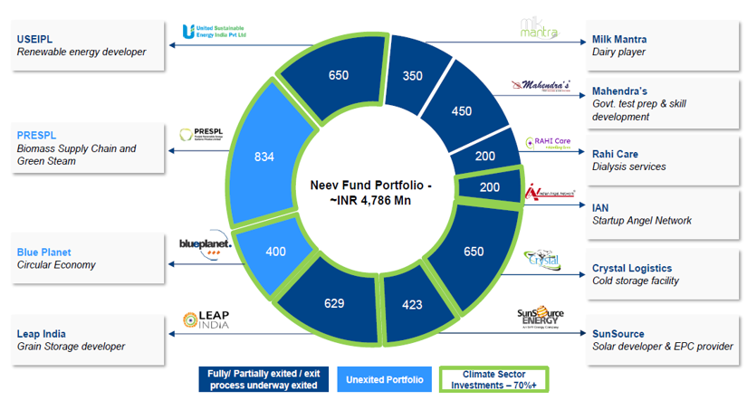

About changes to UK ODA
As IEF moves into its last phase before closing, the focus is on completing exits, returning the capital deployed, lesson learning and dissemination. IEF is a good example of a modern development partnership using investments and expertise. We have adjusted Technical Assistance to support initiatives that are relevant at this stage i.e. ensuring compliance and closure. We are also working closely with the portfolio companies and the fund manager for wider impact. This ensures that we are able to preserve the impact created by the programme and make a responsible exit from the Fund.

Summary supporting narrative for the overall score in this review

IEF continues to demonstrate strong performance in its last year, maintaining its A rating. The Fund Manager is focused on fund closure and distributing proceeds. The team has taken initiatives to try to bring about systemic change through its portfolio investees, engaging actively with industry platforms to disseminate learnings while ensuring alignment with the UK India priorities. Few examples of such initiatives have been listed below and also under Output#3. A summary of progress is below:

Investments & Mobilisation: IEF has invested in 10 businesses across focus sectors. This has led to cumulative mobilisation of c. £200m from strategic, development, and commercial investors – thereby validating its Theory of Change that early-stage investments in more challenging geographies can attract commercial capital and deliver inclusive development.

Exits: Out of 10 investments made, Neev has successfully completed 6 full exits and 2 partial exits, returning 78% of our invested capital. This corroborates the original hypothesis that it is possible to make returns by investing in sustainable businesses. Returns in pounds sterling have been impacted by the recent weakening of the Indian rupee; however, we expect to recover all capital with a small profit.

The exit phase is complex due to policy changes, market volatility, and geopolitical dynamics, all of which influence capital flows.

Development Impact, ESG and Gender:
IEF has created over 22,000 jobs created and benefitted ~1.4 million people through improved infrastructure. c.70% of investments support climate objectives, adding 320 MW of clean energy, leveraging £125.6m in green finance, and reducing 1.2m tonnes of CO₂ emissions. Innovations include cleaning up landfill sites and turning waste into useful material in a way that supports recycling and reuse.

ESG has been mainstreamed by linking manager incentives and appointing a dedicated ESG lead at the Fund level. Investees have strengthened their performance, with average ESG score rising from 1.2 to over 3.0, supported by targeted training and manager engagement. New investors cite ESG maturity as a key investment driver.

On gender, there are both hits and misses last year, but within a steady positive trajectory. Certain sectors, like education and healthcare, show stronger balance, while the infrastructure sector continues to lag due to operational constraints, cultural norms, and lack of facilities. Despite IEF not being gender-focused initially, proactive integration has raised women’s representation to 25% in leadership/board positions and 18% in employment, as a result of active engagement and the fund managers’ positive orientation. Gender mainstreaming is proving to enhance diversity and performance. While these results are encouraging, systemic impact in the wider industry requires sustained effort over a longer timeframe. We are addressing this at the portfolio level, leveraging the combined weight of all fund managers to gather the necessary momentum for change.

Systemic Impact: Under IEF, the UK partnered with a first-time fund manager in SVL and helped develop its institutional frameworks by bringing international best practices. From managing our initial capital of c. £40m, it has now scaled to managing £5bn and is supporting delivery of key investment initiatives for India. It has established credibility and is mobilising international investors to catalyse growth and jobs. The OECD has also recognised SVL’s contributions and developed a case study on how it has deployed catalytic capital to foster inclusive, climate-aligned growth in India. In addition, through its investees, such as in waste management and biomass sectors, the programme has actively contributed to national-level policy advocacy and regulatory reforms (more details in Output 3).

Major Lessons learnt

- Structured exit planning is critical: Global shifts—like the changing climate priorities in US —are affecting capital flows and impacting closure timelines for climate-focused funds. Close engagement with investment managers and wider market is needed to explore all options and manage delays.
- Small and medium scale enterprises (SMEs) take time to mature. SMEs’ resilience to external shocks directly influences their capacity to scale and attract investments. While several portfolio companies are emerging as market leaders, few others have struggled to adapt to evolving market conditions. Patient capital plays a critical role in enabling long term systemic impact, especially as policy transmission unfolds over time and investors focus on responsible exits.
- Policy advocacy with investments is catalytic: Investees like Blue Planet and PRESPL have influenced national-level reforms in waste management and biomass usage, showing that targeted policy engagement via investees can amplify impact. Policymakers increasingly seek robust data and evidence to inform and drive policy decisions - programmes should prioritise these initiatives.
- Alignment of the Fund Manager on the fund strategy is essential for delivering outcomes and impact. A dedicated ESG officer and output-linked financial incentives are some of the practices that have helped embed standards and ensure alignment with the UK India priorities.

Recommendations for the final year of implementation:
- FCDO team to evaluate fund closure options through deeper engagement with the market, Fund Manager, other investors, and legal advisers. If an extension of fund life is proposed, requisite internal approvals will be pursued in line with ProF guidance. Action: PRO by end January 2026.
- In line with the Management Assurance Process (MAP) approach agreed with the Programme Board and Development Director, Capital team proposes to undertake a proportionate DD refresh on SVL at the portfolio level. Since Neev is in its exit phase, an independent financial review of the fund has already been commissioned. Action: to be completed by PRO by March 2026.
- FCDO team and Fund Manager to ensure dissemination of case studies and lessons from investments, gender mainstreaming and policy influence with internal and external stakeholders including with GOI. Learnings to inform design of future funds. Action: FCDO & SVL
- FCDO team to engage with Niti Aayog to share policy inputs from investees in the circular economy sectors and feed into the Sustainable Market Initiative (SMI) to amplify impact. Action: SRO (ongoing)
- FCDO team to finalise the Project Completion Report (PCR) closer to the end date and capture reflections on - investments, partners, influence on the markets, sustainability after exits, impact & response to external shocks etc.

B: THEORY OF CHANGE AND PROGRESS TOWARDS OUTCOMES [1-2 pages]

Summarise the programme’s theory of change, including any changes to outcome and impact indicators from the original business case. [1/2 page]

No change is proposed in programme’s theory of change from last year.
Financial (£):
FCDO
£39.5 million in returnable capital and £1.5 million in TA

People (HR):
Private Sector Development (PSD) Adviser (0.3FTE), Inclusion and Sustainability Lead (0.3 FTE), Senior PSD Adviser (0.1 FTE),
Programme Manager- (0.5 FTE)

£ and Staff at Partner, Investors

Research /studies
Cost benefit data, Sectorial studies, Infrastructure financing suite of products

Policy-relevant knowledge generation
Studies on infrastructure interventions, economic analysis (’before’) and developmental impact (‘after’)
Case studies on successful, innovative interventions for wider adoption and advocacy of direct and indirect investment approaches
Financial Products, Institutional Capacity
Use of financial products, direct or indirect investments to address the specific risk/challenges in infrastructure sub-sectors in eight LIS.

Capacity building of partner institution to create systems, procedures, bring in the required skills, expertise to undertake projects (incl. PPPs) in eight LIS and target sub-sector

Partner Organizations / /Private Sector firms/ Financial institutions / Private Equity firms/ intermediaries/
Service Providers or Government /Agencies

Direct beneficiaries comprise businesses and households who receive infrastructure services (power, roads, urban services etc.)

Indirect beneficiaries would be the poor as construction workers or in further upstream/downstream jobs, users of infrastructure (local businesses, logistic providers, and the wider society) including many women and children.
Sustainable private sector supported pro-poor infrastructure projects delivered in the targeted sub sectors in India's eight LIS

Inputs
Outputs:
Increased number of private sector infrastructure projects in targeted sub-sectors in India’s eight low-income states (LIS)
Development orientation of the project partners and portfolio companies strengthened.
Policy relevant knowledge on private sector approaches to pro-poor infrastructure sub-sectors generated.
Activities Participation
Outcome

Investments, Projects
Develop commercially viable infrastructure projects and businesses that provide a double bottom line return.
Successful/On-track projects (including PPPs) in the eight LIS across 8 sub sectors demonstrating attractiveness of subsectors/states for investment.
Pilots in clean energy, innovation, or impact interventions across sub sectors
Indirect or fund of funds investments
Increased investor interest in pro-poor infrastructure sectors in the eight LIS

Impact

Describe where the programme is on/off track to contribute to the expected outcomes and impact. What action is planned in the year ahead?

Performance of the programme against outcome level indicators is as follows:
Outcome level indicators |  | Forecast  (Year 12) | Actual  Year 12  (Sep’25) | Progress Year 12  (Sep’25) | Comments
1 | Number of women and men benefitting from increased availability and quality of infrastructure services | 1,200,000  (200,000) * | 1,429,063  (1,71,861) * | 1.2x | Exceeded
2 | Volume of additional private sector investments leveraged | £200m  (£10m)* | £200.1m  (£20.1m)* | 1.0x | Met
3 | Number of women and men with jobs (long term /short term) | 18,000  (3,000)* | 22,750  (808)* | 1.26x | Exceeded
* Figures in bracket indicate increase from last year’s reported figures

IEF has delivered systemic impact beyond its portfolio, influencing policy, investment strategy of investors, and standards. Investments across eight low-income states created ~22,000 jobs, improved livelihoods, and supported sectors like renewable energy, agri-logistics, and waste management, directly benefiting ~1.4m people through clean energy, food security, and health services. IEF has also demonstrated strong progress in delivering impact and returns and mobilised 5x of public capital.

Justify whether the programme should continue, based on its own merits and in the context of the wider portfolio
IEF has delivered strong outcomes, particularly on climate with results exceeding targets on capital mobilisation, ESG and impact. IEF has also achieved successful exits, attracting new investors in climate sectors. There are examples of investees supporting the Growth agenda by way of investments and jobs in the UK’s circular economy sectors. IEF continues to play a catalytic role in underserved sectors and has established credibility within the impact of investment ecosystem. Continuing the Programme will help unlock remaining value by ensuring responsible closure and returning proceeds to the UK.

C. DETAILED OUTPUT SCORING [aim for 1 page per output]

Output Title | Increased private investment in targeted sub-sectors and exits from portfolio
Output number: |  | 1 | Output Score: | A
Impact weighting (%): |  | 60 | Weighting revised since last AR? | No

Indicator(s) | Milestone(s) for this review | Progress
New Investors in the portfolio (mobilisation)  Exit from the portfolio | 6 investors to be inducted  Exit in 7 companies | Partially met expectations  4 new investors have been inducted. Overall, 28 new investors have been inducted in the portfolio that exceeds target.  Met expectations - 8 Exits overall: Out of 10 investments, 6 exits completed; 2 partially exited with a defined path for completion.
Pilot projects supported that demonstrate innovation or potential for high impact (application of new methods or processes) | 18 over baseline | Exceeded expectations  Overall, 33 (27 previous reporting + 6 added during the year) initiatives led by investees across sectors. Several of these initiatives have potential to create wider industry impact.

Briefly describe the output’s activities and provide supporting narrative for the score.
During the year, four new investors were inducted into the portfolio reflecting sustained mobilisation efforts despite market challenges. Recent example includes new investment from a reputed global investor to help Blue Planet scale its circular economy business; this will support India’s trajectory to green growth.

Neev has exited two more businesses in the last year viz. Rahi Care – a dialysis service provider and Milk Mantra – an agri business. With this, the Fund has fully exited from six businesses with additional two partial exits, returning 78% of our invested capital. Challenges remain in achieving full exits from the remaining companies as financial performance for some of them have been impacted due to changing market conditions. Going forward, SVL is evaluating various options to exit the full portfolio – while continuing to support growth and positioning investees for higher scale.

Additionally, a few pilot initiatives showcasing potential for wider impact were led by portfolio enterprises, some of which are listed below along with recognition received.

Punjab Renewables (PRESPL) | PRESPL is launching a new business venture to process agricultural waste into biochar and wood vinegar to be sold to farmers and industries. This will create a new sustainable product to replace fossil fuels in hard to abate sectors like steel and cement.  PRESPL has also entered to a strategic Memorandum of Understanding (MoU) with a leading bio energy business to jointly identify, develop, and execute Biogas and Compressed Biogas (CBG) projects in India. | 
Blue Planet | BP has entered into strategic collaboration with new partners for advancing sustainable energy solutions across the middle east, focusing on areas such as landfill mining, biogas production, tank cleaning, disaster recovery and complementary environmental services. Read here | 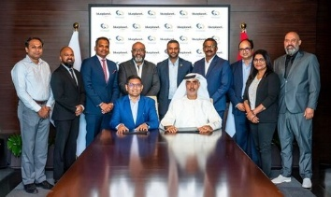

Major Awards and Recognitions in the portfolio:
Blue Planet | - Achieved spot 14 among 50 companies at the 29th Edition of the Enterprise 50 Awards - Read here  - Featured in the inaugural issue of GMR Aerocity LIVE magazine (India), spotlighting, mission to redefine how the world sees waste. Read here
PRESPL | - PRESPL won two awards (Best Case Study on Low Carbon Initiative and Innovative Clean & Green Technology Solution Provider) at the CII National Energy Efficiency Circle Competition in 2025  - PRESPL won the Sustainability Excellence Award for "Corporate & Institutional" in 2025, recognising its work in renewable energy. Watch video
IAN | - Phool.co honoured as a Climate Innovator at TOI Social Impact Summit in Mumbai. Read here  - Chakr Innovation won the Good Air Award 2024 Council in the “Innovative Carbon Capture Solutions” Category. Read here
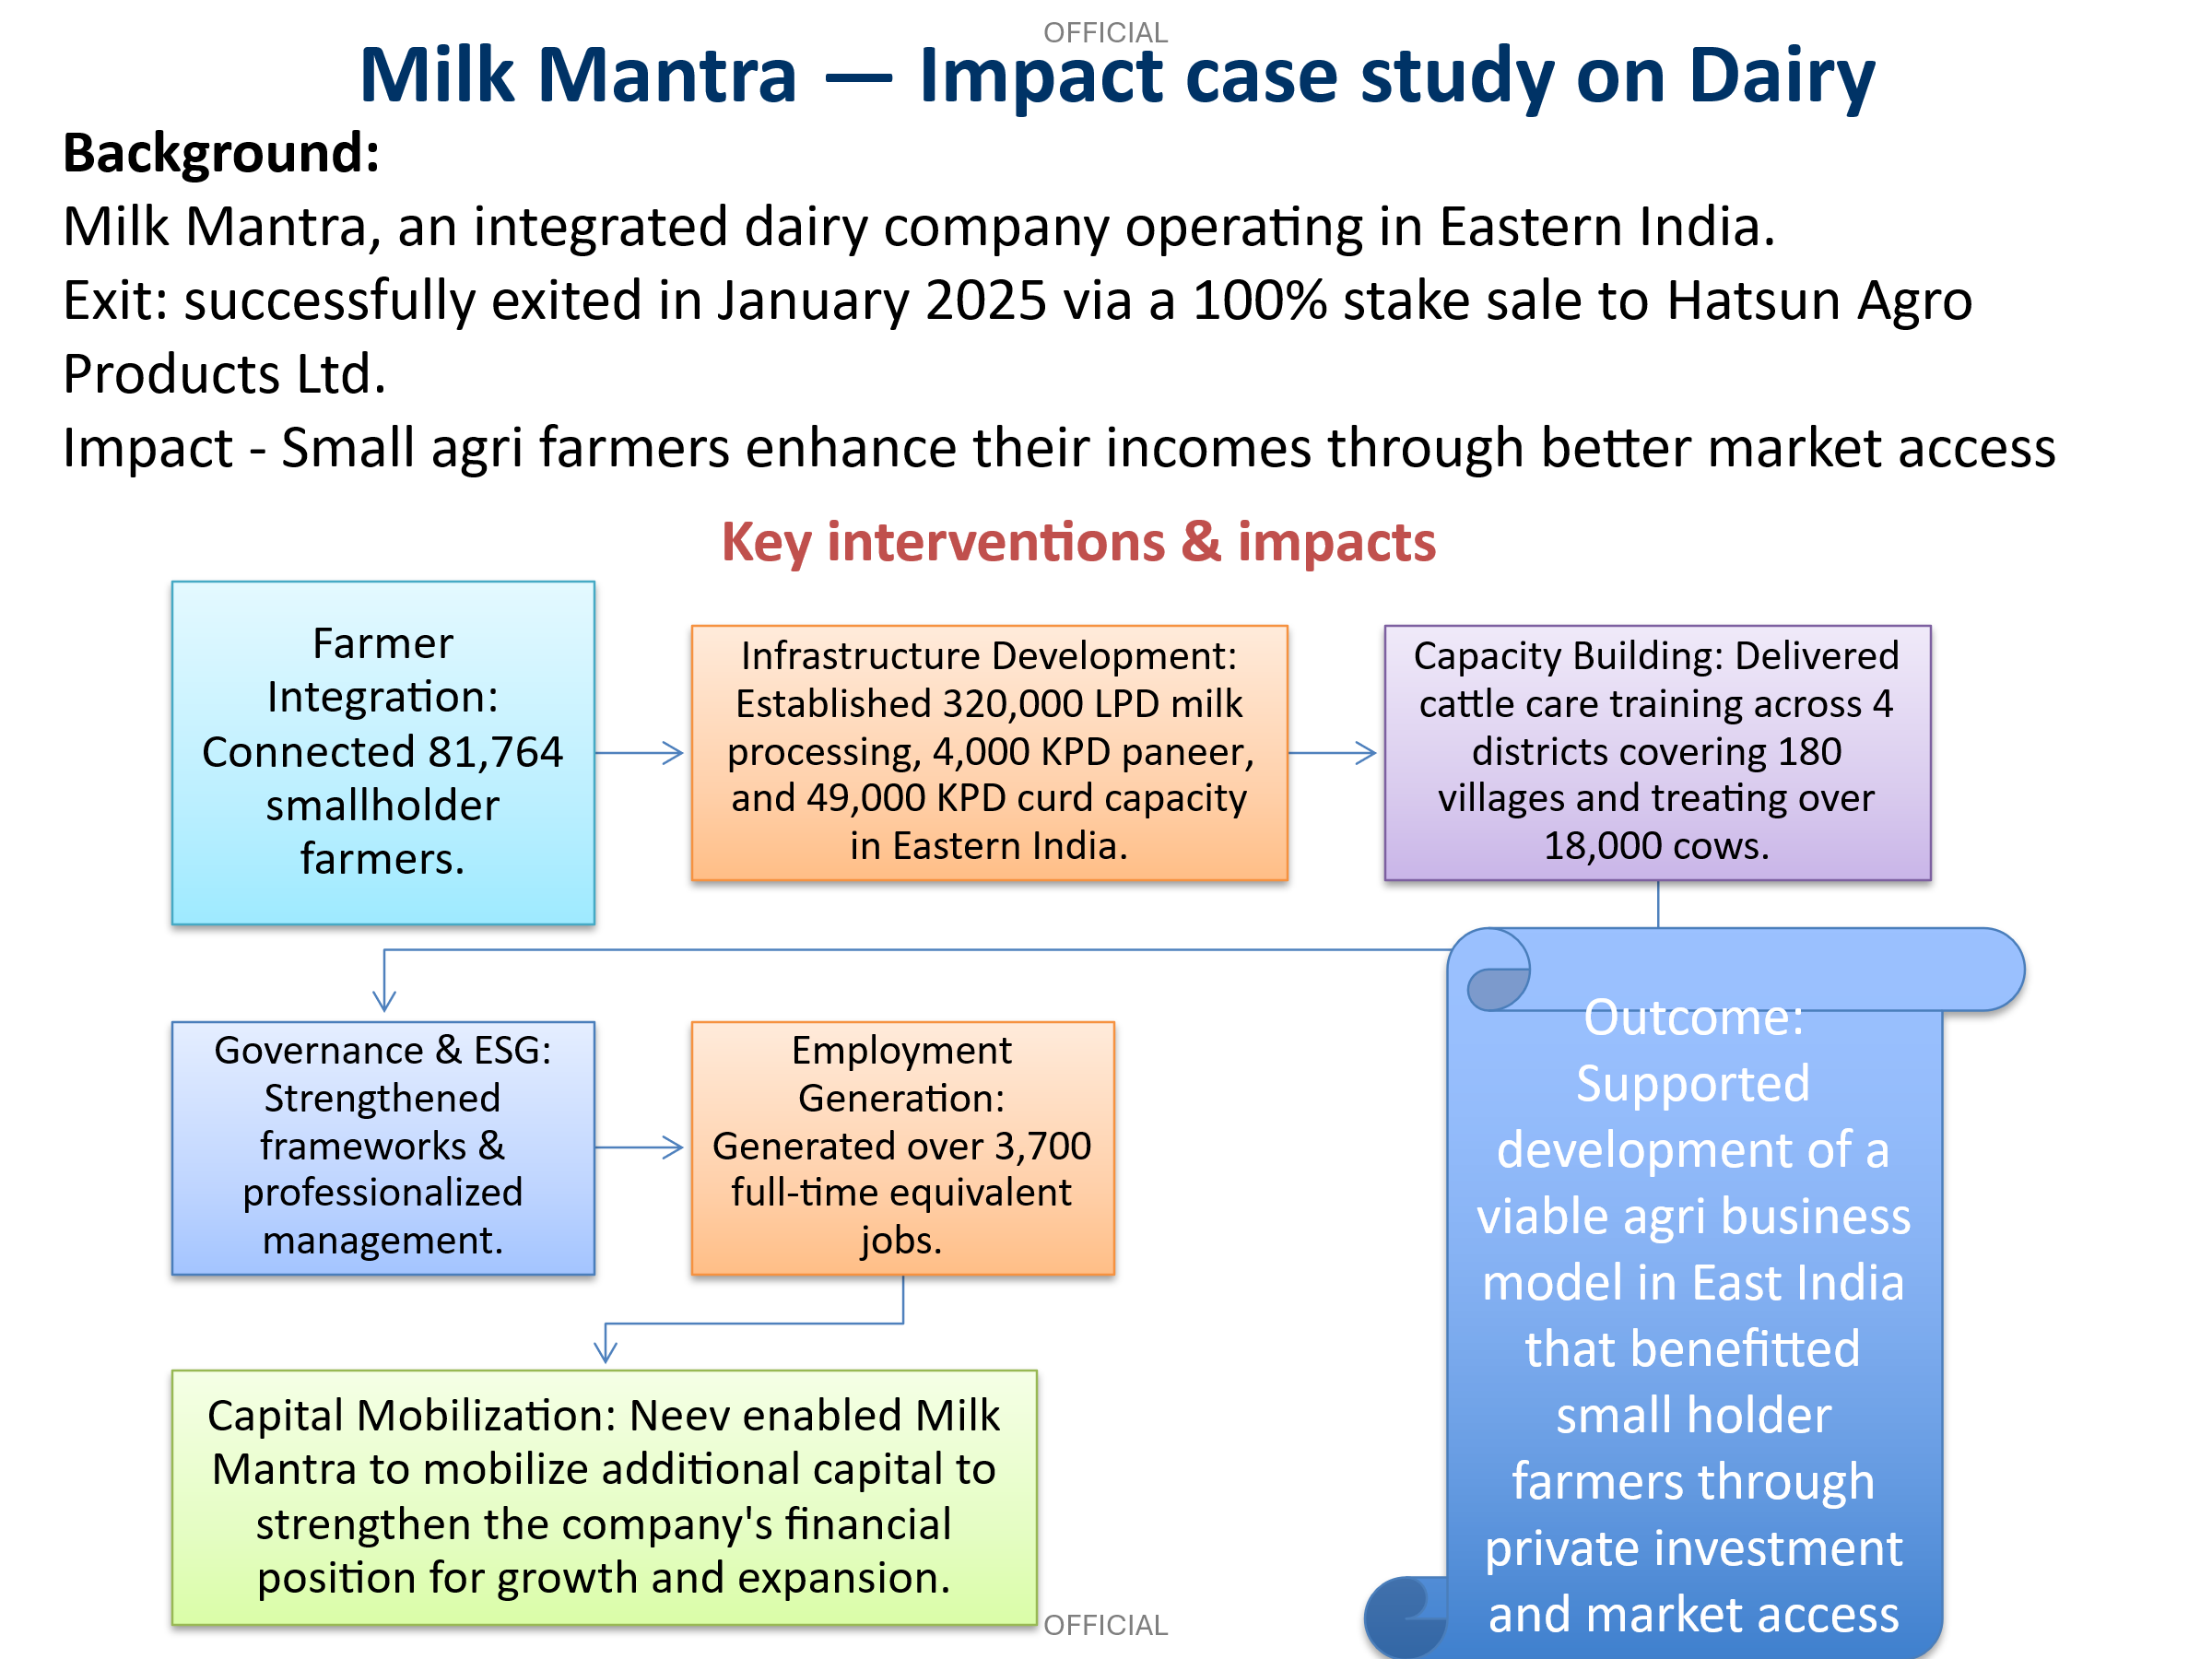

Describe any changes to this output during the past year, and any planned changes as a result of this review.

No changes have been made to the output indicators during the past year. Only exits will be tracked going forward.

Progress on recommendations from the previous AR (if completed), lessons learned this year and recommendations for the year ahead

Recommendations | Actions
Engage with the fund manager to showcase the impact created amongst the wider community and Government partners for wider dissemination | - Showcased ESG and gender achievements at several industry forums and policy platforms - Completed  - Fund Manager represented at marquee investor events such as India Venture Capital Association (IVCA) Green Returns Summit and Impact Investor Council (IIC) 2025 and at other global events including in Japan and Singapore to showcase impact and attract new investments – Completed.  - Ongoing initiatives to unlock potential of UK-India investment corridor in SVL’s new climate investment initiatives.
Review and track exit pathway for the fund actively. FCDO team to leverage the UK network and bring in the sectoral experts during exit approvals | - Team is in active discussions with Fund Manager and legal advisers to evaluate closure options (ongoing).  - Investment committee includes external sectoral experts. Board of Advisors (BoA) comprises of experts including from the UK who are consulted for strategic steers. Completed.
Analyse factors that led to higher systemic impact across certain portfolio investments vis-à-vis others and disseminate learnings | - FCDO/SVL teams disseminated impact (including ESG, gender) at multiple industry forums, including via OECD reports that have global reach. Completed.  - Developed case studies and refreshed ESG frameworks to align with global standards - Completed
Carry out portfolio analysis of links with the UK and make appropriate connections with the DBT. | - Ongoing engagement with DBT and investees including senior level meetings and site visits to explore Growth links.  - A detailed assessment is proposed under non-ODA for Growth potential in UK’s wider investment portfolio in India.

Key lessons include the need for close engagement with fund managers to understand market challenges and plan for closure. Regular communication helps identify risks early and adapt strategies. Using sector expertise and external advisers supports effective closure.

Recommendations for the year include maintaining flexibility in planning fund closure - considering all options to ensure regulatory compliance and investor protection.

Output Title | Development orientation of the project partner and portfolio companies strengthened.
Output number: |  | 2 | Output Score: | A
Impact weighting (%): |  | 30 | Weighting revised since last AR? | No

Indicator(s) | Milestone(s) for this review | Progress
Portfolio ESG score at project and portfolio level | Portfolio - 3.2; 80% of the investee companies achieving ESG projected score | Partially met expectation  Overall portfolio ESG score - 3.03 (up from baseline 1.2).  3 out of 4 investees that are currently under the fund’s management (75%) have exceeded ESG score of 3.0, indicating strong improvement in performance from baseline.
Poverty and gender and climate targets clearly defined, and results achieved in invested infrastructure projects. | 90% of the invested projects have clear focus on poverty/gender/climate as defined with 70% of the portfolio impacts measured by third party | Exceeded expectations  - 100% of the projects have a development focus  - On Poverty – 7 of 10 (~70%) projects are delivering affordable basic services for the poor viz. skill development, agriculture, and healthcare.  - Climate and environment – 7 of 10 projects (70%) contributing to ICF.  - Gender - number of women in board/leadership role (25%), and employment (18%) in the portfolio for this year.

Briefly describe the output’s activities and provide supporting narrative for the score.

Environment, Social and Governance (ESG) integration and impact - All portfolio companies undergo rigorous ESG due diligence and periodic monitoring by the designated ESG officer at the Fund, resulting in an improvement in overall ESG performance. The portfolio’s average ESG score rose to 3.03, up from a baseline of 1.2, with three of the four remaining investees surpassing the benchmark score of 3.0—a clear reflection of strengthened governance and sustainability practices. These efforts have not only enhanced investor confidence but also positioned the fund as a model for ESG-integrated growth.

Climate and Environment: The programme demonstrates a strong commitment to climate action, with 70% of its portfolio aligned to International Climate Finance (ICF) objectives. These initiatives span key sectors—including renewable energy (solar, wind, biofuel), waste management, cold storage, and agri-warehousing—driving low-carbon growth. Collectively, they have delivered 320 MW of installed clean energy capacity, generated ~8,300 green jobs and mobilized £125.6 million in green finance.

Gender: Gender-inclusive employment has grown across the portfolio from a slow start. This has been supported by policies such as safeguarding, equal pay, and anti-discrimination measures. The Fund itself demonstrates this commitment, with 25% women representation on its Board and 33% in managerial roles. Efforts by SVL and FCDO team have resulted in increased number of women. For example, large businesses like Blue Planet have established gender policies, fostered an inclusive culture and promoted work-life balance. They plan to broaden these policies to suppliers, contractors and visitors.

While these are encouraging results, significant gaps still exist in the industry that need to be addressed going forward. FCDO/SVL teams have collaborated to curate several such initiatives for wider dissemination and cross-learning with industry stakeholders.

Describe any changes to this output during the past year, and any planned changes as a result of this review

No changes have been made to the output indicators during the past year. Only exits will be tracked going forward.

Progress on recommendations from the previous AR (if completed), lessons learned this year and recommendations for the year ahead

Key learnings from the current fund should inform the design of future programmes. This will ensure a more structured and proactive approach to gender mainstreaming. The Fund managers should have a clear and well-defined strategy to embed gender indicators across all stages—from due diligence and investment decision-making to portfolio monitoring—so that gender outcomes are measurable and impactful.

Output Title | Policy relevant knowledge on private sector approaches to pro-poor infrastructure sub-sectors generated.
Output number: |  | 3 | Output Score: | A+
Impact weighting (%): |  | 10 | Weighting revised since last AR? | No

Indicator(s) | Milestone(s) for this review | Progress
Projects generating policy relevant knowledge | Target of 16 (Cumulative) | Exceeded expectations  28 overall (6 during the year). Key initiatives are summarised below.

Briefly describe the output’s activities and provide supporting narrative for the score.

The programme continues to share evidence-based insights and best practices on climate solutions by the private sector to influence policy/industry and attract new investors. Some of the achievements through its investees are noted below:

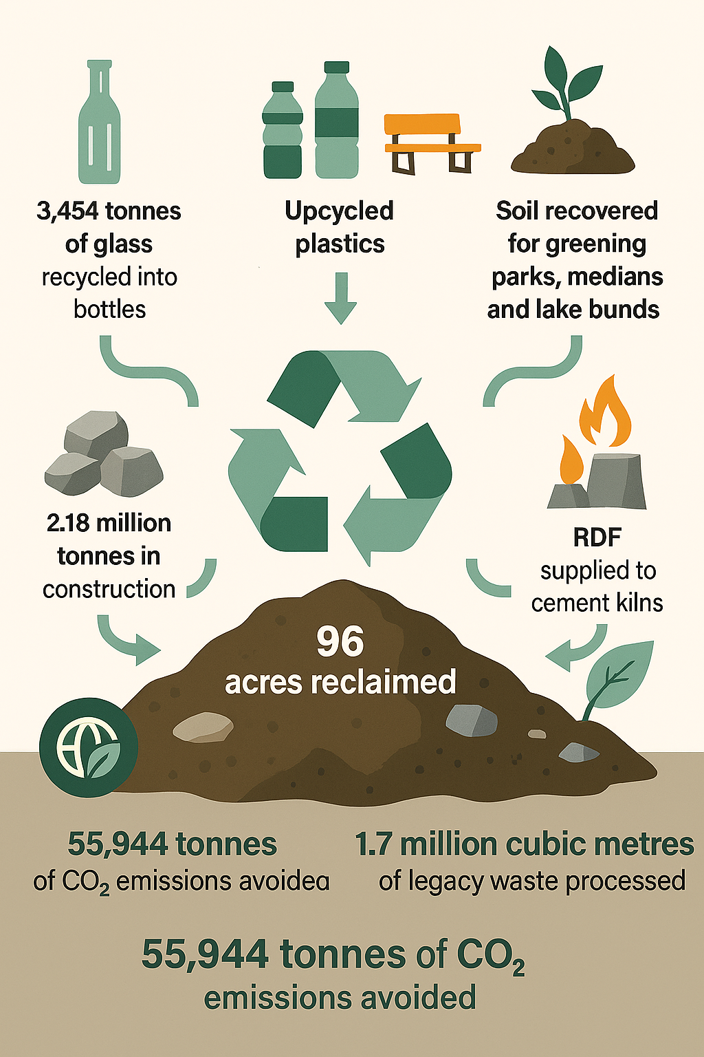
Blue Planet (BP) provided technical inputs to NITI Aayog and Urban Local Bodies, influencing the “Waste Wise Cities” framework on advancing biomining and circular economy reforms. It contributed to a study on ‘Harnessing Biotechnologies for Sustainable Landfill Management’ – the recommendations were disseminated to government bodies, including the Central Pollution Control Board (CPCB). CPCB utilised these recommendations for its submissions to the National Green Tribunal (NGT), reinforcing scientific waste management practices. Further, BP is also working closely with Chennai municipal authority in driving sustainable waste management and circular economy solutions.


PRESPL has engaged with municipal authorities to promote biomass briquettes as a sustainable alternative in crematoriums, with adoption underway in four states, reducing carbon emissions and creating replicable model for clean energy transition.
Chakr Innovation has developed a prototype for a next-generation battery technology – an alternative to lithium ion - a new model for sustainable battery solutions for electric mobility and storage.

In addition - the Fund released a report on ‘Biomining and Bioremediation of Legacy Waste Dumpsites’ in collaboration with FICCI, which was launched at the Sustainable Business Futures Summit 2025. This will help policy makers and industry participants understand sustainable ways to handle waste.

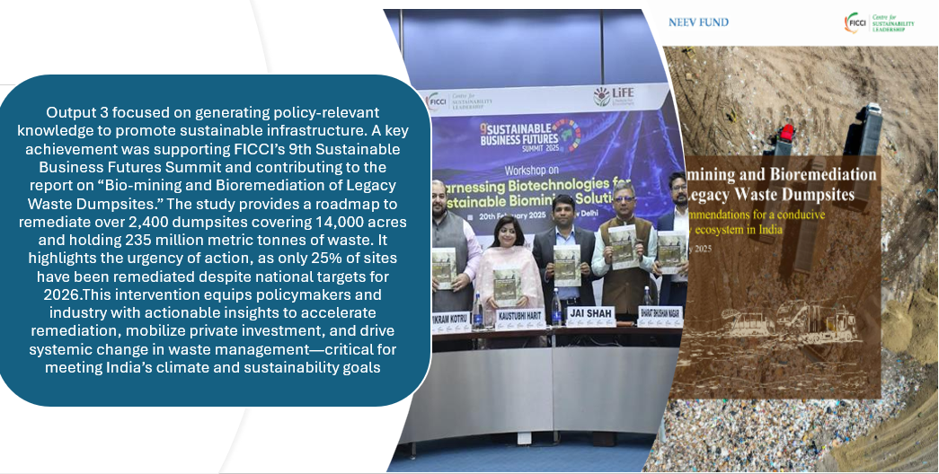

Industry Engagement: Fund representatives participated in key industry events such as the IIC’s flagship event ‘Prabhav 2025’ and IVCA’s ‘Green Returns Summit 2025’. These engagements allowed the fund to share insights on scaling climate investments, blended finance, and the evolving role of ESG in sustainable development. SVL team has received industry recognition for their initiatives as acknowledged by Government and industry stakeholders. This was further corroborated by OECD featuring Neev as a case study from India as a successful example on scaling SMEs.

Describe any changes to this output during the past year, and any planned changes as a result of this review
No major changes were made to the output structure during the year. Only exits will be tracked going forward.

Progress on recommendations from the previous AR (if completed), lessons learned this year and recommendations for the year ahead [1-2 paragraphs]

Recommendations | Action
Design next phase of collaboration with Industry Associations like IVCA and IIC and follow up on wins from recent events like the Green Returns Summit | Completed.  Fund Manager represented at various domestic and international events and conferences including Green Returns Summit by IVCA and IIC 2025.
Collaborate with SBI investment team to unpack initiatives for boosting UK India investment corridor under the recent MoU | Ongoing – Team is in discussions with SVL and SBI for strategic initiatives under the FCDO-SBI MoU. SVL team is also engaging with potential UK investors for their next Fund.
Develop a structured engagement plan alongside x-HMG Investment team to identify opportunities for the tie ups and investments from the UK | Ongoing. DBT team at Post are working closely with SVL for potential UK partnerships. Various meetings, site visits and other engagements have been organised with sector leads. FCDO team has also bid for non-ODA to drive this more strategically using external expertise.

Lessons learned this year: Policy advocacy combined with investment is catalytic in driving systemic change in sectors like waste and renewable energy. Industry collaboration helps in scaling impact and attract capital for follow on funds. Neev has successfully used these industry platforms to disseminate impact and influence the market. The ESG lead in Neev supports IIC, the impact industry body, as a Chair of their Executive Committee on sustainability and keeps a watch on emerging trends.

Recommendations: FCDO/SVL to convene Government stakeholders and key industry participants for a x-learning session on successes and lessons learnt under the investment partnership. This will help shape future strategy for private sector initiatives planned by GOI and its institutions. SVL should leverage on strong relationship with industry associations and policy forums to upstream learnings from the portfolio. SVL to develop a compendium of case studies to disseminate learnings, sector-wide best practices, and position the fund as a leading voice in impact investing.

D: VALUE FOR MONEY (1 page)

Key cost drivers and performance

VfM performance compared to the original VfM proposition in the business case

A brief assessment of VfM indicators against those set out in the Business case is provided below:
Economy  (Costs for FT & TA) | The programme invested in high-impact, high-risk sectors at competitive fees, with incentives linked to ESG and development outcomes. Over 75% of capital has been returned, and full recovery is expected, though profits may be affected by currency fluctuations
Efficiency  (Private Sector deliver efficiency) | Privates sector delivery mechanisms enabled scale and timely execution, with several investees emerging as market leaders in new sectors. This approach has facilitated capital mobilisation in challenging sectors, while policy interventions driven through private sector partners have contributed to systemic change.
Effectiveness  (Improvement in services & capital mobilisation) | The programme has delivered on the targets for job creation, infrastructure access, private capital mobilisation - with significant outcomes on climate and policy. It has supported sustainable assets that will continue to deliver impact beyond the programme’s lifecycle.
Equity  (women beneficiaries) | Gender mainstreaming has been systematically integrated across fund manager and investees, resulting in increased participation of women in leadership roles and in employment.

Assessment of whether the programme continues to represent value for money
Based on the analysis of outcomes, outputs, theory of change, and value for money, there is clear and sufficient evidence that the programme continues to represent strong value for money. It has exceeded its development targets, delivered good financial returns so far and has influenced market practices and policy areas, particularly in climate and ESG. It has also contributed meaningfully to UK-India Vision 2035.

E: RISK [½ to 1 page]

Overview of risk management [1/2 page]

While the programme’s overall residual risk remains Minor due to strong portfolio performance, the exit risk is assessed as Moderate due to macroeconomic volatility and forex fluctuations. Risk appetite across all seven categories remains within FCDO’s corporate thresholds.

S. No | Risk Description | Risk Category | Mitigation Strategy | Residual Risk Rating
1 | Risk that adverse exits or forex movements reduce capital returned to HMG. | Policy & Programme Delivery | The fund manager is assessing all viable exit routes to protect value, with portfolio gains expected to balance losses. | Moderate
2 | Risk that limited funds reduce ability to deliver wider impact. | Policy & Programme Delivery | Deploy expertise available with partners and in-house for wider impact. | Minor
3 | Risk that funds are lost to fraud or corruption, reducing capital recovery. | Financial & Fiduciary | Effective controls, audits and oversight by the team including periodic reviews. Further independent assurance via eg. financial review initiated. | Minor
4 | Safeguarding breaches, including SEAH, could harm vulnerable people | Safeguarding | Effective controls, audits and oversight, backed by a dedicated ESG officer at the fund. | Minor

F: PROGRAMME MANAGEMENT: DELIVERY, COMMERCIAL & FINANCIAL PERFORMANCE

Summarise the performance of partners and FCDO, notably on commercial and financial issues.

The Fund Manager has delivered strong commercial and financial performance, with timely reporting, effective portfolio oversight, and successful exits. FCDO has provided strategic guidance, ensured alignment with UK priorities, and supported impact dissemination. Fund Manager provides quarterly unaudited and annual audited financial statements.

As the programme has entered its closure phase, the focus has shifted to finding buyers and returning funds to FCDO. An independent third-party financial review of the fund is also underway – done as part of standard assurance process in the final stages. Technical Assistance has been adjusted to support activities that matter most at this stage—such as compliance checks and planning for orderly closure. A due diligence refresh on the partner is also proposed going forward as it manages multiple funds.

Date of last narrative financial report | 31 March 2025 | Date of last audited annual statement | 31 March 2025

G: MONITORING, EVIDENCE AND LEARNING

Monitoring, Evaluation and Governance
The programme has maintained rigorous monitoring and evaluation practices, with systematic tracking of results against the logframe and recommendations. The Fund Manager provides quarterly performance updates, annual ESG assessments, and bi-annual independent valuations, ensuring transparency and accountability. FCDO complements this through site visits, monthly reviews, and strategic oversight via the Investment Committee and Investor Advisory Committee. Additionally, a Board of Advisors (BoA), including UK experts, has been constituted to provide strategic guidance and strengthen UK growth linkages.

Performance and Learning
IEF has consistently scored well in recent years. Evidence demonstrates sustained overachievement of targets, particularly in climate impact, ESG performance, job creation, gender inclusion, and mobilisation. Insights from the programme have informed the design of subsequent initiatives, reinforcing its role as a learning platform for future development interventions.

A Hindi word meaning ‘foundation’.
Press Release during PM visit in Oct ’25.
Full Report: Scaling Up Public Financial and Non-Financial Support for SME Sustainability | OECD
SunSource Energy, Leap India, USEIPL, Crystal, Rahi, Milk Mantra
Mahendra’s and 29 exits from portfolio held under Indian Angel Network (IAN)

