Business Case Summary Sheet
Department CDD/Portfolio/ Business Plan Summary:

The DFID Research and Evidence Division (RED) will contribute to the achievement of the ODA strategy and accelerated progress of the 2030 Agenda. Over the period to 2020 RED will ensure that DFID remains a global leader in knowledge, technology and innovation - funding high-quality, problem focused research that generates new technologies and knowledge, able to deliver tangible development impacts.

This programme will deliver against commitments in the RED Business Plan to increase investments in technologies, their delivery and take up to generate new opportunities for evidence and development returns. These investments prioritise testing products and services, building evidence and ensuring they can be scaled. This will be achieved through strategic partnerships, including with the private sector. The programme also aligns and delivers against the priorities set out in the 2018 DFID Strategic Direction on Harnessing Technological Innovation for Development (HT4D) and the 2016 DFID Research Review.

Title: Mobile for Development: Strategic Partnership for Inclusion, Innovation and Scale (M4D)
Country/Sector – Global/Mobile Technology
Programme summary:

DFID recognises that mobile phones can be a cost-effective, large-scale channel for delivering a range of services and socio-economic benefits. Mobile coverage is expanding dramatically with
4.8bn mobile subscribers in 20171.

The Strategic Partnership for Mobile Inclusion, Innovation and Scale’ (M4D)2 programme will build on a successful partnership between DFID and the GSMA (the global mobile technology industry association, comprised of 800 members in over 90 countries) to unlock mobile-enabled innovation that delivers against the Sustainable Development Goal (SDG) targets.

The programme will deliver impact in key areas: digital inclusion for women, expanding connectivity, mobile-enabled smart cities, water, sanitation and energy, and mobile-based tools for climate resilience. A cross-cutting agenda on inclusion will include expanding our understanding of how mobile can benefit those living with disabilities and how we can provide livelihood opportunities to young people. (See Figure 1).

M4D will achieve its aims through a combination of research and analysis, catalytic funding for innovation and targeted advocacy within the mobile and technology industry and to inform national policy.

1 https://www.gsma.com/mobilefordevelopment/wp-content/uploads/2017/07/accelerating-affordable-smartphone-ownership-emerging-markets-2017.pdf
2 The acronym for the Strategic Partnership will remain as M4D even though the title of the programme has changed.
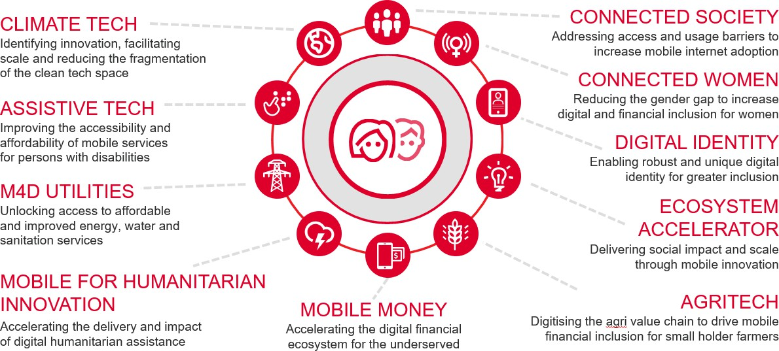
Figure 1: Overview of the proposed M4D strategic partnership programme
What is the rationale for UK Aid spending?

DFID has partnered with the GSMA since 2012; building a strong and successful partnership that has reached more than 20 million people with mobile-enabled innovation, catalysed 60 business models and leveraged £212 million of private funding (a 1:24 leverage ratio from DFID’s funding) - see Annex
B. This new business case will build on this successful model, with an increased focus on scaling, innovation and leaving no-one behind.

The programme aligns with the 2018 DFID Strategic Direction on Harnessing Technological Innovation for Development (HT4D). HT4D clearly sets out the need to support the scale-up of promising innovations, invest in local entrepreneurs, partner with the private sector and meet our commitment to leave no-one behind; enabling DFID to maintain global leadership in the innovation and technology for development agenda. DFID's Digital Strategy 2018-2020 highlights the role of mobile technology as an enabler to deliver benefits to people.

In addition to these policy priorities, it is recognised that private sector investment will be crucial to meet the 2030 SDG targets and that donor funding can play a vital role in stimulating and shaping this investment. DFID can provide risk capital, share research and evidence as a global public good. Furthermore, DFID funding helps ensure that the poorest and most vulnerable are reached where the commercial argument may not yet be clear.
Programme Value:  £38.0 million3  Further details in Section D. | Country/ Region or Sector:  Region: Global – focus on Sub-Saharan Africa, South Asia, Middle East and North Africa (including FCAS)  Sector: Technology, research, innovation, private sector.
Department/Country Office confirmation  Contact name | HoD: Alastair Ager  SRO: Magdalena Banasiak Partnership Manager: Chris Edwards
Threshold for Approval: | Deputy Director
Date of Approval of Concept Note: | 20/12/2018 |  | Approver: MoS Baldwin
Date of Approval of Business Case | dd/mm/yyyy |  | Approver: Alastair Ager
Programme Code: 203804 | Start Date: 30/07/2019 |  | End Date: 31/03/20233
Overall programme risk rating:  Further details in “Risk” sections | Moderate
Vault Number: | 48989022

3 With possibility of up to £100 million additional scale up funding and extension to 2027 based on performance and assessed at a mid-way review point in the programmes (subject to additional approval at that stage)
A. Strategic Case

In 2016 the World Bank set out to describe the benefits of technology for the lives of the poor. The World Development Report "Digital Dividends" highlighted that technology at its best can deliver greater inclusion of citizens, improved efficiency of markets and increased innovation. But it also found that technological innovation without the appropriate guidelines can aggravate existing societal inequalities, give greater control to particular actors thereby limiting expression and result in economic concentration.

In 2019, we are now faced with two crucial questions on digital and the delivery of the 2030 Sustainable Development Goals:

- Given the large scale of mobile technology (5.1 billion people connected) and the value of digital solutions like IoT (internet of things) and mobile money (866 registered million accounts), in what ways can donors more fully leverage digital solutions to deliver impact?
- Secondly, how can we mitigate and respond to the rising numbers who are being left behind by digital? There are an estimated 800 million people with no mobile internet coverage and 3.2 billion people who have coverage but don't use mobile internet. It is hard to see how the aims of poverty alleviation and economic prosperity can be fully realised without a base level of digital inclusion.

This business case extends the scope and scales up the current multifaceted strategic partnership between GSMA and DFID which has been in place since 2017, itself an evolution from the original M4D Utilities partnership established in 2012. Over the past two years DFID and the GSMA have continued to work together to seize the opportunities of mobile technology to provide access to life-enhancing services to over 20 million people. This business case looks to build on this success to date by impacting the lives of millions more with scalable and sustainable mobile-enabled solutions.

Overview

DFID recognises that mobile phones can be a cost-effective, large-scale channel for delivering a range of services with socio-economic benefits and potentially a route out of poverty. Mobile coverage and subscription has increased dramatically with 4.8bn mobile subscribers in 20174. By 2020 there will be 1.3bn mobile connections across Africa alone. In sub-Saharan Africa and South Asia, more poor households have a mobile phone than have clean water or electricity. However, 4bn people (the majority of which are in developing markets) still do not have access to mobile internet, which is increasingly important for accessing a range of essential services and for social and digital inclusion.

This scale up of M4D programme will reach more than 26 million people by programme completion, or almost 47 million people when combined with the beneficiaries to-date. This impact will be achieved through a combination of research and analysis, catalytic funding for innovation and targeted advocacy within the mobile and technology industry and to inform policy. This tripartite approach will be delivered across these three key areas (see Figure 2 and Figure 3).

DFID investment will drive impacts in the themes of digital inclusion for women, expanding connectivity, mobile-enabled smart cities, water, sanitation and energy, increasing uptake of digital identities and mobile- based tools for climate resilience (see Figure 2). A cross-cutting agenda on inclusion will include expanding our understanding of how mobile can benefit those living with disabilities. Support in the form of funding and technical assistance5 for start-ups will be provided across these thematic areas.

4 https://www.gsma.com/mobilefordevelopment/wp-content/uploads/2017/07/accelerating-affordable-smartphone-ownership-emerging-markets- 2017.pdf
5 This includes, but is not limited to, bespoke support in areas such as data collection, marketing, investment fund raising, partnering with private sector, regulation environment and technology solutions.
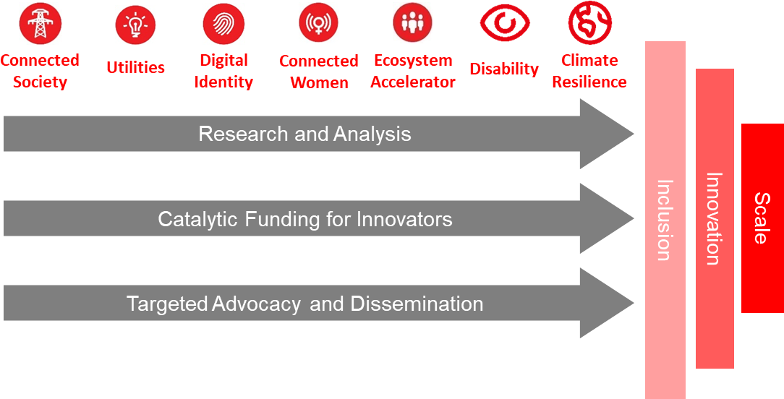

Figure 2: The thematic focus and approach of M4D Strategic Partnership
The DFID - GSMA Partnership identifies three focus areas - Inclusion, Innovation and Scale - to deliver impact through innovative mobile-enabled digital solutions:

- Inclusion - Over 4 billion people remain digitally excluded from mobile broadband (800m+ who are not covered by 3G/4G and 3.2bn+ living within the footprint of a network but not using mobile internet services). Women, in particular, in low- and middle-income countries are 10% less likely to own a mobile phone, 26% less likely to use the internet and 33% less likely to use mobile money. People living with disabilities are rarely considered in the development of digital products and services which could make significant improvements in their social and economic well-being. This partnership will unearth critical insights on the needs of the underserved, especially women and people with disabilities, identify and invest in mobile-enabled innovations and business models which can drive inclusion, and advocate for the needs of the underserved at a global and national level.
- Innovation - New technologies and new business models to deploy that technology for the underserved have been crucial to delivering socio-economic impact. Mobile money started as an innovative pilot just 11 years ago and is now an industry at scale; Pay-as-you-go (PAYG) energy is increasingly highlighted as another such example, which went from innovation to scale over the past 6 years. DFID has been at the forefront of both of these innovations, investing early in promising technological solutions and innovative business models. The DFID-GSMA partnership will look to identify the new mobile-enabled digital technologies and business models which could deliver socioeconomic impact to the underserved, provide risk capital in early stage innovations and finally, capture and disseminate insights to encourage replication and continued innovation.

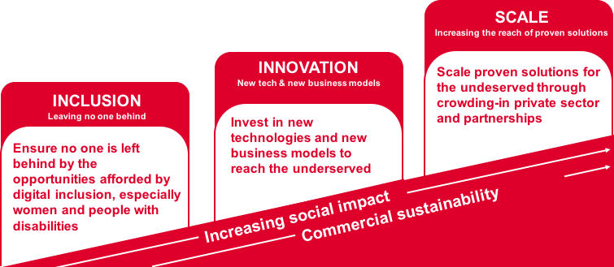
- Scale - The greatest level of socio-economic impact takes place when an innovation for the underserved reaches scale. Scaled services are also where private sector has the greatest potential to create sustainable business models, meaning interests are aligned between philanthropic capital/ social outcomes and private sector/commercial sustainability. This partnership will focus on ensuring that 'proof- of-concept' technologies and proven business models will be taken to scale, thereby leaving no one behind. GSMA will
broker partnerships between innovators and large private sector players like mobile network operators (MNOs) and encourage large private sector players (especially MNOs) to roll out business models which reach the underserved at scale.
Figure 3: Inclusion, Innovation and Scale

Model for Impact
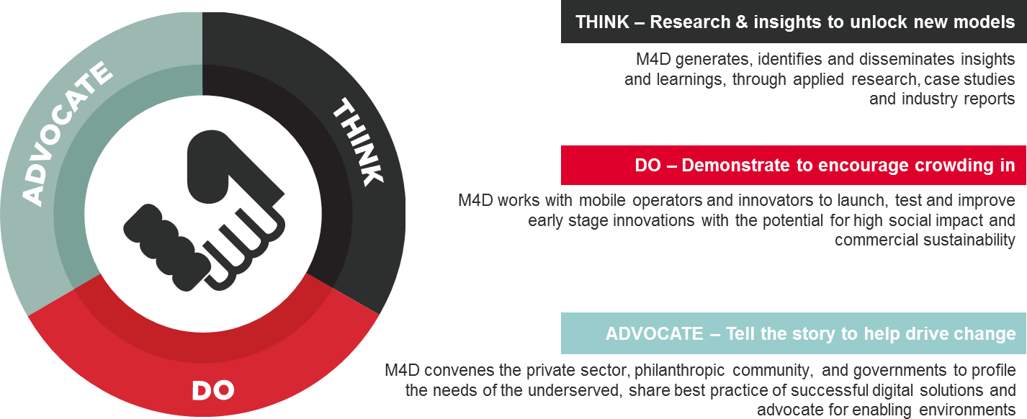
Mobile for Development has a "Think, Do, Advocate" model across its programmes. The partnership develops "sector-first" research to unlock new understanding of an issue, catalyse private sector innovation to establish proof of concept and demonstrate what is possible through advocation for the adoption of inclusive policies and principles to scale these innovations.

Figure 4: Model for Impact

Using this model for impact and focussing on the identified three focus areas, some of the headline results
to be delivered by the partnership between 2019 and 2023 include a proportion of at least:

  - 5 million people with increased access to modern energy, water and sanitation and other utility services;
  - £61.5m of additional funding crowded into new business models/technologies trialled through the innovation fund, improving scalability of circa 30% of M4D-enabled solutions.
  - 7.5 million women and 1 million PWDs with increased access to life-enhancing digital services;
  - 6 technological innovations commercially launched to bring connectivity to the underserved.
  - 300,000 more people reached with mobile identity solutions;
  - 2 million people can access mobile-enabled Clean Tech services, boosting resilience to climate change.

Why UK Aid and why the GSMA
Donor funding can be invested in building rich understanding of the needs of the underserved. Indeed, it is donors who have been able to take the early stage risk to demonstrate the proof of concept for break through innovations.

The role of donor funding is vital in order to:

    - Create publicly available knowledge on the needs of populations (including Base of Pyramid and refugee populations) in low and middle income (LMIC) countries, to help roll-out innovative services and identify new business models

    - Provide risk capital for pilots targeted at the underserved and prove commercial viability
    - Highlight policy blocks which are exacerbating digital exclusion and advocate for enabling environments to deliver innovations at scale

    - Invest in light-house projects, which drive replications and attract crowd-in funding
      - Early donor investment acts as a catalyst to crowd in private capital. The additional funding raised by M4D Utilities and Ecosystem Accelerator’s (EA) grantees as well as match funding the grantees contributed during their grant period reached £212m by June 2018, 40% more than the target for the year and representing a 1:24 leverage ratio (see Figure 5 below, the Commercial section of this business case and Annex C for more on crowding-in stories).
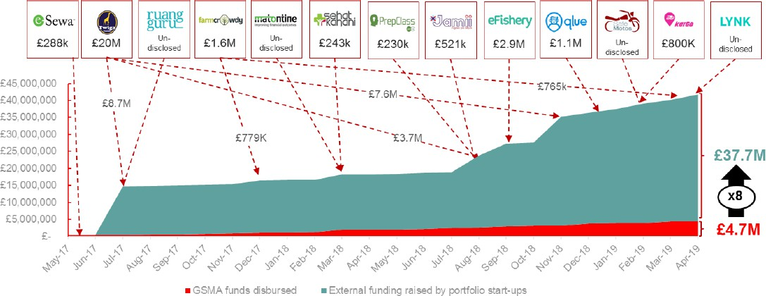
Figure 5: A summary of the top EA 13 start-ups who raised additional funding over £200k (May 2019).

The mobile industry has been one of the first industries committed to the Sustainable Development Goals. The GSMA provides DFID with industry-leading technical expertise, a proven ability to leverage private sector finance and unparalleled opportunities to scale promising solutions through its relationships with global Mobile Network Operators. This partnership can be categorised as a win/win for all parties, stimulating digital innovation to hit the sweet spot between commercial opportunities and social outcomes for the underserved.
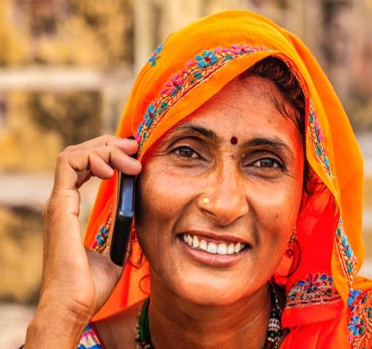
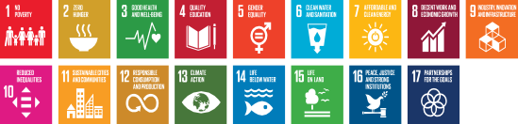
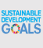

We drive innovation in digital technology to reduce inequalities in our world
Mobile for Development
Figure 6: M4D works to tackle all 17 SDGs

Alignment to broader DFID priorities

Mobile for Development will support the delivery the recent Strategic Direction on Harnessing Technological Innovation for Development (HT4D), for which it would deliver impact against 4 of the 6 pillars, namely;

- Supporting the path to scale-up for a portfolio of existing innovations with an ‘end-to-end’ approach.
- Promoting ownership of locally relevant technological solutions by investing in local partners, including tech entrepreneurs, and providing them with the venture and ecosystem support needed to get innovations to scale through links to the UK science, innovation and technology community.
- Ensuring that development technologies are inclusive, are not harmful to vulnerable communities and are in line with DFID’s commitment to Leave No-One Behind.
- Profiling DFID’s role as a global leader in setting the agenda.
The proposed 2019 Strategic Partnership for Inclusion, Innovation and Scale will leverage mobile technologies and private sector action to double down on inclusion, continue to drive innovation and build out scale. M4D is therefore also supportive of a number of other core DFID strategies, including;

- DFID Digital Strategy (2018)
  - Particularly: the role of technology as an enabler to deliver benefits to people.
- DFID Economic Development Strategy (2016)
  - Particularly: stimulating investment to spur economic growth in developing countries and supporting our partner countries to harness new technologies for growth.
- DFID Research Review (2016 - 2020)
  - Particularly: a significant increase in support for technology investment, research and innovation;
- UK Aid strategy (2015)
  - Particularly: commitments to promoting global prosperity, helping the world’s most vulnerable, and strengthening UK trade and investment opportunities around the world.

Thematic Programme summaries

GSMA will leverage the three areas of opportunity mentioned -- inclusion, innovation and scale – and work across seven programmes. Five of the programmes already exist, while 2 programmes are new and are asterisked in Table 1 below. More granular detail on the specific challenges, opportunities and focus areas for each programme can be found in Annex C.

Programme |  | Inclusion | Innovation | Scale | Impact  (millions by June 2023)
 | Connected Women - The gender gaps in mobile ownership and mobile usage in low- and middle-income countries persist and will not close on their own. Connected Women has developed powerful insights, catalysed private sector action and advocated for digital and financial inclusion for women, which resulted in 36 mobile operators committing to increase the proportion of women in their mobile money and/or mobile internet customer bases reaching over 9.6 million women to date and the programme taking a leading voice at multi- stakeholder forums including the Broadband Commission Working Group on the Digital Gender Divide, EQUALS Access Coalition, and W20.  Sustained and targeted efforts are required to ensure that women are not being left behind in an increasingly connected world. We propose to further build out insights for inclusion, by monitoring the size of the gender gap, building greater understanding of triggers for women's mobile internet and mobile money usage, and documenting models which work at scale. We would also seek to motivate further private sector action to scale business models which address the gender gap. Finally, Connected Women will continue international advocacy efforts to raise awareness and call for action  on this issue. |  | (no innovation fund) |  | 7.5
 | Assistive Tech* - An estimated one billion people globally suffer from some form of disability (20% in developed, 80% in developing countries), and yet only one in ten of those are getting access to the assistive technology they need. Furthermore, disabilities significantly affect mobile use, increasing the magnitude  of the digital divide. As more services become ‘digital by default’, there is an increased risk that Persons With |  |  | Nascent/ exploratory workstream | 1.0
Programme |  | Inclusion | Innovation | Scale | Impact  (millions by June 2023)
Disabilities (PWDs) may be once again left behind if technology products and services are not made accessible and affordable to all.
The technology ecosystem addressing disabilities is still nascent, but technology giants such as Microsoft and Google are becoming increasingly active, through Big Data & Artificial Intelligence. GSMA believes that mobile operators (such as Safaricom that have taken steps to make M-Pesa more accessible to people with visual impairment) have a central role to play to drive the creation of a fully inclusive digital ecosystem.

Using the initial learnings from research and insights on the current mobile access gap for PWDs and on the commercial opportunity for mobile operators, GSMA will now champion the use of mobile technology to improve the lives of PWDs by addressing barriers in the three areas of impact: (i) promote mobile services accessibility and affordability as a commercial opportunity across its members; (ii) advocate for the importance of inclusion of PWDs and push the issue onto the agendas of government and regulators; (iii) foster and nurture innovation by providing funding and technical expertise
to local entrepreneurs and promote partnerships with mobile operators.
 | Connected Society - The story of the ubiquity of 2G (voice and text) has been transformative, with more than 5 billion people connected worldwide. However, whilst mobile operators continue to invest heavily in extending 3G and 4G networks, there are nearly 1 billion people who are not covered by a mobile broadband network (the ‘coverage gap’), and over 3 billion people who have access to mobile broadband coverage but are either unable or unwilling to use it (the ‘usage gap’). Addressing the barriers to digital inclusion is important since the mobile internet has become an essential enabler for economic growth and societal development and a key driver for achieving progress across all of the United Nation’s Sustainable Development Goals.  Connected Society has successfully delivered tools and analysis to advance digital inclusion, including mobile coverage maps to guide rural infrastructure investments, a toolkit for mobile internet skills to increase digital skills, the Mobile Connectivity Index and a first-of-its-kind innovation fund to test innovative low-cost mobile internet connectivity solutions. Connected Society would like to increase its work on supporting mobile operators and their partners to reduce the coverage gap, through additional funding for innovative coverage solutions and supporting the scale-up of proven coverage solutions. On coverage and usage, we will continue to monitor the size of the issue, document commercially viable approaches, highlight the barriers and triggers for  adoption, document effective commercial models and |  |  | Scale from existing innovation fund grantees | 5.5
Programme |  | Inclusion | Innovation | Scale | Impact  (millions by June 2023)
 | increase advocacy efforts on necessary public-private collaborations to reduce the coverage and usage gaps.
 | Digital Identity - As governments, NGOs and other stakeholders explore new ways to reduce the ‘identity gap,’ the idea of a digital identity has taken hold. The GSMA Digital Identity Programme has supported mobile- enabled digital birth registration in Pakistan, catalysed investment in the development of new use cases, such as with Vodafone Ghana to test the viability of a digital economic ID for farmers and brought private sector together with National ID authorities to facilitate dialogue on national ID initiatives. The programme has also established itself as a credible source of research, data and insights, with key publications on policy and regulatory issues and end-user experiences being cited by partner such as the World Bank, UNHCR and AFI and across platforms such as the World Economic Forum Annual Meetings in Davos, the World Bank Annual Meetings and the UN General Assembly.  Despite momentum within the sector, the business models and services that will underpin digital identity services are nascent. The GSMA proposes an evolution to the scope and model which includes (1) unearth new innovations and business models using risk capital and  (2) the integration of digital identity use cases across other M4D verticals rather than seeking stand-alone solutions. Meanwhile, the advocacy stream would ramp up in-country policy engagement and address ID-related barriers, while also tackling new issues around privacy, transparency, data portability and the ethical issues  related to digital profiles and personal data. |  |  | Nascent/ exploratory workstream | 0.3
 | M4D Utilities - Access to energy, water, or sanitation remains a shocking gap for most citizens in low- and middle-income countries. These 'off-grid' populations are often covered by mobile solutions – such as mobile money or internet of things (IoT) – enabling new and improved models of service delivery. M4D Utilities has been instrumental, as a thought leader and a provider of patient capital, driving the development of pay-as-you- go solar business models from a very early stage to scale. Additionally, the programme has enabled innovation for both energy and water, while articulating the emerging role of mobile for sanitation services.  In the Partnership for Inclusion, Innovation and Scale, M4D Utilities proposes to:  - leverage its expertise to provide follow on support to alumni of the Innovation Fund to achieve scale, through technical assistance, insights and advocacy  - leverage IoT technologies and pay-as-you-go models to support cities in becoming more resilient and inclusive for the poor, especially in areas such as waste  management, recycling, or logistics. |  |  | Scale from grantees from the first GSMA- DFID  Partnership | 5.0

 | Programme |  | Inclusion | Innovation | Scale | Impact  (millions by June 2023)
 |  | Ecosystem Accelerator – Local start-ups in low- and middle-income economies are developing some of the most innovative and impactful solutions for the underserved, however, reaching scale and sustainability is often the biggest challenge these companies face. Mobile operators are uniquely positioned to be such partners. In the past 3 years, Ecosystem Accelerator has directly supported 35 organisations with funding and technical assistance, facilitated 10 partnerships, impacted 1.6 million beneficiaries and unlocked £21.5m of direct crowding-in.  In order to bring innovations to scale, the programme proposes to build a structured matchmaking & collaboration platform to increase the number of partnerships. Additionally innovator-alumni of Ecosystem Accelerator will also receive follow-on support and visibility to show the level of impact and scale which can be reached over time. Finally, the Ecosystem Accelerator will be the central Innovation Fund facility across M4D to unlock innovation across other verticals and cutting edge digital technologies (E.g.  AI) which can deliver impact. |  |  | Scale for grantees from the first GSMA- DFID  Partnership | 5.0
 |  | CleanTech* - Mobile technology is uniquely positioned to provide and enable tools to empower people and organisations against the impacts of climate change. Early stage digital tools can be found across climate mitigation (e.g. clean energy) climate adaptation (e.g. weather forecasting and smart irrigation), and response to climate shocks (e.g. emergency alert systems, expansion of social protection). | Inclusive by design but not core focus area
 |  | Proposed work on climate resilience will include landscaping studies to prioritise potential areas of innovation across mitigation, adaption, and climate resilience considering opportunities for end user products and services, enterprise solutions and data analytic models. Additionally frameworks will be developed in conjunction with DFID and other development organizations to design the optimal areas for private sector engagement and public-private partnerships. |  |  | Early indication of scale | 2.0
A more mature area of work will be to establish proof of concept for big data partnerships for weather observations and forecasting for increased quality of climate adaptation services. Given the low availability of technologies needed for ground level measurements, lack of efficient weather modelling techniques and limited capacity of national meteorological agencies, there is an opportunity to leverage mobile IoT and big data assets to support new and innovative climate adaptation solutions
e.g. low cost connected weather stations for weather
monitoring, mobile networks’ microwave links data for rainfall measurements.

Finally, while not a programme, we will have one additional area of work; the Digital for Development (DFD) Insights Unit. This Unit will landscape and advise on the use and impact of frontier digital technologies and engage with DFID staff and offices to support the implementation of D4D strategies; currently planned for inclusion (following x-DFID engagement) are; a landscaping study of mHealth interventions, landscaping the future of work in Africa and youth employment opportunities in the digital economy; mapping use of big data for monitoring the spread of infectious diseases e.g. Malaria, Ebola; along with producing additional data coverage maps.

See Annex C for further information and how we plan to offer this as a cross-DFID draw-down facility.
B. Appraisal Case

What are the feasible options that address the need set out in the Strategic case?
There are five main options available for delivery. The first is the counterfactual, do nothing. The other three are more proactive approaches designed to address the many challenges laid out in this business case and support underserved communities with access to mobile-enabled solutions to pervasive challenges. These options provide a range of approaches and technologies and the options to scale them up.

Do nothing

This would be a low risk option with low demand on DFID resources (but high risk to DFID reputationally in terms of R&D research). Existing initiatives under the partnership with GSMA would continue to spark small scale successes, such as M-KOPA, Wonderkid, Twiga Foods and so on. Another donor (e.g. DFAT, SIDA co-funders of M4D) or organisation may choose to support such a wide mobile innovation programme, although there is no evidence of such large-scale intent at this time.
The counterfactual would represent a low resource cost to DFID – although resources saved could be diverted to other areas of programming or supporting existing programmes. Without DFID investment, other donors will continue to fund individual thematic areas but are unlikely to support a more strategic approach to working with GSMA, therefore limiting opportunities for inclusion, innovation and scale. Whilst other donors may step into the space, experience has shown that when DFID is able to step up as an initial investor, others tend to follow (as was the case with mobile money and financial inclusion - mPESA). Not engaging misses an opportunity to support innovation and potentially support some highly scalable solutions and technologies

There would be a significant opportunity cost of not investing including lost potential for major scale-up of successful initiatives (including those already ongoing), lost revenue for entrepreneurs involved in developing or adopting technologies, lost opportunity to provide improved services to those currently hard to reach but who have access to mobile technology (including women, the elderly and ethnic/other minorities). It will also negatively impact on DFID reputation as global leader on technology and innovation.

Pros:

  - A significant short-term cost saving that could reallocate resource elsewhere within DFID.
Cons:

  - There is a significant economic cost to ignoring the access gaps across mobile connectivity, as well as missed economic opportunities by engaging MNOs in LMICs.
  - Missing out on major opportunities to solve development challenges through inclusive mobile- enabled solutions – severely misaligned to DFID strategies of leaving no-one behind and HT4D.
  - Current grantees’ scale trajectory could be jeopardised unless they acquire funding elsewhere.
  - Missed opportunity to leverage current momentum and capability built with GSMA as well as loss of significant private sector expertise and finance.

Set up a new challenge fund and work directly with individual players from the mobile industry
This would be a potentially high risk, high input approach. DFID would directly manage and contract out the challenge fund operation, and directly fund the work on M&E, research studies and so on. It would require time and resources to dedicate to establishing networks and undertaking research to set the parameters for the challenge fund, developing an understanding of the mobile industry, challenges and barriers for them to take on and sustain successful models, etc.

The contracting of the challenge fund could be relatively straightforward as we could draw on the experience from other challenge funds across DFID. It would require an initial phase of about 12- 18 months to establish to develop an understanding of the competitive landscapes in different markets (tower
sharing, energy outsourcing) and to gain a working knowledge of mobile technologies including mobile money and machine to machine communication to inform the challenge fund. The challenge fund itself would run on similar terms to those outlined in this proposal for the innovation fund, however more work would be needed to (a) clearly define the terms, criteria etc and (b) create the enabling environment (RIU, Research, data portals) which will maximise the impact of any successful models.
Managing such a programme internally would take up considerable DFID management and advisory human resources, which are not available but should save DFID financial resources, as it would save the proposed GSMA administration fee of 7%. However, the due diligence indicated this 7% is low for the industry. It’s likely that there would need to be an external body running the challenge fund for management alone would be between 15 - 20%.

Pros:

o Provides an opportunity to build on existing programme to improve and sustain access to digital life- enhancing services.
- DFID have capability and knowledge to run challenge funds in many of the relevant areas.
- Direct MNO engagement could unlock additional benefits (e.g. access to data, funding…).
Cons:

- High admin costs to get a project such as this off the ground, requires ongoing consultancy fees.
- There would be a lack of continuity with existing partnership and portfolio.
- M&E / analysis work would be conducted internally; limited ability to produce knowledge products and carry out advocacy work, which would limit the reach and scale of the work.
- DFID staff lack technical expertise in digital intersection of these sectors and also networks with mobile industry and technology providers, would take a significant investment of time and resources to establish this.
- Impact would be limited (e.g. geography, ambition) by partnering directly with specific MNOs.
- Advocacy and brokering role across mobile industry would be missing and hard to replicate.

Implement the programme through GSMA Strategic Partnership scale up
GSMA Foundation is a not for profit organisation, uniquely positioned to leverage their relationships with the mobile industry to develop service provision solutions, achieve significant economies of scale and reach millions of people. GSMA is a trade organisation, representing over 800 Mobile Network Operators (MNOs) from around the world, which seeks to support all members equally and share learning across the whole industry. Through the experience GSMA has gained through M4D to-date (as well as the humanitarian and agricultural work we have undertaken with them), we would in effect be buying in the knowledge of the mobile sector and obstacles/barriers to take up of mobile applications to scale. They would continue to manage the procuring of the Fund Manager and also provide the wrap-around services and activities which will increase the likelihood that pilots are adopted by the mobile industry, critical for long term sustainability.
This phase of funding from DFID represents a significant increase to the work undertaken so far and wants to act as a catalyst to achieve truly scalable and sustainable solutions to long-term development challenges, building on the successes achieved on this journey already through previous iterations of our relationship. Lessons learnt from the M4D partnership since 2012 have informed the design of this programme.
Pros:

  - Working directly with established, credible mobile industry leader with access to influential players, GSMA’s credibility and reach across its membership base can be leveraged.
  - Flexibility in programme management and enables learnings and synergies across portfolio.
  - Building on existing model strengthens the VFM proposition by minimising start-up costs.
  - Ability to provide technical expertise across a number of thematic areas and also have global reach.
  - Will support DFID’s ambition to provide global leadership on technology.
Cons:

  - Default bias – we know the partnership to be effective and may be blinkered to alternatives.

Individual GSMA programmes scaled through different DFID teams
This option would take the current strategic partnership with GSMA and split it up into its constituent programmes, proposing to manage each programme separately from the corresponding DFID team; e.g. Gender Equality team would run Connected Women, EPIC would run Connected Societies, Digital Identity, CEW would run M4D Utilities, Clean Tech, etc. It would combine the expertise and experience of GSMA with the technical knowledge of expert DFID advisors, working directly on the programmes without a centralised conduit. While tempting to consider this a viable option, this way of working would miss the perspective achieved via the broader strategic partnership and would lack the join-up and cross-fertilisation across programmes that makes this partnership as uniquely synergetic and pioneering as it is today.
Pros:
  - Working directly with established, credible mobile industry leader with access to influential players.
  - DFID expert advisors have greater exposure to GSMA programmes, may offer alternative inputs and direction.
Cons:

  - Lack of strategic perspective across portfolio, likely to engender further siloed thinking within DFID, limit the opportunity for synergies and learning across investments.
  - More overheads; both for GSMA to co-ordinate and for multiple DFID teams to resource. Overall not good VFM from both an efficiency and effectiveness perspective.

Use a competitive process to identify a consortium to manage a similar programme
This option would require drawing on some of the ideas outlined in the GSMA proposal but focusing it specifically on the seed and trial innovation fund components. DFID would invite proposals from organisations/consortia with appropriate experience to manage the programme. It is likely that they would then need to commission a challenge fund manager (similar to Coffey) and run activities around this which support research, analysis, advocacy, communicating impact, monitoring and evaluating as well as overall challenge fund design. It is likely that organisations such as KPMG (who for example have done work on mobile payments in Asia) or similar consultancy firms could bid to manage such a programme. If we did choose to select an alternative management agent for a similar programme, we would need to design our own programme, which would cover similar areas to those proposed by GSMA. This runs the risk that other donors may support GSMA’s work and which then essentially competes with something new and similar set up by DFID that does not have buy in from the mobile industry.
Pros:
  - Potentially more control of bringing onboard academics and other researchers.
  - Consultancy firm would have contacts and broad perspective across a number of relevant sectors.
Cons:

  - Increased cost to DFID through higher admin and management fees with such consultancies.
  - Lack of continuity as substantive lead in time for tender and contracting up to 18 months.
  - Loss of powerful connections to mobile networks and operators, necessary for maximum impact, therefore limited ability to scale solutions, leverage private sector expertise and financial resources and advocate in the sector.
  - Risk of challenge from GSMA for drawing on ideas to replicate in alternate partnership.

Uncertainty and sensitivity
The results of the appraisal are subject to a degree of uncertainty, namely;
  - The specific nature of the trials and innovation activities funded under the grant component
  - The actual pace of market development in the given markets under a BAU scenario
  - The potential failure rate of trials undertaken as part of the programme (could be as high as 5 in 10 though current mortality rates are running closer to 30%).
  - The capacity of service providers to maintain supply over time Summary of available options and the preferred approach See the comparison of options table over the page (Table 2).
For the reasons set out in the appraisal and outlined in Table 2, Option 3: Implement the programme through a scale up of the GSMA Strategic Partnership is the preferred approach. This option demonstrates the greatest potential to:

  - Achieve the intended impact, outcome and outputs as set out in the strategic case;
  - Scale identified solutions to long-standing development challenges with broad MNO engagement;
  - Leverage private sector technical expertise and resources;
  - Deliver on DFID, UK and commonwealth priorities;
  - Present good value for money for the UK tax payer; and
  - Complement other digital and mobile enabled programmes, both within and external to DFID

Table 2 – Summary of available options

Criteria | Option 1: Counterfactual | Option 2:  Challenge/innovation fund and work with individual MNOs led by DFID | Option 3: GSMA Strategic  Partnership Scaled up | Option 4:  Individual GSMA programmes scaled through different DFID teams | Option 5:  Outsource to a commercial provider/consortium
1. Maximising impact and potential from current portfolio. | 1 | 3 | 5 | 3 | 2
2. Ensuring delivery of innovative mobile enabled products and services and ability to scale through MNOs | 1 | 3 | 5 | 3 | 2
3. Enable flexibility to scale up what is working and scale down what is not – managing risks | 1 | 3 | 5 | 3 | 4
4. Affordability and value for money for the UK taxpayer  – cost of delivery v impact | 2 | 3 | 4 | 3 | 3
5. Transaction costs for DFID in setting up and implementing the arrangements | 4 | 2 | 4 | 2 | 1
Total | 9 | 14 | 23 | 14 | 12

(1 = poor fit against the objective, 5 = strong fit).

Further detail on preferred option

Available evidence

Medium: DFID’s investment in mobile technology solutions to date has established a valuable proof-of- concept for how mobile can address development challenges. The Pay-As-You-Go solar industry is a strong example of this (and see Figure 7 below). The current partnership with DFID and the GSMA has established a broad evidence base that is respected across the industry and often cited in other such programmes.

Nevertheless, key gaps in evidence do exist: in thematic areas such as sanitation, smart cities and climate, in technology areas such as Artificial Intelligence and rural connectivity, and in policy areas such as ethics and security. We are committed to working with the GSMA to further uncover enabling evidence that can lead to the adoption of life-enhancing technologies.

Evidence and learning will be continually fed into the programme with sufficient flexibility in funding allocations to allow for DFID to adjust programme focus during delivery. This adaptive style of programming has allowed us, in the existing partnership, to dedicate funding to disability and expand into the humanitarian context.
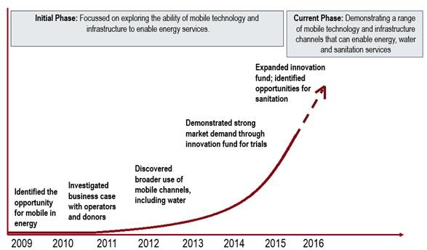
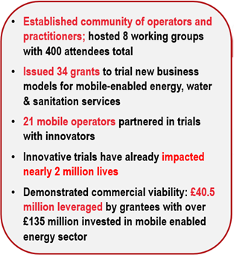

Figure 7: Story of GSMA M4D Utilities DFID investment from 2009-2016

Risk

The risk category is moderate, which is within the risk appetite for the Research and Evidence Division and is considered manageable with potential high returns. The rating stems from the inherent uncertainty from funding innovation and operational risk would be rated as minor. Through our existing partnership we have built an effective risk management system; which will be transferred through to this new programme.
Risk will be proactively managed throughout programme delivery with regular reporting to DFID and an active risk matrix (see Table 3 below). Furthermore, the programme is designed to incorporate adequate resource for monitoring and evaluation (outlined later in this document), which will enable the programme to respond flexibly to learning and any contextual change.

Fiduciary risk exists to a more limited extent and is significantly mitigated using highly experienced and trusted partners, suitable due diligence of downstream implementation partners and strong combined DFID/GSMA systems and oversight.
Table 3 – Risk matrix for preferred option:

Risks and Description | Probability | Impact | Mitigating Actions
Research, Innovation and Uptake Risks
New mobile technology and business solutions do not directly benefit the poor and underserved communities | L | M | The Partnership only fund Operators’ initiatives that have both socio-economic and are chances to be sustainable over time. In addition, all applications to the Innovation Fund must have a clear charitable purpose. Impact data will be  disaggregated so that impacts on women and people with disabilities are understood
Mobile Network Operators are not interested in the products and business models developed and as such scale up does not occur. | L | H | - The Partnership programmes ensure that, for each project, they work with teams and decision makers within lines of business (as opposed to CSR).  - The programmes also develop strong business cases for local operators to invest time and money in M4D services. This is needed when the level of investment needed to deliver a project without immediate return on investment is important.  -The programmes also work with Innovation Fund grantees to help them partner with Mobile Operators and therefore support them in the route to scale.  - The programmes diversify their partners to minimise risks of impact of change of priority by operators
Achievement of some programme goals can be dependent on regulatory environments that could  delay projects | M | M | The Partnership programmes regularly engage with regulators to build the case of the socio-economic benefits of M4D projects and build enabling environments that let M4D services flourish.
The applications received and supported, and business models developed do not generate sufficient market demand to meet output and outcome indicator  targets | L | H | The programmes using the Innovation Fund undertake targeted outreach including sending personalized emails large number of contacts, working strategically with a number of regional tech hubs or accelerators to promote the Fund.  In order to support crowding-in of the programme innovations, the programme profiles them to operators and also at big events (e.g. M360s….)
Market uptake of the recommendations and ideas demonstrated by the disseminated research and innovation support is  less than anticipated | L | M | The Partnership programmes leverage GSMA convening platforms (e.g. Mobile World Congress; M360 Africa and India) as well as high level platforms (e.g. World Bank; WEF; UN General Assembly) to disseminate and profile the messages of the partnership.
Governance and Programme Management Risks
Programme activities do not fulfil the priorities of  the private sector and philanthropic sector | L | L | The different programmes will have – when relevant – an advisory group that will convene DFID, Mobile operators and  other industry stakeholders – as relevant. The advisory group will guide the strategy of the programme
Risk profile is increasing given DFID commitment to fragile countries, leading to reputational  risks for DFID | L | H | GSMA has developed a risk assessment framework to analyse country risk levels and align the sub-grant pre award due diligence and monitoring processes with the risk

Figure 8 - Theory of change for the preferred option

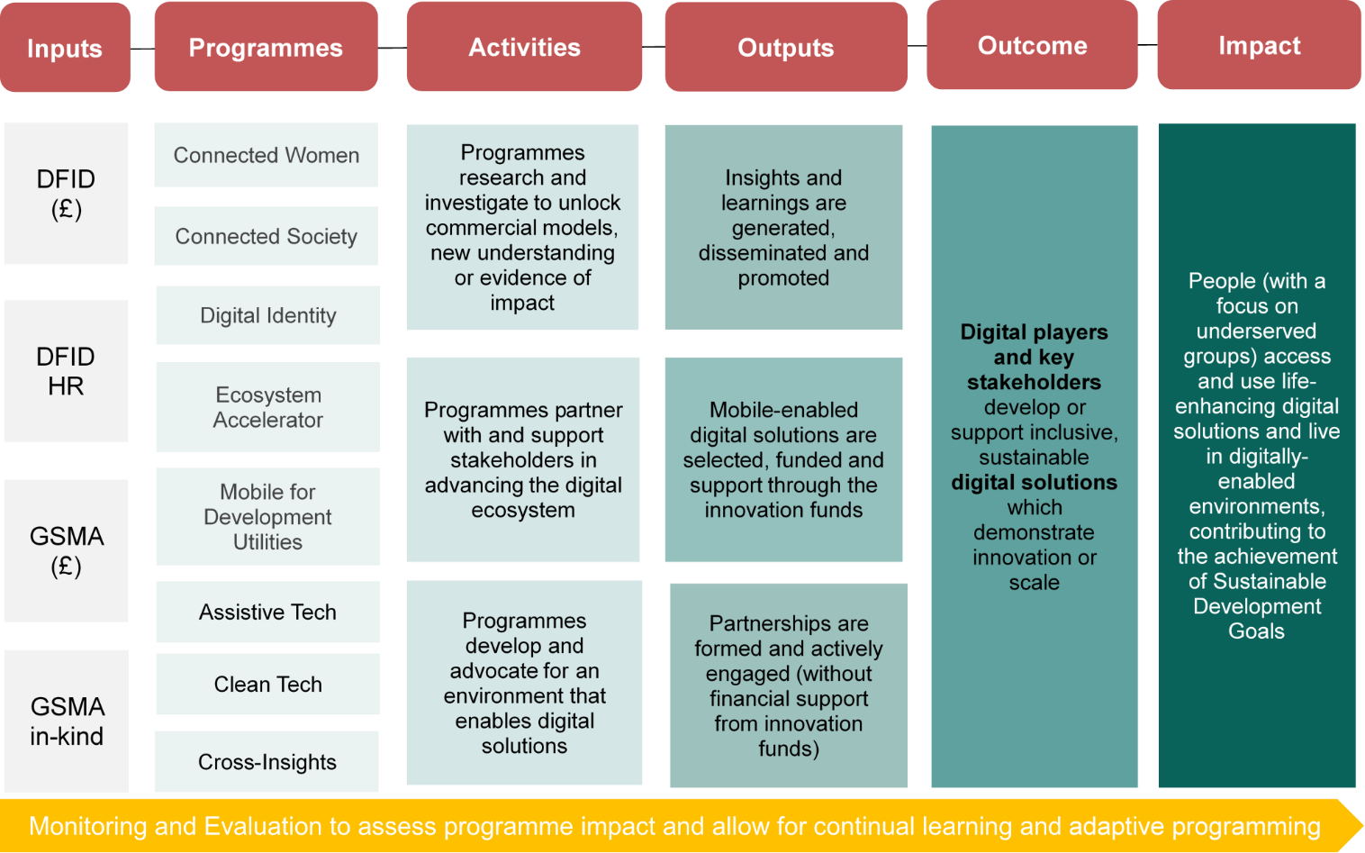

&

Figure 8: M4D Theory of change
Value for Money (VFM)
Summary Value for Money statement for the preferred option
The total estimated impact is up to 26.3 million people as a result of DFID’s £38.0 million investment, equivalent to a cost of roughly £1.43 per person who has increased access to life-enhancing digital solutions. The principles of ‘Economy’, ‘Efficiency’, ‘Effectiveness’ and ‘Equity’ will be considered and monitored throughout programme design and delivery. In the existing partnership with the GSMA we are confident that there is a strong VfM case for this type of intervention (additional funding raised by grantees has reached £212 million, representing a 1:24 leverage ratio from DFID’s input).

Through DFID’s programme management we will track management and operational costs, and work to decrease them over the lifetime of the programme where possible. The Annual Review process will assess the Value for Money across the 4 Es of the programme. The preferred option presents the best VfM due to the following:
- Internally coherent programme model, with clear pathways to impact and take-up of evidence. With a team of circa 100 employees divided into intelligently designed teams to meet the requirements of this bespoke programme, M4D is flexible by design. It is comprised of complimentary research, advocacy and innovation workstreams. This allows us to plug research outputs back into programme activities to continuously sharpen the investment strategy and enhance effectiveness and efficiency of the funds. Working with a reputable and well-established industry partner provides opportunities to influence and ensures that outputs are relevant to major mobile players.
- Strong focus on leverage and scale: the programme has already mobilised over £6m from other government donors (USAID, DFAT, Sida) and over £200m of private finance from impact investors and will look to crowd in over £60m more in the coming years. It will support almost 100 businesses and directly improve the lives of over 26m people. The focus on scalable business models and building markets will maximise impact of our investments, at times also supporting UK businesses looking to expand abroad (presenting DIT engagement opportunities).
- Significant potential for wider take-up of research outputs within DFID and beyond. Research outputs will have broad application for DFID’s investment portfolio including CDC and other impact funds. New evidence and tools on impact measurement and poverty targeting will improve VfM of CDC and UK development capital more broadly. The programme will deliver 46 thought-leadership publications, over 100 closed-door convenings of key national and regional stakeholders and 90 messages disseminated at high-level global forums.
- VfM by sharing costs with other DFID programmes: Governance and processes will align closely with DFID’s existing partnerships with Unilever, the Shell Foundation and Acumen, to share management costs and lessons.
Table 4 - Value for Money measurements:
VFM Metrics | How VFM is assessed/measured | Indicators
Economy –whether the project has bought inputs of the appropriate quality at the right price? | Procurement: The GSMA is governed by the GSMA Procurement Policy covering all purchasing process, whether as purchasers, negotiators or authorisers; and in all business interactions with suppliers on behalf of the GSMA.  Human resources: The GSMA has strict policies in terms of recruitment, remuneration (based on set market benchmarks) and performance appraisal. In addition, staff are generally recruited in the market / close to the market of programme focus.  Travel: Booked in advance and at the cost of economy fare only. The hotel and subsistence rates meet GSMA’s strict travel policy guidelines to ensure best value for money per trip. | - Benchmarking of costs.  - Savings from aligning with activities across DFID programmes (e.g. deal sourcing, due diligence, research collaboration, and follow-on investing)
Mobile for Development (M4D) Business Case [June 2019]
20

VFM Metrics | How VFM is assessed/measured | Indicators
Efficiency- how well the project is converting inputs into outputs? (‘Spending well’) | Input maximisation: cross-collaboration between programmes of the partnerships to mutualise inputs (staff, suppliers, travels, processes) and maximise output impact (joint research and joint advocacy)  DFID Profiling: GSMA M4D activities have been able to leverage GSMA flagship events such as Mobile World Congress and the Mobile 360 events and high level platforms (UNGA, WEF) to profile the Partnership outputs  Monitoring and evaluation: constant improvement of services based on user feedback, business intelligence and monitoring and evaluation feedback.  Strengthened due diligence to mitigate risks that sub-grantees of the Innovation Fund could misuse funds | - % of outputs delivered on time, where timeframe is specified  - Number and quality of research outputs e.g. number of publications in peer reviewed journals, number of downloads of online resources  - Number, attendance and cost of any conferences/international seminar and dissemination events.  - Invoicing within +/- 2% of forecasts
Effectiveness- how well the outputs produced have had the intended effect/ achieved the outcome? (‘Spending wisely’)  Cost-effectiveness - What is the project’s ultimate impact on poverty reduction,  relative to the inputs that we invest in it? | Achievement and overachievements of all targets  as set in the agreed logframe  Crowding in of new donors, demonstrating the effectiveness and attractiveness of the Partnership to other donors | - Regular reporting on an agreed theory of change  - Number of pipeline businesses supported  - Additional finance leveraged  - Number beneficiaries reached/adoption of tech
Equity - ensuring that research is inclusive and benefitting the target group | All the programmes in the Partnership monitor the number of women impacted. In addition, the Connected Women programme has a specific focus on reducing the gender gap on Mobile Internet and Mobile Money.  Finally, GSMA has commissioned a study to explore how mobile can act as transformative technology for people with disability in emerging markets (with first results details in section I of this report. | - Number of businesses supported that are owned or managed by individuals based in Africa and South Asia  - Number of businesses supported with women in leadership positions  - Focus on inclusivity in investment (products and services that target women,  youth and the poorest)
Assurances of the preferred option:

Leave No One Behind
The programme is consistent with DFID’s approach on ‘Leave No One Behind’ by integrating a strong focus on social inclusion and ensuring specific attention to differential needs (in different contexts) of women, men, older and younger people and persons with disabilities. Sustained and targeted efforts are required to ensure that women and PWDs are not being left behind in an increasingly digital and connected world. The M4D programme will continue to gather industry-level data through the Connected Women and Assistive Tech programmes and disseminate good practice on inclusion. We are confident that the programmes will be proactive in this area and are compliant with the Gender Equality Act. The regular research work undertaken will be developed in a user-centric way that is sensitive to the needs of different stakeholder groups. The programme will also ensure that monitoring and evaluation generates data that can be used to evaluate how inclusive the interventions are, disaggregating by sex, age and disability where possible, and analysing this data to strengthen and improve the programme.

Mobile for Development (M4D) Business Case [June 2019]
21

Climate and environment
This programme is not expected to have negative impacts on climate change or the environment, although there will be limited indirect environmental impacts associated with its operations. All options are likely to require some international travel to facilitate knowledge sharing and collaboration; this has a negative environment impact but justified by its benefits in terms of building local capacity, stronger partnerships and development impact. Where possible and appropriate, the programme will use local partners to engage with overseas stakeholders to limit environmental impacts. It will also take other mitigating measures where appropriate, such as use of video-conferencing and fewer but longer trips. Ultimately, the limited impacts from operations should be outweighed by the programme’s actual outputs, especially from the new Clean Tech programme.

Sustainability

Local start-ups in low- and middle-income economies are developing some of the most innovative and impactful solutions for low income communities, however, reaching scale and commercial sustainability is often the biggest challenge these innovators face. This new programme proposes a dedicated stream of work on scaling. M4D will focus on ensuring that 'proof-of-concept' technologies and proven business models can be taken to scale. GSMA will broker partnerships between innovators and private sector players such as mobile network operators (MNOs). MNOs are uniquely positioned to be a scaling partner by offering valuable assets such as consumer reach, technology, brand and connectivity. The programme will also offer follow on grant investment when appropriate and encourage private sector players to invest in business models showing promise. In this way, successful ideas will have the means to continue operating and become sustainable. In the existing portfolio a number of innovations have already scaled such Twiga, eFishery, Ruanguru, WonderKid, across a number of different sectors (see Annex B and Figure 5).
C. Commercial Case
The proposed arrangement for the partnership is to transition from the current Accountable Grant arrangement to a Memorandum of Understanding (MoU). We feel this presents the best fit for DFID to work in partnership with the GSMA across such a broad portfolio of programmes that has significantly expanded in remit since the original AG was signed. Given GSMA also contribute in-kind and cash contributions to the work, an MoU is more fitting than the current AG. This would be similar to the TRANSFORM arrangement with Unilever and the partnership with the Shell Foundation. Performance against the MoU terms will be measured against output and outcome indicator and impact target reporting, as well as frequent narrative updates to the SRO. There are also quarterly review meetings and annual business planning for each strand of the programme, signed off by DFID.

GSMA will lead on sub-partner procurement, which would be governed by their Procurement Policy to maximise the value from contracts. DFID will have oversight of major contractual arrangements and will be involved in major procurement decisions. GSMA has a robust procurement policy in place and will ensure that any procurement using grant funds meets international good practice, remains untied and free of narrow national self-interest, using transparent processes, fair and open competition and good contract management, including prevention of malpractice. Its protocols were independently verified by an April 2019 due diligence process, conducted by PwC.
GSMA ensures competition for all procurement over the value of £50,000 and encourages it also for lower value transactions. GSMA meets with suppliers on a quarterly basis to review progress and address any performance related issues. For firms to qualify for funds they must have had their accounts audited in the last 2 years and all grantees must hit pre-defined milestones before any payments are released.

Why is this right for this intervention, with this development partner?

This proposal would be directly funding the GSMA Foundation who would act as the managing agent for this programme and with whom DFID has had a long-standing relationship since 2012;

- The GSMA Foundation is uniquely placed to manage this programme, as its mandate enables it to combine its core GSM Association role, representing the global mobile phone industry (a membership of the 800+ mobile phone companies) with its commitment to development and open access of data to maximise the development impact of mobile. It is a not-for-profit organisation, but one that both understands and is trusted by the private sector mobile operators.

- Partnering with GSMA provides access to its established global, regional and local infrastructure, large-scale global corporate events (e.g. Mobile World Congress, m360) and influential stakeholders. This will continue to allow the programme to maximise its coordination and engagement with a wide group of relevant industry experts.

- This approach will allow the programme to draw on a wide network of technical expertise in mobile and digital capabilities (complimentary to EPIC), along with its French language capabilities (especially useful in West Africa).

- Using the existing DFID/GSMA management and administrative infrastructure will allow costs to be minimised, with savings accruing as a result of efficiencies made and minimal transaction costs.
- ​
- GSMA in-kind and cash contribution demonstrates the buy from GSMA to the implementation of Mobile for Development but also more than off sets the overhead and the compliance fee required by the Foundation.

Value for Money

Further to the VFM measurement criteria and principles of ‘Economy’, ‘Efficiency’, ‘Effectiveness’ and ‘Equity’ described in the Appraisal section, we will continue to ensure VFM is achieved through a combination of the following approaches;
Innovation funds

DFID’s transaction costs are significantly reduced under the agreement with GSMA that allows us to utilise a funding mechanism which they have already tried and tested many times over the years. GSMA will continue to manage implementation of the innovation funds in accordance with their rules and regulations (see Annex A for examples of innovation fund investments). An independent Grant Manager and Fund Panel will manage the award of grants through a competitive independently assessed process. The current Fund Manager (Coffey) was found via a competitive tendering process run by GSMA in collaboration with DFID to defined criteria to ensure VFM. This service is due to be retendered upon the approval of this business case to ensure continued VFM for the future innovation funds within this partnership.
It is anticipated that the competitive innovation funds will continue to be oversubscribed and that the market place will respond positively to future calls for proposals – over 700 applications are expected during this next phase of funding. A recent call for the humanitarian innovation fund (also run by the GSMA) was oversubscribed, receiving 264 applications for projects active in 77 countries, though only nine grants were awarded.

DFID funding provides ‘risk capital’ where the private sector would be unable to invest in early-stage innovation. In this way, DFID will unlock further funding and ‘crowd in’ investors. A strong demonstration of value for money is the volume of private capital raised by sub-grantees: the additional funding raised by M4D Utilities and Ecosystem Accelerator’s grantees as well match funding the grantees contributed during their grant period reached £212m by June 2018, 40% more than the target for the year and representing a 1:24 leverage ratio. See Figure 9 and 10 below - Annex B has more information on the scaling stories.
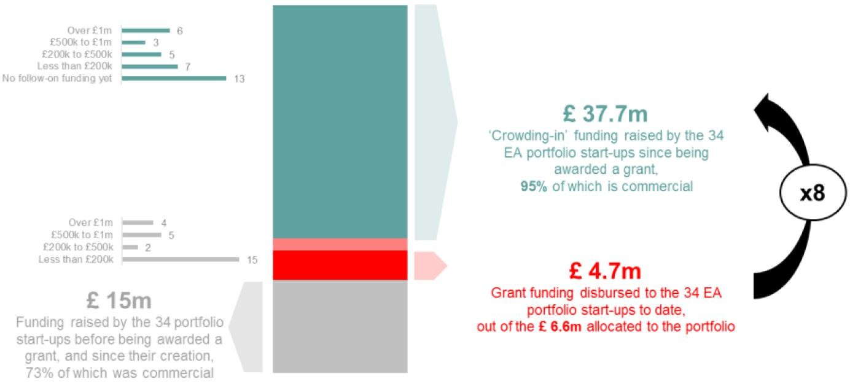
Figure 9 – Ecosystem Accelerator portfolio start-ups crowding in (May 2019)
Crowding in other donors

Investments and inputs to downstream innovation partners are designed to support them to scale so that upon grant completion they can operate without UKAid support. As a foundation arm of a wider organisation, the M4D team in GSMA receives other donor funding and will be prepared well in advance for the programme end with DFID.

GSMA is committed to crowd in further donors to the individual M4D programmes and to M4D more broadly. Under the first partnership, GSMA was able to position DFID’s contributions as an “anchor donor”, which then motivated a further three donors to participate: DFAT, Sida, USAID. DFAT has contributed
£3.4m (AUD 6.31m), USAID has contributed £380k ($500k) and Sida has contributed £2.2m (SEK26m).

GSMA will again take the same approach this time, in sharing the commitment DFID has made and encouraging other donors to join the partnership. They will look to crowd-in geographical diversity (e.g. APAC) and topical diversity (e.g. Climate/Cleantech). Active but preliminary conversations with donors
include: Inter-American Development Bank, BMZ / GIZ / KFW, DFAT, Sida, MasterCard Foundation, Ikea Foundation, Rockefeller Foundation and CIFF. GSMA aims to confirm 3 of these into the partnership.

During the period from 1 April 2017 to 31 March 2018, GSMA contributed £1.1m in-kind (in-line with the original VFM proposition) and £2.6m cash (higher than the £1.65m envisaged in the original business case). This higher contribution is related to one-off ask from GSMA members to increase activities on digital inclusion, especially regarding affordability/taxation). The in-kind contribution will continue, alongside a cash injection of £1.5m annually.
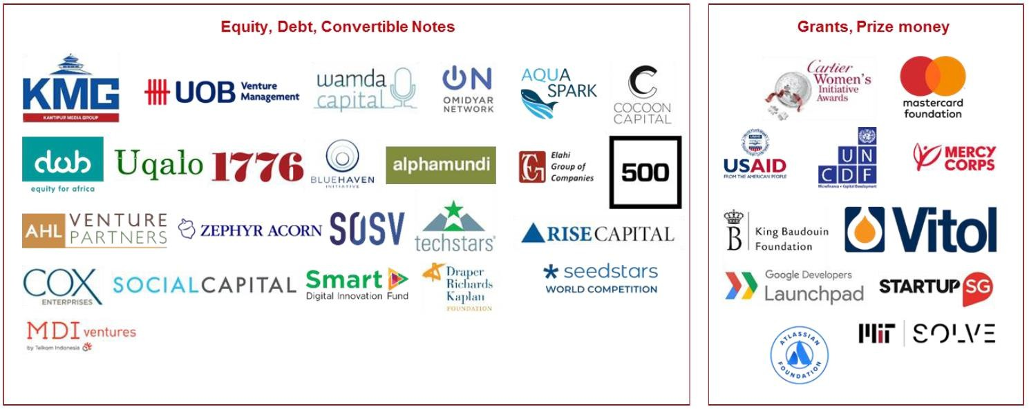
Figure 10 – Ecosystem Accelerator portfolio investors crowding in (May 2019)
Overhead costs to support compliance activities of the GSMA Foundation

The GSMA Foundation’s admin fees charged to donors are applied to the indirect expenses of the Foundation. In February 2013 when GSMA Foundation signed the first agreement with DFID (# 203804) the Foundation was charging 5% admin fees to donors. Since then, the GSMA Foundation has grown considerably, taking on a wider scope of activities and greater complexity. To ensure sufficient fiduciary and safeguarding responsibility, the Foundation has increased its investments in compliance and legal resources, and in 2015, the GSMA Foundation took the decision to increase the admin charge/compliance fee to all donors to 7%.

The GSMA Foundation’s admin fees charged to donors cover only a portion of the Foundation's indirect expenses. In the last fiscal year, the Foundation recorded 13% of indirect cost of which the GSMA Foundation currently charges 7% to donors. The rest is covered as an in-kind contribution by GSMA. PwC verified the legitimacy of this admin fee in the updated due diligence report (2019), noting it was ‘conservative’ and that based on their ‘wider knowledge of the industry, the average fee for indirect costs is around 13% to 15% of total costs.’6

Assurances

Counter Terrorist Financing
Given the focus of this work, the partners proposed, and the funding modalities involved, we do not expect there to be any significant risk of financing terrorism, either directly or indirectly. The GSMA programme management team, under supervision from the DFID Senior Responsible Owner (SRO) for this programme will also ensure that all funding and implementing partners associated with this intervention have rigorous processes in place to ensure that no funds are transferred to individuals or groups associated with terrorism. The overall risk level related to terrorist financing associated with the programme has been assessed as low.

Public Sector Equality Duty
All work commissioned under this programme will be compliant with the Public Sector Equality Duty requirements under the Equality Act 2010, DFID. The process of commissioning individual activities will be

6 DFID/M4D - PWC Due Diligence Assessment 2019, p.41
designed and assessed to ensure the need to: (1) eliminate prohibited conduct under the Act (unlawful discrimination, harassment and victimization); (2) advance equality of opportunity between people who share a protected characteristic and people who do not share it; and (3) foster good relations between people who share a protected characteristic and those who do not share it. The DFID programme management team, under supervision from the DFID Senior Responsible Owner (SRO) for this programme will also ensure that all funding and implementing partners associated with this intervention are also compliant.

Safeguarding
Safeguarding considerations have been embedded into the design of the programme. Under the existing partnership, GSMA has drawn on DFID guidelines to consolidate and strengthen its Safeguarding policy, including bringing in dedicated staff resource. This policy was approved by DFID in 2018. PwC was contracted in April 2019 to undertake a due diligence process to assess the GSMA’s mechanisms to meet DFID enhanced requirements on safeguarding, whistleblowing, HR recruitment and selection, risk management, code of conduct, governance, and accountability. The assessment confirmed GSMA’s zero- tolerance for all forms of harm to children and vulnerable adults including abuse and exploitation. It also noted GSMA’s requirement that all downstream partners are contractually required to comply with GSMA’s safeguarding policies.
This programme has also been designed to incorporate a robust monitoring and evaluation methodology, which will enable the programme to flexibly respond to risks (including safeguarding risks) as they emerge and to any contextual changes. Though none are expected, areas with potential for safeguarding issues to arise are where the programme indirectly interacts with people with disabilities, children and other vulnerable populations.
D. Financial Case
DFID has worked with GSMA since 2012 and has built a good understanding of the capability of GSMA and processes required to effectively support innovation. A timescale of 5 years will be sufficient to:
- Run multiple rounds of innovation funding with enough time to establish business models in difficult contexts across a range of sectors.
- Generate research and insights based on real-world business models being trialled.
- Achieve measurable policy change based on the evidence generated.
From the existing partnership we have identified what we want to do more of, and where we feel DFID’s investment is not required. For example, we will now have a dedicated stream of work on scaling innovation and we will focus our sanitation and water investments in the urban context, where the need and potential for impact is greatest. We will no longer work on the National Dialogue process, which is now financed by the Swedes and continue to have policy input but no significant investment in the mobile money work. Several other shifts have been made under individual programme strands.
The proposed programme will complement a concurrent scale up of the approved GSMA mNutrition programme, submitted to Ministers and run by the Agriculture Research team. We have liaised with them to ensure consistency and coherence in approaches and management of the programmes.
Budget overview

The proposed budget is £38.0m for 3.5 years (start date: July 2019, end date: March 2023). It is proposed to start the 2019 Partnership for Inclusion, Innovation and Scale with this amount and re-assess in 2 years’ time, based on the achievements of the Partnership by then against agreed logframe metrics, with the possibility of up to £100m additional scale up funding and an extension to 2027 (subject to additional approvals).
Table 5 – Budget split by programme:

Programme | Total cash (£m) | % funds
Connected Women | 3.12 | 8%
Connected Society | 3.18 | 8%
Digital Identity | 1.80 | 5%
Assistive Tech | 2.02 | 5%
M4D Utilities | 2.47 | 7%
Ecosystem Accelerator7 (including managing innovation funds and market engagement) | 3.10 | 8%
Clean Tech | 3.28 | 9%
D4D Insights | 1.37 | 4%
M&E | 2.18 | 6%
Innovation Fund8 | 12.76 | 34%
Compliance Fee | 2.47 | 7%
TOTAL | 37.75 | 100%

An additional ~£1million will be included in the new MoU in addition to this budget to account for funds received from other DFID-funded programmes for bespoke services commissioned to the D4D Insights team (demand for which is referenced in the Strategic Case and Annex C).

7 The EA programme will be responsible for managing the allocation of the overall fund budget to specific initiatives in collaboration with DFID and M4D management, as well as building a roadmap that maximises the visibility and relevance of each round, while optimising the use of our resources. A central market engagement team in Ecosystem Accelerator, with strong presence across sub-Saharan Africa and Asia Pacific will manage the set-up, selection, due diligence, contracting, and grant management of each round, regardless of its topical focus. Strong coordination will be in place to ensure that the programmes relevant to each round contribute their subject matter expertise at key milestones: design of the round, shortlisting, review of applications, technical assistance. Strong links will also be built between Ecosystem Accelerator and the programmes looking to run an innovation fund (e.g. Assistive Tech, Climate, M4D Utilities and Connected Society) to ensure that all learnings and case studies from the grant portfolio contribute to the insights and advocacy agendas of the respective programmes.
8 The Innovation Fund Challenge Fund has a minimum of £11 million, with a potential to grow further based on (1) the opportunity to increase the amounts per round per topic and (2) the opportunity to do subsequent rounds on the same topic, assuming the full 5/6 years’ timeline of the grant is realised. This amount will be available for each programme within M4D to pitch for when relevant. It is anticipated some programmes will run one round, others may be able to run two rounds, pending available funds remaining.
Table 6 – Budget split by category:

Budget Heading | Year 1  Q2 2019 to  Mar20 (£m) | Year 2 Apr20 to Mar21  (£m) | Year 3 Apr21 to Mar22 (£m) | Year 4 Apr22 to March 23  (£m) | TOTAL (£m)
Direct Costs - costs against actual activities (including travel**, personnel, meetings, dissemination costs…) | 0.86 | 6.14 | 6.62 | 6.72 | 20.34
The amounts indicated here covers the analyse, advocate and market
engagement activities outside the innovation fund
Innovation Fund  Challenge funding awarded to external innovators through competitive calls | 0 | 3.0 | 5.55 | 2.45 | 11
Innovation Fund  Non-personnel fund management costs (including external fund management) | 0.05 | 0.67 | 0.77 | 0.27 | 1.76
Monitoring & Evaluation (M&E) | 0.12 | 0.60 | 0.56 | 0.90 | 2.18
Indirect costs (e.g. overheads to support risk management and compliance activities of the Foundation) | 0.07 | 0.73 | 0.95 | 0.72 | 2.47
Programme Funded post – Strategic Partnerships Manager and Due Diligence | Under  current programme | 0.06 | 0.06 | 0.06 | 0.18
TOTAL | 1.10 | 11.20 | 14.51 | 11.12 | 37.93

** Any travel costs are costed at economy rate in line with DFID policies and salaries/staff costs have been measured against other similar organisations, verified by the 2019 Due Diligence assessment.

GSMA will contribute to the Partnership both in cash and in-kind:

- In-kind contribution of £1.1m a year: as inspected by PwC during the due diligence, GSMA in-kind contribution is made up of staff who work on donor funded projects but whose costs are not recovered by the Foundation (e.g. HR, AP, etc), IT costs and facilities costs.
- Cash contribution of £1.5m a year

Programme funded post
An A2L programme funded post will continue to be financed through the programme. The main objective of the post will be to support the implementation of the partnership, ensuring a coordinated and coherent approach aligned to DFID interests and objectives. The post will support GSMA in the co-ordination of inputs and exchanges from across DFID, including private office engagement, work with DFID policy teams
e.g. Gender and Disability and country offices in relation to the delivery of their DFID co-funded programmes. This post will conform to DFID rules on Programme Funded Posts as set out in SMART Rules.

Disbursement arrangements
A GSMA Finance Business Partner reviews each programme budget on a monthly basis to ensure that:
- Money is spent wisely, with the maximum impact on our DFID targets
- Programme financial forecasts are within the +/-2% variance
- Budget management is compliant with DFID guidelines
Budgets will be forecast by GSMA and closely assessed by DFID on an annual basis with updates provided every quarter. GSMA forecasts on a yearly basis are very reliable; allowing the ability to make confident and dependable spending decisions both within the project itself and for wider decisions outside the project for the DFID implementing team. The GSMA Foundation closed 2017 within 0.2% of the forecast. This was a great achievement driven by the collaborative efforts of the Finance / Compliance team and Programme Services team. DFID will work with GSMA to keep annual spending within forecast.

DFID will disburse funds (GBP sterling) quarterly and in arrears on receipt and approval of a quarterly statement of expenditure and report. Funds will be disbursed into the designated accounts of GSMA Foundation, which will be responsible for disbursing to downstream implementation partners / suppliers. This programme will continue to be funded by DFID’s Research and Evidence Division’s programme budget, Climate, Energy and Water (CEW) Team.

The programme is expected to start upon approval of this business case in the second quarter of the 2019/20 financial year.

Financial Risk
Fiduciary risk exists but will be significantly mitigated by the implementation arrangements being managed through a trusted and highly experienced partner, whose systems and procedures for supplier management and oversight are equivalent to DFID’s. Other risks are outlined later in this document in both the Appraisal and Management sections.

Due diligence
All DFID investments will be made through an existing partner (GSMA Foundation). An updated due diligence assessment was carried out by PwC in April 2019 and the GSMA was assessed to have equivalent systems/processes to DFID. The assessment acknowledged “the great strides the Foundation and GSMA have made to develop the processes and controls to support the effective management of the DFID partnership since its implementation.” The report did also make eight recommendations to further improve current procedures which are in the process of being agreed upon and actioned at the time of writing and will be considered and monitored as a part of the annual review process.

Monitoring and evaluation and accounting for funds.
GSMA Foundation’s programme team (along with the appointed Fund Manager) will be responsible for monitoring fraud risk and accounting for funds. A complete check of the financials will be conducted before any funds are released to the downstream partners. DFID has experience in working with the partners and they have well established robust financial management and procurement systems, as well as internal audit and checks to monitor compliance with these.

The DFID Programme Manager will ensure accurate forecasting through developing a strong working relationship with the partners and enabling effective engagement on programme issues including financial management issues. DFID will hold regular meetings with the GSMA (in addition to the ongoing frequency of engagement via the programme-funded post) to get an update on the programmes, discuss any risks/concerns that arise during implementation and associated mitigation strategy, etc.

Use of funds for the intended purpose
As for all the DFID funded programmes, a zero-tolerance approach is taken to corruption and fraud. This programme will be subject to regular review on this issue as part of DFID’s annual review process. The programme may be subject to independent review by DFID’s Internal Audit Department and the implementing partners may be subject to a formal audit if deemed appropriate.

Our assessment is that the risk of fraud is minor and manageable. As part of this up-scaling process, due diligence refreshes on individual downstream suppliers will be undertaken as appropriate. Scrutiny of any extensions to current funding recipients will be managed in the normal way, ensuring that only suppliers
with strong financial management and accountability systems in place will be contracted. All DFID programme funds will be fully under the control of the GSMA Foundation, who will be held accountable for all expenditure and will be required to submit audited annual audited accounts. DFID will reserve the right to conduct its own audit or deploy its own auditor if required. Monitoring and accounting of expenditure will use DFID’s ARIES system (or its successor). Invoices will be reviewed to ensure VfM, ensuring quality milestone achievement before payments are released. The DFID project manager will be responsible for monitoring all financial reports. To date there has been one identified instance of misuse of funds which was effectively handled and resolved in close partnership with DFID’s internal audit team.

Cross HMG funding
The potential to bid for international climate finance (ICF, GCF) will be considered with regard to the proposed workstreams on smart cities, climate resilience and renewable energy. This programme is to undertake early landscaping work, after which we will refine the logframe indicators as necessary.

We will remain receptive to cross-HMG funding opportunities such as with DIT on supporting UK entrepreneurs and the innovation ecosystem in the countries of operation. To date the programme has leveraged funding under CHOGM (2018) to support work digital identity and women in Commonwealth countries. The Emerging Policy and Innovation Capability (EPIC) team within DFID is also funding other digital identity initiatives, including a programme to fund the World Bank's ID4D initiative (which is complimentary to the funding already invested through GSMA via the CHOGM digital identity programme).

Elsewhere in DFID, work is underway to strengthen innovation ecosystems within key markets such as Kenya, Nigeria and South Africa, in collaboration with DCMS. We will continue to stay engaged and involved as necessary in this work. As mentioned in the D4D Insights summary and the Finance section, we will also look to support teams and country offices from across DFID in accessing the draw-down facility to receive technical support and consultancy services from GSMA. There is budget available within this business case to support some instances of this work (e.g. proposed mHealth mapping), but we also plan to allow for other DFID-funded programmes to use their expenditure to procure GSMA’s D4D Insights team to conduct work on their behalf (subject to GSMA resources).
E. Management Case

Governance and management arrangements
The core set-up of the programme will remain largely unchanged, following the more strategic approach to governance set up in 2017. GSMA will continue to provide the lead management resource and support to individual programme strands. DFID will provide a supporting management and oversight resource, via the SRO and Strategic Partnership Manager, and also support through the engagement of specialist advisers across the different pillars of engagement, drawing on internal expertise and enabling the sharing of best practice (e.g. DFID’s Gender Policy team to engage with the connected women strand; DFID’s EPIC digital team on the digital identity and connectivity strands; etc.). In this way, we intend to create a platform on to which other parts of DFID can engage with GSMA, facilitating the cross-fertilisation of expertise across areas such as gender, disability, connectivity and digital identity.

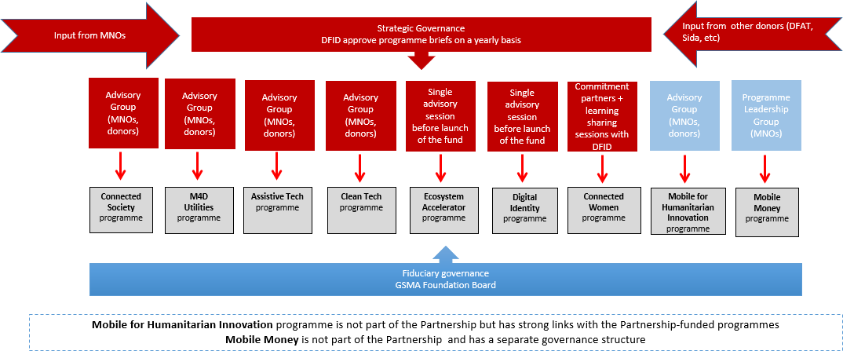
The partnership between GSMA and DFID will operate under the management structure illustrated in Figure 11 below. DFID representatives are present at key decision-making points and DFID advisers input into the specific theme areas.

Figure 11: The updated M4D governance structure for the new partnership

A Partnership Strategy Group, made up of DFID and other core supporting donors, the Operator Chairs of the Programme Leadership Groups, and key members of the GSMA M4D leadership will meet once at the start of the year to agree an annual strategic plan and again half-way through the year to make any necessary course corrections. The donors, the GSMA and GSMA member operators in the Programme Leadership Group will have input and approval of the Annual work Plan.

The Innovation Fund (centralised under Ecosystem Accelerator) will have independent Fund Panels (drawing on appropriate expertise for each sector/programmatic area) to determine allocations for each of the focused calls, and GSMA Foundation and DFID will each have a seat on the panel alongside independent experts. The panels will continue in their existing, well tested and effective format.

Each GSMA programme described in this document will continue to have a strategic governance in the form of an advisory group, with representatives from the private sector and DFID. This strategic governance will leverage the lessons learnt from the first Strategic Partnership, which showed that having both public and private sector around the table built robust dialogue and strong impact. The exact terms of reference for each programme's advisory group are defined for all but Connected Women, which is in the process of building its protocols following the 2019 Due Diligence report from PwC.
Stakeholder considerations

M4D will build upon its existing ‘virtual team’ to provide value as a platform across multiple stakeholders. It will expand existing collaboration with DFID country offices, other DFID departments (EPIC, PSD, Policy teams such as Gender/Disability and RED health team) and across HMG (e.g. DIT). In addition to the programme funded post - that has a strategic overview of the total portfolio - an EPIC digital advisor is currently allocated to work 30% of their time on the GSMA partnership. The EPIC resource works across the Connected Societies, Connected Women and Digital Identity programmes and provides a natural link to DFID’s internal digital and innovation capabilities. This will be strengthened further through a Cross-Cutting Insights Unit at the GSMA, which DFID can use to explore opportunities at a sector, regional, national or country level. Country offices will also be able to draw down on this facility for specific requests and technical support. The unit will produce landscaping reports, data analysis and insights to serve DFID staff/office needs, e.g. data privacy issues, regulation or landscaping new areas of tech and investment.













The primary partner for this programme will be the GSMA Mobile for Development team. The GSMA has over 800 mobile industry members in more than 90 countries, and DFID would partner with the foundation arm of the organisation. GSMA provides an industry-leading expertise on mobile technology and a genuinely unique access to private sector in DFID’s priority countries; namely mobile network operators and technologists. We are confident that continuing with
x-RED
Policy
makers /
investors
x-DFID
M4D
MNOs
Country
Offices
x-HMG
this partner presents good value for money (see Appraisal for more detail).

Other important stakeholders are entrepreneurs, Mobile Network Operators, policy makers and investors. Citizens and consumers of the innovation we support will be the main beneficiaries. Monitoring and Evaluation (M&E) activity will capture their feedback and views, and evidence of ‘user-centred design’ will be a criterion for all grant investments. Many stakeholders have been consulted during this business case design and ongoing engagement will be essential for effective delivery.

Fiduciary Governance:

Figure 12 – M4D’s ‘virtual team’
DFID funds will be managed by the GSMA Mobile for Development Foundation, Inc. which is a 501(c)(3) organisation in the US, and who hold fiduciary governance. The Foundation board annually reviews the progress of the programmes funded by donors to ensure alignment with the Foundation’s annual business plan.

The GSMA Mobile for Development Foundation is a supporting organisation to the GSMA and its articles of incorporation state its purpose on:

- Develop and engage in projects that utilise mobile communications to relieve the poor, the distressed or the underprivileged;
- Develop and engage in projects that utilise mobile communications to promote community health in the developing world;
- Develop and engage in projects in the developing work that utilize mobile communications to instruct the public on subjects useful to the individual and beneficial to the community.
To achieve these aims, the GSMA Mobile for Development Foundation enters into grant agreements with donors and is responsible for complying with the terms of the grant agreement. The foundation relies on the management and staff of GSMA divisions, especially Mobile for Development, within the GSMA to implement the programmes and deliver the contracted results. A dedicated Mobile for Development Foundation Compliance function sits within the Foundation and is responsible for:
  - Development, implementation and monitoring of policies, procedures and effective internal controls
  - Timely and accurate submission of grant contract reports, audit reports and all federal compliance reports
  - Authorisation and oversight of all receipts and expenditures, ensuring adequacy of supporting documents and allocation in accordance with grant agreements
  - Monitoring financial performance of grant funded programmes
  - Review of sub grantee reporting from third party assurance provider (Coffey) to ensure proper oversight of sub grantee disbursements
  - Development of programme budgets and quarterly forecasts
  - Identification and escalation of financial risks and opportunities to senior management
  - Lead on annual compliance audit
In addition, the Mobile for Development Compliance team works closely with a dedicated legal expert in reviewing new grant applications, grant contracts, grant amendments and sub-grantee contracts. The funding for the risk and compliance function is covered by the 7% donor administration fees mentioned in the Finance section.

Risk Management Strategies applicable to the Partnership’s Programmes;

- At organisational level, a Group Risk Matrix is maintained to document strategic risks for GSMA along with an assessment of the impacts, risk ratings based on the likelihood and impact assessments and the mitigation in place to address the risks. Risk management is part of the remit of the GSMA Controls, Compliance and Ethics Committee.

- At Partnership programme level, risk and issue management procedures are applied to the management and delivery of GSMA programmes, under the responsibility of each Head of Programme and Programme Manager. High ranking risks and issues have mitigation plans, are tracked on at least a monthly basis, owners assigned, and updates are recorded in the programme log (RAID log). Top priority risks and issues are reported monthly to the GSMA Leadership Team.

- At Grant Portfolio level, risk matrices (RAID logs) are held to record risks and issues relevant to the overall portfolio. Key risks are reported monthly to senior management. For each grant, risks and issues are logged through the monthly reporting mechanisms owned by the programme teams. Medium to high impact and/or high proximity risks or issues may be escalated to the Fund Manager (Coffey International Ltd.) and Programme Manager who provide support in developing and implementing mitigation strategies. A dedicated Conflict of Interest log (COI) is maintained for applicants to the Innovation Funds as well as the Fund panel making the portfolio selections.
- New risk assessment framework: GSMA has developed a risk assessment framework to analyse country wise risk and align sub-grant pre-award due diligence and monitoring processes with the risk. Countries are classified into 4 categories (sanctioned countries; extreme risk countries; high risk countries; others). In order to mitigate these risks in the riskier countries, strengthened due diligence processes have been put in place for countries in the extreme risk and high-risk categories. These new due diligence processes are applied before the applicant is presented to the Fund Panel (DFID). The indicators help assess the likelihood of key risks including: Terrorism financing, Safety and security, Legal/regulatory non-compliance and Operational disruption.

- DFID Safeguarding guidelines: DFID issued new guidelines in June 2018 for organisations working with children and vulnerable people. Six areas are covered in this assessment: safeguarding; whistleblowing; HR recruitment and selection; risk management, code of conduct; governance and accountability. GSMA replied with a state of compliance in June 2018. GSMA will report to DFID on programme regularly and at least at each quarterly review. GSMA will create a tracker document to record progress.

Monitoring and Evaluation

Targets & KPIs

As put forward at the beginning of this business case, at least 46.3 million people (direct and indirect beneficiaries) will have improved access to and use of life-enhancing mobile services as a result of the activities of the Mobile for Development partnership since its inception in 2012. This includes those who will benefitted through the current programme (i.e. 20 million people). So this business case will impact an additional 26.3 million people. It is expected that the programmes will work in a number of the same markets and it is expected that some people will be impacted by more than one of the programmes.

M4D looks to generate impact in four main ways:

- Building a base of unique insights on technology's role to deliver transformative socioeconomic impact through innovative mobile-enabled digital solutions
- Disseminating and profiling the learnings through strategic engagements at national, regional and international levels
- Delivering tangible projects through partnerships or mobile-operator led initiatives
- Providing seed-funding to establish proof of concept for cutting edge innovations Proposed outcome level indicators include:
  - Quantifying influence: citations of programme messages and endorsement of programmes by non-
MNO influential stakeholders
  - Quantifying actions:
    - Cases where digital players and their partners implement action plans/ new business strategies / use cases / partnerships to better reach underserved populations through digital solutions
    - Cases where public sector stakeholders take actions towards a more enabling environment
  - Quantifying innovation: technological innovations and/or business models commercially launched
  - Quantifying scale:
    - Additional £ funding mobilised for the services trialled through the innovation fund
    - Cases where scalability of solutions improves through engagement with M4D

Some of the headline expected outcomes and outputs for each of the seven strategic areas are shown in
Table 7 below (these are not exhaustive):

Output level | Outcome level
Assistive Tech
Number of commitments made by mobile operators to increase the proportion of PWDs in their mobile internet subscriber base or mobile money customer base. | Number of persons with disability reached by participating partners.  Target: at least 1 million
Connected Society
Number of initiatives launched which increase access to and use of the mobile internet. | Number of citizens who can access and use the mobile internet as a result of the activities of the GSMA and its partners.  Target: at least 5.5 million
Connected Women
Number of commitments made by mobile operators to increase the proportion of women in their mobile internet subscriber base or mobile money customer base. | Number of women reached by participating partners.  Target: at least 7.5 million women
Clean Tech
Number of operators whose services or infrastructure are being used for mobile enabled clean tech services to scale.  Number of innovative mobile enabled approaches to natural resource management, smart infrastructure or circular economies. | Number of citizens that benefit from access to improved services.  Target: at least 2 million  Amount of additional funding mobilised for the services trialled through the innovation fund.
Output level | Outcome level
 | Target: £1.5 million
Digital Identity
Number of countries with a launch of integrated and scaled mobile identify solution targeting the unregistered.  Number of commitments made by operators and governments to reduce the identity gap through mobile solutions. | Number of citizens reached with mobile identity solutions delivered by participating partners.  Target: at least 300,000
Ecosystem Accelerator
Number of innovators supported by the Ecosystem Accelerator.  Number of new business models and / or technologies i) piloted and ii) adopted by GSMA partners.  Number of operators who commit / take action to becoming better partners for the innovation community (e.g. opening APIs, partnering/funding innovators). | Number of end users reached with life- enhancing services by innovators supported by the Accelerator.  Target: at least 5 million  Number of new business models and / or technologies identified and trialled at scale by GSMA partners across the programmes.  Target:7  Amount of additional funding mobilised for the services trialled through the innovation fund.  Target: £45 million
M4D Utilities
Number of operators whose services or infrastructure are being used for mobile enabled utilities services to scale.  Number of innovative mobile enabled approaches to energy, water, sanitation, hygiene or other utility access provision. | Number of people with improved access to energy, water and sanitation services.  Target: 5 million  Amount of additional funding mobilised for the services trialled through the innovation fund.  Target: £15 million

Monitoring and Evaluation Approach
The new phase of the DFID-GSMA partnership will build on the opportunity to gather evidence and draw conclusions across programmes focussing on inclusion, innovation and scale towards the SDGs. This common framework will be developed through partnership between the programmes and monitoring, evaluation and learning experts in the sector, building on a review of internal and external approaches.
Monitoring:
Monitoring efforts will assess the internal validity of our work and provide quality assurance and opportunities for learning, as well as ensuring delivery against the logframe. To this end, the theory of change and logframe indicators have been developed through consultation with the GSMA leadership team, the heads of programme and the wider M4D team to ensure they provide actionable insight.
A suite of tools will be designed which collect comparable data across the different programmes. These monitoring tools will be developed during the first year of the partnership and are likely to include:

- Trackers for collecting key data from market engagement projects, events and citations/endorsements.
- Self-assessment tools for projects, particularly but not limited to Innovation Fund grantees, to collect comparable evidence about the sustainability and scalability of solutions over time.
- Standardized survey modules for deployment with users across selected projects to assess the level of inclusion across key demographics (e.g. for women, people with disabilities, people living below the poverty line) as well as other beneficial consumer insights.
- Annual survey and/or interviews of key stakeholders in the digital ecosystem (including MNOs, service providers, public sector, (i)NGOs, internet companies, key digital investors, key non-digital partners) to gather evidence which contributes to programme strategy.
- Bespoke product diagnostics for selected services, which use data generated by services to develop insights for service improvement.

Innovation fund grantees provide the most accessible source of data; however, it is a key finding across grants that an opt-in model generates the most appetite for evidence gathering and learning among all
partners. The central M&E team will develop an approach to ensure that the only essential data is collected across the board, and that additional data collection is of benefit to all stakeholders.
Evaluation:

Evaluation approaches will build on the monitoring data to answer questions about how, and how well, the programmes and projects tackle evaluation questions across the three opportunity areas. Examples of the kinds of evaluation questions and the tools to collect against them are outlined below – these will be reviewed and augmented through the design of the M&E framework.
- Inclusion:
Examples of evaluation questions: to what extent are GSMA programmes promoting inclusion of women, people with disabilities, and people living below the poverty line through mobile-enabled digital solutions? What is the impact of the grant on these underserved groups? How do M4D programmes promote inclusive achievement of the SDGs? What can be done to promote more inclusive solutions?
Examples of tools: Cross-programme quasi-experimental study: Focusing on areas with engagement from multiple programmes, we will work with partners to design a study which maps access to SDG- promoting solutions across all programme verticals in rural and urban communities across demographics (e.g. for women, people with disabilities, people living below the poverty line). Data should be collected at baseline and endline to understand how mobile-enabled digital solutions and surrounding infrastructure are changing access to SDG-promoting solutions, and to estimate the level of contribution of the Partnership grant in specific locations.
- Innovation:
Examples of evaluation questions: Does the grant promote innovative solutions to existing problems? How well does innovation (and innovation funds) solve those problems? How does innovation drive inclusion, scale and achievement of the SDGs?
- Scale:
Examples of evaluation questions: To what extent is the grant contributing to the scale of digital solutions? How effectively do different approaches (removing barriers to scale through advocacy work, creating partnerships) drive inclusion and achievement of the SDGs?
Example of tools for both innovation and scale evaluations:
  - Pathways to scale analysis: data from the monitoring tools will be blended with information from key informant interviews to evaluate how the grant is contributing to change across areas including:
    - The problem space where innovative technologies and business models are playing a role
    - Barriers to scale and approaches to overcome them
    - Sustainability including operating model, partnerships, other support structures.
  - Outcomes harvesting tools to evidence changes observed in complex environments, generating comparable evidence in cross-vertical market engagement projects. A similar tool will deliver comparable evidence across advocacy projects.
  - Bespoke outcomes evaluations: Certain projects will be complimented by bespoke evaluations using face-to-face or phone surveys, and/or in-depth interviews, with users to evidence socio- economic outcomes for end-users, with a focus on underserved groups. In order to ensure these evaluations add value for the solution provider, these studies will also provide insight on how operations could be improved for end users. In some cases where particular operational questions come to light, it might be appropriate to include approaches from human-centred design or usability testing.

Learning

Each of the tools and evidence groups outlined above will be collected with the purpose of aiding project and programmatic learning and helping the programmes to evolve their approaches. To this end, the M&E framework will provide qualitative tools which help the programmes to reflect on the findings, as well as their activities and their progress across workstreams (combining insights, market engagement and advocacy) throughout the grant and gather evidence of this process. Similar reflective tools will be designed for the grant as a whole. These tools will help us to tell a cohesive story about what we have achieved, and what we have learned along the way.
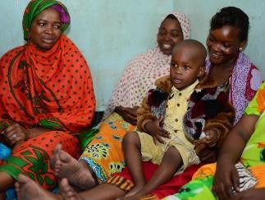
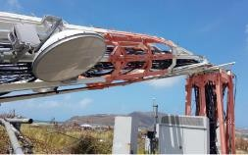
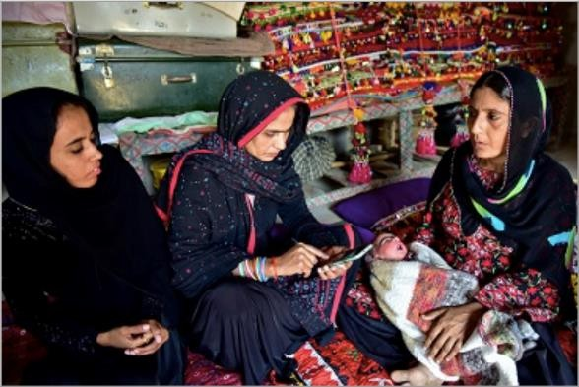
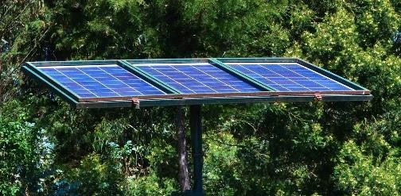
4) Ecosystem Accelerator is supporting Jamii Africa in Tanzania (and 34 other start-ups). Jamii enable people from low-income populations or the informal sector to have access to an affordable healthcare financing scheme. With the GSMA grant they will enrol more hospitals and allow users to register via mobile.
F. Annex A – Examples of innovation funds under current M4D partnership
2) Connected Women has created a toolkit - The Gender Identification and Analytics Toolkit (GAIT) – that enables operators to identify the gender of their subscribers using machine learning, allowing them to take more targeted action to close the mobile gender gap.
1) In 2015, the GSMA M4D Utilities awarded SunCulture a grant to design and scale solar-powered irrigation systems that make it cheaper and easier for farmers in Kenya to grow high-value fresh fruits and vegetables.
The RainMaker is a solar-powered irrigation system aimed at smallholder farmers, utilising pay-as-you-go technology to ensure affordability and therefore extending access to water pumping solutions to underserved communities in the developing world, starting with Kenya.

3) Connected Society launched an innovation fund In 2018 to support innovators in Ghana and Uganda who have technological solutions for the rural connectivity challenge. This fund is now at the contracting stage and will catalyse these early innovations, helping bring down the cost of last-mile connectivity and ensure more people have access to mobile-enabled services.
 | 

5) The Disaster Response programme (now Mobile for Humanitarian – M4H) worked closely with Digicel and Natcom in Haiti to enhance their disaster preparedness and response efforts. The team reviewed the current systems in Haiti and identified suitable early warning systems (EWS) for the country based on current capacity. The Disaster Response team will continue supporting the Department of Civil Protection, Digicel, and Natcom throughout the coming year to complete installing the DEWN system in Haiti.
G. Annex B – EA Scaling Stories: Crowding in private financing

INTRODUCTION
The GSMA Ecosystem Accelerator programme focuses on bridging the gap between mobile operators and start-ups, enabling strong partnerships that foster the growth of innovative mobile products and services.
These partnerships bring impactful mobile solutions to the people and places that need them most, generating the greatest socio-economic impact. In particular, the programme operates an Innovation Fund which supports start-ups from Africa and Asia Pacific with direct grant funding, technical assistance, and connections with mobile operators. To date £4.7 m of grant funding has been disbursed to 34 start-ups in 23 countries in Africa and Asia Pacific. DFAT co-funds the EA and has focussed more of its funding on start-ups in Asia Pacific.

CROWDING-IN SUMMARY
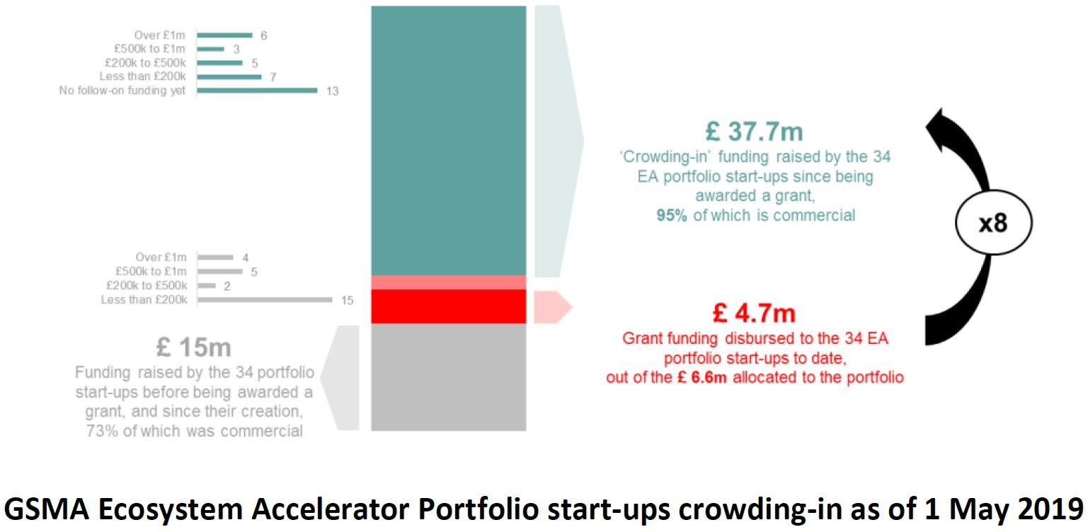
Since April 2016, the Ecosystem Accelerator portfolio start-ups have successfully raised £37.7 million in additional funding (after receiving grant funding from the GSMA Ecosystem Accelerator Innovation Fund). The image below compares the funding raised prior to grant funding vs post-award of grant funding.
Case study examples:

TwigaFoods | Kenya | Founded in 2014 | Crowding-in: £20m
Twiga connects smallholder farmers in rural areas to informal retail vendors in cities. GSMA funding from April 2017 enabled Twiga to build a mobile version of their food distribution service, connecting food stall owners and smallholder farmers, and to launch a financial services platform. Twiga has grown their userbase from 300 farmers to over 14,000 since the beginning of the GSMA project.

The Twiga team acknowledged that the GSMA partnership has “shown potential investors their ability to plan, execute and manage a project end to end which has given them confidence in Twiga’s ability to manage investor funds”.

Since DFID’s initial funding, TwigaFoods has raised additional commercial investment from several VC firms including Wamda Capital, MasterCard Foundation, Shell Foundation, Overseas Private Investment Corporation (OPIC), IFC and TLCom, Omidyar and Alpha Mundi.
For more: https://www.forbes.com/sites/mfonobongnsehe/2018/11/16/kenyan-startup-twiga-foods-raises- 10-million/
Ruangguru | Indonesia| Founded in 2014| Crowding-in: exact figure not public; north of seven figures (GBP)
Ruangguru is a freemium learning management system that helps students prepare for exams using content tailored to the national curriculum and helps teachers to crowdsource educational content and distribute it to students.
Following the funding that was secured from GSMA Ecosystem Accelerator in April 2017, Ruangguru has raised additional commercial investment from several venture capital firms including UOB Venture Management, MIT Solve, Atlassian Foundation, and East Venture.
For more: https://www.techinasia.com/edtech-startup-ruangguru-raises-series-b
eFishery | Indonesia | Founded in 2013| Crowding-in: £2.9m
eFishery offers an Internet of Things (IoT) and mobile-based smart feeding solution to improve efficiency and accountability in fish and shrimp farming
Following the funding that was secured from GSMA Ecosystem Accelerator in February 2018, eFishery was successful in attracting further substantial commercial investment backed by series of global investors such as Aqua-spark, Wavemaker Partners, 500 Startups, Maloekoe Ventures, Social Capital, Unreasonable Capital, Triputra Group.
For more: https://e27.co/indonesian-smart-fishery-platform-efishery-raises-us4m-funding-round-20181113/
Farmcrowdy | Nigeria | Founded in 2016 | Crowding-in: £1.6m
FarmCrowdy is Nigeria’s first agri-tech platform that connects investors with under-financed farmers in Nigeria’s agricultural economy.
Further to securing funding from GSMA Ecosystem Accelerator in February 2018, FarmCrowdy has raised additional investment from several venture capital firms including Cox Enterprises, Techstars and Ajayi solutions. GSMA’s funding helped the start-up de-risk the business and set up the required technical infrastructure to scale the business.
For more: http://disrupt-africa.com/2019/03/nigerias-farmcrowdy-raises-1m-in-additional-seed-funding/
Qlue | Indonesia | Founded in 2016 | Crowding-in: £1.1m
Qlue is a civic engagement app that allows users to actively report or share their neighbourhood conditions to city officials and/or businesses.
Further to securing funding from GSMA Accelerator in September 2018, Qlue has received a significant investment from Venture Capital (VC) owned by Telkom through MDI Ventures, where the funding is led by Global Digital Prima (GDP) Venture.
For more: https://e27.co/smart-city-app-qlue-secures-funding-from-telkom-indonesia-vc-20190212/
Overall the portfolio has surpassed expectations with 95% of the additional investments coming from commercial investors which is an encouraging trend for the sustainability of the portfolio. This is one factor to consider when assessing the path to scale for innovations. In addition to this metric, the Ecosystem Accelerator aims to also measure the number of start-ups which are reaching an early indication of scale. This is defined by the programme as the number of start-ups which have raised at least one million USD in additional funding. To date, eight start-ups (23% of the portfolio) have reached this milestone.

Mobile for Development (M4D) Business Case [June 2019]
39

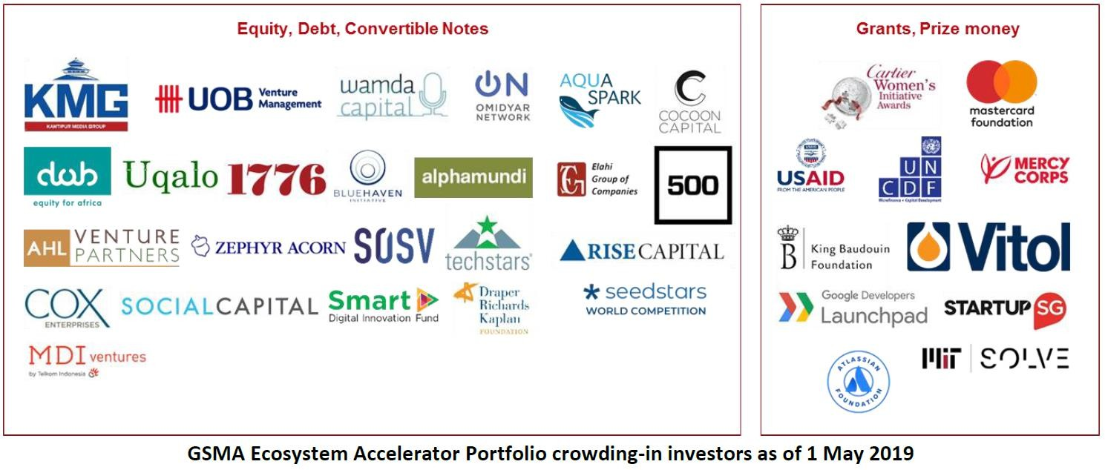
The level of crowding-in achieved has been facilitated by the Ecosystem Accelerator team based on a number of different features including:

- Timing of fund: For many start-ups, the grants awarded by the Ecosystem Accelerator programme were provided to the start-ups at the seed funding stage before they pursue growth or before their first venture capital (VC) investment. The grant funding is crucial to helping de-risk the start-ups business model, to bridge the gap with VC funding (often starting at around USD500k at the lowest) and to provide a catalyst to hone the product offering, refine their business model and strengthen their pitch.
  - Quote from Start-up: “Discussions with potential investors (especially the ones who flatly turned us down and then explained why, and with other start-up founders, really helped to bring certain topics and issues into sharp focus”.

- GSMA brand recognition: The GSMA brand is a well-recognised global brand. Start-ups have benefitted from their affiliation to the Ecosystem Accelerator programme and the profile given to them at key GSMA events such as Mobile World Congress, Four Years from Now (4YFN), M360 Series and leveraged the brand to position our portfolio of start-ups at other industry events e.g. Seedstars, VIVATECH, AfricaCom. The start-ups also feature in our publications and through a video case study series.
  - Quote from Start-up: “…Thank you and your team so much for a fantastic last week. I learned a lot and New Day was able to make strong connections to further our business. One highlight is that I met with LinkendIn’s Business Development Head of Africa/Asia. After seeing our pitch […] we discussed opportunities to partner...”
  - Quote from Investor: “Very helpful case studies highlighting new business models, and landscaping of emerging technologies”

- Lead generation: The due diligence process undertaken to award funding to start-ups is thorough and rigorous, through our investor networks we have shared insights with investors who were keen to invest in the portfolio. For example, Global Innovation Fund. In addition, the Ecosystem Accelerator team have facilitated leads to investors through the Ecosystem Accelerator Bootcamp (annual event) through one to one meetings.
  - Quote from Investor: “Bootcamp was very organized. My highlight was the session one 2 one between start-up and investors. It is very important”.

MNO partnerships

Securing a partnership with a Mobile Operator is a significant milestone and key enabler for the start-ups supported by the Ecosystem Accelerator programme as it provides a level of validation for early business models. To date the GSMA Ecosystem Accelerator programme has facilitated 18 partnerships between portfolio start-ups and Mobile Operators. Below are some examples taken from the Start-up portfolio booklet.
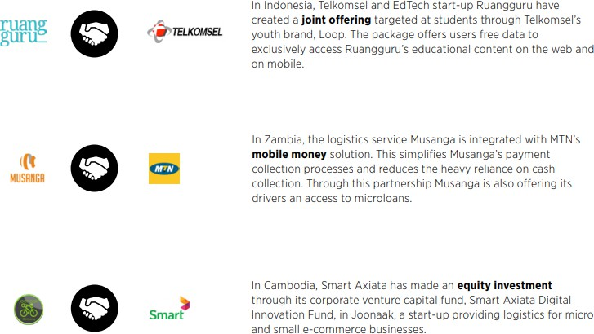
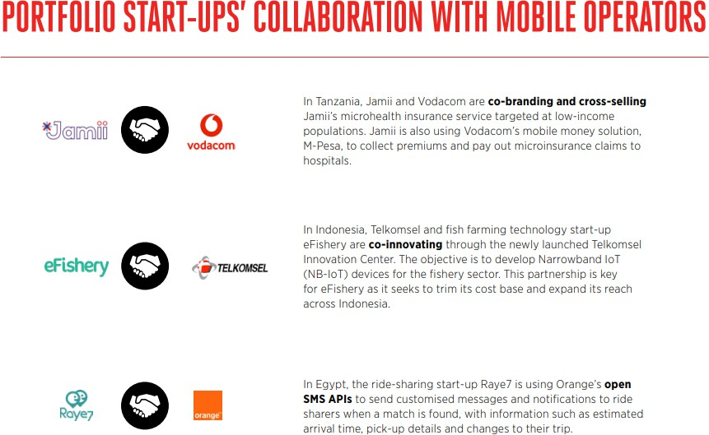
H. Annex C – Further detail on the seven proposed workstreams

Connected Women

Target beneficiary impact:
7,500,000 women who are digitally included using mobile internet and other mobile services Problem:
Mobile phone ownership, mobile internet and mobile money use have increased significantly among women, driving digital and financial inclusion. As the reach of mobile grows, it is becoming an increasingly powerful tool for delivering life-enhancing information, services and opportunities to millions who have not had the opportunity to access them before. Despite this growth, the gender gaps in mobile phone ownership and usage in low- and middle-income countries persist, especially for more transformative services such as mobile internet and mobile money. Across low- and middle-income countries, women are 10% less likely than men to own a mobile phone, 23% less likely to use mobile internet and 33% less likely to use mobile money with larger gender gaps in different regions and countries. The mobile gender gap also extends to usage where it widens further with women using a less diverse range of services and even when they use them, their intensity of use is lower. It is important to look at the full journey from mobile phone ownership to adoption and use of mobile internet and mobile money services, to ensure that women are able to use the services that can have significant impact on their lives. Women’s lower levels of mobile ownership and use not only reflect existing gender inequalities, but also threaten to compound them. If these mobile gender gaps are not addressed, women risk being left behind as societies and economies digitise. These gaps will not close on their own but require sustained and targeted efforts and cooperation. The fast pace of change also means there are emerging issues and opportunities that can have significant impacts on women that need to be considered (e.g. AI which can reinforce existing gender inequalities and new use cases which are emerging).

Opportunity:

While access is increasing, many of the women who could potentially stand to benefit the most from mobile connectivity are still the furthest away from being able to access it. Sustained and targeted efforts are required to ensure that women are not left behind in an increasingly connected world. Addressing these issues and gender gaps will deliver substantial benefits for women, their families and society. Not addressing them could exacerbate existing gender inequalities. The Connected Women programme is well placed to drive further action on this issue particularly in terms of digital and financial inclusion for women and driving efforts to reach women at scale. The programme has developed powerful insights which are widely cited and driving increased awareness and action on this issue; catalysed private sector action resulting in 52 commitments by mobile operators, who have reached over 16 million women; and has taken a leading voice at multi-stakeholder forums such as EQUALS, W20 and the Broadband Commission. The programme proposes to further build out insights for inclusion and scale, by monitoring the size of the gender gap; building greater understanding of the opportunities for driving women’s mobile internet and mobile money usage including more advanced use; documenting models which work as scale; and sharing insights on emerging issues and opportunities from a gender perspective. The control aspect (meaning making sure that women who access phones, or mobile money, have control over it) is also considered in our qualitative research as part of the research and evaluation activities of select initiatives. All these approaches would also seek to motivate further action to scale business models and approaches which address the gender gap. Finally, Connected Women would continue international advocacy efforts to raise awareness and call for action on this issue.

Focus:

- Inclusion – those being left behind are disproportionately women and by focussing on addressing these gender gaps Connected Women works to help ensure that no one is being left behind.

- Innovation – the programme will continue to support mobile operators to deploy innovative approaches to reach women. Our experience is that, in most cases, the "innovation" that is required is merely a modification of existing activities (marketing, distribution, etc.) to consider the wants, needs and
circumstances of women in different markets. To address the gender gap, it is often a matter of integrating the consideration of gender across existing activities than stand alone or "new" innovations. One discrete area of stand-alone innovation is the GAIT algorithm to estimate the gender gap in existing customer bases; The programme will continue to expand its GAIT algorithm, in collaboration with the Mobile Money team.

- Scale – while mobile access is increasing for women, a significant gender gap persists which won’t close on its own without targeted, measurable effort that delivers at scale. Connected Women is focused on driving and evaluating efforts focused on delivering at scale.

Assistive Tech 
Target Beneficiary Impact:

1,000,000 people with disabilities with access to mobile enabled services Problem:
An estimated one billion people globally suffer from some form of disability (20% in developed, 80% in developing countries), and yet only one in ten of those are getting access to the assistive technology they need to live healthy, productive, independent, and dignified lives; to participate in education, the labour market and civic life. Furthermore, disabilities significantly affect mobile phone use, increasing the magnitude of the digital divide. As more services become ‘digital by default’, there is an increased risk that Persons With Disabilities (PWDs), may be once again left behind if technology products and services are not made accessible and affordable to all. Actions are further hindered by the lack of evidence that exists today about the adoption levels and usage of mobile devices and services by PWDs, but also by the negative attitudes and perceptions of PWDs as a non-viable market segment for the private sector.
Opportunity:

As mobile connectivity continues to transform the lives of billions and has a profound impact on the Sustainable Development Goals, it is time for the mobile industry to take action and maximise the positive impact on the lives of PWDs.

In line with the AT2030 programme, led by the Global Disability Innovation (GDI) hub, and after having collected insights on the current mobile access gap for PWDs in Kenya and Bangladesh, GSMA will address Inclusion and Innovation opportunity areas:
- Inclusion to leave no one behind - M4D will provide critical insights and evidence on the global role mobile could play as an assistive technology across regions and sectors, as well as develop a framework of actions for the mobile ecosystem and champion the inclusion of PWDs, promoting accessibility of services;

- Innovation to test new ideas - M4D will foster and nurture innovations facilitating and enabling access to mobile services for all and applied to assistive technology products, by providing funding / technical expertise bringing together mobile operators and entrepreneurs; and capture and disseminate pilot learnings to encourage scaling and continued innovation.

Focus:

- Improving accessibility of mobile services for PWDs:
- Supporting the development of appropriate mobile products (e.g. voice recognition platform for mobile operators) and mobile enabled assistive technology products using universal design;
- Promoting and championing PWDs for and within the mobile industry.
The programme will be in liaison with the recently approved (DFID funded) AT2030 initiative to ensure that efforts are complementary and not overlapping.

Connected Society

Target Beneficiary Impact:

5,500,000 people covered and/or using mobile internet Problem:
Mobile is driving digital inclusion and for most of the world’s population, mobile is the primary way to access the internet with over 3.6 billion people connected to mobile internet. However, whilst mobile operators continue to invest heavily in extending 3G and 4G networks, there are nearly 800 million people who are not covered by a mobile broadband network (the ‘coverage gap’). In addition to this, there are over 3.2 billion people who have access to mobile broadband coverage but are either unable or unwilling to use it it (the ‘usage gap’). There is therefore a need to focus on both the coverage and usage gap to ensure digital inclusion for the underserved. Key to extending mobile broadband networks and addressing the coverage gap will be reducing regulatory and cost barriers to deployment, including rural infrastructure costs, which can be twice as expensive with revenues up to ten times lower than in urban areas. There are new innovations emerging, but many are untested, commercially unproved or not yet scaled. There is an ongoing need to assess these innovations and their potential for extending coverage along with the approaches to deploying them. There is also a need to engage with other key stakeholders such as governments and investors to help drive effective enabling environments and partnerships in this area. Coverage is not sufficient, and efforts are also required to address the substantial usage gap. Many of those not using the internet where it exists lack the means, awareness, skills, motivation or the trust, and often it is a combination of these factors. Addressing the usage gap requires that it is accessible, affordable, relevant, safe and secure while ensuring people have the skills and confidence to effectively use it.
Opportunity:

Addressing the barriers to digital inclusion is important since the mobile internet has become an essential enabler for economic growth and societal development and a key driver for achieving progress across all of the United Nation’s Sustainable Development Goals. In the current phase of the programme (2016-2020), Connected Society has already successfully delivered tools and analysis to advance digital inclusion, including mobile coverage maps to guide rural infrastructure investments, a toolkit for mobile internet skills to increase digital skills, the Mobile Connectivity Index and an innovation fund to test innovative low-cost mobile internet connectivity solutions. The Connected Society programme is well placed to drive further insights and action to address both the coverage and usage gap, driving increased digital inclusion and scale. Extending coverage and increasing adoption and use of mobile internet requires increased understanding of the emerging innovations and business models and their potential to scale. The programme is uniquely positioned to support mobile operators and their partners in these efforts and to assess these approaches to extending mobile internet coverage and usage, developing insights for inclusion and scale. The programme also proposes to support and test innovations which can reduce the cost of rural connectivity or key barriers to mobile internet adoption to understand their commercial and technical viability. It would also seek to motivate further action to scale business models and approaches which drive digital inclusion including scaling efforts to expand mobile internet skills. Finally, Connected Society will undertake advocacy to raise awareness and call for action on these issues as well as foster partnerships which can drive digital inclusion.

Focus:

- Inclusion: despite the substantial benefits mobile internet brings there are many who remain unconnected, including many unserved and underserved population groups who could potentially stand to benefit the most from mobile connectivity. The efforts of Connected Society will be focused on helping to drive digital inclusion for the underserved.

- Innovation: there are a number of innovations emerging which have the potential to drive digital inclusion and Connected Society will focus on supporting, testing and assessing these innovations and their potential to extend mobile internet coverage and usage.
- Scale: the size of the challenge required coordinated action by many stakeholders to deliver at greater scale. Connected Society will focus on driving and evaluating efforts which have the potential for commercial sustainability and scale.

Digital Identity
Target Beneficiary Impact:

300,0009 people with mobile enabled digital identities enabling them to access services Problem:
Over a billion people around the world lack formal identification. The majority are women, girls and Forcibly Displaced Persons (FDPs) in Africa and Asia. Most of them reside in developing countries whose governments may currently be leapfrogging outdated identification models by developing Digital Identity ecosystems and exploring ways to link such Digital IDs with the provision of several social benefits, health, educational and/or e-Government services. This can further exacerbate the exclusion or marginalisation of underserved groups who may (still) be unable to access a Digital Identity. The current phase (2016-2020) of the Digital Identity programme demonstrated that Mobile Operators can play a role in closing the Identity Gap, by supporting Governments’ efforts to register more people e.g. through Digital Birth Registration initiatives or National Digital ID enrolment processes. There is also a risk of vulnerable groups being left behind as LMIC transition from paper-based to digital processes. The lack of a clear and tested business case may be limiting Mobile Operators’ risk appetite to explore more innovative services that leverage their own customers’ data assets (responsibly) to improve beneficiary identification in development contexts while achieving social impact. This could in turn slow down Digital Transformation of developing economies and/or lead to missed opportunities for driving more effective digital and financial inclusion among underserved populations.
Opportunity:

Inclusion: Digital Identity has established that MNOs can play an important role in leveraging their reach and assets to support Government efforts to accelerate, digitalise and improve Foundational ID processes including Digital Birth Registration processes (Pakistan, Ghana, Tanzania), National digital ID enrolment (Nigeria) but also sharing best practice where Mobile ID drives Digital Transformation (Moldova, Estonia). The GSMA Digital ID programme has established itself as a thought leader and gained a wealth of insights and experience to build on and share. We therefore propose to focus the next phase of the DFID partnership on promoting PPP models where MNOs support Foundational ID ecosystem - through global and local advocacy and building partnerships between Governments, MNOs and other key stakeholders, as well as disseminating information on the useful roles MNOs could play in accelerating or supporting the roll-out of Digital ID ecosystems, and how this can be done most effectively based on cross-country experiences. A tangential but hugely relevant opportunity is to understand and advocate for privacy frameworks that build and maintain consumers’ trust in Digital ID ecosystems. The absence of such frameworks – including checks and balances on governments’ powers to access communications data – allows for possible exploitation of citizens’ data which would in turn impact trust.

Innovation: Identify and financially de-risk a few specific innovative use cases involving Mobile Operators (working alone or with partners), leveraging customer data assets to develop enhanced beneficiary identification services. Mobile operators already have access to a variety of attributes linked to a registered SIM card (approximate location, frequency of being topped-up, mobile money transaction history if registered to the same person, call data records, customers’ identity data where robust SIM registration processes are in place etc.). MNOs therefore have an opportunity to offer, personalised life-enhancing

9 Digital Identity's experience over the last 3 years showed that despite initial interest expressed by MNOs in proposed use cases, maintaining MNO interest and turning their ‘soft’ commitments into actual projects with dedicated resources proved to be a challenge. One explanation is the need to de-risk the uncertainty of the business model. A second hypothesis is that as more consumers are participating in their countries’ digital economies, actual and perceived privacy concerns may inevitably impact their willingness to adopt and use new digital services (whether offered by the Government or the Private sector). For example, we have found that 40% of countries mandating SIM registration have no Privacy or Data Protection policies in place. We also know that many underserved individuals may already have a mobile phone and a formal identification but have either failed to see the value of registering in their own name using a formal ID or they registered but do not use their mobile as a means to access other (personalised) life-enhancing services. Any Identity-linked mobile services offered by MNOs will therefore have to be designed in a way that engenders consumers’ trust and respects their privacy, even in countries that lack such formal privacy laws.
services to mobile users and/or improve processes where beneficiary identification is important (e.g. a G2P or P2G use case).

Focus:

- Disseminate information on the useful roles MNOs can play in supporting or accelerating the roll-out of Digital Identity ecosystems; For example, by positioning and promoting the role of MNOs as ideal Government partners for supporting National Digital ID enrolment and CRVS (e.g. Digital Birth Registration) strategies

- Understand the pain points that may be limiting MNOs’ commercial appetite to invest in Digital Identification services that leverage their customers’ data assets to achieve social impact. Investigate how to mitigate these pain points and ensure findings are shared with MNOs/partners and are reflected in the Advocacy efforts.

- Provide innovation funding to a few Mobile Operators (whether working with partners or not) in developing use case(s) where mobile-derived data assets are used to improve beneficiary identification (in a given context) and therefore accelerate the digital transformation of socially impactful services.

M4D Utilities
Target Beneficiary Impact:
5,000,000 people with access to water, sanitation and/or modern energy services. Problem:
The Mobile for Development Utilities programme has been at the forefront of leveraging digital solutions to address UN Sustainable Development Goal 6 on clean water and sanitation and Goal 7 on affordable and clean energy. Through research, grant funding and advocacy the programme has demonstrated that digital technology can contribute towards safe, reliable and affordable water, sanitation and energy services for the underserved. In particular, the M4D Utilities programme has played a strong role in supporting the emergence and growth of the pay-as-you-go (PAYG) off-grid solar industry, encouraging crowding-in of both public and private funding, as well as replication of the PAYG model to other industries such as water or cooking gas. Since 2013, the programme has catalysed innovation (53 grants awarded across 28 countries) had a meaningful impact in the lives of the underserved (directly impacting over 2.7 million people and indirectly over 27 million people) and accelerating crowding-in (from the £9.4 million awarded, a further £233 million was raised by the grantees). Two important areas remain where more work is needed to innovate and scale essential and inclusive utility services that in turn drive socio-economic outcomes: leveraging M4D Utilities programme’s experience to tackle the challenges facing the growing urban poor populations in emerging countries and supporting PAYG models to maturity.

Opportunity:

The M4D Utilities programme is uniquely positioned to leverage its expertise in utility service provision for people at the base of the pyramid in emerging markets. Since 2013, the programme has a proven track record of catalysing the multi-stakeholder partnerships – with municipalities, utility service providers, tech innovators, and MNOs – that are needed to address the complex and dynamic challenges of making essential urban utility services accessible and reliable for all, with a specific focus on the urban poor who are suffering the most from the absence or inefficiency of urban utility services. Mobile enabled-solutions have tremendous potential to improve urban utility service delivery across 1) digitisation of payment systems (e.g. CityTaps),
2) Digitising utility operations (e.g. Wonderkid) and 3) Digitising the utilities ecosystem following a ‘platform model’ (e.g. KCCA). By focussing on carefully selected rapidly growing cities looking to leverage their digital ecosystem, the M4D Utilities programme will showcase mobile and digital tools as key enablers for urban utility service delivery models that:
- Increase the access and reliability of utility services for the urban poor
- Make service provision payments more manageable through digital solutions
- Increase the adaptability of these services to rapid population growth
In the first months of this new phase, the programme will undertake further landscaping, which will refine the prioritisation of areas of impact.

Focus:

The M4D Utilities programme will have three focus areas:
- Innovating new ways to bring reliable and accessible urban-focused utilities services to the underserved
- Inclusion to ensure the needs of the underserved are prioritised within urban utility services
- Scaling interventions (e.g. replication in new markets and including start-ups from the current portfolio).
Within this work, there will be a focus on providing utilities for the urban poor, itself split into four main areas; 1) Energy, 2) Water, 3) Sanitation, 4) Mobility. These areas have been identified as service areas that (1) impact the same target (urban poor), (2) can be strengthened through public private collaboration with a similar set of stakeholders, and (3) deliver impact through the similar applications of mobile technology. In the first months of this new phase, the programme will undertake further landscaping, which will refine the prioritisation of areas of impact, and ensure the specific needs of the urban poor are addressed by the programme.

Ecosystem Accelerator

Target Beneficiary Impact:

5,000,000

Problem:

Today in emerging markets, more than anywhere else, there are opportunities for mobile operators and start-ups to collaborate across a range of verticals. Mobile operators have reached the level of scale that start-ups lack, while start-ups have the local innovation mobile operators need to stay relevant to their existing customers and to attract new customers. The potential for collaboration is a real opportunity to scale mobile and digital innovation across those markets and to drive a significant socio-economic impact. Operators who collaborate successfully with start-ups are often able to strengthen market penetration and brand loyalty, maintain or grow revenues, and deliver meaningful social and economic impact. In the past year, research conducted by the Ecosystem Accelerator programme shows that there are over 1,000 active tech hubs powering start-ups in Asia Pacific and Africa and 13% of those hubs are run in partnership with local mobile operators.
Opportunity:

The Ecosystem Accelerator programme has built a robust model for sourcing relevant start-ups, enabling operator-start-up partnerships for commercial and socio-economic impact and driving further ecosystem collaboration through insights and advocacy. These partnerships bring impactful digital solutions through mobile to the people and places that need them most, generating the greatest socio-economic impact. In the first 3 years of the programme, the Ecosystem Accelerator has directly supported 35 start-ups in 23 countries with grant funding (£6.5m allocated) and technical assistance, facilitated 18 partnerships between portfolio start-ups and mobile operators and impacted 1.8 million beneficiaries; collectively the 35 ventures have raised an additional £36m in investments (‘crowding-in’), the large majority of which (95%) is commercial. Building on this model and leveraging in-house expertise, there is an opportunity to apply the model to the different areas explored by this Partnership between GSMA and DFID as well as to key emerging areas trends for the next generation of innovative solutions where patient capital and technical assistance are needed to support the development and scaling of innovative solutions. It is critical that the Partnership plays a role not only in identifying which frontier technologies or innovations can have a disruptive impact on ‘M4D’, ‘ICT4D’, or international aid more generally, but also in providing direct support to local private sector players – start-ups in particular – who are focusing their resources on addressing these. Indeed, the GSMA’s track record in building expertise and clear messages and advocating for the powerful role of digital technology in addressing the Sustainable Development Goals, relies strongly on their ability to complement their advocacy and insights with demonstration projects, specifically through the innovation fund mechanisms.
Focus:

- Innovation by (a) managing the entire Innovation Fund of the GSMA-DFID Partnership in a centralised structure in support of the other programmes, and (b) directly delivering one innovation fund round on Frontier Technology.
  - Based on the experience of the Ecosystem Accelerator programme, the programme will take the lead on managing the innovation fund for the Partnership. By replicating this successful model, the programme will be able to drive more consistency in the approach to outreach, due diligence, partnerships, the way innovations are profiled to external stakeholders and crowding-in. The expertise and fund management know-how will drive more operational efficiencies and opportunities for synergies in the approach to monitoring and evaluation.
  - The purpose of this round of funding will be to validate the chosen frontier technology/ies’ potential to generate socio-economic impact in a commercially sustainable way. Links with the DFID FTL and Futures work will be established as part of this work.

- Scale interventions (e.g. replication in new markets, and including start-ups from the current Partnership)
- See Annex B for scaling stories from the EA to-date.

Clean Tech

Target Beneficiary Impact:
2,000,000 people have access to mobile enabled clean tech services that make them more resilient to climate change.

Problem:
For over a decade GSMA M4D has put the focus on innovating in social impact space and scaling successful and solutions through partnerships, technical support and grant funding. At the same time the global environmental crisis has reached unprecedented scale, with: extreme weather conditions becoming a norm ; population sizes of wildlife decreasing by 60% globally between 1970 and 2014 with biodiversity reduction trend projected to result in Africa losing 50% of its birds and mammals by 2050 and a complete collapse of Asian fisheries ; daily loss of over 100,000 acres of rainforests (UN) that lead to 50% of temperate rainforest being already lost, and projections of climate catastrophe released in October 2018 by Intergovernmental Panel on Climate Change October with estimated 11 years horizon left to make a meaningful transition to new operating models. The impact of the environmental damage will continue to affect the poorest of the world the most, as their ability to adapt, get through a loss of key assets, migrate and/or switch to alternative livelihoods is the most limited. While digital solutions are commonly seen as a solution to socio-economic challenges, digitisation of society has its own environmental implications. New solutions and devices, including mobile phones, solar panels for PAYGO systems, batteries, sensors - all have a limited lifespan, which tends to shorten over time with the increased rate of innovation.
Environmental impact of mining for valuable elements as well as health and environmental impact of sending the technology to landfill was until recently underestimated, which resulted in lack of processes and systems for responsible disposal of electronics, and consequent health implications. At the same time a provision of connectivity to support the digitisation of the economy has ever increasing demand for power and in most off-grid environments relies on the dirtiest of all energy sources – diesel.

Opportunity:
‘Healthy environment is the foundation for all life on earth, including human civilizations.’ Digital technology is the enabler for the world’s transition towards sustainable production and consumption models. New and emerging technologies such as IOT networks and AI, combined with established connectivity, rise of smartphone and mobile money adoption - allow for a range of solutions required for conservation and natural resource management industry, adaptation and preparedness to climate shocks in cities and smart urban infrastructure. While the transition towards sustainability needs to happen rapidly, the prevalence, availability and financial viability of digital solutions for natural resource management, climate adaptation and optimisation of infrastructure in developing countries remains minimal and fragmented. Leveraging the GSMA global team’s experience in unifying technology practices across sectors and regions and catalysing
private sector participation in high impact sectors, GSMA is well placed to: identify innovation, facilitate scale and move from fragmentation to replicable best practice models in the nascent and new "Clean Tech space" in developing markets. GSMA can broker partnerships across industries and sectors, create best practices and common narrative to support advocacy efforts required for the transition to resilient, equitable and decarbonized societies. At the same time through their access to member network of mobile operators, device manufactures and equipment providers, GSMA is one of few organisations that can credibly lead the transition towards circularity in the digital economy’s supply chain.

Focus:

GSMA has identified among other possibilities, three main areas of impact (see Figure 13 below): natural resource management (NRM), smart and resilient infrastructure and circular economy. Opportunities for impact span across three types of geographical environments.

- Resilient Communities - Traditional environment where GSMA has been predominantly testing new innovations is in rural areas. Although significant progress has been made in extending connectivity, income-generating assets (PAYGO), digital financial and information services (e.g. health) to rural communities, experimentation on climate adaptation subject began only recently – e.g. climate smart agriculture advisory and weather information under GSMA mAgri programme.

- Resilient Cities - With the exponential rates of urbanization from late 1990s10 the future focus of M4D work should be equally concerned with the second geographical type of environment – cities, per-urban and informal settlements, focusing on the poor and those most impacted by climate change.

- Natural Capital - Third geographical environment to be considered for impact is the areas of protected or unprotected nature hold majority of the natural capital (forest, water, wetlands, soil), provide habitat for flora and fauna, and have fragile and ever moving boundaries with the neighbouring communities. This segment appears to be a later-comer to digitisation efforts, well behind more prominent sectors of the industry which are commercially driven and embrace innovation earlier on the adoption curve.

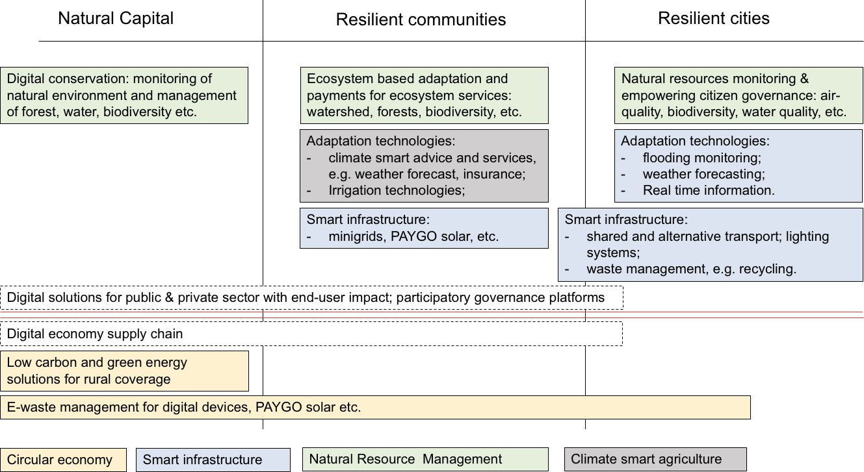
The initial focus of this new element to the partnership will be to conduct an in-depth landscaping study to understand the broader ecosystem as it is today across the three areas defined above. It will inform the direction and granular focus of the programme moving forwards, ensuring M4D continues to prioritise the areas of development where the GSMA, MNOs and mobile-enabled solutions have true additionality and credibility to engage with sustainable interventions.

Figure 13 – Clean Tech opportunities for impact
10 https://ourworldindata.org/urbanization

Digital for Development: Cross-cutting Insights (D4D Insights) Unit
Problem:
Digital inclusion and the use of mobile platforms have become key factors for a global access to the information society and knowledge economy. This is true for development agencies and the donor community as well, where digital has become a powerful tool for impact. While most emerging markets are pursuing their transition to mobile broadband networks and services, there is a risk of creating a digital divide if the foundations of a digital ecosystem are not properly considered (ex. that includes accessibility and affordability of services). At the same time, frontier technologies such as Artificial Intelligence and Blockchain, and the upcoming deployment of 5G networks, will greatly impact markets, industries and communities. In this fast- changing technological landscape, it is hard to understand the reality and impact of the digital channels on people and institutions, and how to define the key areas of interventions for Digital for Development (D4D) strategies and their implementation.
Opportunity:

Through its global expertise in mobile for development (financial services, health, agriculture, identity, utilities, start-ups, disaster resilience and gender equality), GSMA M4D is uniquely placed to become a knowledge and thought partner to guide and inspire DFID in its digital journey. Positioned as an M4D Central programme, this small & agile team will strengthen the M4D collective work while providing insights and expertise to DFID staff and offices on frontier Digital for Development subjects. Pending internal demand, this will offer a draw-down capability for teams across DFID to access GSMA’s expert consultancy for tactical and technical assistance, proactively responding to and supporting DFID offices and teams on a variety of topics. This will be similar to how the GSMA (via M4H) have supported DFID’s humanitarian efforts following Hurricane Irma and with the epidemiological applications of GSM data in tracking migratory diaspora in Ebola-affected DRC. We intend to set up this facility in a way that also allows other DFID-funded programmes and country offices to commission additional work from their own budgets, e.g. the separate Agri-Tech programme with GSMA.

Focus:

- Advising on the use and impact of frontier Digital for Development technologies.
- Engaging with DFID staff and offices to support the implementation of D4D strategies; currently planned for inclusion (following x-DFID engagement) are; a landscaping study of mHealth interventions, landscaping the future of work in Africa and youth employment opportunities in the digital economy; mapping use of big data for monitoring the spread of infectious diseases e.g. Malaria, Ebola; along with producing additional data coverage maps.

