Annual Review

Title: Mobile for Development (M4D): Strategic Partnership for Inclusion, Innovation and Scale
Programme Value £ (full life): 75,565,000 |  | Review date: August 2025
Programme Code: 203804 | AMP start date: 30 Sept 2019 | AMP end date: 31 Mar 2029

Summary of Programme Performance
Year | 2020 | 2021 | 2022 | 2023 | 2024 | 2025
Overall Output Score | A+ | A+ | A+ | A+ | A+ | A+
Risk Rating | Moderate | Moderate | Moderate | Moderate | Moderate | Moderate

DevTracker Link to Business Case: | https://iati.fcdo.gov.uk/iati_documents/D0007332.odt  https://iati.fcdo.gov.uk/iati_documents/D0005499.odt
DevTracker Link to results framework: | D0007333.xlsx

A. SUMMARY AND OVERVIEW

Description of programme

Digital innovation has the potential to revolutionise the lives of the poor, unlock development and prosperity, and accelerate progress towards the Global Goals. In low- and middle-income countries (LMICs) mobile phones are the main – and often only – way for people to connect to the internet. While legacy technologies, such as USSD, IVR and SMS will, in many cases, remain key service delivery channels to reach the underserved, integrating these with emerging technologies such as artificial intelligence (AI) or the Internet of Things (IoT) will be critical in enabling the development of smarter, data-driven, inclusive solutions that address socio-economic challenges. Mobile technology can also be an enabler of scale for social enterprises as it provides the infrastructure for payments, communication and content, and allows new and more direct access to markets.

However, there remain multiple barriers to ensuring that digital technologies become truly powerful tools for countries, businesses, and citizens to overcome socio-economic challenges. There is a risk of entrenching the digital divide, with an estimated 235 million fewer women than men using the mobile internet in LMICs. Entrepreneurs face challenges pioneering digital business models, having to overcome a still-nascent funding ecosystem. Finally, LMICs face several barriers in scaling emerging technologies – especially AI – including limited access to financing and infrastructure, lack of skills and expertise, concerns around privacy and ethics, and complexities in ecosystem collaboration.

The purpose of the Mobile for Development (M4D) programme is to bring together the mobile ecosystem and the development sector to stimulate digital innovation to deliver sustainable business models and large-scale socio-economic impact for low-income people in the developing world. This is being achieved by unlocking mobile-enabled innovations which deliver on the UN Sustainable Development Goals (SDGs), as well as improving people’s access to and use of digital and mobile services.

The FCDO has partnered with the GSMA Mobile for Development Foundation since 2013. The current business case started in 2019 and was extended in 2024 (‘Partnership Phase 3’). FCDO’s support to the programme has demonstrated that mobile technology can deliver digital and gender inclusion, improve access to employment, and strengthen climate resilience at scale. However, challenges persist, with a post-pandemic slowdown in rates of digital inclusion, the growing impact of the climate crisis, and the risk of LMICs being left behind by emerging technology, particularly AI.

The Partnership is flexible in nature to respond to FCDO’s priorities and focuses on four core areas:
- Digital inclusion of women and girls and other underserved groups [Connected Women & Connected Society programmes];
- Climate change mitigation, adaptation and resilience [Climate Tech & Digital Utilities programmes];
- End-to-end innovation and investment, harnessing digital technology, partnerships with mobile network operators, and leveraging private capital to support start-ups transition into scale-ups [Innovation Fund]; and
- Emerging Tech to unlock the potential of AI and emerging technologies for the underserved in LMICs [Emerging Tech programme].

In addition, the Partnership provides tailored expertise to FCDO country offices on how mobile, digital and emerging technologies can help unlock positive impact at scale [Central Insights Unit (CIU)].

FCDO’s funding since 2019 has leveraged a total of £25.7m from other funding partners, including Sida, the Gates Foundation, USAID, GIZ, Visa and NORAD. The GSMA also supports the current phase of the Partnership through in-kind and cash contributions with a total commitment of £14m.

Summary supporting narrative for the overall score in this review

The Partnership has met or exceeded all of its annual impact, outcome and output milestones.

Key achievements from this reporting year include:
- Increases reach: The Partnership has reached an additional 44.7m people (57% female) with access to life-enhancing mobile-enabled services during this reporting period, increasing the total number of people reached to 211m since 2016. Figure 1 shows the scale of impact since the start of the first phase of the Partnership.
- M4D acting catalytically: The 45 grantees supported through the first six Innovation Fund rounds since 2021 have raised an additional £15.5m in funding during this reporting period, thanks to the support they received through the programme. More and more grantees/alumni are replicating across continents with the first merger between two alumni (Knowledge Platform and Eneza, see box 2) also happening this past year.
- M4D grantees improving livelihoods and increasing resilience: An inclusivity study (conducted across four Innovation Fund alumni) showed that users of these grantees’ services report improved livelihood and increased resilience coming from increased asset security, ability to access information and financial services that can support income generation.
- GSMA’s role in advancing AI for impact: GSMA has played a pivotal role in harnessing the momentum around AI for development, focusing on three core areas:
  - Research: GSMA’s research on AI has attracted significant interest (see Box 7), with four new research initiatives launching in FY25/26. Notably, there is also significant demand from FCDO for AI-focused research through the Central Insights Unit, reinforcing the relevance and urgency of GSMA’s work in this space.
  - Engagement with Mobile Network Operators (MNOs): M4D is deepening collaboration to ensure AI solutions are both impactful and scalable (see Box 4).
  - Innovation: The Innovation Fund for Impactful AI has received a record number of applications, underscoring the sector’s enthusiasm and the fund’s relevance.
- Strengthening the connection with FCDO country offices and local actors: The CIU has proven to be instrumental in strengthening post-level collaboration in priority countries/regions. Over the past year, there has been a clear trend in requests centred around AI and climate. The trend will continue in the coming year with four requests accepted – three on AI and one on climate.

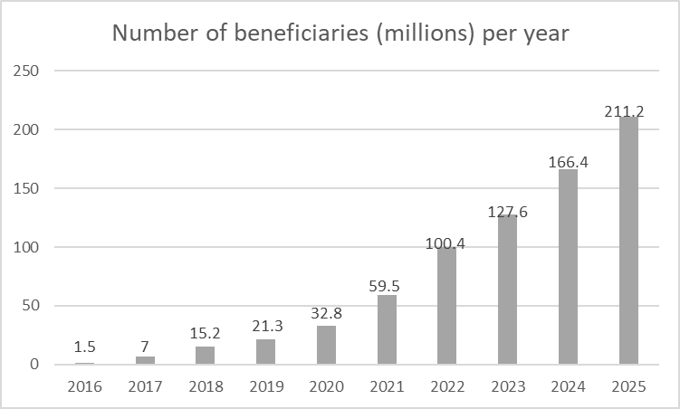
Figure 1: Increase in beneficiary figures over time, in million (Phases 1 - 3)

Major lessons and recommendations for the year ahead

Lesson learnt | Recommendation
AI: The demand to understand the opportunities and risks of AI for development is growing amongst stakeholders in LMICs, as testified by the high demand from local FCDO posts and the number of citations and views from M4D’s recent studies on that topic (see box 7 and annex 3). AI is increasingly used by innovators in LMICs as a facilitator or catalyst for scale or automation, as well as MNOs to propose innovative services facilitating digital inclusion of the most vulnerable communities.  However, several barriers hinder the responsible and effective deployment of AI, including regulatory gaps, data ecosystem deficiencies, infrastructure and computational constraints and a skills gap. Furthermore, without deliberate inclusion strategies, AI risks reinforcing existing inequalities and excluding women, people with disabilities, and rural communities from its benefits.  GSMA published two flagship reports on AI in Africa to explore this further AI for Africa: Use cases delivering impact and AI in Ethiopia: Promising use cases for development. | Over the next reporting year, the Partnership should:  - Select high-quality grantees of the Innovation Fund on AI for Impact and support them on topics such as responsible AI to ensure they deploy their services in a responsible way.  - Develop a clear learning agenda for the AI Innovation Fund round to better understand the additionality of AI in reaching impact objectives, the risks and challenges in building inclusive AI solutions and ecosystems, as well as the role of MNOs in enabling and scaling AI innovations in LMICs, amongst other things. This learning agenda should be developed in partnership with the FCDO, including our other programmes working on these topics.  Learning that will be generated through the IF will be complemented by four planned research pieces on AI commissioned through the CIU.
Inclusivity: M4D commissioned an external study (summary published here) to the socioeconomic impact of the GSMA Innovation Fund with four case studies: Key findings:  - Economic vulnerability:  - Users from all grantees were from economically vulnerable communities, typically in the 2nd and 3rd quintiles.  - Impact on resilience:  - The impact was significant in improving resilience through income stability and security.  - Job creation:  - Evidence of job creation was limited and often involved low-quality jobs due to regulatory challenges.  - Role of digital technology:  - Digital tools were most effective when complemented by low-tech/ offline solutions, enhancing access and localised information.  - The catalytic value of digital varies among grantees based on market conditions, business model, and the solution’s contribution to poverty alleviation. | The external study also made a number of recommendations, including on enhancing user retention and long-term engagement, as well as addressing regulatory and market constraints by engaging with policymakers on key constraints and supporting grantees’ participation in industry associations or regulatory discussions. FCDO and GSMA should analyse those recommendations, and jointly agree which ones are appropriate to take forward in the current context.  Furthermore, the programme should undertake a grantee digital scalability learning paper to look at the role of digital in grantees' impact pathways at scale. The objective is to understand more about the types of grantees and contexts in which digital both generates scale and creates impact. This will be used to inform the programme’s impact approaches and methodologies and should be published externally.
Climate: The programme commissioned a formative evaluation aimed to review its climate portfolio and assess how the strategy and programming can be strengthened.  The study found that  - Mobile and digital technologies can positively influence climate action, but their impact is often limited unless implemented through more holistic, system-based approaches.  - GSMA’s current initiatives demonstrate promise, particularly engaging multiple stakeholders and addressing various aspects of climate vulnerability.  - The evaluation also identifies strategic gaps in GSMA’s problem analysis and assumptions. While the programme is effectively executing many aspects of its model, it has not fully articulated or addressed the structural, political, and institutional factors that drive climate vulnerability. | Once the final version of the report has been agreed, it will be important for FCDO and GSMA - together with our climate advisors and in-country colleagues - to jointly reflect on the evaluation findings, ensuring that the insights and recommendations we endorse are effectively carried forward.
Reduction in aid funding: The UK’s and other donors’ cuts in ODA spend will have a repercussion on the M4D programme. It is critical to ensure that GSMA remains best positioned to deliver for FCDO and the most vulnerable communities reached by its programmes. | FCDO and GSMA will engage in a strategic and iterative dialogue to determine the optimal scope and structure of the M4D programme in alignment with FCDO’s priorities - including thematic focus, delivery mechanisms, and desired outcomes - ahead of the FY26/27.  In parallel, GSMA and FCDO should collaborate to strengthen stakeholder relationships and identify opportunities for efficiency gains across the FCDO’s Technology and Innovation Unit portfolio.  Additionally, GSMA should place greater emphasis on securing additional co-funding for M4D. FCDO will support GSMA in its fundraising efforts by facilitating engagement with potential funding partners.

B: THEORY OF CHANGE AND PROGRESS TOWARDS OUTCOMES

Summarise the programme’s theory of change, including any changes to outcome and impact indicators from the original business case.

In response to the challenges set out in Section A, the overall goal of the programme is to support underserved groups to strengthen their climate resilience, wellbeing and livelihoods opportunities, through improved access to and use of mobile phones and digital services (IMPACT). The programme is implemented through four parallel, yet mutually reinforcing workstreams: grant funding, research, market engagement and advocacy.

This impact statement is supported by a series of outcome indicators which the programme directly contributes to:

- Enabling environment: number of cases where public sector stakeholders take actions towards a more enabling environment for climate action, digital and gender inclusion, and/or emerging technologies.
- Enabling environment through research uptake: number of citations of M4D's data and research by non-MNO influential stakeholders
- Innovation & scale: number of cases where scalability of solutions improves through engagement with M4D
- Innovation & scale: number of new business models and/or tech innovations commercially launched by grantees
- Reach: number of people accessing and using mobile and digital services to meet their life needs or have improved resilience to climate shocks, as a result of M4D activities.
These outcome indicators are supported by two intermediary outcomes:

- Investment for scale: Innovative and inclusive social business models secure investment for scale​, measured by the additional funding mobilised through the Innovation Fund
- Design and implementation: Partners design and implement mobile-related products/services/initiatives to promote digital inclusion, gender inclusion, climate action, and/or support the development of innovative, inclusive and emerging technologies, measured by the number of cases where stakeholders design, adapt, and pilot new strategies, use cases, and/ or partnerships to better reach underserved populations.
There are four outputs which are fully attributable to the programme and which will be further discussed in section C.

- M4D leverages its insights and expertise to inform policy around climate action, digital inclusion, and emerging tech
- Partners, governments, and FCDO local offices engage with, share, and cite M4D data and research
- Innovative and inclusive business models, products and service are tested and iterated
- Partnerships are formed and actively engaged around climate action, digital inclusion, gender and emerging tech
The theory of change for this programme has been updated to reflect the new phase of the programme (Figure 2 below) and ensure that it is based on the latest evidence and priorities.

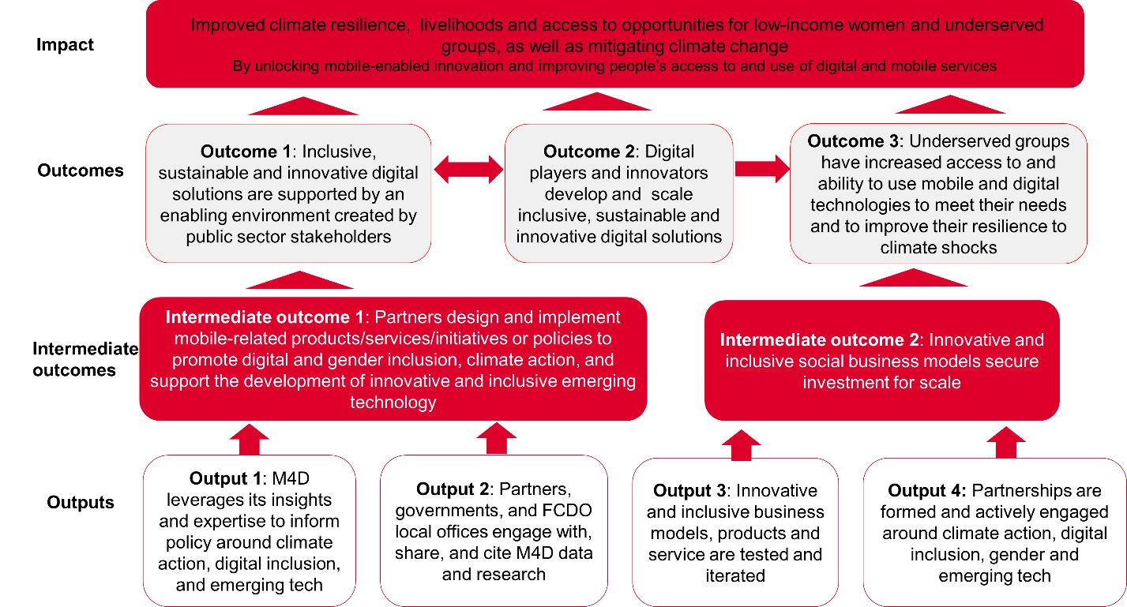

Figure 2: The Partnership’s Theory of Change

Describe where the programme is on/off track to contribute to the expected outcomes and impact. What action is planned in the year ahead?

The annual milestone for outcome 1 (enabling environment) was slightly exceeded with 8 new cases (target: 7) where public sector stakeholders acted towards creating a more enabling environment due to an M4D intervention. An example is provided in box 1 below.

Box 1: GSMA helping shape international guidelines on people-centred smart cities (outcome 1)

The GSMA Digital Utilities programme partnered with its longstanding partner UN-Habitat to help shape the international guidelines on people-centred smart cities, adopted at the UN-Habitat Assembly (May 2025, Nairobi).
Developed through a two-year global consultation, the non-binding framework is built on four principles (Shared prosperity, Digital rights, equity & inclusion, Sustainability & resilience and Community participation) and four enablers (governance, digital literacy, public infrastructure & smart services, financing).

GSMA’s input emphasised public-private partnerships and innovative business models to reach low-income communities.

The annual milestone for outcome 2 (enabling environment through research uptake), was significantly exceeded, with 69 (target: 47) citations of M4D's data and research by non-MNO influential stakeholders. A large number of these citations were about the AI for Africa report, with citations from e.g. Fortune, The Economist or Business Daily Africa.

The annual milestone for outcome 3 (innovation & scale) was achieved with 18 new cases (target: 18) where scalability of solutions improves through engagement with M4D. An example is showed in Box 2.

Box 2: Intercontinental replication and scale

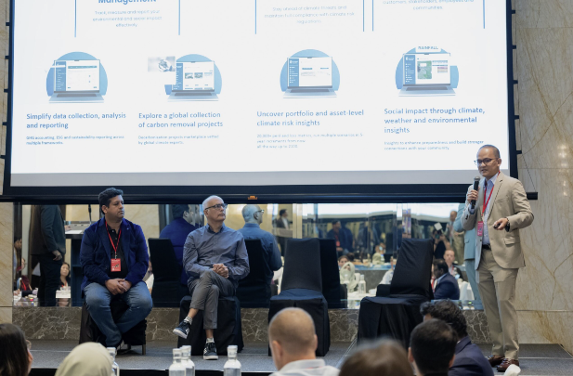
GSMA grantees are increasingly expanding across continents. At the Asia Bootcamp (May 2025), ventures like Komunidad and Deaftawk shared their cross-regional growth stories.

A milestone in this trend was the merger of two GSMA alumni: Knowledge Platform, a leading Pakistan edtech venture, and Eneza, a leading Kenya edtech venture.

Facilitated by GSMA, the merger in October 2024 created a leading Africa-Asia edtech venture, now serving 1M+ learners through both B2C (SMS learning) and B2B/B2B2C models.

“We deeply appreciate GSMA’s support for the individual entities and for your leadership in bringing us together. We believe that we will unlock tremendous innovation and synergies. We look forward to all possible support from our partners, including GSMA, on moving forward.” - Mahboob Mahmood, CEO Knowledge Platform.

The annual milestone for outcome 4 (innovation & scale) was exceeded with 19 new business models and/or tech innovations (target: 17 new) commercially launched. An example is showed in box 3.

Box 3: Generative AI to solve the agriculture information gap: Crop2Cash
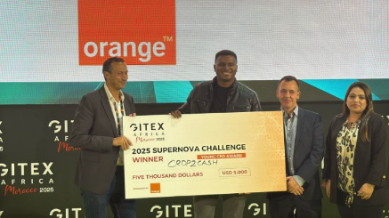
In November 2022, the GSMA awarded a grant to Crop2Cash (Nigeria) to support farmers with climate-smart content and a digital marketplace. Since then, it has reached 500,000+ farmers, unlocked $2.8m in credit, and increased incomes by 70%.
With over 30 million smallholder farmers and a severe shortage of extension agents (1 per 10,000 farmers), Crop2Cash launched the National Hotline for Agriculture in July 2024. This generative AI-powered IVR service delivers real-time, personalized advice in Yoruba, Hausa, English, and now two more local languages.

So far, 12,000+ farmers have used the hotline, with an average call lasting 18 minutes, indicating strong engagement. Crop2Cash has expanded to Kenya and signed an NDA with Dialog Sri Lanka to support 1 million farmers. It has also received multiple awards, including: Africa Impact Award 2024, GITEX Africa 2025: Young CEO of the Year, Grand Prize winner of Heifer Internationals AYuTe Nigeria Challenge.

“The GSMA Innovation Fund grant has been catalytic to our growth. Since receiving the grant and other support, we have doubled the number of farmers on the Crop2Cash platform, from 250,000 to 540,000 smallholder farmers. The technical assistance provided has been very helpful to the team, exposing them to new knowledge and learning opportunities, while the investment showcase has introduced us to investors that will soon finance Crop2Cash's growth across Africa.” - Michael Odungare, founder and CEO, Crop2Cash

The annual milestone for outcome 6 (reach) was exceeded, having reached an additional 44.7m people in the last reporting year (57% female). This raises the overall reach figure to 211m (62% female), distributed across 42 countries.

The breakdown of these 44.7m additional beneficiaries is as follows:
- 31.6m people (49.9% female) benefitted from M4D’s climate-related workstreams, mostly from the Innovation Fund (Climate Tech and Digital Utilities programmes);
- 6.7m people (50.4% women) benefitted from the Connected Society programme; and
- 6.4m women benefitted through the Connected Women programme.

The annual milestone for intermediary outcome 1 (investment for scale) was exceeded, with £15.5m additional funding mobilised for the services trialled through the Innovation Fund (target £12m), despite the challenging market conditions for fundraising. Since the beginning of the current business case, organisations supported by the Innovation Fund have raised £223m, and this figure increases to £399m since 2017.
For example, in Ethiopia, GSMA supported grantee GreenAgro in enhancing its Lersha platform, which already provided smallholder farmers with access to digital services and farm inputs. With GSMA’s support, the platform was expanded to include agricultural finance and climate-risk insurance. As a result, GreenAgro secured a seven-figure investment from AGRA to implement inclusive market and finance solutions for the soya and wheat value chains. Additionally, FSD Ethiopia invested to help onboard 170,000 smallholder farmers to a digital wallet, with over 17,000 farmers completing micro-loan applications through formal financial institutions.

The annual milestone for intermediary outcome 4 (design and implementation) was achieved, with 27 new cases (target 27) where stakeholders and partners design, adapt, and pilot new strategies, use cases, and/or partnerships to better reach underserved populations. Two examples are presented in Boxes 4 and 5 below.

Box 4: Using generative AI to build a pathway to inclusive entrepreneurship in Sri Lanka

In January 2025, Dialog Sri Lanka’s Ideamart for Women partnered with GSMA to pilot a generative AI tool that simplifies app creation in local languages. Built on Dialog’s AppMaker platform (launched in 2020), the initiative aims to empower women entrepreneurs by removing coding barriers.

After discovering that 90% of users dropped off before publishing an app, GSMA facilitated ideation workshops and user feedback sessions. This led to the development of a pilot local-language AI assistant using a large language model (LLM), allowing users to describe app ideas in Sinhala, Tamil, or Singlish via voice or text.
This innovation addresses a major inclusion gap - over 70% of Sri Lankans speak Sinhala, yet mainstream AI tools rarely support it. The new interface enables intuitive, natural language-based app creation, opening mobile entrepreneurship to women and underserved communities.

Early feedback has been positive, with users praising the platform’s accessibility and the AI’s ability to understand mixed-language speech.

GSMA continues to support Dialog as it prepares for national rollout, with plans to replicate the model in other markets facing similar language and digital inclusion challenges.

Box 5: Designing integrated and inclusive interventions

MTN Uganda faced challenges in driving smartphone adoption - particularly for its 4G Kabode device - and increasing mobile internet usage. Sales staff struggled to communicate the device’s value, especially to women and underserved customers, and lacked the training to support basic digital skills.

To address this, GSMA partnered with MTN Uganda to improve in-store customer engagement using the GSMA Mobile Internet Skills Training Toolkit (MISTT). Throughout 2024, GSMA delivered virtual learning and strategy sessions to equip MTN teams with best practices for in-person education and follow-up support. In June, MTN piloted the approach in Kampala stores, focusing on Kabode device financing.

A “train-the-trainer” model was used: GSMA trained store managers, who then trained staff to deliver tailored, face-to-face guidance using MISTT. Staff were equipped to highlight relevant mobile internet use cases and address barriers faced by women and basic phone users.

By November 2024, around 11,000 customers had been trained. MTN reported increased Kabode uptake, store traffic, and data usage. Staff also reported greater confidence, stronger customer relationships, and improved ability to identify needs and position the device effectively. Based on these results, MTN is scaling the initiative nationwide- demonstrating the impact of tailored, in-person education on digital inclusion.

Justify whether the programme should continue, based on its own merits and in the context of the wider portfolio

The programme should continue. It has met or exceeded Logframe expectation, demonstrates strong VfM in scaling innovation, generating research and leading advocacy work.

M4D is strongly aligned with the UK Government’s strategic ODA priorities, particularly in promoting inclusive economic growth and investment, climate resilience, gender equality, and harnessing AI. The UK is committed to a modern, partnership-based approach to development - one that the programme is well-positioned to advance through its focus on supporting locally-led innovation and working with government and private sector in Africa and Asia.

By working with GSMA, FCDO is tapping into its world-leading subject matter expertise on digital and mobile technology, its thought leadership, connections with the private sector (in particular MNOs) and its convening power.

C. DETAILED OUTPUT SCORING

Output Title | M4D leverages its insights and expertise to inform policy around climate action, digital inclusion & gender, and emerging tech​
Output number: |  | 1 | Output Score: | A+
Impact weighting (%): |  | 15% | Weighting revised since last AR? | N/A

Indicators | Milestones for this review | Progress
1.1 Number of instances where M4D contributes to or informs policy at international, regional, national or local level | 1 | Slightly exceeded: 3
Briefly describe the output’s activities and provide supporting narrative for the score

This output is newly introduced and reflects the programme’s capacity to influence or inform policy at international, regional, national, or local levels - an integral component of the Theory of Change. The milestone associated with this output has been slightly surpassed, with an example in Box 6.

Box 6: GSMA M4D’s role in advancing digital gender equality at Beijing +30
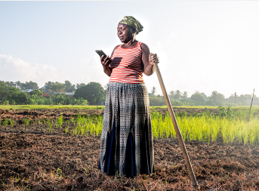
In March 2025, UN Member States adopted the Beijing +30 Political Declaration at the 69th Commission on the Status of Women (CSW69) - a landmark document that will shape national gender equality agendas for years to come.

The GSMA Mobile for Development programme played a pivotal role in ensuring digital gender equality was reflected in the final Declaration. Through a targeted, multi-pronged advocacy strategy, GSMA developed a positioning paper urging governments to recognise digital inclusion as essential and commit to halving the digital gender gap by 2030. This paper was disseminated via the Commonwealth Secretariat to 54 governments and key partners, including the FCDO.

GSMA also coordinated two joint letters - addressed to UN Women Executive Director Sima Bahous and UN Secretary-General António Guterres - co-signed by EQUALS founding members (GSMA, ITU, ITC, UN University), advocating for the inclusion of digital gender equality in the Declaration. As a result, bridging the digital gender gap was named one of six priority areas in the Beijing +30 Action Agenda, marking a major step forward in global digital inclusion.

This achievement is especially significant given that the original 1995 Beijing Platform for Action made no mention of digital issues. The inclusion of digital in the 2025 Declaration signals a shift: digital inclusion is now recognised as fundamental to achieving gender equality, and governments are encouraged to embed gender considerations into their digital strategies.

Describe any changes to this output during the past year, and any planned changes as a result of this review.

No change, this is a new output.

Progress on recommendations from the previous AR (if completed), lessons learned this year and recommendations for the year ahead

Lessons-learnt

Policy influence: The GSMA conducted a baseline assessment to evaluate M4D’s approach to supporting and informing policy as part of the third phase of the Partnership. Insights from the assessment highlight GSMA’s role in fostering an enabling ecosystem for digital inclusion and climate action during the second phase, through three key avenues:
- Advocating for inclusive policy: GSMA supports national digital strategies and regulatory reforms through evidence-based toolkits, policy diagnostics, and advisory services—resources that underpin its policy advocacy and are highly valued by government partners, often prompting GSMA’s deeper involvement in policy development.
Example: GSMA influenced gender-inclusive digital and ICT strategies in Pakistan through its collaboration with the Pakistan Telecommunication Authority.
- Convening trusted multi-stakeholder platforms: GSMA’s ability to foster trust and alignment among governments, international organisations, mobile network operators (MNOs), startups, and donors is a core strength.
- Evidence-based policy advocacy: GSMA’s research-driven approach is widely respected and has informed policy in areas such as digital financial services and gender inclusion.
Example: The Gender Gap report has been instrumental in shaping national gender strategies.

Recommendations for the year ahead
- Despite global headwinds, the programme should continue to advocate on topics such as climate and diversity, equity and inclusion, leveraging evidence from its research and broader evidence, including at forums such as CSW, W20, G20, and UNGA.

Output Title | Partners, governments, and FCDO local offices engage with, share, and cite M4D data and research
Output number: |  | 2 | Output Score: | A+
Impact weighting (%): |  | 25% | Weighting revised since last AR? | Yes

Indicators | Milestones for this review | Progress
2.1 Number of thought leadership pieces produced by the partnership | 94 | Achieved: 94 (14 in the last reporting year)
2.2 Number of convenings where M4D messaging is shared with high-level stakeholders | 528 | Significantly exceeded: 586 (131 in the last reporting year)
Briefly describe the output’s activities and provide supporting narrative for the score

This output reflects the Partnership’s research and learning activities, which are central to its Theory of Change. Both milestones have been met or exceeded, underscoring the programme’s ability to produce research that resonates with key stakeholders. Illustrative examples are provided in Boxes 7 - 9, with a comprehensive list of thought leadership pieces available in Annex C. Over the past reporting year, the programme also organised 131 convenings (Output 2.2), where M4D messaging was shared with high-level stakeholders.

Box 7: unveiling the transformative impact of AI in Africa

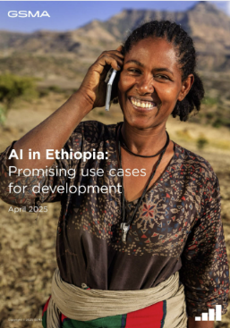
In partnership with various FCDO country offices in Africa, GSMA published a flagship series of in-depth country deep-dives examining the AI ecosystems in Nigeria, Kenya, South Africa, and Ethiopia. Each report offers a comprehensive analysis of the enablers and barriers shaping the development and responsible deployment of AI across a range of key sectors, including agriculture, food security, energy, climate action, education and healthcare.

The series has attracted widespread attention - featured in 36 articles from the likes of Fortune, The Economist, and Nation Media; covered by broadcasters including BBC News, Semafor, CNBC Africa, and Developing Telecoms; and cited by the Global Centre on AI Governance in their AI in Africa landscape report. Additionally, findings from the Kenya country deep dive have directly informed the design of the UK-Kenya AI Challenge Fund, launched in November 2024 by the UK Digital Access Programme.

The programme’s most recent publication, AI in Ethiopia: Promising Use Cases for Development was unveiled at the UK-Ethiopia AI Forum in April. The event was held at the British High Commission in Addis Ababa and was attended by 130 participants. In May, the report was showcased at the (Ethiopian Tech Expo 2025, the largest tech event in East Africa, with over 10,000 attendees. The study has contributed to building the case for a bilateral partnership between Ethiopia and the UK focused on AI for development.

Box 8: FCDO Philippines and the future of EdTech

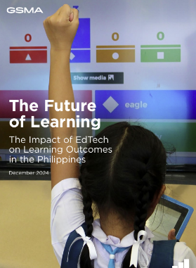
Commissioned by FCDO’s country office in the Philippines and published in November 2024, The Future of Learning: The Impact of EdTech on Learning Outcomes in the Philippines offers a detailed landscape assessment of the EdTech ecosystem in the Philippines.

Key findings highlight the fragmented nature of EdTech efforts across the country, a lack of capacity building for both teachers and learners, and the pressing need for a unified national strategy to guide implementation. The report also emphasises the emerging role of AI in accelerating EdTech adoption and improving learning outcomes.

The report has been used by the FCDO to support the work of The Second Congressional Commission on Education (EDCOM II), which undertook a national assessment and evaluation of the performance of the Philippines’s education sector. The Commission included the GSMA report’s findings and recommendations in its report published in January 2025 “Fixing the Foundations: A matter of national survival”. GSMA also co-authored an article with EDCOM II to further amplify key messages and engaged in a series of dissemination activities, including two in-country workshops and a presentation at the UK Southeast Asia Tech Week in April organised by the FCDO and the Department of Business and Trade in Manila. Finally, this report was also used within the British Embassy in Manila as a guidance to review applications to the International Finance Facility for Education (IFFEd), a financing facility that helps LMICs invest in education and skills development.

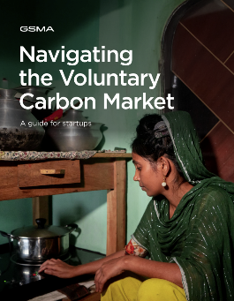
Box 9: Navigating the voluntary carbon market – a practical guide

Carbon markets are increasingly seen as a vital tool for accelerating climate action in developing countries, where climate finance needs far exceed available resources. Yet, for many climate tech startups, especially in LMICs, entering the Voluntary Carbon Market (VCM) remains a complex and often inaccessible opportunity.
Conversations with GSMA Innovation Fund grantees revealed a strong interest in engaging with the VCM, but also a significant information gap that leaves many early-stage startups feeling unprepared. To address this, GSMA developed Navigating the Voluntary Carbon Market: A Guide for Start-ups, designed to help start-ups and SMEs in LMICs assess their potential to participate in the VCM.
The guide offers a clear overview of the fundamentals and end-to-end process of generating carbon credits, includes a breakeven calculator to assess project viability, and features case studies of successful business models in clean cooking, solar home systems, and sanitation. It is being disseminated across M4D’s network of partners - including grantees, alumni, and other innovators - and served as the foundation for a working session at the GSMA Asia Bootcamp in May 2025.

Describe any changes to this output during the past year, and any planned changes as a result of this review.

This output was renamed, with targets added until 2029 (as part of the extension of the current MoU between FCDO and GSMA)

Progress on recommendations from the previous AR (if completed), lessons learned this year and recommendations for the year ahead

Both recommendations from the previous year are ongoing.

- AI research: To inform the Innovation Fund round on Inclusive AI, it was recommended that the CIU build on the ‘AI for Africa: Use Cases Delivering Impact’ report by conducting an action-oriented research project. The aim of this research is to identify promising innovations LMICs that could be supported through the planned Innovation Fund round focused on AI.
Progress on this research was delayed due to a mid-project change in supplier, prompted by performance concerns. The publication is now scheduled for release in mid-September 2025.
- Health and emerging tech research: The programme was advised to produce a research piece exploring how digital and AI technologies can support the prevention and response to communicable diseases in LMICs, including outbreaks, epidemics, and pandemics. This work builds on existing efforts by MNOs in the digital health space, where there is limited evidence on what approaches are most effective.
The research is now funded by GSMA and scheduled for completion in 2025. Preliminary consultations with MNOs and digital health providers are helping to refine the scope, and an outline is currently in development. FCDO’s Health Research Team also provided input into the ToR.

Lessons-learnt and recommendations for the next year

The need for high-quality evidence on digital extension
- Lesson-learnt: Independent evidence on the impact of digital advisory services in LMICs is limited, with most studies focusing on reach rather than long-term effects on smallholder farmers' livelihoods and resilience. Scalability remains poorly understood, with few digital agriculture solutions achieving widespread active use, and scale does not necessarily equate to impact. Emerging insights suggest that sustainable, impactful models often require bundling services, human interaction to build trust, and a supportive enabling environment.
- Recommendation: The FCDO is in the final stages of contracting a highly regarded academic partner to undertake a comprehensive study aimed at strengthening the emerging evidence base on digital extension services for smallholder farmers. Building on an initial literature review, the study should conduct robust evaluations of three grantees to assess the impact of their solutions on income, productivity, resilience, and other key outcomes. In addition to the publication of academic papers, the findings should inform the development of a practical ‘playbook’ targeted at non-academic audiences, outlining how to design impactful and scalable private sector-led digital extension models.

X-FCDO engagement
- Lesson-learnt: The programme has stepped up its engagement with sectorial teams across the FCDO, which is crucial to ensure that the work aligns with FCDO’s strategic objective and to provide technical challenge. Over the last year, this has been the case for GSMA’s research on tech-facilitated gender based violence (TGBV) handset affordability, VCMs, urban development, blue economy and AI.
- Recommendation: It is advised to continue to strengthen engagement between GSMA and FCDO’s sectorial teams and country offices, including on TGBV, Digital Utilities and blue economy.

Success of the AI research
- Lesson learnt: The success and local resonance of the AI country deep-dive series were driven by three key factors.
  - First, the reports filled a critical knowledge gap by providing country-specific insights on priority sectors such as agriculture, climate, and energy - while capitalising on the growing momentum around AI.
  - Second, validation by an expert advisory group of local industry leaders enhanced credibility and contextual relevance. There was also strong engagement with national governments and associated bodies.
  - Third, strategic dissemination through high-profile events (e.g. Kenya Tech Week, Connected Africa Summit, Mozilla Festival) amplified visibility and uptake.
The series has also played a valuable role in strengthening local networks, which continues to support activities such as Innovation Fund outreach and future research.
- Recommendation: GSMA should integrate these learnings into its future AI-related initiatives. Demand for evidence on AI remains high, with four out of five CIU pieces for the upcoming reporting period focused on AI: Enhancing Digital Agriculture with AI in Indonesia, Strengthening the Data Ecosystem for AI Innovation in Kenya, Pathways to an Ethical AI Ecosystem in South Africa, and Bridging the compute gap: Edge AI for LMICs.

Output Title | Innovative and inclusive business models, products and services are tested and iterated
Output number: |  | 3 | Output Score: | A+
Impact weighting (%): |  | 30% | Weighting revised since last AR? | Yes

Indicators | Milestones for this review | Progress
3.1 Number of applications received through Innovation Fund rounds | 2,989 | Exceeded: 3,234 (795 in the last reporting year)
3.2 Number of grantees testing innovative and inclusive business models, products, and services | 63 | N/A: 63 (no new grantees planned)
Briefly describe the output’s activities and provide supporting narrative for the score

This output captures the number of business models selected and supported towards scale through the Innovation Fund and is measured by the number of applicants received and the number of grantees contracted.
The milestone for output 3.1 (number of applications received through Innovation Fund round) was exceeded, with a record number of applications to the AI Innovation Fund round, demonstrating strong demand for this kind of funding, as well as an effective dissemination strategy by the GSMA. Output 3.2 is non applicable this year, as no new grantees were planned to be selected.

Figure 3 shows a map of all Partnership 2.0 portfolio grantees, and annex B an overview of the achievements of the individual innovation fund rounds.

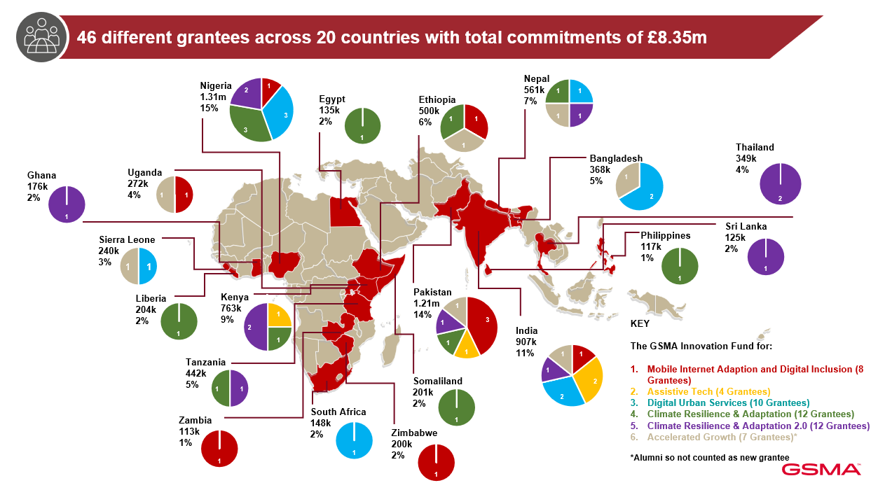

Figure 3: Current approved portfolio by thematic pillars and geographies

Box 10: GeoKrishi creating hyperlocal and sustainable impact on Nepalese farmers

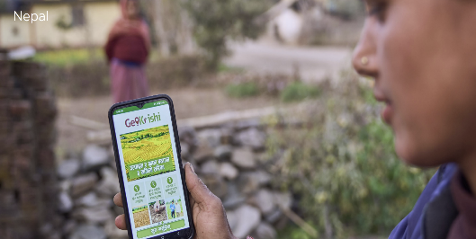
Founded in 2017, GeoKrishi is a leading agritech company in Nepal, serving primarily lower- to middle-income farmers, many of whom are subsistence or small-scale commercial growers. In 2022, with support from the GSMA Innovation Fund, GeoKrishi began delivering hyperlocal, digital agricultural information to over 50,000 farmers across the country. The recent external study on the Innovation Fund’s inclusivity highlighted GeoKrishi’s contribution to poverty alleviation, improved livelihoods, and job creation - demonstrating how tailored insights on crops, soil, fertilisers, and weather empower farmers with actionable knowledge
According to GSMA’s endline assessment, GeoKrishi’s mobile app enhances efficiency and reduces costs by offering services such as remote agrovet consultations and timely weather alerts, enabling farmers to take preventative action. This highly relevant, just-in-time support ensures farmers receive the right information when they need it most. The impact is promising: 97% of users report improved anticipation of major weather events, 97% report better knowledge of sustainable practices, and 99% have implemented the recommendations.
The external Innovation Fund study found that these improvements translate into greater resilience. Since adopting GeoKrishi, 76% of users report increased income, 78% report more stable household finances, and 62% say they are better able to withstand economic shocks - critical gains for subsistence farmers seeking long-term security.

Box 11: Taskmoby: Scaling digital Job platforms for youth employment in Ethiopia

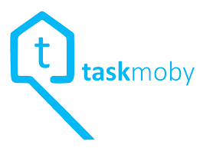
Taskmoby, a digital platform connecting service providers with customers, first received GSMA support in 2018 to expand operations from Kenya to Addis Ababa. The platform has connected over 5,600 gig workers to longer-term employment, which has helped young workers transition into more stable employment - primarily unemployed graduates from Ethiopia’s Technical and Vocational Education and Training (TVET) institutions.

This has a significant impact, especially in Ethiopia, where youth unemployment stands at 23% and where in 2022, 42% of university graduates were unemployed after completing their studies. The external evaluation on the Innovation Fund found that the platform’s key impact lies in the consistency of income it provides. While earnings may not always be life-changing, 53% of respondents reported an income increase after using the platform - slightly higher among women - while 27% saw no change or a decrease. While users may not view these jobs as long-term careers, their role as a stepping stone is significant. In fact, 27% of respondents identified increased access to job opportunities as the biggest benefit of TM. In focus groups, some participants noted that the platform helped them move from unstable informal work to more structured employment. Regardless of the amount earned, the stability of income enabled users to search for other jobs, expand their businesses, or invest in skills development. Users noted increased financial independence through TM jobs, with some using their earnings to invest in small businesses or household assets.

In 2024, Taskmoby received an Accelerated Growth (AG) grant from the GSMA to develop two key features - TaskCredit and TaskCentre - and to expand into secondary cities while continuing to scale in Addis Ababa. The results have been impressive:
- The platform’s user base grew by 48%, including over 600 new users outside Addis Ababa.
- Revenue increased by 20%, driven by the expanded user base.
- Taskmoby secured £127,000 in follow-on funding.

GSMA’s support played a pivotal role in overcoming barriers to scale. While the new features and geographic expansion were part of Taskmoby’s long-term vision, the AG grant provided the patient capital needed to accelerate implementation. In addition, Taskmoby benefited from targeted technical assistance:
- Investor readiness support helped position the company for investment discussions with Axian Group.
- Mentorship from EY Ripples led to a strategic shift - advising a phased, city-by-city expansion approach rather than a simultaneous rollout.

Describe any changes to this output during the past year, and any planned changes as a result of this review.

This output was renamed, with targets added until 2029, as part of the extension of the current MoU between FCDO and GSMA.

Progress on recommendations from the previous AR (if completed), lessons learned this year and recommendations for the year ahead

Two recommendations from last year are completed, with two ongoing.

Ongoing:
  - Last year’s recommendation to update M4D’s impact portfolio by adding the latest achievements of R1 to R4 grantees and adding R6 and Accelerated Growth grantees is ongoing, with publication expected in July 2025. This is an important outreach tool for to investors (existing database of 64 investors). either through the bootcamps and regular 1 to1 calls.
  - The recommendation to assess the effectiveness of the Accelerated Growth Fund before replication is ongoing, with an internal report expected in July. Preliminary findings are included in the lessons learnt section below.
Completed:
  - The recommendation to strengthen collaboration with other funds supported by FCDO has been completed, with EY Ripples providing in-kind support to various M4D grantees, GIF attending the GSMA bootcamps, active pipeline sharing and expertise sharing, for example on impact measurement during a recent x-TIU meeting on this topic. Such collaboration will continue to be important as we are looking to increase the efficiency and effectiveness across our programmes.
  - The recommendation to better understand the impact of the IF has been completed through the published Innovation Fund Investment Inclusivity Study (lessons in section A).
Lessons-learnt and recommendations

Use of AI by GSMA Innovation Fund Grantees
Lessons-learnt: Over the past few years, an increasing number of GSMA Innovation Fund grantees and alumni have integrated predictive and generative AI into their projects. To better understand how AI is being applied, a baseline assessment was conducted across a selection of grantees, focusing on the types of AI used and their intended purposes. Key findings include:
- Grantees are leveraging AI in diverse and often complementary ways, frequently combining multiple AI techniques within a single solution.
- AI’s primary value lies in its role as a facilitator or catalyst - enabling scale, automation, and efficiency. While AI itself may not directly create social impact, it significantly enhances the reach and effectiveness of impact-driven products and services.
- Looking ahead, developing a practical and context-appropriate (adopted to start-ups) ethical framework - tailored to startups operating in low- and middle-income countries (LMICs) - will be essential. Such a framework can guide grantees in deploying AI responsibly and effectively, ensuring that innovation aligns with ethical standards and local realities.
Recommendation: In collaboration with other FCDO partners, GSMA should enhance its technical support on AI for both future grantees and alumni. This will involve leveraging an existing responsible AI framework tailored for start-ups, or - if none is available - adapting a broader AI framework to meet the specific needs of early-stage ventures.

Gender inclusion in start-up funding
Lesson-learnt: The GSMA published a report on funding female-inclusive start-ups in LMICs, highlighting the persistent barriers female entrepreneurs face in accessing capital—receiving, on average, just 65% of the funding secured by male-led ventures. The report identifies key challenges such as the gender funding gap, underrepresentation of women in investment decision-making, and the need for tailored support. It also underscores how investing in female leadership can drive more inclusive innovation and business models.
To address these issues, the report recommends five key actions for investors:
- Broaden outreach by addressing geographic and language barriers and partnering with women’s business associations and accelerators.
- Showcase female entrepreneurs to challenge stereotypes and signal inclusivity.
- Adapt strategies by region, recognising the uneven distribution of female-led start-ups.
- Prioritise female leadership by offering targeted support during the application process.
- Implement tailored gender action plans for all investees, using tools like the SEAF Gender Equality Scorecard© and 2X Criteria to track progress and set goals.
Recommendation: Building on this, GSMA should conduct a gender review of its two most recent grantee portfolios. This will assess what worked in increasing both the number of female-led start-ups funded and the number of female beneficiaries reached. Insights from this review will inform the development of a gender action plan framework for future grantees.

Accelerated Growth (AG) Round
Preliminary learnings: All AG grantees increased both user numbers and revenue during the project period. The funding enabled them to refine their business models based on insights from earlier phases particularly around user engagement, retention, and operational costs. While most activities were already part of their scale-up plans, the AG grant provided the patient capital needed to overcome key barriers that would have otherwise stalled progress. Although none have fully achieved scale yet, all grantees made significant strides toward it by enhancing the competitiveness and uniqueness of their offerings. Examples of progress include:
- Istem integrated its solution into WhatsApp and IVR to improve accessibility and retention, resulting in a 370% increase in users and over 100% revenue growth.
- ATEC introduced gamification features to boost market appeal, achieving an 18% increase in users and 35% revenue growth.
Recommendation: GSMA should begin compiling and publishing lessons from Round 6 grantees, with the round concluding by the end of 2025.

Output Title | Partnerships are formed and actively engaged around climate action, digital inclusion & gender, and emerging tech​​
Output number: |  | 4 | Output Score: | A+
Impact weighting (%): |  | 30% | Weighting revised since last AR? | Yes

Indicator(s) | Milestones for this review | Progress
4.1 Partnerships are formed and actively engaged around climate action, digital inclusion & gender, and emerging tech​​ | 171 | Exceeded: 188 (42 in the last reporting year)

This output describes the partnerships formed and engaged through the programme’s market engagement function (i.e., through in-kind support, but without financial support from the Innovation Fund) and is measured by the number of action plans/partnerships agreed.

The programme facilitated the development/ formation of 42 new action plans/partnerships (output 3.1), with a couple of examples in the boxes below.

Box 12: MNOs committing to addressing disability inclusion


The GSMA’s Principles for Driving the Digital Inclusion of Persons with Disabilities offer a strategic framework for MNOs to address the barriers persons with disabilities face in accessing and using mobile technology. These include affordability, limited digital skills and low perceived relevance, barriers that have a disproportionate impact on the 1.3 billion people with disabilities. As of today, 15 MNOs across Africa and Asia have made new commitments (e.g. Ethiotel; Banglalink, etc.) or renewed earlier commitments (e.g. Dialog Sri Lanka; Safaricom etc.).

Each signatory submits structured commitments outlining actions taken and planned ranging from discounted cost of mobile internet data, accessible app and web design, digital skills training, to inclusive customer service, integration of assistive technologies like audio navigation or sign language tablets, inclusive marketing campaigns, partnerships with Organisations of Persons with Disabilities and initiatives promoting online safety and relevance.

For instance, Dialog Axiata in Sri Lanka established a strategic partnership with DeafTawk, a grantee of the M4D Innovation Fund, to deliver real-time sign language interpretation services. As part of this initiative, Dialog deployed DeafTawk’s digital interpretation tablets across 23 customer care centres, enhancing communication accessibility for deaf customers. The service is set to expand to 110 locations nationwide, significantly broadening its reach. Additionally, Dialog conducted in-person digital skills workshops -supported by sign language interpreters—which engaged over 1,500 participants and led to a marked increase in service adoption among the deaf community.

Box 13: Grantees to leverage AI to collaborate with MNOs for scale
Crop2X, a current grantee of the GSMA Innovation Fund, is a Pakistani agri-tech start-up using mobile technology and predictive AI to deliver real-time insights to farmers. Their platform provides data on crop conditions, water and nutrient levels, yield forecasts, and crop classification.

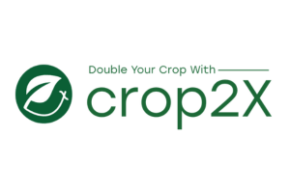
In 2024/25, GSMA facilitated a strategic partnership between Crop2X and Telenor Pakistan. Under this agreement, Crop2X receives expert guidance, IoT data SIMs, and marketing support from Telenor. Most notably, a commercial 8-month pilot - set to launch in July 2025 - will integrate Crop2X’s AI-powered solution into the My Telenor App, offering access to over 20 million farmers. This presents a major opportunity to scale their impact.

Telenor sees strong value in Crop2X’s AI modules, particularly yield prediction and crop classification, as a competitive differentiator in the market.

“GSMA played a pivotal role in facilitating our partnership with Telenor, which represents a strategic step forward in scaling our agri-tech solutions. This collaboration enables seamless integration with Telenor’s network, expanding our reach to rural and underserved farming communities. With GSMA’s support—connecting us to stakeholders, offering strategic guidance, and enhancing our credibility—we’re now aligned with a shared vision of advancing digital agriculture in Pakistan.”
— Humaira Rana, Project Manager and General Manager, Crop2X

Describe any changes to this output during the past year, and any planned changes as a result of this review.

This output was renamed, with targets added until 2029. as part of the extension of the current MoU between FCDO and GSMA.
Progress on recommendations from the previous AR (if completed), lessons learned this year and recommendations for the year ahead
No recommendations from past year.

Lessons-learnt
- Designing integrated and inclusive interventions: As highlighted in Box 5, programme experience shows that interventions must be integrated and inclusive from the outset. For example, digital skills training is ineffective without access to affordable devices, and handset affordability schemes fall short without user education. Without intentional design to reach underserved groups - especially women and rural populations - interventions risk deepening digital divides. This insight has shaped M4D’s approach, which advocates for simultaneous implementation of digital skills, affordability, and inclusion strategies, alongside efforts to address broader barriers like restrictive social norms. These insights have also informed a FCDO CSA note on digital inclusion, which GSMA contributed to.

Recommendations for the year ahead:
None

D: VALUE FOR MONEY

Key cost drivers and performance

Key costs | % total budget  (April 2024-March 2025) | Cost drivers
Research, insights and dissemination | 38% | External consultancy, staff costs, travels, marketing
Innovation fund | 34% | Grantee payments, staff costs, Fund manager costs, travel
Market engagement | 17% | Travel, staff costs, event costs
Monitoring & evaluation | 11% | External consultancy, staff costs

VfM performance compared to the original VfM proposition in the business case
The VfM proposition outlined in the Business Case identified various routes to achieve VfM through (i) reducing the costs per beneficiary; (ii) effective programme design with mutually reinforcing workstreams; (iii) strong focus on crowding-in additional resources; (iv) high uptake of GSMA’s research; and (v) cost sharing with other FCDO programmes.

Overall, the VfM proposition in the Business Case holds, with the table below demonstrating how the Partnership continues to deliver value for money.

 | VfM examples
Economy | Procurement: The programme has robust procurement processes in place, which are consistent with international good practice. M4D always negotiates with prospective suppliers to ensure VfM. For example, the Innovation Fund team negotiated a 24% reduction in price to procure a consultant to provide technical support to grantee Pricepally. Additionally, an Emerging Tech consultant provided advisory support valued at over £30,000 at no additional cost, reflecting their strong alignment with the programme’s mission, interest in this particular project, and a shared commitment to maximising impact.  HR: Recruitment and remuneration are based on set market benchmarks and performance appraisal. Staff are recruited in the market/close to the market of programme focus where relevant.  Travel: Rates meet GSMA’s strict travel policy guidelines, including air travel at economy rates only.
Efficiency | Input maximisation: Cross-collaboration between programmes of the partnership as well as other GSMA programmes allows for maximum impact. A couple of examples include:  - The launch of the Emerging Tech programme is a cross collaboration between M4D and GSMA’s “AI for Impact” initiative. This partnership allows the programme to leverage existing research, tools, and technical resources from the AI for Impact team, avoiding duplication and ensuring relevance for LMIC contexts.  - The GSMA ClimateTech Horizons research leveraged subject-matter expertise from across the GSMA, drawing on climate insights and case studies from several M4D and M4H programmes, as well as the GSMA AgriTech team and GSMA Climate Action team.  Monitoring and evaluation: Constant improvement of services based on user feedback, business intelligence and monitoring and evaluation feedback. In addition, the M4D MEL team has embarked on several new outreach initiatives that include forming strategic partnerships with academic institutions, engaging in communities of practice, and participating in conferences. These efforts aim to raise awareness of GSMA’s impact among broader audiences and position GSMA as a key partner with evidence-based organisations.  Effective dissemination strategy, including by leveraging diverse marketing channels to engage stakeholders, including LinkedIn live and Devex.  Strengthened due diligence to mitigate risks that sub-grantees of the Innovation Fund could misuse funds. GSMA has developed a risk assessment framework to analyse country-wide risk and align the sub-grant pre-award due diligence and monitoring processes with the level of risk.
Effectiveness | Cost per beneficiary: The original business case predicted a cost of roughly £1.43 per person reached, but this figure fell to £0.21 as of this annual report  Relevance: GSMA’s work is in areas of high priority for FCDO, including on investment, climate, gender, emerging technologies (AI) and scale, which means they have broad application for FCDO’s innovation and investment portfolios.  Leveraging support: The partnership has performed well in terms of crowding in additional resources, both from commercial investors to scale the enterprises (as outlined in the sections above) and from other donors/ organisations to support M4D programmes:  - The Gates Foundation is co-funding the Digital Inclusion programmes, providing funding to help address knowledge gaps in how to reach women micro-entrepreneurs and provide handset affordability schemes that are effective and sustainable, with a focus on improving women’s livelihoods.  - In April 2025, Sida signed a third phase of its long-standing partnership with the GSMA, providing co-funding with FCDO on digital inclusion & gender, climate and emerging tech themes.  - The Partnership leverages the GSMA assets, especially the regional GSMA policy teams and events (e.g. MWC). These events help profile the UK Development brand on the world stage and increase the outcomes of the Partnership.  - The GSMA funds several in-kind services (e.g. office space, IT, account payable and HR supports) and other services that support the activities of the Partnership. During the last reporting year, GSMA contributed £2m to the programme.
Equity | The Connected Women and Connected Society programmes are mandated to integrate gender and disability considerations across the entire M4D portfolio. This is achieved through collaboration with other programmes during project and research design, as well as through contributions to policy and technical assistance.  For example, the M4H programme used data from the Mobile Gender Gap Report 2025 in a presentation at the World Bank’s regional meeting on Connectivity for Refugees. The data helped highlight inclusivity as a key barrier in humanitarian contexts—emphasising the need for better data and inclusive design to improve programme effectiveness.

E: RISK

Overview of risk management

The overall risk rating for M4D is moderate, unchanged from last year. The programme takes an innovative approach across a broad range of areas and contexts, thus has an inherent level of risk that is within FCDO and Research and Evidence Directorate’s risk appetite. Some of the key risks and actions from this reporting period include:

- Partner capacity/ delivery risk – Minor (no change): Regular meetings are held with the delivery partner to closely monitor performance and address any risks in a timely manner. This allows the FCDO to shape the direction of programme components as needed. Additionally, delivery partners are required to have strong governance and management arrangements in place, along with proven expertise and track records in delivering ambitious outcomes. They work with leading sector experts, and country offices to ensure effective programme delivery.
- Management risk – Moderate (no change): The risk regarding operational complexity associated with onboarding new projects and partners remains moderate. It is important to continue to closely monitor the onboarding process to guarantee that the strategic objectives of Mobile for Development remain in line with those of the funding partners.
- Strategic & Operational – Major (change): The anticipated reduction in the UK Aid budget from FY26/27 onwards will necessitate ongoing discussions with GSMA to address the future strategic direction and priorities of the Partnership.
- Safeguarding risk – Moderate (no change): Implementing partner not adhering to FCDO safeguarding guidelines, which could lead to issues that need to be monitored and addressed to ensure the safety and well-being of beneficiaries. The FCDO continue to advise and build up GSMA expertise, so they are equipped to monitor for any safeguarding issues and raise awareness of any concerns to the M4D programme team.

The programme builds on the success and learnings of the Partnership so far and GSMA and FCDO continually jointly monitor the risks. The FCDO programme team and GSMA meet on a quarterly basis to formally review the programme’s progress and jointly decide on actions for the upcoming quarter. This includes a discussion on risks and finance. In case of urgent issues, these are escalated to FCDO immediately.

The programme is currently going through a due diligence refresh process by FCDO on GSMA’s standards of due diligence and fiduciary control, including reviews of governance structures, commitments to integrity and ethical conduct, name screening and bank account checks.

F: PROGRAMME MANAGEMENT: DELIVERY, COMMERCIAL & FINANCIAL PERFORMANCE

Summarise the performance of partners and FCDO, notably on commercial and financial issues.

M4D2 | Financial year | Year 1  FY 19/20 | Year 2  FY 20/21 | Year 3  FY 21/22 | Year 4  FY 22/23 | Year 5  FY 23/24 | Year 6  FY 24/25
M4D2 | Disbursed cash (£) | 699,964 | 7,371,154 | 6,204,646 | 7,497,665 | £6,687,635 | 7,157,224
M4D3 | Financial year | - | - | - | - | - | Year 1  FY 24/25
M4D3 | Disbursed cash (£) |  |  |  |  |  | 1,899,551

The programme has an approved budget of £76.565 million (£38.265 million for Phase 2 and £37.3 million for Phase 3), with £37.5 million disbursed as of March 2025. Financial performance is jointly monitored by FCDO and GSMA, ensuring adherence to the FY 2024/25 budget, which closed with a variance of just 3%.

GSMA demonstrates strong financial management, including accurate forecasting, asset tracking, and quarterly reporting of underspend to FCDO, enabling joint decisions on fund reallocation. Since 2013, GSMA has consistently submitted timely narrative reports, and annual audits by BDO have been clean for twelve consecutive years.

FCDO continues to view the partnership as transparent, responsive, and grounded in mutual trust. GSMA has remained flexible and timely in responding to evolving budget requirements and FCDO requests.

G: MONITORING, EVIDENCE AND LEARNING [1/2 - 1 page]

Monitoring and Evaluation

M&E is led by GSMA’s internal team, with support from external partners as needed. External suppliers are engaged for specific tasks such as field data collection - for example, during the evaluation of Innovation Fund Round 6 grantees - or to establish baselines for new programme phases.
Where relevant, the M&E team also collaborates with MEL functions across other TIU programmes to share best practices and lessons learned.

Learning
M4D conducted a total of four studies this year to support the learning of the programme.
- Innovation Fund Investment Inclusivity Study
- Strengthening Climate Action Formative Evaluation: The formative evaluation aimed to review GSMA’s Mobile for Development’s climate portfolio and assess how the strategy and programming can be strengthened. The report will be published in the coming reporting year.
- Mapping Resilience - participatory digital mapping for mangrove conservation learning paper: A participatory digital mapping project in Setabu Village, Indonesia, demonstrated how community-owned geospatial data can empower local stakeholders to improve land-use planning and governance, leading to reduced mangrove degradation in an area where conservation and livelihoods are closely intertwined.
- Baselines for the third phase of the Partnership: GSMA conducted a set of baseline assessments aligned with the updated theory of change outcomes. These baselines helped to s synthesise M4D’s impact and process learnings from the second phase of the Partnership, while identifying the actions and questions needed to effectively measure the programme’s achievements throughout the third phase.
Date of last narrative financial report |  | Date of last audited annual statement

Annexes
- Annex A: Update on recommendations from last year
- Annex B: Overview of Innovation Fund rounds
- Annex C: List of publications from this reporting year
Annex A: Update on recommendations from last year
Recommendation | Progress
The programme should step up on its evaluation work. In particular, over the next reporting period, it should continue and commence work on the following impact evaluations:  - Impact of the innovation fund: This evaluation will assess the ways in which GSMA’s grant making activities have contributed to reducing poverty, improving livelihoods, and generating employment, in particular decent jobs among vulnerable populations targeted by digital solutions.  Timelines: To be completed by the end of the reporting year.  - Impact of M4D’ climate work: This evaluation will assess to which extent M4D’s climate work has contributed to climate action or would have the potential to, in the future, with different programme design models.  Timelines: to be completed by the end of the reporting year.  - Impact, scale and commercial viability of M4D’s agricultural extension investments: This will look across the numerous extension services the programme supported during previous rounds of the Innovation Fund and contribute to the emerging evidence base on what works to support business-led digital extension services which are impactful, commercially viable and operate at scale. This work should be done with input from the FCDO Agriculture Research Team.  Timelines: ToR agreed and put out to market by the end of the reporting year. | Ongoing  Impact of the Innovation Fund: published as Innovation Fund Investment Inclusivity Study  Impact of M4D’s climate work: draft study provided to FCDO and EQAULS; we’re waiting for a revised draft.  Impact, scale and commercial viability of M4D’s agricultural extension investments: The FCDO is in the final stages of contracting an academic partner to undertake a comprehensive study aimed at strengthening the emerging evidence base on digital extension services for smallholder farmers.
Continuing to build its unique thought leadership position on emerging tech, especially AI:  Over the next reporting year, the programme should  - Conduct a research project with the objective to identify and assess use cases and specific examples of impact-driven digital solutions that leverage AI and emerging technologies in LMICs. There should be a particular focus on understanding where the mobile industry can add the most value in this field. The project should be done across LMICs and complement the country specific research pieces.  Timeline: Research piece completed by the end of the calendar year.  - Launch an open funding round on AI for development. We will work closely with other FCDO programmes working on AI to ensure this funding round complements this work. The above-mentioned research project will inform the scope of this.  Timeline: Funding round launched by MWC in February 2025. | Ongoing  (1) This research has been delayed because of a change of supplier in the middle of the project, due to performance issues. The research is now planned to be published in mid-Sept 2025  (2) The Innovation Fund on impactful AI has been launched with the recommendation Panel scheduled for July 2025 and an announcement of the grantees planned before the end of the calendar year.
GSMA’s work on technology-facilitated gender-based violence: TGBV is a key barrier which prevents women from using the internet and was therefore identified as an important priority area for the next phase of the programme. GSMA is uniquely positioned to work with MNOs, the tech sector and end users to tackle the threat of TGBV. To kick off this new workstream, GSMA are in the process of contracting a supplier to conduct a landscaping piece on this topic. Various FCDO (T)GBV/ gender experts provided input into the RFP. | Ongoing: the research has now been delivered by the supplier. GSMA will work in the second half of 2025, in coordination with FCDO to frame and publish the document to be published externally.
Disability inclusion: The programme should re-instate its work on disability inclusion on a lighter-touch basis to support MNOs in increasing the number of people with disabilities in their customer base. Timeline: agreed action plan for this work by the next quarterly review (November 2024). | Achieved: As shown in box 12, GSMA has strengthened its approach on disability inclusion with now 15 MNOs committed to the GSMA’s Principles for Driving the Digital Inclusion of Persons with Disabilities.  The GSMA will continue these efforts in the coming years, budget permitting.
Annex B: Overview of the Innovation Fund rounds
Innovation Fund | Status | Total funding awarded | Number of grantees | Comments
Mobile Internet Adoption and Digital Inclusion Fund (‘Round 1’) | Closed in March-23 | £1,767k | 9 | Projects completed in Mar-23. 2.1 million beneficiaries so far and £8.7m crowding-in.
Assistive Tech Fund (‘Round 2’) | Closed in March-23 | £712k | 4 | Projects completed in Mar-23. 492k beneficiaries so far and £2.8m crowding-in.
Digital urban services Fund (‘Round 3’) | Closed in Sept-23 | £1,329k | 10 | Projects completed in Sep-23 (4 on energy, 3 on WASH and 3 on waste management). 1m beneficiaries so far and £21.5m crowding-in.
Climate adaptation and resilience Fund (‘Round 4’) | Closed in Sept-24 | £1.25m (plus a £1m investment by Sida) | 12 | Projects completed in Sept-24 (2 on aquaponics, 3 on mapping & weather alerts, 5 on Agri bundles and 2 on NRM). 55.3m beneficiaries so far and £14.3m crowding-in.  The list of published case studies are: GeoKrishi ;  BENAA; Komunidad; Bakhabar Kissan;  CoAmana; Lersha; Dayaxa; JPalm, Crop2Cash and Hello Tractor. The Simusolar case study will be published by Jul-25
Climate adaptation and resilience 2.0 Fund (‘Round 6’) | Projects live since Mar-24 | £1m (plus a £989.7k investment by Sida) | 12 | Following the Fund Panel in Oct-23, the 12 grantees were announced at MWC Barcelona-24 (3 on regenerative agriculture, 2 on fisheries; 3 on pastoral agriculture; 2 on food loss and waste; 2 on agri bundles): 674k beneficiaries so far and £5.9m crowding-in. 1 grantee (Cam Dairy) was cancelled as the company was liquidated.
Accelerated Growth Fund | Closed in Mar-24 | £699.2k | 7 | The Fund Panel selected 7 alumni for funding (Africa118, Ensibuuko, Freetown Waste Transformers; Orenda; Diyalo, ATEC and I-Stem) in Mar-24. Please see high level learnings and results in Box 11 and lessons learnt section below. 981k beneficiaries so far.
AI for Impact | Open in Jan-25 | TBD | TBD | The Fund received 795 applications, the highest number of received applications so far. The recommendation Panel will take place in Jul-25 with announcement planned in Nov-25

Annex C: List of publications from this reporting year

- AI for Africa: Use Cases Delivering Impact - Nigeria deep-dive (downloads: 190; views: 3,086)
- AI for Africa: Use Cases Delivering Impact - South Africa deep dive (downloads: 170; views: 3,086)
- AI for Africa: Use Cases Delivering Impact - Kenya deep dive (downloads: 389; views: 3,086)
- Advancing Sustainable Fisheries with Digital Technologies: The Gulf of Thailand (downloads: 66; views: 141)
- AI in Ethiopia (downloads: 67; views: 421)
- The Future of Learning: The Impact of EdTech on Learning Outcomes in the Philippines (downloads: 197; views: 683)
- Scaling Digital Innovation in Low- and Middle-Income Countries (downloads: 130; views: 303)
- Funding Female Inclusive Start-ups in LMICs (downloads: 117; views: 312)
- Innovation Fund Investment Inclusivity Study (N/A as not promoted yet)
- SOMIC 2024 Report (downloads: 1,161, Views: 8,958)
- Delivering Digital Skills Training for Impact: Learnings and insights from Sierra Leone (downloads: 83; views: 177)
- Mobile Gender Gap Report 2025 (downloads: 366; views: 887)
- Carbon credits toolkit (downloads: 46; views: 292)
- ClimateTech Horizons report (downloads: 331; views: 24)

FCDO Digital Development Strategy, 2024 – 2030
Digital Development Overview: Development news, research, data | World Bank and Facts and figures 2021 (itu.int)
GSMA Mobile for Development, The Mobile Gender Gap Report 2025
The split for beneficiaries between 2021 – 2025 is: 95% direct beneficiaries/ 5% indirect beneficiaries (household members).
Replication across continents refers to a company expanding its operations by launching an existing product from in continent A into continent B. This involves entering a new geographic market and applying the (adapted) business model that was tested and validated in the original market. The replication can be carried out through various approaches, such as establishing a new subsidiary or entering into a merger or partnership with a local entity.
Measured through a combination of the Innovation Fund scale metrics (scalability survey and crowding in figures), along with outcome harvesting from M4D’s market engagement work to provide advice in scaling MNO initiatives.
178.4m during the current business case which started in 2019.
GSMA – The Mobile Gender Gap Report 2024
In addition to the 1,161 downloads of the main SOMIC report, there have also been 641 downloads of the key findings PDF, 71 downloads of the French key findings and 50 downloads of the Spanish key findings.

