Annual Review

Title: Global Innovation Fund
Programme Value £ (full life): £75,600,000 |  | Review Date: May 2025
Programme Code: 202604 | AMP Start Date: 30 June 2013 | AMP End Date: 31 March 2027

Summary of Programme Performance
Year | 2013-  2015 | 2016-  2017 | 2017-  2018 | 2018-  2019 | 2019-  2020 | 2020-  2021 | 2021-  2022 | 2022-  2023 | 2023-  2024 | 2024-2025
Overall Output Score | A | A | A | A | A | A+ | A | A | A+ | A
Risk Rating | Major | Major | Major | Major | Major | Major | Major | Major | Major | Major

DevTracker Link to Business Case: | https://iati.fcdo.gov.uk/iati_documents/5435489.odt
DevTracker Link to results framework:

A. SUMMARY AND OVERVIEW

Description of programme

The Global Innovation Fund (GIF) is an impact-driven investment vehicle, supported by the UK Government and a coalition of like-minded government, philanthropic, and private sector partners. Through its venture-style approach, GIF helps scale private sector-led solutions to global development challenges. GIF’s investment at an early stage derisks innovations, catalysing additional private sector finance. This aligns with the Government’s priority to modernise the UK’s approach to development, putting partnerships first, and mobilising private capital for international development and climate projects by strengthening links with the financial sector and international partners.

Headquartered in London, GIF invests in high-potential innovations that deliver social impact, benefitting people living on less than $5/day. Beyond funding, GIF strengthens the global evidence base by evaluating the effectiveness of these innovations and disseminating findings through impact assessments and peer-reviewed research.

GIF delivers on its mission through two core objectives:
- Supporting the scaling of high-impact social innovations that have the potential to outperform traditional development approaches, investing catalytic capital to derisk them for future investors
- Advancing global knowledge of ‘what works’ by generating high-quality evidence and insights to inform both investment and policy decisions.

GIF has invested in 74 innovations since 2015, benefitting over 127 million people to date, and is expected to improve the livelihoods of 157 million in the future. Just 5 investments are expected to generate a net social benefit of $3.35bn. In addition to funding from FCDO, GIF has secured $114.5 million in funding from USAID, SIDA, DFAT, Global Affairs Canada, and other corporate and philanthropic partners. For GIF Growth, in addition to FCDO’s funding, GIF has commitments totalling $12m from the US Development Finance Corporation (DFC), the Korean International Co-operation Agency (KOICA) and This Day (private investor).

Strategic investment priorities
GIF delivers high social impact efficiently for government and private investors through its evidence-led approach and ability to blend and catalyse public and private finance. Its flexible use of financial instruments helps innovators overcome investment barriers and market failures to scale effectively.
The programme prioritises FCDO development goals, investing in innovations that strengthen adaptation and resilience for vulnerable communities affected by climate change. Its focus on the poorest and most vulnerable, especially women and girls, aligns with FCDO’s commitment to inclusive, sustainable economic development

GIF Growth: Bridging the ‘Missing Middle’ in Development Finance
Launched in 2024/25, GIF Growth is a blended finance programme bridging the gap between early-stage innovation and commercial investment. By leveraging bilateral commitments, it aims to attract private investment to scale businesses across Africa and Asia, fostering economic growth and social benefits. GIF Growth will deploy $12–15m annually, aiming to disburse over $200m and unlock at least five times that amount for 50+ businesses over 10 years. It will also provide technical assistance to help portfolio companies grow and deliver impact.

This year’s Annual Review scores an A. The programme has met or exceeded all its output targets, as well as met all of the outcome targets. GIF has maintained and exceeded targets against its impact statements largely based on its impact methodology that provides confidence in the extent to which GIF is improving livelihood benefits.

Programme highlights from the reporting period:

Launching GIF Growth
- GIF Growth Fund launched: GIF formally launched its returnable investment vehicle to address the critical financing gap faced by high-impact businesses in emerging markets. A launch event was hosted in Washington, DC, at the UK Deputy Ambassador’s residence, where GIF announced commitments from the US Development Finance Corporation (DFC) and KOICA, with key donors and investees in attendance.
- First Growth investments made: The fund is now operational, investing in businesses positioned for commercial scale, helping to bridge the ‘missing middle’ in development finance. The Growth website and launch video were published

Mobilising investment for development
- GIF’s portfolio attracted $188m in follow-on investments in 2024, with over 51% of this coming from private investors with a total mobilisation ratio of $8.4. Total cumulative follow-on investment into GIF’s portfolio stands at $1.4B.
- Investment for GIF Growth: GIF has commitments totalling $12m from the US Development Finance Corporation (DFC), the Korean International Co-operation Agency (KOICA) and This Day (private investor). Other investors are also currently working through due diligence on the fund.
- FCDO renewed its partnership with GIF, signing a three-year replenishment contract worth £24.5m. GIF also extended its relationship with Sida to end of-2025, with a view to establishing a new multi-year funding agreement beyond 2027.

Demonstrating overall programme impact, and impact across gender and climate resilience portfolios

- From just 5 of the programme’s 74 investments, GIF has contributed to the creation of $3.35B in net social value, of which $1.15B is directly attributable to the programme. For every $1 dollar invested, the programme has generated at least $9 so far in social returns, an increase of $3 from last year. This increase is due to continued scaling up mature investments including One Acre Fund, Lively Minds and MindSpark.

- GIF’s portfolio reached 87 million people in 2024. Reach is calculated based on reported data from investees.
  - Of these, 48 million are women and girls.
  - 48 million people were also supported to cope with the impacts of climate change in 2024, across the climate-focused portfolio.
  - The average depth of the programme portfolio this year is 7.4% (approx.) - which means that the 87m people reached this year will experience an average improvement in their incomes and livelihoods by 7.4%.
  - Gender-focused climate change solutions remain a priority, ensuring women and girls are not disproportionately affected by the impacts of climate change. An example of this would be Build Change, (added to the portfolio in 2024) who are supporting marginalised women in Indonesia to access financing for climate-resilient housing.

Strengthening evidence and policy influence
- ImpactAssets, the impact investing leader with a 15-year track record of mobilising capital for good, has selected the Global Innovation Fund for inclusion in the Emerging Fund Manager category of their ImpactAssets 50™ (IA 50) 2025, the definitive guide to impact investment fund managers globally.
- GIF’s measurement and impact approach was cited as the gold standard in the Smith School UKAID Impact Report, underscoring its leadership in evidence-based climate-compatible growth.
- Donor engagement: In September, GIF facilitated a field visit to India for key stakeholders from FCDO and Sida, which strengthened partnerships, increased visibility for the showcased innovations, and enabled knowledge sharing regarding four GIF-supported innovations—Boomitra, Breakthrough, J-PAL, and S4S Technologies—on local communities and development initiatives.
- GIF contributes proactively to three cross-TIU portfolio working groups on Communications, Monitoring & Evaluation, and Scaling, enhancing collaborative efforts and knowledge sharing within the FCDO TIU/RED innovation fund network.

2024 highlights from the portfolio
Risk Capital
Scaling with a public-private partnership model

In 2024, Drinkwell signed a Revenue Share Agreement (RSA) with Dhaka WASA, one of South Asia’s largest water utilities. This agreement is a major milestone, as it allows Drinkwell to earn a share of revenue from each water ATM, rather than a fixed fee. This means Drinkwell’s income grows as more people use its services, making the business model financially sustainable and supporting further expansion. Years of partnership helped Drinkwell earn Dhaka WASA’s trust in its technology and service. With the RSA, Drinkwell can reinvest revenue to expand its network by 50%. To date, Drinkwell has directly deployed 550 water ATM’s impacting over 1.7m people across Bangladesh and India. Each ATM can benefit up to 3000 people, providing safe drinking water via prepaid cards.

GIF’s $500k investment in GIF in 2019 was made to help scale Drinkwell’s partnership with water utilities, an innovative and unique public-private partnership approach. Since then, Drinkwell has operationalized relationships with all 6 water utilities in Bangladesh – in 2024 they sold over 400m litres of water.

Image: Google maps showing Drinkwell water ATM locations in Dhaka

Figure 2 Drinkwell
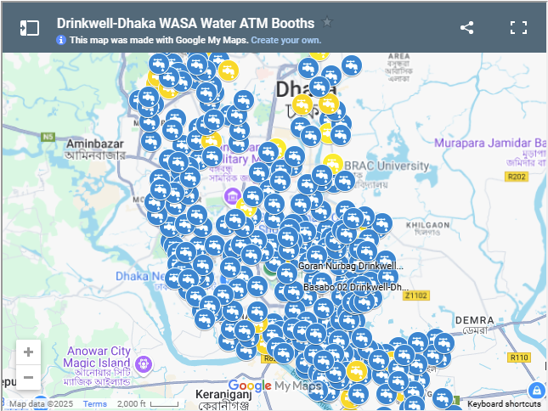

Strengthening local Government climate resilience capacity in the Philippines
Figure 1 Komunidad
Komunidad, supported by a $500,000 credit facility from the Global Innovation Fund (GIF) in 2024—following an early-stage grant from FCDO’s innovation sister fund portfolio partner, the GSMA Mobile for Development Foundation in 2022 —made a significant impact as a technology consultant on the Climate Resilient Cities (CRC) project in the Philippines, partnering with CRS and USAID. Komunidad developed and delivered early warning systems for Batangas, Borongan, Cotabato, and Zamboanga, empowering local governments and communities to better anticipate and respond to climate risks with timely, actionable data and forecast
GIF’s credit line enabled Komunidad to scale its technology and operations, customising climate intelligence tools to address the specific needs of these vulnerable cities. As a result, 52 government staff were trained and 1.7 million people gained access to life-saving Early Warning Systems. Komunidad achieved all project objectives and also fully repaid the GIF credit line, demonstrating both social impact and financial responsibility.

Separately, In 2024, Komunidad acquired Databourg, known for its rainfall intelligence system using satellite terminals and telco signals. Databourg processes data from over 50,000 terminals across the Philippines, Indonesia, and Brazil. This acquisition strengthens Komunidad’s Climate Action Platform and expands its Environmental Intelligence and Early Warning System services.
Figure 1 Komunidad
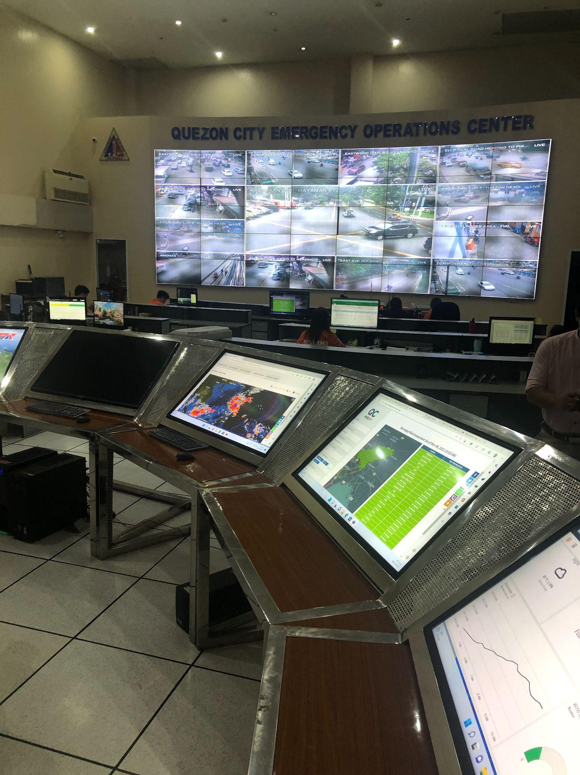

GRANTS
Exponential Scale through Government Systems

StrongMinds delivers life-changing mental health services to low-income African women and adolescents through facilitator and peer-led Group Interpersonal Therapy (IPT-G). Now active in six Sub-Saharan African countries, StrongMinds has treated over 1 million patients—mostly women and girls—including 427,000 in 2024 alone, an 18-fold increase since GIF’s 2019 investment. They have also cut costs from USD 109 to USD 30 per patient while maintaining high depression-free rates of 74–84%.

GIF’s support enabled StrongMinds to scale through partnerships with civil society and governments in Zambia, Uganda, and Kenya. Over 55% of patients are now treated by government community health workers and teachers. In 2024, StrongMinds successfully graduated from the GIF portfolio.

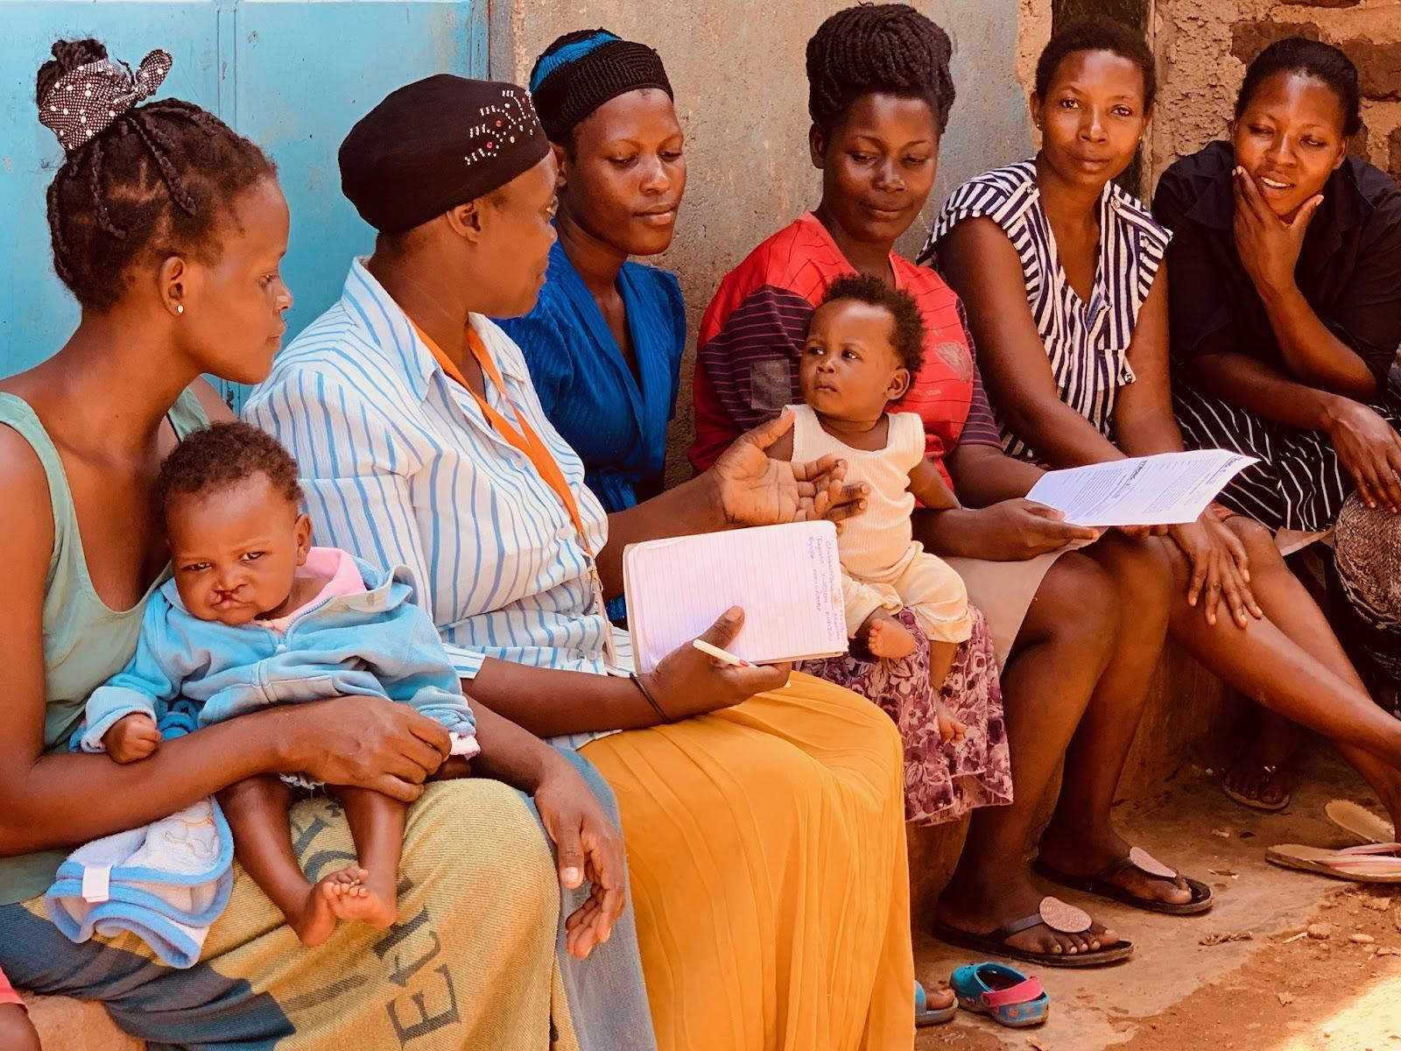
Figure 3 Strong Minds

Scaling with Government in Tanzania
Scaling innovations through government offers a financially sustainable route to reaching millions of people in poverty. GIF is supporting two innovations working to scale with the government in Tanzania: Amani Girls LINEA Programme and ideas42 behavioural interventions for cash transfer recipients.
In 2024, GIF provided funding to Amani Girls Organisation to pilot its evidence-based LINEA programme, which aims to prevent age-disparate transactional sex through radio drama and classroom sessions. Additionally, the GIF team targeted their support to enable Amani Girls to secure MoU’s with four key ministries and develop scale readiness plans for the next phase of implementation, positioning the programme for nationwide expansion. Building on this foundation, Amani Girls now plans to reach 100,000 beneficiaries across Tanzania in the next three years.
Also in 2024, ideas42 achieved a major milestone in Tanzania by doubling the reach of its behavioural interventions to 400,000 households. Rigorous GIF-funded evaluations showed that these low-cost interventions significantly improved outcomes for poor households receiving cash through the government’s Productive Safety Net Programme. Based on this strong evidence, the Tanzanian government invested its own resources to scale up the programme, demonstrating the value of evidence-based innovation in driving large-scale impact.
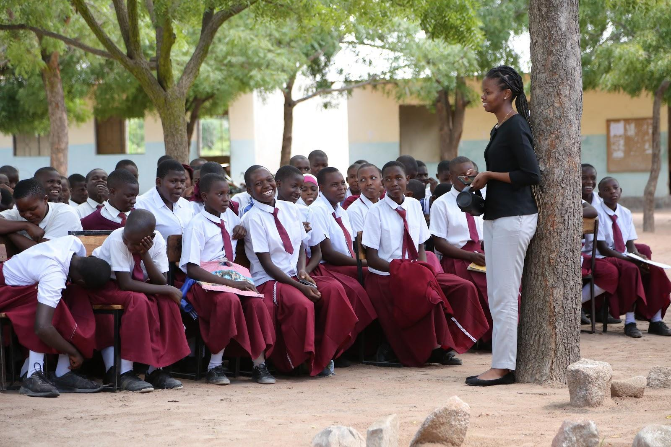
Figure 1 Amani Girls

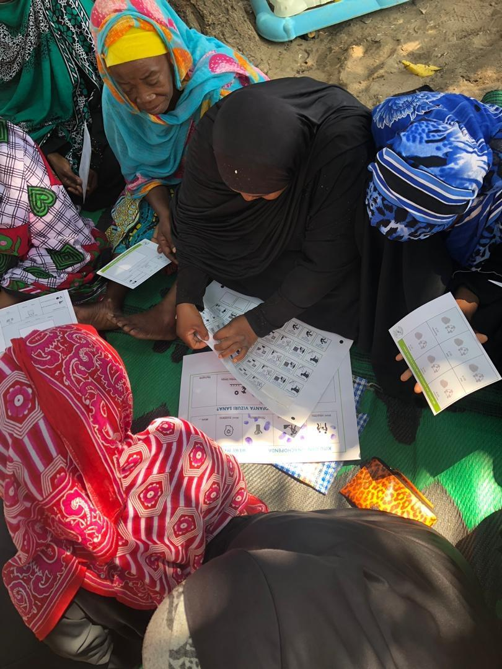
Figure 2 Ideas42

Major lessons and recommendations for the year ahead
- Engagement with the private sector:
- Lessons
  - With the closure of USAID and major donors reducing development spending, governments are increasingly using ODA to leverage private sector collaboration for development outcomes. Vehicles like GIF Growth, which use public capital to unlock private investment, are now more strategically important. GIF Growth has strengthened its risk capital approach by focusing on evidence-based decisions, disciplined investment, active portfolio management, technical support, and diversification. This enables informed risk-taking and long-term sustainability. The strategy centres on creating financial vehicles that attract private capital and reduce risks, building a strong pipeline for large-scale investment in private sector innovation.
- Recommendations
  - The programme should leverage the launch of GIF Growth to actively drive new engagement and interest in GIF. This includes attracting additional investors to create a robust pipeline of investable growth-stage companies, aiming for a leverage ratio of 5x for each £ invested, and building a portfolio exceeding £10m in the first year of operations. Additionally, GIF should identify opportunities to collaborate with FCDO and other government partners to widely disseminate its successes in private sector-led development collaboration, particularly highlighting its alignment with the UK Government’s Growth agenda. [Owner: GIF & FCDO; Review: Oct 25, Jan 26]

- New leadership and personnel
- Lessons
  - New leadership has enhanced organisational capabilities and rebalanced GIF’s regional footprint. They have combined the organisation's generalist strengths with the need for deeper thematic expertise, particularly in areas such as Climate and AI. The rebalancing of GIF’s regional presence has refocused the team in Asia and Africa, positioning them closer to the innovators developing local solutions and the communities they serve. This approach has strengthened GIF’s capacity to invest and respond to market shifts.
- Recommendations
  - GIF to deepen its approach to engaging with donors, creating integrated touchpoints with multiple teams within FCDO, Sida and future donors, identifying opportunities to be a learning partner, and leveraging their networks in both investee and potential donor countries to build new connections, supporting both investment and fundraising efforts. [Review: Oct 25, Jan 26, Owner: GIF, FCDO]
  - GIF should leverage the announcement of the new CEO, together with the launch of its new strategy, as engagement tools to build their profile with its target donor/investor audience, through in-person engagements, industry events and digital communication channels. [Review: Jan 26, Owner: GIF]
  - GIF should develop a detailed implementation plan in Q3 to support the new strategy. This plan should outline required new or revised frameworks, structural changes, capability needs, and cultural shifts. [Review: Jan 26, Owner: GIF]

- Implementation of fundraising strategy:
- Lessons
  - Following board approval of the new fundraising strategy in mid-2024, GIF renewed its commitment by allocating additional resources to implement this new strategy. The team has proactively engaged bilateral governments, reconnected with past donors, and approached foundations and impact funds to support both Core and Growth funds. Achievements include the successful launch of the GIF Growth fund in Washington, DC, and securing KOICA funding for Technical Assistance. A key lesson is that greater clarity on priority areas and geographies is essential to attract new donors. In today’s funding environment, donors favour catalytic investments with trusted, proven organisations. FCDO can play a vital role by facilitating introductions to high-potential donors through its existing relationships.

- Recommendations
  - GIF’s new corporate strategy will guide the focus of future fundraising materials. Dedicated resources must be allocated to support prospecting, relationship-building, and funding applications. [Review: Jan 26, Owner: GIF]

B: THEORY OF CHANGE AND PROGRESS TOWARDS OUTCOMES

Summarise the programme’s theory of change, including any changes to outcome and impact indicators from the original business case
GIF’s ToC outlines two broad channels contributing to the overall IMPACT statement of ‘Improved wellbeing for hundreds of millions of poor people in low- and middle-income countries’.

- GIF-backed innovations which scale through GIF support together with that from an additional third-party, including through demonstration effects and market transformation.
- Increased effectiveness of other international development stakeholders in reaching their impact objectives.
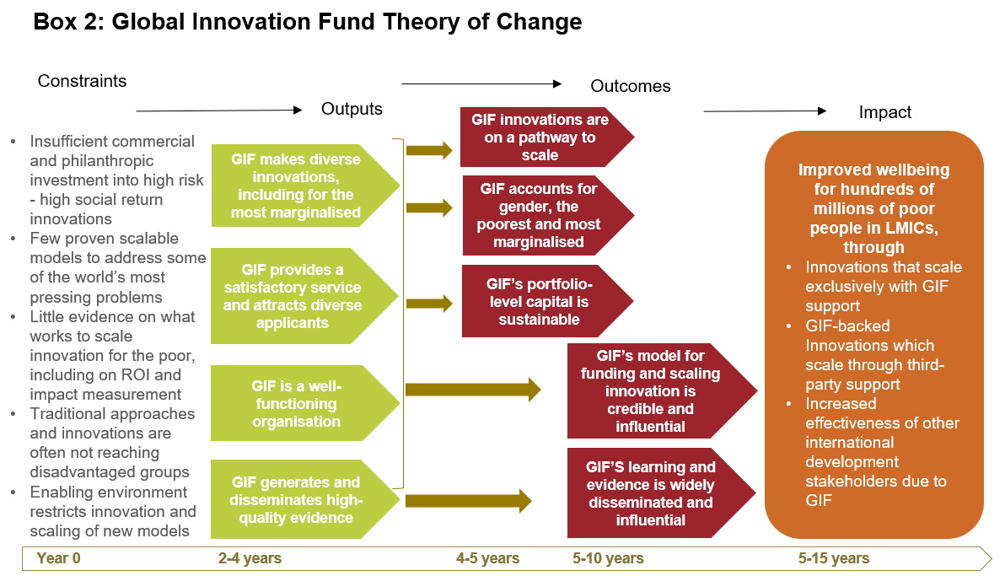

Describe where the programme is on/off track to contribute to the expected outcomes and impact. What action is planned in the year ahead?
The programme has met or exceeded all except one of its outcomes and impact.

Impact:
GIF has cumulatively impacted 127m people to date across 36 countries. Cumulatively, GIF achieved a total of 12.4 million Person Year Income (PYI) as impact in 2024 increasing by 0.4 million since the last reporting date. PYI (Person Year Income) measures changes in well-being, based on income or equivalent benefits. E.g a 20% income increase equals 0.2 PYI per person. PYI also covers non-monetary benefits like education or health, using set conversion factors

There are now three portfolio innovations which have reached >20m people (Paga, One Acre Fund and DMI), two which have impacted >10m people (Viamo, Komunidad) and six which have impacted >1m people (Breakthrough, Chrysalis, Educational Initiatives, Simprints, No Means No Worldwide, Online Pajak.) There has been an increase in innovations reaching 10m and above in this year.

GIF has generated $3.35bn in net social benefits (against a target of $2.5bn – $3bn). From which $1.15m is directly attributable to GIF’s investment. This year, the programme started using a 3% discount rate, which is more standard, to give a fairer value to successful education projects—because a lower rate means future benefits are not undervalued.

The programme has invested $113 million to achieve an average 5% improvement in living standards for 157 million people per year by 2034. Average cost is less than $1 per person reached, Adjusting for risk, GIF will annually generate 7.8 million Person Year Income (PYI) or income equivalent. This includes lives saved and morbidity related DALYs averted per year. This is calculated using GIF’s Practical Impact tool (PI) to forecast, track, and evaluate impacts across its investment cycle.

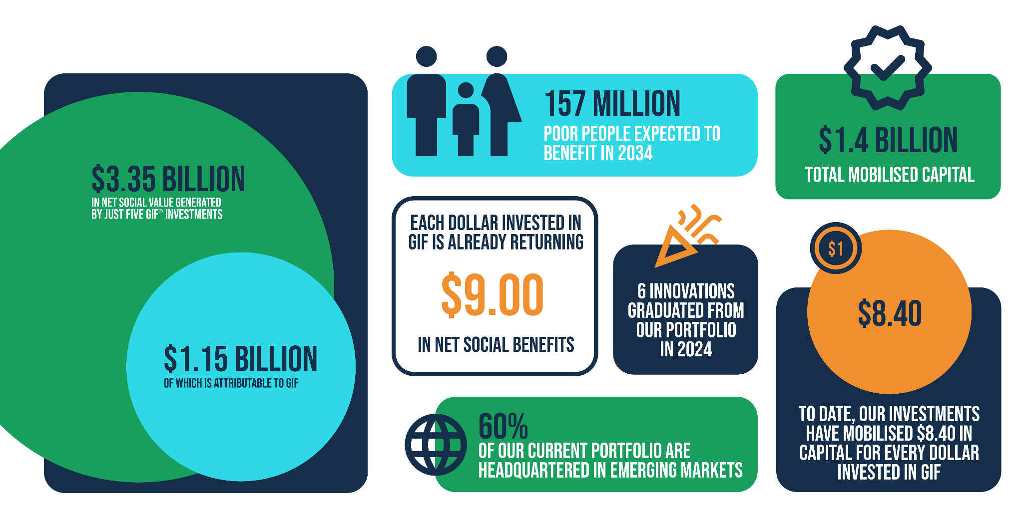

Outcomes
Outcome | Indicator | Milestone | Progress | Supporting Text
1. Innovations are on a path to scale | Cumulative additional finance, concurrent and subsequent attracted to innovations ($) | 1B - 1.15B | 1.4B (+$ 200m in the last reporting year) | For 2024, the programme has revised its methodology for calculating follow-on funding to ensure consistency across all programmes within the TIU portfolio. The definition is as follows:  Attribution/Contribution: Partners will use a qualitative measure to assess the importance of their support in attracting financing. They will ask how critical their support was, with three possible responses: not critical, somewhat critical, and very critical. For responses of somewhat critical and very critical, attribution/contribution is reported as 100%. For responses of not critical, attribution/contribution is reported as 0%
 | For Test & Transition and scale investments at 5+ years since GIF investment, cumulative proportion that have demonstrated demand for scale. | 30% | 58% | By the end of 2024, 18 out of 31 deals (58%) are T&T or Scale, reaching or exceeding 5 years since the initial GIF investment and demonstrating demand for scale.  The 18 are divided between Risk Capital and Grants as follows:  Risk Capital: 44%  Grants: 56%  In 2024, 6 deals reached the 5-year threshold, with 3 showing demand for scale.
2. Learning and evidence generated by GIF is being shared and is influential | Cumulative proportion of innovations in GIF portfolio conducting RCT’s | 30% | 34% (25 out of 74) | Out of 74 innovations funded by GIF, 25 have established research partnerships to conduct rigorous RCTs, either funded by GIF or related to GIF-funded innovations. In 2024, Proximity and Simprints were added to this list.
 | Cumulative proportion of innovators scaling up rigorous evidence | 50% | 56% (14 out of 25) | Of the 25 innovations in GIF's portfolio conducting rigorous impact evaluations, 14 are successfully scaling up based on the evidence. The remaining 11 have either closed or paused their evaluations, are still in implementation, or have not yet used their evidence to inform scaling.
3. GIF’s returnable capital investments are sustainable | Change in value of GIF’s risk capital | Tracked | $2.2m (Gross) | In 2024, the gross value of GIF's risk capital portfolio increased by $2.2m, pre-impairment. The net value remains unchanged from 2023 at approximately $16.7m, post-impairment provision. The final value is subject to an ongoing impairment review. The programme made two new risk capital investments: $0.5m in Boomitra and $0.5m in Komunidad. Additionally, four follow-on investments were made in S4S, Sparkmeter, Mr Green Trading, and Viamo, totalling $1.5m. Since inception, GIF has gained approximately $9m in returned capital from exits, loan repayments, and interest.
4. GIF’s model for funding and scaling innovation is credible and influential | Additional $ pledged to GIF during reporting years (Core and Growth) | $10m | $12m | US DFC announced a $10m commitment to GIF Growth, KOICA announced a $1 million investment in GIF at the GIF Growth launch event, This Day (private investor) has committed $1m.
 | Annual increment in # of new donors to GIF (Core and Growth). | 1 | 3 | Growth investors: US DFC, KOICA, This Day

GIF’s additionality in growth trajectory of risk capital deals - example of Mr Green Africa

2

Scaling cutting edge technology for development

GIF’s investment enabled Boomitra to create valuable proof points for registering its first carbon project with global standard body Verra, while extending the business's cash runway. This additional time allowed Boomitra to achieve Verra registration in February 2025. The company is now working towards its first credit issuance and payments to farmers.
This critical milestone demonstrates the maturation of carbon markets, facilitating capital flows from large carbon credit buyers in the Global North to suppliers in the Global South. GIF participated in Boomitra’s pre-Series A round in August 2024 with a $500,000 investment via a convertible note. Boomitra, through its partners, helps farmers enhance soil carbon capacity by incentivising sustainable agricultural practices.
Boomitra’s innovation uses remote sensing and artificial intelligence to monitor soil organic carbon, significantly reducing monitoring, reporting, and verification costs. This eliminates the need for extensive soil testing, which has been cost-prohibitive and hindered the deployment and scale of soil carbon projects. This digital approach makes carbon markets accessible to smallholder farmers by increasing the financial viability of their carbon credit projects. Boomitra provides farmers with a new income stream from carbon credit sales, with the majority of revenue paid to the farmers.
Boomitra won the 2023 Earthshot Prize for the "Fix our Climate" category. While such accolades bring media attention and prize money, long-term patient capital investors are crucial for companies like Boomitra to scale effectively.
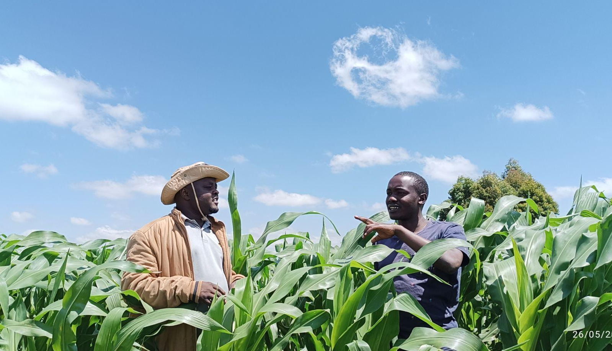

Justify whether the programme should continue, based on its own merits and in the context of the wider portfolio

The Global Innovation Fund (GIF) has shown strong performance and value for money in scaling innovation and generating evidence, particularly in climate and gender areas, which are key FCDO thematic focuses. The recommendation is to continue this programme. Its emphasis aligns with recent speeches by the Foreign Secretary and Minister Dodds, who have stressed the importance of modernising the UK’s development approach by fostering partnerships and mobilising private capital.

In her speech to the London Stock Exchange, Minister Dodds underscored the vital role of private sector finance in driving sustainable development and economic growth. GIF’s strategy of blending public and private sector finance has proven effective. By derisking early-stage innovations, GIF has catalysed additional private sector investments, thereby amplifying the impact of its funding, especially in initiatives addressing climate change and gender equality.

C: DETAILED SCORING OUTPUT

Output Title | GIF makes diverse innovation investments at an appropriate pace
Output number: |  | 1 | Output Score: | A+
Impact weighting (%): |  | 40% | Impact weighting % revised since last AR? | No

Indicator(s) | Milestone(s) for this review | Progress
1.1: Cumulative number of innovations ever supported | 69-73 | 74 Exceeded – (6 in the last reporting year)
1.2: New transactions this year | 6-7 | 8 (Exceeded)
1.3: Proportion of innovations in past year where investee’s primary headquarters is in a developing country | 33% | 67% (Exceeded)
1.4: Proportion of new innovations led by women | 50% | 50% (Met)

This output scores an A+, in recognition of meeting all of the targets for the year, and exceeding 75% of them, especially the proportion of new investees which are locally-led. The cumulative number of innovations ever supported has increased to 74 (36 of which are live, 38 of which are closed). This encompasses 49 grant disbursements and 25 risk-capital investments. Over half of all investments (44) have been made at ‘Test and Transition’ stage (where innovations already have evidence of initial success and are preparing to scale), and the average ticket-size at this investment stage is $1.54m. 20 pilot-stage investments carry an average ticket-size of $280k and 10 scale-stage investments have an average ticket size of £4.96m.

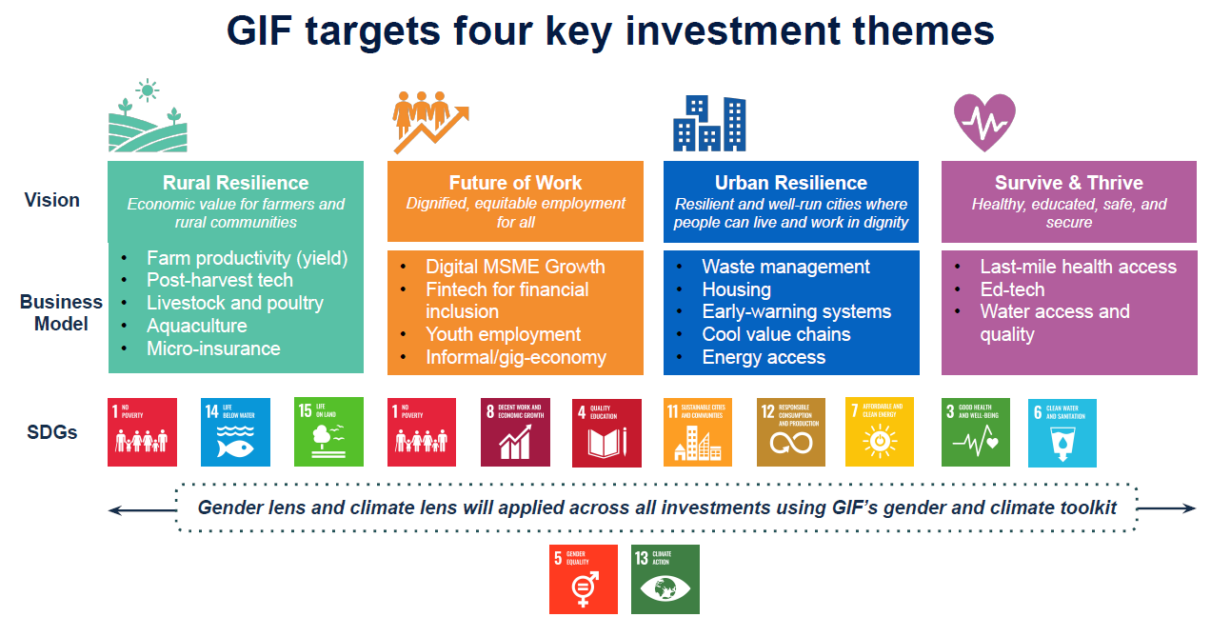

GIF’s flexible funding model
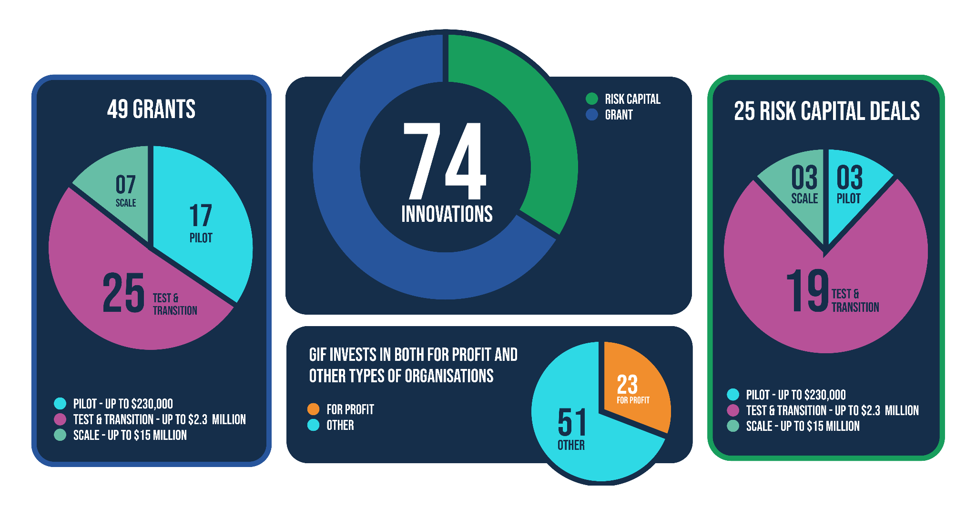

Localisation

As part of an enhanced localisation strategy, GIF staff in Nairobi and Singapore have increased face-to-face engagement with local early-stage funders, accelerators, incubators, research institutions, and sector experts. This on-the-ground presence fosters trust, collaboration, and a deeper understanding of locally-led innovation challenges. The team also actively participates in strategic sector-specific convenings, roundtables, and investment forums to enhance GIF’s visibility and identify high-impact local innovations.

Since opening the Singapore office in Q3 2022, locally-led innovations from Southeast Asia in GIF’s portfolio have increased significantly. In 2023, GIF made one investment in the Asia-Pacific region (14%). In 2024, four out of six new investments (67%) were in the Asia-Pacific region (Build Change, Boomitra, Komunidad, Proximity), demonstrating growing momentum.

GIF’s portfolio in numbers:

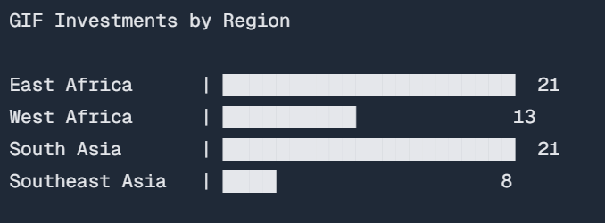

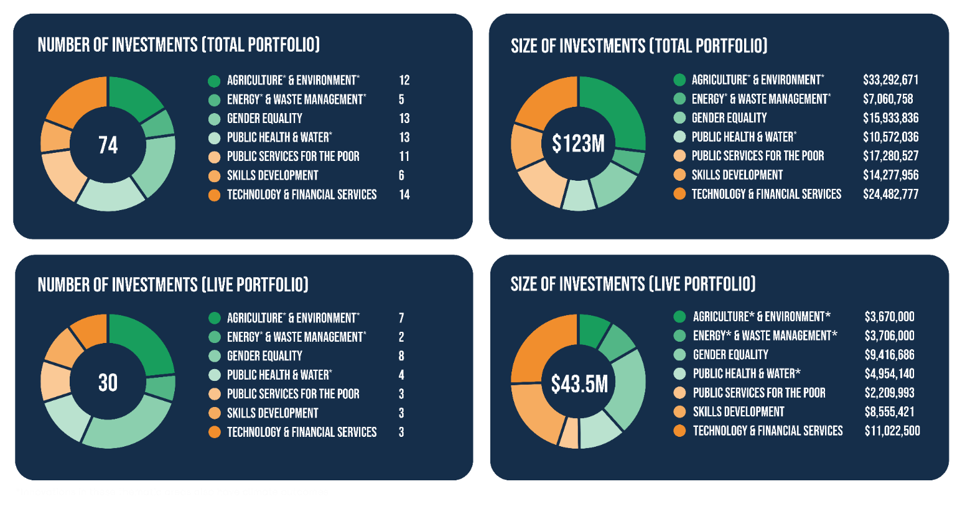
Please see Annex 1 for a summary of GIF’s 2024 new investments

Describe any changes to this output during the past year, and any planned changes as a result of this review

Given GIF’s ongoing focus on localisation, next year’s target will increase to 50%. In addition, the definition of “locally led” will be broadened beyond country headquarters to include factors such as the composition of organisational leadership

Progress on recommendations from the previous AR (if completed), lessons learned this year and recommendations for the year ahead
Progress on recommendations
Recommendation (2023) | Progress
Review sub-fund structures  Review the existing structure of the sub-funds, to determine whether they best serve the needs of GIF’s gender and climate thematic investing. | Yet to be actioned: This will be reviewed as part of the new GIF strategy by Q3, with Board input.
Expand GIF pipeline  Engage with hubs and RED innovation funds to increase the number of FCDO supported innovations considered for the GIF pipeline | Ongoing: GIF will continue collaborating with the FCDO programme team on this recommendation. In 2024, new channels were established for FCDO-backed innovations to enter the GIF pipeline, including direct engagement with organisations supported by UK Growth Gateway, Transforming Energy Access (TEA), AT2030, and GSMA Mobile for Development. GIF also presented to FCDO colleagues working on EcDev programming in East Asia, with ongoing follow-up. In 2025, GIF will increase efforts to present its specific application criteria to potential applicants.
Update Bylaws  Complete a diagnostic of organisational bylaws and make necessary changes which would allow GIF to pursue new ecosystem focussed partnerships, in line with its strategy for the coming year | Achieved: GIF updated its by-laws in Summer 2024, including removing outdated bylaws, which prevented the organisation pursuing ecosystem focussed partnerships.
Partnerships  Pilot at least one ecosystem partnership with thematic and regionally focussed expert partners, enabling investment to nurture local technology ecosystems in priority FCDO areas | Achieved: Discussions regarding PATH partnerships are developed. GIF aims to launch PATH partnership at event in Q2 2025 which will focus on unlocking scale pathways for climate and health solutions  Calls with advisers and thematic experts at FCDO and Sida have taken place.

Lessons learned & Recommendations

Local Impact
Lesson
- Expanding investment teams in Kenya and Singapore demonstrates that a localised approach is improving the programme’s sourcing capabilities. This shift towards greater localisation enhances understanding of regional challenges and also fosters stronger relationships with local innovators, ultimately leading to more locally based investments.

Climate Pathways
Lesson
- GIF has doubled its investments in climate this year. Increased climate sourcing and investment has highlighted that climate adaptation and resilience innovators must not only develop new solutions, but new scale pathways too. For climate adaptation, the scale pathways are likely to look different than a pilot, test and transition and scale framework.
Recommendation
- GIF to build learning objectives into its investments with a view to understanding alternative scale pathways for climate adaptation innovations. [Review: Oct 25, Jan 26, Owner: GIF]

Due Diligence
Lesson
- The programme conducts rigorous due diligence, has reputable ESG analysis and clear KPIs to support their investments move through stages of growth. However the importance of this is underplayed when communicating with existing and potential donors as well as potential investees and other peer-organisations. The GIF team should do more to elevate the value it provides here.
Recommendation
- GIF will raise the profile of the value of GIF’s technical assistance work through its communication products for knowledge sharing, fundraising and investment sourcing. [Review: Oct 25, Jan 26, Owner: GIF]

Output Title | GIF generates and disseminates high-quality evidence
Output number: |  | 2 | Output Score: | A
Impact weighting (%): |  | 20% | Weighting revised since last AR? | No

Indicator(s) | Milestone(s) for this review | Progress
2.1: Cumulative number of peer-reviewed papers or studies publicly disseminated | 24-27 | 27 (Met) 2 new papers published this year
2.2: Proportion of innovations with basic data on IATI | 100% | Met 100%

Briefly describe the output’s activities and provide supporting narrative for the score
This output scores an A, in recognition of the total number of research outputs disseminated this year and commitment to aid transparency standards. Two new papers were publicly disseminated in 2024, bringing the overall number to 27, meeting the milestone of 24-27 (output 2.1). These publications have had 2,194 google citations, which is an increase of 1,621 from 2023.

GIF’s 2024 Research Output

Partner | Citation | Available From | Dissemination examples
ICM | Angrist, N., Kabay, S., Karlan, D., Lau, L., & Wong, K. (2024, September 14). Human capital at home: Evidence from a randomized evaluation in the Philippines. [Working paper]. Pepperdine Digital Commons. | Human Capital at Home: Evidence from a Randomized Evaluation in the Philippines∗ | The paper has been disseminated across several academic and research platforms they are; EdWorkingPapers (Annenberg Institute, Brown University), SSRN, Northwestern University's Institute for Policy Research, and Pepperdine University's Education Division Scholarship repository.
J-PAL Health | Krishnan, A., Mukhopadhyay, T., & Pal, G. (2024, October). Institutionalising a culture of data-driven decision making Working paper. | Institutionalising a Culture of Data-Driven Decision Making | Findings were published on the Clear Evaluation South Asia website.

Other related highlights


GIF continued to use LinkedIn as its primary social media platform. In 2024, GIF increased its number of followers by 31% in comparison with 2024, to just over 23,000 from just under 17,600 in 2023

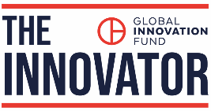
GIF continued to publish The Innovator, its monthly newsletter providing an overview of GIF’s news, approach and investments. In 2024, the number of subscribers increased by 38% in comparison with the previous year, reaching 10,460 subscribers

- The programme team spoke at and contributed to numerous high level global conferences, including MWC Barcelona; the Connect conference (part of London Climate Action Week); The Africa Impact Summit, The Earthshot Prize Innovation Summit (& New York Climate Week) , AfricaHealthTech Summit, COP29, the African Venture Philanthropy Alliance (AVPA) inaugural conference, the Africa Women Innovation & Entrepreneurship Forum, the What Works Climate Solutions Summit in Berlin Reset, the Africa Climate Tech Week, Segal Connect Southern Africa 2024, AfricaTech Summit, COP29 and the Blended Finance Africa conference.
- GIF co-hosted side events with Spring Impact and Grand Challenges Canada at 2024 Skoll World Forum Marmalade Festival in Oxford in April, unpacking the key lessons for mission-driven organisations and funders scaling with government, and with Grand Challenges Canada at the United Nations 68th Session of the Commission on the Status of Women (UNCSW68) in New York, addressing the role of innovation in achieving gender equality by 2030.
- GIF Growth was launched at a reception at the UK Deputy Ambassador’s Residence in Washington DC, to coincide with the Annual Meetings of the International Monetary Fund and The World Bank.
- CEO Joseph Ssentongo was interviewed by Devex World, explaining how GIF Growth is designed to fill the financing gap that high impact companies are facing in emerging markets:
- GIF welcomed colleagues from the Fonds d'Innovation pour le Développement (FID) to their London office for a learning exchange day on key topics of mutual relevance including XYZ.
- GIF collaborated with Innovations for Poverty Action (IPA) ‘Best Bets’ Report, which featured several GIF investments as emerging opportunities for achieving impact at scale.

GIF has continued to support and achieve transparency objectives (output 2.2) through encouraging the publication of datasets alongside academic articles (where commercial sensitivity allows), and ensuring all relevant
financial information for all innovations in GIF’s portfolio has been published via the International Aid Transparency Initiative.

Describe any changes to this output during the past year, and any planned changes as a result of this review

The weighting of this output has been reduced from 30% - 20%, to accommodate the increased emphasis on output 1, relative to output 2.

As an output of this Annual Review, the programme will commit to establishing measurable targets relating to its disseminating and influencing work beyond peer-reviewed papers published by its portfolio.

Progress on recommendations from the previous AR (if completed), lessons learned this year and recommendations for the year ahead
Recommendation (2023) | Progress
Liaise with the FCDO programme team ahead of funding decisions relating to new RCT’s. | Achieved: GIF continues to liaise with FCDO regarding RCT discussions. Of the new innovations entering the portfolio in 2024, only Boomitra included an RCT. GIF informed FCDO about Boomitra's entry into the portfolio in mid-2024.
Review and update GIF’s evidence strategy, to incorporate macro-level research; examining trends, patterns and interactions aggregated at portfolio-level | Yet to be actioned: This was delayed whilst resource gaps at GIF were filled, with the team now including this in the review of their wider corporate strategy.
GIF to identify and implement revisions to reporting processes which improve standardisation | Ongoing: Started in 2024, the analytics team conducted an internal review. Completion of this recommendation has been deferred to 2025, in agreement with the FCDO programme team, to align with CEO recruitment and the 2025-2030 corporate strategy
Strengthen external review of the Practical Impact methodology | Ongoing: To be completed in 2025. However, to note Smith School, UKAID Impact reports cite GIF’s Practical Impact as gold-standard. From an organisational perspective, adhering to PRI principles from the ESG perspective.
GIF to strengthen dissemination activities for completion reports, as part of its wider communications strategy. | Ongoing: GIF agreed with FCDO to focus more cross portfolio learnings rather than individual completion reports, therefore this recommendation has been integrated with others relating to their learning strategy update which is due for completion Q3 2025.

Lessons & Recommendations
Measuring Impact approaches for Climate Innovations
Lesson
- Climate innovations are not always ripe for an RCT and nor will they be relevant for decisions to scale or replicate in different climate hazard contexts. To best assess the efficacy of these interventions, broadening the types of evidence generated to include quasi-experimental design may be more beneficial
Recommendation
- GIF should expand its evidence generation toolkit by incorporating a variety of high-quality methodologies, such as lean data and quasi-experimental designs. This diversification will enhance the robustness of findings and provide a more comprehensive understanding of the impacts of its investments. [Review: Oct 25, Jan 26, Owner: GIF]

Diversify capture of climate impacts
Lesson
- The increased focus on Climate resilience and the launch of GIF growth provide opportunities for the programme to enhance how it captures and articulates impact. For climate, this could be an exploration of impacts beyond income increases and livelihood benefits. For GIF Growth, metrics capturing other impacts such as shaping new markets could be considered.
Recommendations
- GIF should develop specific Key Performance Indicators (KPIs) and metrics tailored to climate resilience initiatives and GIF Growth investments. These tailored measures will enable more effective tracking of progress and impact, ensuring that the organisation can assess the success of its strategies in fostering climate adaptation and market development. [Review: Oct 25, Jan 26, Owner: GIF]

- Review and update GIF’s learning strategy, to incorporate macro-level research and insights; examining trends, patterns and interactions aggregated at portfolio-level, develop learning themes which GIF linked to new learning products and embed learning objectives within its investments. [Review: Jan 26, Owner: GIF]

Output Title | GIF accounts for gender, the poorest and most marginalised in its strategy and investments
Output number: |  | 3 | Output Score: | A
Impact weighting (%): |  | 30% | Weighting revised since last AR? | No

Indicator(s) | Milestone(s) for this review | Progress
3.1: Proportion of people reached living on less than:  - $6.85 PPP/day  - $3.65 PPP/ day  - $2.15 PPP/ day | Tracked (To switch to targeted from 2025 onwards) | - On average, 84% of those reached by GIF are people living under $6.85 PPP/day.  - On average, 54% of those reached by GIF are people living under $3.65 PPP/day.  - On average, 28% of those reached by GIF are people living under $2.15 PPP/day.
3.2: Proportion of live portfolio innovations compliant with gender disaggregated reporting | 75% | Exceeded: 87.5%
3.3 Number of people supported by GIF innovations to better adapt to the effects of climate – projected at year 10 | Indicator currently tracked not targeted | 48 million

Briefly describe the output’s activities and provide supporting narrative for the score [max 1/2 page]
This output captures GIF’s performance in investing in scalable innovations that measurably and meaningfully improve the lives of the poorest and most marginalised people in the developing world.
GIF has achieved an A score due to its gender-inclusive work and focus on reaching the most marginalised populations. Since introducing gender lens investing, 28 out of 32 grantees comply with gender KPIs developed with GIF as part of their agreements. This marks an incremental increase from 81% in 2023, 78% in 2022, and 70% in 2021. The team continues to support innovations that have yet to meet these targets. All new deals are now reviewed against GIF’s gender marker during the investment process. In 2024, three deals were marked as Gender Neutral, two as Sensitive, and one as Positive, with no gender-negative deals.
The programme is also focusing on localising investments and capturing better quality impact data on the salary thresholds of people in poverty impacted by GIF’s portfolio. The first criterion in GIF’s application process requires innovations to benefit those living on less than $5 a day, with a specific interest in those targeting individuals living on less than $2 a day.
GIF now collects and tracks information on different segmentation of reach by poverty levels, incorporating this into regular information collection from investees/grantees. This will transition to a targeted indicator for 2025 Annual Review. 2024 results are as follows:
84% of those reached by GIF live under $6.85 PPP/day.
54% of those reached by GIF live under $3.65 PPP/day.
28% of those reached by GIF live under $2.15 PPP/day.

Box 3: S4S: Example of GIF investments having a positive impact for women and girls and targeting poorest and marginalised groups.

S4S has significantly improved the livelihoods of marginalised farmers and women by purchasing unsellable produce, offering price guarantees, and enabling farm-gate sales, which increase farmers’ incomes and reduce costs. GIF's support has been crucial in scaling S4S's operations and expanding its impact across new product lines and communities. GIF facilitated introductions to debt providers aligned with S4S’s mission, helping secure working capital.

In 2024, S4S expanded procurement to include grains, pulses, and milk, benefiting more farmers with immediate payments and fairer prices, especially in the dairy sector.

For women, GIF supported S4S in developing a framework to measure gender agency, focusing on empowering women across the value chain. S4S has created opportunities for off-farm entrepreneurship, increased access to credit and government programmes, and enabled women to take on skilled technical roles. This has enhanced women's economic independence, agency, and participation in household financial decisions.

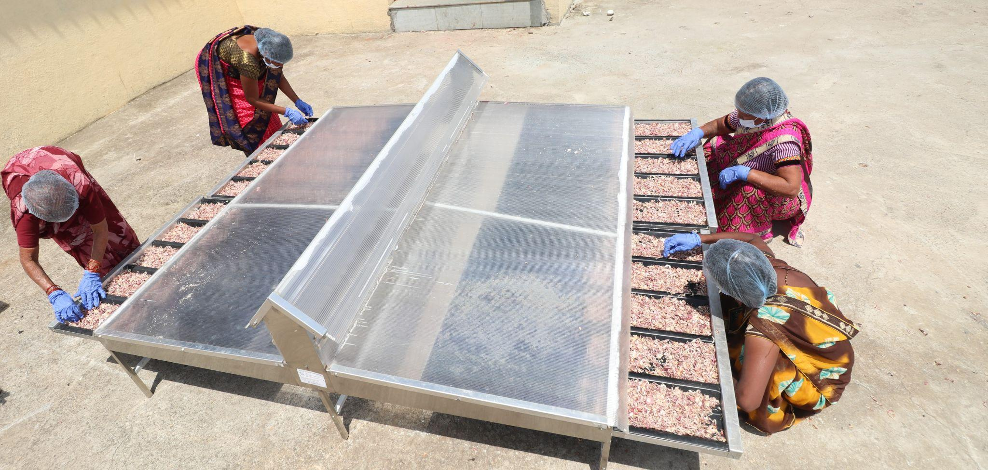

Describe any changes to this output during the past year, and any planned changes as a result of this review
Removed old indicator 3.1, which focused on how gender sensitive new innovations are. With gender now mainstreamed across the organisational approach, there is no longer a need to track this. This has been replaced with a new indicator focused on reaching the poorest populations, introduced too late to be targeted for 2024, targets set for 2025.
The new indicator examines the percentage breakdown of beneficiaries against poverty markers. FCDO and GIF will agree on the terminology for measuring this in the 2025 Annual Review.
Progress on recommendations from the previous AR (if completed), lessons learned this year and recommendations for the year ahead
Progress on recommendations
Recommendation (2023) | Progress
Present approaches and impact from the Gender portfolio to key stakeholders within FCDO’s gender research team and wider gender portfolio. Work with FCDO colleagues to exchange learning with other aligned gender programmes funded by FCDO. | On track for 2025: GIF and FCDO had scheduled an expert day at FCDO in March 2025 for GIF to present its work on gender, climate, and the private sector. This event was postponed by FCDO to later in 2025 due to announcements made at that time
GIF to engage GDI Hub in order to run a disability inclusive review of the GIF application process | Achieved: GDI hub have been engaged to plan this review. Implementation will follow in 2025.

Lessons and Recommendations

- Climate innovations encounter significant adoption challenges, particularly among the poorest and most vulnerable populations. Challenges stem from factors such as cost, lack of information, and risk aversion, which hinder the uptake of innovative solutions at both household and community levels. Addressing and overcoming these adoption barriers should be a critical priority.

- Sourcing innovations at the intersection of gender and climate remains challenging. GIF’s investment team is building expertise in supporting climate adaptation innovations to incorporate gender outcomes where they previously had not.

Recommendations

- GIF should actively seek out and source new climate and/or gender focused innovations that prioritise both gender equality and climate outcomes. GIF will generate a lessons learned and knowledge paper on gender outcomes through climate adaptation investments. [Review: Jan 26, Owner: GIF]

- Where possible, gender outcomes should be incorporated into impact frameworks for existing climate-focused innovations (which are yet to have them embedded). [Review: Jan 26, Owner: GIF]

Output Title | GIF provides a satisfactory service and attracts diverse applicants/investees
Output number: |  | 4 | Output Score: | A+
Impact weighting (%): |  | 10% | Weighting revised since last AR? | No

Indicator(s) | Milestone(s) for this review | Progress
4.1: Proportion of open window applications with GIF response within 60 days | 76% | 88% (Exceeded)
4.2: Investees’ Net Promoter Score on question: “How likely are you to recommend that a fellow innovator apply to GIF for funding?” | 0% (-100% to 100% range) | 64% (Exceeded significantly)

Briefly describe the output’s activities and provide supporting narrative for the score [max 1/2 page]
This output scores an A+, reflecting GIF’s 88% timely response rate to applications—well above the 76% target. The Net Promoter Score (NPS) rose by 16 percentage points, from 55% to 64% (output 4.2), following a 20-point increase the previous year. With NPS ranging from -100% to +100%, a score above 20% is considered favourable. Of 14 investee survey responses (from 31 requests), 11 (79%) would recommend GIF to other innovators, 2 (14%) would not, and 1 (7%) was neutral. NPS is calculated as the percentage of promoters (scores of 9 or 10) minus detractors (6 or below), resulting in a strong score of 64%.

Number of applications received vs response from GIF within 60 Days (2019 – 2023)

Year | Number of Applications | Response within 60 days
2024 | 4990 | 88%
2023 | 5,525 | 93%
2022 | 2500 | 76%
2021 | 2266 | 2%
2020 | 3624 | 65%
2019 | 2263 | 60%

GIF Investee Interviews

Interviews with investees during the Annual Review highlighted several consistent strengths of the GIF investment team. Investees praised the team’s expertise, continuity, and tailored support. One investee remarked, “Compared to other bilateral funders, GIF has been a much better experience. It is a highly capable and knowledgeable team who remember last conversations,” emphasising the value of continuity and expertise.

Staff retention at GIF was also commended: “They don’t have massive staff turnover, so we know the contacts will be there the next time we need them.” This stability fosters trust and strong collaboration.

Investees appreciated the trust GIF places in their operational judgement, especially in challenging contexts: “They know and trust our ability to operate in a very challenging situation… and the questions they ask are important technical questions.” This trust enables more effective, tailored support.

Practical support was also highlighted, such as flexibility on a revolving credit line: “We were able to have iterative conversations on increasing our revolving credit line to help support project scaling—it was really valuable.” Investees also valued GIF’s role in facilitating strategic partnerships, stakeholder introductions, and support for internal policies and impact indicators, all of which enhanced operational effectiveness.

As in previous years, some investees identified the lengthy process from initial application to receiving the first tranche of investment as a challenge. However, they acknowledged that GIF clearly communicates expected timescales upfront, helping to manage expectations.

Several investees also suggested that GIF could further strengthen its offer by creating more opportunities for peer engagement and collaboration. They expressed interest in connecting with other innovators facing similar challenges, noting that facilitated networking, knowledge-sharing events, or collaborative forums could enhance learning and foster partnerships across the portfolio.

Describe any changes to this output during the past year, and any planned changes as a result of this review

Proposed revised wording for Output 4, Indicator 1:

‘Proportion of Open Window applications receiving a response within 60 days of the application window closing.’

Progress on recommendations from the previous AR (if completed), lessons learned this year and recommendations for the year ahead
Progress on recommendations

Recommendation (2023) | Progress
GIF to review opportunities for additional venture building which could be made available to its portfolio | In Progress: GIF has undertaken a review of opportunities. As part of its new 5 years strategy, GIF will see how venture building fits in. GIF will share the results of this review.

Lessons Learned

- New leadership has enabled governance reforms, including piloting targeted climate windows and strengthening relationships in-country and with peer funders. The organisation should now leverage AI and other technologies to streamline internal systems for portfolio selection and management, driving efficiencies that will boost team productivity and enhance support for investees.

Recommendations

- GIF should conduct a review to explore how AI and other technology can enhance their internal systems and processes. This initiative is vital for improving team productivity and streamlining operations, ultimately leading to a more efficient and effective support system for their investees. By identifying and implementing innovative technological solutions, GIF can optimise workflows, reduce administrative burdens, and enhance the overall quality of their offerings, thereby driving greater impact and success for both the organisation and its partners. [Review: Jan 26, Owner: GIF]

D: VALUE FOR MONEY

VfM performance compared to the original VfM proposition in the business case

The VfM proposition in the business case is to achieve value for money by: (i) supporting innovations that deliver greater impact at lower cost per beneficiary; (ii) using a staged, evidence-based funding model to ensure only effective solutions are scaled; (iii) leveraging additional resources through co-investment with donors and private investors; (iv) maintaining lean management and operational costs; and (v) focusing on rigorous monitoring, evaluation, and learning to maximise impact and efficiency.

Overall, the VfM proposition in the Business Case holds, with the table below demonstrating how the Partnership continues to deliver value for money.
 | VfM Measures | Relevant examples and commentary
Economy | Procurement: GIF is governed by its Procurement Policy covering all purchasing process. Robust procurement processes are in place, which are consistent with international good practice.  Human resources: GIF has clear policies in terms of recruitment, remuneration (based on set market benchmarks) and performance appraisal. In addition, staff are increasingly recruited in the regions in which they invest.  Travel: Travel policies use FCDO travel as a baseline. | Procurement: No changes  Human Resources:  GIF has robust recruitment and reward policies, supported by a dedicated performance management portal. An extensive benchmarking exercise was conducted with Willis Towers Watson. Recruitment spans multiple disciplines, using both internal networks and external advertising.  In the last year, GIF experienced the resignation of two executive team members (including the CEO) and one GIF Growth board member. The COO became Acting CEO from 1 April 2024, and two new board members joined GIF Core.  GIF expanded its Kenya office with four new hires in 2024.  Operating Expenditure:  Opex increased to ~$6.4m in 2024 (from $5.4m), primarily due to team changes and increased fundraising and communications costs, aligned with board-approved organisational objectives.
Efficiency | Rigorous due diligence to mitigate risks in the selection phase of the investment lifecycle.  Input maximisation: cross-collaboration across the TIU portfolio has seen GIF sharing knowledge and expertise in support of the portfolios scaling ambitions.  Leveraging new marketing channels to engage stakeholders (e.g. LinkedIn). | GIF’s investment process includes multiple layers of scrutiny: climate and gender working group reviews, internal investment committee assessment, anti-money laundering checks, external expert consultation, majority approval by an external decision panel, and final CEO sign-off.  For example, In 2024, GIF’s due diligence on Komunidad included: engaging sector experts, conducting a detailed financial audit, stakeholder interviews, and a comprehensive ESG gap analysis. Independent reviews by the Gender and Climate Working Groups ensured alignment with best practices, demonstrating GIF’s commitment to responsible, high-impact investment.
Effectiveness | - Crowding-in of other donors in the Partnership enables FCDO investment to be more effective.  - Multiplier effect between the crowding-in by start-ups and the amount initially invested in the Innovation Fund’s alumni grantees.  - Monitoring and evaluation: constant improvement of services based on user feedback, business intelligence and monitoring and evaluation feedback. | Crowding-in: FCDO’s anchor investment has leveraged an additional $111m in direct funding for GIF Core from bilateral donors, philanthropic, and corporate partners. Despite strong headline figures, attracting supplementary funding for Core has been challenging, with missed targets in consecutive cycles. However, 2024 saw success for GIF Growth, securing $12m, including $10m from the U.S. DFC. Core fundraising remains a strategic focus and will be reflected in the new strategy.  Multiplier Effect: To date, $125m has been invested into the portfolio, securing $1.4B in follow-on funding. This additional finance has been calculated alongside and after GIF funding up until 2023, and only for 2024 onwards.
Equity | - Gender: A gender lens is now mainstreamed across all stages of GIF’s investment lifecycle and impact measurement processes.  - Poverty Reduction: An explicit poverty reduction focus is central to GIF’s investment criteria. GIF utilises the World Bank definitions of poverty.  - Disability and Inclusion: Disability and Inclusion is considered as part of GIF’s ESG analysis and recommendations | Mainstreaming: Gender analysis tools, including the Gender Marker, are applied to all pipeline deals, classifying investments from gender negative to gender transformative. In 2024, GIF joined the 2X Challenge, expanding the Gender Marker to meet 2X criteria for Risk Capital investments. Of the six deals made in 2024, 50% were gender neutral, 33% gender sensitive, and 17% gender positive. Three deals will contribute to the 2X Challenge in 2025, meeting criteria in entrepreneurship, leadership, employment, supply chain, and products/services.  Poverty Reduction: GIF now collects data on beneficiaries' poverty levels, focusing on those living on less than $2 a day.  Disability and Inclusion: Due diligence includes disability barrier analysis, inclusion policies, employee accommodations, and product/service accessibility. In 2024, GDI Hub began a comprehensive disability review at GIF. The ESG team also worked with Komunidad, Build Change, and Tiyeni to develop inclusion policies. Additional measures have been recommended to align with FCDO’s disability priorities.

E: RISK

Overview of risk management
Overview of risk management
The overall risk rating for GIF is major. In 2014 the programme was rated medium to high. Following a change in the risk rating categories in 2016, GIF was rated as major and that rating has remained unchanged. Top 3 programme risks currently as follows

The programme is currently going through a due diligence refresh process by FCDO on GIF’s standards of due diligence and fiduciary control, including reviews of governance structures, commitments to integrity and ethical conduct, name screening and bank account checks.

Risks and Description | Probability (H, M, L) | Impact  (H, M, L) | Mitigating Actions
(Financial & Fiduciary)  As the funding landscape changes, FCDO ODA cuts may impact forecasted plans | High | High | GIF undertakes scenario planning to prepare for all eventualities.  GIF uses extreme caution when signing new downstream partner contracts and ensure they communicate clearly with the FCDO programme team, as well as ensuring contracts include break clauses.
(Policy & Programme Delivery)  The current funding landscape may impact on the progress of the Growth Fund and how quickly it attracts funds. | Medium | High | GIF to actively monitor the global situation. FCDO to work with GIF to support diversification of funding sources through grants and partnerships.  GIF regularly updates FCDO on the Growth Funds progress.  Explore what FCDO can do to help leverage other bilateral commitments and encourage private equity investors.
(Strategy & Context)  GIF's current donors are effected by national priority changes or global economics, which impacts on the funds they are able to commit. | Medium | High | Continue to work closely with GIF keeping an open and regular dialogue relating to attracting new donors.  Monitor the implementation of their new funding strategy.  FCDO to be active in brokering new funding for GIF from major donors.  Ongoing conversations between GIF leadership and SRO.  FCDO board member (Helen King) to monitor at a board level.

The programme team continually monitors risk and reviews and assigns mitigating actions for any risk on a quarterly basis. The Programme Team meets at least once a month. Discussions between the FCDO and GIF continue to be open and collaborative, whilst providing a good level of challenge.

F: PROGRAMME MANAGEMENT: DELIVERY, COMMERCIAL & FINANCIAL PERFORMANCE

Summarise the performance of partners and FCDO, notably on commercial and financial issues
The total approved budget for the programme is £75.6 million, of which £62.4 million has been funded as of December 2024. This Annual Review marks a significant milestone as it is the first to cover the new business case that resulted in an uplift of GIF's funding from £50 million to £75.6 million. This increase in funding includes specific allocations for the launch and scaling of GIF Growth, highlighting the programme's expanded scope and ambition.

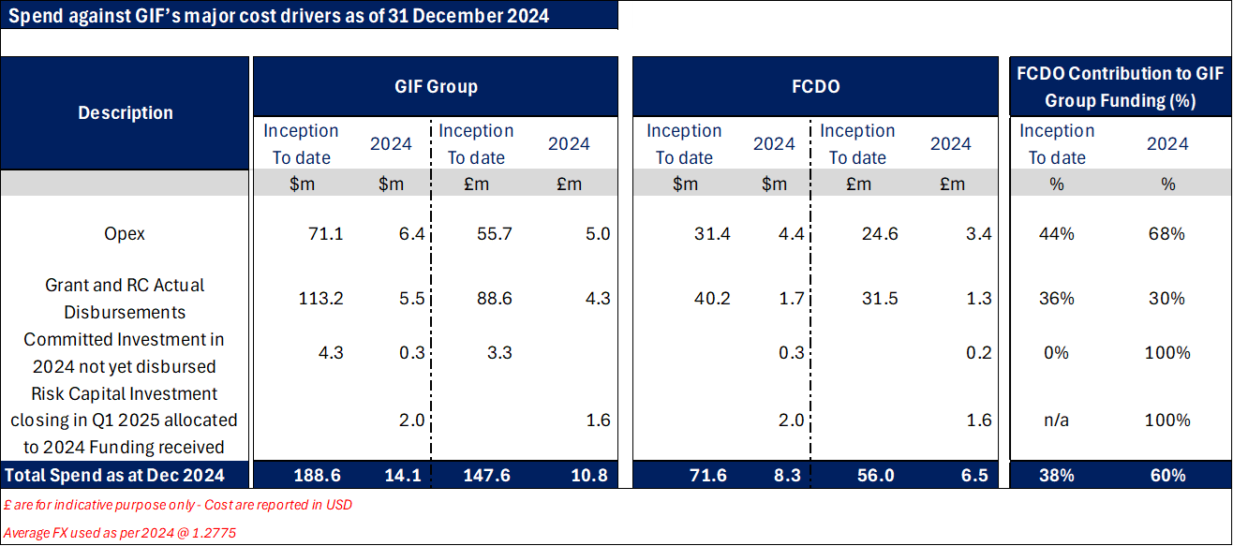
Investments:
- $0.25m commitments in 2024 relates to Boomitra commitment, the balance of $0.25m was paid out in Feb 2025.
- At the end of 2024, 3 investments entered the final stage with contracting expected in 2025 which amounted to $2m (Argos, Keep IT Cool & Blackfrog). All three investments were expected to close by March 2025
- Table excludes £6m Investment into GIF Growth as at 2024
Opex:
- 2024 Opex reflects team increase in line with strategy.
- FCDO working with GIF to standardise cost classification
- 68% refers to FCDO Share of GIF total Opex = FCDO £ applied to opex / Total GIF Opex £ = 68% (in 2024)
- Opex applied from FCDO funding = £ applied to Opex / Total £ received from FCDO <=50%

G: MONITORING, EVIDENCE AND LEARNING
G: MONITORING, EVIDENCE AND LEARNING [1/2 - 1 page]
Monitoring and Evaluation
Summarise monitoring activities throughout the review period
Field visits are a critical component of the Global Innovation Fund’s (GIF) due diligence, learning, and monitoring processes. In 2024, GIF's investments in Tiyeni, Mafisa, and Boomitra were informed by site visits to Malawi, Zambia, and Kenya, respectively. These visits were instrumental in assessing the climate context, potential impacts, and the strength of innovators’ relationships with beneficiaries and partners.
GIF places significant emphasis on frequent reporting and interactions with innovators, including assuming roles as Board Directors in companies where they hold equity stakes. For example, GIF’s investor nominee director, accompanied by the General Counsel, attended an in-person board meeting for Mr Green Africa in Nairobi in June 2024, and another board nominee director attended a meeting for Viamo in Washington DC in December 2024. Additionally, members of GIF’s Risk Capital team visited SwipeRx in Jakarta, gaining valuable insights into their operations and supporting small urban pharmacies.
In September 2024, programme leads from the Foreign, Commonwealth & Development Office (FCDO) and the Swedish International Development Cooperation Agency (Sida) joined GIF on a learning visit to India. This visit provided an opportunity to meet with investees J-PAL Health, Breakthrough, and Boomitra, and underscored how GIF’s portfolio aligns with UK international development strategies, particularly in climate adaptation, gender focus, and economic growth.
Briefly describe the Annual Review process itself including any inputs from outside the programme team (within or beyond FCDO). If there is an evaluation linked to this programme provide an update on findings (if not covered elsewhere in the AR).
This Annual Review (AR) provides an in-depth assessment of GIF’s progress, impact and strategic direction. It draws on extensive research and analysis, including:
- Previous Annual Reviews, programme logframes, risk registers, and delivery plans
- GIF’s 2024 Impact Report, website, and quarterly financial statements.
- Interviews with GIF’s grant and risk capital investment portfolio organisations
- Consultations with GIF Board members, senior leadership, and FCDO Programme Managers.

The findings, lessons learned and recommendations presented in this review are shaped by this comprehensive evaluation process, offering key insights to inform future investment and policy decisions.

Delivery chain mapping: GIF’s delivery chain is monitored as part of FCDO’s rules on delivering programmes. FCDO receives a comprehensive view of all partners receiving FCDO funding through GIF’s quarterly reports and through access to their investment spreadsheet. An updated delivery chain map, identifying and capturing the names of all GIF investees is recorded on FCDO’s Aid Management Platform and the information is also used to establish which countries benefit from UK ODA through GIF contributing to the country footprint information available on FCDO programmes.
Assets: GIF’s physical assets mainly consist of computer equipment and an updated list of IT equipment and phones is held in the Delivery Plan. All assets are bought or rented on short-term agreements, and the value is deemed immaterial to GIFs overall assets.

Date of last narrative financial report | Jan 2024 | Date of last audited annual statement | December 2023

157 million is GIF’s future estimated impact on people’s lives drawn from its impact methodology which is a snapshot at year 10 for each investment. It understates the cumulative impact because it is a snapshot in a particular year in the future.
Using their internal SROR methodology, GIF estimates that between 2015 and 2024, six investments have created over $3.35 billion of social benefits, net of operational costs, out of which GIF’s attributable net social benefits are $1.15 billion. After nine years, six SROR innovations have yielded benefits that exceed GIF’s total costs for early innovations, returning $9 in net social benefits attributed to GIF for every dollar invested in GIF, using a 3% discount rate. A change to the discount rate in the methodology after a review of current theory and practice in cost-benefit analysis accounts for the large increase in net social value being generated from our investments.
Based on GIF’s social rate of return calculations, this is taking into consideration five investments (Development Media International, One Acre Fund, LivelyMinds, Educational Initiatives, Viamo and Paga), all initiated in 2021 or earlier. This is a lower bound estimate.
When an innovation reaches the five year mark the deal lead reviews that deal against the following criteria: *for RC - market demand seen as growth of sales *for Grants - adoption through replication or public sector scale up *for both Grants and RC tangible scale 5 years post GIF *impact thesis still benefits GIF target population Deals that meet all three criteria are included in the scoring as ‘demonstrated demand for scale’.
Whilst the current indicator wording allows for the same publication to be counted twice if it goes through substantial reworking, all 27 attributed to date are unique.

