Annual Review

Title: Global Agriculture and Food Security Program (GAFSP)
Programme Value £ (full life): £206million (over 12 yrs) |  | Review date: 28 May 2025
Programme Code: 202571 | AMP start date: 1 October 2012 | AMP end date: 30 June 2031

Summary of Programme Performance

Year | 20  13 | 20  14 | 20  15 | 20  16 | 20  17 | 20  18 | 20  19 | 20  20 | 20  21 | 20  22 | 20  23 | 20  24
Overall Output Score | A | A | A | A | A | A | A | A | A+ | A+ | A+ | B
Risk Rating | Medium | Medium | Medium | Major | Major | Moderate | Moderate | Moderate | Moderate | Moderate | Moderate | Major

DevTracker Link to Business Case: | https://iati.fcdo.gov.uk/iati_documents/3744990.odt  https://iati.fcdo.gov.uk/iati_documents/5205221.odt
DevTracker Link to results framework: | https://iati.fcdo.gov.uk/iati_documents/4754763.xls

A: SUMMARY AND OVERVIEW

Description of programme

The Global Agriculture and Food Security Program (GAFSP) is a multi-donor financing platform launched by the G8 and G20 in the wake of the 2007-2008 food price crisis. GAFSP is dedicated to fighting hunger, malnutrition, and poverty in the world’s poorest countries (IDA) and has pooled over US$2.5 billion in funds from 12 donors to date. GAFSP is set up to deliver through various tracks:

- Country Grants: The GAFSP Public Sector Window, referred to in this review as the Grant Based Financing Track (GBFT), provides grants to recipient sovereign governments to support national agriculture and food security investment plans. Led by the Coordination Unit, funds are allocated competitively through calls for proposals, based on needs assessment, expected impacts, ownership and readiness. Governments can choose between accredited Supervising Entities to support project preparation and implementation. As of June 2024, the GBFT portfolio totalled US$2 billion. The US has been a major donor of this track.

- Producer Organisation Grants: Introduced within the GBFT in 2020 and delivered by the same set of Supervising Entities, GAFSP’s Producer Organisation (PO) led track, aims to bridge the gap between the public and private mechanisms, providing grants to farmer organisations to increase productivity or innovate. As of June 2024, PO-led projects constituted US$80.4 million (4 percent of the GBFT portfolio).

- Private Sector Investments: The GAFSP Private Sector Window (PrSW) provides concessional (blended) finance to agribusinesses mainly through direct investment, delivered by IFC, the private sector arm of the World Bank Group. The PrSW increases access to finance for agrifood companies with significant smallholder farmer engagement to leverage impact. Specialised advisory services scope and support agrifood investments to de-risk and deliver impacts, and to showcase innovation and best practice. As of June 2024, donors have committed a total of US$420 million to the PrSW (US$359 million for investments, and US$60 million for advisory services). It is a revolving fund: cumulative reflows from investments to the PrSW total US$195.9 million, meaning there was ~US$182.4 million available as of June 2024. This means UK funds can effectively be spent again, delivering double the results and leveraging even more investment for food security, agrifood and for vulnerable smallholder farmers – at no further cost to the UK taxpayer.

- In October 2024, a new two-year Business Investment Financing Track (BIFT) pilot was launched to provide grants and concessional finance to private sector partners through the private sector arms of eligible Supervising Entities including IFC but, importantly, enabling others to access this finance (including IFAD, IDB Invest, AfDB, ADB). The aim is to scale concessional (blended) finance in resilient food systems in low-income countries. Proposals for the BIFT are emerging in early 2025 (outside of this reporting period).
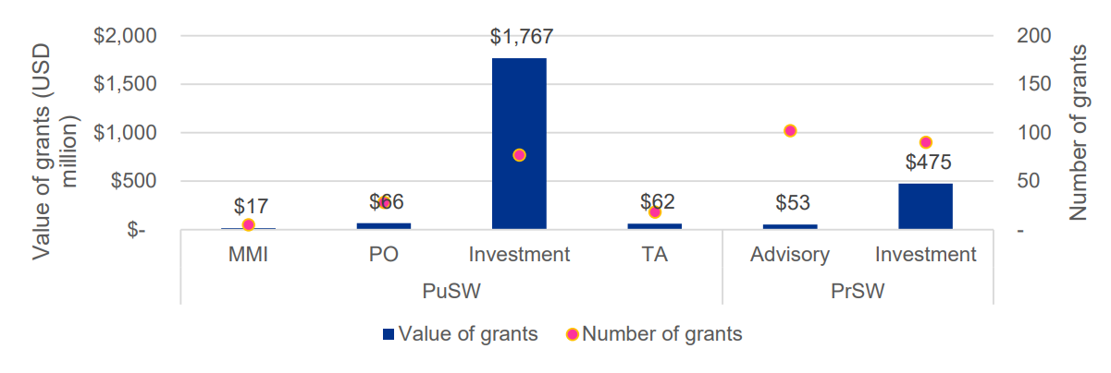
Gov Investment
Figure 1 Breakdown of GAFSP grants by window and type, KPMG 5-Year Evaluation of GAFSP
While over 75 percent of donor funds have been directed toward the GBFT to date (Figure 1) FCDO funding to GAFSP is weighted more heavily toward the PrSW (Figure 2) at ~65 percent. In this review period FCDO approved funding for a new £20 million local currency pilot within the PrSW. The pilot is beginning implementation in 2025 with progress a priority for the year ahead. 100 percent of FCDO funding to GAFSP contributes to the UK International Climate Finance (ICF) commitment.

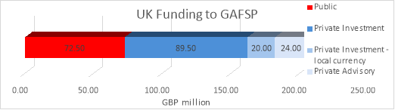
Figure 2 FCDO
To provide oversight of funding and impact, FCDO plays a key role in GAFSP’s governance through the Steering Committee; an inclusive structure consisting of regional representatives, civil society organisations and Supervising Entities, currently chaired by the US. The UK is Chair of the PrSW Donor Committee, and therefore also a member of the GAFSP Steering Committee Leadership Group, alongside the Coordination Unit, IFC and US. A key priority for GAFSP’s governance in this reporting period has been “Vision 2030”, a process to set strategic direction for the period 2025 to 2030, referenced throughout this review.

Summary supporting narrative for the overall score in this review

Annual Review approach: This year’s Annual Review takes a revised approach to assessing GAFSP’s performance and results compared to previous years - outlined in detail in Annex A and summarised here. Previous Annual Reviews assessed GAFSP’s delivery against its overarching food system outcome objectives. FCDO’s scoring of the programme did not distinguish between the GBFT and PrSW, reflecting significant historical UK contributions across both windows. Each year GAFSP has scored either A or A+ to date, with the programme meeting its milestones overall.

The revised approach to this year’s Annual Review applies a much larger weighting to the performance and results of the PrSW. This reflects the increased balance of UK funding toward this window in recent years (~66 percent to date, 100 percent since 2020). Furthermore, the UK now has a sizeable Trust Fund of investment reflows in the PrSW, and a leadership role as Chair of the PrSW Donor Committee. New indicators have been added to allow for fuller review of the PrSW, and output areas have been reorganised to allow for separate scoring of the two windows. This ensures the UK is not claiming attribution of cumulative results from GAFSP in full but seeking to assess delivery in proportion to live funding and influence. The additional scrutiny of the PrSW also reflects the new FCDO’s overall pivot toward an ‘investor’ approach. The performance and results of the PrSW constitute 70 percent of the overall score; GAFSP’s performance across windows 20 percent; and results from the GBFT 10 percent. Scoring of the programme is then set against broader assessment of GAFSP’s ability to deliver outcome and impact objectives.

Summary narrative for overall score: GAFSP overall continues to deliver impressive results against targets through projects approved in previous years – albeit through a slow-moving mechanism and with relatively little new funding - led by effective expert teams in the World Bank, the IFC and in the Supervising Entities. Using the methodology of previous Annual Reviews, GAFSP would likely have scored an A. However, applying greater scrutiny to the PrSW, FCDO’s assessment is that the window in its current form faces limitations targeting investment and advisory funds in accordance with GAFSP’s impact objectives. This is demonstrated by several key missed output level targets in this review period. The new UK-funded local currency pilot is a response to these limitations and has started well but cannot yet contribute significantly to the overall score in this review.

Furthermore, FCDO’s overall assessment is that the broader GAFSP programme has not evolved to establish its specific and strategic value-add in a rapidly changing ODA landscape. Vision 2030 has this ambition and is informed by a comprehensive and high-quality KPMG 5-Year Program Evaluation. However, there is not yet a realistic plan to deliver Vision 2030 that reflects the reality of current donor funding positions and the operational constraints of Supervising Entities.

Overall, the programme has scored ‘B’ for the period.

With the revised scoring approach outlined above, the overall score for this review is B.

 | Output description | Impact Weight | Output Performance
GAFSP Global Programme | 1. Public Sector Window (grant-based) activities to improve livelihoods | 10% | Outputs met expectation (A)
GAFSP Global Programme | 2. Performance of GAFSP as a funding mechanism | 20% | Outputs met expectation (A)
GAFSP Private Sector Window | 3. Performance of the Private Sector Window as a funding mechanism | 30% | Outputs did not meet expectation (B)
GAFSP Private Sector Window | 4. Private Sector Window (investment and advisory) activities to improve livelihoods | 30% | Outputs did not meet expectation (B)
GAFSP Private Sector Window | 5. Local currency pilot | 10% | Outputs met expectation (A)

Major lessons and recommendations for the year ahead

The context for GAFSP has shifted significantly since its inception in 2008. The problem GAFSP seeks to address ensured with global food security and malnutrition crises persist (36 countries classified in protracted food crises, more in IPC 1 and 2). However, the international development architecture for food and agriculture has grown more complex and fragmented, with multiple overlapping initiatives and funding mechanisms. Fundamentally GAFSP has not established itself as the major, well-resourced food security fund within this architecture, akin to GAVI or the Global Fund, able to pull in sizeable replenishments from traditional, non-traditional, philanthropic, climate or other finance. Now, GAFSP must navigate an increasingly pressurised and divisive multilateral system and the gradual geopolitical shift away from aid that has accelerated dramatically in the last six months. ODA budgets are significantly reduced by GAFSP donors including the US (responsible for a third of GAFSP funding to date), the UK and Netherlands and potentially Germany and Canada among others , . It is time to think differently and act more decisively.

GAFSP needs a realistic plan for its strategic positioning and for its operation to 2030. Uncertainty remains but GAFSP needs to prepare for a scenario of under-resourced supervising entities, and no or severely reduced further funding until its scheduled end date of 2030 and take bolder steps to deliver existing resources and wrap up well, and/or to focus down for greater strategic impact. The plans forming in the CU in 2024 for a US$1.5 billion funding round for 2025-2030 from traditional, climate and other finance, need a rethink. Further, it is more critical than ever that ODA in the programme is used effectively and efficiently for food security outcomes. For GAFSP this means ensuring swifter processes, and funds which benefit the most vulnerable and food insecure countries, communities and farmers, while facilitating growth and climate resilience to sustain impact. Within this, the relatively independent Private Sector window must form a clear action plan to invest the remaining funds efficiently and effectively, including bolder ways to ensure the target groups are reached, with a responsible final set of investments in 2026.

In this context, FCDO has communicated to the Coordination Unit and IFC that it has no plans to contribute new funding to GAFSP in the upcoming Spending Review cycle. The UK holds important live investments and uncommitted funds in GAFSP: the new £20 million local currency pilot and the recently re-flowed ~US$90 million UK Trust Fund (in the revolving investment). These funds are important effectively pre-positioned development capital funds allowing the UK to leverage even greater finance and results for agriculture and food security in low-income countries without drawing on new ODA. The assessment of this Annual Review is that a set of urgent actions are needed by IFC to ensure these funds are better managed to move faster, and better utilised to reach smaller agri-SMEs that are crucial for sustainable, inclusive growth of smallholder farmers and for domestic food markets in low-income countries.

Therefore, FCDO’s priority for the year ahead is to work with IFC, utilising its role as a respected partner of IFC and PrSW Donor Chair, to address the challenges they face in developing a pipeline, and then efficiently and effectively investing donor funding to maximise impact. This includes and builds on, close monitoring of the UK funded local currency pilot. Overall, the objective remains to better target funds to benefit smaller agri-SMEs, farmer supply chains in growing domestic markets, and vulnerable households, in lower income countries – enabling it to deliver better against one or more of the five GAFSP outcomes (see below). Further, although considerable progress has been made integrating climate as a central concern throughout GAFSP, a stronger emphasis on climate and nature is critical to reflect the food system’s impact on biodiversity and natural capital, and to build resilience to climate change.

The UK will deploy its oversight resources where our funds are concentrated but will support the wider GAFSP Steering Committee to ensure any last UK funds are spent well and to support difficult choices in the face of dramatically reduced financing available for the programme, its supervising entity multi-laterals, and others like it. Central to this, the UK will play a light touch, proportionate, role in shaping GAFSP’s implementation plan for Vision 2030, ahead of its planned agreement at the December 2025 Steering Committee.

Specifically, FCDO should:

Recommendation 1: Work with IFC to agree a plan to better utilise and target the funds remaining in the UK Trust Fund in the PrSW, with a strengthened approach to environmental sustainability, by December 2025, with all investments and new arrangements made by December 2026. The FCDO programme team should work with FCDO commercial and finance, and with additional specialist support, to consider a range (and combination) of options. These might include:
- modification of investment criteria
- intermediated investments or grants to local or regional funds
- co-investment with other DFI, IFI or impact investors
- in each, building in climate and nature more robustly - with monitoring markers
The FCDO rep in the PrSW Donor Committee should disseminate and promote to other GAFSP donors the settlement agreed for the UK funds. See analysis of Outputs 3 and 4 in Section C.

Recommendation 2: Monitor closely the pipeline development and impact of the local currency pilot, requesting direct regular reporting from IFC on pipeline and projected and achieved output and outcome results (covering cross cutting as well as food system outcomes). The FCDO programme team should also seek FCDO Posts’ scrutiny of projects where possible. This monitoring should (i) inform a decision on conversion of any further UK funds in the PrSW – including to allow a faster depletion of capital – to deliver impact; (ii) support and inform efforts to bring on board other donors to fund local currency investment through GAFSP; and (iii) generate broader learning for FCDO and other stakeholders on mitigating barriers to high impact investment. See analysis of Output 5 in Section C.

Recommendation 3: Ensure the PrSW reports against the 5 outcome areas and cross-cutting markers, including on climate on the farm to market linkages which their investments often enable. See analysis of Outcome level results in Section B.

Recommendation 4: Play a light-touch, proportionate role in shaping Vision 2030 into a prioritised and realistic strategy, with budgeted scenarios including for no or reduced additional funding ahead of the December 2025 Steering Committee. FCDO guidance for the Vision 2030 implementation plan is that it should (i) continue to draw from the findings of KPMG’s 5-Year Evaluation of GAFSP and from regular consultation with donors and Supervising Entities; (i) further strengthen GAFSP’s climate approach and introduce a clearer approach to protecting and restoring nature (with FCDO focusing on PrSW now). Delivery of these priorities will depend on support from the wider Steering Committee. See analysis of Outputs 1 and 2 in Section C.
Further recommendations are made throughout Section C; however, the above three recommendations reflect the top priorities for the FCDO programme team in the year ahead. If this progress is made in the PrSW, the UK contribution to GAFSP would be on track to again score A/A+.

B: THEORY OF CHANGE AND PROGRESS TOWARDS OUTCOMES

Summarise the programme’s theory of change, including any changes to outcome and impact indicators from the original business case.

GAFSP’s Theory of Change has two goals: increasing rural incomes (SDG1 - "no poverty") and improving food and nutrition security (SDG2 - "zero hunger"). These are supported by five food system outcomes – productivity, farm-to-market linkages, reduced risk and vulnerability, livelihoods and entrepreneurship, and improved institutions – and three cross-cutting outcomes on climate, gender and nutrition. Smallholder farmers and their households and communities are the intended beneficiaries. Inputs and outputs vary across projects but include public and private sector investments, technical assistance and blended finance instruments. The Theory of Change has been updated in 2022. GAFSP’s Vision 2030 process seeks to repivot the programme in its final five years, but through largely operational proposals rather than necessarily amending the Theory of Change. For instance, proposing “One GAFSP” encompassing all financing tracks, that is better positioned in the current global financing landscape - if financed.

Setting and monitoring of outcomes at project level is the responsibility of the relevant Supervising Entities, in line with GAFSP’s results framework and indicators, while using that agency’s existing tools, formats and processes. FCDO draws on GAFSP’s monitoring and evaluation framework, assessing a subset of indicators and results through a logframe. As outlined in Section A, FCDO has updated its approach to assessing GAFSP’s results and performance, to better reflect the weighting of UK funding and strategic leadership. This is reflected in a reorganised and re-weighted FCDO logframe, which also includes a small number of new indicators for the PrSW and to better reflect FCDO priorities such as climate. These new indicators are highlighted in Section C.

Describe where the programme is on/off track to contribute to the expected outcomes and impact. What action is planned in the year ahead?

As of June 2024, GAFSP has reached over 32 million people cumulatively since the start of the programme in 2012 (~21 million through country and producer organisation led GBFT projects and ~10.5 million through the Private Sector Window). This includes climate smart support to over 2 million farmers; the proportion of beneficiaries reported as receiving this kind of support is low (~10 percent) but should rise in coming years. This is because the requirement for projects to incorporate at least one climate-related indicator was only introduced in 2022 (a result of UK influence), with many of the relevant projects in early stages of implementation. GAFSP has also provided 367,000 direct jobs and directly benefitted 25,624 producer organisations. Impact level data on food security, nutrition, and climate resilience is not available at programme level, only through case studies. KPMG’s Evaluation recommended defining and deploying a strategy to measuring impact on the program level, which is one of five recommendations the Coordination Unit have prioritised for implementation.

KPMG’s Evaluation found high levels of achievement against GAFSP’s five food systems outcomes: higher in the GBFT than the PrSW, with an average achievement rate of 82 across closed projects analysed compared to 68 percent across 55 PrSW projects (Figures 4 and 5). This likely reflects less reporting by the PrSW, as well as lower achievement. KPMG noted less PrSW reporting on relevant food system output indicators, with the window naturally supporting achievement on outcomes 3 and 4 (rural livelihoods and institutions) but not others. Aggregated and consistent outcome data across GAFSP continues to be a challenge, with improvements made with the 2022 M&E framework update.

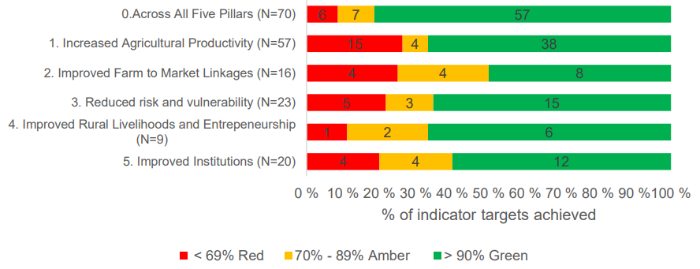
Figure 4 Food System Outcome achievement, GBFT, closed projects only (N=195), KPMG
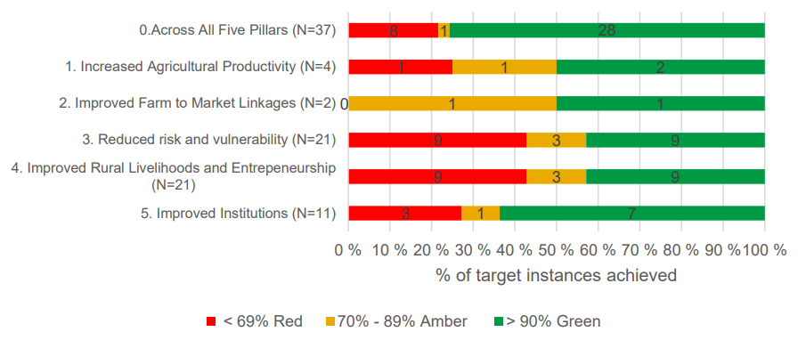
Figure 5 Food System Outcome achievement, PrSW, closed projects only (N=96), KPMG
KPMG found GAFSP projects have lower achievement of targets on cross-cutting outcomes (climate, gender, nutrition), with monitoring and reporting on these outcomes also not consistent across the public and private windows. According to KPMG, results achievement is highest under Empowered Women and Girls and Improved Nutrition outcomes (Figure 6).
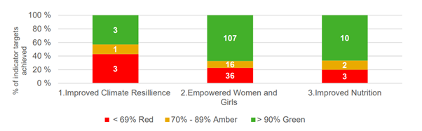
Figure 6 Cross-cutting outcome achievement (GBFT and PrSW, Closed projects only) N=180
Climate: GAFSP’s climate focus is primarily centred on adaptation and resilience activities, with a range of strategies deployed (Figure 7), dominated overall by a “resilience through” approach, with adaptation integrated with broader development objectives for example scaling climate smart agriculture practices in Bangladesh and agroforestry to improve soil fertility in Rwanda. KPMG found an average 66 percent achievement rate across the GBFT for climate outcomes, and 51 percent for the PrSW. GBFT has over time developed a systematic approach to align projects with climate finance opportunities, including ensuring all projects align with national climate strategies and commitments. UK has proactively pushed for building in climate, and independently reviews progress: a CLEAN Helpdesk climate review of GAFSP commissioned by the FCDO in 2024 recommended seeking more detailed information from IFC on “climate tagged” investments to inform the ICF-eligibility of the new local currency pilot, with FCDO mandating that these new projects include climate mitigation and/or adaptation approaches. KPMG found that, with the data available, “GAFSP’s ability to foster climate resilience and sustainable adaptation appears moderate”. Interrogating GAFSP’s approach to protecting and restoring nature is an FCDO priority for the year ahead – with a focus on where UK resources are focused now.
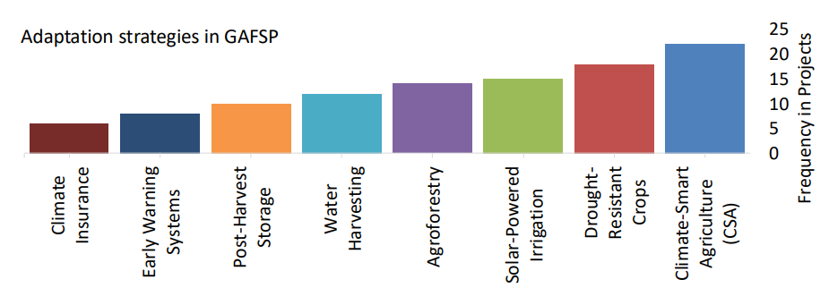
Figure 7 Adaptation strategies in 6th and 7th Call for Proposals, GBFT Portfolio Review
Gender: GAFSP, particularly the GBFT, has decent gender inclusion results, for example 42 percent of beneficiaries are women (39 percent for the producer organisation led track). In the PrSW 52 percent of those reached overall are women. However, KPMG found that “empowering” interventions, such as access to finance, markets, land and representation in decision-making bodies, should be better defined and measured. Nevertheless, there are positive empowerment case studies. For instance, in the PrSW entrepreneurial coaching of 2,000 women from 30 cocoa cooperatives in Cote D'Ivoire leading to the establishment of 459 new businesses and 77 percent of women reporting an increase in diversified monthly income. FCDO has stepped up its engagement on women in agriculture in the last reporting period, with an emphasis on women’s economic empowerment, including joining the FAO’s Commit to Grow Equality initiative. Subject to capacity and resources, FCDO could explore a GAFSP gender review in 2025, similar to the climate review in 2024, for example through the AGIL Helpdesk.

Nutrition: There is only one nutrition focused GAFSP indicator (number of people accessing improved nutrition services and products) which captures output rather than outcome level results. Nevertheless, in the two recent GBFT Call for Proposals, 97 percent of country-led projects were tagged for nutrition contributions, with nutrition financing 45 percent of overall. In the PrSW in this reporting period there is one example of a nutrition focused project, Pearl Dairy, discussed in Section C.

Further revision of GAFSP’s M&E framework is unlikely to be prioritised in the next year, meaning it will be up to the Steering Committee, Coordination Unit and PrSW Management Team to promote cross-cutting outcomes in any upcoming Call for Proposals for projects. This should emphasise integrating climate, nutrition and gender, building on some positive recent examples: improving knowledge on climate change resilience to improve food security and nutrition with a target of 30 percent women in Honduras; including nutrition and climate data with a focus on women users in a digital platform in Laos; and combining climate-smart and nutritional education for women farmers in Togo.

Outcome level results are generally weaker for GAFSP’s PrSW than the GBFT, with further analysis of performance and results in Section C (Outputs 3 and 4). FCDO’s initial assessment is that PrSW funds could be better targeted to provide finance to harder to reach smaller agri-SMEs who can drive inclusive and sustainable growth in local markets of low-income countries. A review of the historical targeting and impact of the PrSW portfolio of investments is recommended in Section C, to test this assessment and inform collaboration with IFC to strengthen the approach going forward.

In the year ahead the Vision 2030 process (that the UK will play an only limited role in) will seek address four key questions - how GAFSP can: (1) Act as a platform to bring together different stakeholders and tools; (2) Aggregate and leverage scarce grant resources effectively; (3) Be used more efficiently as part of a collective response to global food crises; and (4) Ensure the inclusion of countries, entities and groups with the highest need. Questions 2 and 4 are particularly pertinent to the challenges in the PrSW, and for the FCDO. The appointment of a GAFSP Senior Strategy Advisor in the last reporting period has helped consolidate engagement with stakeholders on the future of GAFSP, and to formulate an aspirational Vision 2030 (Figure 8). In the coming year an implementation plan with realistic budgeted scenarios by CU and IFC is critical to delivering any of the ambition currently laid out. A realistic and actionable plan is crucial in the context of changing approaches to ODA of several donors who historically contributed to GAFSP, with the Senior Strategy Advisor’s continued support key to resource mobilisation strategy.
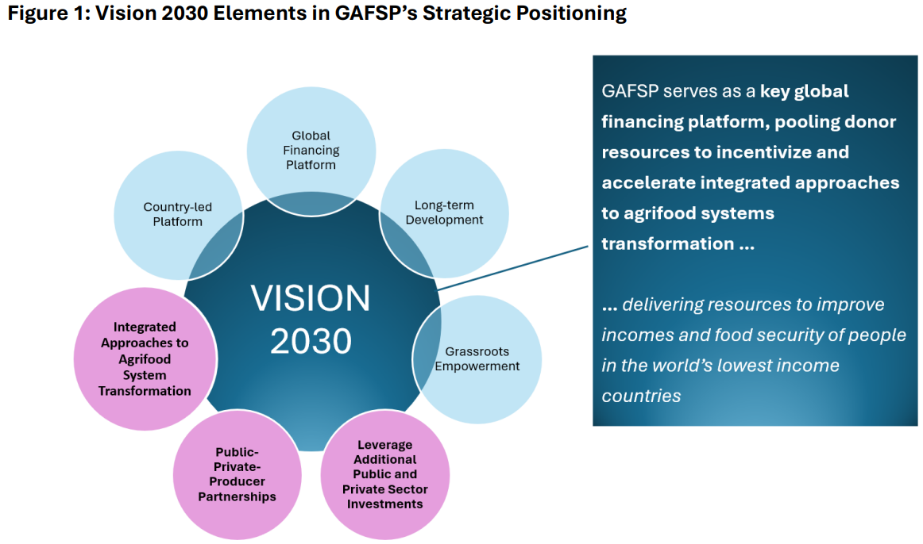
Figure 8 Vision 2030 Elements in GAFSP’s Strategic Positioning
Justify whether the programme should continue, based on its own merits and in the context of the wider portfolio

The programme should continue but with a focus on making the most of live UK funds and moving these to disbursal in the coming months – no more funds will be put in. The UK’s live funding in GAFSP’s PrSW has the potential to deliver impactful results and learnings. In the year ahead, FCDO efforts to redirect the sizeable reflows in the UK Trust Fund, combined with delivery and monitoring of the new local currency pilot, will provide significant learnings on tackling access barriers to finance, delivering climate and nature positive investments, and navigating the multilateral system to enhance impact. More broadly, GAFSP remains unique in bringing crisis response and resilience-building, together with agrifood sector growth and investment, and in convening a diverse range of stakeholders (donors, DFIs, CSOs, POs) - as such GAFSP at the moment remains a platform for the UK to engage internationally on food and agriculture, as a well-established partner – this will be kept under review as UK ODA and staffing resourcing is clarified in Autumn 2025.

C. DETAILED OUTPUT SCORING

GAFSP GLOBAL PROGRAMME RESULTS

Output Title | PUBLIC SECTOR WINDOW (GRANT BASED) ACTIVITIES TO IMPROVE LIVELIHOODS
Output number: |  | 1 | Output Score: | A – outputs met expectation
Impact weighting (%): |  | 10% | Weighting revised since last AR? | Yes, weighting of public sector results revised down overall. New output designed to consolidate public sector results using existing indicators, except one new indicator (1.3).

Indicator(s) | Milestone(s) for this review | Progress
1.1 Number of beneficiaries reached | 17,509,282 (39% women) | Exceeded expectation: 19,509,282 beneficiaries (42% women)
1.2 Number of smallholder farmers receiving productivity enhancement support | 5,743,567 (women = 2,078,890) | Met expectation: 6,699,770* (36% women)  *However, the result is lower than last year’s achieved result (8,446,510) due to a data cleaning exercise.
1.3 [New] Number of farmers receiving inputs or service on climate resilient or sustainable agriculture practices | 818,379 (52% women, and 69% adoption) | Met expectation*: 1,517,639 (42% women, and 6% adopted the technologies being promoted)  *Exceeded target in total numbers but the low adoption rate is a cause for concern.
1.4 Number of producer organisations supported | 22,656 | Met expectation: 23,897 producer organisations
1.5 Number of people receiving improved nutrition services and products | 5,657,541 (2,709,840 women) | Met expectation: 5,959,760 people (2,997,126 women)
1.6 Direct employment provided | 306,508 (101,615 women) | Did not meet expectation: 286,496 full time jobs (107,260 women)  The result is lower than last year’s (405,152) due to a data cleaning exercise.
Briefly describe the output’s activities and provide supporting narrative for the score.

This output reflects the activities of the GAFSP country and PO-led tracks within the GBFT, with a cumulative 128 projects totalling US$1.91 billion in grant financing. Between 2011 and 2019 the UK contributed £72.5 million to the GBFT, ~3-4 percent of the $2 billion GAFSP Financial Intermediary Fund (FIF) to date. Most recently, FCDO contributed £28.5 million in 2019 as part of the Fifth Call for Proposals for projects led by fragile and conflict affected countries. As of December 2023 (i.e. halfway through this reporting period), 100 percent of funds from the Fifth Call had been allocated through the competitive grant process – though only 16 percent of funds had been disbursed. As of December 2024, 40 percent of funds disbursed. These funds have been slower to move given the focus on fragile countries. Therefore, as of December 2024 all UK funding in the GBFT has been committed, with £17.1m still to be disbursed. Results can therefore still be attributed to UK funding in this reporting period and the next. GBFT targets are end of project figures agreed between the Coordination Unit and Supervising Entities. Annual milestone targets for FCDO reviews are pro-rated retrospectively by the Coordination Unit using the disbursement rate.

As of June 2024, GBFT projects have reached an impressive 19.2 million beneficiaries to date (Output 1.1) exceeding expectations and reflecting an increase of ~1.8 million beneficiaries in this review period (Figure 9). Most other indicators have met the milestone targets set by the Coordination Unit, including number of POs supported (Output 1.4) at 23,897 cumulatively (5,000 in this reporting period). The milestone for direct employment provided (Output 1.6) was not met, and furthermore the result is lower than last year. This is the result of a data cleaning and validation exercise conducted across the GAFSP project portfolio to harmonise M&E plans. However, while the overall employment result decreased following this exercise, the total number of women benefitting from direct employment increased by ~6,000. This reflects a good gender balance of 42 percent more broadly across all GBFT beneficiaries. Overall, this output met expectation and scores an A.

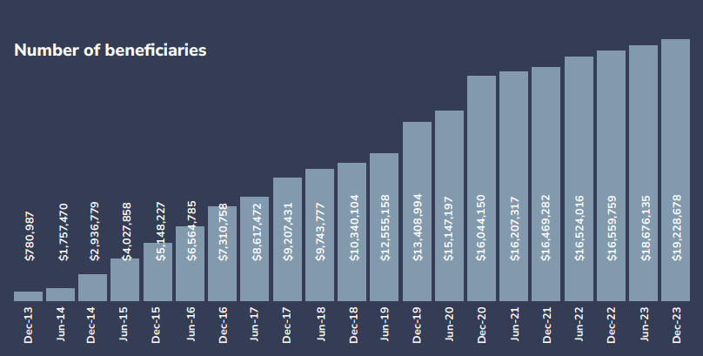
Figure 9 Number of GBFT beneficiaries, GAFSP Annual Report
Describe any changes to this output during the past year, and any planned changes as a result of this review.

This output has been reorganised to consolidate public sector results and reduce their weighting overall, reflecting the balance of UK funding away from the GBFT over time. FCDO maintains a leading role in GAFSP’s governance but has not been consistently represented at the GAFSP Working Group for the PO-led track.

A new indicator has been added to better capture GAFSP’s results on climate adaptation and resilience; Output 1.3 (and 4.3) which aligns with FCDO’s ICF KPI #1 on the number of people supported with climate adaptation. The GBFT exceeded expectations for this target by nearly 2x, due to steady overachievement in the two years since the indicator was added to the GAFSP M&E framework. However, the adoption rate of climate smart practices and technologies, by those who have received inputs or services, is very low at 6 percent. Most relevant projects were approved recently and have not begun reporting on this indicator, and technology adoption takes time with new practices requiring adequate dissemination and uptake among beneficiary farmers. As these projects progress into full implementation the rate of adoption should increase, but FCDO and the Steering Committee should monitor this.

Progress on recommendations from the previous AR (if completed), lessons learned this year and recommendations for the year ahead

The previous Annual Review recommended FCDO push to ensure that strengthening PO institutional capacity was a priority for the PO-led track. The upcoming Call for Proposals includes a mandatory PO capacity assessment for both proposal development and results measurement, to ensure capacity building is thoroughly evaluated and tracked. As above, FCDO has also added Outputs 1.3 and 4.3 in response to last year’s recommendation to explore additional indicators to capture uptake of new climate services or products for farmers to give greater confidence to internal ICF reporting.

Recommendation 5: FCDO programme team should offer the opportunity to the FCDO Food and Agriculture Network for a representative to consistently join and monitor the GAFSP PO Working Group given the innovative nature of these projects and associated learning opportunities. FCDO should also promote the upcoming Eighth Call for Proposals and its outcome to Posts (to be launched in May 2025 and awarded Spring 2026).

Recommendation 6: FCDO should request the Coordination Unit and IFC keep the Steering Committee updated on beneficiaries’ adoption rate for climate smart technologies and practices (Outputs 1.3 and 4.3) and include quantitative and qualitative analysis on adoption rates in their FCDO ICF results return for KPI #1 to support learning.

Output Title | GAFSP FUNDING MECHANISM PERFORMANCE – PUBLIC AND PRIVATE SECTOR WINDOWS
Output number: |  | 2 | Output Score: | A – Outputs met expectation
Impact weighting (%): |  | 20% | Weighting revised since last AR? | No, previous iteration of this output area (output 6) on funding mechanism performance was weighted the same. However, one new indicator has been added (2.4).

Indicator(s) | Milestone(s) for this review | Progress
2.1 Public and Private Sector Windows working effectively together | N/A | Did not meet expectation: 3 integrated projects across GBFT and PrSW (advisory):  (i) Haiti Horticulture  (ii) Nicaragua Mercon Coffee  (iii) Côte d'Ivoire AfDB Women-led Coops  This indicator is subject to qualitative assessment by the FCDO, as below.
2.2 Disbursement rate (Public Sector) | N/A | Did not meet expectation: 21.5 month overall average time-elapsed between project approval and first disbursement (based on data from 41 completed and 31 ongoing projects).
2.3 Leverage ratio (Public and Private Sector) | N/A | Met expectation:  GBFT: 1.86 ($1 of GAFSP grant attracted $1.86 from other sources).  PrSW:  - GAFSP to total project size 1:6.3  - GAFSP funding to IFC Investment: 1:3.0
2.4 [New] Volume of financing that supports core themes (climate, gender, nutrition)  - 2.5.1 climate related  - 2.5.2 gender sensitive  - 2.5.3 nutrition related  (Public and Private Sector) | N/A | Met expectation:  GBFT:  - Climate: 91% of projects have climate co-benefits (49% of funds, $880m)  - Gender: 42% of project beneficiaries are women.  - Nutrition: 78% of projects have nutrition contributions (31% of funds, $550m)  PrSW:  - Climate: 32 investments classified as climate (IFC definition)  - Gender: 16% beneficiaries are women. 67% of approved projects and 57% AS ‘gender flagged’  - Nutrition: 1 US$8.8m investment in Pearl Dairy

Briefly describe the output’s activities and provide supporting narrative for the score.

This output area reflects GAFSP’s overall performance as a funding mechanism across the public and private sector windows. As these indicators lack milestone targets, qualitative analysis is applied. This output includes how effectively the two windows work together (Output 2.1). In this review period improvements have been made at the level of GAFSP global governance, including the introduction of joint portfolio updates for the Steering Committee. However, progress requires a disproportionate lobbying effort by the UK as PrSW Chair (and other donors) and does not yet deliver at operational project level on the ground. The KPMG evaluation found that coordination and collaboration is not working “due to lack of incentives and/or strategic direction” while recognising “notable” examples of collaboration in the projects in Haiti, Nicaragua and Cote d’Ivoire. It should be noted that these collaborations are the result of a dedicated UK GBP£10 million contribution to the PrSW Advisory Services Trust Fund in 2019 to support increased public-private linkages within a Special Call for Proposals. The projects have been portrayed for several years as best practice for coordination and integration across GAFSP, with no new examples provided since, indicating they are exceptional rather than reflecting a systemic approach across GAFSP.

In this review period, the GBFT’s average speed of disbursement (time from project approval to first disbursement) was 21.5 months (Output 2.2). This is a function of GAFSP’s operational efficiency, influenced significantly by Supervising Entity as well as Coordination Unit processes. It is not reported for the PrSW. Average speed has fluctuated from 21 to 25 months in recent years, with the result this year better than last year at 25.35 months. This improvement is due to shortened timelines between GAFSP award and Supervising Entity approval from the most recent Call for country-led projects, with PO projects still facing a long time lag (Figure 10). FCDO should advocate for enhanced efficiencies in the upcoming Eighth Call for Proposals for PO-led projects, especially considering the long implementation period of 3-4 years for these projects. Longer disbursement times are a downside of GAFSP’s multilayered governance, which also holds significant benefits (inclusivity, options for recipients). Noting that, as above, UK funds committed in 2019 for the Fifth Call are still not fully disbursed, overall, the disbursement rate for GAFSP does not meet FCDO expectations. Efforts to reduce disbursement timelines should continue, given the shorter timelines for other multi-donor Financial Intermediary Funds (FIF), such as GAVI and the Green Climate Fund at ~12 to 13 months.

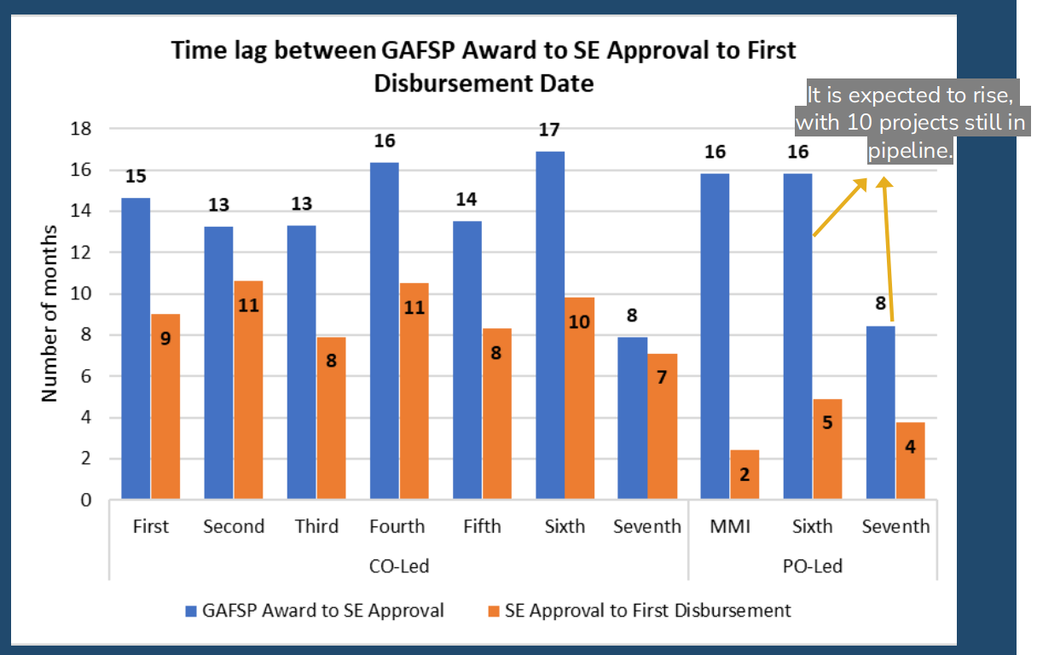
Figure 10 GBFT data as of Dec 30, 2024, GAFSP Joint Portfolio Update
Leverage ratio (Output 2.2) is the extent to which GAFSP funding is instrumental in mobilising funds from other sources. This is an indicator of the programme’s catalytic and system-shaping impact. Overall, co-financing for the GBFT totals US$3.5 billion, with each $1 leveraging an average of $1.86 (1:1.86 ratio). Co-financing for country-led projects is primarily from implementing Supervising Entities, and for PO-led projects from the beneficiary organisations themselves. The Special Call for Proposals for Fragile and Conflict Situations (FCS) in 2019 had an impressive leverage ratio of 1:6.8; a positive indication that GAFSP can mobilise significant additional finance (from Development Banks i.e. Supervising Entities) to the most vulnerable countries. The PrSW average leverage ratio is 1:6.3, having peaked at 1:16.3 during Covid in FY21. Higher leverage for private sector investment than for public sector grants is expected, and structural to the PrSW design, discussed under Output 3.

As discussed in Section B, the proportion of funds spent on cross-cutting themes (Output 2.4) is challenging to assess as they are not measured consistently. The KPMG Evaluation recommended GAFSP develop higher quality indicators to measure these outcomes consistently across windows. Nevertheless, notably 91 percent of GBFT projects have climate co-benefits and 49 percent of funds. On the PrSW side, we see less systemic mechanisms to integrating cross-cutting themes. Enhancing the approach to climate, and introducing a clearer approach for nature, should be factored into discussions on better targeting the UK Trust Fund. Overall, this output area met expectations and scored an A.

Describe any changes to this output during the past year, and any planned changes as a result of this review.

This output area has been maintained to consider GAFSP’s overall performance across windows. In this reporting period, Supervising Entities began developing proposals for the BIFT pilot (no direct UK funding), a significant development in GAFSP’s overall structure and design. There remains a risk that BIFT further fragments GAFSP’s operations, especially if it is seen as a reaction to IFC acting as the only implementing Supervising Entity for the PrSW. however, it is also feasible that BIFT facilitates better integration (or a bridge) between the GBFT, including PO-led projects, and the PrSW. An aspirational visualisation of the segmentation of GAFSP investments, or “graduation agenda” is at Figure 11, developed as part of the Vision 2030 process. This would involve a progression of support and maturity for beneficiaries from the GBFT (capacity building) to the BIFT (pre-commercial finance), to the PrSW (commercial finance). While a useful conceptual model, FCDO deems it highly unlikely that such progression will occur for actual GAFSP recipients. Recognising wholesale reform is unlikely, particularly in the global ODA context, FCDO should instead advocate that GAFSP pilots one or a small number of ‘test cases’, where GAFSP’s multi-window structure is coordinated at country or regional level.

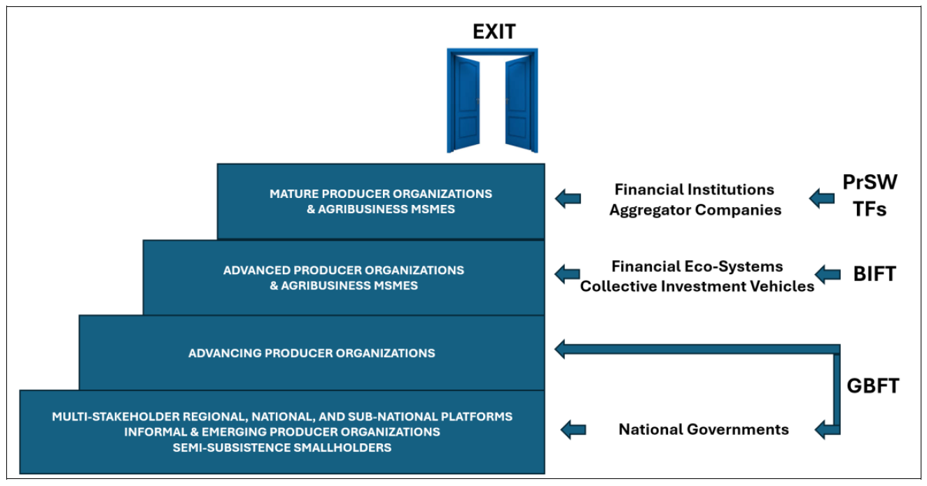
Figure 11 Aspirational visualisation of segmentation of investments, Vision 2030 decision note for SC
Progress on recommendations from the previous AR (if completed), lessons learned this year and recommendations for the year ahead [1-2 paragraphs]

The previous Annual Review recommended FCDO continue to be an active member of the BIFT Working Group, and that the BIFT pilot should be launched by end 2024. FCDO remained engaged and the pilot was launched in October 2024. The KPMG Evaluation recommended that a way to improve PrSW and GBFT coordination could be to pilot joint projects under the BIFT; this has not yet been acknowledged, or indeed actioned, by IFC or Supervising Entities. The UK will step off this working group in the course of 2025, given the funding is nearly approved.

Recommendation 7: At the GAFSP PO Working Group, any light touch involvement by FCDO should advocate for improved efficiencies in the disbursement of funding for the upcoming Eighth Call for Proposals for PO-led projects; ideally for the disbursement rate to (at least) match that for country-led projects. FCDO should also advocate for continued focus on PO capacity-building in order that organisations can effectively absorb funds.

PRIVATE SECTOR WINDOW TRUST FUND RESULTS

Output Title |  | PERFORMANCE OF PRIVATE SECTOR INVESTMENT AND ADVISORY MECHANISM
Output number: | 3 |  | Output Score: | B – did not meet expectation
Impact weighting (%): | 30% |  | Weighting revised since last AR? | Yes, weighting of private sector performance revised up. New output designed to consolidate private sector results using all new indicators except one (3.2)

Indicator(s) | Milestone(s) for this review | Progress
3.1 [New] Number and value of projects committed and disbursed | Investment pipeline included 7-9 new projects (~US$50-60 million)  Advisory pipeline for this period was 13 projects (US$8.2 million) | Did not meet expectation: 4 new investment projects committed (US$35.12 million). 6 disbursements made to new projects, with US$39.38 million in total disbursements.  5 new advisory services projects approved, with additional funding to 4 existing projects (US$1.33 million)
3.2 Leverage ratio | N/A | Met expectation: GAFSP to total project size 1:6.3; GAFSP funding to IFC Investment: 1:3.0
3.3 [New] Percentage of projects rated successful on development outcome | N/A | Did not meet expectation: 25 of 45 projects (~55%)
3.4 [New] Product distribution of projects—debt, equity, guarantees, advisory services | N/A | Met expectation:  Loans = US$19.4 million  Equity = US$2.5 million  Sub-Loan = US$8.5 million  Advisory = US$1.33 million
3.5 [New] Country distribution of project -percentage of projects in fragile and conflict-affected states | N/A | Met expectation: 28% of approved investment volume; 56.6% of approved advisory services volume
3.6 [New] Volume of financing that supports core themes (climate, gender, nutrition)  - 3.6.1 climate related  - 3.6.2 gender sensitive  - 3.6.3 nutrition related | N/A | Did not meet expectation:  Climate: 32 investments classified as climate (IFC definition)  Gender: 16% of beneficiaries are women. 67% of approved projects and 57% of funding allocation of AS were ‘gender flagged’  Nutrition: One US$8.8m investment in Pearl Dairy
Briefly describe the output’s activities and provide supporting narrative for the score.

This new output area considers the performance of the GAFSP PrSW as a funding mechanism. Results for Outputs 3.1 can be compared to planned activities, otherwise progress is assessed qualitatively. The PrSW aims to benefit smallholder farmers in the poorest countries (IDA-only), financing projects that may not otherwise attract commercial funding due to perceived or actual high risks. GAFSP funding, co-invested alongside IFC at an average 1:3 ratio, provides ‘softer’ terms to enable IFC to invest in earlier stage or riskier projects with higher development impact. In this period the proportion of PrSW projects rated as “successful” on development outcome (Output 3.3) was only 55 percent. This is nevertheless 10 percent higher than the previous reporting period and may be partly explained by the fact that projects are only rated at maturity for investment or at completion for advisory.

As mentioned under Output 2, the PrSW leverage ratio (total project size to GAFSP investment) is 1:6.3, since inception 2013 (Output 3.2). Additional finance leveraged is mainly from DFIs and private investors and includes 1:1.9 leverage of IFC funding by GAFSP. The Covid (FY21) peak of 1:16.3 reflects the overall ramp up of lending by IFC (and other MDBs) during the pandemic (Figure 12). KPMG found that the PrSW successfully catalysed investments and financial intermediaries in riskier markets, but there was a need for improved reporting on concessional finance and development impact.
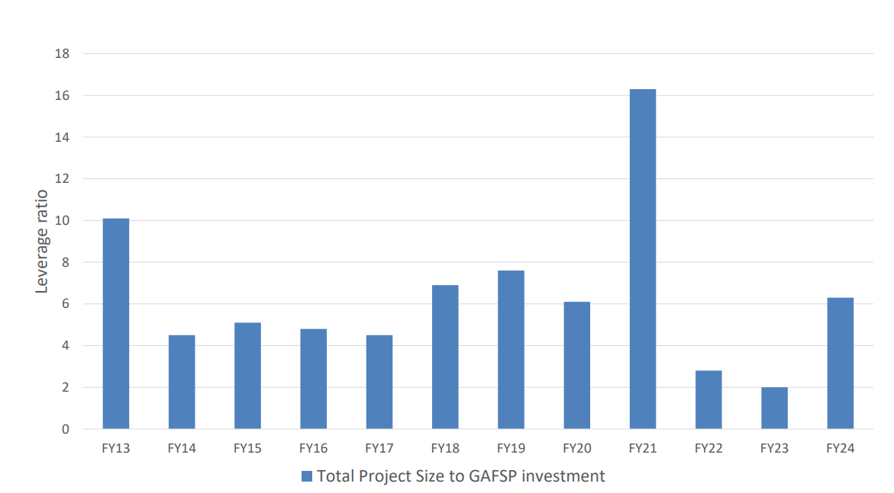
Figure 12 PrSW Investment Portfolio Leverage, IFC PrSW Strategic Overview
Beyond reporting limitations, IFC faces challenges efficiently disbursing PrSW funding in accordance with GAFSP’s impact objectives. The value of funding approved each year is significantly less than the investment pipeline at start of the year (Figure 13) and much smaller than the funds available for investment in the PrSW. In this reporting period four projects (three debt, one equity) totalling US$30.4 million were approved from a US$64.8 million pipeline (Output 3.1), with US$165.2 million of funding available at the start of the review period. IFC recognises its project and pipeline development challenges, noting instability from climate and conflict; smaller average deal sizes for agriculture projects in recent years; weak local currencies; the nature of smallholder supply chains (lack of professionalism, unreliable quality and/or quantity of supply); and handholding needed for investees from business development to portfolio supervision. Partly due to technical assistance needs of investees, the PrSW advisory portfolio does not appear to face the same pipeline challenges. As of June 2024, disbursements for these projects stood at US$41.7 million (77 percent of committed funds).
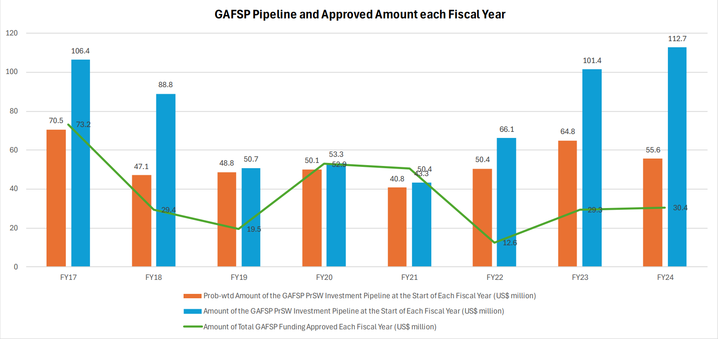
Figure 13 GAFSP Joint Portfolio Update
Responding to pipeline challenges, FCDO agreed in 2022 that IFC could use £10 million of UK investment and advisory funding in IDA-Blend countries as an exception to GAFSP’s IDA-only mandate. This had clear stipulations that funding to these countries must demonstrate a mitigating impact to food insecurity (heightened in the wake of Russia’s invasion of Ukraine). These funds have been fully disbursed. Indeed, three of the four new investments in this reporting period were in IDA-Blend countries: ~65% of the value of GAFSP’s overall investment (discussed further under Output 4). One of the four investment projects was in a fragile and conflict-affected country (FCS) country, Nigeria, bringing the portion of PrSW investment volume in FCS to 28 percent (lower than 44 percent last year). The result for advisory services in FCS is 56.6 percent, a good increase from 17 percent last year (Output 3.5). Overall, this output did not meet expectation and scores a B – based primarily on operational limitations, rather than lack of expertise and willing of the IFC team.

Describe any changes to this output during the past year, and any planned changes as a result of this review.

This is a new output area, with several new indicators added from GAFSP’s M&E framework, to support more thorough review of the PrSW by FCDO. Furthermore, in this reporting period FCDO has been reviewing the status of UK funds in the PrSW. As of December 2024, the balance of the UK Trust Fund was a substantial ~US$90.7 million. The UK has contributed £110.5 million (~US$147 million) for PrSW investment to date. The current Trust Fund balance reflects a much lower rate of capital depletion than expected and the pipeline development challenges discussed above. A top risk for the FCDO is that UK funding is not fully deployed in advance of the current PrSW “end utilization date” (i.e. when no further investments are made with donor contribution funds) of 31st December 2026. Returns would then ultimately flow to IFC’s balance sheet rather than be recycled to intended beneficiaries – the UK will monitor this carefully.

By end 2025, FCDO will co-develop an approach with IFC to better utilising and targeting the funds remaining in the UK Trust Fund. This could include additional use of intermediate investment through local funds or financial institutions that can more easily reach smaller agri-SMEs in local food markets and/or coordinated co-investment with other IFIs or agri-food investment funds. Modification of GAFSP investment criteria will also be considered, avoiding misalignment with GAFSP impact objectives. For example, a further exception for IDA-Blend investments will not be pursued as an option. Not only does investment in IDA-Blend diverge from GAFSP impact criteria, but it also further reduces the possibility of coordination with the GBFT. On the other hand, additional local currency funding could be considered as a mechanism to mobilise impactful funding through a capital-depleting product, subject to the success of the current pilot (see Output 5).

Progress on recommendations from the previous AR (if completed), lessons learned this year and recommendations for the year ahead

The previous Annual Review recommended a “fail fast” approach by IFC to avoid prolonged effort maintaining portfolio partners that do not match investment conditions. IFC efforts to enhance their project review and appraisal process align with this approach. However, the priority is now for FCDO work with IFC to mitigate the challenges posed by these investment conditions and better target GAFSP funds. The previous Annual Review also recommended a dedicated VfM assessment of GAFSP: a delayed but now forthcoming FCDO specialist review of PrSW investments will support deeper VfM assessment as we move to confirm the plan for 2025/26.

Recommendation 2 [as per Section A]: work with IFC to agree an approach to better utilise and target the funds remaining in the UK Trust Fund in the PrSW. The FCDO programme team should work with FCDO commercial and finance, and with additional specialist support, to consider a range (and combination) of options. Options could include modification of investment criteria, for instance further local currency investments (depending on the success of the pilot), intermediated investments or grants to local or regional funds, and/or co-investment with other DFI, IFI or impact investors.

Recommendation 8: The FCDO GAFSP programme team should secure additional specialist support to review the status of UK funds in the PrSW and overall past portfolio of PrSW investments. This should rapidly test the team’s initial assessment that UK (and other donor) funds are not being deployed efficiently in alignment with GAFSP impact objectives (affecting overall VfM) and support development of options to pursue alongside IFC.

Output Title | PRIVATE SECTOR (INVESTMENT AND ADVISORY) ACTIVITIES TO IMPROVE AGRICULTURE, LIVELIHOODS & FOOD SECURITY
Output number: |  | 4 | Output Score: | B – did not meet expectation
Impact weighting (%): |  | 30% | Weighting revised since last AR? | Yes, weighting of private sector results revised up overall. New output designed to consolidate private sector results using existing indicators, except one (4.3)

Indicator(s) | Milestone(s) for this review | Progress
4.1 Number of beneficiaries reached | 4,100,827 (545,126 female, 13.3%) | Did not meet expectations: 2,119,308 (351,761 women, 16.6%)
4.2 Number of SHFs receiving productivity enhancement support | 71,958 (10,543 women, 14.7% women) | Exceeded expectations: 81,428 farmers (20,831 women, 25.6%)
4.3 [New] Number of farmers receiving inputs or service on climate resilient or sustainable agriculture practices | 2,184,420 (358,157 women, 16.4%) | Did not meet expectations: 767,604 farmers (160,025 women, 20.8%)
4.4 Number of producer organisations supported | 1,260 | Exceeded expectations: 1,727
4.5 Projects providing people with improved nutrition services and products | 16% for investment projects  17% for advisory service projects | Met expectations: 16.1% for investment projects (15 out of 93 projects); 16% for advisory projects (17 out of 106 projects)
4.6 Direct employment provided | 30,210 (7,654 women, 26.3% women) | Met expectations: 38,909 (15,426 women, 39.6%)
Briefly describe the output’s activities and provide supporting narrative for the score.

This output area reflects the results delivered by the GAFSP PrSW, which in turn generate benefits for smallholder farmers and households in low-income countries. Milestone targets are set out by IFC (alongside the Coordination Unit) for shared GBFT and PrSW indicators. In this reporting period, the PrSW missed by almost 2 million its target for “number of beneficiaries reached” (Output 4.1), with an increase of 131,450 beneficiaries in this reporting period bringing the total number of farmers supported to over 2 million. This indicator is integral to GAFSP’s mission, counting farmers that have secured market access through GAFSP agribusiness clients, or accessed financial services through GAFSP financial institution clients. The number of farmers supported with climate adaptation (Output 4.3) was also lower than targeted, though farmers receiving productivity enhancement support (Output 4.2) was moderately higher. Lower than projected farmer beneficiaries indicate the on-the-ground impact of the pipeline development challenges discussed under Output 3. IFC projects that 4.7 million farmers will be reached through GAFSP PrSW projects, which is more than double those reached to date. This results shortfall is expected given 18 of the 93 approved investment projects to date have been cancelled or dropped (worth US$140.4 million). Data lags will also mean results are backloaded toward the end of the programme, which is not uncommon. Rapid mobilisation of a better targeted pipeline is required to deliver projected results for farmers and wider beneficiaries.

More positively, the disaggregated gender inclusion results in this output area are higher than targeted in terms of the proportion of female farmers reached (though not in absolute terms). The number of POs supported (Output 4.4) exceeded expectations and is on a continued upward trajectory, at 1,727. The PrSW provides technical assistance to producer organisations through advisory services. For example, with GAFSP support, IFC has created the Agribusiness Leadership Program to streamline and standardize support to producer organisations (or cooperatives), building on a 2014 cooperative professionalisation program pilot with Cargill. The Agribusiness Leadership Program could potentially be leveraged for the PO-led track, offering an opportunity for coordination across tracks.

One PrSW project in this reporting period provided improved nutrition services and products (Output 4.5), bringing the percentage of nutrition focused projects to 16.1 percent for investment, meeting the target, and 16 percent for advisory, marginally missing the target. The relevant project is part of the UK funded IDA-Blend pilot, Pearl Dairy in Kenya. Pearl is expanding production, processing and distribution of dairy products in Kenya and Uganda including ultra-high temperature and powdered milk. IFC project that this will benefit dietary diversity and combat malnutrition for more vulnerable and underserved consumers without access to refrigerators. However, to demonstrate the project has improved access to nutritious foods, assurance would be needed that lower-income consumers could afford the products (UHT is often expensive) and that the products do not end up as ingredients in ultra-processed foods such as milk powder for coffee creamers. FCDO should seek further information from IFC on the company’s consumer base and products they are competing with or replacing. It should be noted that GAFSP lacks an outcome level indicator on nutrition, and that further FCDO review is required to confirm alignment with GAFSP’s theory of change for delivering nutrition outcomes. A review could be explored subject to FCDO capacity.

IDA-Blend projects have strong read across to GAFSP cross-cutting outcome objectives, although further scrutiny of outcomes is needed. Alongside Pearl Dairy on nutrition, Pula in Kenya has a strong climate story having provided climate insurance for more than 15 million smallholder farmers to date. However, it should be noted that these businesses are arguably “usual suspects” for development finance rather than the underserved agribusinesses GAFSP seeks to reach, for example Dutch Development Bank FMO has invested in Pearl, and British International Investment (BII) in Pula. In Q1 2025, Pula was one of only five companies in Africa receiving 90 percent of investment in agriculture technology companies. This reflects the risk that donors (including via funding to DFIs and IFIs) “pick winners” and further marginalise underserved agribusinesses and farmers. Furthermore, it should be noted that BII exited early from Pula due to lack of success generating expected development impact.

Overall, this output area did not meet expectations and scores a B.

Describe any changes to this output during the past year, and any planned changes as a result of this review.

This output has been reorganised to consolidate private sector results and increase their weighting overall, reflecting the balance of UK funding toward the PrSW over time. As per Output 3, a priority for the year ahead is to better target FCDO funds in the PrSW, with the ultimate objective to general better results overall for beneficiaries.

For the reasons discussed above FCDO will not approve further PrSW investment in IDA-Blend countries, unless they are part of regional investments with a large share of finance in IDA-only countries. Regarding individual investment decisions, IFC are operationally independent, and donors do not have decision-making power. However, FCDO should ensure cross-learning from GAFSP and other FCDO funded DFI investments. For example, the third IDA-Blend investment in this reporting period is Nigerian cocoa company Johnvents, who have just received a new US$40.5 million investment from BII.

Progress on recommendations from the previous AR (if completed), lessons learned this year and recommendations for the year ahead

There are not relevant recommendations from the previous AR to consider. Based on the discussion above, the recommendations for the next reporting period are as follows.

Recommendation 9: FCDO to explore with IFC and the Coordination Unit whether the Agribusiness Leadership Program could be leveraged to support beneficiaries of other GAFSP tracks, for instance the PO-led track, to improve coordination and integration.

Recommendation 10: FCDO should request reporting of the output and outcome level (including cross-cutting climate, gender and nutrition) results from the IDA-Blend projects from IFC, given the GAFSP contribution is fully UK funded and can be easily attributed to FCDO.

Recommendation 11: FCDO to draw on the experience of the GAFSP PrSW, alongside that of BII and other DFIs, to contribute to the cross-FCDO policy objective to mobilise better targeted development finance for agrifood systems, and to deepen the development impact of existing investments (for example through technical assistance).

Recommendation 12: FCDO programme team to utilise the experience of the PrSW to inform FCDO policies and processes on end-of-life provisions for ODA funding contributions to investment vehicles, ensuring that exit strategies are clear and maximum impact.

Output Title | PRIVATE SECTOR WINDOW LOCAL CURRENCY PILOT
Output number: |  | 5 | Output Score: | A
Impact weighting (%): |  | 10% | Weighting revised since last AR? | Yes, this is a new output area.

Indicator(s) | Milestone(s) for this review | Progress
5.1 Number of businesses in local currency pipeline and geographical spread | At least 4-5 businesses in the pipeline, in underserved IDA only countries. | Met expectations: 7 businesses in the pipeline (6 projects) – one of which is approved
5.2 Value of pipeline | At least £20 million (US$26 million) | Met expectations: US$43.43 million
Briefly describe the output’s activities and provide supporting narrative for the score.

This is a new output area for the new £20 million local currency facility pilot approved by FCDO in this review period. The pilot is beginning implementation at the time of writing this Annual Review and is considered here to reflect significant new funding central to delivering FCDO’s strategic objective of increasing access to finance. The pilot should enable the PrSW to mobilise higher impact investments, reaching businesses that would otherwise not be investible given their inability to access Forex-denominated loans. GAFSP will step in with a full buydown of the extra interest rate charged to manage the exchange rate risk of IFC local currency loans (the swap rate). This “swap rate buydown” (Figure 14) will reduce the interest rate for the client company to a reasonable and affordable percentage and facilitate IFC local currency loans to agribusinesses.
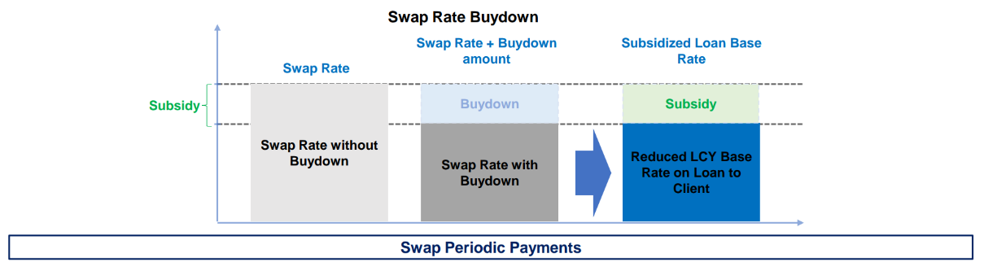
Figure 14 Illustrative swap rate buydown structure, IFC
At the time of writing there is one approved project in the local currency pilot pipeline. This is a GAFSP swap rate buydown of up to US$650,000 for an IFC local currency loan of up to EU€5 million equivalent in two locally owned Senegal based poultry farming and processing enterprises. These enterprises operate across the poultry value chain and cater to local and regional markets. Affordable long-term financing will increase local production capacity, including through construction of an 80,000-ton-per-year feed mill, and mitigate the challenge of costly imports of hatching eggs and feed materials in the sector. The project appears to have a strong impact focus, though FCDO should seek further detail from IFC on the project’s contribution to GAFSP’s cross-cutting outcomes. Furthermore, pipeline development is slower than expected, leading to delays in disbursements to IFC. FCDO will need to monitor this closely. While the pilot is not significantly off track in this reporting period, it will be if delays continue into the next year.

The Senegal project is one of six in the current pipeline (Output 5.1), which is worth a total US$43.3 million (Output 5.2). This meets expectations, with the pipeline exceeding FCDO’s US$26 million commitment, a geographical focus of IDA-Only and FCS countries, and a prevalence of value chains relevant for local food security (staple crops, meat, vegetables). However, progress is slower than expected with three of the projects still at “early lead” stage and IFC delaying its request for FCDO funds beyond an initial £6 million disbursement in late 2024. Notably, local currency pilot projects reflect half of the current overall PrSW investment pipeline in terms of value, indicating the criticality of such mechanisms to mobilise GAFSP capital. FCDO will need to closely monitor progress and impact of the pilot, including rate of pipeline development. Based on this, considering expanding it in response to broader PrSW pipeline challenges and potentially encouraging other donors to follow suit. Overall, this output area meets expectations and scores an A.

Describe any changes to this output during the past year, and any planned changes as a result of this review.

Following the return of the reflows, the local currency pilot now reflects a large contribution of “live” UK funding in GAFSP, alongside the UK Trust Fund of reflows. Therefore, this output area will have a higher weighting in the next Annual Review, once implementation of the pilot is fully up and running and delivery of results begins.

Progress on recommendations from the previous AR (if completed), lessons learned this year and recommendations for the year ahead

There were no relevant recommendations in the previous Annual Review. Based on the discussion above, the recommendation for the next reporting period is as follows.

Recommendation 3 [as per Section A]: FCDO should monitor closely the pipeline development and impact of the local currency pilot, requesting direct regular reporting from IFC on pipeline and projected and achieved output and outcome results (covering cross-cutting as well as food system outcomes). The FCDO programme team should seek scrutiny of projects from FCDO Posts where possible. This monitoring should (i) inform a decision on conversion of any further UK funds in the PrSW to allow a faster depletion of capital to deliver impact; (ii) support and inform efforts to bring on board other donors to fund local currency investment through GAFSP; and (iii) generate broader learning for FCDO and other stakeholders on mitigating barriers to high impact investment.

D: VALUE FOR MONEY

VfM performance compared to the original VfM proposition in the business case

GAFSP’s primary goal is to make much needed public and private sector finance available faster and more efficiently and effectively, where agricultural projects and investments are based on strong demand and clear evidence of need and expected impact in the poorest and most food and nutrition insecure countries. As a multi-donor initiative, GAFSP does not report directly against FCDO’s Value for Money (VfM) framework. Therefore, this section provides qualitative analysis of GAFSP’s VfM applying the framework, with particular emphasis on the PrSW given the weighting of FCDO funding in recent times.

Economy: The key cost drivers for GAFSP vary across individual projects, contexts and Supervising Entities (SEs) but include staff time, consultancy fees, costs of agricultural inputs, cash transfers, M&E costs, and indirect costs. Indirect costs include those for the Coordination Unit, the World Bank Trustee team for the GBFT, the IFC Management Team and individual SE indirect support costs (ISCs) for each GAFSP funded project. The multilayered structure of GAFSP means the wide range of input costs are not always readily visible to donors. However, projects are all managed in line with the relevant SE’s procedures, including robust procurement systems and benchmarking of staff salaries.

Support costs vary considerably across SEs and are not captured in budgets in a consistent and transparent way. For example, GAFSP’s standard admin fee is 5 percent, with the Steering Committee approving 7 percent for FAO in the previous review period for technical assistance projects that have a larger share of the budget for SE staff and direct implementation. Furthermore, the standard admin fee ceiling for PO-led projects is 9 percent. Further scrutiny by the FCDO programme team of GAFSP’s approach to support costs was ultimately not prioritised in this reporting period. Broader oversight is instead provided by FCDO’s commercial and multilateral effectiveness teams. The issue of comparative indirect costs is of lower priority to FCDO as UK funding has shifted to the PrSW, which is managed solely by IFC. Nevertheless, it should be noted that GAFSP’s admin costs remain lower than those being proposed for other World Bank Trust Funds, such as the Green Climate Fund at ~9.5 percent.

Efficiency: GAFSP output results generally show good progress in the GBFT, although with relatively long delays between project approvals and start dates. There are some challenges meeting expectations in the PrSW, as outlined in Section C. As discussed, IFC faces challenges effectively converting the forecasted pipeline into actual investments, despite considerable effort and experienced management and country teams. This reflects limited absorption capacity within the financial, additionality and impact conditions set by GAFSP and by IFC internal rules for PrSW. The UK has sought to address barriers to investment through the local currency pilot, though (as noted under Output 5) IFC has already delayed the original payment schedule agreed with FCDO for the pilot due to delayed pipeline development. Further scrutiny of use of UK funds in the PrSW is a priority for the months ahead, with additional specialist support (Recommendations 2 and 8). Furthermore, GAFSP has good funding leverage ratios of 1:1.86 for the GBFT and 1:6.3 for PrSW projects, discussed under Outputs 2 and 3.

Effectiveness: The KPMG Evaluation found that the current competitive framework for projects (Calls for Proposals) implicitly prioritises efficiency (in terms of getting value for money) over “reaching the further behind”. GAFSP has sought to mitigate this, and to direct funding where it is needed most. For instance, through the dedicated call for proposals for fragile and conflict affected countries in 2019. This has helped deliver stronger outreach to these countries, now reflecting 63 percent of countries supported by GAFSP overall and 29 percent of funding provided under the GBFT. The BIFT will trial an alternative approach to the GBFT Call for Proposals as a non-competitive framework. Overall, GAFSP delivers well against its Theory of Change, although limitations remain in measuring impact level results. For the PrSW a per farmer cost would not be an appropriate metric given that investments aim to drive a suite of indirect benefits (access to markets, incomes) that are ultimately sustained by the market in the long run. FCDO is contributing to the development of a new Catalytic Capital Framework, which may help to benchmark the impact of initiatives designed to use public money effectively and efficiently to catalyse private investment in agrifood sectors.

Equity and Inclusion: GAFSP is designed to target poor households in the most vulnerable countries in the world, with one of the four areas of focus in the PrSW linking farmers to market with a gender focus. The GAFSP Coordination Unit also reviews all projects for gender inclusion. GBFT gender inclusion results are higher than the PrSW at 42 percent for all beneficiaries, compared to 20 percent in the PrSW 67 percent of approved PrSW projects are “gender flagged”, but female beneficiaries are lower proportionately. This is in large part a function of low female participation in formal agri-food production, rather than an indicator of the level of effort on gender within the PrSW. This low ‘starting point’ is arguably reason to use private sector interventions as a vehicle to improve inclusion and drive women’s economic empowerment.

Assessment of whether the programme continues to represent value for money

The programme continues to represent good value for money overall, with several examples of strong output and outcome level results. There are some shortfalls, as outlined in Sections B and C. However, the coming year presents a critical opportunity for FCDO accelerate delivery of impactful results through the PrSW, through the local currency pilot and by setting a plan in motion to better target the UK Trust Fund of reflows. For broader GAFSP, the lack of new donor funding opportunities presents a significant limitation to delivering a game-changing Vision 2030. Significant effort by the Coordination Unit, IFC and Steering Committee to date on Vision 2030, now needs to be translated into a realistic plan to avoid sunk costs.

E: RISK

Overview of risk management

The GAFSP Coordination Unit and IFC Management Team do not hold a formal GAFSP risk register at the programme level. GAFSP relies on each Supervising Entity’s risk assessment tools that are in place at project level. These are then reviewed on a regular basis as part of project supervision cycles. For example, the World Bank uses the Systematic Operations Risk-Rating Tool (SORT) to assess development outcome risk, the ability to achieve expected outcomes effectively, efficiently and sustainably, and the risk of harm or unintended consequences. The FCDO programme team holds a GAFSP risk register and reviews programme risks on a regular basis based on issues raised at GAFSP Steering Committee and Steering Committee Leadership meetings. GAFSP is also reviewed on a quarterly basis as part of the FCDO Major Programme Portfolio review process. The three priority risks for FCDO in the next reporting period are:

Top 3 Risks | Mitigations
PrSW funding is not invested effectively and is ultimately returned to the IFC balance sheet rather than reaching most underfunded agri-SMEs and farmers. | Agree approach with IFC to better target reflows, working with FCDO commercial and finance teams, with additional specialist support.
Pipeline development for the UK funded local currency pilot is slow, reflecting challenges in the broader PrSW, limiting impact from UK funding ahead of the end utilization date of December 2026. | Monthly monitoring by FCDO of IFC’s pipeline development. Consider redirecting UK funding to local currency pilot in the next reporting period if funds are not moving at sufficient speed and with intended impact.
Including due to slow disbursal of GBFT funds and reduced priority from donors, GAFSP GBFT struggles to deliver outcome level results in final years, including on climate/nature. | FCDO is not contributing further funds to the GBFT, or to the wider GAFSP program. FCDO will request strengthened outcome measurement on impact, including climate/nature, for delivery of funds remaining.

The overall risk rating for GAFSP is major, revised from moderate given the risks surrounding funding to delivery Vision 2030 and effectively utilising the PrSW Trust Fund. The GAFSP risk register has been reviewed as part of this Annual Review as included in Annex B. A summary of GAFSP Risk Categories and levels are below.
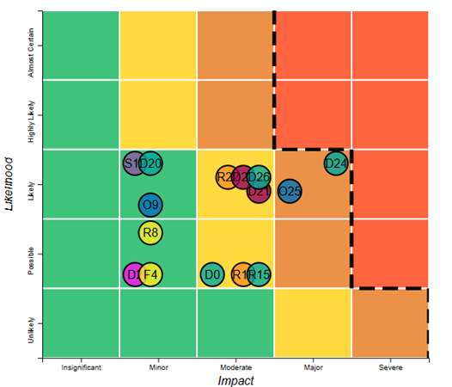

F: PROGRAMME MANAGEMENT: DELIVERY, COMMERCIAL & FINANCIAL PERFORMANCE

Summarise the performance of partners and FCDO, notably on commercial and financial issues.

Governance: The GBFT is a multi-donor Financial Intermediary Fund (FIF), hosted within the World Bank Group. The World Bank serves as Trustee. The PrSW is set up as two Trust Funds within IFC (Advisory Services and Investments) dedicated to each donor – for the UK, the investment trust fund includes the local currency funds and the reflows, that are separated for management purposes. IFC hold the fiduciary responsibility for the PrSW. The Coordination Unit supports GAFSP’s Steering Committee as the central governance mechanism. IFC supports the PrSW Donor Committee (currently chaired by the UK). The KPMG Evaluation highlighted distinct governance structures as a reason for limited collaboration between the public and private windows. FCDO should continue to pursue synergies via the Steering Committee Leadership Group.

Performance: Once approved by voting members in the Steering Committee, all GAFSP projects and investments are delivered in accordance with rules and procedures of the Supervising Entities, overseen by the Coordination Unit and reporting against GAFSP’s results framework. An annual portfolio review of all windows is undertaken, using project data to present the overall health of the GAFSP portfolio to the Steering Committee. KPMG’s Evaluation of GAFSP found high levels of achievement across the programme’s food system outcomes, with less success overall for cross-cutting outcomes.

Grant Based Financing Track: Cumulatively, the GBFT has disbursed US$1.2 billion (97 of 120 approved projects), with disbursement expected to increase significantly in the next couple of years. PO-led projects still face a lengthy time lag between GAFSP award to Supervising Entity approval (Figure 16). The KPMG evaluation highlighted that lengthy Supervising Entity processes and project selection inefficiencies were affecting country and PO projects.
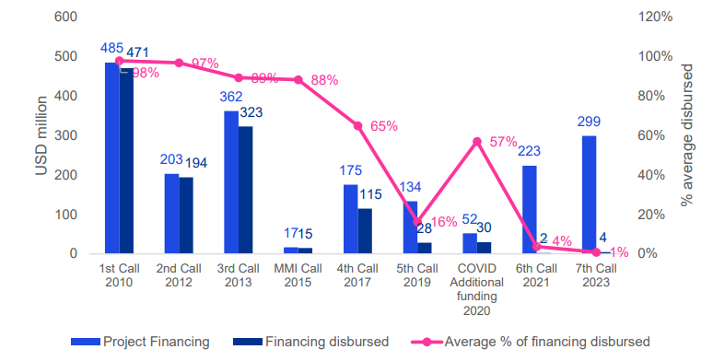
Figure 16 KPMG Evaluation
Private Sector Window: As of June 2024, a total of 93 projects have been approved for an aggregate investment amount of US$505.6 million, including repaid, cancelled, and dropped projects. There are currently 35 active investment projects (23 developing as planned and 12 being restructured or facing delays). Though there is room for improvement on targeting and impact as discussed, the flexibility of GAFSP funding coupled with concessional features helps mobilize and leverage commercial investment from IFC and other global private sector investors. Figure 17 summarises the PrSW advisory and investment portfolios by theme and product. Senior loans comprise 45 percent of the overall portfolio while de-risking solutions through subordinated loans, guarantees and equity account for the remaining 55 percent. Swap rate buydowns through the local currency pilot adds a new product to the PrSW.

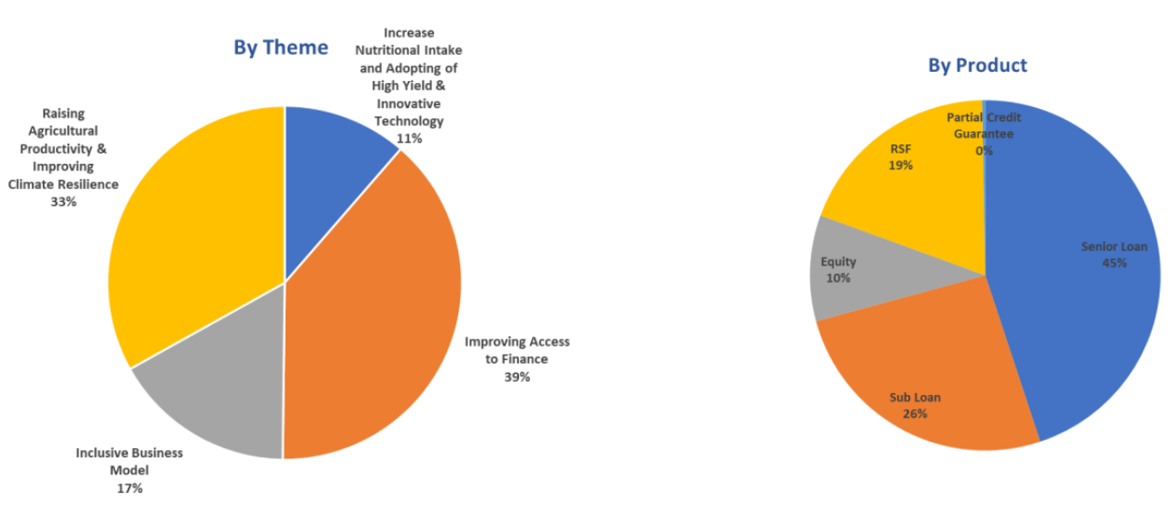
Figure 17 GAFSP PrSW Investment Portfolio as of June 2024, PrSW FY24 Annual Report

G: MONITORING, EVIDENCE AND LEARNING

Monitoring and Evaluation

GAFSP uses the Monitoring and Evaluation Plan and framework agreed by the Steering Committee in August 2023. KPMG’s evaluation found GAFSP’s M&E Framework to be fit for purpose in streamlining measurement of results achieved across the broad programme, but that there was room for improvement capturing cross-cutting outcome level results and impact level results. Furthermore, the framework can be difficult to manage in practice for some stakeholders, particularly producer organisations who have limited management capacity and/or find indicators do not cover the breadth of their work. FCDO draws from the GAFSP M&E Framework its own review and reporting, with the Coordination Unit and IFC providing annual results based on FCDO reporting timelines and logframe indicators (as per Section B and C). In this reporting period, FCDO updated its logframe and Annual Review approach to reflect the UK’s specific contribution to GAFSP, now balanced in favour of the PrSW.

Additional Annual Review inputs this year include the CLEAN Helpdesk climate review, and extensive FCDO engagement with GAFSP stakeholders (World Bank, IFC, donors, Supervising Entities, Civil Society Organisations). In March 2025, FCDO’s Head of Food Agriculture Land and Social Protection attended the in-person GAFSP Steering Committee in Washington DC alongside the FCDO SRO to support strategic discussions around progress and future direction of the programme. This focused on pragmatic implementation of Vision 2030 and effective use of PrSW Trust Fund reflows, heavily informing this Annual Review. In the coming year FCDO should explore informal opportunities to visit GAFSP projects, particularly for FCDO advisers at Post in country.

Evidence

Given the wide range of partners and modalities within the GAFSP, there is significant scope for evidence generation and learning. Supervising Entities have noted that GAFSP enables evidence generation that would otherwise not have been possible with their own funds. However, impact level results are not systematically measured on at a programme level. Donors’ ability to mobilise funding is constrained without robust evidence on the impact of the programme. Responding to this, GAFSP has introduced cross-portfolio evaluations on various themes, with the first covering the FCS portfolio and cross-cutting themes in 2024. FCDO would support GAFSP efforts to mobilise a plan for better impact level reporting, as per KPMG’s recommendation. FCDO is part of the GAFSP Evaluation Working Group to shape the evaluation agenda moving forward, however in the coming reporting period this group will be primarily focused on strategy to delivery Vision 2030. Vision 2030 draws heavily from the comprehensive findings and recommendations of the KPMG 5-Year evaluation of GAFSP, referred across this review.

Learning

GAFSP lacks a comprehensive learning function to enable Supervising Entities to share learning across projects and countries; a missed opportunity given the global reach and diversity of the programme. In the coming year, FCDO prioritise learnings on blended finance, from the PrSW as well as from the BIFT pilot. IFC’s 2024 annual report notes commitment to increasing the knowledge base and transparency around blended finance solutions. FCDO learning and evidence priorities for the year ahead will focus on the impact of the local currency pilot in tackling finance access barriers and increasing development impact in the PrSW. There is also a critical learning on navigating Trust Funds to adapt and improve targeting and impact.

Recommendation 13: FCDO should encourage the Steering Committee, Coordination Unit and IFC to continue to draw from the KPMG 5-Year Evaluation, including ensuring that Supervising Entities and GAFSP beneficiaries have access to its findings and are incentivised to consider them. This should include continued efforts to reflect impact level results.

Date of last narrative financial report | December 2024 | Date of last audited annual statement

Annexes:
- Annex A: Revised approach to the FCDO Annual Review of GAFSP
- Annex B: FCDO Risk Register for GAFSP
- Annex C: Overview of progress on previous Annual Review recommendations

Acronyms
ADB | Asian Development Bank
AfDB | African Development Bank
ALP | Agribusiness Leadership Program
AMEA | Agribusiness Market Ecosystem Alliance
AMP | Aid Management Platform
AS | Advisory Services
BIFT | Business Investment Financing Track
BII | British International Investment
CAADP | Comprehensive Africa Agriculture Development Programme
CSO | Civil Society Organisation
CU | Coordination Unit
DFI | Development Financial Institution
FAO | Food and Agriculture Organisation
FCDO | Foreign, Commonwealth and Development Office
FCS | Fragile and Conflict-affected Situations
FCV | Fragility, Conflict and Violence
FTE | Full-Time Equivalent
FY | Fiscal Year
GAFSP | Global Agriculture and Food Security Programme
GBFT | Grant Based Financing Track
GHG | Green-House Gas
GWFP | Global Warehouse Financing Programme
IADB | InterAmerican Development Bank
ICF | International Climate Finance
IDA | International Development Association
IFAD | International Fund for Agricultural Development
IFC | International Finance Corporation
IFI | International Financial Institution
INDC | Intended Nationally Determined Contribution
KPI | Key Performance Indicator
LAC | Latin America & Caribbean
M&E | Monitoring and Evaluation
PO | Producers’ Organisation
PrSW | Private Sector Window
PuSW | Public Sector Window
SAR | South Asia
SC | Steering Committee
SDG | Sustainable Development Goal
SE | Supervising Entity
SME | Small and Medium Enterprise
UHT | Ultra-High Temperature
VfM | Value for Money
WB | World Bank
WFP | World Food Programme

ANNEX A: Revised approach to the FCDO Annual Review of GAFSP

GAFSP is a complex, multi-track programme, operating with global reach across low-income countries. It has evolved substantially since it was established in 2010. Throughout this period, the UK, similarly to other donors, has made a range of contributions of different sizes and with varying parameters (see below) a set of agreements (and multiple amendments) with the World Bank on the Public Sector Window or Grant Based Financing Track (GBFT) and IFC on the Private Sector Window (PrSW). As below, in recent years the UK has only contributed to GAFSP’s Private Sector Window, although the £28.5m commitment to the GBFT made in 2019 is still being used for implementation of projects.

UK contributions to GAFSP

Date | Amount (GBP£ m) | Window
2012 | 12.5 | Public
2013 | 37.5 | Private Investment
2015 | 26 | Private Investment
2015 | 30 | Public
2016 | 25.5 | Private Investment
2016 | 4.5 | Private Advisory
2018 | -8.5 | Private Investment
2018 | 8.5 | Private Advisory (moved from Investment)
2018 | -1 | Private Investment
2018 | 1 | Private Advisory ($1.234m (~£1m) investment > advisory)
2019 | 30 | Public
2019 | 10 | Private Advisory
2022 | 10 | Private Investment (IDA-Blend Pilot)
2024 | 20 | Private Investment (Local Currency Pilot)
Total | 206

Although the UK and all other PrSW donors advocate for further integration across GAFSP, ultimately the design, planning and implementation across the various tracks has always been separate with limited overall coordination. In particular, the PrSW is governed separately by the IFC with a small subset of GAFSP donors.

Given this background, FCDO PRO and SRO for GAFSP have agreed a new approach for this Annual Review based on the following points:

- FCDO cannot claim attribution of GAFSP cumulative results in proportion to the UK’s total historical contribution and should instead realistically assess GAFSP achievements in proportion to live contributions.
- FCDO should differentiate the weighting of results achieved with the UK’s earlier contributions to the PuSW and the more current funding to the PrSW. Direct attribution to PrSW investment and advisory projects is more straightforward, given the delivery mechanism through separate IFC Trust Funds and the much larger share of UK development capital in proportion of that of other and fewer PrSW donors.
- Nevertheless, in addition to funding contributions, some weight should be given to the UK’s broader influence on GAFSP results and strategic outlook through our active participation in GAFSP’s governance and leadership structures.
In this context, the revised approach to reviewing GAFSP’s performance and results is outlined below.

Previous approach - FCDO logframe as of 2023

In previous years, the six “output areas” were based on GAFSP’s five food system outcomes, plus one output area to reflect the programme’s performance as a funding mechanism. Weightings were based on relative strategic priority, with no distinct scoring for GBFT and PrSW results, and with most analysis based on GBFT results.

Output area | Output Indicators | Window | Impact Weight
1. RAISING AGRICULTURAL PRODUCTIVITY | - Number of beneficiaries reached  1.2 Number of smallholders receiving productivity enhancement support | Public and Private | 20%
2. LINKING FARMERS TO MARKETS | - Total distance of roads built  - Number of markets built | Public | 20%
3. INSTITUTION BUILDING AND CAPACITY DEVELOPMENT | - Number of producer-based organisations supported | Public and Private | 10%
4. REDUCING RISK AND VULNERABILITY | 4.1 Number of people who benefited from cash or food transfer interventions  4.2 Number of people receiving improved nutrition services and products | Public (all) and Private (4.2 only) | 15%
5. IMPROVING NON-FARM RURAL LIVELIHOODS | - Direct employment provided | Public and Private | 15%
6. PERFORMANCE OF GAFSP AS A FUNDING MECHANISM | - Performance of GAFSP as a funding mechanism (qualitative)  - Disbursement rate  6.3 Leverage Ratio | Public (all) and Private (6.1 and 6.3) | 20%

Revised approach - FCDO logframe as of reporting period 2023-24

In the revised logframe, most indicators from previous years have been re-used, albeit reorganised and with new weightings in favour of PrSW results, where the most of recent UK contributions is. New indicators (shown in green) provide a fuller picture of PrSW performance, and further reflect cross-cutting outcomes, particularly climate. GBFT and PrSW “activities to improve livelihoods” are separated (Outputs 1 and 4), with PrSW results worth 30% and GBFT 10%. Output 2 considers the performance of the programme overall, critically considering integration across the two windows, and is weighted at 20%. Output 3 considers the performance of the PrSW as a funding mechanism, weighted at 30%. Output 5 considers progress of the local currency pilot under the PrSW, weighted at 10% given it is only just starting implementation.

Output area | Output Indicators | Window | Impact Weight
1. PUBLIC SECTOR WINDOW (GRANT BASED) ACTIVITIES TO IMPROVE LIVELIHOODS | - Number of beneficiaries reached  - Number of smallholders receiving productivity enhancement support  - Number of farmers receiving inputs or service on climate resilient or sustainable agriculture practices  - Number of producer organisations supported  - Number of people receiving improved nutrition services and products  - Direct employment provided | Public | 10%
2. GAFSP FUNDING MECHANISM PERFORMANCE | 2.1 Public and Private Sector Windows working effectively together  2.2 Disbursement rate  2.3 Leverage ratio  2.4 Volume of financing that supports core themes (climate, gender, nutrition) | Public and Private (except 2.2) | 20%
3. PERFORMANCE OF PRIVATE SECTOR INVESTMENT AND ADVISORY MECHANISM | 3.1 Number and value of projects committed and disbursed  3.2 Leverage ratio  3.3 Percentage of projects rated successful on development outcome  3.4 Product distribution of projects—debt, equity, guarantees, advisory services  3.5 Country distribution of projects—percentage of projects in fragile and conflict-affected states  3.6 Volume of financing that supports core themes (climate, gender, nutrition) | Private | 30%
4. PRIVATE SECTOR (INVESTMENT AND ADVISORY) ACTIVITIES TO IMPROVE LIVELIHOODS | - Number of beneficiaries reached  - Number of smallholders receiving productivity enhancement support  - Number of farmers receiving inputs or service on climate resilient or sustainable agriculture practices  - Number of producer organisations supported  - Number of people receiving improved nutrition services and products  - Direct employment provided | Private | 30%
5. LOCAL CURRENCY PILOT | 5.1 Number of businesses in local currency pipeline and geographical spread  5.2 Value of pipeline | Private | 10%

2024 Annual Review score using previous approach

As per the results in Section C, using the revised approach the score for this Annual Review is ‘B’. Using the previous methodology, GAFSP would likely have scored ‘A’, as below.

Output Description | Impact Weight (%) | Output Performance
Raising agricultural productivity | 20% | Outputs met expectation (A)
Linking farmers to markets | 20% | N/A - results not provided
Institution building and capacity development | 10% | Outputs moderately exceeded expectation (A+)
Reducing risk and vulnerability | 15% | Outputs met expectation (A)
Improving non-farm rural livelihoods | 15% | Outputs did not meet expectation (B)
Performance of GAFSP as a funding mechanism | 20% | Outputs met expectation (A)

ANNEX B: FCDO risk register for GAFSP

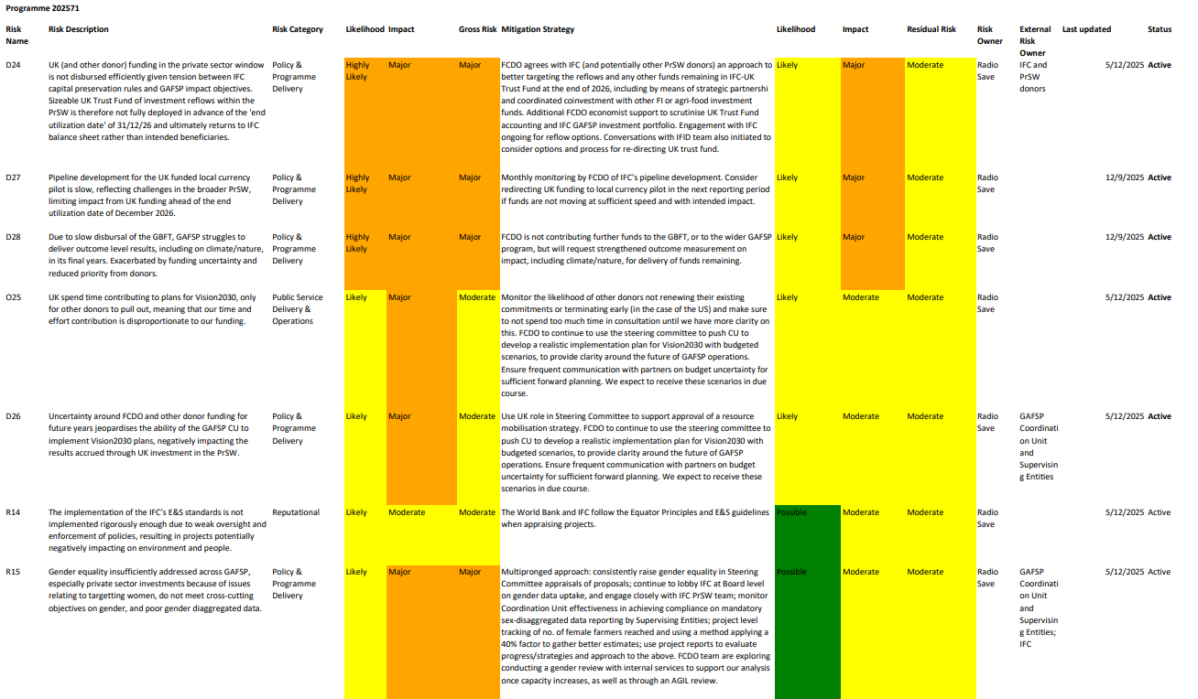

ANNEX C: Overview of progress on previous Annual Review recommendations

Area/output title | Recommendation from 2023 Annual Review | Progress (or flag if N/A)
Strategy, Vision and Governance | Recommendation 1: By May 2024, CU should set out remaining issues within the GAFSP restructuring package which need further clarification and discussion at the Steering Committee. | GAFSP Restructuring Package officially approved by the May '24 GAFSP Steering Committee Meeting
Raising Agricultural Productivity | Recommendation 1.1: FCDO to explore whether there are additional Tier 2 indicators that could be used to better capture uptake of new technologies/services or changes is practises as a result of support received that would give better indication of the likelihood this output is contributing to higher level results, including on sustainably increasing productivity and yields, and to give greater confidence to our internal reporting of climate results. | FCDO introduced a new indicator to the logframe – GAFSP Tier 2.2 output indicator on “Number of farmers receiving inputs or service on climate resilient or sustainable agricultural practices (farmer)”
Strategy, Vision and Governance | Recommendation 2: FCDO to continue to be an active member of the BIFT working group and to provide advice on BIFT design. By end 2024, BIFT pilot should be launched. | FCDO engaged in the BIFT WG and the BIFT Pilot was officially launched in October ’24. FCDO continues to engage via the Steering Committee and Leadership Group.
Linking Farmers to Markets | Recommendation 2.1: The CU encourages projects and SEs to build roads that adapt to all weather conditions and resilient to climate change. At the same time the CU encourages the SEs to fund projects that innovate markets in rural areas to contain cold storage and modern methods for preservation against different climate related risks. As part of logframe update, FCDO should better understand SE’s procedures for climate risk assessments and review whether there are opportunities to strengthen these elements within the programme. | SEs apply the joint MDB methodology primarily in country-led projects by systematically identifying the project’s physical climate vulnerability context. They make an explicit statement of intent to address the identified climate change vulnerabilities and clearly articulate the causal link between specific project activities and the physical climate risks outlined. SEs address these risks through a combination of complementary measures, including (1) risk management integration; (2) direct adaptation actions; and (3) addressing root causes of vulnerability. More could have been done by FCDO to scrutinise SE climate risk assessment procedures.
Linking Farmers to Markets | Recommendation 2.2: Linking farmers to markets requires more than built infrastructure. FCDO to explore whether there are suitable indicators, relevant to both GAFSP windows, that can capture some of this wider work to strengthen market systems and links to private sector off-takers. E.g Number of farmers accessing financial services, or support to access marketing opportunities (both are indicators in the GAFSP M&E plan). | This year’s review focused more heavily on the PrSW. Within this window, the indicator “farmers reached” counts farmers with market access through IFC/GAFSP clients in the real sector, or farmers accessing financial services through IFC/GAFSP FI clients.
Strategy, Vision and Governance | Recommendation 3: FCDO sees the CSO role on the Steering Committee as critical to GAFSP’s inclusive governance model; their voice and input being a core strength of the programme. By April 2024, CU, working with the Trustee and CSOs to have agreed an appropriate and sustainable solution to fund the CSO representation on the SC. | The Steering Committee has now approved a FY25 Budget supporting (i) CSO Member engagement in the Steering Committee; and (ii) field-level portfolio monitoring and stakeholder engagement by CSO service providers.
Institution Building and Capacity Development | Recommendation 3.1: Continue to explore options to better capture gender dimensions individual Pos (e.g could they be disaggregated by those headed by women?). | FCDO is limited by what is included in GAFSP’s M&E Plan. However, CU could explore opportunities for new pipeline projects to include through further gender dimensions via the due diligence review process. Furthermore, as part of the Tier 3 output indicator #4, CU regularly conducts cross-cutting analysis and the recent exercise results were presented in the SC meeting on April 2nd, including analysis on the gender empowerment.
Institution Building and Capacity Development | Recommendation 3.2: Draw on the PO learning report to drive improvements in the PO led track, especially around capacity building. Potential solutions could include capacity needs assessments of POs at the start of projects, to ensure targeted support and a baseline from which to measure improvements in institutional capacity. Guidance or parameters on the SE/PO relationship may also help ensure that the necessary capacity building is built into projects. Furthermore, mitigations to ineffective SE/PO relationships may include national level steering committee models that bring in a wider range of actors to engage with and guide projects. The CU should be empowered to monitor more closely and enforce agreements. | The upcoming 8th Call for PO-led proposals will include the following key updates:  - A mandatory PO capacity assessment for both proposal development and results measurement, to ensure that capacity building is thoroughly evaluated and tracked; and  - Clarified guidance on the relationship between SEs and POs in the Call Guidelines—particularly regarding the fee structure for technical assistance SEs—to ensure that POs, as partners, fully understand the associated costs and their collaboration with SEs.
Strategy, Vision and Governance | Recommendation 4: FCDO should continue engage with GAFSP donors and the CU on GAFSP’s future strategic direction. By May 2024, the CU should present the concept to the SC and set out the process for soliciting feedback from SC and wider stakeholders. | Vision 2030 concept presented by the CU to the May 2024 Steering Committee Meeting and consultation of SC Members and external stakeholders launched by the Coordination Unit. Further work is needed in the coming year to develop a realistic plan.
Reducing Risk and Vulnerability | Recommendation 4.1: FCDO to better understand the way in which cash/food transfers are provide in GAFSP projects to understand the extent to which this indicator is still relevant and how much is done through longer term shock-responsive social protection systems. Could we disaggregate this indicator by those reached through more permanent systems? | This indicator originates from the 2011 and 2017 GAFSP M&E plans. It was adopted and tracked by six projects—two from the 1st call, two from the 2nd call, and two from the 3rd call—all of which have now been closed. Currently, the only active project reporting on this indicator is from the 5th call, which is scheduled to close next year. As this indicator is no longer included in the new GAFSP M&E plan, it will no longer be tracked or reported going forward. Furthermore, the FCDO has deprioritised scrutiny on the public sector window.
Reducing Risk and Vulnerability | Recommendation 4.2: FCDO logframe needs to be updated with alternative indicators from the revised GAFSP M&E plan. Direct employment is already under Output 5. FCDO should work with CU to clarify how cash for works type programming, could be better differentiated from longer term, permanent employment opportunities. | This has been updated accordingly
Reducing Risk and Vulnerability | Recommendation 4.3: FCDO to review the methodology for GAFSP indicator ‘Number of farmers whose livelihood has become more resilient to shocks (farmer)’ which uses the capacity score index and consider alignment with the ICF KPI on resilience. | FCDO has not completed this recommendation and should carry it forward for the next review period.
Monitoring, Evaluation and Learning (MEL) | Recommendation 5: By end June 2024, FCDO should update the FCDO logframe to better align with the revised GAFSP M&E plan. This should capture all the output recommendations relating to logframe indicators (see also Output level recommendations 1.1, 1.2, 2.1, 2.2, 4.2 and 4.3) and update milestones and targets to ensure they are relevant and stretching in light of current GAFSP Portfolio. | This has been updated accordingly
Monitoring, Evaluation and Learning (MEL) | Recommendation 6: By end 2024, FCDO should continue to push for progress in the GAFSP Working Group on the PO-led track, alongside key allies such as Germany and the USA to ensure the core priority of strengthening PO institutional capacity is delivered, which requires close TA and professionalisation support to improve services to members (see recommendation 3.2 under Output 3 for more detail). Only supervising entities with a proven track record and the political will to build PO institutional capacity should be eligible to do this. | As indicated in Response 3.2, the PO-led Call is working on ensuring the core priority of strengthening PO institutional capacity is delivered with rigorous assessment with a stronger emphasis on results. Under this context, the Call will require a PO capacity assessment to be part of the proposal development, and the CU is also collaborating with PrSW Advisory Services to organize an information session on the GAFSP-financed Agribusiness Leadership Program (ALP). This will support the proposal development process, including the needs assessment and the design of capacity building activities based on the ALP curriculum.
Monitoring, Evaluation and Learning (MEL) | Recommendation 7: FCDO should continue to engage in the evaluation working group discussions to shape the evaluation, including seeking EQUALs review of Inception Report and Final Evaluation Product. By end 2024, 5-year programme evaluation completed. | FCDO has engaged actively in the SC evaluation and strategy working group to shape the evaluation for both the 1) 5-year programme evaluation and 2) FCS cross-portfolio evaluation. The 5-year programme evaluation has been finalized and SC provided written responses, including inputs from FCDO.
Fund Performance and Value for Money | Recommendation 8: Before the 8th Call; CU to review the proposal and approval process for FCAS projects to ensure that there is more time and attention given to the assessment of some of these issues at the design and approval stage. The independent Technical Advisory Group which reviews proposals received from calls has provided excellent recommendations, which should flow into this review. | The CU has taken the findings and lessons learned from the FCS cross-portfolio evaluation and TAC’s assessment from the past PO-led Call to inform the 8th Call for PO-led proposals and details can be referred to in the SC Decision Note. Findings will also be reflected in the questions included in the Full Proposal Template.
Fund Performance and Value for Money | Recommendation 9: By June 2024; CU to facilitate a discussion with the Steering Committee, including GAFSP Trustees to clarify SC’s risk appetite. This is essential for realistic, pragmatic and successful operations in particular in IDA FCAS contexts. | During the SC meeting on April 2nd, the key results and recommendations of first cross-portfolio evaluation undertaken for the FIF portfolio on Fragile and Conflict Situations were presented. For the recommendations, a SC response will be prepared by the CU to consider responses for each. The recommendations cover a wide range including strategic orientation of the program, adjustments to future Calls for Proposals, portfolio management issues such as strengthening tracking FCS status during the life of the project, as well as future research agenda.
Fund Performance and Value for Money | Recommendation 10: The Steering Committee should continue to scrutinise GAFSP and SEs’ approach to indirect support costs (ISCs) which vary considerably across SEs and are not capture on project budgets in a consistent and transparent way. By end 2023, FCDO should lead challenge on GAFSP and SE’s approach to ISCs associated with projects, to ensure transparency and consistency wherever possible. This will feed into broader work on multilateral effectiveness within FCDO. | Following the SC discussion and decision on FAO’s ISC issue (the note also includes the position of WFP, the other TA SE that faces similar cost items), the CU has not had discussion with investment SE as they pass the grants all to the recipients. The FCDO programme team has not picked this, instead deferring to central teams such as multilateral effectiveness and the commercial grants hub.
Fund Performance and Value for Money | Recommendation 11: By end 2024; FCDO should undertake dedicated VfM assessment of GAFSP in 2024 ahead of the next Annual Review, drawing on the 5-year GAFSP programme evaluation and IFC led private sector window review. | FCDO has not completed this recommendation but is securing additional specialist support to review PrSW activity and portfolio in the year ahead. This will inform a deeper VfM assessment.
Fund Performance and Value for Money | Recommendation 12: FCDO should continue reviewing portfolio performance with IFC, encouraging them to take a “fail fast” approach whereby they bring forward as much as possible the critical decision point, to reduce the funds actually committed and to avoid prolonged team effort in trying to keep in portfolio partners that don’t really match the investment conditions | Adopting a "fail fast" approach is in line with the PrSW’s ongoing efforts to enhance our project review and appraisal processes. We are focusing on having targeted conversations with project teams to ensure earlier alignment on qualifying criteria and desired project outcomes. From a portfolio management perspective, IFC expect this approach to help them better manage their resources and focus our efforts on high-potential and high-probability opportunities that can drive significant impact.
GAFSP Visibility and Comms | Recommendation 13: In 2024, FCDO should increase its engagement with our country network and ensure that all country posts with GAFSP-funded projects are informed about active and under-preparation projects in their host country. This will support join-up between posts and potentially useful actors in country, and links/lessons learned for FCDO programmes. By end 2024, FCDO network should provide feedback for next year’s Annual Review. | Engagement with FCDO’s country network has increased, but more should be done in the year ahead to promote GAFSP’s activities, in particular around the next Call for Proposals for PO led projects.
UK International Climate Finance (ICF) | Recommendation 14: As part of the Logframe review and strategic planning exercise, by June 2024, FCDO should undertake a more detailed review on climate related aspects of the programme – ensuring that reporting aligns with ICF methodologies; new ICF guidance for Agriculture and Food Security and that it should continue to count as 100% ICF. | Internally in FCDO a thorough CLEAN Helpdesk climate review of GAFSP was undertaken. Strengthened ICF indicators were also added to the logframe.

IDA Borrowing Countries, International Development Association, World Bank
Australia, Canada, Gates, Germany, Ireland, Japan, Netherlands, Norway, South Korea, Spain, UK, USA
Hosted and staffed by the World Bank
World Bank, Africa Development Bank, Asia Development Bank, Inter-American Development Bank, International Fund for Agricultural Development, UN Food and Agriculture Organisation, World Food Programme
This track began with a “Missing Middle Initiative” pilot in 2016, which focused on enhancing access to finance for producer organisations. In 2020 GAFSP widened the scope to a broader range of PO-led projects.
Nearly half of the PrSW advisory portfolio is directly linked to a PrSW investment.
Canada, Netherlands, US, UK, Japan, Australia.
This accounts for subtracted funding for approved projects, monitoring and evaluation and administration fees
The UK has contributed £206 million to GAFSP to date: £72.5 million (~$100.3m) to the GBFT and £133.5 million (~$170.3m) to the PrSW. See all historical UK contributions to GAFSP at Annex A.
See Section C, Output 5
FCDO funding to the GBFT funding is not fully disbursed, though there have been no new commitments since 2019. Further explained in Section C, Output 1.
Each donor to the PrSW has a separate Trust Fund. The GAFSP Common Charter set options for individual donors on whether reflows from investments would return to the funder or to back to the GAFSP Trust Fund. The UK chose the latter meaning there is now a substantial Trust Fund balance of over US$90 million (see Section C).
UK Minister for Development at the International Development Committee, May 2025
The AR score would likely have been an A if based purely on output level results and using purely output level results (i.e. not considering bigger picture challenges). See Annex A.
GAFSP receives independent program evaluations every five years, with the latest completed by KPMG in late 2024. This evaluation provides the evidence on what has been effective and impactful in recent years, and what could have been done better.
FAO State of Food Security and Nutrition in the World 2024
Prior to budget cuts, development finance flows to agriculture had only increased by 0.2 percent between 2015 and 2022 - FAO Financing Food for a Better Future
Donor budget tracker
Around USD$84m of the UK Trust Fund has been disbursed/invested to date.
See Section C, Outputs 3 and 4
Theory of Change update in 2022 added the three cross-cutting outcomes (gender, nutrition, climate)
GAFSP 2022 M&E Plan
Following FAO’s definition of Climate Smart Agriculture
GAFSP Joint Portfolio Update presented to the Steering Committee in March 2025
Steering Committee note on KPMG Evaluation
For 32 GBFT and 55 PrSW closed projects included in KPMG’s analysis, results achievement on output indicators have been classified relative to the target. If results achievement on target for a project’s reporting on Output Indicator X is 90% or above, it has been classified as achieved and is considered a ‘green indicator’
GAFSP portfolio review on cross-cutting themes, 2025
GAFSP business case addendum 2024
In the PrSW “reached” means benefitted from improved market access
Project with Cargill in Cote d’Ivoire – Strengthening the Cocoa Supply Chain while Improving Farmer Livelihood, GAFSP PrSW FY24 Report
GAFSP 2023 Annual Report
See justification at Section A, p.3, and at Annex A
The GBFT was previously referred to as the Public Sector Window, prior to the introduction of the BIFT and producer organisation led track.
See Financial Intermediary Funds
The definition of producer organization within GAFSP ranges from grass-roots organisations to larger federations. Current reporting indicates that over 97% of POs supported by GAFSP fall under the country-led track.
A gap between climate adaptation support and adoption is expected but should increase significantly from 6% e.g. a bilateral FCDO programme has a 70% adoption target for farmers supported with good production practices.
KPMG 5 Year Evaluation of GAFSP
Steps have been taken in the 7th call for proposals to increase the disbursement rates, with a significantly faster SE approval time than in previous Calls (avg. 3-6 months vs. 17 months), but still low compliance: only 8 out of 20 fulfilled the (non-binding) requirements.
GAVI disbursement timelines are over 12 months and Green Climate Fund ~13 months
There is a small overlap between Output 2 and Output 3 indicators: PrSW leverage ratio (2.3, 3.2) and volume of financing supporting cross-cutting themes (2.4, 3.6). These PrSW results are included under Output 2 alongside GBFT results to provide a holistic view of the programme, but are discussed in more detail, and have a greater weighting under Output 3.
Country projects now all align with national climate strategies and commitments, require climate vulnerability analysis in design, and reporting on climate resilience impacts, GAFSP Annual Report 2023
Initially it was envisioned that other SEs would be able to access PrSW funding, which has not occurred.
“IDA-only” countries can borrow from the International Development Association (IDA) based on their relative poverty, defined as GNI per capita below an annually updated threshold ($1,335 in fiscal year 2025). They are “IDA-only” as they lack the creditworthiness to borrow from the IBRD.
For direct investments (mainly equity and debt projects), the average GAFSP:IFC investment ratio is ~1:1, with GAFSP investing in parallel with IFC. For projects with financial institutions the average GAFSP:IFC ratio is 1:2, with GAFSP often providing a first loss or counter guarantee (up to 50%) to IFC in risk sharing facilities to mitigate the risk profiles of the underlying portfolio (PrSW Annual Report 2024)
GAFSP PrSW FY24 Year in Review
“Successful” reflects projects that are rated highly successful, successful or mostly successful through a framework for assessing Development Effectiveness developed by IFC and the World Bank Group’s Independent Evaluation Group (IEG)
Investment projects are rated on a sample basis. Some Advisory projects are also not subject to a development effectiveness rating.
Total cost to implement the project from the initial phase to completion
Moody's credit opinion of IFC
GAFSP PrSW FY24 Year in Review
GAFSP PrSW FY24 Year in Review
“IDA-Blend” countries are countries eligible for IDA borrowing based on per capita income levels and are also creditworthy for some IBRD borrowing. IDA vs IDA-Blend country groupings are similar, but not the same, as Low-Income Country vs Lower Middle-Income Countries.
The IDA-Blend pilot was restricted to the £10m UK contribution in 2022, with FCDO clearly stating that any further funding to these countries would be subject to a case-by-case rationale based on development impact and to address specific situations of food insecurity.
The total GAFSP investment for approved FY24 projects is USD$30.4m, with the three IDA-Blend investments totalling USD$19.8m - GAFSP PrSW FY24 Year in Review
As of May 2025, including the £20 million local currency pilot
The GBFT operates exclusively in IDA-Only countries.
GAFSP PrSW Strategic Direction Donor Committee paper
As of June 2024: 93 PrSW investment projects have been approved, of which 40 are completed and repaid (US$193.9m), 12 are delayed or being restructured (US$33.4m), 23 are developing as planned (US$137.9m) and 18 have been cancelled or dropped (US$140.4m). GAFSP PrSW FY24 Annual Report.
average PO size for PrSW projects is ~250 members, but ranges from 70 to almost 650 members, depending on the country/crop combination.
Advice from FCDO nutrition adviser.
AgBase analysis. The five companies were Pula ($10m), Khula ($6m), SupaMoto ($4m+), Sunculture ($4m), Sistema.bio ($3.5m).
BII Pula Investment
BII Johnvents Investment
IFC and other DFIs often cannot take on local currency lending without an ODA subsidy to buy down the exchange rate risk, because of their investment rules and the need to return a profit within a relatively short time.
IFC Swap Rate Buydown overview for GAFSP PrSW Donor Committee
Couvoir Amar and Africaine de Production Animale.- IFC disclosure
The GCF charges 9.5% ISCs for grants up to USD$10m, 9% over USD$10m, and 4% for small grants. GCF general principles and indicative list of eligible costs
KPMG 5-Year Program Evaluation of GAFSP
GAFSP FCS Portfolio Evaluation
Led by the Agri-SME Learning Collective under the Global Donor Platform for Rural Development
GAFSP 2023 Annual Review
GAFSP PrSW FY24 Year in Review
KPMG 5-Year Evaluation of GAFSP

