Annual Review
Title: I2I - Ideas to Impact - Testing new technologies and innovative approaches to address development challenges

Programme Value £ (full life): ODA: £39,601,000  Non-ODA: £2,487,715 (from central non-ODA BC)  Total: £42,088,715 | Review Date: 24 Sept 2024

Programme Code: 201879 | AMP Start Date: 30 Apr 2014 | AMP End Date: 30 Sept 2026

Summary of Programme Performance
Year | 2015 | 2016 | 2017 | 2018 | 2019 | 2020 | 2021 | 2022 | 2023 | 2024 | 2025
Overall Output Score | A | A | A | A | A | A | A | A | A | A
Risk Rating | Severe | Major | Major | Major | Major | Major | Major | Major | Moderate | Moderate

DevTracker Link to Business Case: | Business Case and Summary 201879 (Published - April 2013)  Addendum to the Business Case 201879 (Published - March 2019)
DevTracker Link to results framework: | Logical Framework (D0000799) 201879 (Published - May, 2022)

Contents
A. SUMMARY AND OVERVIEW 2
B: THEORY OF CHANGE AND PROGRESS TOWARDS OUTCOMES 6
C. DETAILED OUTPUT SCORING 13
D: VALUE FOR MONEY 27
E: RISK 29
F: PROGRAMME MANAGEMENT: DELIVERY, COMMERCIAL & FINANCIAL PERFORMANCE 30
G: MONITORING, EVIDENCE AND LEARNING 32
CASE STUDY 1: Early Warning Forest Fire Detection System in Pakistan 34
CASE STUDY 2: Smart GeoSeals to Track Delivery of Humanitarian Aid 35
CASE STUDY 3: Wakanda Beyond Peer Action Group 36
ANNEX A: ORIGINAL I2I THEORY OF CHANGE 37
ANNEX B: NEW I2I THEORY OF CHANGE TO BE ADOPTED IN FYR 24/25 38

A. SUMMARY AND OVERVIEW

Approach to this Annual Review
This Annual Review (AR) was primarily undertaken through a desk-based review by the SRO and PRO, built on extensive reporting and recommendations from the delivery partners.
This AR is also based on the recent findings of an independent external evaluation of the largest I2I component –Frontier Technologies Livestreaming (pilots).

Description of programme
The world is dealing with a wide variety of interconnected social and environmental challenges. In parallel, there is a proliferation in emerging technologies, which are rapidly evolving and becoming used more and more in day-to-day life. While there are risks to manage, the utilisation of emerging technologies brings huge opportunities for impact, including improvement in livelihoods, health and education for all global citizens, through making new and/or improved products and services available to larger numbers of people, more efficiently and effectively.
The Ideas to Impact (I2I) programme (2014 – 2026) comprises a group of interventions to support FCDO to develop, test, and deploy technologies and innovations addressing global and development challenges, and to generate and share evidence on what works.
Since 2014, the majority of I2I programme components have been completed, as outlined in previous Annual Reviews (ARs). Frontier Technologies 2 is the main remaining component of work, with some additional support being provided to the International Development Innovation Alliance (IDIA).
Accounting for 97% of the remaining I2I funding, Frontier Technologies 2 (FT2) supports FCDO staff and implementing partners to pilot frontier technology solutions for impact, to generate knowledge and evidence on what works (and what doesn’t), and to progress high-potential solutions on the pathway to scale. FT2 is delivered by The Frontier Technologies Hub (FT Hub), a consortium of three organisations: Results for Development (R4D), DT Global (formerly IMC Worldwide) and Brink. FT2 has been operating since 2014 and acts as a key ‘frontier tech’ engine for the FCDO. Since 2014, the FT Hub has invested into and supported 71 pilots, and the programme earned the Civil Service Award for Innovation in 2017.
FT2 is structured around five interconnected components, summarised in the diagram below. Through Livestreaming, pilots are supported to test new ideas, surface learning and evidence, and share these findings in the form of research and evidence outputs. With the aggregate knowledge from a diverse portfolio of pilots, Evidence & Thought Leadership surfaces cross-cutting insights and trends which are shared with wider FCDO and external communities, so that they can apply the learning to their work. While the target audience is primarily FCDO staff, where possible, all new knowledge and evidence is made publicly available to ensure it has the greatest potential for wider impact. Through Futures, the programme supports FCDO staff to explore the implications of future frontier technologies for FCDO’s development and foreign policy objectives. The FT2 Network provides opportunities for staff and partners to convene and build connections. This capacity strengthening part of the programme helps FCDO staff to increase their confidence and skills in the use and application of frontier technologies and innovative methods, with the aim of increasing FCDO’s development impact. Finally, the new Demand-Led strand of work is engaging more deeply with local FCDO programmes, country offices and the innovation ecosystems they work in. Deeper local engagement enables identification of the demand for tech innovations from key local stakeholders then analysis and co-design of experiments to support adoption of tech and alignment to the ecosystem.
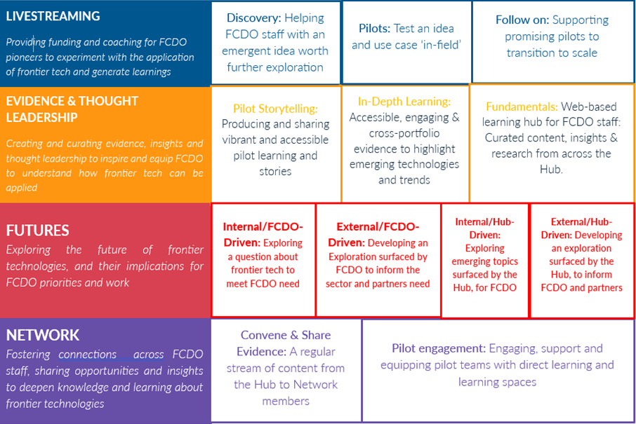
I2I was due to close at the end of March 2025. A new Business Case Addendum is being prepared to seek ministerial approval to extend the programme by a further 5 years. While the new business case addendum is being approved, and to allow the launch of this year’s pilots (with an expected duration of 18 months), a no cost extension has been approved to move the end of the programme to September 2026.
DEMAND LED
Programme and ecosystem engagement at a local level. To identify the demand, provide technical assistance and co-design experimentation.
Program Immersion
Working with FCDO and program partners to identify priority challenges and potential tech solutions to test and adopt.
Science tech & innovation teams
Working in partnership with FCDO and science & innovation teams to identifying opportunities with the local ecosystem to identify priority challenges and test & adopt frontier tech.

Summary supporting narrative for the overall score in this review
This programme scores an A overall, with a moderate risk rating. The FT2 programme is continuing to meet high expectations, providing a strong offer to FCDO in terms of supporting innovation and exploration of frontier technologies for development as well as for FCDO operational delivery. The 2024 Independent Evaluation of the Livestreaming component (~50% of programme spend) concludes that FT Livestreaming is a unique strand of work which is important to FCDO for the following reasons:
- it gives valuable hands on experience and opportunities to learn to pioneers who understand problems and are given opportunity to test creative and cutting edge solutions to them;
- it creates a safe space for failure in an organisational culture which is often risk averse;
- it is well aligned to FCDO and wider Government strategic priorities for technology up-skilling and application.
Looking beyond FCDO, the evaluation finds that the FT Livestreaming work strengthens technology partners, starts to move many innovative solutions to development challenges along the innovation pathway towards scaling and sustainability, and generates practical evidence of technology in applied contexts.
The International Development Innovation Alliance is a well-managed alliance that gives FCDO staff working in innovation an important and regular point of collaboration with other influential innovation donors.
Output 4 is the single logframe Output that captures all of the work under FT2 and IDIA (the other Outputs represent completed work strands). The results for this year are shown in the following table and explained in Section C.

Output Indicator | Work Strand | Weighting | Score
4.1 | FT2: Livestreaming | 75% | A
4.2 | FT2: Evidence (Research and Learning) | 10% | A++
4.3gric | FT2: Futures | Not scored
4.4 | FT2: Network | 10% | A
4.5 | IDIA: Partnerships | 5% | A+

Major lessons and recommendations for the year ahead
The following section summarises the major lessons and recommendations. Detailed recommendations are laid out in the main text of this review.
Strategic: a programme strength is its flexibility, but this is also a weakness – responding to contextual changes (e.g. COVID), FCDO priorities and programme learning has resulted in ambiguity and lack of consensus about its aims and objectives, and as a result it is hard to use the existing theory of change or logframe metrics to really demonstrate its value, achievements and effectiveness more substantively. It’s value, as demonstrated in this annual review is largely evidenced by clear strong case studies and reports of individual work activities and the subsequent feedback received. However, the FT Hub, in collaboration with the FCDO have developed an updated theory of change and corresponding metrics that will help demonstrate programmatic impact and improve measurement and understanding of progress – these will be implemented from this AR going forwards. Additionally, if the follow-on phase of the programme is approved, this will be used to fully reset and clarify the programmes aims and objectives (based largely on the next theory of change).
Livestreaming: The FT Hub has successfully grown its portfolio to over 71 pilots and has adapted and evolved its methods over the years in an attempt to provide more effective support to its grantees. As a highly experimental innovation portfolio, it is natural that pilots will advance along the scaling pathway to different degrees. However, there is a recognition that adjustments to the coaching practice, further quality assurance of evidence gathered, and deeper country engagement could help to support the most promising pilots to advance towards adoption and sustainable scaling in the longer term. To address this, three key activities are recommended:
- Instate a forum for regular rigorous review of individual pilots after each sprint (Pilot Advisory Boards) as well as a forum for holistic assessment of the wider portfolio on a quarterly basis (Portfolio Committee). Now these oversight mechanisms are in place, two portfolio evaluations should be considered:
- Portfolio impact evaluation to understand the impact of pilots
- Gender and inclusion evaluation, an area identified as very weak by the Independent Evaluation. This will include also the work the FT Hub has started, in collaboration with IDIA Spoke 2, to mainstream and monitor principles of localised and responsible technology.
- The pilot process follows a one-size-fits all format in terms of coaching support and funding/sprint structure. Responding to feedback from pioneers with higher levels of innovation and technology expertise, there is a need to allow pilots to be more tailored to the pioneers, partners and pilot objectives.
- With the additional funding made available for the Follow-on-Fund, enhance the Follow-on-Fund process and offer, including development of a funder network and specialist technical assistance network to provide additional tailored support to grantees on their scaling pathways.
Evidence: The independent evaluation found that there was wide agreement across stakeholders that learning and evidence generation is a priority for FT Livestreaming but different views about what it should look like and how it should be used and disseminated. While 80% of pioneer survey respondents thought their pilot had done a good job of capturing useful lessons, almost a third (29%) seems to have no knowledge about which audiences lessons had been shared with. Focusing on pioneers themselves, 69% of survey respondents stated that they had applied (or intended to apply) their learning, knowledge and understanding from their pilot to their programme, policy or diplomatic work. It is important therefore that the FT programme has clarity about the purposes of, and audiences for, evidence and learning to define objectives and focus effort accordingly – this work will build on changes the Hub is already implementing whereby ‘evidence deep-dive’ proposals very clearly articulate the target audience, including FCDO staff, and the tangible value to those audiences.
Helpdesk and programme immersion: An important finding of the independent evaluation is that while FT2 has clear alignment with FCDO strategic objectives, as reflected in the International Technology Strategy and International Development White Paper, the touchpoints where the FT programme activities engage with, influence and are adopted by FCDO staff are less well defined. Further, the transfer of frontier tech learning and evidence to programmes is generally ad-hoc. While not all of the frontier technology work needs to influence FCDO staff or programmes, FCDO programmes offer significant potential as vehicles to test and scale tech, but also building FCDO capacity will increase future use of frontier technologies. As a result, the Helpdesk, Programme Immersion and Country Office engagement need to be bolstered in the next year and next programme phase.
Additional cross-cutting recommendations: The following key themes have emerged as learning and are recommended to be considered for the next phase of work, FT3:
- Exploring truly frontier ideas: Dedicating resources to actively scout for, and experiment with, nascent technologies that have the potential to disrupt traditional paradigms. This includes investing in research and development activities, participating in global innovation networks, and engaging with thought leaders and innovators from diverse sectors.
- Refreshing governance arrangements: New governance structures and processes, both at the FT Hub consortium level as well as within the FCDO programme delivery team, will be implemented to facilitate rapid delivery and innovation, and greater FCDO capacity to oversee and collaborate on the programme.
- Seeking opportunities for spinouts and new entities: As with the FT work providing the early roots of growth for entities such as COVIDAction and AT2030, the FT Hub will continue to look for possibilities to create bigger sustainable entities that can drive change outside of the FT Hub.
IDIA: is a well-managed and well-attended alliance of innovation donors. However, FCDO still gets limited value from our engagement due to the burden of engagement falling largely on the I2I SRO. It’s important that FCDO’s TIU and wider teams involved in innovation do not conflate IDIA with the FT programme. IDIA has much broader applicability than simply in the Frontier Technologies space and has relevance to all innovation programming where partnerships are important. While efforts have been made to increase wider engagement, including consideration of bringing GSMA in as a new IDIA contributing member, the TIU should take more collective responsibility for engaging with IDIA and encouraging engagement from other parts of the FCDO.

B: THEORY OF CHANGE AND PROGRESS TOWARDS OUTCOMES

Summarise the programme’s theory of change, including any changes to outcome and impact indicators from the original business case
As stated in the I2I Business Case Addendum (2019), the theory of change for I2I has effectively been replaced by the FT2 programme theory of change, given that it is the main remaining component. The FT2 Theory of Change updated by the FT Hub in 2022 (to align with the FT2 2022-25 strategy) is shown on the following page, while the original I2I theory of change is included in ANNEX A for reference. The FT2 theory of change captures and builds on the FT components of the original I2I Theory of Change as well as incorporating programme changes requested by FCDO.
For consistency of programme monitoring, Annual Reviews still report against the original I2I Outcome Indicators as per the next section. However, to ensure full relevance to the FT2 theory of change, the indicator scores are also discussed within the framing of the FT2 outcomes. The two sets of outcomes capture similar intents as per the following mapping:
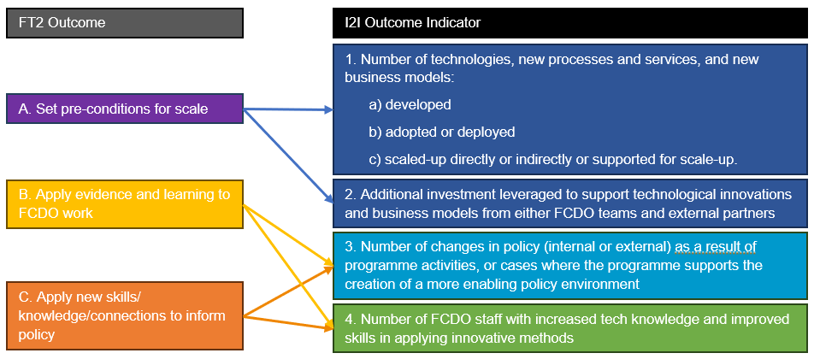
Updated Theory of Change and associated indicators: This mix of outcome indicators and theories of change has arisen due to the programme pivoting to respond to changing external contexts (e.g. COVID), FCDO priorities and programme learning about what generates most impact. However, the 2023 Annual Review (AR) recommendations 1 and 2 recognise that the current theory of change does not clearly define the intended flow of activities to impact and the associated logframe indicators do not enable capturing programme impact. The Independent Evaluation also picked up this lack of clarity about objectives as a recurring theme and, as well as hindering demonstration of activity effectiveness and programme impact, it has led to a perceived lack of consensus between consortium partners on approaches to innovation to drive outcomes.
From November 2023, the FT Hub has led a process, with FCDO collaboration, to develop a refreshed Theory of Change and Logframe indicators which better capture the full spectrum of activities and outcomes that the programme has evolved to encompass and a clearer articulation of how these contribute to the programme’s intended impact. This updated Theory of Change (see ANNEX B) will be adopted in FY 24/25 and will form the basis of the new FT3 Theory of Change.
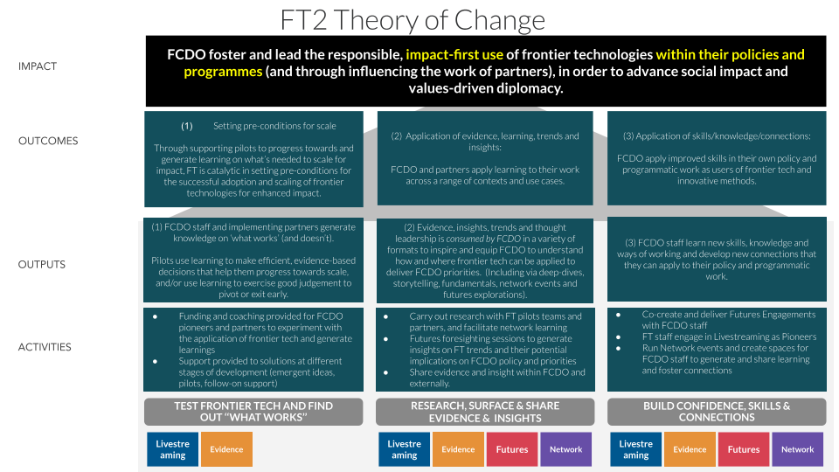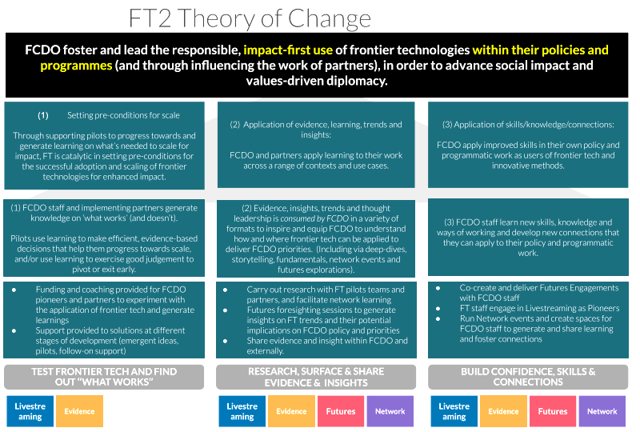

Describe where the programme is on/off track to contribute to the expected outcomes and impact. What action is planned in the year ahead?
Indicator | Milestones  (Apr 23 - Mar 24) | Progress
Impact
Percentage of pilots which achieve a ‘high’ score (60%+) against our scorecard which considers factors relating to the delivery of high-value learning | 70% | Exceeded: 87%. 7 out of 8 pilots that completed their initial pilot phase this year received a ‘high’ score
Outcome 1
Number of technologies, new processes and services, and new business models:  a) developed  b) scaled-up directly or indirectly or supported for scale-up | a) 10  b) 2 | Partially met:  a) 8  b) 2
Outcome 2
Additional investment leveraged to support technological innovations and business models from either FCDO teams or external partners | £500,000 | Exceeded: £15.33 million – including £98,000 in external co-investment for active FT pilots and £15.25 million in external follow-on investment received by 2 former FT pilots
Outcome 3
Number of changes in policy (internal or external) as a result of programme activities, or cases where the programme supports the creation of a more enabling policy environment | 2 | Exceeded: 3 (see notes below for detail)
Outcome Indicator 4
Number of FCDO staff with increased tech knowledge and improved skills in applying innovative methods | 17 | Exceeded: 20 new FCDO staff members engaged in the programme as Pioneers

Impact:
Recognising that pilots are explorations of very early-stage ideas, and that the aspirational social impact is likely to occur years later, the indicator of final ‘pilot score’ has been used as a proxy for impact. On this basis, the programme is achieving good results with higher pilot scores than targeted. However, as noted in the section above, this is a very loose proxy. Going forwards, this indicator will be replaced with a much tighter indicator to measure the number of people reached with access to life-improving technologies/solutions. This will be through both alumni outreach to understand how pilots go on to impact people, and through developing a mechanism to predict Social Return on Investment (SROI) based on existing work.

FT2 Outcome (1): Set pre-conditions for scale (including testing new ideas)
The FT2 Livestreaming programme is successfully testing and developing new tech-driven solutions to global challenges. Seven of the eight Call 7 pilots (launched in 2022) that have finished this year have developed new technologies or business models as well as one Call 6 pilot that used its follow-on-funding to develop an online tool to support Medical Drones in Nepal. This number of technologies developed (8) is slightly below the target (10) due to ongoing work of 6 other Call 7 pilots which are expected to have developed their new technology solutions within the first six months of FY 24/25.
Two former pilots have demonstrated the value of their solutions by scaling outside the FT programme. The De-duplicating aid to enhance the impact of the humanitarian assistance platform was adopted by one of the leading humanitarian agencies in Nigeria. Kijenzi, who were supported by the FT Hub to develop a 3D manufacturing hub in Kenya, have since scaled their operations to become the largest digital manufacturer in the region, having now manufactured over 100,000 units, including products for low-income farmers in Kenya, eye care parts for a Japanese firm, and custom orthotics as part of a trial with CURE International. Kijenzi also achieved their first net profit quarter.
Ongoing projects show high potential for scaling, garnering strong local ecosystem buy-in. The Early Warning Forest Fire Detection System in Pakistan (see Case Study 1) has received commitments from both government and local community stakeholders to continue beyond the lifetime of the pilot. The Smart Geoseals to Track Delivery of Humanitarian Aid (see Case Study 2) partnered with UNICEF and UNWFP in Ethiopia to trial real-time tracking of medical supplies. The Geoseals team have received FT follow-on-funding to transition from a pilot to scale as part of FCDO Ethiopia’s EC2R humanitarian programme.
Further indication of the programme’s success in setting up ideas for scale is in the external finance leveraged. This year, FT Hub partners past and present leveraged at least £15.35 million in additional funding to support solutions developed through the programme. £98,000 was raised in co-investment from grantees undertaking pilots, £15 million was raised in equity funding by Ampersand (pilot link) to ramp up electric motorcycles in Rwanda and Jokosun received £150,000 to continue developing and testing retrofitted electric motors for water transport in Senegal.

FT2 Outcome (2): Application of evidence and learning to inform FCDO and partners’ work
The FT Hub has continued to produce high levels of in-depth evidence through research and learning outputs. The Hub was also more active in disseminating this learning both within FCDO and among other relevant actors.
87% of Call 7 pilots that finished this year received ‘high’ scores compared to 83% last year and a target of 70%. This shows that almost all FT pilots are committing to a learning mindset and generating and disseminating evidence. This finding is backed up by the Independent Evaluation which found that there was wide agreement across stakeholders that learning and evidence generation is a priority for FT Livestreaming but different views about what it should look like and how it should be used and disseminated. Evidence generated focuses on both potential value and viability of their innovation for social impact, and considerations for implementation. Dissemination both informs stakeholders and increases potential buy-in. However, the evaluation also found that while 80% of pioneer survey respondents thought their pilot had done a good job of capturing useful lessons, almost a third (29%) seems to have no knowledge about which audiences lessons had been shared with – this highlights the need for clarity about the purposes of and audiences for evidence and learning to define objectives and focus effort accordingly. Focusing on pioneers themselves, 69% of survey respondents stated that they had applied (or intended to apply) their learning, knowledge and understanding from their pilot to their programme, policy or diplomatic work.
Key dissemination highlights include:
- The ARVR for Conflict-Related Sexual Violence (CRSV) Accountability pilot team shared a prototype of their virtual reality tool at the International Criminal Court (ICC) All State's Parties conference. This generated valuable stakeholder sensitisation and feedback.
- The AI for WASH Asset Management in Nepal pilot co-presented at a national conference with the Nepalese Department of Water Supply and Sewerage Management. The team has secured buy-in to trial the solution with government officials with a view to longer-term government ownership.
- The Using Climate Change Scenarios to Inform Community-Based Adaptation and Planning in Nepal pilot team presented their use of mural art for dissemination of flood risks to local community members at COP 28 and won a ‘Knowledge into use award’ from the Global Resilience Partnership.
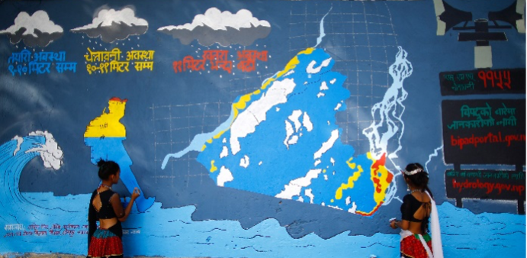

Flood Risk Murals being painted at a school in Rajapur, Nepal - The FT pilot experimented with murals as a means of communicating data on flood risks derived from a range of monitoring technologies (IoT Sensors, satellites, etc).

There are 4 instances where programme activities have resulted in ecosystem strengthening, changes in policy (internal or external) or supported the creation of a more enabling policy environment. The FT-supported the Wakanda Beyond UAV Peer Action Group (PAG) which has worked with multiple African Civil Aviation Authorities (CAAs) to share insights to improve the regulatory environment for drones and the technology required. For example, one country evolved their regulations around the mandatory use of drone corridors for drone testing, while another CAA introduced regulations mandating the use of digital services for improved registration of drones, flight planning and flight tracking. While these developments are not necessarily entirely attributable to the PAG, participants at UAV PAG convenings all agreed that engaging in peer learning shaped and informed their work – see Case Study 3 for more detail. Using Climate Change Scenarios to Inform Community-Based Adaptation and Planning in Nepal supported local governments in Bhotekhosi and Rajapur municipalities to make more informed policy and budget decisions by using the BIPAD portal – a digital Disaster Information Management System containing data relating to natural disasters like landslides and floods. Following the AR/VR for CRSV Accountability pilot’s engagement with other humanitarian innovation organisations, a VR and Gender-Based Violence (GBV) community of practice was set up.
The Hub has continued to work with the FCDO East Africa Research and Innovation Hub (EARIH) and Kenya National Innovation Agency (KeNIA) to use Futures and Foresighting methods to support the development of Kenya’s National Innovation Master Plan, launched by President Ruto in December 2023 and sighted as an integral component of the national development strategy.
Evidence generated through the programme has been shared within FCDO. The FT Hub ran multiple events to translate pilot learnings into lessons and guidance for staff, including sessions on AI-based pilots and IoT sensors, co-hosted with GSMA's Mobile for Development Programme. The FT Hub Network held around 20 events, including "Show and Tells," averaging 41 attendees at each.

FT2 Outcome (3): Application of new skills/knowledge/connections to inform policy and programmatic work
Twenty FCDO staff became new Pioneers in 2023/24 (running FT pilots) and are receiving coaching and hands-on experience with frontier technologies, applying lean and agile work methods. The FT Network's 'Launchpad' events facilitated knowledge sharing, with 80% of Call 8 Pioneers attending at least one session and 30% attending half or more. The FT Hub Network grew by over 80% in the last year, reaching 304 members across 50 countries.
Feedback from surveyed pioneers indicates that 90% (10 of 11 respondents) believed that participating in a frontier technologies pilot has helped them to improve their skills in innovation methods and knowledge of frontier technologies respectively, with one Pioneer stating that: "The programme has given tremendous benefit to improving my skill sets in agile learning, monitoring & evaluation, and design-thinking."
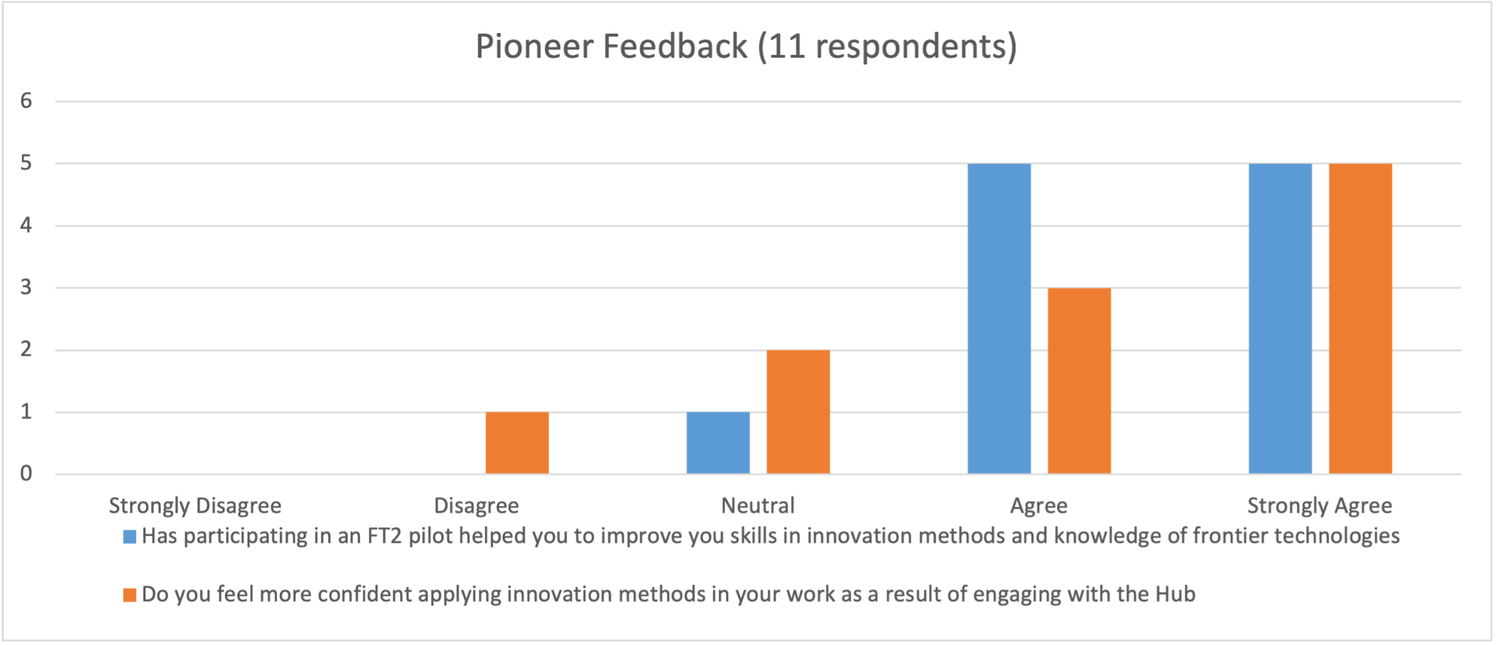
73% (8 of 11) of Pioneers surveyed felt more confident applying innovation methods in their work because of engaging with the Hub. As one Pioneer stated: “Working with the FT Hub has made me more comfortable with the intersect between policy and technology, and I have proactively reached out to explore if AI could support my team's work…The outcome is that the team is encouraged to think about how new tech can support our ways of working.’’
50% (3 of 6) of pioneers who responded to the follow-up survey after completing their pilot have already applied what they have learned to their own work, while others identified plans to do so. One Pioneer stated: ‘‘the project has been an eye-opening experience regarding how many [healthcare] challenges that we address locally can have pivotal effects when putting technology in the equation. It has opened many important conversations with local stakeholders as well as changed the mindset of our team, which I think is incredibly valuable. As for the sprints, I found the methodology to be game-changing in terms of projects/priorities management. I will implement it to track our advance in several areas.’’
These findings are supported by the Independent Evaluation findings. Its pioneer survey found that the pilot process appears to significantly improve most pioneers’ knowledge, understanding skills: 90% of survey respondents thought that their knowledge and understanding had improved by the end of the pilot, with 52% of respondents reporting a substantial increase (of two scale points or more) with 65% claimed improved experience with innovation pathways, 41% experience of development innovation on the ground, 38% engagement with a wider ecosystem of actors and 35% new ways of thinking in approaching development challenges. Almost all respondents (92%) reported that they had applied or intended to apply their improved knowledge, understanding or skills, principally by sharing knowledge with FCDO colleagues (77%) or by applying learning to programs, policy or diplomatic work (69%). But respondents also indicated that certain types of learning (e.g., lean/agile methods, sprinting) are more difficult to apply due to FCDO organisational factors.
The evaluation’s organisational design assessment also found that the original vision for learning from pilots to complement pioneer’s broader programme work at FCDO has only happened in an ad hoc, rather than an intentional, way. AR2024 Recommendation 1 there is a clear need to be more intentional about finding ways to transfer learning from pilots to strengthen programmatic and policy work. The FT Hub’s new ‘Demand-Led’ work (described in the Description of Programme section above) has got most traction where it has engaged directly with a large FCDO programme and dedicated innovation country network – this work needs to be further developed including in the next phase of work (FT3).

Justify whether the programme should continue, based on its own merits and in the context of the wider portfolio
The 2024 Independent Evaluation explored the value of the FT Livestreaming component of the programme. As the largest component (>half the funding), these findings are an important endorsement of some of the programme’s value across a number of areas: as a stand-alone initiative; as a key part of the TIU portfolio; and as part of the FCDO’s broader strategy to support staff to innovate and embrace new and emerging technologies in their work. The evaluation conclusions were:
“The evaluation findings demonstrate that FT Livestreaming is a unique programme which is important to FCDO: it gives valuable hands on experience and opportunities to learn to pioneers who understand problems and are given opportunity to test creative and cutting edge solutions to them; it creates a safe space for failure in an organisational culture which is often risk averse; and it is well aligned to FCDO and wider Government strategic priorities for technology up-skilling and application.”
“Looking beyond FCDO, FT Livestreaming strengthens technology partners; starts to move many innovative solutions to development challenges along the innovation pathway towards scaling and sustainability; and generates practical evidence of technology in applied contexts.”
The other components of the programme similarly demonstrate value to the FCDO and wider innovation and development community as evidenced by the other AR findings and the collection of examples and case studies described through this review.

C. DETAILED OUTPUT SCORING
The FT2 and IDIA strands of work are captured under I2I Output 4 – Frontier Technologies 2. The other Outputs (1-3 and 5) have been retired as their corresponding work strands have finished. FT2 Outputs 4.1 to 4.5 correspond with the 5 strands of the programme work, as outlined in the Description of programme section above.

Output Title | Frontier Technologies 2 - Livestreaming
Output number |  | 4.1 | Output Score | A
Impact weighting (%): |  | 75% | Weighting revised since last AR? | N/A

Indicator(s) | Milestone(s) for this review | Progress
a) Number of pilots supported using lean impact sprints | 9 | Exceeded: 10 (8 Pilots and 2 Discoveries which subsequently graduated to pilot status)
b) Number of pilots awarded follow-on scaling support | 4 | Met: 4
c) Number of applications received | 75 | Not met: 56 eligible applications received for Call 8

Briefly describe the output’s activities and provide supporting narrative for the score
New pilots: In the reporting year up to May 2024, the FT Hub ran its 8th call and received 56 eligible applications from across 25 countries - including some country offices that have not previously applied (Brazil, Costa Rica, Thailand, Fiji, Mauritania, USA, South Korea). A key theme across applications was AI, with 29% (16) of applications incorporating an AI element. Following the application process 10 projects were awarded funding and were supported to pilot innovations, with eight Pilots and two Discoveries commencing work within 2023/24. In addition to supporting new grantees and awarding follow-on funding, Livestreaming continued its support for 12 ongoing projects from previous calls.
Non-ODA pilots with FCDO as the primary user: This year the Hub received applications for the development and testing of innovative solutions that support FCDO staff with their own work. Applications with an ‘internal’ FCDO focus were generally strong and four new ideas were selected. The FT Hub helped to identify relevant technical and subject matter experts within FCDO to support the progress of each pilot, and help teams identify key questions for exploration. This initiative has been an opportunity for the FT Hub to build its profile within FCDO and work collaboratively with both the new FCDOx department and the FCDO’s Centre for Data and Analysis (CFDA).
Follow-on funding and support: The Hub continued its commitment to provide follow-on support to promising pilot innovations assisting them in taking the next step towards scaling their solutions. Seven applications were received for additional funding within FY 23/24, of which four were awarded funding. While the specific scope and required support varied, all grantees used the funding to develop and test business and operating models. The pilots receiving additional follow-on-funding are: Elek Tey, Early Warning Forest Fire Detection System, VR/AR in Conflict-Related Sexual Violence Accountability and Flying Medicines Over Mountains in the Nepali Health System.
Portfolio Highlights 1 - Effective ecosystem engagement by pilot teams: 66% of technical partners surveyed by the Hub found that working with the programme had enabled them to effectively engage with key stakeholders to influence their knowledge, understanding and adoption of their innovation. This engagement is critical to longer term engagement.
The Integrating AI Into the Asset Management of Rural Water Supply Schemes in Nepal pilot regularly engages stakeholders within Nepal's Department of Water Supply and Sewerage Management (DWSS), including the NWASH team.

Turning Drylands Into Global Carbon Sinks in Senegal has engaged with multilaterals, NGOs and technologists, including the World Food Programme, COP Desertification, ICRAF World Agroforestry, Tree aid, Cross-boundary, 1 Trillion Trees (1t.org) and Boomitra, to develop a collective learning space for understanding effective approaches to deliver and measure carbon sequestration in dryland environments.
The eTriage for Social Inclusion pilot in the Philippines is developing a digital solution to help social health programmes better identify vulnerable patients and improve their care. The team from Ateneo de Manila University partnered with Pasig City's health department, testing the solution in clinics and hospitals. Health officials have been advising the pilot from the start, with MoUs and ongoing communication to ensure it meets their needs. The new digital features and workflows are now being implemented in health facilities across Pasig City.

Describe any changes to this output during the past year, and any planned changes as a result of this review
Updates to the pilot methodology - Sprint 0: To help teams better understand the problem and use case they are trying to solve, and make evidence-informed decisions earlier in the pilot process, pilots were required to undertake a ‘sprint 0’ which involves:
- Summarise existing evidence and identify knowledge gaps.
- Scope the solution holistically using the FT Hub’s scaling framework ((user needs, technology, business model, impact, etc)
- Develop a learning agenda of questions and assumptions.
- Identify and test the riskiest assumptions first
Coaching methodology has been refined to encourage progress reviews against the scaling framework, focusing particularly on testing stakeholder engagement and viable business models – see Portfolio Highlights 2 below. Pilots are also contractually required to share more detailed findings from individual experiments, including on methodology used and data generated.
The Hub extended its Call process to include ideas to support internal FCDO operational delivery. Due to tighter governance and security constraints, this has required running pilots through a separate internal FCDO procurement process with some additional burden falling on the pioneer as well as the I2I SRO and PRO.
Portfolio Highlights 2 - Developing and testing business models: Business models have been highlighted as an area of pilot work that needed strengthening, even at quite an early stage, in order to effectively learn about the potential viability of the idea and identify barriers to scale. All Follow-on-Fund grants focussed in part on developing and testing business models.
Harnessing Sensor Technologies to Improve Beekeeping Productivity in South Africa developed a business model for scaling IoT sensors for hive monitoring through market research and beekeeper surveys. The team found it economically viable for commercial enterprises but not for low-income beekeepers.
Bioplastic Future: Using Bioplastics to Transform Domestic Plastic Production in Nepal developed and tested different business models at a very early stage of the pilot for producing sustainable bioplastics. Technical work involved retrofitting non bioplastic machinery and market research and customer engagement to explore likely costs and revenue. This helped the pilot to quickly establish approaches to scaling bioplastic production in Nepal that are unlikely to work - namely retrofitting existing legacy machinery.
Testing the Production of Hydroponic Fodder for Cattle validated the potential of hydroponic fodder to increase milk yields for farmers supplying dairy farms. The pilot identified business models with potential to recover investment within 12-36 months, but further stakeholder engagement is needed.

Progress on recommendations from the previous AR (if completed), lessons learned this year and recommendations for the year ahead
AR2023 Recommendation 3: The number of FT Livestreaming (pilots) applications peaked in 2021 as shown in the graph below. To understand if this represents a dropping of demand, the Independent Evaluation surveyed a number of people who showed an interest in the FT Livestreaming work but did not apply. Findings suggest that there is still a significant audience to tap into for pilot ideas, but there are reasons why people are not submitting applications, including a lack of time to develop ideas. These recent findings will be built upon by the FT Hub who have plans to conduct a survey and some targeted outreach to pioneers and applicants. Going forwards, these findings will inform a strategy to support staff, who have a problem or solution, to develop their ideas. To increase the supply of pilot ideas, the next phase of the programme (FT3) is also anticipating generating pilot ideas from other strands of work such as direct engagement with FCDO programmes looking to better harness tech for impact.

Figure 1. Graph of FT Livestreaming applicants per call.
AR2023 Recommendation 4: The objectives and impact of the non-ODA internally facing pilots have not aligned clearly with the existing development-focused Theory of Change and Logframe. The FT MEL team has widened the relevance of the programme’s intended outcomes and impact, as well as the indicators used to measure these, so that they are more applicable to more recent non-ODA work.
AR2023 Recommendation 5: After some Call 8 ‘Discovery Phase’ pilots deviated significantly from the scope that was agreed during the Dragons Den selection, the FT Hub have worked to revise the methodology for the Discovery Phase to spend more time exploring and understanding the problem that the proposed solution aims to solve – this aims to help those Discovery Phase pilots achieve more focused exploration.
AR2023 Recommendation 6: To improve the relevance of pilot findings, the FT Hub has developed new tools and mechanisms for ensuring pilots generate and share more robust technical data, with clear consideration of the target audience. As part of the new Pilot Advisory Board (PAB) and quarterly Portfolio Committee (PC) meetings there is a mechanism to review evidence and data after each sprint cycle.
AR2023 Recommendation 7: There has been a degree of confusion over the role, expectations and minimum level of engagement for an FCDO Livestreaming Pioneer. While requiring a strong pioneer commitment may deter some busy staff, pioneers are a key touchpoint for the FT Hub to influence FCDO staff and are important facilitators and champions for most pilots. To understand pioneer perspectives, the Hub is capturing feedback from Pioneers. This will complement findings from the external evaluation and ideally identify some actionable insights to improve pioneer engagement and better set up front expectations.
AR2023 Recommendation 8: To ensure coaches can receive and act on constructive feedback and are accountable, the FT Hub has introduced mechanisms to collect feedback and share with coaches, PABs and quarterly PC meetings.
Pilot Lesson - Gender, Disability and Social Inclusion: The Independent Evaluation found that the Livestreaming component has paid very little attention to gender equality, disability and social inclusion (GEDSI). AR2024 Recommendation 2: This is an avoidable weakness that will be addressed in future programme design and implementation.
Follow on Fund Lesson – More flexibility in ticket size: While the target grant for follow-on-fund applicants has been £40k over 9 months, the Geoseals pilot is an example where this limit did not fit the compelling need. Instead of using FoF funding to explore additional investment options, the Geoseals project is set to scale in FCDO Ethiopia’s EC2R humanitarian project. But to achieve this, there are further technical developments and assurances it needs to provide that require double the typical amount. AR2024 Recommendation 3: The FoF should have more flexibility with how funds are allocated based on need as agreed by the FoF assessment group.
Follow on Fund Lesson – Pipeline partnerships with external funders: The FoF aims to take pilots that have reached proof of concepts and help sell the ideas to other investment opportunities. Building on the work the programme also does with other donors through the International Development Innovation Alliance (IDIA), the FT Hub’s FoF team recognise the potential to feed FT pilots into other agencies’ pipelines of projects for funding. AR2024 Recommendation 4: The FT Hub should be given additional FT Hub staff resource to allow it to build relationships with key transitional funders that would potentially be interested in funding FoF pilots.
Follow on Fund/Pilot Lesson - Transitioning Pilots to the Follow-on Fund: Pilots are not always aware of the FoF offer or clear on what the key eligibility criteria are for accessing the FoF. AR2024 Recommendation 5: The FT Hub should ensure that coaches are routinely communicating the FoF opportunity and application process to pilots; and that coaches are aware of the eligibility criteria
Follow on Fund/Pilot Lesson - Providing Technical Assistance (TA) alongside grant funding: As well as the funding, pilots need targeted Technical Assistance that is less to do with the technology and more to do with exploring investment and scaling opportunities, e.g. by developing a robust business model. AR2024 Recommendation 6: The FT Hub should provide i) expertise that does not currently exist within the pilot team; ii) expertise that the pilot implementers cannot currently afford; and/or iii) an external perspective on how they can continue to grow and develop their business

Output Title | Frontier Technologies 2 – Evidence
Output number |  | 4.2 | Output Score | A++
Impact weighting (%): |  | 10% | Weighting revised since last AR? | NA

Indicator(s) | Milestone(s) for this review | Progress
c) Number of lighter touch outputs (e.g. blog posts) sharing emergent learning and insights from FT Pilots and activities | c) 30 | Substantially Exceeded: 58
d) Number of research outputs delivered sharing in-depth evidence and insights from FT Pilots and activities | d) 6 | Exceeded: 8
e) Number of visits to FT website where evidence and learning outputs are housed | e) 1,000 | Substantially Exceeded: 2,830

Briefly describe the output’s activities and provide supporting narrative for the score
The Evidence strand has three core aims: sharing emergent learning from the Livestreaming portfolio, generating easy-to-digest in-depth evidence, and disseminating this evidence within FCDO and to wider stakeholders.
Sharing Pilot Learning: This year, 58 outputs were delivered, including 44 blog posts and 11 detailed pilot completion reports. The end-of-pilot report format was updated for more technical detail. Pilots were supported to experiment with the production of light-touch video content, resulting in 3 pilots producing short videos to showcase their work.
In-depth Evidence Generation: Eight research outputs were produced to share more in-depth evidence and insights from across FT pilots. These include learning on: blockchain innovations, IoT sensors pilots, and two in-depth videos from pilots. Work is ongoing to finalise a further output on pilots which have tested solutions for accessing the voluntary carbon market, and an AI learning module which explains key concepts around AI for FCDO staff, drawing on FT Hub case studies. New partnerships with academic institutions like UCL and Climate Collective were formed to produce in-depth evidence with a view to formally publishing results. Additional outputs include a white paper on hydroponic fodder and two published journal articles on machine learning to assist black soldier fly farming and an assessment of the effectiveness and acceptability of a sexual and reproductive health and rights (SRHR) chatbot.
Increased Dissemination and Engagement: Deep Dive reports received over 2,830 views, doubling last year's traffic. The Hub ran well-received webinars for FCDO staff on IoT sensors and AI innovations, each attracting close to 100 participants, with the IoT webinar receiving a positive comments from RED’s Chief Scientific Advisor.

Describe any changes to this output during the past year, and any planned changes as a result of this review
This year the Evidence Team updated the approach and format for end of pilot reporting and introduced new tools and requirements for pilots to generate and share in-depth data and findings from pilot experiments. The goal of these changes is to enable greater transparency on the results of individual pilots and ensure that evidence outputs from pilots meet the needs of external audiences who may be interested in further supporting a pilot’s work, replicating the proposed solution, or more generally learning from the pilot’s work.

Progress on recommendations from the previous AR (if completed), lessons learned this year and recommendations for the year ahead
AR2023 Recommendation 9: recognised that, in the process of scoping and designing future Deep Dives, an FCDO champion should be nominated as early as possible to inform the scope based on FCDO’s global needs for evidence, and to intentionally identify and connect with key audiences and networks within FCDO to ensure there is strong demand, engagement and uptake of the final outputs. This is now being done.
Evidence Learning - inconsistencies in pilot evidence: After improvements last year, pilots are now producing more in-depth pilot reporting. However, some pilots focus on technical issues without due consideration for the wider context or whether the riskiest assumptions are being prioritised and tested first. AR2024 Recommendation 7: The evidence team should support Livestreaming to bring in additional quality assurance mechanisms. This includes regular pilot evidence reviews, which feed into the newly created Pilot Advisory Boards. This will ensure that pilots are generating and sharing meaningful data and insights from pilot experiments, draw appropriate conclusions from experimentation, and encourage experiments on the most critical assumptions for testing first.

Output Title | Frontier Technologies 2 - Futures
Output number |  | 4.3 | Output Score | N/A
Impact weighting (%): |  | 0% (no targets set – see explanation below) | Weighting revised since last AR? | N/A

Indicator(s) | Milestone(s) for this review
a) Number of Futures sessions run (including e-Futures) | No targets set for 2022/23, given the uncertain allocation of resources and therefore results expected to be achieved on this strand.
b) Number of FCDO staff attending multiple Futures sessions
c) Number of different FCDO teams attending Futures sessions

Briefly describe the output’s activities and provide supporting narrative for the score
This year, the FT Futures workstream completed three major activities: wrapping up the Web 3 symposium, completing the Future of Frontier Tech in Development exploration, and completing the engagement with Kenya National Innovation Agency (KeNIA).
Web 3: Following the Web 3 symposium in 2022/23, the team held an internal round table event with the FCDO in April 2024 to discuss the global research findings and future directions. While a concept note was created to capture and present potential for further experimental work, the research findings suggested that many of the benefits anticipated by Web 3 technologies can be achieved with other existing technologies. As such, the concept was not taken further.
Future of Frontier Tech for Development: In 2023, the team completed an exploration of the Future of Frontier Tech for Development. This showcases the FT Futures SCAN method (surface, cluster, add, network) for exploring future scenarios and covered EdTech (education), DemTech (democracy), AgriTech, MedTech, and GovTech. The team developed use cases and speculative scenarios, highlighting risks and actions for development practitioners. Unfortunately the research activities themselves struggled to generate FCDO engagement and input, so the FT Hub successfully used alternative formats to disseminate findings, including a 20-minute summary video, a blog post, and a DevTech talk, reaching over 115 FCDO attendees. They also shared insights at the Global Digital Development Forum and developed a method handbook. These efforts informed the strategic direction for the next fiscal year.
Futures highlight: Application of Futures and Foresighting methods to Kenya’s Innovation Master Plan:
At the request of the East Africa Research and Innovation Hub (EARIH) at the British High Commission in Nairobi, the FT Hub worked with the Kenya National Innovation Agency (KeNIA) to develop a 10-year ‘masterplan’ for Kenya’s innovation sector. The FT Hub utilised foresighting methods in a consultative process to help move beyond the immediate political priorities and ‘buzz’ around innovation driven by the new government, to develop a masterplan that would respond to immediate priorities while still being fit for purpose in 10 years’ time.
The result of this support was two core documents: 1) a visionary masterplan; 2) a shorter stakeholder engagement document. Shared with the KeNIA board, the masterplan was launched by President Ruto in December 2023, who identified innovation as a key element of the national economic development plan and with the masterplan cited as an integral component of the national development strategy and a flagship endeavour. This initiative aims to unite Kenya around a long-term vision for innovation, making it a national artefact owned by the people.
Foresighting methods were shown to be a valuable addition to a government’s policy development toolkit. Here it played a significant part in looking back at how far innovation had progressed on a national level to inform a new way forward.
Designed as a ‘blueprint’, this pilot provides resources that could easily be applied in other similar contexts as well as evidence of the value of this offer for developing bilateral relationships. This groundbreaking pilot marked the first time the Futures methodology had been applied to an external team arising from an FCDO-identified need.
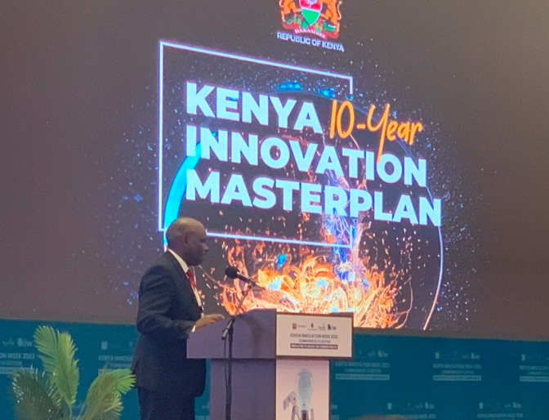
Launch of the masterplan at Kenya Innovation Week

Describe any changes to this output during the past year, and any planned changes as a result of this review
The Futures workstream took a more modular approach this year than in previous years, exploring how the Futures method could be adapted and applied to meet the different needs arising from both FCDO and external stakeholders.
Building flexibility into the offer and using the tailored SCAN approach allowed the team to respond more readily to FCDO needs, especially when time and resources were limited. Both Web 3 and the Kenya Innovation Master Plan demonstrated how connecting FCDO to the broader ecosystem can be useful in generating impact and increasing engagement, particularly when compared to the efforts of the ‘Future of’ series to achieve the same.
The insights from the three engagements conducted in 23/24 have informed the development of a new strategy for 24/25 which focuses explicitly on the application of Futures and foresighting methods ‘in context’ - moving away from the online format of delivery to apply methods to a specified need. In the coming year (FY 24/25), FT Futures will conduct two activities to test this approach to understand how Futures methods might be applied as part of a toolkit to support FCDO’s role in shaping the direction of technological trends:
- Application of Futures methods to fast-paced tech development: A series of interactive engagements (i.e. storytelling, visualisation, immersion) that bring to life the impact of fast-paced technology on our daily lives and how participants can map out potential benefits, opportunities, risks, unintended consequences and actions they can take today to mitigate them. The aim is to reduce the barrier to entry and the overwhelm that surrounds a 'new' technology. AI will be the focus for the pilot of this approach.
- Application of Futures methods to developing tech ecosystems: Supporting FCDO to understand different Futures methods that are available to them and their role in addressing a tangible problem. We want to build FCDO staff confidence and encourage them to apply these methods to complement the work they are doing to shape the responsible use of tech and realise the economic and societal benefits tech can bring as well as protecting against known harms.

Progress on recommendations from the previous AR (if completed), lessons learned this year and recommendations for the year ahead
AR2023 Recommendation 10: To better understand the usefulness of Futures work, the Hub are exploring ways to include a metric on the usefulness of sessions based on a feedback survey or similar. This work is ongoing as it was wrapped into the theory of change and logframe indicator revision for FY 24/25. However, given that the ‘Futures of…’ exploration series was stopped due to the lack of engagement by FCDO, this is clearly an important area to explore. In the next year, the Futures team is going to see whether a ‘show not tell’ method is more useful than a series of facilitated engagements.
AR2023 Recommendation 11: The FCDO and Hub have reflected on the value of the depth vs breadth of FCDO engagement, and whether trying to appeal to a broad FCDO audience makes gaining meaningful traction difficult. Pre-COVID, the Futures workstream provided week-long immersive tech and innovation experiences for FCDO country posts. However, this approach took a lot of resource and struggled to maintain any long-term change after the event. The KeNIA Futures work described above is a successful example of deep country engagement but grounded in a specific task. As a result, for the next year, and going into FT3, Futures will explore how it can engage more deeply with FCDO programmes and country office networks, with a focus on informing new business cases.
AR2023 Recommendation 13: Given the success of the KeNIA work, FCDO and the FT Hub have considered whether this was a one-off opportunity or whether it could be impactfully replicated in other countries. The work was designed to test and understand how a toolkit designed for one government might be adapted and applied to another which could be used as a blueprint for later engagements. The Hub is engaging with the EARIH and SIN network to explore additional opportunities.

Output Title | Frontier Technologies 2 – Network and Stories
Output number |  | 4.4 | Output Score | A
Impact weighting (%): |  | 10% | Weighting revised since last AR? | N/A

Indicator(s) | Milestone(s) for this review | Progress
a) Average click-through rate on FT Newsletter (through which evidence and learning is disseminated to FCDO) | a) 7%  (Industry average is ~5-7%) | Not met: 4.5%
b) Number of FCDO Pioneer Community Events | b) 4 | Exceeded: 6 (Launchpad)
c) Average % of current FT pioneers attending FCDO Pioneer Community Events | c) Target still to be added | 82%

Briefly describe the output’s activities and provide supporting narrative for the score
This year, the FT Hub’s Network and Storytelling workstream formalised its offer to influence, engage, and upskill key stakeholders on responsible innovation and frontier technologies by creating engaging content, building networks & audiences, and sharing FT Hub content in a range of tailored ways. The workstream shares FT Hub news, opportunities, stories, and evidence via a monthly newsletter and social media, organised events like the Livestreaming Call launch events and as well as Show & Tells, managed the FT Hub website, and launched the Launchpad series to connect and upskill Call 8 Pioneers and partners.
Ecosystem Strengthening: The FT Hub Network grew by over 80% to 362 members across 50+ countries, with balanced membership between FCDO staff and external contacts. LinkedIn followers increased by 400% to 921, leading to over 24k post impressions and 886 website clicks. Tailored outreach to FCDO cadres using surveys helped understand network member interests – batteries, big data, and solar are some of the top tech interests of the year. This outreach built audiences for FT Hub work and informed other workstream priorities. These activities allowed the workstream to serve as the ‘front door’ to the FT Hub.
Pilot Engagement and Capacity Building: The ‘Launchpad’ series of learning events offered a structured content-rich learning journey for pioneers on aspects of pilot development including coaching on lean methodologies, evidence, and storytelling. 80% of Call 8 Pioneers attended at least one session and 30% attended half or more. The workstream supported pilots in storytelling, conducting interviews, and running workshops on audience defining and narrative mapping. Encouraging pilot-generated content increased social media engagement and helped pilots become thought leaders.
Content Production: A new external communications strategy focused on consistency, evergreen content and pilot amplification. The team ran four mini-campaigns (AI Summit, COP28, National Storytelling Week, and Learning-through-Doing) and responded to over 25 production or storytelling support requests, including video production, graphic design, website copy, animations, and 1:1 workshops. They also created new feedback loops with FCDO, starting a biweekly comms update and planner tool.
FT Newsletter: The Hub produces a monthly newsletter sharing news, learning updates, stories, opportunities and event alerts. As per Output indicator a), the average newsletter click-through rate was 4.5% this year, significantly lower than last year’s rate of 12% and below the industry average. This is something that the FT Hub need to understand the significance of and look to increase click-through or find an alternative medium of engagement.
Dissemination and Outreach: The Network and Storytelling team organised around 20 events, including bespoke FT Hub events (60%) like Show & Tell and FCDO features, averaging 41 attendees each. They experimented with internal posting on Viva Engage and rebranded the Hub, redesigning its website for better user experience. This year, they published 45+ blogs, attracted 10,000 unique visitors, and achieved 39,000 page visits, an 85% year-on-year growth rate, with 33% of referrals from the FCDO SharePoint site implying strong internal FCDO interest in content.

Describe any changes to this output during the past year, and any planned changes as a result of this review
One key strategic shift in FT Hub communications and social media work was to encourage and measure pilot-generated content, which the Hub could then amplify. This was to ensure pilots were directly “learning out loud” with their own communities and engaging with the process as the messenger. This helped the FT Hub to reach a wider audience, deliver more authentic content, and set up pilots to be better thought leaders in the long run. This saw a great increase with some months receiving notifications of 10+ pilot-generated posts on social media.

Progress on recommendations from the previous AR (if completed), lessons learned this year and recommendations for the year ahead
AR2023 Recommendation 14: The FT Hub has integrated Network and Stories under a single comms strand of work. This has successfully created efficiencies by linking content production to dissemination and audience management, allowing for curated content for specific audiences as well as accurate management of outputs.
AR2023 Recommendation 15: There is a need to clarify FCDO champions and target audiences before starting work packages. Specifically, it’s important to clarify who the primary and secondary target audiences are for the individual workstreams and their associated outputs, what the purpose/impact of the engagement should be, and the best approach to engage them. While this work is ongoing, it has already been clearly adopted by Hub workstreams. All evidence products, for example, include clearly the defined audience and value expected to be generated for that audience.
AR2023 Recommendation 16: To improve statistics collection and better understand engagement levels, the Network team has shifted to MailChimp which has better engagement statistics. The Network team now has clearer indicators of engagement across website, social media, VE, and pilot-level learning out loud. Additionally, the team will work with the MEL team to conduct targeted learning on FCDO engagement preferences.
AR2023 Recommendation 17: To increase FCDO engagement the Network team have built on the newsletter by publishing it on the website, then diversifying content dissemination via LinkedIn, SharePoint, and FCDO’s internal Viva Engage to build FT Hub awareness. However, there is an increasing proliferation of newsletters being shared by FCDO teams and programmes, including for example by GSMA. AR2024 Recommendation 8: the FT Hub should consider whether there is merit in partnering with other Tech and Innovation Unit programmes to generate a combined newsletter for its FCDO audience, with the rationale that a combined newsletter could be more interesting where separate newsletters will compete.
Network and Stories Learning - Delivering more bespoke events: Featuring in established FCDO calls (e.g., SIN Teach-ins) is high reward, in terms of reaching new people, but bespoke FT events are better for “going deep” on FT content. Implementing partners can be valuable guests who speak with insight and passion. AR2024 Recommendation 9: FT Hub should try connecting its social media, newsletter and events through topic-based cycles that are more likely to resonate with specific audiences, beginning with a humanitarian-focus in September and October.
Network and Stories Learning - Stories are critical for engaging audiences: Having stories available has proven essential for other workstreams when needing accessible and engaging case studies to use in presentations, meetings and initiatives. AR2024 Recommendations 10: Aligning content production and Network activities with upcoming priorities provides VfM and we can use them as an indicator of where the FCDO evidence need is e.g. on particular technology topics, on FT processes, call idea submissions, helpdesk requests, etc.
Output Title | Frontier Technologies 2 – Partnerships
Output number |  | 4.5 | Output Score | A+
Impact weighting (%): |  | 5% | Weighting revised since last AR? | N/A

Indicator(s) | Milestone(s) for this review | Progress
a) Number of external strategic partners engaged to support programme outcomes | a) - | Previous stream of Partnerships work has stopped.
b) Percentage of IDIA principal seats at each meeting represented by at least one principal per organisation | b) 75% | Exceeded: 82%  (Washington DC had 13/14 member agencies represented, Oxford had 10/14 = average of 82%).

Briefly describe the output’s activities and provide supporting narrative for the score
The International Development Innovation Alliance (IDIA) is a collaboration platform that brings together the senior leadership (Principals) from the innovation teams, labs and departments of some of the world's leading development agencies. IDIA is run by a secretariat sitting in the Results for Development organisation (also the FT2 consortium lead).
IDIA Principals’ meetings: IDIA convenes Principals’ meetings four times a year – two in person and two virtually. This year’s events were in Washington DC in October 2023, hosted by USAID, and in Oxford in April 2024, hosted by the Skoll Foundation. All events had strong participation from the majority (average 82%) of the 14 core member agencies, with the Oxford meeting also providing IDIA Principals with in-depth time with senior government innovation leaders from Nigeria, Sierra Leone, Kenya and Ghana. This forum continues to provide FCDO staff with an important opportunity to directly engage with innovation counterparts in other agencies, inform, collaborate in and/or learn from their activities and discuss major topical issues. Personal relationships and engagement developed through IDIA meetings have supported separate FCDO collaboration with GIZ (on Futures work), UNICEF (with particular emphasis on innovation in Ethiopia’s humanitarian programme) and WHO (on Oxygen CoLab).
IDIA joint technical work: IDIA continues to leverage the collaboration of its members to co-produce global evidence pieces and advance member action on key innovation topics. Through a ‘hub (core premise and learning synthesis) and spoke (related work strands)’ model, IDIA is facilitating work across six areas: Innovation Ecosystems; Responsible and Localised Tech; Equity and Innovation; Scaling Innovations; Systems Innovation; and Public Sector Scaling. This year, the FCDO continues to co-chair (with the Netherlands’ Ministry of Foreign Affairs) an IDIA ‘Spoke’ exploring how donors can meaningfully improve their approach to making emerging technology programmes responsible and localised – the work is led by African innovation experts and the outputs will be available by the end of 2024. The Frontier Technologies Hub is well placed to contribute to and benefit from the outputs being delivered through this work. To date, FT Hub members contributed ideas to development of new metrics for monitoring whether innovation programmes are responsible and localised, and the Hub will seek to pilot new metrics once they are available to improve the monitoring of its own portfolio.
The FT Follow-on Fund continues to engage with other IDIA agencies particularly in relation to pipeline-sharing and ensuring pilots/innovations have the opportunity to access further funding opportunities. This includes one-to-one conversations with the Global Innovation Fund, Grand Challenges Canada etc.
IDIA is continuing to evolve the way its platform supports collaboration among its members, and in Q3 2024 will be trialling a new approach enabling members to showcase key programmes (and collaboration opportunities) to each other in more depth. The IDIA Hub meeting in India in November 2024 will be an opportunity for FCDO to share a more detailed overview of the proposed FT3 phase, and to highlight specific areas where the collaboration (financing / participation) of other funders would be beneficial to enhancing FT outcomes. Examples of these potential collaboration touch points include the Follow-on Fund, the Helpdesk and the Futures workstream more broadly.

In 2025, there will also be an opportunity to take high-level learning around the role of frontier tech in development from across the FT programme and feed this into the drafting of an IDIA collective statement on ‘The Next Decade of Innovation’ that is being prepared for launching in conjunction with the Fourth International Conference on Financing for Development in June 2025.

Describe any changes to this output during the past year, and any planned changes as a result of this review
There are no changes to this output based on the past year.

Progress on recommendations from the previous AR (if completed), lessons learned this year and recommendations for the year ahead
AR2023 Recommendation 19: To increase the value of IDIA meetings to FCDO more broadly, the recommendation was for FCDO staff attending in-person IDIA Principals meetings to do two things: 1) offer to colleagues to engage other agencies if useful; and 2) present the learnings back to innovation colleagues after the event in a more robust way. This has happened with the FCDO IDIA lead engaging with senior WHO innovators in Ghana to build connection with the FCDO’s Oxygen CoLab programme who had previously struggled to meaningfully connect. Prior to the Oxford meeting, the FCDO IDIA lead reached out across RED and received an update from FCDO’s humanitarian innovation team that was then relayed to relevant partners in the IDIA meeting ‘newsroom’. However, FCDO still gets limited value from its engagement due to the burden of engagement falling largely on the I2I SRO. It’s important that FCDO’s TIU and wider teams involved in innovation do not conflate IDIA with the I2I/FT programme. IDIA has much broader applicability than simply in the Frontier Technologies space, so has relevance to all innovation programming where partnerships are important. AR2024 Recommendation 11: While efforts have been made to increase wider engagement, including consideration of bringing GSMA in as a new IDIA contributing member, the TIU should take more collective responsibility for engaging with IDIA and encouraging engagement from other parts of the FCDO. This includes wider participation at IDIA meetings (FCDO has 2 seats) – as a start, the RED comms lead and TIU disability champion are both attending the IDIA meeting in November.
Partnership Learning - Targeted collaboration from IDIA principals: FCDO membership of the IDIA Hub continues to generate many different kinds of value, notably in (a) exposing the FCDO team to the tech and innovation strategies and programming of other funders; (b) building relationships with tech and innovation leaders across the Global South (through the IDIA Global Innovation Advisor Network and guests at the Hub meetings, which in April included Innovation Ministers and leaders from Sierra Leone, Ghana, Kenya and Nigeria; (c) collaborating in the development and dissemination of joint outputs, including principles, tools and frameworks that can be directly utilised by wider FCDO staff. However, it would be advantageous to create a more structured approach through which FCDO IDIA Principals can promote and invite targeted collaboration from other IDIA members on different aspects of its work, particularly the FT Hub. AR2024 Recommendation 12: Develop a more structured mechanism for sharing and developing opportunities that link between IDIA and FT Hub, including creating a focal point in FT Hub that can bring learning from both programmes together.

D: VALUE FOR MONEY

Key cost drivers and performance
Key observations on Value for Money (VfM) across the FT Hub portfolio are summarised below according to the FCDO typology of economy, efficiency, effectiveness and equity.
There were efforts made in late 2023/early 2024 to develop a VfM analysis across the FT Hub work. However, while indicative findings could be presented, the scope of this has proved extremely difficult given the breadth of programme activities, flexible remit and difficulty in clearly delineating types of work (e.g. Hub fees to run activities vs management overheads). Further, similar activities, such as pilots, can require very different levels of Hub support, in terms of coaching for example, depending on the experience of the partners and complexity of the pilot technology. However, this analysis sends an important message within the Hub that VfM is important and further efforts will be made to understand it. AR2024 Recommendation 13: the FCDO needs to decide on the level of ongoing VfM analysis warranted for this complex innovation programme. It should then work with the Hub to establish a clear and appropriate framework and criteria for VfM, with the available support and resources to do this properly.
Economy - travel: The programme has continued to manage and monitor pilots via a hybrid approach of online and in-person monitoring and coaching. Travel decreased this financial year (likely due to the backlog of visits needed post-covid, 2022-2023) with expenses accounting for £42,000 compared to £74,000 last year across ODA and Non-ODA. A total of 14 trips were taken by 15 Hub staff to visit 15 pilots. The workstreams have coordinated and consolidated trips where possible and have reported highly cost-effective travel with the cost per pilot/event averaging £3,000 for the 99 days of travel undertaken.
Economy - fee rates: The FT Hub continues to operate under the agreed fee rate caps per role category and is largely meeting the agreed blended average daily rates as anticipated at the beginning of the programme, in spite of significant global inflation. Against the blended average daily rates, the Hub has effectively achieved a net saving of £192,092.

Efficiency / Effectiveness - agility: The FT Hub optimises resource allocation by adjusting effort levels across the consortium in response to evolving strategic priorities, scope requirements, and funding availability. This financial year, the Hub refined its financial processes to incorporate light-touch VfM analysis on key cost drivers within each workstream, resulting in the establishment of benchmarks that will guide future resource management and cost-effectiveness assessments.
Efficiency / Effectiveness - operating in cycles: Managing grants on an annual ‘Call’ basis has allowed for continued efficient onboarding and staged management processes. Grant disbursements have been accelerated to ensure timely wrap up of pilot activities within a 24-month window, with 87% of Call 7 pilot funding being disbursed, which is 10% above the average for all previous calls under the Frontier Tech programme. Meanwhile, Call 8 pilot disbursements have been slightly slower than in previous years in its first six months owing largely to the introduction of the low-cost ‘setup sprint’ - Sprint 0 - and the challenges of navigating complex partnerships and activities across the Non-ODA portfolio.
Efficiency / Effectiveness - standardisation and templates: The Hub makes effort to capture and codify all of its repeatable processes. For example, to support improvements in pilot learning, the Evidence workstream created new slide decks, crash courses, and report templates, starting with the Call 8 pilots. These resources are strategically designed to increase evidence outputs from each of the FT Hubs pilots, ensuring that the workstream's objectives are met effectively. Similarly, Network also created templates, guidelines and resources for blogs, profiles, photo briefs and interviews, to ensure that each of these are created more efficiently and consistently across the Hub.
Equity - project selection: The FT Hub continues to commit to equity throughout the programme. Of all new entities supported by the programme this year with either grant funding, technical assistance or a combination of the two, 60% are local entities, 33% are external, and 7% deliver solutions at a global level. The Livestreaming selection process was enhanced last year for Call 7 to ensure greater equity across all applications, with blind scoring made mandatory for all reviewers and further consistency introduced for the Dragons’ Den pitches. The same process was maintained this year for Call 8, drawing on inputs from reviewers with sector and geographical expertise from across FCDO regional and country offices. In June 2024, FT Hub started to design a project to create a framework on responsible and inclusive technology, to support our pilots to better understand and engage with the use of their technology in a responsible and inclusive way. This work will continue into Q3 2024, and aim to be finalised before the end of year 2024.
Equity - GEDSI: Gender equality, disability equity and social inclusion (GEDSI) considerations are centrally important to innovation and technology. Supporting inclusive innovation and technology is a priority for the FT Hub. However, the independent evaluation of the FT Livestreaming component found it to be almost GEDSI blind. There was very little evidence that inclusion considerations have been integrated into programme design, management structure, processes, activities or objectives. This means the program has not been meeting minimum standards for GEDSI good practice in the DevTech space. AR2024 Recommendation 14: the FCDO needs to decide on the level of ongoing VfM analysis warranted for this complex innovation programme. It should then work with the Hub to establish a clear and appropriate framework and criteria for VfM, with the available support and resources to do this properly.

VfM performance compared to the original VfM proposition in the business case
The programme continues to deliver good VfM through a complementary package of grant support and technical assistance to innovators to test and scale the application of frontier technologies, whilst building the capability of FCDO staff and contributing to the global evidence base on what works. Pilots have generated significant evidence and understanding on the application of technologies which can be applied in other FCDO programmes as well as the wider technology sector.

Assessment of whether the programme continues to represent value for money
Both FT2 and IDIA are unique work strands that provide FCDO with a strong internal offer to test innovative technology. While the outcome and impact of the programme are hard to monetise, the value of the programme has been consistently recognised, including through a Civil Service Award for Innovation in 2017 and ministerial sign-off for scale-up in 2019. The FT Livestreaming has just run its 9th Call for Applications – each year, the FT Hub builds on previous experience and, where possible, continues to strengthen the offer. This gives the FCDO confidence that the programme still represents good value for money.

E: RISK

Overview of risk management
The risk rating for the programme is moderate – no change since last year. The count of risks is shown in the following table.

Risk Count (August 2024) | Minor | Moderate | Major | Severe | Total
Strategy And Context | 1 | 0 | 0 | 0 | 1
Public Service Delivery & Operations | 2 | 4 | 0 | 0 | 6
Financial and Fiduciary | 0 | 2 | 0 | 0 | 2
Policy & Programme Delivery | 21 | 3 | 0 | 0 | 24
Reputational | 4 | 1 | 0 | 0 | 5
Safeguarding | 2 | 2 | 0 | 0 | 4
Total | 30 | 12 | 0 | 0 | 42
Risks for 2023 AR (comparison) | 8 | 15 | 10 | 0 | 33
Recognising that the programme had been carrying 10 major risks from the previous Annual Review, which were outside the FCDO's risk appetite, the SRO, PM, and FT Hub undertook an in-depth risk review during Q2 of FY 24/25. During this process, it was found that the partners were often considering risks from the perspective of an affected individual rather than within the context of a large and varied programme. This misalignment in the risk documentation approach prompted a more focused evaluation to ensure that the identified risks accurately reflected the programme’s context and priorities, allowing for better risk mitigation and management aligned with FCDO standards and expectations. The result of this re-evaluation was the downgrading of a number of major risk to moderate.
The innovative nature of the FT Hub in supporting early-stage innovations/start-ups, many of whom are new partners who’ve not previously worked with the FCDO, means there are inherent risks within the programme. The FT Hub also tests and develops untried solutions in challenging contexts – as such there are more delivery risks than other programmes.
The FT Hub continues to proactively monitor and mitigate the risks throughout the programme and conducts regular risk review meetings in partnership with FCDO where required. An example risk and mitigation are:
- Risk: “Key audiences within FCDO are not receptive to the learning being shared by the FT Hub, reducing the impact of the evidence that is generated”.
- Mitigation: The FT Hub mitigates for this risk in “many ways. (1) Actively scope out potential audiences for different pieces of work ahead of starting them (2) Proactively build networks for learning on specific pilots and from deep dives, (3) Collaborate with FCDO management to understand different Networks within FCDO who would be receptive to Hub learning (4) Gather engagement data for key outputs, such as the newsletter and our website”.
The FT Hub travel policy has been updated through this reporting period. All contract holders are now advised to undertake travel security training for free offered by DT Global prior to deployment. Travel to FCDO- Red and Orange rated locations will not be approved to ensure safety of staff; FT Hub coaches deliver their support remotely if not based in the country of operations (although FT Hub tries to position coaches who are from the country of operations if possible).

F: PROGRAMME MANAGEMENT: DELIVERY, COMMERCIAL & FINANCIAL PERFORMANCE

Summarise the performance of partners and FCDO, notably on commercial and financial issues
The FT Hub continues to provide high-quality quarterly financial and commercial narrative reporting to FCDO, supported by Quarterly Review meetings, in addition to more ‘informal’ updates through FCDO/R4D monthly calls to discuss any rapidly emerging programmatic or financial challenges. The FT Hub continues to respond efficiently to any ad hoc requests/questions from FCDO on financial risks, spend and major activities. FT Hub finances are actively managed by the FT Hub Programme Manager and FT Hub Senior Finance and Operations Manager, in collaboration with the FCDO Programme Manager and SRO. Internal financial operations meetings have moved to a bi-weekly basis to ensure that key staff are up to date with forecasts, spend to date and risk management. R4D continues to operate a monthly invoicing cycle and payment timeframes from FCDO (which were noted as delayed in the previous AR) improved toward the end of FY23/24.
The FT Hub continues to review the central support that is provided across the programme and has agreed with FCDO to bring on additional support in the form of a Deputy Programme Manager. This role supports management and strategic functions, enabling efficiencies across the FT Hub.
The FT Hub has completed work to address AR2023 Recommendation 20. All workstreams now have standardised roadmaps and workplans, which includes sub-activities, costs for each activity and budget analysis. The roadmaps help to visualise the touchpoints between the workstreams as well as deliverables that might support/add value to other workstreams. The Hub has also revamped the monthly workstream meetings to share information, learning and insights, as well as highlight areas for tangible collaboration.
The FT Hub’s continuing proactivity in managing finances has led to improved forecasting and spending against those forecasts, with variance between monthly financial reports against forecast reducing to an average of -2% in this reporting period. Last year the FT Hub reported a total spend against forecast of +3% for the ODA component and -15% for the non-ODA component.
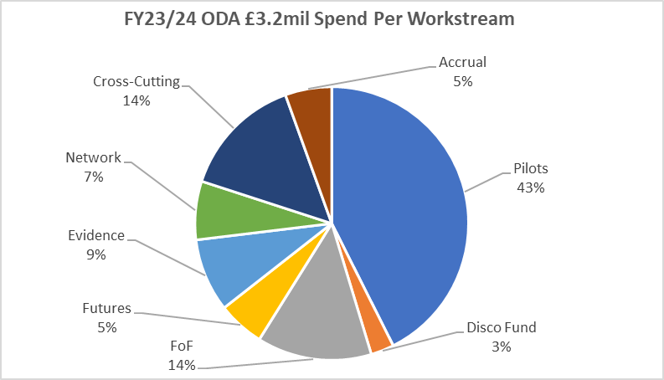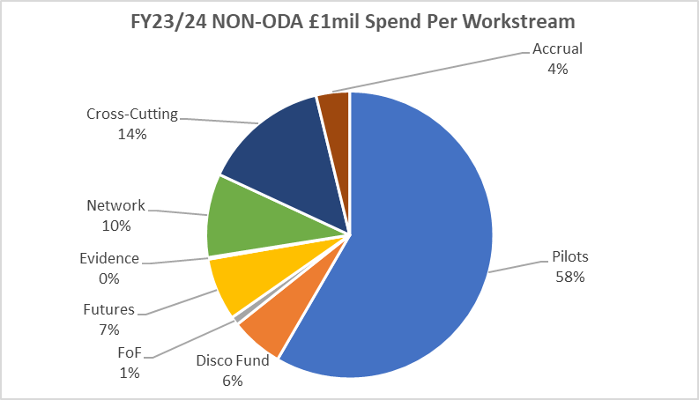
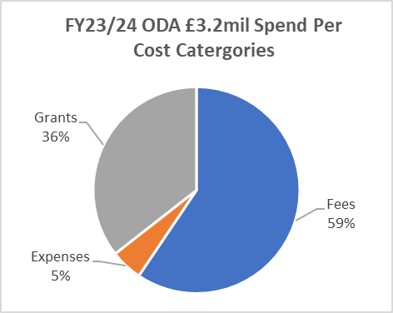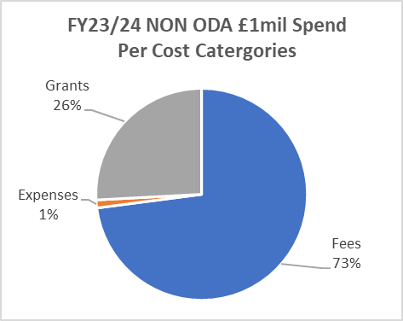
Delivery chain mapping has been maintained on a regular basis and re-submitted to FCDO quarterly, alongside the programme Asset Register and all assets are disposed of in-line with FCDO’s Programme Operating Framework (PrOF). In addition, R4D has continued to submit annual spend data to the International Aid Transparency Initiative.

G: MONITORING, EVIDENCE AND LEARNING

Monitoring and Evaluation
The FT Hub’s Monitoring, Evaluation, and Learning (MEL) team spent FY23/24 updating the programme’s Theory of Change (ToC) and formalising its MEL framework. The MEL framework (to be finalised in FY24/25), includes updated logframe indicators and 'progress' indicators which will streamline data collection, support formative learning and allow better informed management and decision making. Additionally, based on feedback from FCDO, the MEL team set out a plan to learn about FCDO engagement through various FT Hub workstreams in FY24/25.
In FY23/24, the MEL team trialled Pioneer and Partner Feedback Surveys (due at mid and end-points of pilots). The Pioneer Feedback Survey showed strong support for FT’s coaching and lean and agile methodology. Pioneers reported improved innovation skills, knowledge of responsible frontier technologies, and confidence in using tech and innovation in their work. 66% of implementing partners said working with the FT Hub helped them achieve new goals. Suggestions for the Livestreaming portfolio include developing pre-pilot resources (helping pioneers familiarise themselves with lean and agile methodologies), focusing on user-first approaches, and enabling Pioneers to engage colleagues within FCDO for broader support.
This year, the FCDO commissioned an Independent Evaluation of the major FT2 component - FT Livestreaming. The evaluation aimed to get an independent external perspective on, and assessment of, the major pilot programme activities. The evaluation also helped inform the design and implementation of the Livestreaming workstream of the planned follow on programme, ‘FT3’. The evaluation is being conducted by Triple Line between April 2024 and November 2024.

Evidence
This year, the MEL team focused on enhancing the quality and use of evidence at the programme level. They developed a MEL framework and updated logframe indicators to capture more qualitative data in FY24/25. Responding to FCDO feedback from FY22/23, they planned for more substantial data collection at the outcome and impact levels to better understand the results of key activities and outputs.
The 2024 Independent Evaluation of the FT Livestreaming component has provided rich evidence on what is working well in the programme pilots and where improvements can be made. The findings have informed this annual review and the recommendations for improvements throughout.

Learning
The innovation landscape evolves rapidly, making it challenging to stay updated on trends, use cases, safety, ethics, inclusion, and evidence about emerging frontier technologies. The FT MEL team supports the FT Hub, FCDO, and other stakeholders in continuous learning and adaptability. They use existing channels like quarterly and annual reviews and monthly pilot coach forums to reflect on programme-level evidence. The new MEL framework aims to make these reflections more regular and streamlined.
The key challenge identified by the Independent Evaluation for the next phase of the programme is to resolve the ambiguity and lack of consensus about its aims and objectives, and to be able to demonstrate its value, achievements and effectiveness more substantively. Meeting this challenge will help the programme to resolve its inherent tensions, noted across the evaluation, in relation to its purpose, beneficiaries, innovation stage supported, innovation approach, learning aspirations and management. Inclusion must also be strengthened as a priority.

Date of last narrative financial report | 30th September 2023 in respect of R4D Financial year 1st January - 31st December 2022.  Note: The R4D narrative financial report for the year ending 31st December 2023 will be produced and signed off by 30th November 2024. | Date of last audited annual statement | September 2023 in respect of R4D Financial year 1st January - 31st December 2022.  Note: The R4D Financial statements for the year ending 31st December 2023 will be produced and signed off by 30th November 2024.

CASE STUDY 1: Early Warning Forest Fire Detection System in Pakistan
Forest fires have become more frequent in Pakistan due to drier and warmer conditions caused by climate change, with 17,879 fire incidents recorded between 2001-2019. Despite the frequent forest fires and the damages caused to livelihoods of forest dependent communities, the infrastructure for fire protection is weak. There are 1,687,000 forested hectares across Pakistan which need better protecting.
The Early Warning Forest Fire Detection System pilot in Pakistan is leveraging AI and machine learning to detect wildfires early and alert authorities. This innovative system uses thermal sensors, imaging, and weather data to identify fire hotspots before they escalate.
Its credibility is shown in its inclusion in the GSMA AI for disaster risk reduction: Combatting forest fires in Pakistan report, published in May 2024, which states that “Once the model is fine-tuned to a high degree of predictive and detection accuracy, it could play a valuable role in a larger-scale roll out.” Through FT funding to date, the Early Warning System has been implemented in six locations across Khyber Pakhtunkhwa province.
The FT Hub has awarded follow-on-funding and additional coaching to support this pilot to refine their idea, improve the accuracy of the solution and prepare for scaling. The pilot's ability to demonstrate tangible results has been instrumental in unlocking buy-in. A transparent and collaborative approach, with regular stakeholder consultations, including government agencies, local communities, and international partners, has been key to maintaining support and interest in the project.
If this pilot is able to take their iterated solution and scale, wildfires could be better controlled, or even mitigated to save forests, communities, habitats and livelihoods in Pakistan and beyond.
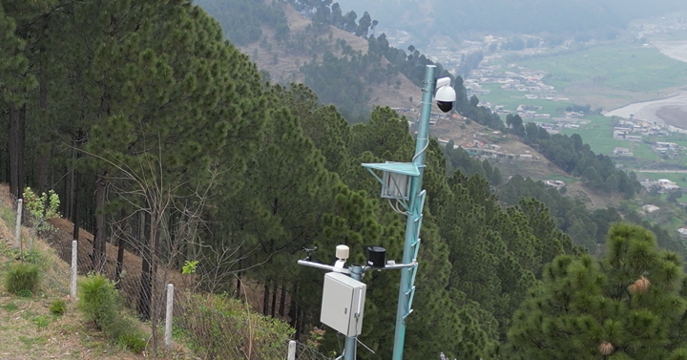

A camera installed in Pakistan as part of the Frontier Technologies Early Warning Forest Fire Detection System pilot. The camera is connected to individual AI modules, which process images and visually detect the presence of a fire.

CASE STUDY 2: Smart GeoSeals to Track Delivery of Humanitarian Aid
How do you ensure availability of life-saving emergency malnutrition aid across thousands of rural health points in Ethiopia, especially in times of conflict?
Smart GeoSeals are designed to reduce leakage and stock outs in the humanitarian aid pipeline by providing real-time data on the movement and delivery of aid. During their follow-on-funding phase this pilot successfully installed six “hubs” across warehouses and health point stockrooms, which can track the arrival of nutritional aid from the central warehouses in Addis Ababa to their destinations in rural Harar, by scanning low-cost RFID stickers on each box as it enters the stockroom. The pilot team is aiming for their solution to achieve 85% accuracy in tracking supplies, which could be critical in helping avoid stock-outs of life- saving nutrition products.
The pilot has been awarded an additional grant from FT, to continue their work and prepare to scale. The GeoSeals team will use the final phase of FT support to monitor the real-time data from installed sensors, install a second set of hubs across WFP’s supply chain, and work with FCDO and partners to build a data platform to integrate with their existing systems to track the supplies. They are already seeing a successful data map of stock being transferred and logged by the sensors installed, and a further step is to move the sensor network to work on satellite in addition to cellular networks, to ensure resilience to communications blackouts in conflict zones.
Two additional focusses for the final phase of work will be engaging ecosystem actors and raising awareness of their solution by hosting an online event to share a film and demonstration of achievements to date, and to design a business model which can take them to scale beyond direct funding. Part of this process will include working to reduce the cost of a hub from £400 to £200.
The pilot has also attracted interest from other potential funders such as UNICEF, USAID, and WFP. Additionally, the GeoSeals team has garnered attention from the Ethiopian Agricultural Transformation Agency, which sees potential in applying their technology and learning to improve last-mile tracking of government fertiliser subsidies for smallholder farmers.
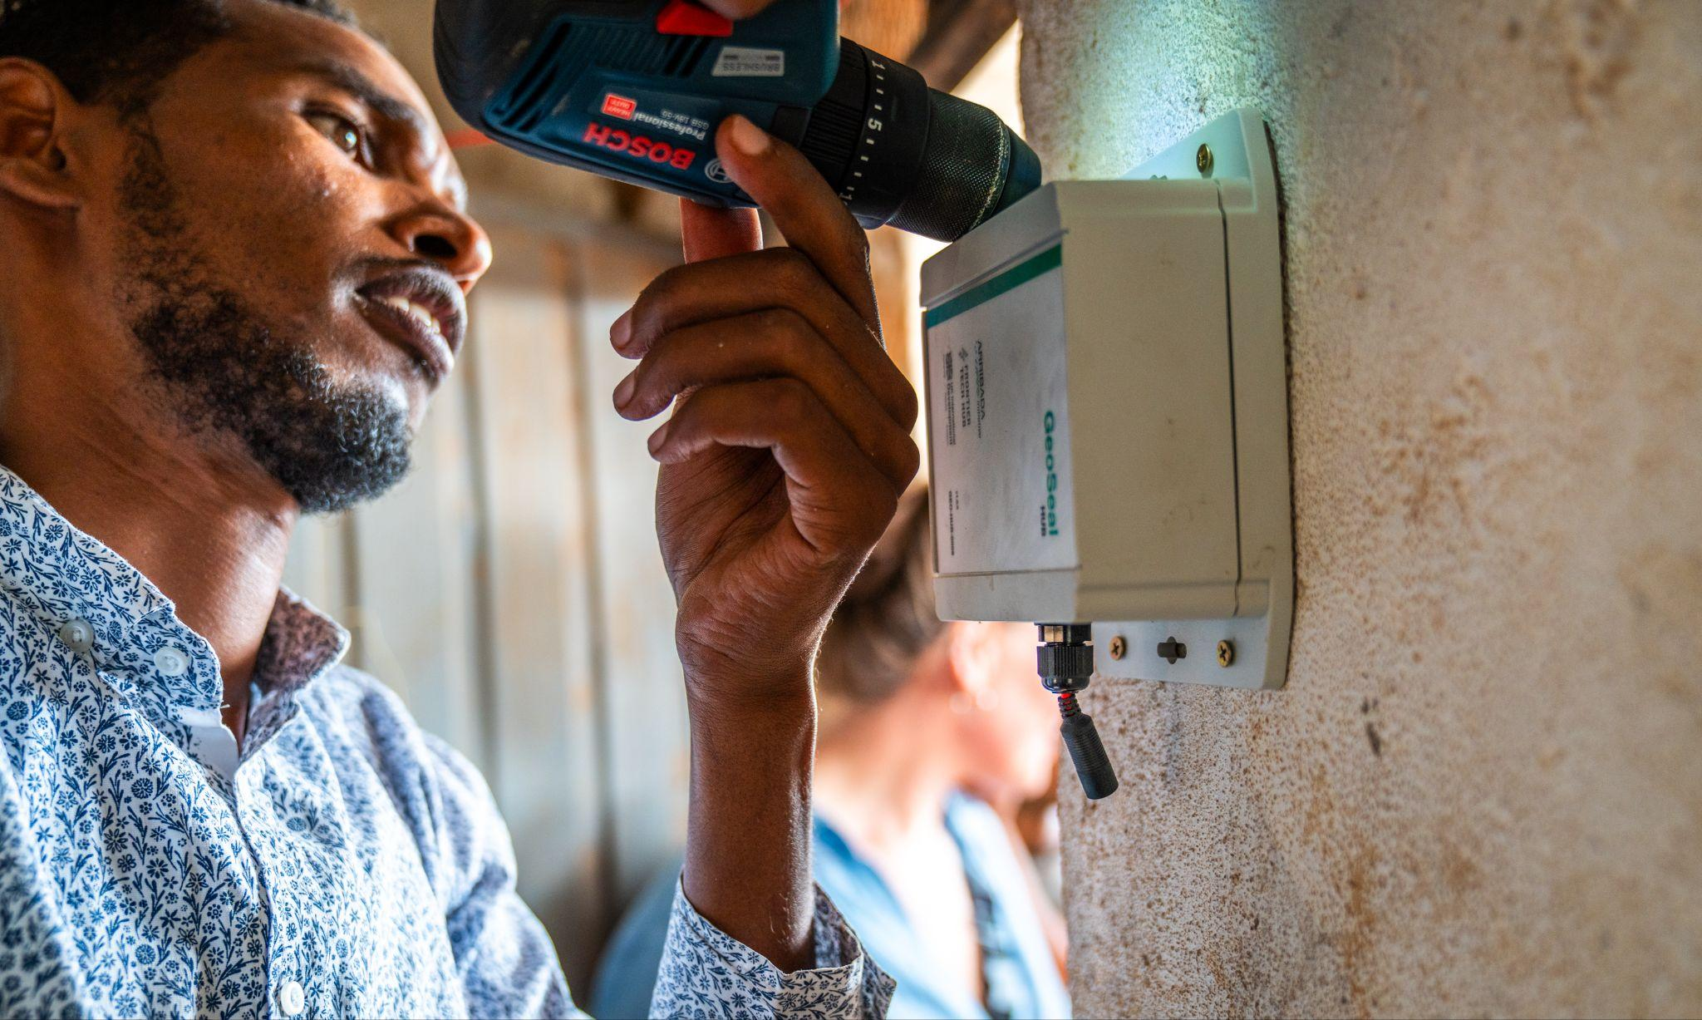

A technician installing an IoT enabled Geo Hub at a health point stockroom in Ethiopia for monitoring delivery of aid.

CASE STUDY 3: Wakanda Beyond Peer Action Group
The Wakanda Beyond UAV Peer Action Group (PAG) is a network of nine African Civil Aviation Authorities (CAAs) and Ministries committed to exploring solutions to increase safety and security around UAV technology, convened by the Drones Doing Good Alliance and FT Hub with support from GIZ and Smart Africa.
Throughout the last year, the FT Hub continued to convene and support the PAG. This involved both supporting CAAs individually to conduct experiments to develop digital solutions for enacting drone regulation (including solutions for managing drone registration, licensing and tracking), and experiments for testing elements of new regulations and policies. The FT Hub also convened actors both virtually and in person for peer learning activities and supported them to share lessons on implementation of regulatory and policy changes (such as the introduction of drone corridors), and the implementation of digital Unmanned Air System Traffic Management (UTM) solutions. This year convenings took place in Kigali, Rwanda (August 2023), and Abidjan, Côte d’Ivore (March 2024). Both events involved a combination of interactive workshops, expert presentations, discussions, and live demonstrations. Nine CAAs were present in Rwanda, and six in Côte d’Ivore. Outside convenings, CAAs periodically shared specific resources amongst themselves, including draft regulations and technical specifications for UTM systems.
As a result of participating in the PAG several of the participating CAAs pivoted their plans, especially with regards to developing digital tracking and traffic management solutions – with many CAAs prioritising initial steps they could take (e.g. online registration processes) to solve some of the challenges they face, before implementing more comprehensive and complex solutions. All the participants that engaged with the PAG this year agreed that the exchange was valuable, and that their view of regulatory tools had changed as a result of participating. As one participant at the Rwanda event commented: “I have a better overview on how other countries are managing their drone industry on the regulatory meeting such that we will apply some of the ideas in my country.”
Next year, the Drones Doing Good Alliance will continue to engage the PAG and are seeking further support for several complementary strands of work building on the priorities surfaced this year; including developing global technical goods that can be adapted and used by different CCAs, such as a mobile application to communicate regulations, open source UTM, a common web application for drone registration, open source tracking solutions, and a digital Specific Operations Risk Assessment (SORA) service.
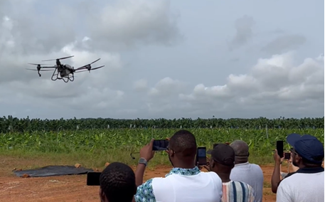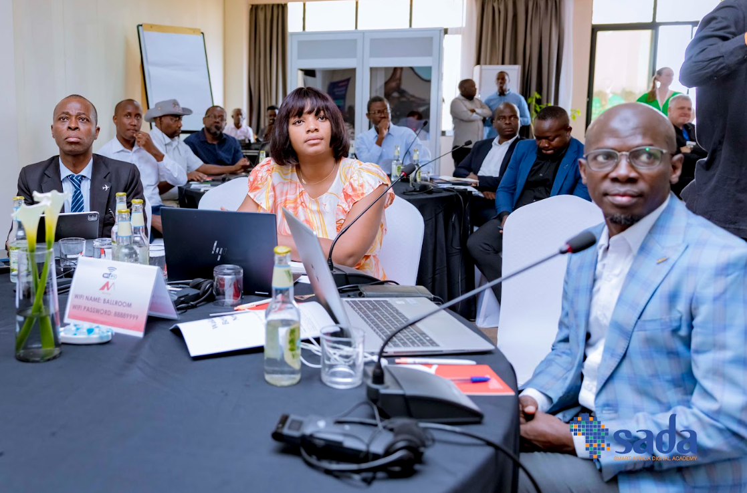
A drone takes off as part of an agricultural spraying demonstration in Abidjan, Côte d’Ivoire (left). The group discusses inputs for the Regulation Checklist during the Kigali meetings (right).

ANNEX A: ORIGINAL I2I THEORY OF CHANGE
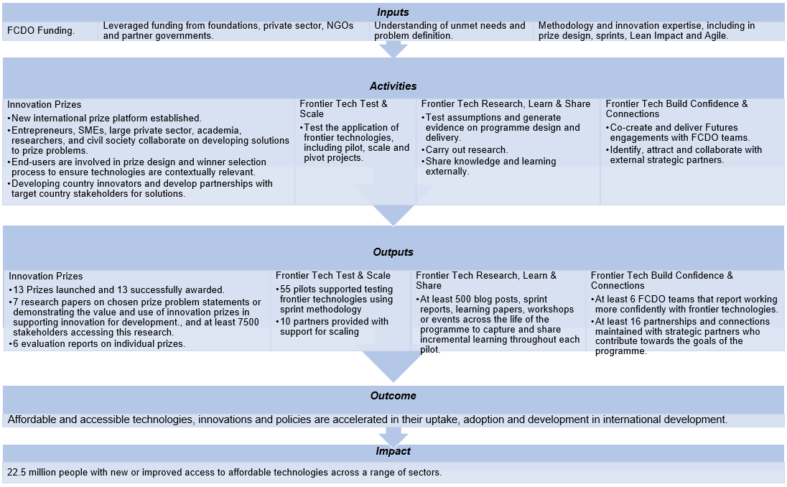
Note: This ToC is now out of date, so is representative only.

ANNEX B: NEW I2I THEORY OF CHANGE TO BE ADOPTED IN FYR 24/25
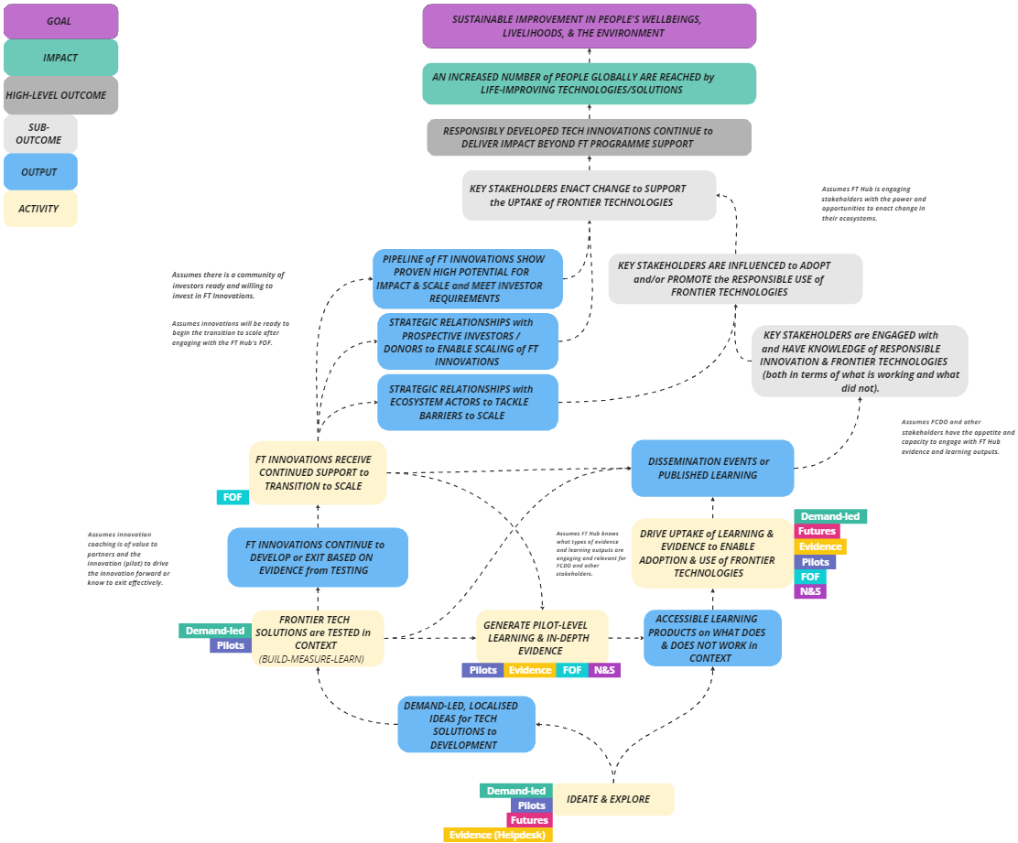

IDIA is a unique collaboration platform that brings together the senior leadership from the innovation teams, labs and departments of some of the world's leading development agencies - International Development Innovation Alliance (idiainnovation.org).
This figure includes Discoveries, Pilots, and Follow-on Fund investments since the start of Frontier Technologies Phase 1 (2014).
Pilot potential is based on progress to date and future potential for social impact.
A 'high' score is averaging 8 out of 10 or greater across four key areas of pilot assesment: 1. Engaging real-world users; 2. Generating learning; 3. Velocity: Did the pilot use learning to make efficient and evidence-based decisions? 4. Dissemination of learning and evidence.
From 2022, Outcome 1 dropped an indicator that captured “number of technologies, new processes and services, and new business models being b) adopted or deployed”. This indicator was superseded and incorporated by the remaining indicator capturing technologies that have been scaled-up directly or indirectly or supported for scale-up which implies a degree of adoption.
See footnote 4 above.
Within the TIU portfolio, the Frontier Technologies programme uniquely supports the earliest stage ideas.
A Masterplan in this context refers to an aspirational and educational document offering a shared vision for Kenya’s innovation sector that could be used as inspiration for subsequent policy documents
Local entities are defined as having a physical presence and permanent staff based in the country where the project is taking place.

