Poorest State Inclusive Growth (PSIG) Annual Review

Title: Poorest State Inclusive Growth (PSIG) Programme
Programme Value £ (full life): £65m |  | Review Date: 16 December 2024
Programme Code: 114293 | AMP start date: 23/12/2008 | AMP end date: 30/06/2025

Summary of Programme Performance
Year | 2012/13 | 2013/14 | 2014/15 | 2015/16 | 2016 - 17 | 2017-18 | 2018-19 | 2019-20 | 2020-21 | 2021-22 | 2022-23 | 2023-24 | 2024-25
Programme Score | B | A | A | A | A | A | A | A | A+ | A+ | A | A | A
Risk Rating | Medium | Medium | Medium | Medium | Moderate | Moderate | Moderate | Moderate | Moderate | Moderate | Moderate | Moderate | Moderate
DevTracker Link to Business Case: |  |  | https://devtracker.dfid.gov.uk/projects/GB-1-114293/documents
DevTracker Link to Log frame: |  |  | https://devtracker.dfid.gov.uk/projects/GB-1-114293/documents

Abbreviations | Full Form
BCs | Banking Correspondents
CBP | Country Business Plan
COVID19 | Corona Virus 2019
DeMo | Demonetisation (November 2016)
ESG | Environment Social and Governance
FCDO | UK Foreign, Commonwealth & Development Office
FI | Financial Inclusion
GHG | Green House Gasses
GoI | Government of India
GST | Goods and Services Tax
HMT | Her Majesty’s Treasury
ICF | International Climate Finance
IRR | Internal Rate of Return
LIS | Low-income states
MFIs | Micro Finance Institutions
MSMEs | Micro Small and Medium Enterprises
NAV | Net Asset Value
P&D | Promotion and Development (P&D) vertical, SIDBI
PSC | Project Steering Committee
PSIG | Poorest State Inclusive Growth Programme
RBI | Reserve Bank of India
SF | Samridhi Fund
SHGs | Self Help Groups
SHPIs | Self-Help Promoting Institutions
SIDBI | Small Industries Development Bank of India
SRF | Swavalamban Resource Facility
SRLM | State Rural Livelihood Missions
SVCL | SIDBI Venture Capital Limited
TA | Technical Assistance
ToC | Theory of Change

A: SUMMARY AND OVERVIEW OWARDS OUTCOMES [1-1 ½ pages]

Description of programme

- The Poorest State Inclusive Growth (PSIG) programme aims to promote Financial Inclusion and Inclusive Growth in India’s low-income states through better access to financial services and enhanced private investment. It is delivered through two main components: 1) Technical Assistance (TA) (£30 m) and 2) Development Capital Investment (Samridhi Fund (SF); £35 m) – implemented by an Indian Development Finance Institution (DFI) - Small Industries Development Bank of India (SIDBI) and its subsidiary SIDBI Venture Capital Limited (SVCL), respectively.

- The programme aims to support 13 million poor and vulnerable people, especially women, in the low-income states (LIS) to benefit from economic growth and is aligned to Government of India’s flagship schemes and priorities for inclusion. PSIG implementation started when microfinance institutions (MFIs) were facing an existential crisis as a fall out of the “AP crisis” (2010–12).

- Component 1 provided technical assistance for better policies for the sector, improved governance and systems for partners and for financial and digital literacy and micro enterprises for women. It also provided loans, guarantees and retail lending that allowed the MFIs to raise funds from the market and scale up their operations in underserved areas. SIDBI recovered the funds as reflows (loans, guarantees) worth £11m and consolidated them through the Swavalamban Resource Facility (SRF) in 2020 to help ensure the sector was sustainable.

- SRF has implemented 70 projects since its inception, reaching out to more than 212,000 people. In the last two years, SRF has focused on creating entrepreneurs in underserved and difficult regions of India. This was accomplished by offering skills trainings, access to finance and market connect support. Overall, 36,000 men and women have been supported to set up or scale up businesses of which 97% were women. A snapshot of SRF supported projects can be found here. The overall impact created by the programme and lessons learnt are mentioned in the next section.

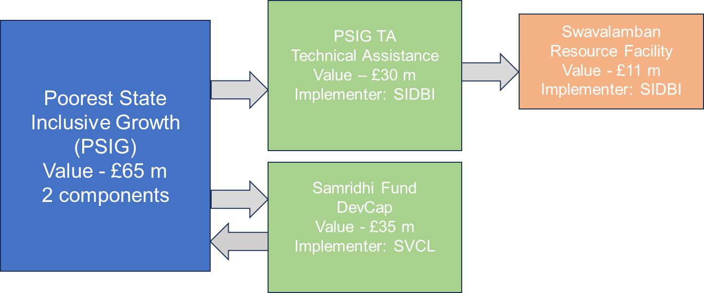

The 2019 and 2020 Annual Reviews discussed the progress of the TA component in detail. The 2021 Annual Review, and the subsequent reviews give an update on progress of SRF.
- Component 2 on Development Capital Investments- It invests in enterprises which have potential for high development impact in the eight low-income states. The states find it difficult to attract entrepreneurs or impact investments due to their limited infrastructure and perceived limited growth potential. ‘Samridhi Fund (SF)’, set up in 2013 with SIDBI (Government of India’s apex institution for financing MSMEs) and SVCL as fund manager, provided equity to scalable enterprises that benefit the poor in the low-income states. The equity investment is used by these enterprises to further raise debt, expand area of operations and reaching scale resulting in more jobs, increased earnings of people and reducing the cost of goods and services. SF was to end in June 2024 and has now received an extension till April 2025 from Securities and Exchange Board of India. The end date is April 2025 which enables SF to liquidate its investments in a more responsible way and maximising UK tax-payer value.

- SF, with a total fund value of c.£43m (INR 414.4 crores), is one of the first Development Capital investments under the UK-India co-investment partnership model. It is also SIDBI’s first Social Venture Impact Fund for low-income states. UK took an anchor investor role with c.78% share and has invested £35m in the Fund. The Fund also mobilised capital from India’s domestic insurance players – Life Insurance Corporation (LIC) and United India Insurance (UII). The fund invested in 23 companies. The fund is currently exiting from the portfolio and distributing returns to the investors. SF has achieved the development impact targets and therefore, it was agreed in the 2021 review that the subsequent reviews will report only the financial returns, to keep the annual reviews proportionate.

Summary supporting narrative for the overall score in this review

- The programme, in the current review period, has met expectations and the overall score is A. The review covers the output on financial returns from Samridhi Fund. At portfolio level, SF is expected to preserve capital and provide financial returns. Of 23 investments, the fund till date has achieved 18 full exits and 1 partial exit. The exits till date have returned the invested capital to FCDO. Exits have been delayed on account of various factors i.e. longer negotiations with buyers, fund availability issues with investees, delay in receiving approvals by the investees from regulatory bodies. The team is actively managing risks through stakeholder discussions and seeking expert advice on options to effectively wind up the fund with responsible exits for investors.

- The programme through its two components – technical assistance and investments has achieved the stated outcomes as noted below-

- Reached over 13 million women: Increased use of financial services (credit, savings, insurance), leading to better social and economic well-being.
- PSIG supported Micro Finance Institutions (MFIs) partners showed an annual growth of 26% against the average 10%. The end line assessment that was carried out noted a small but significant reduction in poverty rates (9 percentage points for the rural areas and by 13 percentage points for urban). The intervention deepened the outreach in underserved regions.
- Overall, the TA demonstrated a cost benefit ratio of 1:11.
- Generated employment income of £49m and reduction in cost to poor consumer/ Increase in earnings to poor producers of £1b.
- Created an institutional mechanism (SRF) for SIDBI to continue to build on the TA interventions.
- The TA component reached over 13 million women and improved their social and economic well-being; deepened the outreach in underserved regions, reduced poverty rates and promoted responsible finance practices and policies.

- SF achieved its target outcomes with increased employment income; reduction in cost of services; increase in earnings as producers. It demonstrated large social return of 41% with Benefit Cost ratio of 9:1.

Component 1- Financial Inclusion/SRF

- Swavalamban Resource Facility (SRF) was launched in April 2020 to build on the successes of the programme with a focus on women and underserved regions. SRF is aligned to SIDBI’s umbrella Mission Swavalamban (independent/self-sufficient) to promote entrepreneurship and is led by the Chief General Manager, Programmes For Development And Impact (PDI) Vertical of SIDBI. The initial time frame for SRF is five years. The programmes are primarily focusing to create micro-women entrepreneurs in rural parts of India in different sectors.

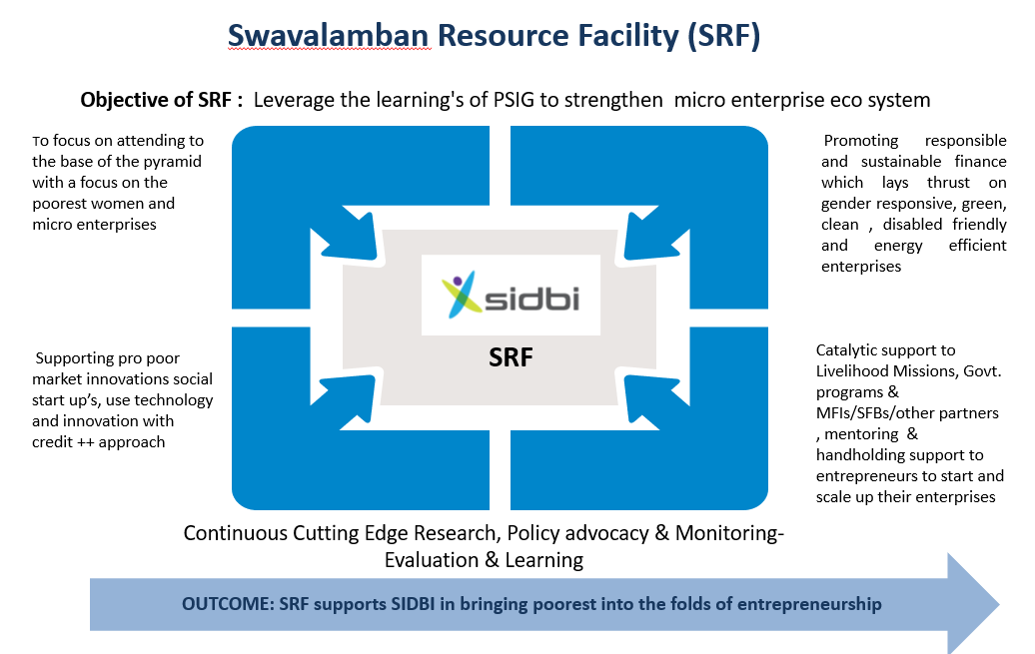

- SRF is an important vehicle for SIDBI to have greater impact in unserved/underserved regions and sectors. SRF implements programmes with an objective to strengthen micro-entrepreneurs with a focus on creating women entrepreneurs in low-income regions of India.

- The Project Steering Committee (PSC) headed by the Deputy Managing Director, SIDBI, provides strategic oversight, approves work plans and monitors progress for SRF. UK is represented in the Steering Committee and in the Project Approval Committee. Programme team works with the SRF team which comprises 5 members including gender leads.

- Progress: Since its inception in April 2020, SRF has supported micro entrepreneurs and micro enterprises through implementation of pilot programmes, scaling up the successful pilots and incubating social enterprises. So far, SRF has supported 70 projects (total amount sanctioned: £8.83m/ INR 95.60 crores; 43 live projects) till September 2024. It has directly supported 72,160 people including people with disabilities (91% women; 3,17,504 indirectly).

- The interventions in SRF are targeted to develop a culture of having more women entrepreneurs in the regions where there are hardly any women owned businesses. These interventions include sensitising, educating, training on basic financial and connecting with credit institutions to access finance. SRF is currently implementing projects in Maharashtra and Karnataka to provide training on basics of entrepreneurship for people with disabilities and skills trainings to provide employment opportunities. (Disability type- autism and intellectual disability).

- Impact created by ongoing projects include:

- Swavalamban Challenge Fund (SCF) (Oct 2023-March 2024) – SCF aimed to identify innovative ideas from social start-ups and support the finalists with a grant. The themes of the challenge funds were a) Innovation in livelihood and financial inclusion b) Enterprise solution for building rural economy c) Sustainable initiatives for social causes d) Strengthening market connects for artisans. Over 500 social start-ups submitted their ideas out of which 10 were shortlisted. An award ceremony was organised in March’24 to felicitate the selected start-ups. Some of the examples of selected ideas included a) solar based seed deshelling machines which can create women nano entrepreneurs in Jharkhand b) women led creation of silk fabric value chain by enabling solar energy efficient technology, trainings and integration on digital platforms.
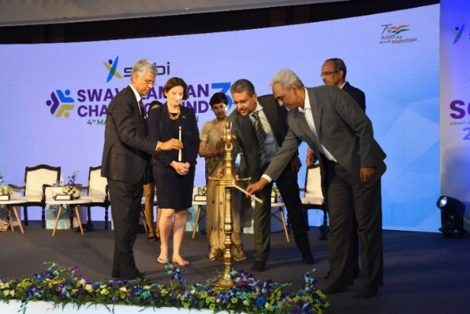
- Skill development for youth with disabilities: Over 100 youth with autism and intellectual disabilities have been trained to get jobs in the hospitality e-commerce sectors. These young adults got internship opportunities in Ginger Hotels and Amazon. The trainings were imparted by SolsArc, affiliated to Hospitality Skills Council, under National Skills Development Corporation. About 50 of these have got certificates and employment opportunities.

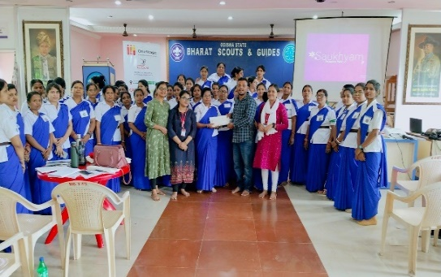
- Enterprise development for women: Interventions such as entrepreneurship awareness camps, boot camps, training camps, market linkage exhibitions to create 12,000 women entrepreneurs in 12 districts (10 districts classified as “aspirational” i.e., states having poor socioeconomic indicators) in Odisha; 100 women have been trained to produce banana fiber based reusable sanitary pads in Tamil Nadu, Karnataka and Odisha; A program to train 800 women to become entrepreneurs has been launched this year. It aims to provide registration to 300 women owned businesses on MSME portals in Karnataka.

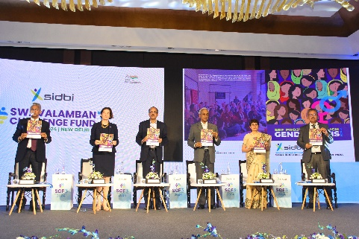
A report on ’SRF projects through Gender lens’ was prepared, covering all the skill development, entrepreneurship, mentorship, and other capacity building interventions. The report was launched by Christina Scott, Deputy High Commissioner, BHC, Secretary, MSME and other dignitaries from the Government in the Swavalamban event in March 2024.

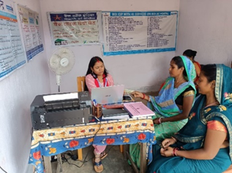
- Partnerships with State Rural Livelihood Missions (SRLM) – Jharkhand– Under this project, more than 650 SHG women members were deployed as Business Correspondents (BC) Sakhis across 24 districts having average monthly transaction of more than £ 1.2 million (INR 12,00,000). The current support in Jharkhand focuses on digital access to BC Sakhis to expand their portfolio and business models for producer groups. For due diligence purpose, proper visits were undertaken to the project locations and SRF team met the beneficiaries. During the discussion, one BC Sakhi mentioned as below:
"I have been the member of SHG for last 3 years. I got to know about this project at the cluster level meeting. I'm educated but I was not doing anything in the village before this. After becoming a Sakhi, I am getting respect. Village women call me Didi and come to seek advice on financial products. I am being heard in the community and this feeling is beyond the joy of income.”

Component 2 – Samridhi Fund

- Samridhi Fund has invested £38.5m in 23, mostly early-stage companies across sectors like healthcare, agriculture & allied, financial services, water and clean energy.

- The investors approved extension of the fund till April 2025. The Fund Manager has been actively working to ensure exits from all investees by April 2025.

Exits & Financial Returns: The Fund is in exit phase i.e. has started selling its equity stake in the investee companies to buyers and has returned £32.4m to FCDO till date (gross amount) (i.e.~100% of invested capital3) from 18 full exits, 1 partial exit and other income from investments in companies (e.g. dividends, interest). On an average, based on actual exits made and valuation of the remaining investees, ~50% of the portfolio (by volume) is expected to give significant returns, ~10% to preserve capital and ~40% to incur losses. The Fund has paid back the invested capital to its investors and is now distributing profits.

The Fund is in the process of making complete exit from 2 more investees, including 1 where partial exit has already taken place, by end November 2024. The Investment Committee of the Fund has approved exit from 2 more investees where Buyers have been found and exit documentation and formalities are being completed. Fund manager is working with the last investee to find a buyer; they are also in discussions with investment banks to assist in the exit. Fall back arrangements for an exit from the last investee are also being explored in case an exit is not possible by the end of life of the fund.

Box 1 | Examples of Investees achieving Scale & Sustainability beyond Exits
Samridhi Fund exited from companies such as Annapurna Finance and Saggraha with good development and financial returns. After exits, these companies have scaled further and mobilised capital from the market. A) Annapurna Finance (a microfinance company, also provides finance to MSMEs) has raised USD 75m investment from Piramal Alternatives, the fund management division of Piramal Group, a large Indian business group. This will enable further growth of the operations. Annapurna had in 2022 raised USD 15m from Proparco, the private sector financing arm of the French public entity Agence Française de Development Group.
B) After the merger with SAVE Group, Saggraha (a company providing banking services and financial assistance including business loans, group loans, etc., through its network of BCs) is deriving synergies across the financial services value chain and scaling their operations with expansion into new geographies and launch of new products. The company has raised USD 13m from Incofin India Progress Fund, an impact investment fund and Maj Invest Financial Inclusion Fund for growth.

- Development Impact: the independent end line evaluation of the Samridhi Fund highlighted the significant development impact and critical role SF played in the growth of the investee companies. Some of the key takeaways are as below-

  - SF investment led to a substantial expansion in the business operations of the investees leading to an average 5 times growth in the turnover. 35% investees have women promoters.
  - In majority of the investments (c.75%), SF was the first/ second institutional investor and had SF not invested, the enterprises would have remained undercapitalised. Investees have mobilised £700m (i.e.,15 times) capital.
  - 5x growth of the investees (with a number of market leaders emerging from the portfolio – 2 scaled into Small Finance Banks, 1 applied for Universal bank license and 1 listed for public funding. Others include – largest online fintech, leading exporter of fruits from India etc.).
  - 17,000+ jobs (20% for women); 7m people with access to financial services; 2m with access to low-cost quality healthcare; 1.8m with access to clean drinking water; 29,000 farmers with access to services; 125,000 with skill development training (70% women) and 41% social IRR.

Box 2| Examples of Development Impact under Samridhi:
The lessons on development from Samridhi continue to feed into the results and learnings to shape the overall portfolio’s strategy.

Siddhi Vinayak Agri Processing Pvt. Ltd: SF invested £500,000 (INR 5 crores) in SV Agri in 2019, when it was under severe distress. Post investment, the company started focusing on ESG which helped them streamline their systems/ processes, provide clean, transparent and traceable supply chain, enable access to capital, thus making the company more competitive in the global market. It has now partnerships with various global firms that would enable the sustainability of its outcome/ impact. The company reaches 12,000 farmers from 12 states, 75% from LIS. Farmers using the company’s seeds have reported a 12% reduction in input costs, a 25-30% increase in yield per hectare and a 17% increase in price earned per sale. SF exited from this company with good development returns and 6.5% financial returns.

- ESG Performance – ESG stands for Environmental, Social, and Governance. It's a framework used to assess an organization's business practices and performance on various sustainability and ethical issues. Its rationale is to guide organisations in operating in a more sustainable, ethical and socially responsible manner. It helps assess how businesses manage risks and opportunities related to environmental impact, social responsibility and governance practices.

The UK introduced the ESG Framework through the Fund to strengthen the compliances by investee companies and linked the remuneration of the fund manager with ESG performance. Significant progress was noted in ESG compliances by investees through independent assessment from baseline to endline with 90% of investees improving their ‘Environment’ indicators; 73% investees improving in ‘Social’ indicators and 60% improving in ‘Governance’ indicators. The overall average score (out of 4) in Environment increased from 1.3 to 2.9; Social from 1.7 to 3.2; and Governance score from 2.6 to 3.3. This is majorly attributed to UK’s role as a majority investor to embed ESG Framework in the Fund and Samridhi Fund’s continuous engagement with the investees across sectors. The lessons were disseminated with wider investment programme teams.

Lessons learnt and recommendations:

Overall

- Systemic Changes: PSIG has helped build the institutional capacity of GoI’s key institutions - SIDBI and SVCL, drawing a deeper focus on low-income groups/states and in its investment portfolio. The Board of SIDBI and SVCL have mainstreamed ESG as corporate policy. On the back of the SF experience, SVCL is now managing various venture capital funds for Governments of Maharashtra, Tripura, West Bengal, and Assam, and funds to scale startups and export-oriented enterprises.

Component 1
Lessons

- Based on last year’s recommendation, SRF has scaled up some of the successful models this year for women and people with disabilities in new regions. The programmes are aligned with government priorities. Nearly 6,000 jobs have been generated. The programme has successfully been able to provide tailored training and employment opportunities to diverse population – men, women, artisans, tribals, youth and people with disabilities.

- Some of the key challenges that SRF programmes have seen are credit and market linkages. Formal institutions are reluctant to offer credit to underserved groups, but partners are consistently providing the necessary hand holding support to entrepreneurship cohorts to get finance access from the banks.

There is a scope for aligning the SRF projects with UK priorities to meet the joint objectives in the climate, technology and inclusion themes. It can be used to showcase our current capital portfolio work.
Recommendations

- Showcase events: SRF has established several success stories which can be advocated and presented in the right forums. SRF can use key upcoming GoI events like Start-up Mahakumbh’25 among others to present the successful models that operate commercially and successfully in poor regions.

- New activities to be strategically aligned to UK’s current priorities: SRF to relook at the sectors and areas to align with UK-India priorities. It should also deepen its focus on green enterprises and tech solutions in line with SIDBI’s and UK’s overall priorities. These could include interventions/ round tables/events/visits along with GoI to learn from best examples from both the nations. Accordingly, results framework of SRF can be aligned. Agree and implement by March 2025.

Component 2:
Lessons

- Being one of the first development capital programmes, SF continues to be an important learning ground for the UK, informing the design of the new programmes. It has helped confirm several hypotheses including, what has worked and not, factors that necessitated shifts and the extent to which we have been adaptable.

- The earlier Annual Reviews cover lessons in detail. This review captures few lessons from the exit phase of the Fund. In addition, the Project Completion Report, due next year, will cover the reflections from the journey of the Fund.

  - Regular review of the progress of exits from investee companies can help speed up the process of exits.
  - Many of the investees are scaling post exit. With initial investment from SF, they were able to attract investors – domestic and international by demonstrating the robustness of their business models and impact on the ground. Some are emerging as market leaders in the industry and working with policy makers to open new markets. Some investees (in micro and small segments) have scaled down their operations due to unviable models. These were unable to adapt to the changing market context.
  - There is manpower constraint at the SVCL level. The fund management team should be adequately resourced with senior experienced members to manage exits from large number of investments. Linking team size with the volume of the investments should be looked at as one of the ways to mitigate risks. This should be documented clearly in the agreements. Additional independent expertise (e.g. financial, legal and tax advisers) should be onboarded early in the exit phase to help assess all possible options.
  - The Investment Committee composition should be revisited during the exit phase and additional industry expertise should be added wherever necessary. Being on the IC provides greater oversight to the UK which helps manage risks early and bring in stakeholders to discuss key issues. This also helps in reducing the information asymmetry.
  - As market forces and regulations are dynamic, exits can get de-railed. A detailed investee wise strategy and exit plan should be developed and agreed. The process of exits should be started as early as feasible to ensure timely exits.

Recommendations

- Programme team to do regular follow-up and review of the progress of exits from remaining investees
- Programme team to capture reflections on the decisions with regards to investments, exits, partners; influence on the markets/stakeholders; sustainability after exits; impact & response to external shocks etc. in the Project Completion Report (PCR) in 2025.
- Programme team to disseminate lessons with the wider portfolio (including new programmes) on exits, gender, MSME sector, policy work etc (continuous) and also explore cross fund portfolio synergies.

B: THEORY OF CHANGE AND PROGRESS TOWARDS OUTCOMES [1-2 pages]

Summarise the programme’s theory of change and any major changes in the past year (1/2 page)

- The programme is based on the theory of change (ToC) that: a) access to finance protects poor households from economic shocks; b) catalytic donor support is needed to expand services to poor geographies; c) microfinance platforms can be leveraged to empower women; and d) there is an unmet need for investment in the poorer regions due to perceived high risk by investors and untested business models that reach base of pyramid. There were a lot of changes in the external environment that were unforeseen and that impacted both the components. PSIG adapted its interventions to respond to these external factors as highlighted in the earlier reviews. Overall, the theory of change remained valid for both components.

Describe where the programme is on track to contribute to the expected outcomes and impact, and where it is off track and so what action is planned as a result in the year ahead (1/2 page)

- Component 1 has achieved the stated outcomes related to (i) Improvement in targeting low-income clients in PSIG states; (ii) enhanced economic value generated as increased employment incomes by investments in enterprises; and (iii) Proportion of women included in economic mainstream; proportion of women being able to take decisions on household savings and investments. SRF has designed interventions for diverse population in a substantive way.

- Component 2 has also achieved its targets at the outcome level (noted in last reviews) with (i) generation of employment income (ii) reduction in cost of goods and services to poor consumer (iii) increase in earnings to poor producers, and (iv) employment generation, 17,000+ jobs (20% for women) were created. In addition, 10% of the investments (i.e. investments in solar water pumps and solar Engineering Procurement and Construction (EPC) services for rural areas) have contributed towards UK’s ICF commitments and contributed towards reduction in GHG emissions, access to clean energy and mobilization of climate finance. In terms of impact, UK’s capital helped in expansion of enterprises to low-income states, mobilized additional finance for investees (including from the private sector), and enabled enterprises towards scale and sustainability, with some emerging as market leaders to influence the sector’s trajectory. As per the independent endline evaluation, the value generated by the Fund yields a significant social IRR of 41% over the 7-year period and goes up to 67% for 12 years with Benefit Cost ratio of 9:1

Justify whether the programme should continue, based on its own merits and in the context of the wider portfolio

- SF is focused on delivering sustainable and inclusive economic growth in the low-income states of India. It has continued merit as it shapes our joint investment narrative and underpins the model of delivery under the UK India strategic partnership and CBP objectives on Enterprise and Innovation. It is now in exit phase and has returned c. 100% of the capital and will now be returning surplus on exit from balance investees. The fund is expected to be wound up by April 2025. There is no further drawdown envisaged, and the operating expenses & fees are borne through the reflows and fund income. The Fund should continue to operate to allow exits from balance investments and distribution of financial returns to the investors, including the UK.

Explain major changes to the log frame in the past year

- The Technical Assistance component ended in March 2020. SIDBI continues to track the outcome and impact of the funds and report to the UK Government periodically. Background context is described in Para 2, 12 and 15. For component 2, there were no change to the log frame.

Describe any planned changes to the log frame as a result of this review:
No changes are planned and only financial returns under SF will be tracked.

C. DETAILED OUTPUT SCORING [aim for 1 page per output]

Output Title | Businesses that enable the poor to benefit as producers, skill providers and consumers, are promoted
Output number per LF |  | 3 | Output Score | A
Risk: |  | Moderate | Impact weighting (%): | 100%
Risk revised since last AR? |  | N | Impact weighting % revised since last AR? | N
*This review only scores the financial returns as fund is in exit phase & development impact has been achieved.

Indicator(s) | Baseline | Cumulative Milestones Dec 2022 | Progress December 2024
Development* and Financial Returns on Capital from invested funds | NA | Capital Preservation +  Gross portfolio IRR up to 8% | Exits have been delayed and 5 investees are yet to be exited. Delayed exits pose a risk given the timelines are till April’25 but the fund manager is working towards exiting from the portfolio. However, the portfolio has already returned all of the invested capital and is expected to provide further returns.

Briefly describe the output’s activities and provide supporting narrative for the score. [max 1/2 page]

- This output has scored “A” as the fund has returned the capital, and the balance exits are expected to provide more money to reach close to the estimated target returns. However, exit timelines have been affected due to external market forces and remain a risk. The Fund had invested £38.5m across 23 investments. It has fully exited and distributed returns from 18 enterprises (~78%) and partially exited from 1 portfolio company. The balance 4 are in the financial services sector and buyers have been identified for 3 of them, 1 remain high risk (plan B for exit has been planned in case exit is not possible by fund end date). The programme team is actively managing the risks through stakeholder engagement and have requested the fund manager to appoint external advisors/investment bankers to expedite exits.

- Till date, the Fund has returned c £32.4m (gross amount) (i.e.~100% of invested capital3) back to HMG from exits/ other income from investments (e.g., dividends, interest). The final gross portfolio IRR will be calculated once all exits happen (it is estimated ~4-6% in local currency). The following charts show a) the exits & distributions made by the Fund to all investors over years and b) trajectory of gross and net IRRs during the disinvestment period (in local currency).

a) the exits & distribution made by the fund to all investors

The graph above showcases that exits got delayed due to COVID19 but picked up pace after FY22. There were 10 exits between FY22 and FY24 when compared with just 7 exits between FY20 and FY22.

b) trajectory of gross and net IRRs during the disinvestment period

The above graph showcases the impact of DeMo and COVID19 on the valuations of businesses resulting in lower returns (IRR) on the investments. There is a steep fall in valuation post DeMo in November 2016 with Net IRR falling from 22% in Mar’16 to just 2.5% in Mar’17. Though the market recovered post DeMo, COVID19 again impacted the valuation of businesses and Net IRR fell from 12% in Mar’19 to just 3.5% in Mar’20.

- Based on the latest available March 2024 valuation report, the Net Asset Value (NAV) of the Fund has increased to £20.2per unit (INR 2,025 per unit) as against face value of £10 per unit (INR 1,000 per unit). The NAV has grown by ~16% over the last year from £17.4 per unit (INR 1,740 per unit) which shows consistent value creation by the portfolio. This also demonstrates the strong intrinsic value of the portfolio. The chart shows the movement after the end of investment period in Mar’19 – affected by COVID19 in Mar’20 and Mar’22 but improved subsequently as businesses recovered. A slight dip in Mar’22 numbers is due to exits & erosion in value of few companies due to second wave. Post that, there has been an upward trend due to improvement in performance of some microfinance companies (clean-up of balance sheets etc).
DeMo
COVID19

- Development Impact on an aggregate basis has been significant. It has improved outreach and overachieved targets at outcome level as noted in sections above. In addition, an independent ESG endline audit of the Fund noted the significant improvement in compliance scores over the baseline as covered in previous reviews.

Describe any changes to this output during the past year, and any planned changes as a result of this review. [1 paragraph]

- There were no changes to the log frame in the past year and no changes are planned for future as fund is in winding up phase and will close by April 2025.
Progress on recommendations from the previous AR (if completed), lessons learned this year and recommendations for the year ahead [1-2 paragraphs]

- Progress on recommendations of last year:
Recommendations | Progress
Team to propose extension of the fund by 1 year to enable exits. | Completed. Fund life was extended till April 2025 as per SEBI guidelines.
SVCL to explore all possible exit options. SVCL to appoint advisors for exit. | Partly completed. SVCL has been able to achieve full exits from 18 portfolio companies and partial exit from 1 portfolio company. Full exit from 4 portfolio companies is expected by January/February 2025.
Programme team to finalise the Project Completion Report (PCR) closer to the fund end date and capture reflections on - the decisions with regards to investments, exits, partners; influence on the markets/stakeholders; sustainability after exits; impact & response to external shocks etc. | The fund life was extended till April 2025 to enable exits from balance portfolio companies. PCR will be done closer to April’25.
Programme team to disseminate lessons with the wider portfolio (including new programmes) on exits, gender, MSME sector, policy work etc (continuous). | Partially completed. Learnings from the progress of the fund have been incorporated in the side letter/agreements for new funds.

D: VALUE FOR MONEY (1 page)

Key cost drivers and performance

The main cost drivers of the programme now are management fees, fund expenses and performance related fees for the Fund Manager. Operating expenses and fees will continue to be borne out of reflows and fund income. The Fund Manager and programme team at FCDO have robust mechanisms in place for monitoring the financial progress and tracking the exits and reflows from the Fund.

VfM performance compared to the original VfM proposition in the business case

As per the endline assessment of TA, a programme level calculation of the cost benefit ratio based on the methodology where benefits to customers are added to the financial value created by the investee, the Samridhi Fund indicates high cost-benefit ratio of 1:11. The benefits taken into account are access to financial services, access to low cost and quality healthcare, access to clean drinking water, clean energy, reduction in greenhouse gas emissions and new employment opportunities.
The Samridhi Fund has delivered well on development, ESG and financial results. The endline evaluation notes the significant social return of 41% with Benefit to Cost ratio of 9:1. The total financial returns will be known at the closure of the Fund, however till date, the portfolio has been able to return the invested capital to FCDO and will be returning surplus through exit from balance investees. Investees have been able to mobilize 15 times capital after SF investment.
Assessment of whether the programme continues to represent value for money

Economy: The key cost factors for Fund investment are the fee paid to the Fund Manager, fund expenses and the performance-related “carry” – share of the Fund manager in the profits of the Fund beyond a minimum return to the investors. The fees and costs to the Fund partners are in line with industry practices and have been negotiated to ensure VfM (including significant lowering of fee in the last extension). Operating expenses and fees will continue to be borne out of reflows and fund income. In addition to social returns, the investments generate financial returns which are returned to the UK Treasury and can be further invested in other development projects.
Efficiency: The cost-effectiveness ratios for the TA component for reaching low-income households at small, if not minuscule proportions of GNI per capita suggest a high level of efficiency for the programme. The endline evaluation of the DevCap component notes the significant social return of 41% with Benefit to Cost ratio of 9:1. Till date, the portfolio has been able to return our capital and investees have been able to mobilize 15 times capital after SF investment.
Effectiveness: The TA component reached over 13 million women and improved their social and economic well-being; deepened the outreach in underserved regions, reduced poverty rates and promoted responsible finance practices and policies. The DevCap component achieved its target outcomes with increased employment income; reduction in cost of services; increase in earnings as producers. It demonstrated large social return of 41% with Benefit Cost ratio of 9:1.
Equity: The programme has closely tracked women representation at fund and investee levels. Programme teams have consistent conversations with the Fund Managers and Investees to ensure women participation. The ESG endline audit has shown a good increase in all aspects of equity including gender, climate and environment.

E: RISK [½ to 1 page]

Overall Risk Score: Moderate

The overall risk is assessed as ‘Moderate’ mainly on account of delayed exits. The residual risk after the mitigation measures remains within the tolerable limit of UK’s risk appetite. The table below indicates the key risks and the mitigation strategy. A detailed risk register has been updated in AMP.

Risk Description | Risk Category | Mitigation Strategies | Residual Risk
Exit Risk: As per Regulations, if exits are not materialised within fund life, the residual investments have to be either transferred to a new scheme or distributed to investors or written-off. This will lead to additional costs, greater administrative burden and loss of value for the UK. | Policy & Programme Delivery | - Investors have given an extension to FM till April 2025 (based on new regulations).  - Out of the 23 investees, complete exit has happened from 18 investees, partial exit from 1. Complete exit will happen from 2 investees by November 2024 end and from 2 by January/February 2024. FCDO will continue working with FM to ensure that balance exit happen within the extended fund life.  - UK is in active consultation with stakeholders – investors & legal advisers to explore feasible options.  - Oversight & regular meetings with SIDBI Chairman.  - Regular monitoring through workplans, IC & Investor.  - FM working with Investees to expedite exit offers. | Moderate
Sustainability of investees post exits | Policy & Programme Delivery | - IC reviews each exit proposal to ensure responsible exits. Sustainability, scale, alignment with buyer, job retention etc are important parameters.  - Portfolio is built on assumption that some investments will fail and some will succeed.  - Many companies have mobilised capital after SF investment and scaled. Many have mainstreamed ESG and impact at centre of their business operations. | Minor
Reputational risks related to investments including financial frauds, safeguarding and ESG related. | Reputational | - FM is governed by GOI’s strict mechanisms to ensure good governance & financial management practices.  - Fund Manager is represented on the Board of investee companies to ensure oversight.  - Due diligence is done on the Fund level as well as investee levels. Quarterly utilization reports, annual audited statement of accounts are received.  - ESG Endline Audits are completed with significant progress noted.  - Continuous monitoring and oversight and timely action in case of any incident by FM.  - Contractual safeguards to protect UK’s interest. | Minor
Misappropriation or poor management of funds | Financial & Fiduciary | - UK commissioned an independent financial review at fund level for greater assurance. No red flags noted.  - Partners are Government of India bodies governed by strict mechanisms ensuring good governance and financial management practices.  - Robust financial management - including regular meetings with partners, review of financial reports.  - IC approval is required for all investments and exits, also ensuring partner/supplier adherence to procurement policies that meet our standards.  - Team closely engages with UK Finance team during entire programme cycle to ensure risks are managed | Minor
SRF projects not aligned to UK India strategic partnership goals | Policy and programme delivery | - UK and SIDBI teams to determine a strategy and a workplan for the balance time of the fund life to align with climate, technology, and inclusion.  - UK team to explore interventions that help fund managers, investees and overall sector of target. | Moderate
Climate and Environment not aligned with Paris agreement | Climate & environment | - UK has exited from majority of the portfolio and only financial services investees are left.  - 10% of the investments under Samridhi Fund have contributed towards UK’s ICF commitments. These companies are providing solar powered pumping solutions and solar projects across the low-income states.  - ESG endline audit has been concluded for all the investees and has no major red flags on climate and environment. | Minor

F: PROGRAMME MANAGEMENT: DELIVERY, COMMERCIAL & FINANCIAL PERFORMANCE [1 - 1 ½ pages]

Performance of partners and UK, notably on commercial and financial issues
- Our working relationship with SIDBI and SVCL has been collaborative. The SRF team - four full time project staff supported by three SIDBI core staff - is in place and is led by the Chief General Manager, MSME Development, SIDBI. This has ensured alignment with SIDBI’s institutional mandate.
- SRF team is well resourced, have strong governance structure and reporting mechanisms. In the reported period, partners have provided high quality and timely technical and financial reports.
- SVCL is working with a small team which has reduced in strength over time. This has been constantly highlighted by the programme team (also negotiated in the amendment agreement) with the top management of SVCL and SIDBI; however, capacity has not been enhanced. The Board members are providing greater oversight to manage the winding up phase. Timely exits remain a risk.
- The programme risk register is updated quarterly. All the key documents are published on the FCDO’s development tracker as per the transparency policy.
- Financial Management: SIDBI is a public sector financial institution with strong financial management systems. The SIDBI team conducted periodic reviews of the projects against expected performance and spend. It achieved substantial savings by closing poorly performing activities/components of the programme and consolidating others.
- The Fund undertakes half-yearly valuation of its investments by an independent valuation expert and shares annual audited accounts, quarterly unaudited accounts, half yearly valuation reports. The Fund also shares the statement of account for units held by UK on each distribution made. All these reports are shared with UK’s Financial and Accounting Reporting (FAR) team periodically. Fund finances are monitored regularly through Investment Committee and workplan meetings. As part of the extension phase, we completed an independent financial audit review of the fees & expenses which are being met by the reflows/fund income etc. No major issues were highlighted in the review.

G: MONITORING, EVIDENCE AND LEARNING [1/2 - 1 page]

Monitoring and evaluation:
- Overall programme performance for both the components is measured against the results framework, work plan and previous year’s recommendations; regular meetings and field visits with beneficiaries and downstream partners to understand ground realities. Independent impact assessments have been completed for both the components.
- For Component 1, UK has a representation in the Project Approval Committee which reviews the proposals above £50,000 (INR 5,000,000). SIDBI has an internal board that decides the themes, sectors and interventions. They design, deliver and monitor the interventions. SIDBI provides monthly progress reports to the programme team of UK Government.
- For Component 2, Investment Committee (IC) meets quarterly or on need basis to discuss exit strategy, approve exits, review progress, portfolio updates and key risks. Fund Manager has bi-monthly workplan meetings to provide progress updates. In addition, there are regular documents shared with UK as noted above. A meeting between all the investors was also held in May 2024 to discuss the exit risks and agree next steps. As part of risk management, the team has regular discussions with senior stakeholders, legal and tax advisers. Wherever required, team has commissioned independent advice. Team also interacts with several investees to understand their growth post exit.

Evidence

An independent end line evaluation was completed for both the components and noted significant development impact. These findings were captured in the previous Annual Reviews.

Learning:

The programme continues to be a learning ground for all future programmes. The lessons have been captured in the Annual Reviews in detail. The learning aim for the programme going forward would be to disseminate lessons with the wider portfolio (including new programmes) on exits, MSMEs, partners among others. Detailed lessons, learnings and reflections over the journey will be captured in the Project Closure Report.

Date of last narrative financial report | Latest quarterly progress report and unaudited financials for the Fund for period ending Sep 30, 2024, on Oct 10, 2024. | Date of last audited annual statement | Annual audited Fund accounts for Mar 24 received on June 28, 2024.

Excessive lending, high interest rates and unscrupulous practices by a few MFIs in the Indian state of Andhra Pradesh (AP). It led to severe backlash and criticism of the sector.
Rajasthan, UP, MP, Bihar, Chhattisgarh, Jharkhand, Odisha, West Bengal These states constitute 53% of India’s population with 61% below $3.1 per day income (source end line evaluation).
This is the amount invested in investees and excludes fees paid to the fund manager.
PSIG provided loans, guarantees and retail lending that allowed the MFIs to raise funds from the market and scale up their operations in underserved areas. These funds were returned during the life of the project. They are being used by SIDBI to continue the activities after the end of the contract in March 2020.
Five project staff – including gender and evaluation leads; four core SIDBI staff; headed by Chief General Manager, PDI.
17 in Micro Small and Medium Enterprises- MSMEs and 6 in Financial Services.
£1 = INR 100

