Annual Review

Title: AI for Development: Responsible AI, Empowering People (‘AI4D’)

Programme Value £ (full life): £53,000,000 |  | Review Date: 15/04/2025
Programme Code: 400191 | AMP Start Date: 15/04/2024 | AMP End Date: 31/03/2029

Summary of Programme Performance
Year | 2025 | 2026 | 2027 | 2028 | 2029
Overall Output Score | A+
Risk Rating | Moderate

DevTracker Link to Business Case: | https://iati.fcdo.gov.uk/iati_documents/D0006995.odt
DevTracker Link to results framework: | Awaiting publication

A. SUMMARY AND OVERVIEW

Description of programme
Rapid advances in AI present substantial opportunities and risks. While AI demonstrates potential to accelerate progress on a wide range of SDGs, without rapid, careful and concerted policy efforts, the onset of AI could substantially exacerbate existing inequalities between and within countries.

Artificial Intelligence for Development (AI4D) is a programme that aims to foster safe, inclusive, locally led and responsible AI ecosystems that empower people and accelerate progress on challenges in international development. AI4D supports responsible AI ecosystems where experts in developing countries are enabled to develop their own solutions to development challenges and mitigate AI risks through safe, inclusive, rights-based and sustainable AI applications and policies.

The second phase of AI4D was launched in 2024 as a 5-year, £63,600,000 (£53m from the FCDO) partnership between FCDO and Canada’s International Development Research Centre (IDRC) spanning Africa and Asia. It builds upon the first phase of the ‘AI4D Africa’ programme, launched by IDRC and SIDA in 2020, which laid the foundations by supporting responsible AI policies, multidisciplinary research, and innovative projects across the African continent.

The current phase of the programme will contribute towards two critical outcomes: (i) shaping responsible and inclusive AI policies and regulations and (ii) scaling impactful AI innovations, which are supported by work across five pillars: AI policy and governance, data, talent and skills, innovation and scale.

Summary supporting narrative for the overall score in this review
This year’s Annual Review scores an A+, in recognition of the achievements detailed in this review. The headline result is that the programme made good progress against all targeted indicators during this reporting period, particularly in areas of high priority to FCDO. The programme continues to demonstrate sound management, value for money, and operational efficiency.
With AI4D being a new programme, this reporting year was primarily a programme building year, with an emphasis placed on project design and start-up, building new partnerships and strengthening existing relationships with programme partners.

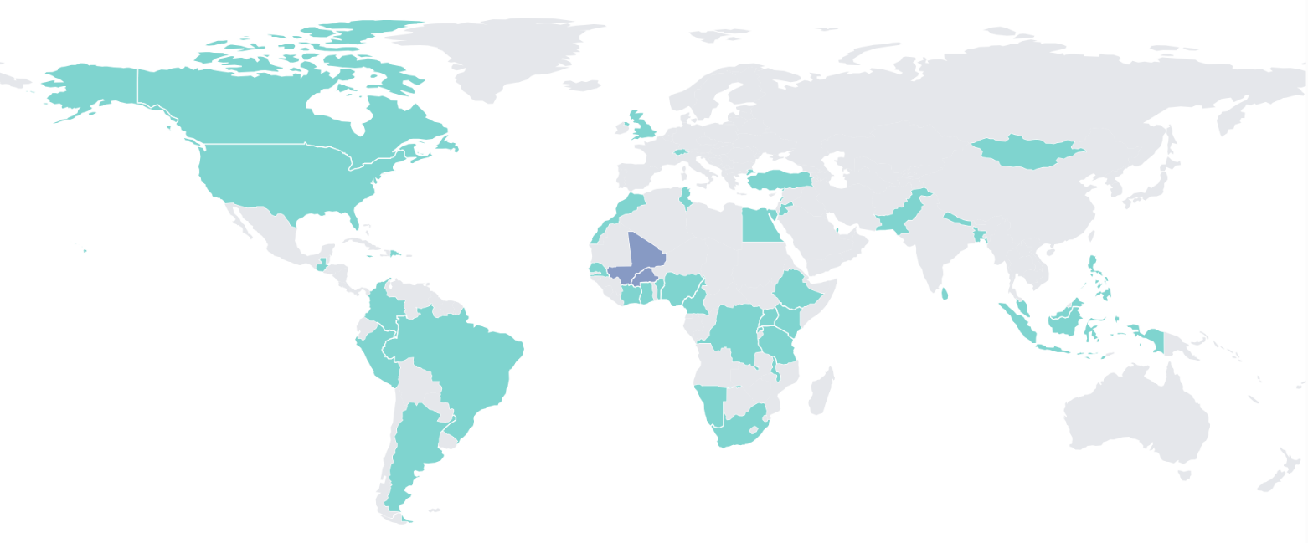
Figure 1. Country locations of AI4D activities.
Note: purple indicates country (labs) solely funded by IDRC.
The four key achievements from this reporting year include:
- Shaping responsible AI policy: Several AI4D grantees were consulted in the drafting of national and continental AI policies, demonstrating their increased credibility amongst policymakers at various levels resulting from the quality of their research. These engagements have occurred both through our policy hubs and multidisciplinary labs. This year alone, AI4D grantees have contributed to drafting of the Senegalese, Ghanaian, Nigerian, Kenyan, Ugandan, and South African National AI Strategies and the African Union Continental AI Strategy. AI4D grantees have also been involved in supporting the implementation of regional (UNESCO, AU) and national (Senegal, Benin, Ghana) AI strategies and frameworks.
- Scaling responsible AI innovation: During this reporting year, AI4D added 34 individual projects to its portfolio (19 new projects, 15 projects from the first phase) in nine new countries and three new regions. All 34 projects are strongly aligned with AI4D’s mission. Some of the early-stage innovations from the first phase of the programme are now being tested, with some ready to scale. This includes an innovation supported through the AI for Agriculture and Food Systems network, co-designed with female smallholder farmers in Nigeria, to enhance the production, management and marketing of the Nsukka yellow pepper, as well as an Assistive Artificial Intelligence technology for Kenyan Sign Language, supported by the EduAI Hub, that translates spoken English to Kenyan Sign Language (KSL) for deaf people with visual representation using virtual signing characters. In addition, the AI4D-funded Lab for the Ethics, Policy and Scaling of Responsible AI (LEPSAI) at the African Centre for Technology Studies (ACTS) is supporting 13 African AI innovators through their responsible AI mentoring process to refine and scale their innovations. The LEPSAI team continues to work on building out and refining the mentorship process while also engaging in a learning-by-doing process and resourcing the mentors with tools (such as GIZ’s responsible AI audit tool) and training sessions.
- Strengthening AI Fundamentals: AI4D has established 12 multidisciplinary AI research labs at public universities in 11 African countries (Senegal - with two labs, and Tanzania, Uganda, Kenya, Ghana, Rwanda, Ethiopia, South Africa, Nigeria, Mali and Burkina Faso – with the latter two solely funded by IDRC), three AI policy hubs aimed at supporting , AI policymaking regionally (in Senegal covering West and Central Africa; in Kenya covering East Africa; and in South Africa covering Southern Africa) and three thematic AI innovation networks (one on AI and food security based out of Kenya, another on AI and health coordinated from Uganda and a third on AI and gender based in Senegal).
  - AI4D’s multidisciplinary labs are an essential capacity strengthening input into the responsible AI ecosystem and a long-term, sustainable approach to developing and nurturing local talent related to responsible AI that responds to the talent requirements of the public and private sector. By expanding AI4D’s multidisciplinary lab presence to 11 countries, AI4D’s grantees contributed to the development of over 10 policies (at the national, regional, and global levels).
  - The three policy hubs have been able to smoothly transition their policy engagements and dialogues from the IDRC/SIDA-funded phase. This has resulted in continued deep policy engagements in Ghana, Kenya, Senegal, and South Africa and emerging ones in Benin. Although the primary object of the labs is to strengthen capacity, they have also become hubs of innovation and national centres of excellence and are being called on by local governments to speak to issues of policy. For example, the Responsible AI Lab (or RAIL) hosted by the Kwame Nkrumah University of Science and Technology (KNUST) in Ghana has undertaken several projects in collaboration with Google and the French Embassy, including developing a responsible AI framework and designing AI-enabled assistive technologies. The principal investigator at RAIL also contributed to the Ghanaian AI Strategy and is receiving separate funding from the FCDO regional office in Ghana to deepen its policy engagements.
  - The programme also extended innovation networks on AI for pandemic and epidemic preparedness, as well as AI and sexual, reproductive and maternal health throughout Asia, Africa, Latin America and the Middle East.
- Expanding impact through strategic positioning and partnerships:
  - AI4D Funders Collaborative: FCDO and IDRC have established the AI4D Funders Collaborative, a group of the AI for development funders (including the Gates Foundation, GIZ, with previous involvement from USAID) who are committed to coordinating funding efforts under the common vision of uniting with local partners to combat inequality through responsible AI grounded in shared principles such as local leadership, equitable opportunities, localisation, gender and inclusion, and international collective action. The AI4D Funders Collaborative is quickly becoming a recognised as a model for effective collaboration for AI for development (and beyond). In the last year, the AI4D Funders Collaborative have participated in several joint announcements at high visibility events (e.g. G7 in Puglia, French AI Action Summit). The programme’s leadership in this group also leveraged co-funding from USAID (prior to its restructure) and the Gates Foundation on a new compute initiative, as well as a £8M joint investment with the Gates Foundation for an African languages hub. As a consequence of this leadership and convening role within the AI4D Funders Collaborative, AI4D is now working with Global Affairs Canada to develop a proposal for a new announcement for Canada’s G7 Presidency in June 2025.

Major lessons and recommendations for the year ahead
From a programme design perspective, since its inception, the AI4D programme has developed iteratively in response to insights from our local partners and external developments in a rapidly evolving field. In early 2024, IDRC commissioned Genesis Analytics to conduct an evaluation of the first phase of the AI4D programme to inform the design of the second phase. The report provided a retrospective view of what the programme had achieved as well as recommendations for the programme going forward.
Some key lessons learned, which are applicable to the current phase of the programme in its first year, and associated recommendations for the next year are summarised below:
The programme’s potential as a connector
Lessons:
- As the African AI ecosystem develops, the AI4D programme has immense potential to ‘connect’ various stakeholders - both within the programme’s partner network and amongst the wider ecosystem. Acting as this facilitator spans from encouraging partners to integrate better with private and public sector stakeholders to linking more intentionally with demand for skills and innovations. In order to fulfil this role, AI4D has already made four key changes:
  - The programme provided a grant to the African Observatory on Responsible AI to work with Niyel, a West African agency and one of AI4D policy hub, to ensure greater policy coordination across the AI policy hubs in their engagement with various countries in Africa.
  - The programme also gave a coordination grant to RAIL to ensure all AI labs in the 11 countries work more closely together and support similar pathways to responsible AI capacity building and scaling.
  - IDRC also built stronger foundations for responsible AI through developing a project with ACTS to mentor AI4D’s innovation portfolio on issues related to responsible AI.
  - Finally, as recommended by the evaluation, IDRC has changed the design of the innovation networks to be as much about undertaking research in the field of AI and various sectors, as supporting innovation itself.
- As the programme expands beyond Africa, this will also include enabling peer-to-peer learning among countries at similar stages of AI readiness across regions.
Recommendations:
- The programme should act as a ‘connector’, and in the next year, AI4D should continue to connect our grantees to principal events taking place in the field, such as the UN General Assembly, donor-focused events (e.g., G7 and G20), and Africa AI events. Upcoming activities such as a planned partner workshop in Q2/Q3 should strengthen collaboration between and within players in different programme pillars so that they can leverage each other’s networks and expertise. Timing: workshop in Q2/Q3, ongoing collaboration.
Improvements to knowledge sharing across the programme and communicating impact:
Lessons:
- There is a growing need to improve knowledge sharing across the programme, via events, convenings and shared platforms for quick and easy sharing of ideas, experiences and challenges between partners. In response, the programme is working with the African Observatory on Responsible AI to coordinate and knowledge share across the programme, thus ensuring real time updates of the AI4D website.
- In addition, there is scope for improving communication of the programme’s impact.
Recommendations:
- To improve knowledge sharing across the programme, AI4D should focus on increasing opportunities for engagement online, in addition to exploring annual or semi-annual face-to-face meetings with grantees to discuss programme progress, emerging outcomes, monitoring and evaluation frameworks, and communications. Timing: ongoing throughout the year.
- A planned partner workshop in Q2/Q3 will strengthen collaboration between and within players in different programme pillars so that they can leverage each other’s networks and expertise. Timing: workshop in Q2/Q3.
- The recently revamped AI4D website will be continuously updated to reflect partner activities and outcomes, curated reviews of evidence and the AI4D programme’s impact, and opportunities for grantee engagement. Timing: website launch in Q4 2024, ongoing updates.

Strengthening inclusion:
Lessons:
- Diversity and inclusion considerations are vital in designing, developing, and deploying AI systems which deliver trustworthy, reliable and equitable outcomes. When diverse voices and perspectives shape AI, it is more likely to produce unbiased outcomes and inclusive of a broader spectrum of the population. FCDO worked closely with IDRC to improve the programme’s inclusivity, identifying clear approaches and objectives in regard to the inclusion of women, girls and persons with disabilities. AI4D has firmly positioned itself at the forefront of critical discourse on responsible AI by incorporating various principles such as inclusivity, gender-responsiveness, and ethical considerations into the programme, defining clear targets and developing its approach to capacity development. This includes a focus on contributing to AI policies and innovations that work to bolster inclusion of people who are typically left behind or overlooked by AI innovations, thus contributing to maximising the potential of AI while minimising its risks and combatting potential widening inequalities.
Recommendations:
- Recognising that there are some gaps in the translation of responsible AI principles in practical settings, AI4D’s focus should be to shift into translating these principles into practical application across the various pillars, hubs and regions. AI4D are working with Gender at Work and Ladysmith to provide support to AI4D grantees, until at least 2026, to intentionally integrate Gender, Equality, Disability and Inclusion (GEDI) principles in their programme activities and innovations through mentorship, collaborative research, and learning partnerships. Timing: ongoing development of GEDI plans facilitated by consultants; learning partnership meeting to consider progress on GEDI outcomes in Q3.

Box 1: Deep Learning Indaba
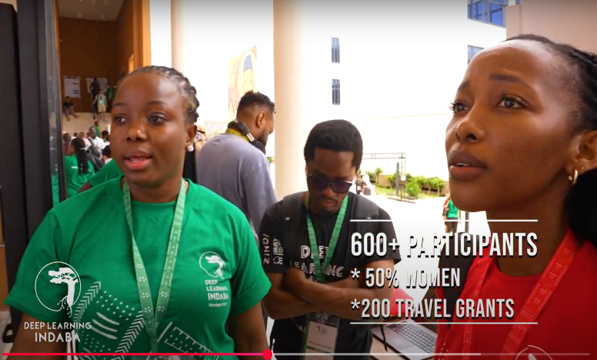
The 6th edition of the Deep Learning Indaba (DLI), held in September 2024 in Dakar, Senegal, brought together over 600 participants from Africa and beyond (50% women).
DLI is designed to position Africans as leaders in AI, instead of recipients of technology developed in the Global North. It brings a wide range of ecosystem actors, from students to research to private sector representatives. The impact of the Deep Learning Indaba has inspired the establishment of numerous IndabaX Communities (local AI communities and events) across Africa.
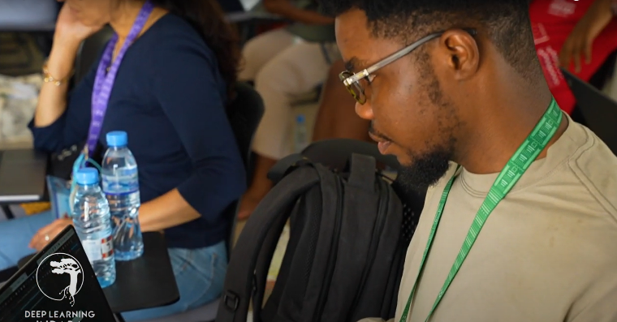
The AI4D programme’s support to the event improved its accessibility to Francophone stakeholders, through support for translation services. In addition, the programme conducted a workshop as a side-event, bringing together AI4D grantees to design the programme-wide MEL approach and to develop collaborative objectives across the innovations pillar. The event also allowed IDRC to convene a meeting of the Funders Collaborative to discuss joint investments and strategic global engagements, also providing an opportunity to engage in local expert consultations on coordinated approaches to African languages programming.
Highlight reel here: Deep Learning Indaba: Dakar, Senegal 2024 Highlight Reel - YouTube

B: THEORY OF CHANGE AND PROGRESS TOWARDS OUTCOMES

Summarise the programme’s theory of change, including any changes to outcome and impact indicators from the original business case.
The overarching goal of the AI4D programme is to support the research, development, and scaling of policy, innovations, and expanded leadership to spur a responsible AI ecosystem that improves the quality of life for all in Africa and beyond. The long-term intended IMPACT of the programme is to engender an inclusive responsible AI ecosystem that improves the quality of life for all in Africa and beyond.
AI4D’s impact statement is supported by two key OUTCOMES:
- Global, regional, national responsible AI policies and regulations are enacted to stimulate AI that is safe, inclusive, rights-based, sustainable, and reflective of local perspectives and which minimise potential harms from AI (such as human rights violations and increased social and gender inequalities for marginalised populations), measured by i) number of countries in Africa and Asia that improve their score on Global Index on Responsible AI
- Responsible AI innovations, that have been shown to address key development challenges in Africa (in the areas of gender, disability, health, education, environment, etc.) are appropriately scaled, measured by i) number of AI4D supported innovations that were effectively/appropriately scaled to support a development challenge; ii) number of beneficiaries reached, disaggregated by gender and people with disabilities; iii) additional funding secured by AI4D-supported innovations.
The programme’s activities contribute directly to six OUTPUTS:
- AI policy and governance: Local researchers have greater opportunities and skills to position the evidence they generated for use within global, regional, national policy and regulation.
- AI policy and governance: High-quality (gender and disability sensitive, locally driven) evidence on (i) AI governance and regulation, and (ii) the socio-economic and political effects, is funded.
- Data: Inclusive, robust data ecosystems are built locally through increased availability, findability, sustainability, and use of relevant and inclusive machine learning ready datasets.
- Talent and skills: Interdisciplinary labs and networks are created and strengthened to develop and apply responsible AI innovations.
- Innovation: Responsible AI Innovations, using both cutting edge and established AI solutions, are generated that address development challenges.
Scale: Responsible AI innovations with proven impact are supported in their scaling journey.
There are several assumptions within this theory of change:
- Continued relevance of AI will drive increased interest from funders and governments, leading to enhanced funding and demand for research and evidence.
- Leadership from local (southern) entities will result in more impactful outcomes.
- There is international interest in southern perspectives, research and evidence on responsible AI.
- Contextual evidence-informed policies and regulations will lead to a more responsible and inclusive AI ecosystem.
- New AI technologies will continue to emerge and/or evolve from existing applications. AI4D will need to remain flexible to maintain relevance and impact.
- Responsible and gender-sensitive AI innovation and research lead to more inclusive benefits from AI.
- Innovators and researchers are open to take on responsible and gender sensitive approaches.
- AI solutions have the potential to solve persistent social and economic challenges.
- Multidisciplinary teams are necessary for the development of responsible AI and high-quality research.
- Scaling pathways are different in different domains and will require different approaches.
There were no substantive changes made to the outcome and impact indicators during the reporting year. Changes were made to the output indicators, notably the removal of an output on convening funders around a common vision and approach to funding. Recognising that this is a rapidly evolving field, IDRC and FCDO will continue to jointly review the logframe and Theory of Change to ensure contextual alignment.
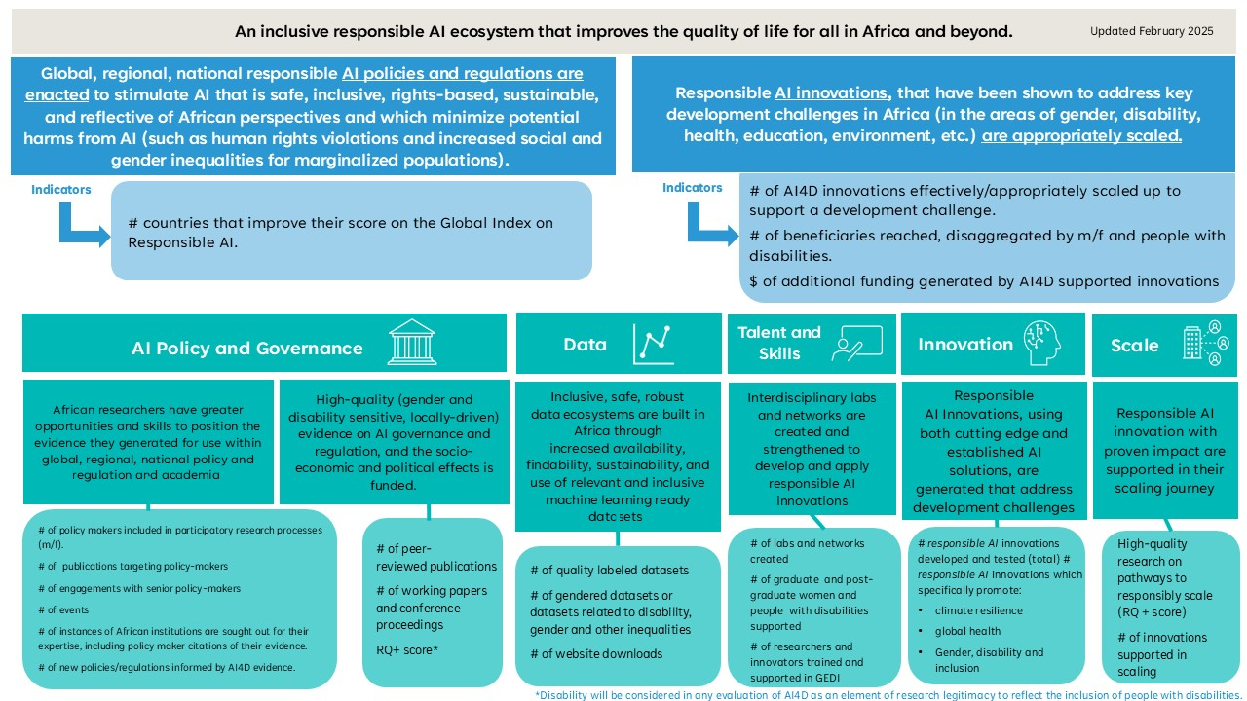
Figure 2: AI4D programme Theory of Change

Describe where the programme is on/off track to contribute to the expected outcomes and impact. What action is planned in the year ahead?
The programme has set up almost all the foundations and is on track to contribute towards the expected outcomes and impact. For this first year, milestones were not set for outcomes; rather, the programme has established the baselines for each outcome that will enable monitoring against outcome indicators in future years.

Outcome 1 (AI policies and regulations) is measured by the number of countries in Africa and Asia that improve their score on Global Index on Responsible AI. The first edition of the Global Index on Responsible AI (‘the Index’) was released in 2024, with the second edition expected to be released in mid-2026, as it takes roughly 2 years for data collection and analysis. Data collection for the second edition of the Index will commence in Q2 of 2025. The programme anticipates reporting a positive result on this indicator in the 2026/27 annual review. For the countries in which AI4D is active, the programme expects to see an improvement in the scores by the time the next edition of the Index is released.

Towards this outcome, the programme has provided multi-year support to three policy hubs in East, South and West Africa, the African Observatory on Responsible AI, and the African Union Development Agency (AUDA-NEPAD). Outputs from these partners are reflected below. These partners have been deeply engaged with policy processes in the region, and we anticipate that their efforts will contribute to countries enhancing their scores on the Global Index on Responsible AI.

Baselines for the three indicators for outcome 2 (AI innovations) were also established. The number of AI4D supported innovations that were effectively/appropriately scaled to support a development challenge (outcome 2.1) was set at one, based on a scaled solution from the first phase of AI4D (Jacaranda Health) that the programme is continuing to support on its journey to scale. Given the second programme phase is in its infancy, no additional innovations were ready for scaling in the first year.

The number of beneficiaries reached in the last reporting year, (outcome 2.2) was 1100 (milestone 1100, with 550 males, 550 females). Disaggregated data on this indicator was not available this year but will be reported in subsequent years. This figure can be attributed to innovations developed through the first phase of the AI4D programme, under the Innovation Hub on Artificial Intelligence for Sexual, Reproductive and Maternal Health in Africa (HASH). Innovations supported through this network continue to demonstrate the potential of AI in maternal healthcare applications (see box 2).

Most of the innovations supported through Phase 1 of HASH were chatbots targeting different groups (see box 3 below). These tools aimed to address gaps in knowledge around sexual and reproductive health, especially amongst young men and women. Building on this, Phase 2 will scale these efforts into a foundational SRMH conversational assistant, which will provide more functionality than a chatbot. Building on learning from the different tools developed under Phase 1, the aim is to create a flexible, accurate and user-friendly AI conversational agent that can be quickly scaled in sub-grantee countries.

The programme met its milestone to leverage £950,000 of additional funding for AI4D-supported innovations (milestone £950,000). The RAIL (KNUST) Lab in Ghana recently received a grant of €1.03m from the Embassy of France in Ghana in support of the Lab’s activities in AI in agriculture, health, energy, education, and advancing responsible and inclusive AI. This is an indication of the partners supported through the AI4D programme being increasingly seen as impactful in their initiatives to address key development challenges in Africa.

Box 2: Prediction of miscarriages among women seeking antenatal care in Uganda: A machine learning approach
In Uganda, one-third of women report at least one adverse pregnancy outcome during their lifetime with a higher incidence of pregnancy loss due to spontaneous or induced abortion or other causes.

James Bumba, a Masters student at Makerere University who participated in HASH Phase 1, carried out a project on predicting miscarriages among women seeking antenatal care in Uganda.

This project involved developing a machine learning (ML) model to predict miscarriage risk using a diverse dataset that included both socio-demographic and clinical variables. The model demonstrated the utility of ML in transforming predictive analytics in obstetrics, particularly in handling categorical and high-dimensional data effectively.

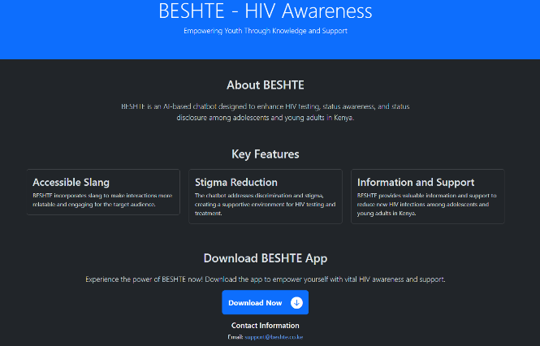
Box 3: BESHTE
Adolescents and young adults in Kenya are disproportionately affected by HIV/AIDS, accounting for 40% of new infections in the country, with females bearing a higher burden. Factors such as HIV-related stigma, inadequate knowledge, community norms and structural barriers hinder HIV testing and treatment behaviour among adolescent boys and girls and young men and women. Under HASH Phase 1, the University of Embu developed an AI-based chatbot, BESHTE, that incorporates slang to enhance HIV testing, status awareness and status disclosure while addressing discrimination and stigma towards adolescents and young adults seeking testing and treatment. The chatbot seeks to reduce new HIV infections among this group by providing information and support. BESHTE is multilingual, capable of conversing in English, Swahili, and Sheng.

The app has 500 young people in high schools and universities accessed the chatbot and interacted with it.

BESHTE was identified as a promising innovation and has been connected to the AI4D responsible AI mentorship process managed by ACTS, which began this year.

Justify whether the programme should continue, based on its own merits and in the context of the wider portfolio
The AI4D programme has demonstrated significant potential and strong initial performance, warranting its continuation. The programme has met all its logframe milestones, including the release of the first edition of the Global Index on Responsible AI and the successful scaling of responsible AI innovations that address key development challenges in Africa. These achievements align closely with FCDO’s strategic priorities, such as promoting inclusive and sustainable development, empowering marginalised populations, and fostering innovation.

The programme has also demonstrated good value for money, as evidenced by the significant additional funding secured by its partners, such as the €1.03 million grant received by the RAIL Lab in Ghana from the Embassy of France in Ghana. The programme is on track to achieve its outcomes, provided that the theory of change assumptions holds. Given its progress and alignment with broader departmental goals, the AI4D programme is well positioned to continue delivering impactful and sustainable outcomes, justifying its continuation within the wider portfolio.

C. DETAILED OUTPUT SCORING

 | AI for Development: Responsible AI, Empowering People (‘AI4D’)
Output Title | Researchers have greater opportunities and skills to position the evidence they generated for use within global, regional, national policy and regulation
Output number: |  | 1 | Output Score: | A++
Impact weighting (%): |  | 23% | Weighting % revised since last AR? | No

Indicator(s) | Milestone(s) for this review | Progress as of March 2025
1.1 Number of instances of policy makers included in participatory research processes (m/f). | 20 (5 female, 15 male) | Substantially exceeded: 66 (22 female, 44 male)
1.2 Number of publications targeting policy makers and decision makers​ | 9 | Substantially exceeded: 13
1.3 Number of engagements with senior policy makers | 22 | Met: 22
1.4 Number of events supported by AI4D | 10 | Substantially exceeded: 27
1.5 Number of instances of African institutions being sought out for their expertise, including policy maker citations of their evidence. | 20 | Substantially exceeded: 67
1.6 Number of new policies/regulations informed by AI4D evidence | 11 | Met: 11

Briefly describe the output’s activities and provide supporting narrative for the score.

This output captures the extent to which researchers have greater opportunities and skills to position their research to inform policies and regulations through engagements with policymakers, involvement in participatory research, and events.

This output scores an A++, as four milestones have been substantially exceeded and two have been met, which demonstrates the programme’s ability to successfully position researchers to influence AI policy and regulation.

Several mechanisms position the AI4D programme to influence responsible AI policy across the continent, including awareness-raising, engagements with policymakers, leadership in high-level events, and convening discourse events. Programme partners have become thought partners and trusted knowledge hubs for policy advice.

Publications targeting policymakers (output indicator 1.2) during this period included the ‘Por que es importante Regular la Inteligencia Artificial en El Sector de la Salud (Why is it important to regulate Artificial Intelligence in the Healthcare Sector?)’, published by the Sexual, Reproductive and Maternal Health Hub - Latin America & the Caribbean, led by Centro de Inteligencia Artificial y Salud para America Latina y el Caribe (CLIAS) in July 2024. This document analyses the need to establish a regulatory framework for AI in health, highlighting the importance of ensuring the quality and safety of the technologies implemented.

Indicator 1.3: The programme’s policy hub in West Africa, led by Niyel – a women-led, Senegal-based impact-driven advocacy firm - is steering collaboration between governments in several Francophone countries. Niyel ensures that governments understand the global context, respond to positive global pressure, and are clear and explicit about what they have to gain or lose from AI policy and implementation. Further, in January 2025, the Ministers of Higher Education, Research and Innovation; Minister of Communication, Telecommunications and the Digital Economy; and Minister for Agriculture, Food Sovereignty and Livestock as well as the UK High Commissioner to Senegal attended the launch of AI4D’s new multidisciplinary labs in the country. This highlights both the support of the local policy-maker community and the appetite for Senegalese government officials to partner with the labs on issues of related to AI policy (more information here).

Throughout the year, the African Union’s AUDA-NEPAD has led roundtable discussions, high level meetings, and country needs assessments towards policy outcomes involving the participation of policymakers, approximately 40% of whom were women, especially at the technocrat levels.

The African Observatory on Responsible AI co-convened a Wilton Park conference with FCDO, Google, and the African Leadership University on the transformative potential of AI in tackling some of Africa’s most pressing economic and societal challenges. The high-level event convened stakeholders from governments, civil society, academic and the private sector (including AI4D grantees) to foster collaboration and develop strategies to shape innovative, responsible and inclusive AI adoption.
Describe any changes to this output during the past year, and any planned changes as a result of this review.

Indicators 1.5 and 1.6 were moved from outcome 1 to output 1 given the strong contribution of AI4D funds towards those outputs and their direct implications for policy influence at all levels.

Progress on recommendations from the previous AR (if completed), lessons learned this year and recommendations for the year ahead.

Lesson learned: There is an abundance of opportunities for both grantee and programme-level engagement in national, regional, and global policy fora. The milestones need to better reflect this reality.
Recommendation: To ensure an efficient and effective use of human resources, the programme team will continue to develop a strategic engagement plan within the AI4D team, as well as assist AI4D projects in doing the same. These plans will be updated on an ongoing basis through regular consultation with key stakeholders. Timeline: ongoing.

 | AI for Development: Responsible AI, Empowering People (‘AI4D’)
Output Title | High-quality (gender and disability sensitive, locally driven) evidence on (i) AI governance and regulation, and (ii) the socio-economic and political effects is funded.
Output number: |  | 2 | Output Score: | A+
Impact weighting (%): |  | 23% | Weighting % revised since last AR? | No

Indicator(s) | Milestone(s) for this review | Progress as of March 2025
2.1 Number of published peer-reviewed publications | Not targeted | Not targeted:(2 (all have been published in peer-reviewed journals) recorded in the first reporting year: April 2024 to March 2025)
2.2 Research quality plus (RQ+) score * | Not targeted | Not targeted:(0 recorded in the first reporting year: April 2024 to March 2025)
2.3 Number of published working papers and conference proceedings | 10 | Substantially exceeded: 19

Briefly describe the output’s activities and provide supporting narrative for the score.
This output captures the quantity and quality of academic research that is produced on AI governance, regulation, and the socioeconomic and political impacts of AI. This output has been awarded an A+ grade. This is due to one indicator substantially exceeding expectations and two indicators not being targeted.

Indicator 2.1: Given that this is the inaugural year of the programme, the number of peer-reviewed publications has been understandably limited. This was anticipated due to the extended lead time typically required for the publication of peer-reviewed research.

While this indicator was not targeted for this year, two grantees published the following peer-reviewed articles during this reporting period:
- AI4AFS network, led by the African Technology Policy Studies Network (ATPS): PERSPECTIVE article in Frontiers, published in January 2025: ‘Enhancing Africa’s agriculture and food systems through responsible and gender inclusive AI innovation: insights from AI4AFS network’: This paper examines experiences from AI4AFS, highlighting a set of case studies of AI-driven solutions for pest and disease detection in 8 Sub-Saharan countries.
- SRMH Hub – South Asia, led by AI-Sarosh: Nature partner journals | digital medicine article, published in March 2025: ‘Transforming healthcare through just, equitable and quality driven artificial intelligence solutions in South Asia’: The paper explores the factors that enable or hinder the broader use of AI solutions in LMIC healthcare settings.

Indicator 2.2: Not targeted at this time due to the limited number of publications, which makes it challenging to determine an average rating of research quality. Currently, IDRC is unable to assess the quality of outputs using the Research Quality Plus (RQ+) framework, as this is the beginning of the programme and many research outputs were published towards the end of the reporting period. The assessment process is planned to commence in the coming year, with the aim of providing an average RQ+ score in the next reporting period.

Indicator 2.3: the programme almost doubled the annual target related to this output. Conference proceedings included contributions from the South Asian Sexual, Reproductive, and Maternal Health Hub (AI-Sarosh) at the 8th Global Symposium on Health Systems Research in November 2024. This platform enabled the team to share their findings, methodologies, and impact with a diverse audience of global health experts, fostering dialogue and collaboration on critical health issues.

HealthAI produced two working papers based on a needs assessment study that was conducted amongst researchers and innovators in the AI4GH network. This needs assessment aimed to understand their knowledge, experiences, and needs regarding AI regulation, Responsible AI, AI ethics, and gender equity in AI in health. The two papers discuss 1) How human factors influence AI development in LMIC contexts; 2) Navigating the complexities of building local AI governance in LMICs and the intrinsic motivation of individuals to practise Responsible AI principles. A key finding from the needs assessment was that in LMICs, cultural, linguistic, and economic diversity means that top-down AI solutions often fail to address local priorities and realities. Active human participation throughout the AI lifecycle—from design to deployment—is critical to ensuring that AI systems are responsive, ethical, and aligned with societal values. As such, it is essential to include multidisciplinary teams in the process. To ensure ethical AI, teams must include computer scientists, ethicists, healthcare professionals, and social scientists to anticipate risks, mitigate biases, and improve inclusivity.

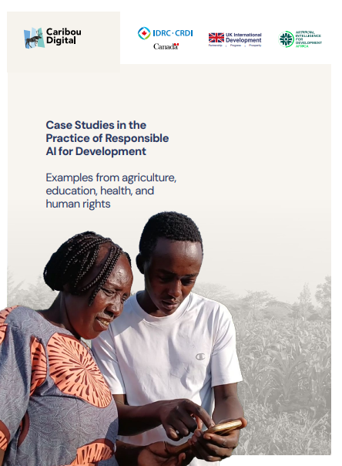
Box 4 - Caribou Digital: Case Studies in the Practice of Responsible AI for Development

In 2024, the AI4D programme commissioned a study to Caribou Digital to document promising use cases of responsible AI in international development. The goal of the study was to engage with projects that have implemented discrete AI use cases resulting in measurable impact and to learn from their practices, successes, and challenges, particularly around the responsible use of AI.
These cases involve both predictive and generative AI applications. The study, which was published in September 2024, draws on interviews with eight different organisations across various sectors, including health, education, agriculture, and human rights. Case studies featured three IDRC grantees: i) Jacaranda Health’s PROMPTS platform, an AI message triage tool; ii) RobotsMali’s project using AI to create local language schoolbooks, and iii) ACADIC, using machine learning to track Covid-19 in South Africa.

Describe any changes to this output during the past year, and any planned changes as a result of this review.
There were no changes to this output during the past year. Indicator 2.3 was significantly exceeded this year, resulting from increased engagements by AI4D-supported researchers in conferences, highlighting the quality of research that partners have produced. The programme delivery team will engage in more detailed discussions with AI4D grantees around their planned research outputs to adjust milestones for future years.

Progress on recommendations from the previous AR (if completed), lessons learned this year and recommendations for the year ahead.

Lessons learned: AI4D programme research grantees are producing more research outputs than originally anticipated. Whilst this is excellent for the programme, and the target for next year will reflect this, it also presents monitoring challenges as we attempt to stay up-to-date with all research publication output. To aid in this effort, IDRC programme staff are designing a streamlined monitoring and research output submission process.
Recommendations: The AI4D programme team should continue to engage with IDRC’s internal IT systems to streamline data collection related to the research outputs submitted by grantees. They are also exploring ways to integrate RQ+ assessments at the data collection point to increase ongoing monitoring effectiveness. Similarly, the programme team has adopted a new system for communicating key research outputs with the website management teams, so that new key outputs are posted to the website as soon as possible.

It is recommended to recalibrate milestones to be more realistic, given the discrepancy between expected and actual outputs. For example, the milestone anticipated 10 papers, but 19 were produced. The team should analyse these exceptional results to improve future milestone setting and programme planning.

 | AI for Development: Responsible AI, Empowering People (‘AI4D’)
Output Title | Inclusive, robust data ecosystems are built in Africa through increased availability, findability, sustainability, and use of relevant and inclusive machine learning ready datasets
Output number: |  | 3 | Output Score: | A+
Impact weighting (%): |  | 13% | Weighting % revised since last AR? | No

Indicator(s) | Milestone(s) for this review | Progress as of March 2025
3.1 Number of new labelled datasets to address an underserved population or problem, updated existing datasets to be more representative are produced or old datasets are updated to be more sustainable. | 3 | Moderately exceeded: 6
3.2 Number of gendered datasets or datasets related to gender inequalities | Not targeted | Not targeted: (0 recorded in the first reporting year: April 2024 to March 2025)
3.3 Number of datasets related to disabilities | Not targeted | Not targeted: (0 recorded in the first reporting year: April 2024 to March 2025)
3.4 Number of dataset downloads | 400 | Moderately exceeded: 513

Briefly describe the output’s activities and provide supporting narrative for the score.
This output captures the number of new datasets created to improve representativeness and minimise bias.

The overall score for Output 3 is A+ as the indicators that were targeted have moderately exceeded expectations.

Regarding output 3.1, grantees created six datasets across the following sectors during the last year – agriculture (1), health (3), energy (1) and languages (1). The RAIL (KNUST) Lab created 3 new datasets. These include:
- An Accent Classification Dataset (Ghana), which comprises audio recordings collected from native and non-native English speakers across various regions of Ghana (see box 7 below);
- a dataset that provides experimental data collected from a pilot agrivoltaic system in Ghana. The study examines the integration of solar energy production with crop cultivation under agrivoltaic photovoltaic (PV) panels;
- an Afrocentric crop disease dataset that offers a thorough understanding of disease patterns and manifestations by including annotated pictures of leaves from a range of crops.
The Sexual, Reproductive and Maternal Health Hub in Latin America developed 2 new datasets including a dataset that seeks to assist non-experts in accurately identifying relevant foetal images and potential anomalies during ultrasound exams. This is particularly important for low-income countries, particularly in remote communities with a shortage of trained sonographers and high maternal mortality rates, where developing AI tools to assist non-experts in accurately identifying relevant foetal planes and potential anomalies during ultrasound exams is crucial.
The programme exceeded its target for new labelled datasets (6 against a target of 3); indicators 3.2 and 3.3 on gendered datasets and datasets related to disabilities respectively, were not targeted this year.
The programme also slightly exceeded its target for indicator 3.4, which measures dataset downloads. Specifically, it achieved 513 downloads against a target of 400, comprising of downloads of datasets developed by the RAIL lab in Ghana. These achievements demonstrate that the programme has effectively met its overall expectations.


Box 5: Accent Classification Dataset (Ghana)

The Accent Classification Dataset (Ghana) developed by the RAIL (KNUST) Lab comprises audio recordings collected from native and non-native English speakers across various regions of Ghana. The dataset highlights the rich linguistic diversity and regional variations in spoken English within the country. Each participant contributed by reading the same three predefined scripts, ensuring consistency across samples. The recordings capture distinct accents and speech patterns, providing valuable data for linguistic analysis, accent classification, and speech recognition studies. This dataset is a vital resource for researchers and developers working on language processing, dialect identification, and regional accent modeling in Ghana and beyond.

Indicators 3.2 and 3.3 (Not targeted): Given most of the data work is planned on languages and that has been set up (only now close to being launched), many dataset outputs were not expected for this reporting year. Similarly, datasets specifically related to gender and disability will require dedicated dataset investments, which AI4D is currently scoping.

The datasets created (indicator 3.1) and downloaded (indicator 3.4) reported in this annual review were produced by AI4D’s multidisciplinary labs and innovation networks.

Describe any changes to this output during the past year, and any planned changes as a result of this review
There were no changes to this output during the past year. The milestones for the following years will be adjusted in line with what was achieved this year.

Progress on recommendations from the previous AR (if completed), lessons learned this year and recommendations for the year ahead
Lessons learned: AI4D programme research grantees are producing more datasets than originally anticipated, from more diverse sources (e.g., the labs have created several datasets this year).
Recommendations: The programme team has almost finalised the AI4D monitoring and evaluation form, which will be shared with grantees for feedback, to ensure ease of use and accuracy of reporting. While this is applicable to all indicators, for datasets in particular, the form will include functionalities to incorporate details on thematic areas as well as downloads.

 | AI for Development: Responsible AI, Empowering People (‘AI4D’)
Output Title | Interdisciplinary labs and networks are created and strengthened to develop and apply responsible AI innovations
Output number: |  | 4 | Output Score: | A+
Impact weighting (%): |  | 23% | Weighting % revised since last AR? | No

Indicator(s) | Milestone(s) for this review | Progress as of March 2025
4.1 Number of labs and networks | 25 | Moderately exceeded: 28
4.2 Number of graduate and post-graduate (disaggregated by M/F and people with disabilities) supported | 10 (5 female, 5 male) | Substantially exceeded: 19 (7 female, 12 male)
4.3 Number of researchers and innovators trained and supported in GEDI | 85 | Met: 85

Briefly describe the output’s activities and provide supporting narrative for the score.

This output captures the number of multidisciplinary labs created to support capacity development and strengthening, as well as the extent to which researchers and innovators are able to embed gender, equality, disability and inclusion (GEDI) principles in their work.
This output received an A+ rating, as one indicator was met, another moderately exceeded expectations, and a third substantially exceeded expectations.
Indicator 4.1 : Including all labs and innovation networks/hubs, AI4D now has a presence in over 36 countries. Over the past year, 12 labs in 11 countries were established or expanded, with FCDO support contributing to 10 of these labs. Additionally, 3 thematic innovation networks (HASH, GRAIN, and AI4AFS) and 4 health-focused innovation networks (one of which is a global hub managing 4 regional hubs, effectively making it 7 health networks) received follow-on grants.
The multidisciplinary AI4D labs supported by FCDO are located in Senegal (2 labs), Ghana, Nigeria (soon to be established), South Africa, Tanzania, Rwanda, Kenya, Uganda, and Ethiopia (soon to be established). Additionally, the AI4D labs in Burkina Faso and Mali, although funded solely by IDRC, benefit from being part of the AI4D network.

Indicator 4.2: the programme supported 19 graduate and post-graduate students (7 female, 12 male; against a milestone of 10). While there were no persons with disabilities amongst students supported in this year, this is anticipated to increase in the next year through a targeted scholarship launched by the African Centre for Technology Studies (ACTS) which will support 7 students with disabilities. This will include support to 4 PhD and 3 ECA AI research scholarships at sub-Saharan public universities.

Indicator 4.3: Inclusion considerations are in-built into programme design and integrated by project leads. For example, The Center for Artificial Intelligence and Health for Latin America and the Caribbean (CLIAS), which leads the Sexual, Reproductive and Maternal Health Hub in Latin America, established an interdisciplinary team composed of experts in gender studies, ethics, sexual and reproductive health, and maternal and child health. This team not only contributed key expertise but also guided the proposal submission process to ensure gender sensitivity. The calls for proposals required projects to explicitly integrate gender equality in their design, implementation, and outcomes. Additionally, projects were expected to actively engage affected communities in the research process, ensuring the representation of vulnerable groups such as adolescent women, migrants, Afro-descendants, LGBTIQ+ individuals, people with disabilities, and those living in poverty.

Researchers, funded through the Responsible AI and Inclusivity Theme of the RAIL (KNUST) Lab in Ghana are working on developing assistive devices for persons with disabilities. These researchers have received funding and other resources through computing power and partnership with the Department of Health Promotions and Disability Studies at KNUST. A total of seventeen researchers are working on assistive devices for persons with disabilities (PWDs) – these include an AI-enabled wheelchair (iWheel), and AI solutions for the visually impaired (iSee), and hearing-impaired (iHear). Partnering FCDO’s AT2030 programme with AI4D at the Ghana lab, guided by UCL’s Global Disability Innovation Hub, could accelerate assistive technology innovation for persons with disabilities.

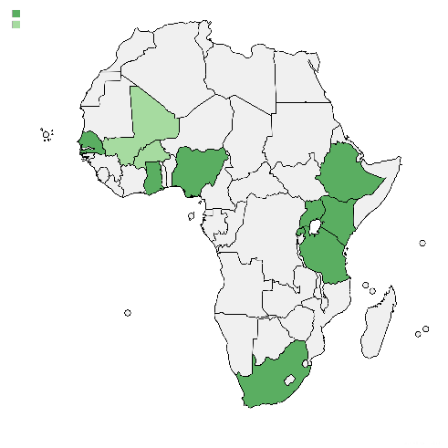
Box 6: Student Profile - Amina Salifu

Amina Salifu, a PhD student at RAIL (Ghana), is playing a leading role in mentoring and developing the talents of female researchers in AI through her activities in the Women in Data Science Ghana Initiative. She is an integral member of the Initiative and has led a series of training sessions for female developers. She made two presentations last year at IndabaX-Ghana and Deep Learning Indaba (Senegal). Her novel work in accent classification was judged among the best presentations at Deep Learning Indaba. She is a future research leader and a role model for female AI researchers at the Kwame Nkrumah University of Science and Technology (KNUST).

Figure 3. Country locations of AI4D’s multidisciplinary labs.
Note: countries highlighted in darker green are IDRC/FCDO-funded; those in lighter green are only IDRC-funded.

Describe any changes to this output during the past year, and any planned changes as a result of this review

There were no changes to this output during the past year.
Progress on recommendations from the previous AR (if completed), lessons learned this year and recommendations for the year ahead
Lessons learned: Innovators and researchers are most interested in GEDI mentorship and training that has a direct, technical relevance to their work.
Recommendation: AI4D will offer a streamlined version of the sociotechnical responsible AI mentoring (described in Output 6) to the labs

 | AI for Development: Responsible AI, Empowering People (‘AI4D’)
Output Title | Responsible AI Innovations, using both cutting edge and established AI solutions, are generated that address development challenges
Output number: |  | 5 | Output Score: | A+
Impact weighting (%): |  | 18% | Weighting % revised since last AR? | No

Indicator(s) | Milestone(s) for this review | Progress as of March 2025
5.1 Number of responsible AI innovations which specifically promote climate resilience | Not targeted | Not targeted: (0 recorded in the first reporting year: April 2024 to March 2025)
5.2 Number of responsible AI innovations which specifically promote global health | 47 | Substantially exceeded: 57
5.3 Number of responsible AI innovations which specifically promote gender, disability and inclusion | Not targeted | Not targeted: (1 recorded in the first reporting year: April 2024 to March 2025)
5.4 Number of responsible AI innovations which specifically promote education | Not targeted | Not targeted: (0 recorded in the first reporting year: April 2024 to March 2025)
5.5 Number of responsible AI innovations which specifically promote agriculture | Not targeted | Not targeted: (1 recorded in the first reporting year: April 2024 to March 2025)

Briefly describe the output’s activities and provide supporting narrative for the score.
This output captures the number of responsible AI innovations developed and tested, with a specific focus on innovations promoting climate resilience; global health; gender, disability and inclusion.

The overall score for Output 5 is A+ as the indicator that was targeted has substantially exceeded expectations.

Indicators 5.1, 5.3, 5.4, and 5.5 were not targeted this year, as the programme’s focus was on establishing the innovation networks and the responsible scaling hub (Output 6). In its first year, the AI4D programme established 3 innovation networks (Agriculture, Sexual, Reproductive and Maternal Health, and Gender), and strengthened 4 global-health focused hubs. The establishment and strengthening of these networks are already captured under output 2; however, they are essential prerequisites for the programme’s innovation work as the innovations are managed through these networks so are worth mentioning here for context. These initiatives are still in the early stages of selecting innovations to support. including some from the first phase and are now beginning to receive funding through FCDO. Despite not being targeted, indicator 5.3 and 5.5 moderately exceeded expectations (through the innovation work housed in the multidisciplinary labs, output 4).

Indicator 5.2. AI4D also finalised six supplements to global-health projects, including sexual and reproductive health hubs in South Asia, Latin America, and the Middle East as well as a global network focused on using AI for pandemic and epidemic preparedness (AI4PEP). Each of these projects leveraged IDRC-previous funding and work in AI for Global Health, allowing for a seamless continuation of existing programming and expanding the research and scaling funds available to ongoing projects. These four hubs operate using a hub-and-spoke model, sub-granting to AI and Global Health innovations in their regions, including the AI for mosquito classification project described in the box below.

AI4D’s responsible AI innovations in global health are outlined in the recently published discussion paper on Strengthening health systems through responsible AI, which was also featured in the monthly research roundup by the Center for Global Digital Health Innovation at Johns Hopkins University.

Box 7 - Mosquito classification in Ghana using AI-enabled acoustics
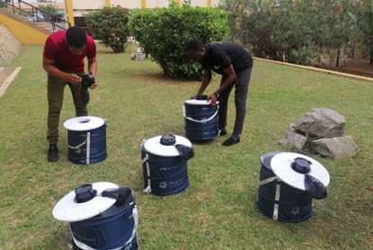
A team at Kwame Nkrumah University of Science and Technology in Ghana, supported through the AI4PEP project, is using AI to classify mosquitoes by species, count them, determine their age, and identify potential vectors of new pathogens. The team developed a deep learning model using a 2D convolutional neural network (CNN) trained on 25,344 audio recordings of mosquito wingbeats, achieving a 92% success rate. This innovative, non-invasive approach aims to improve targeted interventions for mosquito-borne diseases, with plans to expand its application to other regions. The project involves diverse stakeholders to ensure it meets the needs of vulnerable communities. This model is poised to enhance targeted interventions, particularly in regions like Africa, where mosquito-borne diseases are prevalent. Plans are underway across the AI4PEP network to leverage this work for other mosquito-borne diseases in Southeast Asia, South America and the Caribbean

Describe any changes to this output during the past year, and any planned changes as a result of this review

Following discussions with the programme team, this output has been disaggregated into 5 indicators to allow for measuring innovations across five key thematic areas.
Progress on recommendations from the previous AR (if completed), lessons learned this year and recommendations for the year ahead

Lessons learned: It has taken longer than anticipated to determine the appropriate approach and partner for the education, climate change and disability programming within AI4D, as these areas will be different from the previous AI4D programming with IDRC/SIDA.

Recommendations/Actions: Continue advancing the climate change innovation project, with an early allocation planned for 2025-2026. Begin consultations on AI4D’s approach to disabilities as approved for Q4 2024-2025. Additionally, leverage the design of the AI4D Funders Collaborative Sprint group to enhance the education network’s initiatives moving forward.

 | AI for Development: Responsible AI, Empowering People (‘AI4D’)
Output Title | Responsible AI innovations with proven impact are supported in their scaling journey.
Output number: |  | 6 | Output Score: | Not Targeted
Impact weighting (%): |  | 0% | Weighting % revised since last AR? | No

Indicator(s) | Milestone(s) for this review | Progress as of March 2025
6.1 High-quality research on pathways to responsibly scale (RQ+ score)* | Not targeted | Not targeted: (0 recorded in the first reporting year: April 2024 to March 2025)
6.2 Number of innovations supported in scaling | Not targeted | Not targeted: (1 recorded in the first reporting year: April 2024 to March 2025)

Briefly describe the output’s activities and provide supporting narrative for the score.

This output captures the support provided to responsible AI innovations with proven impact as they embark on their scaling journey. This output has not been scored because its indicators were not targeted. We did not expect to scale any innovations in Year 1, as we are still in the process of establishing the pipeline.

Indicator 6:1:
There are planned RQ+ assessments for research publications produced in association with output indicator 6.1. As the programme has just begun, no research publications related to pathways to scale have yet been produced. The programme has plans to begin a research activity on pathways to scale in 2025-2026 and, thus, will likely have research publications outputs to assess using the RQ+ framework starting in 2026-2027.

Indicator 6.2:
This year focused on establishing a responsible AI scaling support structure, with no scaled innovations anticipated. Despite this, the programme has made significant progress in laying the groundwork for future scaling efforts.

To support the scaling of responsible AI innovations through mentorship and capacity development (indicator 6.2), the programme has delivered a grant to the African Centre of Technology Studies, which hosts the Lab for the Ethics, Policy and Scaling of Responsible AI (LEPSAI). LEPSAI will support AI innovators in Africa to scale their solutions ethically through a mentoring programme where innovators will be guided by mentors selected from the GPAI-SRAI (Global Partnership for AI-Scaling Responsible AI Solutions) initiative. This initiative as well as the broader AI4D scaling efforts will be supported by the AI4D innovation database (provided separately) that was compiled earlier this year. This database is a key resource for both the AI4D programme and the AI4D Funders Collaborative as it consolidates all of the previously funded seed innovations from IDRC, GIZ, Gates, and USAID. The LEPSAI scaling mentorship programme is AI4D’s primary mechanism for achieving its objectives related to scaled innovations responsibly and appropriately.

The Global South AI for Pandemic Preparedness and Response (AI4PEP) Network seeks to address existing knowledge and practice gaps in the Global South by establishing a multi-regional network to deepen the understanding of how responsible AI solutions can improve public health preparedness and response. Researchers from this network have developed several innovations to address public health challenges. For example, this includes support towards AI_r, a technological innovation developed in South Africa that monitors air quality, providing a tool to help address a broad range of public health issues. The AI_r project in South Africa successfully scaled its AI-enabled pollution monitoring network, deploying 30 devices with plans for 120 more by 2025.

Box 8 -AI_r: Scaling local innovations in South Africa for enhanced pollution monitoring

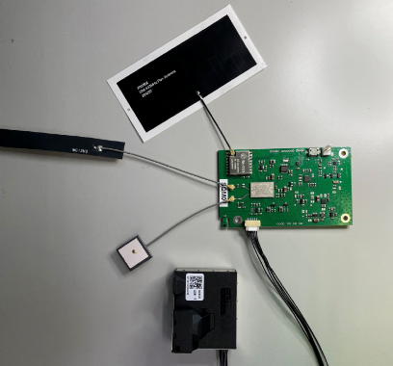
A multidisciplinary team at Wits University and iThemba LABS in South Africa, supported through the AI4PEP project, established a cost-effective, high-quality network of AI-enabled sensors across Gauteng province. These sensors, developed at a cost of about US$100 each, measure particulate concentration and provide real-time data to the South African Air Quality Information System (SAAQIS). The initiative involves community and governmental collaboration, ensuring transparency and public engagement. With plans to expand nationwide, the project seeks to improve air quality predictions and integrate data with public health interventions to reduce disease incidence. The first 30 devices were placed in Soweto, Braamfontein, Johannesburg and Kya Sands, with an additional 120 devices to be installed around Gauteng by 2025. This will be the largest and most cost-effective air quality network in Africa.

The project has secured an agreement with a leading Internet Service Provider in South Africa, Evotel, to leverage their infrastructure to deploy AI_r sensors nationwide. The AI_r project is working successfully with government and private sector partners to expand the reach of real-time air quality monitoring through sustained community involvement, reliable power supply, enhanced security and protection, and strong buy-in and support from government bodies.

AI4D programme staff are currently developing a project to help catalyse Jacaranda Health’s AI-enabled PROMPTS system to scale-up to new countries, while also conducting a concurrent retrospective and prospective learning agenda that distills keys insights of scaling up a digital innovation that can be shared with a global audience. This project will likely be a key mechanism for achieving the programmes appropriate scaling objectives as well as an important knowledge contribution in the AI for Development innovation space.
Describe any changes to this output during the past year, and any planned changes as a result of this review
There were no changes to this output during the past year.
Progress on recommendations from the previous AR (if completed), lessons learned this year and recommendations for the year ahead
Lessons learned: While several responsible AI mentoring tools exist, to our knowledge, there is no literature related to the implementation of these tools, certainly not in the African context. Therefore, the AI4D responsible AI LEPSAI mentorship process is truly unique and innovative. This carries with it challenges as the programme looks to build a mentorship process that pulls from widely accepted responsible AI principles and consolidating across different frameworks and implements this in a way that is applicable for different mentors who are support innovators whose tools are at different development stages.
Recommendation: LEPSAI will continue to take a reflective and iterative approach to the responsible AI mentorship process, adjusting their approach and documenting their learning as they go. This will allow the programme to proceed with offering responsible AI mentorship support while also ensuring that emerging best practices are applied and communicated to broader innovation and research communities.

D: VALUE FOR MONEY

Key cost drivers and performance
The key cost drivers of the programme have remained consistent with those outlined in the approved business case. Specifically, these are research grants, staffing, travel, and dissemination events.
- The largest cost driver relates to research costs, of which a majority contributed directly to grants, with a smaller proportion going towards portfolio level activities, such as scoping studies and knowledge sharing.
- Other cost drivers include staff remuneration, and travel and engagement.

The AI4D programme has adhered to the proportions indicated in the table below.

Programme Activity Strand | % total FCDO budget (Apr 2024 - Mar 2025) (£) | Cost drivers
Research and dissemination | 86.0% | Grantee payments, external consultancy
Programme delivery | 4.9% | Staff costs, travel costs
Indirect costs | 9.1% | Indirect costs
Total | 100.0%

VfM performance compared to the original VfM proposition in the business case
The Value for Money (VfM) proposition outlined in the Business Case identifies several strategies to achieve VfM: (i) reducing expenditure on programme inputs; (ii) efficiently converting these inputs into outputs; (iii) wisely transforming outputs into impact; and (iv) ensuring fairness by considering inclusion and equity. Overall, the VfM proposition in the Business Case remains robust, as demonstrated by the table below, which illustrates how the programme delivers value for money.

Economy (inputs, i.e. spending less). Using the lowest cost use of goods and services within a project and ensuring and that input unit costs are benchmarked against market norms | - The current phase of the AI4D programme builds on existing structures that were set up and contextual knowledge derived from learnings during the first phase of the programme. This has allowed for minimising the costs of set up and delivery of the programme.  - AI4D drives economy through scrutiny of budgeted and actual costs of each grant. IDRC reviews budgets and expenditure and projects comply with IDRC day rates and expenses policies, which are consistent with FCDO’s. All out-sourced components are procured through competitive procurement ensuring VfM and comply with IDRC agreed rates and expenses policies. Technical experts are carefully selected and use approved IDRC rates. Management and administrative fees are as agreed with FCDO.  - Prior to contract signature, due diligence checks evaluate risk, and payments and payment schedules are adjusted accordingly.  - Travel and Subsistence (T&S) costs are proportionate to activities and the budget and are scrutinised by the Programme Management Unit.
Efficiency (i.e. spending well). This refers to ensuring the quality and quantity of inputs are appropriate to achieve the envisaged outputs and that inputs are managed in an efficient way during project delivery | - Since the establishment of the second phase of the AI4D programme, 34 grants have been issued, ensuring that the foundations for the programme are sufficiently set up. This includes the set up of a total of 12 multidisciplinary labs to date.  - IDRC continues to leverage the breadth of its research capacity across its networks to ensure the utilisation of high-quality expertise when designing projects and ensuring their sustainable impact. This approach not only enhances the efficiency of project implementation but also contributes to achieving cost-effective outcomes.  - Day-to-day operations of projects are managed by Programme Officers (POs) who are also able to draw on the substantial financial and programme management capabilities of IDRC.  - Through the activities of grantee partners, the programme has built a positive reputation among the development donor community, which has allowed the programme as well as grantees to secure additional funding. For example, this includes a grant from USAID. In addition, IDRC has been engaged in direct consultation with Global Affairs Canada on potential additional funding towards compute, directly aligned with the AI4D programme’s outcomes.  - IDRC has also been working in concert with the Gates Foundation to ensure that investments are complementary and help to build common outcomes – an example of this is the African Languages initiative, designed jointly, and funded jointly by the Gates Foundation.
Effectiveness (i.e. spending wisely). Demonstrating that the chosen outputs are the most effective way to achieve the outcome | - Grantee partners continue to be sought out as key thought partners by governments and international bodies in the formulation of responsible AI policies at all levels. A key example of this is the direct involvement of several grantees in the drafting of the African Union Continental AI Policy and implementation plan. Such evidence is aligned with IDRC’s approach towards translating locally-led research into impact at scale.  - The Lab for the Ethics, Policy and Scaling of Responsible AI (LEPSAI) at the African Centre for Technology Studies has supported 13 African AI innovators with scaling their responsible AI solutions within the last year. These innovations aim to address development challenges across health, climate and environment, education, and agriculture.
Equity  This considers how the needs of poor and marginalised groups are incorporated | - Fostering inclusion is a core tenet of the AI4D programme. Based on learning from the first phase of the programme, there was a need to expand and improve the responsible AI implementation efforts and Gender Equality, Disability and Inclusion (GEDI) learning for the second phase of the project. Given this, the programme is working with Ladysmith and Gender at Work, consultants with expertise in gender and inclusion, to ensure that GEDI issues are understood and addressed at all levels within project teams. The project will support individual capacity strengthening in developing and deploying inclusive AI systems as well as fostering stronger institutions working in the AI space from a GEDI perspective. This is expected to influence the broader AI and research ecosystem toward inclusion as a central consideration in building new tools or implementing AI policies.  - The Lab for the Ethics, Policy and Scaling of Responsible AI (LEPSAI) at the African Centre for Technology Studies recently disseminated a request for proposals targeting persons with disabilities for 4 PhD and 3 Early Career Advancement AI research scholarships at sub-Saharan public universities. Submissions are ongoing, with results forthcoming in the next annual review.

Assessment of whether the programme continues to represent value for money
The AI4D programme continues to represent value for money. It has effectively leveraged existing structures and networks to minimise costs while maximising impact. The programme's achievements in establishing 12 AI labs, three AI policy hubs, and three thematic AI innovation networks across multiple African countries, along with securing additional funding from donors such as USAID and the Gates Foundation, demonstrate its efficiency and effectiveness. The focus on inclusion and equity ensures that the benefits of AI are broadly experienced, particularly among women and marginalised groups. Additionally, the programme's efforts in fostering responsible AI practices and influencing AI policy processes at various levels highlight its strategic alignment with broader development goals. Given these accomplishments and the robust internal management practices deployed by IDRC, the programme is well-positioned to continue delivering value for money and achieving its intended outcomes.

E: RISK

Overview of risk management
The overall risk rating for the AI4D programme is moderate and in line with FCDO’s risk appetite. The ‘Strategy and Context’ and ‘Policy and Programme Delivery’ categories are rated ‘Receptive’, accepting major risks, and the other categories are rated ‘Cautious’, accepting only moderate risks. There are no risks across the programme that sit outside these appetites. An overview of key risks is provided in the table below.
Some of the key risks and actions from this reporting period include:
Policy & Programme Delivery risk – Moderate (no change from Business Case): IDRC is currently assessing the level of programme delivery risk related to new government of Canada restrictions on research funds going to Named Research Organizations (i.e., Government of Canada research funding institutions are not permitted to fund researchers with affiliations at NROs). As a Government of Canada research funder, IDRC will apply these guidelines to their programming, which could constrain IDRC’s granting to certain institutions that may have affiliations with Named Research Organisations in the Indo-Pacific. IDRC is currently undertaking a bibliometric study to explore the prevalence of researchers in LMICs in the Indo-Pacific who are affiliated with NROs to determine the actual potential effect of this new policy on AI4D’s programme deliver. Based on the findings of that research, IDRC will adjust as needed to ensure minimal effects on the AI4D programming in the Indo-Pacific. The programme team continually monitors risks and assigns mitigating actions and discusses any updates to the risk register.
Overall, AI4D has demonstrated its ability to deliver its programming - contracted 34 new projects during the previous reporting year. The programme and management team will continue to monitor the project pipeline, as well as extending the programme into the Indo-Pacific in 2025-2026.
The following two minor changes to existing risks were identified and discussed this year. These have no effect on overall programme risk.
- Limited Absorptive Capacity of African institutions: with the increasing efforts towards a coordinated investment in compute and African languages from the AI4D Funders’ Collaborative, governmental institutions, and private sector actors, it is more likely that a large influx of funds will be invested in Africa. This still risks overwhelming the relatively small number of institutions; however, in addition to previously highlighted mitigation strategies, IDRC is exploring the possibility of integrating higher-capacity intermediary organisation(s) to take on funds while promoting local leadership and supporting African institutions through financial capacity strengthening. Relatedly, there has been a spike in government interest in AI4D; however, all members of the AI4D Funders’ Collaborative continue to work very closely to align funding priorities and avoid duplication of efforts.

- Downstream partners in fragile or unpredictable regions: In relation to the increased conflict in the Middle East, IDRC continues to work with the appropriate contacts to ensure plans are in place for any potential adjustments necessary in our protocols and operations. IDRC continues to also work collaboratively with FCDO on our management of (a limited number of) sub-granted projects in high-risk regions.
Safeguarding risk – Minor (no change from Business Case): The FCDO will continue to work with IDRC by regularly monitoring and evaluating safeguarding practices, providing ongoing training, and ensuring robust reporting mechanisms. IDRC will integrate safeguarding commitments into agreements, enforce a zero-tolerance policy on mishandling disclosures, and foster continuous improvement through feedback and collaboration. This partnership aims to uphold the highest ethical standards and protect vulnerable persons effectively.
The programme team continually monitors risks, assigns mitigating actions, and reviews these with the management team on a quarterly basis.

F: PROGRAMME MANAGEMENT: DELIVERY, COMMERCIAL & FINANCIAL PERFORMANCE

The current phase of the programme has an approved FCDO budget of £53 million, of which £6,455,678.00 has been disbursed to date.

AI4D’s total budget for the last financial year was successfully allocated in line with the programme priorities, with a total combined programme spend from FCDO and IDRC of £ 7,505,299.00.

The financial performance of the programme continues to be tracked by FCDO and IDRC staff which ensured the FCDO’s budget for the last financial year was achieved as planned, with an annual budget variance of 7.1%.

The AI4D programme is governed by an executive committee and management group.

The Executive Committee (made up of one senior staff member from FCDO and IDRC) serves as the highest governing body for AI4D, accountable for the overall assurance of the portfolio, ensuring it can deliver the programme objectives and that it provides value for money. It is responsible for:
- regularly reviewing strategic direction and aims, ensuring appropriate strategies and procedures are in place to support delivery of AI4D objectives
- approving business plans, policies, procedures, and budgets;
- monitoring operational performance and reviewing Annual Work Plans and reports, ensuring implementation is robust in terms of its objectives, performance measures, investment priorities, and affordability;
- setting the risk appetite within AI4D given the context of the funding partners’ own policies and procedures
The Management Group serves as the operational management body for AI4D, responsible for reviewing the Delivery Unit’s (IDRC’s) proposed business plans, policies, procedures, and budgets for recommendation or approval by the Executive Committee. It monitors the performance of the portfolio and manages the risk profile of the AI4D portfolio. In addition to regular informal meetings between IDRC and FCDO Responsible Officer from relevant divisions, the management group meets on a quarterly basis to discuss financial and programmatic progress and make adaptive management decisions.
From a programme management and delivery perspective, IDRC has demonstrated flexibility in adapting to changes in FCDO reporting and financial requirements. Through close internal collaboration and innovative approaches, IDRC has enhanced its ability to manage expenditures in alignment with financial targets. The Asia supplement has benefitted from these lessons through a refined budget design, with FCDO and IDRC each covering specific line items at 100%. This ensures the programme avoids the double burden of seeking financial approvals from both FCDO and IDRC for every project.
The programme management structure continues to work well. FCDO staff will continue to work closely with IDRC to ensure the programme continues to progress towards its objectives.

G: MONITORING, EVIDENCE AND LEARNING

Monitoring
During the review period, monitoring activities ensured effective implementation and informed programming decisions. Regular field visits and reviews facilitated direct engagement with grantees and beneficiaries, fostering real-time feedback and adaptive management. Collaboration with private, public, academic, and civil society representatives in Asia and globally kept the programme aligned with community needs.
In February 2025, a major consultation workshop alongside RightsCon gathered diverse stakeholders, with insights currently being analysed by Digital Asia Hub. They also conducted a scoping exercise to identify innovative and scalable AI4D R&D investment opportunities.
IDRC’s digital solutions team developed an internal monitoring and evaluation form to streamline data collection and improve cost-effectiveness. The Annual Review process included input from both internal and external contributors, including an IDRC-commissioned evaluation of Phase 1, which provided critical insights for future improvements. Monitoring efforts will also support the storytelling and outcome harvesting initiative to capture and share lessons and successes.
Feedback from a grantee highlighted the need for adjustments in the mentorship structure and the redesign of scholarship calls. The mentorship work package saw the development of a draft mentorship playbook template and the identification of a responsible AI toolbox in collaboration with partners. The scholarship work package was redesigned to address the low response rate from female PWD candidates, leading to a combined evaluation process for both PWD and women candidates. Grantees reported a smooth transition since FCDO’s joined the programme, with no major change in overall direction. They acknowledged the importance of the programme to continue promoting networking and collaboration across Africa and sectors, to further expand understanding and application of inclusion and safety by design.
Evaluation
The Phase 1 evaluation underscored AI4D’s role as an early investor in Africa’s AI ecosystem and a champion of ethical AI adoption. It highlighted the programme’s commitment to integrating Gender Equality, Diversity, and Inclusion (GEDI) principles. Monitoring data aligned with the ‘Leave No One Behind’ agenda by disaggregating information by age, sex, disability, geography, and other key variables to promote inclusive development.
AI4D-supported experts played a significant role in drafting national and continental AI strategies, reinforcing the importance of ethical AI policy development. These insights will inform future programme strategies, ensuring that AI-driven solutions continue addressing critical challenges in a responsible and inclusive manner.
Evidence
As AI4D plans to expand into Asia in 2025, a scoping exercise by Digital Asia Hub is guiding programme design, implementation, and operational frameworks. Evidence gathered through desk research, on-site studies, and stakeholder consultations will help identify innovative and scalable AI4D R&D investment opportunities. This evidence is crucial for supporting the region in achieving its SDG targets safely, inclusively, and responsibly.
Feedback from a grantee also provided valuable evidence for programme adjustments. For example, the shift from a 3-tier to a hybrid 2- and 3-tier mentorship model was necessary to enhance direct interaction between mentors and mentees. This change was informed by experiences and feedback from previous mentorship initiatives.
Learning
Over the past year, AI4D has implemented various learning processes to capture and share insights, new evidence, and expertise. Workshops—such as the one held in Senegal during Deep Learning Indaba 2024—facilitated peer learning and knowledge exchange among grantees. The newly launched AI4D website enhances communication and collaboration, with plans for expanded functionalities.
The storytelling and outcome harvesting initiative aims to document and share key lessons and success stories across the programme. Notable lessons include the impact of early investment in Africa’s AI ecosystem, the role of programme partners as trusted experts in responsible AI policy, and the development of AI-driven solutions tackling challenges in agriculture and food systems.
Feedback from a grantee emphasised the importance of adaptability in programme design. The need to revise the mentorship structure and redesign scholarship calls underscored the importance of flexibility to meet emerging needs and challenges. Ensuring inclusivity in calls for proposals and mentorship programmes is crucial for reaching a diverse range of beneficiaries and achieving broader impact. Another grantee also called for flexibility and adaptability to respond to the fast-changing AI landscape to ensure AI4D can respond to new challenges and trends.
Looking ahead, AI4D’s learning priorities include fostering knowledge-sharing discussions among grantees, enhancing the AI4D website for improved communication, and advancing the storytelling and outcome harvesting initiative to capture and disseminate valuable lessons. Insights from monitoring efforts will continue to inform these learning processes, ensuring continuous programme refinement and impact.
The Annual Review was led by the FCDO programme lead and programme manager. It was quality assured by the team’s portfolio lead.

Date of last narrative financial report | 31 December 2024 | Date of last audited annual statement | 31 March 2024

£63.6m including IDRC co-funding
Research Quality Plus (RQ+) was developed by IDRC as a flexible and holistic approach for evaluating the quality of research for development. This approach embraces a broad definition of research quality that includes scientific rigor but also recognizes other critical dimensions. RQ+ takes contextual factors into consideration, includes customizable assessment rubrics, and promotes the use of empirical evidence to inform expert evaluations of research quality. For further information see: Research Quality Plus | IDRC - International Development Research Centre

