Business Case Template - Smaller Projects in programmes

Portfolio/ Business/Country Plan Summary
HMFD Business Plan Goal 5: Robust diplomatic support to cross-HMG work to reduce irregular migration to the UK including work to increase returns; alongside efforts to ensure a fair and effective visa system.
Programme Title: BIOT voluntary returns and reintegration
Programme summary (100 words maximum):
A tailored package of support to incentivise the voluntary return of irregular migrants currently on BIOT. The proposed package, approved by Ministers at the BIOT Migrants Small Ministerial Group, is ODA-eligible and includes initial finance support, accommodation, education, training and employment support.
Programme Value: up to £300,000 over three years |  | Directorate/Department/Post/ Region or Sector:  Migration and Demining Department
Post confirmation of review processes  N/a |  | Confirmed
Contact names |  | PRO/SRO: Greg Houston
Threshold for final approval of Business Case: Head of Migration Department
Business Case approval: | 02/10/2024 | Name and role of Approver: Greg Houston
Programme Code: | Programme Start Date: 02/10/2024 |  | Programme End Date: 02/10/2027
Overall risk rating: | Minor
Teams link: | MDD BIOT channel

Business Case
For a Smaller Projects programme

Strategic Case

- What are the context issues/ problem you plan to address through your programme outcomes?

- A total of 349 (mostly Sri Lankan Tamil) migrants arrived on BIOT between October 2021 and December 2022. 135 have left voluntarily on flights back to Sri Lanka and 150 independently on their own boats. 64 remain, 8 of whom are currently in Rwanda for medical treatment. Among the 64, 39 pose safeguarding or international protection concerns. This includes children and their families, victims and potential victims of abuse, and individuals with complex and long-term medical needs.
- What are the intended policy objectives/outcomes for the programme?

To incentivise and facilitate the safe voluntary return and reintegration of migrants to Sri Lanka.

- What is the rationale for FCDO spending?

- The situation requires an urgent solution because:
- There are significant safeguarding risks to some of the migrants (especially children). Two migrants have been convicted of sexual offences against children and vulnerable women and there are credible allegations that young children and adolescents have been sexually abused. More broadly, life on BIOT is highly challenging and potentially dangerous for the migrants due to the difficult conditions there and lack of facilities. They are housed in a camp within sensitive US military facilities on an island with no permanent habitation.

- We face mounting litigation from the migrants, in multiple courts and against multiple defendants, including that focussed on the conditions that they are currently living under.

- There is an ongoing cost to the UK of circa £50m per annum while the migrants remain on BIOT.

- What are the risks associated with this programme and potential individual projects?

Limited risk to project delivery. It is the same approach that the UK uses elsewhere to support voluntary returns and reintegration and IRARA have worked frequently for the Home Office as a Trusted Provider. IRARA have a strong track record and have successfully managed complex reintegration processes worldwide based on the same approach. There is a risk that few migrants choose to take up the offer but that costs are incurred.

- How will the programme ensure compliance with FCDO rules/commitments on:
- ODA eligibility
- Gender equality.
- Disability inclusion
- Public Sector Equality Duty
- Inclusive Data Charter Action Plan - GOV.UK (www.gov.uk)
- Safeguarding, against Sexual Exploitation, Abuse and Harassment.
- Impact on climate and the environment.
- Human rights (HR) assessment.

Appraisal Case

- Describe the criteria under which each Project in the programme will selected for funding.
.

It is a single project. Criteria include ability to deliver a comprehensive reintegration package on the ground in Sri Lanka and the ability to operationalise that within weeks.

- How will value for money be delivered throughout the programme and in each project?

IRARA have agreed cost reductions for both fixed costs and the cost per migrant as part of our negotiations with them. FCDO will monitor delivery to ensure effective delivery and ongoing value for money.

- What do you anticipate the maximum project value will be?

This will depend on how many migrants choose to take up the offer. For planning purposes, we estimate that up to ten would at a cost of up to £300,000.

Commercial Case

- How will delivery partners be selected? What funding arrangements are likely to be used?
The Home Office operates a focused Returns Reintegration Programmes to 11 priority countries where delivery is linked to maintaining or improving returns cooperation. Following a competitive tender exercise to identify the most appropriate reintegration delivery providers across priority returns countries, the Home Office selected IRARA and two other main organisations to deliver these services. IRARA delivers reintegration services in nine of eleven countries and is a globally recognised organisation with extensive experience in managing very complex return and reintegration programmes. IRARA have staff on the ground in Sri Lanka and substantial experience in returning Tamils.

IRARA were selected as a Trusted Partner able to operate at the speed required for this urgent Ministerial priority. An initial one-month upfront (25%) payment will be made to hem, followed by quarterly payments in advance over the subsequent period of the contract. Prior to those quarterly payments being made, monthly project and financial reviews will be undertaken by the project team responsible to ensure that the funds are being spent correctly and milestones achieved. Once proof of spend has been evidenced, further payments will then be made, however no additional payments will be issued where IRARA may have funds remaining ahead of each subsequent quarter.

- How will the programme manage the risk associated with delivery through each partner?
Specifically how you will approach due diligence on partners in a proportionate way beyond the necessary background checks on potential partners.

FCDO is relying on Due Diligence of IRARA carried out by the Home Office. As it progresses, the project will be scrutinised by the SRO.

Financial Case

- Outline the total budget, its source and where applicable the allocations for each financial year for the programme.

Up to £300,000 over three years. The planning assumptions assume 10 migrants will accept the offer but it is likely to be fewer than that so costs are likely to be lower. Migration Department has the funding available, drawn from a recent uplift to upstream migration funding.

Management fees:
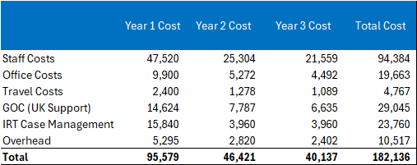

Costs for services:
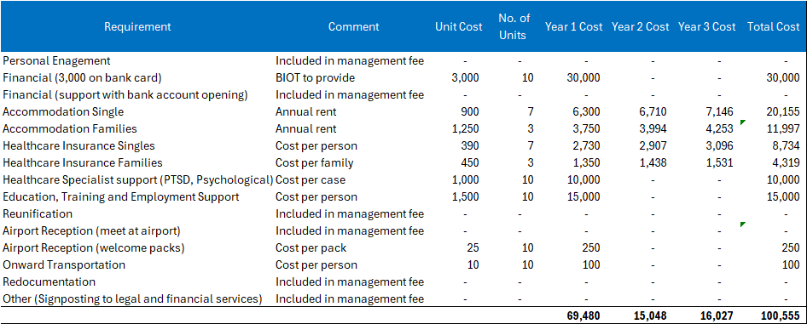

- How will you manage financial risks?
This includes how you will ensure funding is paid to the intended recipient and only be used for the purposes formally agreed. This could be as simple as, for example, receiving receipts, checking that an event took place by attending, or doing (post event/delivery) checks. Where applicable, indicate how FCDO funding will be tracked, and how often forecasts will be updated.

An initial one-month upfront (25%) payment will be made, followed by quarterly payments in advance over the subsequent period of the contract. Prior to those quarterly payments being made, monthly project and financial reviews will be undertaken by the project team responsible to ensure that the funds are being spent correctly and milestones achieved. Once proof of spend has been evidenced, further payments will then be made, however no additional payments will be issued where IRARA may have funds remaining ahead of each subsequent quarter.

Management Case

Governance arrangements and Programme Management Team
- How will the programme be managed and governed?
Include the governance mechanism for selection and approval of individual projects, who will take on the roles of the Senior Responsible Owner and Programme Responsible Owner, and how Project Officers/Leads will be assigned.

The SRO is Greg Houston and the Project Officer is Ian Ball. Migration Department has significant experience of managing project delivery and the project will be managed and overseen as part of Migration Department’s wider portfolio of programming.

Monitoring and Reporting
- Please describe the lines of accountability, responsibility, and reporting from projects to the programme and the portfolio. Also describe how projects delivery will be monitored

Reporting mechanisms will be confirmed when the number of migrants and taking up the offer, and therefore the scale of activity, is confirmed. We will meet with IRARA regularly over the first quarter – at least every 4 weeks; subsequent monitoring will be based on how many migrants accept the voluntary offer and when.

Risks
- Summarise the main risks to the programme and mitigation measures as appropriate.
Describe who owns the risks for the programme, and where appropriate for individual projects. For example, stating the name of the specific team that owns the risk.

You may wish to use a table like this to summarise risks.

Programme risk will be held by SRO for this project, being regularly reviewed in collaboration with programme colleagues who are brought in to support. A risk register will be developed as part of the inception period, and standard FCDO policies on safeguarding, fraud, political and climate risks will all be included in the contract.

Risks | Likelihood (no mitigation) | Impact (no mitigation) | Mitigation
Safeguarding: It is possible that the Sri Lankan authorities may see returnees as suspect and push for information on them given that many previously fled as refugees to India. | Low | Medium | IRARA’s robust approach to data protection.
Reputational and Fiduciary: The project is a fairly standard voluntary returns and repatriation package being delivered by a Trusted Provider so the risks are low. There is a risk that the project’s perceived interaction with ongoing legal disputes is perceived negatively. | Low | Low | Strong project oversight and financial controls in place. Comms plan in place to explain the rationale and nature of the project.
Political: There is a risk that the project’s perceived interaction with ongoing legal disputes is perceived and portrayed negatively. | Low | Low | Comms plan in place to explain the rationale and nature of the project,

State the overall programme risk assessment, and whether it is within the overall risk appetite.

