Programme Completion Review

Title: Facility for Oil Sector Transformation 2
Final Programme Spend £ (full life):  Budget £18,998,200  Spend: £17,069,409 | Review Date: | 30 Sept 2023
Programme Code: 205126 | Start Date: | End Date: 30 June 2023

Summary of Programme Performance

Year | 2016 | 2016/17 | 2017/18 | 2018/19 | 2019/20 | 2020/21 | 2021/22 | 2023 PCR
Programme Score | Inception | A | A+ | A | A+ | A | A | A+
Residual Risk Exposure Rating | Medium | Year 1  Medium | Year 2  Medium | Year 3  Medium | Year 4  Medium | Year 5  Medium | Year 6  Medium | Year 7  Medium

DevTracker Link to Business Case (and any addendum): | http://iati.FCDO.gov.uk/iati_documents/32808415.odt
DevTracker Links to all logframes used during programme lifetime: | http://iati.FCDO.gov.uk/iati_documents/5748730.xlsx

A. Summary and Overview

Description of the programme and what it has achieved

- FOSTER (Facility for Oil Sector Transparency and Reform) 2 was a seven-year project (July 2016 to June 2023) designed to transform the oil sector for the benefit of Nigeria. Oxford Policy Management (OPM) managed the Foreign, Commonwealth and Development Office (FCDO) contract to deliver FOSTER 2. FOSTER 2 was a programme designed to enhance a more effective use of Nigeria's extractives industry resources to support national development, initially over a five-year period, July 2016 to June 2021, then extended to June 2023 with a focus on climate change. It was the successor programme to the Facility for Oil Sector Transparency and Reform (FOSTER 1), which ran from 2011 to 2016.

- FOSTER became a valued, trusted part of the oil and gas ecosystem in Nigeria, supporting government, accountability bodies, private sector and civil society to strengthen the management and transparency of the sector. Significant sums of government revenues which were generated or safeguarded are clearly traceable to FOSTER’s activities. The programme increased the speed, quality and scale at which improvements took place in the sector. FOSTER increased the likelihood of major reforms taking place when the political and economic context allowed. Removal of the fuel subsidy and approval of the PIA are examples where FOSTER increased the chances of success and in some respects improved the quality of reforms.

- Work on the fuel subsidy and on gas flaring and emissions reduction directly supported the UK’s macroeconomic reform objectives in Nigeria by increasing revenues and reducing wasteful expenditure. This work also supported climate change objectives by encouraging the proper, economic pricing of fossil fuels. Systematic evidence gathered by FOSTER from clients on its achievements and corroborated in FCDO annual interviews supports a narrative that the programme helped shape outcomes positively.

- FOSTER was affected by the impact of the Covid pandemic on the UK (United Kingdom) economy which forced the UK government to take tough but necessary decisions relating to official development assistance (See Box 1). FOSTER activities were initially curtailed in March 2021, three months short of the initial duration of five years. However, in mid-2021, the programme was extended by two years to June 2023, but redesigned to focus on interventions aligned to Nigeria’s international climate change commitments. The additional two years were implemented using the programme’s unspent budget and eligible expenditure was classified as International Climate Finance (ICF).

Box 1
- Recognising the significant and unanticipated costs incurred to support the people of Ukraine and Afghanistan escape oppression and conflict and find refuge in the UK, the government is providing additional resources of £1 billion in 2022-23 and £1.5 billion in 2023-24.
- We will focus spend according to the priorities set out in the International Development Strategy, while maximising the best value for money and our flexibility to respond to new or emerging priority issues.
- Experts on the ground will be empowered to determine with our partners which programmes to continue in line with our approach to prioritisation. The FCDO strives to ensure that every penny of ODA spend brings maximum strategic coherence, impact and value for taxpayers’ money.
- In due course, we intend to update ODA allocations and the spending commitments set out in the International Development Strategy once we have worked through these decisions with our partners and suppliers.
- The UK will remain a world leader in development, not just through the impact of our ODA spend but also through our business, trade, civil society, research and technology expertise.]
- This Programme Completion Review reflects that the programme has had limited time to deliver planned results, as well as reflecting the progress and achievements that have been possible. Where objectives have not been completed this does not necessarily reflect on the quality of programme design or delivery

- Nigeria’s oil and gas sector has shaped its economy, development, politics and the environment. Producing up to two million barrels of oil per day, crude oil makes up 90% of exports, about half of government revenues and contributes to around 10% of GDP (Gross Domestic Product). But Nigeria has consistently failed to get the most out of its oil and gas resources. Corruption and mismanagement have been pervasive in the sector. Helping Nigeria to make better use of its own resources is critical for Nigeria’s prosperity, environment and development and for peace and security.

- Despite the importance of the sector to the stability of the economy, Finance Ministers, Parliamentarians, and the Nigerian public have historically had limited influence or insight into the workings of Nigeria’s most important revenue stream. For instance, Nigeria’s budget has subsidised petrol for consumers at almost any price. Corruption and fraud have been pervasive, but this subsidy has proved politically challenging to remove. Modern legislation to reshape the oil and gas industries and ensure proper regulation has also been missing.

- FOSTER set about its goals by conducting evidence-based policy research and by providing capacity-building and issue-specific technical support to Ministries, Departments and Agencies (MDAs) of government. Institutions supported included: Nigerian National Petroleum Corporation (NNPC), Department for Petroleum Resources (DPR), Federal Ministry of Petroleum Resources (FMoPR), Federal Ministry of Finance (FMoF) and Federal Ministry of Environment (FMoE) to improve their performance. FOSTER has also supported civil society organisations (CSOs) and the private sector and key governance institutions such as the National Assembly (NASS) and Nigeria Extractive Industries Transparency Initiative (NEITI).

- FOSTER had five workstreams in the first five years of its life, followed by one primary workstream in the final two years. For its first five years, FOSTER delivered the programme’s objective through five workstreams set out as follows:

- Revenue Management workstream: FOSTER focused on reducing revenue leakages and increasing government take from the oil and gas sector by building the effectiveness of reforming MDAs and supporting advocacy for sector reform. Activities contributed to additional scrutiny of NNPC finances and significant and multifaceted work to remove the fuel subsidy.
- Industry Restructuring workstream: The oil and gas sector is poorly regulated and managed, owing to outdated legislation and regulation and weak accountability. The resulting environment deters investment and provides an environment for massive corruption through the sector. Activities included supporting preparation and consultation amongst stakeholders of legislation including the Petroleum Industry Bill which became an Act in July 2021.
- Gas Management workstream: FOSTER’s work in the gas sector was to encourage a commercially viable and sustainable gas sector that contributes to Nigeria’s development. The programme supported implementation of the Nigerian Gas Flare Commercialization program (NGFCP) and was instrumental in increasing penalties to discourage gas flaring and the capture and distribution of gas from oil fields.
- Local Communities workstream: This work stream aimed to reduce the harmful effects of environmental degradation on host communities as a result of oil and gas production and to involve communities in matters affecting them. This included consultation on legislation and on oil spill clean-up plans, as well as and strengthening bodies mandated to mitigate social and environmental impacts of oil and gas activities.
- The Accountability workstream: FOSTER focused on (i) identifying and supporting partners that push for oil sector reforms (termed ‘demand side’ partners as they increase the demand or pressure for reforms); and (ii) using social media and other advocacy platforms to create public awareness on key industry issues. The programme helped shine a spotlight on and progress issues such as Beneficial Ownership (knowing the real owners of oil and gas assets).

- For its last two years, FOSTER’s annual budget was reduced to approximately one-fifth of it’s former level, and a single primary workstream (mostly ICF):

- ICF workstream: FOSTER undertook a focused set of activities aiming to contribute to improved management of Nigeria’s extractives industry, including preparing the extractives sector for lower future GHG emissions. This included, for instance, assisting regulatory bodies in the oil and gas sector to improve detection and reduction of gas flaring and methane emissions.

- As stated above, the FOSTER programme is scored an A+ primarily on the basis of output scoring. This output scoring is backed by significant outcome level achievements and by FOSTER’s important contribution to potentially game-changing reforms.

- The programme credibly contributed to several major changes during the life of the programme – such as the passage of the Petroleum Industry Act, the decision by the Tinubu government to remove the fuel subsidy, gas flare and emission reductions and improved rights of Host Communities close to onshore oil & gas production.

- The programme reached its outcome goals and made significant impact at the outcome level.

  - The programme identified an additional £1.3 billion from potential revenues and from prevention of losses of revenues due to the programme, exceeding target by 30% (Outcome indicator 1).

  - FOSTER improved Nigeria’s Natural Resource Charter (NNRC) score beyond baseline against seven out of 12 criteria termed ‘precepts’ (Outcome indicator 2). This target was achieved in 2017 as assessed through a benchmark exercise. Further progress will likely have been made as a result of the passage of the PIA, although a follow-up benchmark exercise has not taken place.

  - As FOSTER took on new ICF-funded work in years 6 and 7, an indicator was added to the logframe (Outcome indicator 3): Improved political will and capability in Nigeria's oil and gas sector to mitigate GHG emissions. There was some stepwise improvement against the outcome indicator due to the work in the last 24 months. However, it is highly significant that work in the first five years of the programme – and indeed in FOSTER 1 – likely contributed to creating the conditions for the most significant economic and climate-related policy change in a generation, with removal of the fuel subsidy in May 2023.

Diagram X: Mapping of Outputs to workstreams for the first phase 2016-21 and second phase 2021-23
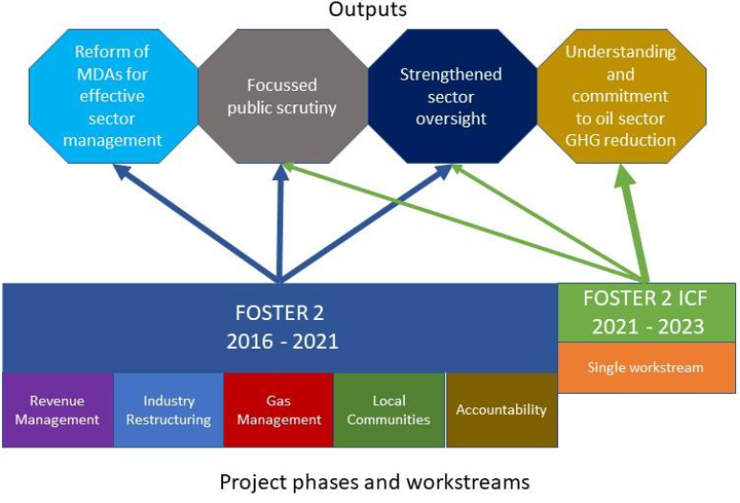

- As stated above, PCR score of A+ based on achievement. Outputs map to workstreams as shown in Diagram X above. The A+ score means that the weighted score of programme outputs exceeded expectations. Over the implementing period, FOSTER met or exceeded targets in 12 out of 13 milestone indicators, as follows:

- In the first five years, FOSTER envisioned outputs focusing on three key thematic areas: (1) creating widespread understanding of Nigeria’s extractives industry issues; (2) providing strengthened capability to those committed to reform; and (3) empowering those demanding reform. Three outputs were specifically identified, namely:

  - Output 1: Reform of Ministries, Departments and Agencies (MDAs) for effective sector management - Two indicators exceeded, one missed – Score A

  - Output 2: Deepening and widening understanding of the sector to increase focused public scrutiny – Media, International Oil Companies (IOCs), Nigeria Natural Resource Charter (NNRC), Civil Society Organizations (CSOs), Unions, Professional bodies, etc – All five indicators exceeded – Score A+

  - Output 3: Strengthen sector oversight and scrutiny by governance institutions and other statutory accountability bodies (e.g. National Assembly (NASS), state Houses of Assembly (HOAs), Nigeria Extractive Industries Transparency Initiative (NEITI) and Economic and Financial Crimes Commission (EFCC) – Both indicators exceeded – Score A++

- In the last two years, the extension period of the programme, August 2021- June 2023 an additional output was added:

  - Output 4: MDA’s, HoR Committees and other key sector actors better understand options and commit to actions that will lead to a reduction in Nigeria’s GHG emissions from the oil and gas sector. Both indicators net – Score A

 | 2016-21 |  | 2021-22 |  | PCR 2017-23
 | Weighting | Score | Weighting | Score | Weighting | Score
Output 1 | 40% | A | 5% | A | 35% | A
Output 2 | 30% | A+ | 5% | A | 25% | A+
Output 3 | 30% | A++ | 5% | A | 25% | A++
Output 4 |  |  | 85% | A | 15% | A
Overall | 100% | A+ | 100% | A | 100% | A+

External context

- During FOSTER’s seven-year implementation period, there were significant changes that affected activities and affected some project outcomes.

- Government commitment to reform: One of the biggest challenges in the delivery was the diminishing appetite for reforms and uncertainties over policy direction by GoN. FOSTER used a range of intervention approaches to manage this. Political economy analyses assessed actors' willingness, awareness and capability to influence and broker coalitions for change. This analysis was then reflected in the choice and design and redesign of activities and partners.

- COVID 19 pandemic: presented significant challenges to FOSTER and its ability to continue to deliver results. Difficulties including the lack of physical engagement with MDAs, CSO’s, media and industry stakeholders, as well as the diminished capacity of government to engage in effective policy reform processes. FOSTER adapted by using a mix of online and offline methods to keep engaging with stakeholders. There were upsides to this change: using the virtual environment, FOSTER conducted three times the number of engagements and reached far more stakeholders within a shorter time to advocate on current industry reforms. As described in Box 1, the pandemic impacted ODA allocations. As a result of this, activities underway in late 2020/21 were curtailed in order to minimise spend spilling into 2021/22 before decisions had been taken on FOSTER’s budget. Without this, activities would have continued until June 2021, which at the time was the scheduled end of the programme. Curtailing some activities 3-4 months earlier than expected risked the sustainability of some interventions with institutions supported such as NEITI and MoF Oil and Gas section because the exit plans had to be truncated.

- COP26 and focus on climate change: In 2021, Nigeria submitted its revised Nationally Determined Contribution (NDC) under the United National Framework Convention on Climate Change (UNFCCC). The revised NDC recognises that Nigeria has a key role to play in delivering the aims of the Paris Agreement as it is both highly vulnerable to the impacts of climate change and is also one of the largest emitters of greenhouse gas (GHG) across Africa. The NDC commits to zero gas flaring by 2030 and a 45% or 60% reduction in fugitive methane emissions by 2031 (the latter dependent on financing support). Though not explicit in the NDC, other oil and gas sector issues – such as fuel subsidy elimination – are also important for mitigating the impact of climate change; economic (unsubsidised) pricing of fossil fuels is a critically important step to underpin climate change mitigation especially in a large country of 200 million people. FOSTER’s extension of two years was designed to look for opportunities to support early steps towards implementation of the revised NDC.

- Volatile global oil prices, fuel subsidy and oil production problems: In early-2020 as the pandemic hit, the fuel subsidy automatically but temporarily reduced to zero. Even though the government committed to making the elimination of the fuel subsidy permanent, as global fuel prices recovered in late-2020 and in 2021, the subsidy was reintroduced. In early-2022, at the onset of the Russia/Ukraine crisis, oil approached record levels. With the fuel subsidy still in place, the cost of the policy ballooned to over $10 billion in 2022 (over 2% of GDP). Industrial scale oil theft meant that there was little benefit to Nigeria’s economy of high oil prices which is expected for a country that exports more oil products than it imports. However, in the run-up to the 2023 elections the manifestos of all three major parties recognised the need to remove the fuel subsidy. In his inauguration speech, President Tinubu announced the subsidy gone and NNPC higher, unsubsidised petrol prices two days later.

- Petroleum Industry Act: Nigeria’s long-awaited oil sector reform act was signed into law on 16 August 2021. The new legislation is intended to improve the basis for sector governance, increase Nigeria’s oil sector global competitiveness, improve investor confidence, and protect communities affected by oil and gas production. The PIA is welcome although it has weaknesses which are likely to result in amendments in the following years. It also requires implementation. With reduced budget and mostly ICF funding, FOSTER was able to provide only very limited inputs to support implementation despite requests including from newly created institutions.

Implementing partner performance

- During the programme, OPM performed strongly, designing and reviewing strategy and structures as needed, and flexing activities to reflect the changing context. Large amounts of feedback recorded in project reports from the different institutions the programme works with evidence that the support was highly valued. The FCDO reviewers in annual and project completion reviews also heard suggestions from interviewees on how FOSTER could increase its effectiveness. The review teams heard that FOSTER’s work was valued for a number of facets including its expertise, the strength of its networks, the tactical astuteness it conveyed to institutions it supports, its approach to capacity building and the trust it holds with different partners:

- Technical expertise – FOSTER combined international knowledge with deep understanding of Nigeria’s oil and gas sector. Some experts fielded as part of FOSTER teams had previous experience working with government and the advice they provided was regarded as objective and challenged the way things worked in order to make improvements (such as NNPC financial reporting – See Output 1)
- Advice on effective engagement advocacy – FOSTER supported stakeholders to adapt approaches to advocacy in order to increase their chances of success. Examples included improving use of evidence and data, or changing engagements approaches from being adversarial to being more collaborative in order to achieve goals.
- Well trusted and with good convening power – FOSTER was said to be regarded as highly committed and neutral. FOSTER has deep knowledge of actors in the oil and gas sector, is extremely ‘well networked’ and uses this constructively to support connections and access between stakeholders. In the gas sector it helped facilitate dialogue when there were large number of different views on the sector. FOSTER was able to be challenging while maintaining trust e.g. saying things ‘that don’t sit well with opinions in the room’. It also helped shine an international light on the oil sector but without losing its trust with different stakeholders.
- Capability building – FOSTER helped build the credibility of a range of non-government partners and accountability bodies by improving their technical capacity and how they engage. Amongst MDAs, FOSTER’s approach to providing technical assistance was highly regarded by the Home Finance Unit of the FMoF because of the quality of advice but also because of the commitment to ensuring the benefits of the training provided were sustained.

- OPM was a responsive implementing partner on programme management. This included preparing two proposals for no cost extensions in November 2020 and again in April 2021. Financial reporting and risk management processes were strong. OPM was also highly responsive in implementing the requirement to avoid expenditure in 2021/22 due to ODA prioritisation.

FCDO performance

- FCDO’s performance was broadly good through the programme. The strategy and focus of the programme was periodically reviewed when the context or progress necessitated this. A good system for assessing proposals for new project activities was put in place; these were scrutinised routinely for clarity of objectives, methodology and team composition. The risk management element of proposals for new activities became increasingly the main focus of assessment. Routine programme management - financial, contract and risk management were strong, including when revising budgets and financial forecasts to meet reduced ODA availability during 2020/21. Two business case amendments were prepared – firstly in November 2020 and then a revised version in May 2021 – and two contract amendments followed.

- The abrupt cessation of programme activities at the end of March 2021 resulted in challenges with partners and beneficiaries requiring support. Some interventions geared towards establishing end line parameters were not undertaken. For example, the intervention to deliver the 2021 Nigeria Natural Resource Charter (NNRC); Benchmarking Exercise designed to provide end-line data to assess FOSTER performance against its outcome indicator 2, targeted at strengthening management of extractive industry was not conducted.

Major lessons learned, evidence generated and recommendations

- FOSTER identified and documented lessons throughout its implementation. The lessons provided useful insight into improved internal processes and on what worked best in promoting and supporting future reforms. Key lessons learned in FOSTER include the following:

Thinking and Working Politically
- Embedding Political Economy Analysis (PEA) in programming is essential to navigate a complex problem such as Nigeria’s oil and gas sector. Policy reversals occur frequently, oftentimes as response to political pressures. For example, FOSTER’s work with the PIA, with downstream sector deregulation (particularly fuel subsidy removal), and the Nigerian Gas Flare Commercialization program (NGFCP) suffered many reversals. In each case, PEA proved to be a critical tool, identifying the most important drivers of policy, areas that are potentially amenable, opportunities for new partnerships, and recommendations on the way forward for continuity and greater sustainable results.

- FOSTER observed through its work that developing a technically sound piece of legislation does not in itself guarantee assent into law. There are many competing interests and interest groups in reforms delivery, and collaboration and a level of trust between the key players especially the Government, the National Assembly as well as other industry players is required. A major reason for the decline of assent by the President to the then Petroleum Industry Governance Bill (PIGB) during the 8th Assembly, according to FOSTER analysis, was an antagonistic leadership at the National Assembly following the 2015 election, but the emergence of a supportive leadership in 2019 paved way for the Petroleum Industry Act (PIA) in August 2021.

- An adaptive approach was supported by the form of funding received from the FCDO; a flexible fund with many activities approved separately enabled progress to be made against the five workstreams in the best way possible given the enabling environment. FOSTER teams were able respond to developing risks, as well as to engage with political actors to maximize impact. FOSTER maintained a partnership model that was flexible, with an activity selection process that hinged on the nature of the issue; the scope and depth of intervention required; the risk and profile of partners; funding requirements; capacity to engage; expected outputs and level of influence.

Patient programming
- FOSTER benefitted from being a follow-on programme; ten years of operating at scale between 2011 and 2021 gave time for reputation and trust to be built over the duration of two five-year business cases (the second then extended to seven years). A review of FOSTER’s input into the assent of the PIA process concluded that a long-term presence and being independent player like FOSTER plays a vital role by keeping the key issues on the front burner while ensuring that the institutional memory is retained and transferred from one legislative assembly to the other. FOSTER operated within two election cycles. FOSTER’s experience showed that in an election year, campaign issues are generally prioritised over reforms and slow responses from government Ministries, Departments and Agencies (MDAs) were generally observed. The political moment for assent of the PIA and fuel subsidy removal happened in the tenth and twelfth year of implementation (taking both FOSTER programmes into account).

Visibility, including low-key UK branding
- FOSTER did not actively promote itself - this low-key approach to its visibility was important for retaining the perception of neutrality, empowering institutions it worked with and to building trust. This included not proactively publicising the fact that it was funded by UKAid. FOSTER’s approach was to provide high quality, independent advice, but to leave evidence products in the hands of the institutions it supported and for those institutions to make decisions. FOSTER-supported analysis is reflected in many publications of partners – NEITI, media and others. But FOSTER did not have a website, and products were rarely posted by OPM. This approach likely contributed to FOSTER’s ability to operate freely, to gain and retain trust on sensitive topics and to play its valued convening role. However, in the 2020 annual review some interviewees regarded this under-the-radar approach as a lost opportunity to deliver a bigger impact. The argument was heard that it was more difficult for partners to align with FOSTER when it did not have a ‘position’ on sector issues. The programme also did not ‘take the credit for things’ that it contributed to.

Coordination with international community

- FOSTER did not work closely with other donors in the way most UKAid programmes do – especially during 2016-2021; this was partly justified but at the same time may have meant opportunities for synergies were missed. FOSTER’s independence was an important attribute of the programme, valued by stakeholders. Overt interaction with other donors and forming common approaches risked perception of independence. In consultations over fiscal regimes for the PIA, FOSTER was able to convene government ministries, the PIA drafting committee, international oil companies and IMF/World Bank experts to discuss fiscal regimes. In some instances, FOSTER’s advice to Nigerian institutions would be picked up in the policy dialogue between other donors and government (e.g. on gas flaring penalties); the ownership of the policies was wholly the government, rather than seen as the advice of other donor consultants.

- It is likely that with more regular engagement between experts, additional synergies could have been found. For instance, FOSTER may have benefited from the expertise of other donors that work on other countries (although FOSTER also brought international experience to bear in its advice). FOSTER’s political economy insights could potentially have assisted others to have greater impact in their work. There were good exceptions to this. For instance, the approach changed somewhat during the last two years of the programme as it shifted to a climate change focus and operated at a small scale. Some of these are discussed in the next comments on taking forward work.

Value for money: equity
- Meaningful equity VfM indicators should be developed even for programmes that deal systemic issues rather than direct service delivery. FOSTER deployed a strong framework for assessing VFM using the 5Es. The approach involved making evidence-based judgements about how well resources are being used, and whether the value derived is good enough to justify the investment. There was clear evidence of good performance against the four Es of Economy, Efficiency Effectiveness and Cost effectiveness. However, reporting underemphasised the importance of FOSTER’s work for equity. The programme worked on issues that affect poor people indirectly through a number of channels – e.g. working with local communities in oil producing regions, understanding attitudes towards fuel subsidy removal. This should have been expressed more clearly and confidently in VFM reporting.

Risk management
- Exercising risk management diligently so that it reflects FCDO’s differentiated risk appetite on programmes requires intensive effort but can improve implementation and reduce risk. FOSTER was encouraged by FCDO to highlight risks and be frank about how much mitigation activities could be to ameliorate risks. The FCDO risk appetite for each category was extremely helpful for this. It was useful because it differentiates risk tolerance for different type of risks. Even where risks remain at or above FCDO’s risk appetite, there was a system for deciding whether to accept the excess risk or whether there was a way to manage it down to tolerance levels. The approach led to well-informed decisions on several interventions including work in the Niger Delta and on oil sector finances.

Taking forward work in the oil and gas sector:

- FCDO should encourage other donors to take on work where the UK is unlikely to do so or play a major funding role. In the last two years, FOSTER engaged other partners and donors like the Africa Centre for Energy Policy (ACEP), European Union, Global Gas Flare Reduction Partnership (GGFR) housed with the World Bank on key findings from the programme which could inform their work. Nigerian institutions would benefit from continued support including implementing regulations on methane emissions and gas flaring (NUPRC), use of satellite data to identify methane super-emitters and remediation (NOSDRA), LPG Gas Expansion (OVP and others) and work with accountability institutions including NEITI.

- FCDO should build on its comparative advantage in applying political economy analysis to oil and gas, environment and infrastructure policy work and programmes to contribute to Nigeria and UK energy transition objectives. During the PCR process, OPM and FCDON governance, environmental and economic staff met to discuss a note prepared on how FOSTER had implemented the Thinking and Working Politically paradigm. This was valuable as FCDON looks at how to continue to play a significant role on shaping future emissions as Nigeria expands its use of gas. Options for FCDON include: drawing on centrally managed programmes from BIP Centres of Expertise; incorporating a capability on the governance of oil and gas and energy transition into other programmes (future governance and infrastructure programmes). Other donors are likely to scale up their technical assistance offer on energy transition. FCDO can play an important role in the overall international effort by retaining a governance, infrastructure and economic capability and presence in the oil and gas sector.

How this report was conducted

- This PCR drew on OPM’s FOSTER Project Completion Report and other documents prepared by the programme. These included an assessment of FOSTER’s contribution to the passage of the Petroleum Industry Act and a paper on how the programme deployed political economy analysis in strategy and decisions. The PCR also included a series of interviews with representatives of MDAs, CSOs and accountability bodies that the programme engages as well as the FOSTER team. These included: Office of the Vice President (OVP), Nigerian Upstream Petroleum Regulatory Commission (NUPRC), NEITI, Nigeria Oil Spill Detection and Response Agency (NOSDRA), Nigeria Institute for Legislative and Democratic Studies (NILDS), Media Initiative for Transparency in the Extractive Industry (MITEI) and Infracredit. The PCR interviews reflected the climate focus of the final two years of the programme. The annual review for 2020, the last annual review before FOSTER was refocused towards climate change, involved interviews with representatives of: Ministry of Petroleum Resources, the Home Finance Department in FMoF, the Petroleum Industry Bill Drafting Team for the Nigerian Government, the Major Oil Marketers Association of Nigeria (MOMAN), the Oil Producers Trade Section (OPTS), Nigerian Gas Association (NGA) and BudgIT (a civil society organisation focussed on government spending transparency).

Actions following approval of this report

- There are no outstanding actions following approval of this report.

B: Theory of Change and Outcome Assessment

Overall assessment of programme outcomes, sustainability and VfM

Examples of successes that FOSTER contributed to

- Before detailing achievements against programme outcomes, here are four tangible examples of major change where FOSTER undertook successful, effective activities with strong client feedback and that FOSTER has contributed to. In all cases – especially (A) and (B) – the political will had to be right, but FOSTER’s work contributed positively to the environment in which political decisions were eventually made. In the case of (A), (B) and (C) the likelihood, quality or timing of reforms was increased in some cases significantly due to FOSTER:

- Passage of the Petroleum Industry Act (PIA). FOSTER’s engagement with the development and passage of the Petroleum Industry Bill started in 2011 and continued intermittently in various forms until the Bill’s eventual passage and assent by the President in 2021. FOSTER’s inputs to the process ranged from support to public information campaigns and advocacy by civil society, the unions and the media to technical assistance to drafting committees in both houses of the National Assembly. FOSTER played a critical role in the final stages in facilitating negotiations to deliver a bill acceptable to both the National Assembly and the Executive.

- Removal of premium motor spirit (petroleum) or fuel subsidy. Throughout both the first and second phase of FOSTER there was a consistent and continuous focus by the programme on downstream sector efficiency, including the need to ideally remove, or at least reduce, subsidy on petroleum. Interventions ranged from support to the Petroleum Products Pricing Regulatory Agency (PPPRA) to improve its regulatory oversight (including restructuring the fuel pricing template to reflect market forces and providing policy options for the removal of subsidy), diagnostic studies on the daily consumption of petroleum products in Nigeria and cross border smuggling as an impact of subsidy, support to demand side actors to develop advocacy strategies on subsidy removal, and support to the National Assembly in embedding subsidy removal in the drafting of the Petroleum Industry Bill. After a number of false starts (including the announcement of the complete deregulation of the downstream oil sector in 2020), the full removal of subsidy on petroleum products was finally enacted by the incoming President Bola Ahmed Tinubu at the end of May 2023.

- Restoring peace in the Niger Delta. Following the re-emergence of conflict in the Niger Delta region in 2016 that caused massive disruption to the oil and gas sector, FOSTER played a crucial role working with local actors to understand the key drivers underpinning conflict in the region and helping them to define the key issues that needed to be addressed and the routes likely to allow that to happen. This in turn allowed FOSTER to effectively support negotiations between the Federal Government and Pan Niger Delta Forum (PANDEF), which contributed to a cessation of hostilities by militant groups in the region. FOSTER further worked with the Vice President, Niger Delta -focussed ministries and PANDEF to develop what was to be known as the Strategic Implementation Work Plan in an effort to address some of the economic development issues that underpinned the conflict.

- Better utilisation of Nigeria’s gas resources, FOSTER’s work in the gas sector was wide ranging and examples included helping the Vice President ensure an international oil company (Total) honoured its domestic gas supply obligation for the first time, the development of a strategy for gas-based industrialisation for the Minister of State for Petroleum Resources, drafting support for the 2017 National Gas Policy, and technical assistance to revise gas regulations under the Petroleum Act to effect a 1800% increase in the fines payable by oil companies for flaring gas.

Progress against outcomes

 | Starting point | Final result
Budget | Final Programme Spend £ (full life): £18,998,200 | £17,069,409
Timeframe | 5 years | 7 years
Outcomes | Outcome Indicator 1: Additional sources of revenue or reduced losses of extractives industry revenues | £1.2 billion achieved against a target of £1.0 billion
Outcomes | Outcome Indicator 2: Strengthen management of extractives industry sector:  Nigeria's Natural Resource Charter precepts score (NNRC) improved beyond baseline | Improvement beyond baseline achieved in 7 out of 12 precepts against a target of improvement in 6 out of 12 precepts
Outcomes | Outcome Indicator 3: Improved political will and capability in Nigeria's oil and gas sector to mitigate GHG emissions  Extent activity leads to transformational change.  See Annex X and Output 4.2 and 4.3 | Criterion 1 – Leverage and Critical Mass leads to Political Will in FGN to removing fuel subsidy. This indicator scores a ‘4’ this year defined as ‘Fuel subsidy removed with introduction of a fully market-based system for petroleum products marketing and distribution.  Criterion 2 – Nigeria’s capacity/capability to monitor oil and gas components of its Revised NDC, including gas flaring and methane emissions. This indicator scores a ‘3’, defined as ‘Some additional capability/capacity developed: Implementation started of one measure that will significantly improve the monitoring/regulation of oil and gas sector GHG emissions.’ NUPRC’s gas flare regulations for gas flaring and emissions were reviewed, updated and gazetted following consultation with oil companies and other oil and gas sector stakeholders.

Outcome 1 – Additional sources of revenue generated or reduced losses of extractives industry revenues
- FOSTER 2 made significant impact at the outcome level; the programme identified an additional £1.2 billion, exceeding target by twenty percent (20%) from potential revenues and from prevention of losses over the initial five years of the project.

- The specific amounts of money attributed to the programme are based on a transparent, subjective assessment of attribution. The massive sums in the oil and gas sector means that any claims against revenue gains or savings will tend to be enormous. In cases where issues lay dormant for many years (e.g. revision of the Act governing Production Sharing Contracts) and where FOSTER’s work has supported positive change, the attributed figures are very high. This demonstrates good value for money as an appropriate amount of expertise and advocacy appears to have been deployed to unlock issues. FOSTER’s support has been necessary but it has not been sufficient for these changes. The political context needed to allow for these benefits to be unlocked. Table X below sets out the cost of specific IPs and the revenues that the activities helped to unlock.

- These revenues are dwarfed by the fiscal savings from fuel subsidy removal that are now accruing to the government to support economic stability and for allocation between federal, state and local governments.

Outcome 2: Strengthened management of Nigeria’s Extractives Industry Sector
- Outcome indicator 2 uses progress against the 12 Nigeria Natural Resource Charter (NNRC) Precepts as a proxy indicator of improvements to the management and governance of the oil and gas sector in Nigeria (see Diagram X below). FOSTER’s target in relation to this is to see improvements in 6 of the 12 Precept scores compared to the baseline figures of 2014, by 2021.
Table X: Revenue increased or safeguarded due to FOSTER activities

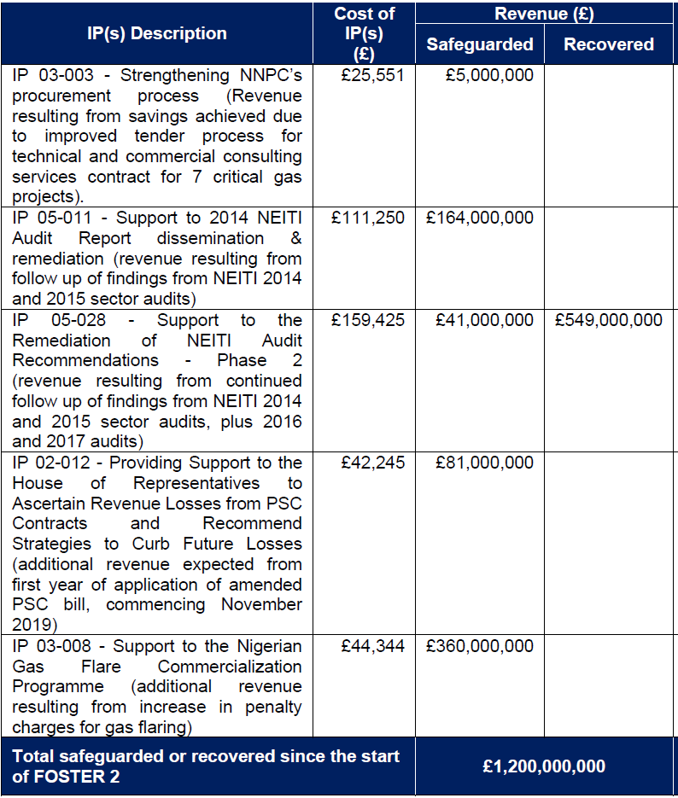

Diagram X: Natural Resource Charter 12 Precepts
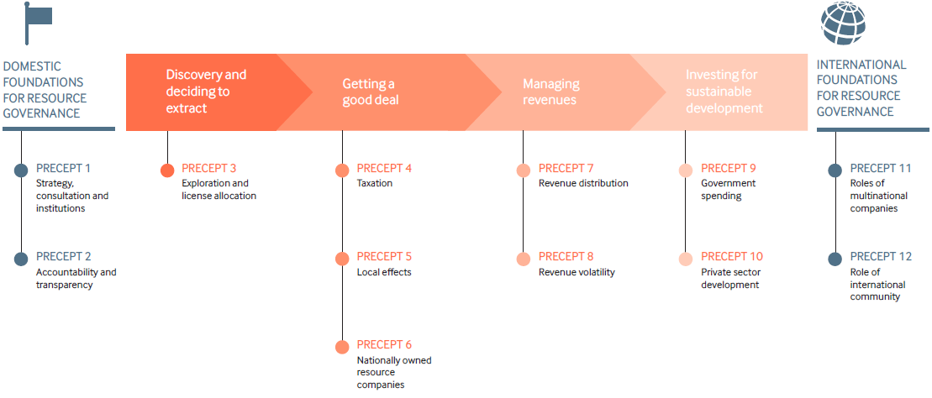

- The assessment of Nigeria’s performance against each are in the 2014, 2017 and 2019 benchmarking exercise reports. Progress against the 12 NNRC Precepts was a proxy indicator of improvements to the management and governance of the oil and gas sector in Nigeria. FOSTER helped improved Nigeria’s Natural Resource Charter (NNRC) score beyond baseline in seven out of 12 precepts (numbers 1, 2, 4, 7, 9, 11 and 12). The 2017 benchmark exercise showed improvement over 2014 across seven of the precepts already, meaning that as of 2017 FOSTER had already exceeded its target for the project as a whole. The 2019 benchmarking exercise found that no significant progress had been made since 2017 although some minor improvements were noted in five of the precept scores in 2019, a minor decrease in score in one precept and no change at all in the remaining six. None of these changes were significant enough however to change the RAG score from 2017.

- Furthermore, the 2019 benchmarking exercise report identifies four precepts where the passage of comprehensive petroleum industry legislation should help make further progress in establishing a workable and effective regulatory framework for the industry (numbers 1, 2, 3 and 6).

- As FOSTER took on new ICF-funded work in the last year, an additional outcome indicator (indicator 3) was added to the logframe: Improved political will and capability in Nigeria's oil and gas sector to mitigate GHG emissions HMG ICF KPI 15: extent activity leads to transformational change. The extent of transformation change achieved is to be measured against two criteria using a scoring system from 1 to 4, details of which are provided in Annex X.

- Criterion 1 – Leverage and Critical Mass leads to Political Will in FGN to removing fuel subsidy. This indicator scores a ‘4’ this year defined as ‘Fuel subsidy removed with introduction of a fully market-based system for petroleum products marketing and distribution’. President Tinubu announced the end of the fuel subsidy on 28 May and two days later NNPC Ltd published details of its pricing template reflecting the full landed cost of imported fuel. Prices have since been adjusted. Important elements of a fully market-based system are yet to be in place – for instance, NNPC still predominantly imports oil and forex shortages still exist for private importers of fuel.

- Criterion 2 – Nigeria’s capacity/capability to monitor oil and gas components of its Revised NDC, including gas flaring and methane emissions. This indicator scores a ‘3’, defined as ‘Some additional capability/capacity developed: Implementation started of one measure that will significantly improve the monitoring/regulation of oil and gas sector GHG emissions.’ NUPRC’s gas flare regulations for gas flaring and emissions were reviewed in consultation with oil companies and other oil and gas sector stakeholders. The regulations are aimed at providing a legal framework for the protection of the environment against the effect of gas flaring, preventing the waste of gas, and at the creation of social and economic benefits to Nigeria from gas flares. To meet the requirements of the PIA (Section 216), and to finalise the process, NUPRC issued a 21-day notice of stakeholder consultation to solicit inputs to the regulations “Gas Flaring, Venting & Methane Emissions (Prevention of Waste and pollution) Regulations, 2022”. FOSTER’s support was evident in the new draft regulations as over 80% of the recommendations were reflected of the regulations. The regulations have been gazetted.

Summarise the programme’s theory of change and results framework, including any changes to outcome indicators.

- FOSTER’s ToC starts from the understanding that Nigeria’s oil and gas sector performs poorly, with reduced government take, losses of oil and petrol, sub optimal levels production, underdeveloped gas markets, and significant barriers to investments. This is caused by weak management and poor transparency and accountability in the sector. The result is that Nigeria’s oil and gas industry falls short of its potential to contribute to national development.

- FOSTER’s ToC is that these weaknesses and barriers can be addressed by (1) working on policy formulation and advice to improve sector management, (2) capacity building of MDAs, governance institutions and demand side organisations such as CSOs and the media, (3) building advocacy forums and coalitions for change, and (4) generating and sharing quality evidence and knowledge to advance public understanding. By increasing the capacity, systems, strategies and processes of ministries, departments and agencies, by informing and focussing public scrutiny via the media and civil society onto the sector, and by building the capacity of sector oversight governance institutions ranging from NEITI to the National Assembly, the FOSTER’s ToC postulates that the sector can be managed in a transparent manner for the national interest and that additional oil and gas revenue can be safeguarded to support national development.

- Several elements of the programme design and implementation ensured this including: the programme structure (see Annex X), the Monitoring, Evaluation and Learning approach and embedding the use of political economy analysis in all aspects of the programme – or Thinking and Working Politically.

Thinking and Working Politically
- FOSTER effectively took a Thinking and Working Politically approach. This was documented in a 2017 review of the first FOSTER programme and the lessons taken forward into FOSTER II. The experience and lessons from a note that fed into the PCR are summarised below. FOSTER’s work followed three core principles of Thinking and Working Politically: 1) strong political analysis, insight and understanding; 2) detailed appreciation of, and response to, the local context; and 3) flexibility and adaptability in program design and implementation.'

- Strong political analysis, insight and understanding. Understanding the political economy of the sector was critical to FOSTER’s ability to operate effectively. In the early years, FOSTER carried out quarterly formal PEA exercises to identify policy failures ripe for action, shifts in context that might create opportunities to act, likely winners and losers from any successful policy change and thus potential sources of resistance to be overcome. Over the years the cumulative experience of interventions and the programme’s ever-growing network of connections meant that the need for formal PEA exercises became less critical, as weekly staff meetings to review progress and plan became essentially mini-PEA updates. In the latter years, FOSTER formal commissioned PEA exercises were carried out only once or twice a year, to verify the current political understanding of FOSTER’s staff, or on occasion to try a new approach (for example a study commissioned to understand the power dynamics and motivations of the President’s inner circle of trusted advisors and political backers).

- Detailed appreciation of, and response to, the local context. A key aspect of the FOSTER approach was to identify and target critical actors and potential reformers within institutions to support policy reform, and not to treat institutions uniformly. FOSTER also sought opportunities to strengthen government and regulatory systems and institutional capacity, to make institutions more effective in carrying out their oversight and accountability roles. Interventions were accordingly focused on one of two approaches:

  - Targeting government institutions that had responsibility for governing the collection and management of oil and gas revenues (those that ‘supply accountability’); and
  - Targeting ‘demand-side’ accountability actors such as CSOs, the media and unions (to build a popular public base for change) and oversight bodies such as the NEITI and the Nigerian National Assembly (to provide formal public scrutiny over the sector and advocate for improvements in governance).

- Flexibility and adaptability in program design and implementation. Having the capability to adapt to changing circumstances and to move quickly to take advantage of emerging opportunities was critical to FOSTER’s operations and its ability to think and work politically. The funding mechanism and the team structure were important components that facilitated this. By having a flexibly managed fund, it was possible to identify and allocate resources to initiatives as the programme went along. Moreover, the programme deliberately took a ‘portfolio’ approach – trying a range of approaches that seemed promising in the knowledge that not all would necessarily be successful.
Box X: FOSTER programme structure
The programme structure for FOSTER is shown in the figures below. Five workstreams contributed to meeting the programme Outcome. These workstreams comprised mini projects called Intervention Plans or IPs. IPs combined analyses, training, advocacy etc – towards a workstream objective. To assist monitoring and reporting, the activities are grouped into three types that constitute the programme’s three Outputs. An IP contributed to multiple outputs where it worked with more than one type of institution and in different ways. The project was scored annually against the three outputs. However, in annual reviews and this PCR, emphasis has been given to impact and change in gauging impact. The outputs and workstreams for the first five years are in Diagram 1 and for the final two years in Diagram 2:

Diagram 1: FOSTER structure – Impact, Outcome, Workstreams, IPs and Outputs – 2016-2021

For the last two years of FOSTER II the outcome, workstreams and outputs were modified as below for ICF funding. Some limited activities continued to support the Outputs 1 to 3 also with non-ICF funding.

Diagram 2: FOSTER structure – Impact, Outcome, Workstreams, IPs and Outputs – 2011-2023
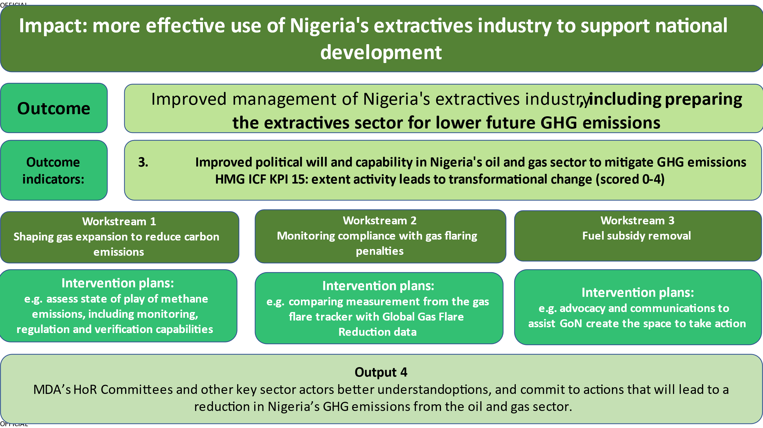

C: Detailed Output Assessment

Output Number and Title | 1. Ministries, departments and agencies target revenue losses and potential leakages
Output Score | A
Impact weighting (%) | 40% |  | Impact weighting revised since last AR? | Yes to 35%
Output Indicator |  | Starting Target | Final Logframe Target | Final Result Achieved
1.1 No. of strategies for reducing losses or increasing revenues developed and implemented by key MDAs |  | 24 | 22 | 16  67% of starting target  73% of final target
1.2 No. of initiatives deliver one or more from: (a) improved effectiveness, (b) clearer vision, (c) clearer roles & responsibilities, or (d) effective mechanism for inter-MDA coordination |  | 22 | 26 | 25  114% of starting target  96% of final target
1.3 No. of actions (policy, step, initiative, process, activity) involving at least 2 MDAs addressing concerns of communities affected by extractives |  | 4 | 8 | 8  200% of starting target  100% of final target

Briefly describe the output’s activities and achievements during its lifetime, and provide supporting narrative

- This output was for activities that supported MDAs to improve management of the oil and gas sector. The output is divided into three categories of interventions: 1.1) strategies to reduce losses or increase revenues, 1.2) initiatives for improving policy and regulatory coherence; and 1.3) initiatives that improved MDA engagement with organisations representing community interest groups.

Output indicator 1.1 – MDAs act to target revenue losses and potential revenue
- FOSTER made significant effort to work with Ministries, Directorates and Agencies (MDAs) to target revenue losses and potential revenue in the oil and gas sector. Since inception, it introduced 15 strategies that were adopted and implemented by MDAs against a target of 24. Examples of outputs were:

- Support to FMoPR and DPR to raise the gas flare penalty to a level close to the export price for gas as a disincentive to flaring, and to encourage gas flaring companies to consider monetising the gas., FOSTER was instrumental in getting penalties for gas flaring from oil drilling increased, legislated for and implemented. This has increased revenues significantly. Penalties have increased from $0.027 per thousand cubic feet to $2, increasing revenues but hopefully reducing wasteful emissions in the future.

- In 2016, EITI introduced the concept of beneficial ownership declarations being made by all corporate entities in the extractives industry. All member countries needed to comply with before 1 January, 2020. However, Nigeria did not have a comprehensive legal framework for beneficial ownership disclosure in the extractive industry. FOSTER supported Nigeria’s anti-corruption drive by collaborating with NEITI by helping establish a Beneficial Ownership Inter-Agency Coordinating Platform jointly led by DPR and the Mining Cadastre Office. This enabled MDAs to take ownership of the process of beneficial ownership reporting. Through FOSTER’s support, stakeholders designed templates for data collection, engaged wider stakeholders, including corporations and demand-side actors, and launched the register in December 2019.

- FOSTER supported NEITI’s Policy Unit in following up on and remediating NNPC audit findings. FOSTER helped set up of a joint committee of NNPC and NEITI to resolve outstanding issues arising from past sector audit reports. At the end point of FOSTER’s support, the joint committee had fully resolved 11 issues (55%), while eight issues (40%) remained partially resolved or ongoing. Just one was yet to be resolved.

- A revised template for reviewing NNPC reports on revenue flows to the Government, which was adopted and implemented by the FMoF from March 2020 onwards to support its work with the Federation Accounts Allocation Committee.

Output indicator 1.2 – Regulatory and policy coherence of MDA’s improved
- FOSTER made excellent progress on this output. Since inception, it implemented 23 Initiatives that improved the regulatory and policy coherence of MDAs, exceeding the project end target of 22. The initiatives delivered one or more from: (a) improved effectiveness, (b) clearer vision, (c) clearer roles & responsibilities, or (d) effective mechanism for inter MDA coordination. Examples of outputs include:

- One important reason why gas is not flowing to power stations to enable power to be generated is the lack of a functioning natural gas market. In particular, fair access to the pipeline network is needed, called third party or open access. One of the most important parts of a system underpinning third party access is a set of rules of access to the system, or network code. In year 3, FOSTER had supported the development of the Gas Network Code (GNC) Ancillary Template Agreement which determines these rules. In year 4, FOSTER conducted a stakeholders’ workshop comprising all the key stakeholders. Following this, DPR adopted the Ancillary Template Agreement and fed it into the final GNC document which was approved by DPR on 23 January 2020.

- Support to the Budget Office of the Federation and the Federal Ministry of Finance to develop a template/model used to deduce impact of Finance Act 2020 and the Deep Offshore and Inland Basin Production Sharing Contract (Amendment) Bill 2019 bills on the oil revenues. This initiative was informed by an impact analysis of these bills on oil sector revenues carried out by FOSTER. FOSTER’s findings formed the basis for the capacity building of 110 staff from Budget Office of the Federation and the Federal Ministry of Finance on how to analyse the impact of bills on oil revenues via virtual trainings.

- FOSTER supported the FMoPR to adapt the Macro-Level Conflict Risk and Impact Assessment (MCRIA) tool to the needs of the Gas Based Industrialization initiative of the Nigerian Gas Flare Commercialisation Programme (NGFCP). NGFCP recognised the usefulness of the MCRIA tool in uncovering and understanding the root causes of current and potential conflict, and the opportunity that analysis offered to companies and government agencies to engage in informed dialogue with local communities to mitigate risk, allowing commercialisation projects to go ahead successfully. Overall, the tool was accepted by the NGFCP as a means of minimizing conflict risk for the programme.

Output indicator 1.3 – MDA engagement with organisations representing community groups
- FOSTER’s efforts brought about eight actions involving two MDAs that address the concerns of communities affected by extractive industry activity, against a project target of four. Examples of outputs include:

- FOSTER supported the Policy and Technical Unit within the Ministry of Niger Delta Affairs (MNDA) to increase the capacity of the Ministry to coordinate development projects in the Niger Delta region. FOSTER’s work on development and approval of the Niger Delta Strategic Implementation Work Plan (SIWP) – a coordinating tool for tracking all planned and budgeted projects and programs of organisations (public and private) operating in the Niger Delta Region. The support provided an improved mechanism for engaging with and addressing development needs of Niger Delta communities.

- With support of a FOSTER consultant, FMoPR, DPR, Ministry of Environment’s National Oil Spill Detection and Response Agency (NOSDRA), and the National Petroleum Investment Management (NAPIMS), held engagements to prevent the shutdown of oil facilities in Onelga and two other neighbouring communities in Rivers State by members of the local communities.

- Following recommendations developed by FOSTER consultants working with the Hydrocarbon Pollution Restoration Project (HYPREP) to improve its effectiveness, HYPREP engaged with the River State Ministry of water resources to provide water infrastructure for the Ogoni people, as part of their response to the emergency measures recommended by UNEP.

Lessons learned through this output, and recommendations for future programming

- Recommendations for Output 1 are common to those in the other outputs and are covered in Section A.
Output Number and Title | The deepening and widening understanding of the oil & gas sector by demand-side accountability partners (CSOs, the media, etc.) for focused public scrutiny
Output Score | A+
Impact weighting (%) | 30% |  | Impact weighting revised since last AR? | Yes to 25%
Output Indicator |  | Starting Target | Final Logframe Target | Final Result Achieved
2.1 No. of evidence-based research and policy analysis products advancing understanding on oil and gas sector issues including revenue losses |  | 30 | 62 | 80  267% of starting target  129% of final target
2.2 No. of engagements between and among public institutions, citizens, CSOs, private sector and NASS that improve sector coordination and accountability |  | 22 | 30 | 33  150% of starting target  110% of final target
2.3 (a) No. of 20 CSOs / media organisations engaged in advocacy |  | 20 | 33 | 44  220% of starting target  133% of final target
2.3 (b) No. of State actor responses to issues raised |  | 2 | 2 | 8  400% of starting target  400% of final target
2.4 No. of examples of capabilities of key demand side CSOs (media, NRGI, NNRC, prof bodies etc) enhanced and those capabilities actioned |  | 7 | 35 | 53  757% of starting target  151% of final target

Briefly describe the output’s activities and achievements during its lifetime, and provide supporting narrative

- This output supports the five workstreams by improving the quality of engagement between MDAs and civil society, private sector and parliament. FOSTER’s work on deepening and widening public understanding of the sector has continued to deepen, delivering a wide range of research and policy advocacy material and partnering with and building the capacity of a significant number of demand side institutions across the CSOs and media.

Output indicator 2.1 – Empirical research, policy analysis and advocacy initiatives advancing understanding on oil and gas revenue losses
- FOSTER made much greater progress than originally planned on this output. From inception, 80 empirical research, policy analysis and knowledge initiatives that advanced understanding of demand and supply side actors on oil and gas revenue losses for increased scrutiny and accountability were undertaken and delivered. This included six activities carried out under Output 2.1 under the final two years of the programme. This significant achievement more than doubles the project end target of 30. Examples of outputs under this indicator include:

- FOSTER conducted a review of all legislative interventions related to the oil and gas sector undertaken by the 8th NASS, to put forward recommendations aimed at preventing the 9th Assembly from experiencing preventable obstacles to progressing laws in the oil and gas sector. No oil and gas Bill was passed into law nor given executive assent by the president during the period of the 8th Assembly (2015-2019), and the only Bill (The Petroleum Industry Governance Bill, 2017) that was transmitted to the president for Executive assent was declined. Feedback from interviews and engagements generally highlighted a gap in knowledge of the petroleum industry by some members of the National Assembly and a negative impact of the frosty executive/legislature relationship on committees’ functions. Key recommendations made to the 9th Assembly included: alignment of the Legislative and Executive Arms of government; alignment with Petroleum MDAs to tap into institutional memory; strategic stakeholder consultation to ensure Industry participation; and capacity building for relevant NASS Committees.

- FOSTER supported a comparative analysis conducted by CSR-in-Action, of methods adopted to address conflict issues in other countries (Peru, Ghana, Russia, and Canada) where refineries are domiciled within indigenous communities. Community Engagement Standards (CES) were developed with the aim of improving the relationship among key stakeholders in oil-producing communities. The CES, which is an adaptation of the MCRIA tool, outlines a set of procedures and guidelines which can be used in negotiations or decision-making during stakeholder engagements to protect the interest of all parties involved. The CES was adopted by the Federal Ministry of Petroleum Resources (FMoPR) and its agencies - NNPC, NAPIMS, NCDMB, DPR, NGFCP and NEITI, as a tool for community engagement.

Output indicator 2.2 – Engagements between and among public institutions, citizens, CSOs, private sector and parliament that improve sector coordination and accountability
- FOSTER made excellent progress on this output. Over the life of the programme, it facilitated 33 engagements that improve sector coordination and accountability (against a project end target of 22) between and among public institutions, citizens, CSOs, private sector and parliament. These included:

- The successful conduct and launch of the NNRC Benchmarking Exercises in 2017 and 2019. The 2019 BER launch involved a policy dialogue in partnership with the Nigerian Bar Association (NBA), private sector and CSOs on ‘What a Good PIB looks like’ and a review of the future of the ‘regulatory architecture’ of Nigeria within the context of the findings of the 2019 BER.

- Hosting sessions bringing together the National Assembly (NASS) Committees on Oil and Gas with Oil Producers Trade Service (OPTS) and Independent Petroleum Producers Group (IPPG) to discuss outstanding Industry concerns, observations, and recommendations with regards to the Petroleum Industry Bill. Senior management of the OPTS reviewed and analysed the PIB and identified several industry concerns that could have impacted their activities if left unaddressed in the PIB.

Output indicator 2.3 a & b – Advocacy initiatives focusing attention on oil and gas revenue losses carried out by the demand side
- This output has two elements: support to CSOs and media organisations to engage in advocacy; and evidence of a state actor responding to an advocacy campaign. FOSTER met and exceeded the requirements of both elements: 44 advocacy initiatives against a project end target of 20 and eight responses from state actors against a project end target of 6. Annex E contains a detailed description of 44 advocacy initiatives and eight responses from state actors, but some individual examples are provided below as illustrations:

- Using knowledge pieces developed by FOSTER such as the study on the oil and gas sector and how this has impacted on the quality of life in Nigeria, FOSTER empowered demand-side actors (CSOs and media) to engage in advocacy initiatives focusing attention and public scrutiny on oil and gas revenue losses. The activity included the use of social media channels, the publishing of articles, and the production and publication of factsheets from the reports over the period between October and December 2019 by Vanguard Newspaper.

- FOSTER’s empirical products on crude oil theft through the NNRC were leveraged by a partner civil society organization - the Civil Society Legislative Advocacy Centre (CISLAC) - to engage the NASS Ad-hoc Committee investigating oil theft on revenue losses due to direct oil theft, sabotage, and spillage.

- FOSTER supported a specialised CSO, BudgIT, that monitors government’s fiscal management and a gas industry body, the National Gas Association, that advocates for sector reform. FOSTER’s grant to BudgIT supported its ability to engage with the Independent Corrupt Practices and other Related Offences Commission (ICPC). This included using a compelling infographic, ‘Key Findings from NEITI's 2016 Audit Report’. This graphic highlighted 12 main observations from NEITI's recent audit that need remedial action. ICPC responded to BudgIT’s advocacy by inviting them to a formal meeting in August 2019 to gather more information on the issues raised. During this engagement, ICPC committed to conducting investigations on two initial issues identified: a) USD7.8m under-remittance of funds by NNPC to the exchequer based on mis-invoicing oil transactions; and b) USD770,000 due to the Niger Delta Development Commission’s account that could not be accounted for.

Output 2.4 – Beneficiaries
- Demand side accountability partners refer to selected demand side actors supported and strengthened by FOSTER to improve public understanding and carry out evidence-based advocacy initiatives to necessary government actors. Supply side actors refer to state actors that benefited from FOSTER’s advocacy initiatives and took action to address issues raised.

- FOSTER supported 16 demand-side actors, including CSOs such as the West African NGO Network and the Civil Society Legislative Advocacy Centre (CISLAC), professional/industry organisations such as the Oil Producers Trade Section (OPTS) and Independent Petroleum Producers Group (IPPG), and Media including The Guardian and Business Day. 15 MDAs and accountability bodies constituted the supply-side actors supported.

Lessons learned through this output, and recommendations for future programming
Recommendations for Output 2 are common to those in the other outputs and are covered in Sections A.
Output Number and Title | 3. Governance institutions’ capability for effective sector oversight and scrutiny improved
Output Score | A++
Impact weighting (%) | 30% |  | Impact weighting revised since last AR? | Yes to 25%
Output Indicator |  | Starting Target | Final Logframe Target | Final Result Achieved
No. of new (not carried out by institution before) or strengthened / improved oversight or scrutiny actions implemented by 1 key governance institution |  | 7 | 12 | 16  229% of starting target  133% of final target
No. of initiatives implemented by governance institutions that involve coordination and common action across multiple governance institutions. |  | 4 | 6 | 7  175% of starting target  117% of final target

Briefly describe the output’s activities and achievements during its lifetime, and provide supporting narrative for the score

- Under this output FOSTER supports governance institutions’ capability to exercise effective sector oversight and scrutiny of oil and gas revenues, including the Ministry of Finance and NEITI. The output also includes support to improve coordination between institutions, such FFMoPR, DPR and FMoE.

Output indicator 3.1 – Governance institutions’ capability for effective sector oversight and scrutiny improved
- FOSTER made excellent progress on this output. It implemented 16 Initiatives against a project end target of seven, improving governance institutions’ capability for effective sector oversight and scrutiny in the process. One example of an output in this area was the results of FOSTER’s extensive support to the 8th and 9th National Assembly towards the review and passage of the Petroleum Industry Bill described in Section B above.

Output indicator 3.2 – Mechanism for collaboration and coordination of institutions engaged with sector governance and scrutiny improved
- FOSTER made excellent progress on this output result. Since inception, it delivered seven mechanisms implemented by governance institutions that involves coordination and common action across multiple governance institutions, against an end target of four.

- One example was that FOSTER supported the development of a collaborative mechanism on a suite of commercial agreements for NGFCP. This involved collaboration and coordination with MoPR and DPR to improve the NGFCP. FOSTER, through provision of a legal peer desk review and workshop targeted at bringing the NGFCP’s three legal commercial instruments to a bankable standard and to ensure that they were aligned with standards of international best practice. The aim was to promote transparency and diminish the likelihood of legal loopholes being exploited for corrupt purposes.

Beneficiaries supported under Output 3

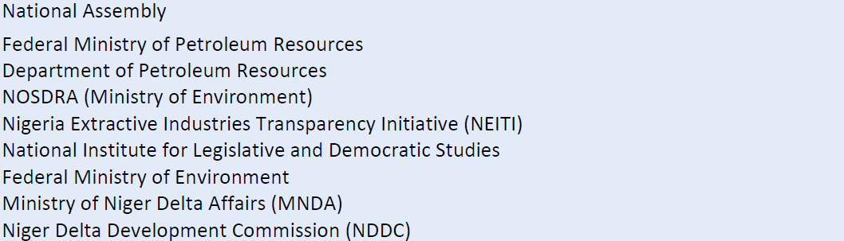

Lessons learned through this output, and recommendations for future programming [1-2 paragraphs]
- Recommendations for Output 3 are common to those in the other outputs and are covered in Sections A.
Output Number and Title | 4. MDA’s HoR Committees and other key sector actors better understand options and commit to actions that will lead to a reduction in Nigeria’s GHG emissions from the oil and gas sector.
Output Score | A+
Impact weighting (%) | 10% |  | Impact weighting revised since last AR? | Yes to 15%
Output Indicator |  | Starting Target | Final Logframe Target | Final Result Achieved
No. of empirical research and policy analysis products developed that advance knowledge on (1) options for emissions reductions and decarbonization within the Nigerian oil and gas industry or (2) alternative uses for Nigeria's oil and gas resources that are in line with NDC emission reduction targets. |  | 7 | 7 | 8  114% of starting target  114% of final target
No. of workshops, meetings or technical dialogues with MDAs or other relevant stakeholders to promote policy options and actions on: decarbonisation in the O&G sector |  | 7 | 7 | 11  157% of starting target  157% of final target
No. of policy or strategy / action related to the topics in 4.2 above developed and committed to by relevant body that has the potential to reduce Nigeria’s GHG emissions from the oil and gas sector |  | 2 | 2 | 6  300% of starting target  300% of final target

Briefly describe the output’s activities and achievements during its lifetime, and provide supporting narrative for the score

- This output created in 2021 is for activities that support Nigeria to implement commitments in its revised NDC relating to methane emissions from the oil and gas sector and other measures in the PIA that support climate mitigation. The output has three indicators: 4.1) Empirical research and policy analysis products developed that advance knowledge, 4.2) Improved understanding across relevant MDAs and HoR Committees; and 4.3) MDA’s or market bodies or industry associations develop policies and strategies.

Output indicator 4.1 Empirical research and policy analysis products developed that advance knowledge on (1) options for emissions reductions and decarbonization within the Nigerian oil and gas industry or (2) alternative uses for Nigeria's oil and gas resources that are in line with NDC emission reduction targets.

- With a new focus on greenhouse gas emissions reduction, FOSTER delivered eight empirical research and policy analysis products that advanced knowledge on methane emissions, gas flaring regulations, LPG finance models and subsidy within the Nigerian oil and gas industry. These studies formed the basis for engagements and further work with stakeholders. This progress surpassed the ICF logframe target of seven such activities. Examples included:

- FOSTER commissioned a study to advance understanding on the level of control of methane emissions from the oil and gas industry in Nigeria and its implications. Findings from the report showed that there are no existing policies or regulations that actively guide action on methane reduction in the sector, although a set of Draft Guidelines initially produced by Department of Petroleum Resources (DPR) cover a significant portion of international best practice policy recommendations. The report found a lack of consistency across national and internationally derived estimates of Nigeria’s oil and gas industry methane emissions, with estimates varying by almost an order of magnitude. The report noted that abating methane emissions in the oil and gas sector has the potential to deliver significant economic and environmental benefits to Nigeria at relatively low-cost, through increasing gas sales by stemming losses to production from leaks and flaring. This potentially will abate up to 20% of Nigeria’s overall GHG emissions in the short term and additional 14% in the long term at little or no net cost; and avoiding future threats to Nigeria’s gas export market by ensuring early compliance with likely new quality standards for low methane LNG.

- FOSTER conducted a series of small studies to review how effective implementation of the Nigerian Flare Gas (Prevention of Waste and Pollution) Regulations, 2018, had been in contributing to reduced gas flaring in Nigeria. The report identified gaps in the existing regulatory framework (the PIA and the gas flare prohibition regulations 2018) which, unless remedied, could impede future enhancement of the flare management and reduction framework. The report also noted that the gas flare payments defined in the regulations also cover vented gas, but did not seem to be being applied at the current time, which is a significant oversight, both in lost revenue terms and in terms of incentivising the industry to take action to reduce gas leakage. Key recommendations were for amendments to be made to the current regulatory framework, and to include a Monitoring, Reporting and Verification (Audit) procedure for flare data.

- A study using satellite data was undertaken to identify super emitter flares, assess operational effectives of oil production facilities and predict methane emissions. An introduction for NOSDRA technical staff to the analytical process followed, with a long-term view that such analysis might be managed in house.

- FOSTER ICF worked with the Nigerian Institute for Legislative and Democratic Studies (NILDS) under a previous FOSTER intervention, to further develop the ‘NILDS Extractive Industry Legislative and Oversight Toolkit’, towards improving its legislative oversight and scrutiny over actions of MDAs in the oil and gas sector that can contribute to the reduction of carbon emissions. The toolkit was expanded as planned and termed ‘Carbon Emissions Reduction Toolkit’ following inputs from the National Assembly (NASS).

- Following a request to FOSTER for technical assistance from the Office of the Vice President (OVP), through the Programme Manager of the National LPG expansion plan FOSTER conducted a study with the aim of recommending options to unlock access to funding to support suppliers’ engagement in the cylinder injection programme for the residential clean cooking segment of the LPG Expansion Programme. The research recommended that the approach to financing must be iterative, structured and utilize a blended approach using a mix of government-based grants, financing instruments from Development Financial Institutions (DFI) as well as cheap commercial loans from local banks; all supported within a properly regulated industry with targeted polices aimed at encouraging private sector investments.

Output indicator 4.2 – Improved understanding across relevant MDAs and HoR Committees on options for reducing emissions / decarbonisation within the oil and gas sector.
- FOSTER organised a series of engagements to improve the understanding of partners across government and the National Assembly on findings from work done under Output 4.1. in line with Nigeria’s Nationally Determined Contributions (NDC) emission reduction targets. Excellent progress was made under output 4.2 as 11 engagements were delivered against a project end target of seven. Examples of this indicator include:

- FOSTER shared findings from its research on methane emissions with about 30 selected stakeholders during a workshop in Lagos in February 2022. The findings were validated by the participants representing the Ministry of Petroleum Resources (MoPR), the Ministry of the Environment (MoE), Nigerian Upstream Petroleum Regulatory Commission (NUPRC), National Oil Spill Detection Regulatory Agency (NOSDRA), Nigerian Gas Association (NGA), Chevron, Natony LTD, Oil and Gas Free Trade Zone (OGFZA), CLN, AEXELA, ENR Advisory, and Afri-Pera. Representatives from NUPRC, NOSDRA, Ministry of Petroleum Resources and Ministry of Environment all highlighted the need to ensure synergy between all institutions for data gathering and data sharing for methane emissions, and that regulators should also agree on a methodology to adopt for data collection and for determining its accuracy.

- Following a series of studies to review how effective implementation of the Nigerian Flare Gas (Prevention of Waste and Pollution) Regulations, 2018 has been in catalysing a reduction of gas flaring in Nigeria, a 2-day workshop was convened on the 7th and 8th February 2022 in Abuja with about 25 participants from various departments of the Nigerian Upstream Petroleum Regulatory Commission (NUPRC). With the agreement of the NUPRC participants, vital amendments to existing regulatory framework were put forward for action. The commission also agreed that it should take the lead in systematic data collection, management, reporting, and verification.

- A workshop for Clerks of committees of the National Assembly was used to finalise a Carbon Emissions Reduction Toolkit and to promote the adoption of the Toolkit as a reference document for the oversight activities of the Committees. The committees represented included, the House of Representatives’ Committees on Nigerian Content Development and Monitoring, Upstream Petroleum Resources, Niger Delta Affairs, and the Senate Committees on Gas Resources, and Upstream Petroleum Resources. Subsequently, a workshop was organised on the 30th of March 2022 for Senators, members of the FMoPR and Federal Ministry of Environment FMoE. The legislators have adopted the toolkit for use in improved legislative oversight.

Output indicator 4.3 – Relevant MDA’s or market bodies or industry associations develop policies and strategies that have the potential to reduce emissions from the oil and gas sector in Nigeria.
- FOSTER made significant progress on this output result, delivering six policies and strategies that have the potential to reduce emissions against a project end target of two. Examples of work under this output are:

- Following FOSTER support to NILDS to develop the ‘Carbon Emissions Reduction Toolkit’, a commitment was made by the Deputy Chairman, House Committee on Niger Delta Affairs, to link the oversight toolkit with the bulk of climate change activities contained in the Legislative Agenda of the 9th Assembly. NILDS has also pledged to institutionalise the toolkit so that it can be presented to the incoming 10th assembly and future assemblies, to incorporate into their legislative agenda.

- Following support to NUPRC to revise regulations on Gas Flare and Methane, NUPRC drafted a new set of regulations captioned “Gas Flaring, Venting & Methane Emissions (Prevention of Waste and pollution) Regulations, 2022”. The regulations are aimed at providing a legal framework for the protection of the environment against the effect of gas flaring, preventing the waste of gas, and at the creation of social and economic benefits to Nigeria from gas flares. To meet the requirements of the PIA (Section 216), and to finalise the process, NUPRC issued a 21-day notice of stakeholder consultation to solicit inputs to the regulations. FOSTER’s support was evident in the new draft regulations as the recommendations were reflected in over 80% of the regulations. The regulations have been gazetted.

Lessons learned through this output, and recommendations for future programming
- Many of the recommendations for Output 4 are common to those in the other outputs and are covered in Sections A and B. However, the short duration, the reduced scale of activity and the stage in the political cycle presented challenges to large-scale change. This was reflected in realistic and specific objectives with partner institutions where there was clear demand e.g. changing emissions regulations with NUPRC, applying satellite data on emissions innovatively with NOSDRA.

- With a longer period, a larger scale of activity and the opportunity to work in the early stages of a political cycle, there would have been more opportunity to contribute to a bigger transformational shift in mindset in the sector towards achieving Nigeria’s revised NDC.

D: Value for Money

VfM performance compared to the original VfM proposition in the business case

- The VfM proposition in the Business Case had a quantitative and qualitative element for the preferred option – a large scale intervention that made significant support available to MDAs, accountability bodies, host communities, CSOs and other stakeholders. The quantitative gauge for good VfM was that a £19.5m programme (plus an estimated £350K of FCDO imputed value of staff time) should safeguard £1bn of revenues over five years, and progress seven out of 12 NNRC precepts as evidence of improved oil sector management. As set out in Section B above, £1.2bn of revenues have been safeguarded and seven precepts have seen improvements, with a further four standing to improve if assessed now following the passage of the PIA and other legislation by the Buhari government.

- The qualitative element was that three conditions be met. The conditions and examples of this based on evidence in this review were:

- Condition 1: The Nigerian Government embarks on substantial reform of either its commercial, regulatory or policy focused key institutions of the oil and gas sector

FOSTER is assessed to have supported
- Passage of PIA and other supportive legislation i.e. CAMA
- Decision to remove fuel subsidy in May 2023
- Establishment of Beneficial Ownership reporting in the extractives industry
- Gas commercialisation and improved gas flaring regulations

- Condition 2: DFID has been requested to be a key partner in this reform, with a request from senior parts of government

There was very high demand for FOSTER to be a partner from MDAs including FMoF, NNPC, DPR, NOSDRA, MND, OVP and Ministry of Environment. FOSTER became a trusted partner able to convene MDAs with each other and with accountability bodies (NASS, NEITI), international oil companies and CSOs.

- Condition 3: The UK support requested will help to deliver a more open and accountable oil and gas sector in Nigeria.

UK support contributed directly to more accountability, for instance through improving FMoF, NEITI, CSOs, thinktanks and media to understand and report on issues such oil theft, fuel subsidy and scrutinising NNPC’s financial accounts.

- FOSTER deployed a strong framework for assessing VFM using the 5Es. The approach involved making evidence-based judgements about how well resources are being used, and whether the value derived is good enough to justify the investment. There was clear evidence of good performance against the four Es of Economy, Efficiency Effectiveness and Cost effectiveness. However, reporting underemphasised the importance of FOSTER’s work for equity. The programme worked on issues that affect poor people indirectly through a number of channels – e.g. working with local communities in oil producing regions, understanding attitudes towards fuel subsidy removal. This should have been expressed more clearly and confidently in VFM reporting.

In summary narrative and then annualised tabular form, FOSTER’s VfM performance was as follows:

Economy
- VfM reporting concentrated on the cost and quality of major cost drivers, primarily use of consultants which included fees, subsistence allowances, and flights. The quality of programme delivery relied on its large pool of consultants, both international and national and their possession of the requisite technical experience to deliver IPs. The fees for these consultants were agreed in advance in line with fee bands set within the programme’s contract. FOSTER managed in accordance with the key economy drivers identified in the inception report, representing very good performance on economy.

Efficiency
- FOSTER pursued efficiency by producing the required quality and quantity of outputs, within the available resources over each period under review. Before implementing IPs, the programme considers the relevance, significance, likelihood and impact if successful. Using these criteria, it ensured that the interventions designed are fit for purpose. IPs were implemented using strong monitoring of work plans and of budgets to flex implementation to changing priorities. OPM’s approach was based on their global learning on adaptable programme management.

Effectiveness
- FOSTER assessed its effectiveness by a) whether it met its output milestones within budget while also b) applying five effectiveness drivers of these outputs for them to contribute to outcomes. The drivers were: 1. Use of political economy analysis; 2. Identifying and managing risk; 3. Synergies and collaboration; 4. Governance and quality assurance of project activities; and 5. Monitoring and results management to ensure that the intended results lead to outcome indicators.

Cost Effectiveness
- FOSTER has targeted increasing the value of additional extractive industry revenues (both potential revenues and prevention of losses) safeguarded and attributable to its efforts, with an initial target of £1bn. Within the period FOSTER has attributed the recovery of £1.2bn. It has also contributed to improvements in Nigeria’s performance against NNRC precepts. The removal of the fuel subsidy will generate massive future fiscal savings; FOSTER contributed to a receptive environment for this policy change when political conditions allowed.

Equity
- FOSTER’s VFM framework did not explicitly monitor equity. This is a missed opportunity given the strong indirect linkages between management of the oil and gas sector and people’s lives and livelihoods. Sector outcomes affect groups differently dependent on factors such as wealth, location, gender etc. Some of FOSTER’s most important work has implicitly been motivated by equity considerations, including work on the fuel subsidy and work with and effecting local communities.

- Support to LPG expansion project was an exception: this included elements focused on women and is fundamentally about improving the availability and affordability of a cleaner fuel for poorer groups. LPG for cooking has strong potential health benefits for women as they are often responsible for cooking and dirtier fuels currently dominate the fuel mix. The LPG survey determining household usage of LPG in cooking was predominantly women. Some development finance institutions that attended the workshop to learn about the study target poverty reduction in women in their investment criteria.

Table X: Summary of annual assessment against VfM critiera
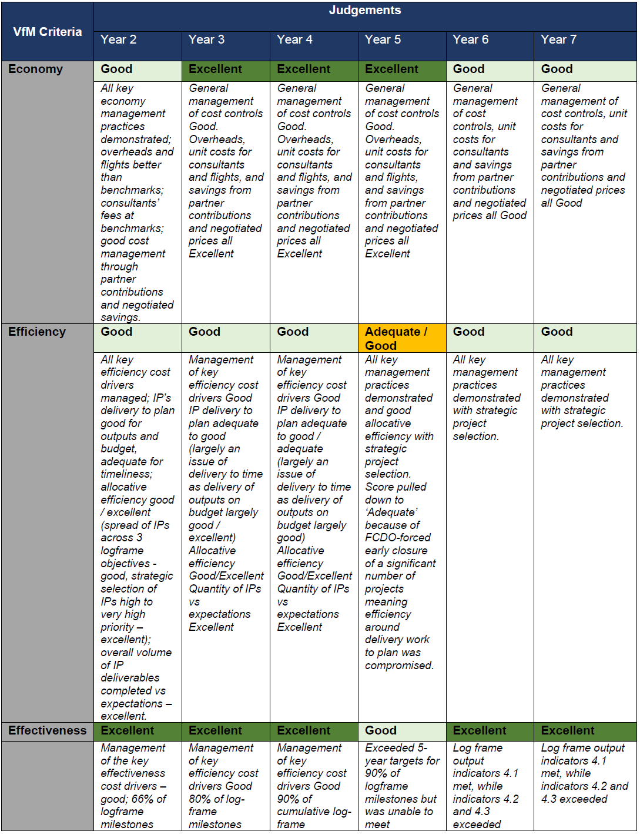

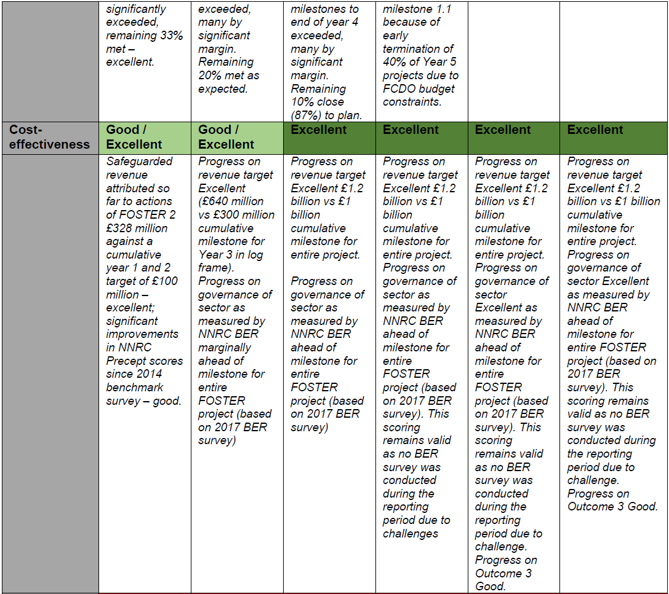

E: Risk

Overview of programme risk during the past year and over the life of the programme, drawing on FCDO’s Risk Management Policy and Risk Appetite Statement and wider risk guidance.

- The Risk Appetite of FOSTER remains Cautious (Moderate). The programme’s risk register was reviewed and streamlined during its final year

- FOSTER’s approach was to focus on identifying risks, mitigating them where possible and managing and escalating this with FCDO as necessary. FOSTER faced four key areas of risk: i) contextual/external risks, especially policy environment and appetite for reform ii) risk to delivery/results, iii) reputational risks to FCDO and FOSTER/OPM; and iv) (in the light of Covid-19 and security) risks to the safety and security of staff. FOSTER’s appetite for risk remained within FCDO’s risk appetite. The programme accepted that there was a relatively high risk of changes in the external context (such as lack of policy reform) hindering programme results. On the other hand, the programme had a low appetite for risks that would damage the reputation of HMG and/or FOSTER. Risk identification in FOSTER took place throughout the lifecycle of interventions. Risks to the programme and to specific activities were recognised and documented on the risk register and discussed during routine quarterly meetings.

- FOSTER’s appetite for risk is within that for FCDO. The programme accepts that there is a relatively high risk of changes in the external context (such as lack of policy reform) hindering programme results. But on the other hand, the programme had a low appetite for risks that would damage the reputation of HMG and/or FOSTER.

- Risk identification in FOSTER took place throughout the lifecycle of interventions. Risks to the programme and to specific activities were recognised and documented on the risk register and discussed during routine quarterly meetings as well as in weekly catch-up meetings. An important tool was the regular use of PEAs (Political Economic Analysis); choice and design of activities reflected the analysis in PEAs and mitigation strategies developed to bring residual risk to acceptable levels. All Intervention Plans (IPs) were approved by the SRO (Senior Responsible Officer). Risks were escalated within the FOSTER team by the staff responsible for each IP to the Team Leader and Programme Manager. These were then reviewed and as required escalated to the Programme Director and FCDO SRO if they could breach the programme’s risk appetite and jeopardise the programme. If necessary, materialising risks was further escalated within FCDON to Development Director and above.

Key lessons learned in FOSTER

- FOSTER was encouraged by FCDO to highlight risks and be frank about how much mitigation activities could ameliorate risks. The FCDO risk appetite for each category was extremely helpful for this. It was useful because it differentiates risk tolerance for different type of risks. Even where risks remain at or above FCDO’s risk appetite, there was a system for deciding whether to accept the excess risk or whether there was a way to manage it down to tolerance levels. The approach led to well-informed decisions on several interventions including work in the Niger Delta and on oil sector finances.

F: Programme Management: Commercial and Financial Performance, Monitoring and Evaluation

Summarise the performance of partners and FCDO, notably on commercial and financial issues, and including VfM measures of economy and efficiency.

Delivery against contract

- The programme was implemented by Oxford Policy Management. It started in 2016 with the planned end date of 2021. In early 2021, following the impact of the COVID19 pandemic on the UK economy, FOSTER’s initial life cycle was shortened by three months and the programme was scaled down on March 31, 2021. However, in August 2021, the programme was redesigned and extended to 2023 with a pivot to international climate finance. With programme focused on measures and commitments for combatting Nigeria’s contribution to climate change via the oil and gas sector activities. Following the refocusing of the project, the budget was downsized. In 2022/23, most of the ICF budget was allocated from FCDO’s Climate and Environment Department and then 2023/24 was provided from FCDON’s budget.

85. OPM delivered against its output, and in some cases exceeded its targets over the lifetime of the contract. The quality, delivery and timeliness of reporting was good, but at times required strong FCDO engagement. Over the lifetime of the programme, the programme built upon the strong trust, willingness and relationships with partners, businesses, stakeholders, and beneficiaries ensuring delivery of interventions.

86. FOSTER’s contracting modality used a hybrid payment by results (PbR) and an input-based system (i.e., time and expenses for core staff and consultants). Invoices were all scrutinised by the programme manager and the SRO provided an additional level of checks before approval. The fees at risk due to the PBR mechanism were clearly identified in the agreed IPs. While the PBR system developed was complex, invoices with claims were clearly identified and verifiable.

87. The programme underwent six contract amendments during its lifetime. The sixth (CA6) and equally the last was completed in July 2021 and designed to make the most of a window of opportunity for oil and gas reform and increased the budgeted spend for the period to March to £600,000 from £500,000.

FOSTER 2 Logframe
88. FOSTER 2 developed and implemented a log frame that reflected the results and Value for Money (VFM) assessed at project design and approval. The log frame clearly outlined the relationship between all Outputs, and the Outcome and Impact. The log frame fixed the delivery pathway for FOSTER, setting appropriate baselines and expected milestones and targets. In the second year of implementation, FOSTER engaged a VFM consultant and a Monitoring Evaluation and Learning (MEL) consultant to review the existing systems in place. A new VfM framework was developed, the TOC revised and the Logframe updated to address issues of duplicates or overlap of indicators and milestones which would make monitoring evaluation and learning difficult. These changes made them smarter and more measurable for IP design.

89. During the last two years of FOSTER 2, the logframe was further revised to accommodate additional climate objectives. Accordingly, an additional outcome indicator (Outcome indicator 3: “Improved political will and capability in Nigeria's oil and gas sector to mitigate GHG emissions”), and a fourth output (Output 4: MDA’s HoR Committees and other key sector actors better understand options and commit to actions that will lead to a reduction in Nigeria’s GHG emissions from the oil and gas sector”) were added to the logframe.

90. Another challenge to implementation was the abrupt cessation of programme activities at the end of 2020/21. Some interventions geared towards establishing end line parameters were not undertaken. For example, the intervention to deliver the 2021 NNRC benchmarking exercise designed to provide end-line data to assess FOSTER 2 performance against its outcome indicator 2 was not conducted.

Quality of Financial Management

91. The overall FOSTER budget was £18.998m with a final spend of £17.069m and an underspend of £1.9m. Total Annual expenditure is reflected in the Table and Diagram X below. To track financial implementation, the programme carried out periodic reviews and spot checks on its financial operations to minimize risk, in collaboration with the FCDO programme team. The service provider provided updates on financial performance within each quarter as part of the quarterly progress reports to FCDO. At the project level, the programme conducts due diligence and cost monitoring on all downstream partners to confirm their ability to implement, as well as their ability to receive and effectively manage funds.

 | Budget | Programme Spend
Inception | £581,763 | £560,382
Implementation (Nov 2016 -Apr 2023) | £18,416,313 | £18,416,313
Implementation (May 23- Jun 23) | £45,000 | £36,263
Totals | £19,043,076 | £19,012,958

Diagram X: Annual forecast vs actual expenditure in FOSTER
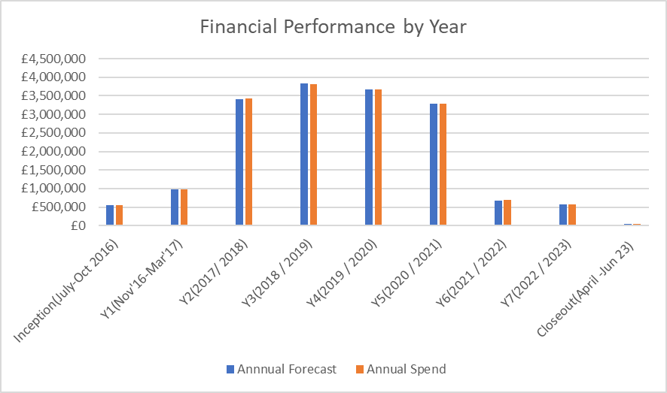

92. The budget for the inception phase of the programme was set at £581,763 which was made up of two lumpsum milestone payments and a ceiling budget of £128,150 for actual expenses. In total £560,382 was invoiced to the FCDO for inception (£453,613 in milestone payments and £106,769.26 in expenses).

93. FOSTER’s budget for Implementation was set at £19,043,076. The cumulative spend up to the end of April 2023 has been £18,976,076. We forecast £45,000 for May and June but spent £36,263 which brought the total implementation spend up to £19,012,958.

94. Over the lifetime of the programme FCDO conducted six annual reviews. In each exercise, it examined FOSTER’s milestones performance against each indicator set in the approved logical framework (log-frame). The exercise involves hard questions and rigorous scrutiny of both the annual report submitted earlier and interviews with key programme stakeholders. The programme is scored according to whether it met the annual output milestones or not. Annual Reviews also come with recommendations on how to improve programme performance. It is scored A++ if it ‘substantially’ exceeded expectations, A+ if it ‘moderately’ exceeded expectations, A if it met expectations, and B or C for not meeting expectations or substantially not meeting expectations.

Year | 2016 | 2016/17 | 17/18 | 18/19 | 19/20 | 20/21 | 21/22 | PCR
Programme Score |  | A | A+ | A | A+ | A | A | A+
 | Inception | Year 1 | Year 2 | Year 3 | Year 4 | Year 5 | Year 6 | Year 7
Residual Risk Exposure Rating | Medium | Medium | Medium | Medium | Medium | Medium | Medium | Medium

95. The programme implementation has been affected over the years by 2 election cycles 2019/2023, the uncertainty of change has usually slowed down the level and appetite for the transformative nature of the programme and its impact on policies. One other major issue was the Covid -19 pandemic which affected the programme and its ability to continue to deliver results in line with its log frame. The key challenges related to the lack of physical engagement with MDAs, Civil Society Organizations (CSO’s), Media and industry stakeholders, as well as the diminished capacity of government to engage in effective policy reform processes. The pandemic required FOSTER to make greater use of remote working, providing information to staff on Covid-19 and adjusting how activities were implemented to minimise face-to-face working. FOSTER continued to implement it programmes and met specific progress on certain objectives through greater use of remote meetings and workshops including online platforms like Microsoft Teams and Zoom. When it was safe to do so face to face, several conferences were held which complied with government guidelines of limiting public activities fewer persons and certain progress was made despite these measures.

Audit, asset monitoring, and control

96. FCDO commissioned annual independent financial audits of FOSTER 2. Audit findings have continued to show that funds were spent within scope and in accordance with contract agreements, and all items were procured following agreed policies. The final closure audit was unqualified, i.e., that means that the Fund Accountability Statement presents fairly, in all material respects, programme receipts and payments for the period under review (1st January 2022 – 31st March 2023) which are in accordance with the International Accounting Standards and agreed terms of the FOSTER 2 contract. All audit recommendations were actively monitored, implemented and no outstanding actions recorded.

97. The programme maintained an asset register, updated by OPM after assets were procured, acquired, or transferred, and reviewed by FCDO Programme Managers and the PRO. Asset management was also reviewed during Annual Reviews and audit exercises. The final asset register was validated by external auditors during the recent programme closure audit.

98. All programme assets at closure were disposed of in line with the FCDO Nigeria asset disposal guidance. During the current PCR, asset disposal through transfer to existing FCDO funded programmes, gifting to verified partners, and disposal through public auction where considered. Disposal through public auction was the most effective approach as there were no expressed interest from other FCDO programmes and PAGs (Partner Across Government) towards inheriting the few programme assets. FCDO managed these processes, ensuring disposal routes delivered maximum value for money. Approvals were received at respective delegated authority levels before implementation. All actions are well documented and proceeds from sales would be returned to FCDO.

Monitoring, Evaluation and Knowledge Management

99. FOSTER operated a separate MEL unit comprising the Lead MEL Manager, a Results, Learning and Knowledge Coordinator and a Results and Knowledge Officer. The team’s key responsibility was to track performance, highlight challenges, and feedback outcomes into the planning process. The continuous monitoring of project performance and challenges created opportunities for learning.

100. The MEL team implemented a process developed at the inception stage to track progress made in achieving expected results, spot implementation bottlenecks, inform decision-making both at work-stream and project management levels to foster adaptive management, and ensure that the overall results and impact of the project are achieved. Figure below shows the FOSTER approach to monitoring, evaluation, and learning.

101. Throughout the life of the project, the MEL team tracked emerging results in collaboration with FOSTER’s five workstreams. On a quarterly basis, data gathered from all live interventions are analysed, and results resonating with logframe targets are aggregated and reported.

102. The MEL team developed and implemented monitoring, evaluation and learning tools over the years including, intervention logic model, monthly intervention plan status tracker/notification system, and intervention plan and consultant closure reports. A revision to the Value for Money (VFM) framework, Theory of Change (ToC) and Logical Framework was carried out in project year two to respond to changing conditions and emerging results.

Fig X: Overview of MEL support and feedback to strategy planning and delivery of activities

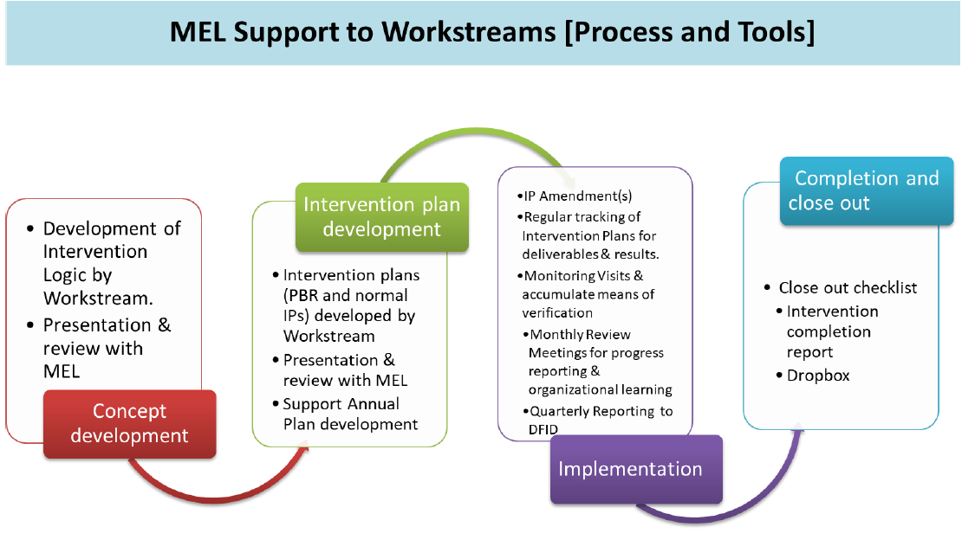
Date of last narrative financial report | March 2023 | Date of last audited annual statement | March 2022

ANNEX X: ICF KPI 15. Determine the baseline | What will success look like / expected basis for scoring | How assessed
1 – Limited incentives and critical mass to create political will in FGN to removing fuel subsidy  The petrol subsidy is set to cost the Nigerian budget about 0.5% of GDP in the next 12 months. The price for petrol is still set and is not market-determined in a way that removes the subsidy. The new Petroleum Industry Act stipulates that the subsidy should be removed ‘within six months’. The Finance Minister has said that this means by mid-2022.  There are strong political economy challenges with removing the subsidy. Labour unions and others are likely to resist and organise general strikes if it’s removed. Opinion in FGN appears split with the Finance Minister proposing subsidy removal mitigated by cash transfers for the poorest and other measures. However, other ministers are nervous about removing the subsidy. Furthermore, the Presidency is yet to signal support for this. | 1. No additional commitment to removing petrol subsidy  2. Some additional commitment to removing petrol subsidy e.g.  - 1 additional FGN figure publicly advocating for subsidy removal (minister, VP or similar)  - Subsidy somewhat lower due to part of petrol cost being passed to consumers  - Evidence of early preparation to introduce a revised petrol pricing formula  3. Significant additional commitment to removing petrol subsidy e.g.  - 2 or more additional FGN figures publicly advocating for subsidy removal  - Subsidy significantly lower due to part of petrol cost being passed to consumers  - Evidence of advanced preparation to introduce a revised petrol pricing formula  4. Fuel subsidy removed with introduction of a fully market-based system for petroleum products marketing and distribution | Assessment of FOSTER’s contribution:  Interviewees with government and private sector stakeholders  Press/media reporting  NNPC monthly reports, MoF  GoN issuing order detailing pricing mechanism
1 – Significant weaknesses in Nigeria’s capacity/capability to monitor key components of its Revised NDC that relate to the Oil and gas sector, including gas flaring and methane emissions  There are significant discrepancies in estimates of Nigeria’s methane emissions. There is also limited knowledge on the contribution of the overall oil and gas sector to emissions from fugitive and other categories of emissions. Information is fragmented on existing policies, standards and regulations to support lower emissions.  There are major discrepancies between different sources of data on gas flaring (and between gas flaring data and revenues that should accrue from the gas flare penalties. | 1. No additional capability/capacity developed  2. Preparatory steps towards developing new capability/capacity  - Agreement amongst major oil and gas sector stakeholders on two significant measures to be implemented after June 2023 that would improve Nigeria’s ability to monitor/regulate methane emissions and/or gas flaring  3. Some additional capability/capacity developed  - Implementation started of one measure that will significantly improve the monitoring/regulation of oil and gas sector GHG emissions  4. Significant additional capability/capacity developed  - Implementation started on two or more measures that will significantly improve the monitoring/regulation of oil and gas sector GHG emissions | Assessment of FOSTER contribution:  Stakeholder interviews: MoEnv, NOSDRA,  Comparison of WB Gas Flaring and NOSDRA Gas Flare Tracker data

In this report, the terms ‘upstream’, ‘midstream’ and ‘downstream’ in the oil and gas sector are used to describe in turn: upstream – exploration and production of oil and gas; midstream – aggregate movement and marketing of raw products from the point of production and their refining and other processes to turn them into finished products; and downstream – movement and marketing of finished products to end-users. In Nigeria, the ‘downstream’ sector reform issues include: who is able to import products and distribute e.g. supply to fuel pump stations around the country.
The Foreign, Commonwealth and Development Office (FCDO) was formed on 2 September 2020, combining the Foreign and Commonwealth Office and the Department for International Development.
The programme, FOSTER 2, is referred to as ‘FOSTER’ for the remainder of this review.
A full list of acronyms is an Annex 1.
Following the passage of the Petroleum Industry Bill (PIB) in August 2021, a new national oil company, NNPC Ltd, and two regulators for the upstream and midstream/downstream sectors have been created which broadly adopt the functions of legacy institutions. For instance, the new Nigeria Upstream Petroleum Regulatory Commission (NUPRC) took over the upstream functions of DPR and the new Nigeria Midstream and Downstream Regulatory Authority (NMDRA) took over functions of Petroleum Products Pricing Regulatory Agency (PPPRA), Petroleum Equalization Fund {Management} Board (PEFMB), the Midstream and Downstream Divisions of the Department of Petroleum Resources (DPR).
This PCR uses the terms ‘workstreams’, ‘outcomes’, ‘outputs’, ‘output briefs’ and ‘intervention plans’. These are elements of FOSTER’s design that support strategic direction and programme and performance management and are explained in Section B below: ‘Structure of the FOSTER programme: how implementation works’.
Marquette, H, Lopez Lucia, E, Buckley, J & McCulloch, N 2017 'Thinking and working politically: Lessons from FOSTER in Nigeria' Developmental Leadership Program, no. DLP Research Paper 48, Developmental Leadership Program, University of Birmingham, pp. 1-28.
‘Beneficial Owner’ is the natural person(s) who directly or indirectly benefits from, owns, or controls the corporate entity. Beneficial ownership information disclosure has become imperative to facilitate detection and curbing of illicit behaviour involving companies such as tax evasion, corruption, money laundering and terrorist financing.
https://www.thisdaylive.com/index.php/2020/12/23/neiti-nnpc-resolve-55-outstanding-audit-issues/
https://www.thisdaylive.com/index.php/2021/12/02/fg-launches-strategic-implementation-work-plan-for-ndelta/

