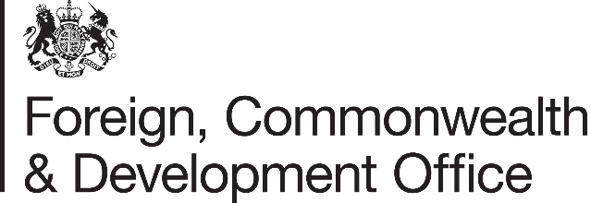

Memorandum of Understanding Amendment Letter

Project Name: Support to the International Committee of the Red Cross (ICRC)
Project Number: 300978-102
PO Number: PUR1081271

- I refer to the Memorandum of Understanding between the Government of the United Kingdom of Great Britain and Northern Ireland acting through the Foreign, Commonwealth & Development Office (FCDO) and The International Committee of the Red Cross (ICRC) signed on 22 August 2022, including subsequent amendments signed on 6 March 2023, 22 May 2023, 30 October 2023, 7 March 2024, 10 October 2024 & 15 November 2024.

- Following recent correspondence, FCDO proposes to increase the amount made available to ICRC by GBP 5,000,000 (Five million pounds sterling).

- I propose that the figures and words £27,200,000 (Twenty Seven Million, Two Hundred Thousand Pounds Sterling) in paragraph 3 of Amendment 06/2024 be deleted and replaced with the figures and words £32,200,000 (Thirty two million, two hundred thousand pounds sterling).

- I propose that the end date of 31 March 2025 in paragraph 4 of Amendment 04/2024 be deleted and replaced with 31 March 2026.

- FCDO proposes to delete the words ICRC Somalia 2024 Appeal in paragraph 5 of Amendment 04/2024 and replace them with ICRC Somalia 2025 Appeal.

- This letter of amendment will place on record our common understanding of the above change(s) and will come into operation on the date you sign your confirmation below. This note will be known as Amendment No. 07/2024.

- Please return a signed copy of this letter and retain one for your own records.

Signed on behalf of FCDO:
Position: | Development Director, British Embassy Mogadishu
Date: | 28 November 2024
Signed on behalf of the Partner:
Position: | Head of Resource Mobilization
Date: | 02 December 2024
Signed on behalf of the Partner:
Position: | Senior Country Manager, Resource Mobilization Division
Date: | 02 December 2024

